WORLD METEOROLOGICAL ORGANIZATION  _________________________  REGIONAL ASSOCIATION V  IMPLEMENTATION - COORDINATION MEETING ON THE GTS AND ISS IN RA V  WELLINGTON, 8 -12 DECEMBER 2003 |  | RA V/ICM-GTS 2003/Doc. 2.1(7)  (05.XII.2003)  ____________  ITEM 2.1  ENGLISH only

STATUS OF IMPLEMENTATION IN FIJI
(Submitted by Leonard Bale)

Summary and purpose of document

A status report is given on the implementation of telecommunications circuits and systems at NMC Nadi, Fiji.

Action proposed

Participants are invited to note the information herein

General Status of Centre

The Fiji Meteorological Service (FMS) Forecasting System has operated its meteorological data processing systems, comprising data collection, message switching, forecasting preparation and product delivery within a distributed Unix environment as shown in Figure 1.

The Computing Message Switching System (CMSS) operates on an IBM RISC 6000 series model J40 processor data server with mirrored disk subsystem fully backed up by similarly configured second machine. The Servers share disk resources and are configured in a mutual takeover configuration. That is, if one server fails, the backup server takes over the disk and network resources belonging to main server, and vice versa.
The Bureau of Meteorology, Melbourne Special Services Unit team provided software for the CMSS in a Unix environment as per FMS needs. The FMS Forecasting System design has the advantages of simplicity, ease of understanding and inherents flexibility. FIMS Applications are the central subsystem. At its core is the relational database, which integrates and combines data from various sources. FMS Communications, FMS Difacs and the satellite ingest software all integrate closely with FMS applications and with each other.

Consequently the FMS Communications has the primary function of transmitting and receiving data to and from external organisations such as other meteorological services, aviation industry and other customers to and from the FMS Applications. Its operation can be closely monitored either by itself or the LAN/WAN network management software. Data can also be sent to FMS Difacs from a scanner and to the satellite ingest software from both geostationary and polar-orbiting satellites. Both these subsystems can interact with FMS Communications, as well as FMS Applications.

Telecommunications Circuits connected to NMC Nadi, Fiji

Nadi-Melbourne GTS Link

A GTS link between Nadi and Melbourne operates at 9600 bps using TCP/IP between Nadi and Melbourne. The Fiji Meteorological Service also makes use of the Airport Fiji Limited (AFL) message switch for access to AFTN data via national/international and regional countries. The GTS link is currently carrying data, pictorial NWP products, radar imagery between Fiji and Australia etc. The configuration is shown in Figure 2.

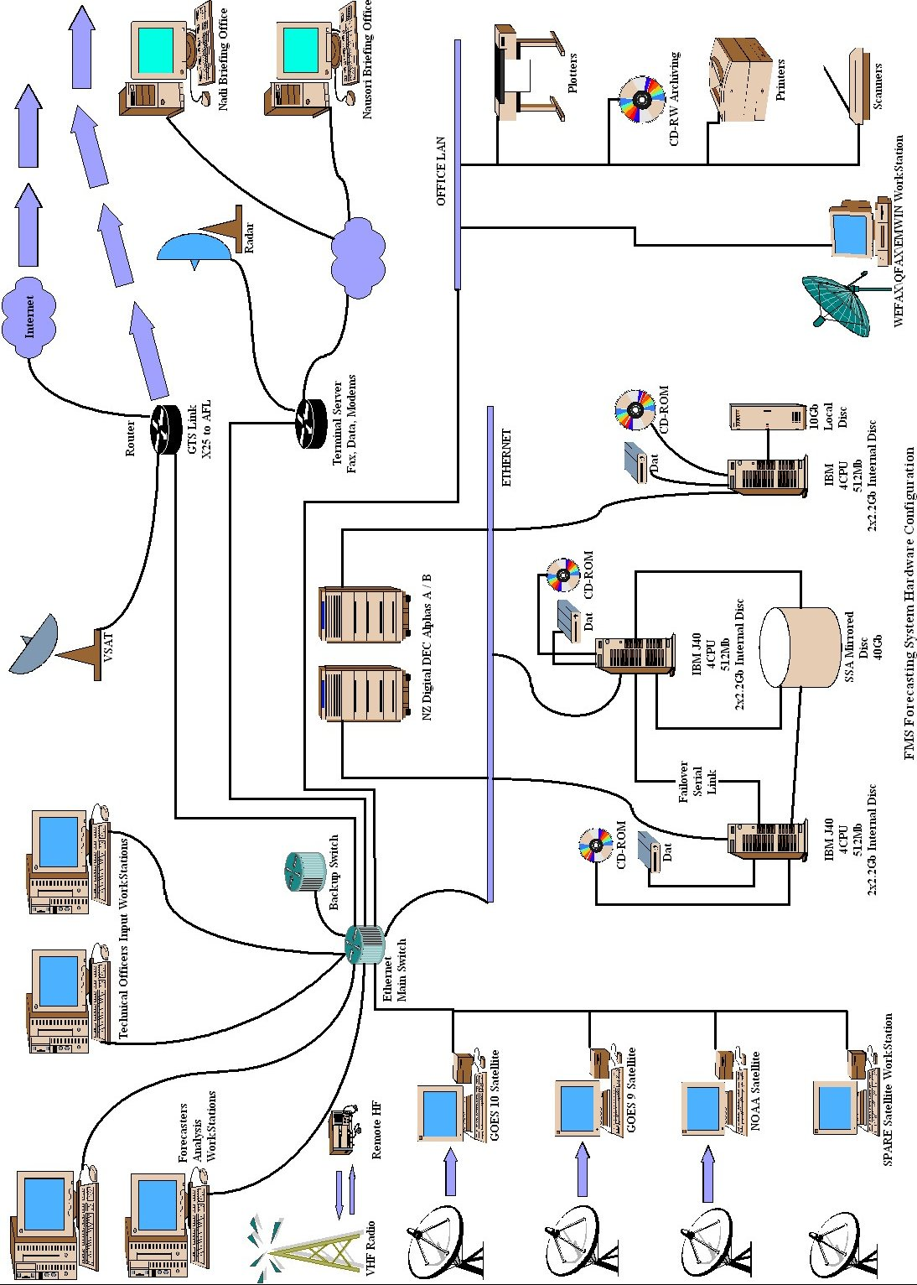
Figure 1
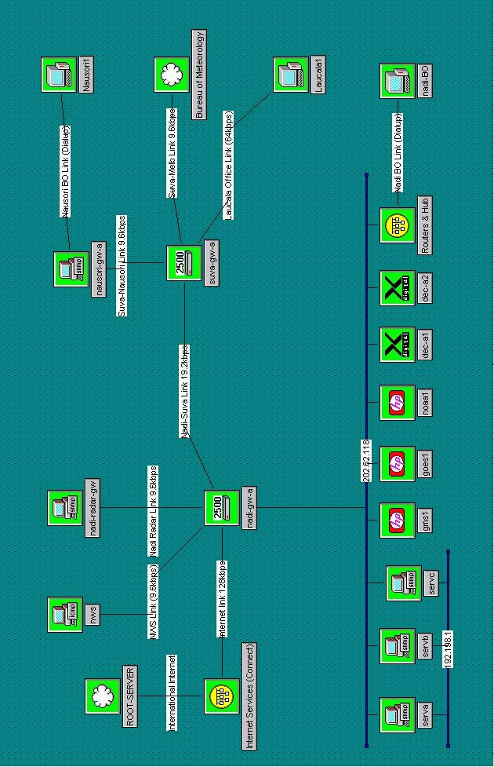
Figure 2
Aeronautical Fixed Telecommunication Network (AFTN) Links via Airports Fiji Limited

The Fiji Meteorological Service has close ties with Airports Fiji Limited (AFL) in the sense that there organisation holds services for our AFTN and the backup link to the National Weather Service (NWS), US via the BandWidth Manager (BWM). The upgrade from the old SAGEM CMSS to the new Promina 1000 BWM has terminated the use of old Telegraphic circuits that were used for AFTN. The following are the status of the AFTN circuits that is currently hosted by AFL.

New Caledonia

There is direct connection to Tontouta using a 64K line but utilising 9.6K for data and 8K for voice, using X.25 protocol.

Brisbane & New Zealand

Direct connection to Auckland using a 64K line but utilising 2.4K for NZ and 4.8K for Brisbane, using 8K voice for both centres..

Oakland

Direct connection to Oakland using a 64K line and 4.8K for data and 8K voice, using X.25 protocol. This circuit also hosts our backup link to NWS using 4.8K using tcp/ip socket connection and is currently being tested with live data.

Kiribati

Direct connection to Kiribati using asynchronous dialup 2.4K line.

Nausori Airport

Direct connection to Nausori Airport using a 19.2K line utilising 9.6K for data and 8K voice, using TCP/IP protocol.

AFL On Going Developments

Aeronautical Telecommunications Network (ATN)

The ATN will provide for the interchange of digital data between a wide variety of end system applications supporting end users, such as; aircraft operators, air traffic controllers, and aeronautical information specialists. The ATN, based on the International Organisation for Standardisation (ISO) Open Systems Interconnection (OSI) reference model, allows for the inter-operation of dissimilar air-ground and ground-ground subnetworks as a singe Internet environment. FMS have held discussions with the CNS/ATM group at Nadi Airport indicating the preferred protocols to be consistent with WMO standards if they were to implement and wish to have access to weather information. Figure 3

Reference: http://www.icao.int/

Aeronautical Fixed Services (AFS)

Airports Fiji Limited's focus on this particular area is to improve application and services and making use of data, voice and mobile protocols, using industry standard communication products within the Air Traffic Management (ATM) sector to provide a secure Internet Protocol (IP) for a secure network service. A proposed Pacific AFS Network is currently in implementation phase and has been approved by ICAO. A draft version is demonstrated on Figure 3.
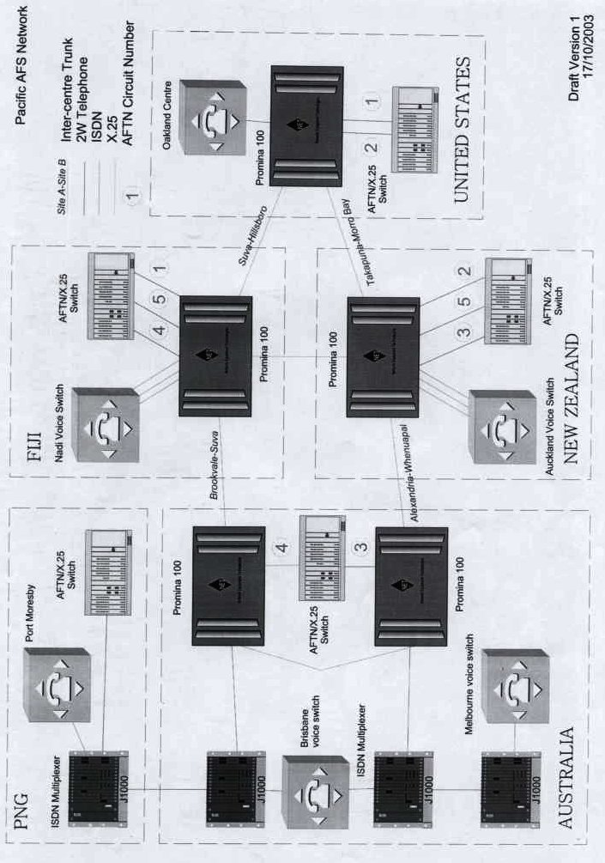
Figure 3
Other Telecommunication Systems and Services

High Frequency Radio (HF)

HF radio services are used in communications with the synoptic stations at Kadavu Island, Nabouwalu, Nausori, Laucala Bay, National Disaster Management, 3DP coastal telecommunication services and recently at Udu point for backup to observations but mainly for Climatic Observations.

Automatic Weather Station (AWS)

The Geostationary Meteorological Satellite (GMS) is a part of an international network and provides operational collection services for DCP (Data Collection Platform) of which 7 of these FMS is responsible for. These are used in communications with the synoptic stations Udu Point, Vanua Balavu Island, Lakeba Island, Ono-I-Lau Island, Matuku Island, Viwa Island and Yasawa-I-Rara Island. The Adelaide, Flinders University National Tidal facility owns 2 Automatic Weather Stations that are used in communications with the measurement of tides and sea surface temperature at Lautoka and Suva Wharves. Three Small Automatic Weather Stations were purchased from New Zealand Met Service and are currently established on the main land and use Public Switched Telecommunication Network (PSTN) which are used in communications with the synoptic stations Labasa, Rakiraki and Sigatoka.

Emergency Managers Weather Information Network (EMWIN)

Uses the WEFAX low-resolution channel of the GOES satellite for distribution, at a relatively low data rate, of meteorological information related to emergency situations, including warnings. This service has expanded and is currently relaying GTS data, Satellite products and meteorological data via the Goes 10 satellite.

Internet

Internet services are provided through a 128K circuit to Telecom Fiji Limited which is the only Internet Service Provider (ISP) in Fiji. This is used for email, File Transfer Protocol (FTP), World Wide Web (WWW).

Facsimile and Telephone

Facsimile and telephone is still one of the primary means of receiving data from other NMCs under special and emergency circumstances and within the country for meteorological data, administrative information, tropical cyclone warnings and for discussing cyclone information.

Satellite communication Facilities

(a) NOAA 1 x HRPT – (NOAA12, NOAA14, NOAA15)
(b) GOES 1 x S-VISSR (GOES10)
(c) GOES 1 x S-VISSR (GOES 9)
(d) GOES Wefax (Low Resolution)
(e) VSAT 1 x WAFS

Collection of Oceanic Reports

Reports from oceanic areas in SHIP code are collected by 3 DP, the Fiji Telecom Limited coast telecommunications service. Reports are passed by PSTN facsimile from 3 DP Maritime Radio to NMC Nadi for entry into bulletins.

Other On-going Developments and Future Plans

- Integration of WAFS data (from VSAT) into existing services is continuing
- Replacement of 'DIFACs' graphical products with locally generated products is continuing
- New WAFs replacement equipment has arrived. This will enable the front end to be changed and protocols from X.25 to TCP/IP.
- Integration of new AWS stations with the computing infrastructure. Still in planning phase.
- Integration of new Radar at Vanua Levu with the computing infrastructure. Still under planning phase.
- Wireless connection between Netown Radar site and RSMC Centre. Implementation phase in progress.
- Standardisation of Forecasters workstation from IBM to Linux OS.
- Integration of Marine Broadcast facility and digital HF into the computing infrastructure. Still under planning phase.

APPENDIX / GLOSSARY

NMC - National Meteorological Centre
FMS - Fiji Meteorological Service
CMSS - Computing Message Switching System
FIMS - Fiji Integrated Meteorological System
PC - Personal Computer
PC-CORA - Vaisala Radiosonde System
PC RAPIC - Radar Display PC
GTS - Global Telecommunication System
Is the international message-switching network controlled by WMO.
AFTN - Aeronautical Fixed Telecommunication Network
Telegraphic communication network still being used by some Pacific Islands
TCP/IP - Transmission Control Protocol/Internet Protocol
Standard communications protocol
AFL - Airports Fiji Limited
Previously, Civil Aviation Authority of Fiji
Kbps - Kilo Bits Per Second
Bps - Bits Per Second
X.25 - Standard communications protocol
SAGEM - Switching system produced in France
HF - High Frequency
3DP - Telecom Fiji Data Processing coastal telecommunication service
GMS - Geostationary Meteorological Satellite
DCP - Data Collection Platform
WEFAX - Weather Fax
NOAA - National Oceanic Atmospheric Administration
GOES - Geostationary Operational Environmental Satellite
WAFS - World Area Forecast System
PSTN - Public Switched Telecommunications Network
McIDAS - Man Computer Interactive Data Access System
Satellite Display System
YABBY - Backup Communications Web based system
CNS/ATM - Communication Navigation Surveillance / Air Trafiic Management

