WORLD METEOROLOGICAL ORGANIZATION  _________________________  REGIONAL ASSOCIATION II  IMPLEMENTATION - CO-ORDINATION MEETING ON THE GTS IN RA II  MOSCOW, 8 - 10 SEPTEMBER 2003 |  | RA II/ICM-GTS 2003/Doc. 3.3 (2)  (4.IX.2003)  ____________  ITEM 3.3  ENGLISH only

REPORT ON THE IMPROVED RMTN PROJECT

(Submitted by Hiroyuki Ichijo (Japan), Rapporteur on the improved RMTN)

Summary and purpose of document

This document includes the report on the status and plans of the improved RMTN project in RA II, and related information on telecommunication market.

ACTION PROPOSED

The meeting is invited to consider the status, plan and suggestions on the improved RMTN and to develop recommendations for further improvement as appropriate.

Appendix : A. Current status of RMTN in RA II as of August 25, 2003
- Plans of RMTN in RA II for 2003-2005
- Sample of information from a marketing company
(Brief summary of investigation report by Telemark Services Ltd)

Note) Appendix C is the other file in PowerPoint format.
- Background

Regional Association II endorsed the concept of an improved RMTN using modern cost-effective network services at its twelfth session (Seoul, 19-27 September 2000). In view of the geographical extension of the Region, it agreed that the design of the improved RMTN could be based on the implementation of several networks with appropriate groups of RTHs and NMCs as appropriate. Figure 1 shows a possible implementation of four group networks linked with the Network II of the Improved MTN (IMTN) as a core.

The outcome of the feasibility study made by the Sub-group on Regional Aspects of the GTS of WG-PIW in RA II in 2000 showed that the ultimate goal could be collaborative implementation of each group’s network using the most beneficial service provided by a single provider, and that cost-effective managed data network services such as Frame Relay and IP-VPN (Internet Protocol - Virtual Private Network) services were available in parts of the Region. On the other hand, it noted that the collaborative implementation of such services would require development of mechanisms in administrative aspect such as procurement and contract procedures, and rules for cost-sharing and the project steering.
Considering that network services could not been always available in the whole Region and that the mechanisms would not be developed shortly, the Association has greed a practical step by step approach for the implementation.

Figure 1 Configuration of a possible implementation for the Improved RMTN in RA II
Zone of
responsibility of
RTH Tokyo
Zone of
responsibility of
RTH New Delhi
Zone of
responsibility of
RTH Tashkent
Zone of
responsibility of RTH Beijing
Zone of
responsibility of RTH Bangkok
Zone of
responsibility of
RTH Novosibirsk
Zone of
responsibility of
RTH Khabarovsk
Zone of
responsibility of
RTH Jeddah
Zone of
responsibility of
RTH Tehran
Improved RMTN
Eastern part (Group IIA) Network
Improved RMTN
Southern part (Group IIB) Network
Improved RMTN
Western part (Group IIC)
Network
Improved RMTN
Northern part (Group IID) Network
Offenbach
Jeddah
New Delhi
Beijing
Tokyo
Tehran
Khabarovsk
Tashkent
Novosibirsk
Moscow
Bangkok
Improved MTN
Network II

The strategy to promote the improved RMTN project further was discussed in the ICM-GTS in Region II [Southern part] (New Delhi, 7-10 January 2002). The meeting developed the following recommendations:
- Each RTH should survey the technical status, capabilities and opportunities of its associated NMCs, as well as the data-communication network services that are commercially available and cost-effective in their respective zone;
- RTHs should assist their associated NMCs in developing implementation plans, including target implementation dates; this plans should include the migration to TCP/IP, which is a key factor for enabling the use of cost-effective systems and communications;
- As an initial step, current circuits should be upgraded as soon as possible using data-communication services that are considerably more cost-effective than conventional leased circuits, such as Frame Relay services;
- Financial assistance is required for a number of NMCs to implement the Improved RMTN. In addition to the development of individual VCP projects on the basis of the NMC/RTH plans, the Secretariat was invited to establish a co-ordinated cooperation project for the implementation of the improved RMTN in Region II.

The meeting particularly stressed the need for focal points on the improved RMTN and an adequate training of the technical staff in NMCs on the relevant information and communication technologies for the Improved RMTN. In this context, 12 focal points were designated and also the Training Seminar on ICT for GTS (Bangkok, 23-27 September 2002) was held.

- Status of progress of the improved RMTN

Each of the four groups already stepped into the first stage. Objectives of this stage are migration to TCP/IP and extrication from expensive leased circuits.
The use of TCP/IP has considerable benefits for each centre in the saving the both of costs and human resource. In fact, installation costs and software development work are reduced through use of industry standard software and systems with common knowledge. Furthermore the use of TCP/IP allows us considerable latitude in selecting a network service.
A charge for a leased circuit has been a burden to each centre for many year. It must be urgent to seek cost-effective alternatives such as Frame Relay and IP-VPN services even if it is on a bilateral basis. Appropriate use of the Internet is now being discussed by many centres.

  - Implementation of circuits

As of August 2003, the RMTN configuration plan in RA II includes seventy-eight circuits (i.e. 8 MTN, 51 regional, 13 inter-regional and 6 additional circuits). Sixty-seven circuits of them are in operation, namely the latest implementation rate is 86 percent. Although this percentage is not so bad, a crucial problem is that quite a few circuits are operating at a low speed. A speed more than 9.6kbps at least could be required in consideration of requirements of the improved RMTN such as dissemination time of observation data within 15 minutes, distribution of processed information of a large volume and handling various data types (e.g. binary, charts and files). Although improvement in circuit speed has been progressed in a last few years as shown in Figure 2, 60 percent of all circuits are still required to increase speed. In most cases financial conditions, especially lack of recurring cost, prevent improving in speed.

Furthermore it is serious that there are still eleven circuits not in operation. Especially NMCs Baghdad (ought to have 2 regional circuits), Kabul (3) and Phnom Penh (1) are isolated from the GTS. In spite of difficult situations, efforts to establish the circuits should be continued in cooperation with RTHs concerned.
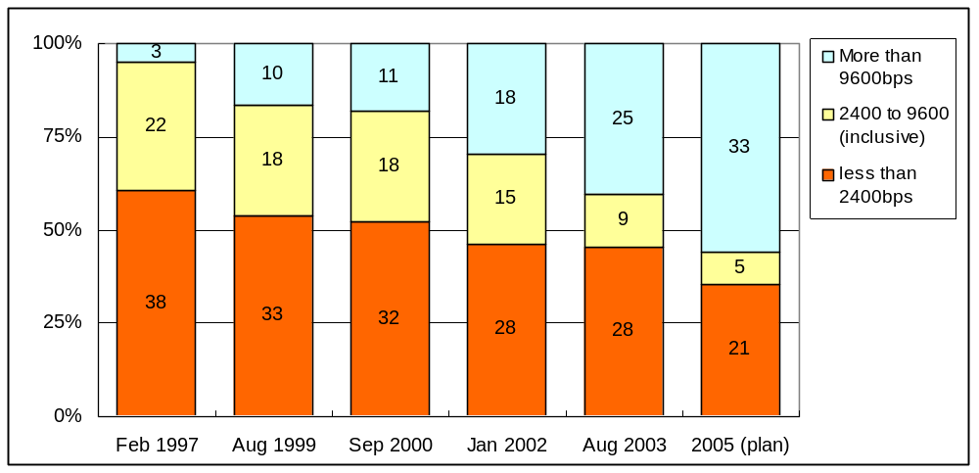
Figure 2 Progress of improvement in circuit speed in RA II
The number
of circuits

  - Migration to TCP/IP

The migration towards TCP/IP on GTS circuits has been progressing considerably since beginning of the 21th century in the Region. Twenty seven circuits, i.e. about 35 percent of all circuits in the Region are operating on pure TCP/IP as of August 2003. Based on each centre’s report on upgrade plans, it is expected that the achievement rate would be over 50 percent by the end of 2005.
number of circuits
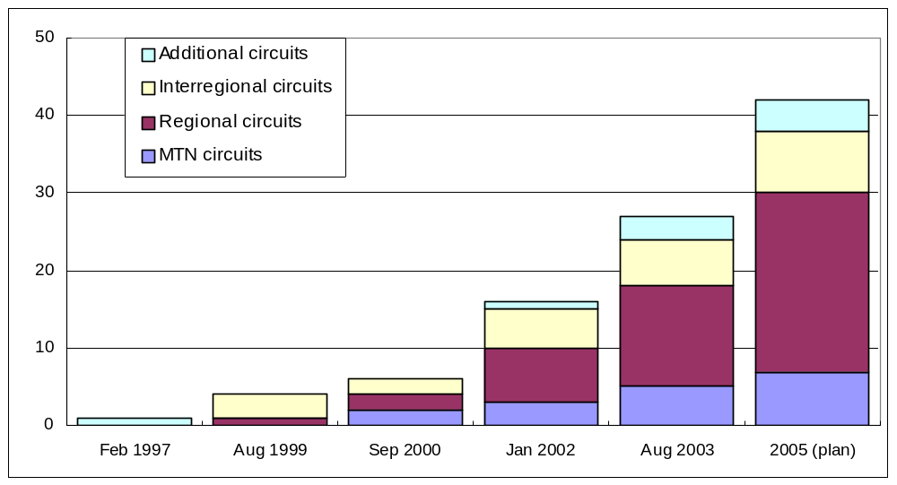
Figure 3 Progress in migration to TCP/IP in RA II
number of circuits

  - Seeking cost-effective connections

2.3.1 Frame Relay services

Migration from leased circuits to Frame Relay circuits has been making steady progress since 2000, along a strategy for the improved RMTN in the eastern part (Group IIA) and implementation of the IMTN project. It is expected that 13 to 15 Frame Relay circuits would be in operation by the end of 2005.
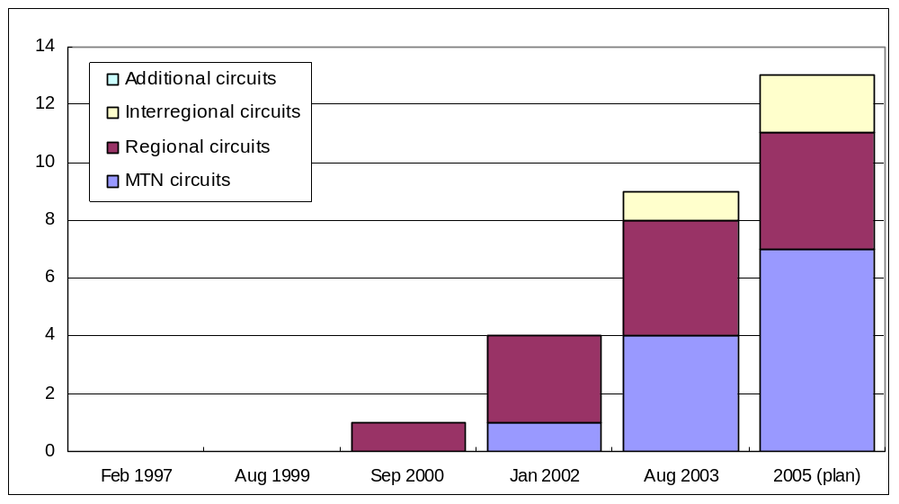
Figure 4 Growth in introducing of Frame Relay circuits in RA II
number of circuits

In the use of managed network services such as Frame Relay and IP-VPN, one of important things is to recognise differences between bilateral basis and one-stop collaboration. To compare the strategy of Group IIA with the IMTN project is a good example in approach to establishing Frame Relay circuits as clearly indicated in Table 1. Concepts of the multi-end-contract and the one-stop-contract are shown in Figure 5(a) and (b), respectively.

Table 1 Remarkable differences between the strategy of Group IIA and the IMTN project
 | Group IIA | IMTN
Administrative view | Multi-end-contract  # the traditional peer-to-peer method for GTS circuits  # Easy to coordinate | One-stop-contract  # a new collaborative framework among centres  # Not easy to coordinate
Technical view | Network-to-Network Interconnection (NNI)  # Inter-connection of two providers / telecom carriers  # Committed Information Rate (CIR) : Symmetric only | Seamless connection  # connection through a network managed by a single provider  # Committed Information Rate (CIR) : Symmetric or Asymmetric





Telecom. Carrier

X
NMHS
A
Telecom. Carrier

Y
NMHS
B
contractual boundary
between X and Y

Contract between A and X
Payment for the X portion to the boundary
Contract between B and Y
Payment for the Y portion to the boundary
Tariff of X in the local currency
Tariff of Y in the local currency
Frame Relay
Network
X
Frame Relay
Network
Y
NNI
Bill
Payment
Bill
Payment
NMHS A
(Primary customer)
NMHS B
(Secondary customer)
Contract between A and X
Payment for the total charge
from A to X
Customers B & C
Tariff of X in a major currency
MoU among customers
Provider X
Bill
Payment
NMHS C
(Secondary customer)
Frame Relay Network
supplied by a single provider X
Customer A
In accordance with MoU
the payment is recovered
from B and C
(a) Multi-end-contract
(b) One-stop-contract (Typical case)
Figure 5 Concepts of the multi-end-contract and the one-stop-contract
Migration to Frame Relay circuits usually bring cost-effectiveness in both concepts.
In examples as the multi-end-contract of the Hong Kong-Tokyo, the Seoul-Tokyo and the Bangkok-Tokyo, about 25 to 40 percent cost-saving could be realized at both ends. In example as the one-stop-contract of the Washington-Melbourne-Tokyo triangle, practical capacity of the circuits could be expanded enormously without extra cost, e.g. throughput from Washington to Tokyo became ten times or more as large as before with a few percent cost-saving.
Meanwhile the Frame Relay service is not available or not adequate in parts of RA II. For example, some of NMCs in the northern part (Group IID) are out of coverage of adequate Frame Relay services and there is no provider which covers all RTHs (Khabarovsk, Moscow, Novosibirsk and Tashkent). In the southern part (Group IIB) and the western part (Group IIC) there are some cases that recurring cost of Frame Relay services is comparatively higher than the present cost of leasing an analogue telephone line. It seems that the cost issue depends on balance of demand and supply in each country.

2.3.2 IP-VPN services

IP-VPN (Internet Protocol - Virtual Private Network) with MPLS (Multi Protocol Label Switching) is a fully managed private network different from Internet VPN. It is secure, flexible, scalable and cost-effective. IP-VPN services, in spite of the promising service for the improved RMTN, have not been introduced so far. Since contracts of IP-VPN services are definitely on one-stop basis, comprehensive administrative coordination required may prevent centres from introducing the services in the improved RMTN.
On the other hand, the IMTN project, which originally started from collaborative use of a one-stop service, will be reviewed in the use of IP-VPN instead of Frame Relay services.






Closed
IP network
by a provider
CE
PE
CE
PE
CE
CE
IP
IP Label
IP Label
Core Router

Core Router

Core Router

PE

IP
VPN group
VPN group
Input
LabelInput
PortOutput
LabelOutput
Port.
.
..
.
..
.
..
.
.
Destination IPVPN
No.Output LabelOutput port.
.
..
.
..
.
..
.
.
Provider’s PEs and Core Routers based on MPLS have Label Tables and switch IP packets forward according to the Tables.

CE : Customer Edge Router VPN : Virtual Private Network
PE : Provider Edge Router MPLS : Multi Protocol Label Switching

Internet
IPsec Product
ESP AH IP
VPN group
VPN group
IPsecVPN products add/remove the ESP for encryption and encapsulation and the AH for authentication to/from an IP packet.

ESP : Encapsulation Secure Payload AH : Authentication Header
IPsec Product
IP
ESP AH IP
IP
IPsec Product
Figure 6 Typical examples of the VPN
(a) IP-VPN with MPLS
(b) Internet VPN with IPsec

2.3.3 Internet links

Expansion of the Internet use in recent years brought a possibility of a new type GTS circuit through the Internet. Although the number of circuits is currently 5 and is expected to increase up to 9 by the end of 2005, further sharp growth is likely to happen with gaining experience in how to establish a link through the Internet.
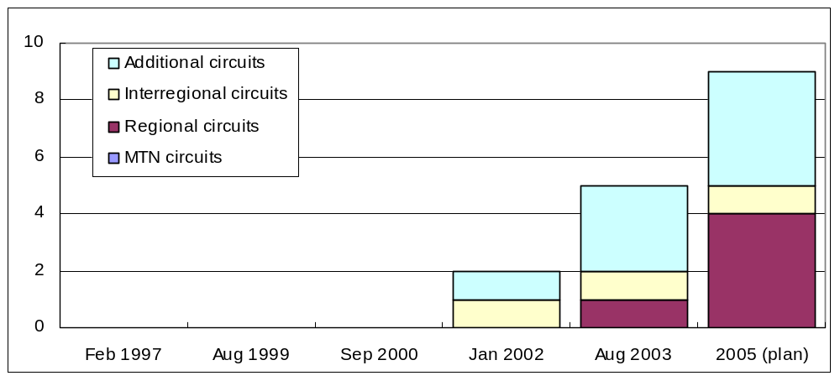
Figure 7 Growth in GTS circuits through the Internet in RA II
number of circuits

The Internet link has specific characteristics of no guarantee in transfer speed, delay time and security, and no responsible body in connectivity. Especially security risks and hidden costs to mitigate them are becoming serious year by year. (refer to the report by Rapporteur on the Regional Aspects on the Data Management and Codes: “RA II/WG/PIW/Doc. 6.4 ADD.1”)
In spite of those negative characteristics, there are various opportunities for cost-saving (no charge except for the connection to ISP), gigantic transport capacity, flexible connectivity and introducing modernized technologies.
Since existing Internet circuits do not use any VPN techniques, insecurity factors lurk in them even if filtering of IP addresses and port numbers is implemented. A risk of invasion attacks by address spoofing and pretense definitely exists. VPN techniques, especially IPsec, is worth paying attention to.

  - Complementary systems

2.4.1 Satellite broadcasting systems

Satellite broadcasting systems are used for complements to the GTS, backup sources and cost-effective alternatives to HF radio broadcasts.
- A VSAT-based broadcasting network by China Meteorological Administration has been fully operating since January 2000. It covers China and some neighboring countries and is integrated into the RMTN as well as METEOSAT/MDD. PCVSAT systems installed in Hanoi, UlaanBaatar and Pyongyang are used for receiving AN and binary data from Beijing as complements of the low speed GTS circuits.
- Russian broadcast using a satellite TV communication system (TV-Inform-Meteo) has been providing fax charts and AN bulletins since 1995. It is the alternative of Moscow’s radio broadcasts ceased in 1996. The rate of a fax signal is 4800bps and the rate of a telegraphic signal is 100 bauds. The coverage is the European territory of Russia, the region of Siberia, countries of the CIS (Commonwealth of Independent States), Baltic states and the Far East. NMCs Bishkek and Dushanbe receive required information through the satellite system.
- WAFS (ISCS, SADIS) broadcasting is regularly used for operation in most of RTHs/NMCs. Furthermore a pilot project for use of the UKSF (UK Satellite Facility) by RA II Members is progressing.
- RTH New Delhi switched their data serving for users including marine vessels from HF radio broadcasts to a satellite-based digital audio broadcast developed by World Space through Asia Star Satellite in August 2003. It is a very cost-effective solution. The approximate cost for distribution of 1 Mbytes through the satellite is US$ 10. A user receives required data using a commercial radio receiver with a small L band antenna and a PC card adapter, which is manufactured by several companies at an approximate cost of US$150.

2.4.2 Internet server systems

Internet access to data servers is one of convenient and promising ways for a complement to the GTS and a backup source. A number of centres currently operate their own data servers and provide WWW data through the Internet on near real-time basis. Most of NMCs which do not have a GTS connection with enough bandwidth usually obtain WWW data from the servers.
- NMCs Ulaanbaatar and Dushanbe use the Internet as a backup source for obtaining necessary data from WWW-servers of RTHs Moscow and Novosibirsk.
- NMCs Hanoi, Hong Kong, Karachi, Kuala Lumpur, Macao, Manila and Singapore regularly access to the RSMC data serving system operated by RTH Tokyo.
- In case of the Beijing-Offenbach circuit outages, RTH Offenbach sends all data to be sent on the GTS circuit via the Internet to RTH Beijing by ftp. And RTH Beijing duly puts all GTS data on the specific directory of its Internet FTP server so that RTH Offenbach can get them.

- Prospect on foundations of the improved RMTN

3.1 IMTN Network II (a core of the improved RMTN)

The IMTN project has already entered into the implementation phase. The Network II of the IMTN is supposed to be established as extension of RA VI RMDCN (Regional Meteorological Data Communications Network). The RMDCN is a well managed Frame Relay network under the contract between ECMWF and Equant.
RTH Beijing joined the Network II and the Beijing-Offenbach circuit was migrated into the Network II in April 2003. RTHs Jeddah, New Delhi and Tokyo are in progress of arrangements to join the Network II. It is expected that the core of the improved RMTN would be established in 2004.

Bracknell
Sofia
Network II
Melbourne
Buenos Aires
Tokyo
Beijing
New Delhi
Nairobi
Cairo
Toulouse
Dakar
Algiers
Moscow
Washington
Brasilia
Network I
Offenbach
Jeddah
Prague
Figure 8 Configuration of the Improved MTN (IMTN)

  - Understanding of network service providers

Fierce competition in the telecom market (so-called “carriers wars”) and assembly/dissolution of global alliances in 1990s carried us a good opportunity to have a new understanding of selecting a network service provider. An age where each user trusts a local PTT with everything for network plans has gone. We have learned the tricks and tips of selecting a provider through discussion on the IMTN and the improved RMTN projects for four years. For example:
- Find the right price
Cut-price with an excessive discount often means a trade-off in service quality. We must keep a balance between price and quality in our minds.
- Assess the quality
We should try to understand each provider’s specific characteristics in backbone network, reliability and availability, performance such as burst limits and round-trip delay, and support capabilities such as help desk services, monitoring and report procedures and local language support.
- Understand difficulties
PTT monopoly often makes a network service less reliable and more expensive. In case of a bilateral connection, nothing goes well without technical compatibility and a contractual agreement between PTTs. In case of a seamless connection by a single provider, it is very hard to coordinate administrative issues on one-stop basis among individual NMHSs (National Meteorological and Hydrological Services) and the provider.

  - Asian market of network services

According to telecom marketing reports and information from centres, the status of the Asian telecom market could be summarized as follows:
- Generally the Asian telecom market is inactive except for the Internet business since the recent recession. New investments by global network service providers have inclined to concentrate on potential markets such as China and India.
- Although each country’s PTT is trying to gradually phase out legacy facilities, its progress is slow in some countries of PTT monopoly. Such poor domestic infrastructure affects reliability and cost-effectiveness of international connections.
- Increasing the number of available providers in eastern Asia has ceased and then unbelievable discounting in late 1990s is coming to an end.
- In business use, the network trend is gradually moving from Frame Relay to VPN services. IP-VPN services are currently available domestically in developed countries and being available internationally among big cities in the world. It is expected that coverage of those TCP/IP based network services would expand on the worldwide level absorbing traditional telephone networks.

- Suggestions in further improving

- Acceleration of TCP/IP migration

All of RMTN circuits in RA II should migrate to pure TCP/IP links with a first priority in the first step. Delay of implementation in one centre may extinguish the whole benefit.
Some NMCs have difficulties in TCP/IP migration. Their telecommunication systems (e.g. Message Switching System) are already obsolete and have no capability to handle the TCP/IP protocol suite. Lack of expertise and funds definitely obstructs replacement of their systems.
Technical and financial support in the early stage of the transition will be effective for promotion of the migration. Related RTHs and WMO Secretariat should consider possible support.

- Selecting an appropriate network service with a possible framework

There are options in cost-effective services such as Frame Relay, IP-VPN, ATM, satellite IP multicast and so on. Regarding the contract aspect, in addition to a bilateral framework which is the current strategy, a one-stop collaboration is becoming an option (e.g. further extension of the IMTN Network II).
Since there are various differences in technical developments and administrative conditions from part to part in RA II, an appropriate network service and its contractual framework are not to be always the same.
Each group and/or part (an RTH and NMCs concerned) should examine and discuss their best solution. In other words, an appropriate network service with a possible contractual framework should be selected by each group/part.

- Use of the Internet for a GTS circuit as the very end solution

The use of the Internet is one of convenient solutions to upgrade the current GTS circuits, especially asynchronous low speed ones. But there are serious risks in security and performance guarantee, as well-known. At present, all centre should first challenge the approach to the best solution mentioned 2) above. If the ordinary approach would be very difficult, the Internet use should be considered.
In case of GTS circuits through the Internet, introduce of VPN techniques is recommended according to “Guide on Virtual Private Networks (VPN) via the Internet between GTS centres” (http://www.wmo.ch/web/www/TEM/ICT-ISS2002/guideVPN.doc) developed by OPAG-ISS.

- Practical use of consulting and marketing companies

It is desirable to use detailed survey reports provided by telecom consulting and marketing companies in identifying available and adequate data communication services and network providers for RMTN and also national networks.

- Building up technical information to help NMCs facing difficulty

The on-line information resources on the GTS are available on the WMO Web server under http://www.wmo.ch/web/www/TEM/gts_online_resources.htm. Although this site is very useful for all the GTS centres to obtain practical information and guidance on the actual implementation of data communication systems and techniques, there seems be still room for improvement and enhancement. WMO Secretariat should strengthen the on-line information resources on the GTS from the view to help small NMCs having no expertise in cooperation with voluntary experts.

In this regard, here are some ideas from GTS colleagues:
- to add easier contents aiming at a newcomer to telecom section, beginner’s dictionary and necessary extractions from textbooks;
- to increase trivial but necessary tips in the implementation collected from centres;
- to add the latest information on telecom marketing and network providers;
- to update contents timely;
- to build a virtual help desk to answer questions from NMCs and to prepare FAQ.

Frame Relay
CIR<16/16K>
Frame Relay
CIR<16/16K>
Frame Relay
CIR<16/16K>
Internet
Frame Relay
CIR<32/32K>
Frame Relay
CIR<16/16K>
Frame Relay
CIR<32/32K>
Frame Relay
CIR<32/768K>
Frame Relay
CIR<16/32K>
Frame Relay
CIR<48/48K>
Internet
Internet
Internet
Internet
connection
Vientiane
Ulaanbaatar
Baghdad
Doha
Kuwait
Bahrain
Dhaka
Yangon
Kathmandu
Kabul
Karachi
Colombo
Male
Hanoi
Phnom Penh
PyongYang
Ashgabad
Macao
64K
14.4K
Dushanbe
Almaty
NI
NI
NI
NI
Seoul
NI
NI
NI
7.2-28.8K (V.34)
64K
9.6K
2.4K
9.6K
4.8K
64K
128K
7.2K
64K
50
50
50
50
50
64K
100
200
1200
1200
1200
2.4K
100
100
100
200
75
75
75
1200
75
50
100
75
100
100
75
75
9.6K
Melbourne
Offenbach
Offenbach
Cairo
Cairo
Algiers
Moscow
Kuala Lumpur
Tashkent
Novosibirsk
Khabarovsk
Bangkok
Melbourne
Washington
NI
NI
9.6-28.8K (V.34)
9.6-19.2K (V.34)
19.2-24K (V.34)
Appendix A Current status of RMTN in RA II as of August 25, 2003
Bishkek
64K
2.4K
Singapore
RTH in Region II
NMC in Region II
Centre in other region
MTN circuit
Regional circuit
Interregional circuit
Additional circuit
Non-IP link
IP link
NI No implementation
Tehran
200
Hong Kong
NI
64K
Manila
Jeddah
9.6K
7.2-28.8K (V.34)
Sanaa
Moscow
Tokyo
Beijing
200
New Delhi
7.2-28.8K (V.34)
via Moscow

-32.5K (V.34)
via Moscow

Muscat
Emirates
Frame Relay
CIR<16/16K>
Frame Relay
CIR<16/16K>
Frame Relay
CIR<16/16K>
Frame Relay
CIR<32/32K>
Frame Relay
CIR<16/16K>
Internet
Frame Relay
CIR<16/16K>
Internet
Internet
Internet
Internet
Internet
Internet
Frame Relay
CIR<48/48K>
Frame Relay
CIR<32/768K>
Frame Relay
CIR<16/32K>
Frame Relay
CIR<48/48K>
Frame Relay
CIR<8/8K>
Frame Relay
CIR<16/16K>
Frame Relay
Internet
Internet
connection
Vientiane
Ulaanbaatar
Baghdad
Doha
Kuwait
Bahrain
Dhaka
Yangon
Kathmandu
Kabul
Karachi
Colombo
Male
Hanoi
Phnom Penh
PyongYang
Ashgabad
Macao
64K
Dushanbe
Almaty
NI
NI
NI
NI
Seoul
NI
NI
NI
7.2-28.8K (V.34)
64K
9.6K
64K
9.6K
64K
128K
64K
50
50
50
64K
100
200
1200
2.4K
100
200
75
75
1200
75
50
100
75
100
100
75
75
9.6K
Melbourne
Offenbach
Offenbach
Cairo
Cairo
Algiers
Moscow
Kuala Lumpur
Tashkent
Novosibirsk
Khabarovsk
Bangkok
Melbourne
Washington
NI
NI
9.6-28.8K (V.34)
9.6-19.2K (V.34)
19.2-24K (V.34)
Appendix B Plans of RMTN in RA II for 2003-2005
Bishkek
64K
Singapore
RTH in Region II
NMC in Region II
Centre in other region
MTN circuit
Regional circuit
Interregional circuit
Additional circuit
Non-IP link
IP link
Plan
NI No implementation
Tehran
200
Hong Kong
NI
Manila
64K
64K
64K
64K
Jeddah
75
9.6K
7.2-28.8K (V.34)
Sanaa
Moscow
Tokyo
Beijing
200
New Delhi
7.2-28.8K (V.34)
via Moscow

-32.5K (V.34)
via Moscow

14.4-28.8K (V.34)
Muscat
Emirates

