
WMO SECRETARIAT

DRAFT

WMO INFORMATION SYSTEM

Functional Architecture

“Managing and Moving Weather, Water and Climate
Information in the 21st Century”

World Weather Watch

Information Systems and Services Division

_________________________________________________________________________________
Version 0.4
3 June 2008
DOCUMENT VERSION CONTROL
Version | Authors | Date | Description
0.1 | Robert Husband, David Thomas and Eliot Christian | 31/01/08 | First draft for discussion
0.2 | Robert Husband, David Thomas and Eliot Christian | 05/03/08 | Second draft
0.3 | Robert Husband  David Thomas  Eliot Christian  Fred Branski | 13/03/08 | Third draft
0.4 | Robert Husband  David Thomas  Eliot Christian  Fred Branski | 03/06/08 | Fourth draft after a review. Major changes include:  i) general textual clarifications;  ii) updates to the model, including:  - changes to A11, A12 and A13 to better illustrate National, Regional and Global activities and to harmonise terminology;  - removal of references to files and bulletins and their replacement with observations, products and information;  - harmonised treatment of internal and external users for the delivery of information (internal information delivery has been removed from A11 and A12 - all information is now delivered via function A5);  - the archive functionality has been separated out and marked out of scope;  - the retrieve functionality has been removed.  iii) 2 types of DCPC have been introduced (a simple DCPC and a DCPC with RTH functionality).

Table of Contents

EXECUTIVE SUMMARY 5
Purpose, Outline, and Authority of this Document 6
Purpose of this Document 6
Outline of this Document 6
Authority of this Document 6
1 Functional Scope of WIS 7
1.1 Basis 7
1.2 Impact on the WIS Functional Architecture 8
1.3 Relationship to Physical Architecture 8
1.4 Open Issues 9
2 WIS Functional Architecture 11
2.1 Adopted Standard for the Functional Architecture 11
2.2 Context (Level 0) 12
2.3 Level 1 Functional Diagram 13
2.3.1 Data Management Thread 13
2.3.2 Service Provision Thread 14
2.3.3 Performance Management Thread 14
2.4 Functional Decomposition Below Level 1 15
2.4.1 Decomposition of A1: Collect Observations, Generate Products, Create Metadata and Archive Information 15
2.4.2 Decomposition of A3: Maintain and Expose Catalogue of Services and Information 16
2.4.3 Decomposition of A5: Deliver Information to Users (Internal and External) 16
2.4.4 Decomposition of A6: Manage System Performance 16
2.5 Relationship Between Model and WIS “In Scope” Items 17
2.6 Hierarchy of Functions 18
3 WIS Components and their Minimum Constituent Functions 19
4 Pre-existing Functions Within WIS 21
APPENDIX A – WIS Functional Model 22
APPENDIX B – Hierarchy of Functions 33
APPENDIX C – List of Abbreviations 34
APPENDIX D – Glossary of Terms 35

List of Figures:
Figure 1: Integration Definition for Function Modelling (IDEF0) 11
Figure 2: WIS Context Diagram 12
Figure 3: Level 1 Functional Diagram 13
Figure 4: Decomposition of A1 - Collect Observations, Create Products and Archive Information 15

List of Tables:
Table 1: Scope of WIS (extracted from the WIS Project Plan) 8
Table 2: Relationship Between “in scope” Items and Functional Architecture 18

EXECUTIVE SUMMARY
This document describes the main functional components of WIS, with the associated data-flows. This high-level description provides a systematic view of how WIS functions.
A structured methodology is used to describe the WIS functions, based on a widely accepted standard (Integration Definition for Function Modelling - IDEF0). The application of this methodology results in a hierarchy of functional diagrams. To facilitate their interpretation, these diagrams are accompanied by a textual description of the main functions and associated information flows.
The overall WIS functional model is then used to propose the minimum functional scope of its constituent components [National Centres (NCs), Data Collection or Production Centres (DCPCs) and Global Information System Centres (GISCs)].
Finally, the WIS functionality is related to the functions carried out within the existing WMO IT systems including the Global Telecommunications System (GTS) and the IGDDS; illustrating the additional functionality provided by WIS.

Purpose, Outline, and Authority of this Document

Purpose of this Document
The purpose of this document is threefold:
- to describe the functional architecture of WIS;
- to relate the WIS functional architecture to its logical components (i.e. NC, DCPC and GISC);
- to identify the WIS functions that form the basis of the existing major WMO IT systems (i.e. GTS and IGDDS).

Outline of this Document
The document consists of the following main sections:

Section 1: Functional Scope of WIS;
Section 2: WIS Functional Architecture;
Section 1: WIS Components and their Minimum Constituent Functions;
Section 2: Pre-existing Functions Within WIS.

Authority of this Document
This document is a reference document that is produced and maintained by the WIS Project Office. The document lies hierarchically below the WIS Project Plan.

Functional Scope of WIS

Basis
A comprehensive description of the context, functional scope and implementation approach for WIS is provided in the WIS Project Plan.
In view of its particular relevance to the functional architecture, the table provided in section 1.3 “Scope” of the WIS Project Plan is duplicated below.

 | In Scope
1 | Routine collection and automated dissemination of time-critical and operation-critical information (‘push’).
2 | Timely delivery service for information (appropriate to requirements) including delayed mode data.
3 | Information subscription services (subscribe to ‘push’) by authorised users.
4 | Ad-hoc requests for information (‘pull’) by authorised users.
5 | Integration and management of duplicated files or messages (information entity) including version control (i.e. corrections and duplicates) The blending of real time and delayed mode information is handled in other processes of information custodians.
6 | Integration of data collection and distribution systems either in place or under development within the WMO programmes including the satellite programme’s Integrated Global Satellite Data Distribution System (IGDDS) and the use of the internet via all programmes.
7 | Access to WMO registries and catalogues, including a portal for metadata discovery (Information Discovery)
8 | Discovery, Access and Retrieval Service (DAR) to information serving directly from GISCs of current content (as distinct from only providing metadata)
9 | Interoperability with other user communities including earth sciences and the various GEO societal benefit areas (GEOSS).
10 | Assurance processes for ensuring adherence to data and information usage policy.
11 | Identification and authorisation processes
12 | Network security
13 | Information security including exchange over open and closed networks. i.e. Ensure the quality of the information is maintained while in the transit and communications components. e.g. quality of service according to GTS manual
14 | Merit assessment of new and existing communication technologies (i.e. solution should be flexible and scalable to allow for taking advantage of new technologies).
15 | Information collection and distribution systems within Member states. Although internal collection and distribution practices within countries are totally under the control of the Member state, these are a part of WIS. Also, WIS should be able to register national systems should members desire international access to them.
16 | Quality and performance monitoring of collection and distribution services and systems
17 | Metadata profiles for describing information and information services.
18 | Management of metadata & effectiveness of metadata, system handling of metadata
 | Not in scope at this time.
1 | Who decides what information passes on WIS. This comes back to the information provider.
2 | User registration and shared user registers, virtual organisation issues.
3 | Information visualisation and integration. This is a value added service available through NC and DCPC. Available and future API may enable users to achieve this function.
4 | Information subsection and creation of new products. Too hard at present and will come in later development stages
5 | Quality control and assurance processes for data and products. These are being managed within other stages in the information creation and collection at present, especially within the NC.

Table 1: Scope of WIS (extracted from the WIS Project Plan)

Impact on the WIS Functional Architecture
The majority of the “in scope” items in section 0.1 have a functional dimension and need corresponding provisions within the functional model.
Table 1, together with incoming and outgoing dataflows, will be used to define the functional scope of WIS. This provides the basis for the WIS functional architecture see section 2 for further details).
Additionally, a cross-check is made with the “in-scope” items defined in section 0.1 to ensure appropriate provisions for the “in scope” items are included within the architecture (see section 0.9).
The “not in scope” items are not addressed.

Relationship to Physical Architecture
The functional architecture is a logical construction and provides an orthogonal view to that of the physical architecture.
Only the minimum functionality associated with an NC, DCPC and GISC is described via the functional architecture (see section 1 for further details),
Actual physical implementations of NCs, DCPCs and GISCs may vary considerably and possibly include distributed designs.

Open Issues
The following table list the open issues that will be addressed in future versions of this document.

Issue Identifier | Issue Description | Sections Affected
1 | The need to relate “threads” to use cases | 2
2 | Possible need to redistribute some of the real-time functions within A6 to functions A1 to A5 (already partially done for A5 - see pages A-8 and A-9 of Appendix A). | 2 and 3
3 | The function related to performance management (A6: Manage System Performance) needs to be further developed:  i) approach needs to define what is appropriate for the WIS and then cross-check with GTS (e.g. Appendix A1.5 of the WMO Manual on the GTS – could build upon the concept of GTS monitoring centres);  ii) options to be considered include a minimalist approach in WIS, with more demanding and detailed requirements decided by individual programmes;  iii) Issues to be addressed in more detail include: service level and infrastructure monitoring; data monitoring; system availability monitoring (key elements need to be continuously monitored); performance requirements (e.g. 2 minutes for centre-to-centre warnings) and the requirement for time-stamping at both ends; latency requirements which are not universally addressed in the current set of operational documentation; minimum requirement is the monitoring of data receipt and transmission times - for data that is exchanged; the data monitoring approach should be adaptive and reflect when the data becomes available, rather than when it was scheduled to be available.  iv) sample SLAs could be a source of information;  v) Need a network availability monitoring approach that works when no data is being transmitted – implementation consideration.
4 | The sub-functions of A5 (and their balance need to be revisited to reflect that 99% of real-time dissemination is event-driven. The menu of delivery service options needs to be reflected in the document, noting that priorities do not map directly onto the service delivery structure (dependent on the product). Also a request/reply service is needed to support GTS RTHs, (e.g. retransmission and adhoc). Also an internal messaging is required (address messaging) and an administrative message service – e.g. for notification of operational information. | 2
5 | Information security – a cross-check with the GTS Manual is required to ensure that all relevant functionality has been included | 2 and 3
6 | Network security – the approach adopted to ensure network security may require an update to the functional architecture. | 2 and 3
7 | Pre-existing functions within WIS – this section needs to further developed to illustrate how the WIS builds upon functions within existing WMO IT systems (and, in some cases, replaces manual functions with automatic functions). Ideally, this will be illustrated by simple overlays. | 4
8 | Terms used need to be harmonised – a placeholder is included in Appendix D | Appendix D

WIS Functional Architecture

Adopted Standard for the Functional Architecture
In order to develop the WIS functional architecture in a systematic and rigorous manner, an appropriate standard was selected that is supported by tools which facilitate the implementation of the standard.
The standard known as Integration Definition for Function Modelling [IDEF0] is both simple and highly regarded. In addition, an important feature of this standard is the clarity of its functional representations, which can be interpreted by a broad audience without the need for specialist skills.
Some of the main features of the IDEF0 standard are summarised in Figure 1 (below).
Function
Input
Output
Control
source data which is transformed by the Function

the result of the transformation carried out by the Function

identifies the resources/facilities that are used by the Function (e.g. humans, computers...)
defines how the Function carries out the transformation
Mechanism
Functions transform the Inputs into Outputs in accordance with the Controls and making use of the Mechanisms

Figure 1: Integration Definition for Function Modelling (IDEF0)
The IDEF0 standard supports the hierarchical decomposition of both functions and data flows. As one drills deeper into any part of the model, further definition is evident in the inherited functions and data flows; yielding a logical hierarchy of data flows and functions.
The particular software tool used to support the implementation of the IDEF0 standard is “Workflow Modeler” - a product of the Meta Software Corporation.

Context (Level 0)
At the highest level, the functional architecture of WIS is determined by its "context" (or environment).
The WIS context is indicated in Figure 2 (below).
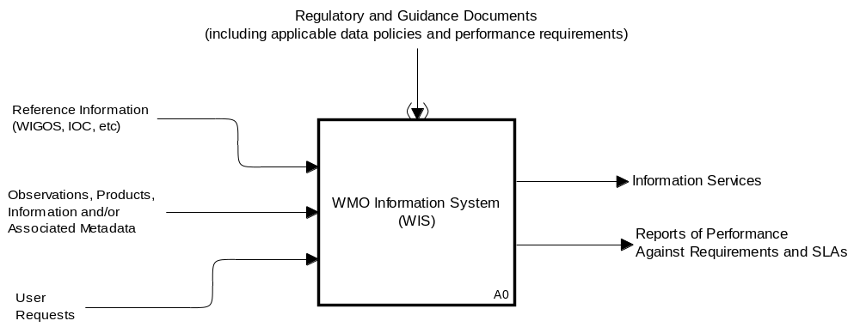
Figure 2: WIS Context Diagram
In accordance with the IDEF0 standard:
- the WIS “inputs” are depicted by arrows on the left of the box;
- the WIS “outputs” are depicted by arrows coming out of the box on the right;
- the WIS “controls” (which define how the WIS functions should be implemented) are depicted by the arrow entering at the top of the box. [The brackets around the arrowhead denote the “tunnelling” of this information – i.e. to avoid the diagrams becoming too cluttered and unreadable, this dataflow is not indicated on the subsequent lower level decompositions].
At the level of the context diagram, the labels attached to the arrows represent the highest level in a hierarchy of data-flows that are subsequently described in the lower level decompositions.
The A0 box itself represents the full scope of all WIS functions and the “bold edging” indicates that this function box has further decompositions within the model. The labelling convention followed for the function boxes is:
A0: Context
A1, A2, A3… Functional decomposition of Context
A11, A112, A113… Functional decomposition of A1, (similarly for A2, A3, etc)
In principle, any function can be decomposed into an arbitrary number of sub-functions. Purely for readability, the decomposition is normally limited to 6 sub-functions by the Workflow Modeler tool (with an absolute maximum of 9 sub-functions). This constraint is only applied to the breadth of the decomposition and not the depth (i.e. the number of functional levels) which is unconstrained.
Some non-WIS functions are included within the model to facilitate understanding of data flows even though they are not within the scope of WIS – e.g. see decomposition of functions A11 and A12.

Level 1 Functional Diagram
The level 1 functional diagram (figure 3 below) lies immediately below the context diagram, inherits its attributes, and provides a high-level overview of how WIS functions.
There are three main threads1 to the level 1 functional diagram:
- The data management thread makes sure that the required data is available within WIS to meet the needs of the users;
- The service provision thread processes user requests for information and provides the associated information to the users;
- The performance management thread monitors and controls the overall performance of WIS and provides performance reports).

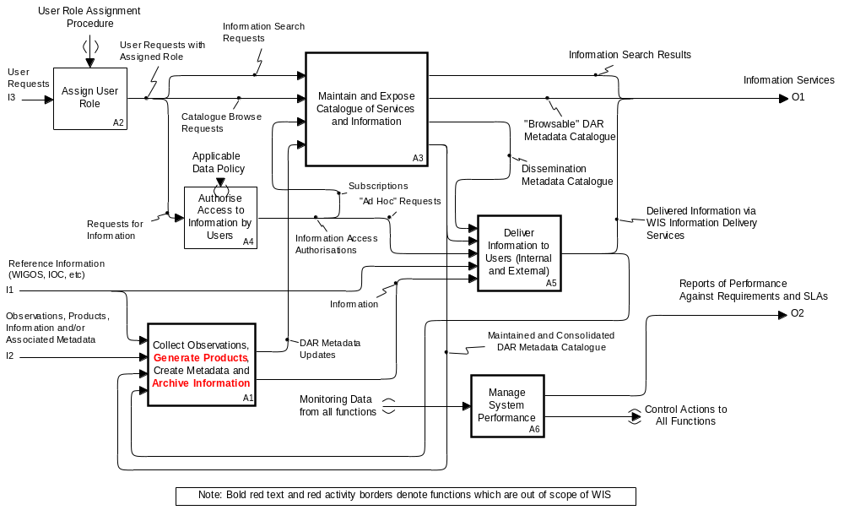

Figure 3: Level 1 Functional Diagram

Data Management Thread

The data management thread primarily involves 2 functions:

- A1: Collect Observations, Generate Products, Create Metadata and Archive Information
- A3: Maintain and Expose Catalogue of Services and Information

The purpose of function A1 is to collect and archive all the relevant WIS information, and to create the required Discovery Access and Retrieval (DAR) metadata. There will be an initial population of the DAR metadata, which will then be maintained by updates.

Function A3 has both a service provision component and a data management component. The data management component mainly involves the generation and maintenance of a consolidated DAR metadata catalogue (see section 0.7.2 for a description of the service provision component of function A3).

Service Provision Thread

The service provision thread primarily involves 4 functions:

- A2: Assign User Role
- A3: Maintain and Expose Catalogue of Services and Information
- A4: Authorise Access to Information by Users
- A5: Deliver Information to Users (Internal and External)

As indicated by function A5, the service provision thread addresses the information needs of both internal and external users.

The thread starts with an initial user request. To process this request the authorised user role(s) must be determined. This determination is performed by function A2 in accordance with the relevant user role assignment procedure.

The subsequent processing of the request then depends on its typology. The three options are identified in figure 3:

a) Information Search Requests;
b) Catalogue Browse Requests;
c) Requests for Information.

Option a): the request is passed to function A3, which searches the consolidated DAR catalogue and provides the search results to the user.

Option b): the request is passed to function A3, which makes available the relevant parts of the DAR catalogue to the user for browsing.

Option c): the request is passed to function A4 for verification that the request is consistent with all the applicable data policies. This could be a follow-on action as a result of previous requests of type a) or b). Once verified, access is authorised and the subsequent process depends on the type of information request. Two options are available:

i) “subscription” requests (a user requests that information be provided on a routine basis);
ii) “ad hoc” requests (no recurring service provided).

Option i): the request is passed to function A3 which updates the dissemination metadata catalogue, and the information is then delivered to the user via function A5 (after being relayed from function A1). It should be noted that the dissemination metadata catalogue defines how information is provided to users by Function A5 and contains all the details as to how the data should be delivered to the user.

Option ii) is similar to option i) with the exception that the dissemination metadata catalogue is not updated (no recurring service) and the request is passed directly to function A5 without the involvement of function A3.

Performance Management Thread

The performance management thread primarily involves function A6: Manage System Performance. This function has a real-time component and an off-line component. The real-time component receives status information from all WIS functions and issues “control” actions as appropriate.

The offline component provides reporting information to WIS management entities on the performance of the WIS in accordance with the WIS performance requirements – see “tunnelled” control in figure 2 (context diagram).

Functional Decomposition Below Level 1
The Level 1 functional decomposition given in section 0.7 is an overview of the main WIS functions and their inter-relationships in terms of dataflows.

This section describes, in a systematic way, their constituent lower level functions and associated dataflows.

Decomposition of A1: Collect Observations, Generate Products, Create Metadata and Archive Information

Function A1 is decomposed into 3 sub-functions (see figure below) which have some similarities in terms of functionality, but are different in terms of scope (national, regional and global).

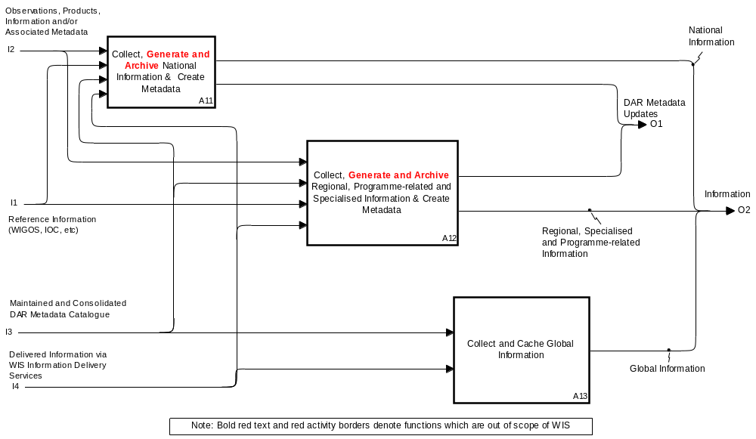

Figure 4: Decomposition of A1 - Collect Observations, Generate Products, Create Metadata and Archive Information

Function A11 operates primarily at the national level with the following functional components (see Appendix A-4):

- Collect National Observations (A111);
- Check Meteorological Content of Products and Observations (A112);
- Archive (A113);
Generate National Products (A114);
- Generate Metadata (A115);
- Unpack Information (A116);
- Verify Correct Telecommunication Attributes of Information (A117).

Note: functions A112 and A114 are not within the scope of WIS (see section 0.1) but have been included because they are commonly associated with this process.

Function A12 is similar to function A11, but operates primarily at the regional level (see Appendix A-5 for further details).

Function A13 (see Appendix A-6) is primarily at the global level and differs from functions A11 and A12 in that:

- it does not collect information and instead relies on functions A11 and A12 for the collection of information;
- it provides a 24 hour cache (for retrieval) of globally-required data.

Decomposition of A3: Maintain and Expose Catalogue of Services and Information

Function A3 consists of three sub-functions (see Appendix A-7):

- Search DAR Metadata Catalogue (A31);
- Maintain and Expose Consolidated DAR Metadata Catalogue (A32);
- Maintain Dissemination Metadata Catalogue in Accordance with Authorised Subscriptions (A33).

Decomposition of A5: Deliver Information to Users (Internal and External)

Function A5 is further decomposed into the following sub-functions (see Appendix A-8 and A-9):

- Schedule and Control Activities (A51):
- Derive Time-driven (synchronous) activity schedule and list of event-driven (asynchronous) activities (A511);
- Monitor for Events (A512);
- Resolve any Activity Scheduling Conflicts, reflecting relative service priorities (A513)
- Package Information for Delivery (A52).

This function ensures information is delivered in a manner that reflects service priorities. To achieve this, the delivery of the data is controlled so that time-driven and event-driven activities are interwoven in a manner that is consistent with service priorities. The process is driven by user requests for data (as reflected in the contents of the Dissemination Metadata Catalogue or “adhoc” requests). This basic input information is used to generate the synchronous activity schedule, and the list of event-driven activities. As events occur (detected by A512) function A513 ensures that the synchronous and asynchronous activities are executed in a manner that reflects the overall service priorities.

Decomposition of A6: Manage System Performance

Function A6 has both an offline (reporting) and a real-time aspect, as reflected in its decomposition (see Appendix A-10):

- Compile Monitoring Data into Performance Reports - A61;
- Ensure Performance is in Accordance with Requirements (including verification of telecommunications aspects) – A62.

The first of these activities (A61) ensures adequate data is available about the operational performance of the WIS. The reports generated will enable a direct correlation between system performance and WIS requirements. The reports will also provide the source information for the conduct of performance reviews.

The second activity (A62) is a real-time activity designed to verify proper functioning of the WIS [note: some these real-time activities are distributed in other functions (e.g. see the decomposition of A5)].

One aspect of A62, that affects all WIS functions, is the need to ensure data is not corrupted by WIS (i.e. what is delivered to users is unchanged from what is provided to WIS). The bracketed text in the function title “including verification of telecommunications aspects” includes this functionality.

Relationship Between Model and WIS “In Scope” Items
The following table illustrates how “in scope” items identified in section 0.1 are reflected within the functional architecture.

Item | Description | Relevant Provisions within the Functional Architecture
1 | Routine collection and automated dissemination of time-critical and operation-critical information (‘push’). | All functions, but principally functions A1 and A5
2 | Timely delivery service for information (appropriate to requirements) including delayed mode data. | Principally function A5
3 | Information subscription services (subscribe to ‘push’) by authorised users. | Principally functions A2, A4, A3 and A5
4 | Ad-hoc requests for information (‘pull’) by authorised users. | Principally functions A2, A4 and A5
5 | Integration and management of duplicated files or messages (information entity) including version control (i.e. corrections and duplicates) The blending of real time and delayed mode information is handled in other processes of information custodians. | No explicit provision yet – A62 could be expanded to cover this item
6 | Integration of data collection and distribution systems either in place or under development within the WMO programmes including the satellite programme’s Integrated Global Satellite Data Distribution System (IGDDS) and the use of the internet via all programmes. | Feature of the chosen implementation solutions, rather than the functional architecture
7 | Access to WMO registries and catalogues, including a portal for metadata discovery (Information Discovery) | Covered (functionally) by A3
8 | Discovery, Access and Retrieval Service (DAR) to information serving directly from GISCs of current content (as distinct from only providing metadata) | Discovery: A3, Access: A2 & A4 Retrieval: A1 & A5
9 | Interoperability with other user communities including earth sciences and the various GEO societal benefit areas (GEOSS). | More of an issue for the Interface Specifications (rather than the functional architecture)
10 | Assurance processes for ensuring adherence to data and information usage policy. | Function A4 is controlled by the “applicable data policy”
11 | Identification and authorisation processes | Assumed to form part of the “User Role Assignment Procedure” and “Applicable Data Policy” – controls on functions A2 and A4 respectively
12 | Network security | Not yet addressed – any functional implications of the adopted approach for achieving network security (once selected) will have to be reflected in an update to the model.
13 | Information security including exchange over open and closed networks. i.e. Ensure the quality of the information is maintained while in the transit and communications components. e.g. quality of service according to GTS manual | Partially covered by function A62. A cross-check with the GTS manual is needed to establish if other aspects need to be considered
14 | Merit assessment of new and existing communication technologies (i.e. solution should be flexible and scalable to allow for taking advantage of new technologies). | Out of scope of the functional architecture
15 | Information collection and distribution systems within Member states. Although internal collection and distribution practices within countries are totally under the control of the Member state, these are a part of WIS. Also, WIS should be able to register national systems should members desire international access to them. | The functional architecture is consistent with these objectives
16 | Quality and performance monitoring of collection and distribution services and systems | Covered in a generic sense by function A6
17 | Metadata profiles for describing information and information services. | Out of scope of the functional architecture – which assumes their existence
18 | Management of metadata & effectiveness of metadata, system handling of metadata | Management of metadata is principally covered by function A3 (with inputs provided by A1)
Table 2: Relationship Between “in scope” Items and Functional Architecture

Hierarchy of Functions
The function tree, derived from the model, is given in APPENDIX B – Hierarchy of Functions

WIS Components and their Minimum Constituent Functions
Based on the guidance given in the WIS Project Plan, the following table defines the minimum constituent functionality for NCs, DCPCs and GISCs. Grey text is used to indicate where apportionment of functionality is determined at a lower level of functional decomposition.
“OOS” Indicates out of scope of WIS.
To facilitate a mapping onto the current GTS architecture, two types of DCPC have been defined:
- DCPC (without the functions associated with an RTH on the GTS);
- DCPC_{RTH} (including the functions associated with an RTH on the GTS).

Function (referenced to functional model) | WIS Component
Function (referenced to functional model) | NC | DCPC | DCPC_{RTH} | GISC
A0 WMO Information System (WIS)
A1 Collect Observations, Generate Products, Create Metadata and Archive Information
A11 Collect, Generate and Archive National Information & Create Metadata
A111 Collect National Observations | X
A112 Check Meteorological Content of Products and Observations | OOS
A113 Archive | OOS
A114 Generate National Products | OOS
A115 Generate Metadata | X
A116 Unpack Information | X
A117 Verify Correct Telecommunication Attributes of Information | X
A12 Collect, Generate and Archive Regional, Programme-related and Specialised Information & Create Metadata
A121 Collect Regional, Specialised and Programme-related Observations |  | X | X
A122 Check Meteorological Content of Observations |  | OOS | OOS
A123 Archive |  | OOS | OOS
A124 Generate Regional, Specialised and Programme-related Products |  | OOS | OOS
A125 Generate Metadata |  | X | X
A126 Unpack Information
A127 Verify Correct Telecommunication Attributes of Information |  | X | X
A13 Collect and Cache Global Information
A131 Unpack Information |  |  |  | X
A132 Verify Correct Communication Attributes of Information |  |  |  | X
A134 Associate Information with DAR Metadata1` |  |  |  | X
A135 Maintain and make available Cache of Global Information for 24 Hours |  |  |  | X
A2 Assign User Role | X1 | X¹ | X¹ | X2
A3 Maintain and Expose Catalogue of Services and Information
A31 Search DAR Metadata Catalogue |  |  |  | X
A32 Maintain and Expose Consolidated DAR Metadata Catalogue |  |  |  | X
A33 Maintain Dissemination Metadata Catalogue in Accordance with Authorised Subscriptions |  |  |  | X
A4 Authorise Access to Information by Users | X¹ | X¹ | X¹ | X²
A5 Deliver Information to Users (Internal and External)
A51 Schedule and Control Activities
A511 Derive Time-driven (synchronous) activity schedule and list of event-driven (asynchronous) activities | X |  | X | X
A512 Monitor for Events | X |  | X | X
A513 Resolve any activity scheduling conflicts, reflecting relative service priorities | X |  | X | X
A52 Package Information for Delivery | X | X | X | X
A53 Deliver Information | X | X | X | X
A6 Manage System Performance
A61 Compile Monitoring Data into Performance Reports | X | X | X | X
A62 Ensure Performance is in Accordance with Requirements (including verification of telecommunications aspects) | X | X | X | X

Pre-existing Functions Within WIS
This section identifies which elements of the WIS functional model are already implemented within existing WMO IT Systems (e.g. IGDDS and GTS).

APPENDIX A – WIS Functional Model

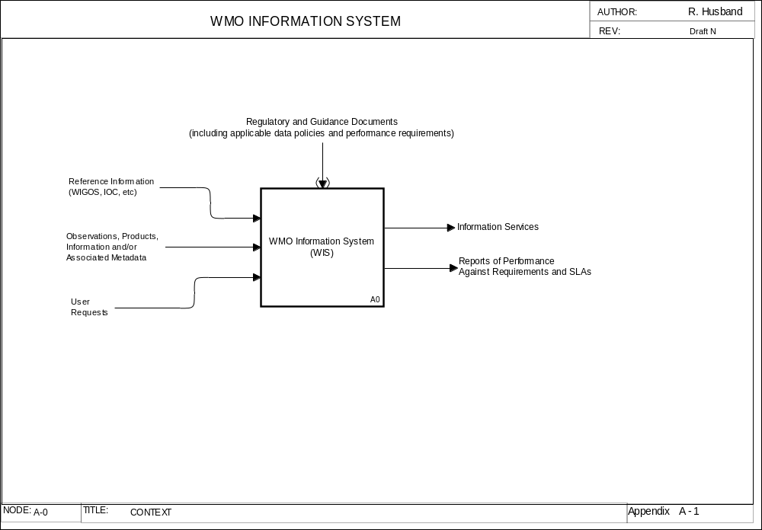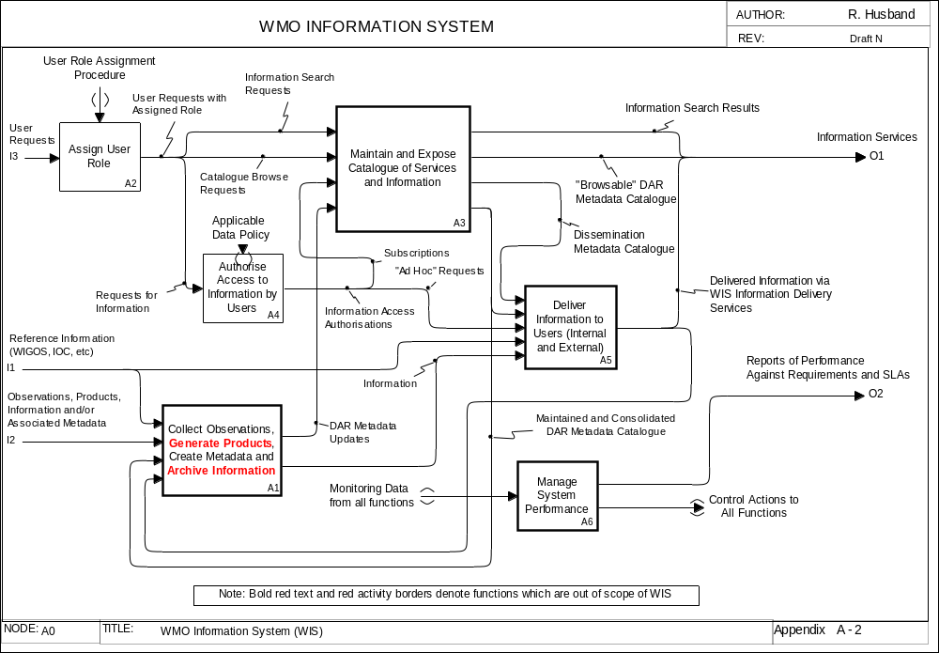
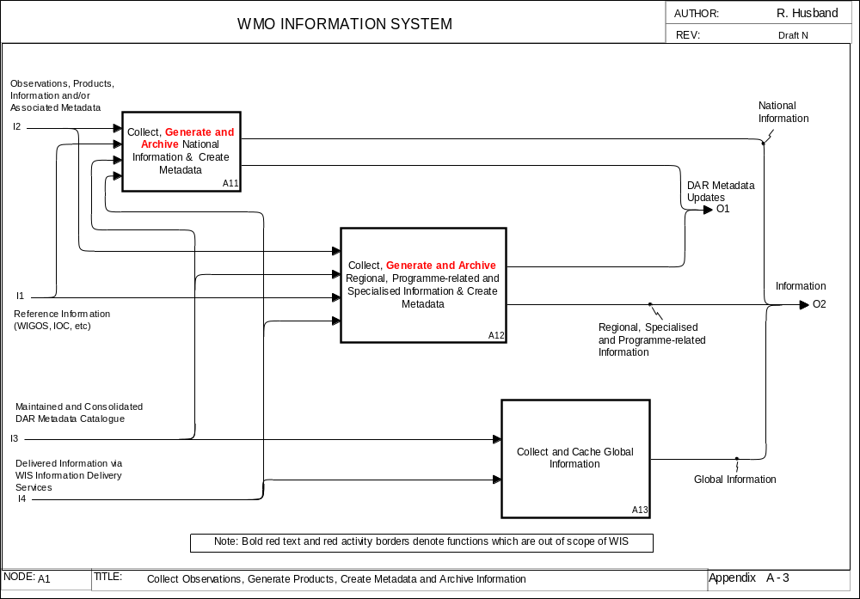
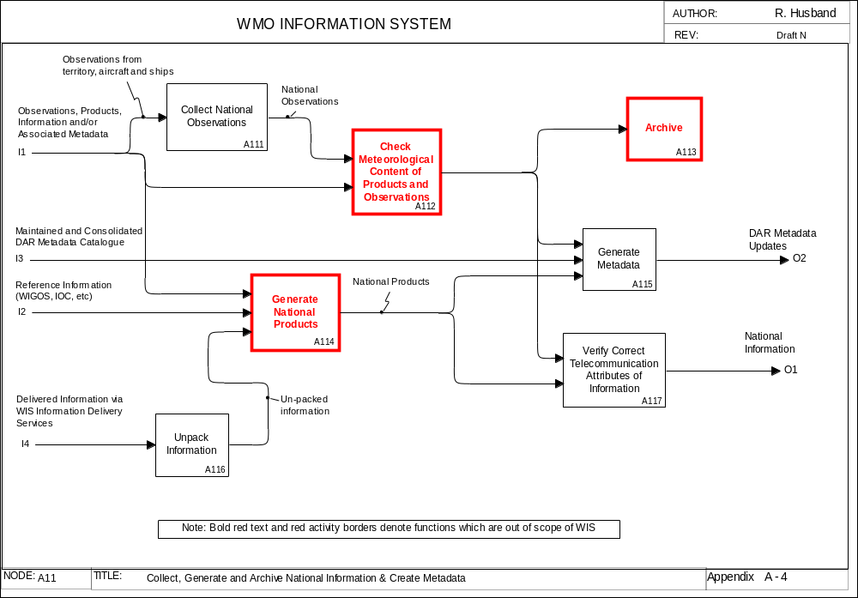
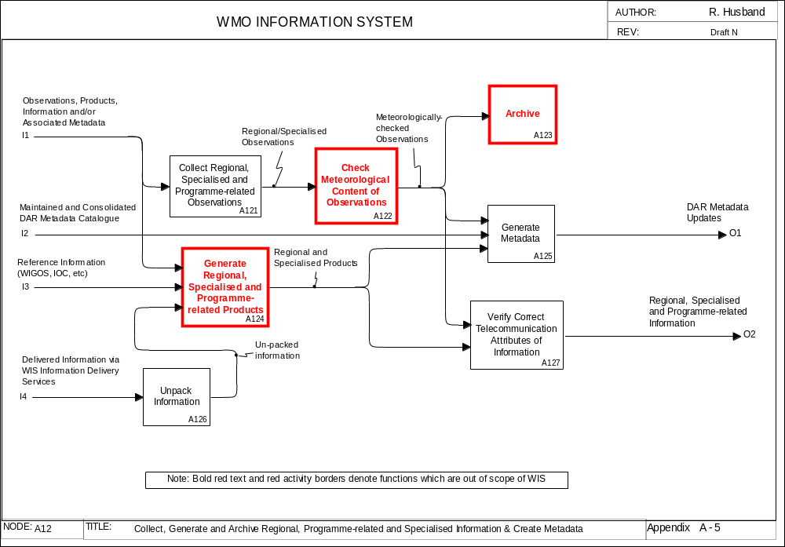
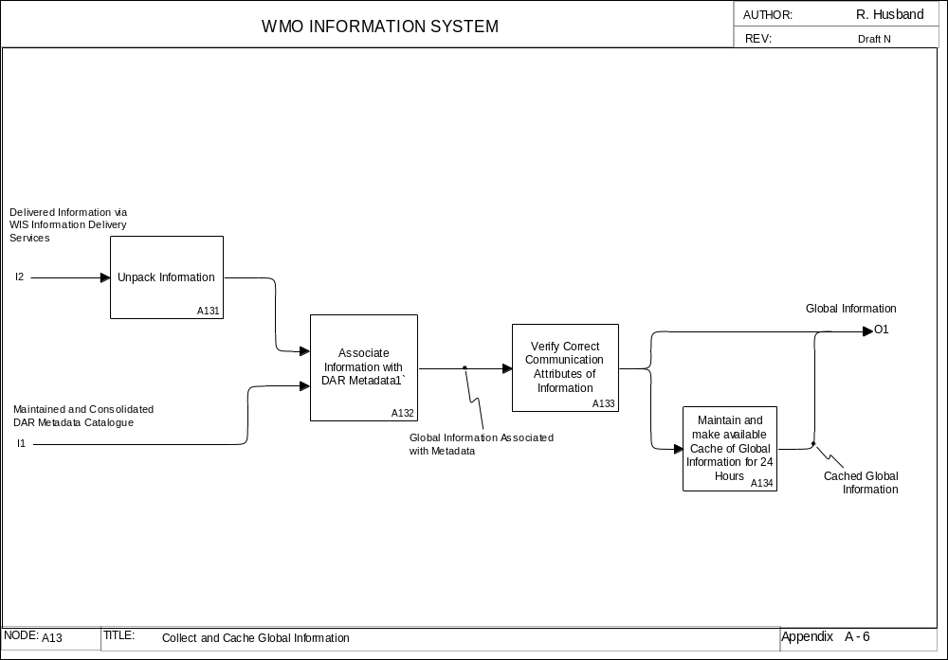
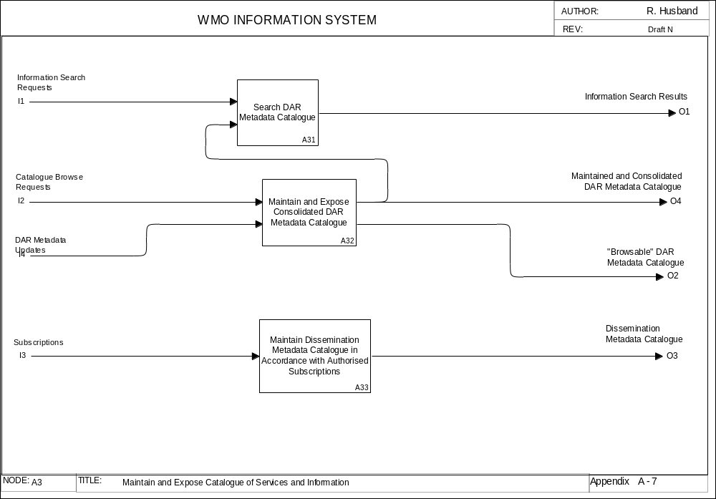
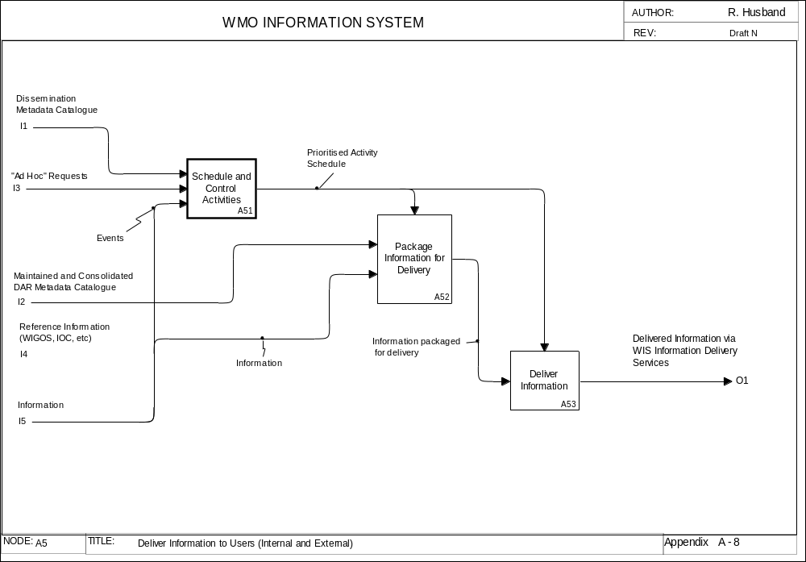
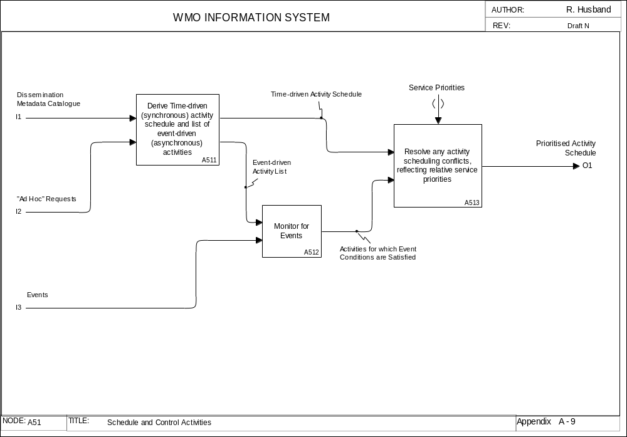
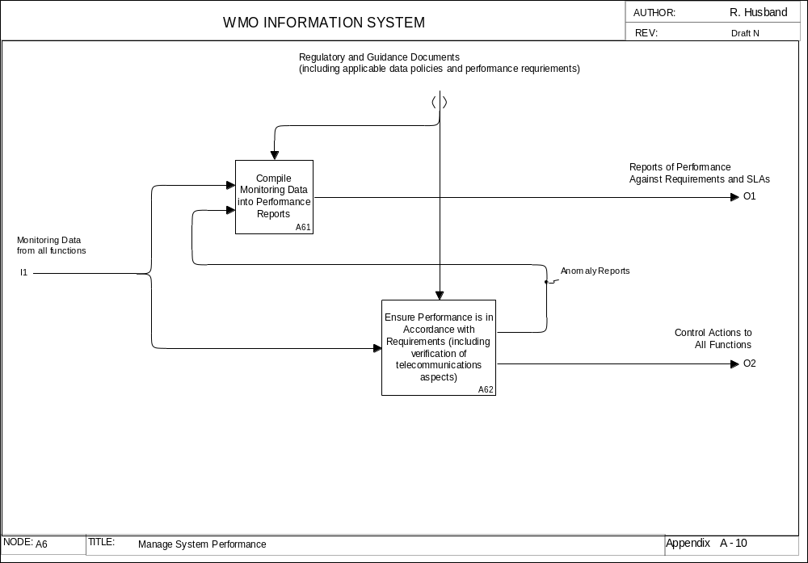

APPENDIX B – Hierarchy of Functions

A0 WMO Information System (WIS)
A1 Collect Observations, Generate Products, Create Metadata and Archive Information
A11 Collect, Generate and Archive National Information & Create Metadata
A111 Collect National Observations
A112 Check Meteorological Content of Observations
A113 Archive
A114 Generate National Products
A115 Generate Metadata
A116 Unpack Information
A117 Verify Correct Telecommunication Attributes of Information
A12 Collect, Generate and Archive Regional, Programme-related and Specialised Information & Create Metadata
A121 Collect Regional, Specialised and Programme-related Observations
A122 Check Meteorological Content of Observations
A123 Archive
A124 Generate Regional, Specialised and Programme-related Products
A125 Generate Metadata
A126 Unpack Information
A127 Verify Correct Telecommunication Attributes of Information
A13 Collect and Cache Global Information
A131 Unpack Information
A132 Associate Information with DAR Metadata1`
A133 Verify Correct Communication Attributes of Information
A134 Maintain and make available Cache of Global Information for 24 Hours
A2 Assign User Role
A3 Maintain and Expose Catalogue of Services and Information
A31 Search DAR Metadata Catalogue
A32 Maintain and Expose Consolidated DAR Metadata Catalogue
A33 Maintain Dissemination Metadata Catalogue in Accordance with Authorised Subscriptions
A4 Authorise Access to Information by Users
A5 Deliver Information to Users (Internal and External)
A51 Schedule and Control Activities
A511 Derive Time-driven (synchronous) activity schedule and list of event-driven (asynchronous) activities
A512 Monitor for Events
A513 Resolve any activity scheduling conflicts, reflecting relative service priorities
A52 Package Information for Delivery
A53 Deliver Information
A6 Manage System Performance
A61 Compile Monitoring Data into Performance Reports
A62 Ensure Performance is in Accordance with Requirements (including verification of telecommunications aspects)

APPENDIX C – List of Abbreviations
Cg World Meteorological Congress
CBS Commission for Basic Systems
DAR Discovery, Access and Retrieval
DCPC Data Collection or Production Centre
ECMWF European Centre for Medium Range Weather Forecasts
GEO Group on Earth Observation
GDPFS Global Data Processing and Forecast System
GEOSS Global Earth Observations System of Systems
GISC Global Information System Centre
GOS Global Observing Systems
GTS Global Telecommunication System
ICAO International Civil Aviation Organisation
ICG-WIS Inter-Commission Coordination Group on WMO Information System
IGDDS Integrated Global Data Distribution System
IMTN Improved Main Telecommunication Network
ISS Information Systems and Services (Division of World Weather Watch)
MTN Main Telecommunication Network
NC National Centre
NMC National Meteorological Centre
NMHS National Meteorological and Hydrological Service
RM-ODP Reference Model for Open Distributed Processing (ISO/IEC 10746)
RTH Regional Telecommunication Hub
SDI Spatial Data Infrastructure
SOA Service Oriented Architecture
TCP/IP Transmission Control Protocol / Internet Protocol
V-GISC Virtual Global Information System Centre
WIGOS WMO Integrated Global Observation Systems
WIS WMO Information System
WMC World Meteorological Centre
WMO World Meteorological Organization
WWW World Weather Watch (Department of World Weather Watch)

APPENDIX D – Glossary of Terms
TERM DESCRIPTION

Reference Information: Slowly varying auxiliary information that is needed by WIS to implement the functions (e.g. place names, centre names, airport abbreviations, country boundaries, etc) – see Volume A of WMO Manual on the GTS.

1 In this context “Thread” is used as a collective term to embrace a set of functions and dataflows which relate to a particular high-level objective (i.e. data management, service provision or performance management)
1 For access to its proprietary information and in accordance with the applicable data policy and authorised user functions
2 For access to the metadata catalogue and global information in accordance with the applicable data policy and authorised use functions

