
WMO SECRETARIAT

DRAFT

GUIDELINE on WIS
(WMO INFORMATION SYSTEM)

Observations Department, WIS Branch,

Information and Telecommunication Services Office

_________________________________________________________________________________
Version 0.2
28 May, 2008
DOCUMENT VERSION CONTROL
Version | Authors | Date | Description
0.1 | Eliot Christian, David Thomas, Robert Husband | 22 Feb 2008 | Framework version (Table of Contents, brief placeholders for major sections) for informal review by Director/WIS (Jean-Michel Rainer)
0.2 | Eliot Christian, David Thomas | 29 May 2008 | Revised framework version for review by ET-WISC
0.3 | Eliot Christian, David Thomas, Robert Husband,  Fred Branski | 7 Jul 2008 | First rough draft of full document for inter-session review by the Expert Team on WIS Centres (ET-WISC) and review by Inter-commission Working Group on WIS (ICG-WIS)
0.4
0.5

Table of Contents
EXECUTIVE SUMMARY 5
1 Purpose, Outline, and Authority of this document 6
1.1 Purpose of this Document 6
1.2 Outline of this Document 6
1.3 Authority of this Document 6
1.4 Types of Regulations Included 6
1.5 Related WMO Documents 7
1.5.1 WIS Compliance document 7
1.5.2 WIS functional architecture 7
1.5.3 Manual on GTS 7
1.5.4 Manual on GDPFS 7
1.5.5 Manual on GOS 7
1.5.6 Manual on Codes 7
2 Organization and Functions of the WMO Information System 8
2.1 Purpose of the WMO Information System (WIS) 8
2.1.1 Background, Evolution of GTS and Internet 8
2.1.2 Trends, System Architecture Principles 9
2.1.3 Implementation Planning 10
2.2 Functions of WIS 10
2.2.1 Management Perspective 10
2.2.2 User Perspective 11
2.2.3 Roles of WIS Centers (GISC's, DCPC's, NC's) 11
2.2.4 Telecommunications 12
2.3 Organization of WIS 12
2.3.1 Authorities and Responsibilities 12
2.3.2 WIS-Related CBS Expert Teams 12
3 WIS Governance 13
3.1 Procedure for Designation as a WIS Centre 13
3.1.1 GISC 13
3.1.2 DCPC 13
3.1.3 NC 14
3.2 Interfacing Existing WMO Infrastructures to WIS 14
3.2.1 Guides and Reference Implementations 14
3.3 Establishing Additional WIS Components 14
3.4 Monitoring and Reporting 14
4 WIS Centres: Practices and Procedures 15
4.1 Common Practices and Procedures 15
4.1.1 Implementation, operation and maintenance of telecommunications 15
4.1.2 Performance and Quality Monitoring 15
4.1.3 User Authorization and Authentication 15
4.1.4 Maintenance and Operation of WIS Catalogues 15
4.1.5 DAR Catalogue Metadata Entry tools 15
4.1.6 Maintenance of Dissemination Information 15
4.1.7 Dissemination Metadata Entry tools 15
4.2 GISC-specific Practices and Procedures 15
4.2.1 WIS GISC Standard Practices and Procedures 15
4.2.1.1 Operation of WIS Global Data Cache 15
4.2.2 WIS GISC Recommended Practices and Procedures 15
4.3 DCPC-specific Practices and Procedures 15
4.3.1 WIS DCPC Standard Practices and Procedures 15
4.3.2 WIS DCPC Recommended Practices and Procedures 15
4.4 NC-specific Practices and Procedures 15
4.4.1 WIS NC Standard Practices and Procedures 15
4.4.2 WIS NC Recommended Practices and Procedures 15
APPENDIX A – List of Abbreviations 16
APPENDIX B – Glossary of Terms 17
APPENDIX C – Acknowledgements 18
REFERENCES 19

List of Figures:
Figure 1. WMO Global Telecommunication System (GTS) 8
Figure 2. Uploading and Downloading of Files in WIS 9
Figure 3. Interoperability among major parts of WIS 9
Figure 4. GISCs form a central hub of WIS 11

EXECUTIVE SUMMARY

Purpose, Outline, and Authority of this document

Purpose of this Document
Centres within World Meteorological Organization (WMO) Member States may be designated as one of the centres forming the core infrastructure of the WMO Information System (WIS). WIS Centres comply with required WIS functions, compiled and regularly reviewed by the Inter-Commission Coordination Group on WIS (ICG-WIS). [CBS-Ext.(06)-7.8] The purpose of the present document is to provide Guidelines for those required WIS functions, serving as official guidance until the issuance of a more formal and comprehensive Manual on WIS.
High robustness and reliability of WIS components are essential to the implementation of WIS, and performance should be evaluated in the designation procedure for GISCs and DCPCs. That evaluation should include assurance that data content flowing via WIS network technologies fully satisfies requirements for security, authenticity, and reliability. Certain aspects of service levels are identified within this document, although more extensive agreements can be anticipated eventually. Also, because WIS cross-cuts all WMO related discipline areas, many other WMO processes, practices and standards intersect WIS. Such functions are primarily defined in their specific publications, e.g., Manual on Global Data Processing and Forecast System (GDPFS), Manual on Global Observing Systems (GOS), WMO Technical Regulation No. 49, and other manuals.

Outline of this Document
This document is structured in terms of the Reference Model for Open Distributed Processing [RM-ODP] (ISO/IEC 10746, Information technology—Open Distributed Processing—Reference Model). RM-ODP defines five viewpoints ranging from broad management interests to details needed by software engineers:
- Enterprise Viewpoint - Presents the high-level vision and goals of WIS as these should be understood by all stakeholders
- Information Viewpoint - Presents in meaningful terms the objectives served by the major components and services of WIS, including a set of "Use Cases" that illustrate how WIS components are used in practice
- Computational Viewpoint - Presents data flow diagrams showing the functional and technical interactions among communications and processing components of WIS, with each level of diagram able to be decomposed into finer detail as needed
- Engineering Viewpoint - Presents the technical requirements of service types that are necessary at interfaces between interacting WIS components, with specifications adequate for implementing software with verifiable interoperability and performance
- Technology Viewpoint (not applicable to this document) - Presents an "as-built" description specific to one instance of technology solutions that implement the Technical Specifications required for WIS interoperability

Authority of this Document
This document, upon approval by the relevant WMO bodies, will be the authoritative source for the Technical Specifications of major "interoperable interfaces" required of the core components of WIS: the Global Information System Centres (GISCs), Data Collection or Production Centres (DCPCs) and National Centres (NCs). These Technical Specifications, given in the "Engineering Viewpoint" section, are likely to be part of a future Manual on WIS and should be useful in an Invitation to Bid on software needed by a prospective WIS DCPC or GISC. Materials in all other sections of this document are provided here only as informative background; authoritative sources for such materials may be found elsewhere. For instance, WIS user requirements are being compiled for inclusion in a future update of the WIS Project Plan. [WIS-Plan]

Types of Regulations Included
(standard practices and procedures, recommended practices and procedures)

Related WMO Documents

WIS Compliance document

WIS functional architecture

Manual on GTS

Manual on GDPFS

Manual on GOS

Manual on Codes

Organization and Functions of the WMO Information System

Purpose of the WMO Information System (WIS)

Background, Evolution of GTS and Internet
WMO communications links enable the timely collection and dissemination of time-critical, operation-critical, and other data and products: the lifeblood of WMO activities. [WIS-Plan] The communications needs of WMO have been supported through the evolving GTS. Traditionally, GTS was designed for connectivity to the National Meteorological Centres (NMCs) of Member countries. Three world meteorological centres (Moscow, Washington and Melbourne) and a series of RTHs connect Members to the Regional Meteorological Telecommunication Networks and to the Main Telecommunication Network (MTN), as depicted in Figure 1 (below).
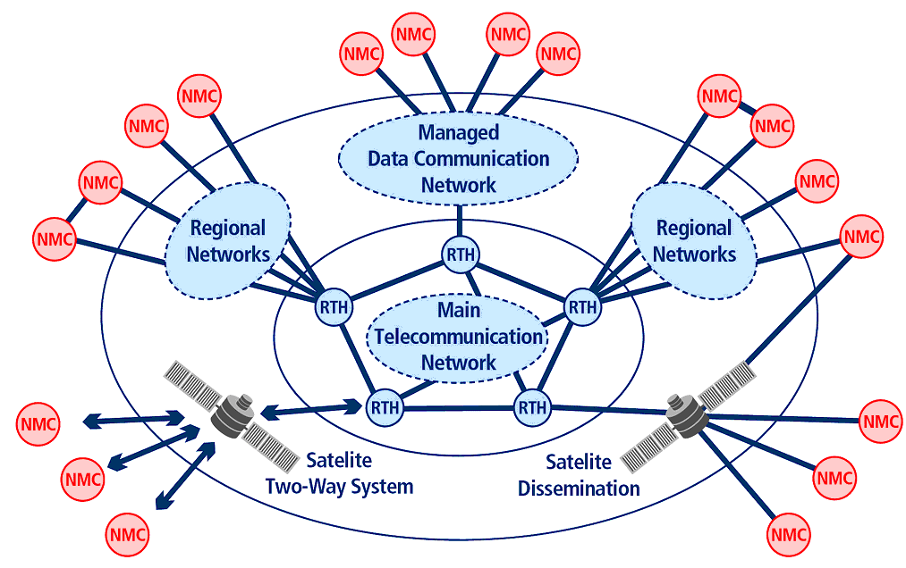
Figure 1. WMO Global Telecommunication System (GTS)
Today, WMO communications links encompass the GTS Improved Main Telecommunication Network (IMTN) and Regional meteorological networks based on a range of telecommunications technologies (leased circuits, Frame Relay, Multi-Protocol Label Switching, Digital Video Broadcasting by Satellite) as well as other public data communications services, including the Internet. Cg XV stated that the WMO Integrated Global Data Dissemination Service (IGDDS), supporting the exchange of space-based observation data and products for WMO Programmes, is a component of WIS. Cg XV is also anticipating support of a virtual all hazards network within the WIS-GTS. [Cg-XV-3.1.2]
In the evolution from customized message switching to off-the-shelf networking technologies, it is customary to regard data as packaged in files that are transferred rather than packaged as messages that are switched. The World Wide Web, electronic mail, and most other applications familiar to users of the Internet are accomplished primarily though file transfers between connected host computers. Among WIS centres, files are "uploaded" when data or products are moved from an NC to a DCPC or GISC, or from a DCPC to a GISC; files are "downloaded" when moved from a GISC to a DCPC or NC, or from a DCPC to an NC. (see Figure 2, next page)


GISCs
DCPCs
NCs
Users
Uploading files:
from user to NC or DCPC;
from NC to DCPC or GISC;
from DCPC to GISC
Downloading files:
from GISC to DCPC, NC, or user; from DCPC or NC to user;
from NC to user
Figure 2. Uploading and Downloading of Files in WIS
WIS will incorporate the connectivity of GTS and the flexibility of new systems such as the Internet, whilst ensuring that a data management framework is able to encompass all WMO information. This is a natural evolution building upon GTS while expanding the overall information system capabilities. GTS itself has developed a data management framework with catalogues of metadata for observation stations and distribution catalogues that detail where information originated and which Members subscribe to which information. With the introduction of WIS, there is a change in focus: from communications-centric (managing connectivity) to data-centric (managing data and products)

Trends, System Architecture Principles
Various data collection and exchange systems throughout WMO are evolving their interfaces under the new "system of systems" known as WIS. This evolution is guided by Service Oriented Architecture principles that enable or simplify interoperability among systems. An especially important principle is the need for diverse systems such as WIS to standardize on a small set of interoperable interfaces.
Figure 3 (below) shows a high-level architectural view of the major parts of WIS, as described in the document titled "Service Oriented Architecture Concepts Applied to Specific WMO Systems" [SOA(2007)] This document focuses on several systems that will utilize WIS as the main data collection and exchange system: the Global Observing System of the World Weather Watch, the Global Atmosphere Watch, the World Hydrological Cycle Observing System, the World Climate Programme, the Global Climate Observing System, the Global Ocean Observing System, and the Global Terrestrial Observing System.
Data and Product Users
Global Information System Centres (GISCs)
Data Collection or Production Centres (DCPCs)
National Centres (NCs)
Figure 3. Interoperability among major parts of WIS
Interoperability opportunities are shown as arrows to users and among GISCs; DCPCs; and NCs. The Technical Specifications of this document focus on the points of those arrows, i.e., the interfaces at touch points where WIS components must interoperate. When WIS is viewed as a Service Oriented Architecture implemented primarily through communications networks, the Technical Specifications for WIS interoperable interfaces are seen as types of network services.

Implementation Planning

Functions of WIS

Management Perspective
The World Meteorological Congress in 2003 (Cg-XIV) formally adopted the concept of WIS, stating that an overarching approach for solving the data management problems for all WMO and related international programmes was required. The Report of Cg-XIV (3.1.2.8, 3.1.2.9) states [Cg-XIV-3.1.2] WIS will:
- Be used for the collection and sharing of information for all WMO and related international programmes;
- Provide a flexible and extensible structure that will allow the participating centres to enhance their capabilities as their national and international responsibilities grow;
- Build upon the most successful components of existing WMO information systems in an evolutionary process;
- Pay special attention to a smooth and coordinated transition;
- Build on GTS for highly reliable delivery of time-critical data and products and base its core communication network on the IMTN;
- Utilise international industry standards for protocols, hardware and software.
Cg-XIV requested particular attention be given to the impact of WIS on Members' responsibilities and resources. The "Study on policy-level implications of the future WMO information system" described in Report of Cg-XIV [Cg-XIV-3.1.2.11] sheds light on envisioned functions of GISCs, DCPCs, and NCs.
The Report of Cg-XIV asserted that introduction of WIS would not result in new responsibilities or additional resource requirements for most Members. Rather, the stated expectation is that WIS would result in lower costs, especially for the least developed Members, through expanded use of commercial off-the-shelf technology and increased use of the Internet.
With regard to DCPCs, the Report of Cg-XIV noted that Members operating a Regional Telecommunication Hub (RTH) may choose to serve other WMO Programmes by operating as a DCPC. DCPCs incur the additional responsibility of handling time-critical data from other WMO Programmes, plus the additional responsibility of providing data and products through request/reply services via the Internet. The Study also noted that various centres around the world provide a variety of products for WMO Programmes, such as long-term forecasts, hydrological products, climatological products, etc. Such a centre could participate in WIS as a DCPC, or it could arrange for another DCPC to receive and disseminate its products. Either case entails changes in agreed-upon practices and procedures, including the provision of metadata associated with the products.
The Report of Cg-XIV stated that no centre was currently providing all of the functions envisioned for a GISC, although the function somewhat corresponds to those RTHs associated with large numerical modelling centres as these already have a responsibility to provide global products. In becoming a GISC, it is expected that creation and maintenance of a product catalogue would be the most significant additional responsibility.
The World Meteorological Congress in 2007 (Cg-XV) reinforced the need for WIS. The Report of Cg-XV [Cg-XV-3.1.2] prescribes that WIS provide three types of services:
- Routine collection and dissemination service for time-critical and operation-critical data and products: This service is based on real-time “push” mechanism including multicast and broadcast; it would be implemented essentially through dedicated telecommunication means providing a guaranteed quality of service.
- Data Discovery, Access and Retrieval service: This service is based on request/reply “pull” mechanism with relevant data management functions; it would be implemented essentially through the Internet.
- Timely delivery service for data and products: This service is based on delayed mode “push” mechanism; it would be implemented through a combination of dedicated telecommunication means and of public data-communication networks, especially the Internet.

User Perspective
Much like modern library systems with public online catalogues, WIS is designed around a set of Discovery, Access and Retrieval (DAR) facilities [Cg-XV-3.1.2]: "union catalogues" that contain records describing the data and information across WMO collections and how these may be retrieved.
Use Cases - A typical example of how users would search for available data though a DAR catalogue is given as Use Case B.6 (detailed in Appendix B to this document). Simply put, the objective is that a user of WIS finds available WMO data and products relevant to his needs. He/she discovers these by browsing the DAR catalogue or by searching the DAR catalogue using discovery concepts such as subject keywords, geographic extent, temporal range, etc. As a result of his/her browsing or searching, the user gets a relevance-ordered list of data and products including "data or product metadata" such as data origin, data type, generation date, availability, use constraints, etc.
Once desired data or products have been identified, an authenticated user can request immediate retrieval ("pull", Use Case B.7), or subscription for recurring delivery ("push", Use Cases B.8). The user's authorization for delivery of the data or product is checked against his/her role (Use Case B.5). The WIS centre then facilitates delivery through any of a broad range of online and offline transmission options, and updates the "dissemination metadata" associated with the subscription or retrieval (Use Case B.10).
include usability of system, access to deep metadata, station history file

Roles of WIS Centers (GISC's, DCPC's, NC's)
WIS Global Information System Centres (GISCs) can be viewed as forming a central hub as depicted in Figure 1 (below).
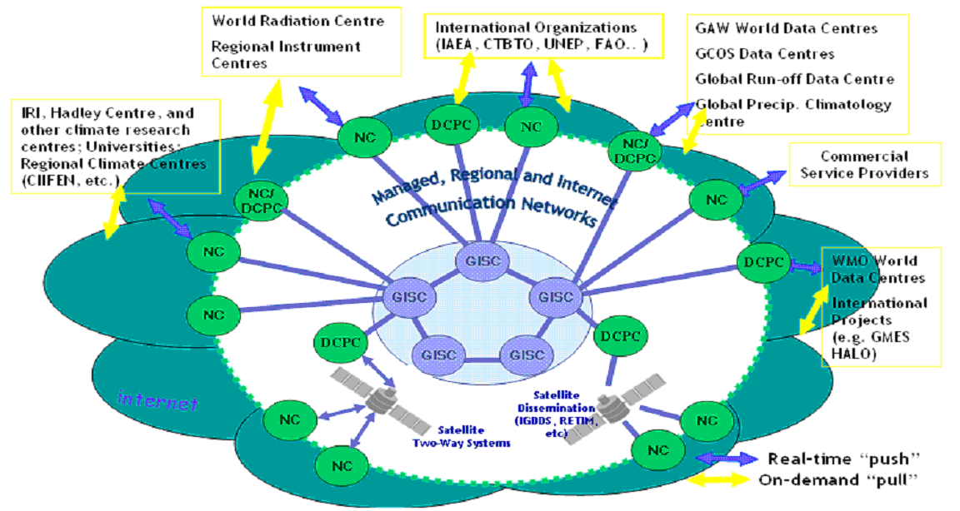
Figure 4. GISCs form a central hub of WIS
In addition to supporting catalogue search of WMO data and products (including satellite products), a GISC disseminates information from National Centres (NCs) and Data Collection or Production Centres (DCPCs) within the GISC area of responsibility. [ICG-WIS(05)-Milestones] A GISC also holds and distributes at least 24 hours of current WMO data and products intended for global distribution.
WIS NCs may be existing National Meteorological Centres (NMCs), or another specialist centre that a WMO Member country elects to connect directly to WIS, such as a World Data Centre. NCs typically serve as a portal for national users, and relay data and information collected or generated in that country to a GISC or to a DCPC.
WIS DCPCs manage the collection, dissemination, and archiving of regional or programme-specific data and products. DCPCs also manage regional or specialised information, and related data and products for international exchange. Similar to GISCs, DCPCs maintain catalogues of their holdings and services. Appropriate parts of this catalogue information are used to update the DAR catalogues of the GISCs.

Telecommunications

Organization of WIS

Authorities and Responsibilities
Resolution 40 + 25 (additional)
Security, Reliability, Performance

WIS-Related CBS Expert Teams

WIS Governance

Procedure for Designation as a WIS Centre
Procedures for the designation of GISCs and DCPCs, as agreed within the Commission for Basic Systems (CBS) upon ICG-WIS recommendations, were endorsed in principle by Congress XV. Until procedures are issued formally, Congress encouraged Members to adhere to the procedures given in Annex III of the report of the 2006 extraordinary session of CBS [CBS-Ext.(06)-7.8].

GISC
The list of WIS requirements and functions as compiled by the ICG-WIS will be published to serve as a basis for offers to perform the required duties. Existing centres from the WMO basic systems may wish to apply for designation as GISC forming the core infrastructure of WIS. The offer should include:
- A statement of compliance with the required WIS functions,
- A proposal for the area of responsibility for WIS data services, and a
- Formal commitment by the PR [Permanent Representative] of the Member to provide such services on a routine basis.
The service offer should be addressed to WMO and will be submitted to the ICG-WIS, which will inform the president of the Regional Association(s) concerned; the ICG-WIS will analyse the proposed services versus WIS requirements as well as the compliance to the required WIS/GISC functions and specifications, and will formulate a recommendation.
[...] The candidate GISCs will be invited to demonstrate to CBS their capabilities to provide WIS services to the accredited users with the necessary reliability and quality. This refers to the real-time functions of data and product collection and dissemination as well as to non real-time services for requests. It should also include storage functions for the complete set of WIS data and products and relevant up-to-date metadata catalogues. The coordination functions with other GISCs and the planning of mutual back-up services should also be demonstrated. Furthermore, the adherence to WIS standards and relevant data exchange policies and access rights must be granted. A formal commitment and time schedule to implement the GISC and to provide GISC services in accordance with the offer will be given by the PR of the Member operating the candidate GISC. Upon acceptance of the demonstration of capabilities of the candidate GISC, CBS will formulate the recommendation for the GISC designation.
[...] The Executive Council will consider for approval the ICG-WIS recommendation and CBS recommendation for the GISC designation; after the EC approval, the GISC will be included in the relevant WMO programme documentation.

DCPC
Since potential DCPCs functions would be undertaken by centres that have been established under the respective WMO Programmes, the relevant Technical Commissions are expected to consider the service offers by potential DCPCs (likely according to procedures similar to [those for GISCs]), and to endorse their programmes’ candidate DCPCs.
[...] the candidate DCPC will be invited to demonstrate to CBS their capabilities to provide WIS services in compliance with the DCPCs functions and responsibilities. This refers to the possible real-time functions of data and product dissemination as well as to non real-time services for requests. It should also include the provision of relevant up-to-date metadata catalogues. The coordination and synchronization functions with the associated GISC should also be demonstrated. Furthermore, the adherence to WIS standards and relevant data exchange policies and access rights must be granted. Upon acceptance of the demonstration of capabilities of the candidate DCPC, CBS will formulate the recommendation for the DCPC designation.
[...] The Executive Council will consider for approval the ICG-WIS recommendation and CBS recommendation for the DCPC designation; after the EC approval, the DCPC will be included in the relevant WMO programme documentation.

NC
Existing National Meteorological Centres (NMCs), as defined in the Manual on GTS, on GOS and on GDPFS are expected to become WIS NCs. However, there may be other centres within the same country having national responsibility for functions falling within a WMO related discipline area but located outside of the National Meteorological and Hydrological Service (NMHS). The participation of these other centres as WIS NCs would be coordinated through the national Permanent Representative to WMO. Every WIS NC must comply with the requirement to supply metadata for their data and products.

Interfacing Existing WMO Infrastructures to WIS

Guides and Reference Implementations

Establishing Additional WIS Components
use of WIS infrastructure as a metadata catalogue for specific projects

Monitoring and Reporting

WIS Centres: Practices and Procedures

Common Practices and Procedures

Implementation, operation and maintenance of telecommunications

Performance and Quality Monitoring

User Authorization and Authentication

Maintenance and Operation of WIS Catalogues

DAR Catalogue Metadata Entry tools

Maintenance of Dissemination Information

Dissemination Metadata Entry tools

GISC-specific Practices and Procedures

WIS GISC Standard Practices and Procedures

Operation of WIS Global Data Cache

WIS GISC Recommended Practices and Procedures

DCPC-specific Practices and Procedures

WIS DCPC Standard Practices and Procedures

WIS DCPC Recommended Practices and Procedures

NC-specific Practices and Procedures

WIS NC Standard Practices and Procedures

WIS NC Recommended Practices and Procedures

APPENDIX A – List of Abbreviations
Cg World Meteorological Congress
CBS Commission for Basic Systems
DAR Discovery, Access and Retrieval
DCPC Data Collection or Production Centre
ECMWF European Centre for Medium Range Weather Forecasts
GEO Group on Earth Observation
GDPFS Global Data Processing and Forecast System
GEOSS Global Earth Observations System of Systems
GISC Global Information System Centre
GOS Global Observing Systems
GTS Global Telecommunication System
ICAO International Civil Aviation Organisation
ICG-WIS Inter-Commission Coordination Group on WMO Information System
IGDDS Integrated Global Data Distribution System
IMTN Improved Main Telecommunication Network
ISS Information Systems and Services (Division of World Weather Watch)
MTN Main Telecommunication Network
NC National Centre
NMC National Meteorological Centre
NMHS National Meteorological and Hydrological Service
RM-ODP Reference Model for Open Distributed Processing (ISO/IEC 10746)
RTH Regional Telecommunication Hub
SDI Spatial Data Infrastructure
SOA Service Oriented Architecture
TCP/IP Transmission Control Protocol / Internet Protocol
V-GISC Virtual Global Information System Centre
WIGOS WMO Integrated Global Observation Systems
WIS WMO Information System
WMC World Meteorological Centre
WMO World Meteorological Organization
WWW World Weather Watch (Department of World Weather Watch)

APPENDIX B – Glossary of Terms
broadcast: a type of telecommunications wherein clients only receive on a one-way connection and sessions are initiated by the host server
client-server: a type of telecommunications wherein a server is always listening for a client to initiate a session and the clients do some processing while servers do most of the processing
communications-centric: focused primarily on managing communications aspects of a system
data-centric: focused primarily on managing the data aspects of a system
Discovery, Access and Retrieval metadata: catalogue records describing available data and products and how these may be retrieved
dissemination metadata: records describing the schedule and the means by which data and products are to be delivered to subscribers
file transfer: a telecommunications procedure wherein a file is sent directly to its destination in one session
interoperability: the ability to perform a task that spans discrete system components implemented with information and communications technology
interoperable interface: a connection between system components that is designed to enable operation with components developed separately
metadata: records containing various characteristics associated with a data or product
network-centric orientation: interfaces are seen as active points of contact on networks, where structured messages are communicated between distinct system components
peer-to-peer: a type of telecommunications wherein both ends must listen and either can initiate a session, and processing responsibilities can be fully distributed
publish-subscribe: a telecommunications procedure wherein a publishing host delivers information directly or provides a cue used by subscribers to fetch the information
pull: the receiver initiates the transmission, and the transmitter provides data to the receiver only as it is read
push: the transmitter initiates the transmission, and continuously notifies the receiver whenever new data is available
real-time: provision of information quickly enough to enable reaction during a given process
request-response: a telecommunications procedure wherein a session may have multiple dialogues consisting of requests answered by responses
service level: the common understanding between a provider and a user concerning measurable attributes of the service provided, such as availability, performance, etc.
Service Oriented Architecture: a discipline for building software systems, derived from distributed computing and modular programming techniques, and focused on defining the interfaces between communicating software components that provide distinct functions
store-and-forward: a telecommunications procedure wherein a file is sent to an intermediate destination and then forwarded to the final destination
terminal-host: a type of telecommunications wherein a terminal is always connected to the host computer and the host computer performs almost all of the processing
Use Case: description of how a goal is achieved through interactions between external actors and particular parts of the system being designed

APPENDIX C – Acknowledgements
The authors acknowledge with gratitude the valuable contributions from reviewers of this document during its development, especially:

Jose Arimatea (WMO/WWW/ISS)
Siegfreid Fechner (DWD)
Marta Gutierrez (ECMWF)
Donald Hinsmann (WMO, D/WWW)
Geerd-Rüdiger Hoffmann (DWD)
Pierre Kerherve (WMO/WWW/ISS)
Heinrich Knottenberg (DWD)
Jean-Michel Rainer (WMO/WWW, C/ISS)
Baudouin Raoult (ECMWF)
Dieter Schroeder (ECMWF)
Lothar Wolf (EUMETSAT)

REFERENCES
[CBS-Ext.(06)-7.8] Commission for Basic Systems, "Recommended Designation Procedures for GISCs and DCPCs (ANNEX III)," 2006, available on the Internet, http://www.wmo.ch/pages/prog/www/CBS/Reports/CBS-Ext06/WMO-1017_English.pdf
[Cg-XIV-3.1.2] WMO Secretariat, "WWW Information System and Services: including the Global Telecommunication System and Data Management," 2003, available on the Internet, ftp://ftp.wmo.int/Documents/SESSIONS/Cg-XIV/English/PDF/D03-1-2.pdf
[Cg-XIV-3.1.2.11] WMO Secretariat, "WWW Information System and Services: including the Global Telecommunication System and Data Management," 2003, available on the Internet, ftp://ftp.wmo.int/Documents/SESSIONS/Cg-XIV/English/PDF/D03-1-2ADD01.pdf
[Cg-XV-3.1.2] WMO Secretariat, "WWW Information System and Services: including the Global Telecommunication System and Data Management," 2007, available on the Internet, ftp://ftp.wmo.int/Documents/SESSIONS/Cg-XV/English/pdf/d03-1-2_en.pdf
[Cg-XV-9.2] WMO Secretariat, "WMO's Role in GEOSS," 2007, available on the Internet, ftp://ftp.wmo.int/Documents/SESSIONS/Cg-XV/English/pdf/d09-2_en.pdf
[GEOSS-Plan] Group on Earth Observations, "GEOSS 10-Year Implementation Plan," 2005, available on the Internet, http://www.earthobservations.org/docs/10-Year%20Implementation%20Plan.pdf
[GEOSS-Plan-Ref] Group on Earth Observations, "GEOSS 10-Year Implementation Plan Reference Document," 2005, available on the Internet, http://www.earthobservations.org/docs/
10-Year%20Plan%20Reference%20Document%20(GEO%201000R).pdf
[GTS-Manual] WMO, "Manual on the Global Telecommunication System (GTS)," 2007, available on the Internet, http://www.wmo.ch/pages/prog/www/ois/Operational_Information/WMO386/ ManualOnTheGTS.pdf
[ICG-WIS(05)-Milestones] Geerd-R. Hoffmann, "An Implementation Timetable for the WMO Information System," Sep 2005, available on the Internet, http://www.wmo.int/pages/prog/
www/ISS/ICG-WIS-II/WIS-milestones.doc
[IDEF0] U.S. National Institute of Standards and Technology, "Integration Definition for Function Modeling (IDEF0) FIPS PUB 183," 1993, available on the Internet, http://www.itl.nist.gov/fipspubs/idef02.doc
[IPET-MI(07)] WMO Inter-Programme Expert Team on Metadata Implementation, "Status of the WMO Core Profile of the ISO Metadata Standard," 2007, available on the Internet, http://www.wmo.ch/pages/prog/www/ISS/Meetings/ICG-WIS_ECMWF2007/documents/I
PET_MI_report-20070731.doc
[ISO-23950] U.S. Library of Congress (standard maintenance agency), "ISO 23950:1998 Information and documentation--Information retrieval (Z39.50)--Application service definition and protocol specification," 1998, available on the Internet, http://www.loc.gov/z3950/agency/
[ITT-FWIS(04)] Geerd-R. Hoffmann, "ITT-FWIS Executive Summary: The Future WMO Information System," Feb 2004, available on the Internet, http://www.wmo.int/pages/prog/www/
ISS/Meetings/ITT-FWIS_Geneva2004/FWIS-Summary.doc
[RM-ODP] Information Standards Organization, "ISO/IEC 10746-2:1996. Information Technology–Open Distributed Processing–Reference Model: Foundations. Common text with ITU-T Recommendation X.902," 1996, available on the Internet, http://standards.iso.org/ittf/
PubliclyAvailableStandards/s018836_ISO_IEC_10746-2_1996(E).zip
[SIMDAT] ECMWF, "Data grids for process and product development using numerical simulation and knowledge discovery," Dec 2006, available on the Internet, http://www.ecmwf.int/services/
grid/simdat/
[SOA(2007)] WMO Secretariat, Eliot Christian, "Service Oriented Architecture Concepts Applied to Specific WMO Systems," Mar 2007, available on the Internet, http://www.wmo.ch/pages/prog/
www/ISS/Meetings/ICG-WIS_ECMWF2007/documents/Doc6-1-SOA-applied.doc
[UML] The Object Management Group (OMG), "Unified Modeling Language (UML) Version 1.3," available on the Internet, http://www.omg.org/cgi-bin/doc?formal/00-03-01
[V-GISC-Cost] Jacques Roumilhac, ECMWF, "Cost Estimation of an Operational V-GISC, Requirements Version 1.0," Sep 2007, available on the Internet, http://www.wmo.int/pages/prog/www/TEM/
ET-WISC-I/D18.1.1%20ConsolidatedMeteoRequirements.doc
[WIS-Plan] WMO Secretariat, David Thomas, "WIS Project Plan," Aug 2007), available on the Internet, http://www.wmo.ch/pages/prog/www/ISS/Meetings/ICG-WIS_ECMWF2007/documents/
WISProjectPlanv0.4.doc

