Report of the WMO Expert team mission for on-site assessment for upgrading/strengthening national GTS components of NMC Male, Maldives

Date of the mission: July 23 to 25, 2005
Experts: Mr. Mahesh C. Rastogi, India Meteorological Department
Mr. Takahiro Saito, Japan Meteorological Agency

A. Technical survey of the current implementation and operation status of the national GTS components including:

  - Message Switching System and/or Workstation
There is no MSS in NMC Male. Two PCs are installed in the NMC; one is for receiving data from RTH New Delhi and the other is for transmitting data to the RTH. Software being used for handling reception and transmission of data was developed by a software company in Pakistan.

Received data are stored in a database on a different PC and the data can be easily displayed on selection. Plotted charts for a predefined geographical area can be composed and printed out. Injection of data to be transmitted is made manually in the form of a GTS bulletin (photo, p. 5, top left).

2. GTS links
i. Technical specifications
Connected with: RTH New Delhi
Link: Internet (ADSL wireless internet lease line)
Access speed: 512 kbps (1:8 (shared with eight users))
Protocol: TCP/IP (WMO Socket)

ii. Contract with telecom carriers
Focus Infocom Private Ltd.

iii. Recurrent costs
USD 600 per month for the existing Internet access. A 64 kbps dedicated link to New Delhi will cost USD 3,000 per month with USD 35,000 for one time fee. NMC Male hesitates in migrating to the dedicated link because of the recurrent cost.

3. GTS related satellite-based components
There is a Meteorological Data Dissemination (MDD) system. This system is supposed to receive GTS data as well as satellite pictures through INSAT. But this system is out of order since last three years.

4. GTS operation
i. Number of operators and their working system
6 persons (same persons for GTS as well as for forecast and observation).

ii. Technical skill
No training on telecommunication.

iii. Tools for link watch and logging
There is a tool to watch condition of the link. Indicator on the PC display becomes black and fault is written in the log file when the link is down.

5. National communication interfaces with national entities
Collection of observational data from remote stations is made by dial-up phone and Fax. Collected data are typed in the form of a GTS bulletin and sent to New Delhi via the GTS link. The data are also uploaded to the Internet web site for wide distribution.

6. Internet availability
i. Connection capability
512 kbps (1:8). Connection fails frequently for half an hour and ever more due to interference in the microwave channel between the airport island where NMC is located and Male where ISP is located. As the link is shared with eight users including those outside NMC, traffic to/from other users significantly affects bandwidth available for NMC, which sometimes results in connection break.

ii. Firewall
No firewall.

iii. IP address allocation
15 addresses are provided by ISP but only one is being used.

iv. Segregation from the GTS
No segregation.

7. In-house network
i. Configuration with the IP addressing scheme
There are around 20 PCs which are connected to LAN. These PCs are having private addresses and are translated into the global address by the router. See page 6 (top) for current configuration of the network.

ii. Security policy
No security policy, however antivirus software is loaded on almost all the PCs.

8. GTS and ICT maintenance
i. Number of technicians and/or outsourced support (e.g. contracts)
5 technicians. Software is supported by a software firm from Pakistan.

ii. Technical skill
Some technicians are technically qualified.

9. Current relation between GTS-MSS and Tsunami Warning system
There is facility in the GTS system, which generates an audio alarm on reception of Tsunami messages and also displays the message in a pop-up window. During the mission, this facility was tested in cooperation with RTH New Delhi and was confirmed to work well on reception of a test Tsunami Watch message (photo, p. 5, top right).

10. Evaluation of results of TWI distribution test on 7, 8 April 2005
RTH New Delhi relayed the Tsunami test message within 10 seconds after receiving from Tokyo. Maldives Department of Meteorology also got the message on two Fax numbers (one is at the headquarters on Male Island and another is at NMC on the airport island) from Tokyo.

11. Infrastructure
i. Electrical supply condition
Quite stable.

ii. Telephone network, cellular phone network and data network providers
Dhiraagu provides all types of these services. A new provider of cellular phone Wathania will come soon.

iii. ISPs;
There are two ISPs: Focus Infocom and Dhiraagu.

B. Identification of and specifications for highest priority upgrades needed for urgent strengthening of national GTS components to meet IO-TWS interim phase requirements, i.e. reception and use of IO-Tsunami Watch messages and related-information;
There is no dedicated circuit between NMC Male and RTH New Delhi and Internet connectivity is being used for exchange of data. This link is susceptible to failure. To make the link more stable and reliable, it is advisable to have another Internet connection through another service provider. The following hardware components are needed:
i. Router (preferably with VPN module)
ii. Firewall
iii. L2 switches

In order to fulfil requirements mentioned in items 12 and 14 below, it is also needed to upgrade the existing system, especially in having a hot stand-by option and message relaying function.

C. Consolidation of the national data exchange requirements related to Multi-Hazard Early Warning, especially IO-TWS, including:

12. Reception and handling of IO-TWS warnings and information
There are strong requirements for automatically relaying these warning messages to authorities concerned through dial-up circuit, Fax, email or SMS without delay.

13. Reception and handling of related data, as required (e.g. tidal gauges data, seismic data)
There is no network of seismological stations but 3 tidal gauges. These tidal gauges were installed by Hawaii University, US, and data goes to EUMETSAT via METEOSAT and then to US through GTS. NMC Male had a requirement for receiving these data through the New Delhi–Male GTS link and requested the expert team for necessary arrangement. Japan Meteorological Agency, which is one of recipients of the data, arranged to forward it to Male via New Delhi as from August 24, 2005.

14. National data collection and retransmission, as required;
Dial-up phone and Fax are means to collect data from remote island stations as recurrent cost for leased circuit is very high. There is a requirement for web based reception and transmission of messages. This utility can be used by the branch offices on islands as well as by other authorities engaged in disaster management.

D. Development of the technical requirements, technical specifications and cost estimates for the full project for upgrading/ strengthening GTS components of NMS, including:

15. NMC Message Switching System and Workstation
Although NMC Male has a PC based system to receive and transmit data via GTS through socket communication and to utilize received data, there is a need to have message switching capability. Upgrade of software of existing system will make this possible. Detailed requirements for upgrade are:
i. to forward messages to clients through dial-up circuits, Fax, email or SMS;
ii. to exchange data in appropriate forms with other PCs on LAN;
iii. hot stand-by option.

Estimated cost for this upgrade of the central system at NMC Male is around USD 9,000.

16. NMC GTS links
Additional Internet access is required to have a back-up route. The new access link should be the primary route and it should be dedicated to NMC so as to ensure bandwidth required for GTS data exchange. Estimated monthly cost for this link is USD 2,100 for 128 kbps or USD 1,300 for 64 kbps. NMC is supposed to pay this cost.

Suggested network configuration at NMC is shown on page 6 (bottom). The router to be installed needs to have two WAN interfaces and to support dynamic routing where the two ISPs would provide different IP addresses to NMC for use with its hosts including GTS system. Estimated cost for this configuration including purchase, installation and training is USD 4,000.

17. NMC GTS related satellite-based components
Efforts may be made to reactivate reception of satellite based broadcast from RTH New Delhi.

18. Possible national data-communication components (e.g. provincial centres)
There is a plan to install a web site at NMC to inject observational data from observing stations located on remote islands.

19. National communication interfaces with national entities involved in Early Warning and Emergencies
Through dial-up circuit, Fax, email or SMS.

20. Training and capacity building;
Extensive training may be imparted to officers/technicians in configuration of router, firewall and MSS at the time of installation of system by OEM.

E. When developing the project, special attention should be given to the impact on recurrent costs in order to facilitate sustainable operation, e.g. priority given to satellite-based components (such as RETIM-Africa, EUMETCast);

F. Preliminary administrative coordination with a view to the implementation of the project.
Focal point for Maldives Department of Meteorology:
Mr. Ali Shareef
Meteorologist, National Meteorological Centre
Tel: +960 326200, 323084 Fax: +960 315509
Email: shareef@meteorology.gov.mv

Telecom carriers and vendors who were contacted on this mission to seek suggestions for possible upgrade of telecommunication capabilities of the Met. Department and for cost estimates:

Telecom carriers:
Mr. Nageeth Abdullah
Director, Focus Infocom Private Ltd., Male, Maldives
Tel: +960 323355 Fax: +960 326413
Email: nageeth@focusinfocom.com.mv

Ms. Mauryn Ijaz
Sales Executive, Dhiraagu, Male, Maldives
Tel: +960 311345 Fax: +960 329009
Email: mauryn@dhiraagu.com.mv

MSS vendors:
Dr. Hasan Mehdi
Technical Expert, 3A Corporation, Karachi, Pakistan
Fax: +92-21-5206204
Email: fjohrc@lycos.com

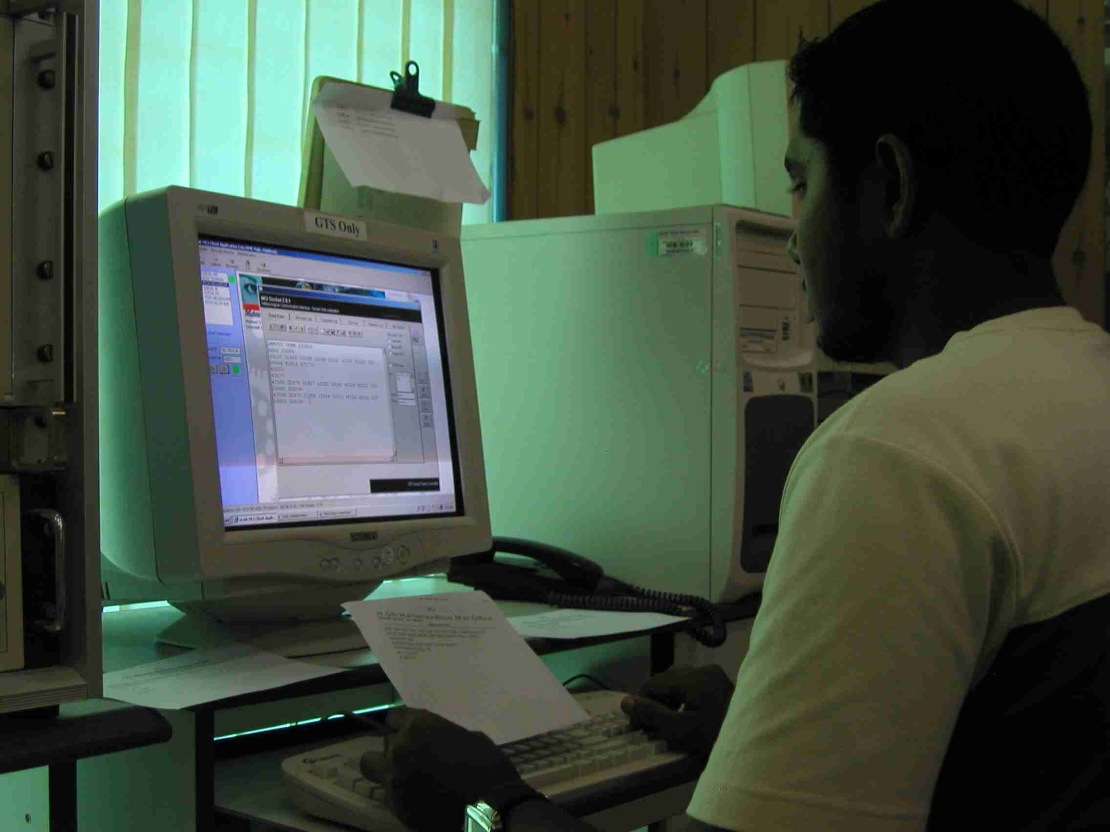
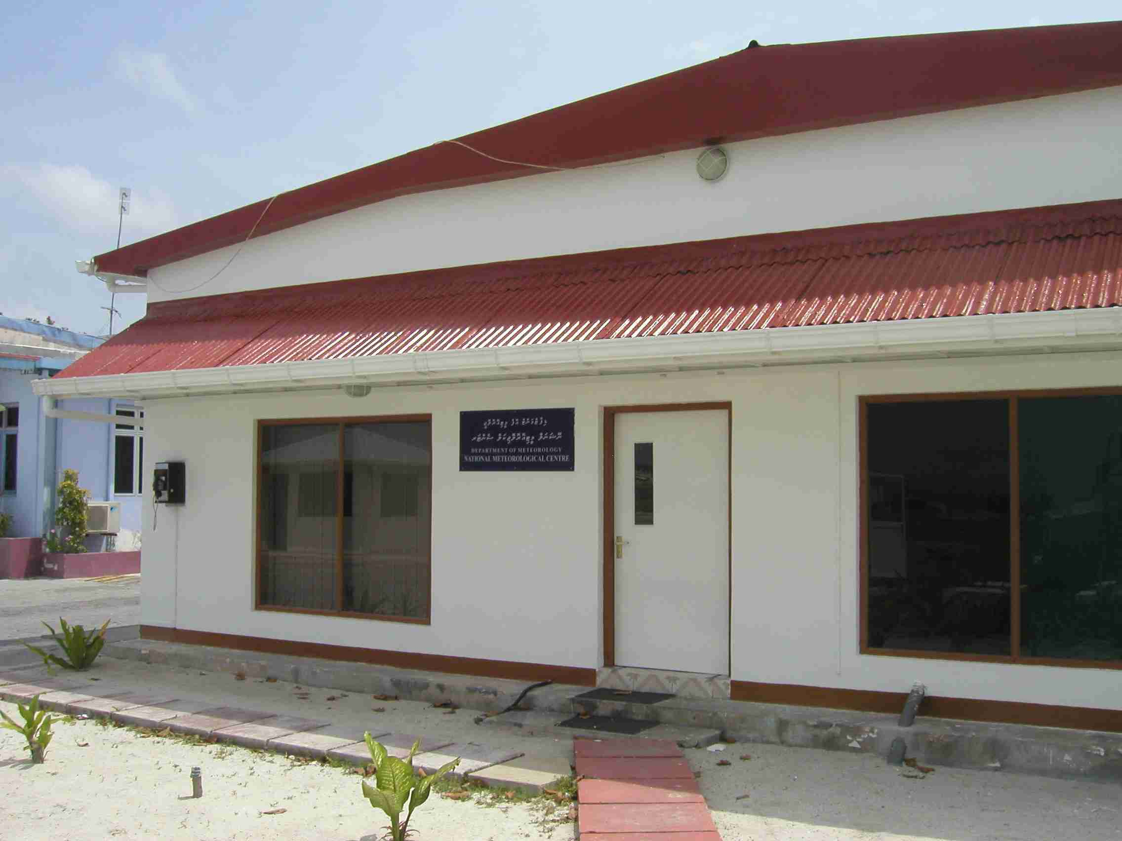
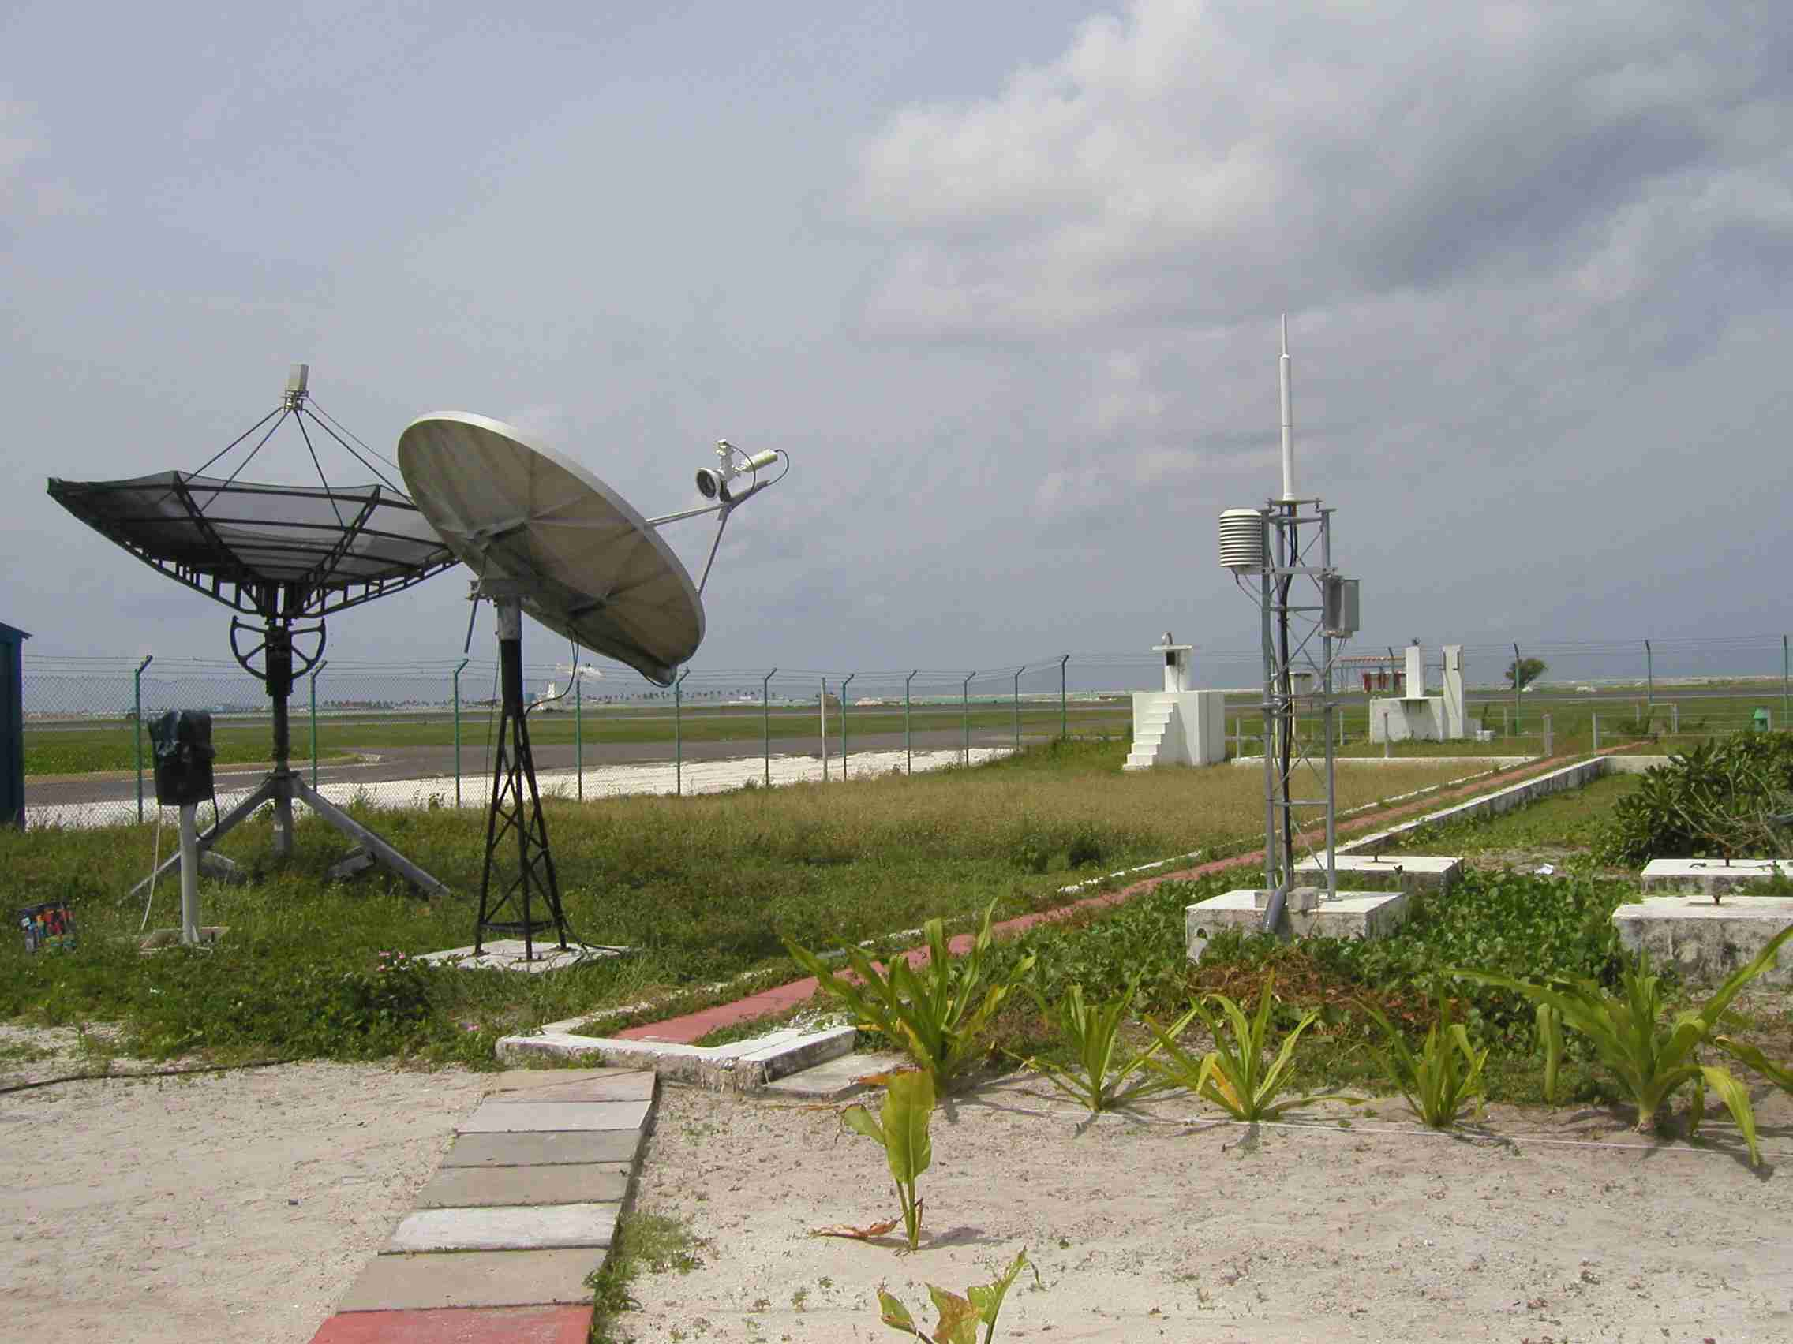
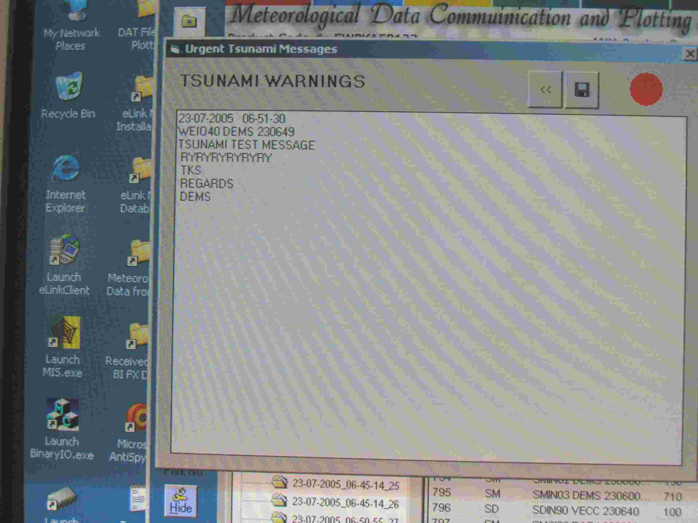
Input of SYNOP reports on the GTS system and transmit to RTH New Delhi
Test message of Tsunami warnings popped up with audio alarm on reception from New Delhi
NMC Male in International Airport. Tsunami wave reached its floor and damaged much equipment in the morning of December 26, 2004.
Satellite dishes for INSAT and SADIS
Telecommunication facility in NMC Male

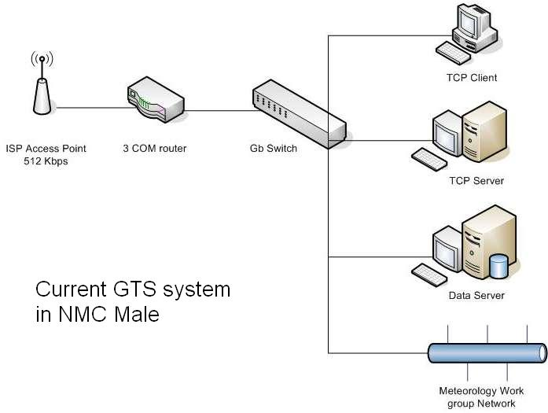
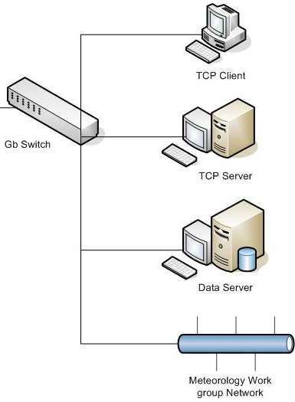


Internet
ISP #2
ISP #1
Firewall
Router
DMZ
Suggested network configuration for improvement of Internet connectivity in NMC Male
Area of improvement
ISP #1: Current provider (Focus Infocom)

