WORLD METEOROLOGICAL ORGANIZATION

COMMISSION FOR BASIC SYSTEMS

REGIONAL ASSOCIATION VI
WORKING GROUP ON PLANNING AND IMPLEMENTATION OF THE WWW

Sixth Session
FINAL REPORT

Toulouse, 15 - 19 September 2008

DISCLAIMER

Regulation 42
Recommendations of working groups shall have no status within the Organization until they have been approved by the responsible constituent body. In the case of joint working groups the recommendations must be concurred with by the presidents of the constituent bodies concerned before being submitted to the designated constituent body.

Regulation 43
In the case of a recommendation made by a working group between sessions of the responsible constituent body, either in a session of a working group or by correspondence, the president of the body may, as an exceptional measure, approve the recommendation on behalf of the constituent body when the matter is, in his opinion, urgent, and does not appear to imply new obligations for Members. He may then submit this recommendation for adoption by the Executive Council or to the President of the Organization for action in accordance with Regulation 9(5).

© World Meteorological Organization, 2008

The right of publication in print, electronic and any other form and in any language is reserved by WMO. Short extracts from WMO publications may be reproduced without authorization provided that the complete source is clearly indicated. Editorial correspondence and requests to publish, reproduce or translate this publication (articles) in part or in whole should be addressed to:

Chairperson, Publications Board
World Meteorological Organization (WMO)
7 bis, avenue de la Paix Tel.: +41 (0)22 730 84 03
P.O. Box No. 2300 Fax: +41 (0)22 730 80 40
CH-1211 Geneva 2, Switzerland E-mail: Publications@wmo.int

NOTE

The designations employed in WMO publications and the presentation of material in this publication do not imply the expression of any opinion whatsoever on the part of the Secretariat of WMO concerning the legal status of any country, territory, city or area or of its authorities, or concerning the delimitation of its frontiers or boundaries.

Opinions expressed in WMO publications are those of the authors and do not necessarily reflect those of WMO. The mention of specific companies or products does not imply that they are endorsed or recommended by WMO in preference to others of a similar nature which are not mentioned or advertised.

This document (or report) is not an official publication of WMO and has not been subjected to its standard editorial procedures. The views expressed herein do not necessarily have the endorsement of the Organization.

CONTENTS

Agenda

Executive summary

General summary of the work of the session

Annexes

AGENDA

- OPENING OF THE SESSION

- ORGANIZATION OF THE SESSION
  - Adoption of the Agenda
  - Working arrangements

- REPORT OF THE CHAIRMAN OF THE WORKING GROUP

- CONSIDERATION OF THE DECISIONS
- of the fourteenth Session of the RA-VI
- CBS Extra-ordinary Session (2006)
- Fifteenth Congress and EC-LIX and EC-LX including requirements for WWW support to other programmes

- STATUS OF WWW IMPLEMENTATION AND OPERATION

- REGIONAL ASPECTS OF THE WWW COMPONENTS, PWS PROGRAMME AND SUPPORT FUNCTIONS, INCLUDING REPORTS BY THE CO-ORDINATORS
  - Integrated Observing Systems (IOS)
  - Information Systems and Services (ISS)
  - Data-Processing and Forecasting Systems (DPFS)
  - Operational Information Service (OIS)
  - Public Weather Services (PWS)
  - WWW-related Cooperation Activities

- NEW DEVELOPMENTS
  - WMO integrated Global Observing System (WIGOS): development and implementation plan
  - Development and Implementation of the new WMO Information System
  - INSPIRE and GMES: Standardization and access to environment related information
  - The RA VI Strategic Plan

- FUTURE WORK PROGRAMME

- CLOSURE OF THE SESSION

Executive Summary
The sixth Session of the Working Group on Planning and Implementation of the WWW in Region VI (Europe) was held at Toulouse (France) from 15 to 19 September 2008 under the chairmanship of Dr Jochen Dibbern.

The meeting reviewed the status of the WWW implementation and operation in Region VI:
- The observing system was functioning well in Region VI although there were still deficiencies in the implementation and operation of the Regional Basic Synoptic Network (RBSN) and the Regional Basic Climatological Network (RBCN) in some areas of the Region as revealed by the monitoring exercises.
- The majority of the GTS point-to-point circuits of the Regional Meteorological Telecommunications Network (RMTN), mainly in the western part of the Region, were running on the Regional Meteorological Data Communication Network (RMDCN) which proved to be efficient and effective. In other parts of the Region, including the south-east and east, the RMTN was mostly running over traditional telecommunication point-to-point circuits or via the Internet, with overall unsatisfactory reliability. The satellite broadcasting systems in Europe have transferred to the DVB technology allowing a significant increase in capacity and reliability.
- The meeting noted the continuing progress made in the development of the Limited Area Models (LMA) and the use of the Ensemble Prediction Systems (EPS), many centres benefiting from the international multi-lateral cooperation through the ALADIN consortium, the HIRLAM grouping or the COSMO grouping.

The meeting made recommendations to ensure that the procedures for the implementation and operation of the RBSN and RBCN are followed by RA VI Members. Noting the developments in the observing networks as well as in NWP data assimilation, the meeting recommended that the RA VI nominate a Rapporteur on the redesign of the RBSN and RBCN. The meeting was informed of the activities of the EUCOS Programme.

The meeting recommended amendments to the Manual on the GTS, including the deletion of several point-to-point circuits from the RMTN plan and the addition of other circuits and to the satellite distribution system EUMETCast/BMD-RA-VI. The meeting reviewed the status of the migration to Table Driven Code Forms (TDCF), and recommended action to ensure that all RA VI Members provide information on the national plan for the migration and on possible existing problems to migrate. The meeting also recommended action to facilitate the migration.

The meeting noted the activities for the improvement of data-processing and forecasting systems, in particular as regards the global and limited area models operated in RAVI, the environmental emergency response and the coupling of atmospheric and hydrological forecasts

The meeting recommended that the RA VI Members review and update the operational information. The meeting took note of the progress on Public Weather Services activities, and particularly expressed its appreciation on the development of the Meteoalarm system. The meeting reviewed the WWW-related cooperation activities. It recommended intensifying the twinning programme to facilitate the Migration to Table Driven Code Forms and the implementation of the WMO Information System (WIS). The meeting recommended action related to the development and implementation of the WMO Integrated Observing System (WIGOS) and WIS. Noting that the INSPIRE Directive framework will pass into national legislation by May 2009, it recommended to develop wider expertise in the technical standards underpinning WIS and INSPIRE.

The meeting reviewed and updated the current version of the WG-PIW work plan.

The recommendations of the session will be submitted to the fifteenth session of the Regional Association VI in Brussels in September 2009.

- OPENING OF THE MEETING

  - The sixth Session of the Working Group on Planning and Implementation of the WWW in Region VI (Europe) was held at Toulouse (France) from 15 to 19 September 2008 under the chairmanship of Dr Jochen Dibbern.

  - On behalf of Mr Pierre-Étienne Bisch, Permanent Representative of France with WMO and Président Directeur Général of Météo-France, Mr Laurent Perron welcomed the participants in the Météopole of Toulouse.

  - On behalf of Mr Michel Jarraud, Secretary-General of WMO, Mr P. Kerhervé welcomed the participants and thanked Météo-France for organising the meeting and for providing these excellent facilities and environment in the Météopole in Toulouse.

  - Mr P. Kerhervé noted that the meeting was invited to review the status of the World Weather Watch and Public Weather service Programmes in Region VI and to develop recommendations for their improvement. The meeting was in particular invited to review the actions taken since the meeting of the Coordinators/Rapporteur of the Working Group held in Langen in January 2007 with reference to the work plan defined by the working group.

  - The meeting was invited to review the development and Implementation plan of the WMO integrated Global Observing System (WIGOS) and of the WMO Information System (WIS) and to develop recommendations on the possible contributions of the Regional Association VI in these initiatives.

  - The fifteenth Congress noted initiatives aiming at standardizing the presentation and exchange of spatial Information, which embedded meteorological data, such as INSPIRE of the European Union, and it stressed the need to ensure that the requirements of the WMO Programmes and the relevant WMO systems and standards were recognized by those initiatives. The fourteenth session of the Regional Association VI requested the working group to keep the development of the INSPIRE initiative under review. The meeting was therefore invited to review the development of the INSPIRE initiative and develop appropriate recommendations.

  - The outcomes of the meeting will be submitted to the fifteenth session of the Regional Association VI in Brussels in September 2009.

- ORGANIZATION OF THE SESSION

  - Adoption of the Agenda

The meeting agreed on the agenda reproduced at the beginning of the report. The list of participants is given in Annex to this paragraph.

  - Working arrangements

The meeting agreed on its working arrangements.

- REPORT OF THE CHAIRMAN OF THE WORKING GROUP

  - The chairman recalled that the fourteenth session of the Regional Association VI, held in Heidelberg (Germany) in September 2005, re-established the Working Group on Planning and Implementation of the World Weather Watch in Region VI.

  - The working group is composed of a chairman, five coordinators of the subgroups on regional aspects of the IOS, ISS, DPFS and PWS, a coordinator of an Ad Hoc Group on WWW Related Cooperation Activities, a Rapporteur on the Regional Table-driven Code Form Migration Plan together with all the members of the subgroups and ad hoc group. The CIMO Rapporteur on Regional Aspects of Instrument Development, related Training and Capacity Building, the chairman of the Steering Group on the RMDCN and the chairman of the Working Group on Natural Disaster Prevention and Mitigation (WG-DPM) in RA-VI were invited to contribute to the working group. The cooperation with the EUCOS Programme to ensure consistency of approach and integration in respect of observing networks, procedures and monitoring was ensured by the chairman of WG-PIW who is currently the EUCOS Programme Manager.

  - In January 2007 the chairman organized a meeting of the Working Group PIW coordinators/rapporteurs at the conference and Training centre of the Deutscher Wetterdienst in Langen. The meeting reviewed the first status reports presented by the coordinators/rapporteurs and recommended:
- That the development of the METEOALARM project be followed by the Sub-group on Regional Aspects of the PWS;
- To draw the attention of the RA VI Management Group to possible duplications in the activities of the Sub-group on Regional Aspects of the PWS and the Working Group on Natural Disaster Prevention and Mitigation;
- To arrange for the international advisers (INTAD6) to contribute to the activities of the Ad Hoc Group on WWW-related Cooperation Activities;
- To invite RA VI Members to update the CBS software registry, informing WMO Members on the software packages offered for the implementation of the WWW, in particular to encourage the update and use by INTAD6;
- To encourage the participation of RA VI Members in the workshop on the migration to table-driven code forms scheduled in 2007;
- That the WMO/EUMETNET Representative in Brussels (EUMETRep) and the chairman of the WG on DPM be invited to participate in the meeting of the working group in 2008.

  - The meeting prepared a work plan for the working group, taking into account the terms of reference of the sub-groups and rapporteurs as approved by XIV-RA VI and the objectives of the RA VI action plan. The work plan and the final report of the meeting have been made available as part of the documentation plan for this meeting.

  - The chairman reported that the provision of Basic Meteorological Data to WMO RA VI via EUMETCast started in September 2005 with the approval of a two years trial phase by EUMETSAT Council. The trial started with the routine delivery of DWD, UK Met Office and ECMWF data sets and was extended by the delivery of NWP data sets from Météo France. To make the benefits of the European Meteorological Infrastructure available for all Members of RA VI is one of the main priorities in the current work of RA VI. The BMD service comprises a broad set of meteorological data especially useful for developing countries. Due to the continuous support of EUMETSAT the BMD service is widely accepted. As the trial period was ending in autumn 2007 the WG-PIW chairman formally requested at EUMETSAT the transition of the BMD service from trial to operations. The meeting was informed that the 63rd EUMETSAT Council has decided to establish the EUMETCast BMD service as an operational service at no costs for RA VI Members. The content and necessary bandwidth for the dissemination of the data is subject to biannual review by EUMETSAT working groups.

  - The chairman represented the WG-PIW at the Technical Conference on the Action Plan of the RA VI Strategic Plan, held in Switzerland 29 to 30 October 2007. The objective of the conference was to review the draft Action Plan as an attachment to the draft Strategic Plan for the Enhancement of National and Hydrological Services in Regional Association VI. Results from the discussion at the conference are given in Annex C of the RA VI Strategic Plan.

  - The chairman, in his function as the EUCOS Programme Manager, participated in the Fourth WMO Workshop on the Impact of Various Observing Systems on Numerical Weather Prediction, organized under the auspices of the CBS OPAG-IOS Expert Team on the Evolution of the GOS (ET-EGOS). The workshop is considered as another important step forward in the process of a design of the future GOS. Since the previous workshop (Alpbach 2004), significant developments have taken place in the GOS, such as the launching of satellites equipped with newer instruments, for example METOP in 2006 and the COSMIC constellation providing radio-occultation soundings. Microwave data are increasingly being assimilated operationally and mesoscale assimilation systems can use local observations such as radar reflectivities, radar Doppler winds and data from surface GPS stations. Conventional observing systems are also being adapted through regional programmes like the EUMETNET Composite Observing System (EUCOS). Targeting strategies are being used or considered for increased use through, for example, the THORPEX Programme and the EUCOS/PREVIEW Data Targeting System (DTS).

  - The chairman participated in the fourth session of the Expert Team on Evolution of the Global Observing System, representing the EUCOS Operational Programme. He reported on recent developments in EUCOS related to the ET-EGOS and OPAG-IOS and on progress with the implementation of relevant EGOS-IP recommendations in RA VI with reference to the EUCOS Programme. ET-EGOS-4 updated the Implementation Plan for the Evolution of the surface- and space-based sub-systems of the GOS. The RA VI WG-PIW, subgroup on IOS was requested to develop a draft implementation plan (EGOS-IP) for the consideration at the XV RA VI session in September 2009. In addition, the ET-EGOS updated the draft “Vision for the GOS in 2025” presented to the ICT-IOS in September 2008.

- CONSIDERATION OF THE DECISIONS OF PREVIOUS SESSION OF CBS, EC and Congress

  - The meeting reviewed the decisions and recommendations of the fourteenth Session of the RA-VI, CBS Extra-ordinary Session (2006), Fifteenth Congress, EC-LIX and EC-LX concerning the Regional Associations.

  - The meeting particularly noted the establishment of the two following expert teams:

  - The Expert Team on the Assessment of Data Representation Systems (ET-ADRS). The ET-ADRS was established by the CBS Management Group to assess advantages and disadvantages, including implications (need for defining standardization, data processing development and integration, costs and benefits: flexibility, compression, feasibility of implementation, etc.), of different data representation systems (e.g. BUFR, CREX, XML, NetCDF, HDF) for use in real time operational international exchanges between NMHSs and in transmission of information to users outside the NMHSs. The ET-ADRS should develop recommendations on the most appropriate system depending on the type of exchange applications and report on the possible impacts of its findings on the migration to Table Driven Code Forms (TDCF). The CBS Management Group emphasized that the ET-ADRS should also aim at developing a proposal for a CBS policy on data representation systems.

  - A conjoint Expert Team between CAeM and CBS to specifically address the requirements of aeronautical meteorology, including ICAO, for Data Representation systems, including issues of the migration of OPMET data to new forms of Data Representation (ET-ODR).

- STATUS OF WWW IMPLEMENTATION AND OPERATION

Global Observing System

  - The RBSN comprised 808 surface stations, 127 upper-air stations, 10 moored buoys and 1 fixed ship. In accordance with the information provided by the WMO Members and published in Volume A of WMO Publication No. 9:
  - The percentage of RBSN surface stations making 8 observations per day was about 98 per cent;
  - The percentage of RBSN upper-air stations making two observations per day was about 84 per cent;

  - The RBCN comprised 576 CLIMAT stations and 95 CLIMAT TEMP stations. In accordance with the information provided by the WMO Members and published in Volume A of WMO Publication No. 9, 88 per cent of both the CLIMAT stations and the CLIMAT stations made relevant reports. The meeting noted that, according to the SMM monitoring reports (see paragraph 5.32), 93 per cent of the CLIMAT reports were received by MTN centres. This showed that WMO Members had not updated Volume A. The meeting recommended to invite the national focal points for matters related to Volume A to take action to update Volume A.

  - The number of operational E-AMDAR aircraft reporting daily observations continued to grow as did the number of daily observations over Europe. The average number of daily number of AMDAR reports was around 35000. In 2008, E-AMDAR had set a target for number of daily profiles at 780 covering 140 airports with 40 airport reporting 3 hourly AMDAR profiles per day. There was concern however that the number of AMDAR observations globally could decrease as a result of the airline industry discontinuing 747-400 operations. Software development for future long haul aircraft, such as the Airbus A380 or Boeing 747-800 was still in the early stages of planning. The number of AMDAR observations could also decrease in the short term due to the high price of fuel adversely impacting on airline operations. The initial evaluation of the WVSS-II sensors by E-AMDAR was originally intended for 2007, however due to several problems with the first batch of sensors a further evaluation trial with an upgrade sensor package has been scheduled for late 2008/early 2009.

  - Dramatic progress has been made in the implementation of the ocean observing networks in the last decade. Overall, the global ocean in situ observing system was 60% implemented, with the JCOMM plan driving to full implementation, in principle by 2012. All data are being made freely available to all Members in real-time. However, completion will require substantial additional yearly investment by the Member/Member States. In Europe, EUCOS, and the European Meteorological Services (EUMETNET) Surface Marine programme (E-SURFMAR) and the EUMETNET Automated Shipboard Aerological Programme (E-ASAP) were particularly providing substantial contributions to the in-situ marine observational networks.

  - The total number of Voluntary Observing Ships (VOS) recruited by 15 Members of the Association was 2099, 2105, 1994, and 1670 as of the end of 2004, 2005, 2006 and 2007, respectively (many historical ships have been deleted from the WMO Publication No. 47 which explained the sudden drop in 2007). The number of Automatic Weather Stations installed onboard ships and providing hourly observations has increased leading to a continued increase in the total number of SHIP reports available on the GTS despite the reduced number of recruited vessels.

  - Sixteen units within the Automated Shipboard Aerological Programme (ASAP) were operated by six Members of the Association, including five by EUMETNET as a whole. The16 units produced 5235 TEMP SHIP reports in 2007 from the North Atlantic and the Mediterranean Sea. EUMETNET was planning to extend the E-ASAP fleet to 19 ships in 2009.

  - The global surface buoy network (DBCP) is essentially complete since September 2005 and being sustained at the level of 1250 units (1199 units in June 2008). Efforts were being made to install barometers on all operational drifters (554 units reporting SLP in June 2008). 40 drifting buoys from 4 countries of the Association and 67 from E-SURFMAR were reporting mainly from the North Atlantic, and the Arctic Basin regions. In addition, a substantial number of drifting buoys deployed by operators from countries in other regions were also reporting from waters within the region. At the same time, agencies in 3 countries in Region VI plus E-SURFMAR were operating at least 46 moored buoys in the Atlantic Ocean and Mediterranean Sea in June 2008. Other marine stations were reporting from the North Sea, Baltic Sea and the Black Sea.

  - The Argo profiling float programme had reached completion in November 2007 (3000 units) and was providing essential upper ocean thermal data for Tropical Cyclones research, monitoring and forecast activities. In July 2008, 3218 floats were operational globally, including 478 by 8 Members of the Association and through projects funded by the European Union.

Global Telecommunication System

  - The majority of the Regional Meteorological Telecommunications Network (RMTN) links in RA-VI, mainly in the western part of Region, were running over the Regional Meteorological Data Communications Network (RMDCN) using modern technology. The overall performance of the managed network was very good, meeting or surpassing the current requirements. Detailed information on the implementation of the point-to-point circuits is given in Annex to this paragraph.

  - In other parts of the Region, including the south-east and east, the RMTN was mostly running over traditional telecommunication point-to-point circuits or via the Internet, with overall unsatisfactory reliability. Detailed information on the implementation of the point-to-point circuits is given in Annex to this paragraph.

  - RMDCN is managed by ECMWF on behalf of the network members, and supplied under contract by Orange Business Services (formerly known as EQUANT). Most RMDCN members have access links with some form of back-up. Many of the bigger centres have Mission Critical System access with diversely routed, dual access lines with hot failover. For most centres, upgrading to a higher speed connection is straightforward, quick and flexible. Current access speeds range from 128Kb/s to 50Mb/s. The connected sites and their connection speeds are given in the Annex to this paragraph.

  - The RA VI RMDCN migration from Frame Relay to IP VPN MPLS was completed on 18 June 2007. The general configuration of the new RMDCN MPLS-based architecture is given in Annex to the paragraph 5.11.

  - The following Region VI countries have not yet joined the RMDCN: Albania, Armenia, Azerbaijan, Belarus, Bosnia & Herzegovina, Cyprus, Georgia, Kazakhstan, Malta, Monaco, Moldova, Ukraine, Montenegro, Israel and Syria. Some countries are actively attempting to join, but there are financial and technical barriers (see Annex to paragraph 5.11).

  - The Improved MTN (IMTN) comprises two interconnected telecommunications networks. The IMTN Network I (also referred as Cloud I) was established in 2003, interconnecting MTN links between Exeter, Melbourne, Tokyo and Washington. Network II (also referred as Cloud II) was basically the RA-VI RMDCN. The providers of Cloud I have served notice that the technology (Frame Relay) must be replaced. This is a general trend among technology providers across the world.

  - The satellite broadcasting systems in Europe have transferred to the DVB technology allowing a significant increase in capacity and reliability. The following satellite systems are included in the RMTN plan:
- EUMETCast (MDD), operated by EUMETSAT,
- RETIM2000 operated by France,
- DWDSAT operated by Germany (via EUMETCast) and
- METEOINFORM operated by Russian Federation.
Italy was operating a satellite system called NUBIS. Almost all RA-VI Members are equipped with EUMETCast receiving systems. A great number operate RETIM 2000. The Annex to this paragraph includes a diagram showing RA-VI point-to-multipoint systems.

  - None of the RA-VI countries carried out radio teletype or radio facsimile transmissions as mentioned in the Manual on GTS, Volume 2, Regional Aspects, Region VI, Para. 3.7.4, Para. 3.9.

  - Other networks and links are used to exchange operationally important data, such as satellite, weather radar and lightning detection data. Some of these informal networks and their voluminous traffic have been included in capacity planning documents for RMDCN in preparation of migration to full operational status. Others such as the ATD lightning detection network have different and demanding latency requirements that RMDCN cannot meet and will persist separately. See annex to this paragraph for the current ATD network.

  - All the RTHs and the vast majority of NMCs in Region VI had access to the Internet, with several centres enabling access to their servers for provision of data and products. Tests coordinated by ECMWF and using IPSec Virtual Private Network (VPN) over the Internet had taken place between some centres. The results were very positive and this is likely to become the main backup mechanism for RMDCN. Most of the RA VI centres had access to the Internet at speeds ranging from 256 Kbps to one Gbps for:
- Reception of additional information which does not come over the GTS;
- Provision of information within countries as well as for other NMCs;
- Arrangement of the GTS circuits or their backing up;
- Observation data collection in the national network;
- Provision of Information to the public and the private sector.

  - Data collection over Region VI is generally satisfactory and exceeds the results of other Regions. However, in the south-eastern part of the region, the results of data collection are significantly lower than on average over the Region at a level from 94 % to 95 % as compared with expected.

  - The majority of countries in this part of the Region changed or are changing to the use of cellular communications (usually GPRS or occasionally GSM) and the Internet resulting in a significant reduction in costs of data collection. However, the reliability of data collection became lower, as under extreme circumstances, these networks experience overloading and even stop functioning.

Global Data Processing and Forecasting System

  - In RA VI, out of fifty NMCs, thirty five are running operational NWP. GDPFS Centres are still increasing the resolution of their models.

  - Five RSMCs (Exeter, Moscow, Offenbach, Toulouse and ECMWF) were running global models. Exeter, Toulouse and ECMWF have implemented 4-D VAR data assimilation. The RSMCs with geographical specialization Exeter, Moscow, Offenbach and Rome, and also Toulouse (but RSMC for transport model) provided regional products to assist NMCs in the forecasting of small-scale, meso-scale and large-scale meteorological systems. Exeter was running a unique non-hydrostatic global model (40 km resolution with 50 levels).

  - ECMWF ran its global T799L91 model. It ran its 50 members ensemble with T399L62 up to 240 h, then T255L62 up to 15 days. ECMWF ran also for extended range forecast a T159L62 model coupled with the HOPE ocean model with 29 levels up to 32 days. A substantial subset of ECMWF products was disseminated for WMO Members on the GTS in GRIB Code, and on Internet, including probabilities, EFI and EPSgrams.

  - The three RSMCs designated for the provision of transport model products for environmental emergency response, Exeter, Obninsk and Toulouse, had implemented the regional and global arrangements for the provision of specialized transport/ dispersion/deposition model products over Region VI and also Region I. Exeter and Toulouse were also Volcanic Ash Advisory Centres and provided ash clouds trajectories and dispersion forecast for aviation.

  - Among the thirty five NMCs running Limited Area Models, eight centres were running limited area non-hydrostatic models at few kilometres resolution. Many centres benefited greatly from the international multi-lateral cooperation through the ALADIN consortium, the HIRLAM grouping or the COSMO grouping. The Deutscher Wetterdienst COSMO/DE model was also shared by several centres, as well as the HRM model. The UK MetOffice Unified Model is also used by other centres.

  - Exeter, Offenbach and Toulouse ran ensemble system for short-range. Vienna ran a 22 members short-range ensemble with ALADIN model. The COSMO consortium was running at ECMWF a nested non-hydrostatic LAM in the ECMWF EPS system with 16 members.

  - The three recognized Global Producing Centres of Long-Range Forecasts: Exeter, Toulouse and ECMWF ran coupled ocean-atmosphere global ensemble systems: Exeter with 41 members up to 6 months, Toulouse with 41 members up to 16 months and ECMWF with 41 members T159L62 up to 13 months. Moscow, running a two tiers ensemble system of 10 members up to 4 months, had been recommended for being recognized as GPC at the next CBS in March 2009.

Availability of SYNOP and TEMP reports from RBSN stations

  - During the July and October 2007, and January and April 2008 exercises of the Special MTN monitoring (SMM), 94 per cent of the SYNOP reports and 78 per cent of Parts A of TEMP reports from RBSN stations located in Region VI were received at MTN centres.

  - The following deficiencies were found during the four SMM exercises:

- Only 55 per cent, 58 per cent and 59 per cent of the expected SYNOP reports were received from Azerbaijan, Israel and Lebanon respectively. Ten stations were silent during the four SMM exercises.
- No TEMP reports were received from Belgium and Slovenia. Less than 30 per cent of the expected TEMP reports were received from Latvia, Lebanon, Lithuania, Romania and The Former Yugoslav Republic of Macedonia. Less than 45 per cent of the expected TEMP reports were received from Armenia, Portugal and Ukraine. Nine stations were silent during the four SMM exercises.

  - The availability of SYNOP and TEMP reports from RBSN stations located in Region VI from 2004 to 2008 is given in Annex to this paragraph. The availability of SYNOP reports was relatively constant (94/95 per cent) during the period 2004-2008, ant that of TEMP reports oscillated around 78 per cent.

  - From the EUCOS monitoring reports, the meeting noted that some TEMP reports were received late and that parts A and B of TEMP reports were received at the same times as the parts C and D. This showed that the following procedures prescribed in the Manuals on GOS and GTS were not followed by some RA VI WMO Members:

- In accordance with the Manual on GOS, the actual (launch) time of regular upper-air synoptic observations should be as close as possible to (H-30) and should not fall outside the time range (H-45) to H.
- In accordance with the Manual on the GTS, the collection of the reports by the National Meteorological Centre shall take place as soon as possible and shall be completed within 15 minutes of the observing station’s filing time, i.e. the time at which the coded meteorological report is first presented to the telecommunication system.

Availability of CLIMAT and CLIMAT TEMP reports from RBCN stations

  - During the July and October 2007, and January and April 2008 exercises of the Special MTN monitoring (SMM), 93 per cent of the CLIMAT reports and 78 per cent of the CLIMAT TEMP reports from RBCN stations located in Region VI were received at MTN centres.

  - The following deficiencies were found during the four SMM exercises:

- No CLIMAT reports were received from Lebanon and The Former Yugoslav Republic of Macedonia. Less than 51 per cent of the expected CLIMAT reports were received from Azerbaijan, Iceland, Republic of Moldova and Slovenia. Twenty-three stations were silent during the four SMM exercises.
- No CLIMAT TEMP reports were received from Croatia, Latvia, Lebanon and Lithuania. Less than 51 per cent of the expected CLIMAT TEMP reports were received from Italy, Poland, Romania and Slovakia. Eleven stations were silent during the four SMM exercises.

  - The availability of CLIMAT and CLIMAT TEMP reports from RBCN stations located in Region VI from 2004 to 2008 is given in Annex to this paragraph. The availability of CLIMAT reports increased from 80 per cent to 94 per cent during the period 2004-2008, ant that of CLIMAT TEMP reports from 65 to 79 per cent.

  - The meeting therefore requested the Secretariat on behalf of the chairman to inform the relevant RA VI International Advisers (INTAD6) of the deficiencies revealed by the SMM and the EUCOS monitoring reports for SYNOP, TEMP, CLIMAT and CLIMAT TEMP reports, and to invite them to inform the Chairman of the RA VI WG-PIW, the coordinator of the sub-group on Regional Aspects on the IOS and the Secretariat of any comments on these deficiencies and any action taken to overcome them.

- REGIONAL ASPECTS OF THE WWW COMPONENTS, PWS PROGRAMME AND SUPPORT FUNCTIONS, INCLUDING REPORTS BY THE CO-ORDINATORS

  - Integrated Observing Systems (IOS)

    - The meeting recalled:

    - The recommended procedures in formulating the RBSN and RBCN (see extracts from the third session of the Implementation/Coordination Team on the Global Observing System (Geneva, September 2004) in Annex to this paragraph),
    - The criteria for inclusion of stations in the regional basic synoptic network (see extracts from the report of the fourth session of the Working Group on Planning and Implementation of the World Weather Watch in Region VI (Geneva, May 2001) in Annex to this paragraph).

    - The meeting requested the Secretariat on behalf of the chairman to invite the national focal points for matters related to the RBSN and the national focal points for GCOS and related climatologically data (RBCN):

    - To take due account of the procedures and criteria mentioned in paragraph 6.1.1,
    - To report to the coordinator of the sub-group on Regional Aspects on the IOS and the Secretariat on any deviations from the requirements, for example upper-air observations not made at 00 and 12 UTC, not reporting Temp A and B when the sounding passes 100 hPa but wait until the balloon burst;
    - To document any changes proposed in the RBSN/RBCN, in particular reasons to close or add stations during the intersession period;
    - To consider the list of RBSN and RBCN silent stations (see paragraphs 5.23 and 5.28 and Tables 2, 4, 6 and 8 in http://www.wmo.int/pages/prog/www/Planning-Impl/RA-6/2008_Toulouse/Doc5(4)-qtyMonitoring.doc)
    - To inform the Chairman of the RA VI WG-PIW, the coordinator of the sub-group on Regional Aspects on the IOS and the Secretariat of any comments on these deficiencies and any action taken to overcome them.

    - The current design of the RBSN/RBCN was developed in 2001. In between, there have been a number of new developments in the observing networks as well as in NWP data assimilation, among others:

    - The significant evolution of the European AMDAR network;
    - Data assimilation of NWP models has improved significantly with advanced capability to make use of high time resolution data;
    - More and more hourly observations from AWS are made available from Members
    - An increase in marine observations from buoys and AWS on ships has improved data coverage over the nearby oceans areas.
    - A subset of the European wind profiler network has achieved operational status and the data are used operationally in different NWP models;
    - Weather radar wind profiles from Doppler weather radars are available which are used in the data assimilation of the Met Office numerical model, and monitored at other NWP centres;
    - Precipitation data from more than 100 weather radars within the Eumetnet countries are collected on a server and used to produce European composite radar images.
    - Water vapour can be derived from ground-based GPS.

    - Due to this, the EUCOS programme was tasked to redesign the EUCOS upper-air network. This redesign will be based on an OSE conducted by ECMWF and other European NWP centres. Results will be coordinated with the EUMETNET Climate Support Network initiative and presented in spring 2009. The meeting recommended that the XV session of RA VI nominates a Rapporteur on the redesign of the RBSN and RBCN. The Rapporteur should conduct his work in close cooperation with the WG-CRM and WG-PIW and should take requirements for nowcasting into account.

    - EUCOS is offering a quality monitoring service for all Members of RA-VI. With the transfer of the responsibility for the Operational EUCOS Programme from the Met Office to DWD at the beginning of 2007, also the monitoring was transferred to DWD. On a daily basis, network performance statistics are delivered for surface synoptic and radiosonde stations (RBSN). Data availability, timeliness and for radiosonde data the number of ascents achieving 100 hPa or 50 hPa are monitored. The latest update of the monitoring portal from September 2008 will also include comparisons between observations and NWP model output. To enhance the usage of this monitoring portal the meeting requested EUCOS to arrange for access to the portal without password.

    - The EUCOS Programme Manager (Dr Jochen Dibbern) informed the meeting on the status of the EUCOS programme and gave an outlook on the near future development of the programme relevant to the evolution of the IOS in Region VI. He reported that in 2007 there have been no major changes to the network design, but reported on further improvements in detail. The network performance and targets are monitored by the EUCOS team; appropriate fault correction procedures are agreed amongst the EUCOS Members.

    - During 2007, the 16 E-ASAP units performed 4032 soundings. Due to operator failure, the high sailing speed of the ships and communications problems the loss rate was still high, 23%. The mean timeliness was smaller than HH+100 and the median burst height smaller than 50 hPa.

    - The EUCOS Programme Manager reported that the E-AMDAR network continues to grow in terms of the number of participating aircrafts; also the number of observations continues to grow.

    - Marine surface observations in the EUCOS area were coordinated by the E-SURFMAR Programme. The number of manned observations reported by Voluntary Observing Ships (VOS) continued to decrease in 2007. This decline is mainly linked to the decrease of port meteorological activities at different NMSs. During the same time, the number of automated weather observations significantly increased. This is partly due to more simple Automated Weather Stations (AWS) installed aboard ships. These stations correctly meet EUCOS requirements but they do not reply to other concerns such as climatology and nowcasting.

    - Drifting buoys are the main component of E-SURFMAR to provide air pressure measurements at the sea surface. In 2007, an average of 80 drifting buoys in operation delivered about 1900 observations per day. The network was extended north-eastwards through some deployments from Ocean Weather Station Mike. The mean lifetime for the buoys which ceased to operate in 2007, was approximately 12 months. The timeliness of drifting buoy data was still worse than this of other components. Due to the use of the system Argos, only one third of the reports were delivered within 50 minutes and another third within the next 50 minutes. This will change with the use of Iridium transmissions: 45 Iridium drifting buoys were ordered to be deployed in 2008.

    - The meeting was informed on the EUCOS Studies Programme activities. The upper-air network redesign OSE will be conducted until spring 2009. The EURORISK-PREVIEW DTS project is progressed so that the trial period can be conducted successfully. Aim of the project is to deliver additional meteorological observations over key sensitive regions to reduce forecast uncertainty for prediction and early warning of high impact weather events over Europe.

    - The EUCOS Programme Manager updated the meeting on the EUCOS support to THORPEX activities. During the summer months June to August 2007, EUCOS organised the support for COPS and ETReC 2007. This support consisted of about 500 additional radiosoundings, which have been carried out by DWD, KNMI, Meteo-France, MeteoSwiss, and the Met Office. Furthermore, E-AMDAR provided additional hourly aircraft measurements at a number of airports located in the COPS and ETReC 2007 areas of interest.

    - The meeting was informed that the European wind profiler network WINPROF will be integrated into the EUCOS Operational Programme. A phased approach was chosen, starting with the managerial integration in 2008 followed by a new, fully integrated programme phase for 2009-2011.

    - Ground-based GPS measurements for total water vapour have been developed in the EUMETNET Programme E-GVAP towards operational implementation. The meeting was informed that currently 13 centres in Western Europe are processing ZTD data for E-GVAP. Today the E-GVAP collects and distributes data from more than 800 sites. The time for the near real-time ZTD data to arrive is short enough for assimilation in regional NWP models. Some NWP centres have started to assimilate ZTD data after having made positive impact experiments which vary between positive and neutral impact. The current phase of E-GVAP ends in April 2009, the follow-on programme phase will be decided in autumn.

    - The Programme Manager reported on future activities of the EUCOS Programme. Among others an Operational Data Targeting System to be continued after the trial phase and a EUMETNET Centralised Monitoring and Production Programme, integrated as DCPC in the future WMO Information System will be proposed to the EUMETNET Council in autumn 2008. The current E-ASAP fleet of 15 ships will be extended by two French, one Danish, and one Icelandic ship. Satellite communication will be switched to Iridium which allows transmitting a BUFR message at the same price as a TEMP message. The E-AMDAR humidity trial continues by installing the re-engineered version of the WVSS-II sensor in Lufthansa aircraft during summer 2008. Assuming that the sensor will perform to satisfaction preparations for a first operational phase will be initiated. In the E-SURMAR Programme the deployment of drifting buoys will continue with an extension in the north-east of the North Atlantic; an area where a lack of air pressure measurements is evident.

    - The ISS Coordinator reported that the use of the GTS and RMTN for the transmission of experimental additional and upper air observations in Asia Pacific region within the framework of the T-PARC THORPEX programme was agreed.

  - Information Systems and Services (ISS)

    - The status of the ISS was presented by the Coordinators on the ISS in RA-VI to the group and previously to the ICT-ISS meeting [Implementation-Coordination Team on Information Systems & Services, Geneva, 18 - 22 September 2006, http://www.wmo.int/pages/prog/www/TEM/ICT-ISS2006/ISSJointCoordinatorReport-Doc2.2(6)1-RVI.doc].

    - The status of implementation of the ISS in the South-Eastern and Eastern parts of Region VI gave the Coordinators the greatest concern.

    - Eight of the circuits, specified in the plan for the RMTN in the eastern part of the region, still do not exist. It is proposed that seven of these circuits be excluded from the RMTN plan but it is planned to implement the remaining six circuits. Most of the circuits in this part of Region use leased analogue/digital channels or the Internet and a significant number of them are expected to migrate to the RMDCN.
RMDCN
    - The Coordinators took part in several meetings concerning the RMDCN, including the Operating Committee, Steering Group and ECMWF Technical Advisory Committee Sub Group on the Future of RMDCN during 2008. The final report of the Steering Group is at: http://www.wmo.int/pages/prog/www/ISS/Meetings/RMDCN-Steering_Vienna2008/documents.html

    - The Steering Group had reviewed the current status of RMDCN and discussed options for its future.

    - The transition to the new MPLS TCP/IP network in June 2007 had been very successful and it was reported that the Steering Group recommended to continue the existing contract with Orange Business Services rather than re-compete.

    - It was stressed that the current RMDCN contract provides good value for money and that the MPLS architecture is adequate for the moment, but the provision of the RMDCN service will have to be reviewed in the light of the development of WIS. In the next two years the requirements for the next-generation RMDCN will have to be defined and different scenarios for the evolution of the network will be investigated to ensure that an enhanced network, supporting the WIS activity, should be in place by 2012/2013.

    - ECMWF now routinely publish annual, monthly, weekly and daily usage charts for each member of RMDCN which are very useful for capacity planning and routine management.

    - The current RMDCN includes five sites outside RA VI and new requests to join are expected. A significant RMDCN increase may introduce flexibility problems and may require more resources for managing the network.

    - Most of these issues are being addressed by a Sub-Group on the RMDCN that was established by ECMWF/TAC to examine the outcome of a telecommunication market survey carried out by ECMWF and to make recommendations towards the future of RMDCN. The Sub-Group will also consider the consequences of any further expansion of the RMDCN to non-RA VI countries. The Sub-Group will submit its report to the ECMWF TAC and ECMWF Council late 2008.

    - The criteria for membership of RMDCN are now clearly formulated. The following NHMSs can join if:
They are a member of ECMWF, or
They are a member of RA-VI, or
They are an RTH on the IMTN, or
They are invited to join by a member of RA-VI.

Improved MTN

    - The Improved MTN (IMTN) comprises 2 interconnected telecommunications clouds. The RMDCN is one of these Clouds, the other is the ‘Pacific Cloud’ network currently comprising links between Australia, the United Kingdom, Japan and the United States of America. A diagram showing the proposed configuration of the IMTN is given in Annex to this paragraph.

    - To accommodate this proposed structure, approval was given in 2002, for centres outside RA VI to be allowed to connect into the RMDCN, for the purpose of establishing direct GTS connections to centres within RA VI. As a consequence, Japan, India and China and Saudi Arabia are now connected into RMDCN. No further progress has been made with Kenya, Senegal, Algeria and Egypt joining the RMDCN.

    - Within the ‘Pacific Cloud’ (Network 1 in Figure 3), links have already been established between Australia-UK, Australia – Japan, USA - UK and USA – Japan. It is not clear whether or not the links Brasilia-Washington and Buenos Aires-Washington will be established over this network. This will depend upon the future development of the RMTN within RA III.

    - There is currently a strong possibility that the South African Weather Service will apply to join the RMDCN, to enable them to receive NWP model boundary condition more reliably and timely than over the Internet, and then allow them to transmit NWP products to EUMETSAT for broadcast to RA-I members via the EUMETCast satellite broadcast.

    - There are also bilateral links from RTH Exeter to Canada and NESDIS in the USA, used to exchange mainly timely satellite data critical for NWP. These are both part of a Frame Relay ‘cloud’, supplied by Verizon. Recently, the performance of the Canadian link has not been good, and CMC are reviewing their links with view to implementing a new solution. As this is a useful backup link to the Exeter – Washington IMTN link, the Canadian proposals are of interest to RA-VI.

EUMETCast

    - The meeting clarified the categories of data and products proposed at the RA-VI PIW Meeting at Exeter, 2004, for the content of EUMETCast/BMD-RA-VI, namely that the content could include:
  - OPMET meteorological data for aviation such as observations, forecasts and warnings
  - Surface observations for land and marine
  - Upper air observations such as TEMP, AIREP report, etc.
  - Surface forecasts and warnings
  - Numerical Weather Prediction Products, based mainly, but not necessarily on the German Numerical Model

    - The meeting reviewed and recommended to forward to EUMETSAT the proposal of Météo-France to add to the broadcast. In particular, the meeting recommended that the existing content be reviewed for usefulness by Members and also for optimal use across existing dissemination systems.

Amendments to the Manual on the GTS, Volume II, Region VI

    - The meeting recommended the following amendments to the Manual on the GTS, Volume II, Region VI as follows:
    - To delete the circuits Moscow-Helsinki, Sofia-Ankara, Sofia-Athens, Sofia-Larnaca, Baku-Tbilisi, Kiev-Kishinev and Kiev- Minsk from the RMTN plan;
    - To add the circuits Moscow-Almaty, Moscow-Bucharest, Moscow-Kishinev, Offenbach-Belgrade, Sofia-Podgorica and Sofia-Sarajevo into the RMTN plan;
    - To include Kazakhstan in the zone of responsibility of WMC/RTH Moscow;
    - To delete “Serbia and Montenegro” from the zone of responsibility of RTH Sofia
    - To include Bosnia and Herzegovina, and Montenegro in the zone of responsibility of RTH Sofia.
    - To include the satellite distribution system EUMETCast/BMD-RA-VI into the RMTN plan.

    - The meeting agreed that the RTT and radio-facsimile broadcasts operated in Region VI are no longer required for the distribution of data and products in the Region, in particular since the Region is covered by several satellite distribution systems. The meeting recommended to delete all references to these RTT and radio-facsimile broadcasts from the Manual on the GTS, Volume II, Region VI, in particular in the paragraphs 3.7.4 and 3.9 of the Part I. The marine broadcasts are still documented in Volume D of WMO Publication No.9. The meeting noted that the Volumes C.2 and D of WMO Publication No.9 were not updated and recommended to invite WMO Members or RTH focal points to send updatings to the Secretariat.

    - The meeting further noted the proposal for the following allocation of data designators AA and CCCC of the abbreviated headings TTAAii CCCC to be used by Bosnia and Herzegovina, and Montenegro:
- For Bosnia and Herzegovina: AA=QB, CCCC=LQSM
- For Montenegro: AA=MK, CCCC=LYPG.
The ET-OI should confirm such allocations.

Migration to TDCF

    - The Meeting considered the report of Eva Červená, the Rapporteur on the Regional TDCF Migration Plan and her information on the current status of Migration to TDCF in RA VI.

    - At the Meeting of coordinators/rapporteurs of the WG on Planning and Implementation of the WWW (WG on PIW) in RA VI held from 23 to 25 January 2007 in Langen, Germany, Work Plan for the Rapporteur on the Regional TDCF Migration Plan for the Intercessional period till 2009 was specified:
- To monitor the migration process in RA VI and to advise members of the Region on all aspects related to migration strategy,
- To produce a set of BUFR samples for several types of traditional data,
- To perform testing of BUFR messages upon request from RA VI members or some manufacturers,
- To participate in further development of the website offering “data verification service”,
- To implement RA VI SYNOP template TM 307086,
- To organize a Workshop on Migration to TDCF for RA VI countries,
- To develop Draft Regional TDCF Migration Plan.

    - The required activities were carried out as follows:
- The Rapporteur closely followed the migration process in RA VI and responded immediately to any questions/requirements expressed by RA VI colleagues. The discussion contributed also to clarification of B/C Regulations.
- Sets of BUFR samples with corresponding TAC data were provided to Focal Points on Migration to TDCF.
- BUFR messages from Finland, France, Germany, Netherlands, Norway, Sweden, Turkey and Vaisala Oyj were tested and feedback provided to the producers.
- Guide for BUFR/CREX verification practices was submitted by J. W. Noteboom (KNMI) to the ET DR&C meeting in Darmstadt in 2007. ECMWF developed a web based verification service for BUFR/CREX data that is available at: http://www.ecmwf.int/products/data/d/check/. Feedback on the ECMWF validation SW was provided by the Rapporteur.
- Since November 2007, the Czech Republic has been producing BUFR messages ISMD06, ISID06, ISND06, ISMD16, ISID16, ISND16 OKPR, containing data described by 307086 (synoptic data including selected groups 9S_{P}S_{P}s_{p}s_{p} recommended by RA VI SYNOP Regulations).
- Workshop on BUFR and Migration to TDCF was held in Langen (17 to 20 April 2007), attended by 33 participants. Presentations were sent to all Focal Points on MTDCF of RA VI.
- Ra VI Regional Plan for Migration to TDCF was distributed for comments in June 2007. The proposed RA VI Regional TDCF Migration Plan is included in the annex to this paragraph.

    - Current status of Migration to TDCF in RA VI (9 September 2008) is available in the WMO web page (http://www.wmo.int/pages/prog/www/Planning-Impl/RA-6/2008_Toulouse/Doc6-2(4)-ADD1.xls). Some National Meteorological Services (NMSs) are already producing TAC data in BUFR (Czech Republic – SYNOP, CLIMAT, TEMP and CLIMAT TEMP data, France – CLIMAT and TEMP data, Germany – SYNOP and TEMP data, Israel – SYNOP, CLIMAT, TEMP and CLIMAT TEMP data, Jordan - SYNOP data, Netherlands – TEMP data, Norway - TEMP and TEMP SHIP data, Turkey – SYNOP and TEMP data), other RA VI countries indicated their intention to progress with Migration to TDCF in compliance with WMO Migration Plan. However, twenty RA VI countries either announced that the Migration process was beyond the capacity of their NMS or did not respond to any inquiry with regard to their National Migration Plans. The Meeting recommended that the President of RA VI sends a letter to Permanent Representatives of these countries inviting them to confirm that their NMHSs will be in a position to produce and process in TDCF the data of Category 1 by November 2010 and the data of Category 4 by November 2012 and to provide him with detailed information on the national plan for the migration or with technical descriptions of existing problems to migrate by those dates.

    - The meeting agreed to endorse the proposed RA VI Regional TDCF Migration Plan as version 1 of the RA VI Regional TDCF Migration Plan as given in Annex to this paragraph.

    - With a view to facilitating the migration and in a more general way the conversion of data representation forms, the meeting recommended that:
- The RTHs facilitate the step-by-step migration by assisting in the definition of arrangements for the migration for the NMCs within their zone of responsibility, and by monitoring the exchange of TDCF bulletins and reports on the GTS;
- The RA VI WIS Data Collection and Product Centres (DCPCs) or the Global Information System Centres (GISCs) provide services to facilitate the conversion of data representation forms for the NMCs within their zone of responsibility.

  - Data-Processing and Forecasting Systems (DPFS)

Global models operated in RAVI

    - The quality of NWP assimilation clearly benefited from new satellite observation data, IASI, SEVIRI, SSMI, DSMP, GPS, AIRS, etc. The meeting noted that five meteorological polar orbiting satellites were operational. The meeting noted the generalization of variational techniques for data assimilation techniques leading to an efficient use of these new satellite data.

    - As regards the Improvements of global models physics, a better parameterization of convection and rainfall improved the accuracy of precipitation forecasts. An Increase of vertical and horizontal resolution of global models allowed direct coupling with high-resolution (2km) limited area models, this allowing global high resolution applications.

    - The forecast range of operational global NWP was progressing into the extended range, with continuous improvement of the quality of the extended range outputs. Two and even three weeks range ensemble temperature forecasts proved to be useful to energy providers and other customers.

    - New specialized products from NWP were becoming operational for marine safety applications, such as rogue waves and storm surge forecasts.

    - For aviation applications, within the framework of the European project FLYSAFE, products like icing and convective clouds charts were under test.

Limited area models in RAVI

    - The meeting noted the convergence of limited area models developments: NMHSs and centres engaged in RAVI NWP consortiums listed below were organizing a fruitful convergence through cooperative code development and shared scientific methodologies, by adopting future common standards for models inputs and outputs, common standards for model monitoring, by developing common data assimilation codes, by developing common codes for models dynamic, by working on standards for common software maintenance.

HIRLAM http://www.hirlam.knmi.nl,
ALADIN http://www.cnrm.meteo.fr/aladin/contact/contact.html,
COSMO http://www.cosmo-model.org,
UK Unified Model http://www.metoffice.gov.uk/research/nwp/numerical/unified_model/

    - Significant improvements were expected from high-resolution limited area models. Horizontal resolution is reaching the km scale, with explicit resolution of convection. Thanks to efficient algorithms and faster supercomputers, these high resolution models were, or were about to be implemented operationally. By the end of 2008, UKMO, DWD and Meteo-France high-resolution limited area models will produce 24H forecasts.

    - High resolution data-assimilation developed for these high-resolution models will benefit from all relevant types of observations (high temporal frequency and high-resolution data), such as:
- Weather radar (radar reflectivity, doppler winds…)
- Networks of automatic ground weather stations,
- Ground based GPS systems providing inputs on humidity

    - Among projected improvements within these high resolution systems, the meeting noted the note strong interest in:
- Developing short range ensemble prediction system,
- Research and development in high resolution data assimilation,
- Intensive cooperation over 4Dvar data assimilation is organized between HIRLAM and ALADIN
- Diagnose of forecast quality,
- Increase the ability to forecast fog and high intensity precipitations,
- Development of surface assimilation scheme (like the one being developed with cooperation between ALADIN community and Meteo-France on a simplified Extended Kalman Filter, this scheme will be able to use satellite-based inputs on the top of 2m observations and will be incorporated into the externalized surface scheme SURFEX)

Environmental emergency response RSMCs (EER RSMC) with atmospheric modelling capability

    - The last international CONVEX3 exercise scenario took place in 2008, Mexico, Laguna Verde. The Mexican SMN provided guidance to the CNSNS with atmospheric dispersion products that were produced and made available by WMO RSMCs (Washington and Montreal), RSMC Toulouse and Exeter provided and distributed their products to area VI and I, RSMC Obninsk also successfully joined this exercise.

    - The dissemination tools based on internet web sites and email were in place, and the joint-mirrored web page designed by RSMC Washington Montreal and Melbourne were operational and used by most of the RSMCs. The meeting noted that the error rate of fax dissemination was regularly much higher than the error rate of email diffusion.

    - Additional numeric products of the RSMCs will be progressively implemented on each RSMCs web servers, allowing use of RSMC model products in other applications.

    - Ensemble approach has been successfully applied to RSMC products of atmospheric modelling, experiments showed the potential benefits for such approach, and these experiments will go on next year.

    - The relationship between IAEA, WMO, and the designated RSMCs was strongly recognised by other relevant international organizations. The meeting noted the successful collaboration between WMO RSMCs and CTBTO (Comprehensive Test Ban Treaty Organization), with on-demand retroplume computation done by all RSMCs for CTBTO, becoming operational in 2008.

Coupling of atmospheric and hydrological forecasts

    - Several European projects were related to the coupling of atmospheric and hydrological information:

    - The EXCIFF work plan (European exchange circle on flood forecasting, early warning) work plan consisted of three priority actions: to implement a EXCIFF internet site related to flood forecasting, to work on flood forecasting information for the general public (the integration of flood forecasting information in general public severe weather warnings has been done in 2007 in France) and to organize training workshops on flood forecasting methods. In connection with EXCIFF, another European exchange circle called EXCIMAP has been set up to prepare a guide of good practice for flood mapping.

- The action COST 731, supported by European Union, on the propagation of uncertainty in advanced meteo-hydrological forecast systems. The main objective of this action was to address issues associated with the quality and uncertainty of meteorological observations from remote sensing and other potentially valuable instrumentation. It will also consider their impacts on hydro-meteorological outputs from advanced forecasting systems. The meeting noted that in May 19-22, 2008, took place a joint COST 731 Mid-term Seminar and MAP D-PHASE Scientific Meeting, in Bologna, Italy (http://cost731.bafg.de/servlet/is/9691/)

- In the framework of the project PREVIEW, coupling of high resolution model and surface model (MesoNH/ISBA/TOP).

  - Operational Information Service (OIS)

    - The objective of the Operational Information Service (OIS) is to collect from, and distribute to WMO Members and WWW Centres a detailed and up-to-date information on the facilities, services and products made available in the day-to-day operation of the WWW.

    - The following operational information is posted on the WMO server under http://www.wmo.int/pages/prog/www/ois/ois-home.htm:

- WMO No. 9, Volume A - Observing Stations
- Catalogue of Radiosondes and upper-air wind systems in use by Members
- Regional basic synoptic and climatological networks
- WMO No. 9, Volume C1 - Catalogue of Meteorological Bulletins
- WMO No. 9, Volume C2 - Transmission programmes
- Routeing catalogues of bulletins
- Monitoring Reports (quality and quantity)
- WMO No. 9, Volume D - Information for Shipping
- WMO No. 47 - International List of Selected, Supplementary and Auxiliary ships
- Operational Newsletter on the World Weather Watch and Marine Meteorological Services
- Additional data and products as defined in Resolution 40 (Cg-XII)
Best practices for the management of the operational information are available from the WMO server

    - Following a request by CBS-EXT. (02) and evolving requirements over the last couple of years, the Secretariat initiated the development and implementation of a revised version of Volume A - Observing Stations. The revised Volume A with interactive web access, developed using the Catalogue Report Forming System (CATREP) software which applies the functions and operations of the Web Feature Service defined in ISO 19143, is currently implemented as a standalone oracle application within the Secretariat for testing purposes. A decision on the full implementation of the application within the Secretariat or in a host country is expected to be taken during the upcoming CBS/OPAG-IOS/ICT-IOS session.

    - With respect to the Volume C1 – Catalogue of Meteorological Bulletins, fourteen MTN centres (Algiers, Beijing, Brasilia, Buenos Aires, Dakar, Exeter, Melbourne, Moscow, New Delhi, Offenbach, Prague, Sofia, Tokyo and Toulouse) are using the data base procedures for maintenance of their own parts of Volume C1. The MTN centres located in Region VI have taken the necessary action. Fourteenth Congress agreed that an important goal was to facilitate the access to the information through interactive on-line access services. An interactive on-line access to Volume C1 is available from http://192.91.247.60/wwwois/index.html .

    - Volume C2 of WMO Publication No. 9 contains the transmission programmes of the distribution systems of the GTS (satellite distribution systems, RTT and radio-facsimile broadcasts). In order to avoid unnecessary duplication of information, in particular with Volume D and routeing catalogues of RTHs, CBS-EXT.(02) agreed that Volume C2 should contain the identification and the technical specifications of each data distribution system and a summary of the transmission programmes. The Secretariat invited Members operating the GTS centres concerned to include the lists of bulletins transmitted through distribution systems in their routeing catalogues and to continue providing updates on data distribution systems as well as a summary of the transmission programmes in an electronic format to be included in Volume C2. The information contained in Volume C2 relevant to Region VI was not satisfactory since its content is not presented in the format agreed by CBS and parts of the content are obsolete or incomplete. The meeting recommended to invite the RA VI Members to update Volume C2 accordingly, in particular as regards satellite distribution systems.

    - Each RTH should prepare a routeing catalogue and make it accessible by the other GTS centres, in particular by its associated NMCs. The routeing directory should be updated monthly if possible, but not less than every three months. The periodicity of updating the routeing catalogues by the RTHs was not satisfactory. RTHs Rome and Vienna had not made available their routeing catalogues. The meeting recommended to invite the RTHs in Regions VI to fully implement the procedures for preparing and updating their routeing catalogues, and to make them available preferably from their web sites.

    - The Secretariat had established a data quality monitoring Index Page on the WMO server (see http://www.wmo.int/pages/prog/www/DPS/Monitoring-home/mon-participating-centres.htm) with links to Web sites containing the quality monitoring information. Fourteenth Congress invited all the quality monitoring centres to provide the Secretariat with the relevant URL addresses of their Web sites and their subsequent updates. The meeting recommended to invite RSMCs Exeter and Offenbach to provide the URL addresses to the Secretariat.

  - Public Weather Services (PWS)

    - The meeting took note of the progress on Public Weather Services activities provided by Mr Chris Little, member of the RAVI WG on PIW, on behalf of Mr David Robinson.

    - The meeting expressed its appreciation on the development of the Meteoalarm system, recognizing its advantage and significance in the cooperation of the European Union and EUMETNET. However the meeting highlighted the still existing differences in thresholds as one of its disadvantages and encouraged the project for the further attempts of rationalization and harmonization of impact statements and thresholds of warnings accordingly. In this regard, the meeting took further note on the continued related discussions/brainstorming of the Meteoalarm project team on the possible options to remove the mentioned barriers. In addition, the cooperation with the Civil Protection Agencies within the Monitoring Information Services and the hydrological institutions has been initiated.

    - The chairman of the WG on PIW invited Mr Martti Heikinheimo, the chairman of the WG on DPM, to attend the meeting and take part in the discussions on the possible overlaps in the tasks of the WG on DPM and SG on PWS. Following the discussions, it was concluded that the WG on DPM has a wider action plan dealing with many relevant organizations for its implementation, and the meeting requested the WG on DPM and the SG on PWS to revise their ToRs in order to avoid overlapping.

  - WWW-related Cooperation Activities

    - The meeting considered the report of the coordinator of the Ad Hoc Group on WWW-related Cooperation Activities, and his progress report. The report was given by Mr Chris Little on behalf of Mr George Pankiewicz.

    - Twinning programmes will help to enable the transfer of capability in the Region. The meeting was informed that Finland has offered to start with the first of such twinning programmes. The meeting recommended intensifying the twinning programme to facilitate the Migration to Table Driven Code Forms and the implementation of WIS.

    - The meeting encouraged the EUMETNET Office to inform RAVI Members on EUMETNET activities on a regular basis.

    - Mrs Natalia Berghi, Project Officer of Regional Office for Europe, WMO, reported on behalf of the Regional Office for Europe of WMO on the ongoing and planned activities of the Office related to the WWW and invited the WG on PIW to contribute to the mentioned activities.

    - In this regard, the most urgent issues raised in the presentation were the needs of Belarus and Georgia to upgrade their telecommunication infrastructure and to connect to the RMDCN. The meeting offered consultative assistance to make progress on the issues raised by the two Members, and Chris Little will provide with the telecommunication costs charged by the Orange Business Systems Company for the requested connection. The Regional Office for Europe was also requested to render its support.

    - The WG on PIW also considered crucial to include the issue of WIGOS pilot projects and INSPIRE Directive and GMES implementation as two of the agenda items of the RAVI Technical Conference, planned for September 2009.

- NEW DEVELOPMENTS

  - WMO integrated Global Observing System (WIGOS): development and implementation plan

    - EC-LX (Geneva, 18-27 June 2008) adopted the draft of WIGOS Development and Implementation Plan (WDIP) V.1.1 and urged Members, Regional Associations and technical commissions to collaborate actively in the implementation of WDIP. It also agreed with the WIGOS Concept of Operations (CONOPS) developed by the EC WG on WIGOS-WIS which contains goals, objectives, major characteristics, operational framework, data policy and benefits of WIGOS.

    - Implementation of the overarching WDIP closely coordinated with the WIS Project and Implementation Plan will be a critical ongoing activity for the Organization during the four-year period 2008-2011. As recommended by the EC, the WDIP will be a “living” document with subsequent reviews and updates that will be done at least annually as the planning proceeds and experience is gained from the various Pilot Projects and inputs from the Technical Commissions, Regional Associations and the advisory/steering bodies of WMO co-sponsored programmes contributing to WIGOS.

    - The meeting agreed that the future work programme of RA VI WG-PIW, as the working body of RA VI, should encompass activities contributing to the appropriate sections/tasks of WDIP which are most relevant to the Region. The meeting agreed to review and update of WDIP and CONOPS (regional aspects) in coordination with EC WG WIGOS-WIS as required.

    - The meeting agreed to contribute to the implementation of WIGOS Pilot Projects (PPs) as follows:

    - Concerning the PP on the integration of AMDAR into WIGOS, the meeting noted the involvement of EUCOS and the EUMETNET AMDAR Programme in that PP;
    - Concerning the PP on the elaboration of the underpinning/crosscutting role and responsibilities of the Instruments and Methods of Observation Programme in the context of WIGOS, the meeting invited the RA VI rapporteur on Regional Aspects of Instrument Development, related Training and Capacity-Building to inform the working group on the development of the project;
    - Concerning the PP on the integration of Marine Meteorological and other appropriate Oceanic Observations into the WMO Global Observing Systems, the meeting invited the coordinator of the sub-group on Regional Aspects on the IOS to liaise with the RA VI rapporteur on Regional Marine Meteorological Services as regards the regional aspects of the development of that PP.

    - The meeting invited the coordinator of the sub-group on Regional Aspects on the IOS to liaise with the National Contact Person on the implementation of the WIGOS Demonstration Projects (DP) in RA VI initiated by the Russian Federation. The meeting agreed to invite other RA VI Members to consider to implement such DPs.

    - The meeting agreed to contribute to the review of the regulatory material (Manuals and Guides, Vol. II, Regional Aspects) in the context of WIGOS-WIS, as required.

    - The meeting agreed to take into account the tasks foreseen by WDIP in the context of WIGOS when reviewing the TORS for the WG-PIW TORs. Following the WIGOS CONOPS, integration will be accomplished at three levels: observation standardization; a common information infrastructure, i.e. WIS; and end-product quality assurance. The meeting agreed on the following activities to be included in the action plan of the working group:

- The Working Group, through its Subgroup on Regional Aspects of the Integrated Observing Systems and in collaboration with the Rapporteur on Regional Aspects of Instrument Development, related Training and Capacity-Building, should ensure standardization of observations from RBSN/RBCN networks by the development and implementation of standardized observing practices, methods and procedures, and standard procedures for assuring the quality of observational data with relevant data quality monitoring;
- The Working Group through its Subgroup on Regional Aspects of Information Systems and Services should keep under review and monitor the progress of meeting the information exchange requirements established within WIS for observational data generated by RBSN/RBCN.
- Carry out a gap analysis in the current RBSN/RBCN data quality monitoring for Region VI. Develop proposals on the improvement of data quality monitoring to facilitate integrated/coordinated data acquisition efforts among NMHSs.

    - EC-LX stressed that implementation of the WIGOS concept should offer unprecedented opportunity to include all WMO and WMO-sponsored networks and subsystems in the integration process thus allowing WMO to more effectively respond to new challenges and evolving user requirements. The Council also reiterated that integration should ensure the continued partnership and participation of the bodies responsible for these observing systems as they become part of an integrated system of systems with sustained sense of ownership. In this connection the Council recognized the importance of CBS Technical Conference on WIGOS (TECO-WIGOS) that will be held in Dubrovnik, Croatia, on 23-24 March, 2009 just before the CBS-XIV. The Council agreed that wide representations of WMO Regional Associations and Technical Commissions at TECO-WIGOS would be very beneficial for all Members. The meeting encouraged members of the working group to participate in the CBS Technical Conference on WIGOS.

  - Development and Implementation of the new WMO Information System

    - The WMO Information System, as agreed by CBS, includes the concepts of Global Information System Centres (GISCs) and Data Collection and Production Centres (DCPCs) that are intended to replace the RTHs, and an improved MTN to distribute the information held by the GISCs. RA VI has been involved in both the improved MTN and the development of a GISC to be sited within RA VI.

    - The concept of a virtual GISC (VGISC) was developed by France, Germany and United Kingdom, in cooperation with ECMWF and EUMETSAT and the participation of Norway, as a WIS pilot project. A VGISC Steering Group and ITT Drafting Team were established to develop such a system, in particular using the software of the European SIMDAT project. The system is being procured from industry using a Competitive Dialogue. Vendors have been short listed and the dialogue is in progress. Software delivery is expected in 2009.

    - Moscow is planning changes to their telecommunications and information systems to prepare for the introduction of WIS. The Russian Federation plans as the first step to deploy a GISC in Moscow and a DCPC in Obninsk. Also, pilot projects to test different ways of improving the operational and future WMO information system are being conducted. A tender for scientific research work has been published to place a contract after September 2008, resulting in the development of GISC/DCPC prototypes providing:
- integration of dedicated data sources (10 to 15 units of resources);
- data collection and metadata base maintenance, reception of metadata with a given granularity, the access granting and the dispatch of a reference on the status of data sources;
- reception and inclusion of metadata in a GISC/DCPC database from the WIS on 3 to 5 units of resources;
- access, table-graphical and map-graphical provision of information on the request of a registered user;
- arrangement of the work of specimens of information cooperation/maintenance/management subsystems;
- function of network infrastructure on the IP protocol basis.

    - As the technologies underpinning WIS are new, the meeting recognised the need to develop expertise across the region and also outside the region, both in nearby regions and globally.

    - The already developed ‘twinning mechanism’ could be used for this, as well as the more conventional workshops and training sessions and the Regional Training Centres.

    - The ISS Western Coordinator gave presentations to groups in RA-VI on the WIS initiative with view to encouraging them to generate metadata catalogue entries conforming to the WIS specifications. In particular, the EUMETNET Opera Programme agreed to this addition to its work plan, and EUMETNET has also been influenced to include the generation of such WIS compliant catalogue entries as a requirement for any data and product orientated programmes.

    - The metadata are essential for the operation of the WIS GISCs and DCPCs, in particular for the implementation of the discovery services. The meeting recommended to urge RA VI Members in generating metadata for data and products for all WMO Programmes in accordance with the WMO core profile of the ISO metadata standard. The meeting felt that support for this production of metadata should be provided to the RA VI Members, for example by sharing experiences between centres inside an outside the Region, in particular as regards the implementation of existing software application. The twinning co-operation mechanism was found appropriate to facilitate such a co-operation.

Future Technologies

    - Various working groups and expert teams within the region, and wider, were studying the longer term possibilities currently offered by very high speed research networks using optical fibre. Details from one such positive experiment, GLORIAD, to exchange very large volumes of processed information and satellite data, are in the Annex to this paragraph.

  - INSPIRE and GMES: Standardization and access to environment related information

INSPIRE

    - A presentation on the EU Inspire Directive was given on behalf of Gil Ross, the UK technical representative for INSPIRE (see http://www.wmo.int/pages/prog/www/Planning-Impl/RA-6/2008_Toulouse/Doc7-3(1)-INSPIRE.doc).

    - The President of RA VI had agreed that the UK MetOffice should represent RA VI in the INSPIRE work Programme and requested the working group to keep the development of the INSPIRE initiative under review.

    - The INSPIRE Directive framework came into force 15 May 2007, and will pass into national legislation by May 2009. The detailed Implementation Rules (IR) are now being defined by Thematic Working Groups and will be finalized by May 2012. Several Thematic Working Groups involve meteorology.

    - The meeting agreed that there was a need to develop wider expertise in this area, as the technical standards underpinning WIS, INSPIRE and other initiatives were the same – namely Web Services, XML, GML, WMO core profile of the ISO metadata standard and the ISO 19xxx series of standards. It was also agreed that the definition of WMO conceptual data models would strongly assist this work in a number of areas of direct interest to Members.

    - Members should involve individual experts and their NMHSs as Legally Mandated Organisations (LMOs) and establish a consensus approach through international groups such as EUMETNET and RA-VI which would be recognized as Spatial Data Interest Communities (SDICs). The EU would request nominations for experts to work on the Thematic Working Groups early in 2009.

    - The meeting recommended that the contribution of experts continue to be made available in this domain, in particular to ensure that the requirements of the WMO Programmes and the relevant WMO systems and standards were recognized by INSPIRE.

GMES

    - A presentation on the GMES EU Framework 7 initiative reinforced the above proposals, as again, the underpinning technologies are the same as those of WIS and Inspire (see http://www.wmo.int/pages/prog/www/Planning-Impl/RA-6/2008_Toulouse/Doc7-3(2)-GMES.doc).

    - Currently, three fast track services are being established with GMES (Emergency Response, Marine Forecasting, Land Monitoring) to be followed by three other additional services (Atmospheric Composition, Security, Climate Change). Land Monitoring and Security were only likely to be of marginal interest.

    - The meeting also suggested that the opportunities offered by GMES may require the re-structuring of some of the RA-VI PIW Sub-Groups, such as the merging of the PWS and DRR, to effectively and efficiently develop a GMES strategy. It was recognized that the timely implementation of WIS could be an effective way of contributing to GMES services and preventing unnecessary duplication of effort within RA-VI.

  - The RA VI Strategic Plan

    - Mr Christian Blondin (France) gave a presentation on the development, implementation and monitoring of the RA VI Strategic Plan and Action Plan. From the beginning the WG-PIW has closely cooperated with the Task Team on the Strategic Plan and made reference in the work plan to the RA VI Strategy. The working group was invited to contribute to the Expected Results 1, 4 and 5 and 7 of the Strategic Plan. The WG on PIW will revise as soon as possible its work plan and will provide the RAVI Task Team before its next meeting with their requested input.

- FUTURE WORK PROGRAMME

  - The meeting recalled that the coordinators/rapporteurs of the Working group on Planning and Implementation of the WWW in Region VI prepared a work plan in January 2007 based on the tasks which were given to the working group by XIV RA-VI.
  - According to XIV RA VI Resolution 22 a Strategic Plan and an associated Action Plan was developed by a Task Team and became effective with Members approval and by decision of the RA VI President as of December 2007.
  - The 15th Session of RA VI is planned to be held from 16 – 24 September 2009. Prior to it there will be a Technical Conference (14 – 15 September 2009) focused on important items of the Strategic Plan. The 15th Session of RA VI will adopt the future Action Plan, as well as the process for the updating of the Strategic Plan.
  - The meeting reviewed and updated the current version of the WG-PIW work plan and decided to reference the specific actions of the work plan to the Expected Results of the RA VI Strategic Plan (see http://www.wmo.int/pages/prog/www/Planning-Impl/RA-6/2008_Toulouse/WorkPlan-for-raVI-WG-PIW_Jan07-upd-Sept08.doc). Key actions of importance that should be discussed at the Technical Conference in September 2009 were identified. During the preparation process of the next RA VI session the Working Group will make recommendations on follow-up actions to be included in the detailed action plan of the Strategic Plan of RA VI for the medium and long term period (2009-2013).

- CLOSURE OF THE SESSION

The meeting was closed on 19 September 2008 at 15:10.
Annex to paragraph 1.2
List of participants

Chairman  Jochen DIBBERN | Deutscher Wetterdienst  Frankfurter Str. 135  D-63067 OFFENBACH, Germany  Tel.: +(49 69) 8062 4491  Fax: +(49 69) 800 863 410  jochen.dibbern@dwd.de
Eva CERVENA (Ms) | Czeck Hydrometeorological Institute  Na Sabatce 17  14306 PRAHA 4, Czech Republic  Tel: +(420 2) 4403 2215  Fax: +(420 2) 4403 2235  cervena@chmi.cz
Laurent PERRON | Météo-France  42, av. Coriolis  31057 TOULOUSE, France  Tel. : +(33 5) 6107 8210  Fax : +(33 5 ) 6107 8209  laurent.perron@meteo.fr
Knut BJORHEIM | Norwegian Meteorological Institute  P.O. Box 43  NO 0313 OSLO, Norway  Tel.: +(47 2) 296 3140  Fax: +(47 2) 296 3050  knut.bjorheim@met.no
Leonid BEZRUK | ROSHYDROMET  B. Predtchensky st. 13  123242 MOSCOW, Russian Federation  Tel: +(7 499) 795 2260 ; 255 1477  Fax: +(7 495) 252 5504  bez@mecom.ru
Mateo DELL ACQUA | Météo-France  42, av. Coriolis  31057 TOULOUSE, France  Tel: +33 5 61 07 81 24  E-mail: Matteo.Dellacqua@meteo.fr
Christian BLONDIN | Météo-France  tel : +33 (0)1 45 56 70 50  fax : +33 (0)1 45 56 70 40  gsm : +33 (0)6 80 05 16 29  e-mail : christian.blondin@meteo.fr  www.meteo.fr
Chris LITTLE | Met Office  FitzRoy Road,  EXETER, Devon EX1 3PB, United Kingdom  Tel: + 44 1392 88 62 78  Fax: + 44 1392 88 56 81  E-mail: chris.little@metoffice.gov.uk
Martti HEIKINHEIMO | Finnish Meteorological Institute  P.O.Box 503, FI-00101  Helsinki, Finland  Tel: +358 9 1929 3300,  Fax: +358 9 1929 4129  mobile +358 500 174 436  martti.heikinheimo@fmi.fi
Alex RUBLI | Federal Office of Meteorology and Climatology MeteoSwiss  Kraehbuehlstrasse 58,  P.O. Box 514, CH-8044  Zurich, Switzerland  Tel. +41 44 256 92 63  Fax +41 44 256 92 66  mailto:alex.rubli@MeteoSwiss.ch
WMO  7 bis, avenue de la Paix  P.O. Box 2300  CH-1211 GENEVA 2  Switzerland | WWW website:  www.wmo.int/web/www/www.html
Natalia BERGHI | Regional Office for Europe  Tel.: +(41 22) 730 8298  Fax: +(41 22) 730 8047  NBerghi@wmo.int
Pierre KERHERVE | World Weather Watch /ISS  Tel.: +(41 22) 730 8218  Fax: +(41 22) 730 8021  PKerherve@wmo.int

Annex to paragraph 5.9

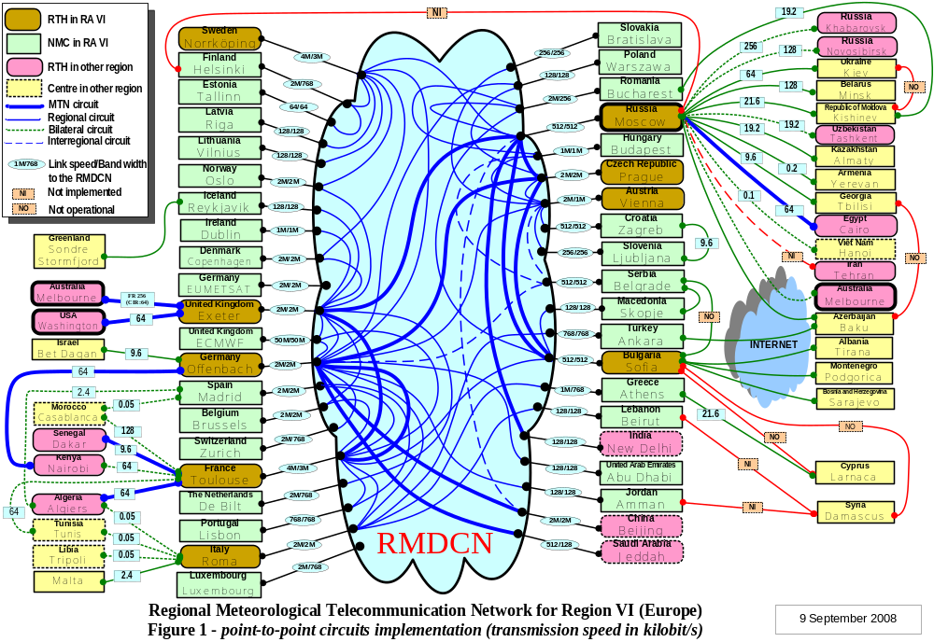
Annex to paragraph 5.10

Status of the RMTN in Central and Eastern Europe

Some of the circuits use dedicated digital lines at the rate of 64-128 kb/s or analogue lines at the rate from 9.6 to 21.6 kb/s.
Four links (Moscow-Baku, Sofia-Tirana, Sofia-Podgorica, Sofia-Sarajevo) are implemented via the Internet.
Three links (Moscow-Helsinki, Moscow-Tehran, Sofia-Damascus) are not implemented.
Seven links do not function (Kiev-Kishinev, Kiev-Minsk, Baku-Tbilisi, Sofia-Athens, Sofia-Ankara, Sofia-Belgrade, Sofia-Larnaca).

The Moscow-Helsinki, Kiev-Kishinev, Baku-Tbilisi links should be excluded from the RMTN plan as the appropriate NMCs and RTHs do not have plans for their use.
Annex to paragraph 5.11

Regional Meteorological Data Communications Network (RMDCN)
There are now 35 members of RA VI connected directly to the RMDCN. ECMWF and EUMETSAT are also connected. A list of the centres connected to the RMDCN is given at Table 1. Those not connected are listed at Table 2.
Following from decisions made by the 13th session of the RA VI in 2002, four other RTHs outside RA VI are also connected to form the GTS and IMTN: China, India, Japan and Saudi Arabia. At the request of RTH Offenbach, UAE also joined the RMDCN.
The network no longer uses Permanent Virtual Circuits, but is an ‘any-to-any’ network based on the MPLS (Multi-Protocol Label Switching) protocol that runs over IP. This is represented in Figure 3. After the very successful planned transition to MPLS in June 2007, it was decided to be conservative in changing the layout of data flows and connections until the network was proven to be stable.
The access lines from the centres to the network range in speed from 64Kb/s to 4Mb/s for NHMSs. ECWMF accesses at 50Mb/s. Access to the network then passes through a ‘gateway’ which may have less bandwidth than the access line speed. This allows centres to flexibly upgrade on paying for higher bandwidth access without the disruption of a new access line.
The are a number of back-up options. Eleven centres have duplicated access lines to the network for resilience, with ‘hot-failover’. These are known as Mission Critical Connections, MCS. Each site has two diversely routed circuits to different OBS Points of Presence. The circuits are connected to two separate routers on the User Site. Other centres can use ISDN dialing as back-up, but this is less effective at the higher speeds, such as above 512kb/s.
Most centres subscribe to the standard, recommended Gold service, which gives three classes/priorities of traffic. It has been agreed that operational traffic is in Class D1.
The RMDCN has proved to be a reliable and cost-effective means of providing an RMTN within RA VI. Some sample performance statistics are at Figures 1 and 2 .
The RMDCN is supplied by OBS (Orange Business Services, formerly known as Equant). The RMDCN contract is managed by ECMWF on behalf of RA VI.
The recent meetings of the RMDCN Operating Committee, RMDCN Steering Group and ECWMF Technical Advisory Committee Sub-Group on the Future of RMDCN recommended that the contract be continued, as good value for money. This decision was based on a comprehensive market survey for a number of possible future scenarios, such as increased bandwidth for the same costs, or the same bandwidth for reduced costs

RA VI RMDCN

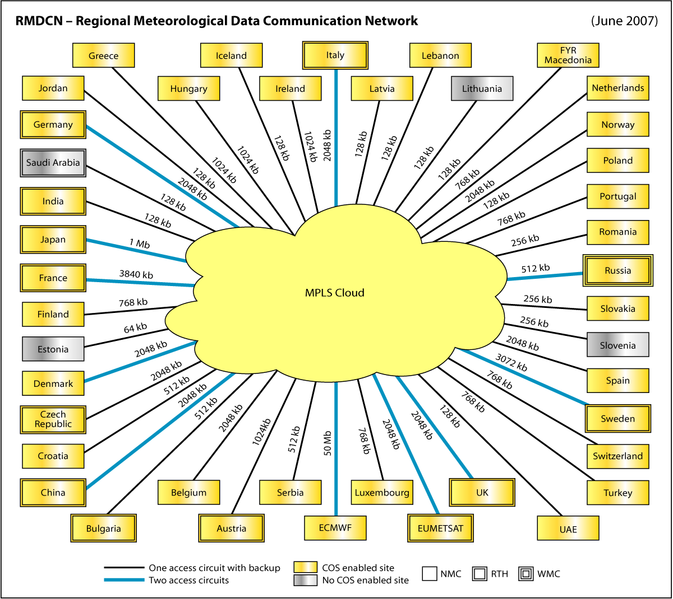
Table 1
Country/Site | RTH  * not RA-VI | Access Speed | IPVPN Port Speed | Resiliency | CoS | Load Balancing | NAS Backup Speed
Austria | RTH | 2M | 1M | enhanced | Gold | NO | 512k
Belgium |  | 2M | 2M | enhanced | Gold | NO | 384k
Bulgaria | RTH | 512k | 512k | enhanced | Gold | NO | 128k
China | *RTH | 2M | 2M | mission critical | Gold | NO | N/A
Croatia |  | 512k | 512k | enhanced | Gold | NO | 256k
Czech Republic | RTH | 2M | 2M | enhanced | Gold | NO | 1M
Denmark |  | 2M | 2M | mission critical | Gold | NO | N/A
Estonia |  | 64k | 64k | enhanced | Silver | NO | 64k
Finland |  | 2M | 768k | enhanced | Gold | NO | 256k
France | RTH | 4M | 3M | mission critical | Gold | NO | N/A
FYR Macedonia |  | 128k | 128k | enhanced | Gold | NO | 128k
Germany | RTH | 2M | 2M | mission critical | Gold | NO | N/A
Greece |  | 1M | 768k | enhanced | Gold | NO | 384k
Hungary |  | 1M | 1M | enhanced | Gold | NO | 256k
Iceland |  | 128k | 128k | enhanced | Gold | NO | 128k
India | *RTH | 128k | 128k | enhanced | Gold | NO | 128k
Ireland |  | 1M | 1M | enhanced | Gold | NO | 512k
Italy | RTH | 2M | 2M | mission critical | Gold | NO | N/A
Japan | *RTH | 1M | 1M | mission critical | Gold | YES | N/A
Jordan |  | 128k | 128k | enhanced | Gold | NO | 128k
Latvia |  | 128k | 128k | enhanced | Gold | NO | 128k
Lebanon |  | 128k | 128k | enhanced | Gold | NO | 128k
Lithuania |  | 128k | 128k | enhanced | Silver | NO | 128k
Luxembourg ** |  | 2M | 768k | enhanced | Gold | NO | N/A
Netherlands |  | 2M | 768k | enhanced | Gold | NO | 384k
Norway |  | 2M | 2M | enhanced | Gold | NO | 1M
Poland |  | 128k | 128k | enhanced | Gold | NO | 128k
Portugal |  | 768k | 768k | enhanced | Gold | NO | 384k
Romania |  | 2M | 256k | enhanced | Gold | NO | 128k
Russian Federation | RTH | 512k | 512k | mission critical | Gold | NO | N/A
Saudi Arabia ** | *RTH | 512k | 128k | enhanced | Silver | NO | N/A
Serbia |  | 512k | 512k | enhanced | Gold | NO | 256k
Slovakia |  | 256k | 256k | enhanced | Silver | NO | 128k
Slovenia |  | 256k | 256k | enhanced | Gold | NO | 256k
Spain |  | 2M | 2M | enhanced | Gold | NO | 512k
Sweden | RTH | 4M | 3M | mission critical | Gold | NO | N/A
Switzerland |  | 2M | 768k | enhanced | Gold | NO | 384k
Turkey * |  | 768k | 768k | extra enhanced | Gold | NO | N/A
United Arab Emirates |  | 128k | 128k | enhanced | Gold | NO | 64
United Kingdom | RTH | 2M | 2M | mission critical | Gold | NO | N/A
ECMWF |  | 50M | 50M | mission critical | Gold | YES | N/A
EUMETSAT |  | 2M | 2M | mission critical | Gold | NO | N/A
* Turkey: secondary Access Speed and IPVPN Port Speed: 384k
** Luxembourg and Saudi Arabia do not have a backup connection.

Table 2

RA-VI Members not connected to RMDCN
Albania
Armenia
Azerbaijan
Belarus
Bosnia-Herzegovina
Cyprus
Georgia
Israel
Kazakhstan
Malta
Moldova
Monaco
Syria
Ukraine

Figure 1

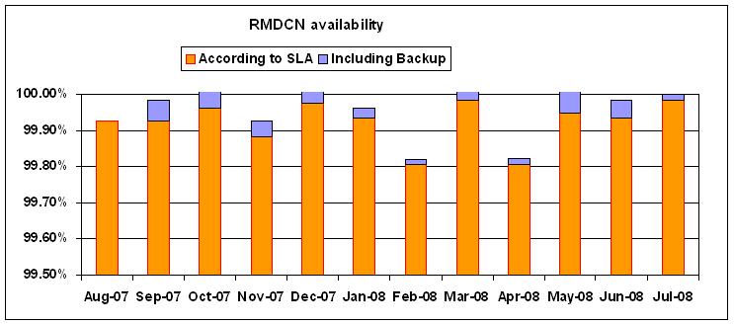

Figure 2

Weekly traffic usage: main access line

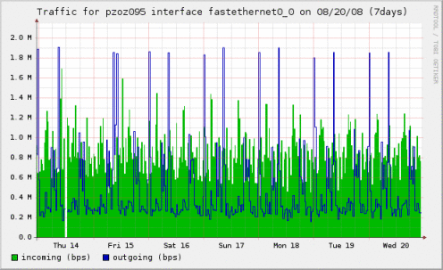

Annex to paragraph 5.15
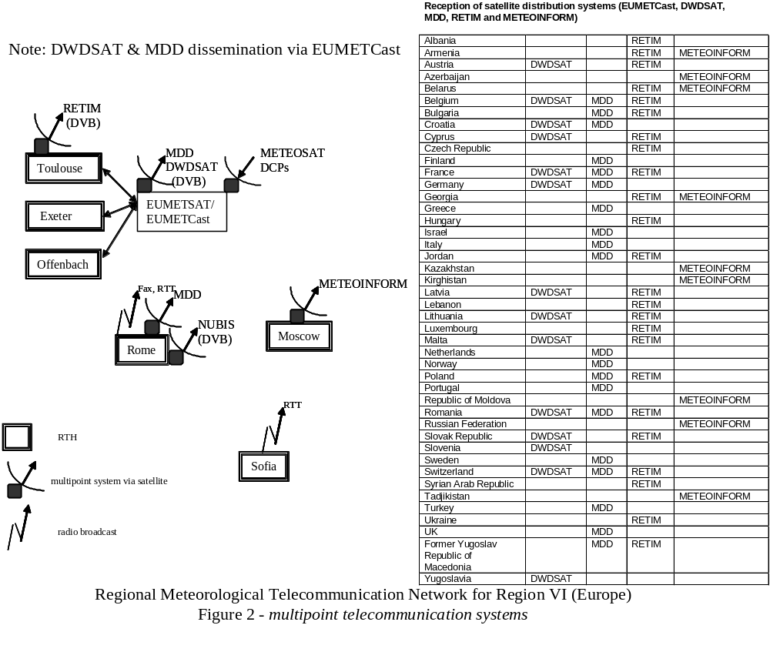
Annex to paragraph 5.17

Existing ATD network nodes

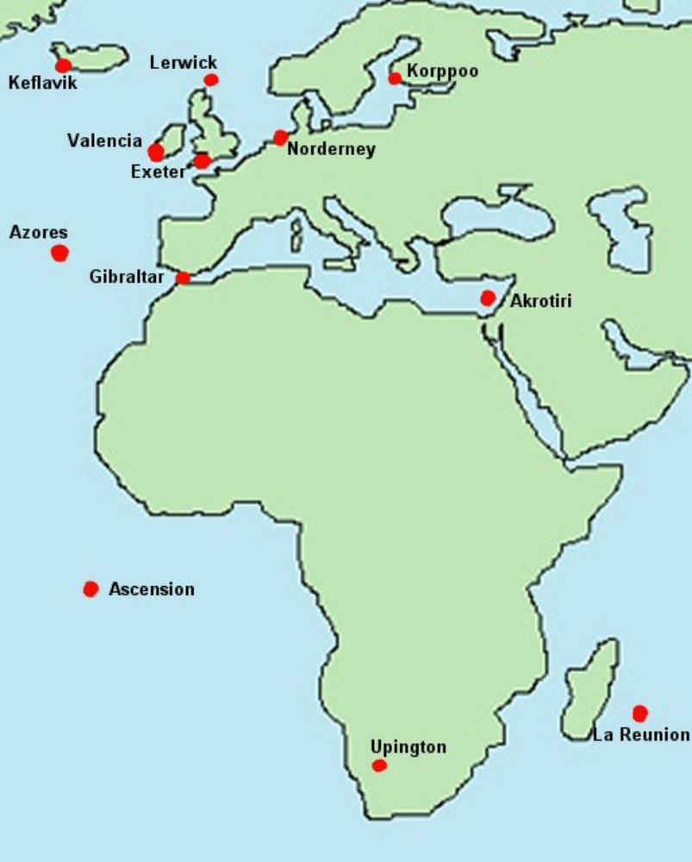
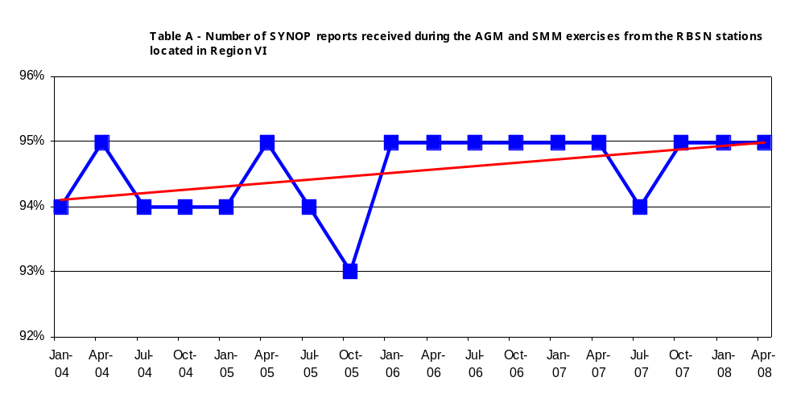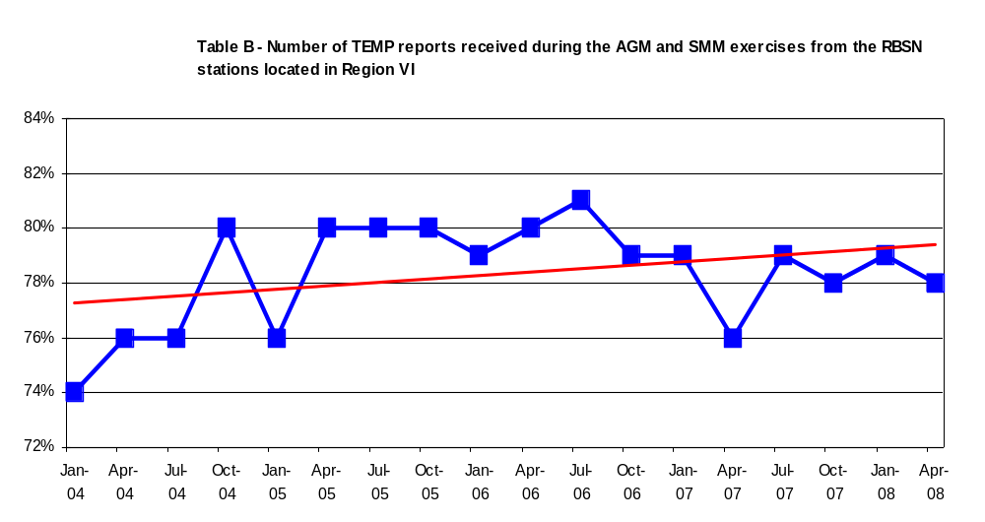Annex to paragraph 5.30
Annex to paragraph 5.34

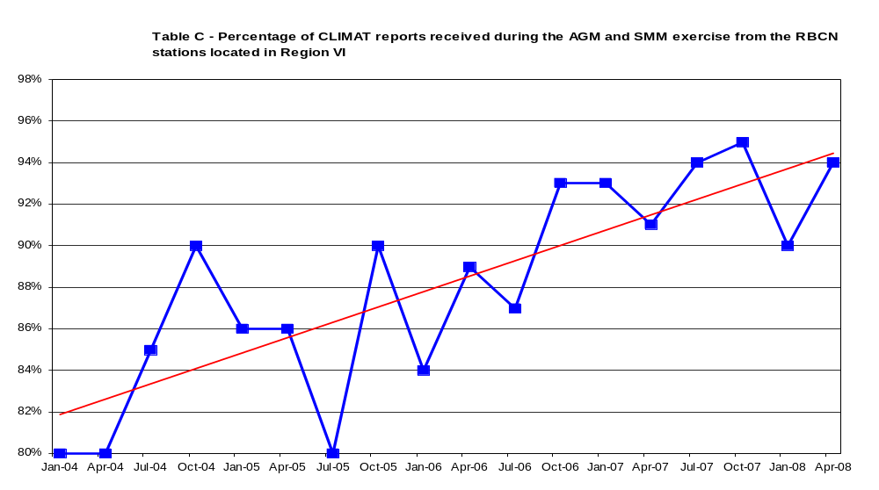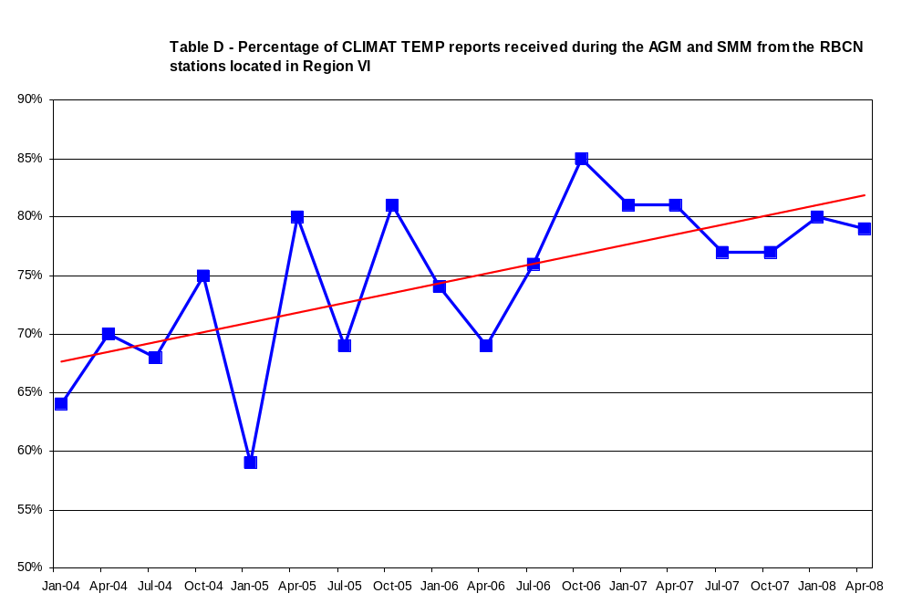
Annex to paragraph 6.1.1

Extracts from the third session of the Implementation/Coordination Team on the Global Observing System (Geneva, September 2004)

Recommended procedures in formulating the RBSN and RBCN

The Rapporteur on the regional aspects of the GOS, in close cooperation with Members concerned, reviews and makes proposals regarding the design of observing systems in the Region, in particular the RBSN and the RBCN in the context of the WWW Programme in the WMO Long-term Plan.

For the purpose of the exercise of the composition of the RBSN and RBCN, it is recommended to use the objective criteria developed by the WG on Planning and Implementation of the WWW in RA VI for inclusion and exclusion of stations. It is noted that the RBCN includes the GCOS network.

The Rapporteur in consultation with the Secretariat, submits the proposed lists of stations to be included in the RBSN and RBCN to the WG PIW in his Region for review and approval.

The Secretariat on the recommendation of the WG PIW in the Region circulates the proposed lists of stations to Members for review and any amendments.

The Secretariat compiles the feedback and the amendments made by Members to their lists of Stations in the RBSN and RBCN and a draft proposal is submitted to the Regional Association (which meets once in 4 years) for consideration and inclusion in the RBSN and RBCN.

The Secretariat on the recommendation of the Regional Association circulates once again to Members the final draft of the proposed lists of stations to be included in the RBSN and RBCN for review and any amendments within a reasonable time frame.

The lists of stations on the RBSN and RBCN for the Region are then finalized by the Secretariat as an annex to the respective Resolutions of the Regional Association.

Certain minor changes in the RBSN and RBCN that do not affect the data requirements of the Region as a whole are inevitable from time to time. To provide a simple and rapid means of effecting changes proposed by the Members concerned, the following procedures shall be followed:

- The Regional Association authorizes the President of the Association to approve, at the request of the Member concerned and in consultation with the Secretary-General, minor changes to the RBSN and RBCN without a formal consultation of the Members of the Association, it being understood that any change of substance, i.e. one adversely affecting the density of the network or proposing a change in observational hours, would still require the formal agreement of Members through the adoption of a resolution by postal ballot;

- The Secretary-General shall notify all Members of WMO by circular letter of changes agreed with the president of the Association.

The RBSN and RBCN are reviewed and revised at each session of the Association by adopting a Resolution containing the current RBSN and RBCN networks. This Resolution is included in the report of the most recent session of the Association.

Extracts from the report of the fourth session of the Working Group on Planning and Implementation of the World Weather Watch in Region VI (Geneva, May 2001)

Criteria for inclusion of stations in the regional basic synoptic network

1. Introduction

In the Manual on Observations the rules for the establishment of Regional Basic Synoptic Networks are laid down:

- the decision on the composition of the Network by the Regional Association concerned;

- the requirements for stations in the Network in terms of performance: parameters, times of observations, etceteras.

The four-yearly decision is generally based on a proposal which is prepared by the Regional working group on Planning and Implementation of WWW.

In this latter preparations, the need for more objective criteria for inclusion of stations is experienced. This refers to (inter alia) spatial distribution and availability of data according to monitoring results. Also, the requirements for the observing programme in the Manual are more an example of perfect performance than a criterion for including or excluding stations.

2. Criteria

For the definition of criteria, two types of requirements are distinguished:

- target requirements (TRQ's) refer to desired characteristics of network stations;
- minimum requirements (MRQ's) refer to threshold characteristics which are decisive for inclusion or exclusion of a station.

The inclusion of a station in the network implies a clear commitment of the Member concerned to make fair efforts for (maintaining) compliance with the TRQ's.

In the table below, TRQ's and MRQ's for RBSN stations are recorded.

Stations are classified according to their performance with reference to the above requirements:

- OK classification is assigned to stations meeting all TRQ's.
- IP classification (incomplete programme) is assigned to other stations meeting all MRQ's.
- BC classification (below criteria) is assigned to other operational stations.
- NO classification (not operating) is assigned to silent stations.

Spatial distribution:

OK stations are acceptable if at a distance of at least 60 km from the nearest network station.
IP stations are acceptable if at a distance of at least 90 km from the nearest network station.
BC stations and NO stations are not acceptable as network station.

 | TRQ surface  stations | MRQ surface stations | TRQ upper  air stations | MRQ upper  air stations
Parameters | pressure  temperature  wind  humidity  land stns:  precipitation amount  present weather  visibility  cloud cover  cloud base  marine stns:  SST  sign wave h | pressure  land stns:  temperature  wind  humidity  marine stns:  SST | Pressure/  geopotential  temperature  wind  humidity | pressure/  geopotential  temperature  wind  humidity
Level | - | - | up to 10 hPa | up to 100 hPa
Observations at main hours | 4 | 3 | 2 (at 00 and 12) | 1 (at 00 or 12)
Observations at main and intermediate hours (3-hourly) | 8 | 5 | - | -
Availability of data | 95-100% | 50% | 95-100% | 25%

Note: The availability percentage refers to the data amount required as a TRQ. For example, if a station makes 5 obs/day, but on average only 3 obs/day are available, it yields an availability of 37.5%, not 60%.

3. Remarks

3.1 TRQ's and MRQ's

The TRQ's are defined in accordance with the requirements after the Manual on Observations. These should be regarded as the level of performance that should be aimed at for all stations.

The MRQ's have been defined as corresponding to the policy that has been applied in practice in the last years. The definitions are such that these will not imply major changes in the current RBSN.

The MRQ's form the minimum threshold for inclusion or exclusion.

3.2 Buoys

In its 12th session (TEL AVIV, 1998), Regional Association VI decided to include some moored buoys in the RBSN surface network. As a consequence, a differentiation has been made in the MRQ's for this type of stations.

3.3 Silent stations

Silent stations should not be included in the network, unless there are clear indications for planned restoration of operations on a short term. The same holds for BC stations.

3.4 Application of the criteria

The criteria are developed for the periodic revision by the Session of the Regional Association, which takes place every 4 years. If, in the inter-sessional period, a station performance drops below the MRQ, no automatic withdrawal is anticipated. In such cases, the continuation of the station in the network should be discussed by the President with the Rapporteur and the Member concerned, and appropriate action should be taken as a result.
Annex to paragraph 6.2.12

Exeter
Sofia
Melbourne
Buenos Aires
Tokyo
Beijing
Nairobi
Washington
Network I
Jeddah
Prague
Toulouse
Dakar
Algiers
Offenbach
Brasilia
Cairo
Managed
data communication network
New Delhi
Moscow
Network II
(RA VI RMDCN Ext.)

ANNEX to paragraph 6.2.26

RA VI Regional Plan for Migration to TDCF
Version 1 - September 2008
1. Introduction
In recent decades, several different code forms for representation and exchange of data have come into being. Each of them was created for certain type of data and has been used by certain circles of users. With automation of data-generation and data-processing in progress, encoding and decoding programs have had to be written and maintained for each of the forms. A need for a universal data format arose in which any measured or observed data could be effectively represented as well as voluminous data files archived. These requirements are fulfilled by the WMO binary code FM 94 BUFR (Binary Universal Form for the Representation of meteorological data). Implementation of the binary formats is, however, limited by the technical level of the Meteorological Service (e.g. exchange of data in the BUFR code requires availability of relevant telecommunication means). Therefore, a new character code FM 95 CREX (Character form for the Representation and EXchange of data) was introduced, as a character modification of the binary code BUFR. This is to avoid the proliferation of new alphanumeric code forms and to ease migration from the traditional alphanumeric codes (TAC) to the BUFR format.
The session of RA VI (Heidelberg, Germany, 7 to 15 September 2005) concluded that more efforts were needed to achieve progress in implementation and use of Table Driven Code Forms (TDCF). Although several National Meteorological Services (NMSs) were already encoding and decoding BUFR messages, the preparation and planning for the transition to TDCF was not adequately advanced. The session agreed to establish a rapporteur who would advise the Members of the Region on all aspects related to the migration strategy and develop the Regional Plan for Migration to TDCF.
2. Plan for Migration to TDCF at the global and regional level
The CBS Extraordinary Session in 2002 recommended „Plan for Migration to Table Driven Code Forms“(WMO Migration Plan) for implementation. In this Plan, the possible impact of migration process on the components of World Weather Watch, i.e. observations, telecommunication, data processing and forecasting, is analyzed. The WMO Migration Plan also contains recommendations to NMSs and offers a variety of solutions taking into account that significant differences in financial and technical circumstances may occur from country to country.
The WMO Migration Plan should apply to all Regions, therefore also to RA VI. However, some progress has been made and experience has been gained since the WMO Migration Plan was developed. This and certain specific features of the Region have been reflected in the RA VI Regional Migration Plan:
- Manual encoding in CREX at stations is to be avoided.
- Data production in TAC and TDCF at stations is appropriate until the migration is complete.
- Detailed instructions for production of upper-air data in TDCF are included.
- Automation of measurements is not a necessary condition for migration to TDCF.
- RTHs and consequently DCPCs or GISCs are expected to assist in the definition of arrangements to facilitate the conversion of data representation forms for the NMCs within their zone of responsibility.
- A more visible approach of RA VI leading centers would be encouraging for the other NMSs.
- XML is likely to be used for the exchange of OPMET information in the future.
3. RA VI Regional Migration Plan
3.1. Observations
National level
At the national level, reports may be produced and collected in TDCF, in an internal national format or in traditional alphanumeric codes (TAC) and BUFR (or CREX) bulletins may be generated in the National Meteorological Center (NMC) for the international exchange. If the data are collected in TAC, however, the required metadata have to be stored and maintained in the NMC to be included into the generated TDCF bulletins. This approach is suitable mainly in the first stage of the migration process. Data production in BUFR at observing sites is considered as the optimal solution, although an internal national format might be preferable for some data types (data dissemination also in TAC until the migration is complete).
Upper-air measurements
Production of reports in TDCF at the stations allows full utilization of the benefits of migration. It applies especially to upper-air measurements, in which case the BUFR (or CREX) message contains also time and position of radiosonde at each level. This additional valuable information is available within the ground-based system at the station, but it cannot be included into TEMP or PILOT reports. Therefore, the upper-air data should be produced in TDCF at the observing site.
In the interest of timely data delivery, the first BUFR (or CREX) message should be sent when level 100 hPa is reached and the second message should be sent when the whole sounding is completed (containing the entire sounding). This requirement has already been met in Regulations B/C 25 for TEMP, TEMP SHIP and TEMP MOBIL data and B/C 20 for PILOT, PILOT SHIP and PILOT MOBIL data.
The existing templates for representation of upper-air data in TDCF are capable of accommodating data with high vertical resolution. Manufacturers of the observing systems should be encouraged to provide a corresponding option in their software.
CREX
BUFR is recommended as the target format. Migration to CREX is to be considered as a temporary solution, but only if the CREX messages are software-generated at the observing site. This approach may be needed if the communication between the station and the national centre does not allow transmission of binary data. The manual encoding in CREX at the stations is to be avoided.
Automation of measurements
Migration to TDCF does not require installation of automatic weather stations (AWS). Automation of measurements, as much as desired, is not a necessary condition for migration to TDCF. Even if the measurements are performed with instruments like mercury thermometers, etc., the reports may be produced in BUFR format at the station, provided that the station is equipped with adequate software and communication. This situation may occur when the AWS is temporarily out of order. Besides that, the data may be collected in TAC and converted into BUFR/CREX at the Centre, the required metadata being included in BUFR messages prior to the international exchange. If a new automated system is introduced, however, encoding of the data in TDCF (preferable BUFR) should be included within this system.
Testing
Testing of the encoded BUFR or CREX reports is necessary before operational dissemination of these data is started. This issue is discussed in detail in paragraph 3.6.
3.2. Telecommunications
Size limit for binary messages
The size limit for binary messages has been increased to 500 000 octets (as from November 2007).
Procedures prior to the start of dissemination of a new BUFR (or CREX) bulletin
A new set of abbreviated headings for TDCF bulletins (Tables C3, C6 and C7) was developed in compliance with the defined data categories and sub-categories and recommended by the CBS Extraordinary Session in 2006. Prior to starting the operational dissemination of a new BUFR (or CREX) bulletin, the NMS has to notify the Secretariat of the insertion of the bulletin into the GTS and to update Volume C1 – Catalogue of meteorological bulletins. This notification is to be done in compliance with the relevant procedures (either directly to the WMO Secretariat or to the associated RTH or MTN center).
The migration process requires substantial updating of Message Switch System directories and adjustment of the monitoring procedures.
Dual dissemination and conversion TDCF <=> TAC
RTHs will facilitate the step-by-step migration by assisting in the definition of arrangements for the conversion of the forms of data representation (TDCF <=> TAC) in case that some centres may wish to stop generating data in TAC, and/or distribution of messages in traditional codes as well as in TDCF (dual dissemination).
3.3. Data processing
Incoming data
The data processing center of the NMS should introduce a BUFR/CREX decoder in the processing chain (reception, decoding, display, archiving) to avoid missing the incoming TDCF data received from GTS, and to handle the national data produced in TDCF at the stations.
Conversion of the incoming TDCF data into TAC is not recommended, although it might be useful in some cases, e.g. for plotting charts. However, unambiguous conversion of TDCF data to TAC is required by ICAO if aviation OPMET data were to be transmitted in TDCF.
Production of multi-subset TDCF messages
A BUFR (or CREX) encoder should be introduced in the NMC to allow production of multi-subset messages for the international exchange. CREX messages will be produced if the communication between the national centre and the associated RTH does not allow transmission of binary data (applies to both parties).
If national data are collected in TAC, the relevant metadata have to stored and maintained in the NMC to be included into the produced TDCF messages as required by the B/C Regulations.
3.4. B/C Regulations and Regional reporting practices
To provide facilities for representation of data reported in the Traditional Alphanumeric Codes, “Regulations for reporting traditional observations data in Table Driven Code Forms (TDCF): BUFR or CREX” have been developed for reporting the data of SYNOP, TEMP, PILOT, CLIMAT and CLIMAT TEMP, and for data of the corresponding maritime traditional code forms (http://www.wmo.ch/pages/prog/www/WMOCodes/TemplateExamples.html). These regulations are referred to in short as “B/C Regulations”.
Within B/C Regulations, the recommended templates and common sequences for Category 1 (Common Codes) and Category 4 (Maritime Codes) are presented, including representation of Regional reporting practices as included in WMO No. 306, Manual on Codes, Volume II.
3.5. Encoding/decoding software
ECMWF responded to a request from WMO to specify, develop and distribute universal BUFR (Edition up to 4), CREX (Edition 1 and 2) and GRIB (Edition 1 and 2) decoding/encoding software. ECMWF is providing the software via free download to the whole meteorological community (http://www.ecmwf.int/products/data/software). BUFR and CREX software is backward compatible. Both a compiled binary and the source code are available for various platforms. The compiled versions can be installed on the LINUX, Windows (only if a CYGWIN LINUX compatible environment and Gnu compilers are available), Decalpha, Sgimips, Macintosh OSX 10.1 and higher.
The German Meteorological Service has developed a BUFR encoder/decoder under Windows that may be purchased by interested countries (http://www.ebp.de/en).
In April 2007, Brazil reported on the development of a Windows and a UNIX based BUFR encoder/decoder. This software is available for free distribution from the website of the INPE (http://tempo.cptec.inpe.br:9080/publicacoes).
3.6. Verification service
Web based verification service
ECMWF has developed a web based verification service for BUFR/CREX data that is available at:
http://www.ecmwf.int/products/data/d/check/
This service handles a data file of maximum size 500 kB that is uploaded to the ECMWF server and expanded, and errors, if any, are reported. Content of a BUFR (or CREX) message is checked and compliance with BUFR (or CREX) Regulations and BUFR/CREX Tables is tested as well as compliance with the B/C Regulations.
Verification procedures are described in detail in “Guide for BUFR/CREX verification practices” (see Final Report of the Meeting of ET-DR&C, Darmstadt, Germany, 23-27 April 2007).
Assistance of the Regional Rapporteur on Migration to TDCF
Verification of the migrated data on bilateral basis is required before their operational dissemination is started. As the Regional Rapporteur is expected to assist the RA VI countries in the process of migration to TDCF, this assistance means also testing of BUFR (CREX) messages, including verification of the migrated data against the co-provided TAC data.
3.7. Assistance of DCPCs or GISCs
RA VI Data Collection and Product Centers (DCPCs) might assist in facilitating the conversion of data representation forms for the NCs within their zone of responsibility. The same would apply to a Global Information System Center (GISC) in RA VI if the NC is directly connected to the GISC.
A more visible approach from the RA VI leading centers, regardless of their position within the WMO Information System, would be encouraging for the other centers in the Region.
3.8. Migration to TDCF or XML
Migration of traditional codes Category 1, 2, 4, 5 and AMDAR
BUFR is the most suitable format for the real time operational exchange of data between the NMSs. XML offers some advantages for distribution of data to the end users, included aviation.
Migration of aviation OPMET data
At the CBS Extraordinary Session in 2006, representatives of some RA VI countries expressed their concerns regarding migration of aviation OPMET data (METAR/SPECI and TAF) to TDCF although BUFR templates and descriptors had met all ICAO requirements. It is highly likely that a recommendation for the use of XML for OPMET information will be made by the Expert Team on OPMET Data Representation (ET-ODR). If XML is to become the format for the exchange of OPMET data, the appropriate XML encoding standards should be developed.
3.9. Training
Guidance materials
In the WMO Migration Plan, importance of training is emphasized. It is recommended to perform this training at three levels, starting with basic understanding of the BUFR and CREX philosophy up to the advanced knowledge needed for development of software and templates. In the WMO server (http://www.wmo.int/pages/prog/www/WMOCodes.html), the „Guide to WMO Table Driven Code Forms: FM 94 BUFR and FM 95 CREX (Layer 1, Layer 2, Layer 3)“ is available that allows studying these codes at the corresponding level (Layer 1 and Layer 2 in English, French, Spanish and Russian, Layer 3 in English).
Training events organized by WMO
WMO has organized training seminars for participants from RA I, RA II, RA III, RA IV, West RA V and East RA VI. At the training seminar held in Muscat, Oman in December 2005, participants from seven countries of eastern RA VI were present. In April 2007, RA VI Training Workshop on BUFR and Migration to TDCF was held in Langen, Germany, and although no WMO financial support was provided to the participants, 33 European experts attended this event. Migration to TDCF was on the agenda of the international training course that was held in Antalya, Turkey in October 2008.
National training
Training at the first level (Layer 1) is recommended for the majority of the professional staff of the NMS, including the top management, to inform them of the advantages of TDCF and the new opportunities that the implementation of migration to TDCF offers. It might be useful to carry out such training also for representatives of the external users of meteorological data. Detailed knowledge of the BUFR format, on the other hand, is necessary only for a rather limited circle, mostly IT experts of the NMS. Consultations are considered to be the optimal solution in this case.
3.10. Migration process at the National Level
National Focal Point
The National Focal Points should participate in preparation of the National Migration Plan and coordinate migration to TDCF in their country. They should also ensure that the country notifies the WMO Secretariat when a new bulletin is to be inserted into GTS and, in particular, when transmission of TAC bulletins is planned to be interrupted.
National Migration Steering Group
It is recommended to establish in every country a national Migration Steering Group, composed of national experts, the National Focal Point included, that would coordinate migration to TDCF in their country. Also representatives of the external users of the meteorological data (e.g. scientific institutions, military, Air Navigation Services) should be invited.
National Migration Plan
The National Migration Plan should be developed taking into account the specific conditions of the NMS to ensure that the migration process will be smooth, well coordinated and without any negative impact on the data flow.
3.11. Code migration schedule
The currently valid schedule for implementation of the migration to TDCF is presented in the Migration Matrix in the next page.
All dates in the Migration Matrix are meant as “not later than”. Therefore, RA VI Members and organizations are encouraged to start experimental and operational exchange of data as soon as possible. Insisting on mandatory completion dates would not be totally feasible. Nevertheless, the RA VI Members are recommended to complete the Migration by the planned dates.
Regarding aviation OPMET data, the ICAO Council adopted the first stage of the WMO Migration Plan (start of the experimental exchange in November 2007). However, ICAO Air Navigation Commission agreed in 2007 that work within ICAO related to migration of OPMET data to TDCF should be suspended until the results of the work of the ET-ODR (Expert Team on OPMET Data Representation) and ET-ADR (Expert Team on the Assessment of Data Representation Systems) are known. In view of the recent developments, it is likely that usage of XML instead of BUFR will be recommended for representation of OPMET data in the future. The migration schedule in the next page shall be modified accordingly.
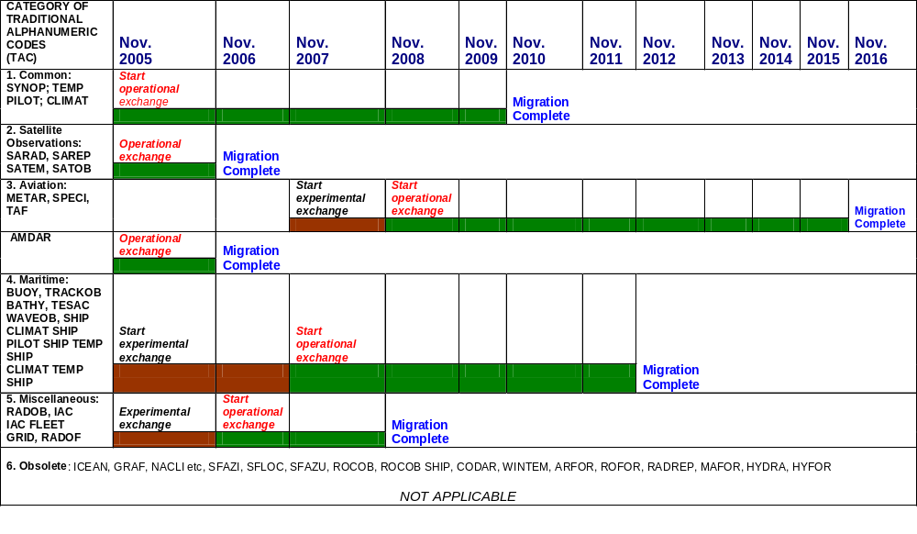
Notes:

All dates above are meant as "not later than". Members and organizations are encouraged to start experimental exchange, and, if all relevant conditions (see below) are satisfied, to start operational exchange as soon as possible.

(a) Start of experimental exchange: data will be made available in BUFR (CREX if needed) but not operationally, i.e. in addition to the current alphanumeric codes, which are still operational;

(b) Start of operational exchange: data will be made available in BUFR (CREX if needed) whereby some (but not all) Members rely on them operationally. Distribution of the current alphanumeric codes will still be done;

(c) Migration complete: at this date the BUFR (CREX if needed) exchange becomes the standard WMO practice. Distribution of the current alphanumeric codes is terminated. For archiving purposes and where BUFR or CREX exchange still causes problems, the alphanumeric codes may be used on a local or national basis only.

Relevant conditions to be satisfied  before experimental exchange  may start |  |  | Relevant conditions to be satisfied  before operational exchange  may start
a) | if corresponding BUFR/CREX-tables and templates are available; |  | a) | if corresponding BUFR/CREX-tables and templates are fully validated;
b) | if training of exchanging parties has been completed; |  | b) | if training of all concerned parties has been completed;
c) | if required software of exchanging parties (encoding, decoding, viewing) is implemented. |  | c) | if required software (encoding, decoding, viewing) is operational.

Annex to paragraph 7.2.7

The Use of the GLORIAD Network

The international GLORIAD project (Global Ring Network for Advanced Application Development, http://www.gloriad.org/gloriad/team/russia) was arranged for the joint solution of large-scale science- and resource-consuming tasks – problems of nuclear physics, arrangement of actions under the conditions of earthquakes and global disasters, space studies, forecasting of dangerous hydrometeorological events, studying of climate variation, etc. In sight, the GLORIAD project implies the creation of a ring global network built on the basis of the technology of switching (Fig. 1) at the capacity of up to 10 Gb/s.

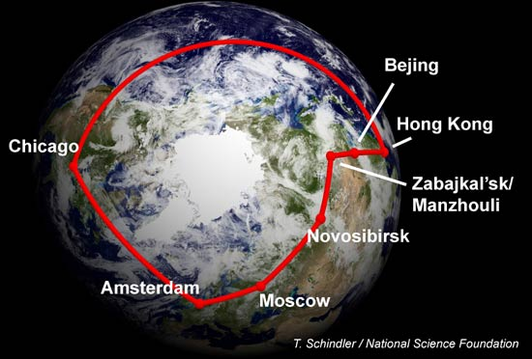

Fig. 1 The GLORIAD network arrangement scheme

The technological model of the project is offered in the form of an integrated international trunk within which some projects were implemented: access to the network of Nortern counties (NORDUNet), access to common to the whole Europe network “GEANT”, access to the system of exchange by scientific-and-educational traffic “starlight”.
On the part of the USA, the American National Centre of Super-Computer Applications (NCSA) takes part in GLORIAD.
The Russian segment of the International GLORIAD network was realized by the “Kurchatovsky Institute” scientific centre. The trunk goes along the following routing: Stockholm (a junction with the GEANT and the channel at StarLight, Chicago) – Moscow – Samara – Novosibirsk – Khabarovsk – Fujan (China), a junction with the CSTNET. In January 2007, in the Russian segment of GLORIAD, a channel at the capacity of 10 Gb/s between Moscow and Amsterdam was created with the subsequent way out to the USA by 2*10Gb/s plus 3 Gb/s channels of GLORIAD partners from the Netherlands and the USA. At present GLORIAD is actively used by such WMO member-states as China, South Korea, Canada, the EU countries.
In 2004 a channel at the rate of 10 Mb/s for receiving from NCEP/NOAA the ensemble medium-range weather forecasts was arranged. The results of the operation of the channel with GLORIAD showed that the reception of the data volumes required was restricted by the channel low capacity. It was necessary to conduct in 2006-2007 the channel upgrade up to 100 Mb/s.
In 2007 the working plan between the WMC Moscow and the WMC Washington was agreed on the arrangement of a VPN channel via GLORIAD for the reservation of the GTS traffic and additional data exchange. The technical parameters of internetwork devices used when arranging and adjusting the VPN technology were agreed.
The realization of the technology will be carried out in the forth quarter of 2008 after the procurement by the WMC Moscow the hardware required.
There is an agreement on the creation and support of special channels “lightpaths” for international projects between the GLORIAD partners. At present Roshydromet reserved an optical line (a lightpath at the capacity of 1 Gb/s to arrange the communication between the WMC Moscow and the WMC Washington in order to enable data exchange between the WMCs with higher reliability.

