WORLD METEOROLOGICAL ORGANIZATION  __________________  REGIONAL ASSOCIATION VI  (EUROPE)  WORKING GROUP ON PLANNING AND IMPLEMENTATION OF THE WWW IN REGION VI  Sixth Session  TOULOUSE, FRANCE, 15 - 19 SEPTEMBER 2008 | RA VI-WG/PIW-6/Doc. 5(4)  (21.VII.2008)  ITEM: 5  Original: ENGLISH | RA VI/WG/PIW-V/Doc. 5(1)  (30.VIII.2004)  ___________  ITEM: 5  ENGLISH ONLY

STATUS OF WWW IMPLEMENTATION AND OPERATIONS
Results of the quantitative monitoring of the WWW
Availability of SYNOP, TEMP, CLIMAT and CLIMAT TEMP reports at MTN centres

(Submitted by the Secretariat)

Summary and purpose of document

This document includes an analysis of the results of the quantitative monitoring of the operation of the WWW, showing the availability of SYNOP, TEMP, CLIMAT and CLIMAT TEMP reports at MTN centres

ACTION PROPOSED

The group is invited to take into account the information provided in the document when considering improvements to be made in the implementation of the GOS and GTS in the Region.

_________

DISCUSSION

1. A summary of the analysis of the results of the July and October 2007, and January and April 2008 exercises of the Special MTN monitoring (SMM) is given in Table 1 to 8 and Figures 1 to 4. Further detailed information on these monitoring exercises is available in the WMO server under http://www.wmo.int/pages/prog/www/ois/monitor/monitor-home.htm.

Availability of SYNOP and TEMP reports from RBSN stations at MTN centres

2. During the July and October 2007, and January and April 2008 exercises of the Special MTN monitoring (SMM), 94 per cent of the SYNOP reports and 78 per cent of Parts A of TEMP reports from RBSN stations located in Region VI were received at MTN centres. The availability of SYNOP and TEMP reports from each country is given in Tables 1 and 3 respectively. The number of SYNOP and TEMP reports from each RBSN station is given in
http://www.wmo.int/pages/prog/www/Planning-Impl/RA-6/2008_Toulouse/smm/STAT1YEAR_synop_stations.rtf
http://www.wmo.int/pages/prog/www/Planning-Impl/RA-6/2008_Toulouse/smm/STAT1YEAR_temp_stations.rtf
The kml files including the number of SYNOP and TEMP reports received from all RBSN stations during the April 2008 SMM are available from
http://www.wmo.int/pages/prog/www/Planning-Impl/RA-6/2008_Toulouse/smm/psy084.kml
http://www.wmo.int/pages/prog/www/Planning-Impl/RA-6/2008_Toulouse/smm/ptt084.kml

3. The following deficiencies were found during the four SMM exercises:

- Only 55 per cent, 58 per cent and 59 per cent of the expected SYNOP reports were received from Azerbaijan, Israel and Lebanon respectively. Ten stations were silent during the four SMM exercises (see Table 2).
- No TEMP reports were received from Belgium and Slovenia. Less than 30 per cent of the expected TEMP reports were received from Latvia, Lebanon, Lithuania, Romania and The Former Yugoslav Republic of Macedonia. Less than 45 per cent of the expected TEMP reports were received from Armenia, Portugal and Ukraine. Nine stations were silent during the four SMM exercises (see Table 4).

4. Tables A and B show the availability of SYNOP and TEMP reports from RBSN stations located in Region VI from 2004 to 2008. The availability of SYNOP reports is relatively constant (94/95 per cent) during the period 2000-2004, ant that of TEMP reports oscillated around 78 per cent. It can be noted that the number of RA VI RBSN stations increased from 770 in 2004 to 807 in 2008 for SYNOP (+5 per cent) and decreased from 135 in 2004 to 129 in 2008 for TEMP (- 4 per cent).

Availability of CLIMAT and CLIMAT TEMP reports from RBCN stations at MTN centres

5. During the July and October 2007, and January and April 2008 exercises of the Special MTN monitoring (SMM), 93 per cent of the CLIMAT reports and 78 per cent of the CLIMAT TEMP reports from RBCN stations located in Region VI were received at MTN centres. The availability of CLIMAT and CLIMAT TEMP reports from each country is given in Tables 5 and 7 respectively. The number of CLIMAT and CLIMAT TEMP reports from each RBSN station is given in
http://www.wmo.int/pages/prog/www/Planning-Impl/RA-6/2008_Toulouse/smm/STAT1YEAR_climat_stations.rtf
http://www.wmo.int/pages/prog/www/Planning-Impl/RA-6/2008_Toulouse/smm/STAT1YEAR_climat-temp_stations.rtf
The kml files including the number of SYNOP and TEMP reports received from all RBSN stations during the April 2008 SMM are available from
http://www.wmo.int/pages/prog/www/Planning-Impl/RA-6/2008_Toulouse/smm/pcl084.kml
http://www.wmo.int/pages/prog/www/Planning-Impl/RA-6/2008_Toulouse/smm/pct084.kml

6. The following deficiencies were found during the four SMM exercises:

- No CLIMAT reports were received from Lebanon and The Former Yugoslav Republic of Macedonia. Less than 51 per cent of the expected CLIMAT reports were received from Azerbaijan, Iceland, Republic of Moldova and Slovenia. Twenty-three stations were silent during the four SMM exercises (see Table 7).
- No CLIMAT TEMP reports were received from Croatia, Latvia, Lebanon and Lithuania. Less than 51 per cent of the expected CLIMAT TEMP reports were received from Italy, Poland, Romania and Slovakia. Eleven stations were silent during the four SMM exercises (see Table 8).

7. Tables B and C show the availability of CLIMAT and CLIMAT TEMP reports from RBCN stations located in Region VI from 2004 to 2008. The availability of CLIMAT reports increased from 80 per cent to 94 per cent during the period 2000-2004, ant that of CLIMAT TEMP reports from 65 to 79 per cent. It can be noted that the number of RA VI RBSN stations increased from 526 in 2004 to 571 in 2008 for CLIMAT (+8 per cent) and remained the same (94 stations) for CLIMAT TEMP.
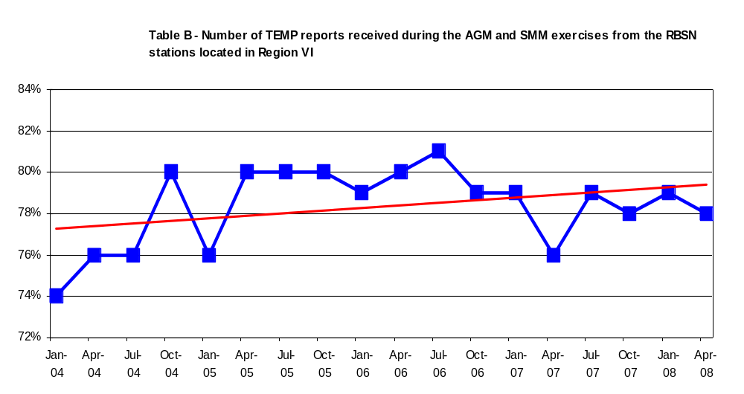
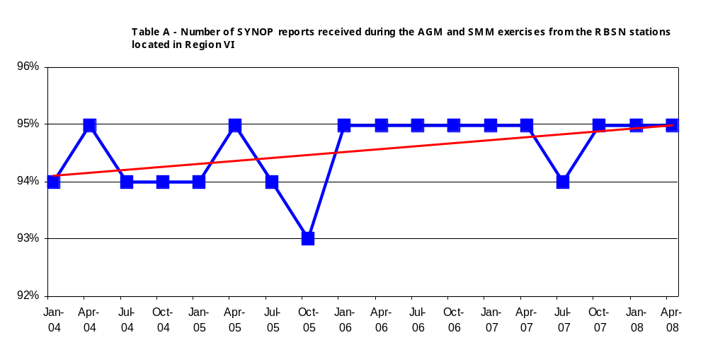
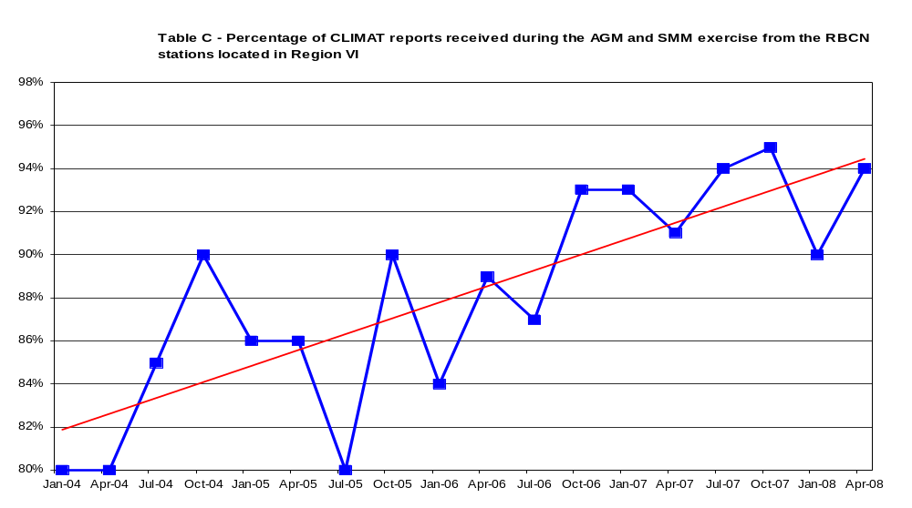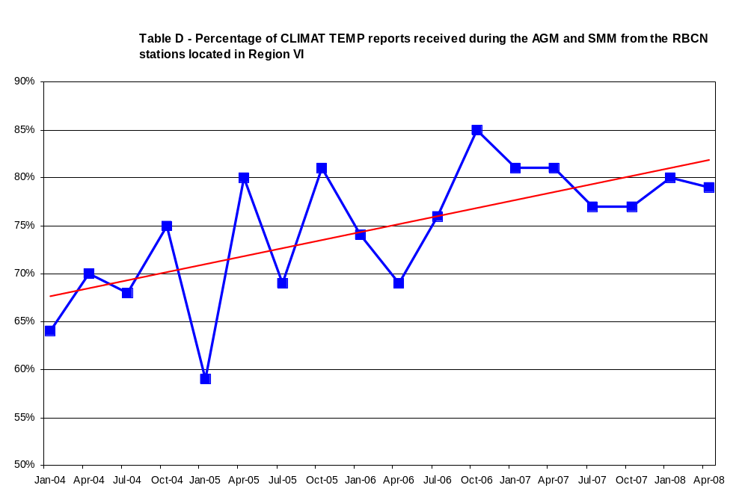

Table 1

Availability of SYNOP reports at MTN centres from RBSN
(source: SMM / Reference dataset: RBSN Jan 2008)
Country JUL OCT JAN APR Average
2007 2007 2008 2008
Armenia 93% 97% 100% 98% 97%
Austria 99% 100% 100% 98% 99%
Azerbaijan 61% 57% 39% 61% 55%
Belarus 100% 100% 100% 100% 100%
Belgium 88% 99% 93% 100% 95%
Bosnia and Herzegovina 98% 98% 100% 98% 99%
Bulgaria 100% 100% 100% 100% 100%
Croatia 99% 99% 91% 98% 97%
Cyprus 100% 100% 98% 100% 100%
Czech Republic 100% 100% 100% 100% 100%
Denmark, Greenland and Faroe 80% 86% 83% 82% 83%
Islands
Estonia 99% 98% 100% 100% 99%
Finland 92% 95% 93% 95% 94%
Former Yugoslav Republic of 62% 63% 64% 66% 64%
Macedonia
France 98% 99% 99% 100% 99%
Georgia 52% 82% 82% 81% 74%
Germany 100% 96% 100% 100% 99%
Gibraltar 100% 100% 100% 100% 100%
Greece 90% 91% 86% 92% 90%
Hungary 98% 100% 100% 100% 100%
Iceland 89% 90% 88% 88% 89%
Ireland 97% 96% 96% 91% 95%
Israel 67% 67% 34% 66% 58%
Italy 95% 95% 93% 95% 94%
Jordan 96% 98% 94% 95% 96%
Kazakhstan 99% 99% 100% 100% 99%
Latvia 98% 100% 100% 100% 100%
Lebanon 85% 38% 50% 64% 59%
Lithuania 98% 100% 100% 100% 100%
Luxembourg 73% 73% 75% 93% 79%
Malta 100% 100% 98% 100% 100%
Montenegro 89% 96% 94% 98% 94%
Netherlands 88% 98% 97% 92% 94%
Norway 99% 98% 99% 100% 99%
Poland 100% 100% 100% 98% 100%
Portugal 97% 96% 97% 98% 97%
Republic of Moldova 100% 100% 100% 100% 100%
Romania 100% 100% 100% 100% 100%
Russian Federation 96% 97% 97% 97% 97%
Serbia 82% 89% 88% 92% 88%
Slovakia 100% 100% 100% 100% 100%
Slovenia 100% 100% 100% 100% 100%
Spain 92% 91% 92% 93% 92%
Sweden 91% 98% 96% 83% 92%
Switzerland and Liechtenstein 100% 100% 100% 100% 100%
Syrian Arab Republic 64% 76% 89% 81% 78%
Turkey 97% 97% 98% 96% 97%
Ukraine 100% 99% 100% 100% 100%
United Kingdom of Great 96% 97% 97% 97% 97%
Britain and Northern Ireland
Total 94% 95% 95% 95% 94%

Table 2

List of RBSN stations for which no SYNOP reports were received by MTN centres
(source: SMM / Reference dataset: Jan 2008)

Country Station JUL OCT JAN APR
2007 2007 2008 2008
Denmark, Greenland and Faroe Islands
04202 0 0 0 0
04207 0 0 0 0
Finland
02971 0 0 0 0
Former Yugoslav Republic of Macedonia
13588 0 0 0 0
Georgia
37403 0 0 0 0
Iceland
04056 0 0 0 0
Israel
40155 0 0 0 0
Serbia
13477 0 0 0 0
13481 0 0 0 0
United Kingdom of Great Britain and Northern Ireland
03495 0 0 0 0

Table 3

Availability of TEMP reports at MTN centres from RBSN stations
(source: SMM / Reference dataset: RBSN Jan 2008)

Country JUL OCT JAN APR Average
2007 2007 2008 2008
Armenia 50% 37% 47% 47% 45%
Austria 100% 100% 100% 100% 100%
Belgium 0% 0% 0% 0% 0%
Bulgaria 50% 50% 50% 50% 50%
Croatia 100% 100% 100% 100% 100%
Cyprus 50% 50% 50% 47% 49%
Czech Republic 100% 100% 100% 100% 100%
Denmark, Greenland and Faroe 70% 71% 71% 71% 71%
Islands
Estonia 50% 50% 47% 50% 49%
Finland 64% 67% 67% 66% 66%
Former Yugoslav Republic of 50% 47% 0% 0% 24%
Macedonia
France 100% 98% 90% 88% 94%
Germany 89% 89% 87% 90% 89%
Gibraltar 100% 100% 100% 100% 100%
Greece 99% 57% 86% 80% 80%
Hungary 75% 75% 75% 75% 75%
Iceland 93% 100% 97% 97% 97%
Ireland 100% 100% 100% 100% 100%
Israel 100% 100% 100% 100% 100%
Italy 97% 69% 97% 97% 90%
Jordan 50% 47% 47% 47% 48%
Latvia 23% 23% 27% 23% 24%
Lebanon 0% 17% 43% 0% 15%
Lithuania 27% 27% 27% 27% 27%
Netherlands 93% 100% 100% 100% 98%
Norway 92% 89% 91% 92% 91%
Poland 97% 98% 97% 99% 98%
Portugal 38% 43% 48% 28% 40%
Romania 17% 17% 17% 17% 17%
Russian Federation 94% 96% 95% 94% 95%
Serbia 100% 100% 100% 100% 100%
Slovakia 100% 100% 100% 100% 100%
Slovenia 0% 0% 0% 0% 0%
Spain 84% 87% 87% 92% 88%
Sweden 73% 74% 76% 70% 73%
Switzerland and Liechtenstein 100% 100% 100% 100% 100%
Turkey 71% 85% 86% 85% 82%
Ukraine 44% 37% 45% 43% 42%
United Kingdom of Great Britain 97% 97% 95% 84% 93%
and Northern Ireland
Total 79% 78% 79% 78% 78%

Table 4

List of RBSN stations for which no TEMP reports were received by MTN centres
(source: SMM / Reference dataset: RBSN Jan 2008)

Country Station JUL OCT JAN APR
2007 2007 2008 2008
Belgium
06476 0 0 0 0
Denmark, Greenland and Faroe Islands
04202 0 0 0 0
06181 0 0 0 0
Finland
02935 0 0 0 0
Germany
10468 0 0 0 0
Romania
15421 0 0 0 0
15480 0 0 0 0
Slovenia
14015 0 0 0 0
Turkey
17280 0 0 0 0

Table 5

Availability of CLIMAT reports at MTN centres from RBSN stations
(source: SMM / Reference dataset: RBCN Jan 2008)

Country JUL OCT JAN APR Average
2007 2007 2008 2008
Armenia 100% 0% 100% 100% 75%
Austria 56% 56% 56% 56% 56%
Azerbaijan 0% 83% 0% 50% 33%
Belarus 100% 100% 100% 100% 100%
Belgium 100% 100% 100% 100% 100%
Bosnia and Herzegovina 100% 100% 100% 100% 100%
Bulgaria 100% 50% 25% 100% 69%
Croatia 100% 100% 100% 100% 100%
Cyprus 100% 100% 100% 100% 100%
Czech Republic 100% 100% 100% 100% 100%
Denmark, Greenland and Faroe 92% 92% 92% 100% 94%
Islands
Estonia 100% 100% 100% 100% 100%
Finland 100% 55% 100% 100% 89%
Former Yugoslav Republic of 0% 0% 0% 0% 0%
Macedonia
France 100% 100% 100% 100% 100%
Georgia 71% 86% 86% 86% 82%
Germany 100% 100% 100% 98% 100%
Gibraltar 100% 100% 100% 100% 100%
Greece 100% 100% 100% 100% 100%
Hungary 71% 71% 71% 71% 71%
Iceland 40% 40% 40% 80% 50%
Ireland 100% 75% 88% 88% 88%
Israel 67% 67% 67% 33% 58%
Italy 85% 91% 85% 88% 88%
Jordan 100% 100% 100% 100% 100%
Kazakhstan 100% 100% 100% 50% 88%
Latvia 100% 100% 100% 100% 100%
Lebanon 0% 0% 0% 0% 0%
Lithuania 100% 100% 100% 100% 100%
Luxembourg 100% 100% 100% 100% 100%
Malta 100% 100% 100% 100% 100%
Montenegro 100% 100% 100% 100% 100%
Netherlands 100% 100% 100% 100% 100%
Norway 100% 100% 100% 100% 100%
Poland 100% 100% 100% 100% 100%
Portugal 83% 83% 75% 75% 79%
Republic of Moldova 50% 0% 50% 100% 50%
Romania 100% 100% 100% 100% 100%
Russian Federation 98% 98% 72% 98% 92%
Serbia 67% 67% 67% 67% 67%
Slovakia 100% 100% 100% 100% 100%
Slovenia 100% 100% 0% 0% 50%
Spain 98% 98% 96% 98% 97%
Sweden 100% 100% 100% 100% 100%
Switzerland and Liechtenstein 100% 100% 100% 100% 100%
Syrian Arab Republic 100% 86% 86% 100% 93%
Turkey 100% 100% 100% 100% 100%
Ukraine 100% 100% 100% 100% 100%
United Kingdom of Great Britain 100% 100% 100% 100% 100%
and Northern Ireland
Total 94% 93% 90% 94% 93%

Table 6

List of RBCN stations for which no CLIMAT reports were received at MTN centres
(source: SMM / Reference dataset: RBSN Jan 2008)

Country Station JUL OCT JAN APR
2007 2007 2008 2008
Austria
11120 0 0 0 0
11146 0 0 0 0
11150 0 0 0 0
11155 0 0 0 0
Azerbaijan
37747 0 0 0 0
Former Yugoslav Republic of Macedonia
13577 0 0 0 0
13583 0 0 0 0
13588 0 0 0 0
13591 0 0 0 0
Georgia
37404 0 0 0 0
Hungary
12772 0 0 0 0
12822 0 0 0 0
Iceland
04097 0 0 0 0
Israel
40155 0 0 0 0
Italy
16310 0 0 0 0
16450 0 0 0 0
Lebanon
40100 0 0 0 0
40103 0 0 0 0
Portugal
08512 0 0 0 0
08515 0 0 0 0
Russian Federation
22602 0 0 0 0
Serbia
13168 0 0 0 0
Spain
08302 0 0 0 0

Table 7

Availability of CLIMAT TEMP reports at MTN centres from RBSN stations
(source: SMM / Reference dataset: RBCN Jan 2008)

Country JUL OCT JAN APR Average
2007 2007 2008 2008
Austria 100% 100% 100% 100% 100%
Bulgaria 100% 100% 100% 100% 100%
Croatia 0% 0% 0% 0% 0%
Cyprus 100% 100% 100% 100% 100%
Czech Republic 100% 100% 100% 100% 100%
Denmark, Greenland and Faroe 43% 57% 57% 57% 54%
Islands
Finland 33% 67% 67% 67% 58%
France 86% 100% 57% 43% 71%
Germany 100% 100% 100% 100% 100%
Gibraltar 100% 100% 100% 0% 75%
Greece 100% 0% 100% 100% 75%
Hungary 100% 100% 100% 100% 100%
Iceland 100% 100% 100% 100% 100%
Ireland 100% 100% 100% 100% 100%
Israel 100% 100% 100% 100% 100%
Italy 40% 40% 60% 60% 50%
Jordan 100% 100% 100% 100% 100%
Latvia 0% 0% 0% 0% 0%
Lebanon 0% 0% 0% 0% 0%
Lithuania 0% 0% 0% 0% 0%
Netherlands 100% 100% 100% 100% 100%
Norway 100% 83% 100% 100% 96%
Poland 33% 33% 67% 33% 42%
Portugal 50% 0% 100% 100% 63%
Romania 33% 33% 33% 33% 33%
Russian Federation 100% 100% 100% 100% 100%
Serbia 100% 100% 100% 100% 100%
Slovakia 100% 0% 0% 100% 50%
Spain 80% 80% 80% 100% 85%
Sweden 100% 100% 100% 100% 100%
Switzerland and Liechtenstein 100% 100% 100% 100% 100%
Turkey 86% 86% 86% 86% 86%
Ukraine 100% 100% 100% 100% 100%
United Kingdom of Great Britain 50% 100% 100% 100% 88%
and Northern Ireland
Total 77% 77% 80% 79% 78%

Table 8

List of RBCN stations for which no CLIMAT TEMP reports were received by MTN centres
(source: SMM / Reference dataset: Jan 2008)

Country Station JUL OCT JAN APR
2007 2007 2008 2008
Croatia
14240 0 0 0 0
Denmark, Greenland and Faroe Islands
04320 0 0 0 0
06181 0 0 0 0
Finland
02836 0 0 0 0
Italy
16245 0 0 0 0
Latvia
26422 0 0 0 0
Lebanon
40100 0 0 0 0
Lithuania
26629 0 0 0 0
Romania
15421 0 0 0 0
15480 0 0 0 0
Turkey
17280 0 0 0 0

Figure 1

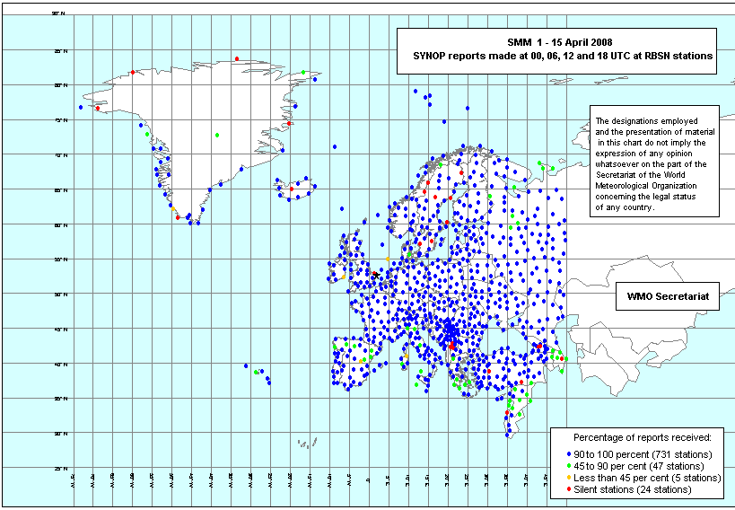
Figure 2

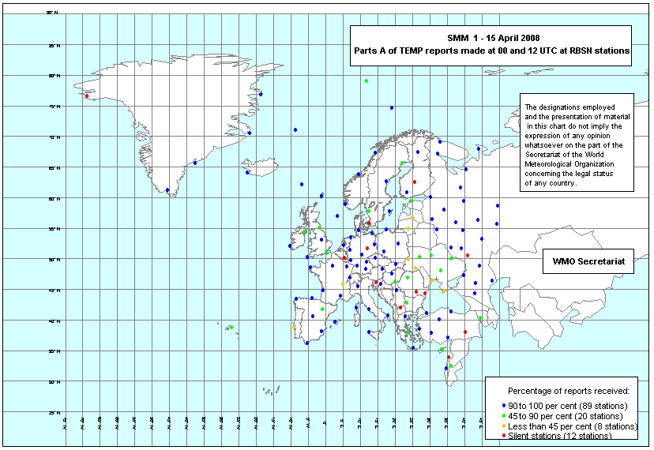
Figure 3

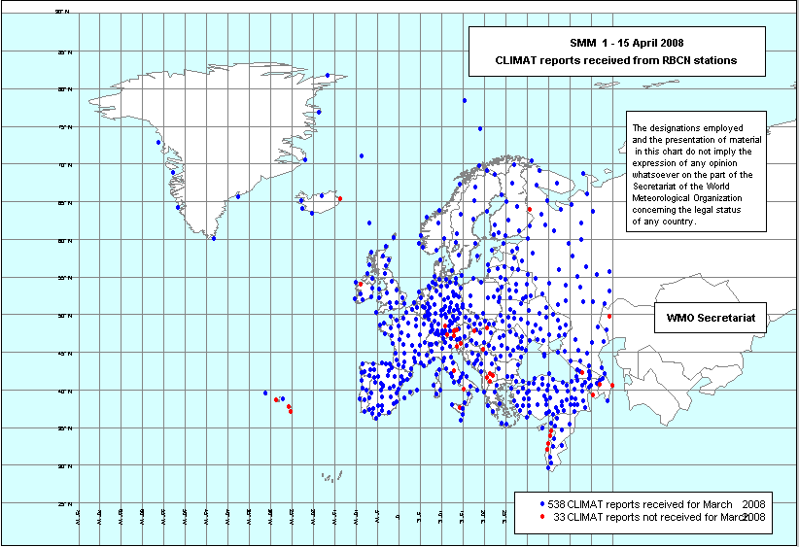
Figure 4

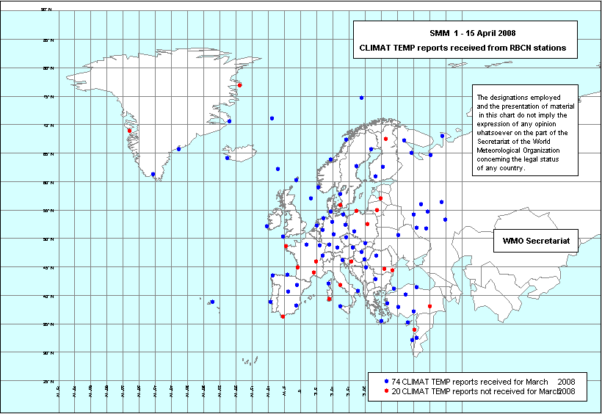

The kml files can be visualised using a kml browser such as Google Earth: the icons are blue for stations for which more than 90 per cent of the reports were received, green for stations for which 45 to 90 per cent of the reports were received, orange for stations for which less than 45 per cent of the reports were received and red for silent stations.
The kml files can be visualised using a kml browser such as Google Earth: the icons are blue for stations for which a CLIMAT/CLIMAT TEMP report was received and red for silent stations.

