WORLD METEOROLOGICAL ORGANIZATION  _______________________  REGIONAL ASSOCIATION II  (ASIA)  WORKING GROUP ON PLANNING AND IMPLEMENTATION OF THE WWW IN REGION II  FOURTH SESSION  MOSCOW, 10-13 SEPTEMBER 2003 |  | RA II/WG/PIW/Doc. 7  (8.VII.2003)  ___________  ITEM 7  ENGLISH ONLY

PUBLIC WEATHER SERVICES

(Submitted by Mr Edwin S. T. Lai, Rapporteur on the Regional Aspects
of the Public Weather Services)

Summary and purpose of document

This document provides information on the activities carried out in RA II under the Public Weather Services Programme.

ACTION PROPOSED

The group is invited to note the information given in this document and consider appropriate measures to further improve PWS-related activities in the Region.

___________

Annexes: I. Participation of RA II Members in WWIS (as on 23 May 2003)
II. ESCAP/WMO Typhoon Committee Members contributing to the SWIC Website (as at 23 May 2003)
III. Suggested Flow Chart for Cross-border Warning Exchanges

DISCUSSION

1. The report by the Rapporteur on Regional Aspects of Public Weather Services for Region II (hereafter referred to as the RA II Rapporteur on PWS) has been prepared in accordance with the documentation plan for agenda item 7 ‘Public Weather Services’ of the CBS/OPAG/IOS Working Group on Planning and Implementation of WWW in RA II, 4th session, to be held in Moscow (Russian Federation) on 10-13 September 2003. Recent development and progress relevant to RA II as presented in the following PWS-related meetings and activities in the past couple of years are highlighted:
- RAII/RAVI Joint Training Seminar on GDPS and PWS, Bahrain, September 2002;
- CBS OPAG/PWS Implementation Coordination Team (ICT) Meeting, Athens, November 2002;
- CBS Extraordinary Session, Cairns, December 2002.

2. The PWS programme was developed to provide comprehensive assistance and support to NMSs to increase their capabilities to meet new challenges and demands in the provision of weather forecasts and warnings through promoting:
- the image of NMS as the ‘single official and authoritative source’ of weather information;
- the use of official weather information from NMSs by the public and the international media;
- the exchange of official weather information and forecasts among NMSs;
- the exchange of warnings of hazardous weather among NMSs;
- the use of the Internet as an effective channel of reaching out to public and the media directly; and
- awareness of the economic benefits of meteorological services.

3. The CBS at its XII Session supported proposals for a pilot project on the use of the Internet to disseminate official information issued by WMO Members together with source identification, and on generating and making available on a central website of a coordinated product of major city forecasts around the world. The pilot project aimed at strengthening the recognition of the public weather services provided by the NMSs and facilitating the accessibility of such services by the public and the media. CBS also agreed that Hong Kong, China would take the lead in developing the concept, which eventually evolved into the World Weather Information Service (WWIS) Website.

4. Another WMO pilot project, also hosted by Hong Kong, China, is the development of a centralized portal site for tropical cyclone warnings in the western North Pacific and the South China Sea for the international media and the public, with contributions by RSMC Tokyo-Typhoon Center and Members of the ESCAP/WMO Typhoon Committee. This project serves as a demonstration of the concept of a centralized website for official warnings of severe weather around the world through the existing NMS/RSMC structure, and hence the name Severe Weather Information Centre (SWIC) Website. It aims to ensure efficient and effective information flow among NMSs, the media and the public on official warnings on severe weather.

5. It is noted that full implementation of these two projects have gradually and surely led to many of the objectives of the PWS programme being wholly or partially attained. Members from RA II also participate in these two projects and utilize the same for enhancing the usefulness of their services to their governments, the public and the media. This report will include an update on the progress of the two Websites, focusing specifically on the extent of involvement by RA II Members over the past couple of years.

World Weather Information Service (WWIS) Website (http://www.worldweather.org)

6. Since the issuance of a circular letter by the WMO Secretariat in February 2001 to invite participation and nomination of contact persons for the project, 81 WMO Members have since responded and forecasts of 777 cities are now included in the project as of May 2003. Of these, 28 are RA II Members, representing more than 80% of the total number of RA II Members and an increase of 12 Members since the last report by the RA II Rapporteur for PWS to the Working Group on PIW in August 2001 (Annex I).

7. The implementation plan of the project comprises two phases. The first phase, completed in late 2001, provides mainly climatological information (mean daily maximum and minimum temperatures, mean total monthly rainfall, mean number of rain days) and static links to participating Members' websites. Since early 2002, the second phase featuring world city forecasts has been meticulously assembled in a step-by-step manner, culminating in the official launch of the WWIS Website on 9 December 2002 with a press release issued by the WMO Secretariat and a media event of launch ceremony organized in Hong Kong, China. Since then, access statistics continue to rise in the early part of 2003, reaching a peak rate of more than 90,000 page visits per day on average by April 2003, thus confirming the Website as a good means to promoting Members’ visibility within the Internet community.

8. The Website supports communication through the GTS nodes, FTP, e-mail, as well as the use of a web-based form to enable participation of all Members. The web-based submission form allows participants to prepare and submit their forecasts manually on-line through the use of web browsers. The diversity of input methods is intended to match the wide range of technological capability among WMO Members. Special care is taken to enable Least Developed Countries (LDC) to join the project and make their official forecasts known to the world. In the case of more developed countries, relevant forecast information are retrieved from their websites and converted to a format suited for WWIS. To allow Members to make available official city forecasts for their local public and media, participating Members, on a trial basis since September 2002, can also download from an FTP server collated city forecasts derived from the WWIS Website. Further effort will be expended to ensure overall system reliability and robustness. The use of graphical icons, in addition to text-based weather messages, will also be explored in the next stage.

9. The successful proof of concept has since led to the parallel development of WWIS in other official WMO languages. Oman, a member of RA II, is hosting and maintaining an Arabic version of the Website (Fig. 1). China, in technical consultation with Hong Kong, China, is also exploring the setting up of an equivalent WWIS Website in Chinese. Meanwhile, the Russian Federation has made available weather information and forecasts for Russia and other regions through the creation of an open-access website.

Severe Weather Information Centre (SWIC) Website (http://severe.worldweather.org)

10. The pilot project on the SWIC Website is designed, at the first stage, to display warnings of tropical cyclones and related information for cyclones in the western North Pacific and the South China Sea in the ESCAP/WMO Typhoon Committee region. The contents of the website have been enriched gradually since the commencement of operational trial in September 2001. Implementation is carried out in phases and in close cooperation with the WMO Tropical Cyclone Programme, RSMC Tokyo-Typhoon Center and participating NMSs.

11. The basic concept of SWIC is to gather dynamic tropical cyclone information from the websites of participating NMSs. Automated checking routines are run to search for updated information and to read relevant metafiles. Warning information from the GTS is also used. Other static information, such as the warning areas of respective centres, tropical cyclone names and hyperlinks to participants' websites, is also included.

12. The SWIC Website, in English only for the time being, was thoroughly tested during the 2002 tropical cyclone season. Further liaison with participating Members has led to a continuing enrichment in Website contents. Enhancement measures have been undertaken in the process to improve the Website layout, navigation and presentation. To avoid possible confusion arising from different track forecasts from different NMSs for the same cyclone, explanatory notes have since been added.

13. CBS at its Extraordinary Session in 2002 supported the extension of the SWIC Website to cover tropical cyclone information in other regions. Prototype web pages to cover tropical cyclone information from RSMCs and TCWCs in RA V, Central North Pacific Ocean, South-West Indian Ocean, and Bay of Bengal and the Arabian Sea have since been developed (Fig. 2). Information from TCWCs in Australia is already being used to update the relevant pages. Arrangements will be made to have all these pages updated dynamically as well.

14. To date, 19 WMO Members are participating in the pilot project. Among the 13 Typhoon Committee Members involved, nine are from RA II, three more than last reported by the RA II Rapporteur on PWS in August 2001 (Annex II). In due course, Members from other Regions will also be invited to participate in the project. Other possible developments in the foreseeable future include the construction of parallel SWIC Websites in different languages by other WMO Members, provision of other means such as FTP for exchange of warning messages and extending the coverage to severe weather systems or phenomena other than tropical cyclones.

Product Development and Service Assessment

15. User-based assessment gauges the perception of targetted user groups regarding PWS accuracy, accessibility, availability, timeliness, utility, language, comprehensibility and packaging. Methods to gather such information include surveys, focus groups, public opinion monitoring, and user workshops.

16. For example, since 1989, the Hong Kong Observatory (HKO) has incorporated a survey programme to assess public opinions of its PWS programme. The telephone-based surveys are done twice yearly and are independently carried out by a private company on a contract basis. Abridged version of the survey results is published in internal annual reports and quarterly newsletters; technical reports on the subject are also released to the public. Apart from regular surveys, HKO also solicits users’ feedback through liaison group meetings and special public forum such as ‘Friends of the Observatory’. Internet usage and page visits are also regularly monitored. The data collected are particularly useful for assessing demands and trends. It is through such statistics that system managers and developers can enhance system design and ensure product delivery even in the worst of weather scenarios. For example, during tropical cyclone events in Hong Kong, more than four million page visits have been logged by HKO in one day (62 million hits), giving rise to serious traffic jam on the information highways. After re-design works in the webpage format and navigation, critical warnings and in-demand information become more readily accessible; and with less time spent on information retrieval, the chance of web congestion recurring during inclement weather situation has been reduced.

17. Apart from the use of questionnaires and surveys which is still the most commonly adopted approach by the NMSs, the trend in PWS user assessment is moving towards more effective use of web statistics and automated telephone system feedback mechanisms in obtaining an overview of how and when people access weather forecast information. In addition, the review of web usage patterns can also provide valuable information on the spectrum and demographics of a NMS’s user community. With more monitoring statistics to serve as guidance, the NMSs are now in a better position to establish and trigger internal mechanisms that will bring about product development and service improvement in their PWS programmes.

18. Further development of user-based PWS assessment would probably necessitate the formulation of a set of recommended core user assessment criteria and questions to be developed for use by NMSs. Responses to such core questions will be particularly helpful in developing a more complete picture of PWS activities worldwide, special flavours and characteristics on a regional basis, and differences in PWS strategies and problems between one country and another. It is a subject that needs to be followed up further in an appropriate forum, e.g., the Kuala Lumpur meeting of the PWS Expert Team on Product Development and Service Assessment in late September 2003, which the RA II Rapporteur on PWS will also attend.

Warnings and Forecasts Exchange, Understanding and Use

19. Basic meteorological information is widely exchanged and circulated through the Global Telecommunication System (GTS) or through regional networks. However, this concerns basically data and products that are tailored for professional meteorologists. As noted by CBS-XII, while the exchange of warnings and forecast information does exist in some regions, there is still plenty of room for improvement and expansion. In many areas where cross-border exchange is practically non-existent, bilateral and/or regional cooperation needs to be further encouraged and expanded according to local requirements.

20. The scope of cooperation between neighbouring Members goes beyond setting up an exchange mechanism in respect of selected meteorological phenomena by agreed criteria. Such exchanges of warnings should be viewed as a cooperative venture specified in terms of intended recipients (between NMSs only, through dedicated websites such as SWIC, or made generally available to the public through other conventional means), timeliness, frequency, content, format and delivery. Of equal importance, accompanying formal supporting agreements, regular review, debriefing, training, drills and exchange visits of operational personnel would also be necessary. Even though an NMS is the official authority for issuing warnings within its area of responsibility, formatting of such information intended for cross-border exchange should be designed in such a way as to facilitate ready dissemination, understanding and response. A flow chart summarizing the considerations and procedures in establishing cross-border exchange mechanisms (Annex III) has been presented for discussion in the PWS ICT meeting in Athens, November 2002.

21. An example of cross-border cooperation among three RA II Members in southern China, namely China, Hong Kong, China and Macao, China, is used as an illustration of the progress made in certain parts of the Region. The Hong Kong Observatory operates a numbered tropical cyclone warning system and a colour-coded rainstorm warning to alert the public of associated hazardous conditions and phenomena. In recent years, Macao, China, and the neighbouring Guangdong province in southern China have also established similar warning systems for tropical cyclones, strong monsoon and rainstorms. Warnings issued by the meteorological centres from these regions are readily obtainable by the public via the Internet and are often compared with warnings issued by Hong Kong Observations. Thus there is obviously a need to maintain close liaison among the three neighbouring regions in the operation of warnings in inclement weather situations.

22. Coordination and consultation among the centres were stepped up in 1996. The three meteorological services will inform one another via GTS, supplemented by fax when warnings of tropical cyclone, strong monsoon or rainstorm are issued or cancelled. Telephone consultation channels have been set up for forecasters, particularly for the purpose of assessing tropical cyclone intensity and the location or timing of cyclone landfall. To facilitate the operation of weather warning systems, arrangements have also been set up for the real-time exchange of data collected from the network of automatic weather stations within the region via dedicated data lines (Fig. 3). Relevant research and development work on subjects of common interest are conducted in support of operational forecasting. Annual technical conferences are held at the three centres by rotation, where forecasters review major weather events of the past year, exchange experience, and compare results. A meeting of senior management to review the cooperative arrangements always follows such conferences.

23. Many NMSs also commit significant resources towards enhancing public understanding of their functions, responsibilities, facilities and operation, the nature and associated risk of the weather phenomena, and raising public awareness and preparedness of natural disasters. A range of educational products and services, designed to support public education campaigns in delivering information that will promote understanding and awareness of hazards, inform people on how best to respond to warnings, and ultimately encourage rational hazard-mitigating behaviour individually as well as community-wise, are now available in many countries. Methods commonly used for communicating the various types of hazard awareness information include pamphlets, brochures, media packages (TV, radio and newspapers), web-based educational resources, school visits, public lectures and seminars, guided tours, shows and exhibitions, as well as special service liaison meetings.

24. However, when warnings are being issued, the emphasis is increasingly on ‘real-time public communication’. This becomes extremely effective in critical weather situations as people are in need of and actively seeking information about the particular threat they are facing. They are receptive to advice that will be of relevance in the current situation and in any future events. Important messages and supplementary advice may be issued to the public during a warning period as text or graphics via television, fax, the Internet, or mobile phones, etc., or by voice via recorded telephone message, television and radio interviews, etc. Particularly successful are direct TV and radio presentations by meteorologists, either live or recorded, allowing weather specialists the chance to add details and explanation to warning and advisory messages. Previously, such initiatives rely very much on a successful partnership with the media or other telecommunication operators. Increasingly, with the trend of NMSs developing their own web-based resources or running their own broadcasting facilities, there should be more opportunities in the future for NMSs to launch real-time public communication programmes in the most timely and innovative manner.

Implementation of the PWS Programme

25. The RA II Rapporteur on PWS has been requested by the Chairman of the Working Group on Planning and Implementation of the World Weather Watch in RA II to organize a regional workshop for training of forecasters in severe weather forecasting, issuance of severe weather warning and communication skills especially for those from developing countries of the Region. However, the funding situation has not improved and the target of setting up a regional workshop remains an elusive goal. Nevertheless, under the WMO PWS programme, a joint RA II and RA VI Regional Training Seminar on Objective Interpretation of GDPS Products and Improvement of Public Weather Services was held on 14 -26 September 2002 in the Kingdom of Bahrain. Fourteen participants from thirteen countries in RA II and RA VI took part in the two-week seminar. The first week concentrated on how to serve the public and other users with improved products and services produced by the NMSs, while the second week dealt with improving forecasting techniques. In the PWS portion, the main objective was to enhance quality, contents, and means of delivering warnings, forecasts and other products to the public in a way that optimizes users’ understanding, applications and response. A particular focus was on the role of the media in achieving the above objective. There will be another opportunity for RA II and RA V Members to benefit from this training seminar when the next one is held in Brunei in September 2003. As the funding situation for a separate specialized regional workshop is unlikely to improve dramatically in the foreseeable future, it is proposed that RA II Members should actively seek such opportunities to be involved in scheduled workshops or seminars organized in the Region under the WMO PWS programme.

26. Apart from the need for adequate training in equipping frontline staff with quality PWS delivery capability, the PWS ICT meeting in Athens, November 2002 also identified lack of resources, frequent staff turnover and weak coordination with users as the main obstacles in PWS improvement. Specific issues such as language problems and data format in information exchange processes would also need to be dealt with and tackled on a regional basis. On the positive side, however, the meeting also noted that progress was made in the following aspects:
- Plans were established to develop and improve national PWS programmes and activities;
- New products were developed and existing products improved;
- More informative bulletins and warnings;
- Relationships with other government departments and agencies were strengthened;
- Relationships with the media were improved;
- Seminars for the users of PWS products and services were organized.

27. Without the benefit of a comprehensive survey, it is difficult to state categorically to what extent RA II Members are affected by the PWS initiative, or the lack of it, in recent years. An earlier plan by the RA II Rapporteur on PWS to launch a questionnaire was shelved owing to logistic problems and the anticipated difficulties in gathering adequate returns in good time. As ad hoc surveys done on a piecemeal basis often involve painstaking effort and a high degree of coordination, the idea of a region-wide questionnaire will not be pursued further. Instead, it is proposed that indirect objective means to assess PWS progress in the Region, less conclusive they may be but certainly more accessible on a regular basis, should be explored and adapted for use wherever feasible. For example, indicators that may be considered include participation in PWS-related activities, information exchange through GTS and other means, visibility in local and international media, weather disasters impact statistics, information availability and product quality on the web (if applicable), and roles in international PWS effort or programmes (e.g. WWIS and SWIC; in fact, RA II Members contributing to SWIC can proudly claim to be the most progressive in becoming the first tropical cyclone basin to have warnings posted onto the WMO Website for the benefit of the international community!).

_______________

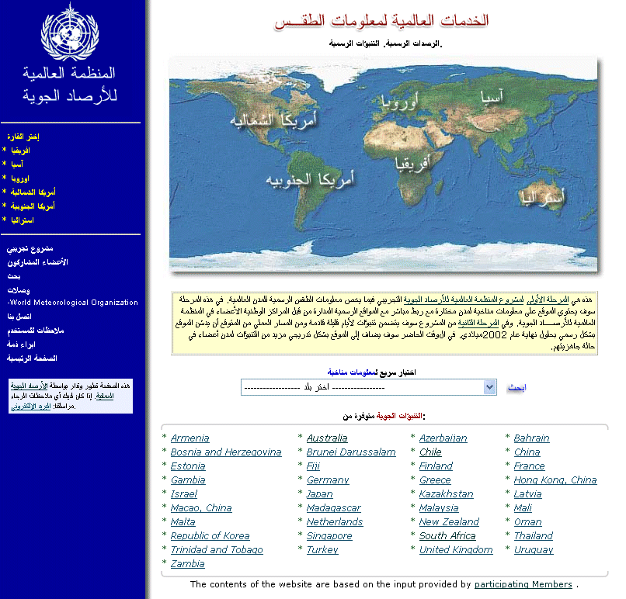

Figure 1 - Arabic version of the WWIS Website developed by Oman.

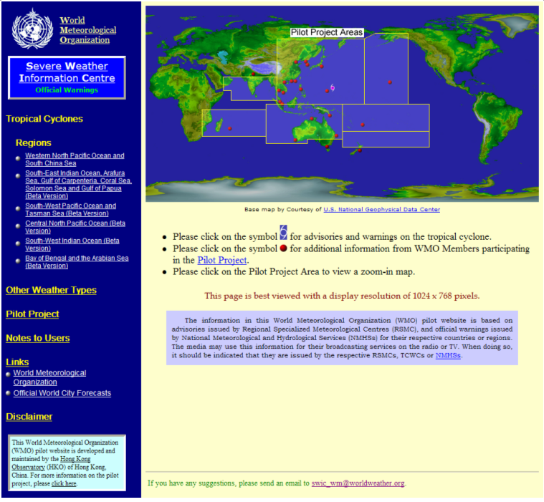

Figure 2 – Current version of SWIC Website, containing prototype pages
for RA V, Central North Pacific Ocean, South-West Indian Ocean,
and Bay of Bengal and the Arabian Sea.

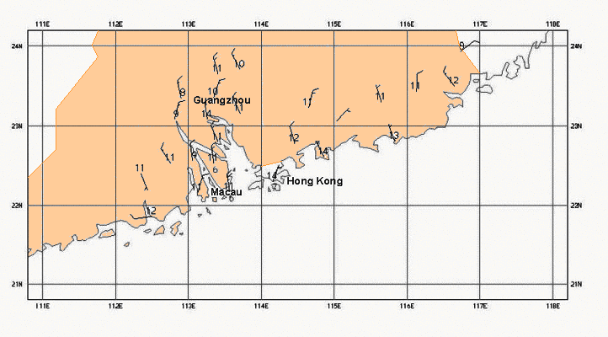
Figure 3 – Observations from networks of automatic weather stations
for cross-border exchange in southern China

Annex I

Participation of RA II Members in WWIS (as on 23 May 2003)

*Bahrain | Mongolia
Bangladesh | *Myanmar
*Cambodia | *Nepal
*China | *Oman
DPR of Korea | *Pakistan
*Hong Kong, China | *Qatar
*India | *Republic of Korea
Iraq | Republic of Yemen
Islamic Republic of Iran | *Russian Federation
Islamic State of Afghanistan | Saudi Arabia
*Japan | *Socialist Republic of Viet Nam
*Kazakhstan | *Sri Lanka
Kuwait | Tajikistan
*Kyrgyz Republic | *Thailand
*Lao PDR | Turkmenistan
*Macao, China | United Arab Emirates
*Maldives | *Uzbekistan
- RA II Members participating in WWIS are in bold italics.
[28 out of 34, i.e. over 80% and 12 more as compared to August 2001]
- RA II Members participating in WWIS with city forecasts also included are marked with an asterisk (*).
[22 out of 34, i.e. about 65% and 16 more as compared to August 2001]

WWIS in All Regions |  | No. of Members providing forecasts | No. of cities
I | Africa | 9 | 40
II | Asia | 22 | 138
III | South America | 5 | 49
IV | North and Central America | 6 | 209
V | South-West Pacific | 9 | 214
VI | Europe | 32 | 127
Total |  | 81 | 777

Forecast Input Method | No. of Members providing forecasts
GTS | 27
AFTN | 3
FTP | 15
Web Form | 9
Email | 41
Note: Some Members are using more than one method to provide forecasts.
Annex II

ESCAP/WMO Typhoon Committee Members
contributing to the SWIC Website (as on 23 May 2003)

Cambodia

China

DPR of Korea

Hong Kong, China

Japan

Macao, China

Malaysia

Philippines

Republic of Korea
Singapore
Socialist Republic of Viet Nam

Thailand
United States of America

Note: Of the above, nine (in bold italics) are RA II Members.

RA II Member that has expressed an interest in SWIC

Lao PDR

____________

Annex III

Suggested Flow Chart for Cross-border Warning Exchanges





