WORLD METEOROLOGICAL ORGANIZATION  -----------------------------  REGIONAL ASSOCIATION I  FIFTH SESSION OF THE REGIONAL ASSOCIATION I WORKING GROUP ON PLANNING AND IMPLEMENTATION OF THE WWW  NAIROBI, KENYA, 25-29 September 2006 |  | DPFS/RA I/WG-PIW/Doc. 5.3(2)  (06.IX.2006)  ---------------------  ENGLISH only

REGIONAL PERPECTIVES

STATUS REPORT FOR GLOBAL DATA-PROCESSING SYSTEM IN RA I
(Submitted by the Rapporteur of GDPFS for RA I)

Summary and purpose of the document

This document contains an abstract of the proposals made by the ICT/DPFS at the last meeting concerning several aspects of Global Data Processing and Forecasting System, and rapporteur’s proposals to improve the NWP system in the RA I and in particular the forecasts of severe weather.

Action proposed
The meeting is invited to note the information in this report to finalize appropriate recommendations to the next session of RA I. .
DISCUSSION

The meeting is invited to take into account the main proposals of the two workshops which have taken place at Casablanca from 12 to 15 September 2005 and from 21 to 25 November at Dakar.
At the first workshop the main recommendations submitted by the participants, following the report established by Mr. Joel Martellet, are on the practical aspects of the implementation of Regional numerical models and some African countries needs assistance in this way. Besides, the participants pointed out the need for the creation of Working Group (WG) on Numerical Weather Prediction for RA I.
This special WG could first make a diagnostic of the existing situation in the frame of NWP. This diagnostic would permit to know in details which kind of regional models are under use in Africa and which human resource and its profile is necessary to run the model and to make the NWP products available to the forecasters at a defined time. Also, it is necessary to define for each national meteorological service which kind of computing power is needed to run a regional model on a specific domain.
After that, the WG has to identify the national meteorological services, which are ready to help the ones who want to run a specific model.
Then, special workshops have to be organized in national meteorological services where models are under user in operational way. After the technical aspect, each national meteorological service has to explore the administrative aspect in order to have the necessary authorization to run its model.

At the workshop of Dakar, there was not a lot of lecture from outside Africa and the quality of the lectures was appreciated, that is a proof that qualification and competence exists in Africa.

In order to permit to a maximum of the African countries to implement a regional model, it will be helpful to organize a workshop on how for example to implement and to run ETA model and how to make the products available to the forecasters as quickly as possible.

To make these actions efficient, I hope that this workshop will be organized with the active participation of WMO, by financing a Personnel Computer for each participant. After the workshop, the participants could go home with a PC containing all the necessary components to run a limited area model.
The concerned national services by these actions have to have an internet link with a speed of at least 1Mb/s, in order to download from a great centre the initial state and the lateral boundary conditions to integrate the regional model with a reasonable horizontal resolution, in a dynamical adaptative way.

2. Present NWP in RA I

The countries which are running models and/or have an access to model outputs are as follows:

ACMAD : African Centre for Meteorological Applications and Development, it has access to GM (Global Models)

La Reunion: It’s a Tropical Cyclone RSMC (Regional Specialized Meteorological Center) and it has access to GM and MSM (Mesoscale Model)

Algiers: It’s a Geographical RSMC and it runs ALADIN as LAM and MSM and ETA model as LAM and MSM

Cairo: It’s a Geographical RSMC and it runs ETA model and MM5 as LAM and MSM

Casablanca: It’s a Geographical RSMC and it runs AL BACHIR, ALADIN NORAF as a regional model and ALADIN as MSM

Nairobi: It’s a Geographical RSMC and it runs RAMS and HRM as LAM

Tunis: It’s a Geographical RSMC and it runs ALADIN as MSM

Pretoria: It’s a Geographical RSMC and it runs GM, GM ensemble, GM (cola) and LAM

Botswana : it runs DWD as MSM

Some NMHSs have been involved in making effort to run LAMs (Limited Area Models). However most of the NHMSs still lack the necessary human resources capability and in some cases lack the basic infrastructure to run LAMs. There is therefore need for capacity building in this area.

There are initiatives through collaboration between ICPAC (IGAD Climate Prediction and Application Centre) based at Nairobi and IRI to develop NMHSs capacity for some 10 countries in Eastern Africa. These initiatives involve running a Regional Spectral Model (RSM) which is basically intended for seasonal and climate forecasting.

IGAD : Inter governmental Authority for development

3. Forecasting Standards and Recommended Practices

The ICT/DPFS meeting noted that two recent documents have been developed and made available to Members via the WMO Web-site at: http://www.wmo.int/web/www/documents.html listed under DPFS. They are:
“A Summary of Recommended Practices for Weather Forecasting” (November 2004),
“Guidelines on Using Information from EPS in Combination with Single Higher Resolution NWP Forecasts” (February, 2006).

The meeting noted that guidance documents should be developed and maintained on forecasting standards and recommended practices, and would be valuable to WMO Members as part of the ongoing Implementation of the GDPFS. For example, the Expert Team on Ensemble Prediction Systems (EPS) is planning to develop a Guide on EPS, and the Emergency Response Activities programme maintains an information volume on its activities and standards in the WMO Technical Note No. 778. The meeting also noted that a review and updating of the WMO Guide on the GDPFS (WMO-No. 305) would require some experts and/or a suitable consultant, coordinated by the Secretariat. The updated Guide would be best made available as a Web-accessible document on the WMO Web-site.

4. Ensemble Prediction Systems Products and Applications

At the last meeting of the ICT/DPFS, Mr Louis Lefaivre (Canada) presented the activities and future plans of the Expert Team on Ensemble Prediction Systems.

The meeting noted that fourteen GDPFS centres are running ensemble prediction systems (EPS), some are running multiple systems, and their products are of considerable interest to all WMO Members. The interest continues to grow, as EPS products are a realization of quantifying uncertainty in the numerical simulations and predictions of the atmosphere. The continuing development of EPS, in terms of model resolution, methods of accounting for uncertainties, forecast ranges, and applications, means it has increasing importance as a vital tool for weather forecasting, and on all time scales (short-range to long-range) of prediction.

WMO Members are encouraged to access EPS products of GDPFS centres and also invited these centres to provide the access information for their respective EPS web-sites. The concept of including uncertainty in all forecasts needs to be promoted to decision makers and managers who in turn could set new requirements for probabilistic forecasts as part of weather information, forecasts and warnings.

In response to guidance that was sought by some WMO Members, the Expert Team produced a draft text entitled: “Guidelines on using information from EPS in combination with single higher resolution NWP forecasts”. This guide is available at the following web-site:
http://www.wmo.int/web/www/documents.html

5. Severe Weather Forecasting

At the meeting of IDT/DPFS, Mr Jean-Marie Carrière, the Rapporteur on Applications of NWP in Severe Weather Forecasting, presented a summary of the background and status of the Severe Weather Forecasting Demonstration Project (SWFDP).

The motivation to organize a demonstration project on severe weather forecasting originated from the following needs:

- To demonstrate how cooperative work among meteorological centres can be further exploited in order to enhance the forecasting process of several types of severe weather and to improve warning services at the NMHSs;
- To make better use of existing NWP models and products including those derived from Ensemble Prediction Systems and train forecasters of NHMSs that have not yet used or applied them and to demonstrate their utility in decision-making;
- To prepare NMHSs and GDPFS centres to implement and benefit from the outputs of the THORPEX research and development programme;
- To improve the ability of NMCs to forecast severe weather events;
- To improve the lead-time of alerting of these events;
- To improve interactions of NMCs with Disaster Management and Civil Protection Authorities before and during events;
- To identify gaps and areas for improvements;
- To improve the skill of products from GDPFS centres through feedback from NMCs.

The project is divided into three phases:

- Phase 1 is the overall project planning. .
- Phase2 is the regional subproject(s) implementation planning and execution
- Phase 3 is the regional subproject(s) evaluation and conclusion.

The first regional subproject will focus on severe weather (heavy precipitation and strong winds) not specifically associated with Tropical Cyclones and will be implemented in the south-eastern region of Africa (RA I) in 2006.

Expressions of interest to participate in the first regional subproject has been expressed by the following centres:
NHMSs: Mozambique, Botswana, Zimbabwe, Tanzania
Regional Centres: RSMC Pretoria (South African Weather Service), RSMC La Réunion (Météo-France), ACMAD
Global Centres: ECMWF, Exeter (Met Office UK), NCEP (U.S.A.)

An organizing meeting of the participating centres was planned for 31 July – 3 August 2006 to establish a Regional Subproject Management Team and to develop the implementation plan for the subproject. The season when severe events in this region are likely to occur is from November to May; there should be sufficient lead-time for the preparation of the subproject, including the provision of essential preparatory training, in order to start the experimentation phase in November 2006.

Another regional subproject will focus on severe weather associated with Tropical Cyclones, and will be considered following the implementation of the first subproject.

6. Emergency Response Activities

6.1 Nuclear Emergency Response Activities

At the last ICT/DPFS meeting, Mr René Servranckx (Canada) presented the activities and future plans for the Coordination Group on Nuclear Emergency Response Activities.

6.1.1 Improved product distribution / access methods

The meeting noted that, faxing remains the official product transmission method and maintaining updated fax numbers and contacts points remains a challenge. Actions will be taken to confirm (testing) and update (via correspondence to PRs) operational contact information.

All RMSCs use web-based technologies to exchange information and products. Some RSMCs have implemented identical (mirrored/congruent) but independent password protected web pages. As an example, RSMCs Washington, Montreal and Melbourne use FTP to exchange their products in order to make them available in a congruent system. The key advantage is that the three Centres’ web sites have identical content while being completely independent from one another. Therefore, even when one server is down, congruency allows accessibility to the RSMC products. The system is tested in monthly exercises and has been implemented in a way that minimizes the risk of failure due to Internet disruptions, as well as accounting for varying capabilities of NMHS to access.

The mirrored / congruent web pages should be extended to include all RSMCs. The exchange of data in GRIB, GRIB2 and BUFR codes will be pursued.

6.1.2 Procedures, services and response to nuclear emergencies

The relationship of WMO, its designated Centres with the IAEA is strongly recognized, including by other relevant International Organizations. Exercises and regular testing are key elements to ensure operational readiness.

Operational test of notification between the IAEA’s Incident and Emergency Centre (IEC) and WMO’s RTH Offenbach is conducted on a monthly basis. Since 2004, quarterly tests have taken place between IEC and lead RSMCs for WMO RAs and will continue in the foreseeable future. The scope of the tests includes the requesting of RSMC products by the IAEA, testing the link between RTH Offenbach and the RSMCs and testing the delivery of products. A test of the full arrangements, including the transmission of messages on the GTS, participation of NMHSs and IAEA Contact Points is to be done every other year.

7. Non-Nuclear Emergency Response Activities

At the last ICT/DPFS meeting, Mr Chris Ryan (Australia) presented the activities and future plans for the Expert Team on Atmospheric Transport Modelling for non-Nuclear Emergency Response Activities.

CBS-XIII (2005) established a new Expert Team on Modelling of Atmospheric Transport for non-Nuclear Emergency Response Activities and its Terms of Reference. This ET complements the Coordination Group on Nuclear ERA and shares many of the experts. The new Expert Team met for the first time in September 2005 at Melbourne.

The meeting noted that it has been widely recognized that the tools used to model the dispersion of nuclear contaminants in the atmosphere can also be applied to other airborne hazardous materials, so the ERA programme has been directed to expand its activities into non-nuclear environmental emergencies. CBS-XIII (2005) agreed that priority should be given to expanding the programme to atmospheric transport and dispersion modeling to support response to chemical

8. Trainings in RA 1 during 2005

In order to help some countries of RA I, two trainings workshops were organized by WMO in 2005. The first one took place at Casablanca (Morocco) from 12 to 15 September 2005 and the second one at Dakar from 21 to 25 November 2005.

The first workshop was organized for countries, which were ready to implement operational NWP system. The countries, which participated, were the following ones: Botswana, Kenya, Libya, Mozambique, Senegal, Tanzania and Morocco. Two participants came from ACMAD. Twenty one participants attended the training and the lecturers were from France, Germany, South Africa and Morocco. The main goal of this workshop was to help the participants to see all the aspects, which needs to be considered in the operational implementation of NWP.

Numerical weather prediction needs human resources with high qualifications and computer knowledge.
As indicated by Mr. Joel Martellet in his report, this workshop was attempting to cover the following step: acquiring and running a local NWP model without data analysis but with verification, which was discussed at Pretoria in 2002. The step one, which consists on acquiring and using existing NWP grid point products, is supposed to be well known.

At the end of the workshop, most of the participants expressed there satisfaction and they wish more practical sessions as:
- More on experimental implementation of NWP and less on theory
- More on hands-on exercises

Suggested follow up actions :

- Expert mission for assistance to Countries trying to implement NWP
- Training in advanced centre
- Create a WG on NWP for RA I

On the other hand, the calendar of WMO actions proposed is as follow:

- Creation of an official WG on NWP for RA I.
- Meeting of RA I in January 2007, who will be asked to endorse the recommendations
- 2007 or 2008: WMO may try to convene a workshop including new members if any, or only for those who were in Casablanca who have achieved implementation.

Concerning the workshop, which took place at Dakar (Senegal) from 21 to 25 November 2005, the participants came from 20 countries plus ACMAD.
The subjects which were treated during this workshop, were on :
- the status of GDPFS and the available products, in the AR I
- use of EPS
- verification and evaluation of NWP products
- Use of ALADIN-NORAF products
- Information about the different data formats: GRIB, BUFR, CREX.
During this workshop most of the lecturers were from Africa.

9. The Algerian experience in severe weather forecasting

9.1 introduction

Severe weather is continually affecting all the regions in the world but the Mediterranean area and central Africa are affected by two different kinds of severe weather. The first one by deepening cyclones like the one who affected Algiers in 2001 and the other one by squall lines, causing loss of life, landslides and flooding.
Unfortunately, the heavy convective rainfalls are often associated with MCSs and great quantities of rain falls over only a relatively small area compared to the spatial scale of the system itself. Therefore, while it is generally possible to forecast a MCS, by correctly forecasting the intensity, duration, and location of the intense rainfall that is part of the system, it becomes problem when using NWP models with a horizontal resolution coarser than about 20 km.
This is to point out that in case of AR I, we do not need to run only LAM models but we need to build nowcasting systems based on: NWP products with fine horizontal resolution, radar data and satellite data and products from the different SAFs in Europe. Besides, we have to develop data assimilation systems to improve the initial field, which we have to use to integrate limited area models over specified regions.

9.2 The 10th November 2001 flash flooding

After the flash flooding of 10th November 2001, which claimed more than 700 casualties, the Algerian Government decided to take actions to ensure such calamities do not occur in the future. The Government decided to improve the warning system and to involve all the concerned services including Meteorology, Hydrology and the different authorities, by initiating a project called: RVZU (Réduction de la Vulnérabilité des Zones Urbaines) (Vulnerability Reduction of the Urban Areas).
After the international call, which was won by UKMO, in addition to the recommendations made to improve the Algeria warning system, the results of the scientific study are as follow:

- A prolonged period of exceptional rainfall is predicted at each resolution tested. However, the observed maximum of 261 mm is never reached.
- Increases in resolution give continued improvements in amount of rainfall.
- Other meteorological fields compare well with observations and analyses.
- Latent heat release played the major role in this event
- The orography influences the spatial distribution of humidity more over land than over sea
- Rainfall is underestimated by the global model
- More convective rainfall with NAE model
- More dynamical rainfall with 4 km model

Another action which is still in the framework of severe weather is that the forecasting system of the Algerian Met service based on: ARPEGE, ALADIN and AROME in the near future is under achievement.
To achieve this project, a new forecasting centre will be built during the next year and a super computer, able to run ALADIN and AROME with data assimilation will be installed before the end of the year 2008.

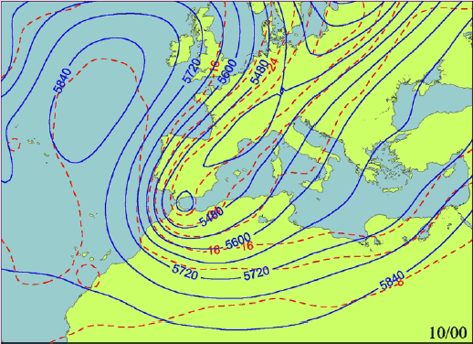
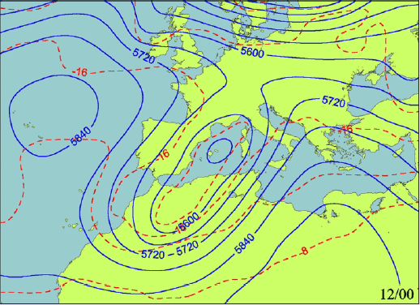

Fig.1 : Z+T 500 hPa of the 10th/11/2001 at 00Gmt and the 12th/11/2001 à 12Gmt
(After Romero et al. (2001))
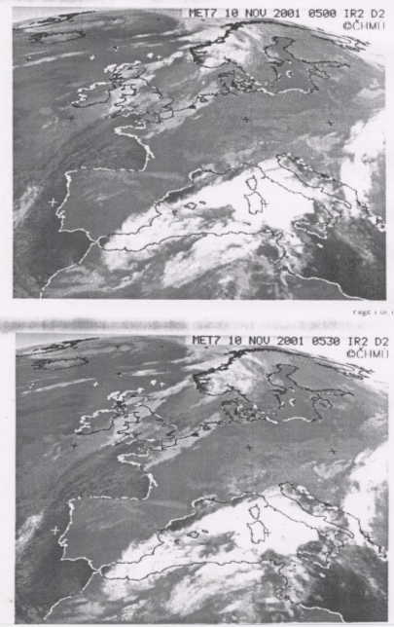
Fig.2 : Satellite pictures of the 10th Nov 2001 at 05h00 and 05h30 Gmt

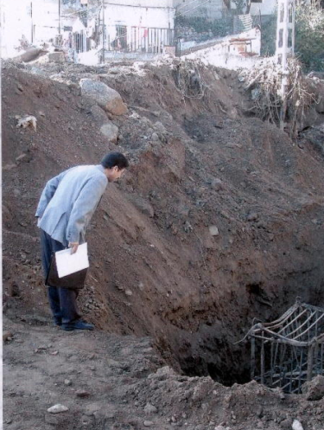

Fig.3: Landside at Algiers 10/11/2001

10. Needs for training in RA I

In order to build capacity for the RSMCs and NMHSs in Region I, to run NWP models and to adapt the NWP products for they own use, it is recommended to :

- Create a Working group for NWP in RA I

- Workshops on practical implementation of regional models at the African NMHSs, where the regional models are running in operational way, with the help of WMO.

- Seminars or workshops on the use and interpretation of NWP products and on how to build some specified derived fields, to help the forecasters.

- Workshops in verification and evaluation of the NWP products.

- Workshops on how to build a nowcasting system.

- Workshops or seminars on the use of new techniques, as potential vorticity anomaly, in the diagnostic and the forecast of deepen cyclogenesis.

