WORLD METEOROLOGICAL ORGANIZATION  -----------------------------  REGIONAL ASSOCIATION I  FIFTH SESSION OF THE REGIONAL ASSOCIATION I WORKING GROUP ON PLANNING AND IMPLEMENTATION OF THE WWW  NAIROBI, KENYA, 25-29 September 2006 |  | RA I/WG-PIW/Doc. 5.2(1-1)  (22.IX.2006)  ---------------------  ENGLISH only

WMO INFORMATION SYSTEM (WIS)
Submitted by the Secretariat

_______________________________________________________________

Summary and Purpose of Document

This document provides information on the WMO Information System.

ACTION PROPOSED

The Working Group is invited to take into account this information when making recommendations related to the WIS in RA I.

WMO INFORMATION SYSTEM (WIS)

Background

Data is the foundation on which our knowledge of the environment // is built, and data exchange and management principles and services ensure effective and efficient international use of the data regardless of location or language. Nearly all programmes collect data, perform quality control, transmit data to processing centres, generate products, transmit products to users, and archive data and products for future use.

Already near the end of the 1990s it became apparent that the various WMO Programmes either had their own information systems, or were in the process of developing them independently of each other. The resulting multiplicity of systems and practices has since then generated incompatibilities, inefficiencies, duplication of effort and higher overall costs for Members. Continuing uncoordinated development would exacerbate these problems and further isolate the WMO Programmes from each other and hinder the information exchange of a wider international user community. Therefore, the Commission for Basic Systems (CBS) developed the concept of an overarching, integrated WMO Information System (WIS) that would meet the requirements of all WMO Programmes, affiliated international organizations and programmes, as well as relevant national non-NMHS users such as disaster prevention and mitigation agencies and research facilities, with respect to:

- Routine collection and automated dissemination of observed data and products (“push”);
- Timely delivery of data and products;
- Ad-hoc requests for data and products (“pull”);
- Data discovery, access, and retrieval service for all data stored by any WMO Programme regardless of location.

The Fourteenth World Meteorological Congress (Cg-XIV, 2003) approved this approach. The fifty-sixth session of the WMO Executive Council (EC-LVI, 2004) set up a high-level coordination mechanism involving all WMO technical commissions to ensure the orderly, coordinated evolution of WIS. EC-LVII (2005) identified the WIS as a major contribution of WMO to the GEOSS // with respect to data exchange and management services.

WIS concept

The main functional components of WIS are: National Centres (NC), Data Collection and Production Centres (DCPC), Global Information System Centres (GISC) and data communication networks connecting the components. The terms are used for describing the necessary functions, not actual organizational entities. There may be organizations, such as NMHSs, which combine all three functions within their structure.

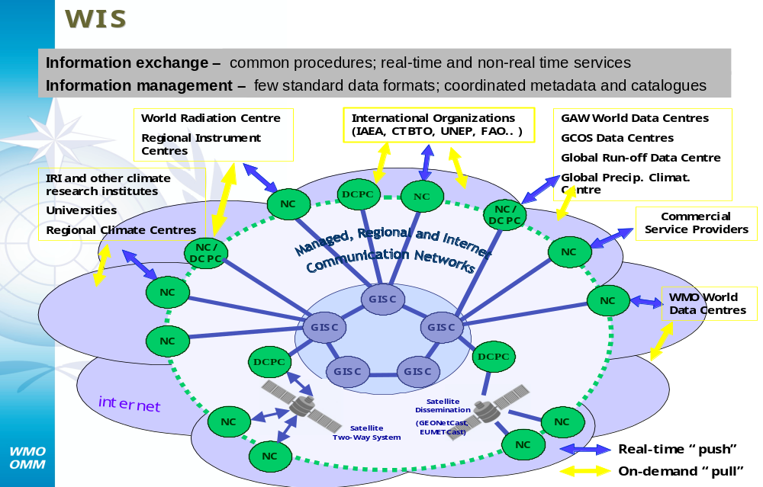

Fig. 1: Functional Structure and User Community of WIS

WIS will provide the solution for the information exchange needs of NMHSs, and other national centres (NCs), such as relevant non-NMHS agencies/users, research facilities, and international programme centres. It will offer (“push” and “pull”) automated collection and dissemination of time-critical information (e.g., meteorological, climatological, environmental and hydrological observations, forecasts, and warnings); timely delivery of high-volume data and products (appropriate to requirements); and ad-hoc information discovery/access/retrieval services.

NC (National Centre)
As is the case in the current GTS of WMO, WIS also requires reliable national centres, referred to as NC. The NC is responsible for collecting and providing observational data and products intended for global or regional distribution to their responsible GISC or DCPC, and distributing data on a national basis. The NCs coordinate or authorise the use of the WIS by eligible national users. According to the national policy, more than one NC can exist in a country. Normally the Permanent Representative (PR) of the country establishes the national policy and practice and coordinates the various users. Globally, 187 NCs (i.e., one per Member country or territory) plus about 100 additional NC with national responsibilities will be part of the WIS infrastructure.

DCPC (Data Collection and Production Centre)
Centres that fulfil within specific WMO Programmes an international responsibility for the collection, generation and provision for international distribution of data, forecast products, processed or value-added information, and/or for providing archiving services, are referred to as Data Collection and Production Centres. DCPCs also provide basic WIS functions such as metadata catalogues, Internet portals and data access management. Examples of DCPCs are the Regional Specialized Meteorological Centres (RSMC) with activity specialization or geographic specialization, the GTS Regional Telecommunication Hubs as well as the Regional Climate Centres, the Hadley Centre (UK), ACMAD, the World Data Centres in Asheville (N.C., USA), Obninsk (Russian Federation), EUMETSAT and NESDIS. In total, about 150 centres are expected to perform DCPC functions.

GISC (Global Information System Centre)
The regional and global connectivity of the WIS structure is guaranteed by the existence of a small number of node centres called Global Information System Centres (GISC). There will be less than ten in total, whose combined areas of responsibility cover the whole World. They collect and distribute the information meant for routine global dissemination, and in addition, they serve as collection and distribution centres in their areas of responsibility, and provide entry points for any request for data held within WIS. Similar to the DCPCs, they maintain metadata catalogues of all information available within the WIS and provide a portal for data searches. This service will greatly facilitate data searches by researchers.

Network structure
The data communication network connecting the various parts of WIS is based on an agreed technology that is commonly available to the participating centres and capable of handling the foreseen traffic. There are satellite communication channels as well as terrestrial links or managed data network services. Generally TCP/IP is the preferred transmission protocol, and the WIS can adjust to any evolving international protocol according to the technological progress. While the WMO code formats will be used for real-time exchange of operation-critical data, the user will be able to select from a wide variety of optional data representation formats. Metadata information should be available in a standard format, e.g. XML. The current diversification of access points and methods would be replaced by a common approach. Furthermore, the portal structure provided by WIS would make it possible for programmes to present their data to their users in a programme specific query format.

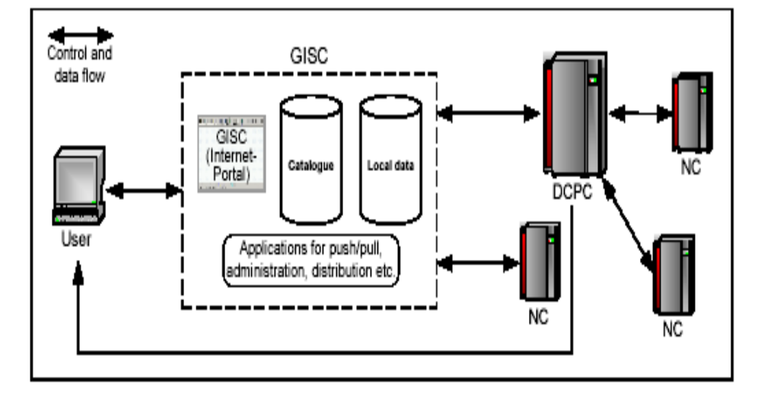
Fig.2 : Structure of WIS

The WIS should provide various types of services to meet the different requirements; the following fundamental types of services could be identified:

(1) Routine collection and dissemination service for time-critical and operation-critical data and products
This service is based on real-time “push” mechanism including multicast and broadcast; it would be implemented essentially through dedicated telecommunication means providing a guaranteed quality of service, e.g. leased circuits, dedicated data communication network services and satellite-based data-distribution systems

(2) Data Discovery, Access and Retrieval service
This service is based on request/reply “pull” mechanism with relevant data management functions; it would be implemented essentially through the Internet (HTTP, FTP,…)

(3) Timely delivery service for data and products
This service is based on delayed mode “push” mechanism; It would be implemented through a combination of dedicated telecommunication means (used for (1)) and of public datacommunication networks, especially the Internet.

It is envisaged that dynamic adjustment and management of services (1) and (3) could be provided through flexible user interfaces.

The GTS is being further improved and will evolve into the core network of the WIS. Based on international ICT standards, WIS will facilitate the coordinated real-time data collection and dissemination service of operation-critical data. In addition, WIS will provide coordinated “push-pull” services and the information discovery, access and retrieval needs of all WMO and relevant co-sponsored international programmes, as well as eligible non-NMHSs users at national level. Through the role of the NMHS’s NMC as an NC, WIS will enhance the visibility and importance of the NMHS in the country. The NMHS gains timely and cost-effective access to information, in particular new data and products, which will enhance its own operations. The National Meteorological Centre (NMC) will also be able to provide to other relevant national agencies/users (such as research, disaster mitigation, agriculture, energy and water management) WIS services in accordance with national policy and practices and facilitate for them access to information that was, so far, not available to them. Upon agreed operating criteria, the NMC will “push” to them routine information, e.g., warnings, advisories, selected measurements, etc., and help discover, select and channel relevant information to the users, either ad hoc, in the “pulling” mode, or in reply to a non-real-time request.

By using industry standards, off-the-shelf hardware and software, including open source software, WIS is a cost-effective solution for all Members and their NMHSs. This means that the initial investment is determined by the cost of PCs and Internet, VPN and VSAT connections, as required. Whether there might be an additional financial burden on the NMC or not will depend on how the national network is organized. There will be no additional cost if the “other” NCs are directly connected to the WIS Network Service Provider as their data would then not flow through the NMC circuits.

WIS complies with the WMO data policy (Res. 40 (Cg-XII) and Res. 25 (Cg-XIII)), and its flexible design can follow an evolution of the WMO data policy. In particular, the handling of essential and additional data and products with respect to Res. 40 (Cg-XII) will be unchanged. Procedures for managing access rights, control of data retrieval, registration and identification of users, etc. can be defined as and when required. Anonymous downloading is technically possible, but depends on whether a NC permits that feature. WIS has no system-inherent features that would defy international legal frameworks, laws, conventions, copyrights, or patents.

Implementation

The implementation of WIS builds upon the most successful components of existing WMO information systems, and a smooth and coordinated transition is crucial.

EC-LVIII “emphasized that with the sustained progress benefiting from Information & Communication Technology (ICT) development made in its implementation, operation and upgrade, the GTS, including satellite-based data-distribution systems and the Improved MTN, would effectively contribute to the WIS implementation as the core communication component for exchange and delivery of time-critical and operation-critical data and products”.

The first phase of the WIS implementation is the GTS for time-critical and operation-critical data, which is under continuous upgrades and improvements. The operational data exchange service provided by the GTS, which is currently mainly focused on WWW requirements, will be extended to operational requirements of other programmes as part of the WIS.

The second phase of WIS implementation would provide for an extension of the information services through more flexible data discovery, access and retrieval services to all users, as well as more flexible timely delivery services.

The concept of WIS requires development of the following major functions and the necessary software packages:

- Metadata catalogues;
- Internet portal;
- Data acquisition service;
- Data discovery service;
- Data distribution service: push and pull;
- Monitoring;
- Operational aspects like data synchronisation, back-up, administrative issues, etc.

To that end, valuable work is being already undertaken by the various pilot projects in the different Programmes, such as:

- CBS RA VI - VGISC project;
- EUMETNET UNIDART project (Uniform data request interface);
- JCOMM GISC-E2EDM prototype (Obninsk, Russian Federation);
- CBS VPN Pilot Project in RAs II and V;
- CCl CliWare in the Russian Federation (Obninsk, Russian Federation);
- CAgM WAMIS (World Agrometeoroloigcal Information Service, South Korea);
- THORPEX/TIGGE (THORPEX Interactive Grand Global Ensemble).

By the end of 2006, it might be possible to achieve, in a few countries, new prototype WIS structures running in a pre-operational mode. The initial phase of the WIS implementation plan includes the following elements:

- The GTS for time-critical and operational-critical exchange of data and products
- Reference implementation WMO Core metadata
- Integration of metadata structures into pilot GISCs and DCPCs
- Internet portal
- Basic data acquisition, discovery and push-pull services
- RA VI VGISC project as a GISC prototype
- DCPCs prototypes including the ECMWF and EUMETSAT DCPC projects associated with the VGISC project
- NCAR DCPC prototype
- DCPC prototype for JCOMM related data
- Technical Conference on WIS (Seoul, Korea, 6-8 November 2006) preceding CBS-Ext.06

Outlook

A concerted effort by the WMO Members that crosscuts over all WMO Programmes and integrates their information exchange needs is being pursued to reach these goals. In this connection, the WMO Executive Council stated in 2003:

“The support and involvement of regional associations and technical commissions [are] needed, as early as possible, in all phases of the WIS development in order to ensure a full and shared ownership of the project, and its effective implementation.”

Furthermore, industrial involvement and strong project coordination are crucial. A crosscutting activity has been launched and a WIS Coordination Office has been established in the Secretariat, which should proactively coordinate these tasks and also act as a channel to the industry. During the Technical Conference to be held in connection with the CBS-Ext.(06) session in late 2006, the status of the implementation will be reviewed.

Based on conclusions and agreements of CBS, pilot projects should become semi-operational to gather valuable experience with the WIS concept. The newly created GISCs should at that time implement the global data exchange envisaged. As a next step, various DCPCs should offer their data for access and ease the data discovery and retrieval burden for the related Programmes. Furthermore, at this stage the different Programmes should extend the metadata catalogue held in the GISCs by bringing in their own special data requirements and use the WIS features to disseminate their products. In this way, the enhanced functions provided by WIS will be gradually introduced and expanded from 2006 onwards.

____________________

Environment in the context of WMO comprises phenomena of weather, climate and water
Global Earth Observation System of Systems (GEOSS)

