WORLD METEOROLOGICAL ORGANIZATION  __________________  WMO INTEGRATED GLOBAL OBSERVING  SYSTEMS (WIGOS) PILOT PROJECT FOR AMDAR,  Fifth Session  &  AMDAR Panel Management Group Meeting  DE BILT, THE NETHERLANDS,  28 FEBRUARY – 4 MARCH 2011 |  | WIGOS-PP-5-AMDAR-MG/Doc.2.1(2)  (17.II.2011)  ______  ITEM: 2.1  ORIGINAL: ENGLISH

STATUS OF THE WIGOS PILOT PROJECT FOR AMDAR

Improved Water Vapor Mass Mixing Ratio and Other New Parameters in the
AMDAR BUFR Template

(Submitted by Axel Hoff)

Summary and Purpose of Document

This document contains information on improved water vapor mass mixing ratio and other new parameters in the AMDAR BUFR Template.

ACTION PROPOSED

The Fifth Session is invited to take into consideration the contents in this document.

____________________

Improved Water Vapour Mass Mixing Ratio
and Other New Parameters
in the AMDAR BUFR Template
Deutscher Wetterdienst (DWD)
German Meteorological Service

Axel Hoff
Dep. Observing Networks and Data
Div. Measurement Technology, TI 22

February 2011

Contents
1 Introduction 5
2 Humidity, a New Parameter for the Water Vapour Mixing Ratio and Upgraded Code Tables 6
2.1 The Conceivable Extreme Values of the Water Vapour Mixing Ratio 6
2.1.1 The Maximum Value of the Water Vapour Mass Mixing Ratio 7
2.1.2 The Minimum Value of the Water Vapour Mass Mixing Ratio 7
2.2 The Size of the Binary Number in BUFR 8
2.3 Code Table No. 0 02 097, “Type of Humidity Sensor” 9
2.4 Code Table No. 0 33 026, “Moisture Quality” 10
3 Other Additional BUFR Parameters 10
3.1 Pressure Altitude 10
3.2 De-Icing 11
3.3 Aircraft Status 11
3.4 Volcanic Ash 11

Acronyms Table

ACARS | Aircraft Communications Addresssing and Reporting System
AMDAR | Aircraft Meteorological Data Relay
BUFR | Binary Universal Form for the Representation of Meteorological Data
CIMO | Commission for Instruments and Methods of Observations
NWP | Numerical Weather Prediction
WMO | World Meteorological Organization
WVSS-II | Water Vapour Sensor System No. II

- Introduction
The aircraft fleet of AMDAR (Aircraft Meteorological Data Relay) will be more and more equipped with humidity sensor systems. The type of instruments (SpectraSensors, WVSS-II) is based on a special absorption measurement technique. The locally measured temperature and pressure of the screened air volume is taken for an internal calculation of the water vapour mass mixing ratio. This value is the instrument’s output parameter. The lower detection limit of the system’s generation of 2006 has been about 0.05 g/kg at ground pressure (≈ 0.25 g/kg at 200 hPa, with the same absolute humidity taken).
The corresponding element in the old BUFR templates is coded with 14 bits and the resolution is 0.01 g/kg (10⁻⁵ kg/kg). This leads to a range until 164 g/kg. Up to now these numbers have been sufficient. Meanwhile some re-engineering of the instrument leads to detection limits being well below 0.01 g/kg.
Additionally, the code tables No.
- 0 02 097, type of humidity sensor
- 0 33 026, moisture quality
do not correspond to the current state.
On the WMO AMDAR Panel Meeting 2009 and the Panel’s Management Group Meeting in March 2010 the new BUFR template No. 3 11 010 was presented. In that template the humidity parameter No. 0 13 002 (Mixing Ratio) has to be adjusted with operator descriptors to change the data width and scale, or an additional mixing ratio parameter has to be created. The new values of resolution (10⁻⁵ g/kg) and range (84 g/kg) are derived in chapter 2. In addition the table No. 0 33 026 of quality items has to be upgraded or replaced.
Furthermore other parameters, such as
- pressure altitude (see 3.1),
- de-icing (see 3.2),
- aircraft status (see 3.3),
should also be integrated in forethought of future ARINC 620 upgrades.

- Humidity, a New Parameter for the Water Vapour Mixing Ratio and Upgraded Code Tables
  - The Conceivable Extreme Values of the Water Vapour Mixing Ratio
The water vapour mixing ratio is defined as
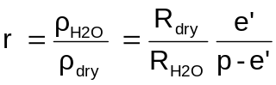 (1)
with the gas constants as described in Sonntag (1990):
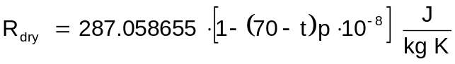 of dry air (2)
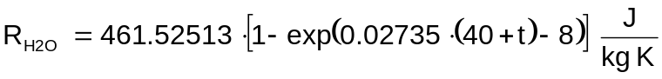 of water vapour (3)
The symbols are
ρ_{H2O}, ρ_{dry} : densities of water vapour and dry air respectively
e’, p : pressure of water vapour and pressure of moist air respectively
t : temperature, in units of: °C
p : air pressure in Formula (2) to be used in units of: hPa
The saturation pressure e_{w,i} of water vapour in the pure phase over water or ice has a fixed relation to the dewpoint temperature as described in Sonntag (1990):
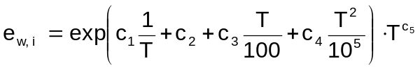 (4)
with
e_{w,i} : in units of: hPa
T : in units of: K
The constants c₁, ..., c₅ are listed in the following table:

 | over water  - 100 ... + 100 °C | over ice  - 100 ... + 0.01 °C
c₁ | - 6096.9385 | - 6024.5282
c₂ | + 16.635794 | + 24.7219
c₃ | - 2.711193 | + 1.0613868
c₄ | + 1.673952 | - 1.3198825
c₅ | + 2.433502 | - 0.49382577

To get the saturation pressure, e’ of water vapour in moist air then the enhancement factors, f_{w} and f_{i} have to be applied:
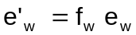 (5)
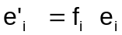 (6)
with
(7)
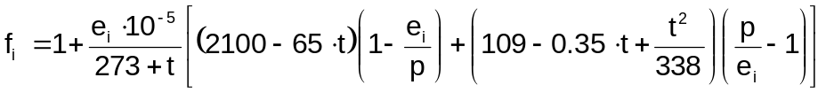 (8)
The symbols are
t : temperature in units of: °C
p : air pressure in units of: hPa

The water vapour pressure values derived by these formulae differ from those coming from the CIMO Guide or from the Technical Regulation 2000 by far below ± 5 %. This has no decisive influence on the calculations about the range and the resolution (see 2.2).
The range of mixing ratios to be found in the atmosphere now can be determined by looking at the corner values of temperature and pressure. The part of the atmosphere we are limited to is the height section between ground and the flight level of 42,000 ft (12.8 km or 170.4 hPa). Very few aircraft may get up to 45,000 ft (13.7 km or 147.5 hPa) but the normal traffic of passenger aircraft is not in this altitude. If an aircraft is the instrument’s carrier, the range of air pressure values to be considered is for sure within 1100 hPa and 150 hPa.

    - The Maximum Value of the Water Vapour Mass Mixing Ratio
The maximum of the observed dewpoints on earth is below 40 °C. Extremes like 30 °C or a few degrees more can occur in the ground level of the troposphere. If one takes the corner value of 40 °C and an air pressure of 1100 hPa the resulting hypothetic mixing ratio value by use of the equations (1) to (9) is

    - The Minimum Value of the Water Vapour Mass Mixing Ratio
The lowest values of the water vapour pressure are given at low temperatures. The most extreme minima observed on ground are above - 80 °C. At relative humidity of 100 % and a pressure of 1100 hPa the mixing ratio there would be at about 3•10⁻⁴ g/kg. In the lower stratosphere at 150 hPa the mixing ratio would fall short of that value only at temperatures being lower than - 90 °C which is never observed. Hence, the corner value of the lowest temperature on ground should be taken.
The other question now to be cleared is about the minimum humidity value to be resolved in the measurements. The CIMO guide gives requirements for the relative humidity, such as
- 5 % in the standard error of upper-air measurements,
- 1 % in the reporting code resolution of surface measurements.
With the application of
- the relative humidity: 1 %,
- the ground pressure: 1100 hPa,
- and the temperature: - 80 °C
we get to a water vapour mass mixing ratio of
r_{min} = 3.1 • 10⁻⁴ g/kg

  - The Size of the Binary Number in BUFR
The resolution of the new parameter for the water vapour mass mixing ratio should be at least 10⁻⁴ g/kg or 10⁻⁷ kg/kg. Then this number should get a length of at least 19 Bit (→ 52.4 g/kg) to cover the physical maximum of 42 g/kg.
The resolution above is beyond the actual performance of the series products in the humidity measurement technique. In the next years there will be some progress in the physical methods to get to lower detection limits. Furthermore, if there should be a leftover of range where a malfunction of the measurement system could be reflected, such as sensors response at its lower or upper limit, another specification is recommendable:
resolution = 10⁻⁵ g/kg = 10⁻⁸ kg/kg
range = 23 bit → 83.9 g/kg
For the assimilation processes in the NWP this leads to an easier identification of incorrectly working sensor units.

  - Code Table No. 0 02 097, “Type of Humidity Sensor”
In this table the IR absorption sensors SpectraSensors, Type WVSS-II, Version 2006 and 2009 have to be inserted (http://www.wmo.int/pages/prog/www/WMOCodes/CodeFlagTables_Mar2010.pdf).
The upgraded table could look as follows:

Code Figure | Sensor Type | Status
0 | VIZ Mark II Carbon Hygristor | Operational
1 | VIZ B2 Hygristor | Operational
2 | Vaisala AHumicap | Operational
3 | Vaisala HHumicap | Operational
4 | Capacitance sensor | Operational
5 | Vaisala RS90 | Operational
6 | Sippican Mark IIA Carbon Hygristor | Operational
7 | SpectraSensors WVSS-II, Version 2006 | Operational
8 | SpectraSensors WVSS-II, Version 2009 | Operational
9 - 29 | Reserved
30 | Other
31 | Missing Value

  - Code Table No. 0 33 026, “Moisture Quality”
The set of numbers within this table should be extended by those for the humidity sensors WVSS-II version 2006 and version 2009 (see also Software Requirements Document for the Atmospheric Water Vapor Sensing System On UPS 757-200F Aircraft, 2005 and 2010).

Code figure
0 | Normal operations - measurement mode
1 | Normal operations - non-measurement mode
2 | Small RH
3 | Humidity element is wet
4 | Humidity element contaminated
5 | Heater fail
6 | Heater fail and wet/contaminated humidity element
7 | At least one of the input parameters used in the calculation of mixing ratio is invalid
8 | Numeric error
9 | Sensor not installed
10 | Normal operation
11 | Calculated RH > 100%
12 | Input laser power too low
13 | Probe WV Temp. out of range
14 | Probe WV Press. out of range
15 | Spectral line out of range
16 | No laser output
17-62 | Reserved
63 | Missing value

- Other Additional BUFR Parameters
This chapter refers to the BUFR Table D of March 2010, where inter alia the new parameters like
- GNSS altitude,
- seconds,
- flight mechanical parameters like attitude angles and speed vectors,
already are inside.

  - Pressure Altitude
As an alternative to the parameter 0 07 004 (pressure) it should be possible to transmit as well the pressure altitude as it is done up to now. This option should be kept open because the currently used air-to-ground data transmissions only send this conventional kind of “pressure” value.

  - De-Icing
Not only the signal of the aircraft’s icing sensor (0 20 042, Airframe Icing) is of importance. The other thing is the activity of the de-icing process. Besides of the front edges of wings and engines also the TAT housings (Total Air Temperature) are heated. Depending on the types of housings this has more or less an influence on the temperature measurement. If the air-to-ground data link is able to transmit this information (1 Bit) it would be very useful for systematic temperature bias corrections.

  - Aircraft Status
Different extensions of the flaps may have different influence on the measurements of wind and even temperature and humidity. For systematic correction processes in the meteorological data assimilation it would be useful to know about the status of the aerodynamic aircraft configuration including the status of the landing gear and the weight-on-wheels switch. A number with 4 bit would give enough information, such as listed in the following table:

Value | Meaning
0 | configuration undefined / not reportable
1 | Clean configuration, gear retracted
2 | first position of flaps extension, gear retracted
3 | second position of flaps extension, gear retracted
4 | third position of flaps extension, gear retracted
5 to 7 | reserved
8 | only landing gear down and in place
9 | first position of flaps extension + landing gear down and in place
10 | second position of flaps extension + landing gear down and in place
11 | third position of flaps extension + landing gear down and in place
12 to 14 | reserved
15 | weight on wheels = True

The last item (15) is of extremely good use at least because of the fact that sometimes there are test runs to be done on ground with the base system (i.e. ACARS). These test reports always disturb the meteorological data interpretation.

  - Volcanic Ash
The very next upgrade of ARINC 620 describing the contents and coding of the data link between aircraft and ground also consists of parameters describing the particle size spectrum of the volcanic ash.
In the table of the following page the parameters are specified for BUFR
(personal communication with Fernand Karcher, Meteo France and Andreas Petzold, DLR).
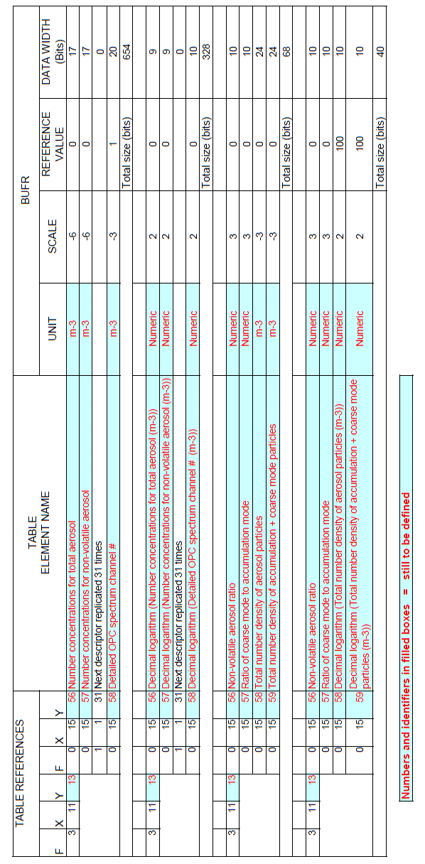
References

WMO: Code Tables and Flag Tables Associated with BUFR/CREX Table B
WMO: Guide to Meteorological Instruments and Methods of Observation (CIMO Guide), WMO-No. 8, Seventh Edition (2008)
Sonntag, D.: Important new Values of the Physical Constants of 1986, Vapour Pressure Formulations based on the ITS-90, and Psychrometer Formulae, Z. Meteorol. 70 (1990) 5, 340 - 344
SpectraSensors Inc., USA: Software Requirements Document for the Atmospheric Water Vapor Sensing System On UPS 757-200F Aircraft (2005)
SpectraSensors Inc., USA: Software Requirements Document for the Atmospheric Water Vapor Sensing System On UPS 757-200F Aircraft (2010)

