WORLD METEOROLOGICAL ORGANIZATION  ____________________  COMMISSION FOR BASIC SYSTEMS  OPAG-IOS  TASK TEAM ON GOS REGULATORY MATERIAL  Second Session  (CBS OPAG-IOS/TT/GRM-2)  GENEVA, SWITZERLAND, 20-22 FEBRUARY 2006 | CBS OPAG-IOS/TT-GRM-2/Doc. 7(2)  (13.II.2006)  __________  ITEM: 5  Original: ENGLISH

Amendments to the GUIDE ON THE GLOBAL OBSERVING SYSTEM

(WMO-No. 488)

(Submitted by WMO Secretariat)

Summary and Purpose of Document

The document contains a proposal for replacement of Part II of the Guide on the Global Observing System, WMO-No. 488, which deals with Requirements for observational data and their evaluation against observing system capabilities, and of Part IV of the same Guide, which deals with the space-based subsystem. The proposal includes the amendments to Part II and Part IV that were already proposed under Document

The purpose of replacing Part II is to introduce the Rolling Requirement Review which has been, since 1998, the main process followed for updating WMO observational requirements and providing guidance for the evolution of the Global Observing System. Rather than summarizing the outcome of the Rolling Requirement Review process, it is proposed to make reference to existing documents such as the “Statements of Guidance” and the “Implementation Plan for Evolution of the space and surface-based subsystems of the GOS”.

The proposed new Part IV is meant to reflect important changes that have taken place in the space-based subsystem of the GOS concerning in particular satellite configuration and data dissemination methods.

ACTION PROPOSED

TT/GRM-2 is invited to consider the proposed text and take the appropriate actions.
Reference:
- Guide on the GOS, WMO-No. 488
- CBS, Extraordinary Session, Cairns, 4-12 December 2005, Abridged Final Report with Resolutions and Recommendations, WMO-No. 955
- CBS, Thirteenth Session, St. Petersburg, 23 February–3 March 2005, Abridged Final Report with Resolutions and Recommendations, WMO-No. 985

P A R T II

REQUIREMENTS FOR OBSERVATIONAL DATA

  - GENERAL

Weather prediction and other environment related activities involve analyses of observational data. Weather prediction, in particular, is based on precise meteorological analyses. All analyses require highly reliable observational data which are received in a timely manner at analysis centres, from a sufficiently dense network or other source of observations. In the case of meteorological analyses, the required accuracy, temporal and spatial resolution and timeliness of these data are dependent upon:

- the different scales of meteorological phenomena to be analysed:
- the resolution and other characteristics of the techniques used to perform the analyses and modelling based upon them.

Requirements for observational data are always specific to purpose and change with time as techniques improve. In general, they have become more demanding as the power of computers has increased and operational Numerical Weather Prediction (NWP) and associated models have become better able to represent smaller scale phenomena.

Various meteorological phenomena in different scales co-exist in the atmosphere. For example, one cell of a thunderstorm is only several kilometres in horizontal scale and has a lifetime of several hours while a tropical cyclone is about 1000 kilometres in horizontal scale and has a lifetime of 10 days or more; many thunderstorms cells appear and disappear during the life cycle of a tropical cyclone. Therefore, the frequency and spacing of observations should be adequate to obtain observational data which describe temporal and spatial changes of the meteorological phenomena with sufficient resolution to meet the requirements of the users. If the spacing of observations is more than 100 km, meteorological phenomena which have a horizontal scale of less than 100 km are not usually detectable. The classification of horizontal scales of the meteorological phenomena given in the Manual on the GOS (WMO-No. 544), Volume I. is as follows:

(a) Microscale (less than 100 m) for agricultural meteorology, e.g. evaporation;
(b) Toposcale or local scale (100 m - 3 km), e.g. air pollution, tornadoes;
(c) Mesoscale (3 km - 100 km), e.g. thunderstorms, sea and mountain breezes;
(d) Large scale (100 km - 3000 km), e.g. fronts, various cyclones, cloud clusters;
(e) Planetary scale (larger than 3000 km), e.g. long upper tropospheric waves.

Horizontal scales are closely related to the time scales of the phenomena. Bigger horizontal-scale perturbations are likely to survive for a longer time period (Figure II. 1). Therefore, short-range weather forecasts require more frequent observations from a denser network over a limited area in order to detect any small scale phenomena and their development. As the length of the forecast period increases, so does the area over which observations are required. Because of the dynamic interaction between the meteorological phenomena at different scales, it may not be possible to specify definitively requirements for individual scales.

Requirements are generally divided into three categories:

- Global requirements refer to observational data needed by WMO Members for a general description of large-scale and planetary-scale meteorological phenomena and processes;

- Regional requirements are related to observations needed by two or more WMO Members to describe in greater detail the large- and planetary-scale atmospheric phenomena, as well as to describe smaller ones on the meso- and small scales as may be agreed by Regional Associations;

- National requirements are determined by each individual WMO Member in the light of its own interests.

Although the above discussion has been focussed upon processes taking place in the atmosphere and meteorological uses of the data, similar considerations apply to processes taking place at the earth’s surface and for applications such as hydrology and agrometeorology. Controlling physical and chemical processes set the scale that analyses must resolve and interactions between them determine the domain from which data are required.
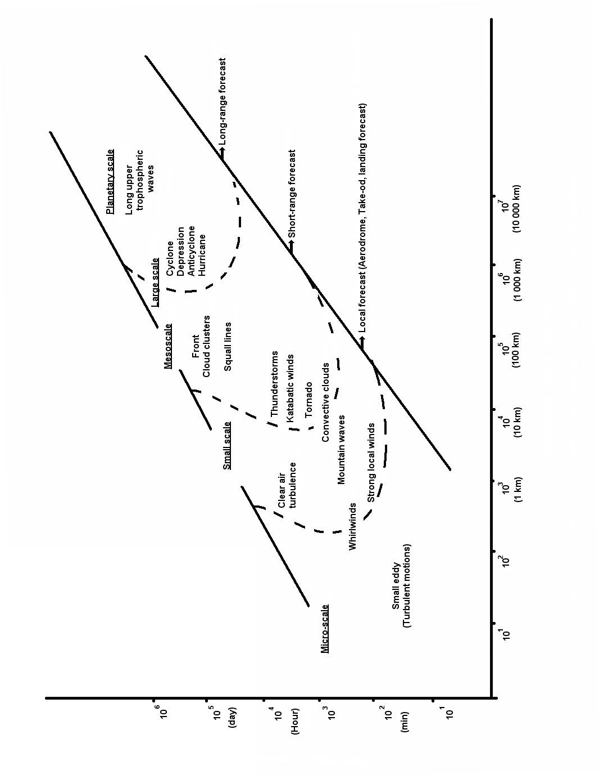
Horizontal scale (metres)

Figure II.1 - Horizontal and time scales of meteorological phenomena

  - ASSESSMENT AND FORMULATION OF OBSERVATIONAL DATA REQUIREMENTS

Assessment of data requirements is an ongoing process based on the need for information services and an evolving level of experience with actual and candidate observing systems. A number of techniques and tools are available to carry out the assessments. Some require substantial resources and are best deployed to test specific hypotheses. They include:
    - Data sensitivity tests or Observing System Experiments (OSEs)
Such tests demand actual observations, from operational, pilot, demonstration or research networks and systems and an NWP capability. Most straightforward experiments may be characterised as data-denial or data-inclusion experiments. Typically, an assimilation-prediction system is run with a control data set, and then with one or more data types withheld, or reduced in quantity. Analyses or forecasts are verified against observations. Comparison of the two runs indicates the effect of data denial, or, equivalently, the value of the observing system when included. OSEs are valuable, for example, in examining the impact of temporal or spatial changes in the network configuration, or of adding or deleting existing observing systems, without actually making operational changes.
2.2.2 Observing System Simulation Experiments (OSSEs)

OSSEs deal with hypothetical or simulated data sets and are useful for estimating how an entirely new observing system might affect forecast accuracy. A historical forecast is usually designated as the control run; it describes the "true" atmosphere. Hypothetical observations with plausible error characteristics are then manufactured from the control run at designated locations and times. The observational data set to be examined is then assimilated by a prediction model, and a new forecast is generated in parallel with the control forecast. The impact of the simulated observing system is approximated by the difference between the two forecasts. OSSEs, despite their limitation to hypothetical observations, are an important part of assessing the potential utility of data from a system before it is actually implemented.
2.2.3 Theoretical studies and simulations

Theoretical studies and simulations of expected data utility from potential future sensor systems can be important in planning changes to the existing observing system. For example, substantial theoretical studies and simulations were conducted prior to the launch of the first GOES I-M series of satellites to predict the performance of the sensors. The results of this work provided an important part of the basis for designing the ground data processing system, as well as many other aspects of the support facilities required. As systems become increasingly complex and costly, the need for well-planned theoretical studies and simulations should increase. They are an important way of reducing the risk in making decisions to develop and implement systems still in the conceptual or research stage.

2.2.4 Laboratory assessments

Some assessments, particularly of data processing and display techniques, are best and/or more economically conducted in a controlled laboratory environment. Several WMO Members have the capability to develop and test techniques for data processing and display. In the past, the results from their work have been instrumental in designing both individual sensor suites and networks.

2.2.5 System design and analysis activities

System design and analysis activities are concerned primarily with identifying the cost and operational impact of recommended changes stemming from the scientific studies. These activities also include the design and coordination of any field and/or pilot projects that may be needed.

2.2.6 Field site assessments

Existing field sites offer the opportunity to examine the impact new data sets could have on forecasting and on the generation of products and services. Such evaluations become especially important in both the early and late stages of development/deployment to ensure that operational support is defined properly, is in place when needed, and that the field personnel are trained to obtain the best results from new systems.

  - THE EVALUATION OF REQUIREMENTS AGAINST SYSTEM CAPABILITES

It is a challenging exercise to bring together the expertise gained as described above and develop a consensus view on the design and implementation of composite observing systems. This is particularly so where the need and implementation occur on global or regional scales. CBS has encouraged the development of a procedure to accomplish this, as objectively as possible. The procedure is known as the Rolling Requirements Review.

2.3.1 The Rolling Requirements Review (RRR) Procedure

The procedure jointly reviews users‘ evolving requirements for observations and the capabilities of existing and planned observing systems. Statements of Guidance, as to the extent to which such capabilities meet requirements, are produced as a result. Initially, the procedure was applied to the requirements of global NWP and the capabilities of the space-based sub-system but more recently the range of requirements has been expanded and the technique has begun to be applied successfully to surface-based observing systems and other application areas.

The procedure consists of four stages:

(i) a review of users' requirements for observations, within an area of application covered by WMO programmes;

(ii) a review of the observing capabilities of existing and planned observing systems;

(iii) a "Critical Review" of the extent to which the capabilities (ii) meet the requirements (i); and

(iv) a "Statement of Guidance" based on (iii).

The aim of the Statement of Guidance, together with the output of the Critical Review, is:

- to inform WMO Members on the extent to which their requirements are met by present systems, will be met by planned systems, or would be met by proposed systems. It also provides the means whereby Members, through the Technical Commissions, can check that their requirements have been correctly interpreted and can update them if necessary, as part of the Rolling Requirements Review procedure.

- to provide resource materials useful to WMO Members for dialogue with observing system agencies regarding whether existing systems should be continued or modified or discontinued, whether new systems should be planned and implemented, and whether research and development is needed to meet unfulfilled aspects of the user requirements.

Clearly, the RRR procedure needs to be repeated periodically as requirements change and further information becomes available. Figure II.2 indicates the anticipated interactions with observing system agencies and user groups.

2.3.2 The Database on User Requirements and Space Capabilities

To facilitate the RRR procedure the WWW Department has been collecting the requirements for observations to meet the needs of all WMO Programmes, based on the techniques such as those listed in section 2.2, and also cataloguing the current and planned provision of observations, initially from environmental satellites and now extended to in situ observing systems. The resulting database is called the Database on User Requirements and Observing System Capabilities and is accessible via the WMO Satellite Activities Homepage: http://alto-stratus.wmo.ch/sat/stations/SatSystem.html . For example, Attachment II.2, extracted from this database, tabulates the observations required currently for Global NWP.

2.3.2.1 User requirements

The user requirements are user oriented, not system dependent; they are intended to be technology-free in that no consideration is given to what type of measurement characteristics, observing platforms, or data processing systems are necessary (or even possible) to meet them. The requirements are aimed at the 2005-2015 time frame. The database has been constructed in the context of a given application (use). The requirements for observations are stated quantitatively in terms of a set of relevant parameters, of which the most important are horizontal and vertical resolution, frequency (observation cycle), timeliness (delay in availability), and accuracy (acceptable RMS error and any limitations on bias). For each application, there is usually no abrupt transition in the utility of an observation as its quality changes; improved observations (in terms of resolution, frequency, accuracy, etc.) are usually more useful while degraded observations, although less useful, are usually not useless. Moreover, the range of utility varies from one application to another. The requirements for each parameter are expressed in terms of two values, a maximum – or “objective“- and a minimum – or “threshhold“- requirement. The "maximum" requirement ( or „objective“) is an optimal value : if exceeded, no significant improvement is expected in performance for the application in question. Therefore the cost of improving the observations beyond this maximum requirement would not be matched by a corresponding increased benefit.

Maximum requirements are likely to evolve; as applications progress, they develop a capacity to make use of better observations. The "minimum" requirement is the threshhold below which the observation is not significantly useful for the application in question, or below which the benefit derived does not compensate for the additional cost involved in using the observation. Assessment of minimum requirements for any given observing system is complicated by assumptions concerning which other observing systems are likely to be available. It may be unrealistic to try to state the minimum requirement in an absolute sense, because the very existence of a given application relies on the existence of a basic observing capability. Within the range between the minimum and maximum requirements, the observations become progressively more useful.

2.3.2.2 Observing system capabilities

Initially, attention has focussed on the capabilities of the GOS space-based subsystem. Each of the contributing space agencies has provided a summary of the potential performances of their instruments, expressed in the same terms as the user requirements, together with sufficiently detailed descriptions of the instruments and missions to support evaluation of the performances. Assessment of service continuity is based on the programmatic information supplied. Particular care has been taken to establish a common language, in the form of agreed definitions for the geophysical parameters for which observations are required / provided and agreed terminology to characterise requirements and performances.

At present, the performance of elements of the GOS surface-based subsystem have also been characterised in a similar manner, taking into account their uneven distribution on a global basis in thirty-four (34) homogeneous regions.

2.3.3 The Critical Review

The comparison of requirements to capabilities utilizes the database delineating both. As the database changes better to reflect the user requirements as well as existing and planned observing capabilities, the RRR must be performed periodically.

The process compares user requirements with the observing system capabilities and records the results in terms of the extent to which the capabilities of present, planned and proposed systems meet the stated requirements. This is a challenging process and considerable work has been done to evolve a process and presentation for the Critical Review to meet the following criteria:

- The presentation must be concise and attractive, and understandable to senior managers and decision makers, whilst retaining sufficient detail to represent adequately the full range of observation requirements and observing system capabilities;

- The presentation of user requirements must be accurate; although necessarily a summary, it must be recognizable to experts in each application as a correct interpretation of their requirements;

- The presentation of the observing system capabilities must be accurate; although also a summary, it must be recognizable to expert data users as a correct interpretation of the systems' characteristics and potential;

- The results must accurately reflect the extent to which current systems are useful in practice, whilst drawing attention to those areas in which they do not meet some or all of the user requirements; and

- The process must be as objective as possible

An example of the output of the Critical Review of the space-based subsystem’s capabilities to meet the requirement to measure wind profiles for the NWP application is shown in Attachment II.1. This is a single parameter for a single applications area. The process produces hundreds of these charts, but software tools have been developed which provide the required subsets of charts to experts involved in the RRR.

2.3.4 Statements of Guidance

The role of a Statement of Guidance is to provide an interpretation of the output of the Critical Review, to draw conclusions, and to identify priorities for action. The process of preparing such a Statement is necessarily more subjective than that of the Critical Review. Moreover, whilst a Review attempts to provide a comprehensive summary, a Statement of Guidance is more selective, drawing out key issues. It is at this stage that judgements are required concerning, for example, the relative importance of observations of different variables.

Since the Preliminary Statement of Guidance published in 1998 [WMO,1998], several updates and additions have been completed in order to extend the process to new application areas, to take into account the evolving nature of requirements, and to include the capabilities of surface-based sensors [WMO, 1999], [WMO,2001].

The latest statements of guidance can be found on the WMO Space Programme Home Page at following address : http://www.wmo.int/web/sat/sog/sog_contents.htm

2.4 ADDITIONAL NATIONAL REQUIREMENTS

Observing networks may be required at national level, in addition to the GOS, for interpretation of processed forecast fields into local weather parameters, for verification of the quality of issued forecasts and warnings, and for other (real or non-real-time) applications. The observational data required for this purpose include surface and upper-air data obtained from land stations and ships, aircraft and buoys, as well as weather radar data and satellite information.

National observing networks are designed by Members according to their needs individually or in agreement with other Members but in accordance with WMO regulatory and guidance material.

In designing these networks, account should be taken of the special requirements for observational data and forecast products of the end-user groups for whom the services are being provided. Much of the data requirements for individual services may often require additional data, denser networks or greater frequency of observations. An indication of the requirements for measured or observed and forecast variables for a selection of important end-user groups is given in Attachment II.3

2.5 EVOLUTIONOF THE GOS

The GOS gradually evolves to address global, regional and national requirements for observational data. Many of the requirements stated cannot be met without space-based observing systems. In most cases, a combination of satellite and in situ data is needed to obtain adequate resolution and to ensure stability of calibration of remote sensing systems. The GOS will, therefore, continue to be composed of the surface-based and space-based subsystems. However, resource constraints require that careful judgements be made on the value of increased quality of GDPFS output products weighed against the costs of additional observations. The definition of requirements and the design of the GOS are largely influenced by cost and by the ability of countries to operate GOS components and facilities. It is, therefore, important to define realistic and achievable goals for Members’ efforts in respect of the composite global observing system.

Based on the Statements of Guidance mentioned above, a „Vision for the GOS in 2015 and beyond“ was developed and agreed by CBS at its extraordinary session in December 2002 [CBS,2002x]. The evolution for the GOS has been framed in the 42 recommendations of the final report of CBS/IOS/ICT-2 (2002). Twenty-two recommendations relating to the surface-based component of the GOS address more complete and timely data distribution; enhanced AMDAR especially over data-sparse areas; optimized rawinsonde launches; targeted observations; inclusion of ground-based GPS, radars and wind profilers; increased oceanic coverage through expanded ASAP observations, drifting buoys and ARGOS; and possible use of unmanned aerial vehicles. The 20 recommendations for the space-based component of the GOS state the need for six operational geostationary and four optimally spaced polar-orbiting satellites complemented by R&D satellites; they call upon rigorous calibration of remotely sensed radiances as well as improved spatial, spectral, temporal and radiometric resolution. The wind profiling and global precipitation mission are singled out for their importance to the GOS.

An Implementation Plan for the evolution of the space and surface-based sub-systems of the Global Observing System (WMO/TD N° 1267) was endorsed by CBS-XIII in February 2005. This Implementation Plan is subject to regular review and provides essential guidance for the evolution of the GOS towards its vision for 2015.

REFERENCES

WMO (1998) | Preliminary Statement of Guidance regarding how well satellite capabilities meet WMO User Requirements in several application areas (WMO/TD No. 913, SAT-21)

WMO (1999) | Statement of Guidance regarding how well satellite capabilities meet WMO User Requirements in several application areas (WMO/TD No. 992, SAT-22)
WMO (2001) | Statement of Guidance regarding how well satellite and in-situ sensor capabilities meet WMO User Requirements in several application areas (WMO/TD No.1052, SAT-26)

WMO (2005) | Implementation Plan for Evolution of the space and surface-based sub-systems of the GOS (WMO/TD No.1267)
CBS (2002Ex) | Abridged final report of the extraordinary session (2002) of the Commission for Basic Systems (Sections 6.1.14 to 6.1.24)

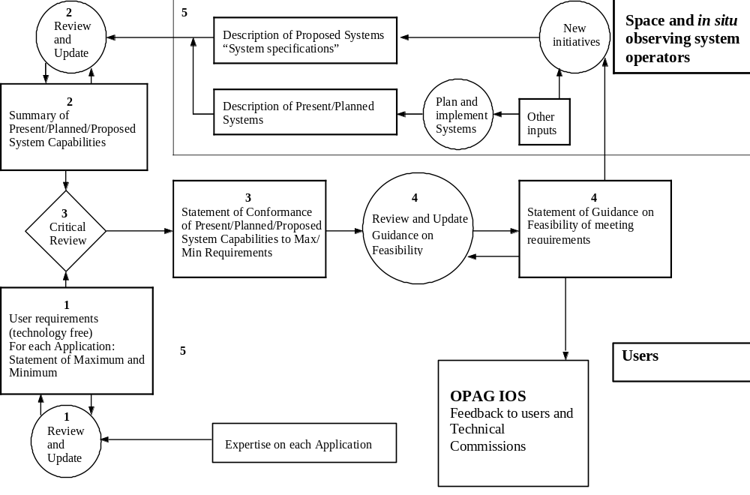Figure II,2 SCHEMATIC OF THE RRR PROCESS

Wind profile 500-100 hPa (HT)
Analysis for Global NWP (in situ and space-based observing systems)
1. Requirement Summary and assessment key
Colour key |  | Hor | Vert | Cycle | Delay | Acc
 |  | km | km | h | h | m/s
Optimum |  | 50.0 | 1.0 | 1.0 | 1.0 | 1.0
 |  | 107.7 | 2.2 | 2.3 | 1.6 | 2.0
Median
 |  | 232.1 | 4.6 | 5.2 | 2.5 | 4.0
Threshold |  | 500.0 | 10.0 | 12.0 | 4.0 | 8.0
Cycle colour assessment based on a constellation of 2 polar-orbiting satellites (1 geostationary)
2. Instruments for: Wind profile 500-100 hPa (HT)
Showing relevant instruments for which details are available
Instrument | Hor |  | Vert |  | Cycle |  | Delay |  | Acc |  | Mission |  | Orbit
 | km |  | km |  | h |  | h |  | m/s |  | name | rating | Orbit
ACARS P RA-VI WE | 175.0 | ##ColourThisCell##17 | 0.1 | ##ColourThisCell##3 | 2.0 | ##ColourThisCell##3 | 1.0 | ##ColourThisCell##3 | 2.00 | ##ColourThisCell##17 | WWW | ##ColourThisCell##17 | G
ACARS FL RA-VI WE | 38.0 | ##ColourThisCell##3 | 0.6 | ##ColourThisCell##3 | 8.0 | ##ColourThisCell##6 | 1.0 | ##ColourThisCell##3 | 2.00 | ##ColourThisCell##17 | WWW | ##ColourThisCell##6 | G
SEVIRI | 100.0 | ##ColourThisCell##3 | 5.0 | ##ColourThisCell##6 | 1.0 | ##ColourThisCell##3 | 1.0 | ##ColourThisCell##3 | 4.00 | ##ColourThisCell##17 | WWW | ##ColourThisCell##6 | G
ACARS FL RA-VI EE | 159.0 | ##ColourThisCell##17 | 0.6 | ##ColourThisCell##3 | 8.0 | ##ColourThisCell##6 | 1.0 | ##ColourThisCell##3 | 2.00 | ##ColourThisCell##17 | WWW | ##ColourThisCell##6 | G
ACARS FL RA-V SW | 167.0 | ##ColourThisCell##17 | 0.6 | ##ColourThisCell##3 | 12.0 | ##ColourThisCell##6 | 1.0 | ##ColourThisCell##3 | 2.00 | ##ColourThisCell##17 | WWW | ##ColourThisCell##6 | G
IMAGER | 150.0 | ##ColourThisCell##17 | 5.0 | ##ColourThisCell##6 | 1.0 | ##ColourThisCell##3 | 1.0 | ##ColourThisCell##3 | 5.00 | ##ColourThisCell##6 | WWW | ##ColourThisCell##6 | G
IMAGER/MTSAT | 150.0 | ##ColourThisCell##17 | 5.0 | ##ColourThisCell##6 | 1.0 | ##ColourThisCell##3 | 1.0 | ##ColourThisCell##3 | 5.00 | ##ColourThisCell##6 | WWW | ##ColourThisCell##6 | G
SOUNDER | 150.0 | ##ColourThisCell##17 | 5.0 | ##ColourThisCell##6 | 1.0 | ##ColourThisCell##3 | 1.0 | ##ColourThisCell##3 | 5.00 | ##ColourThisCell##6 | WWW | ##ColourThisCell##6 | G
ACARS FL RA-II S | 310.0 | ##ColourThisCell##6 | 0.6 | ##ColourThisCell##3 | 12.0 | ##ColourThisCell##6 | 1.0 | ##ColourThisCell##3 | 2.00 | ##ColourThisCell##17 | WWW | ##ColourThisCell##6 | G
ACARS FL RA-IV N | 318.0 | ##ColourThisCell##6 | 0.6 | ##ColourThisCell##3 | 12.0 | ##ColourThisCell##6 | 1.0 | ##ColourThisCell##3 | 2.00 | ##ColourThisCell##17 | WWW | ##ColourThisCell##6 | G
ACARS FL RA-IV C | 380.0 | ##ColourThisCell##6 | 0.6 | ##ColourThisCell##3 | 12.0 | ##ColourThisCell##6 | 1.0 | ##ColourThisCell##3 | 2.00 | ##ColourThisCell##17 | WWW | ##ColourThisCell##6 | G
ACARS FL RA-II W | 429.0 | ##ColourThisCell##6 | 0.6 | ##ColourThisCell##3 | 12.0 | ##ColourThisCell##6 | 1.0 | ##ColourThisCell##3 | 2.00 | ##ColourThisCell##17 | WWW | ##ColourThisCell##6 | G
MVIRI | 150.0 | ##ColourThisCell##17 | 5.0 | ##ColourThisCell##6 | 1.0 | ##ColourThisCell##3 | 2.0 | ##ColourThisCell##17 | 5.00 | ##ColourThisCell##6 | WWW | ##ColourThisCell##6 | G
VISSR (GMS-5) | 150.0 | ##ColourThisCell##17 | 5.0 | ##ColourThisCell##6 | 1.0 | ##ColourThisCell##3 | 2.0 | ##ColourThisCell##17 | 5.00 | ##ColourThisCell##6 | WWW | ##ColourThisCell##6 | G
VHRR | 150.0 | ##ColourThisCell##17 | 5.0 | ##ColourThisCell##6 | 1.0 | ##ColourThisCell##3 | 2.0 | ##ColourThisCell##17 | 6.00 | ##ColourThisCell##6 | WWW | ##ColourThisCell##6 | G
WND P 449 RA-IV C | 700.0 | ##ColourThisCell##2 | 0.3 | ##ColourThisCell##3 | 1.0 | ##ColourThisCell##3 | 0.5 | ##ColourThisCell##3 | 1.50 | ##ColourThisCell##3 | WWW | ##ColourThisCell##2 | G
ACARS FL NAO CST | 50.0 | ##ColourThisCell##3 | 0.6 | ##ColourThisCell##3 | 24.0 | ##ColourThisCell##2 | 1.0 | ##ColourThisCell##3 | 2.00 | ##ColourThisCell##17 | WWW | ##ColourThisCell##2 | G
WND P 915 RA-IV C | 1000.0 | ##ColourThisCell##2 | 0.1 | ##ColourThisCell##3 | 1.0 | ##ColourThisCell##3 | 0.5 | ##ColourThisCell##3 | 2.00 | ##ColourThisCell##17 | WWW | ##ColourThisCell##2 | G
ACARS P RA-VI EE | 692.0 | ##ColourThisCell##2 | 0.1 | ##ColourThisCell##3 | 2.0 | ##ColourThisCell##3 | 1.0 | ##ColourThisCell##3 | 2.00 | ##ColourThisCell##17 | WWW | ##ColourThisCell##2 | G
ACARS FL MED | 156.0 | ##ColourThisCell##17 | 0.6 | ##ColourThisCell##3 | 24.0 | ##ColourThisCell##2 | 1.0 | ##ColourThisCell##3 | 2.00 | ##ColourThisCell##17 | WWW | ##ColourThisCell##2 | G
ACARS FL NAO OPN | 223.0 | ##ColourThisCell##17 | 0.6 | ##ColourThisCell##3 | 24.0 | ##ColourThisCell##2 | 1.0 | ##ColourThisCell##3 | 2.00 | ##ColourThisCell##17 | WWW | ##ColourThisCell##2 | G
ACARS P RA-V NW | 3821.0 | ##ColourThisCell##2 | 0.1 | ##ColourThisCell##3 | 6.0 | ##ColourThisCell##6 | 1.0 | ##ColourThisCell##3 | 2.00 | ##ColourThisCell##17 | WWW | ##ColourThisCell##2 | G
ACARS P RA-V SW | 644.0 | ##ColourThisCell##2 | 0.1 | ##ColourThisCell##3 | 6.0 | ##ColourThisCell##6 | 1.0 | ##ColourThisCell##3 | 2.00 | ##ColourThisCell##17 | WWW | ##ColourThisCell##2 | G
ACARS FL ARC | 270.0 | ##ColourThisCell##6 | 0.6 | ##ColourThisCell##3 | 24.0 | ##ColourThisCell##2 | 1.0 | ##ColourThisCell##3 | 2.00 | ##ColourThisCell##17 | WWW | ##ColourThisCell##2 | G
ACARS FL RA-I S | 330.0 | ##ColourThisCell##6 | 0.6 | ##ColourThisCell##3 | 24.0 | ##ColourThisCell##2 | 1.0 | ##ColourThisCell##3 | 2.00 | ##ColourThisCell##17 | WWW | ##ColourThisCell##2 | G
ACARS FL NIO CST | 334.0 | ##ColourThisCell##6 | 0.6 | ##ColourThisCell##3 | 24.0 | ##ColourThisCell##2 | 1.0 | ##ColourThisCell##3 | 2.00 | ##ColourThisCell##17 | WWW | ##ColourThisCell##2 | G
ACARS FL RA-I N | 375.0 | ##ColourThisCell##6 | 0.6 | ##ColourThisCell##3 | 24.0 | ##ColourThisCell##2 | 1.0 | ##ColourThisCell##3 | 2.00 | ##ColourThisCell##17 | WWW | ##ColourThisCell##2 | G
ACARS FL RA-I T | 402.0 | ##ColourThisCell##6 | 0.6 | ##ColourThisCell##3 | 24.0 | ##ColourThisCell##2 | 1.0 | ##ColourThisCell##3 | 2.00 | ##ColourThisCell##17 | WWW | ##ColourThisCell##2 | G
ACARS FL SAO CST | 414.0 | ##ColourThisCell##6 | 0.6 | ##ColourThisCell##3 | 24.0 | ##ColourThisCell##2 | 1.0 | ##ColourThisCell##3 | 2.00 | ##ColourThisCell##17 | WWW | ##ColourThisCell##2 | G
RAOBS RA-VI WE | 218.0 | ##ColourThisCell##17 | 0.3 | ##ColourThisCell##3 | 16.0 | ##ColourThisCell##2 | 1.5 | ##ColourThisCell##3 | 2.00 | ##ColourThisCell##17 | WWW | ##ColourThisCell##2 | G
ACARS FL RA-III N | 455.0 | ##ColourThisCell##6 | 0.6 | ##ColourThisCell##3 | 24.0 | ##ColourThisCell##2 | 1.0 | ##ColourThisCell##3 | 2.00 | ##ColourThisCell##17 | WWW | ##ColourThisCell##2 | G
ACARS FL NIO OPN | 498.0 | ##ColourThisCell##6 | 0.6 | ##ColourThisCell##3 | 24.0 | ##ColourThisCell##2 | 1.0 | ##ColourThisCell##3 | 2.00 | ##ColourThisCell##17 | WWW | ##ColourThisCell##2 | G
ACARS FL RA-II E | 998.0 | ##ColourThisCell##2 | 0.6 | ##ColourThisCell##3 | 12.0 | ##ColourThisCell##6 | 1.0 | ##ColourThisCell##3 | 2.00 | ##ColourThisCell##17 | WWW | ##ColourThisCell##2 | G
ACARS FL RA-II N | 614.0 | ##ColourThisCell##2 | 0.6 | ##ColourThisCell##3 | 12.0 | ##ColourThisCell##6 | 1.0 | ##ColourThisCell##3 | 2.00 | ##ColourThisCell##17 | WWW | ##ColourThisCell##2 | G
ACARS FL RA-IV S | 690.0 | ##ColourThisCell##2 | 0.6 | ##ColourThisCell##3 | 12.0 | ##ColourThisCell##6 | 1.0 | ##ColourThisCell##3 | 2.00 | ##ColourThisCell##17 | WWW | ##ColourThisCell##2 | G
ACARS FL RA-V NW | 550.0 | ##ColourThisCell##2 | 0.6 | ##ColourThisCell##3 | 12.0 | ##ColourThisCell##6 | 1.0 | ##ColourThisCell##3 | 2.00 | ##ColourThisCell##17 | WWW | ##ColourThisCell##2 | G

ATTACHMENT II.1

ATTACHMENT II,2

Application : Global NWP
Requirement | Horiz. Resolution |  | Vert.Resolution |  | Obs Cycle |  | Delay avail |  | Accuracy |  | Confidence | Remarks | Associate Ident | Source
Requirement | Max | Min | Max | Min | Max | Min | Max | Min | Max | Min
Aerosol profile - Higher troposphere (HT) | 50 km | 500 km | 1 km | 5 km | 6 h | 168 h | 12 h | 168 h | 10 % | 20 % | Tentative |  | WMO_UA_017A | 20/10/2003, ET, ODRRGOS, Geneva, Nov 2003
Aerosol profile - Lower stratosphere (LS) | 50 km | 500 km | 1 km | 10 km | 6 h | 168 h | 12 h | 168 h | 10 % | 20 % | Tentative |  | WMO_UA_017J | 20/10/2003, ET ODRRGOS, Geneva, Nov 2003
Aerosol profile - Lower troposphere (LT) | 50 km | 500 km | 0.1 km | 1 km | 1 h | 168 h | 1 h | 168 h | 10 % | 20 % | Tentative |  | WMO_UA_017 | 20/10/2003, ET ODRRGOS, Geneva, Nov 003
Aerosol profile - Total column | 50 km | 500 km |  |  | 1 h | 168 h | 1 h | 168 h | 10 % | 20 % | Tentative |  | WMO_UA_017F | 20/10/2003, ET ODRRGOS, Geneva, Nov 2003
Air pressure over land surface | 50 km | 250 km |  |  | 1 h | 12 h | 1 h | 4 h | 0.5 hPa | 2 hPa | Firm |  | WMO_Sfc_004 | 20/10/2003, ET ODRRGOS, Geneva, Nov 2003
Air pressure over sea surface | 50 km | 250 km |  |  | 1 h | 12 h | 1 h | 4 h | 0.5 hPa | 2 hPa | Firm |  | WMO_Sfc_004B | 20/10/2003, ET ODRRGOS, Geneva, Nov 2003
Air specific humidity (at surface) | 50 km | 250 km |  |  | 1 h | 12 h | 1 h | 4 h | 5 % | 15 % | Reasonable |  | WMO_Sfc_N011 | 20/10/2003, ET ODRRGOS, Geneva, Nov 2003
Air temperature (at surface) | 50 km | 250 km |  |  | 1 h | 12 h | 1 h | 4 h | 0.5 K | 2 K | Reasonable |  | WMO_Sfc_008E | 20/10/2003, ET ODRRGOS, Geneva, Nov 2003
Atmospheric temperature profile - Higher stratosphere & mesosphere (HS & M) | 50 km | 500 km | 1 km | 3 km | 1 h | 12 h | 1 h | 4 h | 0.5 K | 5 K | Reasonable |  | WMO_UA_003B | 20/10/2003, ET ODRRGOS, Geneva, Nov 2003
Atmospheric temperature profile - Higher troposphere (HT) | 50 km | 50 km | 1km | 3 km | 1 h | 12 h | 1 h | 4 h | 0.5 K | 3 K | Firm |  | WMO_UA_003A | 20/10/2003, ET ODRRGOS, Geneva, Nov 2003
Atmospheric temperature profile - Lower stratosphere (LS) | 50 km | 500 km | 1 km | 3 km | 1 h | 12 h | 1 h | 4 h | 0.5 K | 3 K | Firm |  | WMO_UA_003R | 20/10/2003, ET ODRRGOS, Geneva, Nov 2003
Atmospheric temperature profile - Lower troposphere (LT) | 50 km | 500 km | 0.3 km | 3 km | 1 h | 12 h | 1 h | 4 h | 0.5 K | 3 K | Firm |  | WMO_UA_003 | 20/10/2003, ET ODRRGOS, Geneva, Nov 2003
Cloud base height | 50 km | 250 km |  |  | 1 h | 12 h | 1 h | 4 h | 0.5 km | 1 km | Tentative |  | WMO_UA_N001 | 20/10/2003, ET ODRRGOS, Geneva, Nov 2003
Cloud cover | 50 km | 250 km |  |  | 1 h | 12 h | 1 h | 4 h | 5 % (Max) | 20 % (Max) | Reasonable |  | WMO_UA_N023 | 20/10/2003, ET ODRRGOS, Geneva, Nov 2003
Cloud drop size (at cloud top) | 50 km | 250 km |  |  | 1 h | 12 h | 1 h | 4 h | 0.5 µm | 2 µm | Speculative |  | WMO_Sfc_N022 | 20/10/2003, ET ODRRGOS, Geneva, Nov 2003
Cloud ice profile - Higher troposphere (HT) | 50 km | 250 km | 1 km | 10 km | 1 h | 12 h | 1 h | 4 h | 5 % | 20 % | Tentative |  | WMO_UA_N016 A | 20/10/2003, ET ODRRGOS, Geneva, Nov 2003
Cloud ice profile - Lower troposphere (LT) | 50 km | 250 km | 0.3 km | 5 km | 1 h | 12 h | 1 h | 4 h | 5 % | 20 % | Tentative |  | WMO_UA_N015 | 20/10/2003, ET ODRRGOS, Geneva, Nov 2003
Cloud ice profile - Total column | 50 km | 250 km |  |  | 1 h | 12 h | 1 h | 4 h | 10 g/m2 | 20 g/m2 | Tentative |  | WMO_UA_N018 | 20/10/2003, ET ODRRGOS, Geneva, Nov 2003
Cloud imagery | 1 km | 50 km |  |  | 0.5 h | 6 h | 1 h | 4 h |  |  | Firm |  | WMO_S_218 | 20/10/2003, ET ODRRGOS, Geneva, Nov 2003
Cloud top height | 50 km | 250 km |  |  | 1 h | 12 h | 1 h | 4 h | 0.5 km | 1 km | Firm |  | WMO_UA_009 | 20/10/2003, ET ODRRGOS, Geneva, Nov 2003
Cloud water profile (< 100 µm) - Higher troposphere (HT) | 50 km | 250 km | 1 km | 10 km | 1 h | 12 h | 1 h | 4 h | 5 % | 20 % | Tentative |  | WMO_UA_N013 | 20/10/2003, ET ODRRGOS, Geneva, Nov 2003
Cloud water profile (< 100 µm) - Lower troposphere (LT) | 50 km | 250 km | 0.3 km | 5 km | 1 h | 12 h | 1 h | 4 h | 5 % | 20 % | Tentative |  | WMO_UA_N012 | 20/10/2003, ET ODRRGOS, Geneva, Nov 2003
Cloud water profile (< 100 µm) - Total column | 50 km | 250 km |  |  | 1 h | 4 h | 1 h | 4 h | 10 kg/m2 | 50 kg/m2 | Tentative |  | WMO_UA_007B | 20/10/2003, ET ODRRGOS, Geneva, Nov 2003
Cloud water profile (> 100 µm) - Higher troposphere (HT) | 50 km | 250 km | 1 km | 10 km | 1 h | 12 h | 1 h | 4 h | 5 % | 20 % | Tentative |  | WMO_UA_N013B | 20/10/2003, ET ODRRGOS, Geneva, Nov 2003
Cloud water profile (> 100 µm) - Lower troposphere (LT) | 50 km | 250 km | 0.3 km | 5 km | 1 h | 12 h | 1 h | 4 h | 5 % | 20 % | Tentative |  | WMO_UA_N012A | 20/10/2003, ET ODRRGOS, Geneva, Nov 2003
Cloud water profile (> 100 µm) - Total column | 50 km | 250 km |  |  | 1 h | 12 h | 1 h | 2 h | 10 kg/m2 | 50 kg/m2 | Tentative |  | WMO_UA_007 | 20/10/2003, ET ODRRGOS, Geneva, Nov 2003
Dominant wave direction | 50 km | 250 km |  |  | 1 h | 12 h | 1 h | 4 h | 10 degrees | 20 degrees | Firm |  | WMO_Sfc_018C | 20/10/2003, ET ODRRGOS, Geneva, Nov 2003
Dominant wave period | 50 km | 250 km |  |  | 1 h | 12 h | 1 h | 4 h | 0.5 s | 1 s | Firm |  | WMO_Sfc_018 | 20/10/2003, ET ODRRGOS, Geneva, Nov 2003
Land surface temperature | 50 km | 250 km |  |  | 1 h | 12 h | 1 h | 4 h | 0.5 K | 4 K | Firm |  | WMO_Sfc_008A | 20/10/2003, ET ODRRGOS, Geneva, Nov 2003
Leaf Area Index (LAI) | 50 km | 100 km |  |  | 7 d | 30 d | 1 d | 7 d | 5 % (Max) | 20 % (Max) | Tentative |  | WMO_Sfc_N001 | 20/10/2003, ET ODRRGOS, Geneva, Nov 2003
Long-wave Earth surface emissivity | 15 km | 250 km |  |  | 24 h | 720 h | 24 h | 720 h | 1 % (Max) | 5 % (Max) | Tentative |  | WMO_Sfc_N020 | 20/10/2003, ET ODRRGOS, Geneva, Nov 2003
Normalized Differential Vegetation Index (NDVI) | 50 km | 100 km |  |  | 7 d | 30 d | 1 d | 7 d | 1 % (Max) | 5 % (Max) | Tentative |  | WMO_S_254 | 20/10/2003, ET ODRRGOS, Geneva, Nov 2003
Outgoing long-wave radiation at TOA | 50 km | 250 km |  |  | 1 h | 1 h | 240 h | 720 h | 5 W/m2 | 10 W/m2 | Firm |  | WMO_UA_016F | 20/10/2003, ET ODRRGOS, Geneva, Nov 2003
Outgoing short-wave radiation at TOA | 50 km | 250 km |  |  | 1 h | 6 h | 240 h | 360 h | 5 W/m2 | 10 W/m2 | Firm |  | WMO_UA_016 | 20/10/2003, ET ODRRGOS, Geneva, Nov 2003
Ozone profile - Higher troposphere (HT) | 50 km | 500 km | 1 km | 10 km | 1 h | 12 h | 1 h | 4 h | 5 % | 20 % | Tentative |  | WMO_UA_014A | 20/10/2003, ET ODRRGOS, Geneva, Nov 2003
Ozone profile - Lower stratosphere (LS) | 50 km | 500 km | 1 km | 10 km | 1 h | 12 h | 1 h | 4 h | 5 % | 20 % | Tentative |  | WMO_UA_014K | 20/10/2003, ET ODRRGOS, Geneva, Nov 2003
Ozone profile - Lower troposphere (LT) | 50 km | 500 km | 1 km | 5 km | 1 h | 12 h | 1 h | 4 h | 5 % | 20 % | Tentative |  | WMO_UA_014 | 20/10/2003, ET ODRRGOS, Geneva, Nov 2003
Ozone profile - Total column | 50 km | 100 km |  |  | 1 h | 6 h | 1 h | 4 h | 5 DU | 20 DU | Reasonable |  | WMO_UA_014J | 20/10/2003, ET ODRRGOS, Geneva, Nov 2003
Precipitation index (daily cumulative) | 50 km | 250 km |  |  | 1 h | 12 h | 24 h | 720 h | 0.5 mm/d | 5 mm/d | Reasonable |  | WMO_Sfc_017 | 20/10/2003, ET ODRRGOS, Geneva, Nov 2003
Precipitation rate (liquid) at the surface | 50 km | 100 km |  |  | 1 h | 12 h | 1 h | 4 h | 0.1 mm/h | 1 mm/h | Tentative |  | WMO_UA_N022A | 20/10/2003, ET ODRRGOS, Geneva, Nov 2003
Precipitation rate (solid) at the surface | 50 km | 100 km |  |  | 1 h | 12 h | 1 h | 4 h | 0.1 mm/h | 1 mm/h | Tentative |  | WMO_UA_N022 | 20/10/2003, ET ODRRGOS, Geneva, Nov 2003
Sea surface bulk temperature | 50 km | 250 km |  |  | 3 h | 360 h | 3 h | 180 h | 0.5 K | 2 K | Firm |  | WMO_Sfc_006C | 20/10/2003, ET ODRRGOS, Geneva, Nov 2003
Sea-ice cover | 15 km | 250 km |  |  | 1 d | 15 d | 1 d | 7 d | 5 % (Max) | 50 % (Max) | Firm |  | WMO_Sfc_019 | 20/10/2003, ET ODRRGOS, Geneva, Nov 2003
Sea-ice surface temperature | 15 km | 200 km |  |  | 1 h | 12 h | 1 h | 4 h | 0.5 K | 4 K | Reasonable |  | WMO_Sfc_N014 | 20/10/2003, ET ODRRGOS, Geneva, Nov 2003
Sea-ice thickness | 15 km | 250 km |  |  | 1 d | 7 d | 1 d | 7 d | 50 cm | 100 cm | Speculative |  | WMO_Sfc_021 | 20/10/2003, ET ODRRGOS, Geneva, Nov 2003
Significant wave height | 100 km | 250 km |  |  | 1 h | 12 h | 1 h | 4 h | 0.5 m | 1 m | Firm |  | WMO_Sfc_N059 | 20/10/2003, ET ODRRGOS, Geneva, Nov 2003
Snow cover | 15 km | 250 km |  |  | 12 h | 168 h | 12 h | 24 h | 10 % (Max) | 50 % (Max) | Reasonable |  | WMO_Sfc_023 | 20/10/2003, ET ODRRGOS, Geneva, Nov 2003
Snow water equivalent | 15 km | 250 km |  |  | 12 h | 168 h | 6 h | 24 h | 5 mm | 20 mm | Tentative |  | WMO_Sfc_027 | 20/10/2003, ET ODRRGOS, Geneva, Nov 2003
Soil moisture | 15 km | 250 km |  |  | 1 d | 7 d | 0.25 d | 1 d | 10 g/kg | 50 g/kg | Reasonable |  | WMO_Sfc_012A | 20/10/2003, ET ODRRGOS, Geneva, Nov 2003
Specific humidity profile - Higher troposphere (HT) | 50 km | 250 km | 1 km | 3 km | 1 h | 12 h | 1 h | 4 h | 5 % | 20 % | Firm | Accuracy 5% in RH | WMO_UA_006A | 20/10/2003, ET ODRRGOS, Geneva, Nov 2003
Specific humidity profile - Lower troposphere (LT) | 50 km | 250 km | 0.4 km | 2 km | 1 h | 12 h | 1 h | 4 h | 5 % | 20 % | Firm | Accuracy 5% in RH | WMO_UA_006 | 20/10/2003, ET ODRRGOS, Geneva, Nov 2003
Specific humidity profile - Total column | 50 km | 500 km |  |  | 1 h | 12 h | 1 h | 4 h | 1 kg/m2 | 5 kg/m2 | Firm |  | WMO_Sfc_N044A | 20/10/2003, ET ODRRGOS, Geneva, Nov 2003
Wind profile (horizontal component) - Higher troposphere (HT) | 50 km | 500 km | 1 km | 10 km | 1 h | 12 h | 1 h | 4 h | 1 m/s | 8 m/s | Firm |  | WMO_UA_001A | 20/10/2003, ET ODRRGOS, Geneva, Nov 2003
Wind profile (horizontal component) - Lower stratosphere (LS) | 50 km | 500 km | 1 km | 10 km | 1 h | 12 h | 1 h | 4 h | 1 m/s | 5 m/s | Firm |  | WMO_UA_001O | 20/10/2003, ET ODRRGOS, Geneva, Nov 2003
Wind profile (horizontal component) - Lower troposphere (LT) | 50 km | 500 km | 0.4 km | 5 km | 1 h | 12 h | 1 h | 4 h | 1 m/s | 5 m/s | Firm |  | WMO_UA_001 | 20/10/2003, ET ODRRGOS, Geneva, Nov 2003
Wind profile (vertical component) - Higher troposphere (HT) | 50 km | 500 km | 0.5 km | 10 km | 1 h | 12 h | 1 h | 4 h | 1 cm/s | 5 cm/s | Speculative |  | WMO_UA_N020 | 20/10/2003, ET ODRRGOS, Geneva, Nov 2003
Wind profile (vertical component) - Lower stratosphere (LS) | 50 km | 500 km | 0.5 km | 10 km | 1 h | 12 h | 1 h | 4 h | 1 cm/s | 5 cm/s | Speculative |  | WMO_UA_N020A | 20/10/2003, ET ODRRGOS, Geneva, Nov 2003
Wind profile (vertical component) - Lower troposphere (LT) | 50 km | 500 km | 0.5 km | 5 km | 1 h | 12 h | 1 h | 4 h | 1 cm/s | 5 cm/s | Speculative |  | WMO_UA_N019 | 20/10/2003, ET ODRRGOS, Geneva, Nov 2003
Wind speed over land surface (horizontal) | 50 km | 250 km |  |  | 1 h | 12 h | 1 h | 4 h | 0.5 m/s | 3 m/s | Reasonable |  | WMO_Sfc_010M | 20/10/2003, ET ODRRGOS, Geneva, Nov 2003
Wind speed over sea surface (horizontal) | 50 km | 250 km |  |  | 1 h | 12 h | 1 h | 4 h | 0.5 m/s | 3 m/s | Firm |  | WMO_Sfc_010I | 20/10/2003, ET ODRRGOS, Geneva, Nov 2003
Wind vector over land surface (horizontal) | 50 km | 250 km |  |  | 1 h | 12 h | 1 h | 4 h | 0.5 m/s | 5 m/s | Reasonable |  | WMO_Sfc_010E | 20/10/2003, ET ODRRGOS, Geneva, Nov 2003
Wind vector over sea surface (horizontal) | 50 km | 250 km |  |  | 1 h | 12 h | 1 h | 4 h | 0.5 m/s | 5 m/s | Firm |  | WMO_Sfc_010A | 20/10/2003, ET ODRRGOS, Geneva, Nov 2003

ATTACHMENT II.3

Typical end-user requirements for data

End-user group | Observing elements required by Meteorological Services to satisfy end-user requirements
Agriculture and food production  Farming (including pest control, fertilization, frost protection, seeding, harvesting)  Planning of land use, (crop yields, pest and disease control, microclimatic studies, forestry operations) | Temperature (maximum, minimum, extremes), precipitation (amount, duration, type), dew point/humidity, wind speed and direction at surface to 850 hPa, cloud cover, soil temperature, evaporation, solar radiation, special phenomena  Precipitation (average amounts), temperature extremes, prevailing wind direction and speed, cloud cover, special phenomena
Aviation  Commercial or government operated (on national or international basis) and general aviation | Upper winds, temperatures and tropopause from 850 hPa to 70 hPa  Significant weather en route at 400 hPa to  70 hPa  Terminal and approach zone including cloud base and visibility, significant weather, surface wind and low-level wind shear, turbulence, icing
Land transport  Road and railway conditions (maintenance and safety) | Temperature, precipitation (type and amount), wind at surface, low visibility; state of ground
Marine resources and shipping services  Fishing, transport, off-shore, drilling and mining  Coastal engineering activities and search and rescue operations  Marine pollution | Over-ocean and near-shore surface winds, combined sea/swell, surface visibility, ice accretion, sea ice and icebergs, precipitation, cloud cover, air temperature. and humidity, sea-surface temperature and salinity, mixed layer depth, tsunamis, storm surge and critical wave heights, sea-level measurements  Surface wind direction and speed, wave-swell height and direction, sea-surface current direction/speed, ocean or bay-estuary current deviations
End-user group | Observing elements required by Meteorological Services to satisfy end-user requirements
Hydrology and water resources  Flood control, hydropower production, navigation, irrigation pollution control, municipal and industrial water supply, recreational activities | Real-time measured and forecast variables: precipitation (total amount and form), air and wet-bulb temperature, height of freezing level, wind speed and direction, cloud image indicating tropospheric wind, tropical cyclone or hurricane movement, snow cover (water equivalent, depth, density, surface Temperature, temperature profiles), net radiation, pan evaporation, evapotranspiration, water temperatures (rivers and lakes), soil moisture, frost depth, river and lake ice (thickness, type, character)
Industry  Construction (office, industrial, residential, highway) | Precipitation, freezing or high temperatures, low visibility, high winds (wind chill), frozen ground depth, drying conditions
Environmental monitoring  Air pollution  Emergency response activities, volcanic activity | Temperature, humidity, wind speed and direction (at surface plus profiles in lowest atmospheric levels), precipitation (amount, time of commencement and termination)  - Wind, temperature and humidity (upper-air data);  - Precipitation data (type and amount);  - Surface air temperature data;  - Atmospheric pressure data;  - Wind direction and speed (surface and stack height) data;  - Humidity data
Energy  Electric energy generation (load factors, supply of water, exposure of power lines) | Maximum/minimum temperature, cloud amount and general cover, precipitation amount, wind speed and direction, icing and snow, severe weather (lightning), time series of wind speed, vertical profiles of temperature and wind speed
Public services, health and safety  Extra-tropics  Tropics  Special storm warnings: tropical storm  Severe weather warnings: tornado, heavy thunderstorm, heavy snow, hail/rain, storm winds | Maximum/minimum temperature, cloudiness, wind (comfort index), humidity, precipitation type and intensity  Maximum/minimum temperature, precipitation, thunderstorms  Development, track and intensity over water plus land fall (place and time) and precipitation amount, winds, waves and storm surges and tornadoes over land  Movement of tornadoes and thunderstorms, extent and intensity of heavy snow, hail and rain, storm winds
End-user group | Observing elements required by Meteorological Services to satisfy end-user requirements
Public services, health and safety (contd.)  Recreational services (vacation, leisure, sporting events, parades, boating) | Temperature and humidity range, cloud amount, wind direction and speed, precipitation type and occurrence, weather conditions (e.g. thunderstorms, horizontal visibility, precipitation) and wave heights, period and direction
Climatology and climate services  Research, monitoring of outstanding events/climate anomalies, applications in all sectors requiring climatological information either instantaneously (over last day to last 10 days) or over longer periods, description and analysis of climate and its variations | Variables contained in CLlMAT reports for rapid global dissemination and use; all variables observed for applications and case studies at local and regional levels; all variables for climate description

PART IV

THE SPACE-BASED SUBSYSTEM

4.1 GENERAL

4.1.1 History of the space-based subsystem

The first experimental meteorological satellite was launched by the USA on 1 April 1960. It provided basic, but very useful, cloud imagery and was such an effective proof of concept that the decision was rapidly made to implement a series of operational polar satellites. The Automatic Picture Transmission (APT) system was flown for the first time in 1963 and improved access to image data. APT systems have been flown on many satellites since then to provide images several times a day to relatively inexpensive user stations around the world. By 1966, the USA had launched its first experimental geostationary meteorological satellite demonstrating the value of a fixed viewing point relative to the earth, enabling frequent images to be taken and used to generate animated views of the world's weather. In 1969 the USSR launched the first of a series of polar satellites. In 1974, the USA launched the first operational geostationary satellite. Similar geostationary meteorological satellites were launched and operated by Japan and by the European Space Agency (ESA) in 1977. Thus, within 18 years of a first practical demonstration, a fully operational meteorological satellite system was in place, giving routine data coverage of most of the planet. The network stabilized, in terms of sensor data and services, during the 1980s but there was a resurgence of experimental environmental satellites and an upgrading of the operational sub-system during the 1990s. Further significant improvements are being implemented during the first decade of the new century, both in terms of sensor performance and in terms of additional spacecraft contributing to a more robust constellation of operational and R&D satellites around the earth. This rapid evolution of a new international observing system, entailing major investments, has been unprecedented and indicates the enormous value of these satellites to meteorology and society, when allied to massive improvements in the ability to communicate, process and display information.

4.1.2 Relation to the surface-based subsystem

4.1.2.1 Several factors make meteorological satellite data unique compared with those from other sources and it is worth noting a few of the most significant:

(a) Because of its high vantage point and broad field of view, a satellite can provide a regular supply of data from those areas of the globe yielding very few observations from the surface-based subsystem.

(b) The atmosphere is broadly scanned from satellite altitude which enables large-scale weather systems to be seen in a single view.

(c) The ability of geostationary satellites to view a major portion of the atmosphere continually from space makes them particularly well suited for the monitoring and warning of short-lived storms.

(d) The advanced communications systems initially developed as an integral part of the satellite technology permit the rapid transmission of data from the satellite, or their relay from automatic stations on Earth and in the atmosphere, to operational users. This is still the case after four decades, although the trend is now that broadcasting and observation functions be carried on separated spacecraft that are optimized either for telecommunications or for earth-observation.

(e) Information about the atmosphere or surface is obtained indirectly by measuring properties of electromagnetic radiation reaching a satellite-borne sensor. The use of such data poses particular problems. These manifest themselves in the difficulty of obtaining the required vertical resolution in some measurements and long-term stability generally. Furthermore, errors tend to be spatially correlated, which makes it challenging to use the measurements in defining differential field properties. The underlying surface, whether the actual surface or cloud top, can make contributions to the upwelling radiation which are difficult to remove in inferring the properties of the overlying atmosphere.

4.1.2.2 On the other hand, in-situ measurements can be directly interpreted but may be influenced by local factors, which raises an issue of representativeness. Furthermore, the density of observation networks is not homogeneous.

4.1.2.3 The density of conventional surface and upper-air soundings in some portions of the globe, such as North America or Western Europe, far exceeds the density of similar information over oceanic and less-developed regions. Reports from ships, aircraft, a few buoys, and island stations are often the only surface-based observations available from the oceans, and many of the data are concentrated in limited geographical areas covered by commercial transportation routes. The only other source of environmental data over these and other data sparse areas is the polar-orbiting and geostationary satellites. Winds inferred from cloud and atmospheric pattern motions monitored by the geostationary satellites, particularly over the otherwise data sparse low latitudes, occupy a further important niche. The quality of forecasts and services is directly correlated to the information available on atmospheric conditions, regardless of what scale of motion is examined, although the effects of any deficiencies may not be co-located with them.

4.1.2.4 Forecasts from numerical models are the foundation for routine regional and local weather forecasts. The global temperature-sounding data from polar-orbiting weather satellites, first available in the late 1960s and used operationally since the mid-1970s, have encouraged numerical modelling activities. Computer power and model improvements have made it both necessary and possible to develop increasingly sophisticated methods for extracting the temperature and humidity profiles from the satellite radiances. Sounding data assimilation has a significantly positive impact for both hemispheres thanks to the improved vertical resolution allowed by advanced hyperspectral sounders .

4.1.2.5 Strengths and weaknesses from surface and space-based measurements are complementary which is the reason to consider the GOS as a composite that builds upon the strengths of both components. Satellite observations are critical to the generation of warnings and forecasts of hazardous conditions such as storms, tropical cyclones, polar lows, high winds and waves. More than 90% of the data assimilated in global NWP models come from space systems. Nevertheless, the need for direct measurements from surface, radiosondes and aircraft remains, to complement the space-based measurements, namely to provide geophysical parameters that are not easily derived from remote-sensing, to monitor small-scale phenomena and to provide independent calibration data.

4.1.3 Coordination

The combination of operational environmental satellites that makes up the space-based subsystem is in fact a series of independent national or regional systems coordinated by mutual agreement among satellite operators and WMO through the Coordination Group for Meteorological Satellites (CGMS). CGMS membership involves the actual operators of meteorological satellites, including operational and R&D satellites, and WMO in its capacity as a major user organization. It currently includes meteorological and/or space agencies from China (CMA and CNSA), Europe (EUMETSAT and ESA), France (CNES), India (IMD), Japan (JMA and JAXA), Korea (KMA), Russian Federation (ROSHYDROMET and ROSKOSMOS) and the USA (NOAA and NESDIS). CGMS had its first meeting in September 1972 (when it was known as the Coordination of Geostationary Meteorological Satellites) and has met on an annual basis ever since. CGMS concerns itself with the coordination of a wide-ranging list of operational aspects of the systems such as contingency planning, optimization of the mutual locations of geostationary and polar-orbiting spacecraft, or telecommunications standards. It has helped to ensure that key facilities are harmonized across the entire global system and fosters cooperation on sensor calibration, product derivation and user training. (More information on CGMS can be found at http://www.wmo.int/web/sat/CGMShome.html )

As regards contingency planning, satellite operators within CGMS have established a practice of mutual support among geostationary satellite systems, whenever necessary and feasible. Troubles experienced by a spacecraft generate a contingency situation over one region when continuity of critical missions can no longer be maintained, and no replacement satellite is possible before a long period. In such cases, if another satellite operator has a spare satellite in orbit with sufficient fuel capacity to allow for aditional manoeuvers, it is possible to relocate this spare satellite from its original location to the part of the globe that needs a temporary coverage support. Although all geostationary meteorological satellites have some common mission objectives and have a core set of similar capabilities they are not interchangeable. Because of diverse regional and national standards, and because different technologies arise from the independent phasing of satellite procurements, each satellite system needs its own central ground station and control centre . Relocating a satellite can thus require more or less complicated arrangements depending on whether it is within or beyond the visibility of its central ground station. Such a contingency support was successfully implemented on several occasions in the 1980’s and 1990’s between GOES, Meteosat and GMS spacecraft.

4.2 THE BASELINE SPACE SEGMENT

The World Weather Watch’s (WWW) Global Observing System (GOS) space component is comprised of two types of satellites: operational meteorological, and environmental Research and Development (R&D) satellites.

Operational meteorological satellites are classically designed to be operated in either of the two following orbit classes : geostationary equatorial orbit or sun-synchronous near-polar orbits. Most of the environmental R&D satellites are also in sun-synchronous near-polar orbits although not all.

Six evenly spaced geostationary satellites are required to provide permanent coverage of the globe up to at least 55° latitude. A fully global coverage including the polar regions can only be obtained with near-polar orbiting satellites, four of them on equally spaced sun-synchronous orbital planes can provide frequent enough observations to enable a representative sampling of the diurnal cycle.

Other types of orbits may be adopted for specific missions depending on the coverage requirement. For instance, a 35° inclination orbit was adopted for the Tropical Rainfall Monitoring Mission (TRMM) and a 66° inclination orbit is preferred for an optimized ocean surface topography mission. Highly elliptical orbits are also under consideration but are not planned to be used within the GOS in the near future.

4.2.1 Sun-synchronous polar orbiting satellites

4.2.1.1 A sun-synchronous satellite is such that the plane of its orbit keeps a constant angle with the sun throughout the year, in order to ensure that the satellite always passes over a given latitude at the same Local Solar Time (LST). This is an obvious advantage for many applications because it minimizes scene differences due to the time of day and amount of solar illumination and hence simplifies operational utilisation. Customarily such satellites are used for precise radiance measurements as needed for temperature and water-vapour soundings, monitoring land or sea-surface temperature and radiation fluxes.

Sun-synchronism can be achieved with a Low Earth Orbit (LEO) inclined at about 99° to the plane of the equator (i.e. an angle around 81° in the retrograde direction). Since the orbit overflies both polar regions it is called a polar orbit. Meteorological sun-synchronous satellites are usually on quai-circular orbits with an altitude in the range of 800 km to 1000 km, which implies an orbital period around 101 mn. The satellite thus circles the planet every 101 minutes, i.e. about 14 times each day. Since the earth spins on its axis while the plane of the orbit remains almost constant, the tracks of successive orbits are displaced further to the west of about 25.5° longitude. If the imaging swath width is at least 2900 km there is no gap at equatorial latitudes between the areas covered at each revolution, and there is significant overlap between consecutive passes at higher latitudes. Each satellite can then view the entire planet twice in any period of 24 hours, once during daylight and once at night. A sun-synchronous satellite is classified as a morning (a.m.) satellite if the daylight pass across the equator occurs in the morning. It is said to be an afternoon (p.m.). satellite if the daylight pass occurs in the afternoon. Usually the afternoon pass is “ascending” from South to North, and the morning pass is a “descending” orbit from North to South, although this is not a rule.

4.2.1.2 The USA and Russian Federation have operated polar meteorological satellites since the 1960s, with current satellites of the NOAA-K, L, M and Meteor-3M design respectively. China launched polar meteorological satellites FY 1-C,–D in 1999 and 2002. New generation spacecraft series are being implemented starting with Metop (EUMETSAT) in 2006, Meteor-M1 (Russian Federation) and FY-3 (China) planned for launch in 2007 and NPOESS (USA) at the beginning of the next decade. If these plans can be implemented without significant delay, continuity of observation from the polar-orbit will be maintained and will benefit of greatly enhanced performances. The currently planned configuration for 2008 represented in Figure IV,1 below is expected to include 3 morning satellites (Metop, FY-3 and Meteor-M1) and one afternoon satellite (NOAA-18).

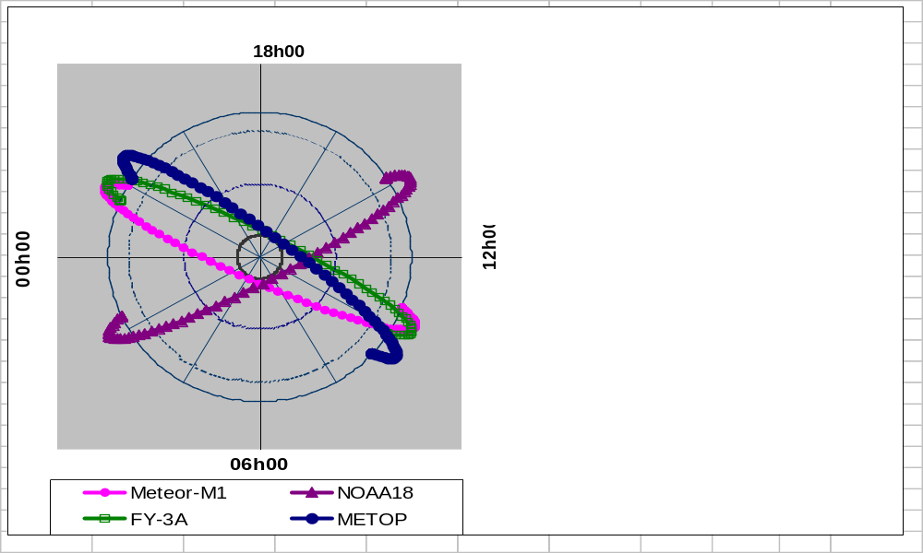
Direction
of the sun
Figure IV,1 . Mean Local Solar Time (MLST) of sun-synchronous satellites as planned for 2008, seen as from above the North pole. (The MLST is 12h00 at the unique point of the earth that is facing the sun and at all points of the same longitude as this unique point.)

4.2.1.3 Observing mission
The relatively low altitude of sun-synchronous polar satellites enables instruments to be flown that observe the atmosphere and the surface with the highest resolution. The core payload of meteorological polar orbiting satellites includes in particular imaging and sounding instruments. Imaging radiometers have a high horizontal resolution and monitor the surfaces of land, sea or clouds, in spectral channels where the atmosphere is weakly absorbing (window channels). Sounding instruments have a high spectral resolution and compare the radiation emitted by the atmosphere in series of narrow channels along atmospheric absorption bands ( CO2 and H2O in infrared, O2 and H2O in microwaves). A variety of other instruments, passive or active, may be part of the payload, depending on the particular mission objectives and spacecraft design constraints.
Table IV,1 below describes the respective payloads of the NOAA-N, N’ and Metop polar satellites. The acronyms are expanded in Section 4.6.

NOAA-N,N’ (USA) | METOP  (EUMETSAT) | Function
AMSU-A | AMSU-A | Atmospheric temperature sounding by microwaves (operates even in cloudy conditions )
HIRS/3 | HIRS/4 | Infra-red atmospheric temperature sounding (useful in clear sky conditions )
 | IASI | New generation infra-red atmospheric sounding with improved spectral resolution (measures temperature and humidity profile with improved vertical resolution, and tropospheric chemical contents)
 | GRAS | Atmospheric temperature sounding at high levels, using radio occultation of a GPS-type signal
MHS | MHS | Atmospheric humidity sounding by microwaves ( all-weather)
AVHRR/3 | AVHRR/3 | Images and temperature of clouds and the surface; vegetation monitoring; supports sounding by identifying cloud free regions
SBUV/2 | GOME | Profiles of atmospheric ozone and other constituents in the upper atmosphere.
 | ASCAT | Wind vectors at the ocean surface (active instrument)
Table IV,1 Instruments aboard NOAA –N,N’ and METOP

4.2.1.4 Data dissemination systems
The data acquired by polar satellites are accessible either by Direct Broadcast or through retransmission by “Advanced Dissemination Methods”. Satellite products are also distributed over the GTS and an increasing number of images or products can be found on the Internet.
Direct Broadcast from the spacecraft provides the user with real-time data when the satellite is within the visibility area of its receiving station, which extends to about 2500 km around the station assuming a minimum antenna elevation angle of 5 degrees. Typical visibility areas of HRPT stations in different locations are indicated in Figure IV,2 .(Variations in shape and extent are an effect of projection on a square latitude-longitude grid.) The data accessed from direct broadcast are relevant to the portion of the globe that is scanned by the spacecraft at the moment of reception, they are thus referred to as local data. While the historical analogue dissemination service (APT) is still available on the current NOAA spacecraft, new generation satellite systems will only include digital dissemination services.
The standards agreed by CGMS for digital dissemination in L-band from polar satellites are HRPT and LRPT for high-resolution and low-resolution data sets respectively. However, the latest planned satellite generations such as FY-3 and NPOESS will also make use of X-band in order to cope with higher data rates. The current baseline for direct broadcast services in the 2006-2015 time frame is summarized in Table IV,2 . Detailed information can be obtained directly from the respective satellite operators as indicated in Section 4.7.

Satellite  series | Service | Frequency (MHz) | Data rate (Mb/s)
Metop | LRPT | 137.1 / 137.9 | .072
Metop | AHRPT | 1701 | 3.5
NPOESS | LRD | 1706 | 3.88
NPOESS | HRD | 7812 / 7830 | 20
NOAA-N,N’ | APT (DSB) | 137.1 / 137.9 (137.3 / 137.7) | .017 (0.008)
NOAA-N,N’ | HRPT | 1698 / 1707 | .665
FY-1 | CHRPT | 1704.5 | 4.2
FY-3 | AHRPT | 1704.5 | 4.2
FY-3 | MPT | 7775 | 18.2
Meteor-M | LRPT | 137.1 / 137.9 | 0.080
Meteor-M | HRPT | 1700 | 0.665
Table IV,2 Main direct broadcast services from operational polar-orbiting satellites in the 2006-2015 timeframe

Direct broadcast delivers raw data (see product level definition in Table IV,4 Section 4.3.1). Several pre-processing software are available : the International TOVS Processing (ITPP) software for NOAA satellites is provided by NOAA/NESDIS, the AVHRR and ATOVS Processing Package (AAPP) that is suitable for NOAA and Metop satellite series is available from the EUMETSAT “Satellite Applications Facility on Numerical Weather Prediction” (SAF NWP) led by the United Kingdom’s Met Office . (See section 4.7)
A Global data set cannot be received from a single local receiving station. Data recorded aboard the spacecraft are downloaded by the satellite operator in one or several ground stations and, after relevant pre-processing, made available through archive retrieval services or distributed in near-real time through various means. As the amount of data acquired exceeds the recording capability of NOAA spacecraft, the global data set of AVHRR imagery is only available at reduced resolution (GAC). Sounding data (ATOVS) are processed and distributed over the GTS. Taking into account the storage time aboard the spacecraft during up to one orbital period, and the time needed for data management, transmission and processing, global sounding data are only available at least 3 hours after acquisition .
Regional retransmission services are being implemented to complement the core ground segment functionalities and combine the advantage of direct broadcast (real-time availability) and of on-board recorded data services (global coverage). As the requirements from regional and global NWP became more demanding in 2001 in terms of coverage and timeliness, the EUMETSAT ATOVS Retransmission Service (EARS) was initiated by EUMETSAT . The principle of EARS is to implement a network of local HRPT stations, to concentrate ATOVS data sets received in real-time by these stations and re-distribute these data in a consistent format to the wider user community. Through the addition of acquisition areas of each HRPT station, the EARS network coverage extends to a large part of the Northern hemisphere from Eastern Europe to North-America, and from the polar cap to North-Africa. Data are available within 30 minutes to end-users. It is planned to implement similar Regional ATOVS Retransmission Services (RARS) in Asia-Pacific and in South-America with the aim to provide a fully global coverage to concentrate sounding data in a timely fashion for regional and global NWP. Extension of these services to other instrument data beyond sounding is also considered.

For the NPOESS programme, this functionality is part of the design of the ground segment since it is planned to reduce the latency time by implementing a network of 15 downlink stations all around the globe that would ensure that the spacecraft are almost always in visibility of a station to transmit their data with virtually no need for on board storage.

Dissemination of data acquired through a RARS is performed either via the GTS or via Advanced Dissemination Methods (ADM). Increasing emphasis is put on the use of ADM for cost-efficient access to satellite data and products. This, not being specific to polar-orbiting satellites, is addressed in further details in Section 4.3.

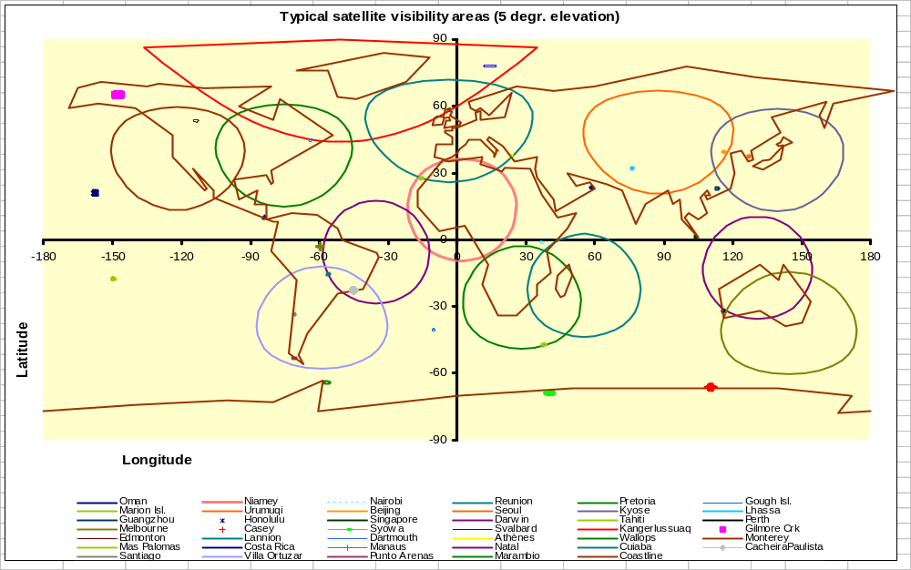Figure IV,2

4.2.1.5 Other communications missions : DCS, SARSAT

Polar orbiting satellites are well suited to support Data Collection Systems (DCS). The payload of NOAA and Metop includes the ARGOS DCS, which uses Doppler frequency-shift techniques aboard the satellite to determine the location of any ARGOS transmitter (or beacon), anywhere in the world, to within around 150 metres. ARGOS can also collect data from sensors on fixed or mobile Data Collection Platforms (DCPs) and thousands of such DCPs are operating around the world. Although continuous satellite coverage is not available for the relay of DCP data, except in the polar regions, the baseline subsystem provides a minimum of four satellite over-flights each day for every point on Earth

A Search and Rescue Satellite-aided Tracking System (SARSAT) uses polar orbiting and other low-orbiting satellites to pick up distress signals from downed aircraft or ships in distress and relays the signals to rescue forces through ground stations in cooperating countries that can locate the signal geographically to assist in rescue operations. The polar and low-orbiting satellites are equipped with transceivers operating at frequencies of 121.5, 243 and 406 MHz.

4.2.1.6 Space monitoring mission

NOAA satellites, in the baseline system, include a Space Environment Monitor (SEM) instrument that measures solar proton flux, electron density and energy spectrum, and total particulate energy distribution at spacecraft altitude. The two detectors included within this instrument are the total energy detector and the medium-energy proton and electron detector. SEM data are used to monitor and predict solar events, such as sunspots and flares, and their effects on the magnetic field. Measurements of arriving energetic particles are used to map the boundaries of the polar aurora that affect ionospheric radio communications and electric power distribution systems.

4.2.2 Geostationary satellites

4.2.2.1 Geostationary satellites stay in almost fixed positions 36,000 km above one point on the equator, circling the earth at the same speed as the planet itself spins on its axis. Since the altitude of the Geostationary Earth Orbit (GEO) is 40 times higher than on a polar LEO, it is technically more difficult to perform high resolution measurements of the earth’s atmosphere and surface, but the advantage of the GEO is to allow a continuous weather watch over a whole side of the earth’s globe. Frequent images, typically every 15 or 30 minutes, can be generated of the full earth disc, or more frequent images of smaller areas (rapid scan). Such images are widely used to support nowcasting, to monitor mesoscale cloud growth, to derive wind fields by analyzing the motion of clouds or water vapour features, for verification of synoptic forecasts and for communication purpose. Geostationary data provide a useful complement to polar-orbiting data to improve the temporal sampling of sea-surface temperature and surface or atmospheric radiation fields, to be used directly or through numerical model assimilation. Image quality is reduced at the greatest distances from the sub-satellite point because of the curvature of the earth but images are considered useful up to a zenith angle of around 70°, which corresponds to a great-circle-arc of about 60° from the sub-satellite point.
4.2.2.2 Some geostationary spacecraft like Meteosat of FY-2 are spin-stabilized platforms, using their own rotation to scan the earth’s disc line by line and to maintain a stable attitude. Other spacecraft design like GOES and MTSAT-1R are 3-axis stabilized, which makes accurate attitude control more difficult but allows more flexibility on the instrument scanning cycle. As a baseline, two geostationary meteorological satellites are maintained by the USA, at 75°W and 135°W, while one is operated by China (105° E), by EUMETSAT (0°), by Japan (140°E) and by the Russian Federation (76°E). In addition, India operates satellites at 74°E and 93°E mainly for national use. The current baseline coverage is illustrated in the figure below, although the actual coverage often differs from the baseline, for example over the Indian ocean. The overall configuration is subject to regular review by CGMS and WMO with the aim to optimize and consolidate the coverage, taking into account the participation of new satellite operators.
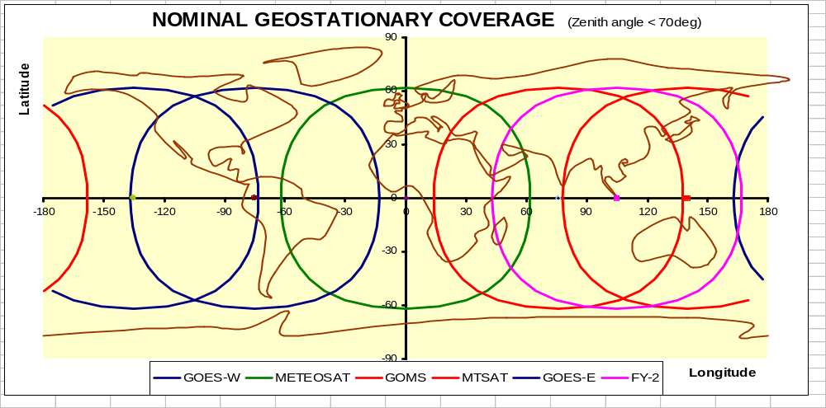Figure IV,3
4.2.2.3 Observing mission
The core mission of operational geostationary satellites is to provide continuous imagery with at least a refreshment cycle of 30 minutes in order:
- to monitor mesoscale cloud features in support of nowcasting and
- to allow the derivation of wind vector fields by tracking cloud or water vapour features in support of of NWP.
Several satellites provide more frequent images, over either the full earth’s disc or a selected area. All operational geostationary imagers include at least the following three core channels : visible, water vapour and infrared around 0.7, 6.7 and 11 µm respectively, with a typical horizontal resolution of 1 km in the visible and 5 km in the IR window bands. In addition, more recent satellites have a medium IR 3,9 µm channel and either a “split-window” 12 µm or a 13 µm channel. The SEVIRI imager aboard Meteosat Second Generation series includes 12 channels. A recommendation from the Implementation Plan for the Evolution of the Space- and Surface-based Global Observing System is to improve the spatial and temporal resolution of GEO imagers in those spectral bands relevant for monitoring rapidly developing small-scale events and wind retrieval. All geostationary satellite instruments are evolving towards more spectral coverage and faster imaging.
Some satellites have an extended payload allowing temperature and humidity profiles by IR radiometry, or earth radiation budget measurement. The latest GOES spacecraft carry a dedicated atmospheric sounding instrument with 8 carbon dioxide channels, 4 water vapour channels, 4 infrared channels, and ozone, nitrogen and visible channels. Soundings are produced hourly primarily over the USA and adjacent waters. The horizontal resolution of the sounding radiances is 10 km.

4.2.2.4 Data dissemination
Geostationary spacecraft also provide direct broadcast digital data dissemination services as described in Table IV,3. HRIT and LRIT are the agreed CGMS standards for direct broadcast from geostationary satellites in L-band, respectively for high and lower data rate, while analogue dissemination services (WEFAX) are progressively being phased out . In addition, increasing emphasis is put on the use of Advanced Dissemination Methods (ADM) which complement or sometimes replace Direct Broadcast. Since the use of ADM is not specific to the geostationary satellites, it is addressed in more details in Section 4.3. Derived products such as Atmospheric Motion Vectors are distributed over the GTS for NWP use.

Satellite | Service | Frequency | Data rate
GOES | GVAR  LRIT | 1685.7 MHz  1691.0 MHz | 2.1 Mbps  128 kbps
Meteosat  (first generation) | HRI | 1694.5 MHz | 166 kbps
Meteosat  (second generation) | LRIT  (primary dissemination is by ADM) | 1691.0 MHz | 128 kbps
MTSAT | HRIT  LRIT | 1687.1 MHz  1691.0 MHz | 3.5 Mbps  75 kbps
Elektro-L | HRIT  LRIT | 1691.0 MHz  1691.0 MHz | 0.665-1 Mbps  64-128 kbps
FY-2 | S-VISSR  LRIT | 1687.5 MHz  1691.0 MHz | 660 kbps  150 kbps
COMS | HRIT  LRIT | 1691.0 MHz
Table IV,3 Main direct broadcast dissemination services from geo satellites in 2006-2010

4.2.2.5 Data collection and Search and Rescue missions
The continuity inherent to geostationary satellite operations provides the capability to collect data from fixed or moving DCPs either according to a fixed schedule or in alert mode.
Each of the operators of geostationary meteorological satellites supports a Regional Data Collection System (RDCS), for gathering data from DCPs at fixed locations within the field of view of their respective satellites. The service has proved valuable in relaying alert information pertaining to e.g. tsunami, flash floods, radiation, over a large sector of the Earth.
The International Data Collection System (IDCS) was established by CGMS to allow the collection of environmental data from mobile DCPs such as those mounted on ships, planes or free drifting buoys and balloons. Such international DCP are transmitting on a fixed frequency that is compatible with any of the geostationary meteorological satellites within communications range. The Automated Shipboard Aerological Programme (ASAP), uses the IDCS to relay atmospheric sounding data obtained from moving vessels.
A COSPAS-SARSAT Geostationary Search And Rescue (GEOSAR) transponder is aboard GOES, Meteosat, Insat, and is planned for Elektro-L. Distress signals emitted by emergency beacons at 406 MHz are thus retransmitted in real-time to dedicated ground stations. Unlike the Search and Rescue system on polar satellites, the geostationary satellite cannot provide the location of the beacon but serves as an immediate indication of an emergency situation (See para 4.2.15 for more information on Search & Rescue on polar orbiting satellites).
4.2.2.6 Space environment monitoring missions
The GOES spacecraft carry a Space Environment Monitor (SEM) consisting of three major components: a magnetometer which measures the magnetic field at spacecraft altitude; a solar x-ray sensor which provides data on solar x-ray activity to monitor and predict solar flares; and an energetic particle sensor and high-energy proton and alpha detector designed to measure energetic particle flux at orbital altitude. X-ray data, monitored in real time from SEM sensors, can disclose the onset of a solar flare that may seriously affect telephone and radio communications. High-energy particles may damage solar cells, cause sensor malfunctions and trigger spurious commands aboard spacecraft. For similar objevtives an Heliogeophysical Measurement System is planned aboard Elektro-L.

4.2.3 R&D Satellites
4.2.3.1 Primary purpose of R&D satellite missions
Weather and climate monitoring and prediction, understanding atmospheric processes, as well as environmental resources monitoring require the observation of many geophysical variables beyond the mission objectives of core meteorological satellites described in paragraphs 4.2.1 and 4.2.2 above. A number of environmental satellites have been launched or are being planned for that purpose in the framework of experimental programmes of space agencies. They are referred to as “R&D satellites”. This category of R&D satellites include a wide range of missions with different status : technology demonstrator for new instrument concepts (e.g. spaceborne lidar), proof of concept for retrieving new variables from remote sensing (e.g. soil moisture), or missions of already proven feasibility providing data that are required in support of process studies (e.g. atmospheric chemistry missions). From a WMO standpoint, R&D satellite missions are primarily valuable through the advances that they make possible in instrument technology, retrieving methods and process modelling, that will ultimately benefit to operational programmes and providing utilization opportunities for future operational polar-orbiting and geostationary satellites.
4.2.3.2 Relevance of R&D satellite missions to the GOS
Since their primary purpose is to fulfil R&D objectives, R&D satellite data do not necessarily comply with operational requirements of long term continuity and real-time data availability. Furthermore, stable and validated algorithm and product definition may not be available. In spite of these limitations, R&D mission data are a valuable complement to operational data to improve the operational coverage, fill possible gaps and support calibration or validation activities. The early use of R&D data in an operational context is also essential as a learning process to adapt assimilation tools and anticipate as much as possible the operational availability of such data. The capability of NWP models to assimilate new data streams is a key factor in reducing the gap between operational and R&D data and optimizing the benefit of R&D missions.
R&D missions bring a particular contribution in the following areas :
- Precipitation: Precipitation is a key variable for environmental and climate monitoring, hydrology and weather prediction. Spatial and temporal rainfall variability and occurrence of extreme events at regional scales require high-density observations. Assimilation of precipitation data contributes to improving numerical weather prediction;
- Cloud Microphysics: Understanding cloud water content, cloud properties and characteristics, is important to parameterize and validate cloud/precipitation processes in numerical weather and global climate models and to determine the earth’s radiation balance;
- Aerosols and Trace Gases: observations in Atmospheric Chemistry affect the radiation budget for climate models and are important to monitor and forecast air quality and atmospheric pollution. Important products include aerosols total column and profile, particle size and optical properties;
- Winds - Surface winds and Atmospheric Motion Vectors (AMVs): AMVs are critical to Weather Predictions Models and wind is a key parameter for many areas of environmental monitoring and prediction such as coupled oceanic and atmospheric models, tropical weather analysis and hurricane warnings, aeronautical meteorology, fire watch;
- Ocean surface variables (temperature, topography, colour, sea-ice): Ocean Surface characterisation is essential for global coupled ocean-atmospheric climate model;
- Land surface variables (such as soil moisture, vegetation) are important for many applications such as agriculture, identification of potential famine areas, irrigation management, and land use monitoring (erosion and desertification) and for Environmental and NWP models. Operational use can provide substantial contribution to NWP models and environmental monitoring;
- Disaster Monitoring: Real-time disaster monitoring and management require high-resolution imagery across large areas, in all weather conditions, day and night. Examples of disaster monitoring include flood, drought, fires, earthquake/landslide, sand/dust storms, tsunami, volcanoes, snow/ice cover, red tide.

A list of R&D satellite missions - actual or planned – that are of direct interest for the Global Observing System is available on the WMO Space Programme web page. Details on the respective spacecraft and missions can be found from individual satellite operators.

4.2.3.3 Transition to operational status
Atmospheric or other environmental variables that were initially monitored in support of process studies have proved to be essential in the long term for climate monitoring and modelling. The range of geophysical variables for which sustainable observation needs to be implemented is thus considerably extended beyond the original scope of the operational Global Observing System. Following a successful proof of concept, R&D instrument are candidates for being followed by an operational version and there is an expectation from the user community that continuity be achieved by an operational follow-on without any gap. A suitable programmatic framework needs to be identified. Transition to an operational status may require implementing first a transition or “preparatory” mission in partnership between R&D space agencies and operational agencies. Strong user involvement in data and products validation activities is also advisable. From a schedule point of view, a transition strategy may also require extending R&D missions beyond their initial objectives to fulfil operational needs, as was the case with ESA’s ERS mission and NASA-JAXA’ TRMM mission for instance, in order to bridge the gap between the original R&D mission and its follow-on.
Priorities for transition to operational status need to be regularly reviewed in the light of evolving requirements and of the outcome of R&D missions and impact evaluation of their data. Current priorities include :
- ocean surface topography (on going transition through NASA-NOAA-CNES-EUMETSAT agreement for JASON-2)
- cloud microphysics and atmospheric chenistry missions to monitor trace gases and aerosols playing a role in atmospheric radiative balance including greenhouse effect.
- global precipitation monitoring (beyond the extension of TRMM and future GPM)
Other missions addressing essential geophysical variables are still at the stage of proof of concept, for instance 3D wind measurements by spaceborne lidar or soil moisture monitoring.

4.3 DATA CIRCULATION AND USER SERVICES

4.3.1 General Features of the ground segment
The ground segment consists of the facilities necessary to operate the spacecraft, perform data acquisition, processing, archiving and distribution, as well as provide user support services.
Spacecraft control normally relies on :
- a Command and Data Acquisition (CDA) station able to receive the raw data stream transmitted by the spacecraft, as well as house-keeping data, and to uplink telecommands
- a ranging system to accurately check the location of the satellite,
- a satellite and mission control centre in charge of monitoring the status of spacecraft and instruments, performing attitude control manoeuvers to maintain the spacecraft within its specified position and addressing any incident through appropriate measures to secure spacecraft operation.

Within a processing facility, data are pre-processed from level 0 (raw data) to level 1 (calibrated and geo-located, or “navigated”, radiances) and subsequently processed to derive geophysical products. Table IV,4 below summarizes the terminology for conventional data levels. Core product processing by satellite operators is often complemented by distributed processing centres having specialized skills in specific application areas (e.g. EUMETSAT network of Satellite Applications Facilities).
Links established among satellite operators or with other entities allow to exchange data from different spacecraft and regions. Access to multi-satellite data sets can thus be facilitated.

Data level | Description | Sub-classification for polar orbiting data | Sub-classification for geostationary data
0 | Raw data
1 | Data extracted by instrument with geolocation and calibration information | 1a: instument counts  1b: instrument counts with calibration and geolocation information  1c: brightness temperatures (IR) or reflectance factor (VIS) of instrument pixels with geolocation and calibration information  1d: brightness temperature (IR) or reflectance factor (VIS) of instrument pixels with geolocation, calibration, and cloud information | 1.0 Instrument counts  1.5 Geolocated and calibrated instrument radiances
2 | Geophysical value (temperature, Rel.humidity, radiative flux…) at instrument pixel
3 | Remapped (gridded) product based on geophysical value derived at instrument pixel
4 | Composite product (multisources) or result of model analysis of lower level data
Table IV,4 Summarized terminology for data processing levels

Products and level 1 data are archived by satellite operators. Detailed information on archive data catalogue, formats and retrieval media is to be found on the operators sites such as http://www.eumetsat.int/ for EUMETSAT’s Unified Meteoroologica Archive Facility (UMARF) or http://www.class.noaa.gov/ for NOAA/NESDIS’ Comprehensive Large Array data Stewardship System (CLASS).
Near-real time data dissemination of data and products relies on a range of communication means including direct broadcast, ADM and GTS distribution, as indicated in Section 4.2.1.4 and 4.2.2.4. Users should refer to the web pages of satellite operators and the WMO Space Programme to get the latest information on data access possibilities made available by satellite operators in specific regions with details on data policy and data formats.

4.3.2 Integrated Global Data Dissemination Service

Direct broadcast from meteorological satellites provides true real-time data access independently of any telecom infrastructure except the receiving station, however there are limitations to this approach. In the case of polar satellites, direct broadcast only delivers data related to the instantaneous field of view of the satellite (local data). Furthermore LEO or GEO direct broadcast users need appropriate software and computer facilities, often expensive, to perform pre-processing and product processing by themselves. In other cases such as the first generation of Meteosat, data are not directly broadcast by the satellite but first downloaded to the central processing site and pre-processed up to level 1.5 before being retransmitted to the satellite and disseminated from there. This alleviates the difficulty of pre-processing by the user. Howerver, another limitation remains since the data rate of meteorological spacecraft dissemination may be unable to transmit the full data set in full resolution.

Emphasis was put in recent years on the use of Advanced Dissemination methods (ADM) whereby satellite data and products are distributed by state of the art commercially available telecommunications means instead of being restricted to the on-board telecommunication function of the meteorological spacecraft. Data distribution can be optimized from a pure telecommunications point of view and evolve with time in order to meet new requirements and benefit from the most cost-efficient technology. Additionally, when the meteorological platform does not have to support dissemination functions, the attitude control requirements can be relaxed, which facilitates extended lifetime operations. The most widespread type of ADM is file transmission with Internet Protocol (IP) by Digital Video Broadcast by Satellite (DVB-S) as available from various telecommunications operators around the world. This allows data rates of more than 20 Mbps to be received with standard low-cost equipment. Dissemination is performed in Ku-Band or in C-band. C-band is used in intertropical regions because of its lower absorption by water vapour and liquid water. It is however more sensitive to local interference with radars.

ADM services can offer unified access to various sources of data including different satellites, LEO, GEO or R&D, as well as multi-satellite composite products, high-level products and non-satellite information. Satellite data dissemination via ADM is not specific to the satellite world and is a component of the WMO Information System.

The Integrated Global Dissemination Service (IGDDS) is the approach to satellite data and products circulation within the WMO Information System (WIS). In pursuing the IGDDS vision, WMO supports cooperation among satellite operators towards establishing ADMs in a coordinated way, organizing global data exchange, ensuring fulfilment of the needs of WMO Programmes and compatibility with overall WIS concepts. Satellite operators will act within IGDDS as Data Collection and Product Centres (DCPC). The objective of IGDDS is to offer integrated access to the data of all satellites available over WMO Regions, in a way that is cost-efficient both for the users ansd for satellite operators. IGDDS relies on the expansion of ADM coverage, together with direct broadcast as a complement, and the follow-on of the current GTS.

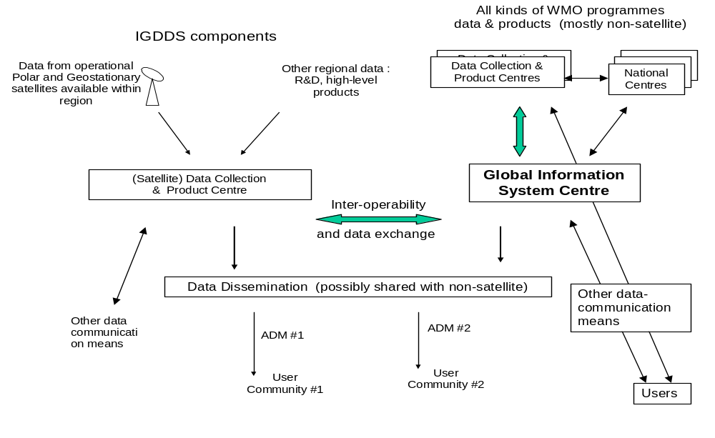
Figure IV,4. Schematic diagram of the IGDDS within WIS framework

4.3.3 User services

Users should refer to the individual web pages of the respective satellite operators to benefit of the available user services. This normally includes updated information on :

- satellite status and operations (eclipse, manoeuvers)
- product catalogue and product algorithm description
- archive catalogue, format description and retrieval modalities
- technical issues for real-time data access, including specifications for receiving devices, software for data reception, decoding, decompression and/or pre-processing
- administrative issues for real-time data access, including registration and subscription formalities, data policy
- background information, publications and user conferences
- user support

4.3.4 Satellite user training

The WMO Strategy for Education and Training in Satellite Meteorology is based on cooperation between satellite operators and some Regional Meteorological Training Centres that take a particular responsibility as Centres of Excellence (CoE) in Satellite Meteorology. The Strategy emphasizes “training the trainers”. The network of CoEs is expanding and currently nearly covers all WMO Regions and provides training in five of six of the WMO official languages, as indicated in Table IV, 5.

Centre of Excellence | Sponsoring Satellite Operator | Primary language | WMO Region
Niamey (Niger)  Nairobi (Kenya) | EUMETSAT | French  English | RA I  RA I
Oman (Oman) | EUMETSAT  and IMD | Arabic | RA II
CIMH (Barbados)  UCR (Costa Rica) | NOAA/NESDIS | English  Spanish | RA IV  RAIII & RA IV
Nanjing (China) | CMA | Chinese & English | RA II & RA V
BMTC (Australia) | JMA | English | RA V
Buenos Aires (Argentina) | NOAA/NESDIS | Spanish | RA III
 | ESA
 | NASA

Table IV,5. Curent network of Centres of Excellence and sponsoring satellite operators

A core component of this strategy is the Virtual Laboratory for Education and Training in Satellite Meteorology (VL) that was adopted by both CGMS and WMO . The VL develops and maintains a range of training materials and tools that are accessible on-line via a Virtual Resource Library. It organizes classical (face-to-face) training events (“training the trainers”) as well as on-line lectures with remote instructors. Cooperation among the CoEs and with sponsoring satellite operators is supported by regular on-line interactive sessions on live meteorological situations. Up-to-date information on the Virtual Laboratory shall be found on the VL web page that is accessible from any of the sponsoring institutions’ homepage as well as the CGMS and WMO homepage.

4.4 DERIVED PRODUCTS
4.4.1 Calibration issues
Instrument counts can only be converted to radiances with calibration coefficients that characterize the instrument’s response as a result of its geometry and detector sensitivity. Industrial pre-launch measurements provide an initial model of the instrument’s response and longterm behaviour but only in orbit commissioning and regular monitoring can provide accurate calibration coefficients as required for any quantitative product derivation. Some instrument designs include on-board calibration devices relying on a black body source (for infra-red sensors) and moon, sun or or deep space viewing. Each calibration cycle then allows to update the nominal calibration coefficients that are included in the disseminated data flow. When no on-board calibration system is available, or in order to check such on-board systems when available, retrospective calibration is achieved by atmosphere radiance measurements over stable and homogeneous targets such as deserts and cloud-free oceans. Results of this retrospective calibration process, known as vicarious calibration, are routinely published by satellite operators.
Monitoring climate change requires the detection of trends in terms of small variations (e.g. a few tenths of a degree of temperature over a decade) which requires particularly accurate calibration ensuring consistency of global data sets from different sensors over a very long period. The instrument nominal calibration thus needs to be followed by an inter-calibration of different sensors that are simultaneously in orbit, comparing data series of carefully space-time co-located scenes with similar viewing angle, in order to provide normalized calibration coefficients.
The use of particularly accurate reference sensors, including airborne calibration campaigns, allows to approach absolute calibration that is ultimately required for climate modelling. Provisions are being made within WMO and CGMS towards establishing a Global Space-based Intercalibration System (GSICS) that would enable to perform intercalibration on an operational basis rather than retrospectively.

4.4.2 Product categories

Some of the products derived from the satellite observations processed at major central facilities are exchanged internationally over the GTS. Some products are broadcast through ADM services together with level 1 data. These products are also available on FTP servers made available by the respective satellite operators. A consolidated list of operational products available from NOAA/NESDIS can be found through the NOAA/NESDIS CLASS Home Page . Similarly, the EUMETSAT Homepage outlines the operational products and services available either from its central product facility (“list of products” ) or from its network of Satellite Application Facilities (“SAFs”) .

CGMS Directory of applications describes the generation and use of a wide range of products that can be derived from satellite observations, including in particular the following categories :
- Radiances and imagery products
Imagery products result of calibration, geolocation, remapping and dynamics adjustment of level 1 data. Imagery and radiance products are a necessary step for derivation of higher level products. In particular, an accurate cloud mask product is a prerequisite for deriving meaningful quantitative surface and sounding products. Cloud detection can be performed through comparison with Infrared brightness temperature thresholds or visible reflectance thresholds, with adjustments depending on the underlying surface (sea or land), the latitude and the season.
Imagery products are also used on a routine basis by direct interpretation either as single-channel images or after further processing such as multispectral compositing, temporal combination of animated sequences, multisatellite mosaics.
- Cloud characterization
Cloud characterization products are an essential support from satellite imagery to Nowcasting and regional short-term forecasting. Multispectral discrimination techniques applied to visible and infrared imagery allow useful identification of cloud types. Cloud top temperature or pressure level can be derived from infrared imagery.
- Atmospheric thermodynamic soundings from polar orbiting satellites.
Vertical temperature and humidity soundings are derived from IR sounder data, in clear-sky, and from microwave sounders in cloudy areas and operationally available from NESDIS on the GTS in SATEM code at reduced resolution. ATOVS data have been shown to have a significant positive impact on NWP in both hemispheres. Advanced NWP centres are increasingly assimilating radiance data directly, rather than the temperature and humidity soundings retrieved from them. Information on the error characteristics of retrieved products or radiances, including biases, is essential for their successful assimilation. Hyperspectral infrared sounders of the AIRS – IASI generation will allow a considerable progress in accuracy and vertical resolution.
- Atmospheric Motion Winds
Such winds are generated automatically by applying a correlation algorithm to sequences of two or three images. They are extracted classically by tracking the movement of cloud fields from a geostationary satellite. Similar approach can be used in the absence of clouds with water vapour features detected on 6.7 μm or total ozone patterns on 9.7 μm imagery. Such geostationary winds are computed within 60° latitude and longitude of the sub-satellite point, at least four times daily at 0000, 0600, 1200 and 1800 UTC, and distributed in SATOB code by all the geostationary satellite operators. The operators are generally moving towards the production of higher resolution products and the use of quality indicators to assist in their use. For polar regions, advantage can be taken of frequent overpasses by polar/orbiting satellites for the derivation of winds, as experienced with water vapour radiances from MODIS instrument aboard NASA-s AQUA satelite.

- Surface temperature
Sea Surface Temperature (SST) may be derived from IR images of both polar and geostationary meteorological satellites on cloud-free areas. The primary advantages of the polar data are that they provide global coverage and have generally better spatial resolution. The advantage of the geostationary satellites is their frequent data coverage gives a better chance to find cloud-free pixels. It also allows frequent temporal sampling necessary to monitor diurnal variations. Regional AVHRR based products are available at high resolution (typically 2 km) or global products at lower resolution (e.g. 10 km) . With METOP it should be possible to derive operationally high resolution products on the global scale. High accuracy SST can be derived from ENVISAT/AATSR and AQUA-TERRA/MODIS. Microwave passive imagery can also support SST measurements.
Infrared imagers also allow derivation of Land Surface Temperature (LST) in combination with visible imagery to take into account the effect of vegetation.
- Snow and Ice products
Snow and ice areas are identified by visible, infrared and microwave imagery (AVHRR, MODIS, SSM/I). Active microwave sensors such as scatterometer or SAR imager are useful to characterize the superficial snow or ice layer.
- Vegetation Index
Daylight NOAA imagery provides an essential indicator of the overall vegetation status, the Normalised Difference Vegetation Index (NDVI) based on difference between reflectance of AVHRR channel 1 (0.6 μm ) and channel 2 ( 0.9 μm ). The index has been used to assess fire risk, and estimating vegetation growth and crop yields. More sophisticated products are the Leaf Area Index (LAI) and the Fraction of Photosynthetically Active Radiation (FPAR).

- Ocean surface

Microwave active sensors are essential to monitor the ocean surface : altimetry data provide sea level information for ocean current monitoring and oceanographic modelling, but also provide information on sea state (significant wave height and wind intensity). Scatterometer data provide ocean surface wind vectors that are an essential input to NWP and tropical cyclone monitoring.

4.5 TRENDS IN THE SPACE-BASED SUBSYSTEM

The space-based observation capability are evolving rapidly in many aspects. One striking element is the increasing number of countries contributing to the space-based observing system, either by operational satellites or R&D satellites. When geostationary satellites from the Russian Federation, India, China, Korea, NOAA, EUMETSAT and Japan will be simultaneously operationally available, new possibilities will arise to optimize the global baseline configuration and ensure its robustness. For polar satellites, more operational spacecraft will allow a better time sampling from the LEO. The growing capability of operational users to take advantage of R&D satellites and arrangements for real-time availability of selected R&D satellites will also contribute to enhance the GOS.
The performance of space-based instruments is dramatically improving, allowing higher temporal and horizontal resolution, and considerably higher spectral resolution. Geostationary satellites will at some stage be all equipped with hyper-spectral infrared sensors allowing frequent temperature and humidity sounding, that so far can only be performed from LEO a few times a day. Active and passive infrared measurements from polar orbit will improve observations of aerosols and atmospheric chemical components. Precipitation monitoring by radar and microwave imagery will be effective at global scale. Doppler lidar on polar satellites will provide 3D global wind fields. Lightning sensors aboard geostationary satellites will improve the monitoring of active convective cells. The potential of microwave passive radiometry will be further developed, to the extent that the relevant frequency bands are kept free from man made interferences, for monitoring soil moisture and ocean salinity as well as for better monitoring of cloud microphysical properties.
The increased resolution and number of instruments will result in an explosion of the data rate acquired from satellites, requiring an updated and flexible dissemination infrastructure that IGDDS is expected to facilitate. The data volume, together with the multiple number of data sources should lead the users to focus their development efforts and strengthen their cooperation in order to be able to rely more on common products elaborated by regional specialized centres along agreed requirements, rather than processing individually only low level data. The need for accurate and consistent data series will also emphasize the importance of sensor calibration and inter-calibration along agreed standards.
Further details on the long-term vision of the space-based subsystem can be found in ”The role of satellites in WMO programmes in the 2010s” (WMO/TD N° 1177).
4.6 ACRONYMS

ADEOS | Advanced Earth Observing Satellite (NASDA)
AIRS | Atmospheric Infrared Sounder (EOS)
ALADIN | Atmospheric Laser Doppler Instrument (ESA)
ALOS | Advanced Land Observing Satellite (NASDA)
AMI | Active Microwave Instrument (ERS)
AMSR | Advanced Microwave Scanning Radiometer (ADEOS)
AMSU | Advanced Microwave Sounder Unit (NOAA)
APT | Automatic Picture Transmission
ARGOS | Data Collection and Location System on NOAA satellites (France)
ASAP | Automated Shipboard Aerological Programme
ASCAT | Advanced Scatterometer (METOP)
ASMET | African Satellite Meteorology Education and Training
ASTER | Advanced Space-borne Thermal Emission and Reflection Radiometer (EOS-AM)
ATLID | Atmospheric Lidar (ESA)
ATOVS | Advanced TIROS Operational Vertical Sounder (NOAA)
AVHRR | Advanced Very High Resolution Radiometer (NOAA)
CDAS | Command and Data Acquisition Station (EUMETSAT)
CEOS | Committee on Earth Observation Satellites
CERES | Clouds and Earth’s Radiant Energy System (EOS-AM)
CGMS | Coordination Group for Meteorological Satellites
CMA | Chinese Meteorological Administration
CrIS | Cross track Infrared Sounder
CSA | Chinese Space Agency
DCP | Data Collection Platform
DMSP | Defence Meteorological Satellite Program (USA)
DRS | Data Retransmission System
DSB | Direct Sounder Broadcast
EC | European Community (also : Executive Council (WMO) )
ENVISAT | Environmental Satellite (ESA)
EOS | Earth Observing System (NASA)
ERS | European Remote-sensing Satellite (ESA)
ESA | European Space Agency
ESOC | European Space Operations Centre (ESA)
EUMETSAT | European Organisation for the Exploitation of Meteorological Satellites
FGGE | First GARP Global Experiment
FY-2 | Chinese Geostationary Meteorological Satellite (CMA)
GARP | Global Atmospheric Research Programme
GCOS | Global Climate Observing System
GERB | Geostationary Earth Radiation Budget (MSG)
GMS | Geostationary Meteorological Satellite (JMA)
GNSS | Global Navigation Satellite System
GOES | Geostationary Operational Environmental Satellite (NOAA)
GOME | Global Ozone Monitoring Experiment (METOP)
GOMS | Geostationary Operational Meteorological Satellite (RSA)
GOS | Global Observing System
GRAS | GNSS Receiver for Atmospheric Sounding (METOP)
GTS | Global Telecommunication System
GUAN | GCOS Upper Air Network
HIRS | High Resolution Infrared Sounder (NOAA)
HRIT | High Rate Information Transmission (standrd for geostationary satellites)
HRPT | High Resolution Picture Transmission (standard for polar-orbiting satellites)
IASI | Infrared Atmospheric Sounding Interferometer (METOP)
IDCS | International data Collection System (CGMS)
IGOS | Integrated Global Observing Strategy (of CEOS et al)
IMAGER | Imaging Radiometer (GOES & MTSAT)
INSAT | Indian National Satellite (ISRO)
IR | Infrared
IRS | Indian Remote-sensing Satellite (ISRO)
ISRO | Indian Space Research Organization
JMA | Japan Meteorological Agency
Jason | TOPEX/POSEIDON follow-on ocean topography satellite
JAXA | Japan Aerospace Agency
LAGEOS | Laser Geodetic Satellite (NASA)
LAI | Leaf Area Index
LANDSAT | Land satellite (USA)
LRIT | Low Rate Information Transmission (standard for geostationary satellites)
LRPT | Low Rate Picture Transmission (standard for polar-orbiting satellites)
MARF | Meteorological Archive Facility (EUMETSAT)
MDD | Meteosat Data Distribution (EUMETSAT)
Meteor | Series of polar satellites operated by the RSA.
Meteosat | Meteorological Satellite (EUMETSAT)
METOP | Meteorological Operational Platform (EUMETSAT)
MHS | Microwave Humidity Sounder (METOP and NOAA)
MISR | Multi-angle Imaging Spectroradiometer (EOS-AM)
MKU | Meteosat Key Unit (EUMETSAT)
MODIS | Moderate-resolution Imaging Spectroradiometer (EOS-AM)
MOPITT | Measurement of Pollution in the Troposphere (EOS-AM)
MSG | Meteosat Second Generation (EUMETSAT)
MSU | Microwave Sounding Unit (NOAA)
MTSAT | Multi-functional Transport Satellite (Japan)
MVIRI | Meteosat Visible and Infrared Imager (Meteosat)
NASA | National Aeronautics and Space Administration (USA)
NDVI | Normalized Difference Vegetation Index
NESDIS | National Environmental Satellite, Data and Information Service (NOAA)
NIR | Near Infrared
NOAA | National Oceanic and Atmospheric Administration (USA)
NPOESS | National Polar-orbiting Operational Environmental Satellite System (USA)
NSCAT | NASA Scatterometer
NWP | Numerical Weather Prediction
PBL | Planetary Boundary Layer
PC | Personal Computer
PDUS | Primary Data User Station (EUMETSAT)
PGS | Primary Ground Station (EUMETSAT)
PR | Precipitation Radar (TRMM)
RDCS | Regional Data Collection System (CGMS)
RMTC | Regional Meteorological Training Centre
ROSKOSMOS | Russian Space Agency
SAR | Synthetic Aperture Radar (ESA)
SARSAT | Search and Rescue Satellite-aided Tracking
SATEM | WMO Code for the exchange of space-based soundings
SATOB | WMO Code for the exchange of winds derived from cloud motion
SBUV | Solar Backscatter Ultra Violet instrument (NOAA)
SDUS | Secondary Data User Station (EUMETSAT)
Seasat | Sea Satellite (NASA)
SEM | Space Environment Monitor (NOAA)
SEVIRI | Spinning Enhanced Visible and Infrared Imager (MSG)
SPOT | Satellite Pour l’Observation de la Terre (France)
SSM/I | Special Sensor Microwave/Imager (DMSP)
SST | Sea Surface Temperature
TIR | Thermal Infrared
TIROS | Television Infrared Operational Satellite (NOAA)
TOA | Top of the Atmosphere
TOMS | Total Ozone Mapping Spectrometer (NASA)
TOPEX/  POSEIDON | Oceanic Topography Experiment (France/USA)
TOVS | TIROS Operational Vertical Sounder (NOAA)
TRMM | Tropical Rainfall Measuring Mission (NASA)
UHF | Ultra High Frequency
VHF | Very High Frequency
VIS | Visible
VISSR | Visible and Infrared Spin-Scan Radiometer (METEOSAT)
WEFAX | Weather Facsimile

4.7 REFERENCES : PUBLICATIONS AND HOMEPAGES

CEOS Handbook | http://www.eohandbook.com/eohb05/ceos/part3_3.html
CEOS/WMO Database | http://alto-stratus.wmo.ch/sat/stations/SatSystem.html
CGMS Directory of applications | http://www.wmo.int/web/sat/index.htm
ESA / Earth Observation | http://www.esa.int/esaEO/index.html
EUMETSAT Homepage | http://www.eumetsat.int/
EUMETSAT SAF NWP  (AAPP software) | http://www.metoffice.gov.uk/research/interproj/nwpsaf/
GOMS/Meteor Homepage | http://sputnik.infospace.ru
Japan Meteorological Agency (MTSAT ) | http://www.jma.go.jp/jma/jma-eng/satellite/index.html
Japan Aerospace Agency | http://www.jaxa.jp/missions/projects/sat/eos/index_e.html
NASA / Earth Observation | http://www.nasa.gov/missions/earth/index.html
National Satellite Met Centre of China | http://www.cma.gov.cn
NESDIS Homepage | http://www.nesdis.noaa.gov/
NOAA Homepage | http://www.noaa.gov/
WMO (1994) | Information on Meteorological and other Environmental Satellites (WMO-No.411)
WMO (1998) | SAT-14, Satellite Data Archiving, (WMO/TD-No.909)
WMO (2003) | Manual on the Global Observing System (WMO-No.544) Edition 2003
WMO (2003) | The role of satellites in WMO programmes in the 2010s, SP-1 , 2003, Technical Document WMO/TD N° 1177
WMO Space Programme Homepage | http://www.wmo.int/web/sat/satsun.html

