WORLD METEOROLOGICAL ORGANIZATION  ____________________  COMMISSION FOR BASIC SYSTEMS  OPEN PROGRAMMME AREA GROUP ON  INTEGRATED OBSERVING SYSTEMS  Second Ad hoc IPET-OSDE workshop on Observing System Network Design  GENEVA, SWITZERLAND, 2-4 FEBRUARY 2015 |  | CBS/OPAG-IOS/OSDW2 / Doc. 6(5)  (28.01.2015)  _______  ITEM: 6  Original: ENGLISH

GCW materials that could be used for developing OSND guidance material

(Submitted by Michele Citterio (Denmark) and the Secretariat)

SUMMARY AND PURPOSE OF DOCUMENT

The document provides information on Global Cryosphere Watch (GCW) materials that could be used for developing OSND guidance.

ACTION PROPOSED

The Meeting is invited to note the information contained in this document when considering its recommendations.

____________

DISCUSSION

Global Cryosphere Watch (GCW)

- Following decisions made by the Sixteenth World Meteorological Organization Congress in 2011, WMO is now developing the Global Cryosphere Watch (GCW) as an IPY legacy with a view towards achieving an operational GCW. This initiative is an international mechanism for supporting all key cryospheric in situ and remote sensing observations. Intrinsically GCW is a cross-cutting activity with interests extending globally. Its activities relate to several Technical Commissions (TCs), all Regional Associations (RAs) and virtually all WMO Programmes. GCW will provide authoritative, clear, and useable data, information, and analyses on the past, current, and future state of the cryosphere. The observing component of GCW is a component of the WMO Integrated Global Observing System (WIGOS).
- As defined in the Manual on WIGOS, GCW shall be a coordinated system of networks of observing stations, methods, techniques, facilities and arrangements encompassing monitoring and related scientific assessment activities devoted to the investigation of the changing cryosphere. The Cryosphere Observing Network shall build on existing cryosphere observing programmes and promote the addition of standardized cryospheric observations to existing facilities. The purpose and long-term goal of the Global Cryosphere Watch shall be to provide data and other information on the global cryosphere to improve understanding of its behaviour, interactions with other components of the climate system, and impacts on society. In designing the GCW Cryospheric Observing Network, the recommendations laid out in the IPET-OSDE OSND Principles have been taken into account.

3. An immediate priority for GCW is to establish the core standardized surface-based observing network called CryoNet, see more details on: http://www.globalcryospherewatch.org/cryonet/, as well as to identify practices that will be applied by the two types of CryoNet sites, see: http://www.globalcryospherewatch.org/cryonet/site_types.html.

4. Recognizing that existing communities, practices and needs for ground based cryospheric observations may partly have a regional character, the GCW CryoNet Team has organized a CryoNet Asia and CryoNet South America workshops which proved to be very successful at bringing together the relevant communities. This will ensure that existing observing networks designed to meet national needs also take into account the needs of GCW and the WMO at the regional and global levels, as recommended by OSDE.

5 CryoNet will be comprised of sites with varying capabilities. It will build on existing cryosphere observing programmes and promote the addition of standardized cryospheric observations to existing facilities in order to create more robust environmental observatories. CryoNet observations cover all components of the cryosphere (glaciers, ice shelves, ice sheets, snow, permafrost, sea ice, river/lake ice and solid precipitation) through in situ observations.

6. Two types of sites are envisioned based on the number of “spheres” that are monitored (e.g. atmosphere, biosphere, cryosphere, hydrosphere, etc.). See Figure 1. CryoNet Basic Sites monitor one or more components of the cryosphere and observe multiple variables of each component. Basic Sites also measure auxiliary meteorological variables, comply with GCW best practices, are actively taking measurements, have a long-term financial commitment, make data freely available, and make data available in (near) real time whenever possible. CryoNet Integrated Sites, in addition to the CryoNet Basic Sites characteristics, monitor at least one other sphere, have a broader research focus, have support staff, and have training capability. CryoNet Integrated Sites are particularly important for the study of feedbacks and complex interactions between the atmosphere, biosphere, cryosphere, and ocean.

7. CryoNet Sites contain one or more CryoNet Stations. Primary Stations have a target (intent) of long-term operation and have at least a 4-year initial commitment. Baseline Stations have a long-term operational commitment and long-term (more than 10 years) data records.

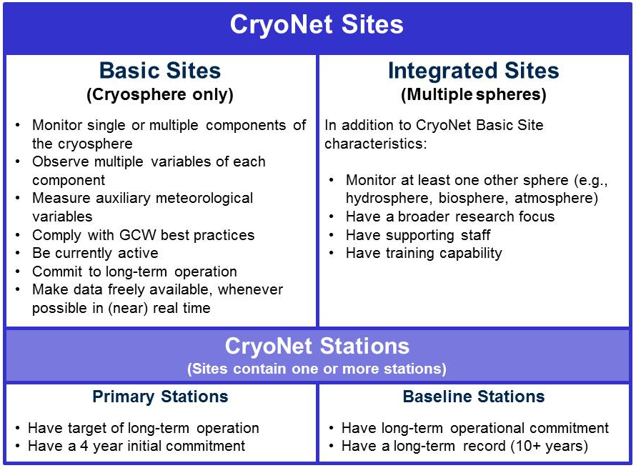

Figure 1: The structure of CryoNet

8. It is envisioned that a number of currently active ground monitoring sites producing valuable cryospheric observations may not satisfy all the requirements to become CryoNet sites. These sites can apply for inclusion in the wide GCW Cryosphere Observing Network as Contributing Sites.

9. In order for a surface measurement site or station to be included in CryoNet, it must meet certain criteria. The minimum requirements are given below. If a site meets these requirements, additional information (metadata) can be provided for further evaluation through the CryoNet Site Questionnaire (a preview is available here). Contributing sites, which are part of the wide GCW surface network but not part of CryoNet, only need to meet the data sharing requirement.
- The site location is chosen such that, for the cryospheric components measured, it is representative of the surrounding region.
- User needs have been considered in the observation design process.
- CryoNet sites have to be active and perform sustained observations according to CryoNet best practices. There shall be a commitment to continue measurements for a minimum of four (4) years.
- Personnel are trained in the operation and maintenance of the site.
- The responsible agencies are committed, to the extent reasonable, to sustaining long-term observations of at least one cryosphere component, including auxiliary meteorological variables.
- The relevant CryoNet observations are of documented quality. The measurements are made and quality controlled according to CryoNet best practices.
- Associated standard meteorological in situ observations, when necessary for the accurate determination and interpretation of the GCW variables, are made with documented quality.
- A logbook for observations and activities that may affect observations is maintained and used in the data validation process.
- The data and metadata, including changes in instrumentation, traceability, observation procedures, are submitted in a timely manner to a data centre that is interoperable with the GCW portal.
- The site characteristics and observational programme information are kept up-to-date in the GCW station information database. Station metadata are also provided to the WIGOS Information Resource (WIR) and maintained regularly.
10. The process of selecting sites and stations as part of the CryoNet network is in its initial stage (see http://globalcryospherewatch.org/cryonet/stations.php). An online site application form has been made available and several sites were identified for the preoperational testing phase, see: (http://globalcryospherewatch.org/cryonet/sites.php?category=core). The whole process will be completed by December 2015 for consideration by EC-68.
11. Acknowledging the importance of historical time series at sites not currently active, the GCW Cryosphere Observing Network will accept such historical time series and encourage efforts aimed at rescuing data from existing archives, their digitalization, and their opening for public access.

12. In order to make cryospheric ground observations available in an open and timely manner to the GCW Cryosphere Observing Network and in particular its core network CryoNet, the design of the network is progressing in parallel with the establishment of the GCW Data Portal. The online data portal collects and maintains metadata records and pointers to the data repositories physically holding the data. The GCW Data Portal implements machine interfaces to the data providers operating the ground observation sites, allowing timely metadata updates when new measurements are added, current time series are interrupted or other relevant changes occur at sites belonging to the GCW Cryosphere Observing Network. This further implements the OSDE recommendations for ‘providing information so that the observations can be interpreted’ and for ‘managing change’

13. As an enabling step toward the development of the GCW best practices and the homogeneity of delivered observational data, a database of cryospheric terms as defined by existing glossaries has been compiled and is available through the GCW Website at http://globalcryospherewatch.org/reference/glossary.php. Further work is needed to evaluate alternative definitions and converge on the official GCW Glossary that will be formally vetted and then translated.

__________

