WORLD METEOROLOGICAL ORGANIZATION  ____________________  COMMISSION FOR BASIC SYSTEMS  OPEN PROGRAMMME AREA GROUP ON  INTEGRATED OBSERVING SYSTEMS  Second Ad hoc IPET-OSDE workshop on Observing System Network Design  GENEVA, SWITZERLAND, 2-4 November 2015 |  | CBS/OPAG-IOS/OSDW2 / Doc. 6(2) Rev. 1  (29.01.2015)  _______  ITEM: 6  Original: ENGLISH

GOS materials that could be used for developing OSND guidance material

(Submitted by Islam MAHER (Egypt), Elena Saltikoff (Finland), and Karl Monnik (Australia))

SUMMARY AND PURPOSE OF DOCUMENT

The document provides information on GOS materials that could be used for developing OSND guidance consisting of the intermediate layer of general guidance that lies between the WIGOS OSND Principles and the lower layers of guidance/documentation that apply / will apply to the individual observing system components of WIGOS.

ACTION PROPOSED

The Meeting is invited to note the information contained in this document when considering its recommendations.

____________

Appendix: A. Global precipitation pattern produced by the General Circulation
B. Global Jet Streams patterns

DISCUSSION

To support the development of guidance material that complements the 12 Observing System Network Design Principles, ET-SBO propose the following text for consideration by OSND-2. This document is laid out in such a way that each Design Principle is followed by the proposed text and the source document, or reference, from which the text is copied.

1. SERVING MANY APPLICATION AREAS
Observing networks should be designed to meet the requirements of multiple application areas within WMO and WMO co-sponsored programmes.

This is discussed in WMO488 p 3-3.
Elena: Sometimes pleasing as many application areas as possible leads to compromises; e.g. a radar network can be optimized either for hydrology or aviation but if you want both, you need to sacrifice the best quality. Funding permitting, parallel networks are sometimes the best solution.

2. RESPONDING TO USER REQUIREMENTS
Observing networks should be designed to address stated user requirements, in terms of the geophysical variables to be observed and the space-time resolution, uncertainty, timeliness and stability needed.

WMO488 p3-25 example from Sweden.
Elena: The user requirements are not always clear for the users themselves. Users are not always aware of connections between properties of instruments and infrastructure. E.g. a station in a location specified as optimal for the user may suffer of power failures, interference or be in flood risk. Increasing timeliness and rapid updates may lead to worsening of observation quality etc.

3. MEETING NATIONAL, REGIONAL AND GLOBAL REQUIREMENTS
Observing networks designed to meet national needs should also take into account the needs of the WMO at the regional and global levels.

Islam: We can’t study Observing networks design without taking into account the meteorolgical principals and our knowledge of general circulation of the atmosphere.

For example: Fig.1 in Appendix A shows the global precipitation patterns, and we can easily identify in which areas the priority for establishing weather radars should be placed. On the other hand when we take a look on Fig.2 in Appendix B, which shows the global jet streams patterns, we identify the areas in which the priority for establishing wind profilers and radio sonde stations should be placed.
WMO488 p3-66 mentions climate dependence for radars.

4. DESIGNING APPROPRIATELY SPACED NETWORKS
Where high-level user requirements imply a need for spatial and temporal uniformity of observations, network design should also take account of other user requirements, such as the representativeness and usefulness of the observations.

* parameter dependance WMO488 p3-2 more detailed than WMO100.
* parameter dependance WMO100 p2-12.
* climate dependance WMO488 p3-66 for radars.

5. DESIGNING COST-EFFECTIVE NETWORKS
Observing networks should be designed to make the most cost-effective use of available resources. This will include the use of composite observing networks.

Karl: The benefit of third party observations should be considered when operating networks. The value of the observations should be assessed together with the effort required to incorporate the data into NMHS systems. The value of observations can be determined by examining the following aspects, which has been presented at a ET-AWS-5 meeting; data quality, available of metadata, inspection and calibration, cost to ingest the data, and legal aspects concerning public access to the data.
WMO100 p2-12.
* WMO488 p3-3 about using the same location for new needs.

6. ACHIEVING HOMOGENEITY IN OBSERVATIONAL DATA
Observing networks should be designed so that the level of homogeneity of the delivered observational data meets the needs of the intended applications.

* WMO488 p3-6 to p3-7 inspections, calibration.

7. DESIGNING THROUGH A TIERED APPROACH
Observing network design should use a tiered structure, through which information from reference observations of high quality can be transferred to and used to improve the quality and utility of other observations.
WMO488 p3-2, the text about station naming may be outdated.

Karl: WCRP 4/2014 includes some information concerning tiered networks. Section 3.1, pg 6. Some example statements below.

It was agreed to dispense with the concept of a network altogether in favour of a concept for grading sets of stations, where “Tier 1” stations represented the Reference Climate Stations, analogous to GRUAN stations in the upper-air network, and the most suitable for long-term monitoring purposes.
It was decided that GCOS/WCRP Atmospheric Observation Panel for Climate (AOPC) should be invited to consider establishing a working group to establish the selection criteria for Reference Climate Stations. Such a working group should take into account the guidance materials referred to above, and later discussions about the terms reference (Tier 1), baseline (Tier 2) and comprehensive (Tier 3). It is also important that the process should also be “socialized” among the climate monitoring community. It was agreed that the tier designation should be a function of demonstrable measurement qualities, such as traceability, metadata, comparability, data completeness, record longevity etc.

8. DESIGNING RELIABLE AND STABLE NETWORKS
Observing networks should be designed to be reliable and stable.

WMO488 p3-3.

Elena: For power outages, two types of solutions must be considered. Short outages can be covered by batteries (UPS), for longer ones, local power sources (diesel generators, solar panels, wind generators of even hydropower microplants). It is important to scale the power sources so that they do not only cover the instrument but also the needs of necessary infrastructure such as computers, telecommunication devices and air conditioning.

Islam: Also the well-trained competencies for the maintenance and calibration is a very important issue.

Karl: Stations in a network should be protected by a long-term lease which allows suitable re-negotiation over time.

9. MAKING OBSERVATIONAL DATA AVAILABLE
Observing networks should be designed and should evolve in such a way as to ensure that the observations are made available to other WMO Members, at space-time resolutions and with a timeliness to meet the needs of regional and global applications.
WMO488 p3-47 (upper air, archiving+ communications).

10. PROVIDING INFORMATION SO THAT THE OBSERVATIONS CAN BE INTERPRETED
Observing networks should be designed and operated in such a way that the details and history of instruments, their environments and operating conditions, their data processing procedures and other factors pertinent to the understanding and interpretation of the observational data (i.e. metadata) are documented and treated with the same care as the data themselves.
WMO488 p3-65 sentences about radars should be rewritten mentioning the WMO radar database.

Elena: It is important to consider the user requirements for metadata. Models read it automatically, and it should be agreed both contents and format of metadata attached to observation reports to be homogenous.

Karl: An Observations metadata standard (as being developed by TT-WMD) should be used to collect and share station metadata between users.

11. ACHIEVING SUSTAINABLE NETWORKS
Improvements in sustained availability of observations should be promoted through the design and funding of networks that are sustainable in the long-term including, where appropriate, through the transition of research systems to operational status.

WMO488 p3-3.

12. MANAGING CHANGE
The design of new observing networks and changes to existing networks should ensure adequate consistency, quality and continuity of observations across the transition from the old system to the new.

Islam: We should establish concepts before establishing observing networks like: good distribution of appropriate items to fill particular gaps and thinking beyond the borders – e.g.: to help developing countries to establish needed system (by any protocols ) instead of overlapping observing systems in lateral rich countries - gives the hoped results.
WMO488 p3-29 ? (training, documentation).

__________

Appendix A

GLOBAL PRECIPITATION PATTERN PRODUCED BY THE GENERAL CIRCULATION

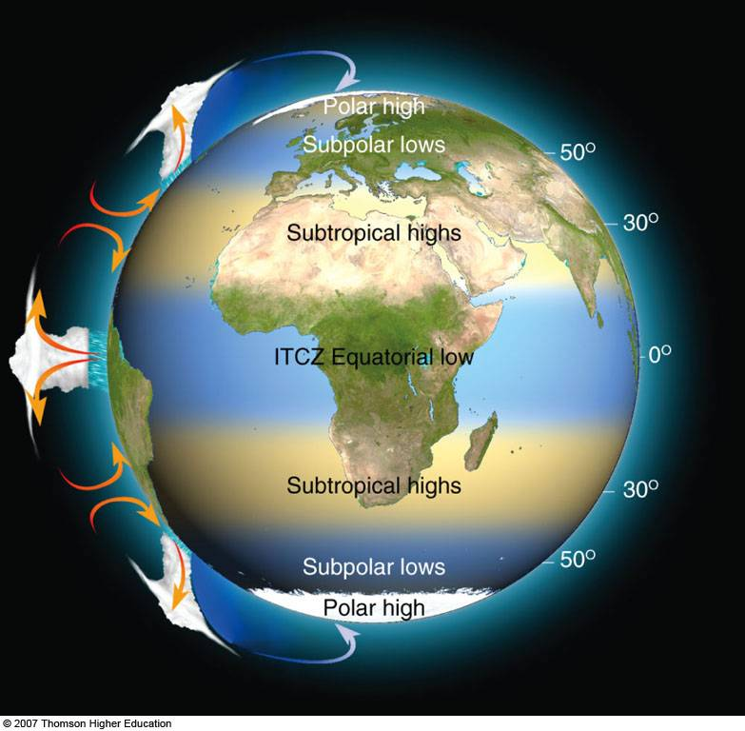

__________

Appendix B

GLOBAL JET STREAMS PATTERNS





