WORLD METEOROLOGICAL ORGANIZATION  ____________________  COMMISSION FOR BASIC SYSTEMS  OPEN PROGRAMMME AREA GROUP ON  INTEGRATED OBSERVING SYSTEMS  Second Ad hoc IPET-OSDE workshop on Observing System Network Design  GENEVA, SWITZERLAND, 2-4 FebruARY 2015 |  | CBS/OPAG-IOS/OSDW2 / Doc. 4  (13.01.2015)  _______  ITEM: 4  Original: ENGLISH

Review the vision for WIGOS guidance and documentation as a whole

(Submitted by the Secretariat)

SUMMARY AND PURPOSE OF DOCUMENT

The document provides information to be taken into account for the development of the guidance material on the Observing System Network Design (OSND) Principles.

ACTION PROPOSED

The meeting is invited to note the information contained in this document when considering its recommendations.

_____________

Appendices:

A Purpose and Scope of WIGOS Regulatory Material

B Draft Manual on WIGOS, Section 2
Subsection 2.2.2.1 – Observing System Network Design Principles

C Draft Manual on WIGOS, Section 2
Appendix 2.1 – Observing System Network Design (OSND) Principles

D Draft Manual on WIGOS, Section 6
Subsection 6 – Observing Component of the Global Cryosphere Watch

E Draft Manual on WIGOS, Section 6
Appendix 6.1 – The minimum requirements for inclusion of a GCW surface measurement site or station in CryoNet

DISCUSSION

- Following the decision of the Sixteenth World Meteorological Congress to proceed with the implementation of the WMO Integrated Global Observing System (WIGOS), the drafts of the WMO Technical Regulations (WMO-No. 49), Volume I, Part I - WIGOS, and the Manual on WIGOS (a future Annex to the Volume I) were developed by the TT on WIGOS Regulatory Material (TT-WRM) of the Inter-Commission Coordination Group on WIGOS (ICG-WIGOS). This marks a very important milestone on the way toward establishing the WIGOS Framework. Appendix A describes the purpose and scope of the WIGOS regulatory material together with brief information about the types of WMO regulations.

- The Commission for Basic Systems at its Extraordinary Session (Paraguay, September 2014) recommended through its Recommendation 3.1(1)/1 (CBS-Ext.(2014)) that the Volume I, PART I – WIGOS and Manual on WIGOS as given in the Annex 1 and Annex 2, respectively to this recommendation, be adopted by the Cg-17 with effect from 1 January 2016.

- The both drafts were available for the review (from 1 October till 31 December 2014) by WMO Members at the WMO web page: http://www.wmo.int/pages/prog/www/wigos/WRM.html. The review process was in accordance with the General Provisions of the WMO Technical Regulations (WMO-No. 49), Volume I, that any amendments to the Technical Regulations submitted by Members or by constituent bodies should be communicated to all Members at least three months before they are submitted to Congress.

- Further information on WMO regulatory and non-regulatory material can be found at: http://www.wmo.int/pages/prog/www/wigos/TT-WRM.html; it is mainly
- Technical Regulations, Basic Documents No. 2 (WMO-No. 49), Volume I – General Meteorological Standards and Recommended Practices, 2011 edition, updated in 2012 and
- Guidelines on the Preparation and Promulgation of WMO Technical Regulations
that were taken into account for the development of the WIGOS regulatory material.

- In accordance with the Basic Documents No. 1 (WMO-No. 15), 2012 edition, decisions concerning changes in the Technical Regulations, together with relevant documents, shall be sent to Members in sufficient time to allow a period of at least nine months between the receipt of these documents and the date of implementation. In no case shall this period be less than two months (Regulation 127).

- In addition to the Technical Regulations, appropriate guides are published by the Organization. The guides describe practices, procedures and specifications which Members are invited to follow or implement. The WMO technical commissions are responsible for the selection of material to be included in the guides. Recommendations for amendments made by an appropriate technical commission are subject to the approval of the Executive Council.

- ICG-WIGOS-3 recommended that the Observing System Network Design (OSND) Principles should be incorporated in due course into the Manual on WIGOS (action completed; see Appendix B). Now, the implementation guidance on the OSND Principles must be developed, incorporated into the Draft Guide to WIGOS, and submitted to ICG-WIGOS-5 (4th Quarter of 2015 or 1st Quarter of 2016) for the review and to EC-68 (2016) for approval.

- High-level guidance on OSND Principles was already presented at IPET-OSDE1 (Doc.10.1). This non-regulatory material should be further developed to provide more detailed guidance (best practices, guideline) on how the OSND Principles (i.e. provisions 2.2.2.1 and 2.2.2.2) should be implemented = applied by NMHS managers responsible for planning, implementation and evolution of national observing systems and networks.

__________

Appendix A

Purpose and Scope of WIGOS Regulatory Material

- The first edition of the WMO Technical Regulations (WMO-No. 49), Volume I, Part I - WMO Integrated Global Observing System (WIGOS) was developed in accordance with the decision of the Sixteenth World Meteorological Congress (2011) to proceed with the implementation of WIGOS, and when approved by the Seventeenth Congress it will be issued as the 2015 edition.

- It is designed to:

- Specify obligations of Members in the implementation and operation of the WIGOS component observing systems; and

- Facilitate cooperation in WIGOS observations between Member countries.

- In essence, the Volume I, Part I specifies WIGOS institutional and system requirements (standards) or recommendations for:

- Establishment of global, regional and national networks and facilities (with their scope, objectives and composition);

- Establishment of an authority or a responsible body;

- Human resources requirements (including education and training, competences, qualifications, etc.);

while the Manual on WIGOS specifies technical requirements (standards or recommendations) of an operational, functional or procedural nature.

Types of Regulations

- The WMO Technical Regulations (WMO-No. 49) comprise standard practices and procedures (standards), and recommended practices and procedures (recommendations). The definitions of these two types are as follows:

- The standard practices and procedures:

- Are those practices and procedures which it is necessary that Members follow or implement; and therefore

- Have the status of requirements in a technical resolution in respect of which Article 9 (b) of the Convention is applicable; and

- Are invariably distinguished by the use of the term shall in the English text and by suitable equivalent terms in the French, Russian and Spanish texts.

- The recommended practices and procedures:

- Are those practices and procedures which it is desirable that Members follow or implement; and therefore

- Have the status of recommendations to Members to which Article 9 (b) of the Convention shall not be applied; and

- Are distinguished by the use of the term should in the English text (except where specifically otherwise provided by decision of Congress) and by suitable equivalent terms in the French, Russian and Spanish texts.

- In accordance with the above definitions, Members shall do their utmost to implement the standard practices and procedures. In accordance with Article 9(b) of the Convention and in conformity with the provisions of Regulation 128 of the General Regulations, Members shall formally notify the Secretary-General, in writing, of their intention to apply the standard practices and procedures of the Technical Regulations, except those for which they have lodged a specific deviation. Members shall also inform the Secretary-General, at least three months in advance, of any change in the degree of their implementation of a standard practice or procedure as previously notified and the effective date of the change.

- In the case of hydrological observations, there is not a widely implemented base of global exchange and global standard practices and procedures. Technical Regulations Volume III -Hydrology provides Members with predominately recommended practices and procedures to be followed. In order to help ensure the quality and comparability of observations within WIGOS, Members making their hydrological observations available through the WMO Hydrological Observing System (WHOS) are governed by the provisions specified within this Part I of the Volume I.

- For this reason, a number of provisions listed herein which are recommended practices and procedures for hydrology in Technical Regulations Volume III – Hydrology have become standard practices and procedures, similar to efforts made by Members for the other WIGOS component observing systems. It is recognized that some of the WIGOS standard practices and procedures might not easily be widely and quickly implemented by all Members for their hydrological observations. Nonetheless, Members are urged to make their best efforts to implement the WIGOS standard practices and procedures in the collection and exchange of hydrological observations and to make such observations available through WHOS.

- Members are urged to comply with recommended practices and procedures, but it is not necessary to notify the Secretary-General of non-observance.

APPENDICES

- Material presented in Appendices has full status as part of the Technical Regulations. Appendices are used where a set of provisions on a single topic might, due to their detailed nature and length, otherwise interrupt the flow of the relevant section of this Manual. Also, Appendices are used to facilitate the ongoing review and update process by identifying sub-sections which fall under the specific responsibility of a particular group.

NOTES AND ATTACHMENTS

- Notes and Attachments are included in the both, Volume I, Part I, and the Manual for explanatory purposes. They do not have the status of WMO Technical Regulations.

- The words “shall” and “should” in any notes and attachments have their dictionary meanings and do not have the regulatory character of standard and recommended practices and procedures mentioned above.

Figure 1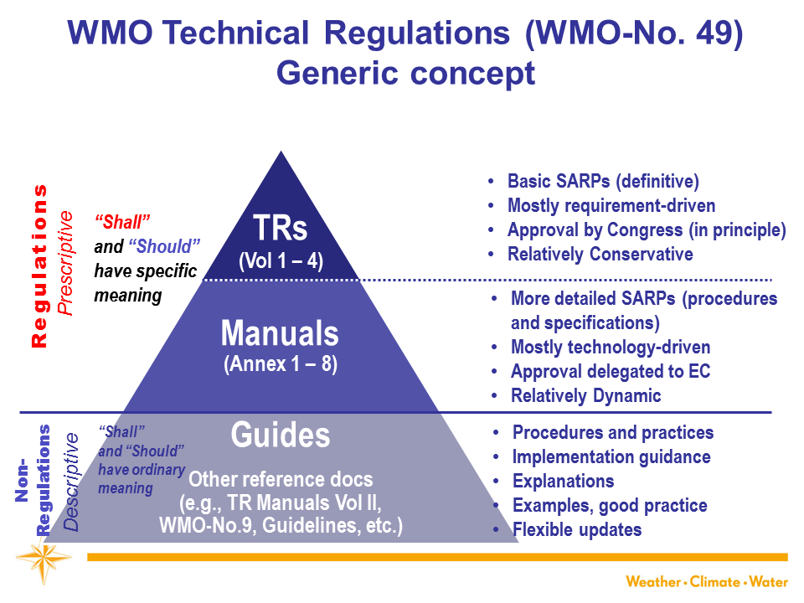
Figure 2
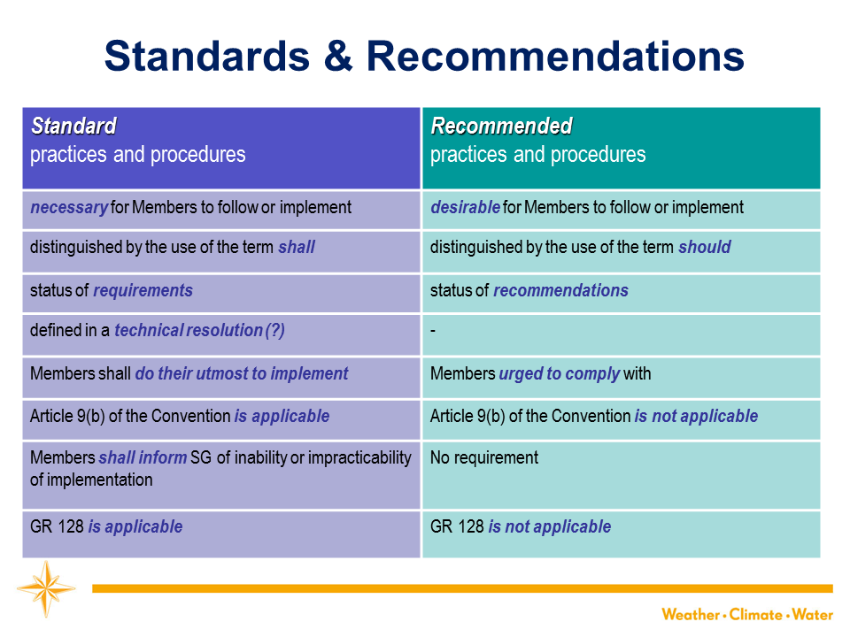

Appendix B

Draft MANUAL on wigos, section 2

2.2.2 Some Principles for Observing System Network Design and Planning
2.2.2.1 Observing System Network Design Principles
2.2.2.1.1 Members should follow the principles specified in Appendix 2.1 when designing and evolving their observing system networks.

2.2.2.1.2 Members should conduct network design studies which address national, regional and global scale questions about the optimum affordable mix of components to best satisfy the requirements for observations.

__________

Appendix C

Draft MANUAL on wigos, section 2

APPENDIX 2.1

Observing System Network Design (OSND) Principles

1. SERVING MANY APPLICATION AREAS
Observing networks should be designed to meet the requirements of multiple application areas within WMO and WMO co-sponsored programmes.

2. RESPONDING TO USER REQUIREMENTS
Observing networks should be designed to address stated user requirements, in terms of the geophysical variables to be observed and the space-time resolution, uncertainty, timeliness and stability needed.

3. MEETING NATIONAL, REGIONAL AND GLOBAL REQUIREMENTS
Observing networks designed to meet national needs should also take into account the needs of the WMO at the regional and global levels.

4. DESIGNING APPROPRIATELY SPACED NETWORKS
Where high-level user requirements imply a need for spatial and temporal uniformity of observations, network design should also take account of other user requirements, such as the representativeness and usefulness of the observations.

5. DESIGNING COST-EFFECTIVE NETWORKS
Observing networks should be designed to make the most cost-effective use of available resources. This will include the use of composite observing networks.

6. ACHIEVING HOMOGENEITY IN OBSERVATIONAL DATA
Observing networks should be designed so that the level of homogeneity of the delivered observational data meets the needs of the intended applications.

7. DESIGNING THROUGH A TIERED APPROACH
Observing network design should use a tiered structure, through which information from reference observations of high quality can be transferred to and used to improve the quality and utility of other observations.

8. DESIGNING RELIABLE AND STABLE NETWORKS
Observing networks should be designed to be reliable and stable.

9. MAKING OBSERVATIONAL DATA AVAILABLE
Observing networks should be designed and should evolve in such a way as to ensure that the observations are made available to other WMO Members, at space-time resolutions and with a timeliness to meet the needs of regional and global applications.

10. PROVIDING INFORMATION SO THAT THE OBSERVATIONS CAN BE INTERPRETED
Observing networks should be designed and operated in such a way that the details and history of instruments, their environments and operating conditions, their data processing procedures and other factors pertinent to the understanding and interpretation of the observational data (i.e. metadata) are documented and treated with the same care as the data themselves.

11. ACHIEVING SUSTAINABLE NETWORKS
Improvements in sustained availability of observations should be promoted through the design and funding of networks that are sustainable in the long-term including, where appropriate, through the transition of research systems to operational status.

12. MANAGING CHANGE
The design of new observing networks and changes to existing networks should ensure adequate consistency, quality and continuity of observations across the transition from the old system to the new.

_________

APPENDIX D

DRAFT MANUAL ON WIGOS, SECTION 6

6. OBSERVING COMPONENT OF THE GLOBAL CRYOSPHERIC WATCH
Note: The provisions of sections 1, 2, 3 and 4 of this Manual are common to all WIGOS component observing systems including the GCW. The further provisions of section 6 of this Manual are specific to the GCW.
6.1 Members should collaborate actively in, and give all possible support to, the development and implementation of the observing component of Global Cryosphere Watch.
Note: GCW implementation encompasses the use of surface- and space-based observations, observing standard and recommended practices and procedures, and best practices for the measurement of essential cryospheric variables, and full assessment of error characteristics of in situ and satellite products. The initial focus of CryoNet, the surface-based standardized core observing network, is to promote the addition of cryospheric observations taken according to GCW standard and recommended practices and procedures, guidelines and best practices, at existing sites rather than creating new sites. The development of GCW includes the development of a CryoNet Guide.6.2 Members should encourage partnerships between organizations to coordinate observing, capacity building and training activities relevant to cryospheric observations and to assist with the compilation and development of manuals on standard and recommended practices and procedures for cryospheric observation.
6.3 CryoNet shall be structured in three different classes of observational sites: Baseline sites, Reference sites, and Integrated sites with the following requirements:
- Baseline sites shall make measurements of at least one element of the cryosphere; e.g. snow, permafrost, sea ice, or glaciers. Baseline sites should be targeted toward long-term, continuous measurements.
- Reference sites shall be the key sites of CryoNet with respect to the assessment of long-term changes of the cryosphere as well as for the validation of satellite data and cryospheric models. The reference site shall provide continuous measurements over a long period. Reference sites should be for operational purposes or may have a research focus.
- The Integrated sites shall promote, through worldwide scientific collaboration, progress in the scientific understanding of the physical processes that change the cryosphere. These sites shall integrate in situ and space-based observations and create platforms of cryospheric observatories. Monitoring at integrated sites should cover multiple components of the cryosphere with a highly process orientated approach. Integrated sites shall either be a single station or several stations or field sites covering a larger region. In general these sites shall be supported by long-term financial commitments running standard monitoring programs of the cryosphere.
6.4 For inclusion of a GCW surface measurement site or station in CryoNet, Members and partners shall meet defined criteria. The minimum requirements are in Attachment 6.1.

______________
APPENDIX E

DRAFT MANUAL ON WIGOS, SECTION 6

ATTACHMENT 6.1

The minimum requirements for inclusion of a GCW surface measurement site or station in CryoNet
1. The site location is chosen such that, for the variables measured, it is spatially/temporally representative for measuring one or several components of the cryosphere.
2. User needs have been considered in the observation design process.
3. CryoNet sites have to be active and perform sustained observations according to CryoNet agreed practices.
4. Technical personnel are trained in the operation and maintenance of the equipment.
5. For reference and integrated sites, there is an intent by the responsible agencies to sustain long-term observations of at least one of the CryoNet variables. For baseline sites the responsible agencies intend to support a long-term observing program.
6. The relevant CryoNet observations are of documented quality. The measurements are made and quality controlled according to CryoNet agreed practices.
7. Associated standard meteorological in situ observations, when necessary for the accurate determination and interpretation of the GCW variables, are made with documented quality.
8. A station logbook for observations and activities that may affect observations is maintained and used in the data validation process.
9. The data and metadata including changes in instrumentation, traceability, observation procedures are submitted to a data centre that is interoperable with the GCW portal in a timely manner.
10. The station characteristics and observational programme information are kept up-to-date in the GCW station information database. Station metadata are also provided to the WMO Operational Information Resource (WIR) and maintained regularly.

_____________

Generic concept of the WMO Technical Regulations (WMO-No. 49) is presented in the Figures 1 and 2 below

