WORLD METEOROLOGICAL ORGANIZATION  ____________________  COMMISSION FOR BASIC SYSTEMS  OPEN PROGRAMMME AREA GROUP ON  INTEGRATED OBSERVING SYSTEMS  Ad hoc IPET-OSDE workshop on Observing System Design  GENEVA, SWITZERLAND, 12-14 November 2013 |  | CBS/OPAG-IOS/OSDW1 / Doc. 4.4.2  (24.11.2026)  _______  ITEM: 4.4.2  Original: ENGLISH

Review of specific regional activities related to observing system design

EIG EUMETNET

(Submitted by Stefan Klink (Germany))

SUMMARY AND PURPOSE OF DOCUMENT

The document explains why the EIG EUMETNET Observations Programme initiates data impact studies from time to time, summarizes results of three completed OSE or adjoint-based data impact studies, outlines the future needs for OSND recommendations in the EUMETNET Observations Programme and describes current and planned observation data impact studies which are coordinated by the EUMETNET Observations Programme.

ACTION PROPOSED

The Meeting is invited to note the information contained in this document when considering its recommendations.

____________

Appendix: A EUCOS Upper-Air Network Redesign Study – Conclusions and Recommendations
B Second space Terrestrial Study –
Resulting final Network Redesign Recommendations
C The Adjoint-Based Observation Impact of ASAP Radiosondes

DISCUSSION

Introduction

The EIG EUMETNET Observations Programme’s main objective is a central management of surface based operational observations on a European-wide scale serving the needs of general forecasting, specifically those of numerical weather prediction, and those of climate monitoring. EIG EUMETNET is a consortium of currently 30 national meteorological and hydrological services (NMHS) in Europe that provides a framework for different operational and developmental co-operative programmes between the services.

The work content of the Observations Programme (former EUCOS Programme) includes the management of the operational observing networks, through the following services and projects:
- E-AMDAR (aircraft observations from commercial airlines),
- E-ASAP (radiosonde observations predominantly from merchant ships),
- E-GVAP (humidity measurements derived from global navigational satellite systems data),
- E-PROFILE (wind profiler and Lidar/Ceilometer measurements),
- E-SURFMAR (buoy and voluntary observing ship measurements), and
- OPERA (weather radar composite production and single site data re-distribution)
The coordination of NMHS owned territorial networks (e.g. radiosonde stations and synoptic stations), data quality monitoring, fault reporting and recovery, a studies programme for the evolution of the observing networks and liaison with other organisations like WMO are among the tasks of the programme.

Changing user requirements concerning observational data and external drivers like new developments in measurement technology and observing systems but also increasing pressure on NMHS’ budgets demand for a periodic redesign of the existing observing networks. Changes in networks should be based on scientific analyses and therefore the EUMETNET Observations Programme launched several studies in the past. Such studies usually comprise of a set of observing system experiments (OSE) or similar experiments which are run to assess the impact of different observing systems on NWP forecast skill. NWP groups of NMHSs or ECMWF conduct the studies and the Observations Programme works as an interface between data users and providers.

EUMETNET Observations Programme (former EUCOS Programme) completed studies

The EUMETNET Observations Programme (former name: EUCOS Programme) has initiated and coordinated various observation impact studies in previous years. For three examples the study type, the purpose of the study, the way it was conducted and the results and derived recommendations are described below. Although the specific network (re-)design recommendations are potentially not applicable in all other WMO regions, the examples nevertheless demonstrate what questions observation network managers can have.

Upper-air network redesign study

Study type: OSE

Purpose: The aim was to define a European-wide composite network of ground-based upper-air observing systems comprising of NMHS owned radiosondes and AMDAR data providing airports. Thereby the configuration and setting of the network should be based on scientific analyses rather than on a simple merging of historically grown national networks.

Description: With the aim of defining a new EUCOS upper-air network design, OSEs were run with different scenarios in order to get a guideline for an optimum setting of upper-air measurements in space and time which maintains forecast skill. Details about the different scenarios can be found in “Review of specific regional activities related to observing system design, Regional Association VI” [submitted by Gergely Bölöni, document reference: CBS/OPAG-IOS/OSDW1 / Doc. 4.4.1]. The OSEs were run by ECMWF, the HIRLAM group and OMSZ.

Results and recommendations:
All participants of the EUCOS upper-air network redesign study provided final reports on their findings and conclusions. These results were presented at EUMETNET internal meetings but also externally, e.g. at the 5th WMO Workshop on the Impact of Various Observing Systems on NWP. Some details of OMSZ’ results and conclusions can be found in “Review of specific regional activities related to observing system design, Regional Association VI” [submitted by Gergely Bölöni, document reference: CBS/OPAG-IOS/OSDW1 / Doc. 4.4.1]. The full list of conclusions and recommendations is attached as appendix A.

The former EUMETNET Programme Board for Observations (PB-OBS) agreed to the recommended scenario 3b consisting of 93 radiosonde stations. Scenario 3b is defined as follows:
- horizontal spacing of 100 km for profiles at 06, 12 and 18 UTC,
i.e. Control minus those land-based radiosondes which are beyond a network with 100 km horizontal spacing, thereby replacing radiosonde sites with AMDAR data if 3-hourly AMDAR measurements are available at those locations,
- but keeping all radiosonde launches at 0 UTC.

However, as long as aircraft do not provide operational humidity measurements over Europe it is recommended to provide radiosoundings twice per day even if AMDAR measurements are available at airports in the vicinity of the radiosonde site. The discussion on reducing 12 UTC ascents in the vicinity of airports will be carried on with the EUMETNET Scientific and Technical Advisory Committee (STAC) when reliable humidity measurements will be available from aircraft in the future.

2nd Space-Terrestrial study

Study type: OSE

Purpose: Key objectives of this study were to assess the impact of a thinned terrestrial observing system on radiance bias correction anchoring and to investigate the impact of a reduced conventional observing system on NWP following the most successful scenarios (3b) and (4) of the Upper-air Network Redesign Study.

Description: The second Space-Terrestrial Study assessed the impact of reduced ground-based observing systems on satellite data assimilation. Experiments had been carried out, investigating the impact of the global radiosonde and aircraft data in different GPS radio occultation (GPSRO) data coverages. The final report was compiled by Gabor Radnoti et al., ECMWF end of May 2012 and it appeared as ECMWF Tech. Memo No.679 and on the EUCOS webpage.

Results and recommendations:
Network redesign recommendations for E-AMDAR, E-ASAP and E-SURFMAR were formulated and discussed at a EUCOS Programme Manager meeting in September 2012 and with the EUCOS Scientific Advisory Team (E-SAT). Eventually E-SAT approved a set of network redesign recommendations (see appendix B) in autumn 2012.

E-ASAP impact study

Study type: Adjoint-based Observation Impact

Purpose: In 2011 the impact and importance of radiosoundings provided by the E-ASAP programme were questioned. In order to assess the impact of this observation type the EUCOS Programme initiated an adjoint-based impact study where the impact of E-ASAP radiosoundings had to be compared to the impact of two control-groups, continental, inland soundings and remote island soundings.

Description: Richard Marriott, UK Met Office conducted the requested impact study and provided the study report “The adjoint-based observation impact of ASAP radiosondes” on 7th November 2011. Details can be found in appendix C.

Results and recommendations: Results can be found in appendix C. Specific E-ASAP related recommendations were not coordinated with the EUCOS Scientific Advisory Team. Due to the urgency of this investigation results were directly presented to the EUMETNET Assembly and were the reason for keeping the E-ASAP service as core activity within the EUMETNET Observations Programme also during the Programme phase 2013-2017!

Future needs for OSND recommendations in the EUMETNET Observations Programme

Within many European NMHSs the budget for non-satellite observations is much under pressure. Efficiency savings or even real reductions in the operational observing networks have to be considered by several Members. On the other hand new observing technologies and new observing networks operated by third parties become available. Examples are aircraft based observations transmitted to ground via air traffic control radars and radio communications (Mode-S, ADS-B) or an improved usage of ground-based GNSS data.

In the framework of the EUMETNET Observations Programme OSND recommendations have to be derived during the next few years concerning the following observing networks and technologies:
- In-situ upper-air profiles: composite observing system comprising of radiosondes, AMDAR data, potentially other aircraft based observations, Mode-S/ ADS-B data, GNSS profile data, wind profiler;
- In-situ surface marine observations: composite observing system comprising of conventional and automated voluntary observing ships, drifting and moored buoys;
- Weather radar derived observations: besides reflectivity and Doppler-velocity measurements, is there a need for dual-polarization data?

Current and planned observation data impact studies

The EUMETNET Observations Management Team has recently initiated a combined AMDAR humidity and TAMDAR impact study and is planning to organize a general Forecast Sensitivity to Observations/ Forecast Error Contributions impact study which helps assessing the impact and importance of all various non-satellite observing systems again.

- AMDAR q/ TAMDAR impact study

Study type: OSE

Purpose: A key issue for EIG EUMETNET is to find an answer to the questions whether aircraft based in-situ humidity measurements prove to have a beneficial impact on NWP forecast skill and how many of such sensors have to be installed in order to obtain a significant positive impact.

Description:
As a sufficient data coverage for doing OSEs with aircraft based humidity observations (e.g. AMDAR humidity or TAMDAR observations) is still not available over Europe it was decided to conduct corresponding experiments over the eastern part of the United States of America where a suitable number of observations is available on a routine basis.

Scenarios to be assessed are:

- Scenario no 1: Baseline
All operationally used satellite observations +
all screen level observations (SYNOP, BUOY, SHIP, METAR, …) +
all radiosondes (temperature and humidity) and all AMDAR (temperature and wind only);
(no radar-derived precipitation, no GPS, no AMDAR humidity, no TAMDAR, this reflects current European operational setup more or less)

- Scenario no 2:
Baseline + AMDAR humidity

- Scenario no 3:
Baseline + TAMDAR (temperature, wind and humidity)

- Scenario no 4:
Baseline + AMDAR humidity + TAMDAR (temperature, wind and humidity)

The OSEs shall be conducted with global and regional, i.e. limited-area models.

Results and recommendations: It is expected to get interim results in the second quarter 2014 and final results before the end of 2014.

- General FSO/FEC study

Study type: potentially hybrid/combined OSE and adjoint/ensemble based impact study

Purpose: Similar to previous space-terrestrial studies where EUMETNET had usually assessed the impact of all various ground-based and satellite observing systems through conventional OSEs an update on these impact results is required. The reasons are changing user requirements, further evolving observing networks but also financial constraints for the national non-satellite observation budgets and the EUMETNET Observations budget.
Also the relatively new method of assessing observation impact with adjoint- or ensemble-based methods is an argument for looking into the impact of all ground-based observation types again. Inspiration came from the short FSO/FEC E-ASAP impact study conducted by UK Met Office, when it was demonstrated that it makes apparently a difference whether an observation stems from a well observed area:
- European continental radiosondes having only small impact
or whether an observation originates from a poorly observed area:
- E-ASAP or remote island radiosondes having much stronger impact per sounding.

The appropriate spatial distribution and density of observations is an interesting issue. Despite the existing WMO RRR requirements concerning e.g. spatial and temporal resolution of observations one goal is to prove the RRR figures and to derive network (re-)design recommendations like this:
- Priority 1:
Need for M observations of variable x per area.
Need for m% more/less observations of variable x per area.
- Priority 2:
Need for N observations of variable y per area.
Need for n% more/less observations of variable y per area.
- …

Description:
Work is in progress to compile and agree the specification for this general ground-based observations impact study.
Some ideas which are currently discussed are described below.

Standard FEC/FSO analyses are powerful and helpful tools, however, for the time being the results we obtain from such analyses is something like this: The FEC/FSO impact of e.g. the entire radiosonde network (an individual radiosonde station) is this or that, given the current density of radiosonde observations themselves and the current density of all other observations.

- When considering observation impact as a function of observation density, how does the function mathematically look like?

Density of observations in 4D space
low
high
?
Observation Impact (of all obs in a given area)

?
high
?

low

threshold
breakthrough
goal

- When considering observation impact as a function of observation density, where on the corresponding curve for a specific observation type are we right now?

Given the currently established observation density
Which observation impact do we reach?
And where could we get if we had more obs?
Observation Impact (of all obs in a given area)
Density of observations in 4D space
low
low
high
high

- Idea: Can we estimate observation impact as function of observation density from a hybrid OSE and FEC/FSO analysis?

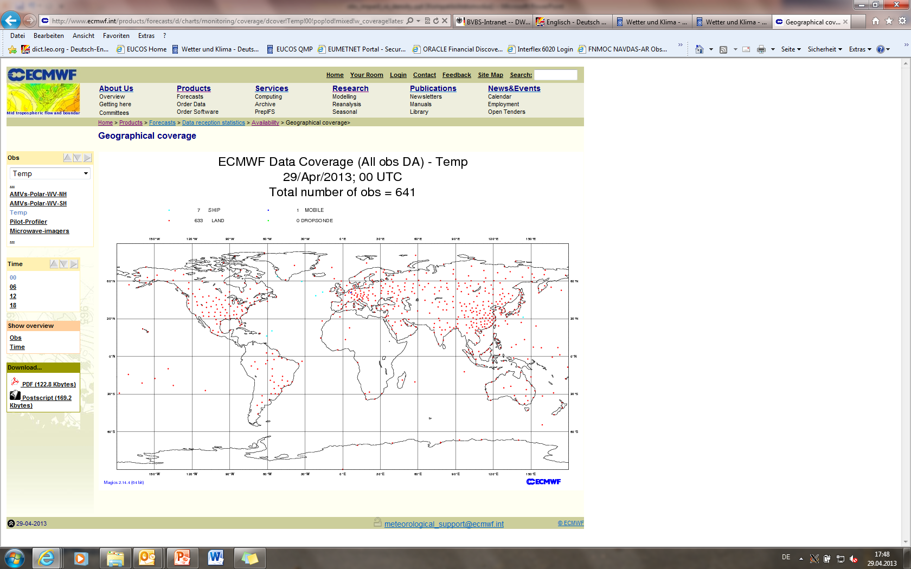
Density of observations in 4D space
low
low
high
high
medium

Observation Impact
(of all obs of a specific type
in a given area)

- Approach: Run an OSE (with one scenario only):

Scenario 1:
- ‚Baseline‘ configuration for all various obs systems (e.g. buoy, VOS, SYNOP, satellites,…)
[baseline in the sense of the baseline scenario in the 1st Space-Terrestrial Study]
- But full observation set (i.e. simply reality, and thereby unevenly distributed) of the observing networks under scrutiny (e.g. vertical profiling systems like radiosondes or AMDAR or combination of both).

Subsequently do a FEC/FSO analysis for the unevenly distributed radiosonde or AMDAR observations.

Explanation: An OSE is required because in operational forecasts not only the obs type under scrutiny (e.g. radiosondes) will show different obs density in different regions but very likely all other obs types, too. Therefore a ‚baseline‘ scenario with as homogeneous as possible obs coverage of all other obs types will be required in the different regions.

Questions:
- Is it a sensible idea to try estimating observation impact in terms of FEC/FSO as a function of observation density?
- How many ‚interpolation points‘ that means regions with differing observation density do we need: 3, 4, 5,… in order to determine the obs impact as function of obs density curve?
- Probably these different regions should all be located in the same hemisphere and in the same latitude band for representativity reasons!?
- Maybe we should do the corresponding analyses from a technology-free perspective, i.e. determining the obs impact of in-situ temperature-, humidity- and wind-profiles in differently dense observed areas irrespective of the instrumental source (radiosonde or AMDAR or windprofiler)?

__________
Appendix A

EUCOS upper-air network redesign study –
CONCLUSIONS AND RECOMMENDATIONS

Conclusions

Based on the study reports provided by ECMWF, the HIRLAM group and OMSZ the EUCOS Scientific Advisory Team (E-SAT) drew the following general conclusions:

- The OSE studies concerning the EUCOS upper-air network redesign (UANR) were conducted with the global model of ECMWF and the limited area models of OMSZ and several HIRLAM members. In general the experiments show similar results.

- In agreement with the previous Space-Terrestrial study the baseline scenario shows a significant and the strongest reduction in forecast skill.

- Scenarios 3a and 3b which removed radiosonde sites collocated to 3-hourly visited E-AMDAR airports show almost no degradation in forecast skill. Results from OMSZ’ regional model show better results for a scenario where 0 UTC radiosonde observations –in vicinity to airports- are kept.

- Further thinning of upper-air observations to 250 km or 500 km spacing shows a significant degradation of forecast skill for most parameters, and for summer and winter periods.

- When thinning radiosonde observations the parameter most negatively affected is relative humidity in lower troposphere.

- Biases are observed between radiosonde and AMDAR temperature measurements. More investigations are needed to correct biases of AMDAR observations.

Recommendations

- A collocation of operational radiosonde observations and 3-hourly AMDAR profile measurements should be avoided. Scenario 3b is recommended for implementation.

- Humidity information in the lower troposphere should not be degraded. It is therefore recommended to improve the coverage of lower tropospheric moisture observations.

- Further it is recommended to work towards a horizontally more homogeneous distribution of upper-air observing sites.
__________
Appendix B

2nd Space-Terrestrial Study –
resulting final network redesign recommendations

Recommendations

E-AMDAR:
- Improve the benefit of aircraft data by:
  - Obtaining more humidity observations from aircraft;
  - Collecting more standard (temperature and wind) aircraft profile measurements (ascent & descent data)
    - in rather under sampled regions;
    - at rather under sampled times;
  - Increasing vertical resolution of profiles especially in the upper part of the troposphere;
- Take measures to reduce the average positive aircraft temperature bias by searching for the reason for the average positive bias;
Remark: Ascent profiles are longer (go higher); and they are more similar (vertical) to radiosonde profiles. (This characteristic is possibly more important for e.g. Nowcasting).
- Ascent profiles are preferred over descent profiles;

E-AMDAR and EUCOS:
- E-SAT recommends to quickly proceed with the envisaged aircraft based humidity observation study over the US;
- E-SAT recommends that once there are sufficient numbers of aircraft based humidity sensors installed in Europe a European-based study will be conducted;

E-ASAP:
- Regarding E-ASAP no specific network redesign recommendations can be made because of the inconsistent results of the data denial experiment;
Instead:
- It is recommended to perform a longer OSE with the hope for getting more robust conclusions;
- Reflecting also results from recent adjoint-based observation impact studies it is recommended that the E-ASAP PM collects information about the launching procedures on E-ASAP units which might influence humidity observing (e.g. conditions for radiosonde storage on board or the ship‘s exhaust‘s influence on temperature and humidity measurements);

E-SURFMAR:
- Use drifting buoys to fill gaps where VOS observations are not regularly available.

__________

Appendix C

The Adjoint-based Observation Impact of ASAP Radiosondes

Original version: Richard Marriott, UK Met Office (7th Nov 2011)

Summary
Met Office adjoint-based observation impacts were used to assess the impact ASAP ship-based radiosondes. ASAP sondes were found to give beneficial impacts of a similar magnitude to land-based sondes situated on remote islands. The mean impact of these sondes was shown to be significantly larger than those situated in continental regions.

Background
Email from Stefan Klink of DWD (12th Oct 2011):

“Following the serious and unparalleled discussions we had last week during the EUMETNET STAC&PFAC Roadmaps workshop, I think it is more important than ever to assess the NWP impact and importance of ASAP radiosonde observations.

“Bruce (Truscott) attended the aforementioned workshop as a Met Office delegate and can give more information on EUMETNET discussions about ASAP if you are interested. To make a long story short: We almost lost the EUMETNET support for ASAP soundings completely. Currently it seems that E-ASAP can keep its ‘mandatory’ status (i.e. all EUMETNET members have to financially contribute to this programme), however, at the upcoming EUMETNET Assembly meeting in November, discussions might come up again and the Assembly can always overrule what STAC and PFAC had proposed before.

“So, I would very much appreciate it if the Met Office could provide us with forecast sensitivity to observation statistics in the way we already talked about.”

Experimental details
The observation impacts analysed here were taken from a trial set up to mirror our operational forecast system prior to PS27; i.e. that used operationally at the Met Office during the period 16 Mar - 20 Jul 2011. The trial period used was 18Z 22nd Aug until 18Z 13th Sept 2010. Impacts for the run 00Z 5th Sept were excluded due to technical issues leaving a remaining 89 forecast-cycles’ worth of data. Forecasts were run at reduced resolution (N320 down from N512) but DA was run at the operational resolution of N216. Adjoint calculations were also performed at DA resolution and a moist energy norm was used to quantify the error in 24-hour forecasts.

The impacts of three groups of radiosondes are being assessed: Those of a group of ASAP sondes; a control-group of continental “inland” sondes; and a control-group of “remote” island-based sondes. Station IDs of sondes in each group were provided by Stefan and are given in table 1. Those sonde IDs highlighted in bold/red were not assimilated at the Met Office during the experimental period. Figure 1 shows the locations of ascents from these stations and ships throughout the period.

Table 1. Radiosonde groups
ASAP  (17/21) | Inland control group  (15/20) | Remote control group  (18/18)
ASDE01 | 02963 | 01001
ASDE02 | 03354 | 01400
ASDE03 | 06210 | 02591
ASDE04 | 06476 | 03953
ASDE09 | 06610 | 04018
ASDK01 | 07145 | 06011
ASDK02 | 07481 | 08522
ASDK3 | 08221 | 16754
ASES01 | 10410 | 60018
ASEU01 | 10548 | 61996
ASEU02 | 11035 | 78016
ASEU03 | 11520 | 88889
ASEU04 | 12425 | 93986
ASEU05 | 13275 | 93997
ASEU06 | 15150 | 94975
ASFR1 | 16080 | 94995
ASFR2 | 17280 | 94996
ASFR3 | 22113 | 94998
ASFR4 | 26850
ASGB01 | 33345
DBLK

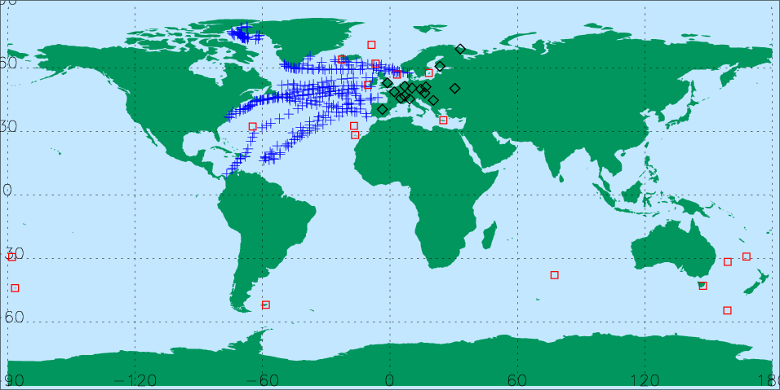
Figure 1. Locations of ascents for those sondes in table 1 throughout the period
18Z 22nd Aug – 18Z 13th Sept 2010.
Results
During the period there were 340/560/598 ascents for the ASAP/Inland/Remote groups with total impacts of -0.4/-0.1/-0.7 J/kg. (Total overall observation impact for the period was -250.8 J/kg with TEMP radiosondes accounting for ~13.4%, PILOT sondes accounting for ~1.1% and wind profilers accounting for ~0.7% of this impact.) Figure 2 shows that, as well as having the largest total impact, the remote island sondes also had the largest mean impact per ascent. The mean impact of ASAP sondes would be the largest if it weren’t for detrimental impacts being measured for humidity observations as shown in figure 3. The impact of humidity observations from remote island sondes was approximately neutral.

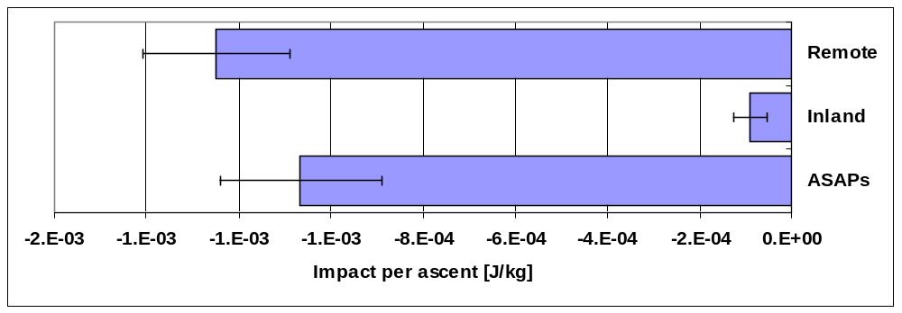
Figure 2. The average observation impacts per ascent for the three groups.
Error bars give an approximation to the standard error of the mean (σ/√N).

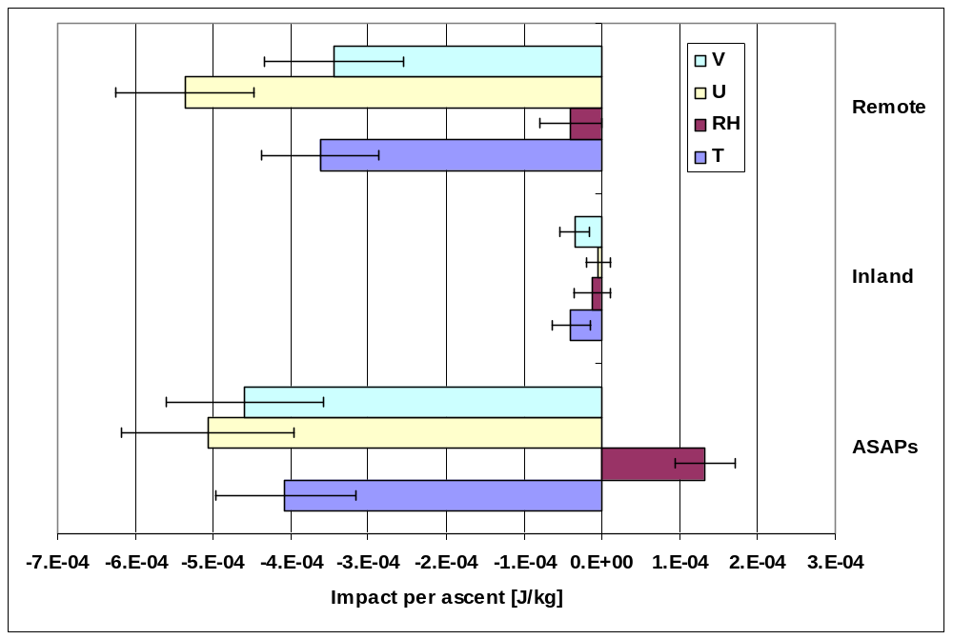
Figure 3. The average observation impacts per ascent for the three groups separated by variable. Error bars give an approximation to the standard error of the mean (σ/√N).

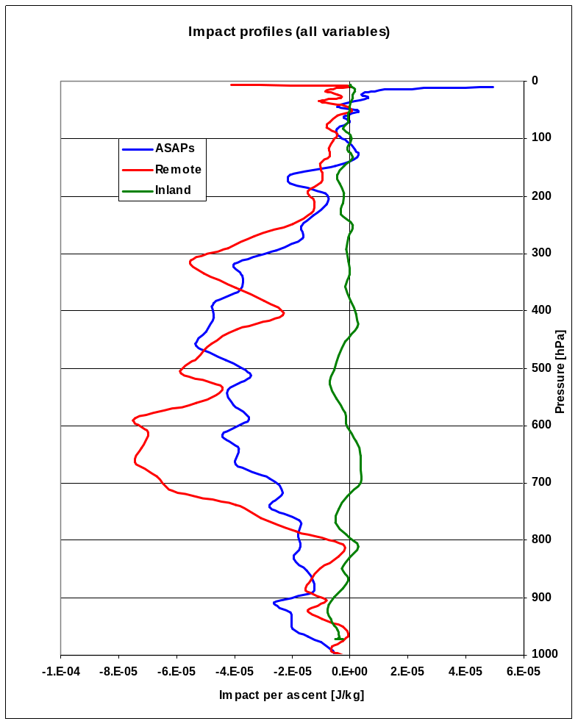
Figure 4. Mean observation impact profile per ascent

Figure 4 shows that the mean impact profile of ASAP sondes is generally similar to that of the remote island sondes. The smaller impact of ASAP sondes at 600-700hPa seems to be due to a difference in the level at which the wind-impacts peak (see figure 5c): This is at ~600 hPa for the remote island sondes but ~400 hPa for ASAP sondes. Figure 5a shows that the ASAP temperature observations below ~750hPa are measured as having a larger beneficial impact than those of remote island sondes.

(Figure 6 contains the same information as figure 5 but the profiles have been grouped by sonde-type rather than by variable.)
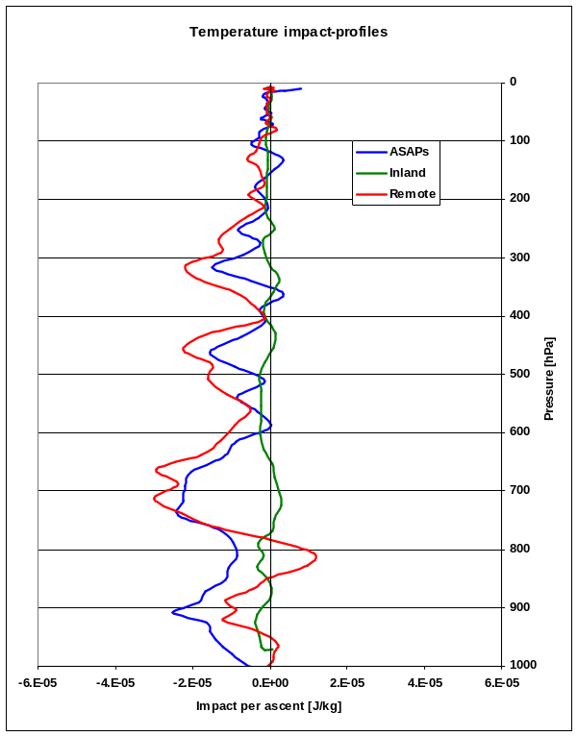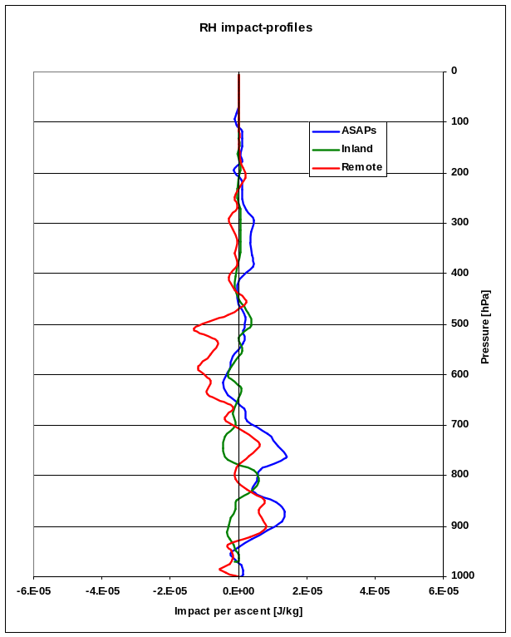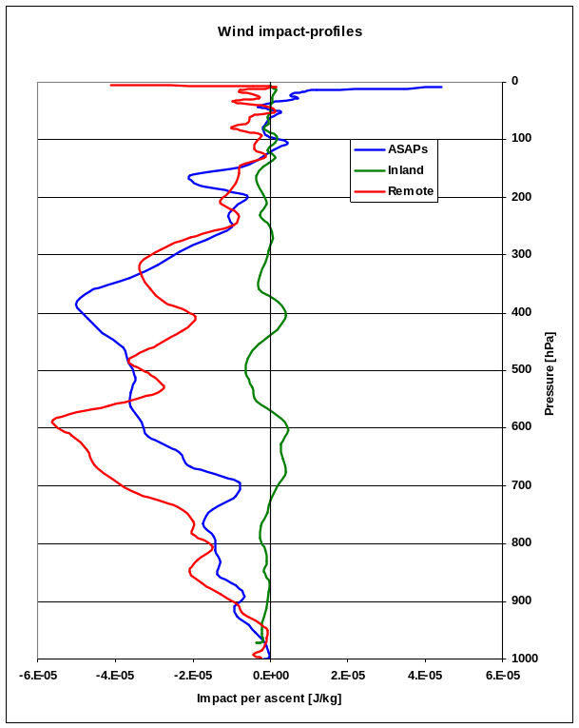
Figure 5. Mean observation impact profile per ascent for each variable
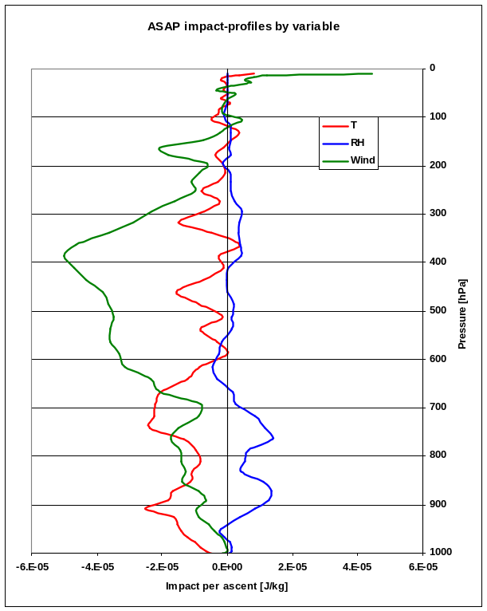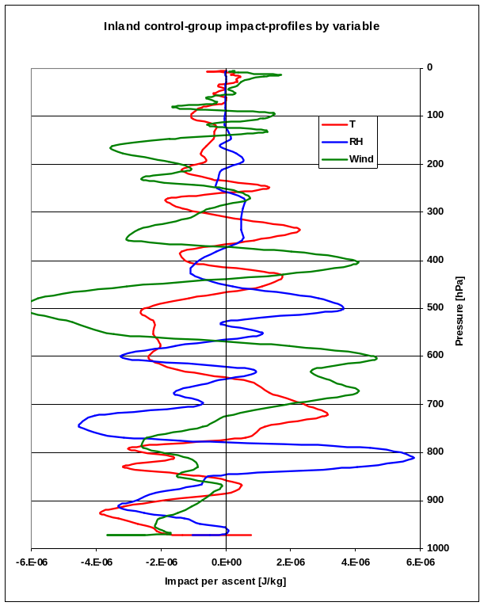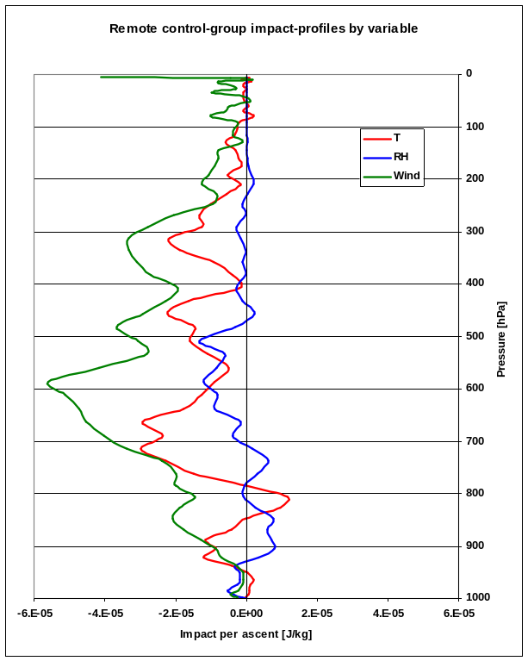
Figure 6. Mean observation impact profile per ascent by variable for each sonde-group

__________

