WORLD METEOROLOGICAL ORGANIZATION  ____________________  COMMISSION FOR BASIC SYSTEMS  THE INTER-PROGRAMME EXPERT TEAM ON WIGOS FRAMEWORK IMPLEMENTATION (IPET-WIFI)  SUB-GROUP ON REGULATORY MATERIAL  (First Session)  Geneva, Switzerland, 14 to 15 April 2016 | CBS/IPET-WIFI/SG-RM-Doc. 5.6.REV1  _________  ITEM: 5  Original: ENGLISH ONLY

DRAFT TEXT ON AIRCRAFT METEOROLOGICAL STATIONS FOR GUIDE TO THE GOS

(Submitted by CBS ET-ABO)

SUMMARY AND PURPOSE OF DOCUMENT
This document contains draft material on Aircraft Meteorological Stations for the Guide to the GOS that has been drafted by CBS ET-ABO, for review by SG-RM during the session and subsequent submission to ICT-IOS-9 for their endorsement.

ACTION PROPOSED
The Meeting is invited to review the draft text contained in the document, to propose any changes required, and to approve the text for submission to ICT-IOS-9.
____________

New Draft for Guide to GOS, WMO-No. 488, 3.4 Aircraft Meteorological Stations.
Draft History

Version | Author | Changes Made | Date
V1D1 | ET-ABO Sub-group on Regulatory Material | Draft 1 of Version 1 – Version produced at the conclusion of meeting of SG-RM. | 19 Dec 2014
V2D1 | Edits by Stig Carlberg | Revisions and edits. | 12 Jan 2015
V2D2 | F. Grooters | Revision and edits. | 10 Feb 2015
V2D3 | D. Lockett | Major revision, restructure and edits.  Inclusion of proposed Annexes. | 24 Feb 2015
V2D4 | D. Body & F. Grooters | Minor edits of body and Annex V
V2D5 | D. Lockett, F. Grooters | Major update:  - Updates to Annexes I and II.  - Re-write of sections 6.1.2 and 6.3.2 by FG  - Superfluous comments removed | 12 Nov 2015
V2D6 | J. van der Muelen | Addition of Annex III | 26 Nov 2015
V2D7 | S. Taylor | Addition of Annex IV | 11 Jan 2016
V2D8 | D. Lockett | Major review and revision by the Secretariat.  Address corrections and comments by ABOP reviewers. | 2 Feb 2016
V2D9 | D. Lockett | Review and input by B.Ford  Minor corrections from various reviewers. | 2 Mar 2016

Contents
1. Aircraft Based Observations 6
1.1 Introduction 6
1.2 History and Background 6
1.3 Description of Aircraft Based Observations Guidance 7
1.4 Benefits of Aircraft Based Observations 7
1.5 Requirements 9
1.5.1 Requirements for Upper Air Data 9
1.5.2 Requirements for Aircraft Based Observations 9
1.6 Sources of Aircraft Based Observations 10
1.6.1. WMO Aircraft Based Observations 12
1.6.1.1 AMDAR Aircraft Based Observations 12
1.6.2 ICAO Aircraft Based Observations 13
1.6.3. Other Aircraft Based Observations 16
1.7 Observational Data Management 18
1.8 Quality Management 22
1.8.1 Member Quality Management System 22
1.8.2 Aircraft Based Observations Quality Management 22
1.9 Provision of Aircraft Based Observations on the GTS 25
1.10 Observational Metadata Requirements and Management 25
1.11 Operations, Maintenance, Incident Management and Change Management 25
1.12 International and Regional Planning and Capacity Development 25
1.12.1 WMO Aircraft Based Observations programme 25
1.12.2 Projects and Development 26
1.12.3 Training and Outreach 27
2. Aircraft based Observing Systems 29
2.1. AMDAR Observing System Development and Operation 29
2.1.1 Requirements and Planning 29
2.1.2 Design and Implementation of the AMDAR system 36
2.1.3 Operations 42
2.1.4 Capacity Development and Outreach 48
2.2 ICAO ABO Systems 50
2.2.1 ADS-C (FANS-1/A) 50
2.2.2 ADS-B 51
2.3 Other ABO Systems 55
2.3.1 Introduction 55
2.3.2 TAMDAR 55
Annex I - Guidance on Quality Control of Aircraft Based Observations 57
Background 57
Basic Data Quality Control Checks 57
Range Check 57
Static Value Check 57
Temporal Variation Check 58
Specific Variable and Special Data Quality Checks 59
Apparent Aircraft Velocity Check 59
Additional Data Quality Control Checks 59
Numerical Weather Model Comparison Check 60
Radiosonde Comparison Check 60
Annex II - Guidance on Quality Monitoring of Aircraft Based Observations 63
Background 63
Quality Monitoring Practices 64
Requirements for WMO Global & Regional NWP Quality Monitoring Centres 65
Automated Monitoring Reports 65
Requirements for WMO Lead Centres on Aircraft Based Observations 68
Requirements for Quality Monitoring and Quality Evaluation by Members 69
Quality Evaluation Information, Tools and Practices 69
Attachment I – Recommended Reporting Format for ABO Quality Monitoring Reports 71
Attachment II – Criteria for the selection of aircraft having suspect observations 74
Attachment III – WMO Lead Centers on Aircraft Based Observations Online Facilities Requirements 75
Annex III - Guidance on Encoding of Aircraft based Observational Data for Transmission on the WMO GTS 77
Introduction 77
ABO Data Requirements 77
BUFR template for AMDAR Version 7 78
Other ABO BUFR Templates 78
Other Obsolete Alphanumeric ABO Data Formats 78
Encoding of AMDAR in BUFR 78
Encoding of ABO Derived from ICAO Aircraft Reports 78
ICAO Aircraft Report - AIREP 79
Encoding of Other ABO Data Sources 83
Encoding of IAGOS Aerosol and Chemical Data in BUFR 83
Attachment 1, Introduction to Message Reporting on the GTS 85
Format used for meteorological messages 85
Description of the bulletin header 86
Description of the BUFR bulletin code (FM 94) 89
Attachment 2, BUFR template for AMDAR, version 7 (table reference 3 11 010) 93
Attachment 3, IAGOS template for a single observation, version 2 (table reference 3 11 011) 101
Attachment 4, Referred Code Tables 103
Attachment 5, Other BUFR templates still in use or used in the past 107
Annex IV - Guidance on Aircraft Based Observations Metadata Maintenance and Provision 108
Background 108
Requirements for Metadata 108
WIGOS Metadata Profile 108
Requirements for ABO Metadata 109
Metadata Requirements for ABO Systems Capabilities in OSCAR 109
Responsibilities for Maintenance and Provision of Metadata 110
Responsibility and Procedures for Maintenance of Metadata Within OSCAR 110
Attachment 1, Aircraft Based Observations Metadata Profile 112
Attachment 2, Aircraft Based Observations Metadata Profile Map 121
Annex V – Guidance on AMDAR Observing System Data Optimisation 122
Background 122
The AMDAR Observing System 122
Requirements for Data 122
Redundant Data 122
Data Coverage 123
Optimization Methods/Strategies 124
AMDAR Software Capabilities 124
AMDAR Optimisation Systems 125
Optimisation System Processes 125
Optimisation System Formats 128
AMDAR Optimisation System Functionality Requirements 129
Appendix A: AMDAR Optimisation Implementations 131
A.1 Australian Bureau of Meteorology 131
A.2 E-AMDAR 131
Annex VI – Guidance on AMDAR Onboard Software Development 133
1. Introduction 133
2. Background 133
3. Automatic Aircraft Data Processing and Communications Systems 134
4. Special Amendment of ACARS for Meteorological Use 135
4.1 AMDAR Onboard Software 135
4.2 Development and Implementation of AMDAR Onboard Software 138
4.3 Ground Component of AMDAR Software 139
Attachment I: List of AMDAR Onboard Software Versions and Platforms 141
Annex VII – General Terms & Conditions for Hosting a WMO Regional Workshop on AMDAR 153
Annex VIII – List of Aircraft Based Observations & AMDAR Technical and Scientific Publications and References 154
WMO Manuals 154
WMO Guidance Material 154
Standards 154
Technical Reports 154
Publications 154
A. AMDAR Data Impact Studies 154
C. General AMDAR References 155
Annex IX – Acronyms 156

1. Aircraft Based Observations

1.1 Introduction
In the context of this guide, aircraft based observations are defined as a set of measurements of one or more meteorological variables, along with the required observational metadata, made at a particular time or according to a defined schedule at a location or series of locations in three dimensional space from an aircraft platform (Aircraft Meteorological Station). Such observations might be made or obtained from commercial passenger, military, private business, unmanned or other aircraft, utilising either existing or purpose-deployed sensors, systems and/or avionics software.
Ideally and whenever possible, ABO should be made so as to best meet or contribute to the meeting of meteorological requirements for upper air data as defined in [REF section 1.5.1].
The thousands of aircraft flying through the atmosphere every day offer an efficient and cost effective way to gather meteorological information. In the case of the majority of modern aircraft, the aircraft’s sensors, while flying, measure air temperature, wind speed and direction, air pressure and other variables of the atmosphere as this information is necessary for the aircraft’s navigation systems and aircraft performance monitoring. While these data are used as input to a range of on-board applications supporting flight operation, they are also often automatically transmitted over the aircraft communications system to the airline for performance monitoring by the operator’s technical division. In the case of the Aircraft Meteorological DAta Relay (AMDAR) observing system, the meteorologically relevant information can be accessed by a specific software package (AMDAR On-board Ssoftware, AOS) for the production of ABO.
In some cases where a sensor or an appropriate communication system is unavailable (e.g. for the measurement of water vapour and humidity), the installation of equipment from commercial manufacturers, including additional sensors and communications facilities, may be required. However, the WMO AMDAR system relies predominantly on the innate aircraft sensors and avionics and communications systems.
Collaboration and cooperation between National Meteorological and Hydrological Services (NMHS) and meteorological service providers, airlines and the aviation industry for the provision of ABO will result in significant positive benefits to the meteorological community, the Air Transport Industry (ATI) and aeronautical agencies – see [REF section 1.4].
In addition to the aircraft based observations provided by the WMO AMDAR observing system, there are several other sources of aircraft based observations that Members should endeavour to obtain, maintain and provide, including those able to be made available by commercial airlines acting in accordance with the International Civil Aviation Authority (ICAO) and national Air Traffic Management (ATM) regulations and guidance.

1.2 History and Background
The history of the use of the aircraft platform as a meteorological observing system dates back to the late 1910’s when so called meteographs were mounted to the wings of early military biplane aircraft. A meteograph made recordings of air pressure, air temperature and humidity. The data were used for tracking layers of air in the higher atmosphere. Once or twice per day pilots flew pre-defined tracks for 1 hour, up to 5000 to 6000 meters in altitude.
Aircraft soundings were discontinued in the early 1940s with the advent of the balloon-borne radiosondes.
The use of modern navigation and communication systems in the 1960s and 1970s sparked renewed interest in the use of aircraft to measure and report meteorological data. Automated Weather Observations by aircraft were first used to relay wind and temperature data in support of the Global Weather Experiment FGGE (1978-1979). One of the instruments contributing to the FGGE dataset was a newly developed automated weather observing system installed in aircraft. This (prototype) ASDAR (Aircraft-to-Satellite DAta Relay) system provided wind and temperature information from different levels of the atmosphere. The information was transmitted through the Geostationary Meteorological Satellite System for transmission on the WMO Global Telecommunication System (GTS).
A consortium of 10 WMO Members funded the industrial development of the next generation ASDAR equipment which was operational in the period 1991-2007. The development phase was supervised by the Consortium for ASDAR Development (CAD). For support of the operational phase the CAD was transformed into the Operational Consortium for ASDAR Participants (OCAP). The OCAP managed a Trust Fund for the financial support of the ASDAR operations and expansion, and for contracting a Technical Coordinator.
The advent of flight computers in modern aircraft allowed an alternative approach to ASDAR by tapping the data from innate systems and instruments on the aircraft. In addition to alleviating the requirement to fit aircraft with expensive, purpose-built hardware, this approach made it possible to retrieve valuable atmospheric information and transmit it in (near) real-time using the aircraft communications system through the installation of a dedicated software package only. This new approach was named AMDAR and is now an operational component system within the Aircraft based Observing (ABO) System in support of the WMO Global Observing System (GOS). Its description and requirements for operation are provided below in [REF section 2.1].

1.3 Description of Aircraft Based Observations Guidance
Aircraft based observations are to be made by aircraft operating on national and international air routes. The provision of such observations for both aviation and meteorological purposes and applications is regulated by both WMO and the International Civil Aviation Organization (ICAO) and described in WMO-No. 49, Technical Regulations, Volumes 1 and 2. The guidance below for WMO Members is provided to supplement the regulations provided within [REF Manual on the GOS, Section 2.5, Aircraft Meteorological Stations].
For the purpose of this guide a distinction is made between three categories of aircraft based observations:
- WMO Aircraft Based Observations
- ICAO Aircraft Based Observations
- Other Aircraft Based Observations
Each of these sources of ABO is described in detail in [REF Section 1.6 below]. Essentially, WMO ABO are derived from aircraft based observing systems operated by WMO Members based on an agreement between the NMHS and its national or other partner airlines, while ABO derived from items 2 and 3 are provided or obtained from observing systems operated under international aeronautical regulations and by 3rd party commercial entities respectively.
Section 1 of this ABO guide provides information on ABO data sources and guidance on how the data should be managed by Members. Section 2 provides information on the systems that produce these data and, in the case of the AMDAR observing system, guidance on its implementation, operation and maintenance.
The WMO AMDAR observing system is currently the chief source of ABO and its description and operational guidance will form the main contribution to the guidance on ABO.

1.4 Benefits of Aircraft Based Observations
The great benefit of aircraft based observations and AMDAR data in particular to meteorology, is the fact that the data are derived according to specific meteorological requirements, so that the meteorological parameters measured are reported at a high frequency during the take-off and landings of participating aircraft. What this means is that the aircraft provides a "meteorological snapshot" of the atmosphere on a vertical trajectory at positions crucial for aeronautical operations and at a frequency that provides a suitable vertical resolution of meteorological variables measured. Vertical profiles derived from aircraft based observations should be considered as being very similar in character and application as those derived from meteorological radiosondes. There are three elements of the AMDAR observing system which make it especially valuable for forecasting applications, including aeronautical meteorology:
- AMDAR wind and temperature observations have been shown to have data quality (i.e. accuracy or uncertainty of measurement) equivalent to that of radiosondes;
- The measurement sensors and systems on the aircraft are able to produce this accurate data at a very high rate or frequency of measurement, thus providing very fine detail within the vertical profiles (in particular at the lower altitudes); and
- Owing to the frequency at which aircraft are landing and taking off from airports, these vertical profiles can be produced on a 1 to 3-hourly-basis at many airport locations.
In addition to the vertical profiles at take-off and landing, the aircraft provide data at selected time intervals during flight at cruise level at around 10,000 to 12,000 metres.
These features of the AMDAR observing system have led forecasters to provide testimony that these data are very valuable and useful, providing significant improvement to applications for monitoring and prediction of weather systems and phenomena such as:
- Surface and upper air forecasts of wind and temperature;
- Thunderstorm genesis, location and severity;
- Wind shear location and intensity;
- Low cloud formation, location and duration;
- Fog formation, location and duration;
- Turbulence location and intensity;
- Jet stream location and intensity;
- Precipitation type, amounts and rates; and
- Conditions leading to aircraft icing.

Modern numerical weather prediction (NWP) systems are able to precisely quantify the benefits of aircraft based observations, resulting in the conclusion that, in most cases these observations are second only to high-volume satellite data in positive impact on NWP improved forecasting skill and error reduction. AMDAR and other aircraft based observations generally provide an improvement in forecasting ability through a reduction in NWP forecast error of up to 10-20% over the first 24 hour forecast period. Studies with High Resolution Rapid Refresh model in the U.S. have indicated AMDAR data to be the number one contributor to that model’s forecast skill.
A study in 2014 provided information on the cost-effectiveness of the AMDAR observations relative to all other data sources used in global NWP systems. When cost estimates for each observing system were included the authors concluded that ABO observations have the largest impact per unit cost.
For more detailed information on the benefits and impact of ABO and AMDAR data, see WMO WIGOS [REF Technical Report 2014-2, The Benefits of AMDAR to Meteorology and Aviation] and the WMO website

1.5 Requirements

1.5.1 Requirements for Upper Air Data
The WMO requirements for upper air observations are maintained and specified under the WMO Rolling Review of Requirements (RRR) process which is described in detail in the [REF Manual on WIGOS, section 2.2.4 and Appendix 2.3].
The RRR defines observational data requirements for WMO Application Areas, which are based on the Statement of Guidance (SoG) documents available for each Application Area and expressed in terms of space/time resolution, uncertainty, timeliness, etc., for each of the required observed variables, independent of the observing technology.
The application areas most relevant to ABO and AMDAR are Global NWP, High Resolution NWP and Aeronautical Meteorology. The requirements are defined for the variables atmospheric pressure, air temperature, wind (horizontal) and specific humidity. ABO data are also useful for most of the other application areas.
More information on the requirements for upper air observations from the AMDAR observing system are provided in [REF Section 2.1.1].

1.5.2 Requirements for Aircraft Based Observations
Members should ensure compliance with the following general requirements in relation to the operation of aircraft based observing systems and the attainment and provision of aircraft based observations on the GTS:
- Observations should meet the WMO requirements for upper air observational data as referred to in [REF section 1.5.1].
- Agreements should be made with operators of other ABO systems and data owners to ensure that data can be transmitted on the WMO GTS in accordance with [REF WMO Resolution 40].
- Observational data should be managed in accordance with [REF sections 1.7 to 1.11].
- AMDAR observing systems should be operated in accordance with [REF section 2.1].

Aircraft based observations reported should consist of at least the following mandatory variables, with desirable and optional variables as indicated:
- (static) air temperature (degrees C, resolution of 0.1C) - mandatory
- wind speed (knots or m/s, resolution of 0.1 knot or 0.1 m/s) - mandatory
- wind direction (degrees from true north, resolution of 1 degree) - mandatory
- pressure altitude (feet or metres, resolution of 10 ft or 3 m) - mandatory
- latitude (decimal degrees, resolution of at least 1 minute) - mandatory
- longitude (decimal degrees, resolution of at least 1 minute) - mandatory
- time of observation (date & time, resolution of 1 second) - mandatory
- turbulence: mean, peak and event-based Eddy Dissipation Rate, EDR (e**⅓, resolution of 0.01 units) - desirable
- geometric altitude (m above MSL, resolution of 1 m) - desirable
- humidity (% of water vapour to dry air, resolution of 1 %) - desirable
- turbulence: derived equivalent vertical gust, DEVG (m/s, resolution of 0.1 m/s) – optional

For more details and further requirements on the measurement processes and data processing associated with these and additional optional variables see [REF WMO AOSFRS, Chapter 3].
For more details on instruments and methods of observation associated with aircraft based observations, see [REF CIMO Guide, Part II, Chapter 3].
In addition to meeting requirements for measurement resolution and accuracy of reported variables, aircraft based observations should be made so as to best meet temporal and spatial and also timeliness requirements for provision of vertical profiles and horizontal observations of variables, which are taken as the participating aircraft are ascending and descending and in level flight respectively.
For more details on requirements for observations in support of WIGOS and the WMO World Weather Watch Programme, see [REF Manual on WIGOS, Sec ???]
For more detailed guidance on the provision of aircraft based observations in support of requirements for upper air observations, see [REF Guide to the GOS, Chapter 3.4, Section 1.5].

More specific details regarding the configuration of systems so as to most optimally meet requirements for upper air data are provided in [REF Chapter 2].

1.6 Sources of Aircraft Based Observations
Sources of ABO can be categorized in terms of a range of different aspects and functions including:
- The system that provides the ABO;
- Which entity or organization is responsible for its regulation or provision;
- How measurements and reports are generated (including whether they are produced automatically/routinely or manually/non-routinely);
- Measurements are obtained from on board sensors installed for the primary functions of the aircraft (innate), or from sensors purposely installed for meteorological observations (additional);
- The communications systems used for air-to-ground relay;
- Whether or not the downlink message always contains meteorological information;
- The format used for air-to-ground downlink;
- The entity responsible for processing the reports on the ground; and
- The format used for transmission on the GTS.
An overview of the various ABO data sources and systems is shown in [REF Table 1].

System / Type | Regulator / Provider | Auto /  Manual | Sensors | Comms | Met. Information | Air-Ground Format | Responsible for Ground Processing | Responsible for GTS provision | Preferred  GTS Format
AMDAR | WMO | Auto | Innate to aircraft | ACARS | Always | AMDAR | NMHS | NMHS | BUFR
AIREP | ICAO | Auto & Manual | Innate & pilot (from cockpit display and subjective) | ACARS | Always | AIREP | MOW or WAFC | WAFC | BUFR
PIREP | FAA | Manual | Innate & pilot (from cockpit display and subjective) | VHF radio / ACARS | Always | PIREP | MOW or WAFC | WAFC | BUFR
ADS-C | ICAO | Auto | Innate to aircraft | ACARS | Optional | ICAO Aircraft Report | MOW or WAFC | WAFC | BUFR
Mode-S | ICAO | Auto | Innate to aircraft | L-Band (SSR) | Derived | ICAO Aircraft Report | ATC / NMHS | NMHS | BUFR
TAMDAR | Other (External) | Auto | Additional | Satellite | Always | TAMDAR | PAC | NMHS | BUFR
AFIRS | Other (External) | Auto | Innate to aircraft and/or additional | Satellite | Optional | AFIRS | FLYHT | NMHS | BUFR
Table 1: Sources of aircraft based observations.

Note that, as of November 2014, Members are required to have ceased transmission of data on the GTS in character based codes in favour of the WMO Binary Universal Form for the Representation of meteorological data (BUFR).

1.6.1. WMO Aircraft Based Observations
WMO aircraft based observations are defined as meteorological observations made from an aircraft platform under cooperation and/or commercial arrangement between aircraft operators or their agents with WMO Member NMHSS, meeting prescribed WMO standards and requirements for reporting and quality and transmitted by Members on the WMO GTS. These observations are to be made in accordance with WMO regulations within [REF WMO No. 49, Volume 1], including its Annexes.

1.6.1.1 AMDAR Aircraft Based Observations
The global AMDAR observing system was initiated by the World Meteorological Organization (WMO) and its Members. National and regional AMDAR programmes are operated by WMO Member NMHSs in cooperation and collaboration with their partner commercial airlines.
The AMDAR programme is an integrated component of the WMO Global Observing System and the WMO Integrated Global Observing System, which is defined and maintained under the World Weather Watch Programme [REF Manual on the WIGOS, Chapter 7].
A technical description of aircraft based sensors and the methods for deriving meteorological observations from them can be found within the Guide to Meteorological Instruments and Methods of Observations, [REF WMO-No. 8, Part II, Chapter 3].
The WMO AMDAR observing system operates under a cooperative arrangement between airlines and NMHSs. The system, as depicted below in [REF Figure 1], collects the following meteorological data from commercial aircraft for global distribution to the NMHS on the WMO GTS:
- High resolution vertical profiles of air temperature, wind speed and direction on aircraft ascent and descent;
- Regular near-real-time reports (e.g. every 5-10 minutes) of meteorological variables while the aircraft is en-route at cruise level;
- Accurate measurement of coordinates (time, latitude, longitude and pressure altitude);
- If available, measurement of turbulence as EDR (Eddy Dissipation Rate) and/ or DEVG (Derived Equivalent Vertical Gust); and
- Water vapour or humidity (from suitably equipped aircraft).

See section 2.1 for a detailed description of the AMDAR system and requirements and guidance relating to (ground) infrastructure and programme development, operation and maintenance.
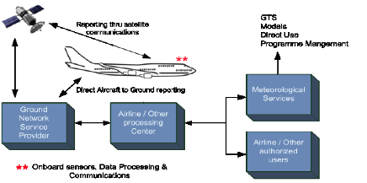
Figure 1. Simplified overview of the AMDAR observing system.

1.6.1.2 Data Reception and Processing
AMDAR observations should be received and processed by the Member NMHS before reformatting into BUFR for transmission on the GTS.
In some cases, AMDAR observations may be processed by one Member on behalf of one or more others under bilateral or multilateral arrangement and agreement. In the interests of programme efficiency and capacity development, WMO strongly encourages such collaboration.
To facilitate such efficiencies Members should ensure that AMDAR observations are provided in a WMO standard format as described in [REF Section 2.1.2.3].
Members shall undertake prescribed minimum quality control of aircraft based observations prior to transmission on the GTS and as described in [REF Section 1.8 and Annex I].

1.6.1.3 Provision of Observations on the GTS
Members shall provide AMDAR on the GTS in accordance with [REF WMO Resolution 40] and in accordance with the provisions in [REF Section 1.9 and Annex III]

1.6.1.4 Maintenance and Provision of Metadata
Members shall maintain a record of AMDAR observational metadata in accordance with the provisions in [REF Section 1.10 and Annex IV]

1.6.1.5 Monitoring and Quality Assessment
Members shall undertake routine monitoring and quality assessment of AMDAR observational data in accordance with the provisions in [REF Section 1.8 and Annex II]

1.6.2 ICAO Aircraft Based Observations

1.6.2.1 ICAO Aircraft Reports
Several sources of ICAO aircraft based observations are to be made available to WMO Members under the regulations of ICAO governing its Contracted States. The requirements for the making of aircraft observations and the provision of aircraft reports (air-reports) are discussed and defined in [REF ICAO Doc. 8896, Ch. 7].
Note: The detailed descriptions and provisions for ICAO aircraft observations are not provided in full within this Guide. The reader is referred to the ICAO and/or WMO publications as indicated.
From [REF ICAO Doc. 8896, Ch. 7]:
A report consisting of a position report and of meteorological information is called a “routine air-report”. (It may also contain operational information.) Reports containing special aircraft observations are called “special air-reports” and, in most cases, constitute a basis for the issuance of SIGMETs.
Routine air-reports are to be made by aircraft with air-ground data link when air-ground data link is used and automatic dependent surveillance (ADS) or secondary surveillance radar (SSR) Mode-S is being applied. Reports are to be made by such aircraft at 15-minute intervals during their en-route phase and every 30 seconds during the climb-out phase for the first 10 minutes of the flight.
A brief description of the ADS and SSR systems that can be used to generate air-reports of various content is provided within [REF section 2.2].
Routine and Special Reports (AIREPs) from an aircraft are prepared during flight in conformity with requirements for position, and operational and/or meteorological reporting as described below in [REF section 1.6.2.1].
From [REF ICAO Doc. 8896, Ch. 7, section 7.7]:
7.7.1 Basic Principles: Air traffic services and meteorological authorities must establish appropriate arrangements to ensure that routine and special air-reports reported to ATS units by aircraft in flight are transmitted without delay to the World Area Forecast Centres (WAFCs) and to the associated Meteorological Watch Offices (MWO).
7.7.3 Additional exchange of air-reports beyond WAFCs: Air-reports exchanged beyond WAFCs are considered as basic meteorological data and therefore their further dissemination is subject to WMO provisions.
While the ICAO ABO derived from AIREPs are made available as basic data to WMO Members for their use in the provision of their mandated services and applications, the primary purpose of these observations are for the applications of Air Traffic Services, MWOs and WAFCs.
Regulations and guidance for WMO Members on the reception, transmission on the GTS and management of ICAO ABO are provided in WMO No. 386, Manual on the GTS, Vol. I, Part I, Section 2.7]. These regulations state that:
Collecting centres designated in the ICAO Regional Air Navigation Plans for the collection of aircraft weather reports shall send all available aircraft weather reports to the NMC situated in the respective country or to other meteorological centres designated by agreement between the aeronautical and meteorological authorities concerned.
RTHs shall collect the aircraft weather reports from the NMCs in their respective zones of responsibility.
Provisions for ICAO ABO are regulated at the highest level in WMO-No. 49 Technical Regulations, Volume 2, Meteorological Service for International Air Navigation, Part I, Section 5, Aircraft Observations and Reports and Part II, Appendix 4, also published by the International Civil Aviation Authority (ICAO) and described in ICAO Annex 3 to the Convention on International Civil Aviation.
Requirements in terms of (mandatory) standards and recommended practices are stated in WMO-No. 49, Vol. 2/ICAO Annex 3, Appendix 4, "Technical Specifications Related to Aircraft Observations and Reports".
Details on data processing and delivery can be found in the following ICAO documents:
- ICAO Doc 4444 PANS/ATM, Air Traffic Management, (see paragraph 4.12 REPORTING OF OPERATIONAL AND METEOROLOGICAL INFORMATION)
- ICAO Doc 8896, Manual of Aeronautical Meteorological Practice (see Chapter 7, AIRCRAFT OBSERVATIONS AND REPORTS)
- ICAO 9377, Manual on Coordination between Air Traffic Services, Aeronautical Information Services and Aeronautical Meteorological Services (see 4.2 REPORTS OF AIRCRAFT OBSERVATIONS RECEIVED IN ATS UNITS)
Based on these provisions, it is clear that NMCs Washington and London are currently responsible for the initial collection of AIREPs from WAFCs and for their provision to WMO Members.
At the current time, meteorological information from Aircraft Reports can be considered to be a supplementary source of aircraft based observations that assist in meeting the requirements of WMO Members for upper air observations – see [REF Section 1.5]. However, In most countries, these Aircraft Reports are either not being made or are not being made available to WAFCs in accordance with ICAO provisions. Members should therefore liaise with their civil aviation authorities to ensure that Aircraft Reports are made and that they are then sent to WAFCs so as to be made available on the GTS as aircraft based observations.
Beyond the provisions that are made in the WMO and ICAO documents above for the derivation of ABO from AIREPs, the additional derivation of ABO from these and other national Air Traffic Management systems and sources is essentially a matter between WMO Members and their respective civil aviation authorities. In the event that such additional ABO data are able to be made available to NMHSs, they should remain subject to [REF WMO Resolution 40] and the requirements for provision of such data on the GTS as described in [REF section 1.8].
For example, the derivation of ABO from PIREPs (described below) and high resolution ADS-B or Mode-S systems, described below in [REF section 2.2] are not regulated under ICAO provisions outlined above.

1.6.2.2 Other National Aviation Aircraft Reports
Pilot Reports
A Pilot Report (PIREP) is a routine or urgent report of actual weather conditions encountered by an aircraft in flight. This information is usually relayed by radio to the nearest ground station, but other options (e.g. electronic submission) also exist in some regions. The message would then be encoded and relayed to other weather offices and air traffic service units. At a minimum the PIREP must contain a header, aircraft location, time, flight level, aircraft type and one other field. The provision of PIREPs by aircraft is regulated in accordance with national requirements and is not subject to regulation by ICAO.
Information on the origins or PIREPs are difficult to find but the requirements, content and other details should be available from the relevant civil aviation authority. In the USA, the requirements for PIREPs are issued as a directive and documented within the Federal Aviation Administration (FAA) [REF Aeronautical Information Manual, section 7-1-20].
While PIREPs should essentially be treated in the same way as AIREPs, subject to the same quality control and reported on the GTS in the same way, it is preferred that they are able to be distinguished from other ABO sources, including AIREPs.

1.6.2.2 Format and Content of Air-reports
The meteorological content of routine air-reports transmitted via air-to-ground data link is provided in [REF ICAO Doc. 8896, Table 7-3], as shown below.
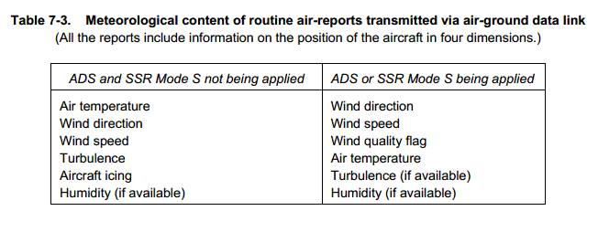
Criteria for Reporting
When air-ground data link is used, the wind direction, wind speed, wind quality flag, air temperature, turbulence and humidity included in air-reports shall be reported in accordance with the following criteria.
- Wind direction: The wind direction shall be reported in terms of degrees true, rounded to the nearest whole degree.
- Wind speed: The wind speed shall be reported in metres per second or knots, rounded to the nearest 1 m/s (1 knot). The units of measurement used for the wind speed shall be indicated.
- Wind quality flag: The wind quality flag shall be reported as 0 when the roll angle is less than 5 degrees and as 1 when the roll angle is 5 degrees or more.
- Air temperature: The air temperature shall be reported to the nearest tenth of a degree Celsius.
- Turbulence: The turbulence shall be reported in terms of the cube root of the eddy dissipation rate (EDR). For further details, see [REF Annex 3, App. 4, par. 2.6].
- Humidity: The humidity shall be reported as the relative humidity, rounded to the nearest whole per cent.

Note: The ranges and resolutions for the meteorological elements included in air-reports are shown in [ICOA, Annex 3, Appendix 4,Table A4-3].
The AIREP format is described in more detail in [REF Annex III].

1.6.2.3 Provision of Observations on the GTS
Members shall provide aircraft based observations derived from ICAO air-reports on the GTS in accordance with the provisions above and in [REF sections 1.8 and 1.9 and Annexes I and III].

1.6.2.4 Maintenance and Provision of Metadata
Members shall maintain a record of observational metadata for ICAO ABO in accordance with the provisions in [REF section 1.10 and Annex IV].

1.6.2.5 Monitoring and Quality Assessment
Members shall undertake routine monitoring and quality assessment of ICAO ABO in accordance with the provisions in [REF section 1.8 and Annex II].
For details on systems that generate ICAO aircraft reports, see section 2.2

1.6.3. Other Aircraft Based Observations
Aircraft based observations are also available through commercial manufacturers and system operators. Such systems are distinct from the AMDAR system in that the collaboration is between the NMHS and a 3rd party commercial entity, rather than between the NMHS and the airline and/or the national civil aviation organization.
Such 3rd parties currently include:
- Panasonic Avionics Corporation under its Weather Solution Program manufactures and deploys the Tropospheric Airborne Meteorological Data Reporting (TAMDAR) sensing system, a device designed to collect and transmit weather and other data during the flight of an aircraft.
- FLYHT Aerospace Solutions Ltd. manufactures the Automatic Flight Information and Reporting System (AFIRS), which interfaces with the aircraft flight data, processes and stores it and transmits it over the Iridium global satellite network.

Both systems provide downlink, voice and text communications and flight-following features as services to the client airline.
Both companies provide a centralised data processing centre at which the data is received, processed and routed to the airline and data subscribers.
In the case of TAMDAR, meteorological sensors are deployed as components of the TAMDAR probe so that some observations of meteorological parameters are made independently from the aircraft. These data are openly shared back with the host airline. With the airline's permission, a host airline's data may also be shared with other participating fleets.
The TAMDAR and AFIRS systems and their operation are briefly described in [REF Section 2.3.3].

1.6.3.1 Data Policy and Agreements with Data Providers
It is critically important that Members are aware of the methods of measurement and observation that are employed by the 3rd party in operation of the observing system from which the aircraft based observations are derived – in particular those aspects that impact on reliability and quality of the data source.
It is important to understand that 3rd party ABO data providers are generally commercial entities and so they operate their systems and provide their services and products in the expectation that they will receive a return on their investment. In some cases, the collection of meteorological data may be considered to be a secondary or tertiary revenue stream for the operator and the primary source may be the service provided to the airline. In any case, the business case for provision of meteorological data to the NMHS still holds. This fact should be utilised in negotiating with the two parties, the 3rd party data provider and the airline, for the provision of ABO. The stronger the business case and the more the NMHS can do to offset the cost of the ABO data through the provision of improved meteorological services to the airline, the greater the likelihood that a lower cost contract or agreement can be negotiated by the NMHS.

1.6.3.2 Provision of Observations on the GTS
Members should ensure that the formation of a contract or agreement with the service provider for the provision of 3rd party ABO data allows the data to be transmitted on the GTS in accordance with [REF WMO Resolution 40].
Members shall provide 3rd party data derived from other aircraft based observing systems on the GTS in accordance with the provisions in [REF sections 1.8 and 1.9 and Annexes I and III].

1.6.3.1.3 Maintenance and Provision of Metadata
Members shall maintain a record of observational metadata for other aircraft based observing systems in accordance with the provisions in [REF section 1.10 and Annex IV].

1.6.3.1.4 Monitoring and Quality Assessment
Members shall undertake routine monitoring and quality assessment of 3rd party aircraft based observational data in accordance with the provisions in [REF section 1.8 and Annex II].

1.7 Observational Data Management
The entities functions and practices described in this section together with the data and quality management practices undertaken by Members and described in [REF sections 1.8, through to 1.11] form the overall ABO Data Management system. Within the data management system, the monitoring and improvement of the quality chain is a leading theme, i.e. improvement follows from evaluation, research and ongoing development of the data processing and production chain. For aircraft based observations, including aircraft derived data from ICAO ABO; this chain is a relatively complex system because of the many data processing operations and autonomous data switches involved. This complex data management and distribution system can be described as a system of entities that each undertake a number of tasks, activities and practices to support observational data management, starting from initial variable measurement on the aircraft platform through to the delivery of data products to data users.
[REF Figure 2] below shows the Proposed Aircraft Observations Global Data Management Framework that was first developed at the WMO AMDAR Panel Aircraft Observing System Data Management Workshop, Geneva, Switzerland, June 2012 and later updated by the WMO Expert Team on Aircraft Based Observing Systems (Session 2, December 2015). While many of the elements of this proposed system are not yet in place, including the ABO Data Centre and the framework for metadata management, it provides an aspirational focus for the future to support improved ABO data management.
While this figure does not depict the data management framework for Other ABO and aircraft based observing systems as described in [REF sections 1.6.3 and 2.3], these data should be managed under a similar data management framework.
The important entities functions, roles and practices depicted in the figure are described below.
Aircraft Observing Platforms
A range of aircraft platforms as described below in [REF section 2] routinely obtain measurements from dedicated sensors, which are processed and controlled and combined with static and dynamic metadata to form observations, which are then dispatched by communications system to the ground based on a programmed schedule of reporting.
Aviation Data Service Providers
Reports of observations (ABO) are provided by Aviation Data Service Providers (Av. DSP) that are responsible for maintaining air-ground and ground-ground communications network in support of the Aviation Communications Addressing and Reporting System (ACARs), delivering reports to airlines, Air Traffic Management (ATM) and ABO Data Processing Centres (DPCs). In some cases, an arrangement between airlines and NMHSs is made for airlines to deliver AMDAR data to the ABO DPC.
World Area Forecast Centres
ICAO World Area Forecast Centres (WAFCs) operated by WMO Members provide weather services in support of air navigation requirements and are responsible for the collection of ICAO Aircraft Reports, which are then made available on the GTS as described in [REF section 1.6.2]. In the future WMO expects that all AIREPs should be processed by two designated ABO DPCs under the authority of the two WAFCs and in line with ICAO and WMO regulations.
Airlines
Airlines of ICAO Contracted States are responsible for meeting the regulations of ICAO for the provision of Aircraft Reports. Airlines providing ABO in partnership with Members are responsible for the delivery of ABO to DPCs under the terms of agreements put in place between the parties and as described in detail in [REF section 2.1.3.1.2]. Airlines should also be responsible for the provision of required aircraft metadata in support of ABO quality management and meteorological applications that require such information.
ABO Data Processing Centres
ABO DPCs are operated by NMHSs and may undertake ABO DPC responsibilities and functions in support of one or more national ABO programmes. ABO DPCs have responsibility for:
- the reception, processing, quality control and archival of ABO and its transmission on the GTS;
- the reception, processing and maintenance of metadata and its relay to OSCAR;
- optimisation of ABO data, in particular the management of data optimisation systems supporting AMDAR observing systems as described in [REF section 2.1.2.2 and Annex V]; and
- in some cases, the provision of data display or visualisation functionality in support of ABO programme management.
Third Party ABO Data Processing Centres
Third Party ABO Data Processing Centres (3P DPCs) are centres that undertake DPC functions on behalf of and in agreement with a NMHS or region. Generally, such centres should not be responsible for provision of ABO on the GTS, which should be maintained as a WMO Member responsibility.
ABO National Meteorological Service
An ABO National Meteorological Service (NMS) is a WMO Member that receives and uses ABO and may or may not contribute ABO through the services or functions of a partner DPC. In the case of the former, the ABO NMS should take responsibility for the provision of required partner or national airline metadata.
Observing System Capabilities Analysis and Review System
The WMO Observing System Capabilities Analysis and Review (OSCAR) system is the repository for all ABO metadata. Members will be responsible for ensuring that ABO metadata is obtained from national airlines and provided to OSCAR in accordance with the requirements described in [REF section 1.10 and Annex IV].
ABO Data Monitoring Centre
WMO ABO Data Monitoring Centres (DMCs) are responsible for monitoring of ABO data and may undertake a global or regional data monitoring role. The requirements of DPCs are specified in Annex II. ABO DMCs will be designated by CBS.
ABO Lead Centre
WMO Global and regional ABO Lead Centres (LCs) are responsible for the monitoring and management of ABO and associated data quality issues. ABO LCs will be designated by CBS. The requirements of ABO LCs are specified in Annex II.
ABO Data Centre
WMO ABO Data Centres will be responsible for the reception, management and maintenance of all ABO data which is expected to include the following functions:
- Reception and database storage of all ABO transmitted on the GTS;
- Maintenance of quality monitoring data and information on ABO data quality issues; and
- Provision of interface to the ABO database and secured provision to WMO Members;

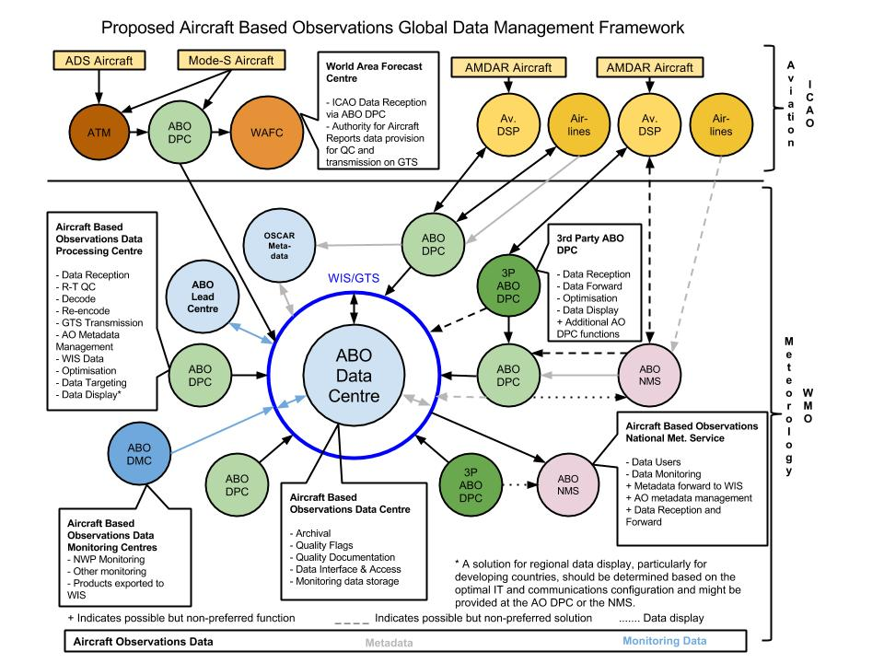
Figure 2: Proposed Aircraft Observations Data Management Framework

1.8 Quality Management
The Manual on WIGOS provides the over-arching framework for quality management for all WIGOS component observing systems and sub-systems. Members shall comply with all the relevant general provisions in the Manual on WIGOS for quality control of their aircraft based observing systems and quality management of their observational data.
In particular, Members should ensure that they are compliant with the provisions for quality management within [REF Manual on WIGOS, Sections 2.6 and 3.6 and the Manual on the GOS, Part V Quality Control].

1.8.1 Member Quality Management System
Members shall ensure that their Quality Management System (QMS) incorporates the required procedures, practices and documentation necessary to maintain their aircraft based observational data at prescribed quality standards. This should include the recommended quality management practices described in this guide.

1.8.2 Aircraft Based Observations Quality Management

1.8.2.1 Aircraft Based Observing System Quality Control
Members that operate AMDAR and other observing systems in collaboration with partner airlines and aircraft operators should ensure compliance with all practices and guidance that impact on observational data quality provided in [REF Section 2].

1.8.2.2 Aircraft Based Observations Data Quality Management
A broad and basic depiction of the data flows and quality management processes in place at the national and international level that impact significantly on the quality of aircraft based observations is provided below in [REF Figure 3].
Members should ensure that each of the following elements and functions are addressed in establishing a national or regional framework for the management of aircraft based observational data quality:
- A person (or persons) should be appointed to the role of aircraft based observations Programme Manager (PM) – in most cases, this person will also serve as the WMO/CBS Focal Point on Aircraft Based Observations. See [REF Section 1.12]. The ABO PM should be responsible for:
  - Establishing that airline partners meet national and international requirements and standards for ABO provision as outlined within this guide.
  - Obtaining and acting upon feedback on data quality issues including those provided by the Quality Evaluation Centre.
  - Obtaining and acting upon changing or new requirements that impact upon the programme.
  - Establishing and maintaining a feedback mechanism with ABO data providers on ABO data quality.
- A facility should be established for the reception and quality control of aircraft based observations. See [REF Section 1.8.2.2.1].
- A Quality Evaluation Center (QEC) should be made responsible for continuously monitoring and analysing the quality of the aircraft based observations. The QEC should receive and utilise feedback on ABO data quality from various sources including national, regional and global data users and the WMO/CBS Lead Center on Quality Monitoring of Aircraft Observations. See [REF Section 1.8.2.2.2].
- A mechanism should be established to ensure that the national ABO programme accommodates the on-going and changing requirements of national and international data users.

1.8.2.2.1 Data Quality Control Practices
Members that receive process and transmit aircraft based observations on the GTS shall as a minimum comply with the requirements for quality control of these data as defined within the following manuals:
- [REF Manual on GDPFS, Part II, Annex II.1, Minimum Standards for Quality Control of Data for Use in the GDPFS]
- [REF Manual on the GOS, Part V, Quality Control]
Members that receive, process and transmit aircraft based observations on the GTS should comply with the observational data quality control practices within [Annex I, Guidance on Quality Control of Aircraft based Observational Data].

1.8.2.2.2 Quality Monitoring and Improvement
WMO Members shall develop and implement policy and procedures for quality monitoring and quality assessment of aircraft based observations so as to continuously assure the quality of such observations transmitted on the GTS.
Members that receive process and transmit aircraft based observations on the GTS should comply with the observational data quality control practices within [REF Annex II, Guidance on Quality Monitoring of Aircraft Based Observations].
The WMO Lead Centre on Aircraft Data is responsible for quality monitoring of aircraft based observations and the dissemination of monitoring information to WMO Members.
The World Meteorological Centre, Washington, has the role as Lead Centre for Aircraft Data with the data monitoring processes carried out by the US National Weather Service, National Centres for Environmental Prediction, Central Operations.
Current requirements for the monitoring of aircraft data by monitoring centres (Regional Specialised Meteorological Centres - RSMCs) are defined in [REF the Manual on the Global Data-Processing and Forecasting System, GDPFS Part II, Attachment 9, Section 5 on Aircraft Data].
Members that receive, process and transmit aircraft based observations on the GTS should utilise the quality monitoring information available from the WMO/CBS Lead Center for Quality Monitoring of Aircraft Observations as described in [Annex II, Guidance on Quality Monitoring of Aircraft based Observational Data] as an integrated component of their quality monitoring practices.
Members that receive, process and transmit aircraft based observations on the GTS shall appoint a representative from their organization to take on the role of the national WMO Focal Point on Aircraft based Observations. The focal point shall be responsible for receiving, utilising and acting upon information from WMO or other Members relating to the quality of their aircraft based observations. This will include the timely rectification of related faults and errors and, when required, the removal of such data from transmission on the GTS until such time as faults are rectified.

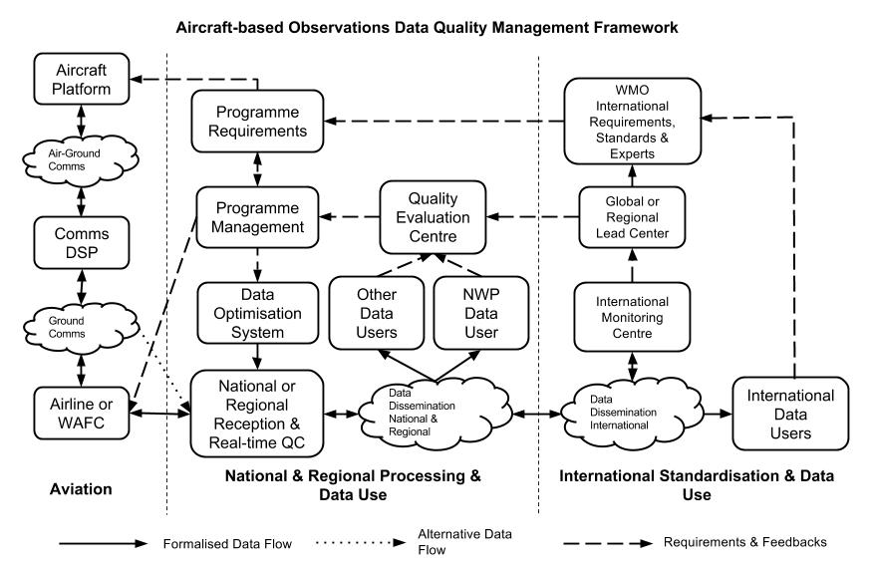
Figure 3: Aircraft Based Observations Data Quality Management Framework.

1.9 Provision of Aircraft Based Observations on the GTS
Members that receive, process and transmit on the GTS aircraft based observations from any source, including AMDAR, ICAO aircraft observations and other aircraft based observing systems shall do so in accordance with [REF WMO Resolution 40] and in accordance with the guidance provided in [REF Annex III, Guidance on Encoding of Aircraft based Observational Data for Transmission on the WMO GTS].
Members shall ensure that, on receipt of advice from the relevant WMO Lead Center on aircraft observations or from other WMO Members, that particular aircraft based observations are errant or of poor quality, they have the capacity to remove or “blacklist” such data from further transmission on the GTS until such time as the data quality is restored.

1.10 Observational Metadata Requirements and Management
Observational metadata refers to all types of metadata necessary to interpret the (sets of) observational data.
Members that receive and process aircraft based observational data from any source shall ensure that they maintain a database of metadata related to the following observational aspects and elements of their observational data:
- Models and types of aircraft;
- On-board sensors and their siting and calibration, maintenance issues and calibration (where available and when able to be provided);
- Specific software and algorithms used to process data to generate the reported variables; and
- Metadata related to quality control processes, data communication practices, data processing and delivering centres.
Members should maintain and provide internationally required metadata relating to their aircraft based observational data in accordance with:
- [Manual on WIGOS, sections 2.5 and 3.5]
- [REF Annex IV Guidance on Aircraft Based Observations Metadata Maintenance and Provision]

1.11 Operations, Maintenance, Incident Management and Change Management
Maintenance consists of the routine processes and procedures that ensure that infrastructure and equipment, upon which the quality and reliability of observing system outputs depend, are planned and implemented.
Members shall ensure that they operate and manage incidents and changes related to their aircraft based observing systems in accordance with the general provisions within:
- [REF Manual on the WIGOS, Sections 2.4, 3.4].
- [Manual on the GTS, Part II, Chapter 5]
Members shall in collaboration with their partner airlines, develop and agree on policy and procedures for the detection, advisement and rectification of issues and errors associated with the quality and operational performance of airline sensors, systems and infrastructure upon which their aircraft based observing systems depend.

1.12 International and Regional Planning and Capacity Development

1.12.1 WMO Aircraft Based Observations programme
In order to coordinate and promote the development of aircraft based observations and national (and regional) AMDAR programmes, the WMO Executive Council decided at its forty-ninth session in 1997 to establish a WMO Panel on AMDAR, composed of WMO Members that operated, or intended to operate, national AMDAR programmes. In 1998 the AMDAR Panel took over the responsibilities for the operation of AMDAR, the remaining ASDAR units and the AMDAR Trust Fund.
At its 16th Session (2003), WMO Congress agreed with a recommendation made by the WMO Commission for Basic Systems (CBS) that AMDAR should become fully integrated into the WMO World Weather Watch (WWW) Programme. In 2007, at its 17th Session, Congress paved the way for the AMDAR observing system to become a recognised, operational component of the WWW Global Observing System.
At its 15th annual Session (2012) the WMO AMDAR Panel agreed that all was in place within WMO and its Technical Commissions to formally hand over full responsibility for the AMDAR observing system and the AMDAR Trust Fund, and for the Panel to cease its activities.
The international Aircraft Based Observations Programme (ABOP), which includes AMDAR, is now supported by an Expert Team on Aircraft Based Observing Systems (ET-ABO) within CBS and also an Expert Team on Aircraft Based Observations (ET-AO) within the Commission for Instruments and Methods of Observation (CIMO).
The tasks and activities of the two Expert Teams include the provision of programmatic and technical support for development, enhancement and maintenance of all aircraft based observing systems and for management of international standards and practices associated with aircraft based observations.
Figure 4 below represents the current governance and programmatic management of aircraft based observations within WMO.
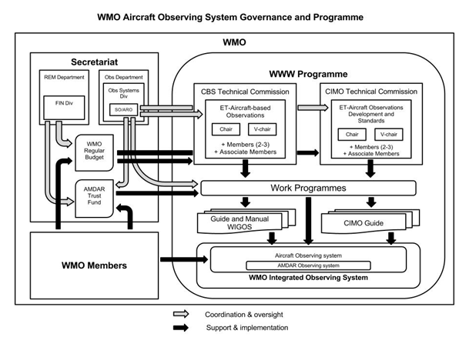
Figure 4: Aircraft based Observing System Governance and Programmatic Structure.

1.12.2 Projects and Development
Under the ABOP, WMO Technical Commissions have instigated a regional approach to aircraft based observations development in collaboration with WMO Regional Associations (RAs) and its Members. The ABOP intends to assist RAs in developing and maintaining ABOP Regional Implementation Plans (A-RIPs) in each of the six WMO regions. These A-RIPs are based on and in line with the relevant actions of the [REF CBS Implementation Plan for Evolution of Global Observing Systems (EGOS-IP), WMO Technical Report No. 2013-4]. An important role in this process is assigned to the WMO National Focal Points for Aircraft Based Observations nominated by the Members. The Focal Points are listed in the WMO Country Profile Data Base.
While AMDAR is now a mature and stable operational observing system, there are many developments and enhancements underway or planned that are expected to improve the benefits of the system, the use of its observational data products and its operational coverage:
1. Development of new programmes that will improve global upper-air data coverage over currently data-sparse areas including:
- Regions I and III
- Eastern Europe
- Western Asia
- The Southwest Pacific
- Central and South America
- The Middle East
2. Implementation of water vapour measurement as a component of the AMDAR Observing System.
3. Implementation of turbulence monitoring and reporting.
4. Implementation of icing monitoring and reporting.
5. Wider implementation of ground-based AMDAR Data Optimisation.
6. Wider integration of AMDAR standards and protocols into the avionics and aircraft manufacturing process.
7. Implementation of routine data targeting in support of weather systems monitoring and prediction.
WMO Members should provide support for the continued development and enhancement of the ABOP through the following actions:
- Continue financial support to the AMDAR Trust Fund in line with the relevant WMO Congress resolutions.
- Contribute staff resources to the membership of relevant WMO Technical Commission and Regional Association work teams and groups.
- Endeavour to obtain and provide aircraft based observations on the WMO GTS.
- Endeavour to develop and maintain operational AMDAR observing systems in line with national, regional and global requirements.

1.12.3 Training and Outreach

1.12.3.1 Training Requirements
Members should ensure that staff members are adequately trained for competency in the following areas of operational practices relating to aircraft based observations and the operation of AMDAR programmes:
- Interaction and negotiation with aviation representatives and contact persons for collaboration on aircraft based observations and AMDAR programme participation.
- Specification of technical and functional requirements for AMDAR observing system planning and design.
- Information Technology (IT) skills supporting data communications and data processing systems infrastructure development and maintenance.
- Data monitoring and scientific and meteorological data analysis.
- Systems and data quality management.
For further information refer to [REF section 2.1.4, Capacity Development].

1.12.3.2 Outreach
It is critical to the maintenance and continued development of the AMDAR observing system that the interests of Members are represented and promoted to the important stakeholders, e.g. relevant sections within the NMHS concerned, ATI organisations, aeronautical associations and associated forums.
WMO and the Aircraft Based Observations programme (ABOP) promote aircraft based observations and the AMDAR observing system through a range of activities:
- Maintaining the ABO and AMDAR areas of the WMO website [REF see: http://www.wmo.int/pages/prog/www/GOS/ABO/index_en.html];
- Publishing the WMO AMDAR Newsletter and maintaining the News and Events website [REF see: http://www.wmo.int/amdar-news-and-events/];
- Maintaining statistical reports and quality monitoring information on the WMO website [REF see: http://www.wmo.int/pages/prog/www/GOS/ABO/ABO_Data.html]
- Developing and maintaining guidance on the benefits and business case for aviation and airline collaboration on aircraft based observations [REF see: http://www.wmo.int/pages/prog/www/GOS/ABO/AMDAR/resources/index_en.html]
- Cooperating actively with airlines and other relevant organisations and participating in aviation related bodies, e.g. Airlines Electronic Engineering Committee (AEEC).

1.12.3.3 Publications
The WMO Technical Commission expert teams on aircraft based observations support the revision and production of technical and scientific studies relevant to aircraft based observations, observing systems and their related technologies. See [REF Annex VIII] for a list of important references.

1.12.3.4 Focal Points
Members should nominate WMO Focal Points on Aircraft-Based Observations who can liaise with WMO Technical Commissions, WMO Lead Centres and fellow focal points on matters related to aircraft based observations and AMDAR. WMO Focal Points on Aircraft Based Observations are listed in the WMO Country Profile Data Base.

2. Aircraft based Observing Systems

2.1. AMDAR Observing System Development and Operation
Aircraft Meteorological DAta Relay (AMDAR) is the World Meteorological Organization (WMO) meteorological observing system that facilitates the fully automated collection and transmission of weather observations from commercial aircraft. The AMDAR programme is an integrated component of the WMO Global Observing System (GOS) of the World Weather Watch (WWW) Programme [REF http://www.wmo.int/pages/prog/www/index_en.html]. The system is operated by WMO Member NMHs in collaboration and cooperation with partner airlines and has grown rapidly and continuously since the early 1990s.
While the AMDAR programme is currently (early 2016) served by a worldwide fleet of over 4000 aircraft contributing around 700,000 high quality upper air observations per day, there are still many areas of the world with little or no AMDAR coverage. WMO is urging Members to work towards improving upper air coverage of the GOS by developing new, and expanding existing national and regional AMDAR programmes.
Figure 1 (REF Section 1.6.1.1) provides a general overview of the AMDAR system in which on-board sensors, computers and communications systems collect, process, format and transmit the data to ground stations via satellite and VHF links. The transmission of this data to the ground is accomplished through use of the aircraft’s ACARS (Aircraft Communications Addressing and Reporting System) system. Once on the ground, the data is processed and transmitted on the GTS for global use by NMHS and other authorised users.
The primary data set of AMDAR data includes: the time of observation and the aircraft position in three dimensional space, wind speed and direction, ambient temperature and, where available occasionally turbulence information. Additional parameters include humidity measurement, requiring the deployment of a water vapour measurement (WVM) sensor and turbulence requiring the implementation of the calculation and reporting a supplementary metric, the Eddy Dissipation Rate (EDR).
See [REF section 1.9] for details on reporting AMDAR data on the WMO GTS.

2.1.1 Requirements and Planning
When considering developing or participation in an AMDAR programme the NMHS should ensure planning and availability of resources to fulfil the following requirements:
- Members should ensure that WMO requirements for upper air data will be met (see [REF Section 1.5.1]).
- Member shall ensure compliance with relevant standards:
  - The AMDAR On-board Software Functional Requirements Specifications [REF AOSFRS] provides a standard for the meteorological functionality of AMDAR software applications and air-ground data formats.
  - The AEEC Data Link Ground System Standard and Interface Specification (ARINC 620, Supplement 8) [REF ARINC 620], providing a specification of the Meteorological Report versions 1 to 6 uplink and downlink messages supporting AMDAR data delivery under the ACARS protocols.
  - WMO-No. 8, [REF CIMO Guide, Part II, Chapter 3].
- Members shall comply with [REF WMO Resolution 40].
- Members should comply with the requirements for the operation of an AMDAR programme as provided below in [REF section 2.1.3].
- Members should comply with requirements for quality management of AMDAR data as provided in [REF Section 1.8.]
- Members should comply with requirements for data quality control of AMDAR observations as provided in [REF Annex I]
- Members shall comply with requirements for the provision of AMDAR data on the GTS as provided in [REF Section 1.9].
- Members shall comply with requirement for the management and provision of AMDAR metadata as provided in [REF Section 1.10]

When considering and planning for the development and implementation of a national AMDAR programme with one or more partner airlines, it is necessary for NMHSs to address each of the following basic topics and requirements:
- Assessment of national, regional and global requirements for upper air data including requirements for measurement of humidity;
- Assessment of the capabilities and potential coverage of national airlines;
- Obtaining airline contacts and commencing negotiations with the airline(s);
- Building a business case for airline participation;
- AMDAR programme cost considerations;
- Contracts and agreements between NMHSs and airline(s);
- Design and implementation of the AMDAR system; and
- Data display and use.

2.1.1.1 Assessment of requirements for upper air observations
Before commencing the development of an AMDAR programme the requirements of upper air data users and applications areas, including national, regional and global, should be gathered and consolidated. These requirements should be assessed against the capabilities of the current national composite upper air observing system and the ability of an AMDAR programme to fill gaps and/or to provide an efficiency dividend. Upper air observing systems that might be considered in such an analysis are radiosondes, radar wind profilers, polar orbiting and geostationary satellites and other ground-based remote-sensing systems.
The national aspects of such an analysis can be undertaken only by each NMHS individually in consideration of both the current configuration of the composite upper air observing system and its likely future evolution.
An obvious consideration is that the AMDAR programme coverage is fully dependent on the flight schedule and coverage of the potential participating airlines. Flight schedules can vary from day to day, week to week, month to month and seasonally depending on customer demand and other airline-dependent factors.
Given the international operations (i.e. regional and long-haul international flights) of many airline operators, it is also important to take into consideration that the AMDAR programme, by its nature, offers the opportunity to collaborate with regional and international NMHS partners to share and optimise the efficiency and coverage that can be provided. It is highly recommended that Members consider the various WIGOS and aircraft based observations regional implementation plans for their respective Regional Association. This may provide the opportunity to collaborate on a regional basis, including the possibility to share costs associated with establishment and operation of the necessary infrastructure (e.g. ground-based data processing systems), resources and data processing.

2.1.1.2 Requirements for Humidity Measurement
It is possible to equip aircraft with instrumentation for high quality observations of atmospheric humidity during all phases of flight. This greatly increases the value of the meteorological information collected by an AMDAR programme. The benefits and cost considerations of this equipment are described in detail in the WIGOS Technical Report 2014-1, The Benefits of AMDAR to Meteorology and Aviation mentioned above.
Members should consider requirements for humidity measurement as a component of their AMDAR programme and endeavour to include this observation capability in new and existing AMDAR programmes. While this does require the addition of equipment to the designated aircraft, that process is well defined and leads to a significantly greater benefit to a national or regional AMDAR programme.

2.1.1.3 Assessment of national airlines capabilities and coverage
Potential operators of a national or regional AMDAR programme should start with a preliminary assessment of the national airlines’ aircraft fleets and analysis of the operational routes serviced by the airlines. In the case where a national airline does not exist, other commercial airlines operating within the nation or region may be considered.
The overall aim of the survey and analysis of the national airlines should be to determine what coverage might be obtained by equipping one or more fleets of aircraft types and which combination of airlines and aircraft fleets most efficiently provides the optimal coverage that best meets established requirements for upper air data.
Generally detailed information on the airline’s fleets and the flight routes that they operate can be found on the airline’s website. If not, then it will be necessary to establish direct contacts within the airline (see section below) to obtain this information.
The following aspects and questions regarding the airline especially require consideration:
- Of prime importance is whether the airline and aircraft have ACARS (communications) capability, which enables the near-real-time automated reporting functionality required for AMDAR.
- Which types of aircraft does the airline operate and which routes does each aircraft type tend to fly?
- Of these types, which fly domestic routes and which fly internationally?
- What is the age of the aircraft? The more modern the aircraft, the more likely they will be able to accommodate an AMDAR software application. Note that it will be necessary to determine exactly which avionics the aircraft have and whether or not they will support an AMDAR software application.
- Which airports does each airline and aircraft fleet service routinely?
- Based on the airline flight schedules, how many vertical profiles per day at each airport are likely to be obtained through equipping the different aircraft types?
- Is the airline well established, stable and likely to continue operation well into the future?
- Does the airline have a strong maintenance division? While this is not crucial and, in fact, there are many airlines outsourcing their maintenance operations, it is certainly beneficial to be able to liaise directly with technical staff and engineers within the airline who will understand the engineering aspects of aircraft maintenance and monitoring via avionics systems.

Once the initial analysis of national airlines has been undertaken, it is then necessary to make a more firm determination on whether or not the airlines and aircraft have the required technical capabilities. This can be done by asking the airline to complete a questionnaire, the Airlines AMDAR Compatible Systems Survey that is available from the WMO AMDAR Resources website. Once the survey has been completed it should be returned to the WMO Secretariat, for analysis and for providing further advice regarding AMDAR software.
The survey should be completed before the airline has agreed to participate in the AMDAR programme and will be necessary to identify the on-board avionics type and capabilities, which will determine the suitability and requirements for AMDAR on-board software, see [REF Section 2.1.2.3 and Annex VI] below.
For a global summary of airlines operating AMDAR suitable aircraft, highlighting those that have been targeted by WMO to contribute to extending global AMDAR coverage, it is also recommended to consult the WMO report, AMDAR Coverage & Targeting for Future Airline Recruitment, February 2013

2.1.1.4 Obtaining airline contacts and commencing negotiations
Once it has been confirmed that one or more national airlines operate aircraft that might be suitable for contributing to the WMO AMDAR programme and the upper air data requirements, the NMHS should seek to establish some key contacts within the airline so as to be able to begin negotiations and present a business case to the airline for participation in the programme. [REF Table 1] below provides the various recommended airline personnel that might be strategic contacts to make and maintain so as to assist, provide information and/or negotiate with in relation to the establishment of an AMDAR programme.

Airline Contact | Role in the Airline | Role in AMDAR Programme Development and or Operation | Comment
Airline CEO or other senior executive officer | Executive manager and high level decision maker | - May understand the impact of weather on airline operations.  - May be a recipient of the business case for programme participation.  - May provide initial, high-level decision on airline involvement in the programme. | - Unlikely to be involved in detailed negotiations.  - Unlikely to be involved in ongoing aspects of the programme.
Chief Pilot | Senior representative of pilots to airline executive and is influential in airline decision making, particularly in relation to those aspects of flight operations and safety | - Will understand the impact of weather on airline operations and efficiency, including fuel usage.  - May provide influence on high-level decision on airline involvement in the programme  - May be a recipient of the business case for programme participation.  - May provide a link to flight operations aspects of the programme. | - May be involved in the initial negotiations  - Unlikely to be involved in ongoing aspects of the programme.
Flight Operations Manager | Manager of all aspects of aircraft flight operations and is often the contact that liaises with NMHSs for weather services. | - Will understand the impact of weather on airline operations and efficiency, including fuel usage.  - May provide a link to aircraft maintenance and engineering areas of the airline. | - May be involved in the initial negotiations and also the ongoing aspects of the programme.  - Often is the first airline contact made by the AMDAR programme manager due to the weather services link.
Avionics and Maintenance Engineering | Responsible for airline aircraft and avionics maintenance. | - Will be involved in determining avionics capabilities.  - Will be responsible for AMDAR software integration. | - Can be a useful first-up contact but usually defers to other airline managers regarding participation in the programme and its benefit to the airline.
Table 1: Airline contacts and their roles and associations with the AMDAR programme.
Once a suitable group of airline contacts has been established, the NMHS should start negotiations with the airline management in order to convince them of the benefits of participation in the programme and assist in the development of a business case for airline participation. The ultimate goal is to reach agreement on the various programme parameters, including AMDAR fleet size and configuration, AMDAR software development and integration, implementation and ongoing costs and other factors associated with the design of the AMDAR system as describe in detail in [REF Section 2.1.2].

2.1.1.5 Building a business case for airline participation
Of critical importance in the process of convincing the airline to participate in the AMDAR programme is the development of a business case. The NMHS should clearly establish the business relationship between the provision of the AMDAR data, the expected improvement in weather forecasting skill and the resulting positive impact on the services to aviation able to be made by the NMHS. It should be made clear that this will lead to improved, more efficient and safer flight operations, reduction in airline economics (e.g. reduced fuel consumption) and increased airline customer satisfaction because the airline shows concern about and is willing to assist in mitigation of environmental issues related to activities in the aviation industry.
For more detailed information on the benefits and impact of AMDAR observation that can be used in developing a business case, see WMO WIGOS Technical Report 2014-1, The Benefits of AMDAR to Meteorology and Aviation.
Other important considerations for inclusion and explanation in the airline business case are the following:
- It should be emphasised that the AMDAR software module, once installed and operational, will have no impact on the aircraft operations. The AMDAR software is tested and certified to ensure seamless and safe integration into the avionics, such as ACMS or its equivalent.
- The AMDAR observations, collected and pre-processed by the AMDAR software, are interleaved with the routine aircraft-to-ground data flow and communications over the ACARS system.
- The airline may argue that the AMDAR data provided to the NMHS improves weather services generally, which benefits all airlines. While this is true, it should be emphasised that there are at least two benefits participating airlines have over non-participating airlines:
  - The performance of on-board sensor(s) providing data to the AMDAR software, which are integral to the operation and performance of the aircraft, are monitored for quality control reasons as a result of the provision of AMDAR data to the NMHS. The NMHS can therefore provide a complimentary service to the airline to inform them if and when a sensor is errant or out of calibration; and
  - The airline can promote its participation in the programme, demonstrating its commitment to improved airline operational performance and service to the nation through a partnership with the NMHS. As a result, it will likely generate greater satisfaction and loyalty from those customers that appreciate the airline’s endeavours to reduce its impact on the environment and support the NMHS in improving forecasting services for the nation.

2.1.1.6 AMDAR programme cost considerations
The costs for the development and operation of an AMDAR programme are highly dependent on the size and complexity of the programme. They also depend on the relationship established between the NMHS and the airline and the extent to which the airline perceives or quantifies the benefits based on the business case for AMDAR programme participation.
Generally, AMDAR programmes have been and should be established between NMHSs and their partner airlines under the understanding and agreement that the mutual benefits dictate that the NMHS should pay no more than the incremental costs of establishing and operating the programme.
A costing model for comparing the estimated costs associated with operating an AMDAR programme with those of a radiosonde programme was developed and the results are available in Annex 5 of WIGOS Technical Report 2014-1, The Benefits of AMDAR Data to Meteorology and Aviation.
In summary, the programme costs are largely dependent on the following factors:
- the communications solutions adopted in cooperation with the airline;
- the contractual arrangements between the particular airline and its data service provider (DSP);
- the size of the AMDAR fleet and the volume of AMDAR data generated by the fleet;
- the extent to which data optimisation methods are deployed and utilised;
- the extent to which the airline perceives and quantifies the benefits of participating in the programme; and,
- the extent to which the airline itself is willing to contribute (financially) to the programme.

The following costs have to be considered:
- Development and infrastructure costs:
  - AMDAR on-board software.
  - Software integration and rollout.
  - Communications infrastructure.
  - Data processing and quality management development.
  - Data optimisation system.
- On-going operational costs:
  - Data communications costs.
  - Aircraft system utilisation costs.
  - Maintenance cost for the AMDAR on-board software and the required ground-based infrastructure and software.

2.1.1.7 Contracts and agreements between NMHS and airlines
It is very important that an agreement, contract or memorandum of understanding (MoU) is established between the NMHS and each participating airline for the operation of the national or regional AMDAR programme. Such a document should outline the terms and conditions agreed upon to cover at least the following aspects of the programme operation:
- The time period for operation of the agreement and the programme, including an arrangement for contract or agreement termination.
- The number of aircraft to be equipped with AMDAR software for reporting AMDAR data at an agreed frequency of reporting.
- Costs payable to the airline by the NMHS.
- Requirements for the airline to ensure data supply and quality.
- Requirements for the NMHS to report to the airline any issues or faults associated with AMDAR software performance and data quality.
- The terms and conditions, including liabilities and the rights of the NMHS and 3rd parties (e.g. NMHS clients) covering use of the AMDAR data, which may desirably include ownership (i.e. jointly with the airline) of the associated meteorological data upon reception. It is critical that this aspect of the agreement at least allows AMDAR data to be distributed on the GTS and used by WMO Members according to [REF WMO Resolution 40.
- 3rd party liabilities associated with operation of the programme and AMDAR data use:
o The NMHS should seek to ensure that the agreement precludes the NMHS from being liable for any damages (including 3rd party claims) associated with any aspect of the aircraft operation (this must be the airline’s responsibility); and,
o The agreement should preclude the airline being liable for damages (including 3rd party claims) associated with any aspect of data use by the NMHS and its data users and clients (this should be the NMHS’s responsibility).
- Ownership and Intellectual Property (IP) rights. The agreement might stipulate that:
  - If appropriate and, depending on which party contributed resources to its development, the NMHS has ownership of the AMDAR on-board software.
  - If the airline claims ownership of the AMDAR on-board software, it should be agreed that this software would be made available for implementation in aircraft of other airlines under a non-exclusive and free licence for use.
  - WMO and/or the NMHS have rights over the IP associated with the specification of the AMDAR on-board software.
Important Notes:
The arrangement of contracts and agreements can be a complex process and such documents must be consistent and in keeping with both national and international laws and legislation. For this reason, it is highly recommended that Members consult with either their own or hired legal staff to assist in this process and ensure that any agreement or contract developed is compliant with the law and does not unknowingly or otherwise disadvantage any parties to the agreement.
In many cases, national laws prevent contracts from the waiving of 3rd party liabilities. In such cases, it is critical to undertake a risk assessment and ensure that each party has developed and implemented appropriate mitigation strategies for any risks associated with the operation of the programme.
If requested, WMO may be able to assist in the process of developing an agreement or contract between a NMHS and an airline for operation of an AMDAR programme.

2.1.2 Design and Implementation of the AMDAR system
When commencing a new AMDAR programme, many requirements must be taken into consideration regarding the design, development and the implementation of the system.
In designing and implementing the AMDAR system, the NMHS must consider all components of the AMDAR system shown in [REF Figure 1] above.
The following are the major system elements to be addressed for design, development and implementation:
- Regional and international design considerations;
- Requirements for measurement of humidity, including sensor installation and maintenance;
- Configuration and optimisation;
- AMDAR on-board software development and implementation;
- Air-to-ground communications;
- Ground-based communications and data processing infrastructure;
- Delivery to data users; and
- Data quality management and monitoring.

2.1.2.1 Regional and international design considerations
There are two international aspects of an AMDAR programme design that might be taken into consideration before designing and implementing an AMDAR programme and system. These are:
- International AMDAR data sharing and optimisation opportunities; and
- International cooperation on AMDAR system infrastructure.

Many national airlines operate internationally and, therefore, may be capable of producing valuable AMDAR data both within and outside national boundaries. This has implications for two aspects of the AMDAR programme. Firstly, if a national airline is not yet ready to participate in the AMDAR programme, it might be possible to provide AMDAR data over or within that country generated by another operational national AMDAR programme. Through a bilateral arrangement, the recipient NMHS would cover the incremental costs to the operational AMDAR programme for providing that data. Secondly, when it comes to the roll-out of the AMDAR fleet to be made operational, it is worth considering equipping a combination of domestic, regional and international aircraft fleets, which, when combined with suitable configuration or optimisation (see below) would allow a more comprehensive national and regional coverage. This would have several advantages including an even greater impact on national, regional and global NWP and the opportunity for collaboration and data cost sharing with other NMHSs.
The second above consideration may lead to significant opportunities for reducing the costs associated with AMDAR system infrastructure. The international aspect of airline operations and communications and the fact that the AMDAR programme relies on using standardised aviation and meteorological communications protocols (i.e. AEEC ACARS and WMO BUFR), makes it possible that AMDAR data can be received and processed by dedicated regional data processing hubs. This offers the opportunity for international and regional collaboration and efficiency dividends in relation to the development of AMDAR programme infrastructure.
Examples of regional cooperation in AMDAR are:
- The E-AMDAR programme (14 airlines, supported by 31 member states) providing supplementary global data outside the EUMETNET domain through bilateral agreements and as a contribution to the WMO World Weather Watch Programme;
- The US MDCRS programme (7 airlines), providing data outside the USA domestic airspace over central and South America; and,
- AMDAR data cost-sharing between Australia and New Zealand.

Cooperative arrangements are strongly encouraged by WMO and can be facilitated through supportive actions within WMO Regional Associations (see: REF Section 1.10 above) and communication between the national WMO Aircraft Based Observations Focal Points.
Under the WMO Aircraft Based Observations Programme (ABOP), Regional Implementation Plans for AMDAR have been developed as a component of the WIGOS Regional Implementation Plans.

2.1.2.2 Network Configuration and Optimisation
Before the development of the AMDAR on-board software (AOS), it is necessary to consider the likely size of the potential national AMDAR fleet and how data production will be configured and controlled. The AOS contains software configuration parameters and functions for optimising reporting based on geographical area, airport identification or time. The default configuration of the software should be discussed with the software developer and specified before the software is developed and released.
When limited to the AOS configurable optimisation functionality only, AMDAR systems and programmes can still have high redundant data levels (up to and more than 50% for large programmes). Given the significant communications costs associated with the AMDAR system, the AOS has been specified and developed to respond to "uplink commands", transmitted through the ACARS system. Some AMDAR Programmes have made use of this AMDAR software functionality by developing and implementing ground-based AMDAR Data Optimisation Systems (ADOS). Based on flight plans between so called “airport pairs” (departure and destination locations) these systems are able to determine the potential AMDAR data that might be produced during a set period of time e.g. one hour. If data is already available or scheduled to be produced during the period by another AMDAR aircraft, the ADOS will automatically compile and send uplink commands to the aircraft in order to reconfigure the reporting configuration of the AOS and thus avoid the production of redundant data not required for meteorological service provision. Such AMDAR Data Optimisation Systems have demonstrated the capability to reduce the communications costs associated with the AMDAR system by 50% or more, while not adversely impacting useful data coverage.
AMDAR Data Optimisation Systems have been implemented in the E-AMDAR and Australian AMDAR Programmes. Commercial service providers (Rockwell Collins/ARINC, SITA) have started to develop optimization systems which can also be used for AMDAR.
For national AMDAR Programmes with fleet sizes of the order of 50 or more aircraft, it is recommended that AMDAR Data Optimisation Systems be implemented as a component of the systems infrastructure.
In addition to reducing costs and data redundancy, AMDAR Data Optimisation Systems also offer the capability of altering and adjusting data observations output based on short-term requirements. Potential applications include the targeting of additional AMDAR data for synoptic weather system monitoring and prediction, or mitigating coverage loss during airline strikes or system outages that impact on data output.
Further information and guidance on the requirements for development and utilisation of an AMDAR data optimisation system can be found in [REF Annex V, Guidance on AMDAR Observing System Data Optimisation].

2.1.2.3 AMDAR On-board software (AOS) development and implementation
The role of the AOS is to facilitate the functions and the required system interfaces of the on-board AMDAR system. The primary functions of the AOS are:
- Interface to a variety of innate aircraft avionics equipment;
- Perform initial quality checks on the input data;
- Perform calculations upon the input data to derive required meteorological variables;
- At set intervals, process collected data into standard output messages for transmission to ground stations; and,
- Accept and process inputs, allowing users to alter the AOS behaviour by manual or uplink command re-configuration.

Given that the full functionality of AOS is relatively computationally complex and demanding, the AMDAR system relies on and is usually best employed in modern commercial aircraft, equipped with the necessary avionics, data computers and communications systems.
The current AMDAR Observing System relies on the communications protocols defined for the Aircraft Communications Addressing and Reporting System (ACARS), which are specified within the standards of the Aeronautical Airlines Electronic Engineering Committee (AEEC).
WMO currently specifies and maintains two meteorological standards for AMDAR On-board Software:
- The AMDAR On-board Software Functional Requirements Specification (AOSFRS), which supersedes the ACARS AMDAR ACMS (AAA) specification series (versions 1 to 3).
- The "ARINC 620" AMDAR On-board Software versions 1 through 6 defined within the AEEC 620-8 Data Link Ground System Standard and Interface Specification (DGSS/IS), which is maintained by the AEEC Data Link Systems Sub-committee. Within the specification, AMDAR reporting formats and functionality are defined through the definition of the Meteorological Report.

The AOSFRS and the ARINC 620 specifications both rely on the basic DGSS/IS ACARS protocols. The specifications or their URL references are provided from the AMDAR Resources Area.
The NMHS and the Airlines will need to reach agreement on the terms and conditions for any software development that is required to be undertaken and whether there will be a requirement for the involvement of a third-party applications developer. The AOS will generally be required to undergo testing and certification with the avionics manufacturer to ensure that it complies with requirements and does not interfere with or adversely affect existing and standard applications.
Further information and guidance on the AMDAR on-board software development can be found in [REF Annex VI, Guidance on AMDAR On-board Software Development].

Flight testing
Once AOS software has been developed, it should be tested operationally to ensure its correct functionality and performance, including message format, response to uplink commands, correct software configuration and quality of the AMDAR data produced. Arrangements to conduct flight testing on one or more aircraft over a suitable period of time (e.g. 1-2 weeks) should be made with the airline and the AOS developer in advance and, if necessary, include a process to correct any software defects or bugs. Such testing can be undertaken at ground-testing facilities or from the ground during aircraft maintenance but it is recommended to also examine and analyse the AMDAR data received from a series of operational flights very carefully before the full AOS roll out occurs and before AMDAR data is transmitted on the GTS. The flight testing process and data analysis should involve a number of checks including (as a minimum):
- Comparing temperature, wind and other meteorological data with co-located radiosonde or NWP data.
- Validating spatial and temporal coordinates.
- Ensuring compliance with the (latest) WMO AMDAR BUFR specification FM 94.

Experts from the Aircraft Based Observations Programme can assist and provide technical advice in relation to AOS specification, development and testing.

Software roll out
Once the AOS and the data quality have been tested, and the AMDAR data processing system is operationally implemented, the airline can be requested to install the software across the entire proposed AMDAR fleet. This will usually occur during standard aircraft maintenance checks and processes.

2.1.2.4 Air to ground communications
The primary system that supports communications for the global aviation industry is called the Aircraft Communication Addressing and Reporting System (ACARS). The aeronautical communications infrastructure that supports air-to-ground communications of ACARS is normally provided by one of the two major aviation Data Service Provider (DSP) companies, e.g. ARINC and SITA. Independent communications companies are operating similar aviation services (Japan, China, Thailand and Brazil) and are linked to the ground-based component of the global services provided by ARINC and SITA. Both companies provide two-way communications based on VHF, HF and satellite systems. Airlines will usually have a contract with one or more of these companies to guarantee global communications services for their own commercial operational purposes.
On-board avionics applications require air-to-ground communications via ACARS utilising both VHF and satellite communications systems for global coverage. AMDAR software applications are however generally configured to use only the VHF communications channel for data delivery. This can mean that en-route reports, compiled over locations where VHF coverage is not available, will be delayed by several hours on long-haul international flights.
The downlinked AMDAR data are received by the ground reception system of the DSP and routed to the airline. Data can then either be routed by the airline to the NMHS or, in some cases and in agreement with the airline, the data can be routed directly to the NMHS by the DSP in parallel. Both approaches would usually require the establishment of hardware and software systems within the NMHS to which the data is routed using an Internet transfer protocol such as, for example, TCP/IP or FTP. In the latter case the NMHS will need to negotiate a contract with the DSP for providing the service.
In both cases the data will be received in a Type-B ACARS message format. The NMHS will have to develop a ground processing system for receiving, de-coding, quality checking the data before re-formatting them into a bulletin for operational use and distribution on the GTS.

2.1.2.5 Ground-based reception and processing
It is the responsibility of the NMHS to ensure that the necessary ground-based processing system for AMDAR data is developed, implemented and made operational by the time the airline(s) commence producing data.
The data acquisition and processing system is normally located in the NMHS and is required to:
- receive the data (most usually delivered as a Type B ACARS message, for which the format can be obtained from the relevant software specification – [REF AOSFRS] or [REF ARINC 620]);
- decode the data;
- conduct rudimentary data quality checks (range, rates of change, observations consistency, etc. - see [REF Annex I - Guidance on Quality Control of Aircraft based Observational Data]; and
- reformat the data into acceptable messages/bulletins for operational use within the NMHS and for exchange on the WMO GTS – see [REF Annex III - Guidance on Encoding of Aircraft based Observational Data for Transmission on the WMO GTS].

2.1.2.6 Planning for Water Vapour Measurement in the ABO Network
The addition of Water Vapour Measurement (WVM) should also be evaluated in the planning of an ABO Network, as that enables the network to include observations of all standard meteorological parameters. WVM can be accomplished with the addition of an appropriate water vapour sensor to some or all of the aircraft participating in the ABO programme. This requires a minor modification to the aircraft for sensor installation, which is typically installed by the partner’s maintenance team. The sensor must also be certified for use on specific aircraft types by the governing aviation regulatory body for the nation or region (e.g. FAA, EASA, CAAC, etc.) This process, known as a Supplemental Type Certification (STC), is explained on the WMO AMDAR website.
The Water Vapor Sensing System (WVSS-II) is a specialized sensor designed specifically for aviation use in AMDAR. It has undergone extensive performance testing and operational evaluation by WMO Member NMHSs in collaboration with the WMO AMDAR Programme. It has been certified for use on multiple aircraft types in the U.S. and Europe. WVSS-II is currently the only sensor deemed to be capable of meeting operational and performance requirements for use with AMDAR [REF WMO AOSFRS, Appendix C2]. A WMO IOM document regarding the performance of WVSS-II has been drafted and is expected to be finalized in 2016.
As at February 2016, there are 141 WVSS-II equipped aircraft reporting WVM into the AMDAR programme globally. The U.S. AMDAR programme operates 133 equipped aircraft and the E-AMDAR programme operates 8 equipped aircraft. Both regions are continuing to expand their implementations of WVM with WVSS-II. WVM data is currently used in various NWP models and recent studies have indicated this addition provides a significant benefit to model performance. [Ref Benjamin, NOAA; AMS 2016 and Ingleby, ECMWF; AMS 2016]
While it is recommended to start a WVM program after standard AMDAR services have begun, reaching agreement for this addition will take time and it is best to get the discussion started with the airline in early discussions with the airline. Factors that should be considered when implementing WVM are:
- Whenever possible, consideration should be given to airline partners that operate aircraft types which already have a sensor certification for the area. This will reduce the need to go through a lengthy certification process, which can take close to a year to complete, depending on many factors.
- The aircraft onboard software must be adapted to accommodate the addition of the new sensor.
- The ground based processing center must accommodate the new data type, including quality controls, data formatting, and management of metadata.
- While ideally all aircraft in the ABO network would be equipped to report WVM, realistically only a percentage of the fleet will typically be equipped. That percentage would be determined by the anticipated frequency and locations those aircraft are expected to operate. Consideration must be given to the fact that an airline will always have a small percentage of their aircraft fleet out of service for maintenance at any one time. Therefore a sufficient number of aircraft must be equipped to ensure WVM data is always available to support NMHS data needs.
- The sensor is typically installed during a scheduled aircraft “heavy maintenance” check. This is a routine aircraft maintenance that typically lasts for one or two months, depending on local practice. Experience shows that installation is easily accomplished during this period without impact to other airline maintenance activities. Since this maintenance is only done on each aircraft approximately every two years, it may take time to get the planned number of aircraft equipped with the sensor.
- While sensor performance has proven to be stable for as many as six years or more, it is recommended that a store of spare sensors of at least 5% of the installed fleet should be maintained. This will allow the most effective maintenance program and not cause undue impact to the partner airline. Maintenance of the sensor unit has proven to be very infrequently required and, when it is necessary, the unit can be replaced within a matter of hours.

2.1.3 Operations

2.1.3.1 General Requirements

Responsibilities of Members
Members shall ensure that their AMDAR system is operated in accordance with the following general requirements:
- Put in place agreements with partner airlines to ensure that they undertake those responsibilities identified in [REF Section 2.1.3.1.2 below] and so that aircraft based observations generated by the programme can be made available to all WMO Members on the WMO Global Telecommunications System in accordance with the requirements of WMO Resolution 40.
- In consultation with airline partners, configuration of AMDAR On-board Software (AOS) in accordance with requirements for upper air data and aircraft based observations (see [REF Section 1.5]).
- If implemented and utilised as a component of the AMDAR system, ensure configuration and operation of the ground-based optimisation systems in consultation with airline partners.
- Processing of AMDAR messages and observational data received from partner airlines - see [REF Sections 1.8 and 2.1.3.3].
- Operation of their AMDAR observing system in accordance with requirements for WIGOS Quality Management - See [REF Sections 1.7 and 2.1.3.3]
- Quality control of AMDAR observations - see [REF Sections 1.7 and 2.1.3.3].
- Reporting of aircraft based observations and metadata in accordance with national, regional and international requirements and for provision of such data on the WMO Global Telecommunications System - see [REF Sections 1.8, 1.9, 2.1.3.4 and 2.1.3.5].
- Monitoring of operational systems and AMDAR data (see [REF Sections 1.7 and 2.1.3.3 and Annex II].
- Management of incidents, including the identification and rectification of defects - see [REF Section 2.1.3.7].
- Maintenance of the observing system components - see [REF Sections 1.11 and 2.1.3.9].
- Planning, implementation and documentation of changes in the operational practices and procedures of the observing system - see [REF Section 2.1.3.8].

Responsibilities of Partner Airlines
Partner airlines have several responsibilities to facilitate and support the planning and operation of an AMDAR Programme and these responsibilities should be negotiated in a formal agreement as described in [REF Section 2.1.3.1.1]. They include:
- Assist in developing AMDAR On-board Software as needed, see [REF Section 2.1.2.3].
- Develop documentation to support AMDAR On-board Software installation and maintenance.
- Assist in flight testing of the software, see [REF Section 2.1.2.3.1].
- Implement the software in avionics systems through roll-out on the selected fleet(s), see [REF Section 2.1.2.3.2].
- Arrange for air to ground communication of AMDAR data to the NMHS, see [REF Section 2.1.2.4].
- facilitate contacts between NMHS and Data Service Provider(s) as needed, see [REF Section 2.1.2.4];
- assist in setting up ground-based data transmission as needed, see [REF section 2.1.2.5];
- allow the NMHS the use or ownership of data for Member mandated purposes in accordance with [REF WMO Resolution 40];
- ensure that updates to avionics system do not disable or adversely affect AMDAR operation;
- provide required operational metadata; see [REF Sections 1.9 and 2.1.3.5];
- rectify sensor issues as soon as possible within operational constraints;
- inform about planned operational changes, e.g. flight schedules and routes, fleet configurations or renewals and other issues that could influence AMDAR data provision; and
- agree on operational programme costs, [See section 2.1.1.5].

Responsibilities of Other Partners
NMHS and airlines may have to contract a data service provider (DSP) for the transmission of AMDAR data from the aircraft to the ground and from the airline’s data processing infrastructure to the NMHS. The contract should:
- guarantee the highest possible reliability of the transmission infrastructure operated by the DSP, see [REF sections 2.1.2.4 and 2.1.2.5];
- include a feedback mechanism to inform the NMHS and the airline about any planned changes or incidental issues that will disrupt the data transmission; and
- define back-up solutions needed to prevent or minimize the duration of disruption in data provision.

2.1.3.2 Observing Practices

Reporting Configuration

Observing Frequency
Members shall be responsible, in collaboration with partner airlines, for ensuring that AMDAR on-board software (AOS) is configured optimally so as to best meet requirements for upper air data and aircraft based observations as described in [REF Section 1.5].
As described in [REF Section 2.1.2.3], the primary standard for AOS is the AMDAR On-board Software Functional Requirements Specification (AOSFRS), maintained by WMO [REF AOSFRS]. The AOSFRS provides the functional and meteorological requirements for AOS that also should underpin any applications that adhere to the uplink and downlink message formats associated with the AEEC ARINC 620-8 Meteorological Report.
Depending on the degree of configurability of the AOS that has been implemented (see [REF section 2.1.2], Members should collaborate with partner airlines to ensure that the AOS reporting configuration is established and maintained so as to best meet the default reporting regime defined within the AOSFRS as a minimum.
The AOS should be used to configure and determine both the frequency of reporting during the various phases of flight, see [REF Figure 4] and also over which geographical areas and locations the observations are to be made and reported.
Figure 4, AMDAR Flight Phases.
The reporting frequency during the ascent, en-route and descent phases of a flight should be in accordance with the AOSFRS as a minimum, either based on air pressure level specification (vertical resolution) or on a time-based specification (temporal resolution) – see [REF Figure 5].
Figure 5. AMDAR Observing Intervals by Flight Phase.

Reporting Location and Optimisation
Ideally vertical profiles of AMDAR observations at airports would be equally spaced (both geographically and temporally) and configured or optimised so as to best meet requirements associated with the relevant WMO Application Areass for which the AMDAR network has been established to address (see [REF Section 1.5]). For example, the AMDAR network might be configured and optimised so as to endeavour to meet the requirements for provision of upper air data or Global NWP. However, in reality and in practice, the ideal data output necessary to meet the precise requirements is very difficult to attain. Airports are located where they are to meet requirements for transport of people and goods. In some areas they are closer to each other, so that observations at all locations would be surplus to requirements, whereas, in sparsely populated areas, there are longer distances between airports and requirements for observations are not able to be fully met. Furthermore, an airline participating in an AMDAR programme might not service all airports needed to deliver the required horizontal coverage of vertical profiles.
The geographical production of observations by the AOS can be controlled through two mechanisms ideally available within the AOS application and as defined within the AOSFRS standard. Firstly geographical boxes can be defined and set either to report or supress observations. Secondly, a list of airports can be defined and set either to report or suppress vertical profiles. Members should collaborate with airline partners to ensure that these configurations are established and maintained so as to best meet the requirements for horizontal resolution of reporting of both vertical profiles and enroute AMDAR observations.

Ground-based Data Optimisation Configuration
Once the AOS is configured and activated, the aircraft will make observations and send reports in the same way during each and every flight. The default AOS configuration settings can be changed but that requires either a manual intervention, usually by the airline, or, if the software has the required functionality, through the sending of configuration change uplink commands to each aircraft in the fleet. As a result, and depending on the number of aircraft in the AMDAR fleet and their flight schedules, the permanent configuration may result in the collection of more data than required at certain airports or along certain routes. These redundant data may be up to fifty percent or more of the total volume of AMDAR data collected and can result in unnecessarily high communications costs for the NMHS. This issue can be alleviated or resolved through the development and employment of a ground-based data optimisation system. More details on the development and implementation of an optimisation system is provided in [REF section 2.1.2.2 and in Annex V].
If Members employ an optimisation system, they should:
- Configure or arrange for configuration of the system to ensure that they optimally meet requirements for provision of aircraft based observations as described in [REF section 1.5];
- Collaborate and cooperate with regional Members and other AMDAR programmes to endeavour to optimise regional and global coverage of aircraft based observations outside and beyond national borders - see [REF sections 1.12 and 2.1.2.2]

2.1.3.3 Quality Management
General requirements and provisions for management of the quality of aircraft based observations are provided in [REF section 1.8]

Data Quality Control

Onboard data processing
Quality control processing shall be applied to AMDAR observational data variables in accordance with the data validation procedures as specified in the AMDAR Onboard Software Functional Requirements Specification (AOSFRS) [REF, AOSFRS].

Ground-based Data Processing
Members should apply the relevant quality control procedures to AMDAR data after reception in the processing center.

Data monitoring and quality assessment
WMO Members shall develop and implement policy and procedures for quality monitoring and quality assessment of AMDAR observations made by their AMDAR programme.
The WMO Lead Center on Aircraft Data is responsible for quality monitoring of aircraft based observations and the dissemination of monitoring information to WMO Members.
The World Meteorological Centre, Washington, has the role as Lead Centre for Aircraft Data with the data monitoring processes carried out by the US National Weather Service, National Centres for Environmental Prediction, Central Operations.
At the current time, aircraft and AMDAR data monitoring is limited to the compilation and notification of monthly Numerical Weather Prediction (NWP) comparison reports that are available online from: NCEP Central Operations, Quality Assessment Project: http://www.nco.ncep.noaa.gov/pmb/qap/
Members shall use the monitoring information and reports provided by the WMO Lead Center for Aircraft Data as an integrated component of the quality management operations of their AMDAR programme.
Members should consider the development and implementation of additional monitoring procedures for AMDAR observational data, which might include:
- Use of statistics and diagnostic results from their AMDAR quality control procedures (see [REF Section 1.7.2.1 and Annex I]).
- Use of the monitoring results of other WMO Member monitoring Centres.
- Use of AMDAR information available at the global aircraft based observations Data Centre.
- Inter-comparison of AMDAR observations with NWP fields.
- Inter-comparison of AMDAR observations with other sources of upper air observations, for example radiosonde data.
- Monitoring diagnostics developed and based on other data analysis techniques such as:
  - Temporal consistency/gradient checks
  - Spatial consistency/gradient checks
  - Aircraft inter-comparison
  - Aircraft apparent velocity checks

Members shall develop procedures for the analysis of available monitoring information and take prompt and appropriate corrective action (see [REF 2.1.3.6]) for systemic defects and issues identified that adversely affect the quality of AMDAR observations transmitted on the WMO GTS.
Detailed guidance on quality monitoring and analysis of aircraft based observational data is provided in [REF Annex II].

2.1.3.4 Data Management and Reporting
Members shall develop policy and procedures for the management of their AMDAR observations in accordance with the provisions defined above and in [REF Sections 1.7, 1.8 and 1.9].

2.1.3.5 Metadata Management and Reporting
Members shall manage and report their AMDAR metadata in accordance with the provision in [REF Section 1.10].
Further detailed guidance on the management and reporting of aircraft based observational metadata can be found in [REF Annex IV].

2.1.3.6 Systems Operations and Management
An operational AMDAR system will have several important communications and data processing components, which may include one or more of:
- A networked data reception computer or server that receives AMDAR data from the aviation Data Service Provider (DSP), airline or other data provider entity.
- A message switching/routing computer or server.
- A data processing computer system.
- A data archival or database computer system.
- If optimisation/uplinking is implemented, a networked computer or server that sends AMDAR uplink commands to the aviation DSP or airline. As the uplink messages are able to change the configuration of aircraft systems, the data link to the DSP or airline should be secure and, if necessary, encrypted.
Members should ensure that they develop and implement a policy, plans and procedures for each of the AMDAR component systems so as to ensure that their operations are maintained and assured at the highest possible level of availability and in order to meet both national and international requirements for the continuous and uninterrupted provision of AMDAR observational data.
Members should ensure that systems management policy and procedures includes suitable provisions for such measures as:
- Computer system redundancy.
- System fault and maintenance switch-over.
- Message and data buffering, archiving and backup.
- Database mirroring or replication.
- Computer hardware, operating system and applications software maintenance.

2.1.3.7 Incident Management
An incident is an unplanned interruption or reduction in the quality of a service or product. Incident Management is the undertaking of procedures and actions in response to such incidents and includes as a minimum their reporting, rectification and documentation.
The objectives of Incident Management procedures are to:
- Recover and return as quickly as possible to normal service production and minimize the negative impact for data users.
- Ensure that the highest possible levels of service quality and availability are maintained.
Examples of incidents that will have a negative effect on the production of AMDAR data are:
- Operational computer system outage or malfunction.
- Malfunction of e.g. a temperature sensor of an aircraft.
- Industrial actions by airline staff (usually announced a few days in advance);
- Unplanned grounding of a number of aircraft for meteorological, environmental, technical or operational reasons;
- Updates of avionics software that disturbs the proper functioning of the onboard AMDAR software.
Members should ensure that suitable policy and procedures for the management of incidents are developed, documented and maintained by staff responsible for the operation of the aircraft based observations programme. Such procedures should ensure that incidents adversely affecting the quality or timeliness of AMDAR observations are rectified in a timely manner.
Members should ensure that incidents, particularly those that impact on data quality or availability, are documented, recording the nature of the incident, the corrective action taken and the times and dates of occurrence and rectification.
Members should in collaboration with their partner airlines, develop and agree on policy and procedures for incident management associated with any additional AMDAR-related, airline-operated equipment or sensors, in accordance with the requirements specified by the manufacturer. This will include, for example, provisions for WVSS humidity sensor replacement in the event of quality or operational failure.
It is recommended that Members report such incidents to the relevant WMO Lead Center on Aircraft Observations and to WMO Focal Points on Aircraft Based Observations through the relevant communications channels.

2.1.3.8 Change Management
Change management involves the planning, defining and implementing of new or modified procedures and/or technologies, either out of necessity or so as to take advantage of opportunities that lead to improvement or greater efficiency in operations.
In contrast to incident management, change management is a planned and managed process that will influence programme operations for a predictable or known time and might change or even reduce the programme’s capability to produce data as normal. Examples of such changes are:
- An airline stops serving a certain geographical area that is part of the current AMDAR programme.
- AAn airline retires a certain aircraft type within its fleet.
- The AMDAR onboard software needs to be replaced by an updated version.
- tThe AMDAR programme changes to using a different data format for provision of data on the GTS

It is recommended that Members should, through the relevant communications channels, report and advise the relevant WMO Technical Commissions, WMO Lead Center on Aircraft Observations and WMO Focal Points on future plans for changes to their operational aircraft based observing system.

2.1.3.9 Maintenance
Maintenance consists of the routine processes and procedures that ensure that infrastructure and equipment upon which the quality and reliability of observing system outputs depend, are planned and implemented.
Members shall as a minimum maintain their AMDAR observing system in accordance with the provisions in [REF Manual on the GOS, Sections 2.4.7 and 3.4.7] and [REF section 1-11].
Maintenance of the aircraft, its sensors and avionics hardware and software is considered to be the responsibility of each cooperating airline. Similarly for the airline’s ground processing system when the AMDAR data is passed through that system to the NMHS.
Members should in collaboration with their partner airlines, develop and agree on policy and procedures for the detection, advisement and rectification of issues and errors associated with the quality and operational performance of aircraft sensors, systems and infrastructure upon which their AMDAR observing system depends.
Members should in collaboration with their partner airlines, develop and agree on policy and procedures for the maintenance and/or calibration of any additional AMDAR-related operational equipment or sensors in accordance with the requirements specified by the manufacturer.

AMDAR Onboard Software Maintenance
Members should plan and budget for maintenance of AOS software and endeavour to comply with the [REF AOSFRS].
The NMHS is responsible for the maintenance of its ground based infrastructure necessary for receiving, processing and distributing the AMDAR data and for the monitoring of the quality of the data and products.

2.1.4 Capacity Development and Outreach
WMO and its Members maintain the work programme of the CBS and CIMO Expert Teams, which includes activities for training and outreach related to the technical development and implementation globally of the AMDAR programme and the use and management of AMDAR data. The work programme is supported by the WMO AMDAR Trust Fund. Members should contribute to the AMDAR Trust in line with [REF WMO Cg-XVII, Resolution 22, Global Observing System], which urges Members: (4) To continue providing contributions to the AMDAR Trust Fund for the support of technical developments and capacity-building related to AMDAR.

2.1.4.1 Regional AMDAR Workshops
AMDAR workshops may be initiated under an agreement between WMO and a hosting WMO Member. Agreement on the hosting of such workshops shall be based on the General Terms & conditions for Hosting a WMO Regional Workshop on AMDAR as maintained by CBS and the WMO Secretariat. The purpose of workshops is not only to assist Members in the planning and commencement of new AMDAR programmes but also to stimulate wider and collaborative development of AMDAR in the region.
The workshop programme covers presentations made by the WMO Secretariat and invited AMDAR experts and discussions on the various aspects of planning, implementation and operation of an AMDAR programme. The programme also includes presentations highlighting the benefits of AMDAR data to meteorology and to aviation.
Workshops have been held in the following countries:
Toronto, Canada, September 2002 for Northern America
Dakar, Senegal, November 2002 for ASECNA
Pretoria, South Africa, October 2003 for the South African Society for Atmospheric Sciences (SASAS)
Budapest, Hungary, December 2004 for Central and Eastern Europe
Bucharest, Romania, November 2007 for South-East European countries
Kuala Lumpur, Malaysia, November 2008 for South-East Asia
Mexico City, Mexico, November 2011 for Latin America
Nairobi, Kenya, June 2015 for South, Central and Eastern Africa
Casablanca, Morocco, December 2015 for Northern and Western Africa

2.1.4.2 On-line interactive training course
An on-line Learning Module on AMDAR, "Introduction to Aircraft Meteorological Data Relay (AMDAR)" is available to WMO Members through the COMET Program of the University Corporation for Atmospheric Research (UCAR).
The content is organized into three sections, focused on the meteorological applications of AMDAR, the aviation applications of the data, and additional information about the systems and requirements for AMDAR implementation. Several experts offer interviews describing examples of AMDAR use in numerous meteorological and aviation applications.
The intended audience for the module includes meteorological service managers and providers, observational development groups, the aviation industry, and others interested in benefiting from an aircraft based observing system in their region. With its broad scope, the lesson should appeal to anyone interested in learning more about the AMDAR program, the observations it provides, and how the data are used.
The Learning Module on AMDAR can be found as part of the COMET’s MetEd freely accessible collection of learning resources for the geoscience community. Among these resources is also the module on volcanic ash describing impacts to aviation, climate, maritime operations and society and includes training for forecasters.
The COMET learning resources can be found at [REF http://www.comet.ucar.edu ] under the MetEd heading. The user needs to register and set up an account (no cost).

2.1.4.3 WMO AMDAR Website
WMO maintains an AMDAR website: [REF http://www.wmo.int/AMDAR] providing information on the AMDAR Observation System, including data statistics, AMDAR Resources, and information on the various national and regional AMDAR programmes. The site also provides access to the News, Events and E-mail groups.

2.1.4.4 Newsletter
The WMO AMDAR Newsletter is published twice a year and contains information on the WMO global AMDAR observing system, aircraft based observations and the work of the Aircraft Based Observations Programme, supported by the relevant expert teams of the WMO Technical Commissions, CBS and CIMO: [REF https://sites.google.com/a/wmo.int/amdar-projects-and-collaboration/email-groups/newsletters-and-news ].

2.2 ICAO ABO Systems
Some of the information in this section is derived from material from the [REF Final report of the EUMETNET ADD FS ET on the feasibility to initiate a new EUMETNET activity for aircraft derived observations, October 2, 2015, version 1.0], with the permission of the EUMETNET observations program.

2.2.1 ADS-C (FANS-1/A)
ADS (Automatic Dependent Surveillance) is a specific application of ACARS that broadcasts or responds to a request to provide Aircraft Reports (Air-reports), which contain position, altitude, vector and other information from the aircraft for use by an Air Navigation Service Providers (ANSP), other aircraft or other Air Traffic Management entities.
An application of the system is "addressed" or "contract" ADS: ADS-C. The data is transmitted based on an explicit contract between an ANSP and an aircraft. This contract may be a demand contract, a periodic contract, an event contract and/or an emergency contract. ADS-C is most often employed in the provision of air traffic management over transcontinental or transoceanic areas which see relatively low traffic levels.
The ANSP initiates the request for the required ADS-C report and the ADS-C system (Future Air Navigation System, FANS) automatically responds with no intervention required on the part of the pilot. The generated ADS reports are addressed and sent to the requesting ANSP. For more details see [REF ICAO Doc. 4444, Ch.13].
The ANSP may use an ADS-C report for a variety of purposes. These include:
- Establishing and monitoring of traditional time-based separation minima;
- Establishing and monitoring of distance-based separation standards;
- Flagging waypoints as ‘overflown’;
- Updating estimates for downstream waypoints;
- Route and level conformance monitoring;
- Updating the display of the ADS-C position symbol, and the associated extrapolation;
- Generating (and clearing) alerts;
- Generating (and clearing) ADS-C emergencies;
- Updating meteorological information; and
- Updating other information in the flight plan held by the ANSP.
The content of ADS-C Air-reports is contained in ICAO Annex 3, Appendix IV as described above in [REF section 1.6.2]. In routine as well as in special Air-reports the meteorological information is transmitted in a separate assigned data block. In accordance with [REF ICAO Doc 4444 and Doc 8896], the ADS-C reports containing a meteorological information block are relayed without delay to the WAFCs for further exchange as basic data to WMO.
The aircraft system sends specific aircraft data in different groups of an ADS-C report. Each group contains different types of data. An ADS-C event report contains only some of the groups, which are fixed. The ADS-C periodic report can contain any of the ADS-C groups, which the ATSU specifies in the contract request. The ADS-C report groups consist ot:
- Basic group
- Flight identification group
- Earth reference group
- Air reference group
- Airframe identification group
- Meteorological group
- Predicted route group
- Fixed projected intent group
- Intermediate projected intent group
For further details on ADS-C see [REF ICAO Doc. 2411, GOLD, ICAO Doc 4444 PANS-ATM and ICAO Doc. 8896].
For more detail on the requirements for provision of meteorological data from ADS-C, see [REF sections 1.6.2, 1.7, 1.8, 1.9, 1.10 and Annex III].

2.2.2 ADS-B
Automatic Dependent Surveillance – Broadcast (ADS–B) is a cooperative surveillance technology, regulated by ICAO, in which an aircraft determines its position via satellite navigation and periodically broadcasts it, enabling it to be tracked. The information can be received by air traffic control ground stations as a replacement for secondary radar. It can also be received by other aircraft to provide situational awareness and allow self-separation.
ADS–B is "automatic" in that it requires no pilot or external input. It is "dependent" in that it depends on data from the aircraft's navigation system. ADS-B is always “on” and requires no operator intervention. It continuously broadcasts aircraft position and other data to any aircraft, or ground station equipped to receive ADS-B and can therefore replace or supplement radar as the primary surveillance method for controlling aircraft worldwide.
The system has two services: ADS-B Out and ADS-B In.
"ADS-B Out" periodically broadcasts information about each aircraft, such as identification, current position, altitude, and velocity, through an onboard transmitter. ADS-B Out provides air traffic controllers with real-time position information that is, in most cases, more accurate than the information available with current radar-based systems. With more accurate information, ATC will be able to position and separate aircraft with improved precision and timing.
"ADS-B In" is the reception by aircraft of ADS-B data such as direct communication from nearby aircraft. The ground station broadcast data is typically only made available in the presence of an ADS-B Out broadcasting aircraft, limiting the usefulness of purely ADS-B In devices.
The ADS-B system has three main components:
- ground infrastructure - a receiving subsystem that includes message reception and report assembly functions at the receiving destination; e.g., other airplanes, vehicle or ground system;
- airborne component – a transmitting subsystem that includes message generation and transmission functions at the source, i.e. the aircraft; and
- operating procedures - the transport protocol; e.g., VHF (VDL mode 2 or 4),1090ES, or 978 MHz UAT*;
(*UAT Universal Access Transceiver)
The system relies on two avionics components: a high-integrity GPS navigation source and a datalink (ADS-B unit). The format of extended squitter (ES), see [ICAO Annex 10, Volumes III and IV] messages has been codified by ICAO in [REF ICAO Doc. 8971].
The ADS-B ES message (112 bits), as depicted below in [REF figure 2.2.1], includes a 56 bit data field used to carry ADS-B information.
Figure 2.2.1
At present no meteorological information is directly available from ADS-B (Extended Squitter, EHS), other than information triggered by MODE-S MRAR (see below in [REF 2.2.3]). However, certain ADS-B data contents, when combined with a selection of Mode-S parameters, allow the derivation of wind and temperature information as described below.

2.2.3 Secondary Surveillance Radar Mode-S
Mode-S is a Secondary Surveillance Radar process that allows selective interrogation of aircraft according to the unique 24-bit address assigned to each aircraft. Recent developments have enhanced the value of Mode-S by introducing Mode-S EHS (Enhanced Surveillance). Mode-S employs airborne transponders to provide altitude and identification data, with ADS-B adding global navigation data typically obtained from a GPS receiver. The position and identification data supplied by Mode-S/ADS-B broadcasts are available to pilots and air traffic controllers.
Mode-S/ADS-B data updates rapidly, is very accurate and provides pilots and air traffic controllers with common air situational awareness for enhanced safety, capacity and efficiency. Further, it can provide a cost-effective solution for surveillance coverage in non-radar airspace.
Mode-S transponder equipped aircraft must also incorporate an Aircraft Identification feature to permit flight crew to set the Aircraft Identification, commonly referred to as Flight ID, for transmission by the transponder. The Aircraft Identification transmission must correspond with the aircraft identification specified in item 7 of the ICAO flight plan, or, when no flight plan has been filed, the aircraft registration. Aircraft equipped with Mode-S having an aircraft identification feature shall transmit the aircraft identification as specified in Item 7 of the ICAO flight plan or, when no flight plan has been filed, the aircraft registration.
In addition to the downlinking of Aircraft Identification, which is a prerequisite for Mode-S Elementary Surveillance (ELS), other specified downlink parameters (DAPs) may be acquired by the ground system to meet the requirements of Mode-S Enhanced Surveillance (EHS).
The Mode-S system requires each interrogator to have an Identifier Code (IC), which can be carried within the uplink and downlink transmissions (1030/1090 MHz). Responding aircraft transponder identification is achieved by acquiring the unique ICAO 24-bit aircraft address.
Further information on Mode-S operation for aviation can be found in ICAO Doc. 9688.

2.2.3.1 Derivation of Meteorological Data from Mode-S and ADS-B
Mode-S MRAR
Mode-S MRAR data contains wind- and temperature observations, measured/calculated by the aircraft (see table below).
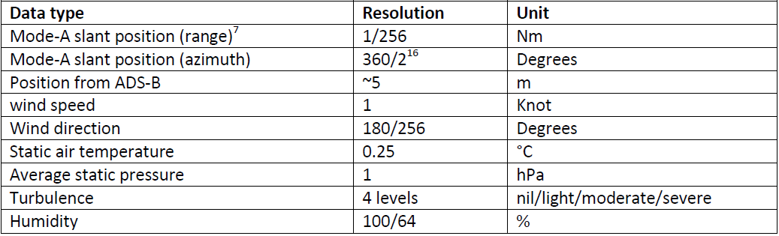
Turbulence and humidity are not (always) available. The quality of the EHS MRAR wind and temperature information is comparable to the quality of AMDAR wind and temperature data. The quality is however dependent on the aircraft type, and is in general good when from commercial passenger aircraft (table below), while biased temperatures are observed when from small business/private aircraft (Strajnar et al., 2015).
ADS-B ES Data Content
[REF Table 2.2.1] below provides a brief description of the ADS-B message content.
Message type | Downlink Format | Data Content
ADS-B ES (112 bits) | DF17 | Airborne position  Surface position  Extended squitter status  Aircraft type and ID  Airborne velocity
Table 2.2.1
Mode-S EHS data does not contain onboard generated meteorological information. However, by combining certain parameters from the Mode-S EHS DAB set and from the ADS-B data elements from the Downlink Format, wind and temperature information can be derived.
From a selection of Mode-S EHS Downlink Aircraft Parameters (DAPs) [REF EUROCONTROL, Mode-S Harmonisation of the Transition Arrangements for State Aircraft, List of DAPs for EHS Capability] and ADS-B ES parameters it is possible to derive good quality wind speed and direction and moderate quality air temperature (see [REF Table 2.2.2] below) at very high temporal frequency (up to 2-second reports).
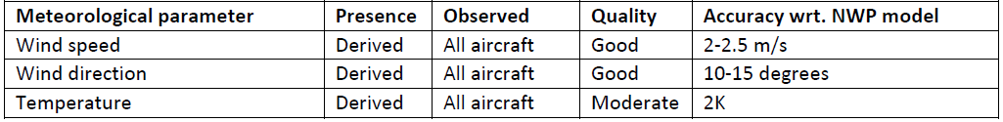
Table 2.2.2
Mode-S EHS data transmission requires active interrogation from am ATC radar and can only be done by an authorized body, e.g. the ATC. The response transmission of the aircraft can be received using a local ADS-B/Mode-S receiver. The frequency of interrogation is dependent on the application and is generally between 4 to 20 seconds.
Aircraft compliant with Mode-S EHS provide the basic functionality features of Mode-S ELS supplemented by eight DAPs, provided either via a basic DAP set or an alternative DAP set, depending respectively on the absence or presence of the Track Angle Rate parameter.
Table 2.2.3 provides an overview of the Mode-S EHS DAP sets.
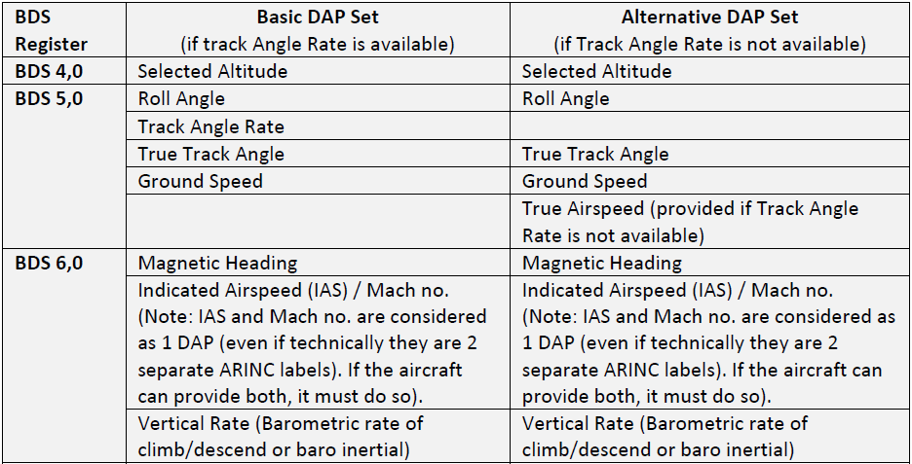
Table 2.2.2

If the magnetic heading has been corrected to true north and corrections have been applied for the airspeed, the correct wind vector can be calculated, resulting in good quality wind speed and wind direction information.
Figure Y provides an understanding how these corrections provide the high quality wind information.
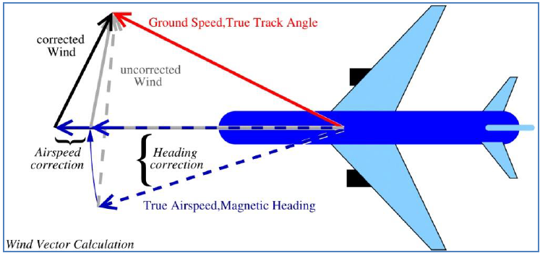
Mode-S EHS air temperature is derived using the measurements of the downlinked Mach number and airspeed. The airspeed is not an observation provided by the aircraft, but derived from the measured Mach number (pitot probe) and temperature. The mach number is the quotient of the airspeed and the speed of sound, and that is dependent on the temperature. Comparison between NWP temperatures and Mode-S EHS temperatures reveal that a temperature correction will be needed for each aircraft, flight pkase and time, resulting in a decrease of the standard deviation. The quality of Mode-S EHS temperatures are therefore considered as moderate (table below).

Further information on the derivation of meteorological data from Mode-S can be found in the [REF CIMO Guide, Part III, Chapter 3.4].
Further information and reference on derived aircraft based observations can be found online at [REF the Royal Netherlands Meteorological Institute website, Mode-S EHS research, http://mode-s.knmi.nl/].

2.3 Other ABO Systems

2.3.1 Introduction
As described in [REF Section 1.6.3], Members are able to receive aircraft based observations (ABO) from other 3rd party sources. This section describes or provides references for descriptions of the systems currently known to and utilised by WMO Members.
Data from 3rd part sources should be processed and transmitted on the GTS in accordance with the guidance provided within [REF 1.6.3 and Annexes I and III].

2.3.2 TAMDAR
Tropospheric Airborne Meteorological Data Reporting (TAMDAR) is a commercially developed, deployed and operated system that obtains and sells meteorological data derived from the predominantly aircraft-independent sensing and communications probe. Unlike the WMO AMDAR observing system, emphasis has been placed on equipping primarily regional air carriers, as their flights tend to (i) service more remote and diverse locations, and (ii) be of shorter duration, thereby producing more daily vertical profiles and remaining in the boundary layer for longer durations. Although TAMDAR is fully functional and regularly operates above 40,000 ft, the aircraft that typically host the sensor often cruise below 25,000 ft.
TAMDAR collects measurements of relative humidity (RH), pressure, temperature, winds, icing, and turbulence, along with the corresponding location, time, and geometric altitude from a built-in GPS. These data are relayed via satellite in real-time to a ground-based network operations centre, where in-line quality control procedures are performed prior to distribution. The overall humidity and temperature data quality is similar to radiosondes (REF Gao et al., 2012). The wind observations are derived in a similar fashion as typical AMDAR winds, using aircraft heading and true airspeed (TAS), and the ground track vector, which is provided by the internal GPS unit.
The TAMDAR sensor samples on a pressure-based interval on ascent and descent, and a time-based interval in cruise, which also varies with altitude from 3 min at lower altitudes to 7 min at higher altitudes. At present, on ascent and descent, the sensor reports every 10 hPa, however this can be adjusted remotely in real time down to 1 hPa (~30 ft) depending on the rate of ascent and descent. During cruise, if any metric changes above a set threshold, the sensor will send a custom report, so turbulent flights through the cloud tops will generate far more observations than a higher-altitude cruise in clear skies.
Under the NOAA Great Lakes Field Experiment in the 1990s, NOAA collaborated with (then) AirDat LLC for the provision of aircraft based observations derived from a large fleet of participating aircraft from several airlines operating in the Great Lakes area of the United States. Under this cooperation, TAMDAR data were made available on the GTS and several impact assessments were undertaken by NOAA which attests to the quality and utility of TAMDAR data for both NWP and other forecasting applications.
The TAMDAR system is described in more technical detail in [REF CIMO Guide No 8 Part II, Chapter 3].

2.3.3.2 AFIRS
FLYHT Aerospace Solutions Ltd has developed the Automated Flight Information Reporting System (AFIRS) avionics system which provides client airlines with global flight tracking and aircraft performance monitoring with voice and data communications using the Iridium global satellite network. The AFIRS system also supports ACARS protocols such as OOOI (Out Off On In) messaging.
AFIRS interfaces to the aircraft flight data computer to obtain high frequency flight data for processing and dispatch via short-burst downlink messaging over the satellite network. It supports an AMDAR-like functionality that allows meteorological data to be downlinked in a suitable format, e.g. text delimited.
FLYHT has collaborated with at least one NMHS for the provision of good quality ABO data which has been made available on the GTS.

Annex I - Guidance on Quality Control of Aircraft Based Observations

Background
This document provides guidance for the operational quality control (QC) of aircraft based meteorological observations received from an aircraft platform. While likely generally applicable to most aircraft based observing systems, it is expected that the data QC practices will be applied to data derived from Member AMDAR observing systems see [REF Sections 1.6.1 and 2.1] and also similar data derived from ICAO aircraft observations [REF see Section 1.6.2]
In addition to the data QC checks specified in this document, Members should also ensure that their QC systems for aircraft based observations meet the more general provisions for quality control of data as specified in [REF Section 1.8].
The data quality control checks specified in this document are for application in ground-based systems, to be applied to observations received from the aircraft based observing system prior to transmission on the WMO Global Telecommunications System.
For quality control requirements and checks for application within on boards systems, see [REF Section 2.1.3.3].
For provisions for quality monitoring of aircraft based observations, see [REF Appendix II].
For general provisions for incident change Management, see [REF Section 1.11].

Basic Data Quality Control Checks
Members should apply the following basic data quality control checks on the meteorological variables of their aircraft based observations:
- Range Check
- Static Value Check
- Temporal Variation Check

Range Check
The Range Check tests whether a value lies within the allowable range as specified for each variable within [REF Table 1] below.

Algorithm
IF v_{i} < lower value of Range THEN v_{i} is erroneous
IF v_{i} > upper value of Range THEN v_{i} is erroneous

Variables Applied to
The Range Check should be applied to all variables within [REF Table 1] below.

Check Failure Action
- A value outside of the range should be flagged as erroneous and not submitted on the GTS.
- If the erroneous variable is a temporal or spatial coordinate, then all variables in the observation should be flagged as erroneous and the observation should not be submitted on the GTS.
- If the behaviour persists for consecutive flights, the aircraft should be black-listed from transmission on the GTS until rectified and the airline notified.

Static Value Check
The Static Value Check tests whether values of particular variables are not varying temporally, as they should, from one observation to the next, usually indicating that the variable is not being updated in the on board data computer.

Algorithm
$$for each valid v_{t },calculate: ∆v= v_{t}- v_{t+∆t}$$
$$where v_{t} is the value of v at time t and v_{t+∆t} is the value of v at time t+∆t$$
IF $∆v is continuously zero^{*} then apply Check Failure Action$
* Continuously zero means that the value of $∆v$ remains zero for each consecutive check and for an extended period of time.
Notes:
- Check Failure Action should only be applied if the check is failed for at least 5 consecutive checks.

Variables Applied to
The Static Value Check should be applied to the variables indicated within [REF Table 1] below.

Check Failure Action
- Every value in the series of checks that have been failed and every value for the remainder of the flight for which the observations are derived should be flagged as erroneous and not submitted on the GTS.
- If subsequent manual checks reveal that the error ceased to occur, then non-errant data can be flagged as good quality.
- If the erroneous variable is a temporal or spatial coordinate, then all variables for all observations for which the checks have been failed should be flagged as erroneous and all observations for the remainder of the flight should not be submitted on the GTS.
- If the behaviour persists for consecutive flights, the aircraft should be black-listed from transmission on the GTS until rectified and the airline notified.

Temporal Variation Check
The Temporal Variation Check calculates the difference between consecutive values of variables and tests whether the difference exceeds a threshold value, indicating a likely error in one, the other or both values.

Variables Applied to
The Temporal Variation Check should be applied to the variables indicated within [REF Table 1] below.

Algorithm
$$for each valid v_{t},calculate: ∆v= v_{t}- v_{t+∆t}$$
$$where v_{t} is the value of v at time t and v_{t+∆t} is the value of v at time t+∆t$$
IF $∆v>T then apply Check Failure Action$
where T is the threshold value from [REF Table 1] below.

Check Failure Action
- If $v_{t}$ is validated by previous checks, value $v_{t+∆t}$ should be flagged as erroneous and note submitted on the GTS. Else if $v_{t}$ has not been validated, both values should be flagged as erroneous and not submitted on the GTS.
- If the erroneous variable is a temporal or spatial coordinate, then all variables for all observations for which the checks have been failed should be flagged as erroneous and all observations for the remainder of the flight should not be submitted on the GTS.
- If the behaviour persists for consecutive flights, the aircraft should be black-listed from transmission on the GTS until rectified and the airline notified.

Specific Variable and Special Data Quality Checks
Members should apply the following specific and special data quality control checks to their aircraft based observations:

Apparent Aircraft Velocity Check
The Apparent Aircraft Velocity Check tests the validity of spatial and temporal coordinates of consecutive observations by calculating an “apparent velocity” at which the aircraft has travelled over the period of time between observations. The apparent aircraft velocity can be approximated by applying a calculation which is a function of the latitude, longitude and time coordinates of the observations.

Algorithm
Calculate the distance (D) in kilometres between the two latitude & longitude coordinates, $\left[{Lat}_{1}, {Lon}_{1}\right] and \left[{Lat}_{2}, {Lon}_{2}\right]$ using the “Haversine Formula”:
$D = R * c$
Where:
$R = 6371$ Is an approximation to the average radius of the earth in km;
$$c = 2 *atan2(\sqrt{a}, \sqrt{\left(1-a\right)} )$$
$$a = \sin\left(\frac{{dLat}^{r}}{2}\right)*\sin\left(\frac{{dLat}^{r}}{2}\right)+\cos\left({Lat}_{1}^{r}\right)*\cos\left({Lat}_{2}^{r}\right)*\sin\left(\frac{{dLon}^{r}}{2}\right) *\sin\left(\frac{{dLon}^{r}}{2}\right)$$
${dLat}^{r}= rad({Lat}_{2}- {Lat}_{1})$, ${dLon}^{r}= rad({Lon}_{2}- {Lon}_{1})$
${Lat}_{1}^{r}=\text{rad}({\text{Lat}}_{1})$, ${Lat}_{2}^{r}=rad\left({Lat}_{2}\right)$
rad() is a function for the angular conversion of degrees to radians
Calculate: $V_{A}= \frac{D}{∆t}$
Where: $∆t$ is the time difference between observations in hours.
IF : ${\text{V}}_{\text{A}}\text{> }{\text{V}}^{\text{T}}$ then apply Check Failure Action
Where: ${\text{V}}^{\text{T}}$ is an appropriate maximum aircraft velocity threshold for the aircraft.
Note: It is recommended that for Boeing, Airbus and similar performing jet aircraft, this value might be universally set to 1250 km/h. However, based on sound reasoning or scientific analysis, varying thresholds may be adopted for particular aircraft types and performance.

Check Failure Action
- All values corresponding to $\left[{Lat}_{2}, {Lon}_{2}\right]$ and all subsequent observations should be flagged as erroneous and not submitted on the GTS.
- If the behaviour persists for consecutive flights, the aircraft should be black-listed from transmission on the GTS until rectified and the airline notified.

Additional Data Quality Control Checks
Members may elect to apply the following additional data quality control checks on the meteorological variables of their aircraft based observations:
- Numerical Weather Model Comparison Check
- Radiosonde Comparison Check
- Vertical Spatial Check
- Horizontal Spatial Check
It should be noted that such checks should be applied as part of the data QC process only if they do not have significant impact on latency of transmission of data on the GTS. See [REF Section 1.5] on requirements for aircraft based observations. In the case that such checks do severely and adversely impact data latency, consideration should be given to applying such checks as a component of the quality monitoring and quality assessment process only – see [REF Annex II].

Numerical Weather Model Comparison Check
The Numerical Weather Model Comparison Check tests whether a value is consistent with the comparative value derived from the output of a NWP model.

Algorithm
IF $\left|\text{v}\text{i }\text{- }{\text{v}}_{\text{i}}^{\text{N}}\right|\text{ > T}$ THEN v_{i} is erroneous
Where ${\text{v}}_{\text{i}}^{\text{N}}$ is the NWP value interpolated and derived as necessary from the NWP model output; T is the threshold value, which may be a function of a number of parameters including the variable being compared, the observation altitude, etc.
Notes:
- The NWP comparison value should, if possible, be derived from the first guess field of the model output.
- The values of T should be determined in consultation with NWP experts and based on the results of comparison statistical analysis.
- The values of T should be such that loss of valid data is prevented or minimised.

Variables Applied to
The Numerical Weather Model Comparison Check should be applied to meteorological variables.

Check Failure Action
- Erroneous values should be flagged and not submitted on the GTS unless the BUFR encoding process makes provision for the setting of aircraft based observations data quality flags and the value is appropriately flagged.
- If the behaviour persists for consecutive flights, analysis should be undertaken and, if appropriate, the aircraft should be black-listed from transmission on the GTS until rectified and the airline notified.

Radiosonde Comparison Check
The Radiosonde Comparison Check tests whether a value is consistent with the comparative value derived from a co-located radiosonde vertical profile.

Algorithm
IF $\left|\text{v}\text{i }\text{- }{\text{v}}_{\text{i}}^{R}\right|\text{ > T}$ THEN v_{i} is erroneous
Where ${\text{v}}_{\text{i}}^{\text{R}}$ is the value from the collocated radiosonde profile, interpolated and derived as necessary; T is the threshold value, which may be a function of a number of parameters including the variable being compared, the observation altitude, etc.
Notes:
- The radiosonde comparison value should be logarithmically interpolated to the aircraft observation value altitude.
- The values of T should be determined based on the results of comparison statistical analysis.
- Comparisons should be made only when the observing systems are suitably collocated, which will usually be when the radiosonde system is located at the airport where the aircraft is ascending or descending.
- Comparison pairs should be derived with a maximum temporal separation of 60 minutes and a maximum horizontal spatial separation of 60km.

Variables Applied to
The Radiosonde Comparison Check should be applied to meteorological variables.

Check Failure Action
- Erroneous values should be flagged and not submitted on the GTS unless the BUFR encoding process makes provision for the setting of aircraft based observations data quality flags and the value is appropriately flagged.
- If the behaviour persists for consecutive flights, analysis should be undertaken and, if appropriate, the aircraft should be black-listed from transmission on the GTS until rectified and the airline notified.

Table 1 – Aircraft based observations variables and QC test information.
Variable | Unit | Range | Apply Static Value Check (Y/N) | Apply Temporal Variation Check (Y/N) | Temporal Variation Check Threshold
Pressure Altitude | Foot (ft)  Meter (m) | -1000 to 50000  -330 to 17000 | Y | Y | 5000 ft/min
Static Air Temperature | ºC | -99 to 99 | Y | Y | 20C degs/min
Wind Direction | º from true N | 1 to 360 | Y | Y | 180 deg/min
Wind Speed | Knot (kt)  m/sec | 0 to 800  0 to 400 | Y | Y | 50 kts/min
Latitude | Degree:minute | 90,00S to 90,00N | N | Y | 30 mins/min
Longitude | Degree:minute | 180,00E to 180,00W | N | Y | 300 mins/min
Time (UTC) | Hour:Minute:Second | 00:00:00 to 23:59:59 | Y | N | N/A
Turbulence (g) | g | -3 to 6 | Y | N | N/A
Turbulence (DEVG) | ms⁻¹ | 0 to 20 | Y | N | N/A
Turbulence (EDR) | m^{2/3}s⁻¹ | 0 to 1 | Y | N | N/A
Humidity (RH) | % | 0 to 100 | Y | N | N/A
Humidity (dew pt) | ºC | -99 to +49 | Y | N | N/A
Humidity (mixing ratio) | gram/kg | 0 to <100 | Y | N | N/A

Annex II - Guidance on Quality Monitoring of Aircraft Based Observations

Background
This annex provides guidance for the operational quality monitoring (QM) and quality evaluation (QE) of aircraft based meteorological observations received from an aircraft platform. While likely generally applicable to most aircraft based observing systems, it is expected that the practices will be applied to data derived from Member AMDAR observing systems see [REF Sections 1.6.1 and 2.1] and also similar data derived from ICAO aircraft observations see [REF Section 1.6.2].
In general the quality monitoring system for aircraft based observations will be consistent with, and should be regarded as a component of the WIGOS Data Quality Monitoring System (WDQMS). The figure below depicts the general framework for the WDQMS.
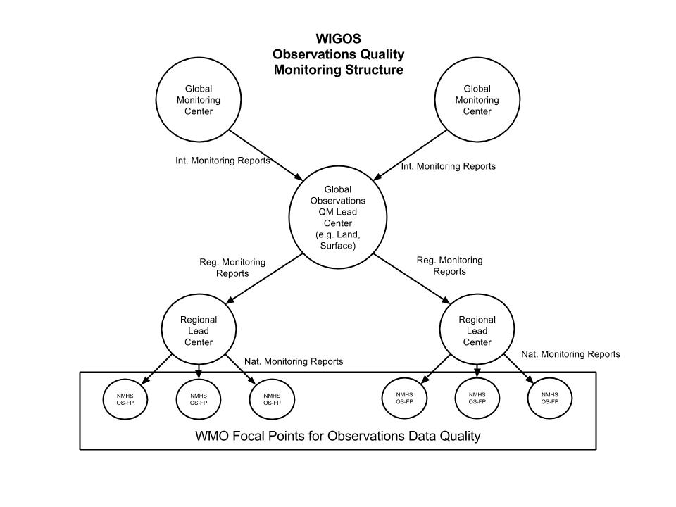
Figure 1: The WIGOS Observations Quality Monitoring Structure, supporting the WIGIOS Data Quality Monitoring System.
For the purposes of this guide, quality monitoring is defined as practices and procedures and the production of reports and diagnostics that allow the quality of aircraft based observations to be assessed. Quality evaluation is defined as the use or application of quality monitoring reports and information and analysis techniques and tools to analyse and assess the quality of aircraft based observations, investigate and isolate systemic issues and make recommendations for improvements to operational practices. These aspects of ABO quality management are depicted in [REF Figure 2, Aircraft Based Observations Data Quality Management Framework in section 1.8.2.2], in. [Figure 2] below provides a more detailed depiction of the regional and national framework that should be established to support ABO quality evaluation at the programme level.

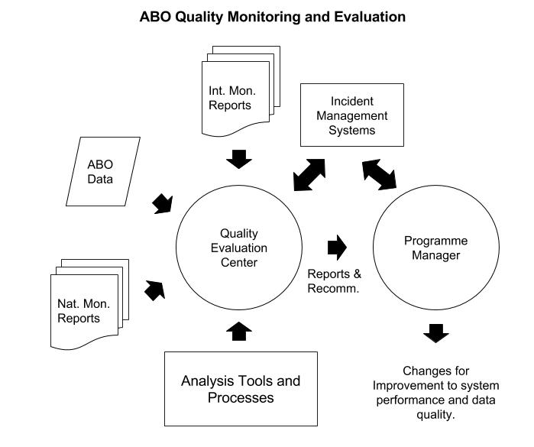
Figure 2: Information, tools and practices supporting the quality evaluation process for aircraft based observations.

Quality Monitoring Practices
Data quality monitoring practices should focus on the measurement of the performance of the system against a set of targets, defined for the functional specifications of the ABO or AMDAR system:
- Performance figures in terms of quantities, for example, number of observations provided for a specific area and period, stated by the system management and confirming the on-board observing programmes.
- Quality indicators of the physical quantities and variables providing a measurement of uncertainties, usually in the form of systematic (bias) and (number or percentage of) incidental (gross) errors.
- Quality indicators for metadata, essential for the interpretation and use of the data (timestamp, horizontal and vertical positions, flight phase) and other information, necessary for appropriate data management (like aircraft identification) and usefulness (timeliness).
- Results of data quality control processes, including error and consistency checking of bulletin formatting and the detection and elimination of duplicate observations.

Requirements for WMO Global & Regional NWP Quality Monitoring Centres
The general description and requirements for WMO designated Global and Regional Monitoring and Evaluation are described in [REF Section 1.8.2].
The following specifications are applicable for both designated Global and Regional Monitoring Centers for ABO but may be used and applied by any NWP monitoring center.
The reports produced by NWP monitoring centers should be made available by email to WMO Focal Points on Aircraft Based Observations.
The reports produced by NWP monitoring centers should be made available and maintained on the Internet.
The current requirements for monthly monitoring of aircraft based observations by WMO global NWP quality monitoring centres are defined in the [REF Manual on the Global Data Processing and Forecasting System, WMO No. 485, Volume I, Part II, Attachment II.9], Procedures and Formats for the Exchange of Monitoring Results. The procedures for Aircraft Data are given in Section 5.
The procedures in the Manual on the GDPFS are considered to be minimal and somewhat limited in terms of serving the modern requirements of aircraft based observations program operators and data users. They provide requirements for monitoring of air temperature and wind only.
The following specification of requirements are the new procedures recommended for adoption by WMO designated and other global NWP quality monitoring centres for aircraft based observations and it is expected they will supersede and replace the requirements provided in the Manual on the GDPFS.

Automated Monitoring Reports

Daily 10-Day-Moving Monitoring Report of Aircraft Based Observations NWP Comparison
WMO Global NWP Quality Monitoring Centers should undertake monitoring of aircraft based observations so as to provide two daily quality monitoring reports to observing system programme managers by email.
These QM reports should be:
- AT and RH Daily 10-Day-Moving Window NWP Comparison
- Winds Daily 10-Day-Moving Window NWP Comparison
- limited to the provision of information that isolates errors or issues with a low probability of false alarm and according to the criteria below;
- made available automatically by email to all focal points for operational aircraft based observations programme managers for the previous UTC day as soon after 0000 UTC as possible;
- provide a 10-day, moving window of monitoring statistics for the current and prior 9 days; and
- provided in the format described within Attachment I.

Criteria for the inclusion of aircraft in the reports are provided in Attachment II.
Based on Attachment I, the suggested report content is shown below for the AT and RH Daily 10-Day-Moving Window NWP Comparison:
[HEADER]
Report Name:Aircraft Based Observations Daily NWP Comparison Check
Issuing Center: [Name of Center]
Report Period of Validity:[hh:mm dd-mm-yyyy to hh:mm dd-mm-yyyy]
Comparison Standard:[Model Identity; Model field used for comparison]
Variables:[Air Temperature and Humidity]
Location of Monitoring Site:[Internet address]
ID: Aircraft identity
[Field Header:Field Description]
[etc]
[/HEADER]
[DATA]
ID, SUS_L, ATd1NA, ATd1NC, ATd1NR, ATd1NG, ATd1MB, ATd1SD, ATd1NA, ATd9NC, ATd9NR, ATd9NG, ATd9MB, ATd9SD, RHd1NA, RHd1NC, RHd1NR, RHd1NG, RHd1MB, RHd1SD, RHd1NA, RHd9NC, RHd9NR, RHd9NG, RHd9MB, RHd9SD
[etc]
[/DATA]
Based on Attachment I, the suggested report content is shown below for the Winds Daily 10-Day-Moving Window NWP Comparison:
[HEADER]
Report Name:Aircraft Based Observations Daily NWP Comparison Check
Issuing Center: [Name of Center]
Report Period of Validity:[hh:mm dd-mm-yyyy to hh:mm dd-mm-yyyy]
Comparison Standard:[Model Identity; Model field used for comparison]
Variables:[Wind speed, wind direction and wind vector difference]
Location of Monitoring Site:[Internet address]
ID: Aircraft identity
[Field Header:Field Description]
[etc]
[/HEADER]
[DATA]
ID, SUS_L, WSd1NA, WSd1NC, WSd1NR, WSATd1NG, WSd1MB, WSd1SD, WSd1NA, WSd9NC, WSd9NR, WSd9NG, WSd9MB, WSd9SD, WDd1NA, WDd1NC, WDd1NR, WDATd1NG, WDd1MB, WDd1SD, WDd1NA, WDd9NC, WDd9NR, WDd9NG, WDd9MB, WDd9SD, WMd1NA, WMd1NC, WMd1NR, WMd1NG, WMd1WVRMS, WMd9NA, WMd9NC, WMd9NR, WMd9NG, WMd9WVRMS
[etc]
[/DATA]

Monthly Monitoring of Aircraft Based Observations
WMO Global NWP Quality Monitoring Centers should undertake monitoring of aircraft based observations so as to provide two monthly quality monitoring reports to observing system programme managers by email.
These QM reports should be:
- AT and RH Monthly NWP Comparison
- Winds Monthly Comparison
- Contain results for all aircraft transmitting data on the GTS;
- made available automatically by email to all focal points for operational aircraft based observations programme managers for the previous UTC month as soon after 0000 UTC of the first day of the new month as possible;
- Sorted so as to provide suspect records first, followed by non-suspect records, grouped by programme.
- provided in the format described within Attachment I.

Criteria for the designation of aircraft as suspect are provided in Attachment II.
Based on Attachment I, the suggested report content is shown below for the AT and RH Monthly NWP Comparison:
[HEADER]
Report Name:Aircraft Based Observations Monthly NWP Comparison
Issuing Center: [Name of Center]
Report Period of Validity:[hh:mm dd-mm-yyyy to hh:mm dd-mm-yyyy]
Comparison Standard:[Model Identity; Model field used for comparison]
Variables:[Air Temperature and Humidity]
Location of Monitoring Site:[Internet address]
ID: Aircraft identity
[Field Header:Field Description]
[etc]
[/HEADER]
[DATA]
ID, SUS, SUS_L, ATplNA, ATplNC, ATplNR, ATplNG, ATplMB, ATplSD, ATpmNA, ATpmNC, ATpmNR, ATpmNG, ATpmMB, ATpmSD, ATphNA, ATphNC, ATphNR, ATphNG, ATphMB, ATphSD, RHplNA, RHplNC, RHplNR, RHplNG, RHplMB, RHplSD, RHpmNA, RHpmNC, RHpmNR, RHpmNG, RHpmMB, RHpmSD, RHphNA, RHphNC, RHphNR, RHphNG, RHphMB, RHphSD
[etc]
[/DATA]
Based on Attachment I, the suggested report content is shown below for the Winds Monthly NWP Comparison:
[HEADER]
Report Name:Aircraft Based Observations Monthly NWP Comparison
Issuing Center: [Name of Center]
Report Period of Validity:[hh:mm dd-mm-yyyy to hh:mm dd-mm-yyyy]
Comparison Standard:[Model Identity; Model field used for comparison]
Variables:[ Wind speed, wind direction and wind vector difference]
Location of Monitoring Site:[Internet address]
ID: Aircraft identity
[Field Header:Field Description]
[etc]
[/HEADER]
[DATA]
ID, SUS, SUS_L, WSplNA, WSplNC, WSplNR, WSplNG, WSplMB, WSplSD, WSpmNA, WSpmNC, WSpmNR, WSpmNG, WSpmMB, WSpmSD, WSphNA, WSphNC, WSphNR, WSphNG, WSphMB, WSphSD, WDplNA, WDplNC, WDplNR, WDplNG, WDplMB, WDplSD, WDpmNA, WDpmNC, WDpmNR, WDpmNG, WDpmMB, WDpmSD, WDphNA, WDphNC, WDphNR, WDphNG, WDphMB, WDphSD, WMplNA, WMplNC, WMplNR, WMplNG, WMplWVRMS, WMpmNA, WMpmNC, WMpmNR, WMpmNG, WMpmWVRMS, WMphNA, WMphNC, WMphNR, WMphNG, WMphWVRMS
[etc]
[/DATA]

Requirements for WMO Lead Centres on Aircraft Based Observations
WMO Lead Centers on Aircraft Based Observations should provide the following functions and services to assist WMO Members in the quality management of their aircraft based observing systems:
- Receive process, archive and analyse monitoring reports from designated WMO Global and Regional Monitoring Centers for ABO.
- Ensure WMO Focal Points on ABO receive monitoring reports and act upon issues arising from them.
- Develop, implement and maintain an Incident Management System to record and manage faults or issues raised through the monitoring and quality evaluation processes.
- Provide technical advice to assist Members in rectifying quality issues associated with their aircraft based observing systems.
- Establish and maintain an online facility that provides the suite of quality monitoring information and tools as described in Attachment III.
- Compile an annual report to the Commission for Basic Systems/OPAG-IOS on the performance of the ABO system and the ABO quality monitoring system, high-lighting any important issues.

Requirements for Quality Monitoring and Quality Evaluation by Members

Quality Evaluation Information, Tools and Practices
The quality evaluation process for ABO can be described in terms of the structure and the related processes and practices that are depicted within Figure 2 above.
The quality evaluation centre (QEC) should be staffed by a suitable number of scientific officers that have:
- A detailed understanding of the ABO system and its operation.
- Scientific knowledge of metrological science and skills in scientific data analysis.
- Skills and knowledge in quality management, systems incident management and report writing.
The QEC should have access to information and data that supports the quality evaluation processes. These include as a minimum:
- Convenient access to the relevant available automated and other global, regional and national monitoring reports;
- Access to the ABO data generated by the ABO system in a form that allows flexible and rapid rendering of the data for analysis, comparison, plotting, etc. A relational database storage of historical data (at least 2 years) is ideal.
- Access to data analysis applications and tools, for example and as a minimum, a spreadsheet application with mathematical, mapping and graphical tools.
The QEC should utilise the incident management system of the organisation for the registering and maintenance of errors and issues identified in the quality evaluation process.
The QEC should utilise the results of quality evaluation practices and results to identify systemic issues that might be addressed through the improvement of the ABO system operation through modification or changes to processes and procedures.
Results of quality evaluation analyses and resulting changes to the observing system should be notified, recorded and documented in line with national, regional and WMO quality management requirements and practices.
As a minimum, routine quality monitoring and quality evaluation practices and procedures undertaken by Member Quality Managers and Quality Evaluation Centers, should consist of the following:
- The production and use of outputs and reports of national programme data quality control processes (see [REF Annex I]).
- The reception and use of QM reports provided by WMO designated Lead Centres and WMO Monitoring Centres.
- The reception and use of reports provided by other global or regional monitoring Centres.
- The routine production and scrutiny of national QM reports.
- Routine analysis of all available QM outputs and reports.
- Initiation and completion of relevant incident management procedures for identified data quality errors and issues, including as a minimum:
  - Blacklisting of errant aircraft from reporting on the GTS;
  - Documentation and update of relevant metadata for recording of issues and errors;
  - Notification to data users and application areas;
  - Compliance with national, regional and global incident management systems operation and maintenance.
- Initiation and completion of relevant system and practice improvements required to rectify systemic errors or issues associated with or causing data quality issues.

Attachment I – Recommended Reporting Format for ABO Quality Monitoring Reports
It is proposed that ABO quality monitoring reports should conform to the following specification, providing a format that is both machine and human readable.
ABO monitoring reports should have the following features and properties:
- The reporting files should be provided as a text file with two distinct information blocks of Comma Separated Values (CSV).
- The reporting files should consist of a Header block and a Data block.
- The Header block should consist of at least one line of CSV information between the Header block markers: [HEADER][/HEADER].
- Each CSV in the report Header should consist of a Header Value Name and a header value separated by a colon: Header Value Name:header value. For example: Report Name: Daily Global Aircraft Observations QM Report
- Each line of the Header should end with a carriage return and line feed.
- The Data block should consist of at least two lines of CSV information between the Data block markers: [DATA][/DATA].
- The first line of the Data block should be a line of CSV information that contains the Field Headers of the data submitted within the Data block.
- Each line of the Data block should provide a CSV for each of the fields corresponding to the Field Headers provided in the Header block.
- Each line of the Data block should end with a carriage return and line feed.
[HEADER]
Header Value Name:header value,Header Value Name:header value,…
Header Value Name:header value,Header Value Name:header value,…
…
[/HEADER]
[DATA]
Field Header 1, Field Header 2, Field Header 3,…
Field 1 value,Field 2 value,Field3 value,…
Field 1 value,Field 2 value,Field3 value,…
…
[/DATA]
Reported monitoring parameter Field Headers are listed below and will take the form VcX, where:
V is the variable indicator (e.g. AT = air temperature)
c is the category indicator (e.g. pl = low pressure category)
X is the statistic indicator (e.g. NA = number of available values)
e.g. ATplNA = number of air temperature values available in the low pressure category.

Non-statistical Field Headers | Description
ID | Aircraft identity (e.g. AU0001)
SUS | Suspect flag: Y = aircraft is flagged as suspect; N or no value = aircraft is not suspect
SUS_L | List (space delimited) of one or more Field Headers for which the aircraft has breached the criteria for being Suspect. Empty if not SUS. E.g. a value of “ATplNG ATpmNG” would indicate that the aircraft was deemed suspect based on the number of gross errors for the LOW and MED pressure level categories for air temperature.

Field Headers For Statistical Parameters
Field Header Variable Indicator | Description
AT | Air temperature
WS | Wind speed
WD | Wind direction
WM | Wind vector difference magnitude
WU | Wind u component
WV | Wind v component
RH | Relative Humidity
MR | Water mixing ratio
RT | Report time
LA | Latitude
LO | Longitude
AS | Aircraft apparent speed

Field Header Category Indicator | Description
pl | In a low (altitude) pressure category
pm | In the mid (altitude) pressure category
ph | In the high (altitude) pressure category
d1 | Calculated over 1 day.
d9 | Calculated over 9 days (prior to the d1 category).
ru | Range upper
rl | Range lower

Field Header Statistic Indicator | Description
NA | number of values available
NC | number of values compared
NR | number of values rejected
NG | number of values with gross errors against criteria
SD | standard deviation of differences
MB | mean of differences (mean bias)
RMS | root mean square of differences
WVRMS | wind vector RMS
NZ | number of zero values

Attachment II – Criteria for the selection of aircraft having suspect observations

Variable | Unit | Report | % Gross Error | Minimum  NC |  |  | Gross Error Difference |  |  | Mean Bias |  |  | RMS
Pressure Levels |  |  | ALL | LOW | MID | HIGH | LOW | MID | HIGH | LOW | MID | HIGH | LOW | MID | HIGH
Air Temperature | Deg. C | Monthly | 2 | 20 | 50 | 50 | 15.0 | 10.0 | 10.0 | 3.0 | 2.0 | 2.0 | 4.0 | 3.0 | 3.0
 |  | Daily | 2 | 20 | 50 | 50 | 15.0 | 10.0 | 10.0 | 3.0 | 2.0 | 2.0 | 4.0 | 3.0 | 3.0
 |  | 9-day | 2 | 20 | 50 | 50 | 15.0 | 10.0 | 10.0 | 3.0 | 2.0 | 2.0 | 4.0 | 3.0 | 3.0
Wind Speed | m/s | Monthly | 2 | 20 | 50 | 50 | 30.0 | 30.0 | 40.0 | 3.0 | 2.5 | 2.5 | 10.0 | 8.0 | 10.0
 |  | Daily | 2 | 20 | 50 | 50 | 30.0 | 30.0 | 40.0 | 3.0 | 2.5 | 2.5 | 10.0 | 8.0 | 10.0
 |  | 9-day | 2 | 20 | 50 | 50 | 30.0 | 30.0 | 40.0 | 3.0 | 2.5 | 2.5 | 10.0 | 8.0 | 10.0
Wind Direction | Degrees | Monthly | 2 | 20 | 50 | 50 | 90.0 | 90.0 | 90.0 | 10.0 | 10.0 | 10.0 | 50.0 | 50.0 | 50.0
 |  | Daily | 2 | 20 | 50 | 50 | 90.0 | 90.0 | 90.0 | 10.0 | 10.0 | 10.0 | 50.0 | 50.0 | 50.0
 |  | 9-day | 2 | 20 | 50 | 50 | 90.0 | 90.0 | 90.0 | 10.0 | 10.0 | 10.0 | 50.0 | 50.0 | 50.0
Wind Vector Difference | m/s | Monthly | 2 | 20 | 50 | 50 | 6.0 | 6.0 | 6.0 | 6.0 | 6.0 | 6.0 | 6.0 | 6.0 | 6.0
 |  | Daily
 |  | 9-day
Humidity | % humidity | Monthly
 |  | Daily
 |  | 9-day

Note:
- The pressure level categories are:
low: surface to 701 hPa
mid: 700 to 301 hPa
high: 300 hPa and above.

Attachment III – WMO Lead Centers on Aircraft Based Observations Online Facilities Requirements
WMO Global or regional Lead Centers on Aircraft Based Observations should establish the following facilities to support quality monitoring and evaluation functions of Members.
- Establishment and maintenance of a database of ABO data and NWP comparison statistics received from monitoring centres (at least 7 months of high resolution data and at least 2 years of daily resolution data from multiple monitoring centers) to support the server-side derivation and delivery of tabular and graphical information and diagnostics for the following parameters:
  - Air Temperature (with NWP comparisons)
  - Wind speed (with NWP comparisons)
  - Wind direction (with NWP comparisons)
  - Wind vector difference magnitude (with NWP comparisons)
  - Humidity (with NWP comparisons)
  - Turbulence
  - Icing
  - Pressure altitude
  - Observation time
  - Latitude
  - Longitude
The database should also support the flagging of data and the display of data based on the following quality checks carried out by the system in accordance with Annex I:
- Numerical Weather Model Comparison Check
- Range Check
- Static Value Check
- Temporal Variation Check
- Apparent Aircraft Velocity Check
- Provision of the following graphical diagnostics for the above parameters:
  - For individual aircraft, time series graph of ABO values and differences (high and low temporal resolution) with following configurable features
    - Time averaging (day, no. of days, week, month, year)
    - Overlay of up to 50 aircraft
- Provision (online viewing and downloading) of the following tabulated data for the above parameters:
  - For individual or selectable set of aircraft, provide statistical reports constructed and generated based on the set of parameters (1 above), related flags and statistical formulations of parameter values as below:
    - Values
    - Mean
    - Standard deviation
    - RMS
    - Count

Annex III - Guidance on Encoding of Aircraft based Observational Data for Transmission on the WMO GTS

Introduction
The full aircraft based observing system, of which the AMDAR observing system is a component system, comprises the end-to-end system of processes and practices, starting from measurement by aircraft sensors right through to the delivery of the data to data users. On the aircraft, Aircraft Data Computers (ADC) obtain, process and format data from onboard sensors. These observational data will be down linked together with metadata from the aircraft to the ground station and will, particularly in the case of AMDAR and ICAO Aircraft Reports, conform to standardized code formats used for telecommunications practices. Once on the ground the data are usually relayed to the National Meteorological and Hydrological Services (NMHS), most often via the participating airline or an aviation authority, and other authorized users as shown within [REF Figure 1, section 1.6.1]. Data received at these data processing centers are decoded and undergo basic quality control checks before being reformatted for distribution to data users both internal to the NMHS and externally to other NMHS via the WMO Global Telecommunication System (GTS). AMDAR data formats as used for the AMDAR Oboard Software (AOS) are described in the [REF AMDAR Onboard Software Functional Requirements Specification (AOSFRS), version 1.1 (WMO IOM-report 115, 2014)]. Other ABO data formats are described in [REF section 1.6 of this guide.
This Annex describes the detailed procedures for recompiling AOB data into encoded data and associated metatdata for international distribution on the WMO Global Telecommunications System (GTS).
A general description of GTS messages and the process for assembling them is provided within Attachment 1.
More general requirements for provision of ABO on the GTS are provided within [REF section 1.9].

ABO Data Requirements
The data and observational metadata listed below are required to compile an aircraft based observation within a report for automatic relay to a ground processing system and data distribution network. The data are derived from the aircraft sensor and navigation data acquisition system and further processed on board as required and as appropriate. At least the following variables and metadata shall be provided, if available, for each single level observation:
Metadata:
- Aircraft identifier (Aircraft Registration Number)
Positional information:
- Latitude
- Longitude
- Pressure altitude (flight level)
- Day and time of observation
- Phase of flight
- Observation number (optional)

Variables
- Air temperature (Static air temperature)
- Humidity (mixing ratio)
- Wind vector, expressed as
  - wind direction
  - wind speed
- Maximum wind speed during level flight
- Turbulence (Eddy Dissipation Rate, EDR)
- Icing
Metadata and variables are generated on board aircraft using dedicated software and by processing the quantities, measured by the on board sensors. Details on the measurement techniques applied can be found in the [REF CIMO Guide (WMO-No. 8), Part II, Chapter 3, Aircraft Observations]. Details on processing the onboard data and download practices are provided in [REF WMO IOM-report 115, AMDAR Onboard Software Functional Requirements Specification].

BUFR template for AMDAR Version 7

Other ABO BUFR Templates
Although the BUFR template for AMDAR Version 7 is the BUFR sequence recommended for use with all ABO, other templates are still in use or were used in the past. For a reference to these older templates see [REF Attachment 4] to this annex.

Other Obsolete Alphanumeric ABO Data Formats

Encoding of AMDAR in BUFR
Because of the international dissemination and use it is recommended to report AMDAR data using a standard, preferred template (or common sequence code). For the further development of the WMO Integrated Global Observing System (WIGOS) framework, a new template (common sequence code) was developed which should be suitable to deliver all types of possible observations (or derived data), performed on board aircraft, including ICAO Aircraft Reports. This template is identified by common sequence 3 11 010 and named “BUFR template for AMDAR, version 7”. These templates, together with the code and flag tables are described below within Attachment 2.

Encoding of ABO Derived from ICAO Aircraft Reports
- Automatic Dependent Surveillance (ADS) reports, generated automatically. ADS is a component of CNS/ATM systems of ICAO (see for details ICAO Doc. 9377, Manual on the Coordination between Air Traffic Control Services, Aeronautical Information Services and Aeronautical Meteorological Services, paragraph 2.2). ADS is a service for use by Air Traffic Services (ATS) in which aircraft automatically provide, via a data link, data derived from on-board navigation and position-fixing systems. As a minimum, the data include aircraft identification, time and position and additional data may be provided as appropriate. The 'additional data' may include a meteorological information data block. Data transmitted by digital data link are required to be forwarded to the WAFCs and RAFCs (as appropriate) without delay in the form that they are received. Only the ADS-C (“contract”) subtype contains meteorological data containing the following elements:
 | ADS element
 | Message type designator
 | aircraft-address
Data Block 1 | Position | Latitude
 |  | Longitude
 |  | Level
 | DateTime Group | Year,Month,Day
TimeHours,
TimeMinutes,
Timeseconds
Data block 2 | Wind-speed
 | Wind-direction
 | Wind-quality-flag
 | Air Temperature
 | Turbulence (if available) | Time-of-occurrence, index
 | Humidity (if available)
Note: Aircraft Icing is not reported if ADS or SSR Mode-S is being applied.
ABS-B ïtself does not provide observational data. ADS reports are generally formatted as AIREP for dissemination over the GTS. Details on the quality of these reports can be found in Haan, S. de, and L. J. Bailey, and J. E. Konnen, 2013: “Quality assessment of Automatic Dependent Surveillance Contract (ADS-C) wind and temperature observation from commercial aircraft”, Atmospheric Measurement Techniques, 6, 199 – 206.
- Aircraft Derived Data (ADD) such as data derived from Secondary Surveillance Radar (SSR) Mode-S EHS (Mode-Select Enhanced Surveillance). Data formats of single level observations as publically received by SSR receivers are explained in Haan, S. de, M. de Haij and J. Sondij, “The use of a commercial ADS-B receiver to derive upper air wind and temperature observations from Mode-S EHS information in The Netherlands. KNMI publication TR-336, 2013.
- Observational data (air reports) received by manual communications with pilots and encoded manually as e.g. AIREP (aircraft report) or PILOT (pilot report), as defined by ICAO.
- Data from commercially operated observing systems, such as the Panasonic Avionics Corp. TAMDAR system and the FLYHT Aerospace Solutions AFIRS system. These may be available on the GTS, depending on the arrangements between the contracting NMHS and the vendor for the purchase of the data.

ICAO Aircraft Report - AIREP
AIREP is an alphanumerical code designed originally for encoding manual (pilot) aircraft observations according to ICAO aviation meteorological requirements. In fact this code is quite comparable by the WMO code format of FM41, CODAR and to a certain extent to WMO code format FM42, AMDAR, both being obsolete (phased out). In practice there is no well defined format of the AIREP code format and national rules are implemented resulting in dissemination of AIREP bulletins not being encode according to any standard (like BUFR or other WMO code formats). The AIREP code format is not regulated by WMO and not published in the Manual on Codes (WMO-No. 306). However, some documentation on AIREP encoding is available ICAO Doc. 8896, Manual of Aeronautical Meteorological Practice, Chapter 7, Aircraft Observations and Reports. Reference to this document can be found in ICAO Doc. 4444, Air Traffic Management (PANS-ATM), paragraph 4.12. Although the detailed instructions on how to encode AIREP in ICAO Doc. 8896, paragraph 7.9 refers to “Detailed Instructions Concerning the Content of Special Air-Reports Received by Voice Communications by MWOs”, i.e. SPECIAL AIREP (ARS), it can also be used for ROUTINE AIREP reports (ARP). Note that this instruction also refers to ICAO Doc. 4444, Appendix 1, Instructions for Air-reporting by Voice Communications (on acronyms to be used to report special phenomena).
AIREP Code format

CCCC | ICAO of transmitting unit
AIREP | Type ARP (Routine AIREP) or ARS (Special AIREP). Will precede all  AIREP text. See Table below for ARS conditions
Aircraft Number | Reported as a seven-character group. The identifier will be a combination of numbers and letters.
Latitude | Four figures indicating the latitude of the aircraft to the nearest minute  followed by the letter N (North) or S (South).
Longitude | Five figures indicating the longitude of the aircraft to the nearest minute  followed by the letter E (East) or W (West).
UTC Time | Four figures depicting time to the nearest minute. For AIREP corrections, add one minute to the actual time.
Flight Level | A four-character group (the letter F followed by three figures),  representing the aircraft altitude in hundreds of feet (e.g., F370).
Temperature | Two figures indicating the temperature in whole degrees Celsius preceded by “PS” (plus) or “MS” (minus).
Spot Wind | A wind group. The first three figures indicate true wind direction in  degrees. The last two figures indicate wind speed to the nearest knot. In  the following code: DDD = True wind direction at current position; SS =  Wind speed at current position. If the wind is above 99 knots use three  figures.
Turbulence | Severe turbulence is reported as TURB SEV and moderate turbulence as  TURB MOD - when turbulence in cloud is experienced INC is added.  TURB SEV is reported immediately on occurrence and this requires an  AIREP SPECIAL (ARS), otherwise TURB MOD is reported only if it  occurs within the last 10 minutes prior to reaching the position.
Icing | Severe aircraft icing is reported as ICE SEV. Moderate aircraft icing is  reported as ICE MOD. ICE SEV is reported immediately on occurrence  and this requires an AIREP SPECIAL (ARS), otherwise ICE MOD is  reported only if it occurs within the last 10 minutes prior to reaching the  position.
Supplementary Information | Cloud bases and /or tops are reported as BASE and/or TOP followed by  the respective height indication F(number) or (number)M or (number)FT. Thunderstorm tops may be reported by TS TOP followed by the flight level.  Other abbreviations include: Present weather – RA (rain), SN (snow),  FZRA (freezing rain), FC (funnel cloud), TS (thunderstorm), FRONT  (front). Clouds – SCT (scattered), BKN (broken), CNS (continuous), CB  (cumulonimbus).  To correct an AIREP, add 1 minute to the initial time and add a remark  (e.g., COR 1814) when the correction is transmitted as the last entry.

Meteorological Conditions Requiring Special AIREP (ARS).
Thunderstorms (see note) | Severe Icing
Tropical Storm | Severe or Extreme Turbulence
Squall Line | Mountain Wave Turbulence
Hail | Widespread Sandstorm
Widespread Duststorm/Sandstorm | Volcanic Eruption or Ash Cloud

Note: The requirement for thunderstorms refers to the occurrence of an area of widespread
activity, thunderstorms along a line with little or no space between individual storms, or
thunderstorms embedded in cloud layers or concealed by haze. It does not refer to isolated or scattered thunderstorms not embedded in clouds or concealed in haze.

Supplementary information that can be reported includes: turbulence, towering thunderstorms etc.
AIREPs are compiled automatically or manually and can be transmitted as a Routine (ARP) or as a Special (ARS) air-report.
Below is an example of a Special AIREP message as recorded on the ground by the MWO concerned from [REF ICAO Doc 8896]
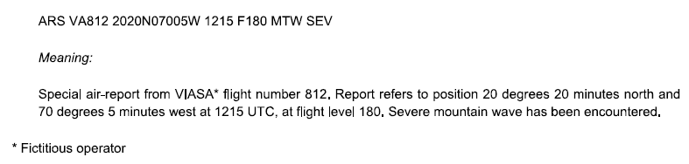

To stimulate uniform use of the AIREP format and to reduce ambiguity due to misinterpreting these reports it is recommended to follow the following standard format:
SECTION 1 AIREP YYGG
SECTION 2 RRR I_{A} ... I_{A} L_{a}L_{a}L_{a}L_{a}A L_{o}L_{o}L_{o}L_{o}L_{o}B GGgg S_{h}h_{I}h_{I}h_{I} i_{p}i_{p}i_{p} SST_{A}T_{A}T_{A} ddd/fff SYMBOLS=
Explanation:
YYGG Day YY and Hour GG in UTC related to the bulletin.
RRR: ARP for routine air-reports, ARS for special air-reports. Use of ARS is mandatory, use of ARP is recommended
I_{A} ... I_{A} Aircraft identification. Aircraft identification consists of either the operator’s designator and aircraft registration, or flight number, reported as one unit without any spaces or hyphens. However it is recommended to provide an identifier, unique for the aircraft (like the aircraft registration number).
L_{a}L_{a}L_{a}L_{a}A Position (Lattitude, in degrees and minutes). Lattitude position is given in in degrees and minutes (four figures for latitude L_{a}, followed without a space by A = N or S, i.e. direction of latitude, N = North, S = South
L_{o}L_{o}L_{o}L_{o}L_{o}B Position (Longitude, in degrees and minutes). Longitude position is given in degrees and minutes (five figures for longitude L_{o}, followed without a space by B= E or W; i.e. direction of longitude, E = East, W = West.)
Note: ICAO Doc. 8896 (7.9.3, Position ) suggests not to use a space between L_{a}L_{a}L_{a}L_{a}A and L_{o}L_{o}L_{o}L_{o}L_{o}B. However it is recommended spaces to avoid misinterpretations.
GGgg Time of observation. The time of aircraft, at the position indicated, is shown in hours (GG) and minutes (gg) UTC.
S_{h}h_{I}h_{I}h_{I} Flight level or altitude. The flight level is shown by sign S_{h} (F for positive flight levels, A for negative flight levels) followed by the actual level h_{I}h_{I}h_{I}; the altitude is shown by an S_{h} followed by h_{I}h_{I}h_{I} and M or FT, as appropriate.
i_{p}i_{p}i_{p} Phase of flight. Flight level S_{h}h_{I}h_{I}h_{I} is followed by “ASC” (level) or “DES” (level) when ascending or descending to a new level; else omitted
SST_{A}T_{A} Sign of the temperature and air temperature in whole °C. If air temperature is zero or positive, SS shall be encoded as the letters PS, if air temperature is negative, SS shall be encoded as the letters MS. Air temperature T_{A}T_{A}, in whole degrees Celsius, at the level given by S_{h}h_{I}h_{I}h_{I}.
Note: it is encouraged to use a three digit T_{A}T_{A}T_{A}, providing air temperature, in tenths of degrees Celsius
ddd/fff wind direction and wind speed separated by a slash. Wind direction ddd to be the true direction, in whole degrees, from which wind is blowing. Wind speed fff, in knots, at the level given by S_{h}h_{I}h_{I}h_{I}. Unit, separated with a space from fff may be added (KT for knots, MPS for m/s)
SYMBOLS Phenomenon prompting a special air-report
- severe turbulence as “TURB SEV”
- moderate turbulence as “TURB MOD”
- severe icing as “ICE SEV”
- moderate icing as “ICE MOD”
- severe mountain wave as “MTW SEV”
- thunderstorm without hail1 as “TS”
- thunderstorm with hail1 as “TSGR”
- heavy duststorm or sandstorm as “HVY SS”
- volcanic ash cloud as “VA CLD”
- pre-eruption volcanic activity or a volcanic eruption as “VA”
General
- In a bulletin of AIREP reports, the contents of Section 1 (the code name AIREP and the group YYGG) shall be included only as the first line of the bulletin.
- An AIREP report shall include Section 2 containing at least the aircraft identifier, its geographical location and the day and time of observation, as well as the observed temperature and wind.
- Use of solidi Data shall be encoded as solidi when not available, when the data collection platform cannot acquire correct data, or in the event of parity errors.
- Section 1 and section 2 data shall be reported on single lines without line breaks. Section 2 data to be ended with a “=”.
Example
AIREP 1521
ARP UAL137 1712N 14249E 2153 F380 M47 100/024=

AIREP 1521 Air report for day 15, at 21 H UTC.
ARP Routine air report
UAL137 Flight Number
1712N Lattitude 17 deg 12 min North
14249E Longitude 142 deg 49 min East
2153 Time 21:53 UTC
F380 Flight Level +380
M47 Air temperature -47°C
100/024 Wind direction 100° true, wind speed 12 m/s (24 knots).

Encoding of Other ABO Data Sources
Other sources of ABO that are described within [REF section 1.6.3] should be disseminated over the GTS using the same BUFR format as described within Attachment 2.

Encoding of IAGOS Aerosol and Chemical Data in BUFR
In addition to this common sequence another template is developed to provide observations and derived data related to chemical components to support the ongoing research of the chemical composition of the atmosphere (common sequence 3 11 011).
For completeness, a brief description of the IAGOS BUFR Template is provided within [REF Attachment 3] to this annex.

Attachment 1, Introduction to Message Reporting on the GTS
Coded messages are used for the international exchange of meteorological information comprising observational data provided by the WWW Global Observing System that also includes aircraft based and derived observations. All these messages are disseminated over the WMO Global Telecommunication System (GTS) linking regional and national telecommunication hubs located at meteorological centres. The encoded messages are composed of a set of Code Forms and Binary Codes and are usually called bulletins. Two types of WMO Code Forms are currently in practice, one code form that consists of binary values (in a Table Driven Codes Format, TDCF) and the other based on alphanumerical characters. Codes with observations that are encoded in the binary format are called BUFR (FM 94–XIV, “Binary Universal Form for the Representation of meteorological data”). For alphanumeric codes there are the so-called Traditional Alphanumercial Codes (TAC), primarily developed for historic communications facilities like telex, and a modern alternative, called CREX, based on a similar TDCF like BUFR (CREX: “Character form for the Representation and EXchange of data”). However, the WMO Commission for Basic Systems (CBS) has decided and it has been approved that, from 11 November 2014, it is mandatory to use only the BUFR code, TAC would no longer be supported and transition from TAC to BUFR by Members should have been completed. Although TAC is phased out already in 2014, it is still in practice by some Members but will end when their transition to BUFR is completed. CREX is intended to be used as an interim solution for those Members, who are not yet able to fully transition to use of BUFR. Because of the limited relevance today of these WMO alphanumeric codes (TAC and CREX), only limited details are given here. For detailed description of TAC (e.g. code format FM42, ‘AMDAR’) and CREX it is recommended to consider the Manual on Codes (WMO-No. 306) and the WMO Codes website at: http://www.wmo.int/pages/prog/www/WMOCodes.html.
Apart from the recommended WMO code forms, another alphanumeric code form representing aircraft data is disseminated over the GTS. These reports are generated and delivered by ICAO entities. To avoid duplications, ensure adequate data quality control and stimulate standardised coding, it has been recommended that, in compliance with ICAO regulaitons, only the two WAFC (World Area Forecast Centres in Washington, USA, and London, UK) may transmit or authorise the transmission of ICAO derived ABO messages (bulletins) on the GTS for global distribution (for more information see [REF section 1.6.2, 1.7, 1.8 and 1.9]. It is expected that national civil aviation authorities should comply with ICAO provisions to ensure that ICAO Aircraft Reports are sent to one or other of the WAFCs for this purpose.
More details on the responsibilities related to data distribution over the GTS can be found in the Manual to the GTS (WMO-No. 386).
A bulletin might consist of a batch of (single level) observations from a single aircraft or observations from several aircraft. So a bulletin may contain one or more encoded reports or messages and one or more observations, but usually contains codes with the same format. For economic reasons it is common practice to collect codes within certain time intervals before dissemination as a bulletin. This interval however should be as short as possible to reduce data latency. It also is desirable to batch data in specific geographical regions. This will allow switching centres to direct data to appropriate users without the need to sort or filter individual observations.

Format used for meteorological messages
A meteorological message consists of one single meteorological bulletin. The lay-out of a message is formatted as follows:
Meteorological Message | Start of Text identifier and starting line
 | Meteorological  bulletin | HEADER
 |  | CODE: TEXT or BINARY BLOCK
 | End of Text identifier

As shown in this figure, the observational information is contained in the text or binary block. This block (i.e. the contents of the bulletin) is preceded by a start of text line and a heading and followed by an end-of-message identification. The bulletin itself consists of a header and a text/binary block. In practice the combination of Start-of-text line, header and end-of-text as shown above are regarded as the ‘envelope’ of the message. Information on this envelope relates to the origin of the message. It is common practice, but not always the case, that the message is generated by the same centre as the text/binary block is generated.

Description of the bulletin header
The header is formatted as follows:
T₁T₂A₁A₂ii CCCC YYGGgg (BBB)
Where:
T₁T₂ are the data type and/or form designators.
  - For binary code messages T₁=I, for alphanumeric messages encoding upper-air data T₁ = U. For upper-air data encoded binary, T₂ = U.
  - For upper-air alphanumeric encoded data, and T₂ = A or D in case of aircraft reports, where T₂ = A is used for FM41 (CODAR) or ICAO AIREP encoded data and T₂= D for FM42 (AMDAR) encoded data. (Note that both FM41 (CODAR) and FM42 (AMDAR) are now considered obsolete.)
A₁A₂ are geographical and/or data type designators (the first observation in the bulletin prevails).
- For Binary encoded data (i.e. with T₁T₂ = IU), A₁ = A for single level observations (both automatic and manual observed, i.e. both AMDAR and AIREP) and A₁ = O for profiles of AMDAR related aircraft observations in ascending or descending flight phase. A₂ indicates the geographical region appropriate for the observations.
Note: A distinction between AMDAR and AIREP can only be made using the Data Category/subcategory values in section 1 of the BUFR message itself, as documented in the [REF Manual on Codes (WMO-No. 306), Vol. I.2, Common Code Table C13: Data sub categories of categories defined by entries in BUFR Table A]; see also [REF Manual on the GTS, WMO-No. 386, Vol. I, Part II, Attachment II.5, Table C6].
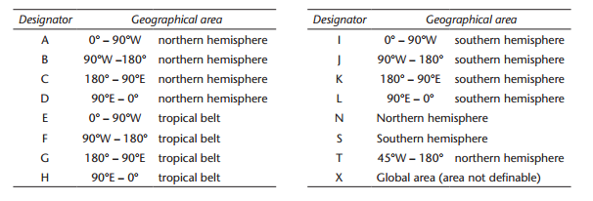
The appropriate geographical region indicator A₂ is defined in the [REF Manual on the GTS, WMO-No. 386, Vol. I, Part II, Attachment II.5, Table C3, Geographical area designator A₂], and presented in the following tables (figure 1) and figure 2:
Figure 1
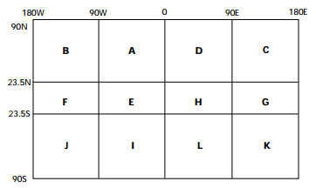
Figure 2
Notes:
  - If the BUFR bulletin contains data from several aircraft flying in different sectors of the globe, X should be coded ‘X’.
  - The tropical belt is defined to be within 23.5° N and 23.5° S.
  - A₁A₂ (for TAC) or A₂ (for BUFR) indicate geographical region appropriate for the first observation in the bulletin.
- For upper-air alphanumeric encoded data (i.e. with T₁T₂ = UA or UD, used for AIREP and FM42 respectively), A₁A₂ indicates the geographical region appropriate for the observations. Details are published in the Manual on the GTS, WMO-No. 386, Vol. I, Part II, Attachment II.5, Table C1, “Geographical designators A₁A₂” (with preference for Part II – Area designators, prevailing over Part I, National designators), see figure 3 below:
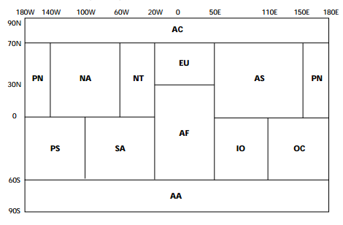
Figure 3
For further details, see [REF AMDAR Reference Manual (WMO-No. 958, 2003)].

ii Shall be a number with two digits (starting with ‘01’). When an originator or compiler of bulletins issues two or more bulletins with the same T₁T₂A₁A₂ and CCCC the ii shall be used to differentiate the bulletins and will be unique to each bulletin.
Note: ii has no significance for BUFR encoded AMDAR bulletins (i.e. with T₁T₂ = IU). For AIREP bulletins, encoded in TAC (i.e. with T₁T₂ = UA), the following rule should be followed (see details in [REF Manual on the GTS, WMO-No. 386, Vol. I, Part II, Attachment II.5, Table D3, “Level designator ii (when T1T2 = FA or UA)”]):
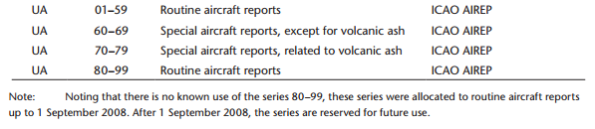
Figure 4: Extract from [REF Manual on the GTS, WMO-No. 386, Vol. I, Part II, Attachment II.5, Table D3, “Level designator ii (when T1T2 = FA or UA)”]
CCCC: International four-letter location indicator of the station or centre originating or compiling the bulletin, as agreed internationally, and published in [REF Weather Reporting (WMO-No. 9), Volume C1 – Catalogue of Meteorological Bulletins, Annex I].
Notes:
- Once a bulletin has been originated or compiled, the CCCC must not be changed. If the contents of a bulletin is changed or recompiled for any reason, the CCCC should be changed to indicate the centre or station making the change.
- Originating/generating centres are also reported within each BUFR bulletin (in [REF Section 1, descriptor 0-01-035; see Manual on Codes (WMO-No. 306), Volume I.2, Common Code Table C-11])
YYGGgg: International date-time group, where:
YY: Day of the month,
GGgg: The time of compilation in UTC (hour and minute)

Note: Only day (of month), hour and minute are given. Year, month, or seconds are not provided.
BBB (without brackets if reported): Because an abbreviated heading defined by T₁T₂A₁A₂ ii CCCC YYGGgg shall be used only once, for any addition, a correction or an amendment, it shall be mandatory to add an appropriate BBB indicator. The BBB indicator shall have the following forms: RRx for additional or subsequent issuance of bulletins; CCx for corrections to previously relayed bulletins; AAx for amendments to previously relayed bulletins; where x is an alphabetic character of A through X as described in the [REF Manual on the GTS (WMO-No. 386), Attachment II-12].

Description of the BUFR bulletin code (FM 94)
A BUFR message is a continuous binary data stream. It is organised into 6 sections. Section 0 is 64 bits, fixed length and is used to indicate the type and length of the total message. Sections 2-4 are variable in length and contain data descriptors and data. Section 5 is 32 bits, fixed content to indicate the end of the BUFR message. The content of each section is best shown in tabular form. This mimics the BUFR encoding process. The contents of each section are organised into 8 bit bytes, called ‘octets’. A constraint placed on all sections is that they must contain an even number of complete octets. Detailed information on these Table-Driven Code Forms (TDCF) can be found in the [REF Manual on Codes (WMO-No. 306)] and available from [REF http://www.wmo.int/pages/prog/www/WMOCodes.html]
Table I: Basic Structure of a BUFR bulletin code:
Section Number | Name | BUFR Table (see Manual on Codes (WMO-No. 306) | Remarks
0 | Indicator section |  | Starting with “BUFR”; length of message, BUFR edition number
1 | Identification section | Table A – Data category | Length of section, identification of the message. For AMDAR, use code figure 4, “Single level upper-air data (other than satellite)”
2 | Optional section |  | Length of section and additional items for local use by automatic data processing centres. Not required for AMDAR
3 | Data description section | Table B – Classification of elements  Table C – Data description operators  Table D – List of common sequences | Length of section, number of data subsets, data category flag, data compression flag and a collection of descriptors which define the form and content of individual data elements
4 | Data section | Table B – Classification of elements  Table C – Data description operators  Table D – List of common sequences | Length of section and binary data
5 | End section |  | Ending with “7777”

Within the BUFR bulletin, the most relevant sections are section 1 (Identification section, containing metadata of the bullet itself), and sections 3 and 4 (Data description and Data section, respectively). Typically, section 3 presents the list of descriptors and common sequences for the datasets, reported in section 4.
Descriptors
Variables, code tables and other elements are represented by so-called descriptors. Schematically, a BUFR descriptor can be visualized as follows:
F | X | Y
2 BITS | 6 BITS | 8 BITS
F denotes the type of descriptor. With 2 bits, there are 4 possible values for F: 0, 1, 2 and 3. The four values have the following meanings:
F = 0 - Element descriptor, and refers to Table B entries
F = 1 - Replication operator
F = 2 - Operator descriptor, and refers to Table C entries
F = 3 - Sequence descriptor, and refers to Table D entries
The meanings of and uses for X and Y depend on the value of F. Evidently, for variables and code tables most relevant are the values for F = 0 or 3. For these values, the descriptor refers to BUFR Tables B or D. X (6 bits) indicates the class or category of descriptor within the Table. In case F=0 reference is made to single variables or predefined table values. For instance, F-X-Y = 0-12-101 stands for “Temperature/air temperature” (Class 12, “Temperature”, is represented with X=12. In case F=3 (Sequence descriptor, used for templates), Category 11 – Single level report sequences (conventional data) – is used to represent AMDAR data, so X=11. For instance, F-X-Y = 3-11-010 for the “BUFR template for AMDAR, version 7”.
Tables
As indicated in this table, references are made to four tables, which are the base of this table driven code format:
Table A – Data category. In fact the data category provides a quick check for the type of data represented in the message
Table B – Classification of elements (F=0). Table B is the heart of the data description language for BUFR. First, each individual parameter, or element, defined for use in BUFR is assigned an element name and a descriptor value (values for the F, X, and Y parts of the descriptor as described above). As noted above, the value of F for all descriptors in Table B is 0 (zero). The X part of the descriptor is determined by organizing all the possible parameters into a set of classes based on their nature (e.g., X=11 for temperature parameters, X=12 for wind parameters, or X=13 for Hydrographic and hydrological elements including moisture parameters). The Y part of the descriptor is the entry within a Class X of the parameter (e.g. Y=101 in F-X-Y = 0-12-101 for “Temperature/air temperature”)
Table C – Data description operators (F=2). These are used when there is a need to redefine Table B attributes temporarily, such as the need to change data width, scale or reference value of a Table B entry. Table C is also used to add associated fields such as quality control information, indicate characters as data items, and signify data width of local descriptors.
Table D – List of common sequences (F=3). A group of data items always transmitted can be defined in what is called a common sequence descriptor, so that, the individual element descriptors will not need to be repeated each time in the data description section. It is only the common sequence descriptor, which will be listed in the data description section. For AMDAR BUFR bulletins, F-X = 3-11 – “Single level report sequences (conventional data)”. A typical example of a common sequences is:
TABLE REFERENCES |  |  |  | TABLE REFERENCES
F | X | Y |  | F | X | Y
3 | 01 | 011 | Year, month, day | 0  0  0 | 04  04  04 | 001  002  003 | Year  Month  Day

Value representation
Descriptors referring to numerical values and defined in Table B are integers based on four such characteristics: unit, scale, reference value, and data width (in bits).
- Units: In most cases, the basic (SI) units for the element. However, numeric, character, code table, or flag table are also possible.
- Scale: The power of 10 by which the element has been multiplied prior to encoding.
- Reference value: A number to be subtracted from the element, after scaling (if any), and prior to encoding.
- Data width (bits): The number of bits the element requires for representation in Section 4.
The table below presents two typical examples, used for encoding AMDAR data
TABLE REFERENCE | ELEMENT NAME | BUFR
F X Y |  | UNIT | SCALE | REFERENCE VALUE | DATA WIDTH (Bits)
0 12 101 | Temperature/air temperature | K | 2 | 0 | 16
0 11 101 | Aircraft ground speed u-component | m s^{–1} | 1 | –4096 | 13

Note: Where a code table or flag table is appropriate, “code table” or “flag table”, respectively is entered in the UNITS column of Table B.
To encode values into BUFR, the data (with units as specified in the UNIT column) must be multiplied by 10 to the power SCALE. Then subtract the REFERENCE VALUE to give the coded value found in Section 4 of the BUFR message. For example, an aircraft ground speed u-component is –200 m s⁻¹. The descriptor is 0 11 101 and the encoded value is –200 x 10¹ – (–4096) = 2096. Or, if the air temperature is –70.32°C (202.83 K), for descriptor 0 12 101 the encoded value is 203.5 x 10² – (0) = 20383 (a data width of 16 bits implies a maximum value of 2¹⁶ -1 = 65535)
Note:
- Missing values shall be set to fields of all ones (e.g. each octet shall be set to 11111111 binary). This shall apply to code tables as well as data elements; flag tables shall be augmented to contain a missing indicator bit where this is deemed to be necessary.
- UNIT is the basic unit before scaling.

Attachment 2, BUFR template for AMDAR, version 7 (table reference 3 11 010)
 |  | Element Name | Mandatory  [8] | Descriptor  (BUFR Table B) | Related Sequence Descriptor  (BUFR Table D) | ABO Data Elements (This Attachment) | AOSFRS Version1.1 | FM42 symbol  [9] | AIREP symbol  [10] | Notes
 |  |  |  | F X Y | F X Y
Metadata |  | Aircraft registration number or other identification | M | 0 01 008 |  |  |  | I_{A}. . . I_{A} | I_{A}. . . I_{A} | [1]; Max 8 characters
 |  | Observation sequence number |  | 0 01 023 |  |  |  |  |  | [2]
 |  | Aircraft flight number |  | 0 01 006 |  |  |  |  |  | [1]
 |  | Aircraft tail number |  | 0 01 110 |  |  |  |  |  | 6 characters
 |  | Origination airport |  | 0 01 111 |  |  |  |  |  | 3 characters
 |  | Destination airport |  | 0 01 112 |  |  |  |  |  | 3 characters
 |  | Add associated field |  | 2 04 002 |  |  |  |  |  | [3]; YYY=2, so 2 bits extra for indicator of quality
 |  | Associated field significance |  | 0 31 021 |  |  |  |  |  | Code table; [3], [4], two bits quality information based on code figure = 8
 |  | Latitude | M | 0 05 001 | 3 01 021 |  | Table 19, Latitude in seconds | L_{a}L_{a}L_{a}L_{a}A | L_{a}L_{a}L_{a}L_{a}A
 |  | Longitude | M | 0 06 001 |  |  |  | L_{o}L_{o}L_{o}L_{o}L_{o}B | L_{o}L_{o}L_{o}L_{o}L_{o}B
 |  | Year | M | 0 04 001 | 3 01 011
 |  | Month | M | 0 04 002
 |  | Day | M | 0 04 003 |  |  |  |  |  | YY
 |  | Hour | M | 0 04 004 | 3 01 013 |  |  |  |  | GG
 |  | Minute | M | 0 04 005 |  |  |  |  |  | gg
 |  | Second |  | 0 04 006
 |  | Latitude | M | 0 05 001 | 3 01 021
 |  | Longitude | M | 0 06 001
 |  | Pressure Altitude (flight level) | M | 0 07 010 |  |  |  | S_{h}h_{I}h_{I}h_{I} | S_{h}h_{I}h_{I}h_{I} | 5
 |  | Global navigation satellite system altitude |  | 0 10 053
 |  | Detailed phase of flight | M | 0 08 009 |  |  |  | i_{p}i_{p}i_{p} | i_{p}i_{p}i_{p} | Code table
wind |  | Wind Direction | M | 0 11 001 |  |  |  | ddd | ddd
 |  | Wind speed | M | 0 11 002 |  |  |  | fff | fff
Aircraft speed |  | Aircraft roll angle quality |  | 0 02 064 |  |  |  |  |  | Code table
 |  | Aircraft true airspeed |  | 0 11 100
 |  | Aircraft ground speed u-component |  | 0 11 101
 |  | Aircraft ground speed v-component |  | 0 11 102
 |  | Aircraft ground speed w-component |  | 0 11 103
 |  | Aircraft true heading |  | 0 11 104
 |  | Temperature/air temperature |  | 0 12 101 |  |  |  | SST_{A}T_{A}T_{A} | SST_{A}T_{A}T_{A} | Static air temperature (SAT)
humidity |  | Aircraft humidity sensors |  | 0 02 170 | Code table
 |  | Change data width |  | 2 01 144 |  |  |  |  |  | [7]; YYY = 144, so Width = (144-128) = 16 bits
 |  | Change scale |  | 2 02 133 |  |  |  |  |  | [7]; YYY = 133, so scale = (133-128) = 5.
 |  | Mixing ratio | [M] | 0 13 002 |  |  |  |  |  | Mixing ratio with enhanced resolution
 |  | Change scale |  | 2 02 000 |  |  |  |  |  | Reset scale
 |  | Change data width |  | 2 01 000 |  |  |  |  |  | Reset data width
 |  | Change data width |  | 2 01 135 |  |  |  |  |  | YYY = 135, so Width = (135-128) = 7 bits
 |  | Change scale |  | 2 02 130 |  |  |  |  |  | YYY = 130, so Scale = (130-128) = 2.
 |  | Relative humidity |  | 0 13 003 |  |  |  | UUU | UUU | Enhanced resolution
 |  | Change scale |  | 2 02 000 |  |  |  |  |  | Reset scale
 |  | Change data width |  | 2 01 000 |  |  |  |  |  | Reset data width
 |  | Delayed replication of 1 descriptor |  | 1 01 000 |  |  |  |  |  | [5]; Y=0 so delayed.
 |  | Short delayed descriptor replication factor |  | 0 31 000 |  |  |  |  |  | [6] (1 bit)
 |  | Dewpoint temperature |  | 0 12 103 |  |  |  | SST_{d}T_{d}T_{d}
 |  | Moisture quality |  | 0 33 026 |  |  |  |  |  | Code table
icing |  | Delayed replication of 1 descriptor |  | 1 01 000 |  |  |  |  |  | [5]; Y=0 so delayed.
 |  | Short delayed descriptor replication factor |  | 0 31 000 |  |  |  |  |  | [6] (1 bit)
 |  | Airframe icing present | [M] | 0 20 042 |  |  |  |  |  | Code table
Liquid water |  | Delayed replication of 3 descriptors |  | 1 03 000 |  |  |  |  |  | [5]; Y=0 so delayed.
 |  | Short delayed descriptor replication factor |  | 0 31 000 |  |  |  |  |  | [6] (1 bit)
 |  | Peak liquid water content |  | 0 20 043
 |  | Average liquid water content |  | 0 20 044
 |  | Supercooled large droplet (SLD) conditions |  | 0 20 045 |  |  |  |  |  | Code table
 |  | Delayed replication of 1 descriptor |  | 1 01 000 |  |  |  |  |  | [5]; Y=0 so delayed.
 |  | Short delayed descriptor replication factor |  | 0 31 000 |  |  |  |  |  | [6] (1 bit)
 |  | ACARS interpolated values indicator |  | 0 33 025 |  |  |  |  |  | Code table
turbulence |  | Delayed replication of 3 descriptors |  | 1 03 000 |  |  |  |  |  | [5]; Y=0 so delayed.
 |  | Delayed descriptor replication factor |  | 0 31 001 |  |  |  |  |  | [6] (8 bit)
 |  | Mean turbulence intensity (eddy dissipation rate) |  | 0 11 075
 |  | Peak turbulence intensity (eddy dissipation rate) |  | 0 11 076
 |  | Extended time of occurrence of peak eddy dissipation rate |  | 0 11 039 |  |  |  |  |  | Code table
 |  | Delayed replication of 2 descriptors |  | 1 02 000 |  |  |  |  |  | [5]; Y=0 so delayed.
 |  | Short delayed descriptor replication factor |  | 0 31 000 |  |  |  |  |  | [6] (1 bit)
 |  | Turbulence index | [M] | 0 11 037 |  |  |  | TBB_{A} |  | Code table; EDR
 |  | Reporting interval or averaging time for eddy dissipation rate |  | 0 11 077
 |  | Delayed replication of 3 descriptors |  | 1 03 000 |  |  |  |  |  | [5]; Y=0 so delayed.
 |  | Short delayed descriptor replication factor |  | 0 31 000 |  |  |  |  |  | [6] (1 bit)
 |  | Vertical gust velocity |  | 0 11 034 |  |  |  | VGf_{g}f_{g}f_{g}
 |  | Vertical gust acceleration |  | 0 11 035
 |  | Maximum derived equivalent vertical gust speed |  | 0 11 036
 |  | Add associated field |  | 2 04 000 |  |  |  |  |  | Cancel associated field
 |  | Delayed replication of 19 descriptors |  | 1 19 000 |  |  |  |  |  | [5]; Y=0 so delayed.
 |  | Delayed descriptor replication factor |  | 0 31 001 |  |  |  |  |  | [6] (1 bit)
 |  | Year, month, day |  | 3 01 011
 |  | Hour, minute, second |  | 3 01 013
 |  | Latitude/longitude (high accuracy) |  | 3 01 021
 |  | Height |  | 0 07 007
 |  | EDR algorithm version |  | 0 11 105
 |  | Add associated field |  | 2 04 007 |  |  |  |  |  | [3]; YYY=007, so 7 bits
 |  | Associated field significance |  | 0 31 021 |  |  |  |  |  | Code table;  [3], [4]; Code figure to be 7, percentage confidence
 |  | Peak turbulence intensity (eddy dissipation rate) |  | 0 11 076
 |  | Mean turbulence intensity (eddy dissipation rate) |  | 0 11 075
 |  | Add associated field |  | 2 04 000 |  |  |  |  |  | Cancel associated field
 |  | Running minimum confidence |  | 0 11 106
 |  | Maximum number bad inputs |  | 0 11 107
 |  | Peak location |  | 0 11 108
 |  | Number of good EDR |  | 0 11 109
 |  | Temperature/air temperature |  | 0 12 101
 |  | Wind direction |  | 0 11 001
 |  | Change data width |  | 2 01 130 |  |  |  |  |  | YYY = 130, so Width = (130-128) = 2 bits
 |  | Wind speed |  | 0 11 084
 |  | Change data width |  | 2 01 000 |  |  |  |  |  | Rest Data width

Notes on this table:
- Care should be taken to use an appropriate identifier. Such an identifier should be a unique identifier related to one single and unique aircraft only (like the aircraft tail number is and which should not be encoded here but is provided, if available, via 0 01 110). The wording ‘aircraft identifier’ was first used in TAC code FM42, indicated by I_{A}...I_{A}. For further details, see AMDAR Reference Manual (WMO-No. 958, 2003). This identifier should not be confused with ‘Aircraft flight number’, which is represented by descriptor 0-01-006 and should only ever be used to encode an aviation or airline assigned flight number, if it is available. The recommended and preferred format to be used for AMDAR is XXnnnn, where XX is a fixed character string representing the country in which the aircraft is registered or representing the national or regional AMDAR programme and nnnn is a unique number assigned to the aircraft within the fleet of the programme. For example, for aircraft identity EU0001, EU represents the EUMETNET AMDAR programme and 0001 is a number that uniquely identifies a particular aircraft within the EU AMDAR fleet. Members shall ensure that the XX identity is unique to the programme by obtaining approval for use of the designator from WMO.
- [2] The sequence number is a simple observation count to be included in the down linked message. It should be reset at 0000 UTC each day and is especially useful for quality control, data management and archiving purposes.
- [3] Data description operators ( with F=2) are used when there is a need to redefine Table B attributes temporarily, such as the need to change data width, scale or reference value of a Table B entry. The following three data description operators are used in sequence number 3 11 010:
TABLE  REFERENCE | OPERAND | OPERATOR NAME | OPERATION DEFINITION
F X
2 01 | YYY | Change data width | Add (YYY–128) bits to the data width given for each data element in Table B, other than CCITT IA5 (character) data, code or flag tables.
2 02 | YYY | Change scale | Add YYY–128 to the scale for each data element in Table B, other than CCITT IA5 (character) data, code or flag tables.
2 04 | YYY | Add associated field | Precede each data element with YYY bits of information. This operation associates a data field (e.g. quality control information) of YYY bits with each data element.

Notes:
(1) The operations specified by operator descriptors 2 01, 2 02, 2 03, 2 04, 2 07 and 2 08 remain defined until cancelled or until the end of the data subset.
(2) If change scale is used, then it may be necessary for the originator of the message to supply an appropriately rescaled reference value and data width.
(3) Cancellation of the use of the redefined value shall be effected by the inclusion of the appropriate operand with YYY set to 000. The value shall then revert to the original Table B value.
(4) Nesting of operator descriptors must guarantee unambiguous interpretation. In particular, operators defined within a set of replicated descriptors must be cancelled or completed within that set, and the 2 07 operator may neither be nested within any of the 2 01, 2 02, and 2 03 operators, nor vice-versa.
(5) Nesting of the operator descriptor 2 04 is defined such that:
(a) Each new definition adds to the currently defined associated field. The order of the included associated information shall correspond with the order in which the associated fields have been defined.
(b) Each cancellation (2 04 000) cancels only the most recently defined addition to the associated field.
(6) When the descriptor 2 04 YYY is to be used, it shall precede the first of the data descriptors to which it applies.
(7) The data description operator 2 04 YYY, other than 2 04 000, shall be followed immediately by the descriptor 0 31 021 to indicate the meaning of the associated field.
(8) In the data stream, the 6 bits described by 0 31 021 (code table) shall precede the YYY bits.
- [4] The result of the Associated Field Significance (0 32 021) follows the preceding Add Associated Filed (2 04 002) value for YYY. In case of code figure values 7 and 8 we have:
Code figure
7 | Percentage confidence | (value)
8 | 2-bit indicator of quality | 0 = Not suspected
 |  | 1 = Suspected
 |  | 2 = Reserved
 |  | 3 = Information not required
- [5] The replication operation. If F = 1, the descriptor shall be called a “replication descriptor”. For this case, X shall indicate the number of descriptors to be repeated, and Y the total number of occurrences (replications) of the repeated subsequence. A value of Y = 0 associated with the replication descriptor shall indicate delayed replication. In this case, the replication data description operator shall be completed by the next element descriptor, which shall define a data item indicating the number of replications. This descriptor may also indicate (by its value of Y) that the following datum is to be replicated together with the following descriptor.
- [6] The “delayed descriptor and data repetition factor” is intended for run-length encoding (e.g. scanning an image). It specifies a count N which applies to both descriptor and data, i.e. the value of the single element defined by the following descriptor is repeated N times (at intervals already specified). A special application of replication consists in specifying a replication factor of either 0 or 1 for a subsequence. For a value of zero, the sub-sequence is replicated “zero” time - that is, not at all. This makes it possible, when appropriate, to shutdown whole sections of a template, thereby shortening the data section. So if e.g. 0-31-00 = 0 a sub-sequence may be replicated zero times, with the result that, although the sub-sequence exists in the template, it is skipped when the sequence is encoded into the Data Section.
- [7] Change Data Width and change Scale. In Table B Scale and Data Width are defined. For example, mixing ratio is defined as follows:

TABLE | ELEMENT |  |  |  | DATA
REFERENCE | NAME | UNIT | SCALE | REFERENCE | WIDTH
F X Y |  |  |  | VALUE | (Bits)
0 13 002 | Mixing ratio | kg kg^{–1} | 5 | 0 | 14

A scale = 5 together with a data with of 14 bits and a reference value of 0 implies a range from 0 to 2¹⁴ x 10⁻⁵ -1, i.e. {0 .. 0.16383} kg kg^{–1} and with a resolution of 1x10⁻⁵ kg kg^{–1}. Because the descriptors are presented as integers, a variable like mixing ratio covering a large number of decades cannot be reporting for its full range and required resolution. As a result the scale and the data width should be enhanced. Using a scale of 5 and a data width of 16 the range becomes 0 to 2¹⁶ x 10⁵, or {0 .. 0.65535} kg kg^{–1} with a resolution of 1x10⁻⁵ kg kg^{–1}.
- [8] M if mandatory; [M] mandatory if available. Note that a large number of descriptors are preceded by FXY = 0 31 000 (Short delayed descriptor replication factor), which implies that reporting is optional (Y = 0 means no report, if the preceding FXY = 1 X 000 (Delayed replication of X descriptors) is set to 0. See note [6]
- [9] Selected descriptor for transition from FM42.
- [10] Selected descriptor for transition from AIREP; see explanation of symbols used under "ICAO aircraft report AIREP" (Other data formats).

Attachment 3, IAGOS template for a single observation, version 2 (table reference 3 11 011)
 |  | Element Name | Mandatory  (M if mandatory; [M] mandatory if available) | Descriptor  (BUFR Table B) | Related Sequence Descriptor  (BUFR Table D) | Notes
 |  |  |  | F X Y | F X Y
 |  | Observation sequence number |  | 0 01 023
 |  | (IAGOS template for a single observation), version 2
 |  | Observation sequence number |  | 0 01 023
 |  | Phase of aircraft flight |  | 0 08 004
 |  | Year, month, day |  | 3 01 011
 |  | Hour, minute, second |  | 3 01 013
 |  | Latitude (coarse accuracy) |  | 0 05 002
 |  | Longitude (coarse accuracy) |  | 0 06 002
 |  | Pressure |  | 0 07 004
 |  | Wind direction |  | 0 11 001
 |  | Wind speed |  | 0 11 002
 |  | Temperature/air temperature |  | 0 12 101
 |  | Delayed replication of 6 descriptors |  | 1 06 000
 |  | Delayed descriptor replication factor |  | 0 31 001
 |  | Atmospheric chemical or physical constituent type |  | 0 08 046
 |  | Change data width |  | 2 01 139 |  | 20 bits long
 |  | Change scale |  | 2 02 126 |  | Scale: 7
 |  | Concentration of pollutant (mol mol^{–1}) |  | 0 15 026
 |  | Change scale |  | 2 02 000 |  | Cancel
 |  | Change data width |  | 2 01 000 |  | Cancel
 |  | Delayed replication of 6 descriptors |  | 1 06 000
 |  | Delayed descriptor replication factor |  | 0 31 001
 |  | Atmospheric chemical or physical constituent type |  | 0 08 046
 |  | Change data width |  | 2 01 138 |  | 19 bits long
 |  | Change scale |  | 2 02 130 |  | Scale: 11
 |  | Concentration of pollutant (mol mol^{–1}) |  | 0 15 026
 |  | Change scale |  | 2 02 000 |  | Cancel
 |  | Change data width |  | 2 01 000 |  | Cancel
 |  | Log₁₀ of number density of aerosol particles with diameter greater than 5 nm |  | 0 15 052
 |  | Log₁₀ of number density of aerosol particles with diameter greater than 14 nm |  | 0 15 053
 |  | Log₁₀ of number density of aerosol particles with diameter between 0.25 and 2.5 µm |  | 0 15 054
 |  | Non volatile aerosol ratio |  | 0 15 055
 |  | Pressure |  | 0 07 004
 |  | Pressure |  | 0 07 004
 |  | Log₁₀ of integrated cloud particle density |  | 0 13 099
 |  | Log₁₀ of integrated cloud particle area |  | 0 13 100
 |  | Log₁₀ of integrated cloud particle volume |  | 0 13 101

Attachment 4, Referred Code Tables
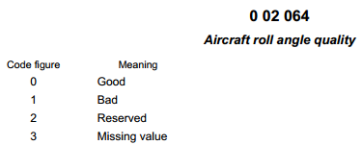

Note: Bad is currently defined as a roll angle > 5 degrees from vertical.

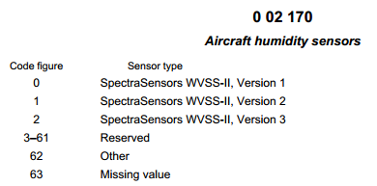

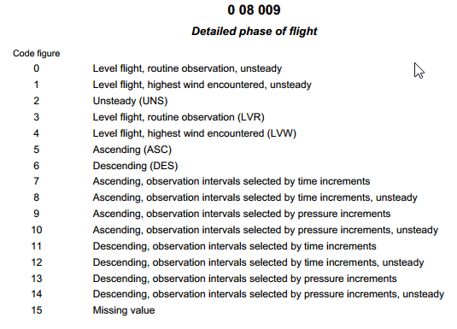
Notes:
(1) Unsteady in case Roll Angle > 5° and will takes precedence over all other codes

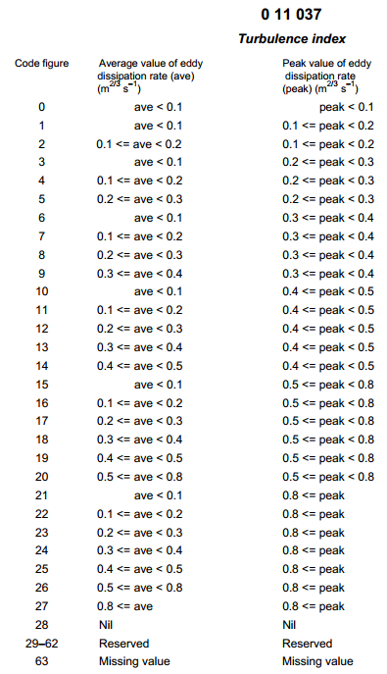
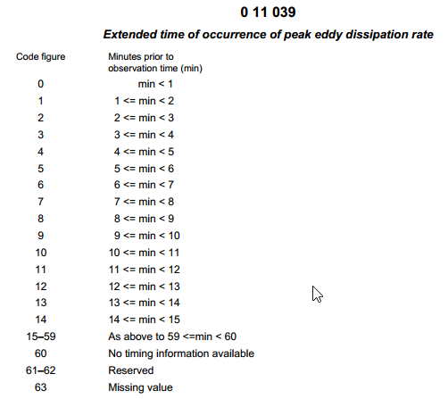

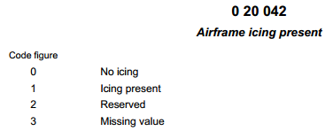

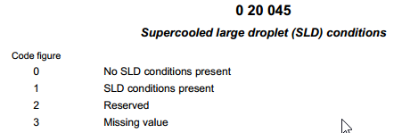

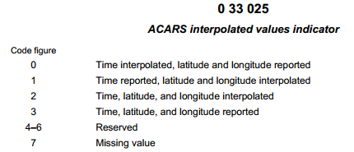

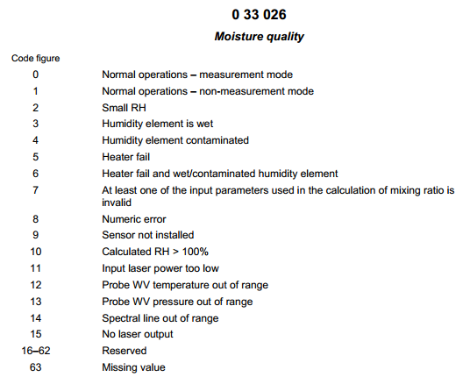

Attachment 5, Other BUFR templates still in use or used in the past
All these templates follow the common sequences, as published in Table D ([REF Manual on Codes, FM94 BUFR]), with F XX = 3 11:
Category 11 – Single level report sequences (conventional data)
3 11 001: Aircraft reports for ASDAR , using common sequence (template) 3 01 051 (Flight number, navigational system, date/time, location, phase of flight) and standard descriptors
3 11 002: ACARS reports, using four common sequences (tempates) only: 3 01 065 (ACARS identification), 3 01 066 (ACARS location), 3 11 003 (ACARS standard reported variables) and 3 11 004 (ACARS supplementary reported variables)
3 11 003 ACARS standard reported variables (used by 3 11 002), with standard descriptors only
3 11 004 ACARS supplementary reported variables (used by 3 11 002) with standard descriptors only
3 11 005 Standard AMDAR reports, using common sequences (template) 3 01 021 (Latitude/longitude -high accuracy), 3 01 011 (Year, month, day), 3 01 013 (Hour, minute, second) and standard descriptors
3 11 006 AMDAR data or aircraft data for one level without latitude/longitude, with standard descriptors only
3 11 007 Aircraft data for one level with latitude/longitude indicated, using common sequence (template) 3 01 021 (Latitude/longitude -high accuracy and standard descriptors
3 11 008 Aircraft ascent/descent profile without latitude/longitude indicated at each level, using common sequences (template) 3 01 021 (Latitude/longitude -high accuracy), 3 01 011 (Year, month, day), 3 01 013 (Hour, minute, second), 3 11 006 (AMDAR data or aircraft data for one level without latitude/longitude) and standard descriptors. This template is designed for reporting profiles based on 3 11 006, AMDAR data or aircraft data for one level without latitude/longitude
3 11 009 Aircraft ascent/descent profile with latitude/longitude given for each level, using common sequences (template) 3 01 021 (Latitude/longitude -high accuracy), 3 01 011 (Year, month, day), 3 01 013 (Hour, minute, second), 3 11 006 (AMDAR data or aircraft data for one level without latitude/longitude) and standard descriptors. This template is designed for reporting profiles based on 3 11 007, Aircraft data for one level with latitude/longitude indicated

Annex IV - Guidance on Aircraft Based Observations Metadata Maintenance and Provision

Background
The obtaining, maintenance and international provision of Aircraft Based Observations (ABO) metadata supports the following primary functions in the operation of ABO observing systems:
- Ongoing and historical documentation by Members of the platforms, systems and sensors that contribute to observing system observations;
- Definition of the capabilities of the observing system in terms of various fundamental aspects, which include uncertainty, spatial and temporal resolution or coverage, latency and reporting frequency;
- Provision of additional information about the observing system including:
  - Variables observed;
  - Purpose of the observation and the networks and applications for which they are intended to contribute;
  - The environment in which the observations are made and their representativeness;
  - The methods of observation employed;
  - The way in which the measurements are sampled and processed;
  - Data ownership and policy; and
  - Contact details of operators, authorities, data owners, etc.

ABO metadata consists of three basic types:
- Metadata about aircraft platforms and associated observational practices to be obtained, maintained and retained by members;
- Metadata about aircraft platforms and observational practices to be provided to and maintained by WMO; and
- Metadata about aircraft-based observations that should be maintained and provided with observational data.
This Annex is chiefly concerned with the first two types of metadata.

Requirements for Metadata
The regulations for maintenance and provision of metadata for WIGOS observing systems are defined within the [REF Manual on WIGOS, Sections 2.4.4].
The requirements for ABO metadata are based upon the WIGOS Metadata Standard, which is defined in the [REF Manual on WIGOS, Appendix 2.4].

WIGOS Metadata Profile
The WMDS provides a framework to define and ensure the availability of all required metadata so as to ensure maximum usefulness of WIGOS observations in support of all WIGOS observing system data users and WMO Application Areas.
Although the WIGOS Metadata Standard (WMDS) is still under development by the Inter-Commission Group on WIGOS (ICG-WIGOS) Task Team on WIGOS Metadata (TT-WMD), the primary categories that have been approved provide a framework for the specification of a metadata profile for ABO.
The WMDS makes provision for the following primary categories of metadata:
- Observed variable
- Purpose of observation
- Station/platform
- Environment
- Instruments and methods of observation
- Sampling
- Data processing and reporting
- Data quality
- Ownership and data policy
- Contact
Eventually, the WMDS will provide a full set of metadata elements that will map to all ABO metadata elements. The current mapping from the ABOM Metadata Elements to the WMDS elements is provided in the first column of the table within Attachment 1.

Requirements for ABO Metadata
The initially envisaged requirements for and applications of Aircraft Based Observation (ABO) metadata were first identified under the WIGOS Pilot Project for AMDAR (WIGOS-PP-AMDAR) and subsequently updated by the Expert Team on Aircraft Based Observing Systems (ET-ABO) based on the outcomes of the WMO AMDAR Panel Aircraft Observing System Data Management Workshop (June 2012). The ABO metadata set, as provided in Attachment 1 has been further refined and approved by ET-ABO in consultation with the WMO OSCAR Project Team.
Members operating ABO Observing Systems that report observational data on the GTS will be expected to provide metadata within several categories and/or levels:
- Metadata in support of ABO Data Discovery – this will generally be in support of the operation of the WMO Information System and is not relevant to this guide.
- Metadata in support of ABO data:
  - Metadata to be maintained at the national level – this is the superset of all ABO metadata, encompassing national, regional and global metadata. Note that not all national ABO metadata required is specifically identified in this guide. Members must identify all national metadata that is required to meet the provisions for ABO observing system operation as described within [REF Guide to the GOS, This Guidance, Section 2]
  - Metadata to be provided at the regional level – to be provided to a regional operator such as the EUMETNET E-AMDAR programme. The requirements for Regional ABO metadata are not specified within this guide.
  - Metadata to be provided at the global level – to be provided as described below via the interface to the Surface component of the Observing Systems Capability Analysis and Review Tool (OSCAR/Surface). More information on this aspect of metadata is provided below.
The ABO metadata elements required to be maintained by ABO observing system operators are specified within the table in [REF Attachment 1] below. The notes below the table provide a description of the columns and their content. These metadata support the requirements for ABO metadata under category 2c. above.
[REF Attachment 2] provides an alternative structural depiction of the ABO metadata elements.

Metadata Requirements for ABO Systems Capabilities in OSCAR
OSCAR (Observing Systems Capability Analysis and Review Tool) is a web based resource being developed through consultancy under coordination by WMO and its Technical Commissions. The system is being developed to store all internationally required metadata for WIGOS observing systems and also to define and allow analysis of the capabilities of the WIGOS component observing systems that support the various WMO Application Areas.
Within OSCAR, the capabilities of observing systems that provide ABO are defined in terms of two observing types;
- Atmospheric vertical profilers – observations made during ascent (ASC) and descent (DES) phases of flight to/from airports; and
- High speed mobile platforms – observations are made during the en-route or cruise (ENR) phase of flight.
OSCAR requires metadata relating to each ABO observing system that will provide a means for determining the capabilities of each ABO observing system in terms of the various user requirements for WMO Application Areas that have been defined and specified within the OSCAR User Requirements database. These requirements include spatial and temporal coverage and resolution, data latency and uncertainty. This means that, in addition to the metadata describing the aircraft platforms and the sensors that provide measurements of atmospheric variables, there will also be a requirement for the provision of programmatic metadata that describes where and when aircraft make observations. It is expected that OSCAR will eventually differentiate between the “programmatic capability” and the “actual coverage” provided by the observations. However, in the first stage of OSCAR development, the capability of horizontal coverage (ENR) will be provided based on a statistical compilation or “snapshot” of observational ABO data, while the capabilities of vertical profiles (ASC and DES phases of flight) will be depicted based on the programmatic information for airport locations serviced by “Aircraft Fleets”, as defined and provided by national programme managers.
Therefore, in addition to the metadata fields defined within the ABO Metadata template and the WIGOS Metadata Standard (WMDS), OSCAR will provide “key link fields” which will associate aircraft with one or more Aircraft Fleets and, which will provide a programme of vertical profiles for an associated set of “Fleet Airports”.
An Aircraft Fleet will be a set of aircraft of the same system type (e.g. AMDAR or ADS-C) with common programmatic and OSCAR capability attributes. The Aircraft Fleet metadata will hold common Observing Systems Capabilities (OSC), e.g. vertical resolution (lower and upper troposphere, observations/km), the uncertainty of the observed variables and latency of observations.
Metadata relating to Fleet Airports will also define a set of airports serviced by the Aircraft Fleet which will provide a specific cycle of vertical profiles at each airport e.g. number of profiles per hour/day/week with any diurnal resolution variance.
This structure along with the associated and require metadata is depicted within the ABO Metadata Profile Map in [REF Attachment 2].

Responsibilities for Maintenance and Provision of Metadata
In order for ABO metadata for operational aircraft based observing systems to be obtained and maintained and the required internationally-exchanged metadata and information provided to the OSCAR system, Members will be required to ensure that roles and procedures are developed and assigned to appropriate staff in order to fulfil the functions outlined below.
- Member Permanent Representative to WMO:
  - Nominate and provide contact details of WMO Focal Point on Aircraft Based Observations.
  - Designate role of ABO Programme Manager
- WMO Focal Point on Aircraft Based Observations:
  - Receive and act upon information and advice relating to ABO metadata management and provision.
  - Liaise with the ABO Programme Manager to ensure requirements for ABO metadata are understood and met.
  - Oversee the development of the procedures of their organisation for timely provision of internationally-exchanged ABO metadata to WMO via OSCAR.
- Member ABO Programme Manager (PM):
  - Establish roles and procedures for the collection, maintenance and provision to WMO of required ABO metadata – see Attachment 1.
  - Liaise with partner system operators, airlines, data service providers, avionics vendors and other relevant 3rd parties to ensure that required ABO metadata are able to be made available to the ABO Programme and establish the procedures for enabling this exchange.

Responsibility and Procedures for Maintenance of Metadata Within OSCAR
As with all OSCAR metadata, Members will be responsible for the routine and timely maintenance of the internationally-exchanged component of ABO metadata through manual and/or machine interface to the OSCAR system.
Detailed instructions for and guidance on OSCAR metadata maintenance procedures will be provided in the developing [REF Guide to WIGOS].
Manual input will be carried out based on the instructions that will be contained within the OSCAR User Manual, which will be contained within the Guide to WIGOS.
Automated input will involve a “machine to machine” exchange, most likely using XML data format.
To allow for the transfer of ABO metadata (not in XML) to OSCAR/Surface, a metadata conversion tool will need to be developed i.e. MSExcel→XML, csv→XML etc. This conversion tool will be the responsibility of the Programme Focal Point.
Members and ABO Focal Points of operational ABO programmes should ensure that they make and implement plans for adherence to the above requirements and responsibilities immediately and should ensure compliance with the requirements for the operation of OSCAR and maintenance of OSCAR metadata upon WMO provision of the relevant regulations and guidance and notification of completion of the operational implementation of the OSCAR system.

Attachment 1, Aircraft Based Observations Metadata Profile
WIGOS MDS Category.  Element | ABO Metadata Element | Parent Metadata Element | Historical Record Required | Description | Examples | AMDAR  (M/O, N/I) | ICAO ABO  (M/O, N/I) | Other ABO  (M/O, N/I) | Additional Comments
9.01 | WMO Member Country |  | N | WMO Member Country having jurisdiction over the ABO observing system and the observations. For a regional collaboration, the ABO Programme Operator or the ABO System Operator field can be used to provide the regional collaborative body – e.g. E-AMDAR or E-AMDAR AMDAR | Canada | M,I | M,I | M,I | This should generally be the country in which the aircraft fleets are registered. However, in the case of some ICAO Aircraft Observations (Air-reports), it may be the country of the Aviation Navigation Service Provider (ANSP) that receives the observations and makes them available for provision on the GTS. If the data provider is the WAFC, this field may indicate the country of the WAFC or delegated authority for putting the data on the GTS but usually only if the WAFC is unable to trace the aircraft to a particular country.
10.01 | WMO ABO Focal Point Contact | WMO Member Country | N | WMO ABO Focal Point contact details: Name, Email, Address, Phone Number |  | M,I | M,I | M,I
2 | ABO Programme Operator | WMO Member Country | N | The name of the observations programme operator – usually this will be the name of the member country NMHS | Australian Bureau of Meteorology | M,I | M,I | M,I | This field is expected to convey the programme owner and will usually be the entity responsible for putting the data on the GTS.
10 | ABO Programme Contact | ABO Programme | N | Set of ABO Programme Manager contact details: Name, Email, Address, Phone Number |  | M,I | M,I | M,I
9.01 | ABO Programme | WMO Member Country | N | Name of the ABO Programme. Will generally be the same as the WMO Member Country. | Canada ABO Programme,  France ABO Programme | M,I | M,I | M,I | Used to collect the ABO systems together under the WMO Member Country.
3-04 | ABO System | ABO Programme | N | Provides the ABO system category. | AMDAR  AIREP  ADS-C  TAMDAR | M,I | M,I | M,I | ABO Programmes will have 1 or more ABO Systems. ABO Systems will have 1 or more fleets of aircraft.
9 | ABO System Operator | ABO System | N | The name of the ABO observing system operator – usually this will be the name of the member country NMHS but it may also be a regional or commercial entity. | E-AMDAR, Bureau of Meteorology | M,I | M,I | M,I
9 | ABO System Operator Contact | ABO System | N | Contact details for ABO System Operator contact: Name, Email, Address, Phone Number |  | M,I | M,I | M,I
3.04 | ABO System Fleet | ABO System | Y | Will identify a fleet based on a set of aircraft within a particular ABO System Type. An ABO System Aircraft Identifier can be in more than one ABO System Type – for example, an aircraft can report under both the AMDAR programme and also provide AIREPs. However a particular aircraft should be associated with only one ABO System Fleet within a particular ABO System. |  | M,I | M,I | M,I | Key field identifier – this allows OSCAR to group aircraft platforms with common programmatic attributes to provide information on “observing system capabilities (OSC)”.
9 | Data Origination Centre | ABO System Fleet | Y | Identity of Centre issuing the ABO report on the GTS. |  | M,I | M,I | M,I | Selectable standard WMO GTS centres only.
9 | Data Origination Centre Contact | ABO System Fleet | Y | Set of Data Origination Centre contact details: Name, Email, Address, Phone Number |  | M,I | M,I | M,I
9 | Operating Authority | ABO System Fleet | Y | Name of organization or country responsible for ownership of the majority of the component sensors deployed. | United Airways,  Panasonic Avionics Corporation | M,I | M,I | M,I
9 | Operating Authority Contact | ABO System Fleet | Y | Set of Data Origination Centre contact details: Name, Email, Address, Phone Number |  | M,I | M,I | M,I
1 | Measured Variable | ABO System Fleet | Y | Provides a Key Link to the set of measured variable metadata for the System Fleet. |  | M,I | M,I | M,I
1.01 | Variable Name | Measured Variable | Y | Name of the measured variable. | Air Temperature | M,I | M,I | M,I | Selectable set of OSCAR standard fields.
7 | Reporting Status | Measured Variable | Y | Provides the current status of reporting of the measurand. “Suppressed” could be used to provide a blacklisting status (usually would require all measurands to be suppressed). | Reported | M,I | M,I | M,I | Selectable set of OSCAR standard fields: Downlink only, Reported, Future Reported, Downlink Suppressed, Reporting Suppressed
8 | Quality Status | Measured Variable | Y | Provides the current quality status of the measurand. | Good | M,I | M,I | M,I | Selectable set of OSCAR standard fields. Should be consistent with Reporting Status.
1.02 | Measured Units | Measured Variable | Y | The units in which the measurand is measured onboard the aircraft | g/kg | M,I | M,I | M,I | Selectable set of OSCAR standard fields.
7 | Reported Units | Measured Variable | Y | The units in which the measurand is reported on the GTS. | % humidity | M,I | M,I | M,I | Selectable set of OSCAR standard fields.
7.12 | Reported Resolution | Measured Variable | Y | The resolution to which the measurand is reported on the GTS. | 5 g/kg | M,I | M,I | M,I | Selectable set of OSCAR standard fields.
6.05 | Measurement Resolution | Measured Variable | Y | The resolution to which the measurand is measured onboard the aircraft | 1 % | M,I | M,I | M,I | Selectable set of OSCAR standard fields.
6.02 | Smoothing | Measured Variable | Y | Has the measurand been smoothed as part of the onboard measurement process. | Y | M,I | M,I | M,I | Y/N/U. (U=Unknown).
6.02 | Algorithm | Measured Variable | Y | The name, version and/or description of the algorithm used to process the measurand onboard the aircraft |  | M,I | M,I | M,I | Free text offering existing field entries as pseudo-standard.
6.03 | Sampling Method Upper | Measured Variable | Y | Indication of method used to sample the measurand in the upper troposphere. Should indicate whether the sampling regime is based on pressure or time. | Pressure | M,I | M,I | M,I | Selectable set of OSCAR standard fields with “Add New” option: Pressure, Time, Event-based, Other.
6.03 | Sampling Method Lower | Measured Variable | Y | Indication of method used to sample the measurand in the lower troposphere. Should indicate whether the sampling regime is based on pressure or time. | Time | M,I | M,I | M,I | Selectable set of OSCAR standard fields with “Add New” option: Pressure, Time, Event-based, Other.
6.03 | Sampling Method Enroute | Measured Variable | Y | Indication of method used to sample the measurand while enroute. Should indicate whether the sampling regime is based on pressure or time. | Event-based | M,I | M,I | M,I | Selectable set of OSCAR standard fields with “Add New” option: Pressure, Time, Event-based, Other.
6.08 | Sampling Frequency Ascent Upper | Measured Variable | Y | Frequency or reporting conditional upon Reporting Method Upper. Used to determine the vertical resolution of the measurand. | 10 hPa | M,I | M,I | M,I | Controlled data entry.
6.08 | Sampling Frequency Ascent Lower | Measured Variable | Y | Frequency or reporting conditional upon Sampling Method Lower. Used to determine the vertical resolution of the measurand. | 1 min. | M,I | M,I | M,I | Controlled data entry.
6.08 | Sampling Frequency Descent Upper | Measured Variable | Y | Frequency or reporting conditional upon Sampling Method Upper. Used to determine the vertical resolution of the measurand. | 50 hPa | M,I | M,I | M,I | Controlled data entry.
6.08 | Sampling Frequency Descent Lower | Measured Variable | Y | Frequency or reporting conditional upon Sampling Method Lower. Used to determine the vertical resolution of the measurand. | 1 min. | M,I | M,I | M,I | Controlled data entry.
6.08 | Sampling Frequency Enroute | Measured Variable | Y | Frequency or reporting conditional upon Sampling Method Enroute. Used to determine the hortizontal resolution of the measurand. | 7 min. | M,I | M,I | M,I | Controlled data entry.
1.04 | Ascent Second Phase Level | Measured Variable | Y | Estimation of the Second Phase Level for transition between ascent flight phases. | 1000 m | M,I | M,I | M,I | Controlled data entry of metres of altitude.
1.04 | Enroute Level | Measured Variable | Y | Estimation of the enroute or cruise level of the fleet. | 10500 m | M,I | M,I | M,I | Controlled data entry of metres of altitude.
1.04 | Top of Descent | Measured Variable | Y | Estimation of the Top of Descent altitude. | 6000 m | M,I | M,I | M,I | Controlled data entry of metres of altitude.
8.01 | Uncertainty | Measured Variable | Y | Uncertainty of the measurand in Reported Units. | 1.0 C | M,I | M,I | M,I | Controlled data entry.
8.01 | Uncertainty Determination Method | Measured Variable | Y | Method used to determine the Uncertainty. | Comparison with national standard. | M,I | M,I | M,I | Free text entry.
7.13 | Data Latency | Measured Variable | Y | Estimate of the data latency of the measured variable, which will generally be consistent across the observations set. Should be estimated based on average availability of 90% of the set of vertical profile data (ascent and descent). | 15 min. | M,I | M,I | O,I | Controlled data entry.
7.05 | ABO System Software | ABO System Fleet | Y | Provides a Key Link to the set of system software metadata for the System Fleet. |  | M,I | NA | O,I | The ABO System Software metadata should be historised.
7.05 | System Software Specification | ABO System Software | Y | The name of the software specification upon which the software is based. | AOSFRS 1.1 | M,I | NA | O,I | Selectable set of OSCAR standard fields with “Add New” option.
7.05 | System Software Version | ABO System Software | Y | The ABO software version as provided by the developer/manufacturer. | Honeywell AOSFRS 1.0 | M,I | NA | O,I | Selectable set of OSCAR standard fields with “Add New” option:
7.05 | Avionics Manufacturer | ABO System Software | Y | The Avionics Manufacturer and name of the avionics system on which the ABO System Software is deployed. | Honeywell ACMS | M,I | NA | O,I | Selectable set of OSCAR standard fields with “Add New” option:
7.05 | Avionics Serial Number | ABO System Software | Y | The Avionics Serial Number of the avionics system on which the ABO System Software is deployed. |  | M,I | NA | O,I | Selectable set of OSCAR standard fields with “Add New” option:
7.05 | Avionics Software Number | ABO System Software | Y | The Avionics Software Number of the avionics system on which the ABO System Software is deployed. |  | M,I | NA | O,I | Selectable set of OSCAR standard fields with “Add New” option:
3.08 | Communications System | ABO System Software | Y | The avionics Communications System unit utilised by the ABO System Software for downlink messaging. | Honeywell ATSU | M,I | NA | O,I | Selectable set of OSCAR standard fields with “Add New” option:
3.08 | Communications Serial Number | ABO System Software | Y | The serial number of the avionics Communications System unit utilised by the ABO System Software for downlink messaging. |  | M,I | NA | O,I | Selectable set of OSCAR standard fields with “Add New” option:
3.08 | Communications Software Number | ABO System Software | Y | The software number of the avionics Communications System unit utilised by the ABO System Software for downlink messaging. |  | M,I | NA | O,I | Selectable set of OSCAR standard fields with “Add New” option:
7.05 | Uplink Configurable | ABO System Software | Y | Binary flag to indicate whether or not the ABO System Software supports uplink configurability. | Y | M,I | NA | O,I | Y/N
6.03 | Number Airport Configurable | ABO System Software | Y | Number of airport locations configurable in the ABO System Software. | 10 | M,I | NA | O,I | Controlled data entry: number from 0 to 99
6.03 | Number Boxes Configurable | ABO System Software | Y | Number of geographical boxes configurable in the ABO System Software. | 5 | M,I | NA | O,I | Controlled data entry: number from 0 to 99
3.06 | ABO System Aircraft Identifier | ABO System Fleet | N | The combination [ABO Programme.ABO System Type.ABO System Aircraft Identifier] must be unique. While it would be preferable to use the Aircraft Tail Number within the unique aircraft identity, this may not be divulged or authorised by the Aircraft Owner. | EU1234 | M,I | M,I | M,I | Aircraft identity mapping list should be held by the ABO System Operator
9 | Airline Name | ABO System Aircraft Identifier | N | Name of the airline to which the aircraft belong. | Jetstar | M,I | O,I | M,I | Selectable set of OSCAR standard fields with “Add New” option:
9 | Parent Airline | ABO System Aircraft Identifier | N | Name of the parent airline | Qantas | O,I | O,I | O,I | Selectable set of OSCAR standard fields with “Add New” option:
10 | Airline Contact | ABO System Aircraft Identifier | N |  |  | O,I | O,I | O,I
9 | Aircraft Owner | ABO System Aircraft Identifier | N | Name of the organization or entity that has ownership of the aircraft platform. May be different from the Airline Name. | United Airways,  British Airways | O,I | O,I | O,I | Selectable set of OSCAR standard fields with “Add New” option:
5 | Operating QMS | ABO System Aircraft Identifier | N | Binary flag to indicate whether or not the airline is compliant with an QMS ISO standard. | Y | O,I | O,I | O,I | Y/N
5 | QMS Details | ABO System Aircraft Identifier | N | Identity of the QMS standard to which the airline complies. | ISO9001 | O,I | O,I | O,I | Free test field.
5.09 | Sensor Type | ABO System Aircraft Identifier | Y | Provides a Key Link to the sets of measured variable metadata for the aircraft. | Total Air Temperature Probe | O,I | O,I | O,I | Selectable set of OSCAR standard fields.
1.01 | MeasurementVariable | ABO System Aircraft Identifier | Y | The variable measured by the sensor. | Air Temperature | O,I | O,I | O,I | Selectable set of OSCAR standard fields.
1.02 | Measurement Units | ABO System Aircraft Identifier | Y | The unit of measurement of the sensor. | Degrees C | O,I | O,I | O,I | Selectable set of OSCAR standard fields.
5.09 | Part Number | ABO System Aircraft Identifier | Y | The part number of the sensor. |  | O,I | O,I | O,I | Free text field.
5.09 | Serial Number | ABO System Aircraft Identifier | Y | The serial number of the sensor. |  | O,I | O,I | O,I | Free text field
5.09 | Manufacturer | ABO System Aircraft Identifier | Y | The name of the manufacturer of the sensor. | Rosemount | O,I | O,I | O,I | Selectable set of OSCAR standard fields with “Add New” option:
3.05 | Aircraft Call Sign | ABO System Aircraft Identifier | N | The aircraft registration call sign. | VH-ABC | O,I | O,I | O,I | While this is the unique aircraft identity used by the airline, it may be a stipulation that this identity is not to be used by the WMO AMDAR programme.
3.05 | Aircraft Manufacturer | ABO System Aircraft Identifier | N | The name of the manufacturer of the aircraft. | Boeing | M,I | O,I | O,I | Selectable set of OSCAR standard fields with “Add New” option:
3.05 | Model Serial Number | ABO System Aircraft Identifier | N | Unique airframe Model Serial Number provided by the manufacturer. | nnnn | O,I | O,I | O,I | Free text field.
3.04 | Type | ABO System Aircraft Identifier | N | Aircraft Type | 747 | M,I | O,I | O,I | Selectable set of OSCAR standard fields with “Add New” option:
3.04 | Series | ABO System Aircraft Identifier | N | Aircraft Type Series | 400 | M,I | O,I | O,I | Selectable set of OSCAR standard fields with “Add New” option:
3.04 | Model | ABO System Aircraft Identifier | N | Aircraft Type Model | 436 | O,I | O,I | O,I | Selectable set of OSCAR standard fields with “Add New” option:
3.05 | Engine | ABO System Aircraft Identifier | N | Aircraft Engine serial number. | 4 x RR RB211-524G2-19 | O,I | O,I | O,I | Free text field.
5.02 | Navigation System | ABO System Aircraft Identifier | N | Navigation System type. | GPS | O,I | O,I | O,I | Selectable set of OSCAR standard fields with “Add New” option: GPS, Inertia
3.05 | Structure | ABO System Aircraft Identifier | N | Aircraft structure type. | Fixed-wing Landplane | O,I | O,I | O,I | Selectable set of OSCAR standard fields with “Add New” option:
3.05 | EASA Category | ABO System Aircraft Identifier | N | Aircraft EASA category. | CS-25 Large Aeroplane | O,I | O,I | O,I | Selectable set of OSCAR standard fields with “Add New” option:
3.01 | Airports | ABO System Fleet | Y | Provides a Key Link to the set of airport metadata for the Fleet. |  | M,I | O,I | O,I | Provides OSCAR with a list of airport locations at which vertical profiles are produced by the Fleet.
6.08 | Profile Time Unit | Airports | Y | Unit of time to which the Number of Profiles pertains. | Daily | M,I | O,I | O,I | Selectable set of OSCAR standard fields: Hourly, Daily, Weekly
6.08 | Hour of Day | Airports | Y | If Profile Time Unit is Hourly, then optionally provide stratification of profiles over each UTC hour of the day. |  | M,I | O,I | O,I | 0,1,2,…23  If used, a Number Profiles for each hour might be optionally specified. If a particular hour is not specified, this should indicate that the Number Profiles for that particular hour is 0.
6.08 | Number Profiles | Airports | Y | Number of profiles per Profile Time Unit (or at Hour of Day). | 2 | M,I | O,I | O,I | Integer from 1 to 99.
3.01 | Enroute Airport Pairs | ABO System Fleet | Y | Provides a Key Link to the set of Enroute Airport Pairs metadata for the Fleet. |  | O,I | O,I | O,I | Provides OSCAR with a list of airport pairs between which enroute legs are produced by the Fleet.
6.08 | Number Enroute Legs | Enroute Airport Pairs | Y | Number of flights or legs between the Enroute Airport Pairs. | 10 | O,I | O,I | O,I | Note that the ordering of the pairs dictates the path or the route: departing from the first airport and going to the second.  Integer from 1 to 99.
6.08 | Enroute Time Unit | Enroute Airport Pairs | Y | Unit of time to which the Number Enroute Legs pertains. | Daily | O,I | O,I | O,I | Selectable set of OSCAR standard fields: Daily, Weekly
6.08 | Hour of Day | Enroute Airport Pairs | Y | If Enroute Time Unit is Hourly, then optionally provide stratification of profiles over each UTC hour of the day. |  | M,I | O,I | O,I | 0,1,2,…23  If used, a Number Enroute Legs for each hour might be optionally specified. The hour indicated should specify and estimate the beginning time of the Enroute leg between the Enroute Airport Pairs. If a particular hour is not specified, this should indicate that the Number Enroute Legs for that particular hour is 0.
6.01 | Uplink Controlled | ABO System Fleet | Y | Binary flag to indicate whether or not the fleet is uplink controlled by a ground based optimisation system. | Y | O,I | O,I | O,I | Y/N
6.08 | Activity Status | ABO System Fleet | Y | Provides an indication of the Fleet’s reporting status | Reporting | O,I | O,I | O,I | Selectable set of OSCAR standard fields with “Add New” option: Reporting, Temporarily Not Reporting, Future Planned, Ceased Reporting

Notes:
- Column “WIGOS MDS Category.Element” provides the mapping to the WIGOS Metadata Standard.
- Column “ABO Metadata Element” provides the metadata element which the “Description” column describes.
- Column “Parent Metadata Element” provides the ABO Metadata Element that is the parent element of the ABO Metadata Element.
- Column “Historical Record Required” provides an indication as to whether the Member and/or OSCAR system should maintain and provide a historical record of changes in the ABO Metadata Element.
- Column “Description” provides a description of the ABO Metadata Element.
- Column “Examples” provides an example of the content of the ABO Metadata Element.
- Columns “AMDAR (M/O,N/I)”, “ICAO ABO” (M/O,N/I)” and “Other ABO (M/O,N/I)” provide an indication as to whether the ABO Metadata Element is a Mandatory (M) or Optional (O) element and if the element is to be maintained at the National (N) or National and International (I) levels for each of the respective ABO System types. “I” indicates that the ABO Metadata Element will be maintained within the OSCAR system. O indicates that the element may not be provided. “NA” indicates that the ABO Metadata Element is not relevant to the ABO Observing System.
- Column “Additional Comments” provides information describing how the element might be submitted within OSCAR.
- If an element is not maintained Internationally (I), then every effort should be made to ensure that the element is maintained Nationally (N) if it is available to the National Programme.

Attachment 2, Aircraft Based Observations Metadata Profile Map
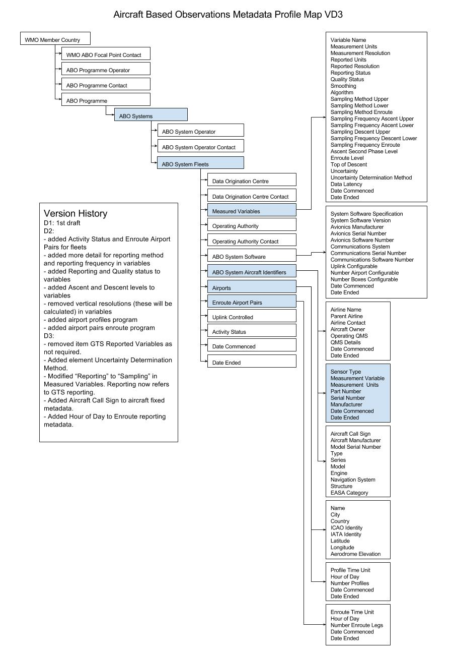

Annex V – Guidance on AMDAR Observing System Data Optimisation

Background

The AMDAR Observing System
Aircraft Meteorological DAta Relay[] predominantly uses the on-board aircraft sensors to measure meteorological information. The resulting data are then transmitted to the ground via VHF or satellite link using the aircraft’s own communications system (ACARS - Aircraft Communications Addressing and Reporting System). When the airline receives the data, it sends it on to the National Meteorological and Hydrological Services (NMHS) where it is processed, checked for quality and incorporated into meteorological applications, including Numerical Weather Prediction (NWP) models and forecasts for aviation.[]
The WMO global AMDAR system now produces over 600,000 high-quality observations per day of air temperature, wind speed and direction, together with the required positional and temporal information and with an increasing number of humidity and turbulence measurements being made.

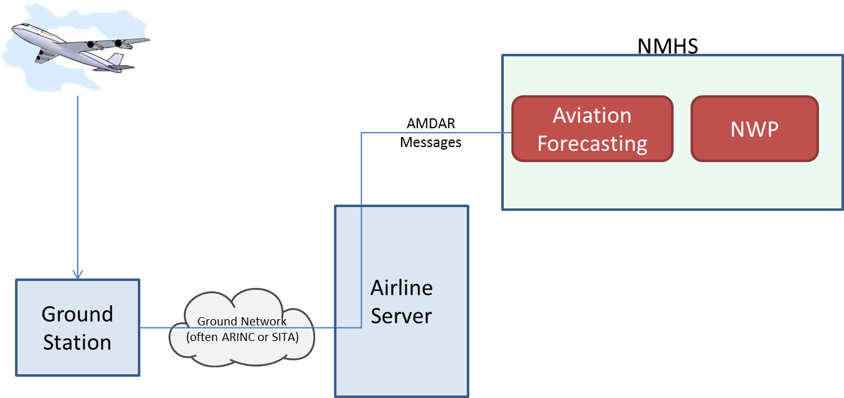
Figure 1: Block diagram of a typical non-optimised AMDAR Observation System
While the cost per observation is generally lower than for other upper air measurement systems, for example, the balloon borne radiosonde measurement system, most AMDAR programs involve a cost for each observation received by the NMHS. A large component of this cost is associated with the air to ground communications which, particularly over remote land and ocean areas, can be significant in a larger program with a fleet of many aircraft. It becomes a more significant issue still when satellite communications are required to be used (in preference to VHF communications).

Requirements for Data

Redundant Data
Redundant data are any observations that are surplus to requirements of data users and their applications. Meteorological requirements for upper air observational data are defined by WMO under its Rolling Review of Requirements[] process. WMO Members should ensure that they are aware of both national and international requirements of data users for the provision of upper air data before determining the best methods and configurations for optimisation of aircraft based observations and AMDAR observing systems.
Importantly, some data users may actually specify a requirement for what might initially be considered “redundant” data. For example, numerical weather prediction systems may be advantaged by the provision of one or more additional observations of particular variables at the same point in space and time so as to obtain or allocate a higher degree of certainty to such observations. Consideration of such requirements should also be made.

Data Coverage
Data coverage refers to the spatial and temporal distribution of aircraft observations.
For an AMDAR Program with redundant data, there are two key aspects of data coverage that are required to be specified and controlled:
- The temporal and spatial separation of vertical profiles (of meteorological parameters) made on aircraft ascent and descent; and,
- The temporal and spatial separation of isolated reports made during level flight.

The principal aim of an effective AMDAR data optimisation system is to enable delivery of output data at sufficient spatial resolution and temporal frequency to satisfy user requirements, without delivering greater volumes than required (redundant data).
One of the challenges is that such requirements may vary with location, local weather situation and season.
Whereas data supply will depend on:-
- passenger demand : this affects the number of aircraft that fly to a destination, and the types of aircraft used;
- Airline priorities and agreements made with NMHS for provision of data; and
- Airport capacity and regulations (for example curfews)
Figure 2 shows modelling based on data from the Australian Bureau of Meteorology. While actual figures for each AMDAR program will vary, the relationship between AMDAR fleet size and the trends in vertical profile production and redundancy are likely to be similar:
- The % of redundant profiles increases linearly with the number of non-optimised aircraft. In this data, with 50 aircraft ~1/3 of the profile are redundant.
- The number of redundant profiles (and hence their cost) increases non-linearly with the number of non-optimised aircraft. That is, a greater percentage of, a greater number of profiles are redundant. In this particular example, the number of redundant profiles increases as the square of the number of aircraft.
Based on this program and the requirements specified, 50 aircraft produce ~66,000 redundant profiles a year. Assuming US$2/profile, this amounts would amount to $132,000/year in redundant data and a potential saving of 33percent of communications costs if eliminated

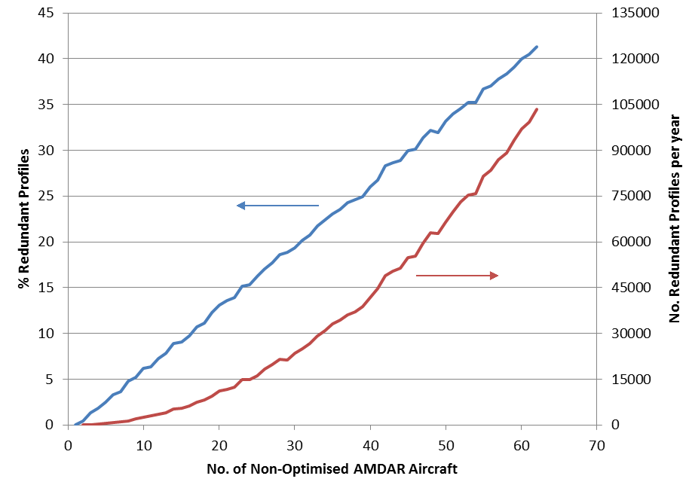
Figure 2: Increase in Redundant Data with number of aircraft

Optimization Methods/Strategies

AMDAR Software Capabilities
The AMDAR On-board Software Functional Requirements Specification (AOSFRS) specifies possible functionality of the AMDAR onboard software which would allow for varying degrees of data optimisation, depending on the level of compliance implemented. This includes:-
- Initiation of AMDAR onboard software configurations to manage:-
- Production of vertical profile data at a list of airports
  - with airport specific profile frequencies
  - with airport specific sampling frequencies
- Production of AMDAR data during the enroute phases with aircraft specific sampling frequencies
- Production of AMDAR data within geographical boxes.
- Production of AMDAR data within time windows.
- Ability to adjust stored configurations both manually and remotely.
- Ability to receive and process requests to remotely make changes to the AMDAR reporting configuration, to be effective either permanently or for the current or next flight only.

While use of the stored/default configurations for each aircraft can provide a degree of control over data output and program optimisation, in isolation, it is (by definition) unable to respond dynamically to the reporting of observations by other aircraft, which will be variable and changing, being subject to airline operational schedules. For this reason, the ability to make changes to an aircraft configuration, both remotely and automatically, in response to a command request, is required.
Remote changes typically require a formatted command message to be sent to the aircraft using the standard ACARS (data) link. This command is often referred to as an uplink.

AMDAR Optimisation Systems
While it is feasible for some degree of data optimisation to be achieved by a person issuing uplink commands in response to changing conditions, the best solution comes from using a ground-based and automated (optimisation) system. This allows 24/7 response to changing meteorological requirements for data and aircraft operations and data availability.
The section below outlines the steps such optimisation software ideally should implement. The perfect system would be one that had the flexibility to manage all the AMDAR equipped aircraft available to a NMHS. This allows the best response to changes in weather conditions and demand.
However, it is recognised that in practice, perhaps due to issues of compatibility between the systems used by different airlines or due to their preferences, an AMDAR optimisation system may well have to rely on individual airline-by-airline optimisation.

Optimisation System Processes
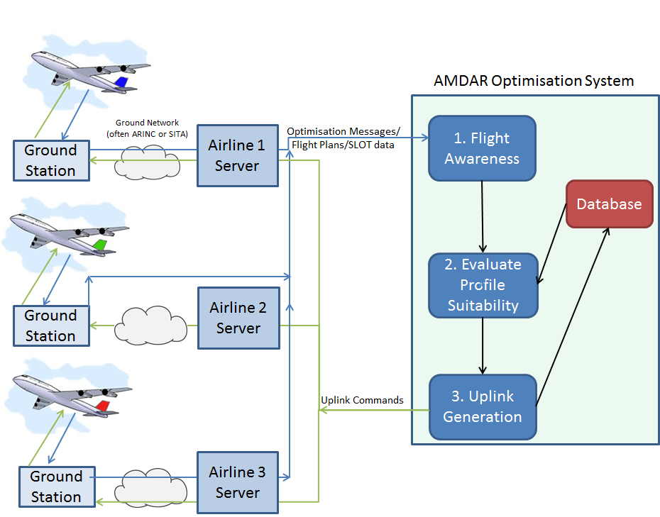
Figure 3: Block diagram of a full AMDAR optimisation system.
A full AMDAR optimisation system is depicted in Figure 4 and consists of three main steps. These are outlined in greater detail below, but consist of:-
- Flight Awareness: Before take-off (generally when the aircraft leaves the gate) it sends an Optimisation Message to the AMDAR Optimisation system. This contains sufficient information for the System to identify the aircraft and the route (origin/destination) involved. Alternatively, the aircraft can be identified from flight plans.
- Evaluate Profile Suitability: Before the aircraft takes off, the Optimisation system decides what data, if any, is required from this flight and
- Uplink Generation: sends the appropriate uplink command to switch on/off data collection during the different flight phases. Even if no data is required from this flight, an uplink command may still be required to override the settings from the previous flight by this aircraft.
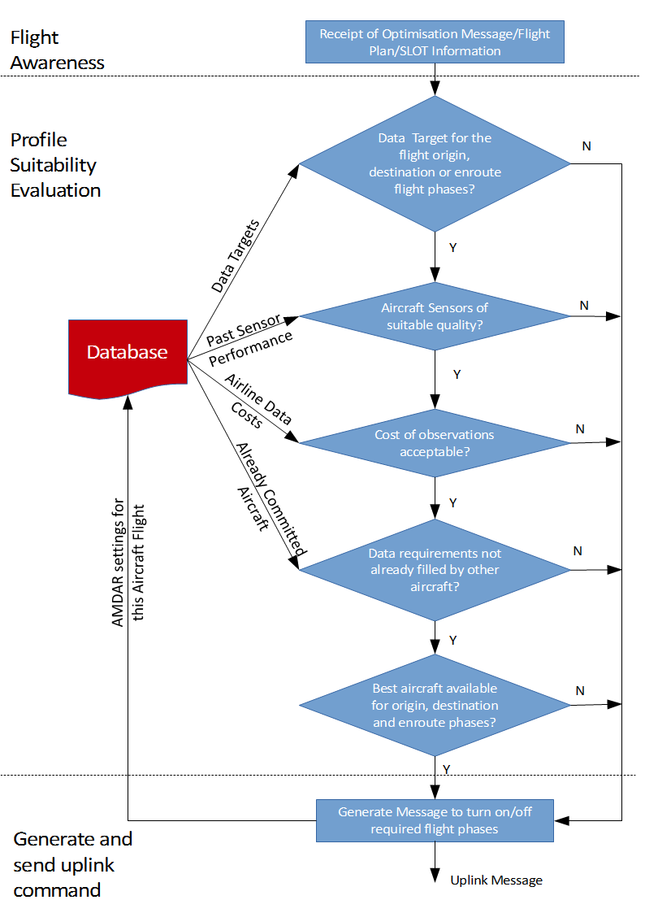
Figure 4: Decision Steps for AMDAR Optimisation processing.
Step 1: Flight Awareness
The first stage of any optimisation is the system “becoming aware” of an AMDAR aircraft flight. This can be the result of the receipt of an Optimisation Message. Alternatively, flight plans can be reviewed to extract the required information.
Whatever the format, the message contains (at a minimum):-
- Aircraft identity – either providing or able to be linked to the aircraft call sign (or tail number)
- Flight origin
- Flight destination
- Time of departure
- Time of arrival at destination
Step 2: Profile Suitability Evaluation
Once the optimization system is aware of a flight, it must decide if that aircraft meets the requirements or if there is a better flight available. In any case the optimization system must decide which flight phases (if any) shall be configured to report AMDAR data.
The decision to activate or deactivate the AMDAR onboard software for data collection will depend on one or more of the following factors:-
- Data Requirements:-
  - From the “Flight Awareness” phase, the flight origin and destination are known. Thus it can be determined where and (an estimate of) when profiles (on aircraft ascent and descent) and the series of enroute reports (made between the departure and destination airports) will be generated.
  - This potential data availability is then compared to a maintained set or database of rules or targets for AMDAR data collection for a list of airports, areas and routes, which are based on the requirements for upper air data. Rules may also be dependent on:-
    - time of day
    - season
    - local weather conditions
    - a preference for ascent profile data over descent
    - a special area or airport configuration
    - a preference for short or long-haul flights
    - a preference for en-route reporting

- Aircraft reporting and configuration status:-
  - From the “Flight Awareness” phase the identity of the aircraft is known. This can be used to interrogate an internal NMHS database to determine the status of the aircraft based on available metadata. Factors to be considered include:-
    - Data quality of reported parameters: Has the aircraft been “black-listed” for reporting based on previous data quality checks, e.g. comparison to computer model or radiosonde.
    - The preference of one aircraft over another for the provision of critical parameters, e.g. the reporting of humidity or turbulence.

- Aircraft/Airline observation cost:-
  - From the “Flight Awareness” phase the identity of the aircraft is known which can then be used to obtain from the database the aircraft or airline-based cost of the data.
  - This can be compared with the costs of any alternative flights for the same time and departure or destination airport and the enroute segment.

- Flights already committed by aircraft not configurable by uplink:-
  - There may already be aircraft committed to provide some or all of the data requirements for the particular time and flight phases offered by the uplink-capable aircraft. While these may not be changed by the optimisation system, they might be taken into consideration if the system is “aware” of their operations.
  - An optimisation system can be made aware of these flights and their output data from their OOOI/Optimisation messages, or deduced from received observations, if these messages and data are provided to and processed by the optimisation system.

- Uplink capable AMDAR aircraft already committed:-
  - Many airlines charge a cost for uplink messages. The comparative cost of uplink vs downlink/observation messages determines whether changing an aircraft configuration in flight provides any benefit.

No data may be required from this flight because the AMDAR quota for the origin and destination airports, and the route are already filled by flights nearby in time and/or space.
An optimisation system may wait to see if “better” aircraft becomes available (for example one with a humidity sensor). While changing an aircraft’s configuration during flight is usually possible, the decision on, at least, whether an Ascent Profile is collected needs to be made before the aircraft takes off.
Step 3: Generate and Send Uplink Command
Once the optimisation system has decided which flight phases (if any) to activate, the system should generate the necessary message(s) and send it (them) automatically.
An uplink message may still be required to turn off flight phases that are activated from previous flights or by default.
Uplink Message Security
Airlines understandably have security concerns about allowing third parties to directly uplink to their aircraft. Instead, the optimisation system may send uplink commands to an airline server, where they undergo further checks before being sent to the aircraft. These checks are ideally automated (to save time and allow continuous, unattended operation), but may require additional interfaces to be developed on the airline server.
Airline server checks include:-
- Message formatting is correct – parameters are within allowed ranges and there has been no corruption during transmission.
- Message type/content is allowed – only certain types/formats of uplink messages are authorised to be sent by the optimisation system. This stops a hacked optimisation system having unlimited access to the aircraft.
- Message volumes are within acceptable limits. This stops a malfunctioning (or hacked) optimisation system overloading the aircraft uplink.

Optimisation System Formats

Flight Awareness Messages
Several formats are currently in use including:-
- OUT[] message
- G-ADOS[] OPS or SLOT format
- AOSFRS[] Optimization Message.

Uplink Messages
Currently a number of different formats for this message are in use. The key difference between the formats is whether the message is:-
- passed unchanged through the airline servers to aircraft [BOM ADOS, AOFSRS]
- in a format that an airline’s server translates into the appropriate (airline specific) format [G-ADOS]

AMDAR Optimisation System Functionality Requirements
Component | Functionality | Section | Importance
System User Interface | Allow modification of targets for data coverage |  | Essential
System User Interface | Allow NMHS direct access via a graphical user interface. |  | Recommended
System User Interface | Allow temporary adjustment of coverage targets for a set period, followed by reversion to a default. |  | Optional
System User Interface | Allow maintenance of fleet metadata |  | Essential
System User Interface | Allow configuration for:-  - airports  - aircraft  - geographic areas |  | Essential
System User Interface | Allow configuration for routes/airport pairs |  | Recommended
Database | Store target number of profiles for an airport (e.g. profiles per hour). | 1.2.3.2 | Essential
Database | Store target data coverage for routes (i.e. airport pair), e.g. route legs per hour. | 1.2.3.2 | Recommended
Optimiser | Awareness of future flights with enough lead time to make decisions as to best aircraft configurations to meet targets | 1.2.3.3 | Essential
Optimiser | Algorithm to decide which phases of flight (if any) to enable | 1.2.3.3 | Essential
Optimiser | Optimisation incorporates preferential selection of aircraft based on measurement capabilities |  | Recommended
Optimiser | Optimisation incorporates preferential selection of aircraft based on observations cost |  | Optional
Optimiser | Optimisation incorporates preferential selection of aircraft based on measurement quality status |  | Recommended
Optimiser | Optimisation incorporates preferential selection of aircraft based on estimated time of flight phase |  | Optional
Optimiser | Reception and analysis of response and non-response to uplink commands |  | Optional
Optimiser | Reception and analysis of AMDAR data to assess response and non-response to configuration |  | Optional
Optimiser | Optimisation incorporates awareness of AMDAR equipped aircraft which cannot have their configurations changed by uplink |  | Optional
Database | Ability to store current aircraft configurations for reference when assessing future flights | 1.2.3.3 | Essential
Communications | Ability to send (re)configuration messages to aircraft (possibly via airline server) | 1.2.3.4 | Essential
Database | Store data quality status information for aircraft to assist configuration decisions | 1.2.3.2 | Recommended
Database | Store aircraft additional sensor (eg. Water Vapour, icing) to assist configuration decisions | 1.2.3.2 | Recommended
Database | Store airline/aircraft data cost to assist configuration decisions | 1.2.3.2 | Optional

Appendix A: AMDAR Optimisation Implementations

A.1 Australian Bureau of Meteorology
The Australian Bureau of Meteorology runs a fully automated AMDAR Optimisation System (ADOS). The screenshot (Figure 4) shows the available options for each aircraft, including:-
- Sensor quality information for Temperature, Wind, DEVG (Turbulence) and Water Vapour
- Aircraft specific rules for
- Airport
- Latitude/Longitude Reporting boxes
- Reporting times.

This system uses the OOOI messages as its Flight Awareness message and generates an uplink command that is passed unchanged to the aircraft after checking by the airline’s servers.
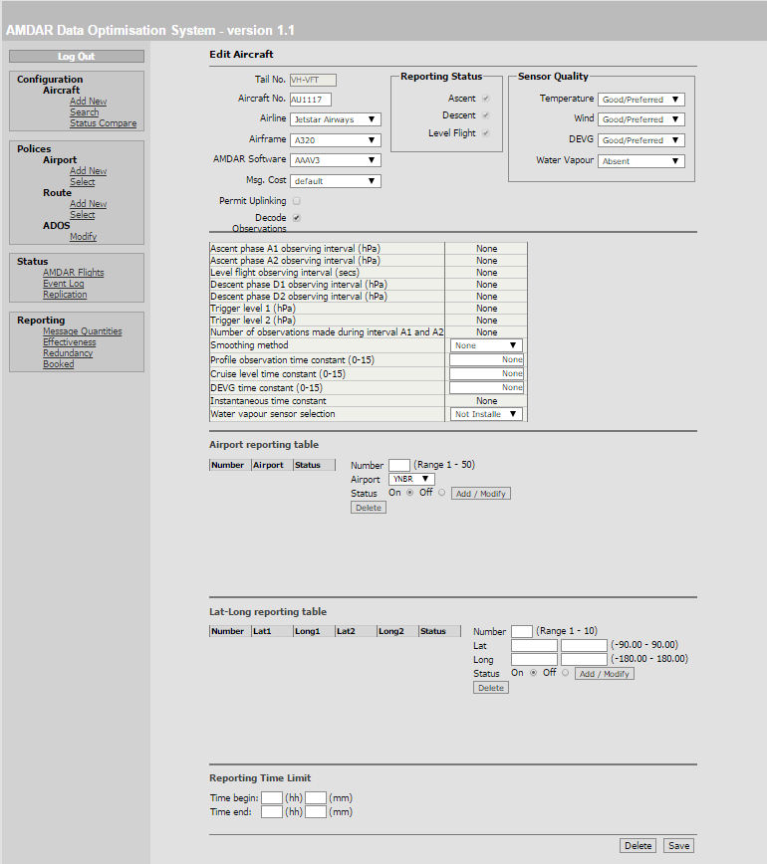
Figure 4: Australian Bureau of Meteorology ADOS system screen shot.

A.2 E-AMDAR
Currently (January 2016), the E-AMDAR program has a range of optimisation options. These include :-
- E-AMDAR Data Optimisation System (E-ADOS):
  - Full automated and flexible AMDAR optimization
  - Graphical interface allows real configuration
  - Optimisation configurations for airports, aircraft, routes and geographic regions in general or for time periods
  - For Flight Awareness E-ADOS accepts several message formats including IATA (ASM and OOOI) messages.
  - Standard format Flight Awareness and Uplink Command messages are generated by the system, which each airline then translates/adapts to their own system. Alternatively an uplink command is generated that is passed unchanged to the aircraft after checking by the airline’s servers.
  - Supports uplink message formats according ARINC-620 and AAA V3 specification.
  - Airlines:
    - Lufthansa (DLH)
    - Lufthansa Cityline (CLH)
    - Lufthansa Cargo (GEC)
    - Germanwings (GWI)
    - Thomas Cook Scandinavia (VKG)
    - Finnair (FIN)
    - Austrian Airlines (AUA)
    - KLM (B737NG Fleet) (KLM)
    - Air France B777 Fleet (AFR)

- AFR Flight Selection System (FSS):
  - Optimisation on profiles in a time period (eg 1 profile in 120 minutes) at an airport
  - Aircraft:
    - Air France A320 Fleets (AFR)
NOTE: AFR A320 fleets may also migrate to E-ADOS.

- SAS Flight Selection System:
  - Optimisation on city pairs (that is, can select ascent, cruise or descent profiles for a route eg. LGKF to ENGM
  - Airlines:
    - Scandinavian Airlines (SAS)
    - Blue1 (BLF)
- NOTE: SAS and any remaining BLF operations will migrate to E-ADOS April 2016.

- British Airways Flight Selection System:
  - Optimisation rules for each participating airport
  - Aircraft:
    - British Airways (BAW) B737, B747, B767 fleets

- EZY ARINC OpCenter:
  - Optimisation on airport/route pairs
  - Airline:
    - easyJet (EZY)
    - Novair (NVR)

Annex VI – Guidance on AMDAR Onboard Software Development

1. Introduction
This document provides brief and general guidance to WMO Members and their partner airlines on the requirements and process to develop and implement AMDAR onboard software on commercial aircraft fleets. Such development enables onboard atmospheric measurements to be accessible in near real-time for use by National Meteorological and Hydrological Services (NMHS) in numerical weather prediction and other meteorological forecasting applications for both aviation and the general public. The document consists of:
- an overview of the various aircraft and avionics (aviation electronics) platforms and AMDAR applications solutions; and
- a simple road map for the process of AMDAR onboard software development and implementation.
General descriptions and information about the AMDAR observing system and its functionality can be found on the website of WMO (see http://www.wmo.int/pages/prog/www/GOS/ABO/AMDAR/).
Specific and detailed requirements for AMDAR onboard functionality are provided in the WMO AMDAR Onboard Software Functional Requirements Specification (AOSFRS), available from the AMDAR/Resources site.
Guidance on the wider requirements for implementation and operation of an AMDAR programme are available in WMO WIGOS Technical Report 2014-2, Requirements for the Implementation and Operation of an AMDAR Programme.

2. Background
Until the middle of the 20th century, information and data relating to various aspects of aircraft flight operation, performance and navigation were available within the cockpit only as visual analogue or coarsely digitized displays and gauges. Then, gradually, the avionics evolved into digitized systems, either receiving digital input or converting the analogue input after reception.
In modern aircraft, atmospheric data, including static and total pressure and air temperature are sampled as close as possible to the sensor elements by the air data computer (ADC) and sent, or made available to other avionics units within the aircraft, for example, the flight management system (FMS), via digital connections.
All the flight mechanical and navigation signals as well as all other system data (for example, engine status) are processed digitally. The real-time flight data are of interest to the cockpit crew for a range of purposes associated with flight operation and aircraft performance and some elements also to air traffic management. Whereas the communication of this information in-flight was once done via voice radio, nowadays, large volumes of data can be automatically transmitted to ground via ground-based or satellite-borne networks of transceiver stations or else downloaded on arrival for use by the airline for post-flight analysis.

3. Automatic Aircraft Data Processing and Communications Systems
The first international deployment of an automatic aircraft communications system is the ARINC system solution called Aircraft Communications Addressing and Reporting System (ACARS). The corresponding equipment aboard an aircraft may be called the Management Unit (MU) or, in the case of newer versions with more functionality, the Communications Management Unit (CMU). Since the late 1990s Airbus aircraft are equipped with a system called Air Traffic Services Unit (ATSU). In addition to the conventional ACARS data and message processing, this system also handles the routing of Air Traffic Control (ATC) information.
These avionics units function both as data acquisition systems and as routers for the processed data.
On some aircraft types (e.g., UPS aircraft Boeing B757) the data sampling and processing is carried out by a system called the Digital Flight Data Acquisition Unit (DFDAU), which sends these data to a separate ACARS unit. Another kind of data acquisition unit is called the Aircraft Condition Monitoring System (ACMS). These units are modular in design and transfer their output data to the system component that provides the ACARS downlink communications function.
There are a range of vendors of these avionics systems that include the most common and widespread in deployment, including Teledyne, Rockwell-Collins, Honeywell, etc.
In most cases, the unit’s sampling behavior is programmable in compliance with special ARINC standards. Key standards include:
- ARINC 618 - Air/Ground Character-Oriented Protocol Specification:
which governs the format of user defined ACARS messages (that is air to ground)
- ARINC 620 - Data Link Ground System Standard and Interface Specification (DGSS/IS):
which describes the sampling activity and frequency being configurable depending on the user’s interest.
- ARINC 429 - Digital Information Transfer System (DITS):
which describes the data bus used on most commercial aircraft.
Using such functionality, purpose-built applications can be developed for the avionics systems to enable the controlled recording and sending of data in real-time or based on various triggers, such as time, or the value of particular parameters and variables. External and ground-based control of these applications is also possible, through the use of uplink commands sent via the communication provider to the onboard ACARS unit or the corresponding data acquisition unit. In this way, the applications can be reconfigured before or in-flight for specified sampling and reporting behavior during different flight phases.
In the case of the AMDAR onboard application - the AMDAR Onboard Software - it is the aircraft’s sampled data of the ambient atmosphere that is of interest for meteorological purposes.

4. Special Amendment of ACARS for Meteorological Use

4.1 AMDAR Onboard Software
In the following description, the AMDAR Onboard Software (AOS) is referred to as the “AOS module”. It consists of the following components and functionality:
- Accept input data from a variety of the aircraft innate avionics equipment.
- Perform high level quality checks on the input data.
- Perform calculations upon the input data to derive required meteorological parameters
(flags and optionally turbulence statistics).
- At set intervals, process collected data into standard output messages for transmission to ground stations.
- Accept inputs, allowing users to alter the AMDAR Onboard Software behavior.
WMO and its expert teams have historically developed and maintained several standards for AOS functionality and corresponding uplink and downlink formats:
- AOSFRS issued by WMO, an approach for overarching the standards for the aircraft communications systems:
[see: http://www.wmo.int/pages/prog/www/GOS/ABO/AMDAR/resources/index_en.html]
This specification provides the primary WMO meteorological-based specification for AMDAR onboard software.
The AOSFRS defines the recommended formats for AMDAR data uplink and downlink for ACARS applications of AMDAR onboard software. This specification will be consistent with and provide the functional requirements for the ARINC 620-8 Meteorological Report Version 6.
The AOSFRS is published and will be maintained as a CIMO, Instruments and Observing Methods (IOM) technical report.
- ARINC 620 issued by Airlines Electronic Engineering Committee (AEEC),
i.e. for applications on ACARS units like MU or CMU (programmed i.e. by Honeywell):
This document contains the specifications of the AMDAR onboard software, Meteorological Report (from version 1 - 6). Data link formats and flags are defined here.
A copy of the latest specification can be purchased from the ARINC Store.
- AAA (ACARS AMDAR ACMS) once written for applications on Teledyne units,
These software applications have been developed by AirDatec and implemented for Qantas and Jetstar Airbus and Boeing fleets, South African Airways Airbus fleets and British Airways fleets. The AAA specification series is now superseded by the AOSFRS (see above).
The standards provide the specification of requirements for functionality and message formats for the AOS module’s implementation by an avionics applications developer. It is recommended that only the most recent versions of these standards are used as a basis for new and future AOS application solutions using ACARS and alternative or succeeding systems. In particular, the AOSFRS provides the full and detailed specification of required functionality for AOS, with version 1.1 compatible and consistent with version 6 of the Meteorological Report formats as specified within the ARINC 620 Supplement 8 and later.
The feasibility of AMDAR implementation, the level of functionality and also the options (humidity, turbulence, event controlled transmissions, optional parameters for quality control) able to be implemented will heavily depend on the performance and architecture of the avionics.
Figure 1 provides a schematic and simplified overview of those parts of the avionics infrastructure playing a role in the AOS operation.
On the left hand side are the existing avionics system components that continuously generate the input for the AOS, such as
- the air data computer for the aerodynamic parameters
- the navigation system delivering flight mechanic data and the position
These data are transmitted to a system normally called the “flight management system” (FMS). Many of the real-time flight operational processes are run in the FMS, for example, the wind calculation.
The parameters listed in the output column of the FMS box in figure 1 are transmitted to the data acquisition unit running the AMDAR on-board software (AOS). On some aircraft types this is the same unit that hosts the data link functions for ACARS (e.g. MU, CMU, ATSU, etc). On other aircraft the AOS may be run on separate data acquisition units, e.g. DFDAU or ACMS.
The parameters FMS 1. to 7. are the conventional set of AMDAR data to be processed by the AOS.
The humidity values get directly into the AOS unit via an extra ARINC 429 interface driven by the humidity sensor system.
The parameters FMS 8. and 9. are requested by the latest ARINC 620 or AOSFRS versions. These parameters are useful input to the nowcasting and the numerical weather prediction respectively.
The parameters FMS 10. to 16. are parameters being required if the AOS also consists of the turbulence statistics process.
The parameters FMS 17. to 19. are temporarily of interest for quality control purposes. The activation depends on corresponding uplink commands sent on demand to the aircraft.
Depending on the avionics architecture or the firmware’s dimensioning the AOS unit can process uplink commands from ACARS.
By all means, this unit sends the AMDAR data to ACARS for downlink transmission.
It may happen that the downlink does not only have to send the regular reports but also additional reports having been triggered in between by turbulence events.

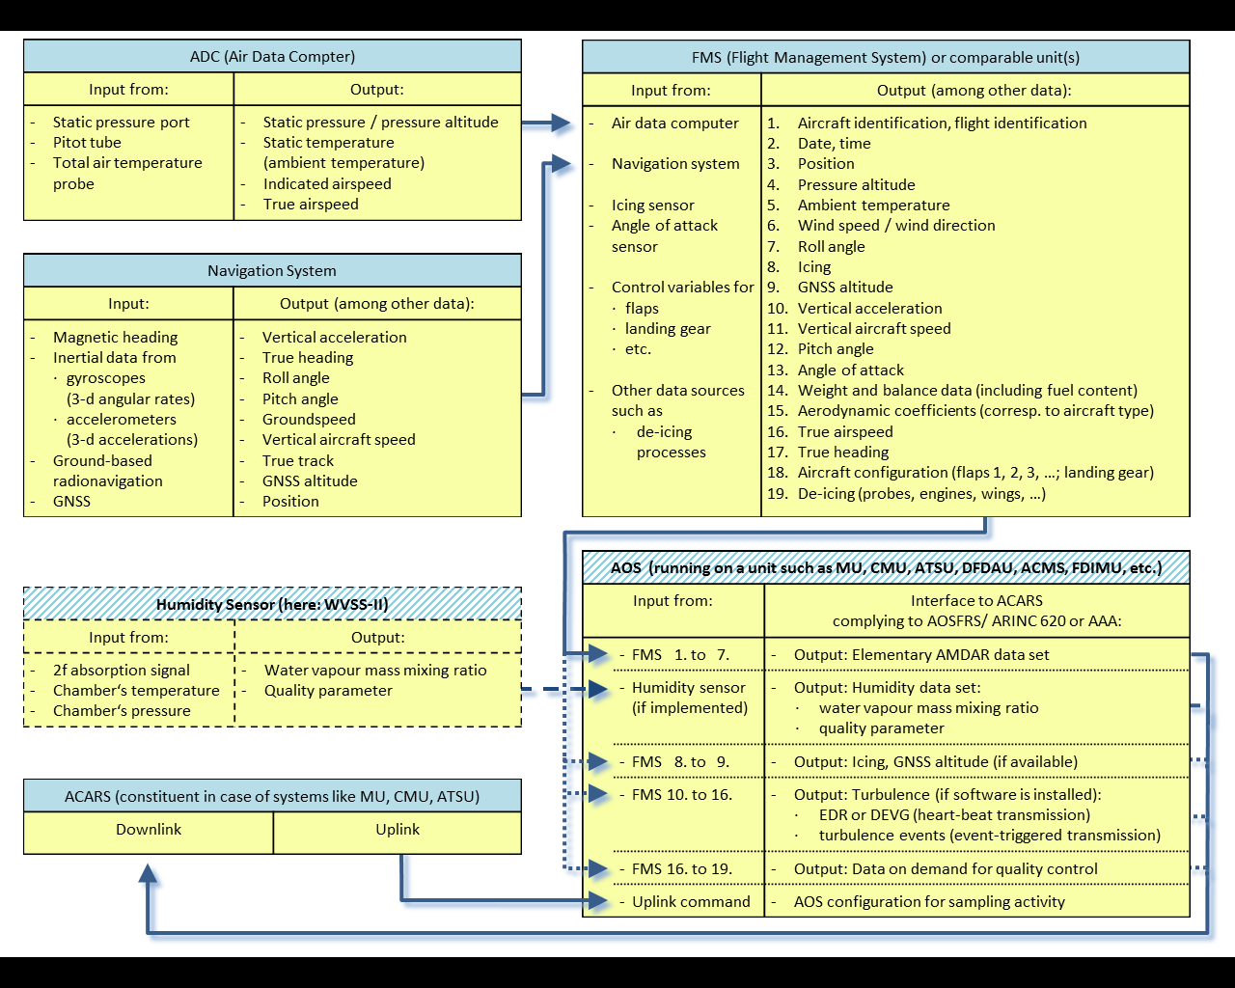 | Figure 1:  Schematic overview of the information flow on an aircraft from the relevant sensors to the system component where the AMDAR On-Board Software (AOS) is running and where the transfer to the downlink process of ACARS is done.  The table blocks with the hatched title bar describe the parts which do not belong to the standard aircraft equipment.  The dashed and dotted arrows mark the handling of parameters beyond the basic AMDAR data set. Provision of humidity data depends on the existence of humidity instrumentation and on the implementation of an AOS complying with the latest AOSFRS or ARINC 620 standard.

4.2 Development and Implementation of AMDAR Onboard Software

4.2.1 Availability of Existing AOS Modules
In some cases, it may be that an AOS application is already available as an ARINC 620 compliant module (enabling provision of AMDAR reporting via the ARINC 620 Meteorological Report) within the existing avionics system and the applications suite delivered by the avionics vendor of the prospective airline AMDAR fleet.
Alternatively, it may also be possible that such an application is available but not yet installed within the particular avionics system in question. This has been true of several AMDAR programs taking advantage of Honeywell systems. However, unfortunately, at the current time, this seems to be rare and, in most cases, a special AOS application development will be necessary, especially in the case that compliance with the latest AOS standards is required.
In addition, an AOS module for the prospective AMDAR airline fleet and its particular avionics configuration may have already been developed and implemented in another AMDAR program. In which case, it may also be possible to arrange for that AOS to be provided or purchased through negotiation with either the relevant airline or avionics vendor. A list of current airframes supporting AMDAR is in Appendix 1.
However, care should be taken to ascertain if the existing AOS module provides the required functionality for the new or prospective AMDAR programme. Additionally it is often the case that an AOS module that functions correctly on one airline fleet, may not do the same on that of another, even if the avionics systems are the same, due to differences in configuration and other factors. Therefore, ground-based and in-flight testing of all AOS modules, whether new or ported from another development, should be undertaken and it should be understood that there may be a requirement for some reprogramming and/or reconfiguration of the AOS module by a developer.

4.2.2 Development of AOS Modules
The development of AOS applications for the relevant avionics equipment of an airline can be done in one of several possible ways:
- the corresponding avionics vendor;
- by a suitably qualified and certified 3rd party contractor; or possibly
- by a specialized department of the airline itself.
In most cases, the airline will make the decision about which of these possible solutions for AOS development is appropriate and/or permissible. The cost of AOS implementation is outlined in the WMO Technical Report No. 2014-02 (Requirements for the Implementation and Operation of an AMDAR Programme). Depending on the circumstances ranging from readily installable routines to the necessity of a completely new software development the costs might be anywhere in the range of US$10K and US$100K.

4.2.3 Process to Achieve AMDAR Onboard Software Implementation
In the Section 4.1 of the document, Requirements for the Implementation and Operation of an AMDAR Programme (WIGOS Technical Report No. 2014-02) the organizational project frame for the software implementation is given.
However, the required meteorological functionalities are to be programmed in compliance with or at least following the latest releases of AOSFRS and / or ARINC 620.

4.2.4 Decision about the commercial structure of the AMDAR project
The question about the topology and herewith the contract partners has to be solved. The NMHS or the regional AMDAR program has to decide if they take either the individual airlines or the network provider as contract partner. As a consequence, the path of the downlinked meteorological data to the principal either goes through the airline’s communication centre or directly via the network provider.
Both cases need the cooperation of the partner airlines.
Two things have to be cleared with the airline either directly or by the contracted network provider:
- the possibility of an AOS implementation (possibly including humidity and turbulence); and,
- the legal frame of the AMDAR data use because the owner of the data is the airline.

4.2.5 The AOS design or preparation
The entity finally to be addressed for any modification of the ACARS functionality is the corresponding airline. They will decide if the communication system may be modified. Some airlines are able to do the software modification or configuration by themselves. But in most cases there is the avionics vendor or another system integration partner having the administration rights and capabilities for the avionics units hosting data acquisition and ACARS. The final success depends on several things, such as:
- performance of the AOS host unit,
- portability of possibly available software to the host unit,
- certification efforts to be financed, if an AOS could interact with system parts being relevant for aircraft security or air traffic services communication.
Depending on the feasibility and finally on the price of the implementation compared to the number of accessible aircraft with compatible AOS hosting units the NMHS or regional AMDAR program can decide about ordering.
On the side of the physical functionalities, apart from the turbulence, all design parts of the AOS are independent of the aircraft type. The extent of handled parameters just depends on their availability via interfaces to the AOS host unit.
The software’s part for turbulence needs some coefficients depending on the aircraft type. This means some extra software configuration for each different aircraft type.

4.2.6 Testing of the AOS
The elementary precondition for this test is the correct operation of the ground systems doing both:
- the separation of the meteorological data from the downlinked ACARS reports; and
- the meteorological data transmission to the NMHS or regional program.
The AOS prototype implementation has to be tested during the normal flight operation over some months. The data analysis has to take into consideration data plausibility, outliers, deviations of the meteorological parameters from the first guess background of models.
The turbulence measurement part of the AOS needs test flights for each different type of aircraft. The sampled data need to be analyzed offline by specialists who derive the correct coefficients to be applied for the aerodynamically different aircraft.

4.2.7 Final Implementation of the AOS
In the case of AOS without turbulence, part the implementation consists of identical software installations on the appropriate family of hosting units of the fleet. In case of covering also the turbulence part the installations need different modules depending on the aircraft type.
However, the realization of AMDAR software implementations always depends on the cooperation of the partner airline. They need to see the advantages of the outcomes for improved weather forecasts as well as the improved quality control possible for the onboard instruments.

4.3 Ground Component of AMDAR Software
While not strictly part of the AMDAR Onboard Software, any development needs to consider the ground software systems that have the job of converting AMDAR data and controlling the AOS activity. Currently there is no international standard for this, with many different implementations in use around the world.
Two main considerations are:-
- Conversion/decoding of downlinked data
- Optimisation of AMDAR data collection

4.3.1 Converter for Downlinked Data
The meteorological data sent to the ground have to be picked out of the ACARS downlink data stream and sent to the corresponding NMHS or the data management centre of the regional AMDAR program. This diverting job can either been done by
- the contracted airline as being the proper receiver of the data or
- (by agreement with the airline directly) the broadcasting network service provider such as ARINC or SITA, or
- by the receiving NMHS
In any of these scenarios it is necessary to implement or at least configure software systems for that data diverting job.

4.3.2 Ground-based Optimisation & AOS Control
Ideally, the AOS should be controllable via ACARS uplinks as this can provide a significant operating cost reduction by limiting redundant data. For example, within a region like central Europe there are a large number of AMDAR configured aircraft. Over the frequented air traffic hubs the problem of costly redundancies from too many ascent and descent profiles has to be considered. Via an optimizing tool controlled by a ground based system, reporting can be activated or deactivated so as to optimally meet meteorological requirements for the production of profiles and possibly enroute data in both time and space.
The AOS features to be uplink configurable should be:
- data production and reporting during selected flight phases;
- modification of configurable software settings and parameters affecting the reporting regime; and
- Addition or removal of optionally-reported flight operations parameters for quality control purposes.
The detailed requirements for the uplinks are given by ARINC 620 and AOSFRS. An overview about the already existing systems for optimization and AOS control is provided in [REF Annex V].

Attachment I: List of AMDAR Onboard Software Versions and Platforms

AMDAR Program | Airline/ Operator | Airframe |  | AOS Specifier/ Standard | AOS Platform (Vendor, Version) |  | AOS Developer  Software Version
 |  | Type | Sub-Type |  | Data Acquisition System | ACARS Unit
Australia | SkyTraders | A 319 | 115 |  | Teledyne (FDIMU) | FLYHT / AFIRS | FLYHT/FLYHT
 | Jetstar  Jetstar Asia | A 320 | 200 | Bureau of Meteorology /  AAA v3 | --- | --- | - T AirDatec/Jetstar
 | Jetstar | A 321 |  | Bureau of Meteorology /  AAA v3 | --- | --- | - AirDatec/Jetstar
 | Qantas | A 330 | 200  300 | WMO /  AOSFRS V1.1 | Teledyne Controls  Flight Data Interface management Unit (FDIMU) | Airbus  /  Air Traffic Service Unit (ATSU) | - AirDatec/Qantas
 |  | B 767 | 300F | ARINC /  AAA v1 | Teledyne Controls  Digital Flight Data Acquisition Unit (DFDAU) | Rockwell Collins /  Communications Management Unit (CMU) | - KLM (1996)/Qantas
 |  | B 747 | 400  400ER | ARINC /  AAA v1 | Teledyne Controls  Data Management Unit (DMU) | Rockwell Collins /  Communications Management Unit (CMU)  or  Data Link Management Unit (DLMU) | - KLM (1996)/Qantas
 | Air Vanuatu | B 737 | 800 | Bureau of Meteorology /  AAA v3 | Teledyne Controls  Digital Flight Data Acquisition Unit (DFDAU) | Rockwell Collins /  Communications Management Unit (CMU) | - AirDatec/Qantas
Canada | Jazz | CRJ | 200, 200ER | ARINC 620-3  for Ascend  ARINC 620-2  for Enroute  & Descend | Rockwell Collins ADC-850A | Rockwell Collins CMU-900  P/N 822-1239-151 | - 832-1748-202 Core 7.3 Operating Software, Rockwell Collins  - 000-JAZZ-A04D Jazz AOC Software, Jazz Air Inc  - 815-4532-A01 AWR (Automatic Weather Reporting Software), Rockwell Collins  - 815-4536-200 APM (Aircraft Performance Monitoring Software) 1 Rockwell Collins
 | Nav Canada | CRJ | 200 |  | Rockwell Collins ADC-850A | Rockwell Collins CMU-900 | - Rockwell Collins PN (SW) 815-4532-200
 |  | DHC-8 | -100 |  |  | Universal Avionics UL-801 | - Universal Avionics SW 80X Type 5 Database SCN 30.X
 | Air Canada | B777 | 200LR
 |  | A330 | 300
 |  | B787 | 9 | AAA
 |  | B787 | 8
 |  | B767 | 300ER
 |  | A321 | 200 | ARINC 620
 |  | A320 | 200 | AAA
 |  | A319 | 100 | AAA
 |  | E190 |  | AAA
 | AC Express | E175
 |  | CRJ705
 |  | B767 | 300ER | ARINC 620
 |  | A319 | 100 | AAA
China | China Southern Airlines Company Limited | B737 | 800 | ARINC/  A620- |  | Honeywell  PN:965-0758-001  965-0758-002 | - Honeywell  998-2145-518  998-2141-517
 | Shandong Airlines CO., LTD | B737 | 800 | ARINC/  A620- |  | Honeywell  PN: 967-0212-002  967-0212-058 | - Honeywell  998-3638-508  998-7033-503
 | Xiamen Airlines CO., LTD | B737 | 86N | ARINC/  A620- |  | Honeywell  PN: 965-0758-002 | - Honeywell  998-2830-518  998-2833-515
 | China Eastern Jiangsu Branch | A320 | 214 | ARINC/  A620- |  | TELEDYNE  795040-31-003  2234320-01-01 | - FLY2240CEA1C217  D05SACF03C0CEAX
E-AMDAR | Air France (AFR) | A318 | 100 | ARINC/  A620-2  FM42 AMDAR 1996 | DMU (Teledyne)  DMU (SAGEM)  FDIMU | Collins ATSU | Air France Maintenance
 |  | A 319 | 100 | ARINC/  A620-2  FM42 AMDAR 1996 | DMU (Teledyne)  DMU (SAGEM)  FDIMU | Collins ATSU CMU900 | Air France Maintenance
 |  | A320 | 200 | ARINC/ A620-2  FM42 AMDAR 1996 | DMU (Teledyne) DMU (SAGEM) FDIMU | Collins ATSU CMU900 | Air France Maintenance
 |  | A321 | 100 | ARINC/  A620-2  FM42 AMDAR 1996 | DMU (Teledyne) DMU (SAGEM) FDIMU | CMU900 | Air France Maintenance
 |  | A321 | 200 | ARINC/  A620-2  FM42 AMDAR 1996 | DMU (Teledyne)  DMU (SAGEM)  FDIMU | Collins ATSU  CMU900 | Air France Maintenance
 |  | B777 | 200, 300 | WMO/  AOSFRS, v1.1 |  |  | Air France Technical Development Department
 | Austrian (AUA) | A 319 | 100 | ARINC/  A620-3 | FDIMU (SAGEM) ATSU CSB6,  DMU 360-4022-015 | Airbus ATSU | ARINC
 |  | A 320 | 200 | ARINC/  A620-3 | ATSU CSB6 ,  DMU 360-03585-320,  DMU 360-4022-015 (SAGEM)  FDIMU | Airbus ATSU | ARINC
 |  | A 321 | 100 | ARINC/  A620-3 | ATSU CSB6 ,  DMU 360-03585-320  (SAGEM) | Airbus ATSU | ARINC
 |  | A 321 | 200 | ARINC/  A620-3 | ATSU CSB6 ,  DMU 360-03585-320  (SAGEM) | Airbus ATSU | ARINC
E-AMDAR | British Airways (BAW) | B747 | 400 | Bureau of Meteorology /  AAA v3 | Spirent DMU  ACMS | Honeywell Mk II CMU | AirDatec
 |  | B767 | 300 | Bureau of Meteorology /  AAA v3 | Spirent DMU  ACMS | Honeywell Mk II CMU | AirDatec
 |  | A 319/320/321 |  | Bureau of Meteorology /  AAA v3 | Teledyne FDIMU  ACMS | Airbus ATSU | AirDatec
 |  | A318 |  | Bureau of Meteorology /  AAA v3 | Teledyne FDIMU  ACMS | Airbus ATSU | AirDatec
 |  | B777 |  | Bureau of Meteorology /  AAA v3 | AIMS FDC | AIMS function | AirDatec
 | Blue1  (BLF) | B717 | 200 | ARINC/  A620-2 | 967-0214-001 FDAMS (Honeywell)  Honeywell CMU CORE SW PN 998-2145-518  Honeywell FDAMS Database PN 998-7055-504 | 965-0758-001 CMU  (Honeywell) | ARINC
 | Royal Dutch Airlines  (KLM) | B 737 | 700 | Bureau of Meteorology /  AAA v3 | 2233000-825 (Teledyne) | CMU 965-0758-006 (Honeywell) | AirDatec
 |  | B 737 | 800 | Bureau of Meteorology /  AAA v3 | 2233000-825 (Teledyne) | CMU 965-0758-006 (Honeywell) | Airdatec
 |  | B 737 | 900 | Bureau of Meteorology /  AAA v3 | 2233000-825 (Teledyne) | CMU 965-0758-006 (Honeywell) | AirDatec
 |  | B 747 | 400 | ARINC/  AAA v1 | 2232000-02B (Teledyne) | CMU 965-0758-001 (Honeywell) | KLM (1996)
E-AMDAR | Lufthansa  City Line  (CLH) | CRJ | 900 | ARINC/  A620-3 | Honeywell 998-2833-519 CMU | Honeywell CMU MK2  965-0758-001 | ARINC
 | Lufthansa (DLH) | A319 | 100 | ARINC/  A620-3 | Honeywell 998-6092-521 CMU | Honeywell CMU MK2+  965-0758-006 | ARINC
 |  | A319 | 100 | ARINC/  A620-3 | Honeywell 998-2459-510 ATSU | Airbus ATSU LA2T0G21006CA10 | ARINC
 |  | A320 | 200 | ARINC/  A620-3 | Honeywell 998-6092-521 CMU | Honeywell CMU MK2+  965-0758-006 | ARINC
 |  | A320 | 200 | ARINC/  A620-3 | Honeywell 998-2459-510 ATSU | Airbus ATSU LA2T0G21006CA10 | ARINC
 |  | A321 | 100 | ARINC/  A620-3 | Honeywell 998-6092-521 CMU | Honeywell CMU MK2+  965-0758-006 | ARINC
 |  | A321 | 200 | ARINC/  A620-3 | Honeywell 998-2459-510 ATSU | Airbus ATSU LA2T0G21006CA10 | ARINC
 |  | A321 | 200 | DWD/LH  A620-3 | SAGEM ED48A200WR System SW: SAGEM, 360-04020-050  DB: Lufthansa Technik, 9907/0004 | Airbus ATSU LA2T0G21006CA10 | Lufthansa Technik
 |  | A330 | 300 | ARINC/  A620-3 | Honeywell 998-2459-510 ATSU | Airbus ATSU | ARINC
 |  | A340 | 300 | ARINC/  A620-3 | Honeywell 998-2459-503 ATSU | Airbus ATSU | ARINC
 |  | A340 | 600 | ARINC/  A620-3 | Honeywell 998-2459-510 ATSU | Airbus ATSU | ARINC
 |  | A380 | 800 | ARINC/  A620-3 | Rockwell-Collins ANSU OPS-2  Rockwell-Collins AOC  RCF5E00000L530C  RCF4300000P430C | Rockwell-Collins ANSU OPS-2 | Lufthansa Technik
 |  | B747 | 400 | ARINC/  A620-3 | Honeywell 998-6092-521 CMU | Honeywell CMU MK2+  965-0758-006 | ARINC
 |  | B747 | 8 | ARINC/  A620-3 | Honeywell 998-6092-521 CMU | Honeywell CMU MK2+  965-0758-006 | ARINC
 | Lufthansa Germanwings (GWI) | A319 | 100 | ARINC/  A620-3 | Honeywell 998-2459-510 ATSU | Airbus ATSU | ARINC
 |  | A319 | 100 | ARINC/  A620-3 | Honeywell 998-6092-521 CMU | Honeywell CMU MK2+ 965-0758-006 | ARINC
 |  | A320 | 200 | ARINC/  A620-3 | Honeywell 998-6092-521 CMU | Honeywell CMU MK2+ 965-0758-006 | ARINC
 | Lufthansa Cargo (GEC) | MD-11 | F | ARINC/  A620-3 | Honeywell 998-2141-517 CMU | Honeywell CMU MK2  965-0758-001 | ARINC
E-AMDAR | easyJet (EZY) | A319 | 111 |  | FDIMU (Teledyne) | Airbus ATSU | Airbus CSB 6.3
 |  | A320 | 214 |  | FDIMU (Teledyne) | Airbus ATSU | Airbus CSB 6.3
 | Finnair (FIN) | A319 | 112 | ARINC/  A620-3 | DMU ED45A300 (SAGEM)  FDIU ED43A1D6 (SAGEM) | Airbus ATSU LA2T0G21006CA10 (Airbus Operations S.A.S.) | ARINC  20TV: A/C Interface LA2T0J1307E00F1  21TX: Configuration LA2T0J60005E0F1  30TX: Router parameter LA2T0J0S6AY05F1  25TX: ATC HMI Utilities LA2T0K00003C0F1  36TX: ATC FANS B Application LA2T0K30001E0F1  37TX: CMA Configuration LA2T0K40001D0F1  31TX: ISM Application LA2T0C20030C0F1  ATSU AOC Application 998-2459-509
 |  | A319 | 112 | ARINC/  A620-3 | FDIMU ED48A100 (SAGEM) | Airbus ATSU LA2T0G21006CA10 (Airbus Operations S.A.S.)
 |  | A 320 | 214 | ARINC/  A620-3 | DMU ED45A300 (SAGEM)  FDIU ED43A1D6 (SAGEM) | Airbus ATSU LA2T0G21006CA10 (Airbus Operations S.A.S.)
 |  | A 320 | 214 | ARINC/  A620-3 | FDIMU ED48A100 (SAGEM) | Airbus ATSU LA2T0G21006CA10 (Airbus Operations S.A.S.)
 |  | A 321 | 211 | ARINC/  A620-3 | DMU ED45A300 (SAGEM)  FDIU ED43A1D6 (SAGEM) | Airbus ATSU LA2T0G21006CA10 (Airbus Operations S.A.S.)
 |  | A 321 | 211 | ARINC/  A620-3 | FDIMU ED48A100 (SAGEM) | Airbus ATSU LA2T0G21006CA10 (Airbus Operations S.A.S.)
 |  | A321 | 231 | ARINC/  A620-3 | FDIMU ED48A200 (SAGEM) | Airbus ATSU LA2T0G21006CA10 (Airbus Operations S.A.S.)
 | Novair (NVR) | A321 | 200 | ARINC/  A620-2 | Teledyne FDIMU  h/w 2234320-01-01 | Airbus ATSU  h/w LA2T0G20503B050 | ARINC
 | Scandinavian Airlines (SAS) | B737 |  | ARINC/  A620-4 | DFDAU (Teledyne)  ACMS | CMU (Teledyne) | ARINC
 |  | B737 |  | Honeywell Proprietary | FDAMS (Honeywell)  ACMS | CMU (Collins) | ?
 |  | A320 |  | ARINC/  A620- 2 | FDIMU (Teledyne) ACARS AOC | ATSU | ARINC
 |  | A330 |  | ARINC/  A620-2 | DMU (Honeywell) ACARS AOC | ATSU | ARINC
 |  | A340 |  | ARINC/  A620-2 | DMU (Honeywell) ACARS AOC | ATSU | ARINC
 |  | CRJ-900 |  | ARINC/  A620-2 | L3 MQAR  ACARS AOC | CMU (Collins) | ARINC
 | Thomas Cook (VKG) | A 321 |  | ARINC/  A620-3 |  | ATSU | ARINC
 |  | A 330 |  | ARINC/  A620-3 |  | ATSU | Honeywell V2 ARINC
Hong Kong |  |  | 400 | A620-3 v2
Iceland |  |  |  | TAMDAR
Japan |  |  |  | ACMS
 |  |  |  | ACMS
 |  | B 777 | 200  300  300ER | ACMS
 |  | B 787 |  | ACMS
New Zealand |  | A320 | 200 | ARINC/  AAA v1 modified | Teledyne  FDIMU | Airbus  ATSU | Air New Zealand/
 |  | B737 | 300 | ARINC/  AAA v1 modified | Teledyne  DFDMU | Rockwell Collins  DLM-900B series | Air New Zealand/
South Africa | SAA | A319 | 100 | Bureau of Meteorology //  AAA v3 | Teledyne  FDIMU  2234320-01-01  Honeywell AOC S/W 998-2459-510  Teledyne Core S/W F230-001-8801 | ATSU  LA2T0G20503B050 | SAA/AirDatec
 |  | A320 | 200 | Bureau of Meteorology //  AAA v3 | Teledyne  FDIMU  2234320-01-01  Honeywell AOC S/W 998-2459-510  Teledyne Core S/W F230-001-8804 | ATSU  LA2T0G20503B050 | SAA/AirDatec
 |  | A330 | 200 | Bureau of Meteorology //  AAA v3 | Teledyne  FDIMU  2234340-02-02  Honeywell AOC S/W 998-2459-510  Teledyne Core S/W F240-001-0006 | ATSU  LA2T0G20503B050 | SAA/Airdatec
 |  | A340 | 300, 600 | Bureau of Meteorology //  AAA v3 | Teledyne  FDIMU  2234340-02-02  Honeywell AOC S/W 998-2459-510  Teledyne Core S/W F240-001-0006 | ATSU  LA2T0G20503B050 | SAA/AirDatec
South Korea |  |  |  | A620-6
 |  |  |  | A620-6
 |  |  | 400 | A620-6
USA | FedEx | A 300 | 600 | A620-3 | Sagem DFDAU P/N ED47F109  All except N687FE to N692FE  Sagem DFDAU P/N ED47C109  N687FE to N692FE only | Collins DLM-705C  P/N 822-0661-003 | VER 007
 |  | A 310 | 200 | A620-3 | Sagem DFDAU P/N ED47F109 | Collins DLM-705C  P/N 822-0661-003 | VER 007
 |  |  | 300 | A620-3 | Sagem DFDAU P/N ED47F109 | Collins DLM-705C  P/N 822-0661-003 | VER 007
 |  | B 757 | 200 | A620-3 | Honeywell DFDAU P/N 967-0212-050 | Collins CMU-900  P/N 822-1239-151 | Core S/W 832-9548-010
 |  | DC-10 | 10 | A620-3 | Honeywell DFDAU P/N 967-0214-001 | Collins DLM-705C  P/N 822-0661-003 | VER 004
 |  |  | 30 | A620-3 | Honeywell DFDAU P/N 967-0214-001 | Collins DLM-705C  P/N 822-0661-003 | VER 004
 | UPS | A 300 | 600 | A620-3 |  | Collins DLM-900  P/N 822-0666-003 | Core S/W 832-1748-114
 |  | B 757 | 200 | A620-3 |  | Collins DLM-900  P/N 822-0666-003 | Core S/W 832-1748-114
 | Delta | B757 | 200 | A620-3 |  | Collins DLM-716C  P/N 622-9676-402 | VER 008
 |  |  |  |  |  | Collins DLM-716  P/N 622-9676-501 | VER 10
 |  |  |  |  |  | Collins DLM-716C  P/N 622-9676-501 | VER10
 |  |  |  |  |  | Collins DLM-716C  P/N 622-9676-501 | Core Unknown
 |  |  |  |  |  | Bendix MUA-45A  P/N 3614291-4518 | Normal 18N
 |  |  |  |  |  | Honeywell Mark 2  P/N 965-0758-001 | Core S/W 998-2145-518  APPL 998-2141-517  Core S/W 998-2145-518
USA | Delta | B757 | 300 | A620-3 |  | Collins DLM-716C  P/N 622-9676-402 | VER 008
 |  |  |  |  |  | Collins DLM-716C  P/N 622-9676-501 | Core Unknown
 |  |  |  |  |  | Bendix MUA-45A  P/N 3614291-4518 | Normal 18N
 |  |  |  |  |  | Honeywell CMU Mk2  P/N 965-0758-001 | Core S/W 998-2145-518
 |  | MD 88 | 88 | A620-3 |  | Collins DLM-705C  P/N 622-9676-201 | VER004
 |  | MD 90 | 30 | A620-3 |  | Collins DLM-705C  P/N 622-9676-301 | VER 005
 |  | B737 | 700 | A620-3 |  | Collins CMU-900  P/N 822-1239-101 | Normal 832-1748-102
 |  |  | 800 | A620-3 |  | Collins CMU-900  P/N 822-1239-101 | Normal 832-1748-102
 |  |  | 900 | A620-3 |  | Collins CMU-900  P/N 822-1239-101 | Normal 832-1748-102
 |  | DC 9 | 51 | A620-3 |  | Bendix MUA-45A  P/N 3614291-4518 | Normal 18U
 |  |  |  |  |  | Bendix Unknown  P/N 3614291-4518 | Normal 18H 18H.3/18J
 | Southwest | B 737 | 300 | A620-3 | Teledyne | Honeywell CMU MK3  P/N 7519200-921 | Core S/W 998-3287-502
 |  |  | 500 | A620-3 |  | Honeywell CMU MK3  P/N 7519200-921 | Core S/W 998-3287-502
 |  |  | Max 7 | A620-3 |  | Honeywell CMU MK3  P/N 7519200-920 | Core S/W PS7028944-07000
 |  |  | 700 | A620-3 |  | Honeywell CMU MK3  P/N 7519200-921 | Core S/W 998-3287-502
 |  |  | Max8 | A620-3 |  | Honeywell CMU MK3  P/N 7519200-920 | Core S/W PS7028944-07000
 |  |  | 800 | A620-3 |  | Honeywell CMU MK2  P/N 65-0758-006 | Core S/W 998-6063-501
USA | Alaska | B 737 | 400 | A620-3 | SAGEM p/n ED47B109 | Collins CMU-900  P/N 822-1239-101  P/N 8221239-151 | Core S/W 832-1748-103  Core S/W 832-9548-012
 |  |  | 700 | A620-3 | SAGEM p/n ED47B109 | Collins CMU-900  P/N 822-1239-101  P/N 8221239-151 | Core S/W 832-1748-103  Core S/W 832-9548-012
 |  |  | 800 | A620-3 | SAGEM p/n ED47B109 on most 800s  SAGEM p/n 261303876-1000 on last 6 each 737-800s | Collins CMU-900  P/N 822-1239-101  P/N 8221239-151 | Core S/W 832-1748-103  Core S/W 832-9548-012
 |  |  | Max 9 | A620-3 | Will be Teledyne eDFDAU p/n TBD | Collins CMU-900  P/N 822-1239-101  P/N 8221239-151 | Core S/W 832-1748-103  Core S/W 832-9548-012
 |  |  | 900 | A620-3 | SAGEM p/n ED47B109 on 12 each 900s  SAGEM p/n 261303876-1000 on all 737-900ERs up through N469AS  Teledyne p/n 2233000-916 on latest 737-900ERs | Collins CMU-900  P/N 8221239-101 (900)  and  822-1239-151(900ER) | Core S/W 832-1748-103  and  Core S/W 832-9548-012
 |  |  | Max 8 | A620-3 | Will be Teledyne eDFDAU p/n TBD | Collins CMU-900  P/N 822-1239-101  P/N 8221239-151 | Core S/W 832-1748-103  Core S/W 832-9548-012
 | American Airlines | B757 | 200 | A620-3 |  | Collins DLM-900  P/N822-0666-003 | Core S/W 832-1748-015
 |  | B737 | Max 8 | A620-3 |  | Collins CMU-900  P/N 822-1239-151 | Core S/W 832-9548-007
 |  |  | 800 | A620-3 |  | Collins CMU-900  P/N 822-1239-151  Collins DLM-900  P/N 822-0666-003 | Core S/W 832-9548-007  Core S/W 832-1748-015
 |  | MD | 82(MDC) | A620-3 |  | Sundstrand (Unknown)  P/N 965-0612-002* | AA1M
 |  |  | 83(SAIC) | A620-3 |  | Sundstrand (Unknown)  P/N 965-0612-002* | AA1M
 |  |  | 83(MDC) | A620-3 |  | Sundstrand (Unknown)  P/N 965-0612-002* | AA1M
USA | United | 757 | 200 | A620-3 |  | Teledyne Uploadable  P/N 2231500-800J | Core S/W DSK2231500-820T
 |  |  |  |  |  | Collins CMU-900  P/N822-1239-101 | Core S/W 832-1748-102
 |  |  | 300 | A620-3 |  | Collins CMU-900  P/N822-1239-151 | Core S/W 832-9548-002
 |  | 737 | 800 | A620-3 |  | Collins DLM-900  P/N822-0666-003 | Core S/W 832-1748-009
 |  |  |  |  |  | Collins CMU-900  P/N822-1239-101 | Core S/W 832-1748-102
 |  |  | Max 9 | A620-3 |  | Collins CMU-900  P/N822-1239-101 | Core S/W 832-1748-109
 |  |  | 700 | A620-3 |  | Collins DLM-900  P/N822-0666-003 | Core S/W 832-1748-109
 |  |  | 900 | A620-3 |  | Collins CMU-900  P/N822-1239-151 | Core S/W 832-9548-012  Core S/W 832-1748-102

AAA: (version 1, 2 and 3 in use)
see: http://www.wmo.int/pages/prog/www/GOS/ABO/AMDAR/resources/index_en.html
A620-x:
ARINC 620-8 Data Link Ground System Standard and Interface Specification (DGSS/IS).
see: http://www.wmo.int/pages/prog/www/GOS/ABO/AMDAR/resources/index_en.html
ARINC 620-8 standard also provides the format specifications for all previous versions of the Meteorological Report.

ADCC: Aviation Data Communication Company

Options include: ACMS

Annex VII – General Terms & Conditions for Hosting a WMO Regional Workshop on AMDAR

- The workshop will generally be held in the location and country of a WMO Member that has a strong interest and commitment to the development of an AMDAR program and where such development will advance the global AMDAR program. The workshop will usually be of duration of 1-2 days.
- One or more national airlines from the host country must be represented at the workshop.
- In order to emphasise the regional importance of AMDAR, there should be at least several other regional Members represented at the workshop and, for most of those, national airline representatives should also be in attendance.
- The host will be responsible for:
  - Providing a suitable conference venue with audio-visual equipment for the workshop;
  - Organisation of all associated local logistical requirements, including information for participants on local arrangements, identification of suitable hotels and any requirements for interpretation and language translation;
  - Invitation of other regional stakeholders, except those under 5.c.; and
  - Unless otherwise agreed with WMO, the costs associated with the above items.
- WMO will be responsible for:
  - The workshop program and agenda, in consultation with the host and regional Members;
  - The provision of lecturers, teaching experts and material;
  - Invitation of Members of the Region/sub-region; and
  - Unless otherwise agreed, the costs associated with the above items, including travel of experts.
- Regional participating members will be responsible for:
  - The costs associated with the attendance of their respective experts at the workshop; and
  - Invitation and any required costs of national airline representatives to the workshop.
- WMO must be advised of the request to host a workshop by official correspondence from the host PR to WMO, preferably six months before the expected date of the workshop.
- A Memorandum of Understanding between WMO and the workshop host with the agreed terms and conditions for hosting of the workshop will be provided by WMO and required to be signed by the candidate host.

Note that, in the case of some regions and areas, particularly in the case of developing and Least Developed Countries, the costs associated with the hosting of the workshop (i.e. the costs associated with item 4) might also be borne by WMO.

Annex VIII – List of Aircraft Based Observations & AMDAR Technical and Scientific Publications and References

WMO Manuals
- Manual on WMO Integrated Global Observing System (Draft)
- Manual on the WMO Information System (WMO No. 1060)
- Manual on the Global Observing System (WMO No. 544)
- AMDAR Reference Manual (WMO No. 958)
- Manual on the Global Telecommunication System (WMO No. 386)
- Manual on the Global Data-Processing and Forecasting System (WMO No. 485)

WMO Guidance Material
- Guide to WIGOS (Draft)
- Guide to the Global Observing System (WMO No. 488)
- Guide to Meteorological Instruments and Methods of Observation (WMO No. 8)

Standards
- AMDAR Onboard Software Functional Requirements Specification ( AOSFRS), CIMO IOM Report No. 115)
- ARINC Specification 620-8 Data Link Ground System Standard and Interface Specification (DGSS/IS) ( Meteorological Report)

Technical Reports
- The Benefits of AMDAR Data to Meteorology and Aviation (WIGOS Technical Report No. 2014-01)
- Requirements for the Implementation and Operation of an AMDAR Programme (WIGOS Technical Report No. 2014-02)
- Validations of the Water Vapor Sensing System WVSS-II (CIMO IOM Report No. XXX)
- Frédéric Falise: AMDAR Benefits to the Air Transport Industry (WIGOS Technical Report No. 2015-XX)
- Graham D. Bruce and Darryl E. Jacobs: AMDAR Coverage and Targeting for Future Airline Recruitment (In AMDAR Data Sparse Regions) (2013, WMO AMDAR Webside, Resources)

Publications

AMDAR Data Impact Studies
- Eyre, J. and R. Reid, July 2014: Cost-benefit studies of observing systems. Forecasting (Research Technical Report No: 593. Met Office, Exeter, UK,)
- William R. Moninger, Richard D. Mamrosh, Patricia Pauley: Automated Meteorological Reports from Commercial Aircraft ( BAMS-2-2003)
- Petersen, R.A.: On the Current Impact and Future Benefits of AMDAR Observations in Operational Forecasts – Part 1 – A Review of the Impact of Automated Aircraft Wind and Temperature Reports (BAMS-x-2014)
- Ralph Alvin Petersen, Lee Cronce, Richard Memrosh and Randy Baker: On the Current Impact and Future Benefits of AMDAR Observations in Operational Forecasting – Part 2 – Water Vapor Observation (BAMS-x-2015)
- Petersen, R.A.: Impact of AMDAR Data on Numerical Prediction Models (WMO-TD No. 1228, 2004)
- Carla Cardinali. Lars Isaksen, and Erik Andersson: Use and Impact of Automated Aircraft Data in a Global 4DVAR Data Assimilation System (BAMS Volume 131, 2003)
- Randy Baker, R. Curtis, D. Helms, A. Homans and B. Ford: Studies of the effectiveness of the water vapor sensing system, WVSS-II, in supporting airline operations and improved air traffic capacity (BAMS, 2011)
- Erik Andersson, Carla Cardinali, Bruce Truscott and Ture Hovberg: High-Frequency AMDAR Data-a European aircraft data collection trial and impact assessment ((ECMWF Technical Memorandum 457, 2005)
- Scientific Publications on AMDAR
- Fleming, J.R.: The use of commercial aircraft as platforms for environmental measurements (BAMS 1996-77, O10)
- Sparkman, J.K. and J. Giraytys: ASDAR, A FGGE real-time data collection system (1981 BAMS 62)
- Ralph A. Petersen and Lee Cronce: Automated Meteorological Reports from Commercial Aircraft: Improving Weather Forecasts and Aviation Safety and Efficiency (2014 Air Transport Research Society World Conference)
- David Helms, Axel Hoff, Herman G.J. Smit, Stewart Taylor, Stig Carlberg and Michael Berechree: Advancements in the AMDAR Humidity Sensing (CIMO-TECO 2010)
- Rex J Freming, et.al.: Water Vapor Profiles from Commercial Aircraft (UCAR/NOAA Report, January 2002)
- Isaksen, L,, D. Vasiljevic, R, Dee, and S Healy: Bias correction of aircraft data (2011 ECMWF Newsletter, 131,6)
- C, Drüe, W. Frei, A. Hoff, and Th. Hauf: Aircraft type-specific errors in AMDAR weather reports from commercial aircraft (2008 Quarterly Journal of the Royal Meteorological Society 134)
- Axel Hoff: WVSS-II Assessment at the DWD Deutscher Wetterdienst/german Meteorological Service Climate Chamber of the meteorological observatory Lindenberg (2009)
- Vance A.K. et.al.: Final Report on the WVSS-II Sensors fitted on the FAAM Bae 146 (Mett Office, 2011)
- A.K. Vance, S.J. Abel, R.J. Cotton, and A.M. Woolley: Performance of WVSS-II hygrometers on the FAAM Research Aircraft (Atmospheric Measurement Techniques, Discussions,7, 2014)

General AMDAR References
- J.J. Stickland and A.T.F. Grooters: Observations from the Global AMDAR Programme (2005)
- Frank Grooters: Aircraft Observations (WMO Bulletin 57(1), 2008)

Annex IX – Acronyms

AAA | ACARS ACMS AMDAR (AMDAR Onboard Software)
ABO | Aircraft Based Observations
ABOP | Aircraft Based Observations Programme (WMO)
ACARS | Aircraft Communications Addressing and Reporting System
ACMS | Aircraft Condition Monitoring System
ADOS | AMDAR Data Optimisation System
ADS-B | Automatic Dependent Surveillance-Broadcast (ICAO)
ADS-C | Automatic Dependent Surveillance-Contract (ICAO)
AEEC | Airlines Electronic Engineering Committee (ARINC)
AFIRS | Automated Flight Information Reporting System (FLYHT Aerospace Solutions Ltd.)
AIREP | Aircraft Report (ICAO)
ATI | Air Transport Industry
AMDAR | Aircraft Meteorological DAta Relay
ANSP | Air Navigation Service Provider
AOS | AMDAR Onboard Software
AOSFRS | AMDAR Onboard Software Functional Requirements Specifications
ARINC | Aeronautical Radio, Inc. (Rockwell Collins)
ARINC 620-8 | Datalink Ground System Standard and Interface Specification (DGSS/IS), Supplement 8
A-RIP | ABOP Regional Implementation Plan
ASDAR | Aircraft-to-Satellite DAta Relay
ASECNA | L'Agence pour la Sécurité de la Navigation aérienne en Afrique et à Madagascar (Agency for Aerial Navigation Safety in Africa and Madagascar)
ATM | Air Traffic Management
BAMS | Bulletin of the American Meteorological Society
BOM | Bureau of Meteorology (Australia)
BUFR | Binary Universal Form for the Representation of meteorological data
CAD | Consortium for ASDAR Development
CBS | Commission for Basic Systems (WMO)
CEO | Chief Executive Officer
CIMO | Commission for Instruments and Methods of Observation (WMO)
CMU | Communications Management Unit
COMET® | Program under UCAR ‘s Community Programs (USA)
DEVG | Derived Equivalent vertical Gust (turbulence measurement representation)
DGSS/IS | Data Link Ground System Standard and Interface Specification (ARINC 620)
DMC | Data Management Center
DPC | Data Processing Center
DSP | Data (communication) Service Provider
E-AMDAR | EUMETNET AMDAR
EDR | Eddy dissipation Rate (turbulence measurement representation)
EGOS-IP | Implementation Plan for the Evolution of the GOS (CBS)
ET-ABO | Expert Team on Aircraft based Observing Systems (CBS)
ET-AO | Expert Team on Aircraft-based Observations (CIMO)
EUMETNET | Network of European National Meteorological Services
FAAM | Facility for Airborne Atmospheric Measurements (UK)
FGGE | First Global GARP Experiment
FM | Meteorological (Data) Format (WMO)
FTP | File Transfer Protocol
GARP | Global Atmospheric Research Program
GDPFS | Global Data-Processing and Forecasting System (WMO)
GOS | Global Observing System (WMO)
GTS | Global Telecommunication System (WMO)
hPa | HectoPascal
ICAO | International Civil Aviation Organization
IT | Information Technology
MDCRS | Meteorological Data Collection and Reporting System (USA)
Mode-S | Mode-Select (ICAO)
MU | Management Unit
MWO | Meteorological Watch Office (ICAO)
NCEP | National Centers for Environmental Prediction (NOAA)
NMHS | National Meteorological and Hydrological Service
NOAA | National Oceanic and Atmospheric Administration (USA)
NWP | Numerical Weather Prediction
OCAP | Operational Consortium for ASDAR Participants
PIREP | Pilot Report
PR | Permanent Representative (WMO)
QEC | Quality Evaluation Centre
QMS | Quality Management System (WMO)
RAN | Regional Air Navigation (ICAO)
RAs | Regional Associations (WMO)
RH | Relative Humidity
RRR | Rolling Review Requirements (WMO)
SASAS | South African Society for Atmospheric Sciences
SITA | Societé Internationale de Télécommunications Aéronautiques
SoG | Statement of Guidance
SSR | Secondary Surveillance Radar
TAC | Traditional Alphanumeric Code
TAMDAR | Tropospheric Airborne Meteorological DAta Reporting (Panasonic Weather Solutions)
TCP/IP | Transmission Control Protocol/Internet Protocol
UCAR | University Corporation for Atmospheric Research (USA)
URL | Uniform Resource Locator
UTC | Coordinated Universal Time
VHF | Very High Frequency
VPN | Virtual Private Network
WAFC | World Aria Forecast Center
WIGOS | WMI Integrated Global Observing System
WMO | World Meteorological Organization
WVM | Water Vapour Measurement
WVSS | Water Vapor Sensing System (SpectraSensors®,Inc., USA)
WWW | World Weather Watch Program (WMO)

FGGE: First GARP (Global Atmospheric Research Program) Global Experiment
Eyre, J. and R. Reid, July 2014: Cost-benefit studies of observing systems. Forecasting Research Technical Report No: 593. Met Office, Exeter, UK, 11pp.
See: http://www.wmo.int/pages/prog/www/GOS/ABO/data/ABO_Benefits.html
See: http://www.wmo.int/pages/prog/www/OSY/GOS-RRR.html
See: http://www.wmo.int/pages/prog/www/OSY/GOS-RRR.html#SOG
An additional sensor is required for measurement of humidity.
AMDAR ABO have historically been submitted also in WMO FM42 format however, since Nov 2014, WMO no longer supports character based formats.
AIREPs have historically been submitted also in WMO FM41 format however, since Nov 2014, WMO no longer supports character based formats.
PIREP is a special type of Aircraft Report developed for use over USA and Canada airspace and is not an ICAO regulated report.
PIREPs have historically been transmitted on the GTS also in FM41 format, however, since Nov 2014, WMO no longer supports character based formats.
Observations from ADS-C have historically been submitted also in WMO FM41 format however, since Nov 2014, WMO no longer supports character based formats.
SSR = Secondary Surveillance Radar
PAC = Panasonic Avionics Corporation
Vertical resolution of around 100 metres in the lower troposphere (to 700 hPa) and temporal resolution of up to around 1 profile per hour depending on fleet size and configuration for reporting and AMDAR fleet traffic at individual airports.
The Water Vapor Sensing System, WVSS-II, is a specialized sensor designed for use in aviation which has undergone extensive testing and operational evaluation by WMO Member NMHS and is currently the only sensor deemed to be capable of meeting operational and performance requirements for use with AMDAR [REF WMO AOSFRS, Appendix C2].
See: http://www.srh.noaa.gov/msd/sram/directives/10-804.pdf
https://www.faa.gov/air_traffic/publications/media/aim_basic_4-03-14.pdf
https://www.wmo.int/cpdb/
http://www.wmo.int/pages/prog/www/GOS/ABO/AMDAR/resources/index_en.html
Available from: http://www.wmo.int/pages/prog/www/GOS/ABO/AMDAR/resources/AMDAR_Coverage_Recruitment_Study.html
Available at: http://www.wmo.int/pages/prog/www/GOS/ABO/AMDAR/publications/Benefit_of_AMDAR_Data_to_Meteorology_and_Aviation.pdf
http://www.eumetnet.eu/
http://www.wmo.int/pages/prog/www/GOS/ABO/AMDAR/resources/index_en.htm
Although a new operational system has recently been developed based on the low earth orbiting satellite system IRIDIUM and may also be an optional consideration.
Observation Sensitivity Experiments with the Hourly Rapid Refresh Using Hybrid-Ensemble/Variational Data Assimilation – Benjamin, 2016 AMS Annual Meeting
Extra aircraft data including humidity: ECMWF evaluation of quality and impact - Ingleby; 2016 AMS Annual Meeting
Message switching is a network switching technique in which data is routed in its entirety from the source node to the destination node.
See: http://www.skybrary.aero/index.php/Transponder
See: http://www.airdat.com/technology/tamdar-sensor-network/
See: http://flyht.com/products/
See note 1 within [REF Attachment 2].
Pressure altitude is a measure of height relative to the standard datum plane of 1013.25 hPa (see Manual on Codes - WMO No. 306 Vol I.1 part A). In fact pressure altitude is the indicated height with an altimeter setting of 1013.25 hPa according to the International Standard Atmosphere (ISA). The standard atmosphere assumes a linear decrease in temperature with height of 6.5°C per kilometre up to 11 kilometres, and a mean sea level temperature and pressure of 15°C and 1013.25 hPa, respectively. From 11 kilometres to 20 kilometres the temperature is assumed constant at -56.5°C. Because the variable Flight Level equals Pressure altitude, altitude may be reported as Flight Level as well. Note that for observations below the level of 1013.25 hPa, Pressure Altitude or Flight Level shall be reported as negative values.
BUFR template or common sequences [3 11 008] and [3 11 009] (Aircraft ascent/descent profile) may be used for reporting AMDAR profiles. However it is recommended to report sets of single level observations according to BUFR template [3 11 010] (BUFR template for AMDAR, version 7)
TAC code formats, FM41 and FM42 are considered obsolete from 11 November 2014 and thus, when this transition is complete, it should be expected that all ABO bulletins would use only the BUFR code format with T₁T₂ = IU.
See http://www.wmo.int/amdar for more information.
The WMO AMDAR Observing System: Benefits to airlines and aviation. http://www.wmo.int/pages/prog/www/GOS/ABO/AMDAR/documents/JN14991_amdar_foldout_080914_en.pdf
See: http://www.wmo.int/pages/prog/www/OSY/GOS-RRR.html
[OUT of the gate, OFF the ground, ON the ground, INTO the gate, collectively known as] OOOI messages are transmitted automatically by aircraft systems to the ground station. These are used by the airline industry to track the status of aircraft.
G-ADOS General Task Description, v1.8 29th October 2014, Deutscher WetterDienst
AMDAR Onboard Software Requirements Specification (AOSFRS). Latest version is available at the WMO AMDAR/Resources site: http://www.wmo.int/pages/prog/www/GOS/ABO/AMDAR/resources/index_en.html#amdar_stds
See also: http://www.wmo.int/pages/prog/www/GOS/ABO/AMDAR/resources/ABO_Papers_References.html
AAA: ACARS AMDAR ACMS (version 1, 2 and 3 in use) see: http://www.wmo.int/pages/prog/www/GOS/ABO/AMDAR/resources/index_en.html A620-x: ARINC 620-7 Data Link Ground System Standard and Interface Specification (DGSS/IS). see: http://www.wmo.int/pages/prog/www/GOS/ABO/AMDAR/resources/index_en.html ARINC 620-7 standard description also involves the descriptions of the previous versions. ADCC: Aviation Data Communication Company
Options include: ACMS

