WORLD METEOROLOGICAL ORGANIZATION  _________________________  COMMISSION FOR BASIC SYSTEMS  OPAG ON INFORMATION SYSTEMS & SERVICES  Seventh Session of the CBS Implementation Coordination Team for the Integrated Observing System  Geneva, 18-22 June 2012 |  | CBS/OPAG-IOS/ICT-IOS/Doc. 4(8)  (10.V.2012)  Item 4  ENGLISH only

REVIEW OF THE MONITORING RESULTS OF THE OPERATION OF THE WWW

Performance Monitoring Results

(Submitted by the Secretariat)

Summary and Purpose of Document

This document includes the results of the monitoring of the operation of the World Weather Watch as regards the availability of SYNOP, TEMP and CLIMAT reports at MTN centres.

ACTION PROPOSED

The meeting is invited to review the results of the monitoring of the operation of the World Weather Watch as regards the availability of SYNOP, TEMP and CLIMAT and to consider recommendations to overcome the deficiencies revealed by the monitoring results.

Availability of SYNOP reports

- In October 2011, the percentage of SYNOP reports available at MTN centres in comparison with the reports required from the Regional Basic Synoptic Networks (RBSN) stations was 83 per cent (see figures 1 and 2). There were still deficiencies in the availability of reports from certain areas, in particular in Region I (56 per cent, worsened from 59% in 2009) and in Region III (70 per cent, improved from 61 percent in 2009). The global availability of SYNOPs shows a slow improvement over the period 2004 to 2011 (from 77% in 2004 to 83% in 2011).

- Table A shows the number of silent stations for SYNOP during the October 2011 AGM exercise by Regions. In total, nine per cent of the RBSN stations were silent; 23% of the RBSN stations in Region I were silent, 16% in Region V and 15% in Antarctica (note, however, that many Antarctic stations are unmanned in October).

Table A - Silent stations for SYNOP

Region | Silent stations for SYNOP | RBSN stations (06/2011) | Percentage of silent stations
I | 178 | 782 | 23%
II | 58 | 1366 | 4%
III | 26 | 436 | 6%
IV | 38 | 534 | 7%
V | 63 | 400 | 16%
VI | 14 | 831 | 2%
Antarctica | 16 | 105 | 15%
Total | 393 | 4454 | 9%

- Detailed information on the availability of SYNOP reports from RBSN stations during the July 2010 to April 2011 AGM/IWM/SMM exercises are available on the WMO FTP server as follows:

Availability of reports by countries
ftp://ftp.wmo.int//GTS_monitoring/AGM-IWM-SMM/From_WMO/201007_201104/STAT1YEAR_synop_countries.rtf
Availability of reports by Regions and countries
ftp://ftp.wmo.int//GTS_monitoring/AGM-IWM-SMM/From_WMO/201107_201104/STAT1YEAR_synop_countries_regions.rtf
Availability of reports by Regions, countries and stations
ftp://ftp.wmo.int//GTS_monitoring/AGM-IWM-SMM/From_WMO/201007_201104/STAT1YEAR_synop_stations_countries_regions.rtf
Silent stations by Regions and countries
ftp://ftp.wmo.int//GTS_monitoring/AGM-IWM-SMM/From_WMO/201007_201104/STAT1YEAR_synop_silent_countries_regions.rtf
Silent stations by Regions, countries and stations
ftp://ftp.wmo.int//GTS_monitoring/AGM-IWM-SMM/From_WMO/201007_201104/STAT1YEAR_synop_silent_stations_countries_regions.rtf

- A KML file including monitoring information for all RBSN stations as in Figure 2, which can be visualized using a kml browser such as Google Earth, is available from the FTP server:
ftp://ftp.wmo.int/GTS_monitoring/AGM/From_WMO/201110/ANALYSIS/maps/synop/agQsy11a.kml

- The timelines of receipt of SYNOP reports is shown in Table 1 of the Annex.
Availability of TEMP reports

- In October 2011, the percentage of TEMP reports available at MTN centres in comparison with the reports required from the Regional Basic Synoptic Networks (RBSN) stations was 75 per cent (see figures 3 and 4). There were still deficiencies in the availability of reports from certain areas, in particular in Region I (29 per cent) and in Region III (54 per cent). After an increase in the global availability of reports during the period 2004 - 2007, the availability of TEMP reports had not globally significantly changed during the period 2007 – 2010; there was an increase of 3% between 2010 and 2011. There were however variations at the regional level. In Region I, the fall in availability of TEMP reports before 2007 has been halted, with availability fluctuating between 27% and 29% since 2008. Region IV has an increase from 90% to 96% availability of TEMP reports between 2010 and 2011.

- Table B shows the number of silent stations for TEMP during the October 2011 AGM exercise by Regions. In total, twelve per cent of the RBSN stations were silent; 54% per cent of the RBSN stations in Region I (increased from 39% in 2009), and 17% per cent in Region III were silent (increased by one station since 2009).

Table B - Silent stations for TEMP

Region | Silent stations for TEMP | RBSN stations (12/2009) | Percentage of silent stations
I | 45 | 84 | 54%
II | 21 | 274 | 8%
III | 9 | 53 | 17%
IV | 2 | 133 | 2%
V | 7 | 92 | 8%
VI | 12 | 127 | 9%
Antarctica | 1 | 15 | 7%
Total | 97 | 778 | 12%

- Detailed information on the availability of TEMP reports from RBSN stations during the July 2010 to April 2011 AGM/IWM/SMM exercises are available on the WMO FTP server as follows:

Availability of reports by countries
ftp://ftp.wmo.int//GTS_monitoring/AGM-IWM-SMM/From_WMO/201007_201104/STAT1YEAR_temp_countries.rtf
Availability of reports by Regions and countries
ftp://ftp.wmo.int//GTS_monitoring/AGM-IWM-SMM/From_WMO/201007_201104/STAT1YEAR_temp_countries_regions.rtf
Availability of reports by Regions, countries and stations
ftp://ftp.wmo.int//GTS_monitoring/AGM-IWM-SMM/From_WMO/201007_201104/STAT1YEAR_temp_stations_countries_regions.rtf
Silent stations by Regions and countries
ftp://ftp.wmo.int//GTS_monitoring/AGM-IWM-SMM/From_WMO/201007_201104/STAT1YEAR_temp_silent_countries_regions.rtf
Silent stations by Regions, countries and stations
ftp://ftp.wmo.int//GTS_monitoring/AGM-IWM-SMM/From_WMO/201007_201104/STAT1YEAR_temp_silent_stations_countries_regions.rtf

- A KML file including monitoring information for all RBSN stations as in Figure 4, which can be visualized using a kml browser such as Google Earth, is available from the FTP server:
ftp://ftp.wmo.int/GTS_monitoring/AGM/From_WMO/AGM/201110/ANALYSIS/maps/TEMP/agQtt11a.kml

Availability of CLIMAT reports

- In October 2011, the percentage of CLIMAT reports available at MTN centres in comparison with the reports required from the Regional Basic Climatological Network (RBCN) stations was 72 per cent (see figures 5 and 6). There were still deficiencies in the availability of reports from certain areas, in particular in Region I (29 per cent). After an increase in the global availability of reports during the period 2004 - 2007, the availability of CLIMAT reports had not globally significantly changed during the period 2008 – 2011. There were however variations at the regional level; for example, for Antarctica, the availability of CLIMAT reports decreased during the period 2007-2008 when the number of Antarctic RBCN stations increased, from 29% to 55% and in October 2011 was 56%.

- Table C shows the number of silent stations for CLIMAT during the October 2011 AGM exercise by Regions. In total, 28 per cent of the RBCN stations were silent; 72 per cent of the RBCN stations in Region I, 18 per cent in Region III and 20 per cent in Region V were silent. The number of silent stations in Regions I and V has risen since 2009.

Table C - Silent stations for CLIMAT

Region | Silent stations for CLIMAT | RBCN stations (12/2009) | Percentage of silent stations
I | 517 | 721 | 72%
II | 88 | 666 | 13%
III | 54 | 298 | 18%
IV | 34 | 315 | 11%
V | 51 | 251 | 20%
VI | 32 | 583 | 5%
Antarctica | 32 | 72 | 44%
Total | 808 | 2906 | 28%

- Detailed information on the availability of CLIMAT reports from RBCN stations during the July 2010 to April 2011 AGM/IWM/SMM exercises are available on the WMO FTP server as follows:

Availability of reports by countries
ftp://ftp.wmo.int//GTS_monitoring/AGM-IWM-SMM/From_WMO/201007_201104/STAT1YEAR_climat_countries.rtf
Availability of reports by Regions and countries
ftp://ftp.wmo.int//GTS_monitoring/AGM-IWM-SMM/From_WMO/201007_201104/STAT1YEAR_climat_countries_regions.rtf
Availability of reports by Regions, countries and stations
ftp://ftp.wmo.int//GTS_monitoring/AGM-IWM-SMM/From_WMO/201007_201104/STAT1YEAR_climat_stations_countries_regions.rtf
Silent stations by Regions and countries
ftp://ftp.wmo.int//GTS_monitoring/AGM-IWM-SMM/From_WMO/201007_201104/STAT1YEAR_climat_silent_countries_regions.rtf
Silent stations by Regions, countries and stations
ftp://ftp.wmo.int//GTS_monitoring/AGM-IWM-SMM/From_WMO/201007_201104/STAT1YEAR_climat_silent_stations_countries_regions.rtf

- A KML file including monitoring information for all RBCN stations as in Figure 6, which can be visualized using a kml browser such as Google Earth, is available from the FTP server:
ftp://ftp.wmo.int/GTS_monitoring/AGM-IWM-SMM/From_WMO/AGM/201110/ANALYSIS/maps/climat/agQcl11a.kml

Polar Observing
- More detailed views of the number of reports received by polar stations are given in Figures 7 to 12. Care is needed when interpreting Figure 9. The AGM, in October, measures reports that are received in the first fifteen days of October. For CLIMAT reports, these correspond to observations made during September. As a consequence, only permanent stations would be in a position to create CLIMAT reports for delivery in October.

Annex of Figures and Tables
Figure 1

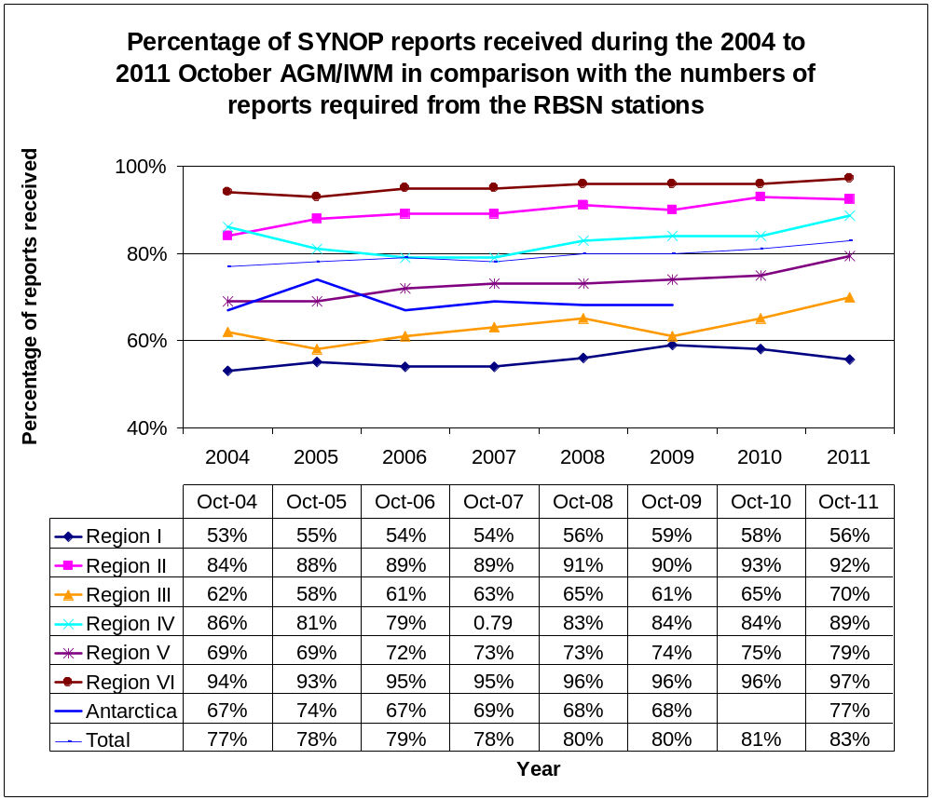

Figure 2

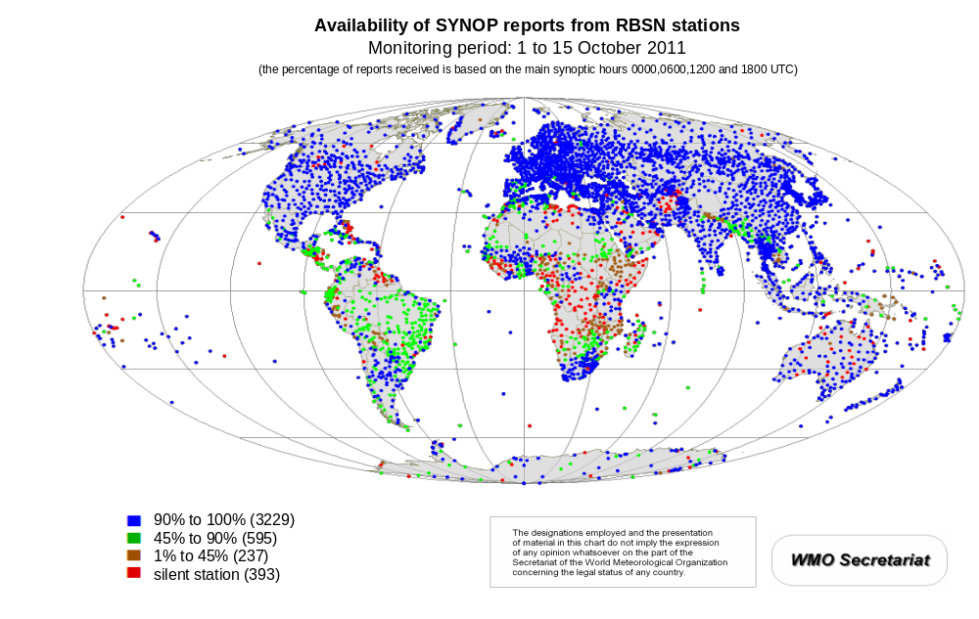

Figure 3
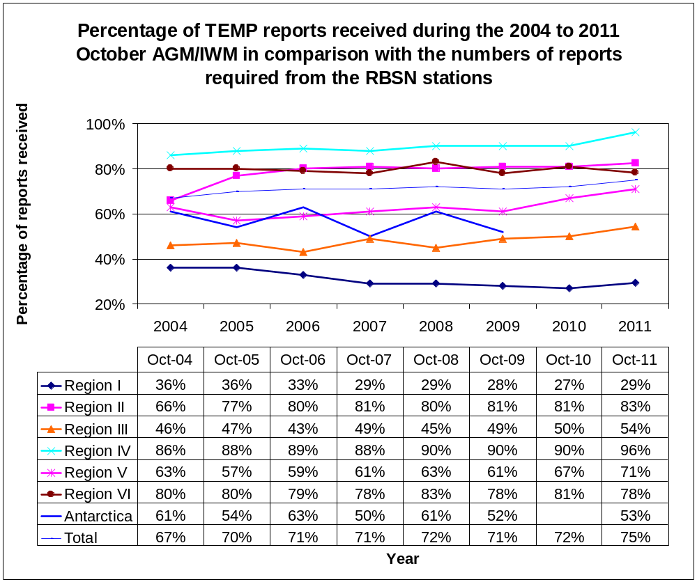

Figure 4

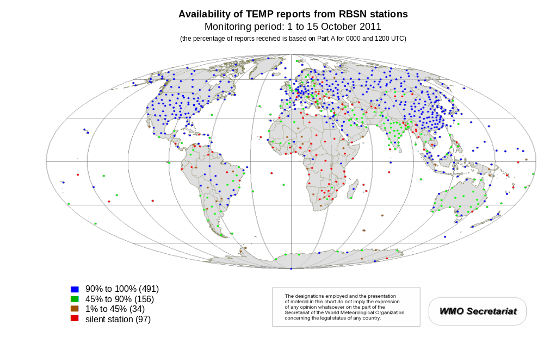

Figure 5
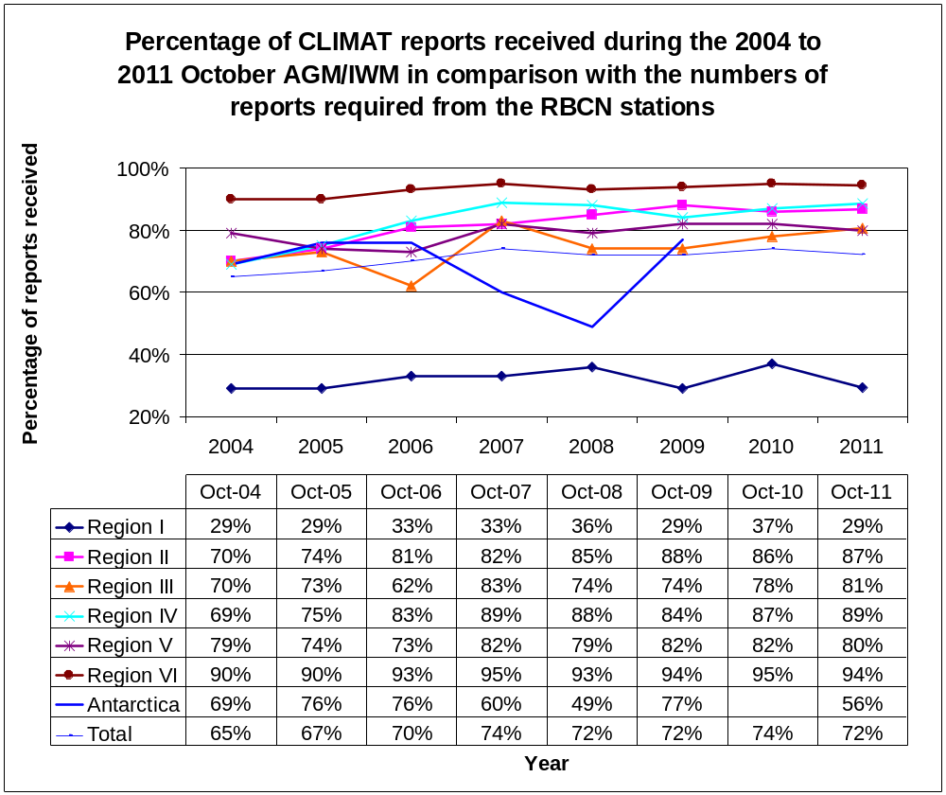

Figure 6

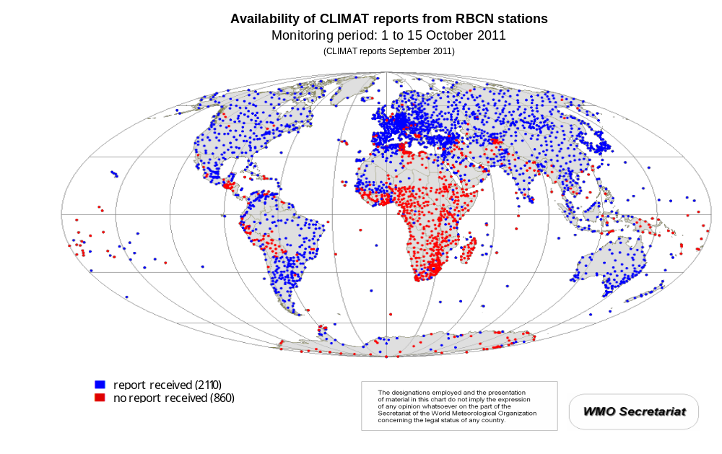
Figure 7
Antarctic SYNOP Reports Received during AGM October 2011

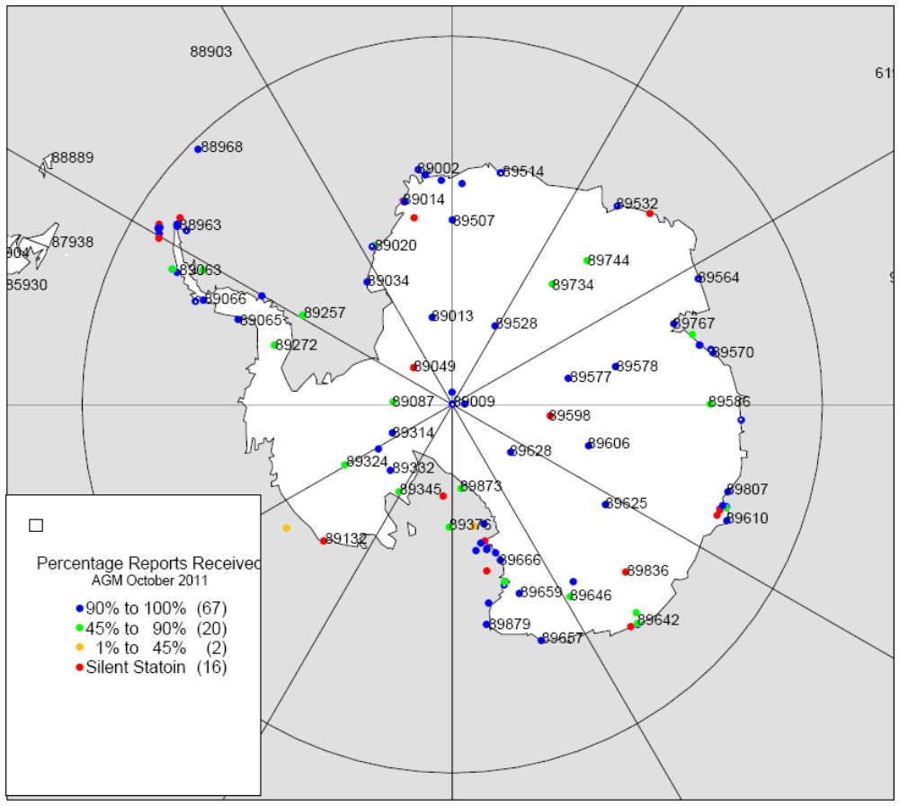
Figure 8
Antarctic TEMP Reports Received during AGM October 2011

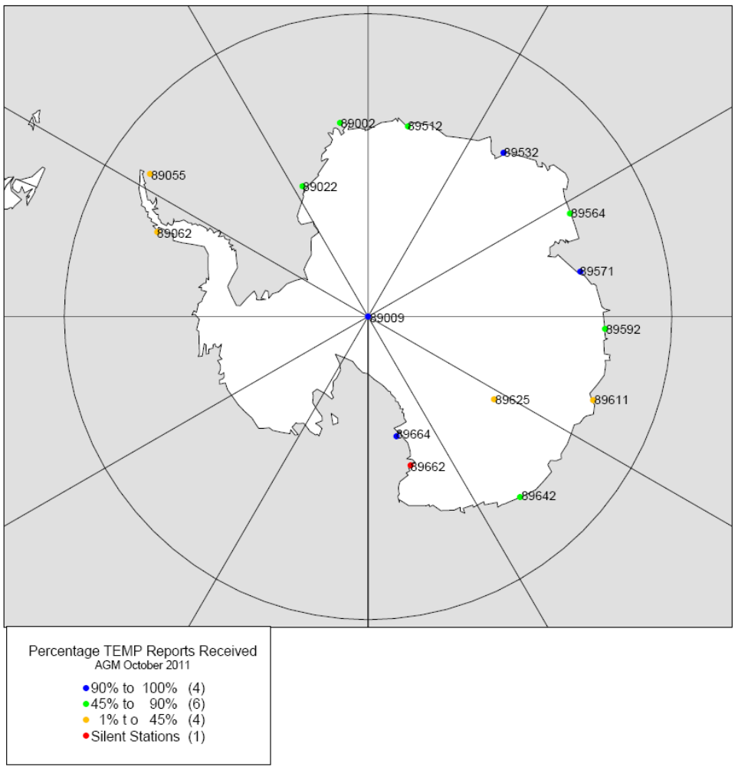
Figure 9
Antarctic CLIMAT Reports Received during AGM October 2011

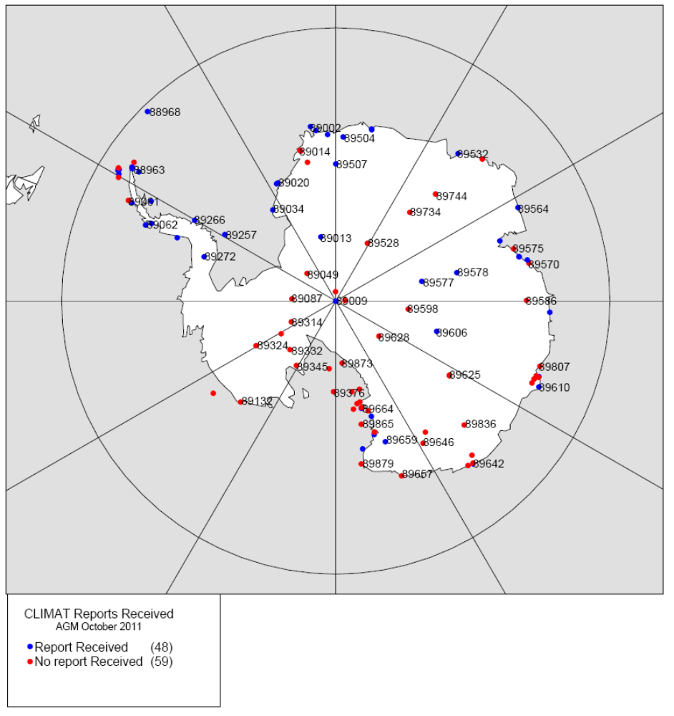
Figure 10
Arctic SYNOP Reports Received during AGM October 2011

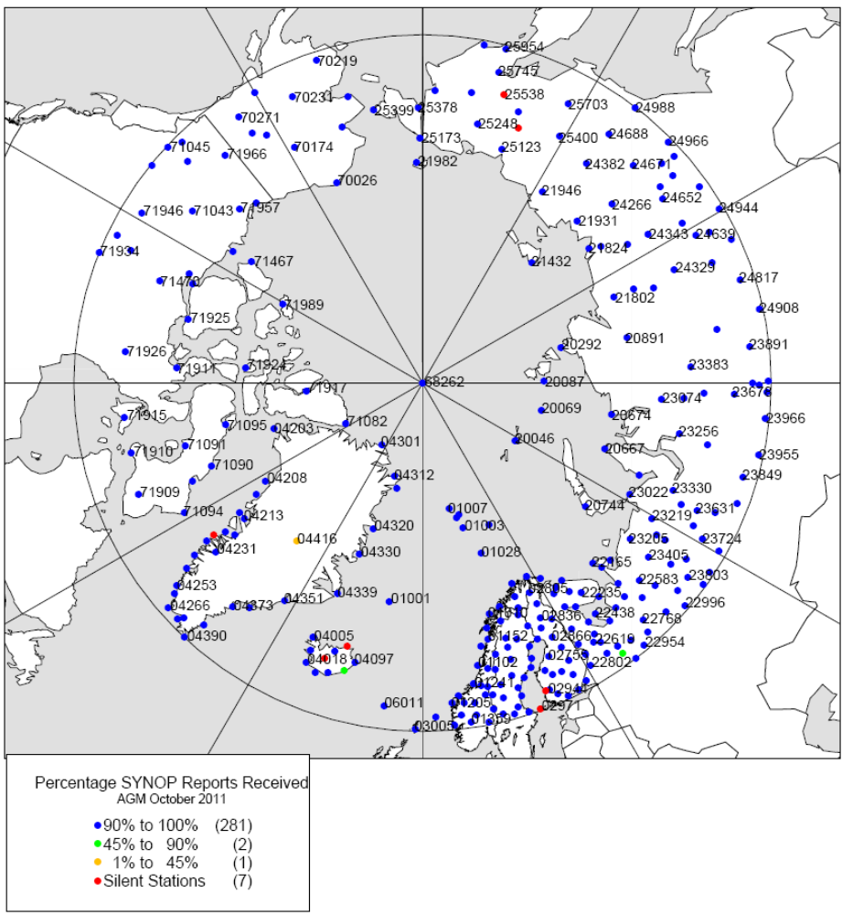
Figure 11
Arctic TEMP Reports Received during AGM October 2011

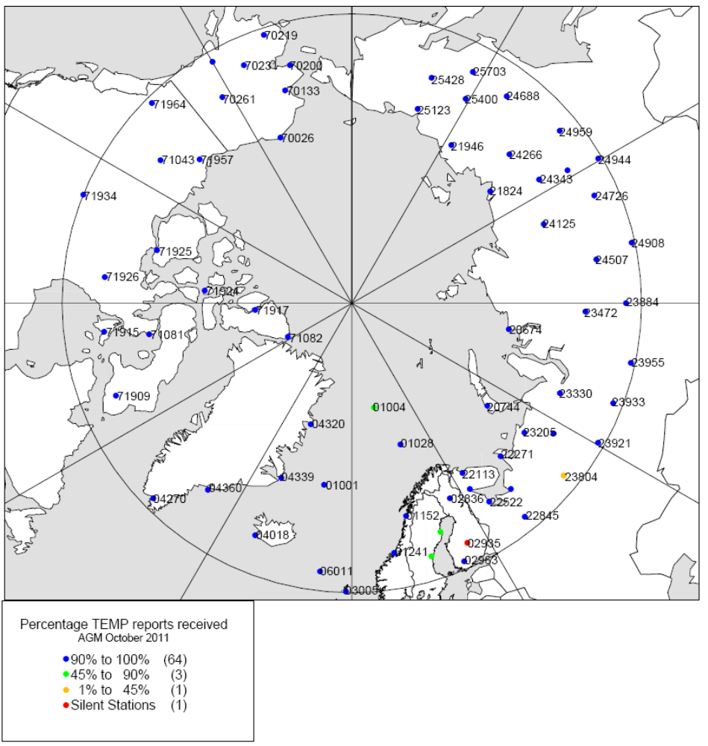

Figure 12
Antarctic CLIMAT Reports Received during AGM October 2011
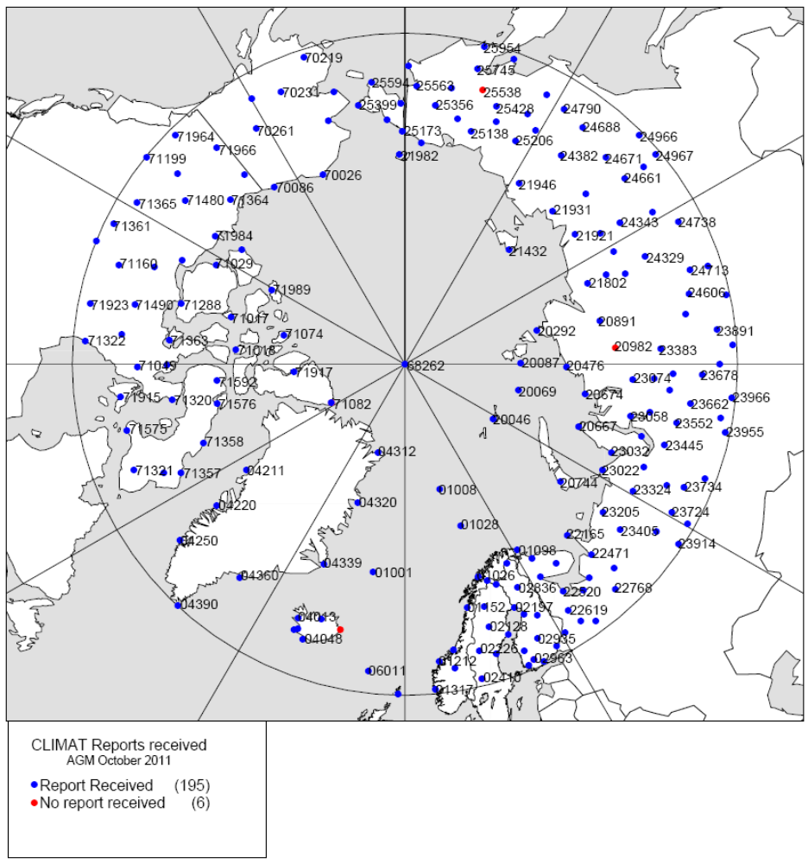
Table 1: Timeliness of receipt of SYNOP reports

Timeliness of reception of SYNOP reports at Main Telecommunication Network centres
Monitoring period: 1 to 15 October 2011
WMO Regions | Number of stations comprising the RBSNs | Percentage of SYNOP reports received in comparison with the reports required from the RBSNs
WMO Regions | Number of stations comprising the RBSNs | Observation 00 UTC received |  | Observation 06 UTC received |  | Observation 12 UTC received |  | Observation 18 UTC received |  | Total received
WMO Regions | Number of stations comprising the RBSNs | in 1hour | after 1hour | in 1hour | after 1hour | in 1hour | after 1hour | in 1hour | after 1hour | in 1hour | after 1hour
Region 1 | 782 | 50.08 | 52.98 | 40.32 | 43.21 | 57.66 | 63.92 | 57.86 | 62.39 | 51.48 | 55.62
Region 2 | 1366 | 87.30 | 89.88 | 90.95 | 92.79 | 92.80 | 94.01 | 92.47 | 93.19 | 90.88 | 92.47
Region 3 | 436 | 85.86 | 87.57 | 72.52 | 73.09 | 29.36 | 30.70 | 87.84 | 88.32 | 68.90 | 69.92
Region 4 | 534 | 89.29 | 90.56 | 88.78 | 89.15 | 84.88 | 85.18 | 89.39 | 89.86 | 88.08 | 88.69
Region 5 | 400 | 73.17 | 76.95 | 80.40 | 81.22 | 79.62 | 80.72 | 77.62 | 78.73 | 77.70 | 79.40
Region 6 | 831 | 97.91 | 98.01 | 95.10 | 95.31 | 97.71 | 97.71 | 97.56 | 97.70 | 97.07 | 97.18
Antarctic | 105 | 68.57 | 77.71 | 61.02 | 73.33 | 68.51 | 80.89 | 64.38 | 75.11 | 65.62 | 76.76
Total | 4454 | 81.13 | 83.33 | 79.12 | 80.69 | 78.63 | 80.66 | 84.53 | 86.02 | 80.85 | 82.67

Table 2: Timeliness of receipt of TEMP reports

Timeliness of reception of TEMP report Part A at Main Telecommunication Network centres
Monitoring period: 1 to 15 October 2011
WMO Regions | Number of stations comprising the RBSNs | Percentage of TEMP report Part A received in comparison with the reports required from the RBSNs
WMO Regions | Number of stations comprising the RBSNs | Observation 00 UTC received |  | Observation 12 UTC received |  | Total received
WMO Regions | Number of stations comprising the RBSNs | in 2hour | after 2hour | in 2hour | after 2hour | in 2hour | after 2hour
Region 1 | 84 | 33.17 | 35.24 | 21.35 | 23.49 | 27.26 | 29.37
Region 2 | 274 | 69.83 | 76.11 | 78.66 | 88.91 | 74.25 | 82.51
Region 3 | 53 | 68.68 | 73.46 | 33.84 | 35.22 | 51.26 | 54.34
Region 4 | 133 | 97.34 | 97.74 | 94.09 | 94.54 | 95.71 | 96.14
Region 5 | 92 | 52.03 | 53.33 | 85.07 | 88.62 | 68.55 | 70.98
Region 6 | 127 | 74.59 | 74.75 | 80.58 | 81.68 | 77.59 | 78.22
Antarctic | 15 | 50.67 | 55.11 | 37.78 | 51.56 | 44.22 | 53.33
Total | 778 | 68.80 | 71.89 | 72.34 | 77.22 | 70.57 | 74.55

