WORLD METEOROLOGICAL ORGANIZATION  __________________  COMMISSION FOR BASIC SYSTEMS  OPEN PROGRAMME AREA GROUP  ON INTEGRATED OBSERVING SYSTEMS  IMPLEMENTATION/COORDINATION TEAM ON THE INTEGRATED OBSERVING SYSTEM  Seventh Session  GENEVA, SWITZERLAND, 18-22 JUNE 2012 | CBS/OPAG-IOS/ICT-IOS-7/Doc. 4(6)  (07.05.2012)  _________  ITEM: 4  Original: ENGLISH

STATUS OF THE SURFACE-BASED AND SPACE-BASED COMPONENTS OF THE GOS

Status of the ground based component of the GOS in Region VI

(Submitted by Klaus-Jürgen Schreiber, Chairperson,
Task Team on the Redesign of the Basic Observing Network in Region VI
and
Dr. Jochen Dibbern, Chairperson,
Working Group on Technology Development and Implementation in Region VI
and
Stefan Klink,
EUCOS Programme Manager, on behalf of the PMs of the EUCOS Sub-Programmes
and the PM of the OPERA Programme)

SUMMARY AND PURPOSE OF DOCUMENT

This document provides information on the status of the EUCOS programme and on other EUMETNET observing programmes as well as on plans and activities in RA VI on the redesign of the basic observing network and on a near future outlook of the evolution of the GOS.

ACTION PROPOSED

The ICT is invited to take the contents of this report into consideration during its deliberations.

____________
DISCUSSION

STATUS OF THE GOS IN REGION VI

1. Introduction

The EUCOS (EIG EUMETNET Composite Observing System) Programme is responsible for improvements in the delivery of terrestrial observations in order to improve regional NWP in the European Domain area. The work content of the EUCOS Programme includes the management of the operational observing networks, through the E-AMDAR, E-ASAP, E-SURFMAR and E-WINPROF Programmes. The coordination of NMHSs owned territorial networks, data quality monitoring, fault reporting and recovery, a studies programme for the evolution of the observing networks and liaison with other organisations like WMO are among the tasks of the programme.

The current design of the RA-VI RBSN/RBCN is based on work done during the late 1990s. Although continuously updated during the last years the design does not take into account those observing systems which have been developed from research applications to observations during the last years. Furthermore, recent improvements in climate change and adaptation science require optimised baseline data. According to the outcome of the XV Session of RA-VI a Task Team on the redesign of the RA-VI basic ground based observing network (TT R/RBON) was established in late 2010 which should run as a WIGOS Demonstration Project.

Regarding the current status of RBSN and RBCN including GCOS stations, an overview of RBSN (surface and upper air) is given in Annex I (see page 15), and Annex II (see page 16) provides an overview of RBCN including the stations in RA VI contributing to GCOS Surface Network (GSN) and GCOS Upper Air Network (GUAN). These tables are mainly based on http://www.wmo.int/pages/prog/www/ois/rbsc-rbcn/rbsc-rbcn-home.htm and on information from the GSN Monitoring Centre (GSNMC) and the CBS Lead Centre for GCOS at DWD.

Information on a day-to-day basis of the quality of RBSN (surface and upper air) and comparisons with NWP can be found at www.eucos.net under RA VI monitoring.

This report provides the status of the EUCOS programme, information on other EUMETNET observing system programmes and on plans and activities in Region VI on the redesign of the basic observing network as well as a near future outlook relevant to the evolution of the GOS.

2. Current Status of the EUCOS Programme

  - General developments and outlook on the new programme phase 2013-2017

During 2011 the EUCOS Team coordinated and contributed to the development of the EIG EUMETNET Observations Roadmap for the period 2012-2020. An EIG EUMETNET Observations Roadmap Drafting Team had been introduced. In the beginning a gap analysis and a brainstorming for potential “high-level activities” during the envisaged period were conducted. In parallel to a ranking (prioritisation) of these potential new high-level activities the existing ground-based EIG EUMETNET observing capabilities operated by either Members or by the EIG EUMETNET programmes E-AMDAR, E-ASAP, E-GVAP, E-SURFMAR, E-WINPROF, OPERA and EUCOS have been reviewed with respect to the newly set EIG EUMETNET observation goals. This review revealed that the existing EIG EUMETNET observations programmes are essential for a comprehensive supply of EIG EUMETNET Members with observations. The range of activities which are undertaken by these programmes was considered being of appropriate size. No possibilities for cancelling certain activities or reducing tasks had been identified.
The Observations Roadmap Drafting Team was asked to prepare a proposal how to save approx. 10% of the overall EIG EUMETNET Observations Programme budget. The Drafting Team proposed a 5% reduction of management costs and an almost 10% reduction of data procurement costs and only a smaller reduction of R&D expenses. As a consequence approx. 10% less observations could be provided to Members in future.
In the first quarter 2012 the EUCOS Programme coordinated the development of the EIG EUMETNET Observations Programme Requirements document for the next programme phase 2013-2017. Considering the Observations Roadmap as framework the Requirements document breaks down the roadmap into more specific actions and deliverables for the Observations Programme in the next five years.

The priorities for the Observations Programme during the phase 2013-2017 will be:
- To foster the OPERA (Weather Radar Operational Service) developments in order to be able to produce quantitatively usable 2D radar products and to exchange single site 3D volume data (reflectivity, Doppler winds) by the end of the programme phase;
- To further expand the E-AMDAR Operational Service by trying to extend the horizontal coverage over the EUCOS area and by considering a further roll-out of humidity sensors on board E-AMDAR aircraft;
- To extend the remit of the E-WINPROF Operational Service with the aim to include Lidar/Ceilometer Observations for the main purpose of volcanic ash monitoring and
- To improve the user consultation process with data users from the Climate and Forecasting Programmes and Members via the central Observation Programme and its Scientific Advisory Team.

  - 2011 EUCOS Network

The EUCOS network design has broadly been fully implemented during the 2002-2006 operational phase. In spring 2010 the EUCOS surface land station list was updated to close major gaps in the network and to allow new EUCOS members to add surface land stations to the network. Further the upper-air network was redesigned according to the Observing System Experiments (OSE) study in 2010.

In 2011 no major changes in the EUCOS networks were proposed. End of 2011 4 Czech wind profilers were introduced to the E-WINPROF wind profiler network.

Table 1 summarises the 2011 EUCOS Network.

EUCOS 2011
Oceanic segment | Ocean platforms | Ekofisk oil rig (2 RW/day)  674 TEMPs in 2011
Oceanic segment | ASAP units (E-ASAP) | 18+1 units operated by E-ASAP producing 4,868 TEMPSHIPs in 2011 (temporary land station Egilstadir 04089 provided soundings on behalf of E-ASAP)
Oceanic segment | Drifting Buoys (E-SURFMAR) | On average 97 drifting buoys providing 666,824 messages in 2011
Oceanic segment | Moored Buoys (E-SURFMAR) | 4 moored buoys providing 33,903 messages in 2011
Oceanic segment | Ships (E-SURFMAR) | On average 133 daily operating conventional VOS ships providing 308 daily observations (annual total 116,240 obs.) and  78 daily operating automated VOS ships providing on average 1,289 daily observations (annual total 465,657 obs.)
Aeronautic segment  E-AMDAR | AMDAR units | In total 17.51 Mio. AMDAR observations including additional data for DWD, KNMI, Météo-France, UKMO. On daily average 1,028 profiles from 145 European airports and 571 aircraft. Taking only EUCOS funded observations into account 12.58 Mio. AMDAR observations and 877 profiles were provided from 135 airports.
Territorial segment | Radiosonde stations | 52 selected stations based on a 500 km spacing providing 2 RW/day: 36,585 TEMPs in 2011
Territorial segment | Surface stations | 268 selected surface synoptic stations according to a 250 km spacing, providing hourly or 3-hourly messages:  1,932,335 SYNOPs in 2011
Vertical profiles segment E-WINPROF | Wind profilers (WP) | 19 operational wind profilers providing half-hourly vertical wind profiles: 461,617 observations in 2011  (11 non-operational WPs providing 104,512 profiles)
Vertical profiles segment E-WINPROF | Weather radars (WRWP) | 59 operational weather radars providing vertical wind profiles:  1,500,040 observations in 2011  (46 non-operational WRWPs due to quality or timeliness issues providing 1,387,597 profiles)

Table 1: 2011 EUCOS Network.

  - Network Performance

Data availability, timeliness and achieving geopotential height

A summary of the network performance regarding data availability and timeliness during 2011 compared to the EUCOS performance targets is provided in table 2.
The performance of most of the EUCOS networks improved or at least remained stable compared to the performance of 2010. Most of the targets have been achieved by the networks in 2011 (achieved targets are marked green in table 2).

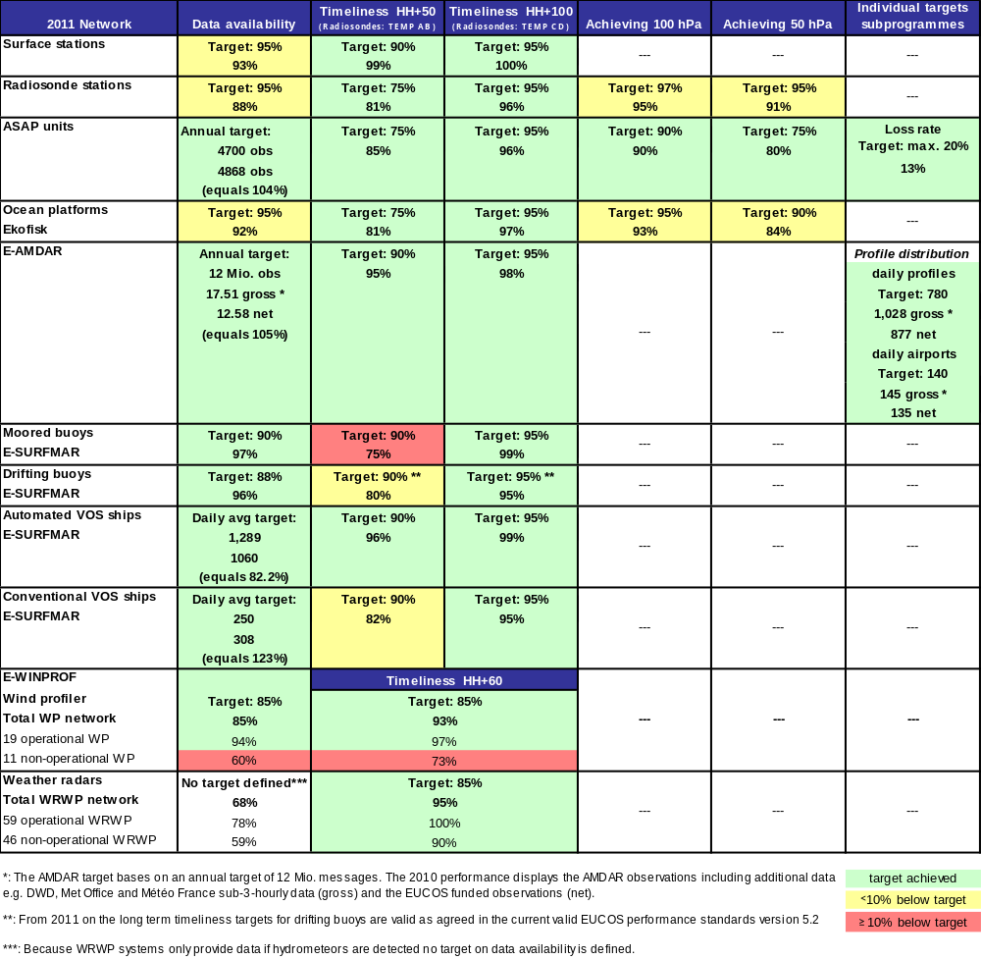

Table 2: EUCOS Network Performance Summary 2011.

Results of comparisons of observations and first-guess fields of COSMO-EU

Table 3 provides the annual averages of comparisons of observations and COSMO-EU NWP first-guess fields of 2011. The figures show that some of the EUCOS threshold targets are very tight and might be revised in the next programme phase 2013-2017.

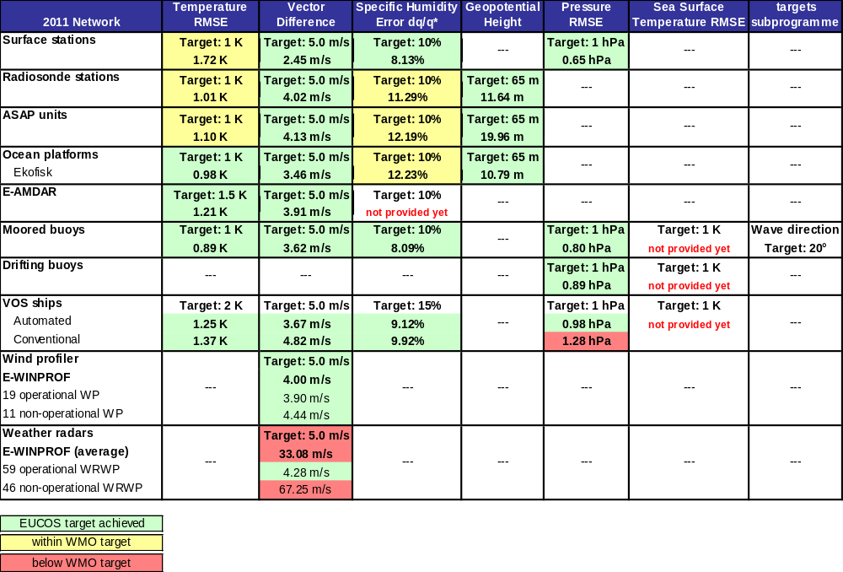

Table 3: Annual average of EUCOS NWP comparison results 2011.

    - E-ASAP

- During 2011 the number of active stations was 19. One of the stations is operated as land station in NE Iceland.
- 4891 soundings (4689 by HH+100) were disseminated over the GTS from all stations (including the Icelandic land station). On average, 87% of the performed launches were disseminated over the GTS.
- The formerly British ASAP station ASGB01 was de-installed from the ship MISSISSAUGA EXPRESS and re-installed on board the ATLANTIC CONVEYOR as ASEU06.

The routine sounding schedule was 3 soundings per day (>75 nm off mainland) for most stations under E-ASAP management.

Figure 1 shows the distribution of TEMP bulletins in 2011 on a 2° x 2° grid without interpolation.
Soundings in the Black Sea from the Research Meteor (ASDE02) are not visible in the map.

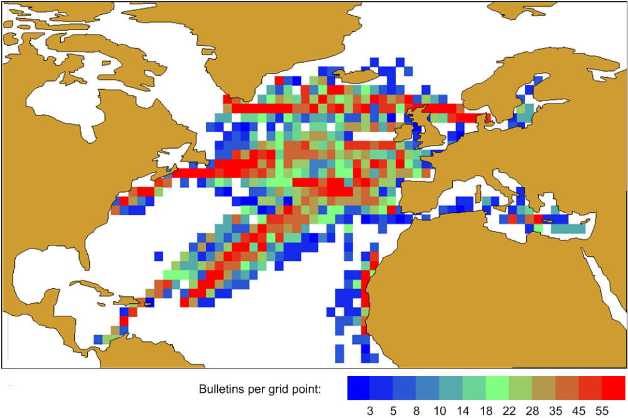

Figure 1: Distribution of TEMP bulletins in 2011 on a 2° x 2° grid without interpolation.

    - E-AMDAR

E-AMDAR showed excellent performance throughout the year and achieved all targets on timeliness, total number of observations and total number of daily profiles within the EUCOS area. Although the gross daily airport totals (taking into account sub-3-hourly data based on national requirements) met the target in 2011 the net daily airport totals did not reach the EUCOS target level for an unexpected reason. The number of regional airports has been increased, but as these are close to main airports they cannot be included as “EUCOS airports.” (cited from E-AMDAR End-of-Year-Progress Report 2011). The timeliness performance remained stable compared to 2010. The total number of E-AMDAR observations was reduced for financial reasons. The number of daily profiles and daily airports increased.
Figure 2 shows the distribution of E-AMDAR single-level data between 0 and 8,000 metres above ground for an exemplary period from 3-16 October 2011.

In 2010 flight programmes of airlines, particularly the newly acquired easyJet, offered several new destinations e.g. holiday destinations in the Mediterranean, and these were included in the observation network.

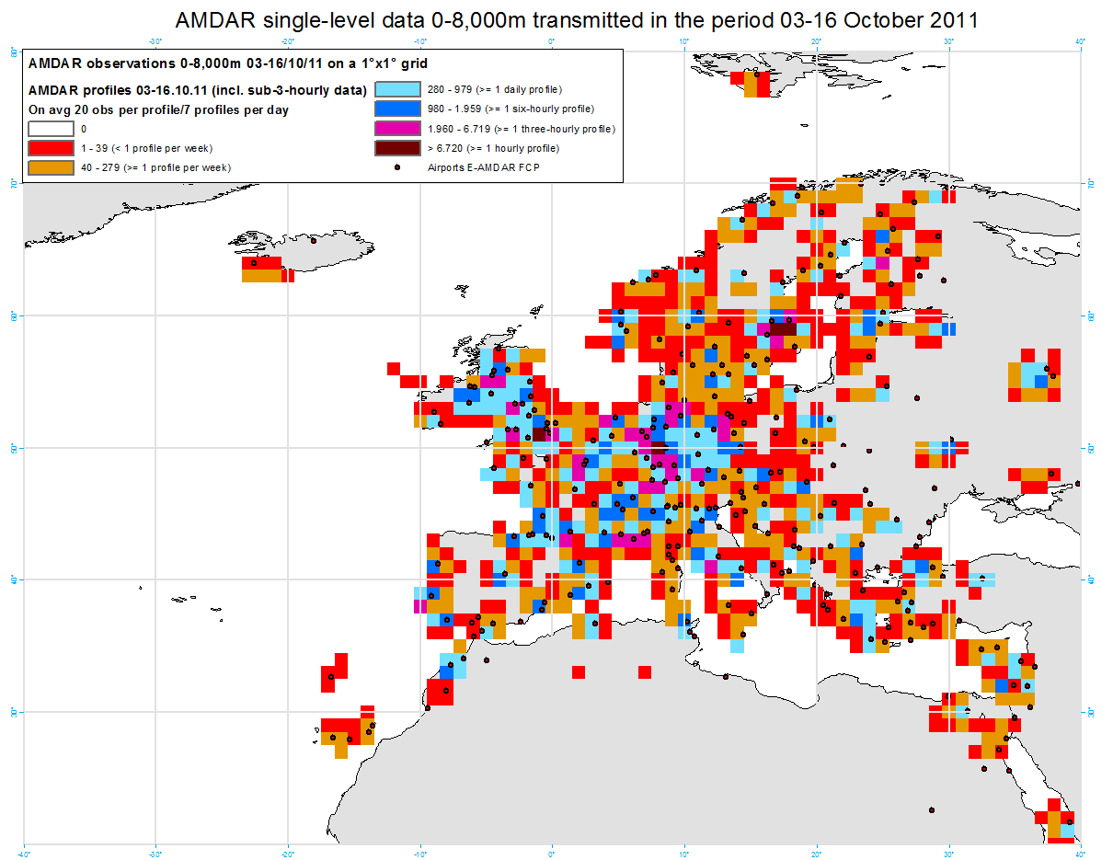

Figure 2: Exemplary distribution of E-AMDAR single-level data between 0 and 8,000 metres above ground, transmitted during the period 3-16 October 2011; assuming that an average vertical profile comprises approx. 20 single-level observations one can derive approximate numbers of profiles per grid point and period (see legend).

    - E-SURFMAR

Key developments in the E-SURFMAR network during 2011:
- Increase again of the number of observations reported by European S-AWS in general and by E-SURFMAR S-AWS most especially;
- Installation of two BaTos S-AWS onboard research vessels: one Irish and one Italian;
- Continuation of installations of BaRos S-AWS onboard ships plying in the Mediterranean Sea thanks to participants in MOON and most especially to ENEA;
- Decrease of the number of EUCOS funded drifting buoys in operation due to a decrease of the lifetimes of buoys (see Figure 3). Work is in progress to improve this situation again.

Figure 4 shows the accumulation of marine sea level pressure observations delivered by E-SURFMAR drifting buoys and E-SURFMAR conventional and automated voluntary observing ships.

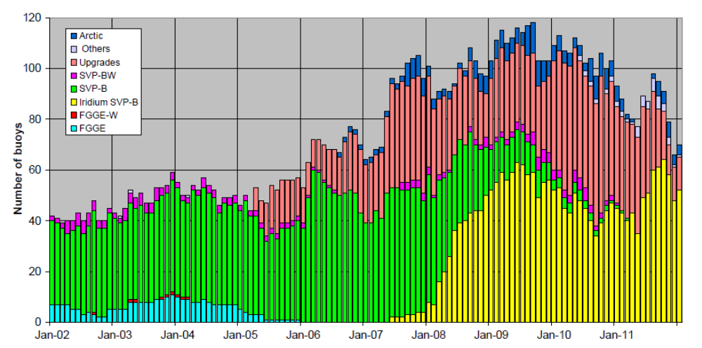

Figure 3: Number of drifting buoys operated by EGOS, then E-SURFMAR in the North Atlantic Ocean according to their type, since 2002.

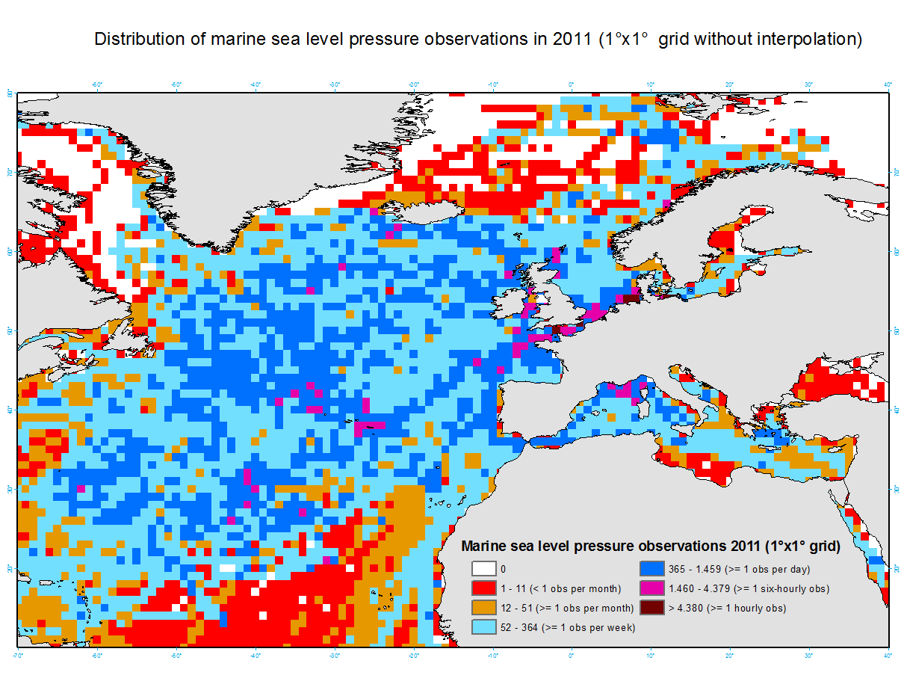
Figure 4: Distribution of marine sea level pressure observations delivered by E-SURFMAR drifting buoys and E-SURFMAR conventional and automated voluntary observing ships.

    - E-WINPROF

- The ‘Operational classification list’ was updated twice during the year.
  - By the end of 2011 19 European wind profilers were delivering good quality data;
  - By the end of 2011 53 European weather radars were delivering good quality vertical wind profiles.

- Daily monitoring of the wind profiler data started in November 2010 and has continued throughout 2011. This includes a daily summary of any problems encountered and informs operators of any interruptions or possible data quality issues. Operators have also been asked to inform the Hub of any issues with their wind profilers and possible interruptions due to maintenance. This is an ongoing task which will continue to be developed further once the hub is fully operational. This feedback has been very useful on a number of occasions quickly identifying problems and so minimising any data outages.

- Technical support and advice was provided to the Czech Republic in the configuration and operation of their 4 boundary layer wind profiler systems. This not only was of significant benefit to the expert and engineer of the observations department but has also improved the data quality and availability to extent that they are considered to be of an operational standard.

  - Current Studies Programme Activities

A second Space-Terrestrial Study had been initiated in 2010 to assess the impact of reduced ground-based observing systems on satellite data assimilation. An interim report was compiled by Gabor Radnoti, ECMWF end of Feb 2011 and a corresponding presentation of first results had been given at the 2011 E-SAT meeting at ECMWF in early March 2011. Key objectives of this study were to assess the impact of a thinned terrestrial observing system on radiance bias correction anchoring and to investigate the impact of a reduced conventional observing system on NWP following the most successful scenarios (3b) and (4) of the EUCOS Upper-air Network Redesign Study. Experiments had been carried out, investigating the impact of the global radiosonde and aircraft data in different GPS radio occultation (GPSRO) data coverages. Presentation of final results and delivery of the final study report is scheduled for 2012.

  - THORPEX and Related Activities

WMO CBS OPAG IOS ET-EGOS
The EUCOS PM represented EUMETNET at the 6th session of the WMO CBS OPAG IOS ET-EGOS. A EUMETNET representative had been invited as an observer to ET-EGOS meetings regularly. The EUCOS PM presented a status update on EUCOS.

THORPEX European Regional Meeting
The EUCOS PM attended a THORPEX European Regional Meeting in Karlsruhe, Germany from 24th to 27th May 2011. The conference included sessions on ‘Predictability and Dynamical Processes’ (PDP), ‘THORPEX Interactive Grand Global Ensemble’ (TIGGE), ‘Data Assimilation and Observing Strategies’ (DAOS) and Field Programs.

- Weather Radar in Europe (EIG EUMETNET OPERA Programme)

The OPERA Data Centre (ODC), also called Odyssey, became operational in June 2011. In the beginning 15 members started sending data. Data from 14 members were used in compositing. The total number of radars contributing to the composites was 118. During the first year of operation some 100,000 composites were produced. As an example Figure 5 shows the Odyssey rain rate product from 3rd October 2011, 14 UTC. Odyssey replaced the OPERA Pilot Data Hub, which started operations in 2006, and which was closed at the end of 2011.
The composites contain a significant amount of non-meteorological echoes, caused mainly by clutter and interfering radio transmitters. The work towards reducing the amount of non-meteorological echoes in the composites was started.
The OPERA pages of the EUCOS Quality Monitoring Portal were finalized. Availability and timeliness statistics are routinely monitored by this system.

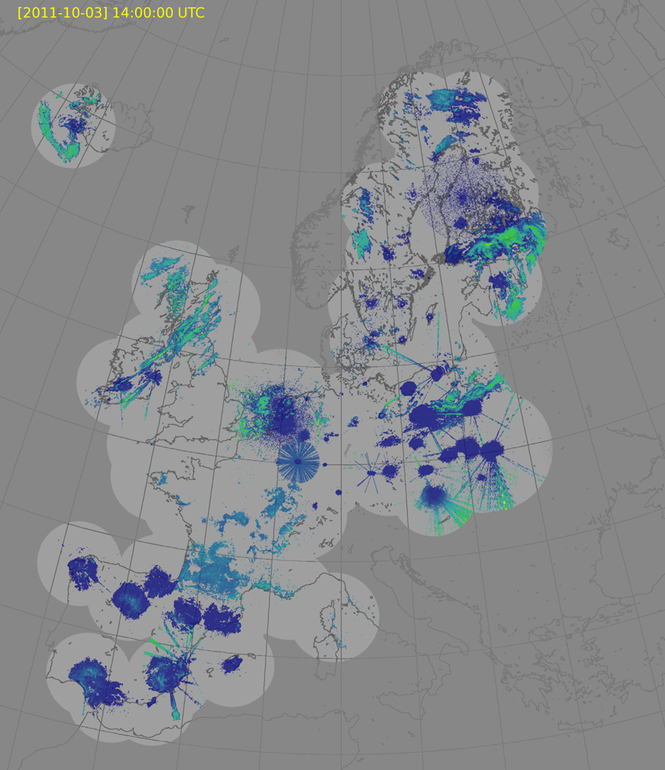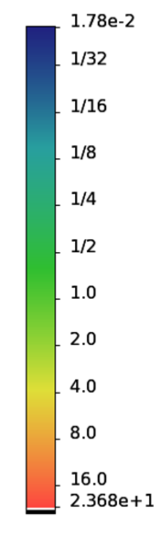

Figure 5: Example of OPERA Odyssey rain rate product.

- GPS Water Vapour Measurements (EIG EUMETNET GNSS Water Vapour Programme)

The E-GVAP observing system continues to grow (see Figure 6). In 2011 a number of more than 1600 unique GNSS sites was reached. The number of Zenith Total Delay (ZTD) observations is about 9 million obtained per month. An improving coverage in Eastern Europe is observed. A new Analysis Centre (AC) has been established in Hungary, producing ZTDs for Hungary. E-GVAP has been offered raw data from Bulgaria, which can be processed at one of the existing ACs (e.g. by METO at UKMO). These belong to the EUPOS network, the members of which are covering most of Eastern Europe. Both EUPOS and E-GVAP are interested in collaboration.

The E-GVAP component of the EUCOS QMP is now operational.

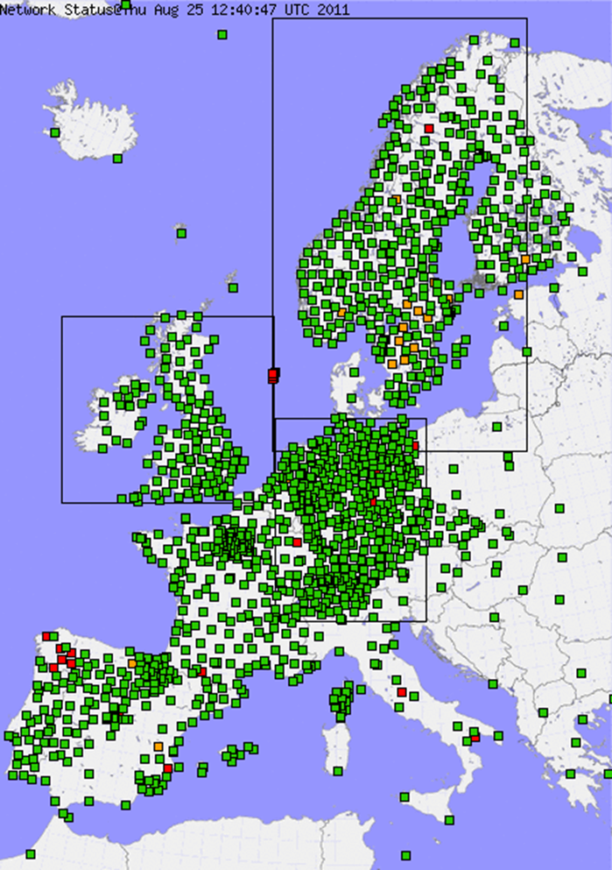

Figure 6: E-GVAP network on 25th August 2011.

- Lightning Detection Systems

EUMETNET members operate ground based lightning location systems with sensors from Safir, Vaisala, Linet/Nowcast or ATDnet. The networks are either operated by the NMHSs or by private data suppliers. At European level, the EUMETNET lightning task team has been set up to exchange knowledge and information, and to work on a common data format, as well as on quality and performance evaluation.

6. Redesign of the RA-VI Regional Basic Observing Network

The current design of the RA-VI RBSN/RBCN is based on work done during the late 1990s. Although continuously updated during the last years the design does not take into account those observing systems which have been developed from research applications to observations during the last years.
The idea in RA VI is to design a Regional Basic Observing Network (RBON) through the integration of new observing systems having reached operational status during the last years as
new satellite observations, new upper-air observing systems like measurements from commercial aircraft, wind profiler and weather radar system as well as ground based GNSS water vapour observations.

To achieve this important objective XV Session of RA VI established within its WG-TDI a Task Team on the Re-design of the Regional Basic Observing Network (TT-RRBON). New ground based observing systems, such as weather radars, wind profiler systems and aircraft measurements should be taken into account in the RBON re-design. The network re-design will also be coordinated with satellite observations. The R-RBON was assigned as a WIGOS Demonstration Project in RA VI.
Furthermore, the available regional assets, such as the European Meteorological Infrastructure (EMI) should be used and expanded over the whole Region. Thus, the EUCOS observing network has been considered as a model and as a core part of the RA VI RBON and the EUMETNET European Climate Support Network (ECSN) activities will form the basis of the regional climate network. The main task of TT-RRBON is to expand these regional assets and develop a draft design of the RA VI Regional Basic Observing Network. Due to the lack of resources, only little progress has been achieved so far. Important EUMETNET activities from the Climate Road Map expected to contribute to the Task Team, have been put on hold.
Currently the status of WIGOS implementation in RA VI was discussed at the WG-TDI/2 meeting in December 2011. Needs and opportunities for the implementation process of WIGOS in RA VI were discussed. Noting that some Members have already conducted projects for the implementation of WIGOS at national level, the need for standardization of WIGOS metadata, and the importance of a quality monitoring at regional level, the WG-TDI proposes to work on the development of a regional plan for WIGOS implementation comprising the following elements:
- WIGOS metadata creation and handling;
- Quality Management;
- Integration of networks (TT-RBON task);
- Compilation and publication of national good practices.
To make Members aware of the regional WIGOS activities and incorporate more Members in those activities, it is proposed to organize a regional WIGOS workshop in late 2012 / early 2013. The workshop will address:
- WIGOS concept and architecture;
- Existing projects on national WIGOS implementation;
- Benefits of WIGOS;
- Capacity building needs.
A critical review of the TT-RRBON tasks should be conducted to define realistic deliverables. The WMO RA VI Pilot Regional Climate Centre (RCC) Network could take a share in identifying the climate requirements for the re-design of the basic observing network.

7. Achievements, Issues and Recommendations

RA-VI Achievements:
- The EUCOS Programme is offering a quality monitoring service on a daily basis for RBSN stations (surface and upper-air) for all Members of RA-VI.
- A GISC installation is running operationally.
- For the migration to table-driven code forms (TDCF) training courses were organized, as response to questions/requirements expressed by RA-VI countries, including the maintenance of the conversion program synop2bufr. 36 countries of RA-VI (77%) produce at least one type of Category 1 data in TDCF.
- A workshop on the WIS Implementation was held in Sofia, November 2011. The workshop was highly successful and developed initial outline for the RA VI WIS Implementation Plan. A first draft of the plan was presented at the MG-6 meeting in April 2012; the implementation plan should be finalized in June 2012 and submitted for approval by the president of RA VI. It is expected that most of the implementation would be completed by the next session of RA VI in September 2013.
- The current structure of the RMDCN comprises 45 NMHSs, ECMWF, EUMETSAT and one disaster recovery site for the Netherlands. The performance of the RMDCN has been very good with its reliability achieving 100% availability over most of the time. In RA VI there are still 14 countries that have not joined RMDCN, mainly due to budget constraints of the NMHSs. The procurement for the next generation of the RMDCN is led by ECMWF. The process would encompass three phases: the first phase was definition of requirements in 2011; the second phase is the procurement itself, which will take place in 2012; the third and final phase is the migration to the new network scheduled to take place during 2013 and the first half of 2014. A workshop on RMDCN for RA VI Members will be organized in May 2012 to inform connected countries and potential new members on the procurement, connection options and migration process.

RA-VI Issues:
- There are still deficiencies in the implementation and operation of the RBSN and RBCN in some areas of the Region as revealed by the WMO Secretariat monitoring exercises.
- For some Members, the migration to TDCF is an issue, because they do not have the necessary resources for the migration process.
- The TT RBON is still lacking of resources, necessary contribution of diferent user groups (e.g. climate) are on a hold.

RA-VI Recommendations:
- Organize and conduct a regional WIGOS Workshop to support the WIGOS implementation in RA VI and to foster the work of the TT RBON in reviewing RBSN and RBCN installations
- Support the ongoing WIS implementation in the Region according to the WIS implementation plan
- Continue supporting the migration to Table Driven Code Forms
- Support actions to improve the availability of SYNOP and TEMP data from some Members and connection to RMDCN

Current RBSN and RBCN NETWORKS in RA VI
Annex I

NUMBER OF STATIONS COMPRISING THE
REGIONAL BASIC SYNOPTICAL NETWORK (RBSN)
WMO Regional Association VI (UPDATED 20 APRIL 2012; changes since April 2011)
All information of RBSN based on http://www.wmo.int/pages/prog/www/ois/rbsn-rbcn/rbsn-rbcn-home.htm
WMO RA | Country/Area (VOLA) | Code | Block-No. |  |  | Surface |  | Radiosonde
 |  |  |  |  |  | No. | changes | No. | changes
6 | ALBANIA | ALB | 13 |  |  | 0 |  | 0
6 | ARMENIA | ARM | 37 |  |  | 3 |  | 1
6 | AUSTRIA | AUT | 11 |  |  | 7 |  | 0 | -1
6 | AZERBAIJAN | AZE | 37 |  |  | 7 |  | 0
6 | BELARUS | BLR | 23, 26 |  |  | 10 |  | 0
6 | BELGIUM | BEL | 06 |  |  | 3 |  | 1
6 | BOSNIA AND HERZEGOVINA | BIH | 14 |  |  | 4 |  | 0
6 | BULGARIA | BGR | 15 |  |  | 9 |  | 1
6 | CROATIA | HRV | 14 |  |  | 7 |  | 1
6 | CYPRUS | CYP | 17 |  |  | 2 |  | 1
6 | CZECH REPUBLIC | CZE | 11 |  |  | 7 |  | 1
6 | DENMARK AND FAROE ISLANDS | DNK | 06 |  |  | 7 |  | 1
6 | ESTONIA | EST | 26 |  |  | 7 |  | 1
6 | FINLAND | FIN | 02 |  |  | 22 |  | 3
6 | FORMER YUGOSLAVIAN REPUBLIC  OF MACEDONIA | MKD | 13 |  |  | 3 |  | 1
6 | FRANCE | FRA | 07 |  |  | 42 | -2 | 5 | -2
6 | GEORGIA | GEO | 37 |  |  | 9 |  | 0
6 | GERMANY | DEU | 10 |  |  | 28 |  | 10
6 | GIBRALTAR (UK) | GIB | 08 |  |  | 1 |  | 1
6 | GREECE | GRC | 16 |  |  | 22 |  | 3
6 | GREENLAND (DENMARK) | GRL | 04 |  |  | 30 |  | 4
6 | HUNGARY | HUN | 12 |  |  | 7 |  | 2
6 | ICELAND | ISL | 04 |  |  | 10 |  | 1
6 | IRELAND | IRL | 03 |  |  | 8 | -1 | 1
6 | ISRAEL | ISR | 40 |  |  | 4 |  | 1
6 | ITALY | ITA | 16 |  |  | 48 |  | 4
6 | JORDAN | JOR | 40 |  |  | 4 |  | 1
6 | KAZAKHSTAN | KAZ | 34 |  |  | 3 |  | 0
6 | LATVIA | LVA | 26 |  |  | 7 |  | 1
6 | LEBANON | LBN | 40 |  |  | 2 |  | 1
6 | LITHUANIA | LTU | 26 |  |  | 7 |  | 1
6 | LUXEMBOURG | LUX | 06 |  |  | 1 |  | 0
6 | MALTA | MLT | 16 |  |  | 1 |  | 0
6 | MONTENEGRO | MNE | 13 |  |  | 6 |  | 0
6 | NETHERLANDS | NLD | 06 |  |  | 9 |  | 1
6 | NORWAY | NOR | 01 |  |  | 40 |  | 7
6 | POLAND | POL | 12 |  |  | 22 |  | 3
6 | PORTUGAL | PRT | 08 |  |  | 16 |  | 2
6 | REPUBLIC OF MOLDOVA | MDA | 33 |  |  | 1 |  | 0
6 | ROMANIA | ROU | 15 |  |  | 23 |  | 2
6 | RUSSIAN FEDERATION (IN EUROPE) | RUS | 20, 21, 22,  25, 26, 27,  31, 34 |  |  | 131 |  | 26
6 | SERBIA | SCG | 13 |  |  | 28 |  | 1
6 | SLOVAKIA | SVK | 11 |  |  | 4 |  | 1
6 | SLOVENIA | SVN | 14 |  |  | 2 |  | 1
6 | SPAIN | ESP | 08 |  |  | 33 |  | 7
6 | SWEDEN | SWE | 02 |  |  | 44 |  | 4
6 | SWITZERLAND AND LIECHTENSTEIN | CHE | 06 |  |  | 7 |  | 1
6 | SYRIA | SYR | 40 |  |  | 9 |  | 0
6 | TURKEY | TUR | 17 |  |  | 58 |  | 7
6 | UKRAINE | UKR | 34 |  |  | 36 |  | 8
6 | UNITED KINGDOM OF GREAT BRITAIN  AND NORTHERN IRELAND | GBR | 03 |  |  | 30 | -6 | 5
6 | TOTAL NUMBER OF STATIONS |  |  |  |  | 831 | -9 | 124 | -3

Annex II

NUMBER OF STATIONS COMPRISING THE
REGIONAL BASIC CLIMATOLOGICAL NETWORK (RBCN),
GCOS SURFACE NETWORK (GSN) AND GCOS UPPER AIR NETWORK (GUAN)
WMO Regional Association VI (UPDATED 20 APRIL 2012; changes since April 2012)
All information of RBCN based on http://www.wmo.int/pages/prog/www/ois/rbsn-rbcn/rbsn-rbcn-home.htm
WMO RA | Country/Area (VOLA) | Code | Block-No. | CLIMAT |  | GSN |  | GUAN
 |  |  |  | No. | changes | No. | changes | No. | changes
6 | ALBANIA | ALB | 13 | 1 |  | 1 |  | 0
6 | ARMENIA | ARM | 37 | 3 |  | 1 | +1 | 1
6 | AUSTRIA | AUT | 11 | 9 |  | 3 |  | 1
6 | AZERBAIJAN | AZE | 37 | 6 |  | 1 |  | 0
6 | BELARUS | BLR | 23, 26 | 12 |  | 1 |  | 0
6 | BELGIUM | BEL | 06 | 1 |  | 1 |  | 0
6 | BOSNIA AND HERZEGOVINA | BIH | 14 | 5 |  | 1 |  | 0
6 | BULGARIA | BGR | 15 | 4 |  | 0 |  | 1
6 | CROATIA | HRV | 14 | 2 |  | 1 |  | 1 | +1
6 | CYPRUS | CYP | 17 | 2 |  | 2 |  | 1
6 | CZECH REPUBLIC | CZE | 11 | 9 |  | 1 |  | 0
6 | DENMARK AND FAROE ISLANDS | DNK | 06 | 4 |  | 2 |  | 0
6 | ESTONIA | EST | 26 | 3 |  | 1 |  | 0
6 | FINLAND | FIN | 02 | 11 |  | 3 |  | 1
6 | FORMER YUGOSLAVIAN REPUBLIC  OF MACEDONIA | MKD | 13 | 4 |  | 1 |  | 0
6 | FRANCE | FRA | 07 | 42 |  | 6 |  | 0
6 | GEORGIA | GEO | 37 | 6 |  | 1 |  | 0
6 | GERMANY | DEU | 10 | 57 |  | 4 |  | 1
6 | GIBRALTAR (UK) | GIB | 08 | 1 |  | 0 |  | 1
6 | GREECE | GRC | 16 | 11 |  | 4 |  | 0
6 | GREENLAND (DENMARK) | GRL | 04 | 8 |  | 5 |  | 1
6 | HUNGARY | HUN | 12 | 7 |  | 1 |  | 0
6 | ICELAND | ISL | 04 | 6 |  | 4 |  | 1
6 | IRELAND | IRL | 03 | 8 |  | 2 |  | 1
6 | ISRAEL | ISR | 40 | 3 |  | 1 |  | 0
6 | ITALY | ITA | 16 | 34 |  | 5 |  | 1
6 | JORDAN | JOR | 40 | 4 |  | 2 |  | 1
6 | KAZAKHSTAN | KAZ | 34 | 2 |  | 0 |  | 0
6 | LATVIA | LVA | 26 | 4 |  | 1 |  | 0
6 | LEBANON | LBN | 40 | 2 |  | 0 |  | 0
6 | LITHUANIA | LTU | 26 | 5 |  | 1 |  | 0
6 | LUXEMBOURG | LUX | 06 | 1 |  | 1 |  | 0
6 | MALTA | MLT | 16 | 1 |  | 1 |  | 0
6 | MONTENEGRO | MNE | 13 | 2 |  | 0 |  | 0
6 | NETHERLANDS | NLD | 06 | 6 |  | 1 |  | 0
6 | NORWAY | NOR | 01 | 14 |  | 10 |  | 1
6 | POLAND | POL | 12 | 10 |  | 2 | -1 | 0
6 | PORTUGAL | PRT | 08 | 12 |  | 3 |  | 1
6 | REPUBLIC OF MOLDOVA | MDA | 33 | 2 |  | 1 |  | 0
6 | ROMANIA | ROU | 15 | 14 |  | 3 |  | 1
6 | RUSSIAN FEDERATION (IN EUROPE) | RUS | 20, 21, 22,  25, 26, 27,  31, 34 | 53 | +1 | 26 | +1 | 2
6 | SERBIA | SCG | 13 | 3 |  | 0 |  | 0
6 | SLOVAKIA | SVK | 11 | 5 |  | 1 |  | 0
6 | SLOVENIA | SVN | 14 | 4 |  | 0 |  | 0
6 | SPAIN | ESP | 08 | 46 |  | 6 |  | 1
6 | SWEDEN | SWE | 02 | 13 |  | 5 | -1 | 0
6 | SWITZERLAND AND LIECHTENSTEIN | CHE | 06 | 8 |  | 2 |  | 1
6 | SYRIA | SYR | 40 | 7 |  | 3 |  | 0
6 | TURKEY | TUR | 17 | 58 |  | 7 |  | 1
6 | UKRAINE | UKR | 34 | 30 |  | 5 |  | 1
6 | UNITED KINGDOM OF GREAT BRITAIN  AND NORTHERN IRELAND | GBR | 03 | 21 |  | 6 |  | 2
6 | TOTAL NUMBER OF STATIONS |  |  | 586 | +1 | 140 | 0 | 24 | +1
___________

