WORLD METEOROLOGICAL ORGANIZATION  __________________  COMMISSION FOR BASIC SYSTEMS  OPEN PROGRAMME AREA GROUP  ON INTEGRATED OBSERVING SYSTEMS  IMPLEMENTATION/COORDINATION TEAM ON THE INTEGRATED OBSERVING SYSTEM  Sixth Session  GENEVA, SWITZERLAND, 28 JUNE – 2 JULY 2010 | CBS/OPAG-IOS/ICT-IOS-6/Doc. 4.5  (25.05.2010)  _________  ITEM: 4.5  Original: ENGLISH

STATUS OF THE SURFACE-BASED COMPONENTS OF THE GOS

Polar and Cryosphere Observations

(Submitted by Secretariat)

Summary and purpose of document

This document provides information on Polar and Cryosphere Observations and relevant activities coordinated under by the Executive Council Panel of Experts on Polar Observations, Research and Services (EC-PORS), with attention to the current status of the Global Cryosphere Watch and a summary of surface based components of the GOS in the Polar Regions.

Action Proposed

- CBS IOS-ICT is asked to note the role of EC-PORS in coordinating and promoting observations in the Polar Regions, including the Antarctic activities formerly handled by the EC Panel on Antarctic Meteorology.
- CBS IOS-ICT is invited to contribute to the identification of supersites, their instrumentation and observations, in the context of integrated monitoring, especially in the context of observations as part of Global Cryosphere Watch.
- CBS IOS-ICT is invited to nominate its focal point to interface with EC-PORS on issues related to polar and cryosphere observations.
_____________

References:

1. Manual on the Global Observing System (WMO–No. 544);
2. Guide to the Global Observing System (WMO–No. 488);
3. AMDAR Reference Manual, WMO-No. 958;
4. Guide to Marine Meteorological Services (WMO No.-471).
5. International Arctic Buoy Program, http://iabp.apl.washington.edu/
6. International Program for Antarctic Buoys, http://www.ipab.aq/
7. EC-PORS, http://www.wmo.int/pages/prog/www/Antarctica/antarctic.html
8. Global Cryosphere Watch, ftp://ftp.wmo.int/Documents/SESSIONS/EC-PORS-/INF04_GCW.pdf

Polar and Cryosphere Observations

- Executive Council Panel of Experts on Polar, Observations, Research and Services (EC-PORS)

  - The Executive Council Panel of Experts on Polar Observations, Research and Services (EC-PORS) was established at EC-LX in 2008. EC-PORS promotes and coordinates relevant activities of WMO programmes that are carried out in the Antarctic and Arctic regions by WMO Members. The Panel interfaces with all WMO programmes as well as other related programmes throughout the world, meeting global needs and requirements for meteorological, climatological and hydrological observations, research and services in the Polar Regions. The Panel is to facilitate acquisition, exchange and archiving of observational data from Polar Regions in compliance with WMO Integrated Global Observing System (WIGOS) requirements related to instruments, data exchange (WMO Information System (WIS)) and Quality Management Framework (QMF), and to underpin the provision of services required for safe operations in the Polar Regions.

  - EC-PORS activities, working documents and a final report of the first session (October, 2009) of EC-PORS are available at the WMO website http://www.wmo.int/pages/prog/www/Antarctica/antarctic.html. The Panel has established task plans for: (a) Antarctic responsibilities; (b) building a framework for its work in observations, research and services; (c) advancing the concept for an International Polar Decade; (d) providing leadership for development of a Polar Prediction System; and (e) building partnerships. All these tasks will require Members’ support in order to deliver WMO activities in Polar Regions. CBS IOS-ICT is invited to nominate its focal point to interface with EC-PORS on issues related to Polar and Cryosphere observing. EC-PORS will continue the operational functions previously handled by EC Working Group on Antarctic Meteorology (EC-PEAM). The Manual on the GOS should be updated to reflect replacement of EC-PEAM by EC-PORS. The second session of EC-PORS will be held in Hobart Australia, 18-20 October 2010.

  - Services are seen as the driver that anchors the Panel’s work. The Panel emphasized that Polar observation is not only a high priority in support of research and services but also that high quality observations are required for mid-latitude forecasts. The challenge of sustaining networks in Polar Regions cannot be overstated. The Panel agreed to acquire information on deficiencies in the implementation and operation of the networks and to define possible measures to close gaps by identifying priorities. Members noted that Pan-Arctic observational networks on hydrology, including all components of the cryosphere, are a major priority. The relevance of supersites for integrated, multidisciplinary monitoring to provide standardized data, not only to WIS and WIGOS, but also for satellite product development and calibration and validation of space based observations, was noted. CBS IOS-ICT is welcome to contribute to the identification of supersites, their instrumentation and observations, in the context of integrated monitoring.

  - The Panel noted the need for more work in the development and validation of satellite and in-situ observation in the Polar Regions. The Panel also noted the need to coordinate WMO weather, climate and its activities with respect to water with other Organizations engaged in hydrology, permafrost (encompassing 25% of the Earth’s surface), glaciology and oceanography. EC-PORS discussed many polar observing networks, not just the GOS. It discussed polar observing issues relevant to GCOS, GAW, Arctic-HYCOS, permafrost networks, Buoy Networks, and University of Wisconsin’s Antarctic Surface Weather Network (AWS) (see working documents http://www.wmo.int/pages/prog/www/WIGOS_6_EC_PORS/EC_PORS1_en.html for further information). A common theme was the challenge of sustaining and funding networks in remote, harsh, cold environments and new networks established during IPY and meeting challenges associated with automation.

  - EC-PORS is to provide the oversight on IPY Legacy Observing initiatives, including Integrated Arctic Observing System (iAOOS), Southern Ocean Observing System (SOOS), Global Cryosphere Watch (GCW) and Sustaining Arctic Observing Networks (SAON). EC-PORS co-chairperson, David Grimes (Canada) represents WMO on the SAON Steering Group. SAON is a process to support and strengthen the development of multinational engagement for sustained and coordinated pan-Arctic observing and data sharing systems that serve societal needs. SAON's goal is to enhance Arctic-wide observing activities by facilitating partnerships and synergies among existing 'building blocks', and promoting sharing and synthesis of data and information. WMO has been active in providing information on its networks, data exchange, and data management including its data policies.

  - EC-PORS recommended pursuing further development and establishment of a Polar Prediction System (PPS) to be hosted within one or more operational facilities. The value of such an approach offers the community a conduit for the evaluation of and experimentation on operational products. This requires articulation of a “Polar Agenda” connecting the user community/decision-makers through to research; and refining the operational outputs and nesting this within the global system. WWRP, with WCRP, is hosting a polar prediction workshop in October 2010 to improve the understanding of polar processes affecting polar weather, the assimilation of data in Polar Regions, and the prediction of high impact weather over Polar Regions. Objective verification of coupled forecast systems poses many challenges in the Polar Regions due to sparse in-situ data and verification using remote sensing is a critical research area for the Polar Regions. An understanding the quality of polar data, including their potential errors and biases is essential in developing a PPS.

  - EC-PORS supported launching the International Polar Decade (IPD) and recognized the need to inform and engage a broad partnership. There is a need to further scope IPD with other relevant scientific bodies and international organizations, with a workshop considered viable in early 2011. One possibility for a “rallying” agenda for IPY follow-on is the elaboration of an Arctic and Antarctic polar prediction capacity.

- Global Cryosphere Watch

  - EC-PORS provides oversight and support to the development of the WMO Global Cryosphere Watch (GCW) initiative. The Panel recognized the importance of, and strongly endorsed GCW, which would extend from observations through research to prediction and services. GCW is recognized as an integrator between water, weather, climate and the cryosphere (e.g. snow, ice, glaciers, permafrost) within the framework of WIGOS (see ftp://ftp.wmo.int/Documents/SESSIONS/EC-PORS-1/INF04_GCW.pdf).

  - An EC-PORS GCW Task Team was established to work within the Panel’s observation framework to support development of the GCW implementation strategy which is to be submitted to Cg-XVI for consideration. Several tasks were identified by the Panel for initial action. It is to determine which IGOS Cryosphere Theme (“CryOS”) recommendations can be implemented in GCW and how. With the support of Members, it would test the GCW concept of operations through selected pilot projects and regional/national demonstration projects. A key task will be to Identify GCW partnerships, including government agencies, institutions and international bodies (such as International Permafrost Association and World Glacier Monitoring Service) that measure/observe/monitor/archive cryosphere data and information from in-situ, space-based and modeled sources, including research and operational sources, and who would contribute to GCW.

  - EC-PORS noted the importance of supersites/reference sites for integrated, multidisciplinary monitoring. GCW aims to implement a standardized network of cryospheric observatories in cold climate regions, not just polar regions, where as many cryospheric elements as possible would be monitored in a standard manner for the long-term. These sites would augment relevant Coordinated Energy and Water Cycle Observations Project (CEOP) reference sites, GAW or Global Terrestrial Network sites and would also be suitable for validation of satellite and model outputs of cryospheric elements. The GCW team, through the co-operation of Members, will identify candidate GCW reference sites, building on existing programs at stations or observatories. These efforts require collaborative compilation of existing guidelines and standards for cryospheric measurements and products from a variety of sources. New guidelines may be required for some cryospheric elements. As noted above CBS IOS-ICT is welcome to participate in this task.

  - GCW will require a robust portal to meet a variety of user needs for cryospheric information. There are several IPY data centers/portals which could be suitable contributors in the development of a virtual portal. Members’ engagement in the process to develop/host a prototype portal is necessary to determine long-term resource requirements. The Norwegian Meteorological Institute has offered to initiate a demo portal, based on advances in interoperability developed during IPY with other cryosphere data centers.

- WMO Networks in Polar Regions

Regional Basic Synoptic Networks (RBSNs) and Antarctic Basic Synoptic Networks (ABSNs)

  - The three RBSNs and the ABSN together form an integrated surface-based basic network that facilitates basic synoptic monitoring over the Polar Regions. RBSN of RA II, IV and VI cover the Arctic area. EC-PORS is currently discussing the definition of “arctic area” for the purpose of monitoring arctic stations. The lists of stations constituting to the RBSNs are given in the reports of the most recent sessions of RAs and are available at WMO website: http://www.wmo.int/pages/prog/www/ois/rbsn-rbcn/rbsn-rbcn-home.htm.

  - The ABSN of surface and upper-air observing stations (covering the Antarctic) will be reviewed by EC-PORS next session (Australia, 18-20 October 2010) and then adopted by EC-LXIII (May 2011). EC-PORS has established a task team to address Antarctic operational issues, to revise relevant Antarctic resolutions, to propose amendments to the ABSN, and review the existing general criteria for inclusion of stations in the ABSN. The list of stations constituting to the ABSN is available at WMO website: http://www.wmo.int/pages/prog/www/ois/rbsn-rbcn/rbsn-rbcn-home.htm.

  - For the status of implementation of RBSNs refer to Doc.4.1, paragraphs 2 and 3.

  - During the intersessional period, the level of implementation of the surface synoptic stations in the Antarctic Basic Synoptic Network (ABSN) that make 8 observations per day (complete observational programme) remained at around 81% (76 stations) out of a total of 94 stations in the ABSN. The number of non established or non operational stations reduced by one to 2 stations (2%). The remaining 16 stations (17%) perform at least one or more observations with 13 of these stations making observations at the 4 main standard hours per day. The average percentage of SYNOP reports received by MTN centers in comparison with expected reports from ABSN stations oscillated around 65% during the Integrated WWW Monitoring (IWM) exercise in 2009.

  - The level of implementation of the number of upper-air stations that make 2 observations per day is around 33% (5 stations) from a total of 15 stations in the ABSN. The remaining 10 stations (67%) perform at least one or more observations per day. There are no non established or non operational upper-air stations in the ABSN. The percentage of TEMP reports received by MTN centers in comparison with expected reports from ABSN stations averaged to 50% during the IWM exercise in 2009

Regional Basic Climatological Networks (RBCNs) and Antarctic Basic Climatological Networks (ABCNs)

  - Three RBCNs (RA II, IV and VI) and the ABCN, composed of selected climatological stations in the respective WMO Regions and in the Antarctic, were established by the respective Regional Associations and the Executive Council, respectively. The three RBCNs and the ABCN together form an integrated surface-based basic network that facilitates basic climate monitoring over Polar Regions.

  - Each RBCN is based primarily on the RBSN stations and includes all GCOS (GSN and GUAN) stations, regardless of whether these report CLIMAT or CLIMAT TEMP. RBCN also includes all other stations that report CLIMAT or CLIMAT TEMP needed for description of regional climate features. These other stations should be selected under the same criteria used for GSN and GUAN stations. Non-RBSN stations reporting CLIMAT messages are considered, particularly those with long records, as well as any Reference Climatological Stations. RBCNs are reviewed and revised at each session of Regional Associations. The ABCN will be revised by the EC-LXIII based on input from EC-PORS.

  - The total number of stations in the RBSN and RBCN within the Arctic Circle (Lat. 66º - 90º North) as of August 2009 is given below.

Observations | RA II | RA IV | RA VI | Total
Surface | 37 | 20 | 59 | 116
Upper-air | 10 | 08 | 10 | 28
CLIMAT | 45 | 25 | 20 | 90

The total number of AWSs in the RBSN within the Arctic Circle is 48 (RA II – 0, RA IV – 19, RA VI – 29), according to information provided by Members in Weather Reporting (WMO-No. 9) Volume A.

  - For the status of implementation of RBCNs refer to Doc.4.1, paragraph 4.

  - During the intersessional period, the overall implementation of climatological stations (53 CLIMAT + 15 CLIMAT TEMP) in the Regional Basic Climatological Network (RBCN) reporting CLIMAT and CLIMAT TEMP remained at above 95% (52 stations) and 100% (15 stations) respectively. The percentage of CLIMAT reports received by MTN centers in comparison with expected reports from ABCN stations averaged around 70% during the IWM exercise in 2009.

Aircraft observations

  - Canadian and European AMDAR programmes contribute soundings in northern high latitudes to the extent possible. A number of European based aircraft are now providing regular ascent and decent AMDAR profiles over Norway, including the Svalbard archipelago. Other Norwegian and Finnish airlines are joining E-AMDAR, which should greatly increase Arctic coverage.

  - Other operational Programmes provide additional on-route information as their aircraft fly over the Arctic Region. These AMDAR observations are generally non-routine and the collection of cruise level AMDAR observations, predominately at 34,000 to 38,000 feet, is dependent on the airlines flight planning procedures.

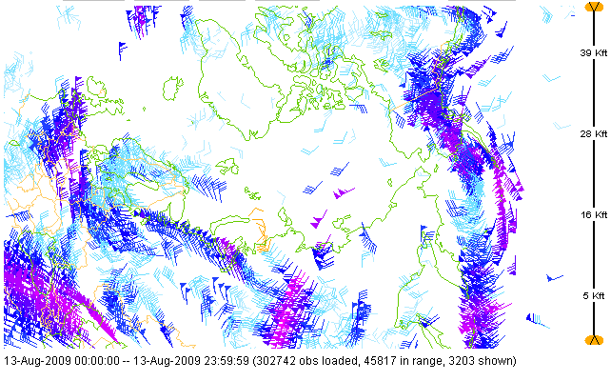

AMDAR Observations over Arctic Region. Courtesy of NOAA ESRL/GSD.

Marine Observations

  - The implementation plan for the global observing system for climate in support of the UNFCCC (GCOS-92) remains as the foundation roadmap guiding the JCOMM Observations Programme Area work plan. It includes Arctic and Antarctic components mainly through the contributions from the International Arctic Buoy Programme (IABP), WCRP-SCAR International Programme for Antarctic Buoys (IPAB).

  - The IABP aims to maintain a network of drifting buoys on the Arctic Ocean to provide meteorological and oceanographic data for real-time operational requirements and for research purposes. Early Russian and US buoy activities, largely for research purposes, evolved into the IABP in 1991 (see below). The International Polar Year, 2007-2008, resulted in a marked increase in the number of buoys. The table does not include the 100 or so buoys that were deployed by the EU project DAMOCLES since these were not available in real-time. IABP is working on getting these data into the IABP data bases, but they have a "research hold" on them, unlike all the other buoy data given below.

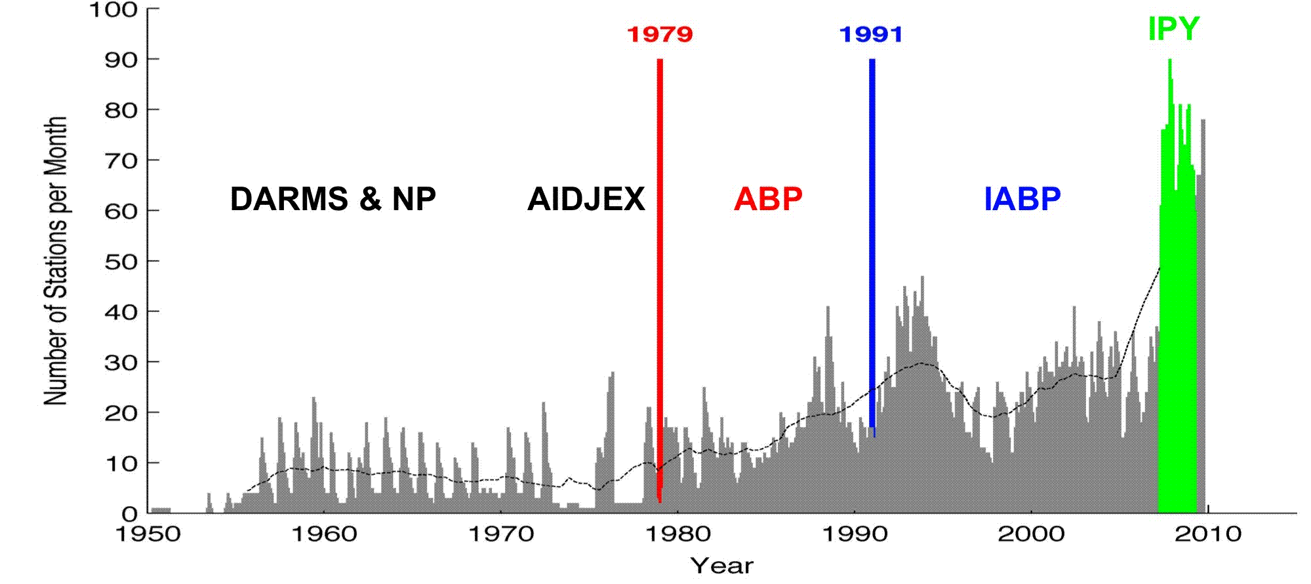

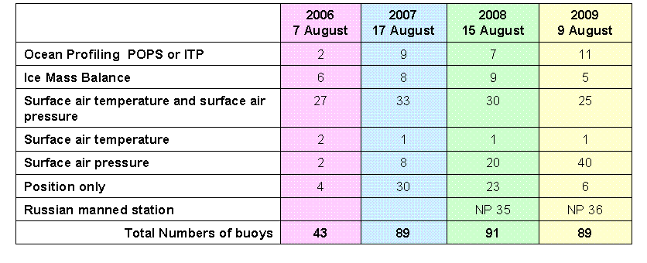
A small number of Ice Mass Balance (IMB) buoys also provide information about ice and snow thickness. The Number of buoys on the Eurasian side of the pole on ice and/or in water remains low (see map below). See also: http://iabp.apl.washington.edu/

3.1.15 The parties of IPAB work together to maintain a network of drifting buoys in the Southern Ocean, in particular over sea ice, to provide meteorological and oceanographic data for real-time operational requirements and research purposes. Parties include national Antarctic programme agencies, meteorological and oceanographic institutes, research and operational agencies and non-governmental organizations interested in Antarctic sea-ice zone studies and contributing actively to the Programme. Buoy deployment relies heavily on the participation of research institutes, and the number of deployments each year is very variable. Further information is at http://www.ipab.aq/.

Daily Tracks with NCEP Ice 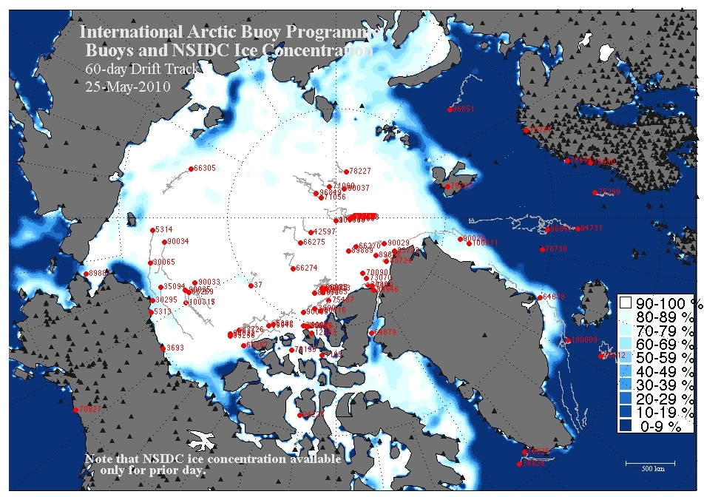

3.1.16 There are very few VOS reporting meteorological observations from Polar Regions. For example, in June 2009, only 2103 VOS reports North of 70N, and 405 reports South of 60S have been received through the GTS for a total of 377812 reports globally (source SOC/DB, Météo France). The Ship Of Opportunity Programme (SOOP) is routinely sampling the upper ocean for thermal data through three high density XBT lines (i.e. AX22 – well sampled in 2008; AX25 – 50% sampled in 2008; and IX28 – 50% sampled in 2008).

3.1.17 The Argo programme was not originally designed to make upper ocean temperature and salinity profiles under ice covered regions. However, some recent technology developments, particularly under IPY, permitted this through the use of Ice Tethered Profilers (ITP) and Polar Ocean Profiling Systems (POPS) but only a few such platforms have been deployed so far, mainly in the Arctic region (see table above).

