WORLD METEOROLOGICAL ORGANIZATION  __________________  COMMISSION FOR BASIC SYSTEMS  OPEN PROGRAMME AREA GROUP  ON INTEGRATED OBSERVING SYSTEMS  IMPLEMENTATION/COORDINATION TEAM ON THE INTEGRATED OBSERVING SYSTEM  Sixth Session  GENEVA, SWITZERLAND, 28 JUNE – 2 JULY 2010 | CBS/OPAG-IOS/ICT-IOS-6/Doc. 4.4  (28.4.2010)  _________  ITEM: 4.4  Original: ENGLISH

STATUS OF THE SURFACE-BASED COMPONENTS OF THE GOS

Marine and Oceanographic Observations

(Submitted by the Secretariat)

Summary and purpose of document

This document provides information on the status of the marine and oceanographic observations as part of the GOS.

Action Proposed

The Meeting is invited to note the information contained in this document for discussion under the appropriate agenda items.

_____________

References: http://www.jcommops.org

Appendix: Status of in situ ocean observing networks in early 2010

Marine and Oceanographic Observations

Status of marine and oceanographic observing systems (June 2008)

1. Introduction

1.1. The development of the oceanographic observing system components of the IOC-WMO-UNEP-ICSU Global Ocean Observing System (GOOS) progressed very slowly since the last ICT-IOS meeting. Sixty-one percent of the overall ocean observing system is now completed. The drifting buoy and Argo float arrays have achieved their initial implementation targets and the preliminary target for VOS Climate (VOSClim) recruitment has been achieved.

1.2 The third session of JCOMM (JCOMM-III), Marrakech, Morocco, 4-11 November 2009, recognized with concern that progress has slowed recently, and agreed that efforts remained to be made to achieve sustainability for those components that reached their design goal, including broadening support for some observing components beyond the traditional research-based funding to include operational support. It therefore requested the Observations Coordination Group (OCG) to develop its work programme for the next intersessional period according to the need to enhance the partnerships between research institutes and operational services. The Commission stressed that integration was key and that every effort should be made to satisfy multiple requirements so that all stakeholders might benefit from Member/Member State contributions. The Commission appealed to Members/Member States to commit additional resources to eventually ensure full implementation and sustainability of the observing components of GOOS and support the integration of in situ and space-based ocean observations.

1.3 JCOMM-III also reviewed the Observations Programme Area (OPA) implementation goals, and welcomed the increasing emphasis on system-wide performance metrics based on Essential Climate Variables (ECVs) as a way to further integrate and rationalize the networks. The Commission requested the JCOMM Observations Coordination Group (OCG) to continue its work towards ECV-based metrics, and directed the OCG to keep the OPA Implementation Goals document under review and update it according to the latest developments with regard to (i) the Progress Report on the Implementation of the Global Observing System for Climate in Support of the UNFCCC 2004-2008; (ii) the outcome and recommendations from the OceanObs’09 Conference; (iii) the outcome of the Third World Climate Conference (WCC-3); (iv) non-climate requirements arising from the CBS Rolling Review of Requirements, including Statements of Guidance and gap analysis, and (v) the forthcoming update to GCOS-92, the implementation strategy for the global climate observing system. The Commission emphasized the importance of a dialogue between those who implement the networks and potential users asking for new capabilities based on their requirements, in order to balance technological capability, network optimization, and funding interest.

2. WIGOS Pilot Project for JCOMM

2.1 The Pilot Project for the integration of marine meteorological and other appropriate oceanographic observations into the WMO Integrated Global Observing System (WIGOS), also known as the JCOMM Pilot Project for WIGOS, is an important contribution to the development of WIGOS and the WMO Information System (WIS).

2.2 The Pilot Project is an interdisciplinary exercise, implemented and sustained by WMO and IOC of UNESCO through JCOMM, to investigate the integration of in-situ and space based ocean observing systems collected within the oceanographic community. The Pilot Project is considering instruments and methods of observation aspects, as well as data management, data exchange, and quality management.

2.3 Due to the important synergies that exist with the International Oceanographic Data and Information Exchange (IODE) Ocean Data Portal (ODP) project of the IOC, a joint Steering Group was established to coordinate the development of the Pilot Project and to provide liaison with appropriate WMO and IOC programmes and subsidiary bodies. The “Joint Steering Group for the IODE Ocean Data Portal and the JCOMM Pilot Project for WIGOS” has two co-chairs - one with an IODE ODP and one with a WIGOS – and more specifically instruments and methods of observation – perspective.

2.4 The Pilot Project identified three key deliverables: (i) document and integrate instrument best practices and related standards, (ii) build marine data systems that are interoperable with the WIS, and (iii) promote quality management and standards through compliance with the WMO Quality Management Framework (QMF).

2.5 Significant achievements have already been realized including a review of the WMO and IOC Technical Publications and updating of the marine chapter of the WMO CIMO Guide, development of the IODE ODP to be interoperable with the WIS as a Data Collection or Production Centre (DCPC), establishment of WMO-IOC Regional Marine Instrument Centres (RMIC) with their Terms of Reference approved by JCOMM-III, development of appropriate quality management standards through the IODE-JCOMM Standards process, and the production of a catalogue on JCOMM best practices and standards published on the web. A strategy for updating WMO and IOC Publications in order to harmonize standards was also proposed by the Pilot Project. Key data-sets have been identified for which interoperability with the ODP and/or the WIS should be developed, and commitments already made by some of the agencies holding these datasets. USA, China and Morocco have offered to host RMIC facilities in RA-IV, RA-II and RA-I respectively. Three training courses on the use of the ODP have been organized, as well as one workshop on Marine Instrumentation to test the concept of RMIC at the facilities offered by the USA.

2.6 WMO Members and IOC Member States are expected to benefit from the integration of marine meteorology and other appropriate observations into WIGOS in a number of ways including (i) reduced financial demands on Members and Member States through the provision of multi-disciplinary access to data from WIS and ODP permitting cost-savings based on synergies between disciplines; (ii) increased visibility for Members and Member States producing ocean observations and related products and services; and (iii) better research for future applications.

2.7 JCOMM, as a joint Technical Commission between WMO and IOC, is providing the appropriate governance and mechanisms to engage with all partners and this has been a major factor in the success of the Pilot Project. The IOC, through its IODE Committee, is providing excellent cooperation and good working relationships were established between the WMO and IOC secretariats.

2.8 The Pilot Project is expected to end in early 2011. A last meeting of the joint Steering Group is planned in Ostend, Belgium, from 1 to 3 November 2010, and will be working at finalizing a project report which will include:

- Key information about the project achievements, test of concept, and pending issues;
- Information on benefits of WIGOS integration regarding oceanographic observations for NMHSs, NODCs, and ocean data users,
- Details about the strengths and weaknesses in the management of the ocean observing systems;
- Some recommendations derived from the analyzed strengths and weaknesses;
- Information on the impact of the marine observing systems integration, and use of recommended standards on the operations of NMHSs, and NODCs; and
- Lessons learned, and a proposal for legacy recommendations based on the lessons learned.

2.9 It is expected that the legacy recommendations will be associated with a proposed future workplan, responsibilities, and costing.

3. Expanded JCOMMOPS function

3.1 The JCOMM in situ Observing Programme Support Centre (JCOMMOPS) is playing an increasingly vital role in the activities of most of the OPA panels. Activities such as increased coordination for opportunistic deployments and management of detailed platform metadata are important for achieving system wide efficiencies and for ensuring the usefulness and long term preservation of the data gathered by the in situ observing system.

3.2 At its second Session, Halifax, Canada, September 2005, JCOMM recommended a review of the JCOMM in situ Observing Platform Support Centre (JCOMMOPS). Hence, the OCG initiated a process to review usefulness and effectiveness of JCOMMOPS. Since then substantial discussions have taken place, not only with those Panels presently supporting JCOMMOPS (for example the Data Buoy Cooperation Panel (DBCP), the Ship Observations Team (SOT), and the Argo profiling float programme), but also with the JCOMM Management Committee, the JCOMM Observations Coordination Group, and the Observing Panels that could potentially benefit from the support and services of JCOMMOPS. These also include the Partnership for Observation of the Global Oceans (POGO), the UNESCO/IOC International Ocean Carbon Coordination Project (IOCCP), the Global Sea-level Observing System (GLOSS), and the Ocean Sustained Interdisciplinary Timeseries Environment observation System (OceanSITES). Meeting reports of the OCG and its Observing Panels are available from the JCOMM web site.

3.3 These discussions confirmed the value of JCOMMOPS, leading to a general agreement that JCOMMOPS was very useful in providing effective support towards the implementation of in situ ocean observing systems under its responsibility, and that there was an urgent need for an expanded Observing Programme Support Centre (OPSC). The extended JCOMMOPS activities should include system performance monitoring, system design evaluation, and authority to recommend deployments to improve system efficiency and effectiveness. This could provide synergies for functions that are now distributed, and make available a more integrated framework for the deployment and further development of ocean observing networks.

3.4. A joint WMO-IOC circular letter was issued in September 2007 to call for the submission of Letters of Intent (LOI) to host a JCOMM Observing Programme Support Centre (OPSC). Fifteen Letters of Intent had been received by the Secretariat and objectively evaluated by a committee led by the JCOMM co-presidents. The Evaluation Committee engaged in a negotiation with the top-ranking institution resulting in a final decision made by the Executive Secretary of UNESCO/IOC and the Secretary-General of WMO to select the proposal from France (CLS and IFREMER).

3.5 With guidance provided by the Evaluation Committee, JCOMM-III discussed the future functions of the OPSC and agreed that the name JCOMMOPS should be kept in order to ensure continuity and to build on the existing worldwide recognition of JCOMMOPS. In order to reflect its view on the matter, the Commission adopted Recommendation 6.4/1 – New Terms of Reference for an Expanded JCOMM In-situ Observations Programme Support Centre (JCOMMOPS). In doing so, it invited Members/Member States to commit resources to support the implementation and operations of the expanded JCOMMOPS, through voluntary contributions

3.6 JCOMM-III urged Members/Member States to commit resources to JCOMMOPS so that JCOMMOPS can realize its full potential of serving a truly integrated observing system serving as many as possible of the ocean observing systems components (drifting buoys, moored buoys, profiling floats, ship-based observing systems, sea level stations, reference stations). Furthermore, recognizing the value of JCOMMOPS metadata holdings to parties outside the panels and associated programmes supporting its work, the Commission urged OCG to find a funding mechanism by which JCOMMOPS can partner with other agencies (e.g. space agencies) for the benefit of JCOMM.

3.7 Maintaining the array of global drifters at its target level, especially in data sparse regions, remains a logistical challenge. A more coordinated approach is needed to address the management of deployment opportunities and the deployment of instruments at sea, including drifters and profiling floats, as well as the servicing of moored buoys. JCOMM-III requested the Observations Coordination Group to propose a strategy for the OPA to enhance deployment opportunities, and Members/Member States to make information on deployment opportunities routinely available to JCOMMOPS.

4. Summary of the status of implementation of the global ocean observation networks

4.1 A summary of essential in situ observing programme implementation status and the challenges remaining to achieve global coverage is given in Table 1 below. The status maps are provided in Appendix to this document.

Status of ocean observing networks under JCOMM programmes:

Network | Target | Status | Issues/Challenges
SST/Velocity Drifters  (DBCP) | 1250 | 100% | Sustaining the array. Developing a High Resolution/Accuracy SST sub-set network as a pilot project in support of satellite validation. Data timeliness. Iridium satellite data telecommunication. Drogue survivability and loss detection. Pilot Project for wave measurements from drifters using GPS.
Barometer Drifters  (DBCP) | 1250 | 50 % | Installing barometers on all drifters. Smaller design units compatible with barometer upgrade scheme. Data timeliness. Iridium satellite data telecommunication.
Salinity drifters  (DBCP) | 300 | 0% | Cost of devices. Life time of units in bio-fouling environment. Development of new cost-effective technology, micro-sensors.
Arctic ice drifters  (DBCP/IABP) | 310 | 29% | 250km x 250km targeted in the Arctic (180 units); Arctic Eurasian sector not well sampled. Increasing area of First-Year Ice and Open Water during summer. Survivability in seasonal ice (e.g. using AXIB). Decreasing IPY deployments. Real-time reporting difficult to obtain in some cases (e.g. DAMOCLES).
Antarctic ice drifters  (DBCP/IPAB) | 130 | 23% | 500km x 500km targeted in the IPAB (South of 55°S, 130 units); episodic deployments; buoys escaping the region of interest; GTS data reporting sometimes problematic.
Wave buoys  (DBCP) | No target | N/A | Pilot Project established by the DBCP for the evaluation of wave measurements from buoys (intercomparisons based on "first five" Fourrier transform). Another Pilot Project is investigating using GPS for wave measurements from drifters.
Tropical moorings  (TAO/TRITON – Pacific) | 72 | 100% | US part operational. Vandalism remains problematic. New smaller, more cost-effective, easier to deploy/maintain vandalism-proof design.
Tropical moorings  (PIRATA – Atlantic) | 18 | 100% | Sustaining the array. Vandalism remains problematic. New smaller, more cost-effective, easier to deploy/maintain vandalism-proof design.
Tropical moorings  (RAMA – Indian Ocean) | 47 | 51% | Expanding. Vandalism remains problematic. New smaller, more cost-effective, easier to deploy/maintain vandalism-proof design.
Deep ocean time-series moorings and observatories  (OceanSITES) | 122 | 75% | Data openly available via the OceanSITES data system but some of the data are distributed in delayed mode only. Stressing real time distribution of ECV data on all sites. Not all sites measure the same variables; some focus on some sites (e.g. circulation, air-sea fluxes, convection, benthic environments...). Core backbone network to be designed (10 to 15 sites) with minimum suite of identical measurements (e.g. atmospheric forcing, air-sea fluxes, ocean/physical in water column, circulation, CO₂, oxygen).
Transport sites  (OceanSITES) | 19 | 84% | Data openly available via the OceanSITES data system but some of the data are distributed in delayed mode only. Stressing real time distribution of ECV data on all sites.
Transport stations  (OceanSITES) | 73 | 92% | Data openly available via the OceanSITES data system but some of the data are distributed in delayed mode only. Stressing real time distribution of ECV data on all sites.
Aerological profiles  from ships  (ASAP) | No target | 21 ships | Fleet decreasing due to ship volatility. Shipping industry providing shorter charter contracts and reduced line services. Shortage of Helium on world market. Iridium now used for data collection (higher resolution data, better timeliness). Main used in North Atlantic (E-ASAP) and NE Pacific Ocean (JMA). About 7000 profiles per year; 95% profiles reaching 100hPa. AMDAR provides for cost effective ascent and descent profiles where airports are located so availability of such reports over the oceans is limited to coastal regions and some islands. ASAP can provide for complementary aerological profile data but the technology remains relatively expensive. E-ASAP (EUCOS, Europe) is targeting 19 ships to provide more than 6000 profiles yearly in the North Atlantic and Mediterranean sea.
VOS ships | No target | n/a | About 4000 ships registered through the WMO Publication No. 47 but only about 1000 of them are reporting daily. VOSClim, which exceeded target used to be 250 vessels, is now being integrated in the wider VOS as a new class of vessel. Recording of the additional metadata and quality elements remains problematic in some instances.
AWS on ships  (VOS) | 500 | 54% | Fleet declining. Number of AWS increasing (out of a total of 4200 recruited VOS; 1800 with e-logbooks; 1000 reporting daily). Less manual and visual observations available for climate applications. Recording of visual observations recommended in conjunction with AWS using e-logbooks but this could be problematic in the future. Volatility of ship routes.
HDX XBT lines from ships  (SOOP) | 26 | 80% | 10 lines under-sampled or not sampled. OceanOBS'09 also reinforced the SOOP programme operating in "line" mode (especially high density) while Argo provides for the broad horizontal 3°x3° network. XBT fall rate equation and depth bias issue.
FRX XBT lines from ships  (SOOP) | 25 | 52% | 16 lines under-sampled or not sampled. Some of the historical low density lines stressed at OceanOBS09 and should be preserved for time series. XBT fall rate equation and depth bias issue. Optimal sampling and frequency to be assessed by Science Team to be formed.
Operational tide gauges  (GLOSS Core Network) | 290 | 68% | Data from 198 stations (68%) are available in near-real time (NRT) via the GTS and/or in fast delivery (FD) mode (quality controlled data provided by data originator within 4-6 weeks of collection). 32 additional stations are operational but provide data with a delay of a year or more (198+32 increases operational status to 79% of GCN). 127 stations include GPS for monitoring vertical land movements, but not all provide data in NRT/FD.  GLOSS tide gauge network used for the ongoing calibration and validation of satellite altimeter time series, and as such is an essential observing component assessing global sea level change. Tide gauges are playing a greater role in regional and global tsunami warning systems and for operational storm surge monitoring.
Geocentrically located/climate quality tide gauges (GLOSS) | 170 | 61% | 103 stations (61%) include GPS and report data in NRT/FD. Tide gauges are operational at 96% of the stations, but not all feature both GPS and NRT/FD access. 86% of stations have NRT/FD access. 66% of stations have GPS.

Status of ocean observing networks under JCOMM associated programmes:

Network | Target | Status | Issues
Profiling floats (Argo) | 3000 | 100% | Sustaining the array; addressing marginal seas. Expanding to under seasonal ice, and marginal seas. Sampling below 2000m. Making additional measurements (e.g. higher resolution vertical sampling near surface, Oxygen, Chlorophyll, nitrates, wind, rainfall).
Ocean Carbon Inventory Lines  (IOCCP) | 37 | 43% | Target is 37 inventory lines per decade. Approximately 45 sustained programmes underway measuring pCO₂ (15 of these on commercial ships); approximately 12 of these programmes are doing full trans-basin sections. Nearly all of these programmes are funded by time-limited funds, and many of them are nearing the end of their funding period. Although this network has provided the basis for estimating the climatological air-sea fluxes of CO₂, the observations are inadequate to resolve year-to-year variations and to provide flux estimates at any resolution higher than several hundred kilometres. IOCCP working on strategy to address this issue using VOS, drifter and time series observations from the Surface Reference Mooring Network and other platforms together with associated products.

Table 1: OPA implementation status and global coverage targets

____________

Appendix

Status of in situ ocean observing networks in early 2010

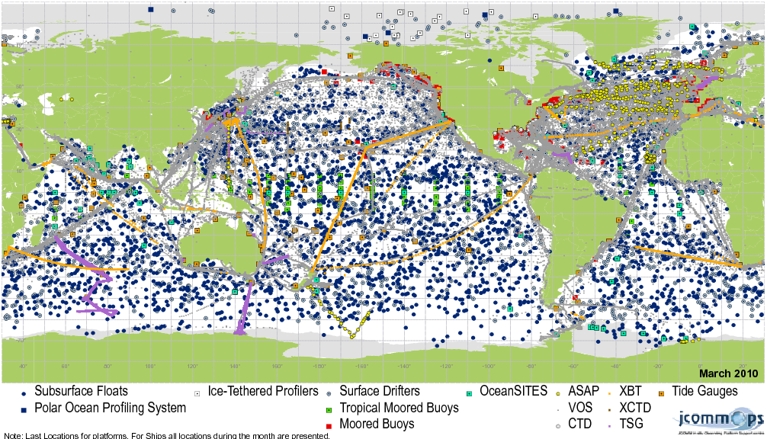
Figure 1: Ocean observing platforms, March 2010

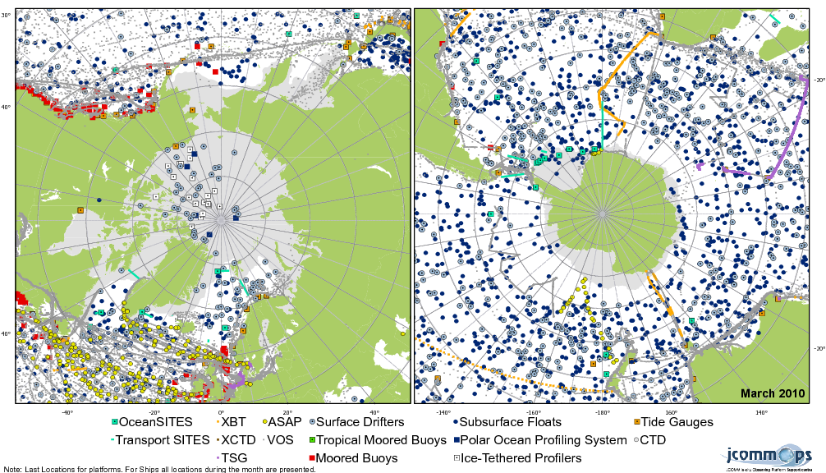
Figure 2: Ocean observing platforms reporting from the polar regions, March 2010

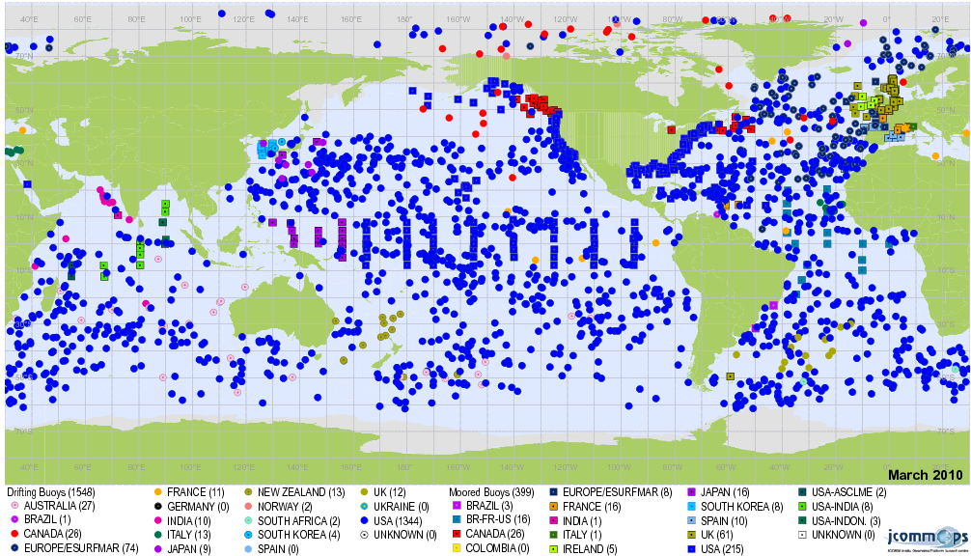
Figure 3: Drifting and moored buoy observations by country (DBCP), March 2010

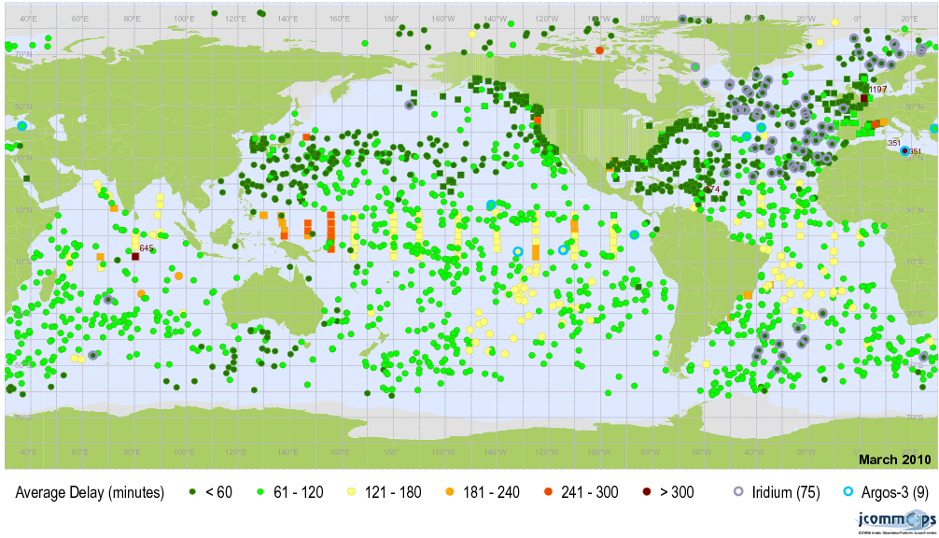
Figure 4: Buoy data timeliness (as received by Météo France from GTS), March 2010

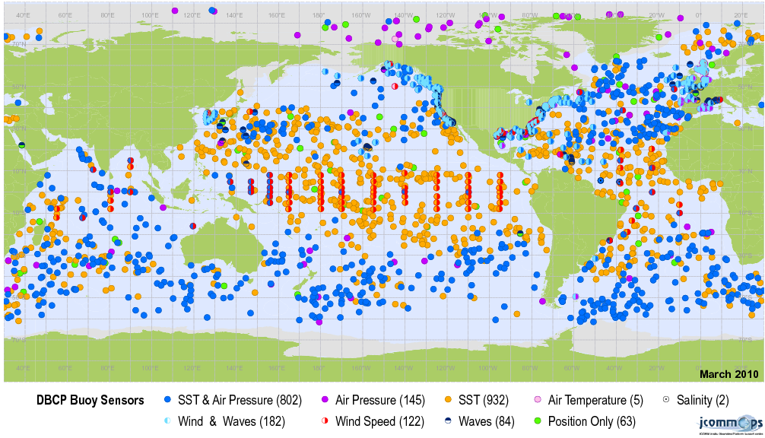
Figure 5: Variables reported by drifters, March 2010

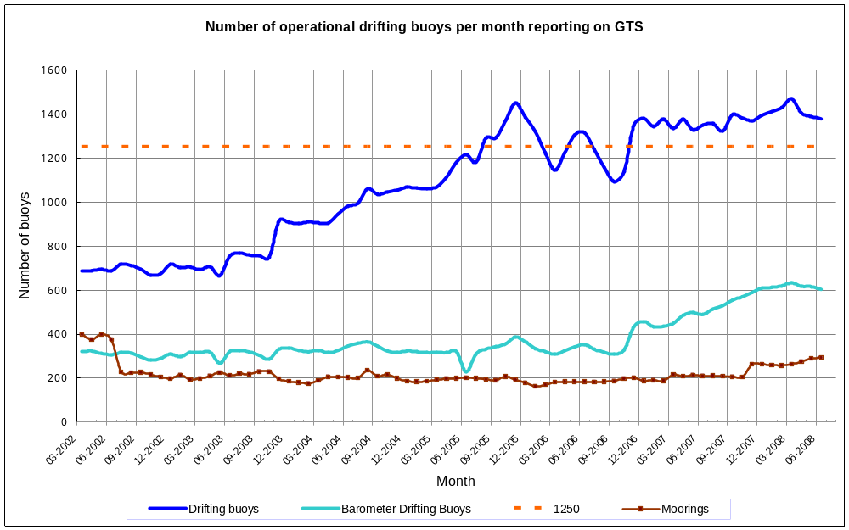

Figure 6 : Monthly evolution of the number of operational drifting buoys reporting on GTS from March 2002 to July 2008 and those reporting air pressures. Operational moored buoys are also included (Data derived by statistics computed from GTS in situ marine data provided by Météo-France – Source: JCOMMOPS).

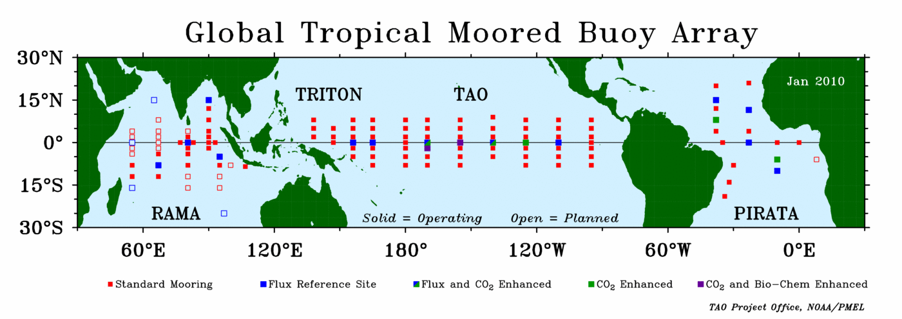
Figure 7: Tropical moored buoy array (operational sites in solid squares), January 2010

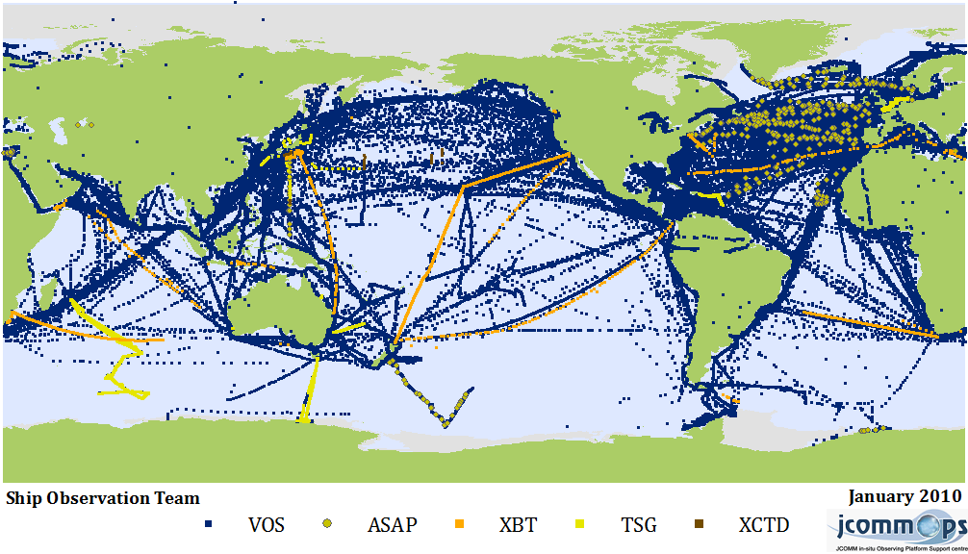
Figure 8: Ship observations, January 2010

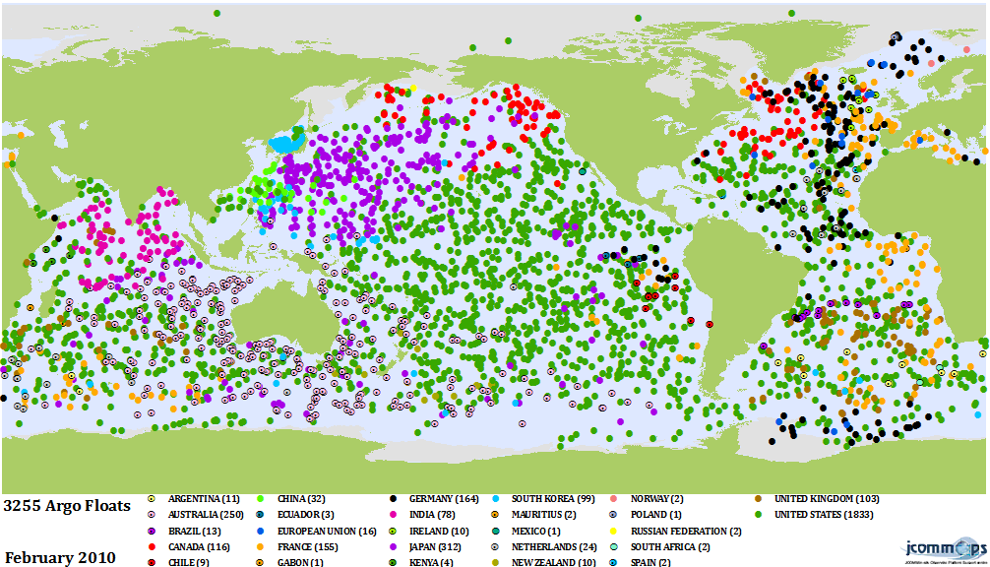
Figure 9: Argo profiling floats by country (Sub-surface Temperature and Salinity), February 2010

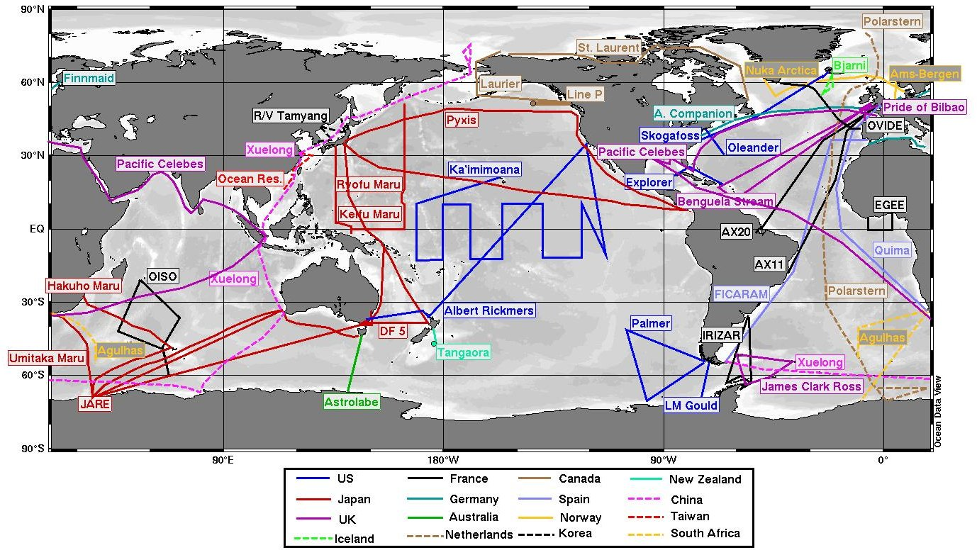
Figure 10: Ocean Carbon on-going and Planned Cruises as of November 2007 (International Ocean Carbon Coordination Project)

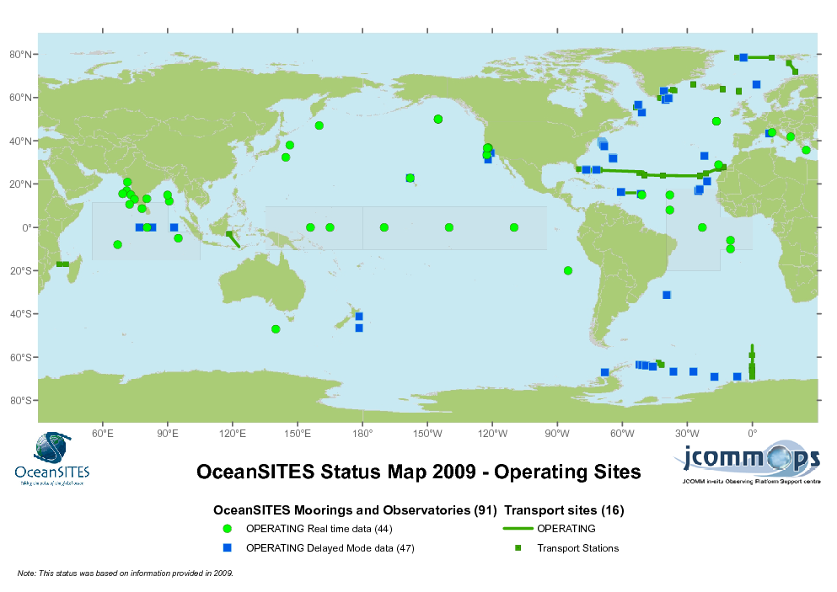
Figure 11: Deep-ocean time-series reference stations (OceanSITES), 2009

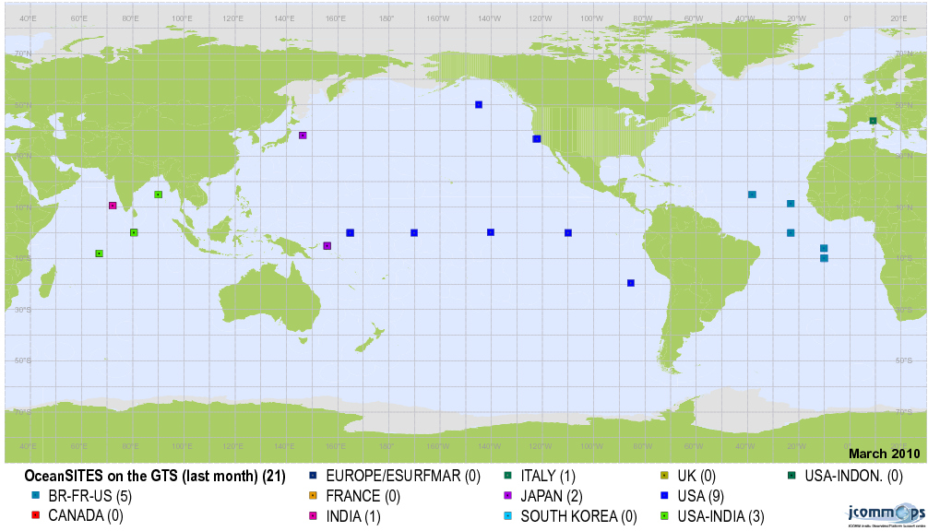
Figure 12: Deep-ocean time-series reference stations reporting on the GTS (OceanSITES), March 2010

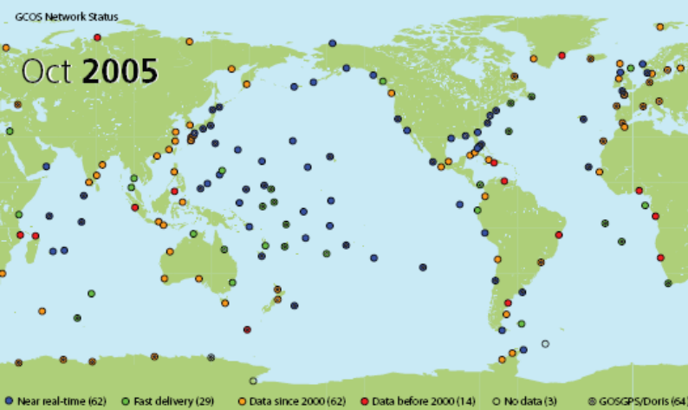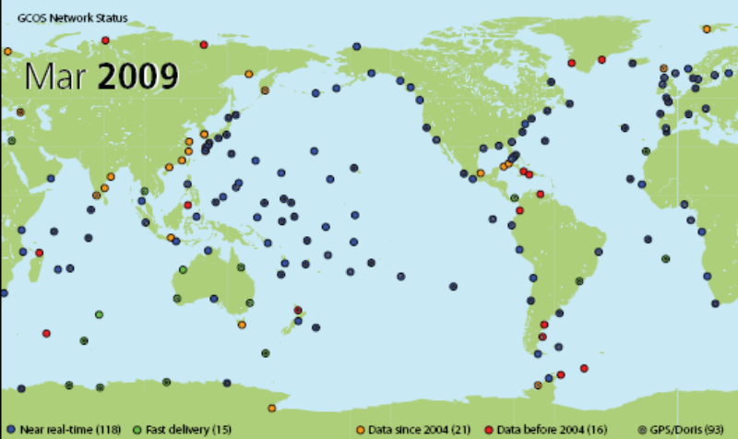

Figure 13: Configuration of the GLOSS/GCOS Core Network in 2005 (left) and 2009 (right). There have been important improvements in the number of tide gauges reporting high-frequency data in near real-time (typically within 1 hour).

____________

: http://www.oceandatastandards.org
: http://bestpractice.iode.org/
: Training Course on the Establishment of National Ocean Data Portal nodes in the Black Sea region (ODINBlackSea), Obninsk, Russian Federation, 20-21 March 2009; First IOC WESTPAC Training Course on the Establishment of National IODE Ocean Data Portal Nodes, Seoul, Republic of Korea, 31 August – 4 September 2009; and Training Course on the Establishment of National Ocean Data Portal Nodes in the Black Sea region (ODINBlackSea) for Georgian and Turkish NODCs, Istanbul, Turkey, 21-23 December 2009
: JCOMM Marine Instrumentation workshop for the Regional Association IV, Bay St Louis, Stennis Space Center, Mississippi, USA, 13-15 April 2010
: http://www.jcomm.info/Publications

