WORLD METEOROLOGICAL ORGANIZATION  __________________  COMMISSION FOR BASIC SYSTEMS  OPEN PROGRAMME AREA GROUP  ON INTEGRATED OBSERVING SYSTEMS  IMPLEMENTATION/COORDINATION TEAM ON THE INTEGRATED OBSERVING SYSTEM  Sixth Session  GENEVA, SWITZERLAND, 28 JUNE – 2 JULY 2010 | CBS/OPAG-IOS/ICT-IOS-6/Doc.4.2.  (17.V.2010)  _________  ITEM: 4.2  Original: ENGLISH

STATUS OF THE SURFACE-BASED COMPONENTS OF THE GOS

GSN, GUAN AND GRUAN

(Submitted by the GCOS Secretariat and Matthew Menne, Rapporteur on GCOS matters )

Summary and purpose of document

This document presents background information on several items for consideration at the ICT session related to the GCOS Surface Network (GSN), the GCOS Upper-Air Network (GUAN), the GCOS Reference Upper-Air Network (GRUAN), and activities related to progress review and planning of GCOS component networks in general.

Action Proposed

The meeting is invited to note the information contained in this document for discussion under the appropriate agenda items and consider proposed recommendations.

_____________

GSN, GUAN AND GRUAN

1. Introduction
The document provides an overview of activities in support of GSN, GUAN and GRUAN implementation, as well as examples for both a major observing systems review and a roadmap for GCOS until 2015 including observational requirements.

2. Achievements (in relation to Terms of Reference)
(a) Continue the preparation and maintenance of reviews of observing systems that are being designed under the auspices of GCOS, e.g. GUAN, GSN, GRUAN and space-based observing systems (GOSSP and CGMS); and provide feedback to Members in maintaining the quality of the networks;

General activities

A major 5-year review of progress and gaps in all global observing systems contributing to climate applications has been undertaken in 2008/2009, culminating in the publication of the Progress Report on the Implementation of the Global Observing System for Climate in Support of the UNFCCC 2004-2008 (“GCOS Progress Report 2004-2008”, August 2009, GCOS-129, GOOS-173, GTOS-70). This Report was compiled under leadership of a writing task team chaired by Prof Paul Mason, with support by the GCOS secretariat, the CBS Rapporteur for GCOSand many other contributors. This Report assesses progress since late 2004 in implementing the Actions called for in the 2004 GCOS Implementation Plan (which has been accepted by ET-EGOS and subsequently by CBS as a Statement of Guidance for Climate Monitoring, covering Climate Change and Climate Variability). Implementing those Actions would help maintain, strengthen, or otherwise facilitate global observations of the climate system.

As sources of information, the Report used performance reports from WMO and GCOS monitoring centres and component observing systems (e.g., monitoring results for GSN, GUAN; annual monitoring results for WMO WWW; CEOS progress reports) and their technical advisory bodies in all domains – atmosphere, oceans and terrestrial. Information on national activities related to systematic observation for climate (‘National Reports’, a synthesis of which has also been made available) provided by Parties was also considered, as well as expert advice and judgment by the Chairs of the GCOS Steering Committee and Panels.

The Report underwent a web-based community open review between April and June 2009 (including all GCOS sponsoring organizations, such as WMO and the Intergovernmental Oceanographic Commission) and was submitted for consideration by Parties at SBSTA 30 in June, leading to formal conclusions by the Chair of SBSTA, as well as to a decision on “systematic observation” by Parties at COP 15 in Copenhagen.

On the basis of the Report, it is clear that most of the Actions set down in the 2004 GCOS Implementation Plan have been enthusiastically embraced at both international and national levels, and implementation of the various observing systems in support of the UNFCCC has progressed significantly over the last five years. Progress on each of the 131 Actions has been assessed on a scale from ‘good’ to ‘moderate’ to ‘none’, and 77% of the Actions have seen at least moderate progress. Agents for Implementation identified in the IP-04 have taken significant steps to attain the specified objectives. In some areas, however, progress since 2004 remains limited or absent (12% of Actions with poor progress, and 11% with none).

Key top-level findings of the Report are that

- The increasing profile of climate change has reinforced world-wide awareness of the importance of an effective Global Climate Observing System.
- Developed Countries have improved many of their climate observation capabilities, but national reports suggest little progress in ensuring long-term continuity for several important observing systems.
- Developing Countries have made only limited progress in filling gaps in their in situ observing networks, with some evidence of decline in some regions, and capacity building support remains small in relation to needs.
- Both operational and research networks and systems, established principally for other purposes, are increasingly responsive to climate needs including the need for timely data exchange.
- Space agencies have improved both mission continuity and observational capability, and are increasingly meeting the identified needs for data reprocessing, product generation, and access.
- The Global Climate Observing System has progressed significantly over the last five years, but still falls short of meeting all the climate information needs of the UNFCCC and broader user communities.

In addition to this Report, GCOS Secretariat, in collaboration with the CBS Rapporteur for GCOS and others, continues to provide guidance and support to networks and systems contributing to GCOS, such as GSN, GUAN and GRUAN (see below). A regular dialogue with space agencies, through CEOS and CGMS via WMO Space Programme ensures that GCOS requirements and concerns are being considered by the agencies in the evolution of the space-based component of the GOS.

GSN and GUAN

Now numbering nine in total, the CBS Lead Centres for GCOS have been working to improve the performance of GSN/GUAN since the first Lead Centre was established nearly seven years ago. In part because of the efforts of each the GCOS Lead Centers, there has been a marked improvement in the number of CLIMAT reports received at the GCOS Archive Centre as shown in Fig. 1. This improvement has resulted from efforts to increase the number of stations in the GSN that submit CLIMAT reports, from identifying and correcting CLIMAT message coding errors, and from troubleshooting issues with the GTS such as out of date routing catalogs. Consequently, the rate of CLIMAT receipt now exceeds 80% percent globally. However, Fig. 2 indicates that there are still large differences in the receipt rates regionally with the percentages from Europe (RA VI) and North and Central America (RA IV) at about 95%; 90% for Asia (RA II); 80% for the South West Pacific (RA V); 65-80% from South America (RA III); and, 50 to 60% for Africa (RA I).

At their Second Coordination Meeting held in November 2010 in Geneva, the CBS Lead Centres for GCOS agreed to expand their efforts to address the data issues within the entire RBCN rather than only the GCOS Surface Network (GSN). The group also noted a common theme concerning failure of GTS routing at RTHs and noted that RTH Melbourne had a policy of forwarding all SYNOP, TEMP and CLIMAT reports that it received and encouraged all other RTHs to follow suit. The group was informed that routing problems currently experienced on the GTS might be eliminated as the WIS developed.

Noting that there are currently a number of focal points with identical or overlapping responsibilities, the Lead Centres for GCOS also recommended that the WMO secretariat and CBS take steps such that Members nominate a single focal point covering RBCN, RBSN, GSN, GUAN and Vol. A.
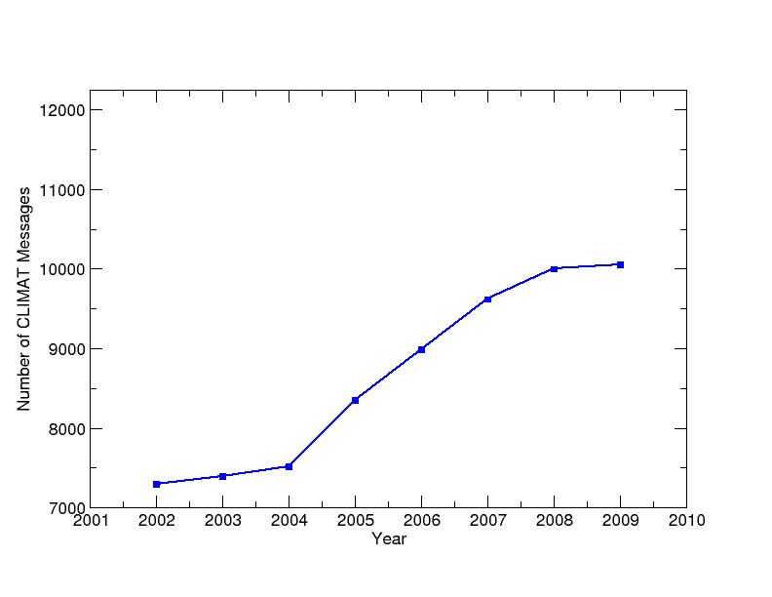
Figure 1: Number of CLIMAT reports received at the GCOS Archive Centre at NOAA/NCDC for stations in the GCOS Surface Network (full implementation = 12 300 reports).

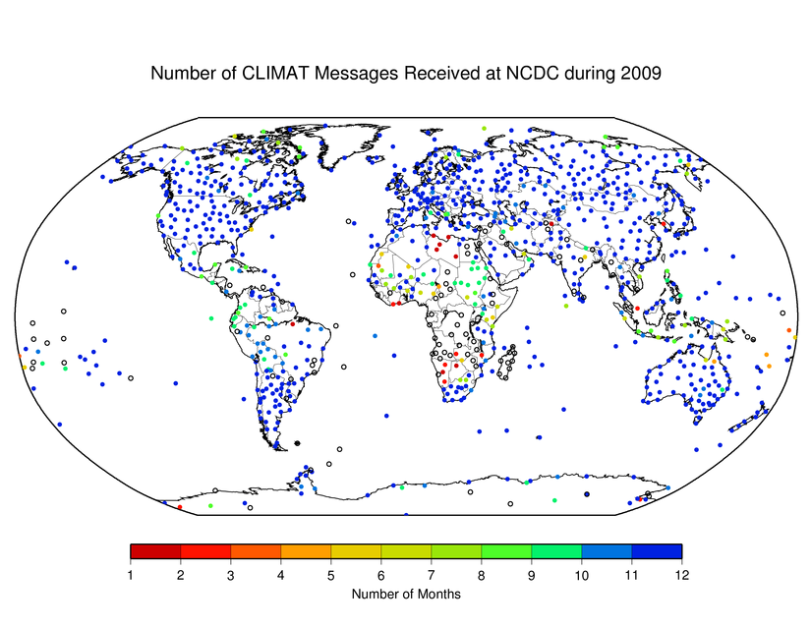
Figure 2. Number of CLIMAT messages received at the GCOS Archive Centre.

Ongoing rehabilitation/system improvement efforts have also led to the near full implementation of the GUAN. Fig. 3 summarizes the number of GUAN sights that meet the minimum performance requirements as defined in GCOS-73.

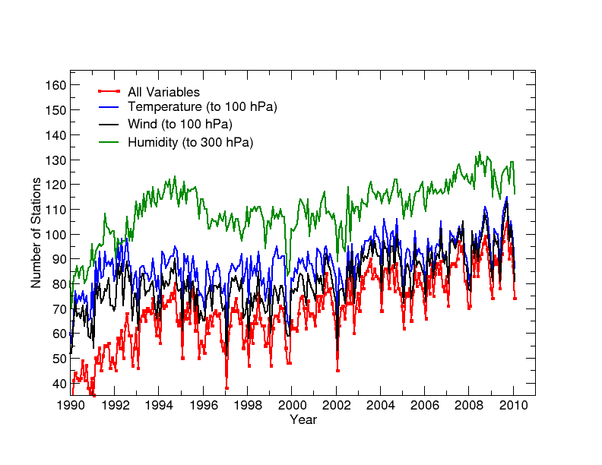
Figure 3. Time series of GCOS Upper Air Network (GUAN) performance as a function of number of stations meeting all minimum requirements (total number of GUAN stations = 169 in 2010).

Daily and sub-daily data from surface and upper-air networks

Recognizing the need for (sub)daily data of temperature, precipitation and other climate variables for studying climate variability and extremes, and for reanalysis, WMO sent a letter to all Members in 2008, calling for regular submission of both near-real-time and historical (sub)daily data records to the World Data Centre for Meteorology at Asheville (NCDC). The need for international exchange of such data was raised at WMO Cg-XV (2007) and repeatedly at AOPC (AOPC-XIII and -XIV, 2007 and 2008), partly in conjunction with the compilation of decadal World Weather Records. Unfortunately, Members’ response to the WMO letter has been very limited, and further action is needed.

(b) Provide input to the ET-EGOS on user requirements relevant to climate monitoring and to the OPAG-IOS on issues relevant to CBS;

2010 Update of the GCOS Implementation Plan

ET-EGOS-5 in December 2009 (Action 43) recognized that an updated set of GCOS requirements will be provided in support of the WMO CBS Rolling Review of Requirements process, along with the finalization of an update of the GCOS Implementation Plan, by the end of 2010. During the open review period between November 2009 and January 2010, the Chair and Members of ET-EGOS have provided a range of useful comments to a draft version of the Plan.

The basis for the updated 2010 GCOS Implementation Plan (“IP-10”) are the 2004 GCOS IP (GCOS-92) and its 2006 Satellite Supplement (GCOS-107), recognition of progress and changes in the past five years in science (e.g., IPCC AR4, Sydney workshop “Learning from the AR4”), technology (e.g., satellite sensors, ocean in-situ platforms), user needs (e.g., stronger focus on adaptation and mitigation options addressing climate change) and international coordination (e.g., GEO/GEOSS, UN System “Delivering as One” on Climate Change).

Implementation of the proposed around 140 Actions in the current draft Plan between 2010-2015 would ensure implementation of a comprehensive observing system for the ECVs that would address Articles 4 and 5 of the UNFCCC, including associated analysis, research, infrastructure and capacity building mainly in support of the needs of the UNFCCC (monitoring, adaptation, mitigation). In the IP-10 the list of ECVs has evolved slowly as scientific requirements change and as technological developments permit. For example, the updated list of ECVs now includes soil moisture, soil carbon, ocean oxygen content, biodiversity and habitat properties, and recognizes the role of chemical precursors in forming some atmospheric composition ECVs, such as ozone and aerosols.

The ET-EGOS agreed at its Second Session in 2006 that the GCOS Second Adequacy Report (2003) and the GCOS Implementation Plan (2004), supplemented by the satellite requirements (2006), provided an adequate Statement of Guidance for Climate Monitoring, covering Climate Change and Climate Variability.

(c) Provide advice and support to the Chairperson of OPAG-IOS on development and implementation of WIGOS concept (GRUAN WIGOS Pilot Project)

During 2009, elements of the implementation of the GCOS Reference Upper-Air Network (GRUAN) have been accepted by CBS-XIV and the WIGOS Project Office as a WIGOS Pilot Project, focussing on (including timeline):
- Development of a GRUAN Implementation Plan (July ’09, completed)
- Report on GRUAN data quality management and intercomparison procedures (“What constitutes a GRUAN measurement?”) (Sept ’09, in progress)
- Development of proposal to define data dissemination among all GRUAN partners, including GRUAN metadata congruent with WIS metadata standards (Mar ’10)
- Participation in CIMO upper-air intercomparison (Summer ’10)
- Development of a mature draft GRUAN Manual of Operations (Summer ’10; particularly dependent on support: by dedicated experts, e.g. a WMO Commission expert team)

Overall progress against stated GRUAN-WPP aims has been satisfactory. There has been progress on planning aspects for the CIMO intercomparison, with the inclusion of the GRUAN Lead Centre Head into the organizing committee for the campaign, but there are remaining issues to be resolved. Secondly, the preparation of a GRUAN Manual of Operations and regulatory materials is a substantial task for 2010 and currently under preparation.

ET-EGOS-5 recommended that CBS establishes, in late 2010, a short-term Expert Team on GRUAN to translate the appropriate operational procedures described in the forthcoming Guide to the GRUAN into the WMO regulatory material (Manual on the Global Observing System (WMO-No. 544), Guide to the Global Observing System (WMO-No. 488) and the Guide to Meteorological Instruments and Methods of Observation (WMO-No. 8).

Progress towards a data dissemination and archive model was made at a meeting in September 2009 at NCDC, with NCDC agreeing to serve as an archive centre for the soundings from GRUAN as a minimum. In this respect, close collaboration with the WMO-WIS project is ongoing. A report on progress in the Pilot Project was presented to the Executive Council Working Group on WIGOS and WIS – Sub-Group on WIGOS in October 2009.

The GCOS Reference Upper-Air Network (GRUAN) is intended to provide long-term high quality climate records of upper-air temperature, water vapour, and other key essential climate variables, particularly in the troposphere and in the lower stratosphere, by a combination of balloon borne and remote sensing state of the art instrumentation, and will constrain and calibrate data from more spatially-comprehensive global observing systems, including satellites and current radiosonde networks (e.g., the GUAN). More information, in particular on the status of GRUAN Implementation, including previous GRUAN meetings in Lindenberg (2008), Norman/Oklahoma (2009) and Payerne (2010) are available from www.gruan.org.

3. Issues
Data exchange over the GTS:
Continuing failure of GTS routing at RTHs has been demonstrated by the CBS Lead Centres for GCOS Data, as shown by the differences in receipt of important reports such as the CLIMAT and SYNOP from GSN stations and the TEMP reports from GUAN stations. In 2009, CBS President and WMO secretariat have been informed of this persistent issue, and a letter has been sent by WMO to all Members who operate the RTH asking them to update the catalogues and routing tables necessary to ensure proper data dissemination. Since then, the response by Members was limited, and many of the RTH focal points still do not respond to requests for assistance and many of the routing catalogues and information files have not been updated. The RTH Melbourne has adopted a policy of forwarding all SYNOP, TEMP and CLIMAT reports that it receives (“spraying”) and has encouraged all other RTHs to follow suit. Advice on further steps to resolve this issue is sought.

Exchange of daily and sub-daily data from surface and upper-air networks
Members’ response to the 2008 WMO letter calling for regular submission of (sub)daily surface and upper-air meteorological data to NCDC has been very limited. Further advice on how to encourage Members to exchange such data is needed.

4. Recommendations
- That ICT-IOS endorse establishment by CBS of an Expert Team on GRUAN to translate the appropriate operational procedures described in the forthcoming Guide to the GRUAN into the WMO regulatory material, as recommended by ET-EGOS-5.

- That ICT-IOS take steps to improve the exchange of key meteorological and climatological data over the GTS, including (sub)daily data, by working with Members hosting RTHs and through other appropriate means.

5. Proposal for the Terms of reference of the Expert Team / the Rapporteur
No proposals are made at this point.

GCOS (2009): Synthesis of National Reports on Systematic Observation for Climate; GCOS-130; April 2009, http://www.wmo.int/pages/prog/gcos/Publications/gcos-130.pdf
Australia, Belgium, Belize, Canada, Denmark, European Community, Finland, France, Germany, Greece, Ireland, Italy, Japan, Lithuania, Netherlands, Poland, Portugal, Russia, Slovakia, Spain, Sri Lanka, Sweden, Switzerland, United Kingdom, United States; All reports are available at: http://unfccc.int/methods_and_science/research_and_systematic_observations/items/4499.php

