WORLD METEOROLOGICAL ORGANIZATION  __________________  COMMISSION FOR BASIC SYSTEMS  OPEN PROGRAMME AREA GROUP ON  INTEGRATED OBSERVING SYSTEMS  IMPLEMENTATION/COORDINATION TEAM ON  THE INTEGRATED OBSERVING SYSTEM  Fifth Session  (GENEVA, SWITZERLAND, 15-18 SEPTEMBER 2008) | CBS/OPAG-IOS/ICT-IOS-5/Doc. 4.6  (27.VIII.2008)  ______  ITEM: 4  Original: ENGLISH

REVIEW OF THE STATUS OF THE SURFACE-BASED COMPONENTS OF THE GOS

Performance Monitoring Results

(Submitted by the Secretariat)

Summary and Purpose of Document

This document includes the results of the monitoring of the operation of the World Weather Watch as regards the availability of SYNOP, TEMP, CLIMAT and CLIMAT TEMP reports. The document also includes a draft proposal to respond to a Cg-XV request to develop new ways of measuring the effectiveness of the GOS

ACTION PROPOSED

The meeting is invited:

- To review the results of the monitoring of the operation of the World Weather Watch as regards the availability of SYNOP, TEMP, CLIMAT and CLIMAT TEMP reports and to consider recommendations to overcome the deficiencies revealed by the monitoring results;

- To respond to the Cg-XV request to develop new ways of measuring the effectiveness of the GOS, in particular by considering the draft proposal given in paragraphs 15 to 17 of the document.

Appendix: Extracts from the report of Cg-XV

Availability of SYNOP, TEMP, CLIMAT and CLIMAT TEMP reports

Introduction

- The monitoring activities include two types of monitoring exercises: the Annual Global Monitoring (AGM) and the Special MTN Monitoring (SMM). About 90 WWW centres provided monitoring results for the AGM exercises, which are carried out from 1 to 15 October each year. Eight MTN centres from Regions I, II, V and VI participated in the SMM exercises, which are carried out from 1 to 15 January, April, July and October. Information on the AGM and SMM is available from http://www.wmo.int/pages/prog/www/ois/monitor/WWWqtyMonitoring.html.

- The Secretariat has started posting a regional analysis of the SMM monitoring
reports on the WMO server (see WMO website: http://www.wmo.int/pages/prog/www/ois/monitor/smm/RAsMonitoringAnalysis.html). This regional analysis includes kml files which can be visualised using a kml browser such as Google Earth, and files detailing the availability of reports at the level of each country/location and each station as well as the list of silent stations during the last four SMM exercises for each Region and for each type of data

SYNOP and TEMP reports

- The percentages of SYNOP and TEMP reports received by MTN centres during the 2004 to 2007 AGM exercises and the January, April and July 2004 to 2008 SMM exercises are given by Regions in Figures 1 and 3. The percentages of SYNOP and TEMP reports received from each station included in the Regional Basic Synoptic Networks (RBSNs) during the April 2008 SMM are shown in Figures 2 and 4. The percentages are calculated with reference to the numbers of reports required from the stations comprising the RBSNs.

- The percentage of SYNOP reports available at MTN centres in comparison with the number of reports required from the RBSN stations was about 76 per cent during the period 2004-2008, with a slight oscillation of a few percents over the period. There were major deficiencies in the availability of SYNOP reports from areas in Region I (51 per cent in April 2008), in Region III (58 per cent) and in Region V (70 per cent).

- The percentage of TEMP reports available at MTN centres in comparison with the number of reports required from the RBSN stations increased from 62 per cent in 2004 to 68 per cent in 2008. The availability of TEMP reports was relatively satisfactory for the northern and eastern parts of Region II, the northern part of Region IV, many countries in Regions V and VI. The availability of TEMP reports was generally insufficient for most of the other parts of the world.

CLIMAT and CLIMAT TEMP reports

- The analysis of the Annual Global Monitoring (AGM) and of the Special MTN Monitoring (SMM) shows lower figures for the availability of the CLIMAT and CLIMAT TEMP reports at MTN centres for the SMM exercises than for the AGM exercises. This is mainly due to the fact that the AGM statistics include the availability of the reports at 18 MTN centres instead of three for the SMM, and that the pre-analysis of the SMM raw data made by Cairo systematically rejects the reports for which the format of presentation is not conform to the WMO standards. Previous monitoring exercises on the exchange of CLIMAT and CLIMAT TEMP bulletins on the GTS showed major deficiencies in the application of WMO standards for the presentation of CLIMAT and CLIMAT TEMP bulletins. For these reasons, only the results of the AGM exercises are used for the presentation of the monitoring of the availability of CLIMAT and CLIMAT TEMP reports.

- The percentage of CLIMAT and CLIMAT TEMP reports received during the 2004 to 2007 October AGM in comparison with the numbers of reports required from the RBCN stations are given by Regions in Figures 5 and 7. The Availability of CLIMAT and CLIMAT TEMP reports from RBCN stations during the October 2007 AGM is shown in Figures 6 and 8.

- The percentage of CLIMAT reports available at MTN centres in comparison with the numbers of reports required from the RBCN stations increased from 65 per cent in 2004 to 74 per cent in 2008. There were major deficiencies in the availability of CLIMAT reports from Region I (33 per cent).

- The percentage of CLIMAT TEMP reports available at MTN centres in comparison with the numbers of reports required from the RBCN stations increased from 68 per cent in 2004 to 78 per cent in 2008. There were major deficiencies in the availability of CLIMAT TEMP reports from Region I (58 per cent) and from Region III (56 per cent).

Draft Proposal to respond to a Cg-XV request to develop new ways of measuring the effectiveness of the GOS

Background

- As stated in Chapter A.1.1 of the Technical Regulations (WMO No. 49), the GOS shall consist of two sub-systems: the surface-based sub-system and the space-based sub-system, the former being composed of the regional basic synoptic networks of surface and upper-air stations, climatological stations, agricultural meteorological stations, aircraft meteorological stations, and other networks of synoptic stations on land and at sea as detailed in Annex V of the Technical Regulations (Manual on the GOS (Publication No. 544), Volume 1) and the latter of near-polar-orbiting and geostationary meteorological satellites.

- A process named the Rolling Requirements Review has been instituted for continuously reviewing the requirements of WMO Members and international programmes and the results obtained under current circumstances. Subsequently, CBS formulates and updates system requirements to provide data to meet product requirements and/or goals. From these requirements/goals CBS generates guidance materials for WMO Members, named Statements of Guidance, thus coordinating the needs of the overall GOS.

- The WMO Technical Regulations contain a list of requirements for the international exchange of observational data (and products) to meet the needs of WMO Programmes. The Appendix II-2 to the Manual on GDPFS contains the observational data requirements for GDPFS centres for global and regional exchange.

- The regional associations and the technical commissions will be involved in the development of the WMO Operating Plan that should expand the Secretariat Operating Plan (see Appendix). This WMO Operating Plan converts the strategic directions of the WMO Strategic Plan into specific, measurable deliverables and related summary of activities of the WMO Major Programmes and activities and the corresponding timelines and key performance targets.

Request from Cg-XV

- Recognising the limitations of the current monitoring statistics, Cg-XV asked CBS to consider new ways of measuring the effectiveness of the GOS (see paragraph 3.1.1.2 of the report of Cg-XV).

Proposal

- With a view to responding to the request from Cg-XV, It is proposed to take the following action:

  - To define key performance indicators/targets of the operation of the GOS in terms of spatial and temporal coverage of observations (quantity and quality), that should be used to present the effectiveness of the GOS in satisfying the requirements of the WMO Programmes in terms of observational data; as an example, the presentation of the 2006 EUCOS monitoring report is based on the definition of targets in terms of quality, availability and timeliness of data;

  - To define methods for computing these indicators and presenting them to WMO expert teams, Technical Commissions, EC and Cg;

  - To consider how the present quality and quantity monitoring exercises can provide inputs for the computation of indicators and the presentation of the effectiveness of the GOS, and to identify the possible additional monitoring activities required;

  - To develop a plan for the computation/presentation of the effectiveness of the GOS at different levels of details to WMO expert teams, Technical Commissions, EC and Cg, and in particular:

    - To identify the possible resources to implement the plan,

    - To define stages and priorities in the implementation of the plan taking due account of the diversity of the requirements,

    - To develop proposals for sharing the workload of the implementation of the plan between Members and the Secretariat.

- The OPAG-ISS, OPAG-DPFS and OPAG-IOS should contribute to the implementation of the above action within their respective activities, as follows:

  - The OPAG-IOS takes the lead for above action 15.1 and 15.4. The OPAG-ISS and OPAG-DPFS will collaborate on issues regarding the quantity, quality and monitoring of data;

    - In order to define key performance indicators/targets of the operation of the GOS in terms of quality, availability and timeliness of data, an ad-hoc expert team will be established under the OPAG-IOS. The ET, in collaboration with the rapporteurs on the regional aspects of the GOS, will establish targets for all Regions based on the RBSN/RBCN stations and will develop a mechanism of updating those targets through the RA sessions.
    - The ad-hoc expert team will also be responsible for defining the methodology for presentation of the effectiveness of the GOS based on the agreed indicator/targets and for the preparation of the implementation plan.

  - The OPAG-DPFS takes the lead for above action 15.2 and 15.3 as regards quality monitoring;

  - The OPAG-ISS takes the lead for above action 15.2 and 15.3 as regards quantity monitoring.

- There will be a need for feedbacks between the OPAGs with a view to:

  - Coordinating/harmonising the presentation of the effectiveness of the GOS as regard quantity and quality aspects

  - Defining a compromise between what should be done and what could be done at different possible stages, taking into account the possible resources available to implement the plan.

Each of the three OPAGs should be invited to design a focal point for the co-ordination of the above activities between the OPAGs.

List of Figures

Figure 1: Percentage of SYNOP reports received during the 2004 to 2007 October AGM, and the January, April and July 2004 to 2008 SMM in comparison with the numbers of reports required from the RBSN stations

Figure 2: Percentage of SYNOP reports received for 00, 06, 12 and 18 UTC from each RBSN station during the April 2008 SMM in comparison with the numbers of reports required

Figure 3: Percentage of TEMP reports received during the 2004 to 2007 October AGM, and the January, April and July 2004 to 2008 SMM in comparison with the numbers of reports required from the RBSN stations

Figure 4: Percentage of parts A of TEMP reports received for 00 and 12 UTC from each RBSN station during the April 2008 SMM in comparison with the numbers of reports required

Figure 5: Percentage of CLIMAT reports received during the 2004 to 2007 October AGM in comparison with the numbers of reports required from the RBCN stations

Figure 6: Availability of CLIMAT reports from RBCN stations during the October 2007 AGM

Figure 7: Percentage of CLINAT TEMP reports received during the 2004 to 2007 October AGM in comparison with the numbers of reports required from the RBCN stations

Figure 8: Availability of CLIMAT TEMP reports from RBCN stations during the October 2007 AGM
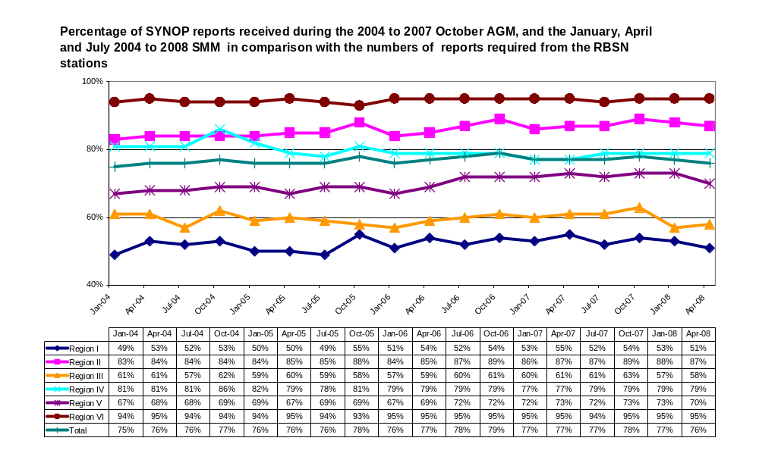
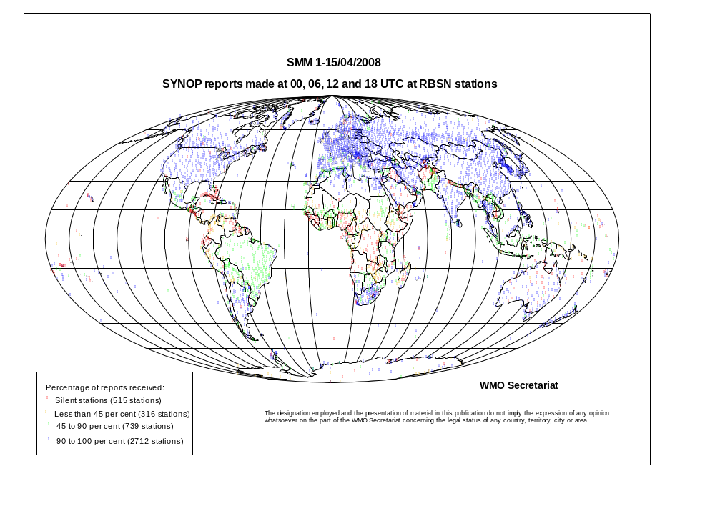
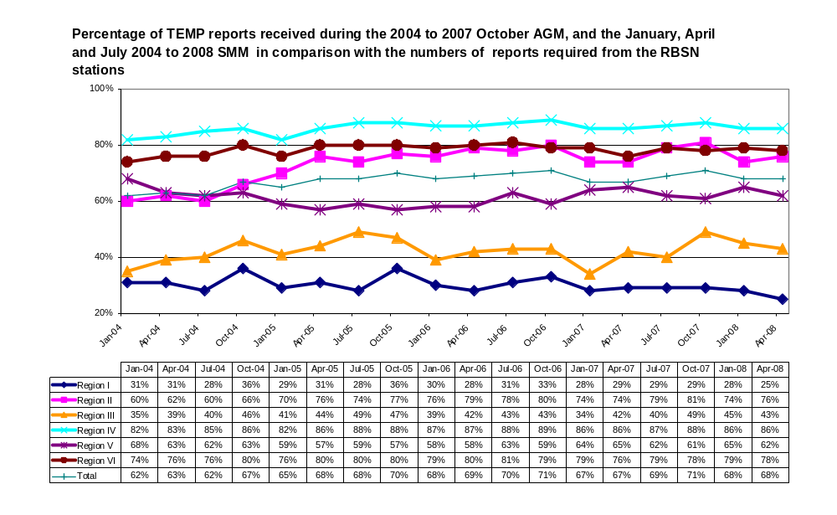
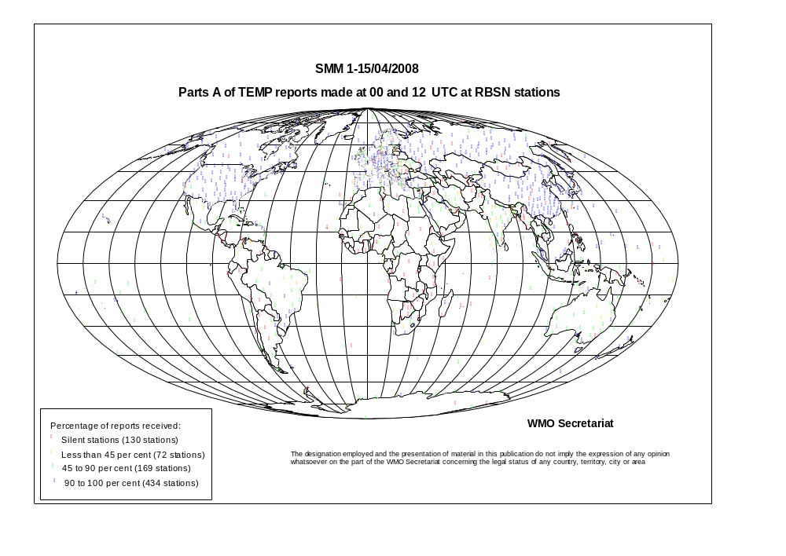
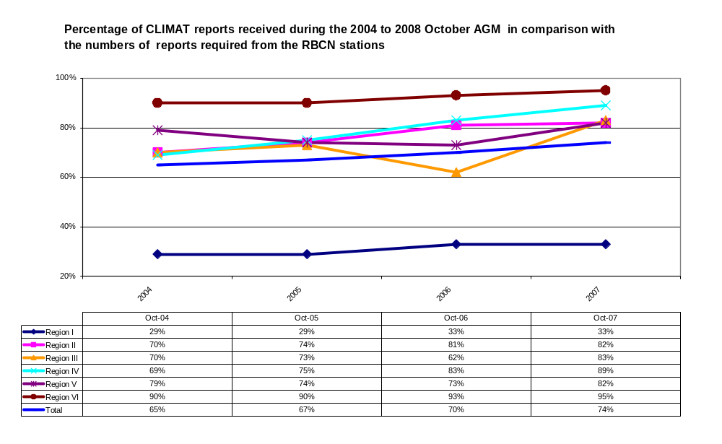
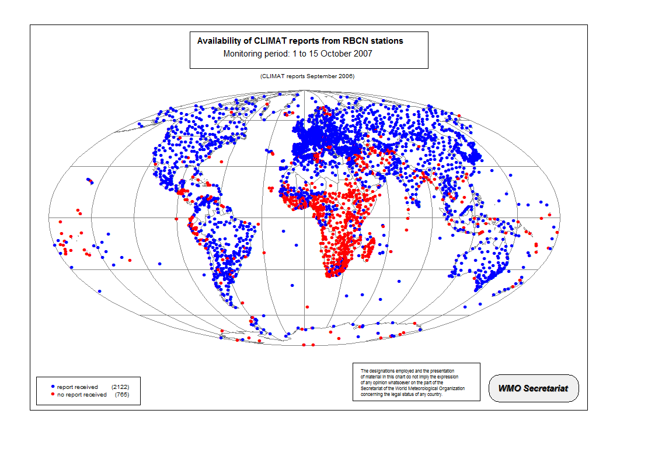
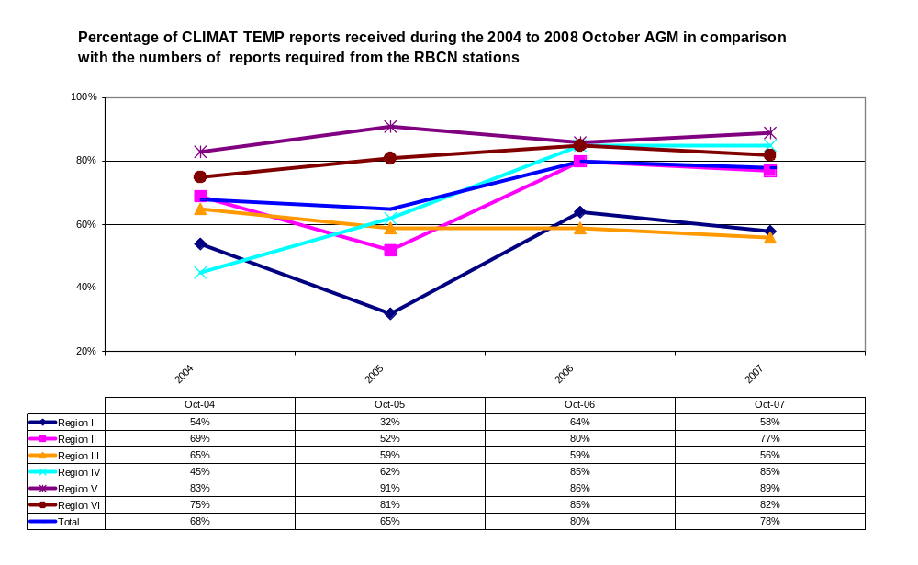
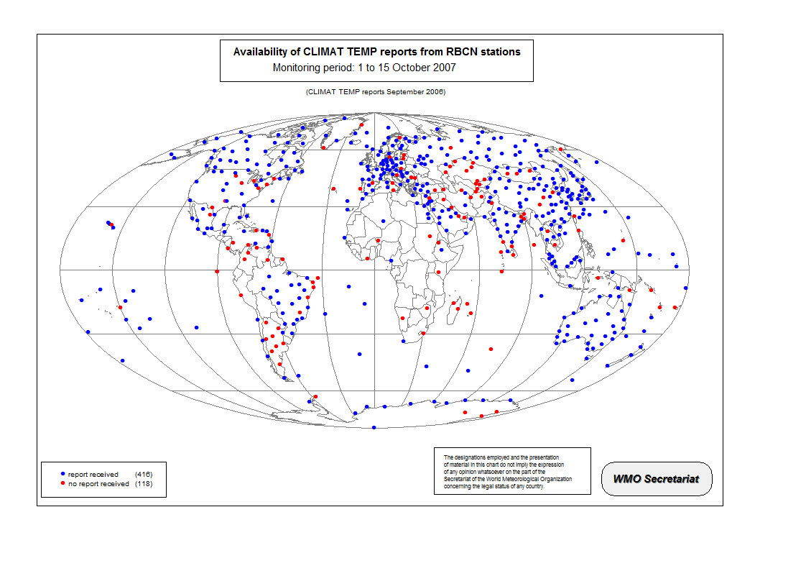
Appendix

Extracts from the report of Cg-XV

WMO Secretariat Operating Plan 2008–2011

6.2.13 Congress recalled the decision of the Executive Council at its fifty-eighth session in June 2006 to engage in an organization-wide strategic, operational and budget planning process. The process resulted in three fundamental documents:

  - WMO Strategic Plan, which provided a high-level statement of future strategic directions and priorities of WMO in the form of the top-level objectives and expected results;

  - WMO Operating Plan, which converted the strategic directions into specific, measurable deliverables and related summary of activities of the WMO Major Programmes and activities and the corresponding timelines and key performance targets;

  - WMO Budget, which connected deliverables, or end results, to resources.

Structure and purpose of the Operating Plan

6.2.14 The Operating Plan described how the WMO Programmes and other major activities, for example Programme Support Services, would contribute towards accomplishing the Organization’s mission and achieving the top-level objectives and the 11 expected results put forth in the WMO Strategic Plan. The Operating Plan used the WMO Programmes as main building blocks and each of their deliverables was attributed to a specific expected result to which it contributed. A timeline indicated the period of realization of each deliverable. The corresponding financial resources were given in the WMO Budget.

6.2.15 Congress noted that in the initial phase, the development of the WMO Operating Plan focused on the Secretariat programme implementation plans and associated activities, and therefore represented the WMO Secretariat Operating Plan. Congress agreed with the Executive Council to expand the Secretariat Operating Plan, in the subsequent phase, into an organization-wide and comprehensive WMO Operating Plan, which would incorporate the contributions of the regional associations and technical commissions as well as of the scientific steering committees of the WMO Joint Programmes. The experiences and results to be gleaned from the first performance evaluation review of the Secretariat Operating Plan in 2009 should be taken into account.

See http://www.wmo.int/pages/prog/sat/Refdocuments.html.
See http://www.wmo.int/pages/about/documents/WMO_1028_web_E.pdf
See http://www.wmo.int/pages/prog/www/ois/monitor/EUCOS_Annual_Monitoring_Report_2006_EUCOS-REP-192_20070327.pdf

