WORLD METEOROLOGICAL ORGANIZATION  ______________  COMMISSION FOR BASIC SYSTEMS  OPEN PROGRAMME AREA GROUP ON  INTEGRATED OBSERVING SYSTEMS  IMPLEMENTATION/COORDINATION TEAM ON  INTEGRATED OBSERVING SYSTEMS  Fourth Session  GENEVA, SWITZERLAND, 11–15 SEPTEMBER 2006 |  | CBS/OPAG-IOS/ICT-IOS-4/Doc. 6.2  (23.VIII.2006)  ____________  ITEM: 6.2  Original: ENGLISH

REVIEW OF THE MARINE SYSTEM

(Submitted by the Secretariat)

Summary and Purpose of Document
This document provides a summary of recent Marine System activities.

ACTION PROPOSED

The ICT is invited to take the contents of this report into consideration during its delibreations.

JCOMM Observations Program Area

The Observations Program Area (OPA) of the Joint WMO-IOC Technical Commission for Oceanography and Marine Meteorology (JCOMM) includes three implementation panels - the Data Buoy Cooperation Panel (DBCP), Ship Observations Team (SOT), and Global Sea Level Observing System Group of Experts (GLOSS GE). These panels sponsor sub panels, task teams, and action groups to coordinate work on specific technical and regional issues. The OPA maintains linkage with other international implementation panels which also provide important contributions to the global ocean observing system even though they are not officially part of JCOMM, i.e. (i) the Argo Steering Team (profiling floats), (ii) the OceanSITES Steering Team (long-term, deepwater reference stations), and the International Ocean Carbon Coordination Project (IOCCP).

Each of the implementation panels continues to deal with issues specific to their ongoing operations such as data formats, instrument intercalibrations and testing, deployment logistics, etc. At the same time, three observing system issues are common across all elements of the OPA, and its Observations Coordination Group (OCG) has chosen to give priority attention to these:

- Achieving global coverage by the in situ networks
- System-wide monitoring and performance reporting
- Funding to meet implementation targets

JCOMM is contributing to the CBS Expert Team on the Evolution of the Global Observing System (ET-EGOS). In this context, JCOMM developed its Statement of Guidance (SoG) relating to marine user requirements. It is being updated and will be published as a JCOMM technical report. There are four major application areas relevant to JCOMM:

  - Numerical Weather Prediction, NWP,
  - Ocean Mesoscale Forecast, OMF,
  - Seasonal to Inter-annual Forecast, SIA, and
  - Coastal Marine Services.

NWP uses the marine meteorological parameters to initialise the numerical models, and the SST distribution becomes one of the most important boundary condition. OMF and SIA predict future ocean status using numerical models, but the former target is higher frequency components (a week to a month) of ocean variability and the latter the lower frequency components (seasonal and inter-annual). Statements of Guidance for the first two of the four application areas are not under the responsibility of JCOMM.

Ocean Mesoscale Forecast is now designed and implemented by a GOOS/GCOS OOPC pilot project, Global Ocean Data Assimilation Experiment (GODAE). Integrating existing and near future ocean observation systems, near-operational ocean mesoscale forecast is or will be conducted in the GODAE project. Demonstration phase of GODAE started in 2003.

Coastal Marine Services include the traditional tasks of the JCOMM community. However, the social needs have increased and become diversified, which forces JCOMM community to redesign the observing systems including backbone GOSs (e.g., GOOS/Coastal Ocean Observing Panel).

A. Achieving global coverage by the in situ networks.

A summary of essential in situ observing programme implementation status and the challenges remaining to achieve global coverage is given in Table 1 below. Status maps are given in annex I.

Table 1: OPA implementation status and global coverage targets

 | 2006 status | Target for global coverage
Surface drifting buoys | 100% | 1250
Barometer drifting buoys | 28% | 1250¹
Tropical moorings | 72% | 119
VOS ships | 4700 ships (about 250000 obs per month) | As many ships as practicable²
VOSClim ships | 60%³ | 200⁴
ASAP ships | 34 ships (about 400 profiles per month) | To be defined in complement to AMDAR⁵
High density and frequently repeated XBT lines | 82%⁶ | 51
GCOS Reference Stations, Real-time | 40% | 170
Argo Profiling Floats | 79% | 3000
Reference time series stations | 21% | 58
Global reference mooring network | 48% | 29
Repeat hydrography and carbon inventory | 43% | Full ocean survey in 10 years

Notes:
¹: Original target was set to 600 barometers to cover extra-tropical regions only. A new target of 1250 barometers was proposed by the DBCP data users and technology workshop, Reading, UK, 27-28 March 2006.

²: It is not realistic to provide for a fixed target number of ships for the VOS fleet because it is dependent on the health of world shipping and their willingness to participate in the VOS scheme. This is a moving target, i.e. as many ships as are willing to join the VOS.

³: 60% of the targeted number of VOSClim ships are now part of the fleet. However, efforts remain to be made for those ships to submit their all of their data according to the requirements and in appropriate format.

⁴: The 200 ships target for the VOSClim will probably be revised by scientific advisers.

⁵: AMDAR provides for cost effective ascent and descent profiles where airports are located so availability of such reports over the oceans is limited to coastal regions and some islands. ASAP can provide for complementary aerological profile data but the technology remain relatively expensive. E-ASAP (EUCOS, Europe) is targeting 18 ships to provide for some 5800 profiles yearly in the North Atlantic and Mediterranean sea.

⁶: 82% of the targeted lines are occupied but not all of these are well sampled. Efforts remain to be made to sample the lines according to the requirements.
There is presently significant international momentum for implementation of a composite global observing system consisting of: 1) the in situ networks; 2) continuous satellite missions; 3) data and assimilation subsystems; and 4) system management and product delivery. The GCOS Implementation Plan for the Global Observing System for Climate in support of the UNFCCC (GCOS-92) has now been published; the plan has been endorsed by the UNFCCC; and the ocean chapter has been endorsed as the ocean backbone of the Global Earth Observation System of Systems (GEOSS). A fundamental requirement detailed by GCOS-92 is achieving global coverage by the in situ networks.

Although the backbone system specified by GCOS-92 is designed to meet climate requirements, marine services in general will be improved greatly by implementation of the global coverage called for by this design. The system will support global weather prediction, global and coastal ocean prediction, marine related multi-hazard warning systems, marine environmental monitoring, and many other non-climate users. JCOMM is identified as the implementing agent, or a contributing implementing agent, for 21 of the specific actions listed in the GCOS-92 ocean chapter. These specific actions now provide an excellent roadmap to guide the OPA work for the next four years.

It is recommended, therefore, that the OPA work plan for the next four years should be based on implementing the ocean chapter of GCOS-92. The GCOS-92 goals are essentially the same ones that the JCOMM OPA and Argo have been pursuing for the past four years – global coverage by the moored and drifting buoy arrays, profiling floats, tide gauge stations, and ship-based networks (plus continuous satellite missions).

Additionally, continuity in the observing system is recognized by the OPA as being of central importance for climate applications. The OPA accepts the GCOS Climate Monitoring Principles as best practice. The work of the DBCP, SOT, and GLOSS GE will be conducted in accordance with the GCOS Climate Monitoring Principles wherever possible.

It also is clear that tide gauge stations and moored buoys for tsunami warning and storm surge are a priority for the international global observing system as well. Opportunities for JCOMM OPA support to the marine related international multi-hazard warning systems include real-time reporting from GLOSS tide gauge stations, coordinated deployment of ocean buoys, and the use of common platforms and logistics infrastructure for multiple observational purposes. It is recommended that implementation of observational components in support of the comprehensive marine related international multi-hazard warning systems should also be a main requirement driver for the OPA work plan over the next four years.

A major milestone has been achieved by the DBCP in 2005. The global drifting buoy array did reach its design goal of 1250 buoys in sustained service. Thus the global drifting buoy array became the first component of the Global Ocean Observing System (GOOS) to be completed. It has taken 10 years to reach this first major milestone since the international community began planning for GOOS with the publication of the Scientific Design for the Common Module of the Global Ocean Observing System and the Global Climate Observing System by the Ocean Observing System Development Panel in 1995.

B. System-wide monitoring and performance reporting.

A major challenge for the OPA is to develop easy to understand performance reports that can help in evaluating the effectiveness of the observing system and help in efforts to convince governments to provide the funding needed to meet global implementation targets. It will not be possible to achieve global coverage of Earth’s oceans with existing resources. Governments need to commit additional resources if JCOMM is to achieve global coverage. JCOMM in situ Observing Platform Support Centre (JCOMMOPS) was established by JCOMM to facilitate the Implementation of operational in-situ ocean and marine meteorology observing systems associated with the Data Buoy Cooperation Panel (DBCP), the Ship Observations Team (SOT), and the Argo Science Team (AST). JCOMMOPS and the OCG are working to develop standard base maps showing required global coverage against what is presently in place, to evaluate observing system status and effectiveness, and to develop summary reports illustrating how advancements toward global coverage improve the adequacy of the observational information.

A standard map projection has now been accepted by the OPA for reporting system status and progress. It is an Equidistant Cylindrical Projection, 90N to 90S, broken at 30E. A standard set of colors indicating country contributions is used by JCOMMOPS (annex I). For indicating system performance, a progression of colors (red, orange, yellow, green, blue) is used varying from red-for-bad to blue-for-good (annex II). For illustrating measurements: hot colors (red) should be used for warm temperatures, other high values, and shallow ocean depths; varying to cool colors (blue) for cool temperatures, other low values, and deep ocean measurements. All Members/Member States are encouraged to use these conventions for mapping their JCOMM contributions.

In addition to platform statistics calculated by JCOMMOPS, quarterly performance reports are now available for sea surface temperature, sea surface salinity, temperature profiles, salinity profiles, and near-surface currents (annex II). The OPA is working to incorporate reports for other ocean variables that have been specified by GOOS and GCOS. Access to these reports is via JCOMMOPS at www.jcommops.org/network_status.

A demonstration project is underway to routinely report observing system monitoring and performance metrics in cooperation with the GOOS Project Office of IOC. A consolidated Progress Report with Contributions by Countries is available at www.jcommops.org/network_status which lists the 64 countries and the European Union that maintain elements of the composite ocean observing system, and the number of in situ platforms and expendables contributed by each country. All JCOMM Members/Member States are invited to routinely review this report and provide corrections as needed to opa@jcommops.org. Note: observing system contributions are included in this report if they provide data to the international community in accordance with WMO and IOC data policies; elements that do not share data freely and openly are not included in this report. This report is used to estimate the total system percent complete as noted in Table 1.

A web page is under development that provides a single entrance portal to link to all web sites being maintained by counties contributing to implementation of the global ocean observing system. This single entrance portal is intended to illustrate to users the “system of systems” that is being implemented by JCOMM and partners. This portal to national center web sites is available through the JCOMMOPS access point: www.jcommops.org/network_status. Members/Member States are encouraged to review the web site and provide corrections as needed to opa@jcommops.org.

At the last CBS ET-EGOS meeting, Geneva, June 2006, the following had been proposed:

- Nomination of appropriate contact point by JCOMM for the in situ components;
- Updating the CEOS/WMO database to reflect (i) recent changes in user requirement (e.g. Tsunami monitoring), and (ii) dramatic progress in recent years regarding instrument performances of in situ components, and in particular with regard to horizontal distribution of observing networks (e.g. drifting buoys, moored buoys, Argo floats);
- Conduct Rolling Review of Requirements (RRR) process and make use of the critical review charts while taking existing JCOMM metrics into account;
- Consideration of JCOMM/OCG phased-in implementation plan;
- Stressing on gap analysis, including the need to provide for long term sustainability of the observational networks.
- Provide for an updated version of JCOMM SoG by mid-2007.

C. Funding to meet implementation targets.

JCOMM must help in efforts to convince governments to provide the funding needed to meet global implementation targets. Global coverage cannot be achieved with the resources that are presently being applied. The baseline GCOS-92 system is only 56% complete. Much work remains to be done and additional resources are needed. One way the OPA can help is to develop easy to understand statistics and reports that the decision makers will be able to use to justify new funding. Efforts in this regard are summarized above.

Following an OPA proposal, JCOMM-II established a common fund for consumables to finance expansion of the ocean system. This should eventually help in having more countries to contribute to the international observing system. The initial thrust of this idea is to support the Ship Of Opportunity Programme (SOOP) of the SOT through the purchase of XBT probes but other expendables could be added in time.

Annex I

Status of in situ ocean observing networks, June 2006

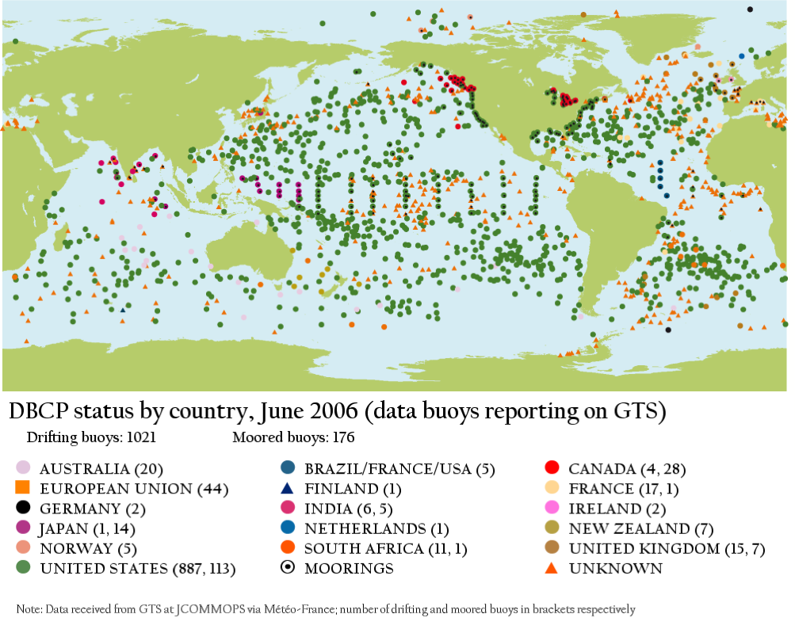

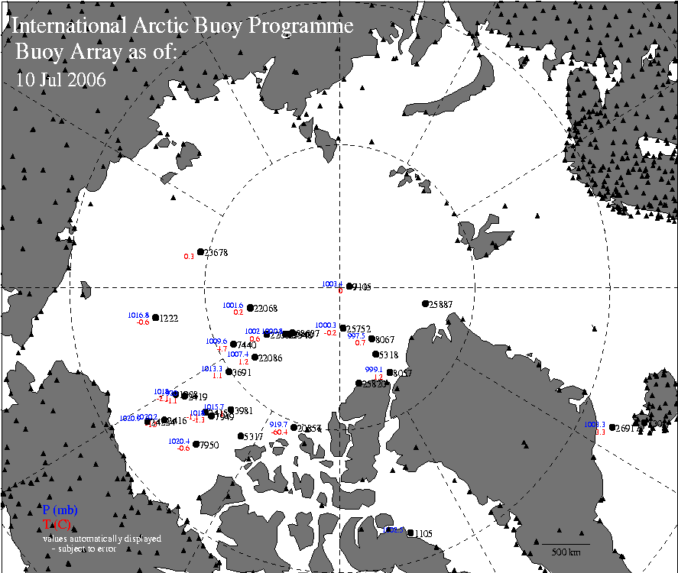

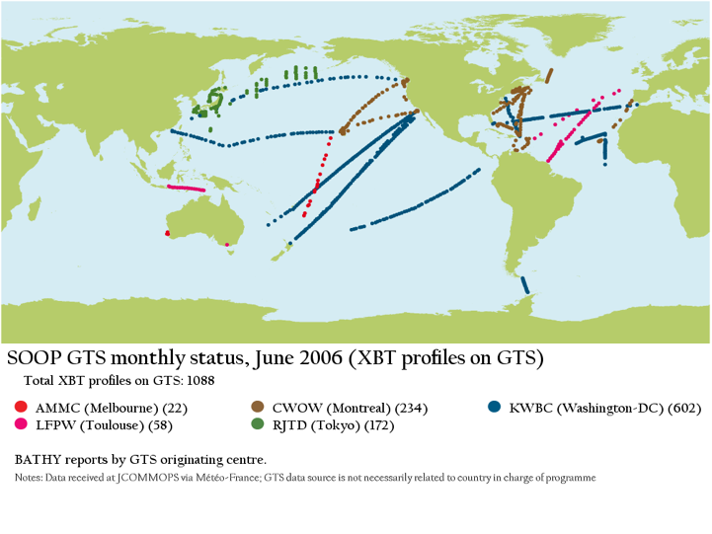

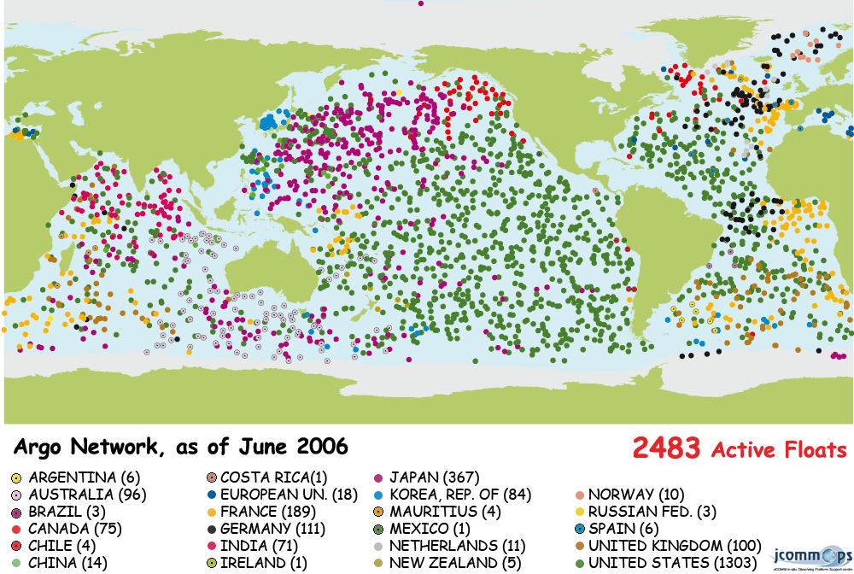

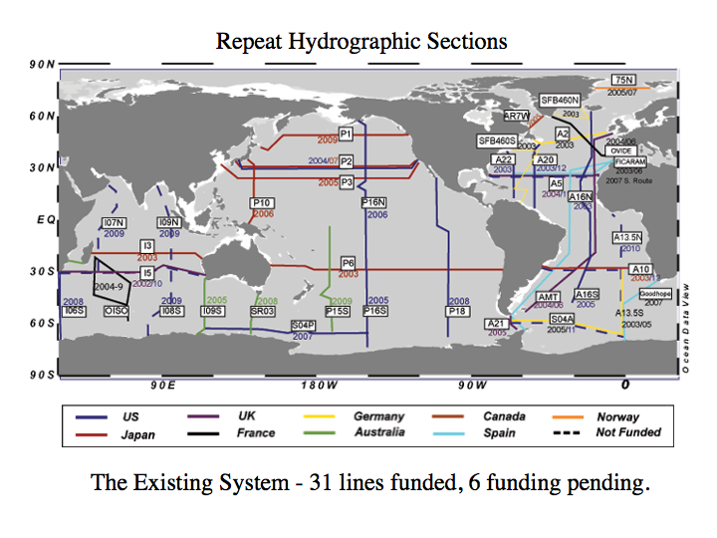

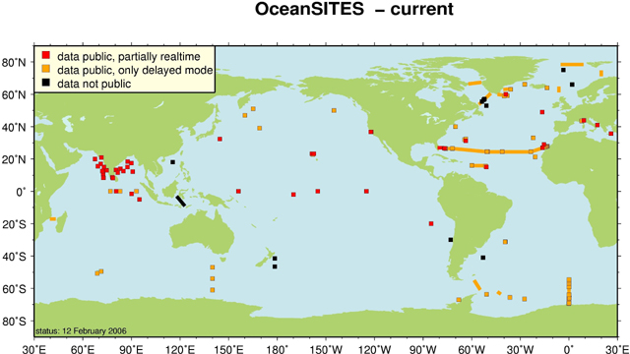

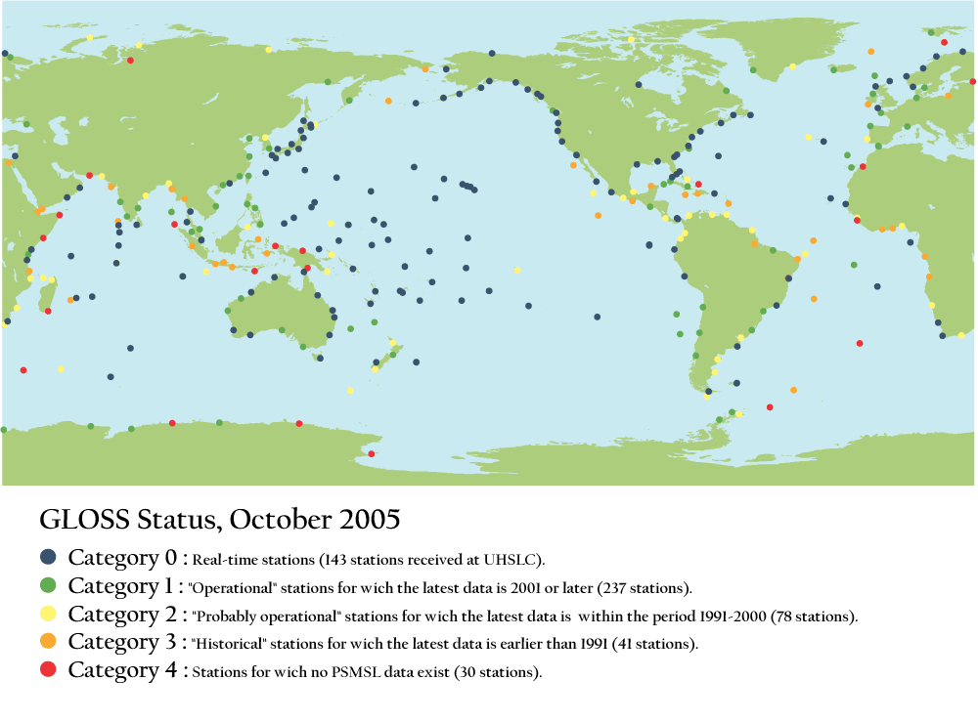

Annex II

Quarterly performance reports for sea surface temperature, sea surface salinity, temperature profiles, salinity profiles, and near-surface currents
April-June 2006



