WORLD METEOROLOGICAL ORGANIZATION  ____________________  COMMISSION FOR BASIC SYSTEMS  OPEN PROGRAMMME AREA GROUP ON  INTEGRATED OBSERVING SYSTEMS  EXPERT TEAM ON THE EVOLUTION OF  GLOBAL OBSERVING SYSTEMS  Seventh Session  GENEVA, SWITZERLAND, 7-11 MAY 2012 |  | CBS/OPAG-IOS/ET-EGOS-7/ Doc. 6.2 REV. 1  (30.04.2012)  _______  ITEM: 6.2  Original: ENGLISH

Update on architecture for climate monitoring from space

(Submitted by the Secretariat)

SUMMARY AND PURPOSE OF DOCUMENT

The purpose of this document is to present progress on developing an architecture for climate monitoring from space, and to seek additional support and guidance from the Seventh Session of ET-EGOS in this regard.

ACTION PROPOSED

The Meeting is invited to note:

- Resolution 19 from the Sixteenth WMO Congress (Cg-XVI) to pursue development of such an architecture for monitoring climate from space, and

- Progress on collaborative efforts to date to develop such an architecture

____________

Appendices: A. Resolution 19 (Cg-XVI) Development of an architecture for climate monitoring from space

B. Report titled, “Strategy Towards an Architecture for Climate Monitoring from Space”

DISCUSSION

Outcome of WMO Congress

1. The Sixteenth Session of the WMO Congress met in May 2011, and adopted Resolution 19 (Cg-XVI), shown in Appendix A. Of interest to ET-EGOS may be the part of the approved, where technical commissions are requested to update WMO regulatory material, including development of the Manual on the WMO Integrated Global Observing System.

Progress since ET-EGOS-6

2. The Sixth Session of the Expert Team on the Evolution of the Global Observing Systems (ET-EGOS-6) was briefed (Doc.8.3.2) on the background and intent for developing an architecture for monitoring climate from space which is largely based on the increasing role that satellites are playing in observing the Earth’s climate, and the need for an end-to-end system to ensure these space-based observations are sustained over time.

3. Since ET-EGOS-6, the ad hoc Writing Team, comprised of representatives from the Committee on Earth Observation Satellites (CEOS), the Coordination Group for Meteorological Satellites (CGMS) and the WMO Space Programme, have written a report titled, “Strategy towards an Architecture for Monitoring Climate from Space” (Appendix A). This report, building upon the Concept Document presented at ET-EGOS-6 was first reviewed by the Global Climate Observing System (GCOS), the World Climate Research Programme (WCRP) and the Group on Earth Observations (GEO).

4. The report was then presented to Plenary Sessions of both CEOS and CGMS in the autumn of 2011. Discussions conducted at both Plenary Sessions were positive and supportive of the overall effort, recognizing that once developed, an architecture for climate monitoring could help ensure coordinated and sustained observations from space. Specific review comments received from both organizations have since been incorporated in the report attached included as Appendix B.

Conclusions

The Meeting is invited to note:

- Resolution 19 from the Sixteenth WMO Congress (Cg-XVI) to pursue development of an architecture for monitoring climate from space, and

- Progress on collaborative efforts to date to develop such an architecture.

__________
Appendix A

Res. 19 (Cg-XVI) - DEVELOPMENT OF AN ARCHITECTURE FOR CLIMATE MONITORING FROM SPACE

THE CONGRESS,

Noting:

- Article 2 of the Convention of the World Meteorological Organization,

- Resolution 5 (Cg XIV) - WMO Space Programme,

- Resolution 30 (Cg-XV) - Towards enhanced integration between WMO observing systems,

- Paragraph 9.2.5 of the Abridged Final Report with Resolutions of the Fifteenth World Meteorological Congress (WMO-No. 1026) reaffirming the Executive Council decisions to provide full support for the GEO process and resulting GEOSS and to support its implementation to the maximum extent possible within the WMO mandate,

- Resolution 3 (Cg-XVI) - Global Observing System,

- Resolution 48 (Cg-XVI) - Global Framework for Climate Services,

Considering:

- The benefits that have been achieved through the coordinated, collaborative and cost-effective approach to the planning and operation of an end-to-end system for weather observations, modelling, analysis and forecasting,

- The increasingly important role that space-based observations are playing in the long-term monitoring of the Earth’s environment,

- The substantial investment that Members have made in Earth-observation satellites to monitor and study weather, water, climate and related natural disasters,

- The importance of long-term, sustained and coordinated observations of the Earth’s climate, climate change and variability for the world’s population, and particularly those at most risk,

- The benefits in efficiency, sustainability and cost-effectiveness that could be achieved through increased coordination of efforts among all parties involved in the planning and implementation of space-based observational capabilities and related operational processing activities for climate monitoring,

- The underpinning role that observations will play in the Global Framework of Climate Services (GFCS),

(7) The importance of integration of ground-based and space-based observations in the successful implementation of the WMO Integrated Global Observing System (WIGOS),

Appreciating:

- The important contributions Members, their satellite operators, international partner organizations and programmes make toward observing, and coordinating observations of the Earth from space,

- The relevant work undertaken by the Global Climate Observing System (GCOS) to identify the requirements associated with the Essential Climate Variables (ECVs) for the long-term and sustained observation of the Earth’s climate system,

- The invitation made by the sixty-second session of the Executive Council to the WMO Space Programme, in coordination with GCOS and with the support of relevant technical commissions, to work with space agencies, the Coordination Group for Meteorological Satellites (CGMS), the Committee on Earth Observation Satellites (CEOS), and the Group on Earth Observations (GEO) in order to develop an architecture for sustained, space-based climate monitoring as a component of the future WIGOS and GFCS, for consideration by the Congress,

- The early work done by the WMO Space Programme to develop a concept and initiate a dialogue among interested parties for an architecture for climate monitoring from space,

Recognizing:

- The WMO Space Programme provides Members with an appropriate framework to advance, in partnership with CEOS, CGMS, GCOS, GEO, the World Climate Research Programme (WCRP) and other partner organizations the development of an architecture for climate monitoring from space,

- The end-to-end system implemented by Members to support weather monitoring and forecasting, which includes the review of observational requirements, satellite observations, intercalibration, as well as product generation and training and user-engagement, can be leveraged for climate monitoring,

- The different, but complementary roles and responsibilities, of satellite operators and their coordinating mechanisms for activities which cover the spectrum of research and development and operational missions,

- That, in this architecture, space-based observations have to be supported by surface-based observations,

Decides that an architecture be developed using as a starting point the concept given in the annex to this resolution to provide a framework for the sustained and coordinated monitoring of the Earth’s climate from space;

Decides further:

- That the development be undertaken as a major initiative of the WMO Space Programme, as an important component of WIGOS, with the support of relevant technical commissions, and in coordination with satellite operators, CEOS, CGMS, GCOS, GEO and WCRP;

- That the results will be made available for the deliberations and final approval by the Executive Council;

Requests:

(1) The Executive Council to monitor, guide, support and consider approving, at its sixty-fourth session, the development of an architecture for climate monitoring from space;

    - Technical commissions to:

- Guide the technical aspects of the development activities;

- Update WMO Regulatory Material, including development of the Manual on WIGOS;

- Provide the technical lead for the architecture through the Commission for Basic Systems (CBS), the Commission for Instruments and Methods of Observation (CIMO), and the Commission for Climatology (CCl);

- Members to:

- Provide experts to participate in the development, implementation and operation of an architecture for climate monitoring from space;

- Provide voluntary contributions to the WMO Space Programme Trust Fund for the further advancement of the architecture development efforts;

- Share relevant experience and cooperate with one another in leveraging the existing end-to-end weather monitoring system to serve climate monitoring needs;

- Continue to enhance and integrate their national climate monitoring capabilities;

- Regional associations to support and coordinate efforts of Members in the development and eventual implementation of an architecture for climate monitoring;

- The Secretary-General to:

- Ensure management and support of the architecture for climate monitoring from space development efforts;

- Support the review and update of WMO Regulatory Material, including the development of the Manual on WIGOS;

Invites CEOS, CGMS, GCOS, GEO and WCRP to collaborate with the WMO Space Programme on the development of an architecture for climate monitoring from space.

__________
Appendix B

Draft report to be replaced by final report

IF AVAILABLE in advance of et-egos-7

(Major Changes not Anticipated)

Strategy Towards an Architecture for Climate Monitoring from Space

CEOS, CGMS and WMO
Revised version incorporating feedback
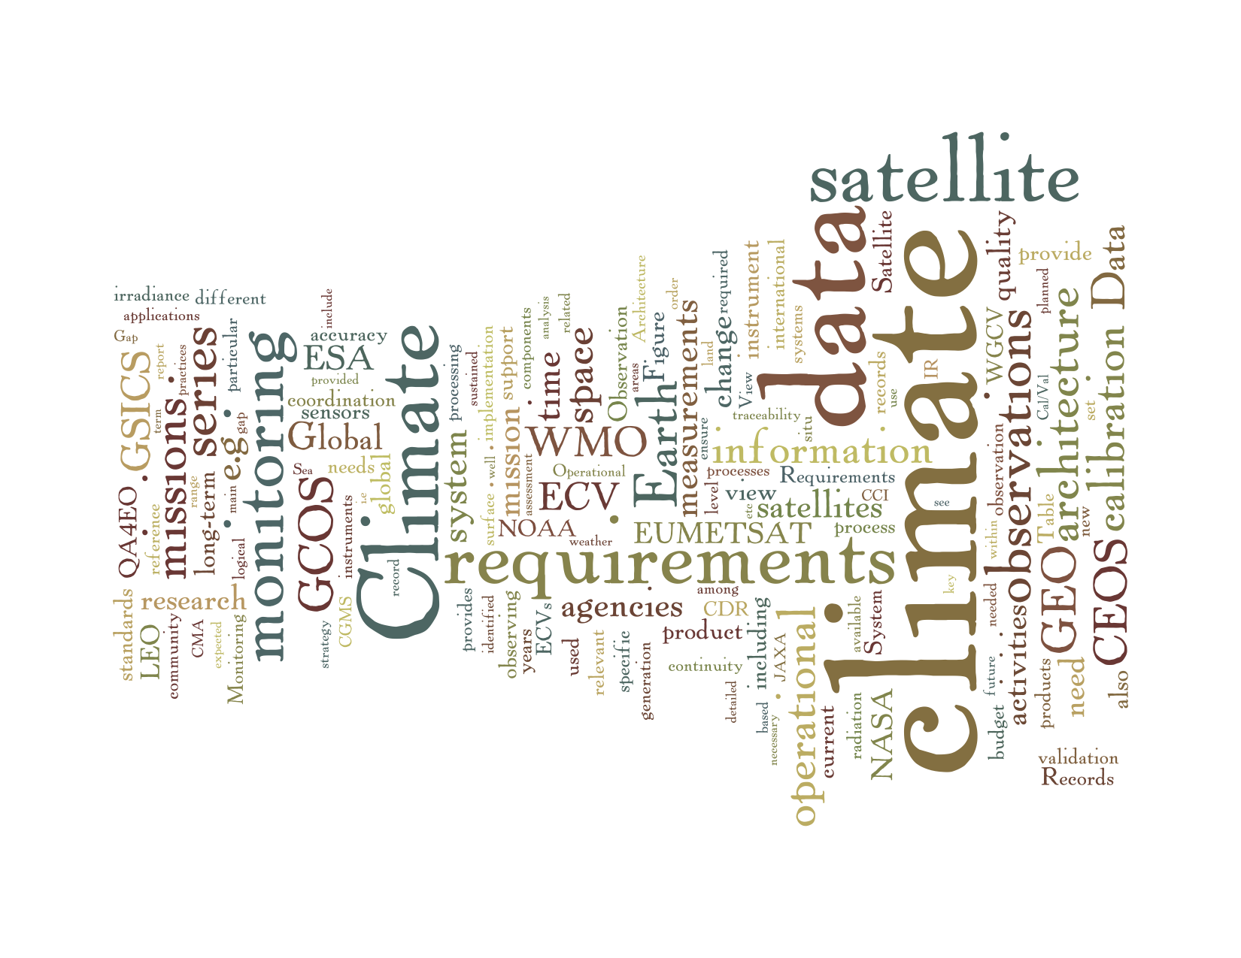

Draft, revised on 13 April 2012

“Sans Badge”

Table of Contents

1. Executive Summary 3
2. Introduction, Objectives and Targets 4
3. Climate Monitoring Principles, Requirements & Guidelines 7
3.1 Specific Requirements for Climate Monitoring 7
3.2 Sources of Requirements 8
3.3 Relevant Requirements for Climate Change Monitoring 9
3.4 Requirements for Data Archiving, Processing, and Distribution 10
4. Existing Capabilities And Processes 15
4.1 Fifty Years of Environmental Satellite Missions 15
4.2 Current and Planned Satellite Missions for Climate 15
4.3 Gap Analyses of Satellite Missions Compared with GCOS Requirements for ECVs 17
4.4 Satellite Instrument Calibration Activities 18
4.5 From Satellite Data to Validated Climate Data Records 19
4.6 Emerging Coordination 22
5. Beyond Research to Operations 25
6. Climate Architecture Definition 27
6.1 What do we Mean by the Term “Architecture”? 27
6.2 Why do we Need an Architecture for Climate Monitoring? 27
6.3 What could be an Appropriate Format/Structure for an Architecture? 27
6.4 What Could be the Main Components of a Logical View? 29
6.5 What Could be the Main Components of a Physical View? 31
7. Mechanisms for Interaction 33
7.1 What are the Needs for Mechanisms for Interaction? 33
7.2 Initial Integrator Activities 33
8. Roadmap for Way Forward 35
9. Glossary 38
10. References 39

1. Executive Summary

The subject of this report focuses on satellite observations for climate monitoring, and the need for an international architecture that ensures delivery of these observations over the time frames required for analysis of the Earth’s climate system. As the title states, the report outlines a strategy for such an architecture – a strategy that is intentionally high-level, conceptual and inclusive, so that broad consensus can be reached, and all relevant entities can identify their potential contributions. The strategy, however, is not sufficient in and of itself and presents a proposed logical architecture that represents a first step in the development of a physical architecture – an end-to-end system – capable of delivering the necessary observations for climate monitoring.

The report was written by a team of people comprised of representatives from the Committee on Earth Observation Satellites (CEOS), the Coordination Group for Meteorological Satellites (CGMS) and the World Meteorological Organization (WMO). The intended audiences are several, and include space agencies, their political and budget authorities, their international coordinating mechanisms, and national or international programmes and organizations with climate-related mandates.

The architecture proposed, herein, calls for a constellation of research and operational satellites, broad, open data-sharing policies and contingency planning. It includes agreements that are essential for bringing the same continuity to long-term and sustained climate observations that we, today, have for weather observations. The task of climate monitoring has requirements that must extend beyond the capabilities of one-time research missions and operational satellite systems in existence today. This report, therefore, identifies an important activity for research and operational agencies to undertake, which is to develop a joint framework for stewardship of climate information. Climate record processing requires a sustained expert understanding of new and legacy climate sensors as well as a sustained web of support activities, including significant effort on calibration and validation, research to reduce uncertainties and establishment of “community reference standards”, and collaborative product assessment and intercomparison. This sustained web will require the continuous effort of both research and operational agencies.

The report also identifies an imperative for further and wider, coordination among all stakeholders, both technical and policy-related, in order to optimize efforts, to measure and document traceability, and to secure the necessary resources for implementation. From a technical perspective, seeking greater involvement from the scientific community, relevant technical groups and other mechanisms for both reviewing the proposed approach and for further development of the physical architecture. From a policy perspective, the proposed logical architecture must be verified, in a top-down approach, to ensure that it adequately supports the depiction of the required information flows from the decision making process back to the sensing capacity/requirements – an essential step so that policymakers are able to appreciate and support the need for an integrated climate monitoring architecture that is capable of meeting both policy and user-service needs. Lastly, a roadmap for the way forward, including concrete actions, is provided.

2. Introduction and Objectives

The role that satellites have played in observing the Earth’s climate variability and change has increased substantially over the last few decades. Significant progress has been made in observing the Earth over temporal and spatial scales, which before the advent of satellites was all but impossible. With satellite observations of the Earth, we have been able to construct global views of many variables across the atmospheric, oceanic and terrestrial domains, including, but not limited to, ozone, cloud cover, precipitation, aerosol optical depth, sea surface topography, changes in polar ice masses, and changes to the land surface. Indeed, with some satellite observations now spanning more than 40 years, the value of this information for climate monitoring purposes is becoming increasingly evident. Yet, more remains to be done. Although the subject of this report focuses on satellite observations for climate monitoring, the role that insitu observations play must not be overlooked. Existing in situ networks provide observations of some parameters that are difficult and/or impossible to measure from space, and serve validation purposes for satellite observations as well as in specific cases (e.g. optical measurements of land and ocean surfaces) a means of vicariously calibrating the space-based observations. Therefore, the combination of satellite and ground-based observations is essential. While recognizing the importance of integrated observing systems, the initial focus of this architecture effort lies with the space-based component.

Many observations have been derived from satellites and sensors which were either not designed for climate purposes, or were not intended to operate over the long time frames needed for climate assessments. Contingency agreements between and among space agencies have been instituted for weather observations to ensure continuous observations for global numerical weather prediction, yet not specifically for climate purposes. While much progress has been made of late, data-sharing policies and practices are still not as robust for climate data, as for weather data. And, to the point of this paper, there currently exists no international comprehensive task definition and planning, or even a strategy or design for such a definition and planning, for climate monitoring from space. An architecture calling for a constellation of research and operational satellites, a broad, open data-sharing policy, and contingency planning are essential to bring the same continuity to long-term and sustained climate observations that we have for weather. Ultimately, such an architecture should result in a combination of existing constellations (both virtual and real) and dedicated satellite missions for climate variables currently not or poorly addressed through the existing monitoring capability. It must include end-to-end climate information stewardship consisting of data collection, data quality, archiving, processing and re-processing, discovery and access required for climate data record production. While some argue that it took more than 40 years to create the end-to-end system that exists today for weather monitoring and forecasting (see Section 4 for more detail), the discussions being held today for climate monitoring are most certainly similar to the early discussions for a globally coordinated “architecture” for weather monitoring.

There are international, as well as national, policy mandates or structures regarding climate and climate change. In 1988, the Intergovernmental Panel on Climate Change (IPCC) was established by the United Nations Environment Programme (UNEP) and the World Meteorological Organization (WMO) to review and provide recommendations to governments regarding the state of knowledge of the science of climate change, the risks associated with human-induced climate change, the social and economic impacts of climate change and possible response strategies. In 1992 the United Nations Framework Convention on Climate Change (UNFCCC) – an international environmental treaty – was established to consider actions for reducing global warming, including adoption by a number of countries of the Kyoto Protocol – a legally binding agreement establishing targets for the reduction of greenhouse gas emissions. Nationally, reports like the United Kingdom’s Stern Review (2006) and the United States’ Decadal Survey (2007) have also contributed to an increased awareness among policy makers of climate change. With this increased awareness come increased expectations that science in general, and Earth observations in particular, can help define and tackle the problem.

In 2009 the third World Climate Conference (WCC-3) unanimously agreed to develop a Global Framework for Climate Services (GFCS). A high-level task force completed its report on the proposed scope, implementation modalities and governance arrangements for the GFCS in 2011. The next steps in the development of the GFCS include the generation of an implementation plan. It is expected that the approach proposed for establishing the satellite component of the required observation infrastructure could benefit from this strategy to develop a climate architecture.

In January 2010, the 10th Session of the WMO Consultative Meetings on High-level Policy on Satellite Matters (CM-10) convened two panels to discuss space agency involvement and coordination of climate observations, and the way forward for space agency collaboration on climate. As an outcome of these discussions, the WMO Space Programme generated an outline for the development of a space-based architecture for climate monitoring which, later in 2010, was presented for review and comment to both the Coordination Group for Meteorological Satellites (CGMS) and the Committee on Earth Observation Satellites (CEOS). Revisions from these groups and/or their members resulted in an expanded outline, and subsequent document, which was then presented to a January 2011 Global Climate Observing System (GCOS) and WMO Space Programme workshop titled, “Continuity and Architecture Requirements for Climate Monitoring – First Workshop on Space-based Architecture for Climate”. This workshop, attended by both policy-level and technical experts, proposed the establishment of a Writing Team, comprised of representatives from CEOS, CGMS and WMO, to develop a strategy document for an architecture for climate monitoring from space. This report is the result of the Writing Team’s efforts.

There are three key audiences for this report. First, the coordinating groups who have undertaken the writing effort, and their members. In the case of CEOS and CGMS, their members are research and development and/or operational space agencies, and organizations that have related Earth observation programmes, and for WMO, it is their Member States. The active involvement from each of these entities is required for the effort to move from strategy to implementation. The second audience for the report includes the governing and/or advisory authorities for these organizations and their members. For example, the space agencies belonging to CEOS and CGMS have their own political and/or budget authorities in either national governments, or in the case of ESA and EUMETSAT, their Member States. In terms of WMO, the Executive Council and ultimately Congress determine its programmes. It will be important for all of these governing bodies to recognize the need for such an architecture and the benefits that international coordination and collaboration can bring particularly with the optimization of resources for satellite systems. The third key audience for this report are programmes with climate mandates or interests, and in particular those who have provided technical reviews of the report – GCOS, the Group on Earth Observations (GEO) and the World Climate Research Programme (WCRP). All of these programmes and frameworks work internationally to strengthen and/or leverage climate observations and research. Their needs can be better met if the strategy for developing an architecture for climate monitoring from space is both technically and politically sound.

The IPCC’s 4th Assessment Report (2007) underscores the urgent need for these data, and an international architecture supporting them, to observe and monitor the global water cycle and the global carbon cycle. Key public sector constituents include major industries such as insurance, agriculture, energy and transportation who have increasingly called for authoritative climate reference data upon which to base investments and strategic plans. Climate data are also required to better observe and predict climate extremes such as droughts, floods and coastal hazards. Improved knowledge in these areas translates into lives saved and property protected, improved economic resiliency, improved security and well-being of the public.

Specific objectives, therefore, include:

- To develop a strategy, bringing together space agencies and their coordinating bodies, to create an end-to-end system for the delivery of longterm and sustained observations of the Earth’s climate system;

- To define both a logical and physical architecture for the sustained delivery of these observations of the Earth’s climate system, and

- To ultimately create a global observing system for climate which builds upon existing systems including international agreements for standards, contingency planning, quality assurance and quality control, intercalibration and broad, open data-sharing policies,

3. Climate Monitoring Principles, Requirements & Guidelines
Climate is the long term averaging of short-term varying meteorological conditions. The climate system varies in response to changes in external forcing, such as solar input and surface morphology, as well as to its internal processes. It is important to monitor climate in such a way that the causes of variations can be traced and future changes predicted. A complete characterisation of the Earth’s climate systems requires observations of the coupled ocean, land, cryosphere and atmosphere system that involves many individual variables.

Box: What is climate ?

Climate : Synthesis of weather conditions in a given area, characterized by long-term statistics (mean values, variances, probability of extreme values, etc.) of the meteorological elements in that area (International Meteorological Vocabulary, WMO N° 182, 1992).

Climate and the climate system: climate is the status of the climate system which comprises the atmosphere, the hydrosphere, the cryosphere, the surface lithosphere and the biosphere. These elements all determine the state and dynamics of the Earth’s climate. (http://www.wmo.int/pages/themes/climate/understanding_climate.php)

Climate involves a complex interplay of processes at many spatial and temporal scales. Despite its essentially long term and global nature, the climate system also drives short time scale and regional behaviours of the environment. For instance a characterisation of extreme precipitation events requires observations with hourly sampling. A characterisation of a long-term change in such extremes requires such observations over several decades. On the contrary the detection of land use changes caused by natural or anthropogenic change of conditions rather requires observations at the seasonal to annual range.

Furthermore, extreme events such as droughts, heat waves, floods have a high impact on humans and their environment. Thus, research on observing and predicting extremes and their impact at different time and space scales has become a high priority. These priorities include dataset development with high temporal resolution that can be used to assess changes in numerous criteria associated with extreme events. Of equal importance is to sustain observing systems to allow predictions of seasonal to decadal time scales. Data sets will be used to evaluate models, e.g., with regard to how well they replicate extremes and their ability to reproduce statistics of storms and how they vary with time

To characterise climate and climate change, data need to be accurate and homogeneous over long time. The signals important for the detection of climate change can easily be lost in the noise of a changing observing system. This inforces the need for continuity in the observing system where observations can be tied to an invariant reference. Such an observing system needs to be maintained over at least several decades and beyond. It is with these boundary conditions that a climate monitoring architecture needs to be formulated.

Climate monitoring principles, requirements and guidelines for the creation of climate data records have been formulated to increase awareness in space agencies to the specific observational and procedural needs for a successful climate monitoring.

The following subsections describe why specific requirements for climate monitoring exist, from what applications the requirements originate and what are the most important requirements for long term observations, considering the quality of observations but also the procedures to archive, process and distribute climate data records.

3.1 Specific Requirements for Climate Monitoring

The high level strategic target of GEO to: “Achieve effective and sustained operation of the global climate observing system and reliable delivery of climate information of a quality needed for predicting, mitigating and adapting to climate variability and change, including for better understanding of the global carbon cycle” (GEO VI, 2009), directly leads to strong specific requirements for an observing system that enables mankind to monitor the variability and changes of the climate system.

The Earth’s climate changes slowly relative to the period over which any individual satellite program lasts. Hence, a monitoring of the climate system is difficult unless a whole-system view is taken. Current space-based climate data records are based mainly on the observations of the research and operational satellite systems primarily built to support short-term weather and environmental prediction applications in combination with ground-based data which provide longer time series e.g., for surface air temperature. Thus, past weather and Earth observations, ground-based and space-borne, have left an enormous legacy of data that provides the basis of our current knowledge on climate variability and change. However, there are a number of peculiarities associated with the satellite data which need to be addressed. These include among others instrument calibration, the absence of documented measurement traceability and uncertainty budgets, changes in the satellite observation time due to orbital drift during the lifetime of the satellite. All of these can introduce artefacts into long-term time series and require careful attention when the resulting climate data record is produced, and consecutive series of satellite observations are integrated over time. In addition, weather observations do not necessarily address all needs for specific climate variables, e.g., the observation of Greenhouse Gas variability has negligible importance for weather but is of ultimate importance for climate monitoring, the same is true for some of the land or ocean biosphere observations and of course the accuracy requirements are also often more demanding for climate monitoring.

In this respect the task of climate monitoring has specific requirements that go beyond the weather satellite systems and one time research missions. For instance it is important that the design of an observing system for climate monitoring including satellite and in situ systems takes account of all needed observations, legacy instruments and guarantees effective continuity in measurements. At the very least, appropriate transfer standards, to enable robust linkage to an invariant (SI) reference system at an appropriate level of accuracy must be provided when instrument or network changes occur in order to ensure integrity of the observing system in operational mode. The provision of such an observing system requires a global strategy in which agencies agree to collaborate to fulfil such a generic continuity requirement. This applies for any observing system that tries to monitor quantities over long time periods and thus is generally applicable.

In addition to requirements originating from the climate variability and change monitoring applications, many other observation requirements come from applications related to the wide range of time scales involved in the climate system. Such applications range from the need to improve, initialise and validate climate models to the provision of climate services as characterised in the WMO Global Framework for Climate Services (WMO-1065). The first implies observing systems that provide new observations as typically delivered from research missions that might not be operationally continued. The latter implicitly includes requirements for the monitoring of non climate, i.e., socio economic variables. There is an inherent difficulty to satisfy the challenging and sometimes mutually exclusive requirements related to climate monitoring. Currently, agencies mostly try to adhere to GCOS monitoring principles and guidelines but the mission and climate data record planning processes of agencies are not well coordinated with each other. An agreed architecture could contain a prioritisation of CDRs and associated observing systems that may lead to a better use of resources and increased efficiency in CDR generation. However, prioritisation of CDRs is a complex issue because the Essential Climate Variables (ECVs) as defined by GCOS (see Box 3.1) are a result of an overall priority setting by the experts represented in GCOS. However, the lessons learnt analysis concerning the 4th IPCC Assessment Report (GCOS-117, 2008) has revealed preferences for some climate system variables to answer actual research questions. Also the Critical Earth Observations Priorities (GEO-Task US-09-01a, 2010) analysis has given some indications for CDR priorities.

3.2 Sources of Requirements

The most relevant and comprehensive set of specific user requirements is provided by GCOS within their supplement Systematic Observation Requirementsfor Satellite-Based Products for Climate (GCOS-154) to the GCOS Implementation Plan (GCOS-138) applicable to climate change and long-term variability monitoring. The GCOS requirements are given for a subset of the Essential Climate Variables (ECV) where the feasibility of satellite measurements has been demonstrated. The requirements are based on expert opinion and are updated every five or six years. This subset of ECVs is intended to reflect the most important climate variables needed to monitor the complete climate system but it is evolving with each update of the supplement.
Furthermore, GCOS has developed Climate Monitoring Principles that set out a general guideline to achieve observations with the required quality. In particular for satellites, the monitoring principles address the key satellite-specific operational issues. This includes the availability of high quality in-situ data for calibration and validation of the satellite instruments.

Many international collaborative initiatives as well as individual agency programs (see section 4) have provided concrete responses to these requirements with their mission plans and data products. In some cases this has been done in a coordinated manner at the international scale (e.g. as in the CEOS response to the first GCOS Implementation Plan).

The recently issued report of the High-Level Task Force for the Global Framework for Climate Services (GFCS) of WMO (WMO-1065) adds another dimension to the requirements that is the direct link to the user’s applications. It defines climate services as climate information prepared and delivered to meet users’ needs. The GFCS describes a need for climate information that encompasses many application areas ranging from disaster risk reduction, agriculture and food security, water resources, health to energy applications and highlights the needs to support in particular developing countries. From this broad range of applications it is clear that the needs of decision makers will appear as very diverse. Thus, the need for tailored services including observational but also prediction components will certainly arise from the implementation of the GFCS. The GFCS further states that decision makers in developing countries do not have the information that would help them to manage current and future climate risks, are sometimes unsure how to make good use of whatever information is available to them and are on occasion not aware that the information they need could actually be provided to them. A holistic architecture should also consider how to answer this very challenging information access requirement.

Additionally, the scientific community has requirements that evolve around specific thematic questions, such as the high priority currently given to research of extremes. Such requirements are slowly integrated into the GCOS Implementation Plan and updates of the Satellite Supplements. Future mission planning, however, is not necessarily in phase with the GCOS requirements process. Therefore, when developing their future mission planning e.g. for Greenland ice sheet monitoring, space agencies should consider these specific, thematic requirements on top of the GCOS process.

Finally, requirements for satellite observations can also originate from the coupled ground/space-based observing system itself. Ground-based observing systems, e.g., radiosondes, are heterogeneous in terms of instrumentation and data from satellite instruments may be used to improve the quality of the ground-based data, and vice-versa. For instance, Radio Occultation observations provide a reference observation for stratospheric and upper tropospheric temperature and can be used to assess the quality of upper air radiosonde temperature records. The comparison of both data sources can be used to characterise uncertainty in data from ground-based systems.

3.3 Relevant Requirements for Climate Change Monitoring

As described above, data records suitable for the detection, quantification and understanding of climate variability and change need to be accurate and homogeneous. Accuracy and stability as shown in Figure 3.1 are two mandatory requirements for climate monitoring across all satellite missions. High accuracy of a measurement is needed to understand short scale climate phenomena and longer-term change processes. However, excellent accuracy is of secondary importance to only detect and quantify a long-term change in a climate variable. This, can be determined as long as the dataset has the required error stability.

For climate trend monitoring, requirements on stability are derived from assumed decadal change signals provided by an ensemble of climate projections. The ad hoc requirement for stability is 1/5 of the predicted change that is sufficient to narrow down the spread of current climate model simulations. Ohring et al. (2005) provide good estimates of the stability requirements for climate variables and the derived requirements for satellite instruments.

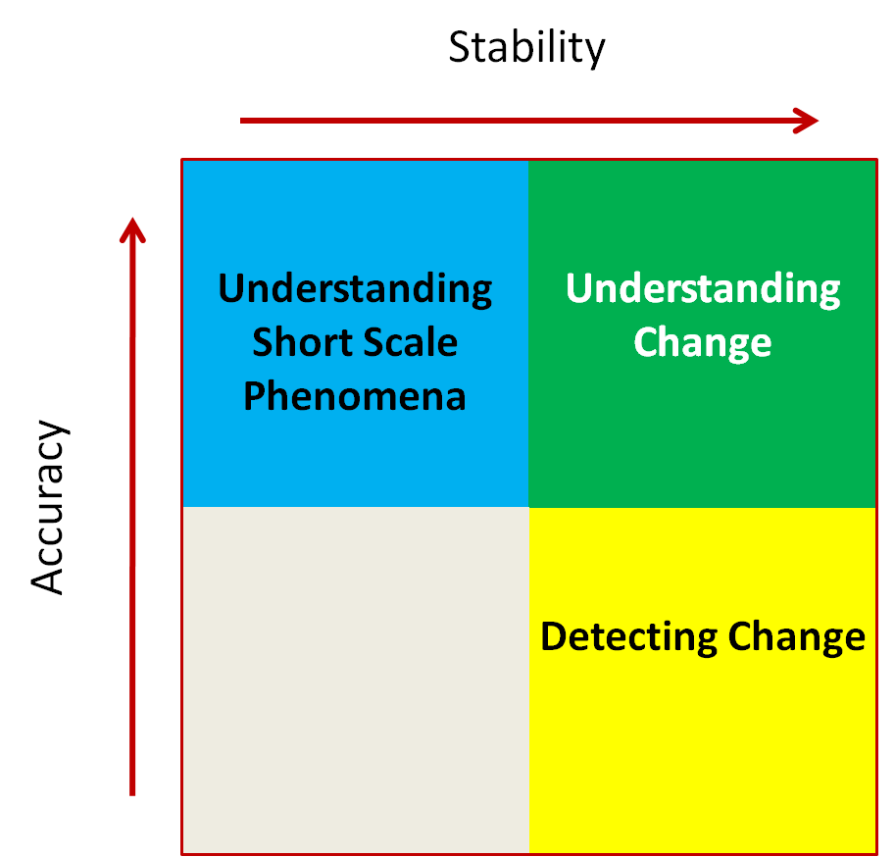

Figure 3.1: Accuracy vs. stability diagram following Ohring et al. (2004)

To achieve the high measurement stability and accuracy required to derive climate data records, on-orbit calibration is of utmost importance. In principle, International System of Units (SI)-traceable reference observations of sufficient accuracy, either from space or from ground, enable to calibrate the fleet of operational and research satellite instruments. As pointed out by the WMO-BIPM (International Bureau of Weights and Measures) workshop (WMO-BIPM, 2010), traceability (see Box 3.2) is a general concept and needs to be established for field measurements (from ground, sea, aircraft, balloon, etc.) as well. In some areas, e.g., passive microwave observations the SI traceability of sufficient accuracy will not be achievable within the next 10 years as the radiometric uncertainties achievable using current standards in National Metrology Institutes (NMIs) in-lab are at the same level as required from satellite sensors on-orbit. A close relationship with at least some representative NMIs needs to be further encouraged to enable them to develop the necessary infrastructure tailored to climate needs in readiness for its use in climate observing systems.

An architecture for climate monitoring from space has the potential to describe the need and the layout of SI-traceability reference observations and to provide a framework in which for instance a space-based calibration mission can be realised.

Requirements on mission continuity and contingency need improvement through international collaboration of space agencies. Although most space agencies accept the climate monitoring principles, there is still only limited coordination of the long-term commitment to collect climate observations.

Another relevant requirement for climate change monitoring is the maintenance of missions once they are no longer operational. In many existing cases, it is not evident that the observations are continued and archived until the mission’s end of life, which would be most beneficial for the climate community in general. Where relevant a clear commitment is required from operating agencies to sustain the production of climate variables from sensors until their end of life. An architecture for climate monitoring from space may define agreed processes that lead to a better planning of long-term observations.

3.4 Requirements Related to Climate Modelling
The understanding of climate processes at different time and space scales is of high importance for developing models that can predict climate at different scales ranging from seasonal and decadal to centennial. The processes that contribute to climate variability and change has not been achieved are not fully understood and are currently the subject of further research. In the context of the IPCC, it recently became obvious that many requirements originating from climate modeling need to be considered by the satellite remote sensing community. Recently, the Climate Modeling User Group (CMUG) of ESA’s Climate Change Initiative (CCI) formulated generic requirements directly related to climate modelling (ESA-CMUG, 2010). These are:

- Model initialisation and definition of boundary conditions
Prognostic quantities in numerical prediction models for climate need to be initialised at the beginning of a simulation and boundary conditions need to be formulated for non-prognostic quantities. Depending on the prediction scale (seasonal, decadal or longer) different priorities for certain Earth System quantities derived from satellite data and their needed accuracy emerge. Those requirements need to be systematically collected and analysed to make the development of CDRs successful for this application.

- Model development and validation
Satellite observations can be an important part of model development in particular
testing the ability of a model to simulate the climatology, annual cycle or specific processes. In models processes are most often represented in form of parameterisations to allow for computational efficiency. Satellite observations can help to improve the understanding of processes by providing process relevant observations and to validate model parameterisation for instance by analysing diurnal and seasonal cycles or comparing statistical relationships between variables in both the model and the observational domains. In terms of observations this requires that a model related observable is measured with a sufficient accuracy and at the relevant time scale. Stability and long term continuity requirements for observations are sometimes less important for this application allowing the use of new and dedicated satellite instruments.

- Data assimilation for climate models
It is envisaged that data assimilation techniques, now mostly used with weather forecast models to improve forecast skill, will also be used to initialise climate models used for seasonal and decadal forecasts. Such forecasts have imminent importance for climate services. The advantage of using satellite data lies in the homogeneous global coverage. To be assimilated the observations must represent a prognostic variable of the forecast model. Specific requirements for related satellite products in terms of accuracy, etc. will emerge over the next years and the envisaged architecture needs to be able to respond to such type of requirements.

Furthermore, climate models can be used to attribute the observed variations to natural and anthropogenic forcing and internal variability. The requirements for this application are those described in section 3.3.

3.5 Requirements for Data Archiving, Processing, Documentation, and Distribution

A basic requirement for the generation of any long-term data record from a successive series of instruments, regardless of satellite or in situ, is the capability to preserve the measurements themselves as well as any related information on and knowledge around the data that were generated during the measurement process. An architecture on space-based climate monitoring can certainly help to define the preservation task as a multi-agency task rather than that each agency is only responsible for storing its own data. Keys for success in this area are the interoperability of archives around the world, and common standards in the documentation of knowledge around the data, formalized through a common definition of metadata. An architecture could help to develop this by requesting, and agreeing on, common best practices, standards and guidelines to be developed by existing international working groups. Such guidelines may also contain procedures to preserve knowledge, for instance by providing support to the key scientist that developed a data record.

A limitation of current archive maintenance requirements is that they are mostly defined for a specific satellite program, whereas the task of the creation of a climate data record clearly covers multi-program data series. Thus, an overarching requirement on the preservation of data and information could be introduced via an agreed architecture on space-based climate monitoring.

An additional mandatory requirement is the capability to process and re-process archived data into CDRs. Experience gained in the GEWEX Data and Assessment Panel has shown that major reprocessing activities are needed to be performed approximately every three to five years. Guidelines (see Box 3.4), on the processing of data, data quality assurance and data product documentation were recently provided by GCOS (GCOS-143, 2010). These guidelines provide a list of twelve essential items that each data generation effort (in situ and satellite) shall follow and report on. Using these common guidelines is very helpful in harmonizing the activities of the different data providers. It needs, however, a more detailed companion that further defines how some of the guideline’s targets can be achieved. In particular processes related to a peer-review process of a new data record and assessments of data records need further definition of what exactly is required. For instance a peer review process can just be the review of a journal publication or the review of the data record itself and the associated documentation versus requirements by experts. A data record assessment is more an expert opinion on the quality of existing data records concerning different applications (GCOS-153, 2011). As ever more climate data records are produced the need for periodic assessments of these data records arises, specifically as the information contained in CDRs potentially will be used within the IPCC process in support of political decisions. The architecture could support the development and use of common data quality assurance, review and assessment methodology to enable interoperable climate data reacord and integrated product development.

A peer review process and data record assessment will only have meaningful results if the documentation of the data records is comprehensive and accurate. The documentation needs to encompass the scientific, engineering and application dimensions providing a full description of the science (measurement and calibration process, algorithms, uncertainty specification, validation results, etc.), the making of the data record (engineering process, implementation verification, technical properties such as versioning, etc.) and advice on the applicability of it (example applications and limitations).

On the technical side of climate data record generation, an architecture could support a further alignment of common standards in software development, data processing procedures and quality assurance within the whole engineering process of implementing and validating the used hard and software. The combined use of data from satellite instruments producing large amounts of data flown by different agencies adds considerable complexity to the data processing and requires a close collaboration among agencies that could be regulated in an agreed architecture.

Also, shared user services may benefit from guidance on how data products should be produced and distributed (GCOS-143, 2010, GCOS-82, 2003). A key requirement is open access to climate data and the associated information. This ranges from the availability of raw satellite data with associated calibration characterisation to the tailored data record supporting a specific climate application. For developing countries, in particular those vulnerable to climate change, better means of accessing climate data and information records including expert advice need to be established. An architecture can provide guidance on data access methodologies as well as metadata and interoperability strategies making the most of the expertise of existing international working groups on such issues. Those needs will be covered in the physical part of the architecture (see section 6). By this the architecture will directly respond to the needs of the developing countries as formulated in the report of the High-Level Taskforce for the Global Framework for Climate Services (GFCS) of WMO (WMO-1065).

Box 3.1 Basic Terminology for Data Records Related to Climate

Of importance in the communication on climate related data records is an understanding of the terminology used. Within this box established definitions with respect to data records in general and satellite data records in particular are listed for reference:

An Essential Climate Variable (ECV) is a geophysical variable that is associated with climate variation and change as well as the impact of climate change onto Earth. GCOS has defined a set of ECVs for three spheres, atmospheric, terrestrial and oceanic (GCOS-82, 2003).

An Earth System Data Record (ESDR) is defined as a unified and coherent set of observations of a given parameter of the Earth system, which is optimized to meet specific requirements in addressing science questions. These data records are critical to understanding Earth System processes, are critical to assessing variability, long-term trends and change in the Earth System, and provide input and validation means to modeling efforts. The term ESDR has been defined by NASA’s Earth Science Division and includes Climate Data Records (CDRs). Because it is not an internationally agreed or adopted definition it is not used explicitly in this document.

A Climate Data Record (CDR) is a series of observations over time that measures variables believed to be associated with climate variation and change. These changes may be small and occur over long time periods (seasonal, interannual, and decadal to centennial) compared to the short-term changes that are monitored for weather forecasting. Thus a CDR is a time series of a climate variable that tries to account for systematic errors and noise in the measurements (NRC, 2004).

The term Fundamental Climate Data Record (FCDR) denotes a well-characterized, long-term data record, usually involving a series of instruments, with potentially changing measurement approaches, but with overlaps and calibrations sufficient to allow the generation of products that are accurate and stable in both space and time to support climate applications (NRC, 2004). FCDRs are typically calibrated radiances, backscatter of active instruments, or radio occultation bending angles. FCDRs also include the ancillary data used to calibrate them. The term FCDR has been adopted by GCOS and can be considered as an international consensus definition.

The term Thematic Climate Data Record (TCDR) denotes the counterpart of the FCDR in geophysical space (NRC, 2004). It is closely connected to the ECVs but strictly covers exactly one geophysical variable where an ECV can encompass several variables. For instance the ECV cloud property includes at least five different geophysical variables where each of them constitutes an TCDR. The term TCDR has been taken up by many space agencies and can be considered as de facto standard.

Box 3.2 Basic Terminology for Definitions of Metrological Quantities

Of importance in the communication on climate related data sets is an understanding of the terminology used. Within this box established definitions with respect to the specification of data record quality are listed for reference:

Accuracy is defined as the “closeness of the agreement between a measured quantity value and a true quantity value of the measurand” (BIPM, 2008). The concept ‘measurement accuracy’ is not a quantity and is not given a numerical quantity value. A measurement is said to be more accurate when it offers a smaller measurement error.

Precision is defined as the closeness of agreement between indications or measured quantity values obtained by replicate measurements on the same or similar objects under specified conditions (BIPM, 2008). Measurement precision is usually expressed numerically by measures of imprecision, such as standard deviation, variance, or coefficient of variation under the specified conditions of measurement.

Measurement error is defined as a measured quantity value minus a referencequantity value. It consists of the systematic measurement error and the random measurement error. The systematic component remains constant or varies in apredictable manner in replicate measurements. The random component varies in an unpredictable manner in replicate measurements (BIPM, 2008).

Bias is defined as an estimate of the systematic measurement error (BIPM, 2008).

Uncertainty of a measurement is a non-negative parameter characterizing the dispersion
of the quantity values being attributed to a measurand, based on the information used (BIPM, 2008). The uncertainty is often described by a random and a systematic error component, whereby the systematic error of the data, or measurement bias, is, the difference between the short-term average measured value of a variable and thebest estimate of its true value. The short-term average is the average of a sufficient number of successive measurements of the variable under identical conditions such that the random error is negligible.

Metrological traceability is the property of a measurement result whereby the
result can be related to a reference through adocumented unbroken chain of calibrations, each contributing to the measurement uncertainty (BIPM, 2008).

Stability may be thought of as the extent to which the accuracy remains constant with time. Over time periods of interest for climate, the relevant component of total uncertainty is expected to be its systematic component as measured over the averaging period. Stability is therefore measured by the maximum excursion of the difference between a true value and the short- term average measured value of a variable under identical conditions over a decade. The smaller the maximum excursion, the greater the stability of the data set.

Metrological Traceability is a property of a measurement result whereby the result can be related to a reference through a documented unbroken chain of calibrations, each contributing to the measurement uncertainty. (BIPM, 2008)

Box 3.3 Climate Data Record of Upper Tropospheric Humidity from HIRS Observations

The example of an Upper Tropospheric Humidity Climate Data Record derived from the NOAA High-Resolution Infrared Radiation Sounder (HIRS) instruments series (see Shi and Bates, 2011 and Shi et al., 2008 for details) provides more insight in problems related to the generation of climate data records at a time GCOS climate monitoring principles were not existing and no specific requirements were implemented into the specific mission programs.

The HIRS instrument was flown on fourteen NOAA satellites and the EUMETSAT Metop-A satellite covering a time series from 1979 to today. The last instrument will be flown on EUMETSAT’s Metop-B satellite expanding the coverage most likely to 2017 that is close to 40 years. Channel 12 of the 20 channel instrument can be used to characterize the humidity in the upper troposphere as it is measuring within the water vapor rotational-vibrational band around 6.7 μm. The HIRS instrument was developed for weather forecast applications with no intention to use it for climate monitoring. Over the whole observation time three different versions of the HIRS instrument were used.

Three exemplary problems with the HIRS record are:

- Differences in spectral response functions among instruments and uncertainties in prelaunch measurement of the spectral response lead to measurements at different heights introducing significant biases in the record.

- Design changes for channel 12 for the HIRS/3 instrument in 1998 (the central wave number was changed from 1480 cm⁻¹ to 1530 cm⁻¹ and the spectral response function was made more narrow) led to a huge jump (~15 K) in the time series due to observations at higher altitude.

- Orbital satellite drifts leading to changes in observing time mix those problems with other effects as the diurnal cycle inherent to temperature and humidity.

An earlier existence of the GCOS climate monitoring principles and following specific requirements, such as on orbit stability, implemented into the mission programs would have led to a much better time series of data from the beginning. However, the existence of the climate monitoring principles has led to a much higher sensitivity of agencies to this kind of problem. This clearly shows the great value of the principles and guidelines as provided by GCOS and of the derived requirements for the generation of data records that provide information on the status of the climate system.

The activities to inter-calibrate the HIRS data as in Shi and Bates (2011) and the analysis of spectral biases using new instruments as EUMETSAT’s Infrared Atmospheric Sounding Interferometer (IASI) onboard Metop-A as in Cao and Goldberg (2009) shows the ability of the scientific and operational community to add value to the original data records that allows for climate analysis applications.

The GCOS guidelines on data processing and quality assurance also help to a broad application of self-assessments of data set maturity as defined in Bates and Barkstrom (2006) and are also in line with assessment work performed in the framework of WCRP where the HIRS data record participates in a specific data set quality assessment of the GEWEX radiation panel (Kummerow et al., 2011).

Box 3.4 Summary of GCOS Guideline for Satellite-based Datasets and Products

- Full description of all steps taken in the generation of FCDRs and ECV products, including algorithms used, specific FCDRs used, and characteristics and outcomes of validation activities.
- Application of appropriate calibration/validation activities.
- Statement of expected accuracy, stability and resolution (time, space) of the product, including, where possible, a comparison with the GCOS requirements.
- Assessment of long-term stability and homogeneity of the product.
- Information on the scientific review process related to FCDR/product construction (including algorithm selection), FCDR/product quality and applications.
- Global coverage of FCDRs and products where possible.
- Version management of FCDRs and products, particularly in connection with improved algorithms and reprocessing.
- Arrangements for access to the FCDRs, products and all documentation.
- Timeliness of data release to the user community to enable monitoring activities.
- Facility for user feedback.
- Application of a quantitative maturity index if possible.
- Publication of a summary (a webpage or a peer-reviewed article) documenting point-by-point the extent to which this guideline has been followed.
4. Existing Capabilities And Processes

4.1 Fifty Years of Environmental Satellite Mission
Over 240 environmental satellite missions have been launched since 1960, with various instrument technologies on-board – either active or passive – observing the Earth through a wide range of the electromagnetic spectrum. These include more than 160 meteorological satellites, many of them in operational series of five or more spacecraft flown namely by the United States, the Russian Federation, Europe, India, Japan and China. More than 50 satellites have also been successfully launched and operated as part of ocean, land, or disaster monitoring series. This has been achieved on a national basis by the Russian Federation, India, the United States, France, Japan or in bilateral programmes e.g. between China and Brazil, the United States and France, the United States and Japan, by international agencies such as the European Space Agency and EUMETSAT, or in mutilateral cooperation or joint undertakings of government and commercial satellite missions or constellations. Furthermore, space agencies have deployed over the years more than 30 satellite missions specifically aimed at observing climate components, supporting climate process studies or demonstrating new technology to be used in climate monitoring. All these missions provide a valuable heritage for future missions in support of sustained climate monitoring from space.

4.2 Current and Planned Satellite Missions for Climate
Increased frequency of satellite measurements, improved satellite and sensor technology, and easier access and interpretation of Earth observation data are all contributing to the increased role of satellite data in our knowledge of the climate system. Approximately 100 satellites are currently operating with an Earth observation mission and some further 140 are planned for launch over the next 15 years. These satellite missions will carry over 400 different instruments measuring components of the climate system, including the atmosphere, ocean, and land surface,.

Although they are optimized to support real-time weather monitoring and forecasting, operational meteorological programmes provide a foundation for longstanding climate records of key atmospheric parameters and are gradually expanding their scope. The international geostationary constellation, currently maintained by seven satellite operators, will fly enhanced visible and infrared imagers, hyperspectral infrared sounders and lightning detectors. Towards the end of the decade, some series will include additional payload for atmospheric composition. The constellation of operational meteorological satellites on sun-synchronous Low-Earth orbits, which perform multispectral imagery and vertical sounding as core missions, will progressively feature more advanced capabilities, including hyperspectral infrared sounding, Global Navigation Satellite System (GNSS) radio occultation sensors, some Earth Radiation Budget instrumentation, atmospheric composition and space environment sensors. While providing a significant contribution to climate monitoring, operational meteorological satellites, however, do not always meet the level of accuracy needed for climate monitoring and do not observe all the variables involved in climate processes.
New data on the chemistry, aerosol content, and dynamics of the Earth’s atmosphere will be gathered by missions from many countries, while space-borne lidar will provide new information on winds in addition to cloud and aerosol observations. The Earth radiation budget is measured at the top of the atmosphere through a combination of measurements from dedicated scientific missions and from operational meteorology missions. Building on the capability demonstrated over more than a decade, the global monitoring of the water cycle will be performed by spaceborne precipitation radar and passive microwave sensors associated with a large international constellation of satellites.
Ocean surface topography measurements by radar altimetry and ocean surface wind vector measurements by scatterometry, initiated twenty years ago on an experimental basis, are continued operationally and expected to be strengthened with follow-on missions. New capabilities are being demonstrated for measuring ocean salinity.
Visible and infrared imagery of the land surface is needed for the terrestrial component of the climate system, as provided by over thirty years of information obtained since the first Earth surface remote sensing spacecraft. Operational meteorological and land monitoring satellite series will supply continuous observation of land surface, vegetation parameters and ice sheets. Advanced Synthetic Aperture Radar (SAR) systems yield new information on land surface properties. Active and passive microwave instruments measure surface soil moisture. A new generation of sensors is emerging with drastically improved capabilities to remotely sense land surfaces the ocean, and the atmosphere, including their chemical composition.

Table 4.1: A snapshot of current and firmly planned satellite mission contributions with respect to ECVs. The table indicates the type of measurements performed by current and planned missions contributing to climate observation, with reference to 12 broad categories, and lists typical climate variables that these measurements observe, or contribute to observe. It should be understood that not all the satellites of each category measure all the variables listed, and not always with the required accuracy.

Instrument or  mission type | Current or planned satellite missions including measurements of that category |  | Essential Climate Variable potentially supported
LEO - Multi-purpose VIS/IR imagery  and IR and MW sounding | NOAA series (NOAA)  Meteor series (Roshydromet)  Metop series (EUMETSAT)  FY-1 and FY-3 series (CMA)  GCOM-C series (JAXA) | EOS-Terra and Aqua (NASA)  NPP, JPSS series (NOAA)  DMSP and DWSS series (DOD)  Megha-Tropiques (ISRO, CNES) | Temperature, Water vapour, Cloud properties, Aerosols, Surface radiation budget, Albedo, Ozone, Methane, CO, CO2, NO2, Sea surface temperature, Permafrost, Snow cover, FAPAR, Leaf Area Index, Biomass, Fire disturbance, Precipitation
GEO - Multi-purpose VIS/IR imagery  and IR sounding | GOES series (NOAA)  Meteosat (MFG, MSG, MTG) series (EUMETSAT)  FY-2/FY-4 series (CMA)  MTSAT/Himawari series (JMA) | INSAT/ Kalpana series (ISRO/IMD)  Elektro-L (Roshydromet)  COMS series (KMA) | Water vapour, Cloud properties  Wind speed and direction  Aerosols, Surface radiation budget, Albedo  Sea surface temperature  Temperature Precipitation
LEO – Radio-occultation sounding | COSMIC-1, 2 (NOAA)  SAC-C and SAC-D (CONAE)  KOMPSAT-5 (KARI)  Tandem-X (DLR)  Meteor-M N3 (Roshydromet)  Metop series (EUMETSAT) | FY-3 E,G (CMA)  Oceansat-2, 3 (ISRO)  Megha-Tropiques (ISRO,CNES)  CHAMP (DLR)  GRACE (NASA/DLR) | Atmospheric temperature  Water vapour  Cloud properties
LEO and GEO - Earth radiation budget | ACRIMSAT (NASA)  SORCE (NASA)  JPSS-1 (NOAA) | Earth care (ESA/JAXA)  FY-3 A, B, C, E, G (CMA)  Meteosat (EUMETSAT) | Earth radiation budget  Surface radiation budget
LEO- Scatterometry / MW polarimetry and imaging | DMSP and DWSS series (DOD)  HY-2A and follow-on (CNSA)  Metop series (EUMETSAT)  GCOM-W series (JAXA)  GPM (NASA, JAXA) | Meteor-M N3 (Roshydromet)  FY-3 E, G (CMA)  Oceansat-2 (ISRO)  Megha-Tropiques (ISRO, CNES) | Sea surface wind speed and direction  Sea ice, Snow cover  Soil moisture, Precipitation
LEO – Radar altimetry | Saral (ISRO/CNES)  HY-2A (NSOAS)  Sentinel 3A,3B (ESA,EUMETSAT,EC) | ERS-2 and Envisat (ESA)  Jason-1 (CNES-NASA)  Jason-2,3 (CNES; EUMETSAT, NASA, NOAA)  Cryosat-2 (ESA) | Sea level  Sea state  Sea ice thickness
LEO or GEO - Ocean colour imagery | AQUA, TERRA (NASA)  ENVISAT (ESA)  Meteor-M N3 (Roshydromet)  FY-3 series (CMA)  Sentinel 3A,3B (ESA,EUMETSAT,EC) | HY-1B, C, D (CNSA)  Oceansat-1, 2, 3 (ISRO)  NPP, JPSS series (NOAA)  COMS series (KMA)  GCOM-C series (JAXA) | Ocean colour
LEO - Imagery with special viewing | Sentinel 3A, B (ESA,EUMETSAT,EC)  Envisat (ESA) | EOS Terra (NASA)  Parasol (CNES)  GCOM-C series (JAXA) | Aerosols, FAPAR  Surface radiation budget
LEO – Cloud & precipitation radar and lidars | EarthCare (ESA/JAXA)  Cloudsat (NASA)  TRMM (NASA/JAXA)  Calipso (NASA/CNES) | GPM core (NASA/JAXA)  ADM-Aeolus (ESA)  FY-3 Rain Measurement (CMA)  GPM-Brazil (INPE) | Cloud properties, Aerosols  Precipitation, Water vapour  Wind speed and direction
LEO and GEO - SW and IR cross-nadir spectrometry | NOAA-POES series (NOAA)  Metop series (EUMETSAT)  Sentinel-5 & precursor (ESA, EC)  Envisat (ESA) | EOS Terra and Aura (NASA)  GOSAT (JAXA)  NPP and JPSS series (NOAA)  Meteosat-MTG (EUMETSAT)  FY-3 series (CMA) | Cloud properties  Aerosols  Ozone, other GHG
LEO - Limb-sounding SW, IR and MW spectrometry | Envisat (ESA)  NPP (NOAA)  Scisat-1 (CSA) | EOS Aura (NASA)  Odin (SNSB, CNES, CSA)  SAGE-III ISS (NASA)  SMILES ISS (JAXA) | Temperature  Water vapour  Ozone, Other GHG
LEO – High resolution optical and SAR imagery | Landsat (NASA, USGS)  LDCM (USGS, NASA)  SPOT (CNES)  CBERS (CAST, INPE)  HJ (CAST)  Resourcesat (ISRO )  Cartosat (ISRO)  ALOS (JAXA) | KANOPUS-V (Roscosmos)  ERS and ENVISAT (ESA) Sentinel-1 (ESA, EC)  Sentinel-2 (ESA, EC)  SAOCOM (CONAE)  Radarsat (CSA)  CSK and CSG (ASI)  TerraSAR-X, Tandem-X (DLR) | Land cover, Biomass  Fire disturbances  Sea ice, Glaciers, Ice sheets

The table above indicates either satellites “series” that are operated over a long period, or individual missions for which such continuity is not planned. On one hand, it shows the considerable effort directed towards climate monitoring. On the other hand, there is no evidence that these missions will, all together, respond to climate monitoring needs in a comprehensive way, noting in particular that many of them are demonstration or research missions with no firm path towards a sustained follow-on. Systematic gap analyses are needed to anticipate potential observation gaps and facilitate timely mission planning decisions.

4.3 Gap Analyses of Satellite Missions Compared with GCOS Requirements for ECVs

Gap analyses were conducted at sensor level, in analyzing for each ECV the current and planned availability of suitable sensors. This entailed a thorough inventory of current and planned capabilities, which is evolving as new programmes develop, satellites are being launched and others are ceasing operation. The gap analysis also implies rigorous evaluation of the expected performance of each sensor and of the accuracy of the ECVs that can be retrieved from its measurements. Two major efforts are being pursued in this domain by CEOS and by WMO respectively, with complementary approaches.

The CEOS database of Missions, Instruments and Measurements (MIM) reflects the annual official mission status and plans communicated by agencies. The MIM is an excellent resource for initial gap assessments, but caution is required as mission timelines are not sufficient to identify measurement gaps because of differences in capabilities. For example, all the missions measuring atmospheric CO₂ might suggest there are no significant gaps, but that is not the case. The requirements (spatial, vertical, uncertainty, repeat cycle) vary according to atmospheric layers and to applications, such as detection of CO₂ sources and sinks near the surface, analyzing CO₂ transport, or chemical processes. A detailed analysis reveals gaps in near-surface CO₂ measurements and temporal revisit rates. The figure below summarizes a gap analysis performed by the CEOS System Engineering Office (SEO) for the CEOS Carbon Task Force and the CEOS Atmospheric Composition Constellation.

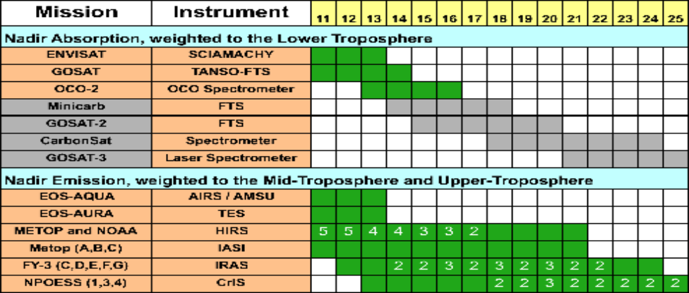

Table 4.2: An outcome of SEO Gap Analysis based on MIM, from 2011 to 2025.The numbers (2, 3, 4, 5) indicate the number of satellite missions when more than one is flying the relevant type of instrument. Mission timelines focused on nadir absorption measurements in the lower troposphere suggests future mission concepts (grey shading) are limited and uncertain beyond 2016. In addition, the combination of these missions does not meet twice-daily temporal sampling requirements to adequately assess sources and sinks. In the case of nadir emission measurements in the middle to upper troposphere, there are numerous science and meteorology missions available to provide adequate spatial and temporal sampling.

WMO maintains a “Dossier on the Space-based Global Observing System” which includes a Gap Analysis with respect to a target configuration defined in order to meet the requirements of the meteorological and climate community. Based on this general information, for each ECV measurable from space, a review was performed of the relevant instrument capabilities and their availability over a period of 50 years including the past 35 years and the next 15 years. Table 4.3 below provides an excerpt of such analysis for one of the 32 variables that have been analyzed: Earth Radiation Budget. This kind of Gap Analysis provides a first level of information for further detailed investigations of critical missions.

Table 4.3 : Excerpt of Gap Analysis for the ECV “Earth radiation budget”

 |  | 75 | 76 | 77 | 78 |  | 79 |  | 80 |  | 81 |  | 82 |  | 83 | 84 |  | 85 |  | 86 | 87 | 88 | 89 | 90 |  | 91 | 92 | 93 | 94 | 95 | 96 | 97 | 98 |  | 99 | 00 | 01 | 02 | 03 | 04 | 05 |  | 06 |  | 07 |  |  | 08 |  |  |  | 09 |  | 10 | 11 | 12 | 13 | 14 | 15 | 16 | 17 | 18 | 19 | 20 | 21 | 22 | 23 | 24 | 25
ERB | LEO broad-band | FPR |  |  |  |  |  |  |  |  |  |  |  | ERB |  |  |  |  |  |  |  |  |  |  | CERES, ERM-1 |  |  |  |  |  |  |  |  | ERM-2, CERES until 2021
 | GEO broad-band |  |  |  |  |  |  |  |  |  |  |  |  |  |  |  |  |  |  |  |  |  |  |  |  |  |  |  |  |  |  |  |  |  |  |  |  | GERB | same
 | Solar irradiance |  |  |  |  |  |  |  | ACRIM-1 |  |  |  |  |  |  |  |  |  | ACRIM-2 |  |  |  |  |  | ACRIM-3, SIM, TIM, … |  |  |  |  |  |  |  |  | same, then TSIS, SIM-2
 | Spectrum (≤16 μm) |  |  |  |  |  |  |  |  |  |  |  |  |  |  |  |  |  |  |  |  |  |  |  |  |  |  |  |  | GOME, … | AIRS, IASI, Sciamachy |  |  | same + improvements and additions

Gap analysis
The heritage of ERB missions is quite long-standing, but long-term commitment beyond ~ 2021 are limited to perhaps too simple instruments. The same holds for solar irradiance monitoring. No commitment is available for continuity in GEO after GERB (expected end-of-life: 2021). As for outgoing spectral radiance, the range utilised for operational SW and TIR instruments (~ 0.3-16 μm) is secured, but external to this range (most critical, Far IR) the only plan is CLARREO, still a process study mission. ECV Earth Radiation Budget is at risk as concerns all aspects: both continuity and quality, of both broad-band and solar irradiance measurements.

Such analyses enable the highlighting of some gaps in historical heritage archived data, or risks of gaps in the future . Absolute gaps result of a lack of a measurement or mission (e.g. instrument being de-manifested, mission not being planned or funded in time to provide continuity), or when the data is unavailable for public access. Relative gaps may occur when the measurement or mission does not satisfy all of the requirements (e.g. the spatial, temporal, radiometric resolution or uncertainty are not adequate). Strategic gap analyses require detailed and quantitative assessments of requirements and mission capabilities. There may be scientific gaps as well, posing a R&D challenge to space agencies and science communities to innovate and improve the observation capability.

Clearly, more thorough gap analyses are needed and shall be conducted as part of developing the architecture.

4.4 Satellite Instrument Calibration Activities

- The need for minimal uncertainty for climate monitoring, together with the need to combine data from a variety of sources (space and in-situ), and emerging products with data assimilation have placed “traceability” and its quantification at the top of the agenda. Many examples demonstrate the need to reduce inconsistencies and biases between in-flight sensors and illustrate how normalisation has enabled establishing long-term records. Improvements are needed at all stages of satellite data production: pre-flight and post-launch calibration and validation and all the intermediate processing steps.

- Inter-calibration enables consistency among satellite measurements to be achieved. Without traceability to stable reference standards inter-calibration is however exposed to the risk of drifting over time and such drifts may obscure the climate trend over several decades. Therefore strategies are being developed to improve traceability to SI units and evaluate biases with sufficient accuracy that enables time series of data sets to be appropriately and reliably linked and relaxes some of the reliance on more conservative and costly strategies such as systematic overlaps. In the optical domain, in particular, efforts are underway to establish networks of SI traceable post-launch reference standards that will support virtual constellations of sensors. A challenging, long-term goal is to enable SI traceable measurements from space at uncertainties commensurate with those obtained in the laboratory through direct use of a primary standard. In order to reach that goal, a dedicated mission flying an SI traceable calibration reference standard would be an important element of a future architecture.

Activities of the CEOS Working Group on Calibration and Validation (WGCV)

The mission of the WGCV is to ensure long-term confidence in the accuracy and quality of EO data and products, and to provide a forum for the exchange of information, for coordination, and for cooperative activities on calibration and/or validation. It is instrumental in the establishment of a common technical language amongst the users of EO data and customers of satellite-derived products. The WGCV coordinates and supports joint experiments and the sharing of facilities, expertise and resources. The group also addresses the need to standardise ways of combining data from different sources to ensure the interoperability required for the effective use of existing and future EO systems. Thus the WGCV and its thematic subgroups contribute to improving the performance of all Earth Observation programmes. Details on WGCV activities can be found on the WGCV web site (http://www.ceos.org/wgcv).

Activities of the Global Space-based Inter-Calibration System (GSICS)

The Global Space-based Inter-Calibration System (GSICS) was initiated in 2005 by the WMO and the CGMS with a goal to ensure consistent calibration of satellite measurements from different instruments and missions contributing to the Global Observing System (GOS), and tie the measurements to SI units. GSICS has defined and implemented procedures for operational, on-orbit satellite instrument inter-calibration. This consists of relating the measurements of one instrument to those of a reference instrument with a stated uncertainty, when both instruments are viewing the same scenes at the same time from the same viewing angle. For satellite data time series in an archive, the overlapping records of two satellite instruments can be compared once a number of effects, such as diurnal cycle, are taken into account. Earth-based or celestial targets are also used as a complement. GSICS inter-calibration allows biases to be removed among satellite measurements. Fifteen operational or research and development (R&D) space agencies are contributing to GSICS. Details on GSICS activities can be found on the GSICS website: http://gsics.wmo.int

QA4EO – A Quality Assurance for Earth Observation (QA4EO)

The fundamental principle of the Quality Assurance Framework for Earth Observation (QA4EO). is that " all EO data and derived products have associated with them a documented and fully traceable quality indicator (QI)" . The QA4EO seeks to ensure that this universally applicable principle is implemented in a consistent manner throughout all EO.

Table 4.4: QA4EO principles
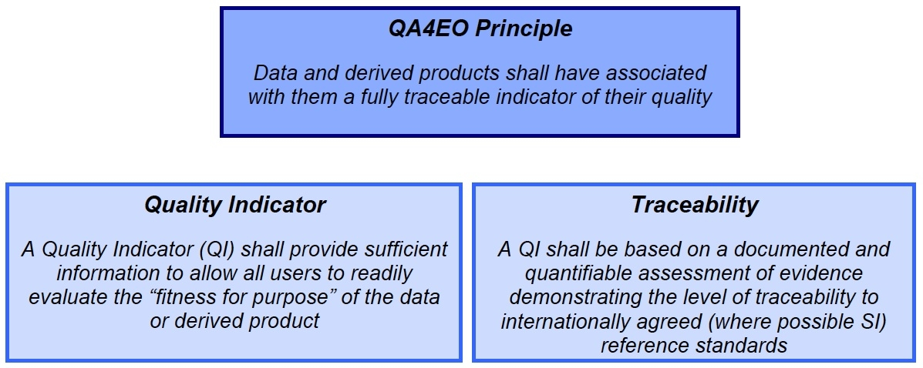

A framework document provides information on the principles and concepts that underpin the QA4EO philosophy. It is complemented by a set of key guidelines to support the adoption of the QA4EO ethos for operational working. These are further enhanced by numerous community- specific guidelines that assist in the practical implementation of QA4EO at the working level. (See details on the QA4EO website (http://QA4EO.org/)

4.5 From Satellite Data to Validated Climate Data Records

According to recommended standards, Climate Data Records (CDRs) should be well-documented, developed through best-practice and transparent processes, reproducible and scientifically defensible.Space agencies have established procedures and guidelines for the evolution of mature research CDRs into a sustaining production context, based on best practices from expert bodies, such as the Global Climate Observing System (GCOS) and the U.S. National Academy of Sciences.

The GCOS Guideline for the Generation of Satellite-based Datasets and Products meeting GCOS Requirements” (GCOS-143), as summarized in Box 3.3, sets expectations for ECV data producers.

Within NOAA a two-phase development approach is considered: Initial Operational Capability and Sustained Operational Capability. In this approach, an Initial Operational Capability (IOC) is achieved when a CDR is publicly released in its earliest useful form; it is characterized by documentation of algorithm development through an Algorithm Theoretical Baseline Document (ATBD), validation, archiving and public release of source code and data, and provisions for feedback from the scientific community. The process is a collaborative effort between algorithm developers and multiple other participants in an end-to-end information stewardship chain (see Table 4.5).

Table 4.5: Proposed Steps to Initial Operations Capability (IOC) for Climate Data Records (CDR).

1) Assessment | 2) Submission | 3) Transfer | 4) Validation | 5) Archival | 6) Access
CDR maturity assessment | Submission agreement | Source code transfer | Validate code archival package | Archive code | Code publicly available
Key decision point | Documentation of code header information | Entering of code into configuration control | Validate supporting documents | Archive documents | Documentation available
 | Sample data transfer | Documents transfer | Validate data | Archive product data | Data available
 |  | Main data transfer |  | Archive ancillary data
After an Agency assesses and approves a CDR algorithm for transition to IOC, a final CDR package is submitted to the sustaining CDR program. The package includes fully commented source code as well as all necessary data. The package then undergoes a submission process, highlighted by the completion of a submission agreement, to place it into an archive. This process includes assessing the research algorithm’s conformance with CDR maturity security and coding standards. The codes, documentation and data sets are placed under configuration or version control as appropriate. After validation and archival steps are completed, the published CDR code, documentation and data are made available to the public via the CDR sustaining Program website.

A Sustained Operational Capability (SOC), is achieved when a CDR is routinely generated, the complete record and supporting data, documentation and source code is residing in an identified archive, and stewardship activities are implemented. The sustained forward extension of the data record entails ensuring ongoing CDR quality assessment and validation, exercising configuration and version control, and ensuring the timely release of incremental extensions to the time series. Sustaining CDRs will occasionally require significant algorithm upgrades. Sustained CDR programs must therefore provide an avenue to replace heritage algorithms and data sets with improved versions once they are successfully demonstrated, validated and available. The ATBD documentation has to be updated acordingly.

Mapping the progress against a maturity matrix (See Table 4.6) or any equivalent standard provides a critical assessment at every step in the climate information value chain, of compliance with user requirements with a view to reduce error or uncertainty and to correct technical artifacts in measurement.

Table 4.6. Algorithm Theoretical Baseline Document and Maturity Matrix

The Algorithm Theoretical Basis Document |  | The Maturity Matrix
The Algorithm Theoretical Basis Document (ATBD) provides the scientific basis of remote sensing retrieval algorithm by detailing the physical theory, mathematical procedures and assumptions. In particular, the ATBD details:  - Observing System Overview  - Algorithm Description  - Test Datasets and Outputs  - Practical Considerations  - Assumptions |  | The Maturity Matrix (Privette et al., 2009) defines six maturity levels for each of the following criteria:  - Sensor Use  - Code Stability  - Metadata and Quality Assurance (QA)  - Documentation  - Validation  - Public Release  - Science and Application

Within Europe different programs are working in a similar way as described above with differences in the details. The ESA CCI (see Box 4.1) is providing an IOC for many ECVs and EUMETSAT’s CDR generation activities are more directly targeting a SOC.

Within NASA, an Earth Science Data Preservation Content Specification is being developed, which addresses eight crucial and inclusive data contents requirements: Preflight/Pre-Operations Calibration, Products (Data), Product Documentation, Mission Calibration, Product Software, Algorithm Input, Validation and Software Tools. This is another possible standardization approach.

Tentative mapping of product availability

Some metric is needed for the overall quality of climate products with respect to the Essential Climate Variable (ECV) requirements. Table 4.7 below is an attempt to illustrate such metric; it communicates the notion that achieving climate requirements requires a long time horizon (50 years in this case) and that the product quality is critical. Since this figure was created, the climate community has continued to evolve metrics for climate product quality. Through the use of a quantitative maturity matrix the qualitative assessment in Table 4.7 could be replaced by a quantitative score for each ECV in time history. Formulating an architecture may foster the coordinated application of such a metric internationally for the benefit of all.

Table 4.7: Schematic representation of time histories for ECV products.
Although the scope of this figure developed by a NOAA-NASA working group on the NPOESS payload was limited to U.S. product and satellite contributions, it illustrated the needs for both sensor availability and product quality. This version is now superseded by other ways to reflect ECV status such as a maturity matrix evaluation.

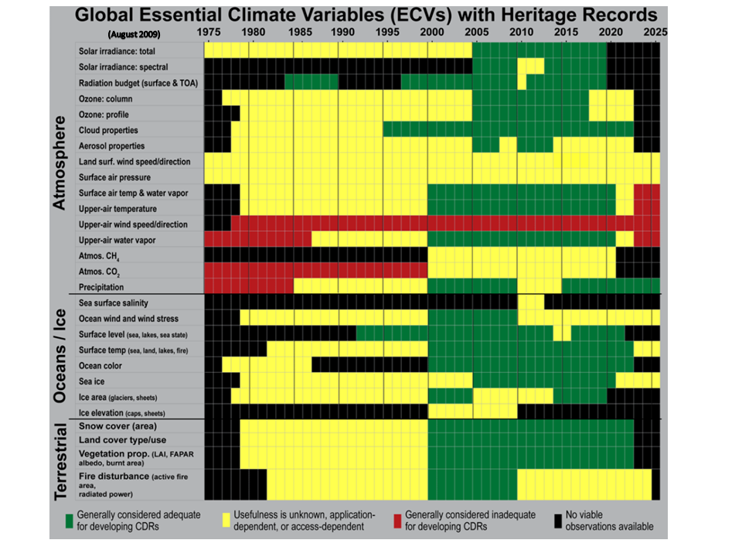

Box 4.1: The European Climate Change Initiative (CCI)

The Climate Change Initiative (CCI) has been conceived to leverage long time series of archived satellite data, mainly from European missions, for generating climate datasets, in response to GCOS needs. It will contribute to the international CEOS response to GCOS in this area. The CCI is coordinated by the European Space Agency (ESA) with research programmes by the European Commission and European states, and is expected to underpin the establishment of a climate service under the European Global Monitoring for Environment and Security (GMES) initiative.

The CCI principal objective is “to realize the full potential of the long-term global Earth Observation archives that ESA together with its Member states have established over the last thirty years, as a significant and timely contribution to the ECV databases required by United Nations Framework Convention on Climate Change (UNFCCC)”.

The CCI complements existing efforts in Europe (e.g., led by EUMETSAT in CM-SAF) and internationally (e.g., under the umbrella of SCOPE-CM). The success of the CCI will be measured by the quality of its satellite-based ECV products and its ability to establish lasting and transparent access for global scientific and operational communities to these results. The CCI puts strong emphasis on the generation of fully described, error-characterized and consistent satellite-based ECV products.

A first set of thirteen ECVs are being addressed in the Atmospheric, Oceanic and Terrestrial domains:
- Atmospheric domain: Ozone, Clouds, Aerosols, Greenhouse gases (CO2, CH4)
- Oceanic domain: Sea level, Sea surface temperature, Ocean colour, Sea Ice
- Terrestrial domain: Land cover, Glaciers and ice caps, Fire disturbance, Soil Moisture, Ice Sheet.

( For more information: http://earth.eo.esa.int/workshops/esa_cci/ESA_CCI_Description.pdf )

Sustained Coordinated Processing of Environmental Satellite Data for Climate Monitoring

The Sustained Coordinated Processing of Environmental Satellite Data for Climate Monitoring (SCOPE-CM) is a global network of centres of excellence on the thematic area of operational climate monitoring, initiated in 2007 by WMO and the CGMS.
The operational satellite operators that are participating in SCOPE-CM currently include: the Chinese Meteorological Agency (CMA), EUMETSAT, the Japan Meteorological Agency (JMA), and the National Oceanic and Atmospheric Administration (NOAA). Several entities are stakeholders in the process, including the Committee on Earth Observation Satellites (CEOS), the Coordination Group for Meteorological Satellites (CGMS), GCOS, the Group on Earth Observations (GEO), the Global Space-based Inter-calibration System (GSICS), the World Climate Research Programme (WCRP) through its Global Energy and Water Cycle Experiment (GEWEX). The WMO Space Programme provides overall guidance and facilitates coordination with other relevant initiatives and EUMETSAT is serving as the SCOPE-CM secretariat.

The establishment of SCOPE-CM is organized in three phases leading to a suatained capability to generate CDRs in operational environment. In phase one five pilot projects are on-going, the maturity matrix being applied as a test case to each of them. As the projects become more mature, the processes to be used to generate CDRs are being reviewed and best practices have been identified with a view to adopt them as SCOPE-CM standard practices. The second phase will sustain the successful pilot projects and will ensure an appropriate involvement of scientific institutions in the SCOPE-CM activities.

Table 4.8. The five Pilot Projects under SCOPE-CM

1: AVHRR based data set of cloud and aerosol properties
2: SSM/I: total column water vapour, precipitation, liquid water path
3: Surface albedo, clouds + aerosols from geostationary satellites
4: Atmospheric Motion Vectors (AMV) + clear sky radiance
5: Upper tropospheric humidity

4.6 Emerging Coordination

In the light of past achievements and already committed efforts, a large part of the capabilities needed for climate monitoring are already planned or available, however some critical gaps remain and the overall system needs to be better articulated to be fully efficient and robust.

The adequacy/inadequacy of current holdings and planned space-based capabilities is kept under review by the GCOS community and evaluated in the report on “Systematic Observation Requirements for Satellite-Based Products for Climate (GCOS-154)”. Gaps or deficiencies are identified or anticipated at almost every step in the value chain from sensor to Climate Data Record:

- Continuity of measurements is at risk for some variables, for example Earth Radiation Budget (ERB), Total Solar Irradiance, or stratospheric ozone and greenhouse gases monitored by limb sounding
- The coverage of some observations is not global, for example for precipitation,
- Space and time resolution of measurements may not be sufficient, for instance for tropospheric CO₂ and CH₄,
- Datasets derived from different sensors may be fragmented and difficult to consistently integrate, like for ocean colour,
- Calibration is not yet done in a systematic, harmonized, and documented way
- Data stewardship needs to be ensured for all ECVs observations,
- Processing into climate records is not yet performed in a quality controlled, traceable way

Initiatives to address these gaps in a coordinated fashion have been taken by Space Agencies in the context of the Committee on Earth Observations (CEOS) and of the Coordination Group for Meteorological Satellites (CGMS), as well as by the World Meteorological Organization (WMO), in response to the GCOS requirements.

In the WMO framework, the evolution of global observing systems is driven by a “Rolling Requirements Review” (RRR) process, whereby user requirements for observations are regularly compared with the capabilities of present and planned observing systems. In this process, WMO strives to optimize the complementary use and optimization of both space and surface-based observation; it also values a cross-cutting approach of the various applications such as climate monitoring, weather forecasting, ocean services, air quality etc, stressing the need for interoperability among systems and applications, this being a specific goal of the WMO Integrated Global Observing System (WIGOS). The RRR process includes the following elements:
- User requirements are quantified and systematically recorded in the WMO Observing Requirements database (http://www.wmo-sat.info/db/), which captures observational requirements inferred from WMO programmes and co-sponsored programmes. For instance, the database contains 104 requirements formulated by GCOS through its Atmospheric, Oceanic and Terrestrial observation panels.
- An inventory and evaluation of observing capabilities is regularly updated. The space-based part of this inventory is contained in the Dossier on the Space-based GOS, which is being migrated to an on-line database.
- A Critical Review of observing capabilities compared with requirements for each given application area is used to prepare a Statement of Guidance (SOG) drawing attention to the most important gaps, in the context of the application.
- A vision is developed to guide the evolution of the observing systems typically 20 years ahead. Based on consolidation of the statements of guidance at a point in time, this vision is primarily user driven, it is however refined in consultation with the providers of observing capabilities since its goal is to be forward looking but achievable. The vision addresses both space and surface-based observations; for its space-based aspects, the Vision for the GOS in 2025 was developed in consultation with CGMS and CEOS. The current Vision of the GOS in 2025 calls for improved data sharing, data quality and traceability, sustainability, Research to Operations transition when relevant, and contains the outline of an architecture. It was developed in 2006-2009 largely in response to GCOS requirements expressed in the GCOS Satellite Supplement.
- An Implementation Plan is then defined to provide a path for realizing the vision. This Implementation Plan identifies actions which are regularly reviewed with expert bodies including representatives of the implementing agents and of the user applications.

CEOS has developed the concept of “Virtual Constellations” aiming to foster partnership in addressing key observational and scientific gaps on specific themes, and prepare for the routine collection of critical observations.

A CEOS Virtual Constellation is a set of space and ground segment capabilities operating together in a coordinated manner, in effect a virtual system that overlaps in coverage in order to meet a combined and common set of Earth Observation requirements. The individual satellites and ground segments can belong to a single or to multiple owners. The Constellation concept builds upon or serves to refocus already existing projects and activities. The Constellations effort provides a unique forum to achieve political visibility and increase mutual benefit among space and other environmental agencies in support of cross-cutting GEO Tasks and Targets. In particular, they offer opportunities to share experience in the development of algorithms, standardize data products and formats, exchange information regarding the calibration and validation of measurements, facilitate timely exchange of and access to data products from existing and planned missions, and facilitate planning of new missions – ranging from coordinating orbits to optimizing observational coverage to sharing implementation of mission components.

The interim goal of a Constellation is to demonstrate the value of a collaborative partnership in addressing a key observational gap; the end goal is to sustain the routine collection of critical observations. Implementation of Constellation activities is ultimately dependent on the coordination of formal agreements among participating agencies. Six Constellations currently exist, each of which has leads from space agencies with a heritage of operations in the relevant EO domain and a team of participants from other space agencies willing to contribute to implementation coordination through CEOS.
(See Box 4.2)

Box 4.2: The CEOS Virtual Constellations
The Virtual Constellations offer an opportunity to share experience in the development of algorithms, standardize data products and formats, exchange information regarding the calibration and validation of measurements, facilitate timely exchange of and access to data products from existing and planned missions, and facilitate planning of new missions.
There are currently six CEOS Virtual Constellations:
- Atmospheric Composition,
- Ocean Surface Topography,
- Precipitation,
- Land Surface Imaging,
- Ocean Color Radiometry,
- Ocean Surface Vector Wind.

The CGMS, with a focus on long-term sustained missions, is maintaining satellite constellations in geostationary and Low-Earth Orbit in accordance with an agreed baseline. While the initial scope of CGMS was historically focussed on weather monitoring for operational meteorological forecasting, the capabilities coordinated through CGMS are now increasingly addressing key climate observations. The agreed baseline describes the missions to be implemented and maintained on a long-term basis; it serves as reference for the commitments of the individual states to contribute to the Global Observing System in the framework of WMO, in response to the Vision and Implementation Plan mentioned above. CGMS defines technical standards or best practices to ensure interoperability across the global system. It has developed contingency plans which provide a framework for action in case of satellite outage or other unexpected unability to fully implement the agreed baseline.

Box 4.3 : CGMS continuity and contingency planning

The CGMS baseline defines (i) a geostationary constellation comprising six satellites nominally located at fixed longitudes (135°W, 75°W, 0°, 76°E, 105°E, 140°E) and performing a set of agreed missions, (ii) a core meteorological constellation in polar sun-synchronous orbit performing imagery and sounding, and (iii) different constellations dedicated to additional missions in either sun-synchronous or inclined low Earth orbits. The CGMS Working Group on continuity and contingency planning keeps under review the implementation of the baseline, the availability of in-orbit back-ups and the risks of interruption of key missions.

CGMS has adopted a Global Contingency Plan which includes guidelines to ensure continuity e.g. in terms of in orbit back-up and re-launch policy, sets criteria for entering into contingency mode, and identifies actions to be taken in such contingency situation. In particular, the Global Contingency Plan defines a generic procedure for relocating a spare geostationary satellite to take over from a failing satellite, which is referred to as the “Help your neighbour” strategy. This global plan is supplemented by bilateral contingency agreements among geostationary satellite operators. On several occasions over the past three decades such contingency relocations have been essential to preserve the continuity of vital operational missions.

While each of the initiatives mentioned in this section represents a valuable advance towards sustained climate monitoring, none of them is exhaustive. There is an imperative need for further and wider coordination among all stakeholders in order to secure the implementation of plans, to optimize the necessary efforts and to ensure traceability along harmonized practices.

5. Beyond Research to Operations

In the early 1990s, research space agencies took the lead in advancing our ability to observe the Earth system at the time, space and accuracy scales to distinguish climate processes. These observing systems have had a major positive impact not only on our ability to monitor climate but also on our ability to monitor weather and many additional aspects of the environment and societal benefit areas. This epoch of initial ramp up of a global climate observing system is ending and thus research and operational space agencies are striving for evolving the technical assets and organisational processes into a sustainable climate observing system over the next few decades.

Achieving a sustainable climate observing system, developing the next generation research observing systems to address emerging and still unobserved ECVs, and developing sustained observing and processing systems at operational agencies are all critical issues today. The climate and global change community, as a relatively new science, is facing evolving relationships and terminology as it enters a more mature phase. Early on, the term ‘research to operations’ was coined to denote a process of sensors and product processing transitioning from research to operational space agencies. Within a single transition, we might envision (Figure 5.1) some increase in the maturity of the instrument and how it works as well as an increase in the information content as more users are serviced by the observations. In order to make the research and operations process more robust, this notional diagram needs to become a formal and rigorous process using common assessment criteria and reviews. This would ensure resources required for transitions are provided.

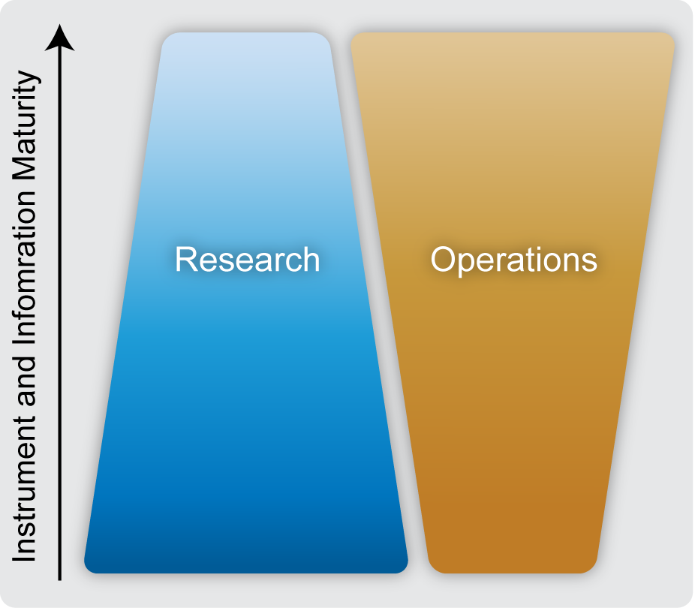
Figure 5.1. Notional evolution of level of effort in a research to operations transition for a satellite mission.

Earlier discussions have highlighted criteria in several dimensions of this transition that are of particular relevance for space-based observation:

  - Technology readiness, enabling requirements to be met by reliable and affordable sensors ,
  - Science and application maturity, which can be characterized by a maturity matrix as discussed in Section 4.5 above, ensuring that downstream activities are ready to benefit from the new data in a sustainable manner,
  - Institutional readiness to manage the new mission in the long run, in interaction with the user and science communities,
  - Recognition of the importance of the new mission to be sustained, understanding that it responds to key societal needs and thereby justifies a continued budget allocation to support a long-term commitment.

Although the term ‘research to operations’ was often used in the past to describe when a particular sensor responsibility moves from one agency to another, it can be understood more generally for moving from a research phase to an operational phase, without regard to any particular institutional arrangement. The climate community has stressed that the overarching goal of observing and monitoring the climate system requires a sustained expert understanding of new and legacy climate sensors and a sustained web of support activities. This sustained web will require the sustained effort of both research and operational agencies.

The roles of product processing, applications, and services teams in Research and Operational Agencies are thus evolving rather than transitioning. Research Agencies have invested in the creation of consistent time series satellite data sets over decades, both through mission science team-based and measurement-based climate product processing and reprocessing. Research Agencies also have made and will maintain significant investment in calibration laboratories, airborne sensors, processing facilities, and ground networks that support calibration and validation activities for satellite programs. These contributions to climate science will need to continue to be a vital element of a collaborative climate observation and processing architecture as operational climate services move forward to emerge in operational agencies.
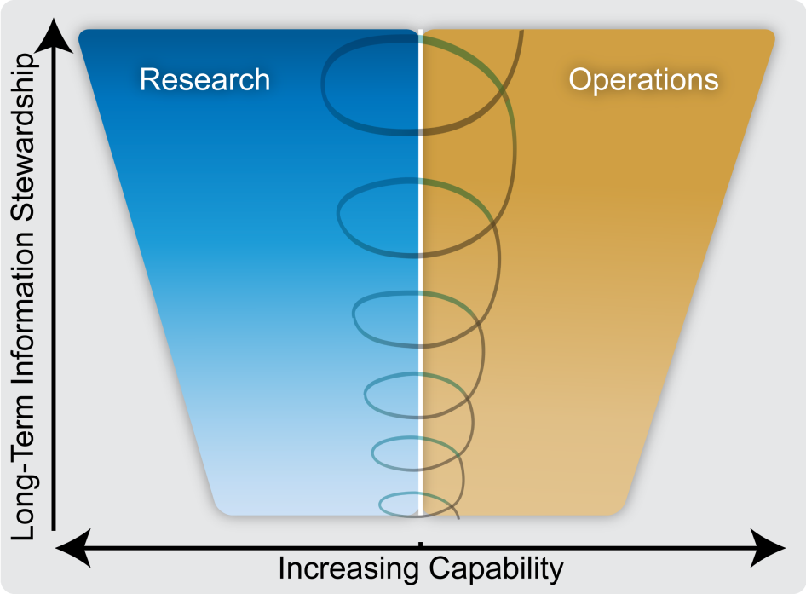
Figure 5.2. A holistic view of the interdependency of research and operations needed for sustained and routine climate monitoring.

A more holistic view of the interplay of research and operational space agencies in sustained and routine climate monitoring involves continuous improvement of capability, or knowledge, over the long term. This truly occurs, not simply with the passage of time, but only when there is careful attention to long-term information stewardship. There are numerous iterative steps involved in the creation of climate data records as illustrated by the expanding spiral; instrument testing on the ground, calibration and validation of the instrument and products, archival and preservation of relevant data and provenance of the data flow, comparisons and assessments of the products. All of this information must be gathered, organized, and preserved for future generations. We refer to this suite of activities and their care and preservation as information stewardship. Thus, an important activity for research and operational agencies is to develop a joint framework for climate information stewardship.

6. Climate Architecture Definition

6.1 What do we Mean by the Term “Architecture”?

An architecture typically describes the structure of a system, as reflected in its building blocks, their relationships to each other, and to the environment. The descriptive format of the architecture is generally tailored to the particular needs of the users/stakeholders and makes use of common definitions and standards in its construction.

6.2 Why do we Need an Architecture for Climate Monitoring?

Based on discussions within the various climate monitoring working groups and related meetings, two main needs/usage scenarios for an architecture have emerged.

A: To promote a common understanding, amongst the various stakeholders, of the implementation implications of meeting the various climate monitoring requirements. To support such a usage, the architecture should depict, in a structured and readily-accessible format, the functions, information flows and dependencies of the processes necessary to satisfy the relevant requirements and support the verification by the originators/owners of the requirements that they have been correctly interpreted. While this should encompass the end-to-end climate monitoring processes (e.g. from sensing right through to decision-making), the initial emphasis is expected to be placed on representing the upstream processes (i.e. sensing and climate data record creation).

B: To support an assessment of the degree to which the current and planned systems meet the requirements, and the generation of an action plan to address any identified shortfalls/gaps. It is anticipated that such an action plan would help promote the fulfillment of user needs through the coordinated implementation of activities across agencies.

For example, this information could be used to assess the capability of the upstream processes to support both current and new decision-making processes (e.g. as part of policy-making) and, working backwards, to ensure that the appropriate sensing data, corresponding processing and applications are in place.

6.3 What could be an Appropriate Format/Structure for an Architecture?

Based on the two identified usage scenarios, an architecture with two main "views" is proposed:

- a logical view;
- a physical view.

The logical view serves the first usage scenario. It represents the functional and data-flow implications of the requirements baseline as a set of interlinked functions and associated data-flows. Leaving aside performance considerations (e.g. accuracy, uncertainty, stability, coverage etc) the logical view could be considered as the "target" for a climate monitoring system and, in the sense that it is applicable to all ECVs, this representation is generic. As this view is intimately tied to the requirements baseline (and not to the physical implementation of a climate monitoring system) this view is as stable as the requirements baseline and, once established, should only need to be updated when the functional aspects of the requirements change.

In contrast, the purpose of the physical view, which supports the second usage scenario, is to describe the current and planned implementation arrangements for each ECV, including how the various functions of the logical view are/will be physically implemented. As this physical view tracks the evolving implementation of the climate monitoring system, it will need to be regularly updated (e.g. once a year).

Also, to avoid ambiguity, two areas that do not lie within the scope of the proposed logical view are noted:

- Planning - as the logical view focuses on the functions and information flows necessary to produce the required climate data records, any components of the requirements baseline addressing upstream planning processes (e.g. requirements addressing the phasing of programmes to ensure sensor overlaps) will not be represented in this view of the architecture. However, the future planning for the generation of climate data records will be reflected in the physical architecture, with this information typically being used to support gap analyses, and the generation of a coordinated action plan to address any deficiencies and/or potential data gaps.

- In-Situ data - although it is anticipated that much of the logical view will be of direct relevance to in-situ data, it is primarily developed in order to represent the processing and information flows associated with satellite data (whilst trying to preserve compatibility with the in-situ data processes wherever possible). It is expected that any incompatibilities will be mostly confined to the use of satellite-specific terminology (e.g. Fundamental Climate Data Records). However, the architecture should also address interfaces with in situ observing systems and in situ-based calibration and validation control sites in this initial phase; at least as far as calibration and validation requirements are concerned. The concept of Integrated Observing Systems is vital.

6.4 What Could be the Main Components of a Logical View?

Before considering a possible representation of a "Logical View", it is stressed that there is no unique solution, with the only measure of success being "fitness for purpose" (i.e. its ability to support the intended usage scenarios). The usage scenarios (particularly Usage Scenario A) require that a logical view is "end-to-end" and, as a result, a four "pillar" logical architecture is proposed (see Figure 6.1).

Sensing

Climate
Record
Creation and Preservation

Applications (Climate and other SBAs)

Decision- Making
(Climate and other SBAs)
Decisions
Reports
Records
Observations
Earth
Environment

Figure 6.1: Main Components of a Logical View

The information flow starts with the sensing of the Earth environment (by EO satellites). The resultant observations are then assembled, processed and converted to climate records. These records are then used by the relevant applications to generate reports which are, in turn, used by decision-making entities (including Policy-makers) to decide on a course of action. In view of the holistic nature of the Earth System, and as depicted in Figure 6.1, the utility of the Climate Records is not confined to the Climate Societal Benefit Area (SBA) and these records are expected to contribute to other SBAs (e.g. Water, Ecosystems, Weather, Health, Agriculture, Biodiversity, etc).

This high-level, conceptual, representation has been specifically generated to highlight the main structural elements of the logical view. However, in order to support the two identified usage scenarios, it is necessary to "drill down" within each of the pillars in order to expose their constituent elements. In this respect, it is noted that the initial emphasis is expected to be on the first two pillars ("Sensing" and "Climate Record Creation and Preservation") and Climate Data Record Creation and Preservation is subsequently used to illustrate the effects of "drilling down".

As the resultant decompositions can be quite complex, with many potential data-flows, methodologies and associated tools are briefly considered. In order to ensure consistency of approach, and to be able to make use of off-the-shelf tools that are essential to manage the complexity, it was decided to adopt the IDEF0 [Reference Needed] standard for functional modelling for the further development of this logical view. The resultant diagrammatic representations differ somewhat in format compared to Figure 6.1 but nevertheless the same high-level components are still evident.

For illustration purposes, and with a focus on the Climate SBA, the result of using the IDEF0 standard to partially decompose some of the high-level components given in Figure 6.1, is provided in Figure 6.2.

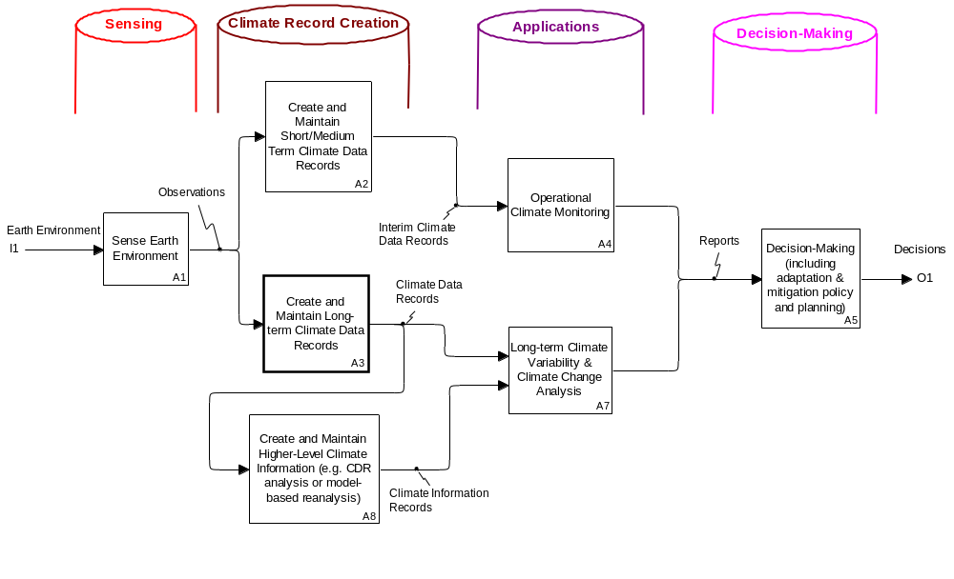

Figure 6.2: Decomposition of the 4 Pillars (with a focus on "Climate Record Creation and Preservation" and "Applications")

As a further illustration of the approach to decomposition, Figure 3 depicts the main constituent elements of function A3: "Create and Maintain Long-term Climate Data Records".

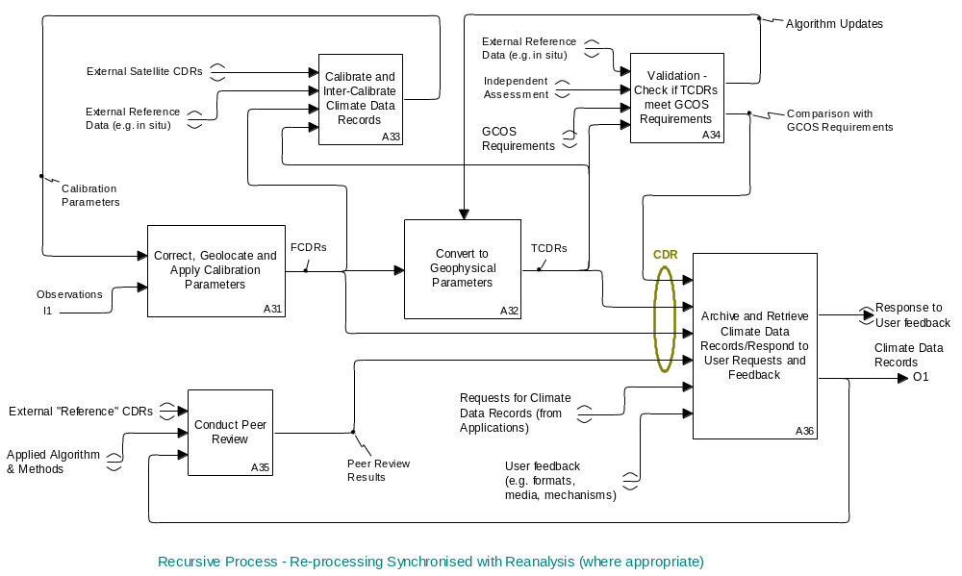

Figure 6.3: Decomposition of "Create and Maintain Long-term Climate Data Records" (function A3 of Figure 6.2)

It is at the level of decomposition of Figure 6.3 that some of the main generic functional elements of the requirements baseline become exposed. The process of creating "Climate Data Records" starts with the availability of "Observations" (assumed to be satellite data). These observations are then corrected, geo-located and calibrated (see function A31) to produce a product that is termed a "Fundamental Climate Data Record", with the calibration parameters applied being derived from a combination of internal data, in situ data and external satellite data (see function A33).

The Fundamental Climate Data Record is then converted (see Function A32) to a set of geophysical parameters which are termed a "Thematic Climate Data Record". Depending on the particular ECV under consideration, this TCDR may correspond directly to an ECV or, if the ECV in question is broadly defined (e.g. "Cloud Properties") the TCDR may form just one component of an ECV (see Box 3.1).

The TCDRs and FCDRs are then archived (see function A36) together with other relevant information such as the results of a comparison with the requirements baseline (e.g. validation of the records with respect the required accuracy) and the results of the "Peer Review" described in GCOS-143 – see function A35. This archived information is collectively termed "Climate Data Records". When access to these Climate Data Records is required, a request is submitted and the appropriate records are then retrieved and dispatched to the requesting entity (see function A36).

It is noted that, in general the functions depicted in Figure 6.3 are recursive as, when improved information becomes available (e.g. better algorithms for the generation of FCDRs/TCDRs, improved calibration information, etc) the Observations are re-processed to generate improved Climate Data Records. Such re-processing activities are typically synchronised with the impending use of the particular Climate Data Records for a major climate-related project (e.g. Re-analysis). Implicit in Figure 3 is also the need to have in place a comprehensive configuration management system to provide full document traceability of the processes and data used to derive the Climate Data records.

It is also emphasised that, even at this lower level of decomposition, the Logical View is generic, as it is applicable to all ECVs (and is not ECV-dependent).

The structure of the logical view has the major advantage that for each of the boxes responsible organisations can be identifed to fulfil that specific function. For instance the creation and maintenance of climate data records (Boxes A2 and A3 in Figure 6.2) involve many activities as shown in Figure 6.3 including the creation of Fundamental Climate Data Records that are best being performed by space agencies operating the specific sensor. In contrast, the generation of Higher-Level Climate Information Records such as climate indices, the number of storms that make landfall in a certain region, etc. often needs the combination of both CDRs originating from space-borne and ground-based systems as well as modelling components. Thus, such an activity might be best placed in an organisation that combines information such as reanalysis centres, climate service centres or environmental agencies. Even at lower level the logical view can be employed to organise tasks within internationally operating groups that create CDRs in a distrubuted way, e.g., the implementation of one retrieval algorithm at different agencies.

Figure 6.3 is also showing that many requriements stated in section 3 are taken up by activities or input to activities in the creation of CDRs. For instance, a peer review process is a mandatory part of the creation of a CDR and an independent assessment can be seen as an input to the validation activity that assesses the quality of a data record versus the User Requirements.

6.5 What Could be the Main Components of a Physical View?

Whilst the Logical View is generic, the Physical View needs to have an ECV-specific reference frame that facilitates an assessment of the implementation status for each ECV (Usage Scenario B). Although the specific definition of physical architectures for individual ECVs is beyond the scope of this report, it is proposed that the Physical View contain three main components:

- ECV-specific Requirements (e.g. ECV identifier, accuracy, spatial and temporal resolution, stability, coverage, etc);

- Current Implementation Status for each ECV, e.g.:

- Sensor/Satellite data set(s);
- Stewardship arrangements for each of the functions in the logical architecture;
- Achieved performance (uncertainty, stability, etc);
- Record length;
- Access arrangements (formats, distribution mechanisms, etc);

- Planned Contributions – with a similar scope/structure as the section on “Current Implementation Status”.

It is anticipated that this physical view would be embedded within an Inventory.

In some cases the relevant requirements are defined at a rather high-level and such an inventory would facilitate a standardisation of characteristics which are very important for users of the data (e.g. formats and distribution mechanisms). As, in general, current observing systems have not been primarily designed from a climate perspective, the inventory will document the contributions of any observing system that has the capability to provide Climate Data Records that meet the relevant requirements.
7. Mechanisms for Interaction

This section makes a distinction between near-term coordination or “Mechanisms for Interaction” and longer-term governance.

7.1 What are the Needs for Mechanisms for Interaction?

From the earliest efforts by the WMO to initiate dialogue and to coordinate views among stakeholders, there has been wide consensus that this effort must be collaborative and inclusive to succeed and attain the desired results. As has already been addressed earlier in this paper, each of the current players (i.e., WMO, CGMS, CEOS, GCOS, GEO, WCRP) brings to the table different expertise and strengths, and contributes different assets and activities. Each focuses on different audiences and also exists in different programmatic, mission, funding, and political environments. Many are themselves coordinating bodies so the challenge is to determine how to best coordinate the coordinators. Finally, while there is a significant level of cross-pollination among these groups, the major task at hand will be to go from coordination mechanisms to sustainable stewardship responsibilities over the next 10-20 years.

While there are various components of the architecture available at the working and technical levels and others at the policy level, there remain gaps and deficiencies in: continuity and contingency planning; coordination of research and operational mission planning; Essential Climate Variable generation; and calibration and validation activities. There is also a pressing need to identify and prioritize gaps, and to holistically integrate the pieces, end-to-end, from the sensing capability to the products and information delivered to decision making process. In addition to the need to advance technical level agreements, long-term sustainability will rest on political agreements that go beyond completely voluntary efforts towards instead establishing secure commitments to building an architecture. An integration mechanism must holistically knit together the components in order to foster end-to-end stewardship and sustainability practices that are realistic and sound in the current political and financial environment.

7.2 Longer-term Governance Considerations

At the core of good governance is a clear articulation of roles and responsibilities,including decision-making and resource commitments, coupled with structures of accountability for outcomes. However, this is the signature of a mature organization or mechanism. It would be premature at this time to provide a detailed prescription for a long-term governance solution.

Key considerations for a long-term governance solution include:
- Early focus should be on coordination of implemeting near-term elements of the architecture strategy. The evolution towards longer-term governance should be incremental or phased and intentionally inclusive.

- In line with the current coordinating mechanism approach, it is strongly recommended to use and strengthen existing coordination mechanisms first and resist the temptation to create a new mechanism or body that is duplicative..

- A fundamental principle for the proposed architecture is full and open data access and dissemination. The governance structure/approach must encourage and facilitate this tenet.
- Credibility and authoritative action must be based on continuous, systematic, and intentional outreach with scientific community.

- Evolution of governance must be carried out with openness, transparency, and inclusiveness of activities, work products, and decision-making.

- From a relational perspective, the proposed space-based architecture for climate monitoring will be a significant contribution to the GFCS observations and monitoring pillar and, yet, independent from the GFCS. To ensure adequate coordination and technical interfaces the current coordinating bodies (CEOS, CGMS, and WMO) should be invited into the advisory mechanisms of the most appropriate governance structures for GFCS.

7.3 Initial Integrator Activities

For the near term, the partners in this current effort must identify an initial holistic integrator as the architecture for climate monitoring from space evolves over the next year. In this capacity, the integrator would identify progress measures, assess progress towards measures, and identify and build necessary communications protocols to sustain integration across organizations and relevant activities.

In order to facilitate the evolution of governance, for the next year we recommend that the Writing Team composed of CEOS, CGMS, and WMO representatives remain in place to develop a detailed roadmap for implementation with specific recommendations for coordination structures and good governance principles based on stakeholder input. In effect, the Writing Team would continue to serve as a “coordinator of coordinators” or the initial holistic integrator, with the understanding that its composition may be augmented to include CEOS and CGMS agency representation who were unable to participate in the initial phase of preparing this strategy.
It would also closely monitor developments related to the GFCS and the revised GEO 2012-2015 Work Plan climate-related tasks.

8. Roadmap for Way Forward

This document is the first step in the establishment of a strategic framework for the development of an architecture for climate monitoring based on space observations.

The approach adopted is intentionally open and inclusive, and has been designed so that all the relevant entities can identify their potential contributions, even if this maybe beyond their existing capabilities and programmatic obligations.

In recognition of the need to obtain the maximum degree of consensus at this early stage in the process, the level of definition of the architecture is necessarily high-level and conceptual.

The proposed architecture consists of two parts: a generic (ECV-independent) logical view that represents the functional components of the assumed requirements baseline (based on GCOS documentation) and a companion physical view that is designed to capture the current and planned physical implementation arrangements on an ECV-by-ECV basis.

Once consensus has been achieved on the overall approach, it is anticipated that work can begin relatively quickly on assessing the capabilities of space-based observation systems to provide the relevant ECVs (through the development of the physical view). The characteristics of the physical view will be embedded within an Inventory, which will form the main knowledge repository. Once generated, the physical view will be used as the inspiration for the derivation of a set of coordinated implementation actions to target identified gaps/shortfalls. It is anticipated that the development of the physical view will require the bulk of the short/medium term effort.

In recognition of the incremental nature of the process, short and medium term activities are proposed for the development of the architecture. Typically, it is expected that short-term activities would be undertaken in the next 2 years, and medium-term activities would be undertaken in the next 2-4 years.

The main steps in the process are illustrated schematically in figure 8.1.

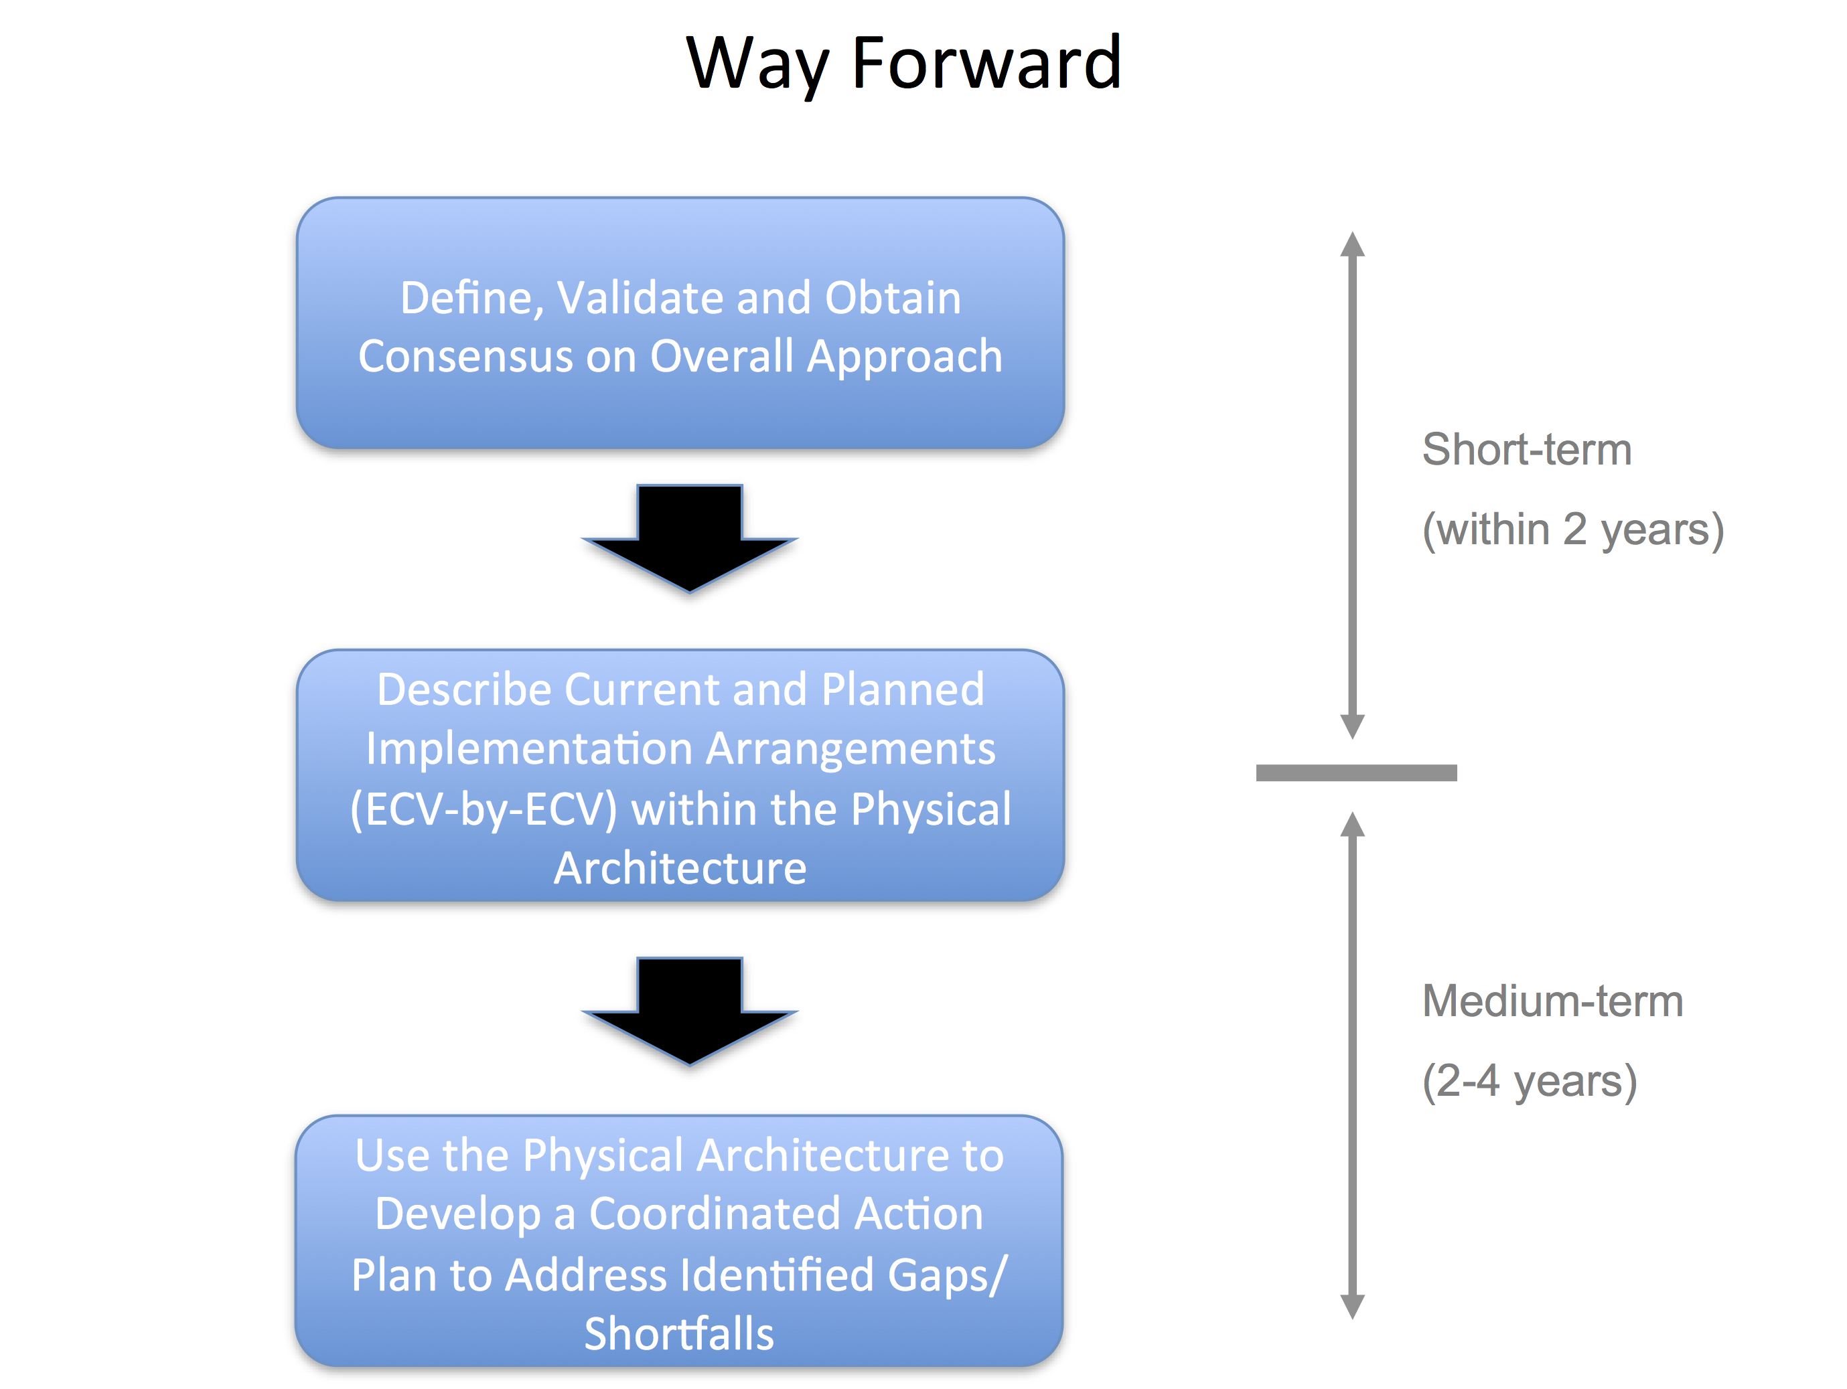

In the short-term the focus will be on achieving consensus about the general approach. This will involve engaging with the relevant coordination bodies and their subsidiary groups (including, but not restricted to, CEOS, CGMS and WMO). As part of the consultation with these coordination bodies, points of contact will be sought for participation in the further development of the architecture, building upon the work already started within this document to identify relevant technical groups and mechanisms (e.g. CEOS Virtual Constellations, CEOS Working Group on Climate, SCOPE-CM etc.).

A second step in the consensus building process will be to further involve the scientific community in reviewing the proposed approach. This will involve both existing multi-national programmes such as WCRP as well as the scientific community at large. In support of this process it is proposed to produce a synthesis of the material prepared for this report in the form on a paper that would be submitted for scientific peer review.

It is considered essential that all involved parties are in agreement with the overall approach before embarking on the manpower-intensive step of developing the physical view.

In the short-term it is also foreseen to verify that the proposed logical view adequately supports, in a top-down context, the depiction of the required information flows from the decision making process back to the sensing capacity/requirements. This capability is fundamental in ensuring that the policy makers are able to appreciate the need for an integrated climate monitoring capability that meets their policy needs.

As a conclusion of the short-term activities, an initial physical view will be developed that systematically describes the current and planned monitoring capability on and ECV (or group of ECVs) basis. In practice this physical view would be populated based on an inventory of all present and planned capacity, and would address all aspects of the requirements represented in the logical architecture as well as other relevant elements (e.g. performance characteristics, record lengths, available formats, access, stewardship arrangements, etc). Ultimately the combined perspective of the logical and physical views should enable the definition of an optimum “macroscale” space system configuration and its components (in form of sub-constellations for each ECV or groups of ECVs), as well as the respective ground systems.

Undoubtedly, the development of the physical view will be a living process that will require continuous/periodic updates as new observational capabilities become available or existing ones mature. However, once an initial representation of the physical view is available then this should be used at the ECV/product level to identify gaps and shortfalls. This information can then form the source material for the formulation of a coordinated action plan to address such gaps and shortfalls.

The availability of an initial physical view is also the trigger for the medium-term activities that need to be undertaken to sustain the long-term implementation of the architecture. The initial activities in this phase will focus on the implementation of the coordinated action plan.

Additionally this phase of activities should put in place an agreed mechanism for monitoring and updating the physical and logical views, with the expectation that the physical view would need to be updated on a much more regular basis (every 1-2 years) than the logical view, which would only require updating when the baseline functional requirements (e.g. GCOS guidelines) fundamentally change.

Furthermore, it is also expected that during this phase of implementation, space agencies and associated programmes would start to address in earnest how the in-situ components of the climate monitoring system could be represented within the architecture. This integration process should take advantage of existing international activities/frameworks which independently coordinate the in-situ observation networks. With this long-term ambition in mind, the logical view presented in this document has been made intentionally generic, so that it can be readily adjusted to describe the functional components of the integrated space-in situ monitoring system at some point in the future.

Finally, as the architecture matures and the development of climate services at the global (i.e. the Global Framework for Climate Services), regional and national level, becomes further defined, then the continued mapping of dedicated case studies resulting from the climate service requirements onto both the logical and physical views should be undertaken. This should both verify the overall robustness of the structure of the architecture to new applications, and the continued maintenance of a clear view of the end-to-end information flows (i.e. sensing => CDR creation => applications => decision-making). The timing of this verification activity will need to be synchronised with the GFCS implementation schedule.

9. Glossary
Beginning list of Acronyms and Initialisms*
CDR | Climate Data Record
CEOS | Committee on Earth Observation Satellites
CGMS | Coordination Group for Meteorological Satellites
ECV | Essential Climate Variables
EO | Earth Observations
FCDR | Fundamental Climate Data Record
GCOS | Global Climate Observing System
GEO | Group on Earth Observations
GEOSS | Global Earth Observation System of Systems
IPCC | Intergovernmental Panel on Climate Change
SBA | Societal Benefit Area
TCDR | Thematic Climate Data Record
UNEP | United Nations Environmental Programme
UNFCCC | United Nations Framework Convention on Climate Change
WCRP | World Climate Research Programme
WIGOS | WMO Integrated Global Observing System
WMO | World Meteorological Organization
VIS | Visible wavelengths
IR | Infrared wavelengths
MW | Microwave wavelengths
GEO | Geostationary Earth Orbit
LEO | Low Earth Orbit
CCI | Climate Change Initiative (ESA)
GFCS | Global Framework for Climate Services
IOC | Initial Operational Capability
SOC | Sustained Operational Capability
ATBD | Algorithm Theoretical Baseline Document

*List does not include satellites or their agencies.

10. References

REFERENCES for section 3.1
GEO VI, 2009:GEOSS Strategic Targets Document 12 (Rev1).

GCOS-117, 2008: Future Climate Change Research and Observations: GCOS, WCRP and IGBP

Learning from the IPCC Fourth Assessment Report, GCOS-117, WCRP-127, IGBP Report No. 58
(WMO/TD No. 1418), 57 pp.

GEO Task US-09-01a, 2010: Critical Earth Observations Priorities for Climate SBA, 47 pp.

REFERENCES for section 3.2

GCOS-154, 2011: Systematic Observation Requirements for Satellite-Based Products for Climate, 2011 Update, December 2011, 139 pp.

GCOS-138, 2010: Implementation Plan for the Global Observing System for Climate in Support of the UNFCCC (2010 Update), GCOS-138 (GOOS-176, GTOS-84, WMO/TD-No. 1523), August 2010, http://www.wmo.int/pages/prog/gcos/Publications/gcos-138.pdf (‘IP-10’).

WMO-1065, 2011:Climate Knowledge for Action: A Global Framework for Climate Services – Empowering the Most Vulnerable. The Report of the High-Level Taskforce for the Global Framework for Climate Services. WMO-1065, 241 pp.

REFERENCES for section 3.3

WMO-BIPM, 2010: Report on the WMO-BIPM workshop on Measurement Challenges for Global Observation Systems for Climate Change Monitoring: Traceability, Stability and Uncertainty. IOM-Report No. 105 and WMO/TD-No. 1557.

Ohring G., Wielicki B., Spencer R., Emery B., and Datla R. (Eds) (2004): Satellite Instrument Calibration for Measuring Global Climate Change. National Institute of Standards and Technology, NISTIR-7047, March 2004. Available at: http://www.nist.gov/pml/div685/pub/upload/nistir7047.pdf.

Ohring G, Wielicki B, Spencer R, Emery B, Datla R, 2005. Satellite instrument calibration for measuring global climate change - Report of a Workshop, 86 (9), 1303 – 1313 (DOI:10.1175/BAMS–86–9-1303).

REFERENCES for section 3.5

GCOS-143, 2010: Guideline for the Generation of Datasets and Products Meeting GCOS Requirements, An update of the “Guideline for the Generation of Satellite-based Datasets and Products meeting GCOS Requirements” (GCOS-128, WMO/TD-No. 1488), including in situ datasets and amendments. May 2010, Available at: http://www.wmo.int/pages/prog/gcos/Publications/gcos-143.pdf, 12 pp.

GCOS-153, 2011: Report of WOAP Workshop on Evaluation of Satellite-Related Global Climate Datasets, Meeting Report, 43 pp.

REFERENCES for Box 3.1

GCOS-82, 2003: The Second Report on the Adequacy of the Global Observing Systems for Climate in Support of the UNFCCC, 74 pp. (http://www.wmo.int/pages/prog/gcos/Publications/gcos-82_2AR.pdf)

NRC, 2004: Climate Data Records from Environmental Satellites: Interim Report. The National Academies Press, Washington,D.C., 136 pp.

REFRENCES for Box 3.2

BIPM, 2008: International vocabulary of metrology — Basic and general concepts and associated terms (VIM), BIPM, JCGM 200:2008 (http://www.bipm.org/utils/common/documents/jcgm/JCGM_200_2008.pdf).

REFERENCES for Box 3.2

Bates, J. J., Barkstrom, B. R., 2006: A maturity model for satellite-derived climate data records, manuscript P2.11, proceedings of the 14th Conference on Satellite Meteorology and Oceanography, 86th AMS Annual Meeting (Atlanta, US) 28-30 January 2006. (Available online from conference website: http://ams.confex.com/ams/Annual2006/techprogram/paper_100658.htm)

Cao C. and M. Goldberg, 2009: Spectral bias estimation of historical HIRS using IASI observations for improved fundamental climate data records. J. Atmos. Oceanic Tech., 26, 1378-1387, DOI: 10.1175/2009JTECHA1235.1.

Kummerow C., J. Schulz, B. Bojkov, 2011: GEWEX/ESA Data User Element GlobVapour Workshop on Long-Term Water Vapor Data Sets, GEWEX News May 2011, 11-12. Available at: http://www.gewex.org/gewexnews/May2011.pdf.

Shi L., J. Bates, C. Cao, 2008: Scene radiance–dependent intersatellite Biases of HIRS longwave channels. J. Atmos. Oceanic Tech., 25, 2219-2229, DOI: 10.1175/2008JTECHA1058.1.

Shi, L. and J. Bates, 2011: Three Decades of intersatellite calibrated HIRS Upper Tropospheric Water Vapour. J. Geophys. Res., Atmos., in press.

REFERENCES for section 4.4

The Satellite Supplement (GCOS (2006): Systematic Observation Requirements for Satellite-Based Products for Climate, GCOS-107 (WMO/TD-No. 1338), September 2006).

Implementation Plan for the Global Observing System For Climate in Support of the UNFCCC
(2010 Update), GCOS-138 (WMO/TD-No. 1523), August 2010.

Home page for Quality Assurance Framework for Earth Observation. http://QA4EO.org

Test-site catalog compiled by USGS. http://calval.cr.usgs.gov/wordpress/satellite/sites_catalog/

CEOS WGCV calibration and validation portal. http://calvalportal.ceos.org

Information and registration for CEOS workshop on post-launch performance and bias evaluation of Earth Observation sensors. http://calvalportal.ceos.org/cvp/web/guest

Climate Absolute Radiance and Refractivity Observatory (CLARREO) mission. http://clarreo.larc.nasa.gov/

Traceable Radiometry for Terrestrial and Helio Studies (TRUTHS) mission. http://www.npl.co.uk/optical-radiation-photonics/environment-climatechange/research/truths

The ESA Climate Change Initiative – Description issue 1 revision 0 - 30/09/09 EOP-SEP/TN/0030-09/SP. http://earth.esa.int/workshops/esa_cci/ESA_CCI_Description.pdf
CCI Guideline Document. http://due.esrin.esa.int/drupal/?q=documents

Response by ESA to GCOS - Results of the Climate Change Initiative Requirements Analysis. http://due.esrin.esa.int/drupal/?q=documents

REFERENCES for Section 4.5

National Research Council (2004), Climate Data Records from Environmental Satellites, National Academies Press, Washington, DC, ISBN: 0-309-55202-8.
Privette, J, B Barkstrom, JJ Bates, M Bonadonna, K Boyd, D Cecil, B Cramer, G Davis, T Karl, J Kaye, C Koblinsky, M Tanner, and D Young (2008), Restoration of NPOESS Climate Capabilities – Climate Data Records, 4th Symposium on Future National Operational Environmental Satellite Systems, The 88th AMS Annual Meeting, New Orleans. http://ams.confex.com/ams/pdfpapers/131058.pdf
Privette, J, J.Bates, T Karl, B Barkstrom, D Markham, E Kearns (2009), NOAA’s Approach to Providing CDRs Within a New Interagency Initiative, 5th Symposium on Future National Operational Environmental Satellite Systems, the 89th AMS Annual Meeting, Phoenix. http://ams.confex.com/ams/pdfpapers/149762.pdf
Saunders, D, D Baldwin, J Biard, A Burden, L Copley and J Privette (2011), Efficient Access to Raw Measurements and Processing Coefficients for NPOESS Preparatory Project (NPP) and Joint Polar Satellite Systems (JPSS) Sensor Data. Accepted for the 7th Annual Symposium on Future Operational Environmental Satellite Systems, 91st AMS Annual Meeting, Seattle.
WMO (2009), Implementation Plan for the Sustained and Coordinated Processing of Environmental Satellite Data for Climate Monitoring (SCOPE-CM), Version 1.3, March 2009 (available through http://www.wmo.int/pages/prog/sat/SCOPE-CM.html)

(WMO, 2009) Vision for the Global Observing System in 2025, Commission for Basic Systems, Fourteenth session, Dubrovnik, Croatia, 25 March-2 April 2009.

REFERENCES for Section 4.6

(WMO 2011) Implementation Plan for Evolution of the Global Observing Systems (EGOS-IP): ftp://ftp.wmo.int/Documents/PublicWeb/www/gos/egos-ip/

(WMO 2009) Rolling Review of Requirements (RRR) is described on: http://www.wmo.int/pages/prog/sat/rrr_en.php

Examples of key surface-based networks contributing to climate observations include, but are not limited to, the GCOS Upper Air Network (GUAN) and GCOS Reference Upper Air Network (GRUAN), the Argo Ocean Buoy Network, the AErosol RObotic NETwork (AERONET), and WMO’s Global Atmosphere Watch (GAW) and Regional Basic Climatological Network (RBCN).
A Global Framework For Climate Services – Empowering the Most Vulnerable – The Report of the High-Level Task Force for the Global Framework for Climate Services: WMO-No 1065.

