WORLD METEOROLOGICAL ORGANIZATION  ______________  COMMISSION FOR BASIC SYSTEMS  OPEN PROGRAMME AREA GROUP ON  INTEGRATED OBSERVING SYSTEMS  EXPERT TEAM ON EVOLUTION OF THE  GLOBAL OBSERVING SYSTEM  Fourth Session  GENEVA, SWITZERLAND, 7–11 JULY 2008 |  | CBS/OPAG-IOS/ET-EGOS-4/Doc. 7.2.5  (03.VII.2008)  ______  ITEM: 7.2.5  Original: ENGLISH

Status of individual Statements of Guidance
and recommended update strategy

Atmospheric Chemistry

(Submitted by the WMO Secretariat)

Summary and Purpose of Document

This document presents the Statement of Guidance (SoG) for Atmospheric Chemistry.

ACTION PROPOSED

The Meeting is invited to consider the document and to incorporate as appropriate into a Statement of Guidance.

____________

References: WMO Global Atmosphere Watch (GAW) Strategic Plan: 2008 – 2015 (GAW Report
No. 172)

Appendix: Statement of Guidance for Atmospheric Chemistry
Discussion

The current version of the Statement of Guidance for Atmospheric Chemistry is dated July 2004. It is based on the IGACO Atmospheric Chemistry Theme Report (WMO TD No. 1235, GAW Report No.159), and is still relevant. The IGACO Strategy is being implemented through the Global Atmosphere Watch (GAW) Programme and has been incorporated into WMO Global Atmosphere Watch (GAW) Strategic Plan: 2008 – 2015 (GAW Report No. 172). The GAW focuses on ozone, ultraviolet radiation, greenhouse gases, aerosols, selected reactive gases, and precipitation chemistry. For each component the following are included in the Strategic Plan: current status, goals, implementation strategy (tasks), and products and services. With regard to atmospheric composition observations, these questions are channelled thus to the GAW Strategic Plan 2008 - 2015.

____________

3.7 Statement of Guidance for Atmospheric Chemistry (updated July 2004)

    - Background

Long term measurements have clearly shown that increase in human population and activity are changing the composition of the Earth’s atmosphere. There have been a variety of remarkable changes since the industrial revolution of the 19th century. Among these are

- global decrease in stratospheric ozone and attendant increase in surface ultraviolet radiation, emphasised by the ozone hole appearing over the Antarctic;
- occurrence of summer smog over most cities in the world, including the developing countries, and the increased ozone background in the northern troposphere;
- increase in greenhouse gases and aerosols in the atmosphere and associated climate change;
- acid rain and eutrophication of surface waters and other natural ecosystems by atmospheric deposition;
- enhanced aerosol and photo-oxidant levels due to biomass burning and other agricultural activity;
- increase in fine particles in regions of industrial development and population growth with an attendant reduction in visibility and an increase in human health effects; and
- long range transport of air pollution to regions far from the industrial activity.

Many of these changes in atmospheric composition have socio-economic consequences through adverse effects on human and ecosystem health, on water supply and quality, and on crop growth. A variety of abatement measures have been introduced or considered to reduce the effects. However, continued growth in human activities, to expand economies and to alleviate poverty, will ensure that these effects continue to be important for the foreseeable future (from the International Global Observing Strategy theme report on Atmospheric Chemistry).

Research has demonstrated the important consequences of such changes for climate, human health, the balance of ecosystems, and the ability of the atmosphere to cleanse itself of harmful pollutants and greenhouse gases. The awareness that chemical species in the atmosphere are key elements of the Earth system, and public concern about the impact of human activities, has led international organisations, such as WMO, UNEP and ICSU, to support national and international research programmes and assessments.

On 27 May 2004, the partners in the International Global Observing Strategy (IGOS) approved the atmospheric chemistry theme report addressing the rationale and priorities in the next 15 years for an Integrated Global Atmospheric Chemistry Observations (IGACO) system. IGACO is a highly focused strategy for bringing together ground-based, aircraft, and satellite observations of 13 chemical species in the atmosphere using atmospheric forecast models that assimilate not only meteorological observations but also chemical constituents. The report critically assesses the status of current observing systems, the requirements on accuracy/precision and spatial/temporal resolution, and the current state of modeling chemical cycles in forecast and climate models. It recommends specific steps to be taken in a phased approach over the next 15 years led by the WMO Global Atmosphere Watch programme in cooperation with other key WMO programmes and the space agencies through CEOS.

Implementation involves utilizing the over-arching plan of IGACO to build the system through key collaborative initiatives supported regionally but having global implications. Maintenance of existing observations, addition of key missing observations and development of mechanisms that glue the system together are major but feasible challenges. WMO/GAW can work through the WMO constituent bodies (the Commission of Atmospheric Science (CAS), the Commission of Basic Systems (CBS), and the WMO Executive Council) as well as the WMO Consultative Meetings on High-level Policy on Satellite Matters to promote the implementation of IGACO. IGACO is the framework with which atmospheric composition observations will be brought together in the planned Global Earth Observations System of Systems. The IGACO Theme Report forms the basis of this WMO OPAG/IOS Statement of Guidance on Atmospheric Chemistry.

The architecture of the IGACO system takes into account the fact that an integrated system for atmospheric chemistry observations is comprised not only of observational networks and satellites but also of quality assurance, data archiving and modelling facilities that are held together with efficient and universally accepted data flow mechanisms. The proposed IGACO system is shown as a flow chart in Fig. 3.7.1; essential components include a system for data collection from various sources, a system for distribution of the data to users and of archiving these data for establishing long-term records, as well as a system for end-to-end quality assurance and quality control that quantifies the uncertainties in the data. It should be emphasised that, although various components and elements of the IGACO system are presently available or projected, a complete system does not yet exist for any atmospheric constituent in the target list of variables that follows.

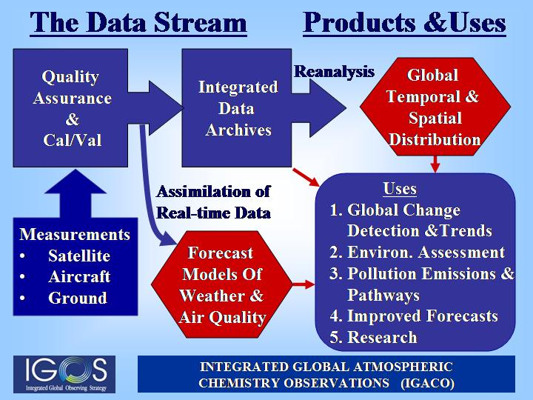
Figure 3.7.1. The major components and critical elements of the IGACO system.
Four grand challenges in atmospheric chemistry underlie the environmental issues indicated above (a) tropospheric air quality; (b) atmospheric oxidation efficiency; (c) stratospheric chemistry and ozone depletion; and (d) chemistry - climate interactions. The scientific understanding of each challenge requires long-term observation of the atmosphere, and points firmly to the need to establish an integrated global atmospheric chemistry observation system. The targeted chemical variables of IGACO and the associated measurement requirements are described briefly below. It is possible to study and monitor the four grand challenges in atmospheric chemistry issues by observing a number of chemical compounds, aerosol properties, and other parameters. A list of these variables and chemical species, and the issues in which they are involved is given in Table 3.7.1. The chemical variables were chosen on the basis of (a) relevance and added-value through integration to IGACO system and (b) feasibility of measurement and integration. Key ancillary variables required for integration are also listed. The target list is far from exhaustive. There are many other desirable variables such as precipitation chemistry and aerosol composition, some of which are already being addressed in the ground-based networks. Details of why each of the variables chosen is relevant to the grand challenges can be found in the IGACO report.

3.7.2 Atmospheric Chemistry Requirements

The requirements for measurements of atmospheric trace species necessary in Atmospheric Chemistry are complex, involving as they do many different gases, whose concentrations and measurement needs vary with altitude. These gases play different roles, generally based on their radiative or chemical effects, or their use as tracers of atmospheric motion. Their importance and roles differ between the troposphere and the upper atmosphere. To date many space-borne instruments have obtained large sets of observations related to the chemistry and distribution of ozone in the stratosphere and mesosphere; results and prospects for the troposphere are much more limited. The stratosphere is more data rich because the absence of clouds and the low density and humidity permit limb-viewing techniques to be used; these facilitate the detection of small amounts of absorbing gases with good vertical resolution. To date only passive techniques have been used for the measurement of trace gases (although lidar measurements of particulates have been made from the U.S. space shuttle).

Measurement requirements to meet the four grand challenges were reviewed by the IGACO panel and are given for gases in Tables 3.7.2 & 3.7.3 and for aerosols in Table 3.7.4. Requirements of some of the target gases in Table 3.7.2 were first set by the review process published in GAW Report #140 “WMO/CEOS Report on a Strategy for Integrating Satellite and Ground-based Observations of Ozone, 2001 (WMO TD No. 1046)”. These were reviewed and adjusted while requirements for additional gases and aerosols were developed by the panel. These requirements currently form the basis for WMO/IOS observational requirements.

Table 3.7.1. Key atmospheric chemical species and the relevant environmental issues. The table gives a list of the atmospheric constituents to be targeted in IGACO together with an indication of their importance to the four atmospheric challenges. Also included are aerosol optical properties – a broad categorisation which encompasses the scattering and absorption of solar radiation by particles of all sizes.

Chemical species | air quality |  | oxidation efficiency | climate | Stratospheric ozone depletion
O₃ | ✓ | ✓ |  | ✓ |  | ✓
CO | ✓ | ✓ |  | - |  | -
J(NO₂) | ✓ | ✓ |  | - |  | -
J(O¹D) | ✓ | ✓ |  | - |  | -
H₂O (water vapour) | ✓ | ✓ |  | ✓ |  | ✓
HCHO | ✓ | ✓ |  | - |  | -
VOCs | ✓ | ✓ |  | - |  | -
active nitrogen: NO_{x} = NO+NO₂  reservoir species: HNO₃ | ✓  ✓ | ✓  ✓ |  | -  - |  | ✓  ✓
N₂O | - | - |  | ✓ |  | ✓
SO₂ | ✓ | - |  | ✓ |  | -
active halogens: BrO, ClO, OClO  reservoir species: HCl, ClONO₂  sources: CH₃Br, CFC-12, HCFC-22 | -  -  - | -  -  - |  | -  -  - |  | ✓  ✓  ✓
aerosol optical properties | ✓ | - |  | ✓ |  | ✓
CO₂ | - | - |  | ✓ |  | -
CH₄ | - | ✓ |  | ✓ |  | ✓
Critical Ancillary Parameters
Temperature | ü | ü |  | ü |  | ü
Pressure | ü | ü |  | ü |  | ü
wind speed (u,v,w) | ü | ü |  | ü |  | ü
cloud top height | ü | ü |  | ü |  | ü
cloud coverage | ü | ü |  | ü |  | ü
Albedo | ü | ü |  | ü |  | ü
lightning flash frequency | ü | ü |  | ü |  | ü
Fires | ü | ü |  | ü |  | -
solar radiation | ü | ü |  | ü |  | ü

Table 3.7.4. Target and threshold requirements for aerosol (mostly optical) properties. Note that these quantities are not independent (for instance aerosol extinction coefficient and sometimes aerosol optical depth can serve as a proxy for the concentration of particulate matter (PM) at the surface). Here precision and trueness are given in absolute values. Note that “Aerosol Optical Depth” and “Extinction Coefficient” are not independent quantities but are specified here separately to allow for column and profile information, respectively.

Theme |  | Unit | Aerosol  Optical Depth  (VIS+IR) | Aerosol  Extinction Coefficient  (VIS) | Aerosol  Absorption  Optical Depth (VIS) | PM1,  PM2.5, PM10
a, d | Δx | km | 1 / 10 | 10 / 100 | 1 / 10 | N/A
Climate | Δz | km | N/A | 0.5 / 1 | N/A | N/A
studies | Δt |  | global daily | global weekly | global daily | N/A
And | precision |  | 0.005 / 0.01 | 0.005 / 0.01 km⁻¹ | 0.002 / 0.01 | N/A
oxidising | trueness |  | 0.01 / 0.02 | 0.01 / 0.02 km⁻¹ | 0.004 / 0.02 | N/A
capacity | delay |  | weeks | Weeks | weeks | N/A
b | Δx | km | 0.25 / 1 | 0.5 / 2 | N/A | 0.25 / 1
Air | Δz | km | N/A | 0.1 in PBL | N/A | 0.1 in PBL
quality | Δt |  | regional hourly | regional daily | N/A | regional sub-daily
(PBL and | precision |  | 0.005 / 0.01 | 0.005 / 0.01 km⁻¹ | N/A | 1 / 10 µg m⁻³
free trop) | trueness |  | 0.01 / 0.02 | 0.01 / 0.02 km⁻¹ | N/A | 1 / 10 µg m⁻³
 | delay |  | near real-time | near real-time | N/A | near real-time
c | Δx | km | 10 / 100 | 10 / 100 | N/A | N/A
Ozone | Δz | km | N/A | 1 / 2 | N/A | N/A
depletion | Δt |  | 10 d | 10 d | N/A | N/A
(UT/LS) | precision |  | 10⁻⁵ / 10⁻⁴ | 10⁻⁶ / 10⁻⁵ km⁻¹ | N/A | N/A
 | trueness |  | 10⁻⁵ / 10⁻⁴ | 10⁻⁶ / 10⁻⁵ km⁻¹ | N/A | N/A
 | delay |  | days | Days | N/A | N/A

Table 3.7.2 Atmospheric species to be measured by an Integrated Global Observing System - a
Atmospheric region | Requirement | Unit | H₂O | O₃ | CH₄ | CO₂ | CO | NO₂ | BrO | ClO | HCl | CFC-12
1 | Δx | km | 5/25 | <5/50 | 10/50 | 10/500 | 10/250 | 10/250 | 50
Lower | Δz | km | 0.1/1 | 0.5/2 | 2/3 | 0.5/2 | 0.5/2 | 0.5/3 | 1
Troposphere | Δt
 | precision | % | 1/10 | 3/20 | 1/5 | 0.2/1 | 1/20 | 10/30 | 10 |  |  | 2*
 | trueness | % | 2/15 | 5/20 | 2/10 | 1/2 | 2/25 | 15/40 | 15 |  |  | 4*
 | delay |  | (1)/(2) | (1)/(2) | (1)/(2) | (1)/(2) | (1)/(2) | (1) | (2)
2 | Δx | km | 20/100 | 10/100 | 50/250 | 50/500 | 10/250 | 30/250
Upper  Troposphere | Δz | km | 0.5/2 | 0.5/2 | 2/4 | 1/2 | 1/4 | 0.5/3
Upper  Troposphere | Δt
 | precision | % | 2/20 | 3/20 | 1/10 | 0.5/2 | 1/20 | 10/30 |  |  |  | N/R
 | trueness | % | 2/20 | 5/30 | 2/20 | 1/2 | 2/25 | 15/40 |  |  |  | N/R
 | delay |  | (1)/(2) | (1)/(2) | (1)/(2) | (1)/(2) | (1)/(2) | (1)
3 | Δx | km | 50/200 | 50/100 | 50/250 | 250/500 | 50/250 | 30/250 | 100 | 100 |  | 1000
Lower  Stratosphere | Δz | km | 1/3 | 0.5/3 | 2/4 | 1/4 | 2/5 | 1/4 | 1 | 1
Lower  Stratosphere | Δt
 | precision | % | 5/20 | 3/15 | 2/20 | 1/2 | 5/15 | 10/30 | 10 | 10 |  | 6
 | trueness | % | 5/20 | 5/20 | 5/30 | 1/2 | 10/25 | 15/40 | 15 | 15 |  | 15
 | delay |  | (1)/(2) | (1)/(2) | (1)/(2) | (2)/(3) | (2)/(3) | (1) | (2) | (2)
4 | Δx | km | 50/200 | 50/100 | 50/250 | 250/500 | 100/500 | 30/250 | 100 | 100
Upper  stratosphere, | Δz | km | 2/5 | 0.5/3 | 2/4 | 2/4 | 3/10 | 1/4 | 1 | 1
Upper  stratosphere, | Δt
Mesosphere | precision | % | 5/20 | 3/15 | 2/4 | 1/2 | 10/20 | 10/30 | 10 | 10
 | trueness | % | 5/20 | 5/20 | 5/30 | 1/2 | 10/25 | 15/40 | 20 | 20
 | delay |  | (1)/(2) | (1)/(2) | (1)/(2) | (2)/(3) | (2)/(3) | (1)/(2) | (2) | (2)
5 | Δx | km | 50/200 | 10/50 | 10/250 | 50/500 | 10/250 | 30/250 | 100 |  |  | 1000
Total  column | Δt
Total  column | precision | % | 0.5/2 | 1/5 | 1/5 | 0.5/1 | 1/10 | 1/10 | 1 |  |  | 4
 | trueness | % | 1/3 | 2/5 | 2/10 | 1/2 | 2/20 | 2/20 |  |  |  | 10
 | delay |  | (1)/(2) | (1)/(2) | (1)/(2) | (2)/(3) | (1)/(2) | (1) | (2)
6  Tropospheric | Δx | km | 10/200 | 10/50 | 10/50 | 10/500 | 10/250 | 10/250 |  |  |  | 1000
6  Tropospheric | Δt
Column | precision | % | 0.5/2 | 5/15 | 1/5 | 0.5/1 | 2/20 | 1/10 |  |  |  | 4
 | trueness | % | 1/3 | 5/15 | 2/10 | 1/2 | 5/25 | 2/10 |  |  |  | 10
 | delay |  | (1)/(2) | (1)/(2) | (1)/(2) | (1)/(2) | (1)/(2) | (1)

Table 3.7.3 Atmospheric species to be measured by an Integrated Global Observing System - B
Atmospheric region | Requirement | Unit | NO | HNO₃ | C₂H₆ | CH₃Br | Halons | HCFC-22 | ClONO₂ | HCHO | SO₂ | UVA JNO₂ UVB JO₃
1 | Δx | km | 10/250 | 10/250 | 50 | 500* |  |  |  | 1 | 1
Lower  Troposphere | Δz | km | 0.5/3 | 1/3 | ? |  |  |  |  | 0.5 | 0.5
Lower  Troposphere | Δt
Lower  Troposphere | precision | % | 10/30 | 10/30 | 10 | 4* | 15* | 2* |  | 10 | 5 | 7/10*
 | trueness | % | 15/40 | 15/40 | 15 | 8* | 20* | 4* |  | 15 | 10 | 15*
 | delay |  | (1) | (1)/(2) |  |  |  |  |  | (1) | (1)
2 | Δx | km | 30/250 | 10/250 | 50 | N/R | N/R | N/R |  | 10 | 10 | 50/500
Upper  Troposphere | Δz | km | 0.5/3 | 1/3 | 2 |  |  |  |  | 0.5 | 0.5 | 3**
Upper  Troposphere | Δt
 | precision | % | 10/30 | 10/30 | 10 | N/R | N/R | N/R |  | 10 | 5 | 10
 | trueness | % | 15/40 | 15/40 | 15 | N/R | N/R | N/R |  | 15 | 10 | 15
 | delay |  | (1) | (1)/(2) |  |  |  |  |  | (1) | (1)
3 | Δx | km | 30/250 | 50/250 |  | 500 | 500 | 1000 |  |  |  | N/A
Lower  stratosphere | Δz | km | 1/4 | 1/4 |  | 5 | 5
Lower  stratosphere | Δt
 | precision | % | 10/30 | 10/30 |  | 4 | 4 | 8
 | trueness | % | 15/40 | 15/40 |  | 8 | 8 | 15
 | delay |  | (1) | (1)/(2)
4 | Δx | km | 30/250 | 50/250
Upper  stratosphere, | Δz | km | 1/40.5 | 1/4
Upper  stratosphere, | Δt
mesosphere | precision | % | 10/30 | 10/30
 | trueness | % | 15/40 | 15/40
 | delay |  | (1)/(2) | (2)/(3)
5  Total | Δx | km | 30/250 | 30/250 | 50 |  |  | 1000 |  |  | 50
5  Total | Δt
column | precision | % | 1/10 | 1/10 | 1 |  |  | 5 |  |  | 1
 | trueness | % | 2/20 | 2/20 |  |  |  | 15
 | delay |  | (1) | (2)/(3) |  |  |  |  |  |  | (2)
6  Tropospheric | Δx | km | 10/250 | 10/250 |  | 1000 | 1000 | 1000
6  Tropospheric | Δt
column | precision | % | 1/101 | 1/10 |  | 4 | 4 | 6
 | trueness | % | 2/20 | 2/20 |  | 8 | 8 | 15
 | delay |  | (1) | (1)/(2)

3.7.3 Atmospheric Chemistry Requirements and GOS Capabilities

It is now possible, or likely to be possible, to measure several atmospheric constituents or parameters globally and on a long term so as to achieve a synergism between satellite ground-based and aircraft observations, and model assimilation systems. The following sections indicate the adequacy of the GOS and the planning through 2020. Demonstration should be interpreted as not yet acceptable, pre-operational as acceptable, and operational as good.

H2O

As the table shows, by 2005 observations of total column water vapour will be operational on three satellites with an additional one coming on-line in 2009. There are numerous satellites making measurements in the period 2003 to 2006 on a demonstration basis. High quality operational vertical profile measurements by satellites in the lower and mid troposphere are expected from 2006. Stratospheric vertical profile data are being provided by second and third generation research satellites. Accuracy and vertical resolution in the UT/LS remain a major issue.

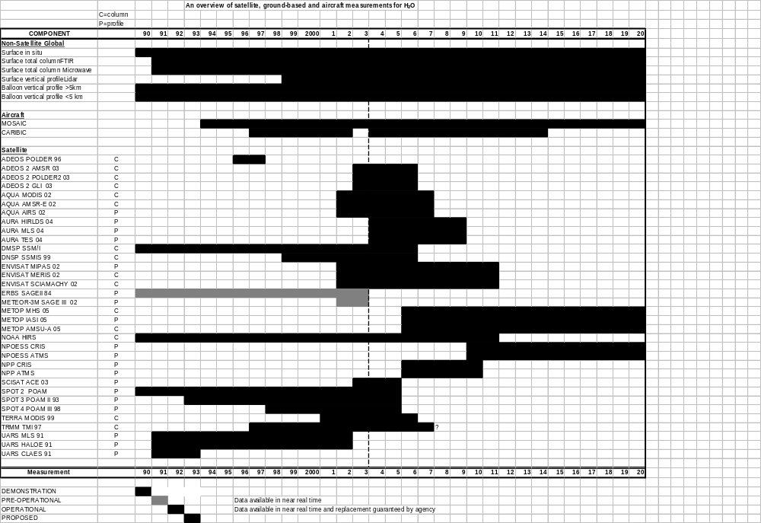
Figure 3.7.2. A timeline diagram for water vapour, H₂O.

Ground-based measurements are in excellent shape for the surface network and balloon sondes below 5 km. However most other measurements are still in the developmental phase, including the critical profiling above 5 km by means of balloon-borne and ground-based remote sensing instruments.

Systematic measurements of in situ water vapour from commercial aircraft are now available for selected routes from Europe; the observations are in the demonstration stage because coverage is not comprehensive, vertical profiles are limited, the data are not yet freely available, and the long-term continuation is still uncertain.

Formaldehyde: HCHO

HCHO is a reactive trace gas in the lower troposphere; some is emitted directly into the atmosphere, but its principal importance is as a product from the atmospheric oxidation of CH₄ and other Volatile Organic Compounds (VOC). It is removed by subsequent oxidation and also by deposition and rainout. Background mixing ratios of HCHO are generally well below 1 ppbv and therefore difficult to measure on a routine basis. However, elevated mixing ratios of up to 10 ppbv or more can be found near forested areas where HCHO is produced from the oxidation of isoprene and terpenes. Elevated HCHO concentrations have also been observed in and downwind of urban areas as a result of anthropogenic VOC emissions and in regions of biomass burning.

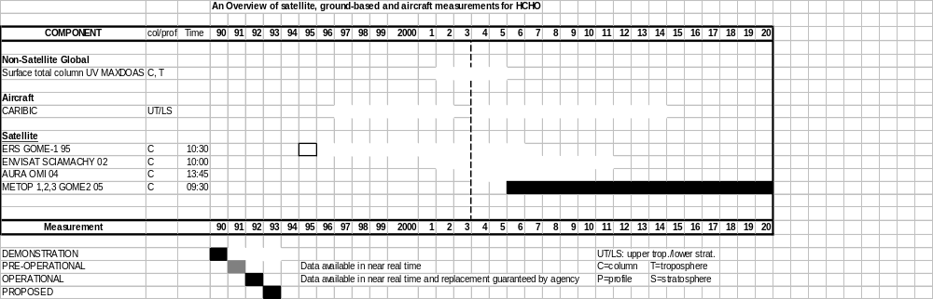
Figure 3.7.3. A timeline diagram for formaldehyde, HCHO.
Techniques to measure HCHO from ground based sites have been developed in the last 10 years, but the number of operational measurements is limited and there remain open issues with data quality. Measurements with long path DOAS and MAXDOAS are being made at a few locations. There are presently no routine aircraft measurements for HCHO.

GOME-1 and SCIAMACHY have demonstrated that the tropospheric column of HCHO can be measured from LEO satellites. OMI aboard EOS-Aura will provide additional LEO measurements. HCHO exhibits an appreciable diurnal variation and is highly variable on small spatial scales, so that observations on short timescales are necessary to use it fully within models. The total column HCHO measurements, now obtainable from space borne sensors, provide information on regional source strengths of both natural and anthropogenic VOCs throughout the world. They provide useful validation products for Chemical Transport Models. The importance of HCHO to IGACO is in the validation of models of oxidation and photo-oxidant production in the troposphere.

Volatile Organic Compounds (VOCs)

VOCs are emitted by the biosphere and are products of the petroleum industry. They are removed from the atmosphere by reaction with the hydroxyl radical and subsequent photo-oxidation to CO₂ and H₂O. VOCs are responsible, together with NO_{x}, for the photochemical formation of O₃ and other photo-oxidant pollutants including secondary aerosol. The lifetime of VOCs ranges from several months in the case of C₂H₆ to hours for the most reactive ones such as isoprene or anthropogenic olefins. The main importance of VOC is in the lower troposphere and especially over, and downwind of, populated areas. Whilst the oxidation products of VOCs are distributed globally, the need to monitor reactive VOCs themselves is confined to the regions of emissions, because of their short atmospheric lifetimes.
Of the hundreds of VOCs emitted into the atmosphere, only a limited number are currently measured routinely at a few well-equipped ground stations and from a small number of aircraft platforms. Only a few components of the VOC family (e.g. C₂H₆) have the potential to be observed by current or proposed satellite instruments (e.g. MIPAS). However, because of its relatively low reactivity, C₂H₆ is not a suitable indicator for anthropogenic and biogenic VOC emissions related to air quality. Furthermore, the observational challenge focuses on the distribution of VOCs in the boundary layer, which is currently not feasible from space. However, satellite measurements of important VOC reaction products, such as organic aerosol are a target for future satellite missions (e.g. CALIPSO).

Obviously there is a great demand to further develop and integrate the existing ground based regional VOC monitoring networks, including regular measurements from small aircraft.

Active Nitrogen: NO_{x} = NO+NO₂

The reactive nitrogen species, NO and NO₂, often referred to as NO_{x}, play a critical role in tropospheric, stratospheric and mesospheric chemistry. NO_{x} is released to the troposphere by the combustion of fossil fuels, biomass burning and lightning. It is also produced during the oxidation of NH₄⁺, and in the reduction of NO₃⁻ in the biosphere. NO_{x} is removed from the troposphere by gas phase and heterogeneous reactions, which form nitric acid, nitrates and other species; these are subsequently deposited to the Earth’s surface and/or biosphere Earth, or they are rained out. NO_{x} in the stratosphere originates from the reaction of O(¹D) atoms with N₂O, transported from the troposphere, and from the transport of NO from the mesosphere and thermosphere, where it is produced by ion-molecule reactions.

In the troposphere, NO_{x} is a dominant factor in the in situ photochemical catalytic production of O₃, and in determining the amount of hydroxyl radical, the most important tropospheric oxidising agent. Thus it plays a critical role in determining the oxidising efficiency of the troposphere. NO_{x} provides a measure of the amount of the reactive nitrogen present, but the ratio of the two species (NO/NO_{x}) is highly variable depending primarily on the actinic flux, which photolyses NO₂ to NO, and on the amount of O₃ present, as well as that of peroxy radicals (HO₂ and RO₂). In the stratosphere, atomic oxygen and other radicals, which react with NO to form NO₂, also influence the ratio.

In the stratosphere and lower mesosphere, reactive nitrogen impedes the efficiency of catalytic destruction cycles involving halogens by the formation of temporary reservoirs, which bind active chlorine and bromine, for example chlorine and bromine nitrates (ClONO₂ and BrONO₂). At high latitudes in winter and spring, the stratosphere is de-nitrified by the formation of polar stratospheric clouds, through the reactions of N₂O₅, resulting in the release of labile halogen compounds. In spring the returning sunlight photolyses these, releasing halogen atoms which then participate in efficient catalytic cycles removing O₃ and producing the so-called ozone hole. The amount of reactive nitrogen present in polar regions is critical to the efficiency of the formation of intermediate products that inhibit the formation of the seasonal Antarctic ozone hole.

The monitoring of reactive nitrogen is complicated by the fact that NO is easier to measure by in situ methods, whereas the NO₂ amount and distributions can be retrieved by remote sensing with instrumentation located on the ground, or balloon or aircraft borne, and satellite platforms. Differential optical absorption spectroscopy (DOAS) is generally used to retrieve NO₂ concentrations. A reasonable estimate of NO_{x} can be obtained through the simultaneous measurement of either NO or NO₂ with O₃ and j(NO₂), which provide the necessary information to calculate the NO/NO₂ ratio.

Although NO₂ has a significant diurnal cycle in the stratosphere, except in winter, NO_{x} is not expected to vary much, NO and NO₂ being inter-convertible. In contrast NO_{x} varies greatly in the troposphere during the day due to the variability of the source and sink processes, which depend strongly on atmospheric conditions. Thus frequent sampling of NO_{x} is required to achieve a realistic representation during the day.

Remote sensing from LEO satellite platforms yields the vertical distribution in the stratosphere, the total atmospheric column and the tropospheric column. An important by-product of the space-borne NO₂ measurements has been the capability of mapping the regions having significant tropospheric sources of tropospheric NO_{x}.

Ground-based measurements of the near surface concentrations of NO and NO₂ are made at some GAW/baseline stations and by environmental agencies; however the data quality achieved by some networks is insufficient for the IGACO needs. The remote sensing of NO₂ columns by DOAS over long light paths is a growing application area. The NDSC provides a limited set of accurate column measurements of NO₂ around the globe in relatively clean tropospheric environments. Additionally the same instrumentation is deployed within other networks in the polluted troposphere. The development of MAXDOAS (multi axial DOAS) now enables the atmospheric column to be separated into upper and lower parts.

Systematic measurements of in situ odd nitrogen species (NO_{y}) from commercial aircraft are now available for selected routes from Europe. The observations are in the demonstration stage because coverage is not comprehensive and there is a need to include both NO and NO₂ in the in situ measurements.

The gaps in the measurements of NO_{x} are that there are no routine aircraft measurements for UT/LS, and there is no comprehensive ground-based network. While the global tropospheric and stratospheric monitoring of NO₂ will be a major contribution to IGACO, much development work is still required to obtain profiles routinely.

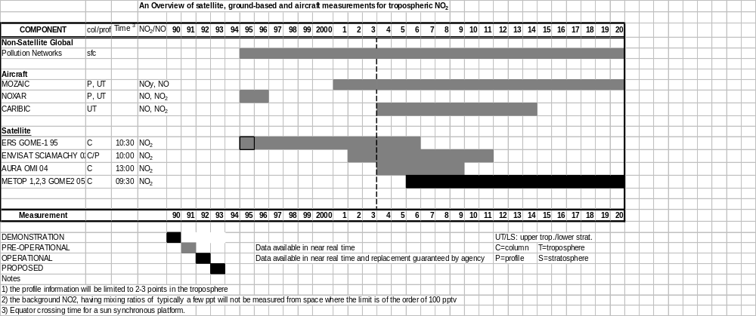
Figure 3.7.4. A timeline diagram for tropospheric NO₂.

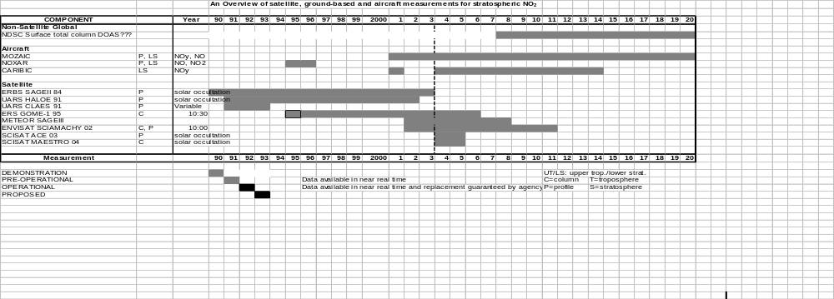
Figure 3.7.5. A timeline diagram for stratospheric NO₂.

Nitrogen reservoir species: HNO₃

HNO₃ is the most important reservoir for odd nitrogen in the atmosphere. It is eliminated from the stratosphere by downward transport to the troposphere and rain out. HNO₃ plays an important role in heterogeneous chemistry in polar stratospheric clouds (PSCs) since PSC type I particles contain HNO₃, either in the form of liquid ternary solutions with water or as solid HNO₃ hydrates. Sulfuric acid aerosols, which find their way into the stratosphere from large volcanic eruptions, convert NO_{x} and the temporary odd nitrogen reservoir, N₂O₅, into HNO₃.

Ground-based measurements of nitric acid column abundances were initiated in the 1950s, with quasi-continuous monitoring since 1985; they are among the priority tasks of the NDSC. Vertical profiles have been measured in the stratosphere initially with balloon-borne in situ filter sampling and later with infrared spectrometry.

Routine aircraft measurements of NO_{y} provide proxy information on HNO₃, which comprises 90% of NO_{y} in the lower stratosphere.

Space-borne measurements were initiated in 1978 by LIMS on board Nimbus 7, followed by ATMOS from 1985 to 1994 and CRISTA in 1994 and 1997. Global time series have been obtained by means of satellite observations (UARS) from 1992 to the present day. Other observations are currently made with MIPAS on board ENVISAT.

Nitrous Oxide: N₂O

Nitrous oxide originates from both natural Earth land-surface sources and anthropogenic sources. It is a greenhouse gas (Global Warming Potential of ~300 relative to CO₂) with a tropospheric mean residence time of 120 years. Its reaction with O(¹D) oxygen atoms in the stratosphere yields NO which makes it the major source of all the nitrogen oxides involved in stratospheric ozone chemistry. Its concentration is increasing in the atmosphere at a rate 0.25% per year. There are major unknowns in its global cycle that remain to be resolved.

N₂O is monitored in situ at 13 ground-based stations by GAW and NASA/AGAGE. In addition, total column N₂O is measured by NDSC at many locations. With its long lifetime, the present ground-based measurement systems are sufficient for IGACO. N₂O profiles will be measured with upcoming satellite instruments; grab samples are taken on some CARIBIC flights. NOAA/CMDL is beginning a programme of routine vertical profiling of the lower troposphere at a large number of locations using light aircraft and automated flask sampling.

Halogen sources: CH₃Br, CFC-12, HCFC-22, halons

Chlorine finds its way into the atmosphere as HCl in volcanic eruptions; salt (NaCl) forms aerosol over the oceans and sea coasts as well as over salt flats. It is thought that some atomic chorine can be formed from NaCl in the polluted boundary layer and that this may play a small role in the initiation of photo-oxidation of VOC. Removal is by conversion to HCl followed by rainout or deposition.

Chlorofluorocarbons (CFCs) are solely of anthropogenic origin, having been extensively used as refrigerants, propellants, and for foam blowing. Because of their chemical stability CFCs are only destroyed in the stratosphere, where they are photolysed by short-wavelength UV radiation to form chlorine atoms which catalyse the removal of stratospheric O₃. Due to the Montreal Protocol and its amendments, the industrial production and usage of CFCs is now limited to a few special sectors and, as a result, the amount of CFCs in the troposphere appears to have peaked. The concentrations in the stratosphere are expected to continue to rise for some time and then only to decrease slowly.

The hydrochlorofluorocarbons (HCFCs), which are now being produced to replace the CFCs are removed in the troposphere by OH radicals and, in consequence, only a small fraction of the emissions reach the stratosphere, leading to a much reduced ozone destruction potential. However they have appreciable global warming potentials and are thus not as ideal replacements for CFCs as originally thought. After a sharp initial increase in the nineties the quantity of HCFCs in the troposphere appears to have levelled off.

The primary sources of organic bromine in the troposphere are surface emissions of methyl bromide, halons and short-lived organo-bromine compounds. Halons are primarily used as fire extinguishing agents and account for about 40% of total organic bromine. The mixing ratios of halons continued to increase in 2002 at a mean rate of 0.1 ppt Br per year. This rate is slower than that observed in the mid-nineties, when Br from the most abundant halons (1211 and 1301) was increasing at a rate of 0.2 to 0.3 ppt per year.

Methyl bromide has both natural and anthropogenic sources and accounts for about 50% of the global organic bromine emissions. Measurements and trends in methyl bromide determined since 1992 are poorly documented so there are large uncertainties in the global trend of total organic bromine in the troposphere.
Measurements of CH₃Br have been made since 1992, albeit with poorly documented quality and representativeness, which imposes large uncertainties on the trend of total organic bromine in the atmosphere.

In the stratosphere, few measurements of bromine compounds were performed during the 1990s and thus the inorganic bromine burden in this region can only indirectly be estimated. However the few measurements suggest that, as-yet unmeasured, organic bromine compounds from natural tropospheric sources are being transported into the stratosphere.

Halogen reservoir species: HCl, ClONO₂

HCl is a major reservoir compound for inorganic stratospheric chlorine. It is formed by the reaction of hydrocarbons with chlorine atoms, Cl, resulting from the photodissociation of organic or inorganic chlorine compounds by solar UV radiation. It is removed from the stratosphere by downward transport to the troposphere, where wet deposition removes it.

HCl was first measured in the stratosphere with a balloon-borne infrared spectrometer in 1974, followed by ground-based measurements of column abundances starting at the end of the 1970s. These ground-based observations are currently included in the key species monitored by the NDSC. Vertical profile retrieval has been recently developed from the same observations and could become operational by 2010.
Space-borne measurements were initiated with the space shuttle flights from 1984 to 1994. Global time series are obtained by means of satellite observations (UARS/HALOE).

Stratospheric long term trends in HCl column abundances have been determined from ground-based observations, and since 1992, from satellite measurements. The updated ground-based observations show that the total column abundances of HCl reached a maximum value around 1998 and are currently starting to decrease. These results provide a robust evidence of the impact of the regulation of the Montreal protocol and its subsequent amendments on the inorganic chlorine loading of the stratosphere.

Active halogen compounds

Active halogen compounds comprise the elements (Cl and Br atoms), and some oxides (ClO, OClO, BrO). Their principal importance is in the stratosphere where they participate in chain reactions which remove O₃. They are formed by the photo-dissociation of the natural and anthropogenic source and reservoir compounds (see above) with low wavelength UV light. They are removed from the atmosphere by gradual conversion to HCl and other halogen compounds, diffusion into the troposphere followed by rain out or deposition.

ClO, OClO and BrO can be observed from space. Satellite measurements include NASA-UARS-MLS measurements of ClO, ESA-ERS-2-GOME-1 and ESA-ENVISAT-SCIAMACHY measurements of BrO and OClO, and ESA-ENVISAT-MIPAS measurements of ClO.

Ground based DOAS and MAXDOAS measurements to obtain profiles of ClO, BrO and OClO from the ground are being made at a limited number of sites. Cl and Br atoms cannot presently be observed directly in the atmosphere. The concentrations and trends of these constituents depend upon on the concentrations and trends in the precursors and reservoir compounds. However the details of their variation with atmospheric conditions are essential in the verification of the models used to describe the atmosphere, and to obtaining an accurate picture of the state of the atmosphere.

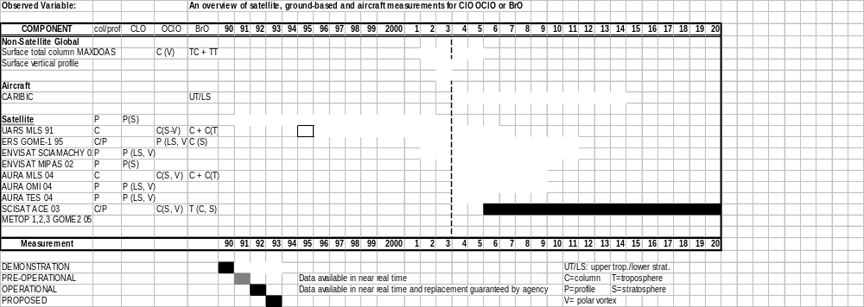
Figure 3.7.6. A timeline diagram for halogen oxides.

Sulfur Dioxide: SO₂

SO₂ is a key species in sulfate particle formation. It is emitted directly by volcanoes, and produced from the oxidation of biogenic compounds. Anthropogenic emissions of SO₂ stem mainly from fossil fuel combustion. They continue to be globally very large, despite the effective desulfurisation technology developed and applied in most developed countries. The oxidation of SO₂, heterogeneously on aerosol and cloud droplets or by homogeneous gas phase reactions, produces sulfuric acid (H₂SO₄) which, in the gas phase, generates aerosol including cloud condensation nuclei. In the stratosphere SO₂ is an important precursor for stratospheric aerosol. SO₂ has a very short lifetime in the troposphere and highly variable sources.

Measurements of SO₂ and sulfate (SO₄) are made with a network of ground based stations around the world. The QA/QC is variable.

The data from the NASA TOMS instruments were used first to detect the SO₂ emitted by volcanoes from space. GOME and SCIAMACHY have demonstrated that SO₂ from pollution in the troposphere and from volcanic eruptions can also be measured from space. The measurements of OMI will also provide SO₂ data.

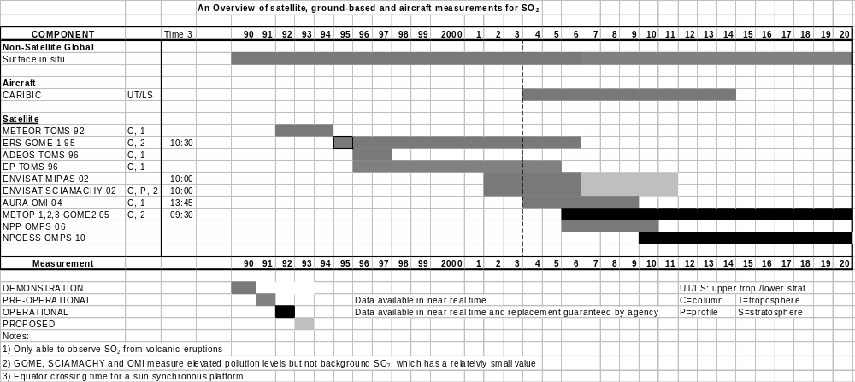Figure 3.7.7. A timeline diagram for SO₂.

Carbon Dioxide: CO₂

CO₂ is the most important anthropogenic greenhouse gas. It is a long-lived atmospheric species and therefore it is well mixed in the atmosphere. Its global mean concentration has increased by more than 30% since pre-industrial times. The available ground-based measurement network operated by WMO/GAW and partners is adequate to detect trends in global mean and meridional concentrations on a seasonal basis. However, it is not adequate to deduce carbon sinks on a regional or continental scale using inversion modelling. Significant uncertainty exists in the CO₂ uptake by the oceans and the terrestrial biosphere. In the planetary boundary layer over vegetation, measurements of CO₂ display a strong diurnal variation, especially during the growing season. The daily cycle induces significant horizontal variability in the CO₂ column over land. Forests, oceans and other sinks may prove highly variable in CO₂ uptake from year to year depending on meteorological conditions.

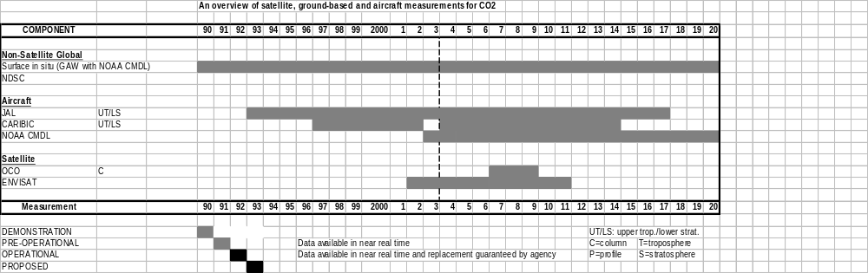
Figure 3.7.8. A timeline diagram for CO₂.

Gaps in the measurement network are being filled. Routine ship measurements are being expanded. Aircraft measurements made by Japan Airlines and the Meteorological Research Institute of Japan between Tokyo and Sydney are continuing into a second phase with continuous measurements replacing flask sampling. NOAA/CMDL is beginning a programme of routine vertical profiling of the lower troposphere at a large number of locations using light aircraft and automated flask sampling. In addition, steps are being taken to encourage researchers engaged in carbon exchange flux studies to link their measurements to the GAW global CO₂ reference standard maintained at the Central Calibration Laboratory operated by NOAA/CMDL and to submit their data to the GAW World Data Centre for Greenhouse Gases in Tokyo.

Measurements of CO₂ total column amount over cloud free regions by satellites has the potential to fill some gaps left by the non-satellite ground-based and aircraft. The International Global Carbon Observatory satellite will be launched by NASA in 2007. It is the first satellite dedicated to measuring CO₂ in the atmosphere with sufficient precision to be of use in carbon sink studies. In the meantime, limited information on CO₂ column density may be forthcoming from ENVISAT and EOS-AURA. It is a challenge for IGACO to decide which combination of ground-based, aircraft and satellite observations most effectively meets the needs of Carbon Cycle researchers. The inverse modelling of CO₂ needs to be explored for establishing global source-sink magnitudes.

Methane: CH₄

Current anthropogenic CH₄ emissions dominate natural emissions by a factor of about 2. CH₄ is an important greenhouse gas currently contributing about 17% to global radiative forcing; concentrations have more than doubled since pre-industrial times. CH₄ is oxidised in the atmosphere by OH, which is its main sink. In turn, CH₄ is one of the main sinks for OH, the prime oxidant of the troposphere, and these interactions provide a firm link between chemistry and climate. CH₄ is also an important source for stratospheric water vapour. The CH₄ growth rate (approx. 0.4% per year) has slowed during the past decade (CH₄ emissions are subject to the Kyoto Protocol) and the CH₄ share in the annual increase in greenhouse forcing decreased substantially in the nineties. Large uncertainties (typically a factor of 2) prevail on magnitudes of both natural and anthropogenic CH₄ sources and consequently on the causes of past variations as well as future trends.

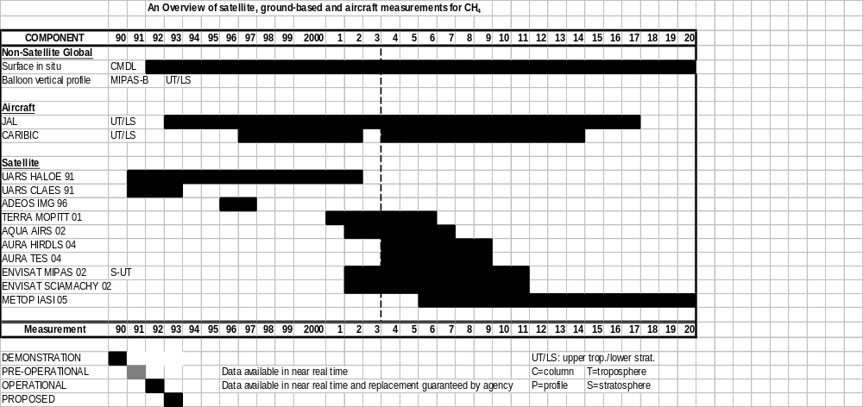
Figure 3.7.9. A timeline diagram for CH₄.

The measurement accuracy requirements for methane are determined by the role that methane plays in climate, stratospheric ozone depletion and oxidising efficiency issues. From the climate perspective, the emission reduction commitments of the Kyoto Protocol, which is approximately a 10% reduction by the 2008-2012 period over 1990 levels, require a measurement accuracy of 1% or better. Owing to its relatively short atmospheric lifetime (ca 8 years) compared with other greenhouse gases, methane concentrations display relatively large variations in space and time. The spatial resolution needed to capture these variations should be of the order of the source/sink scale of 100 km or less. The temporal resolution should capture at least the seasonal variation and avoid potential biases caused by poor diurnal sampling or cloud cover.

The present ground-based network for methane coordinated by GAW is almost identical to that for carbon dioxide shown in Fig. 3.1. It is sufficient to quantify the global spatial and temporal distribution of methane but not for reducing uncertainties in CH₄ emissions using inverse modelling techniques. However, improvements in the global network described above for CO₂, namely addition of ship, flux tower and aircraft measurements, will address this gap in the next decade.

Aircraft measurements made by Japan Airlines and the Meteorological Research Institute of Japan between Tokyo and Sydney are continuing into a second phase with continuous measurements replacing flask sampling. NOAA/CMDL is beginning a programme of routine vertical profiling of the lower troposphere at a large number of locations using light aircraft and automated flask sampling.

Satellite observations of tropospheric CH₄ are presently limited in accuracy and scope. Recently launched and soon to be implemented instruments (SCIAMACHY, TES, IASI) will improve the situation, but the limitations on accuracy, spatial sampling and sensitivity mean that emissions cannot be quantified well enough with satellites alone. The ground based and aircraft measurement network improvements are likely to be the most effective. Stratospheric measurements of sufficient quality to address some of the questions related to the role of CH₄ will be available from research satellites (MIPAS, TES, HIRDLS).

Aerosol optical properties

Aerosols play a role in all four atmospheric chemistry issues. In air quality the effects of anthropogenic particulate matter smaller than 2.5 micrometer (PM2.5) on human health is well documented and beginning to be regulated in many countries. In climate, the IPCC assessment of 2002 has recognised that aerosol forcing of the heat and energy balance of the atmosphere is as important as greenhouse gases and highly uncertain. In particular, the scattering of solar radiation by particles and the absorption of radiation by the black carbon component of particles is critical. In tropospheric air quality and oxidising efficiency, the detailed role of aerosols in gas-particle reactions, in cloud chemistry and in precipitation processes is still uncertain. For the stratosphere, it is now well recognised that gas-particle reactions can affect the chemistry controlling the ozone layer.

Unlike atmospheric gases, atmospheric aerosols cannot be characterised by a single concentration. Instead they have physical, chemical and optical properties, as well as their state of mixture. Therefore, a variety of measurement techniques are required. Accuracy requirements for aerosol measurements are generally expressed in different terms for different applications. Target and threshold requirements have been compiled for an ESA Atmospheric Chemistry mission (ACECHEM) for the purpose of studying atmospheric chemistry and climate. The WMO/CEOS report provides further target and threshold requirements for heterogeneous stratospheric chemistry and climate.

The global measurement system for tropospheric aerosols currently includes a network of ground based in situ aerosol monitoring stations operated by WMO members under GAW and national or regional monitoring programmes such as EMEP. It also consists of a ground-based network of aerosol optical depth measurement stations operated by the GAW community, the Baseline Surface Radiation Network (BSRN) of the World Climate Research Programme, NASA/AERONET, PHOTONS, AEROCAN, DOE/ARM, GMA and SKYNET. This network is currently not well coordinated but efforts are being made by GAW to remedy this.

In addition there are ground-based aerosol LIDAR networks operated by several regional programmes including the European EARLINET, the NASA MPLS, NDSC and members of GAW. They are extremely important in providing missing information on the vertical distribution of aerosols as well as on the aerosol mixing depth in the atmospheric boundary layer. Globally, these types of observations are largely uncoordinated and lack a solid foundation for long term operation.

Routine aircraft measurements of aerosol optical properties are still in demonstration mode with no substantial geographical coverage. Systematic observations of aerosol radiative properties in the lower 3 km of the troposphere have begun under a pilot study conducted by DOE/ARM in Oklahoma in cooperation with NOAA/CMDL. Twice weekly, an instrument package is flown by a light aircraft. Such observations are important in order to parameterise the remote sensing observations of aerosols. They need to be extended to a number of other locations around the world.

Satellite observations of aerosol optical properties have progressed to a point where they range from pre-operational to operational although there are demonstration-mode instruments on a number of research satellites (e.g. Terra, Aqua, and Aura). These carry an unprecedented array of space borne sensors with unique characteristics enabling quantitative observations on a global scale. Other instruments such as TOMS provide valuable long-term measurements of aerosols, although with a lower accuracy and resolution. These space-borne measurements are complemented by the ground-based networks already mentioned. Although occasionally covered on a research campaign basis, there is an obvious lack of continuous, high-quality in situ measurements of aerosols in Africa, South America and Asia. The largest changes in aerosol loading are expected to occur in the coming decades over these continents, and downstream of them; satellites are an obvious way to close the gap.

As their characteristics improve, the new generation of operational meteorological satellites (geostationary: SEVIRI on MSG; sun-synchronous: AVHRR-3 on METOP and VIIRS on NPOESS) will provide some basic column properties of aerosols (aerosol optical depth, Ångstrom exponent, ratio of coarse to fine mode). However aerosol is of such importance that the routine measurements of their optical properties need to be extended to include other properties such as physical size distributions, the UV radiative properties and vertical profiles. The succession of several space-borne lidars (GLAS, CALYPSO) following the LITE space shuttle experiment, should, in the future, complement the monitoring of aerosol vertical profiles in both the troposphere and stratosphere by ground based LIDARS and aircraft. The ground-based networks need to continue to provide a ground truth, retrieving parameters not measurable from space, and filling the gaps in space-borne monitoring. The networks also need to be enhanced in some regions of the world.

The measurement system for stratospheric aerosols currently includes the ground based measurement networks mentioned above with NDSC, AERONET and GAW playing an important role. A number of satellite instruments, e.g. SAGE-III, POAM, HALOE, MIPAS, and TOMS are in place. These measurements include valuable long-term measurements, such as those of the limb-viewing SAM/SAGE instrument series from 1978 onward, as well as highly specialised satellite instruments like POAM and HALOE which are capable of detecting polar stratospheric clouds (PSCs) and identifying the type of these clouds (e.g. ice clouds or nitric acid containing clouds). Concerning the Arctic and Antarctic PSC issue, uninterrupted monitoring will be required to fulfil the requirements of the Montreal Protocol for the protection of the ozone layer. Given that the sulfate budget of the upper troposphere and lower stratosphere is not well understood, a coherent long-term record of the stratospheric aerosol will be essential. With SAGE-III the immediate future is well covered. The enhanced capabilities of satellite instruments for investigating the processes in the tropical tropopause layer will be required in future, including the understanding of deep convective clouds and thin laminar cirrus clouds, and their role in dehydrating air on its way from the tropical upper tropopause into the lower stratosphere. Here lidars, both ground-based and space-borne, will become particularly useful. The active sensing of the NASA GLAS altimetry instrument has proven to shed some light on aerosol vertical distributions. The LIDAR instrument on NASA CALYPSO is designed specifically to provide vertical profiles.

Although major national and international efforts are underway to characterise the chemical and physical properties of aerosols, there exist major gaps that urgently need to be filled if an IGACO system is to be put into place. The biggest gaps are: (i) in coordination of a large number of existing monitoring efforts, (ii) the existence of a data synthesis and analysis centre and (iii) measurements of aerosol chemical composition and the state of internal or external mixing of aerosols. The last can only be filled by ground-based, aircraft and balloon in situ measurements. They are needed to reduce the uncertainty in indirect aerosol climate forcing through their interactions with clouds. No global network currently exists but intensive efforts toward establishing such a network are under way by WMO/GAW.

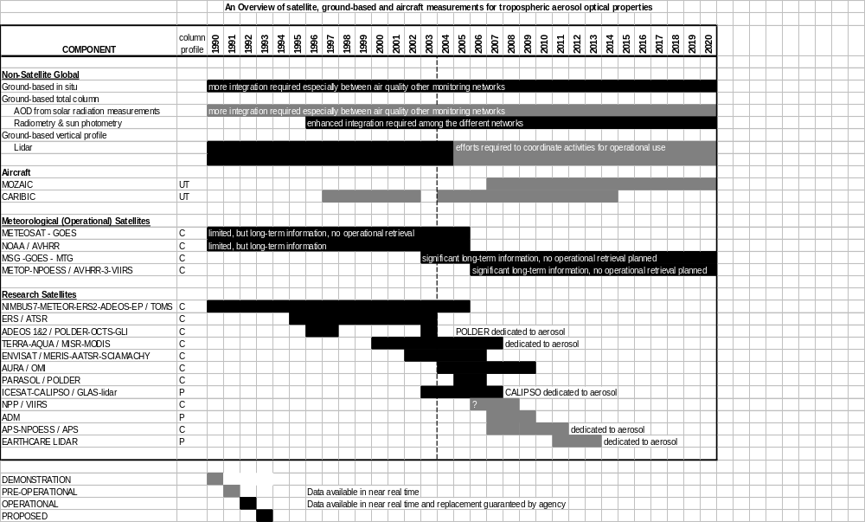
Figure 3.7.10. A timeline diagram for tropospheric aerosols.

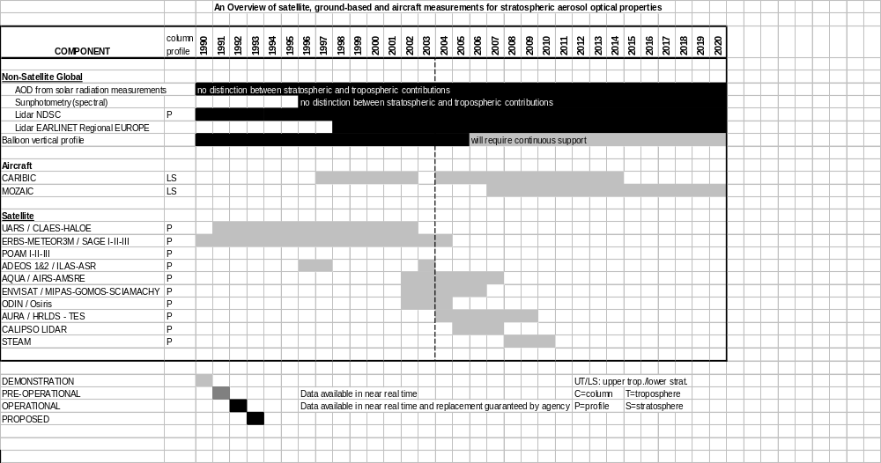
Figure 3.7.11. A timeline diagram for stratospheric aerosols

While it is interesting and economical to obtain aerosol properties as by-products of meteorological satellite measurements (e.g. NPOESS, METOP, ADM), there is a risk that planning of satellite missions will not meet the actual need for continuous aerosol measurements. Although they represent a source of reliable and accurate worldwide aerosol products (some of which are not measurable from space), current networks of ground-based sun photometry rely on uncertain sources of funding, especially in the long-term.

Atmospheric Chemistry Models
Modelling will require a number of ancillary parameters to characterise the physical state of the atmosphere where the detailed measurements of concentration are being made. Most important among these are temperature, pressure, wind speed (u, v, w), cloud top height, cloud coverage, albedo and solar radiation, all measured from the satellite or ground from which the chemical parameters are being estimated.

In addition, satellite measurements of lightning flash frequency, the number of fires and surface properties, such as vegetation index, are necessary for modelling and studies of effects. It is expected that these ancillary measurements will be provided by other satellite systems. There are a number of national ground networks and satellite-based instruments for lightning detection and efforts are being made to establish a data base. The coverage however is patchy at present.

The troposphere is more difficult because measurements are hampered by the presence of clouds, aerosols, and large gaseous absorption, especially by water vapour. These preclude the use of limb techniques below the upper troposphere, and require the use of nadir techniques which are characterized by coarse vertical resolution. In addition, techniques based on both UV-VIS scattering and IR emission techniques tend to have lowest sensitivity near the surface. Numerous reactive gases with short lifetimes are emitted at the surface and have their largest concentrations at the lowest levels, but even these concentrations may be very small.

Clearly, satellite observations are not able to determine the concentrations of all species at all levels, and there is a strong synergy with ground based measurements such as those provided by the Global Atmospheric Watch (GAW), the Network for the Detection of Stratospheric Change (NDSC), and others. In the ideal situation, surface and lower tropospheric measurements would join with satellite-based observations to provide measurements throughout the troposphere, with some ability to depict vertical variations. This synergy is also operating when surface data are used to validate low altitude satellite data, as can occur for ozone, carbon monoxide and aerosol measurements.

The requirements indicate that data with a horizontal resolution of 500 km (in both latitude and longitude) within 24 hours are necessary. The longitudinal requirement is difficult to meet in the stratosphere (only HIRDLS on the EOS Aura spacecraft is designed to meet this requirement). As indicated above, the vertical requirement is difficult to meet in the troposphere. The applications of satellite data to atmospheric chemistry at this time are for research purposes, rather than for operational needs, so that the temporal requirements are generally not stringent. Data availability within 72 hours suffices for most applications. The requirements are given for the Higher stratosphere/mesosphere (here denoted Upper Stratosphere, US), Lower Stratosphere (LS), Higher Troposphere (UT), and Lower Troposphere (LT). The situation for the stratosphere and mesosphere is described first.

3.7.4 Summary of Atmospheric Chemistry SOG

The major points regarding atmospheric chemistry are:

-Through IGACO, the need has been articulated for an integrated system for atmospheric chemistry observations comprising not only of observational networks and satellites but also of quality assurance, data archiving and modelling facilities that are held together with efficient and universally accepted data flow mechanisms. To meet the measurement requirements, it will be necessary to exploit the synergy between satellite measurements and ground based and in situ data;

- Routine ground-based measurements (in-situ and remote sensing) including those from balloons are providing vertical profiles and total column ozone, CO2, CH4, N2O, aerosol optical depth with acceptable accuracy. There is a long tem history of these measurements with local/regional relevance that have proven to be a validation source for satellite data; calibration issues remain and the ground network remains scattered under diverse organisational structures.

- Systematic aircraft measurements are being made of O3, H2O, CO, NO2 (since 1994, ~ 200 flights per month), CO2, CH4, CO (since 1993, twice per month). They offer unique high-resolution tropospheric profiles. The species measured is limited in number as well as space / time coverage; in addition there are sampling biases

- To date there have been many more space-based chemistry observations of the stratosphere and higher than in the troposphere. In the future more tropospheric measurements are planned, but their numbers will still be lower than those planned for the stratosphere and higher;

- Nadir-viewing space based instruments have been providing a near-continuous record of total column ozone since 1978; there are commitments for continuation well into next decade along with a demonstration of tropospheric ozone retrieval. Measurement of CO, NO2, HCHO, BrO, SO2 is still under development. Aerosol optical depthis being measured with acceptable accuracy over oceans and, more recently over continents as well. Advanced instrumentation on new research satellites (new species, limb/nadir matching, spatial sampling) offers promise of acceptable measurement of more chemical constituents.

- Limb-viewing instruments have established a 20-year record of stratospheric profiles of O3, aerosol extinction, H2O, NO2 (occultation) and a 10-year record of stratospheric O3 and ClO with good coverage (emission) and HCl, HF, CH4, O3, H2O, NO2, aerosol extinction (occultation). There will be extensive coverage of stratospheric species on planned new research satellites.

- In the troposphere, space-based observations of O3, water vapour, and CO are being made at acceptable levels, but measurements of aerosols, CO2, long-lived source gases, radicals and reservoirs and sinks do not meet the requirements;

- In the stratosphere and mesosphere, many planned missions (GOMOS, HIRDLS, ILAS, MIPAS, MLS, SCIAMACHY and TES), followed by NPOESS, give promise for acceptable measurements, but adequate resolution within 24 hours appears to be a problem (except for HIRDLS).

- Some of the key recommendations of IGACO regarding evolution of the GOS for atmospheric chemistry include:

(a) long term validation of satellite observations: in order to ensure the accuracy and consistency of satellite measurements, sustained quality assurance measures, over the entire lifetime of satellite sensors, are essential.
(b) Validation of vertical profile data from satellite observations: a set of high performance scientific instruments using ground, aircraft and balloon platforms, possibly operated on campaign basis, must be maintained to provide the crucial validation data.
(c) Comparability: the ability to merge observations of different types must be ensured by insisting that appropriate routine calibration and comparison activities linking diverse measurements together are part of an individual measurement.
(d) Development of comprehensive chemical modules in weather and climate models with appropriate data assimilation should be an integral part.

________________

