WORLD METEOROLOGICAL ORGANIZATION  ______________  COMMISSION FOR BASIC SYSTEMS  OPEN PROGRAMME AREA GROUP ON  INTEGRATED OBSERVING SYSTEMS  EXPERT TEAM ON EVOLUTION OF THE  GLOBAL OBSERVING SYSTEM  Fourth Session  GENEVA, SWITZERLAND, 7–11 JULY 2008 |  | CBS/OPAG-IOS/ET-EGOS-4/Doc. 5.5  (18.VI.2008)  ______  ITEM: 5.5  Original: ENGLISH

REVIEW OF OTHER ACTIVITIES RELATED TO THE ET-EGOS AND OPAG-IOS

GCOS Activities

(Submitted by the GCOS Secretariat and M. Menne, CBS Rapporteur on GCOS matters)

Summary and Purpose of Document

This document presents background information on several items for discussion at the ET-EGOS session related to the GCOS, including:

(i) Update of the GCOS IP and GCOS Progress Report in 2009;
(ii) GCOS, WCRP and IGBP Learning from the IPCC AR4;
(iii) Refined Observation Strategy for Earth Radiation Budget;
(iv) Progress towards implementing the GRUAN;
(v) Implementation of GSN and GUAN;
(vi) Discontinuation of the CLIMAT TEMP reports; and,
(vii) Update of the GCOS observation requirements (agenda item 7.2.8)

ACTION PROPOSED

The Meeting is invited to note the information contained in this document for discussion under the appropriate agenda items.

____________
Discussion

- Update of GCOS Implementation Plan; GCOS Progress Report

The ET-EGOS agreed at its Second Session (Geneva, Switzerland, 10-14 July 2006) that the GCOS Second Adequacy Report (2003) and the GCOS Implementation Plan (2004), supplemented by the satellite requirements (2006), provided an adequate Statement of Guidance for Climate Monitoring, covering Climate Change and Climate Variability (see also item 7).

Following an invitation by the UNFCCC SBSTA, the GCOS will provide a report on progress with the GCOS Implementation Plan by June 2009. The report will consist of an overall assessment of the implementation of the global observing system for climate, as well as present the status of cross-cutting and domain-based Actions as set forth in the Plan. A core drafting team with participation from all three GCOS domains (atmosphere, oceans, terrestrial) has started working on this report at its kick-off meeting which was held in Geneva, 30 June – 2 July 2008.

Along with the GCOS progress report, an update of the 2004 GCOS Implementation Plan - conceived to cover a 5-10 year period - is planned, possibly associated with a review of GCOS observation requirements. Any implications of these activities for the evolution of the GOS, for example possible changes to the Statement of Guidance for Climate Monitoring, will be duly reported to the 2009 session of the ET-EGOS.

The GCOS progress report draws primarily from the following sources: (i) performance reports from GCOS monitoring centres and partner observing systems and their technical advisory bodies (e.g., CBS), (ii) information on national activities related to systematic observation (due by 15 September 2008), (iii) results from the workshop “Future Climate Change Research and Observations: GCOS, WCRP and IGBP Learning from the IPCC Fourth Assessment Report” (see item 2).

- Learning from the IPCC Fourth Assessment Report

Learning from the authors of the IPCC Fourth Assessment Report and its findings to help guide future strategies for climate change observations and research was the key objective of a workshop organised jointly by the Global Climate Observing System (GCOS), the World Climate Research Programme (WCRP), and the International Geosphere-Biosphere Programme (IGBP) (Sydney, Australia, 4-6 October 2007).

Some 66 IPCC authors and other experts associated with the three international programmes discussed some fundamental climate change observation and research needs and challenges, based on gaps and uncertainties identified by the IPCC Working Group I (The Physical Science Basis), and the Working Group II (Impacts, Adaptation and Vulnerability) in their latest assessments. The starting point for this evaluation was the results of a survey of IPCC AR4 authors’ and contributors’ views on gaps and shortcomings, as identified in the most recent IPCC assessment. Among other items, the survey provided comments on the adequacy of global observations for climate, as well as on the list of Essential Climate Variables.

The workshop looked specifically at the gaps in observations and basic science raised by the IPCC, and at deficiencies in the way information about climate change can be used for the assessment of impacts, adaptation, and vulnerability, particularly on the regional scale. For example, three of the priority items identified which currently limit our confidence in projections of climate change are poor understanding of ice sheet behaviour and its implications for sea level rise, gaps in knowledge about the hydrological cycle, and the lack of understanding of terrestrial feedback mechanisms in response to climate change.
Related to understanding the hydrological cycle, interest was expressed in developing hourly global precipitation datasets, especially for predicting and assessing extreme precipitation events, and it was suggested to recommend to the WMO that six and three hourly synoptic data, including where possible hourly precipitation totals, be made available at the World Data Centres. To this end, a letter by the WMO Secretary-General to all WMO Members is currently being prepared.

The workshop also made suggestions on the research necessary to better quantify regional climate change impacts with regional climate change models, for example, by more rigorous validation of these models with observations of Essential Climate Variables. However, these data are often not available, particularly in developing countries. Better connections between global circulation models and regional models were also identified as a major field of necessary action. A full workshop report has been published, and its main results have been submitted for publication in BAMS.

Both pre-workshop survey and workshop results will be considered in the planned update of the GCOS Implementation Plan in 2009, and thus help determine future requirements for climate observations (see item 1).

- Refined Observation Strategy for Earth Radiation Budget

Plans for the revised Vision for the Global Observing System in 2025, as presented to the
ET-EGOS-3 (Geneva, 2007), include an emphasis on long-term observations of Essential Climate Variables, in line with GCOS requirements. The current GCOS requirements for measuring Earth Radiation Budget from space are (GCOS-107):

- At least one dedicated broadband instrument mission in low Earth orbit at any one time, together with at least one instrument providing spectrally resolved measurements of solar irradiance; and

- Well-calibrated geostationary multi-spectral imagery to provide global fields resolving the diurnal cycle.

With the following target (goal) requirements:

- Accuracy: 1 Wm-2 for downwelling solar radiation at TOA; 5 Wm-2 for outgoing SW / LW radiation at TOA;

- Spatial and temporal resolution: 100 km horizontal resolution, 3-hourly observing cycle; and,

- Stability: 1 Wm-2 over five years; 0.2 Wm-2/decade.

At its third session, the ET-EGOS (Geneva, Switzerland, 9-13 July 2007), noted the need for a refined observation strategy for satellite-based Earth Radiation Budget measurements, which are critical for climate monitoring. Upon invitation by the GCOS AOPC to its 14th session in April 2008,
Dr Jörg Schulz (DWD, Member of GEWEX Radiation Panel) provided a discussion paper related to this topic. Recommendations made in the paper are largely consistent with the GCOS requirement (e.g., stressing that the LEO broadband instruments should at least have CERES-type capabilities), but went further in specifying additional needs, namely that:

- Additional observations are needed to better establish a more direct link between the observed fluxes at TOA and the parameters that affect the fluxes. Instruments observing temperature and water vapour profiles, cloud and aerosol properties should be realized on the same operational platform as the ERB instrument. This concept would provide global coverage, sufficient temporal sampling, long-term consistency and high-absolute accuracy;

- Scientific missions like EarthCare, CloudSat, CALIPSO are needed for an improvement of the understanding of the atmospheric processes linked to the ERB; and,

- The broadband CERES-type mission should be supported by an absolute calibration mission such as the planned US CLARREO mission to mitigate overlap requirements of at least 6 months that would be needed to reach accuracy necessary for detection of a climate change signal

In responding to this paper, the AOPC confirmed the need for complementary observations to properly understand the ERB, and recommended that this need be reflected in any future update of the GCOS requirements on satellite-based observations. Further, the AOPC invited the GEWEX Radiation Panel to comment on the paper presented by Dr Schulz. It finally noted that more detailed specifications for measuring ERB might be needed, for example, on the extent to which instruments covered the far infrared spectrum.

4. Progress towards implementing the GCOS Reference Upper-Air Network (GRUAN)

The GCOS Reference Upper-Air Network (GRUAN) is a specialized network building on the GCOS Upper-Air Network. It is a small network, ultimately of 30-40 reference sites, which will provide long-term high-quality climate records to constrain and calibrate data from more spatially-comprehensive global observing systems (e.g., GUAN, GAW networks), including satellites and current radiosonde networks.

Most recently, the Implementation Meeting of the GRUAN, organized by the AOPC Working Group on Atmospheric Reference Observations (WG-ARO), was held in Lindenberg, Germany, 26-28 February 2008. The Richard Aßmann Observatory in Lindenberg was designated by the WMO as the lead centre for the GRUAN network for a pilot phase. The Meeting focused upon necessary actions required to refine the cooperation with all partners, resolve scientific and technical issues from the report of the AOPC WG-ARO, and define a work plan for the implementation of the network. A target date of
1 January 2009 was established as when the GRUAN would begin operations, and this builds upon a key principle of the GRUAN which is to “start small, but start”. An article detailing the GRUAN has also been submitted for publication in BAMS. As part of the work plan,

- A set of twelve initial candidate sites shall be invited by the WMO / GCOS to become GRUAN sites;
- Close linkages with the satellite community, mainly through the GSICS, shall be sought and maintained, particularly in view of utilization of GRUAN data for satellite instrument calibration and validation, and of possible sponsoring of additional radiosondes launches at GRUAN sites; and,
- The GRUAN Lead Centre, in collaboration with initial GRUAN sites, CBS, CIMO and
WG-ARO will develop a manual for operating practices at GRUAN sites; the manual will be included in the WMO regulatory material.

At its eighth session in June 2008, the CBS Management Group agreed to recommend formal establishment of GRUAN to CBS-XIV in 2009.

5. Implementation of the GCOS Surface Network (GSN) and GCOS Upper-Air Network (GUAN)

System Improvement

Overall funding for the GSN and GUAN renovation projects was somewhat higher than last year as contributions from the United States increased slightly and additional contributions came from other Members. Through the GCOS Cooperation Mechanism (GCM), the Netherlands (KNMI) made a major contribution of 1 M € over a five year period for renovation projects for the GSN and GUAN in Africa. Additional contributions were received last year from Spain, United Kingdom, United States, and Germany. The fourth meeting of the GCM Donor Board (Bonn, Germany, 12 June 2008), and a number of potential GCOS improvement projects were reviewed for possible resourcing in 2008 and 2009.

In supporting the GSN, renovation of the observatory at Bjelasnica, Bosnia and Herzegovina, was nearly completed. The exterior of the building was replaced last year with modern, insulated aluminium siding to seal the building. The interior work will be completed in early spring 2008. Both phases of the work were done by a local construction company on contracts awarded directly by the WMO. A high-performance ultrasonic wind sensor has been provided. This unit is supposed to be “ice free”, and has a very high upper range of wind measurement of 75 meters / second. This high performance is needed because of the conditions at this mountain top location. The renovation of the building was funded by the United States while the wind instrument was funded by Germany

In support of the GUAN, radiosondes were supplied to Vacoas, Mauritius and to Yerevan, Armenia and generators were provided to Mahe, Seychelles; Niamey, Niger; and Abidjan, Cote d’Ivoire. One of the biggest initiatives taken in the past year was the GUAN Upper-Air Workshop held in Windhoek, Namibia. All eighteen African GUAN stations were represented and several equipment suppliers participated. The workshop was organized by the WWW / GCOS / CIMO, and covered all aspects of upper-air sounding, including the safe handling of hydrogen and proper balloon inflation techniques.

Despite the identified need for reliable GUAN stations on the Indian subcontinent, no progress could be made with the Indian Meteorological Department (IMD) to initiate upper-air flights using improved radiosondes at some of their stations. The Director of the IMD indicated that they would establish at least one station using improved radiosondes during 2007, but that apparently did not happen.

The United States GCOS Program, recognizing the need for and importance of reference observations, is trying to do for surface observing (at a small scale) what has been proposed for upper-air via the GRUAN. As such, some pilot programs that look to extend the United States Climate Reference Network (CRN) internationally are being undertaken. Two examples include: working with Roshydromet to install up to two CRN systems in the Russian Arctic in the August 2009 timeframe, and working with the World Bank to install 1-2 systems in the Andes of South America as part of a greater project dealing with tropical glacier monitoring that will be taking place in parts of Bolivia, Colombia, Ecuador, and Peru. The installation of stations is expected to begin sometime in 2009.
CBS Lead Centres and Performance Monitoring

The first meeting of the CBS Lead Centers for GCOS Coordination was held at the Headquarters of the Islamic Republic of the Iran Meteorological Organization (IRIMO) in Teheran and in its Regional Office in Isfahan, Iran (5-8 November 2007). The Coordination Meeting / Workshop was instrumental in summarizing existing experience and made recommendations for further enhancement of the Lead Centers functions to the next session of the Commission for Basic Systems (CBS). These recommendations related to: (a) Coordination among Lead Centers; (b) Revised TOR of the Lead Centers; (c) Benefits of Lead Centers; (d) Remedy action; (e) Metadata Guide;
(f) Expanding scope of the work of Lead Centers; (g) Internet gateway for CLIMAT data entry;
(h) Archive of historical data; (i) Modification of performance reports at the NCDC; (j) Quality control reports; and, (k) Verification of completeness of the CLIMAT and TEMP reports.

Now numbering nine total Centers, the CBS Lead Centres for GCOS have been working to improve the performance of the GSN / GUAN and the quality of climate data since the Extraordinary session of the Commission for Basic Systems, Cairns, 2002 (CBS-Ext.(02)) recommended that the first CBS Lead Centres for GCOS data (one for GUAN and one for GSN) be established on a trial basis. In part because of the efforts of each the GCOS Lead Centers, there has been a marked improvement in the number of CLIMAT reports received at the GSN archive at NOAA / National Climatic Data Center as shown in Fig. 1. The geographic distribution of the frequency of reports for a recent 12-month period is provided in Fig. 2.

Rehabilitation / system improvement activities have also had a positive impact on the performance of the GUAN. Fig. 3 summarizes the number of GUAN sights that meet the minimum performance requirements, which are defined as follows:

[…] every month at least one observation on each of at least 25 days should attain the minimum requirements. The observing frequency (1 or 2 per day) in itself is not a criterion, although the Target Requirement for observation frequency is 2 per day, in accordance with WWW regulations for radiosonde observations.

Minimum Requirements:

- Temperature up to 30 hPa;
- Humidity up to 300 hPa; and,
- Wind direction and speed up to 30 hPa.
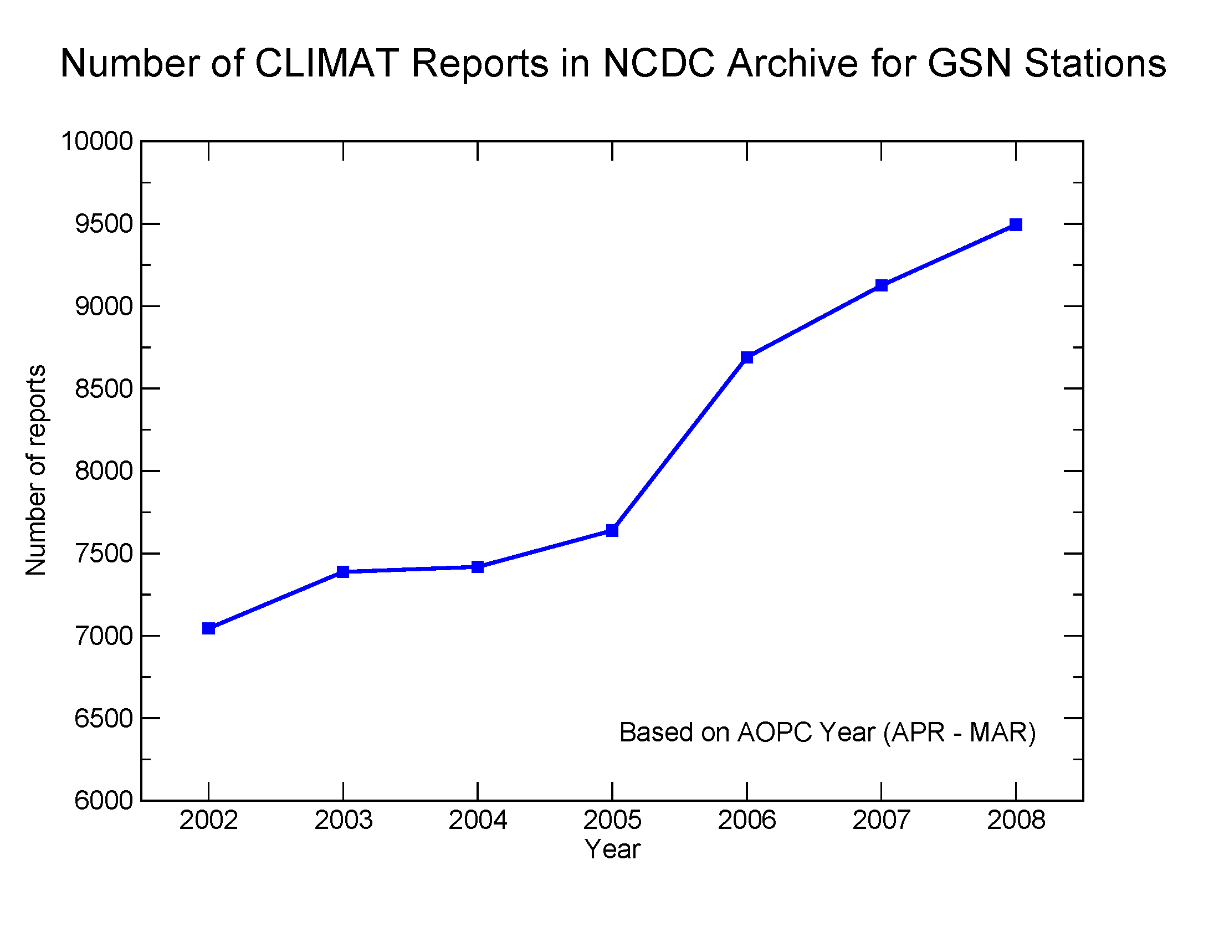
Figure 1: GSN performance as a function of number of CLIMAT reports received at the NCDC archive center.
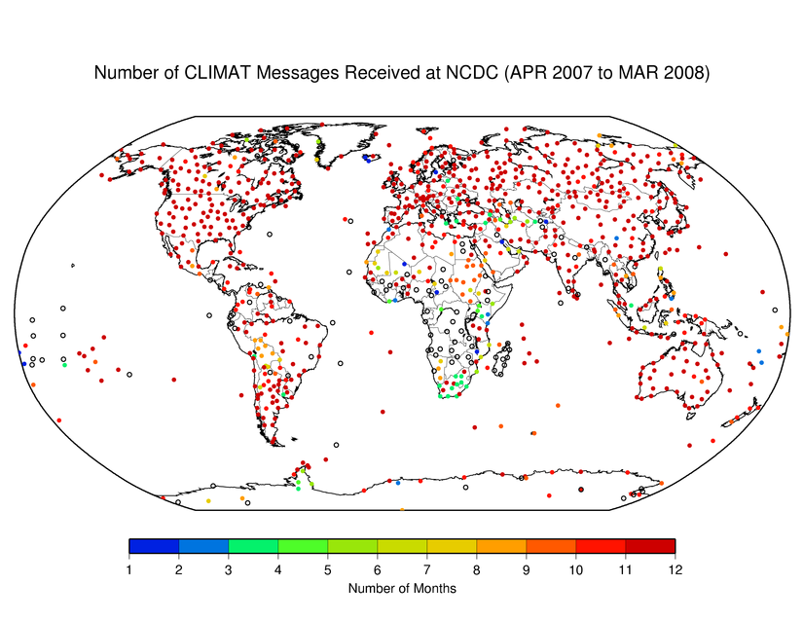
Figure 2: Number of CLIMAT reports received for the GCOS Surface Network. “O” indicates no report received.
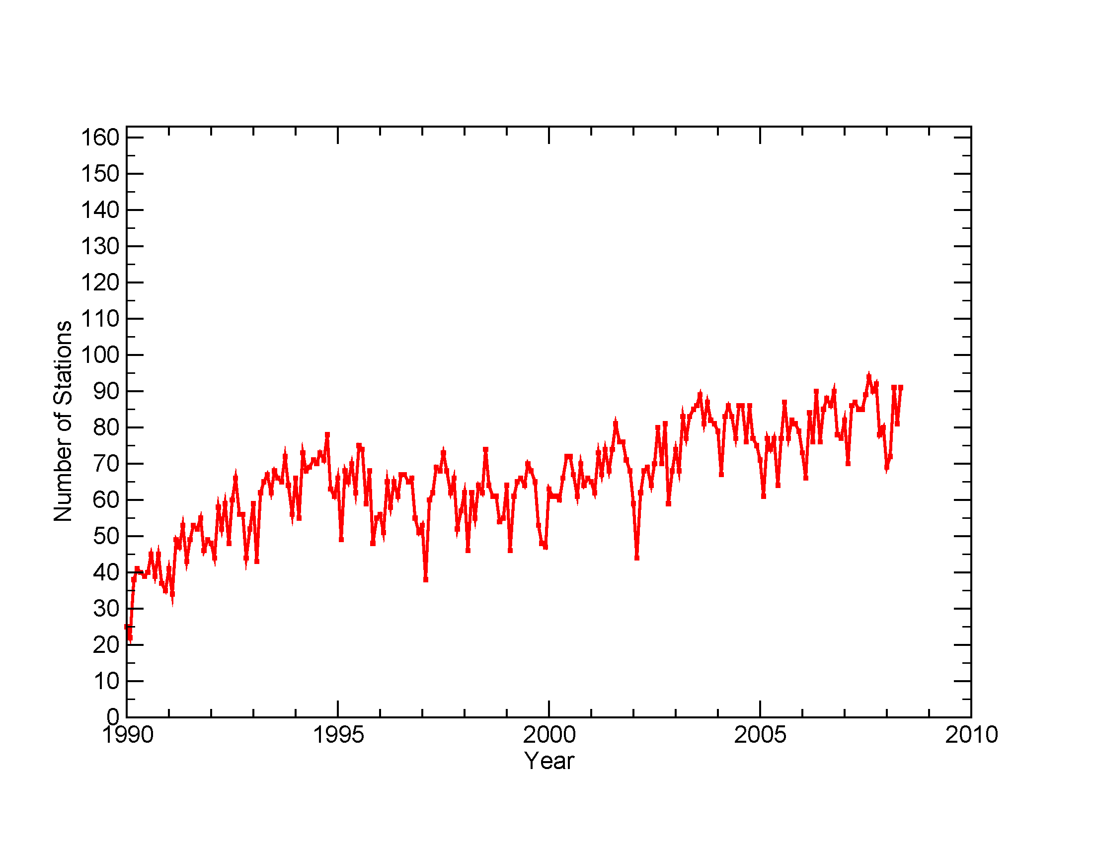
Figure 3: Time series of the GCOS Upper-Air Network (GUAN) performance as a function of number of stations meeting all minimum requirements (total number of GUAN stations = 163).

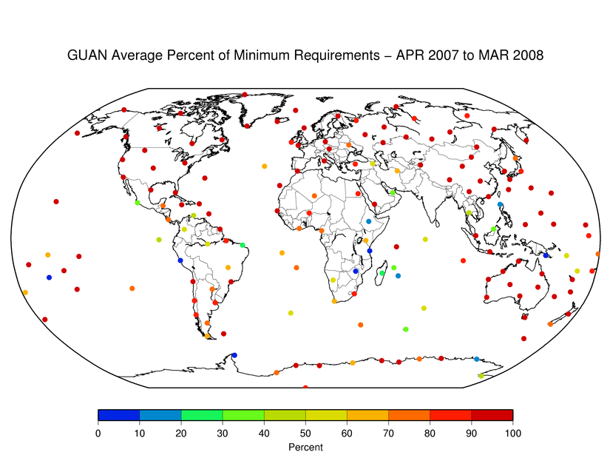
Figure 4: Average GCOS Upper-Air Network (GUAN) performance from April 2007 through March 2008.

6. Discontinuation of the CLIMAT TEMP reports

AOPC-XIII (2007) concluded that the calculation and transmission of CLIMAT TEMP messages was no longer required for GCOS purposes. Having been informed about this matter at its 60th session in June 2008, the WMO Executive Council felt it appropriate that the President of the Commission for Climatology (CCl) and the CCl Management Group were considering the operational impacts of this conclusion by AOPC. It also requested CCl to assess the impacts of a possible discontinuation of CLIMAT TEMP on other domains, such as applied climatology, research, aviation, etc. The Council agreed that if a decision on discontinuing CLIMAT TEMP were reached, CCl should notify CBS to take into consideration required operational arrangements. Additionally, NMHSs, users and instrument manufacturers should be informed, e.g. through the WMO and GCOS websites, as well as through a formal information letter by the Secretary-General to WMO Members. It was noted that the agreement was foreseen with ECMWF and NCDC to pursue their respective TEMP monitoring activities for the GUAN.

The Council finally emphasized that this issue in no way relates to the generation and exchange of monthly CLIMAT messages for surface data, which remain essential to GCOS requirements and to the World Climate Programme needs.

7. Update of the GCOS observation requirements (agenda item 7.2.8)

An update of observation requirements and the Statement of Guidance for Climate Monitoring are planned for June 2009, in order to ensure consistency with the planned update of the GCOS Implementation Plan in 2009.

____________

“Future Climate Change Research and Observations: GCOS, WCRP and IGBP Learning from the IPCC Fourth Assessment Report”, GCOS-117/WCRP-127/IGBP-58, January 2008 (http://www.wmo.int/pages/prog/gcos/Publications/gcos-117.pdf)
“Systematic Observation Requirements for Satellite-based Products for Climate - Supplemental details to the satellite-based component of the Implementation Plan for the Global Observing System for Climate in Support of the UNFCCC”, GCOS-107, September 2006 (http://www.wmo.int/pages/prog/gcos/Publications/gcos-107.pdf).
http://www.wmo.int/pages/prog/gcos/aopcXIV/22a_ERBStrategy.pdf
Meeting report: http://www.wmo.int/pages/prog/gcos/Publications/gcos-121.pdf
See http://www.ncdc.noaa.gov/crn

