WORLD METEOROLOGICAL ORGANIZATION  COMMISSION FOR BASIC SYSTEMS  OPEN PROGRAMME AREA GROUP  ON INTEGRATED OBSERVING SYSTEMS  SECOND CBS/GCOS EXPERT MEETING ON COORDINATION OF THE GSN AND GUAN  ASHEVILLE, USA, 28-30 SEPTEMBER 2005 |  | CBS/OPAG-IOS/  EMCGG-2/Doc. 4.5  (22.VIII.2005)  _________  Item: 4  Original: ENGLISH

Report of the GUAN Monitoring and Analysis Centre, Met Office, Hadley Centre

(Submitted by M. McCarthy)

Summary and Purpose of Document

The document provides information about the activities at the GUAN monitoring and analysis centre at the Met Office, Hadley Centre.

ACTION PROPOSED

The meeting is invited to take into consideration the information contained in this document when discussing the means and procedures to further improve the availability of climate data from the GUAN.

_______________

Report of GUAN Monitoring/Analysis Centre (Hadley Centre)
Mark P. McCarthy
Met Office, Hadley Centre for Climate Prediction and Research, UK

1. Introduction
The principal aims of the GUAN are to ensure a relatively homogeneous distribution of upper air stations that meet specific record length and homogeneity requirements outlined by GCOS and to develop, and make available, their historical data. The current configuration of the GUAN consists of 161 globally distributed stations.
This document summarises activities of the Hadley Centre in its role as a GUAN monitoring and analysis centre.

2. Monitoring of CLIMAT TEMP
2.1 Details of the monitoring procedure
CLIMAT TEMP bulletins are received at the Met Office routinely each month via the GTS, email, post, and fax. These pass through in-house decode and hydrostatic quality control procedures and are maintained on the Hadley Centre archive.
The monthly receipt of CLIMAT TEMP bulletins from GUAN stations is monitored as part of this process. Monitoring statistics are made available through the GUAN website (http://www.guanweb.com) and are updated on a monthly basis.

2.2 Summary of monitoring results
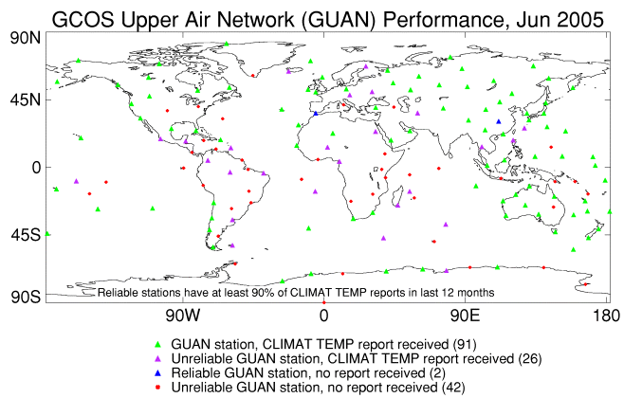
Fig. 1: Receipt of CLIMAT TEMP bulletins from GUAN stations received at the Hadley Centre for June 2005. Reliable stations are those stations that have reported at least 90% of bulletins over the last 12 months

Figure 1 shows the GUAN performance based on CLIMAT TEMP receipt for June 2005. A total of 117, or 73%, of GUAN stations reported CLIMAT TEMP
bulletins that were received and successfully decoded at the Met Office (UK) for this month. A total of 121, or 75%, of GUAN stations have reported CLIMAT TEMP bulletins in at least six of the last 12 months. This can be seen in Figure 2, and is summarised by WMO region in Table 1. A full list of stations and their performance can be found in appendix A.
From this it can be seen that Asia and the South West Pacific (WMO regions II and V) have the most reliable reporting rate, and are also the regions containing the largest number of stations. Africa and South America (WMO regions I and III) have the poorest performance records.

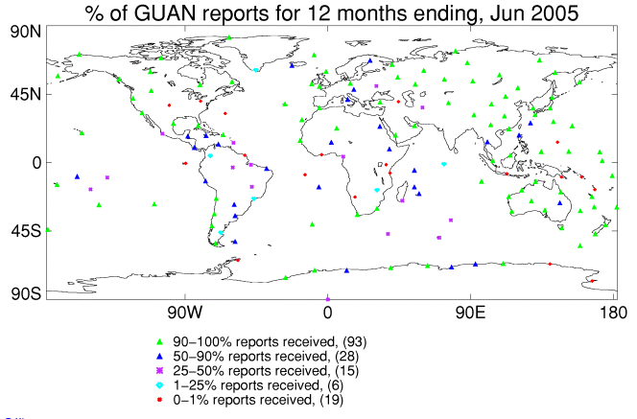
Fig. 2: Percentage of CLIMAT TEMP bulletins from GUAN stations received at the Hadley Centre for the period July 2004 to June 2005.

WMO region | Number of stations | >90% | 50-90% | 25-50% | 1-25% | 0%
I - Africa | 24 | 6 (25) | 7 (29) | 5 (21) | 1 (4) | 5 (21)
II - Asia | 30 | 26 (87) | 2 (7) | 1 (3) | 1 (3) | 0
III - S. America | 18 | 5 (28) | 5 (28) | 3 (17) | 3 (17) | 2 (11)
IV - N+Cntrl America | 23 | 14 (61) | 4 (17) | 2 (9) | 0 (0) | 3 (13)
V - S.W. Pacific | 37 | 27 (73) | 3 (8) | 2 (5) | 0 (0) | 5 (14)
VI – Europe | 17 | 10 (59) | 4 (24) | 1 (6) | 1 (6) | 1 (6)
VII – Antarctica | 12 | 5 (42) | 3 (25) | 1 (8) | 0 (0) | 3 (25)
Globe | 161 | 93 (58) | 28 (17) | 15 (9) | 6 (4) | 19 (12)
Table 1: Number of GUAN stations that have reported a given proportion of CLIMAT TEMP reports over the 12 month period July 2004-June 2005. Numbers in parenthesis refer to percentage of total stations for that region.

Table 2: Most improved and most declined stations in terms of CLIMAT TEMP receipt at the Hadley Centre for July 2004 to June 2005 versus July 2003 to June 2004. Stations are ordered by the magnitude of change between these two periods.
ID | Station name | Country | Perf July 03 to June 04 | Perf July 04 to June 05
Most improved
91610 | TARAWA | KIRIBATI | 0 | 100
23921 | IVDEL | RUSSIAN FED | 0 | 92
27459 | NIZNIJ NOVGOROD | RUSSIAN FED | 0 | 92
29862 | HAKASSKAJA | RUSSIAN FED | 0 | 92
91801 | PENRHYN | COOK ISLANDS | 0 | 75
78762 | JUAN SANTAMARIA | COSTA RICA | 8 | 75
33345 | KYIV | UKRAINE | 0 | 42
84628 | LIMA-CALLAO | PERU | 25 | 67
61995 | VACOAS | MAURITIUS | 42 | 83
98223 | LAOAG | PHILIPPINES | 17 | 58
85469 | ISLA DE PASCUA | CHILE | 58 | 92
71816 | GOOSE, NFLD. | CANADA | 67 | 100
68816 | CAPE TOWN | SOUTH AFRICA | 75 | 100
71836 | MOOSONEE, ONT. | CANADA | 75 | 100
71934 | FORT SMITH, N.W.T | CANADA | 75 | 100
71925 | CAMBRIDGE BAY, N.W.T. | CANADA | 75 | 100
76654 | MANZANILLO, COL. | MEXICO | 0 | 25
78954 | GRANTLEY ADAMS | BARBADOS | 0 | 25
91643 | FUNAFUTI | TUVALU | 75 | 100
43599 | GAN | MALDIVES | 0 | 17
Most declined
83779 | MARTE CIV/MIL | BRAZIL | 92 | 17
83378 | BRASILIA | BRAZIL | 100 | 33
82193 | BELEM | BRAZIL | 92 | 25
04270 | NARSARSUAQ | GREENLAND | 67 | 8
61998 | PORT-AUX-FRANCAIS (ILE KERGUELEN) | OCEAN ISLAND | 83 | 25
91938 | TAHITA-FAAA | FRENCH POLYNESIA | 100 | 42
91925 | ATUONA | FRENCH POLYNESIA | 100 | 42
62414 | ASWAN | EGYPT | 100 | 50
78988 | HATO AIRPORT | CURACAO | 100 | 58
63985 | SEYCHELLES AIRPORT | SEYCHELLES | 100 | 58
82397 | FORALEZA | BRAZIL | 92 | 50
68994 | MARION ISLAND | SOUTH AFRICA | 67 | 25
63450 | ADDIS ABBABA-BOLE | ETHIOPIA | 92 | 50
02836 | SODANKYLA | FINLAND | 92 | 58
87155 | RESISTENCIA AERO. | ARGENTINA | 83 | 50
40745 | MASHHAD | IRAN | 58 | 33
89592 | MIRNYJ | ANTARCTICA | 100 | 75
89642 | DUMONT D’URVILLE | ANTARCTICA | 25 | 0
47936 | NAHA | JAPAN | 100 | 75
61996 | MARTIN DE VIVES (ILE AMSTERDAM) | OCEAN ISLAND | 67 | 42

Improvements and decline in receipt of individual stations are summarised in table 2. The region with the most number of improving stations in this list is North and Central America (region IV), in particular Canada, followed by the South West Pacific (region V) and Russia. The region with the most stations in decline is Africa (region I) followed by South America (region III), in particular Brazil. From this it would appear that Africa and South America are the weakest performing regions, in terms of data receipt, and are continuing to decline. These are particularly important regions for climate monitoring.
Fig. 3 shows the longer-term availability of GUAN data from the CLIMAT TEMP archive held at the Hadley Centre. This highlights the improvement in data availability in Asia and the South West Pacific, and the decline in performance in Africa and South America. Overall 70-75% of the GUAN currently provide CLIMAT TEMP bulletins. This is an improvement since the creation of the GUAN, when the availability of CLIMAT TEMP bulletins was at approximately 65%.

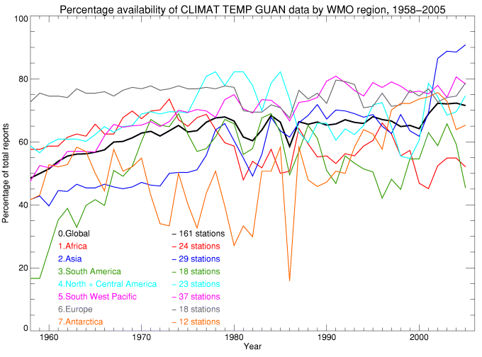
Fig. 3: Annual percentage of CLIMAT TEMP bulletins from GUAN stations received at the Hadley Centre for the period 1958 to 2005.

3. Analysis and Climate Monitoring activities

3.1 Spatial Sampling
The GUAN currently consists of 161 globally distributed stations. Other networks have been used for the analysis of climate variability and change from radiosonde data (for example Angell (1999), Parker et al. (1997), Lanzante et al. (2003)). Sampling errors in trend estimates are not related to the total number of stations, and are most likely sensitive to the station distribution (Free and Seidel (2005), and Rosen et al. (2003)). It is therefore pertinent to attempt to quantitatively define the requirements of sampling density. For climate monitoring the question is: “What spatial distribution of stations is required to adequately capture inter-annual variability of large scale tropospheric temperature and humidity?”
Jones et al. (1997) define correlation decay length (x₀):
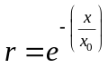
where r is the correlation coefficient and x is the separation between two points. Estimating the correlation decay function from model data (version HadAM3 of the Hadley Centre Atmosphere only model), reanalysis (NCEP/NCAR) and radiosonde data give broadly similar results and these are summarised in Figure 4. In order to fill Figure 4 requires 150 red boxes for temperature, or 360 green boxes for humidity.

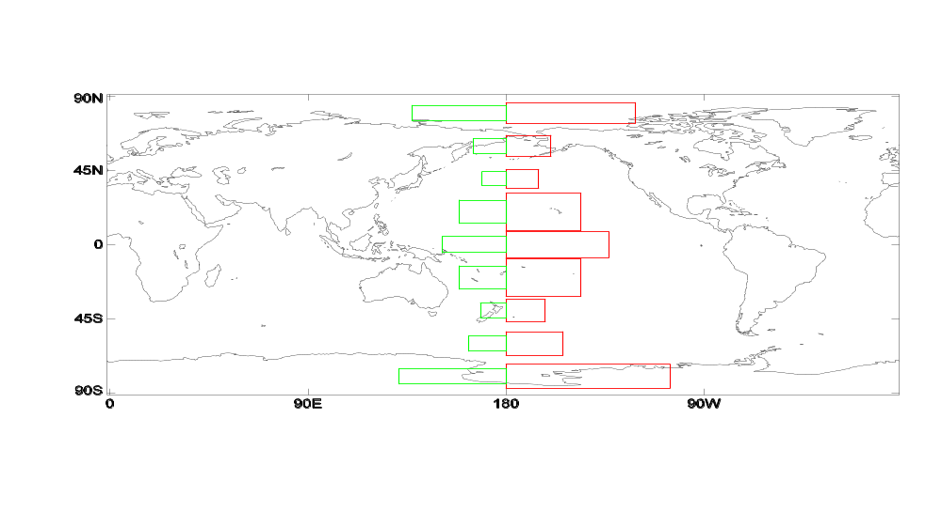
Fig. 4: Example correlation decay areas for different latitude bands for temperature in red, and humidity in green.

Reanalysis and model fields may be used, with caution, to investigate possible sampling biases that may be introduced from theoretical networks that sub-sample the global atmosphere. An example is given in Fig. 5 for the southern hemisphere mid-latitudes. This region is the most poorly sampled especially over the oceans. This leads to significant sampling biases and severely hampers the ability to detect trends in this region. In order to gain the most benefit to the GUAN, observations are required in the remote southern oceans. Statistics such as those presented here will be useful in cost-benefit analysis of proposed modifications to the GUAN in relation to its current configuration.

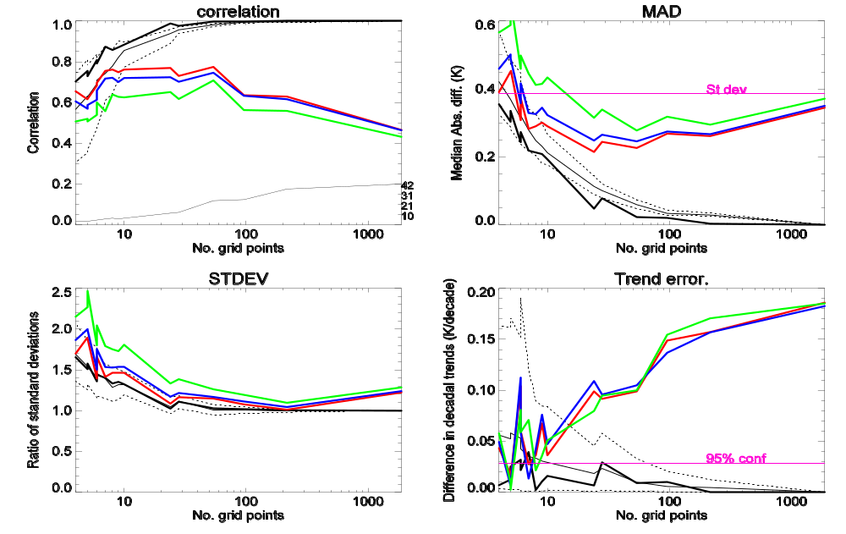
Fig. 5: Analysis of large-scale statistics from reanalysis temperature fields at 500hPa for the region bounded by 30ºS and 60ºS. (a) Correlation coefficient between the time series of the large-scale mean calculated from all grid boxes with the time series of the average of a smaller network of grid boxes. The x-axis denotes the total size of the theoretical network. The black line represents a spatially uniform network, while the dotted lines show the spread of a pseudo-random distribution of the same size, and the thin black line is the median result from these networks. The red line shows the effect of sampling only at locations that contain or have contained a radiosonde station. The blue and green curves are the same as the red curve but with additional noise of 0.5K and 1K added to the data respectively. The total number of possible radiosonde locations in this region is 42. The number of GUAN stations is 19. (b) As (a) but for the Median Absolute Difference (MAD) between the complete and sub-sampled areas. (c) As (a) but the ratio of the standard deviations. (d) as (a) but the difference in the decadal trend estimate (K/decade).
(a)
(b)
(c)
(d)

3.2 Gridded monthly mean products.
HadAT is the Hadley Centre’s new radiosonde global gridded temperature product including uncertainty estimates (Thorne et al (2005)). This is a blend of monthly mean data primarily from the CLIMAT TEMP archive, the Comprehensive Aerological Reference Data Set (CARDS), and Lanzante et al. (2003), and is updated in near real time. The data set is freely available and a full description of this data set and its creation, along with downloads, can be found at http://www.hadobs.org . The
data set consists of a total of 676 stations and is updated in near-real time using a blend of CLIMAT TEMP and the Integrated Global Radiosonde Archive (IGRA) from the National Climatic Data Center (NCDC) of the USA. Figure 6 shows the coverage of HadAT.

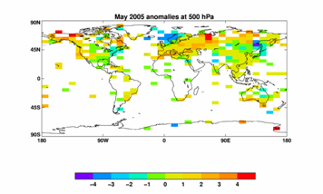
Fig. 6: 500hPa temperature anomalies for May 2005 from HadAT.

3.3 Trends and uncertainties.
The historical radiosonde record contains many systematic biases, in both space and time, which result from changes in instrumentation and observing practices. A number of research efforts have attempted to identify and remove these biases, in order that any climate change signals may be detected. Metadata records at most stations are incomplete and therefore are insufficient to identify and correct for all instrumental changes.
In an attempt to better quantify uncertainty in the historical record that arises from homogenisation techniques, the Hadley Centre has developed an automated system that uses statistical techniques and metadata information to adjust for suspected discontinuities and estimate the uncertainty magnitude. A major advantage of this system is the fact that it is fast and reproducible, therefore it can be run many times with different configurations to assess the sensitivity of long term trends at individual stations to the subjective decisions made during the homogenisation process.
A full description of this process is beyond the scope of this report, but will be submitted as a paper to the peer reviewed literature in due course. Fig 7. shows preliminary results showing large-scale mean trend estimates from the HadAT data set for a range of different configurations of the homogenisation system. The discrepancy between trends at the surface and the troposphere cannot be explained by radiosonde error based upon this small set of experiments. However, work continues at the Hadley Centre to further investigate and better quantify the systematic errors in the global radiosonde temperature record.

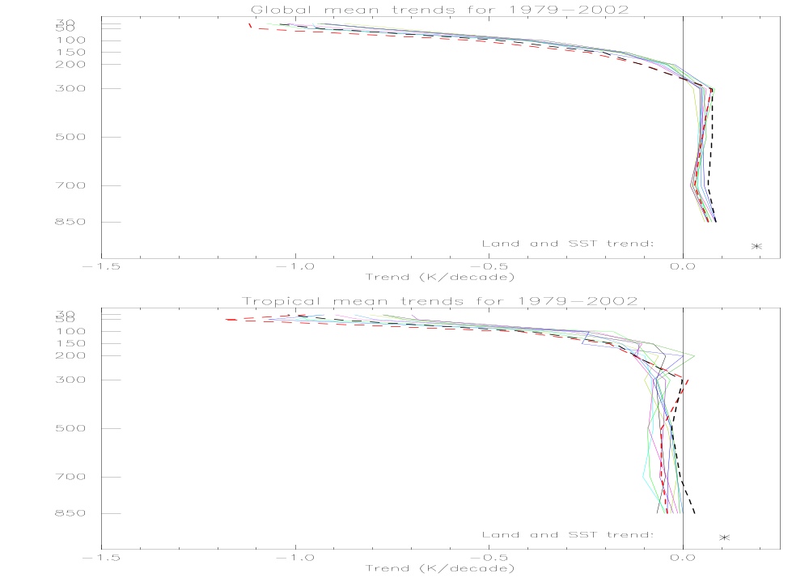
Fig. 7: Trends in mean temperature between 20ºN to 20ºS at pressure levels from different realisations of the HadAT analysis. Land and SST trends sub sampled at radiosonde station locations are shown as a black asterisk.

4. Future activities at the Met Office, Hadley Centre
- Quality control, archive, and monitoring of CLIMAT TEMP bulletins will continue, and http://www.guanweb.com will be maintained.
- A paper on spatial sampling requirements for climate monitoring of upper air temperature and humidity is in preparation.
- HadAT will be updated in near real time and is freely available from http://www.hadobs.org
- A gridded monthly humidity product from radiosondes (HadTH) is currently under development.
- Further analysis of systematic biases and uncertainties in the historical radiosonde records will continue, with the aim of determining whether a robust climate signal can be detected from these data. The magnitude of uncertainties will be estimated both at individual stations and in large-scale means.

5.Conclusions and recommendations
- Africa and South America continue to perform poorly in monitoring statistics and are showing further decline. These are poorly sampled regions of critical
importance for climate research, so maintenance of GUAN stations here is of utmost importance and should be further supported to reverse this decline.
- CLIMAT TEMP bulletins are still used for updating some climate products such as HadAT, and their provision should be supported at least in the short term, although more complete data archives held at NCDC and ECMWF are the primary resource for climate applications.
- The current configuration of the GUAN performs well at monitoring large-scale temperature variability given the constraints of the radiosonde distribution. Future modifications of the GUAN should consider the potential impact on sampling errors where necessary.
- Radiosondes should be supported as a key element of the global climate observing system. Through the GUAN the implementation of the GCOS monitoring principles should be supported to constrain the uncertainty in current and future trends in temperature and humidity of the upper air.
- Radiosondes should be a key element in a global set of about 30 reference stations where their data can be compared with ground-based and satellite-based profiles of the atmosphere.

References

Angell, J. K., 1999: Comparison of surface and tropospheric temperature trends estimated from a 63-station radiosonde network, 1958-1998. Geophys. Res. Letters, 26, No. 17, pp.2761-2764

Free, M., and D. J. Seidel, 2005: Causes of differing temperature trends in radiosonde upper air datasets. J. Geophys. Res., 110, D7

Jones, P. D., T. J. Osborn, and K. R. Briffa, 1997: Estimating sampling errors in large-scale temperature averages. J. Climate, 10, pp.2548-2568

Lanzante, J. R., S. A. Klein, D. J. Seidel 2003: Temporal homogenization of monthly radiosonde temperature data. Part I: Methodology, J. Climate, 16, pp. 224-240

Parker, D.E., Gordon, M., Cullum, D.P.N., Sexton, D.M.H., Folland, C.K., and Rayner, N. 1997: A New Gridded Radiosonde Temperature Data Base and Recent Temperature Trends. Geophys. Res. Letters, 24, 1499-150

Rosen, R. D., J. M. Henderson, and D. A. Salstein, 2003: Sensitivity of continental-scale climate trend estimates to the distribution of radiosondes over North America, J. Atmos. and Ocean tech. 20, pp. 262-268

Thorne, P. W., Parker, D. E., Tett, S. F. B., Jones, P. D., McCarthy, M., Coleman, H., and Brohan, P., 2005: Revisiting radiosonde upper-air temperatures from 1958 to 2002, In press J. Geophys. Res.
Appendix A
List of stations and their performance record for CLIMAT TEMP over the period July 2004 to June 2005.

> 90% receipt – 93 stations
ID Name Country Reliability
-------- ------------------------- ------------------------- -----------
01001 JAN MAYEN NORWAY 100
03005 LERWICK UK 92
03808 CAMBORNE UK 100
03953 VALENTIA OBSERVATORY IRELAND 100
08495 GIBRALTAR, NORTH FRONT GIBRALTAR 92
08508 LAJES/SANTA RITA (ACORES) PORTUGAL 92
10393 LINDENBERG GERMANY 92
17130 ANKARA/CENTRAL TURKEY 100
20674 OSTROV DIKSON RUSSIAN FEDERATION 92
22550 ARHANGEL SK RUSSIAN FEDERATION 100
23472 TURUHANSK RUSSIAN FEDERATION 100
23921 IVDEL RUSSIAN FEDERATION 92
24266 VERHOJANSK RUSSIAN FEDERATION 100
27459 NIZNIJ NOVGOROD RUSSIAN FEDERATION 92
28698 OMSK RUSSIAN FEDERATION 100
29862 HAKASSKAJA RUSSIAN FEDERATION 92
30230 KIRENSK RUSSIAN FEDERATION 100
31088 OHOTSK RUSSIAN FEDERATION 92
32540 PETROPAVLOVSK- KAMCATSKIJ RUSSIAN FEDERATION 100
35121 ORENBURG RUSSIAN FEDERATION 92
41112 ABHA SAUDI ARABIA 100
41217 ABU DHABI INTER. AIRPORT UNITED ARAB EMIRATES 100
45004 KINGS PARK HONG KONG 100
47138 POHANG REPUBLIC OF KOREA 92
47412 SAPPORO JAPAN 100
47646 TATENO JAPAN 100
47827 KAGOSHIMA/YOSHINO JAPAN 100
47971 CHICHIJIMA JAPAN 100
47991 MINAMITORISHIMA JAPAN 100
48698 SINGAPORE/CHANGI AIRPORT SINGAPORE 100
50527 HAILAR CHINA 100
51709 KASHI CHINA 100
52681 MINQIN CHINA 100
53068 ERENHOT CHINA 92
55299 NAGQU CHINA 92
56778 KUNMING CHINA 100
57461 YICHANG CHINA 92
60018 TENERIFE-GUIMAR SPAIN (CANARY ISLANDS) 100
60680 TAMANRASSET ALGERIA 92
61641 DAKAR/YOFF SENEGAL 92
68588 DURBAN (LOUIS BOTHA) SOUTH AFRICA 92
68816 CAPE TOWN (D.F. MALAN) SOUTH AFRICA 100
68906 GOUGH ISLAND TRISTAN DA CUNHA 100
70026 BARROW/W. POST W. ROGERS UNITED STATES OF AMERICA 100
70308 ST PAUL UNITED STATES OF AMERICA 100
70398 ANNETTE ISLAND UNITED STATES OF AMERICA 100
71082 ALERT,N.W.T. CANADA 92
71816 GOOSE,NFLD. CANADA 100
71836 MOOSONEE,ONT. CANADA 100
71925 CAMBRIDGE BAY,N.W.T. CANADA 100
71934 FORT SMITH,N.W.T. CANADA 100
72201 KEY WEST/INT.,FL. UNITED STATES OF AMERICA 92
72250 BROWNSVILLE/INT.,TX UNITED STATES OF AMERICA 100
72293 SAN DIEGO/MIRAMAR, NAS,CA UNITED STATES OF AMERICA 100
72597 MEDFORD/MEDFORD-JACKSON C UNITED STATES OF AMERICA 100
72776 GREAT FALLS/INT., MT. UNITED STATES OF AMERICA 100
78526 SAN JUAN/INT., PUERTO RIC PUERTO RICO & U.S. POSSES 100
85442 ANTOFAGASTA CHILE 92
85469 ISLA DE PASCUA CHILE 92
85586 SANTO DOMINGO CHILE 92
85799 PUERTO MONTT CHILE 92
85934 PUNTA ARENAS CHILE 92
89002 GEORG VON NEUMAYER ANTARCTICA 100
89022 HALLEY ANTARCTICA 100
89532 SYOWA ANTARCTICA 100
89564 MAWSON ANTARCTICA 92
89611 CASEY ANTARCTICA 92
91285 HILO/GEN. LYMAN, HAWAII, PACIFIC ISLANDS 100
91334 TRUK, CAROLINE IS. PACIFIC ISLANDS 100
91376 MAJURO/MARSHALL IS. INTNL PACIFIC ISLANDS 100
91408 KOROR, PALAU IS. PACIFIC ISLANDS 100
91592 NOUMEA (NLLE-CALEDONIE) NEW CALEDONIA 100
91610 TARAWA KIRIBATI 100
91643 FUNAFUTI TUVALU 100
91765 PAGO PAGO/INT.AIRP. SAMOA & AMERICAN SAMOA 100
91958 RAPA FRENCH POLYNESIA 100
93417 PARAPARAUMU AERODROME NEW ZEALAND 100
93844 INVERCARGILL AERODROME NEW ZEALAND 100
93986 CHATHAM ISLAND NEW ZEALAND 100
93997 RAOUL ISLAND, KERMADEC IS NEW ZEALAND 100
94120 DARWIN AIRPORT AUSTRALIA 100
94203 BROOME AIRPORT AUSTRALIA 100
94294 TOWNSVILLE AMO AUSTRALIA 100
94302 LEARMONTH AIRPORT AUSTRALIA 100
94461 GILES AUSTRALIA 100
94610 BELMONT (PERTH AIRPORT) AUSTRALIA 100
94659 WOOMERA AERODROME AUSTRALIA 92
94975 HOBART AIRPORT AUSTRALIA 100
94995 LORD HOWE ISLAND AUSTRALIA (ISLAND) 100
94996 NORFOLK ISLAND AIRPORT AUSTRALIA (ISLAND) 92
94998 MACQUARIE ISLAND AUSTRALIA (ISLAND) 100
96315 BRUNEI AIRPORT BRUNEI DARUSSALAM 100
96996 COCOS ISLAND AIRPORT COCOS ISLAND 100

50% - 90% receipt – 28 stations
ID Name Country Reliability
-------- ------------------------- ------------------------- -----------
02836 SODANKYLA FINLAND 58
04018 KEFLAVIKURFLUGVOLLUR ICELAND 83
11035 WIEN/HOHE WARTE AUSTRIA 83
16245 PRATICA DI MARE ITALY 67
47936 NAHA JAPAN 75
48455 BANGKOK THAILAND 67
61052 NIAMEY-AERO NIGER 67
61901 BOTTOMS WOOD, ST HELENA ST HELENA 83
61976 SERGE-FROLOW (ILE TROMELIN) OCEAN ISLANDS 75
61995 VACOAS(MAURITIUS) MAURITIUS 83
62414 ASWAN EGYPT 50
63450 ADDIS ABABA-BOLE ETHIOPIA 50
63985 SEYCHELLES INTER. AIRPORT SEYCHELLES 58
78397 KINGSTON/NORMAN MANLEY JAMAICA 67
78583 BELIZE/PHILLIP GOLDSTON BELIZE 67
78762 JUAN SANTAMARIA COSTA RICA 75
78988 HATO AIRPORT,CURACAO CURACAO & BONAIRE 58
82397 FORTALEZA BRAZIL 50
84628 LIMA-CALLAO/AEROP. INTERN PERU 67
87155 RESISTENCIA AERO. ARGENTINA 50
87576 EZEIZA AERO ARGENTINA 75
88889 MOUNT PLEASANT, FALKLAND FALKLAND IS 83
89512 NOVOLAZAREVSKAJA ANTARCTICA 83
89571 DAVIS ANTARCTICA 75
89592 MIRNYJ ANTARCTICA 75
91801 PENRHYN COOK ISLANDS 75
94510 CHARLEVILLE AIRPORT AUSTRALIA 83
98223 LAOAG PHILIPPINES 58

25% - 50% receipt – 15 stations
ID Name Country Reliability
-------- ------------------------- ------------------------- -----------
33345 KYIV UKRAINE 42
40745 MASHHAD IRAN 33
61996 MARTIN DE VIVIES-ILE AMSTERDAM OCEAN ISLANDS 42
61998 PORT-AUX-FRANCAIS - KERGUELEN OCEAN ISLANDS 25
64910 DOUALA OBS. CAMEROON 42
67197 FORT-DAUPHIN MADAGASCAR 25
68994 MARION ISLAND SOUTH AFRICA 25
76654 MANZANILLO,COL. MEXICO 25
78954 GRANTLEY ADAMS BARBADOS 25
82193 BELEM (AEROPORTO) BRAZIL 25
82332 MANAUS (AEROPORTO) BRAZIL 33
83378 BRASILIA (AEROPORTO) BRAZIL 33
89009 AMUNDSEN-SCOTT ANTARCTICA 33
91925 ATUONA FRENCH POLYNESIA 42
91938 TAHITI-FAAA FRENCH POLYNESIA 42

1% - 25% receipt – 6 stations
ID Name Country Reliability
-------- ------------------------- ------------------------- -----------
04270 NARSARSUAQ GREENLAND 8
43599 GAN MALDIVES 17
67774 HARARE (BELVEDERE) ZIMBABWE 8
80222 BOGOTA/ELDORADO COLOMBIA 17
83779 MARTE CIV/MIL BRAZIL 17
87860 COMODORO RIVADAVIA AERO ARGENTINA 17

0% receipt – 19 stations
ID Name Country Reliability
-------- ------------------------- ------------------------- -----------
37789 YEREVAN/YEREVAN-ARABKIR ARMENIA 0
61902 ASCENSION ISLAND AIRFIELD ASCENSION IS 0
63741 NAIROBI/DAGORETTI KENYA 0
63894 DAR ES SALAAM AIRPORT UNITED REPUBLIC OF TANZAN 0
65578 ABIDJAN COTE D'IVOIRE 0
68110 WINDHOEK NAMIBIA 0
72451 DODGE CITY/MUN., KS. UNITED STATES OF AMERICA 0
72520 PITTSBURGH/GREATER PITTSB UNITED STATES OF AMERICA 0
78016 BERMUDA NAVAL AIR STATION BERMUDA 0
81405 CAYENNE/ROCHAMBEAU FRENCH GUIANA 0
84008 SAN CRISTOBAL (GALAPAGOS) ECUADOR 0
89055 BASE MARAMBIO(CENTRO MET. ANTARCTICA 0
89642 DUMONT D URVILLE ANTARCTICA 0
89664 MCMURDO ANTARCTICA 0
91212 NWSO AGANA, GUAM, MARIANA PACIFIC ISLANDS 0
91517 HONIARA SOLOMON ISLANDS 0
91557 BAUERFIELD (EFATE) VANUATU 0
92035 PORT MORESBY M.O. PAPUA NEW GUINEA 0
96935 SURABAYA/JUANDA INDONESIA 0

