WORLD METEOROLOGICAL ORGANIZATION  ____________________  COMMISSION FOR BASIC SYSTEMS OPEN PROGRAMME AREA GROUP ON INTEGRATED OBSERVING SYSTEMS  CBS/GCOS EXPERT MEETING ON COORDINATION  OF THE GSN AND GUAN  OFFENBACH, GERMANY, 15-17 MAY 2002 |  |  | Distr.: RESTRICTED  CBS/OPAG-IOS (EMCGG-1)/DOC.4/Add.1  (10.IV.2002)  __________  Item : 3  Original: ENGLISH

SURFACE DATA QUALITY MONITORING ACTIVITIES IN RA I

(Submitted by Mr I. Gitonga)

Summary and Purpose of Document

The document contains a review of surface data quality monitoring activities carried out by the Regional Specialized Meteorologocal Centre (RSMC) Nairobi in Region I.

ACTION PROPOSED

The meeting is invited to take into consideration the information appended to this document when discussing how the existing arrangements can be used to improve monitoring of CLIMAT and CLIMAT TEMP reports.

Appendix: Surface data quality monitoring activities in RA I

Surface data quality monitoring activities in RA I

SECTION I:

SURFACE PRESSURE QUALITY MONITORING IN RA I

- INTRODUCTION

In 1985, the Commission for Basic Systems (CBS) of the World Meteorological Organization (WMO) agreed that there was a need for the major Numerical Weather Prediction centers to monitor the quality of observation by comparing the model first guess with the observation at the station and exchange monthly lists of stations that are persistently in error. The model first guess fields are obtained by interpolating to the observation point.

In 1988, the commission (CBS) appointed 3 lead centers to co-ordinate the results from the observing stations and inform the WMO secretariat of the persistent errors obtained, produce monthly reports and consolidate six monthly reports. The three centers were:
ECMWF-----For radio sonde and pilot observations
Bracknell----For marine surface observations
Washington--For aircraft and satellite observations.

Other centers nominated by CBS for the monitoring of the quality of land surface stations are:
Nairobi-------------------Regional Association I
Tokyo---------------------Regional Association II
Buenos Aires------------Regional Association III
Montreal------------------Regional Association IV
Melbourne---------------Regional Association V
Offenbach----------------Regional Association VI

These centers are supposed to produce monthly lists of observing stations that persistently report erroneous observations. They are also supposed to compile six monthly consolidated lists of suspect stations (stations reporting erroneous data). The purpose of this is to investigate possible sources of the errors on the reported data with the aim of correcting the errors so as to improve on the data quality.
Below (1.1) are some possible sources of errors.

1.1 POSSIBLE SOURCES OF ERRORS
1. -----Coding errors.
2. -----Incorrect sea-level adjustment for height of barometer.
3. -----Corruption during transmission.
4. -----Position errors.
5. -----Barometric errors: - Wrong calibration.
- Faulty barometer etc.

2.0 METHODOLOGY
The monitoring of surface pressure currently going on in NMC Nairobi for Regional Association I is based on the results of the Numerical Weather Prediction (NWP) Model used by the UK Met. Office. The UK MET Office runs a six-day forecast twice a day plus other two day forecasts grid point model with a horizontal resolution of 0.556 degrees latitude by 0.833 degrees longitude with 30 levels in the vertical. Data assimilation is performed in a continuous six-hour cycle using a 3-dimensional variation system. (Details: see Lorenc et al (2000, quarterly Journal of the Royal Met. Soc)).
The basis of all the data quality monitoring are the observation minus background (O-B) differences often referred to as the bias where O = observation at station, B = background or simply the first guess from. Systematic errors from the observations can be identified by taking averages of the (O-B) over a sufficiently long period e.g. one month. By this method, persistent low quality observations can easily be detected. Besides the differences (differences of the observation (O) and first guess (B), calculation of the means and the root mean squares (RMS.) of the same (O-B) are also done. All these analyzed for a reasonably sufficient length of time (at least one month) are used to detect stations with erroneous reports.

2.1 ERROR DETECTION CRITERIA

The O-B statistics having been obtained i.e. mean, RMS, number of observation and percentage gross errors for a given station; cut-off values for error detection are designated. These cut-off values are entirely objective depending on the availability of data and period of time being monitored. The monitoring is done on monthly and six-monthly periods, each of which has its own error detection criteria.

2.1a. For monthly monitoring
* Number of observations = or > 20 and one of the following.
(i) Magnitude of Mean (O-B) = or > 4 hPa or
(ii) Standard deviation = or > 6 hPa or
Percentage gross error at least 25%
NB: The gross error is defined as an observation that depart from the background by at least 15 hPa.

2.1b. For six-monthly monitoring:
* Number of observations = or >40 and one of the following.
(i) Magnitude of Mean (O-B) = or >3.5 hPa. or
(ii) Standard deviation = or >5 hPa or
Percentage gross error at least 25%.

NB: a) the gross error is defined as in 2.1a above.
b) * The number of observations varies in case of land surface synops depending on the availability of data but remains unchanged for ship reports (pressures).

Presentation of Results

Tables
- All suspect stations for a given period eg. July – Dec 2001

 | Stn.No | Stn.Name | Elev | Country | First Date | Last Date | Lat. | Long. | No.of Obs | Mean O-B | SD O-B | % G/Error
1 | 60437 | Medea | 981 | Algeria | 7/2/01 12:00 | 12/30/01 12:00 | 36.3 | 2.75 | 168 | -6.5 | 0.97 | 8.93
2 | 60476 | Khenchela | 1116 | Algeria | 7/2/01 12:00 | 12/31/01 12:00 | 35.4 | 7.15 | 166 | 9.7 | 0.85 | 62.65
3 | 60728 | Nabeul | 5 | Tunisia | 7/2/01 12:00 | 12/31/01 12:00 | 36.5 | 10.73 | 165 | -4.9 | 4.45 | 33.33
4 | 62790 | Nyala | 655 | Sudan | 7/1/01 0:00 | 12/31/01 12:00 | 12.1 | 24.88 | 270 | 3.8 | 1.89 | 56.67
5 | 63170 | Hargeisa | 1326 | Somalia | 7/4/01 12:00 | 12/26/01 12:00 | 9.5 | 44.08 | 57 | 7.0 | 1.06 | 40.35
6 | 63175 | Burao | 1032 | Somalia | 7/2/01 12:00 | 12/26/01 12:00 | 9.52 | 45.57 | 49 | 7.2 | 0.83 | 4.08
7 | 63333 | Combolcha | 1903 | Ethiopia | 7/3/01 12:00 | 12/31/01 12:00 | 11.1 | 39.73 | 63 | 5.1 | 0.63 | 15.87
8 | 63334 | Debremarcos | 2515 | Ethiopia | 7/2/01 12:00 | 12/31/01 12:00 | 10.3 | 37.67 | 60 | 11.4 | 0.65 | 1.67
9 | 63402 | Jimma | 1725 | Ethiopia | 7/2/01 12:00 | 12/31/01 12:00 | 7.67 | 36.83 | 62 | 7.5 | 0.72 | 1.61
10 | 63450 | A/ Ababa-Bole | 2354 | Ethiopia | 7/2/01 12:00 | 12/31/01 12:00 | 9.03 | 38.75 | 53 | 4.0 | 0.87 | 1.89
11 | 63453 | Metehara | 930 | Ethiopia | 7/2/01 12:00 | 12/31/01 12:00 | 8.87 | 39.9 | 63 | -4.3 | 0.85 | 3.17
12 | 63471 | Diredawa | 1260 | Ethiopia | 7/2/01 12:00 | 12/31/01 12:00 | 9.6 | 41.85 | 61 | 9.9 | 0.81 | 1.64
13 | 63478 | Gode | 295 | Ethiopia | 7/2/01 12:00 | 12/31/01 12:00 | 5.9 | 43.58 | 47 | 5.3 | 0.87 | 0.00
14 | 63680 | Kampala | 1140 | Uganda | 7/2/01 12:00 | 12/21/01 12:00 | 0.32 | 32.62 | 67 | -7.7 | 0.91 | 0.00
15 | 63801 | Kigoma | 885 | Uganda | 7/1/01 12:00 | 12/21/01 12:00 | -4.9 | 29.63 | 55 | 8.2 | 0.90 | 14.55
16 | 65355 | Niamtougou | 343 | Togo | 9/17/01 0:00 | 12/31/01 12:00 | 9.77 | 1.1 | 149 | -12.2 | 2.03 | 65.77
17 | 67231 | Cuamba | 607 | M/bique | 7/5/01 12:00 | 12/31/01 12:00 | -15 | 36.53 | 126 | 3.6 | 1.38 | 3.17
18 | 67599 | Mfuwe | 570 | Zambia | 7/17/01 12:00 | 12/29/01 12:00 | -13 | 31.93 | 44 | 4.1 | 1.00 | 4.55
19 | 68030 | P/ntenga | 1071 | Botswana | 7/1/01 12:00 | 11/30/01 12:00 | -19 | 25.63 | 140 | 5.6 | 0.80 | 0.00
20 | 68038 | Sua- Pan | 904 | Botswana | 7/1/01 0:00 | 11/30/01 12:00 | -20 | 25.98 | 133 | 4.9 | 1.02 | 0.75
21 | 68396 | Manzini/M Airport | 641 | Swaziland | 7/1/01 12:00 | 11/30/01 12:00 | -27 | 31.3 | 137 | 4.8 | 1.26 | 24.09
22 | 68530 | Douglas | 995 | S/ Africa | 7/1/01 12:00 | 11/29/01 12:00 | -29 | 23.75 | 96 | 4.0 | 3.42 | 65.63

- Retentions: Showing stations that have re-emerged as suspects.

 | Stn.No | Stn.Name | Country | No.of Obs | Mean O-B
1 | 62790 | Nyala | Sudan | 270 | 3.8
2 | 63453 | Metehara | Ethiopia | 63 | -4.3
3 | 63471 | Diredawa | Ethiopia | 61 | 9.9
4 | 63680 | Kampala | Uganda | 67 | -7.7
5 | 63801 | Kigoma | Uganda | 55 | 8.2
6 | 68030 | P/ntenga | Botswana | 140 | 5.6
7 | 68038 | Sua- Pan | Botswana | 133 | 4.9
8 | 68396 | Manzini | Swaziland | 137 | 4.8

- New Suspects: A table of newly emerged suspect stations is drawn as well.

b)Maps – Geographical locations of suspect stations in the Region for the period monitored. In this case, July-December 2001.
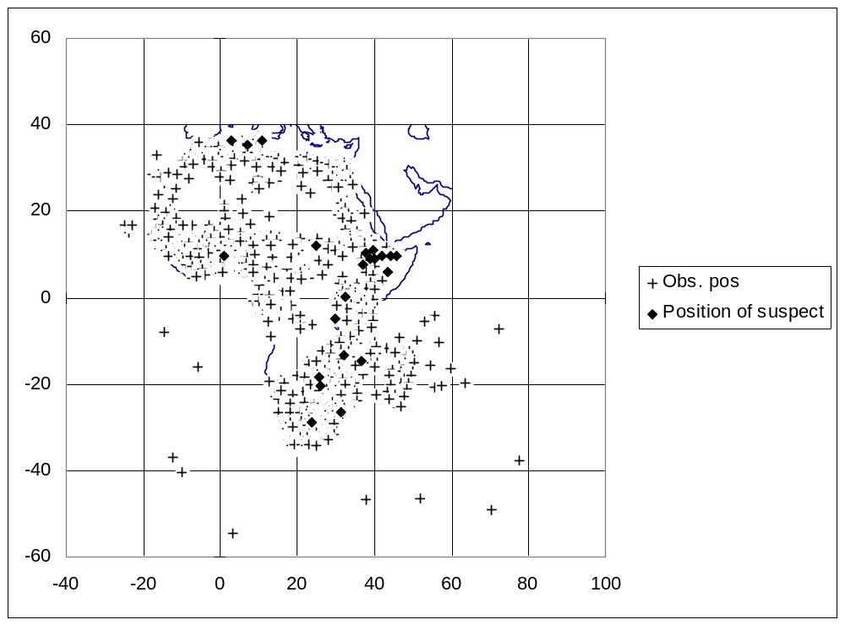

- Time Series: The suspect station, (stn no, 60437 for Jul-Dec 2001 period) shows a mean of a higher magnitude than other co-located stations within 200km.
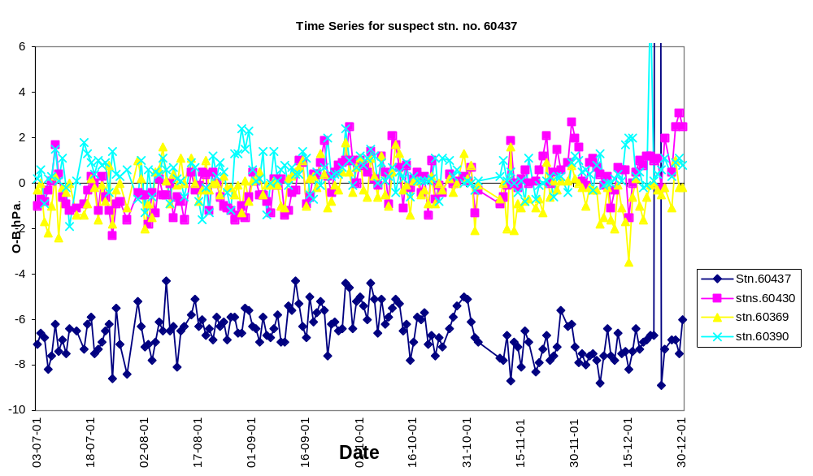

Local: Location of the suspect station (60437, shown in bold), as compared to the neibouring stations.
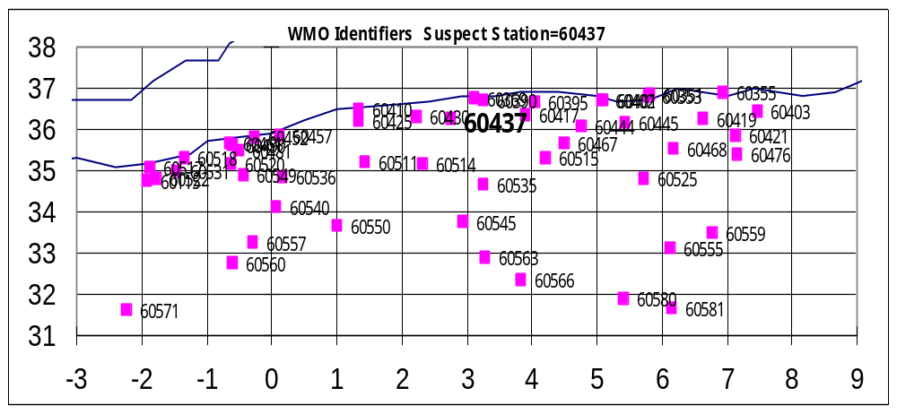

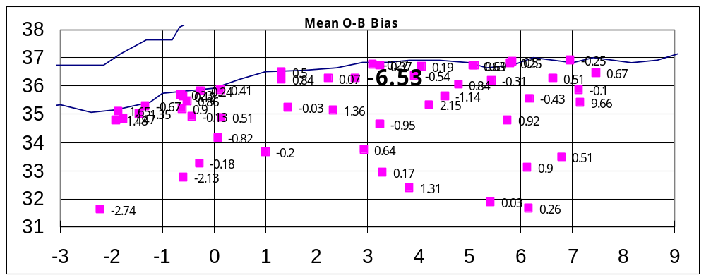A plot of the mean bias for respective stations, in the case below shows the mean of stn. no. 60437 having the highest magnitude (shown in bold). NB. The positions of these values are the same for the stations shown in the preceding map above.

SECTION II: DATA QUANTITY MONITORING
The amount of data from Regional Association I received at RTH Nairobi is monitored on monthly basis. This is to monitor the performance, in terms of the data volume as compared to the data quality of each station in RA I that sends data to Nairobi RTH both surface and upper air stations.

 | DECEMBER-2001
Country code | Country Name | NO. of Stns reported | Total No. of Stns
DAMM | ALGERIA | 65 | 72
DBBB | BENIN | 5 | 6
DFFD | BURKINA FASO | 8 | 11
DIAP | COTE D’IVOIRE | 9 | 14
DNMM | NIGERIA | 3 | 33
DRRN | NIGER | 12 | 16
DTTA | TUNISIA | 7 | 25
DXXX | TOGO | 4 | 9
EGRR | OCEAN ISLANDS | 1 | 14
FAPR | SOUTH AFRICA | 68 | 174
FBSK | BOTSWANA | 14 | 18
FCBB | CONGO | 9 | 16
FDMS | SWAZILAND | 1 | 1
FEFF | CENRAL AFRICAN REPUBLIC | 13 | 14
FIMP | MAURITIUS | 5 | 5
FKKD | CAMEROON | 9 | 19
FMCH | COMOROS | 1 | 4
FMMG | MADAGASCAR | 26 | 27
FOOL | GABON | 13 | 13
FQMA | MOZAMBIQUE | 12 | 23
FSIA | SEYCHELLES | 1 | 6
FTTJ | TCHAD | 15 | 16
FVHA | ZIMBABWE | 12 | 43
FZAA | DEMOCRATIC REPUBLIC OF CONGO | 16 | 57
GABS | MALI | 19 | 20
GCLP | SPAIN/CANARY ISLANDS | 4 | 9
GMMC | MOROCCO | 23 | 35
GOOY | SENEGAL | 12 | 12
GQNN | MAURITANIA | 13 | 16
GVAC | CAPE VERDE | 3 | 3
HAAB | ETHIOPIA | 18 | 17
HCMM | SOMALIA | 4 | 22
HECA | EGYPT | 24 | 58
HKNC | KENYA | 25 | 25
HLLT | LIBYAN ARAB JAMAHIRYA | 22 | 24
HRYR | RWANDA | 1 | 5
HSSS | SUDAN | 28 | 40
HTDA | TANZANIA | 14 | 21
HUEN | UGANDA | 7 | 12
LPMG | MADEIRA | 2 | 3

