WORLD METEOROLOGICAL ORGANIZATION  _________________  CBS LEAD CENTRES FOR GCOS  COORDINATION MEETING  GENEVA, SWITZERLAND  10-12 NOVEMBER 2009 |  | CBS/GCOS LC/Doc. 8.1  (30.X.2009)  ________  ITEM: 8  Original: ENGLISH

REPORT FROM GCOS MONITORING CENTRES

Deutscher Wetterdienst (DWD)
(Submitted by Christiana Lefebvre, Deutscher Wetterdienst)

Summary and Purpose of Document

This document provides information on activities carried out by the GCOS Monitoring Centre, Deutscher Wetterdienst

ACTION PROPOSED

The meeting is invited to take into account the information provided in the document when discussing relevant agenda items

____________

CBS Lead Centres for GCOS Coordination Meeting
8. Reports from GCOS Monitoring Centres
8.1 Germany DWD

Global Climate Observing System Surface Network - Interim Report of the year 2009

Monitoring Period: January to September 2009

Published by Deutscher Wetterdienst (DWD)

- Background and Introduction:
Background information on the GSNMC has been provided in the earlier monitoring reports, and is also available via the GSNMC web site: (http://www.gsnmc.dwd.de/ (Please click there on the UK flag for the English version)

- Monitoring Methods
The monitoring methods have been described in earlier monitoring reports and also on the GSNMC web site: (http://www.gsnmc.dwd.de/ (sea above)

- Monitoring Results:
  - AVAILABILITY AND TIMELINESS OF CLIMAT REPORTS

Compared to 2008, the overall availability of CLIMAT reports for the GSN stations increased slightly reaching up to about 83 % from May to August 2009. In September there was a sudden drop to 78 % (Fig. 3.1.1), which was caused by a reduced receipt of US CLIMAT messages (Fig. 3.1.2). This reduction was caused by a loss of US CLIMAT reports due to the lack of the header line in several US bulletins containing the code name CLIMAT and the month year indicator, which is essential for the decoding of the bulletins.

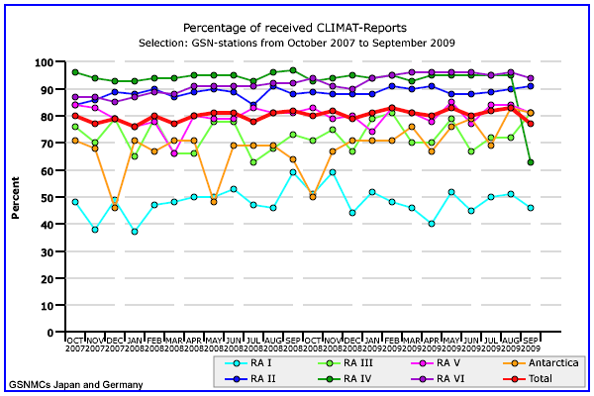

Fig. 3.1.1: Time-series of the percentage of CLIMAT Reports received at DWD and JMA for the GSN Stations over the period October 2007 to September 2009 for the individual WMO RA’s and overall.

Fig. 3.1.1 shows, that there is still a large difference in the receipt of CLIMAT reports from the different WMO regions (RA’s). The percentages of received GSN CLIMAT reports from Europe (RA VI) and North and Central America (RA IV) are about 95 %, which are the highest reception rates during 2009. The exceptionally sharp drop of US reports in September 2009 was already mentioned. The data were received, but could not be identified and decoded due to the missing header. The CLIMAT reports received from Asia (RA II) remained at a level of 90 % and that from South West Pacific (RA V) of 80 %, which was reached at the beginning of the second half of 2008. The reception rate of GSN CLIMAT reports from South America (RA III) continued to vary mostly between 65 and 80 %, while there was a significant increase in availability of CLIMAT reports from Antarctica, which reached more than 80 % in August and September 2009. In contrast, there were no improvements in Africa (RA I), which is still the region with the lowest reception rate of only 50 % or less. The increases to 60 % in September and November 2009 were an exception.

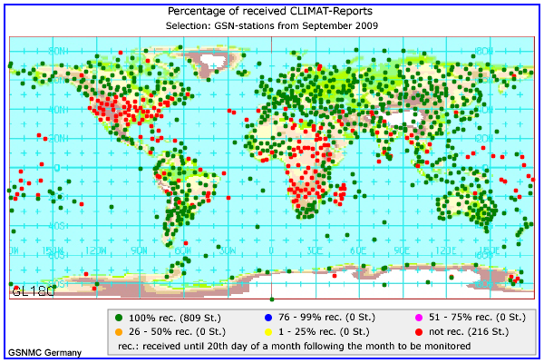

Fig. 3.1.2: Spatial distribution of the percentage of CLIMAT Reports received at DWD for the 1025 GSN stations in September 2009.

Fig. 3.1.3 reflects the spatial distribution of the percentage of CLIMAT reports received from October 2008 to September 2009 at DWD and JMA. Though, there is an overlapping period of 3 months compared to the GSNMC Monitoring Report No. 13 of the year 2008, some improvements during 2009 can be stated: At JMA, the reception rate of reports from South Africa increased, reaching 100 %, the same level as for DWD. Both centres saw an increase of reports from Mozambique (Africa) and from Bolivia and Ecuador (South America). In contrast, there was a decrease in the receipt of CLIMAT reports from Sudan at both centres and from Argentina at DWD. At both centres, data especially from parts of central and southern Africa continued to be often or totally missing. A continued reduced receipt is also to be seen from parts of south-western Asia, especially Iran and Afghanistan. The reduction of CLIMAT reports in the USA reflects the problem from September 2009.
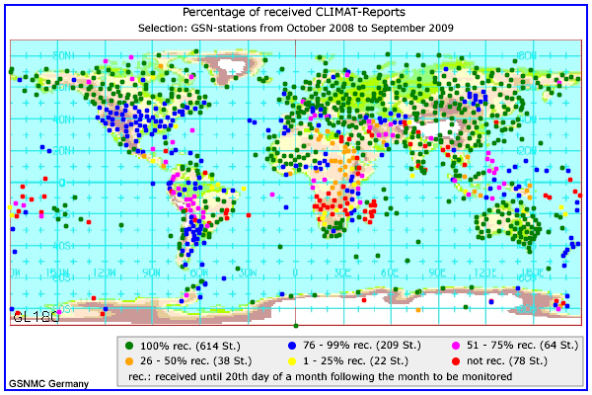

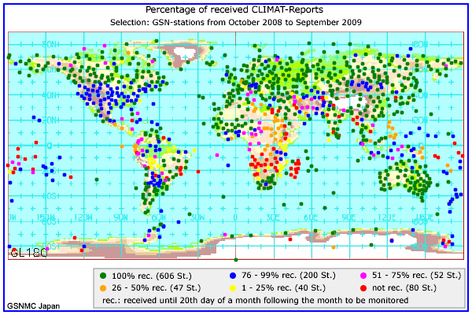

Fig. 3.1.3: Spatial distribution of the percentage of CLIMAT Reports received at DWD (top) and JMA (bottom) for the GSN Stations (1025 stations) over the period October 2008 to September 2009.

Though CLIMAT reports should be distributed globally via GTS, differences in the reception rate at DWD and JMA in different continents could be observed. JMA often received fewer reports than DWD.

As a consequence of increased efforts and liaisons of the CBS Lead Centres for GCOS data, the GCOS Secretariat and the GTS-RTHs the relay of CLIMAT Reports via GTS could be improved, leading to an increase of reports received at JMA. In June and August 2009 even the same amount of messages were obtained as at DWD. In the majority of the months, the combination of both data sets still results in an improvement of the overall CLIMAT receipt.

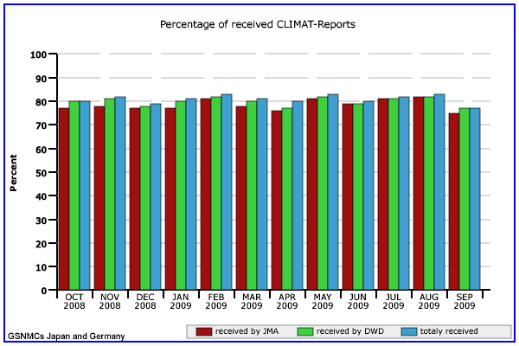

Fig. 3.1.4: Percentage of CLIMAT Reports for the GSN stations received at DWD, JMA and in total over the period October 2008 to September 2009.

According to WMO regulations CLIMAT messages should be disseminated until 5th day and not later than the 8th of the month following the evaluation month.

The timeliness of the monthly CLIMAT reports from January to September 2009 can be obtained from fig. 3.1.5. Like in 2008, there was no significant difference between JMA and DWD. Within the first 5 days after the end of the evaluation month both centres received a portion of 60 to about 73 % of all messages. Between 2 and 17 % followed up to the 8th and further on 2 to 13 % were obtained up to the 20th, the cut-off date for the GSNMC monitoring. Often in 2009, a high portion of CLIMAT reports received up to the 5th was an indicator for an above average total in this month.

  - DATA QUALITY

The performance indicator CA and CC, published on the web site and in ANNEX V of this report, indicates the number of received and correct CLIMAT reports of every GSN station during the previous 12 months.
Owing to problems arising from changes in the setup of the ftp servers at DWD and JMA, the exchange of the monitoring files for the evaluation of the precipitation totals and monthly mean temperatures was hampered, so that the generation of the final GSNMC files containing the QC information for precipitation and temperature was delayed. Therefore the performance indicators CT and CR are currently only available at the web site for October to December 2008, but not for 2009. At the end of October, these ftp problems finally were solved and the results will be published as soon as possible.

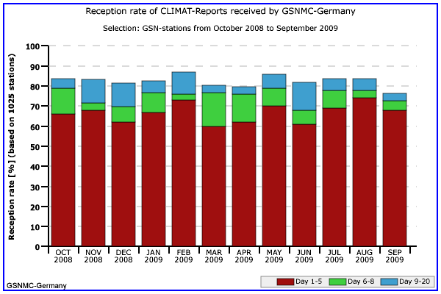

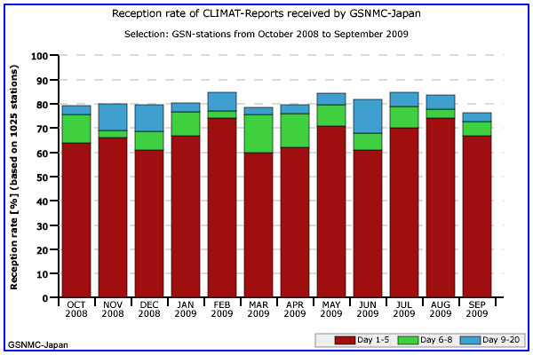

Fig. 3.1.5: Timeliness of the CLIMAT Reports for the GSN Stations received at DWD (top) and JMA (bottom) over the period October 2008 to September 2009.

C. Lefebvre, U. Schneider
Deutscher Wetterdienst
Business Unit: Climate and Environment (KU)
20359 Hamburg
Germany
e-mail: christiana.lefebvre@dwd.de

