WORLD METEOROLOGICAL ORGANIZATION  _________________  CBS LEAD CENTRES FOR GCOS  COORDINATION MEETING  GENEVA, SWITZERLAND  10-12 NOVEMBER 2009 |  | CBS/GCOS LC/Doc. 7  (03.XI.2009)  ________  ITEM: 7  Original: ENGLISH

REPORT FROM THE GCOS ARCHIVE CENTRE

(Submitted by Matthew Menne, NOAA/National Climatic Data Center)

Summary and Purpose of Document

This document provides an assessment of activities at the GCOS Archive Centre at NOAA/NCDC

ACTION PROPOSED

The meeting is invited to take into account the information provided in the document when discussing relevant agenda items

____________

GCOS Archive/Analysis Centre Report

- As of April 2009, 872 out of the 1025 GSN sites have been identified as having daily data from one or more sources in the Global Historical Climatology Network (GHCN)-Daily/GSN archive (up from 850 in 2008). Data have officially been provided for 556 of these sites as part of the GCOS or other bilateral data exchange agreements. As shown in Table 1, the data from these official exchanges comprise about 62% of the GSN database.

Table 1. Summary of the GHCN-Daily/GSN* archive for daily maximum and minimum temperature and total precipitation (TMAX, TMIN and PRCP).
YEAR | Total number of GSN stations identified in GHCN-Daily | Total number of all daily GSN values obtained through official GCOS exchanges  (TMAX, TMIN, PRCP) | Total number of all GSN daily values  (TMAX, TMIN, PRCP) | Percent of GSN database originating via official GCOS or bilateral exchanges
2008 | 850 | 26 571 728 | 42 635 427 | 62 %
2009 | 872 | 28 278 921 | 45 476 237 | 62%
*GSN data are available at http://www.ncdc.noaa.gov/oa/climate/ghcn-daily.

- Between May 2008 and April 2009 the equivalent of about 1500 station years of data were added to the GSN database via official exchanges. The longest station record addition was for Zagreb/Gric, Croatia, which was included in the GSN in 2009. Data provided for this site begin in December 1861 and ended in December 2007. The local focal point has indicated that annual updates will be provided to the Archive Centre, and data for 2008 were added in June 2009.
During the past year or so, Switzerland also provided long historical records of daily data for the GSN stations at Grand St. Bernard (1864 to 2006) and Saentis (1882 to 2006).
Other GSN additions during the past year include:
- Updates for 2006 and 2007 from Sweden
- Daily data from 2004 to 2008 for Kyrgyzstan
- Daily data from 1949 to 2005 from Iceland
- Daily data for 2008 from Latvia
- Daily data for 2004 to 2009 for 9 stations and 1968 to 2009 for 1 station in Norway
- As shown in Fig. 3, ongoing updates of daily data are regularly provided by Iran, Estonia, Uzbekistan, Estonia, Cyprus, USA, and Canada. The GCOS Archive Centre also has an agreement to add real-time updates from Australia. Norway and Mexico have also been identified as good candidates for real-time updating.

- The GSN daily database is managed as a subset of the Global Historical Climatology Network (GHCN) Daily database (http://www.ncdc.noaa.gov/oa/climate/ghcn-daily). For ease of access, a separate directory of GSN station files is maintained (see in particular ftp://ftp.ncdc.noaa.gov/pub/data/ghcn/daily/gsn for daily data from GSN stations and the “tar ball” file ghcnd_gsn.tar.gz). Fig. 4 indicates the status of the daily records from GSN stations at the end of 2008 (as provided for the update to the GCOS Implementation Plan). A station inventory can be provided to all the CBS Lead Centers for GCOS to aid in targeting requests for additions to the GSN daily database. However, from a database maintenance perspective, full period of record updates should be provided for GSN stations whenever possible to help ensure consistency between the GSN archive and the databases maintained by Members. It is also possible to arrange for regular data updates via ftp or web services. In addition, high level discussions regarding the sharing of climate quality daily summaries across the GTS should be encouraged.

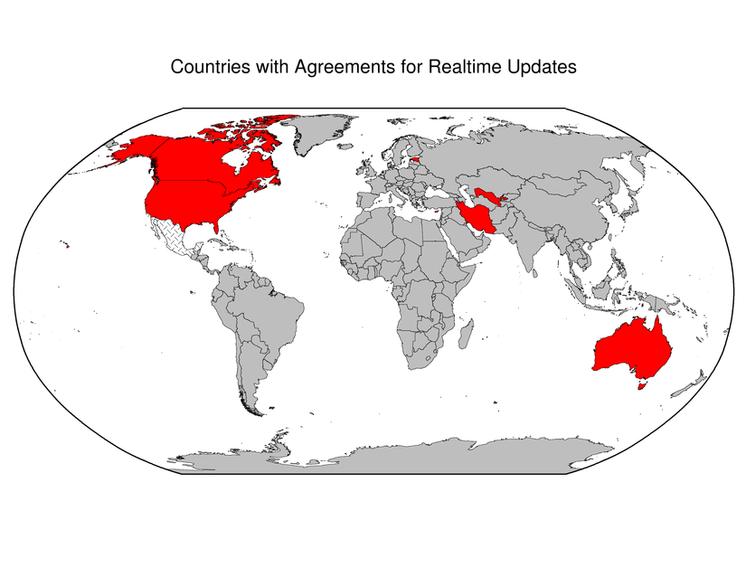
Figure 1. Countries having agreements with the Archive Centre at NOAA/NCDC to provide real or near real-time updates to the GSN database. Countries in hachure have been identified as potential future real or near-real time data contributors.

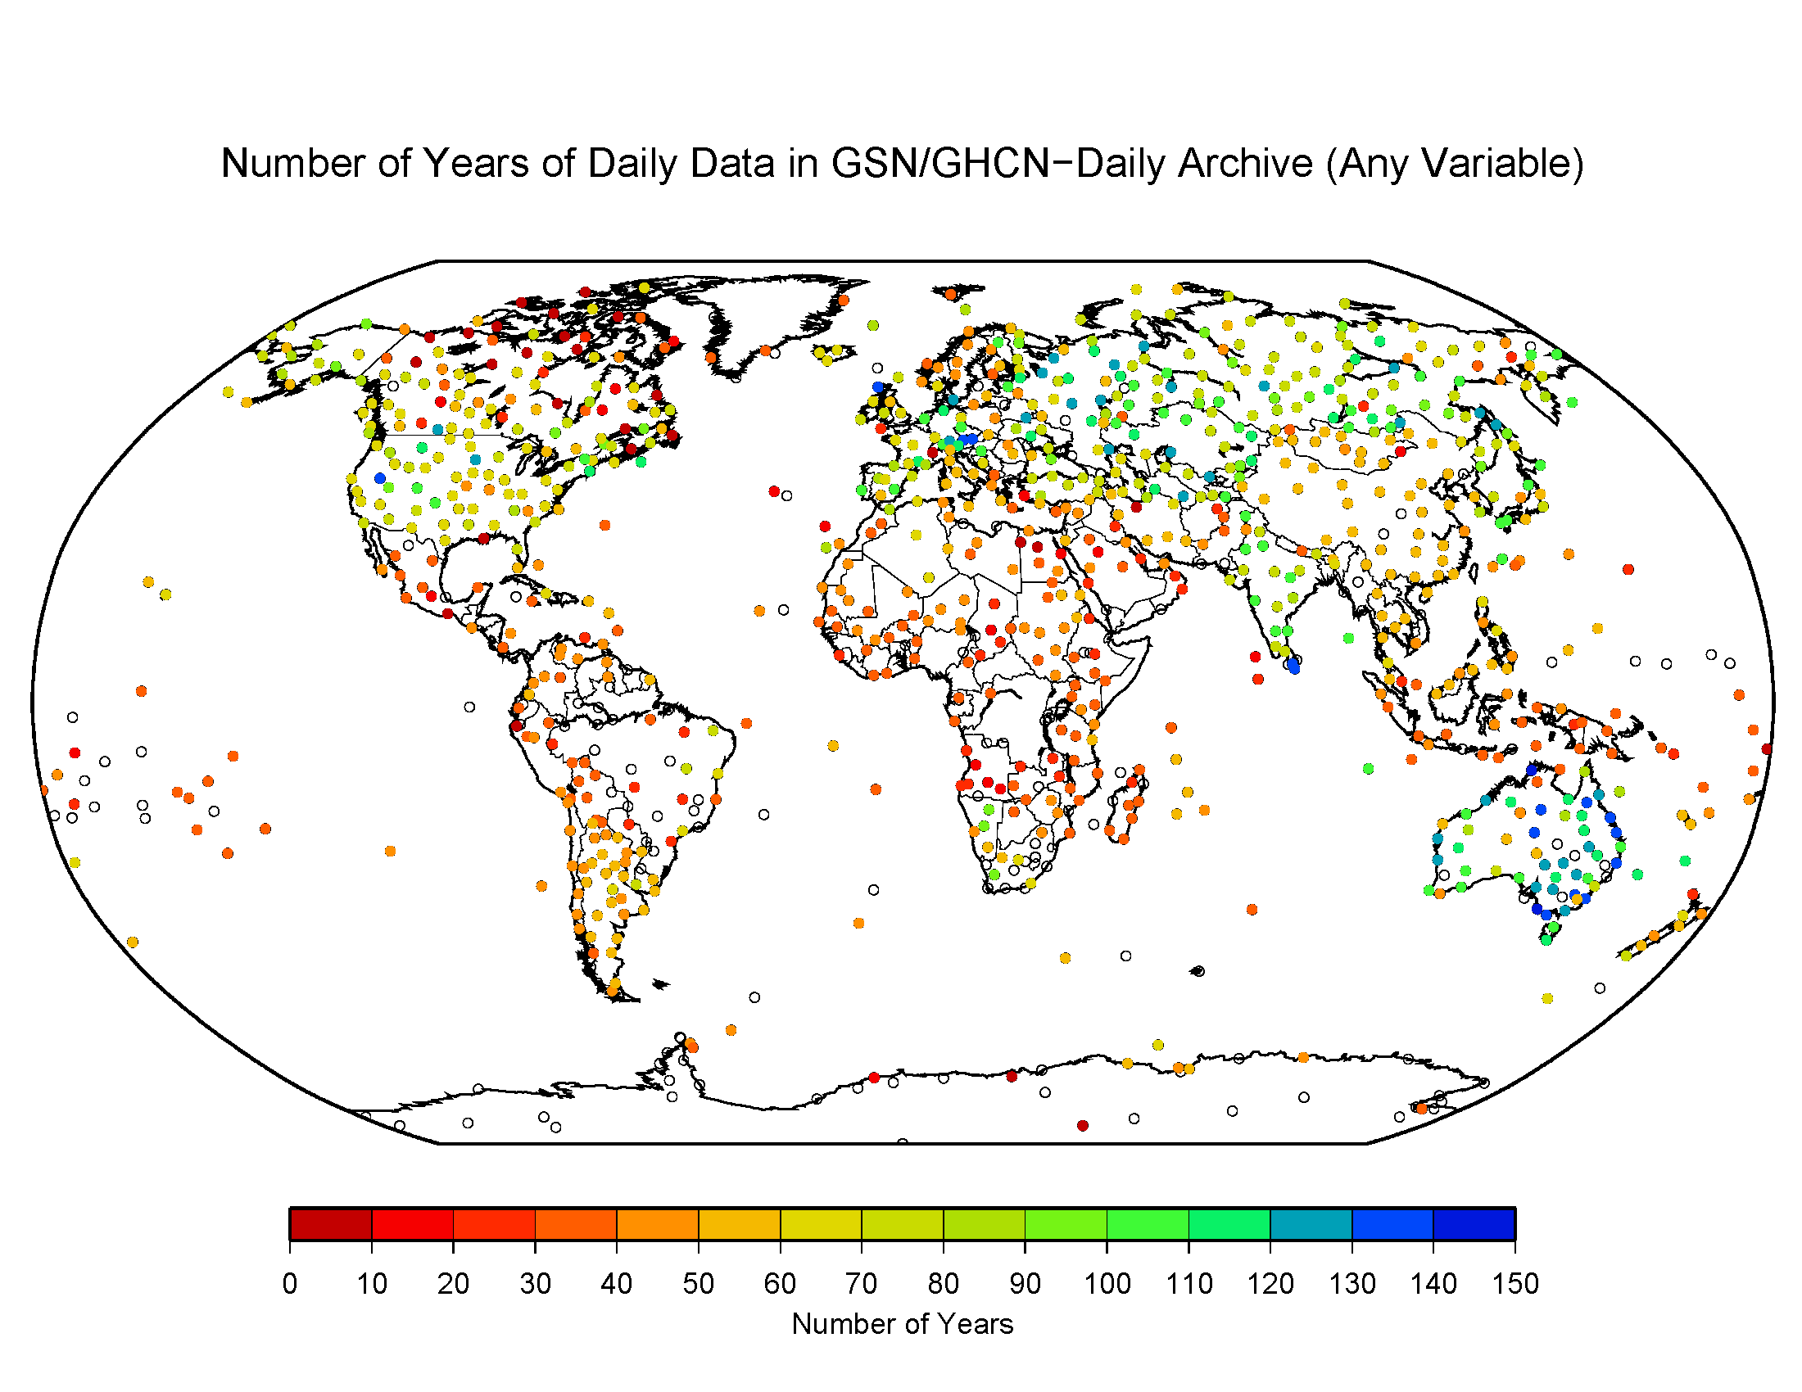
Figure 2. Number of years of data by station in the GHCN-Daily/GSN database at the end of 2008.

- The quality of GHCN (and by implication GSN) daily data are assessed by a suite of comprehensive quality assurance checks as described in a manuscript by Durre et al. (in review). These checks are the same checks that are applied to all daily data from the USA and that will soon become part of the official daily data processing system at NCDC. An overview of the GHCN-Daily dataset is described in Menne et al. (currently in internal review).

- Monthly CLIMAT messages serve as the basis for operational climate monitoring and are used to update NCDC’s GHCN Monthly dataset. Work is currently underway to produce a new version (version 2.5) of this dataset that is more comprehensively updated with CLIMAT messages and that includes new bias adjustments. Currently, internal consistency is not ensured between GHCN Daily and GHCN Monthly; however, this is a long-term goal.

- Metadata standards for GSN sites are still being discussed; however, NCDC can accept (as a minimum) photographs of station siting, as well as information regarding the type of instrumentation and the timing of station location and instrument changes. Such information can be incorporated into NCDC’s metadata information system, which now includes records for stations in Pub. 9, Vol. A. Some potential options to consider:

  - Photographs of present conditions, coordinates, station contacts, instrument type, etc.
  - General description of surroundings (in addition to option (a))
    - As an example, NCDC undertook an attempt in 1990 to gather long-term climatological data for research in global temperature change. Synoptic stations at airports (city/rural), cooperative weather observation stations, and all stations of the USHCN were included. Each station was assigned a code of 0-9 (listed below) which best described the current predominant land use within circles around their station at radii of 100 m, 1 km, and 10 km. More than one code could be used if necessary to describe several predominant characteristics within each circle. The intent was to code the predominant types of land use; not all types.
    - The codes were as follows:

0. UNKNOWN
      - NON-VEGETATED (barren, desert)
      - COASTAL OR ISLAND
      - FOREST
      - OPEN FARMLAND, GRASSLAND OR TUNDRA
      - SMALL TOWN, LESS THAN 1000 POPULATION
      - TOWN 1000 TO 10,000 POPULATION
      - CITY AREA WITH BUILDINGS LESS THAN 10 METERS DISTANT*
      - CITY AREA WITH BUILDINGS GREATER THAN 10 METERS DISTANT*
      - AIRPORT
*of three stories or greater

  - Formal site surveys and ratings such as used by the U.S. Climate Reference Network).

Metadata for the GUAN are provided on the IGRA web site (http://www.ncdc.noaa.gov/oa/climate/igra), which provides examples of metadata event types and classifications.

- Sub-daily data continue to be added to NCDC’s Integrated Surface Database (ISD); however the additions come from archived sources located at NCAR and from keying efforts managed by NCDC rather than from any new submissions provided in response to the request for sub-daily data sent by the WMO to Members in 2008.

