WORLD METEOROLOGICAL ORGANIZATION  _________________  CBS LEAD CENTRES FOR GCOS  COORDINATION MEETING  GENEVA, SWITZERLAND  10-12 NOVEMBER 2009 |  | CBS/GCOS LC/Doc. 5  (03.XI.2009)  ________  ITEM: 5.1  Original: ENGLISH

REPORTS FROM CBS LEAD CENTRES
Morocco
(Submitted by Rachid SEBBARI, Direction de la Météorologie Nationale)

Summary and Purpose of Document

This document provides information on the activities of the CBS Lead Centre for GCOS data for Northern Region I and Madagascar and information on the results obtained during the year 2008.

ACTION PROPOSED

The meeting is invited to take into account the information provided in the document when discussing relevant agenda items

ANNEX: Example of CLIMAT reports sent by email to GTS gateways

____________

I am pleased to report on the progress made during the year 2008 by the Moroccan CBS Lead Centre, referred hereafter as the DMN LC.

As in 2007, one of the main conclusions made during the activities undertaken by the DMN Lead Centre during 2008 is that some Climate reports are not received by NCDC only because there is a lack of a route to these messages through the GTS to reach the NCDC centre. As an example, the Nigerian Meteorological centre begin to send climate report in time, not late then the 5th of each month, for his two GCOS stations since 08/2008 through the GTS Gateways and unfortunately these messages do not reach NCDC until now (see annex 1).

The DMN LC has the responsibility of 30 countries in Africa (with a total of 81 GSN stations and 6 GUAN stations). These countries are: Algeria , Benin, Burkina Faso, Cameroon , Cape Verde, Central African Republic, Chad, Congo, Ivory Coast, Egypt , Gabon, Ghana, Gambia, Guinea , Guinea Bissau , Guinea Equatorial, Liberia , Libyan Arab Jamahiriya, Madagascar, Mali, Niger , Nigeria, Mauritania, Morocco, Senegal , Sierra Leone, Sao Tome and Principe , Sudan , Togo , Tunisia. (Figures below)
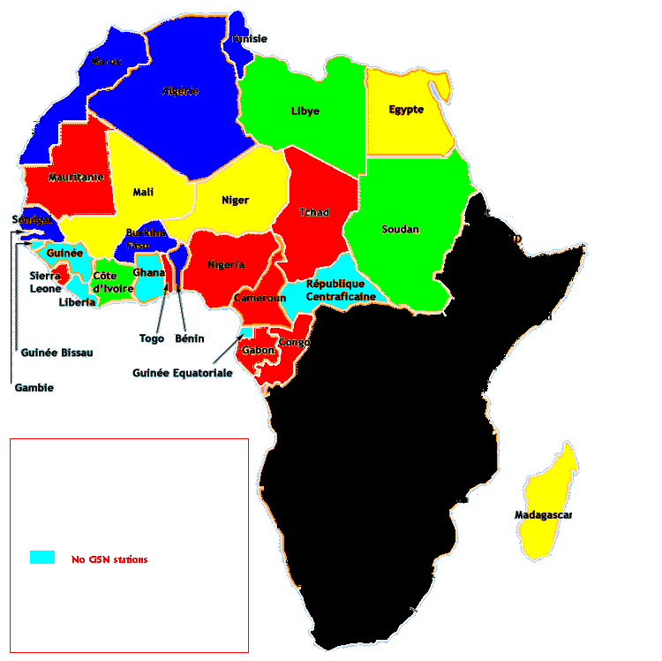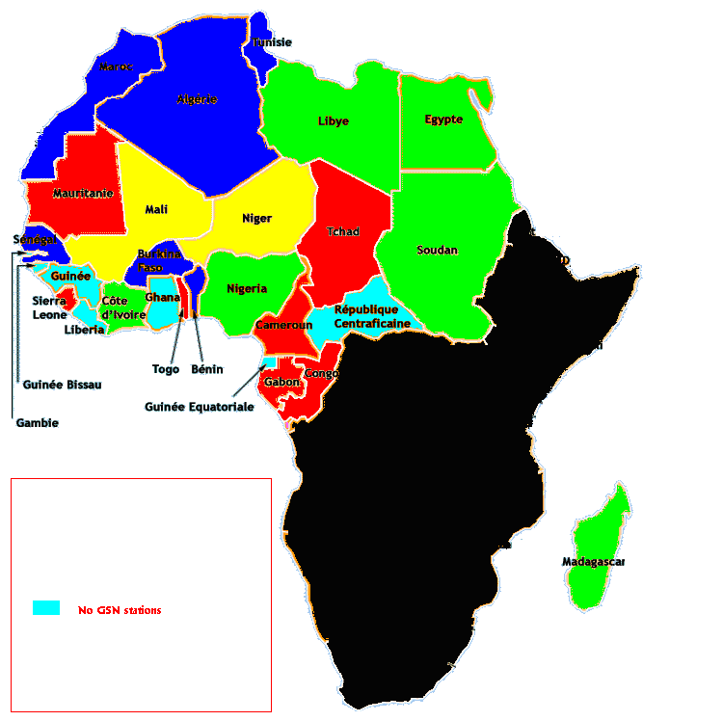
2007
2008

Up to present and as a diagnostic summary:

- 23 countries have at least one GSN station.
- 6 Countries routinely generate climate reports, for their GSN stations, which reach the NCDC (with a total of 16 stations) (blue color on the map).
- 9 Countries do not have a focal point for GCOS (red color on the map).
- 2 Countries did not respond yet to emails sent their GCOS focal point (yellow color on the map). (5 in 2007)
- 6 Countries cooperate already with the DMN Lead Centre through their GCOS focal point (Libya, Sudan and Ivory Coast, green color on the map). ( in 2007)
- many GSN stations have never sent a CLIMAT report and are a GCOS stations

RTHs catalogues are not available through the internet and so tracking CLIMAT route through the GTS is not possible until now. It should be mentioned that RTHs catalogues available on the web are not up to date, and though not useful. We know also that some CLIMAT reports the monitoring centres DWD and JMA but not NCDC centre.
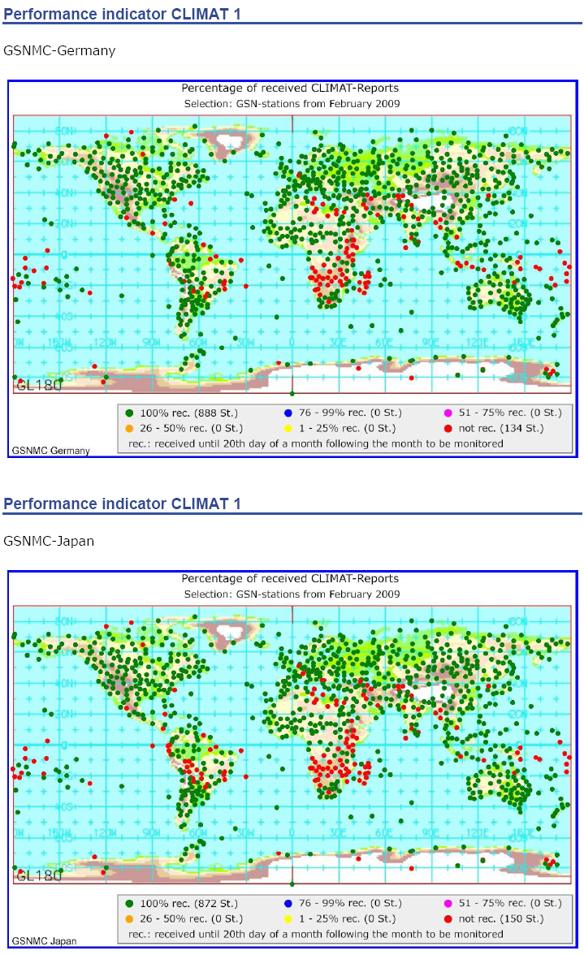

If we look at the GSNMC results through the map above, we can see that most CLIMAT reports for North Africa are received by these centres. However by looking at the monitoring report of NCDC only 27 among 81 reports have been received for February 2009. This fact needs more and further investigations, but most likely the reason is the one just underlined above which is related to the routing catalogues.

The CBS LC has also noticed that only 2 climate reports (Nigerian stations!) among 81 for January 2008 have reached NCDC. This is surprising especially because the GSNMC have received most of January reports. Also, monitoring reports provided by NCDC at the following address: http://www.gosic.org/gcos/GSN/GSN_data_matrix.htm are confusing because they do not tell if the CLIMAT report has been received through GTS, through the GSNMN or by email.

The following graph shows the evolution of CLIMAT reports sent by GCOS stations belonging to the DMN CBS LC region and received by NCDC. More than 50% of CLIMAT reports are received by NCDC. We can see that 2008 is better than 2007. However there is a drop of this number in some months especially in January; further investigations are needed to explain the reason of this drop.

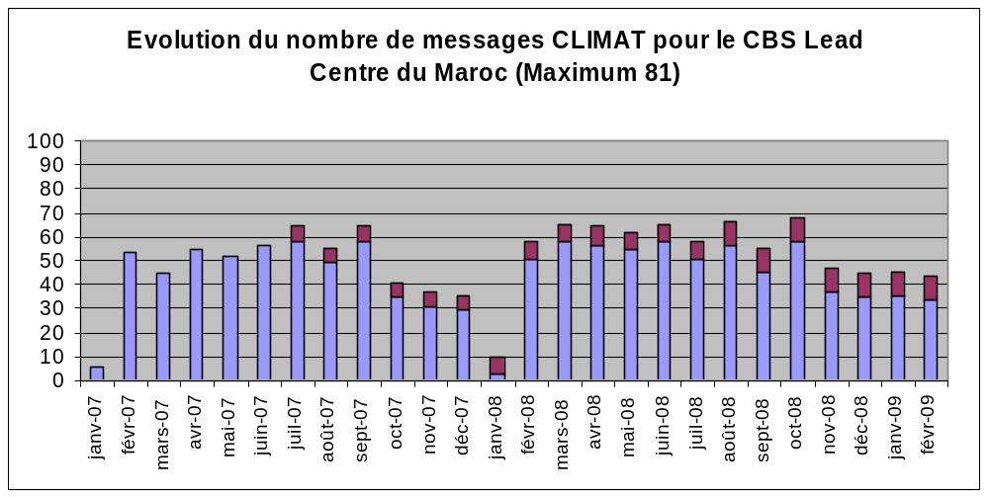

Blue: number of messages received by NCDC.
Red: number of messages not reaching NCDC but we know that they are sent to GTS.

As a summary, the 2008 diagnosis of the DMN LC by country is as follow:

At the beginning of the year 2008, contact has been made with the PR of Nigeria and the GCOS focal point of Niger has been identified. The cooperation between the Nigerian Meteorological office and the DMN LC is actually exemplary. Also contact has been made with the Madagascar GCOS focal point that is willing to cooperate. With Egypt a contact has been made unfortunately the GCOS focal point retired during 2008.

- Nigeria:
Contact has been made with the GCOS focal point who informed us that their direct GTS is faulty for now but they exchange GTS data via Niamey in Niger Republic.

  - Last name: EGWU
  - First name: EGWU
  - Telephone number: +234 8023 091 266 , +234 8054 026 865
  - Fax number: nil
  - Email adresse: ben.egwu@yahoo.com

All the historical CLIMAT reports, kindly sent to the DMN CBS LC by the Nigerian met office have been forwarded to NCDC; These CLIMAT reports concern period: 01/2006 to 07/2008. Since 08/2008, CLIMAT reports are sent to GTS gateways but unfortunately do not reach NCDC. The annex includes an example of the CLIMAT reports sent to GTS gateways.

- Madagascar:
Contact has been established with Sahondra Ranivoarisoa, the GCOS focal point for Madagascar who informed the DMN CBS LC that only the following stations are elaborating climate reports: Ivato, Toamasina, Mahajanga et Taolagnaro. The DMN CBS LC is still waiting for further information about the GCOS stations in this country and means of telecommunications available. We suggest for the GCOS focal point to send their CLIMATE reports through GTS gateways if possible.

- Egypt:
Contact has been made with the Mete office. The GCOS focal point, Youssef M. Yehia, has retired in 2008. There is a need to ask the Egyptian met office to nominate a new GCOS focal point.

____________

Rachid SEBBARI,
Direction de la Météorologie Nationale, Morocco
sebbari@gmail.com

ANNEX

NIGERIA: example of CLIMAT reports sent by email to GTS gateways:

De Murtala Mohammed <nimet_ikeja@yahoo.com>
à mss@inmet.gov.br,
mss.operator@dwd.de

cc joern.kallies@dwd.de,
sebbari@gmail.com

date 4 avril 2009 14:52
objet CSNI01 DNMM 041500
envoyé par yahoo.com

CLIMAT 03009
65123 111 19972 20088 30324009 403920257 5168 60000000 7198101 8000000 9000000
222 07100 19790 20092 30337008 403750248 5187 60009// 7195 8000000 9000000
333 03131 10000 30000 40000 50000 8000000 9000005
444 0034426 1030717 2042075 3024055 4000000 5000000 60000=
65167 111 19877 20084 30330013 404080255 5146 60000000 7202093 8000000 9000000
222 07100 19875 20080 30363006 403990244 5140 60005// 7217 8000000 9000000
333 03131 10200 30000 40000 50000 8000000 9000002
444 0036709 1030701 2043071 3021005 4000000 5000000 60000=NNNN

