WORLD METEOROLOGICAL ORGANIZATION  __________________  CBS Lead Centres for GCOS  Coordination Meeting  Fourth Session  SANTIAGO, CHILE  8-10 OCTOBER 2013 |  | CBS/GCOS-LC-4/Doc. 7  (06.X.2013)  ______  ITEM: 7  Original: ENGLISH

Report from GCOS IM
(Submitted by GCOS Implementation Manager, Tim Oakley)

Summary and Purpose of Document
This document provides information from the GCOS Implementation Manager for the period April to September 2013

ACTION PROPOSED

The meeting is invited to take into account the information provided in the document when discussing the relevant agenda items.

____________

GCOS Implementation Manager (IM)
6-monthly Report of Work

Name – Tim Oakley | Period – April to September 2013
General:

Much of the 1st half of this period was focused on learning the job, improving my understanding of the work & priorities of GCOS and identifying any key issues and risks for my role as Implementation Manager. Had a ‘hand-over’ meeting with the previous implementation manager 14th – 16th May in Geneva (during WMO Executive Council), where we went through in detail the ongoing work, projects, documentation and questions/issues that I had encountered since taking over the job at the beginning of March. Combining this during WMO EC had the benefit of being introduced to many of the contacts for the regions/countries, especially those where the work of GCM is a priority.

Lead on providing the content for a GCOS poster on the Cooperation Mechanism (GCM) which was displayed during a special sessions of the Intergovernmental Board on Climate Services (IBCS), 1st-5th July 2013.

Following feedback from D-GCOS, IM made contact with UNDP with regards several projects, focused on observing networks for Climate Services, which had been initiated in Solomon Islands and Burkina Faso plus the potential of numerous other projects in Africa. Efforts were concentrated on the Solomon Islands project where the local government, using UNDP funding, had issued a TOR for planning, installing and managing a network of AWS’s and Rainfall sites. Background on the GCM and the benefits was provided to the local managers; however recent information has reported that a contract has been offered to the New Zealand Met Service. Will continue to keep in contact with UNDP, offering the service of GCOS and the GCM and will approach the New Zealand Met Service expressing our interest in their work for Solomon Islands, in terms of the GCOS networks.

2nd half of period was holidays for much of Europe, a relatively quiet quarter with the focus on addressing any network issues and preparing for several key meetings in the Autumn.

Attended and presented at a 2 day workshop at ECMWF (Reading) & the CBS-ET on Surface Based Observations (Geneva) at the beginning of July. These meetings were very much focused on the Quality Monitoring/Management of surface based networks and how to make the more ‘real-time’ quality statistics more available and of greater benefit. Both ECMWF & EUMETNET (EUCOS Portal) are proposing to provide real-time access to their products at a global level and my suggestion that this initially could be for the GSN & GUAN was taken forward by ET-SBO. Working through the CBS ET should develop stronger links between GCOS and WMO OBS/CBS.

Followed up on an enquiry from Ecuador for technical support for a new Hydrogen Generator and Upper-Air station. Provided some technical documents on the specification for a Hydrogen Generator and key points of consideration for an upper-air station. From the information provided the NMS has the funding but not the expert technical knowledge/support. Location suggested would make a good addition to the GUAN network in the region, although this would be a new station with no history. My initial contact at the NMS has recently left the service and as yet his replacement has not responded to my offer of support.

Attended & presented at the Regional Conference (RECO) and the first few days of RA-VI in Helsinki (10th – 13th Sept). . My presentations seemed to go OK but generated very little discussion during the sessions and for our GCOS document/text there was nothing so passed straight through to the final report (similar to EC). Perhaps this is good as everyone is happy but I had the feeling that Observations, which was my main pitch, was not the top of anyone’s agenda, although almost everything that was discussed in detailed is reliant on the underpinning observations. I did show some performance tables for the GUAN network, mainly to compare region VI with region I and this did result in some contact with the representatives of those stations in region VI which were below my red line (i.e. not meeting the minimum requirement). Need to consider carefully about a GCOS presence at the other RA meetings next year, here the focus from me would very much be on the performance of the networks, the challenges for the future and their needs for support.

Produced an updated version of the ‘project candidates’ for the GCM, formally known as ‘the shopping list’. Have restructured the information to show the recent requests for support and those considered of operational priority. This document has been circulated to the GCM board members and is also available via the GCOS website.

Network:

Working on improved quality monitoring for the GCOS Upper-Air Network (GUAN), in terms of consistency between the different monitoring centres and an improved performance statistics against the minimum GCOS requirements. Have requested that the monitoring reports from NCEP and ECMWF are changed to reflect the 30hPa minimum requirement for the GUAN.

Annex A provides a table for the GUAN monitoring against the GCOS minimum requirements (25 daily soundings to 30hPa per month) for each region. The key activities for the period are as follows:

Region 1:

More than 50% of the GUAN stations in this region are not meeting the minimum requirement, mainly associated with the necessary funding required to operate and maintain an upper-air station. Communication with the station at a technical level to establish the cause of the poor performance continues to be a challenge and often means that relatively simple issues can go unaddressed for long periods of time.

61902 Station is closed and will be removed from the list in January.
67774 (Harare) & 62721 (Khartoum) both have problems with an ‘ageing’ hydrogen generator. Khartoum has requested support for a new system through the WMO VCP programme and I am investigating whether the GCM can contribute/lead here.

68994 & 68906 are stations where South Africa has undertaken a significant upgrade of the station infrastructure which has affected the observations programme. Not ideal but hopefully will sustain the stations for the future?
61995 is low on consumables and is operating a reduced programme. Support from GCOS was not provided owing to the close proximity of the GUAN station at Gillot.

Region 2:

43599 (Gan) restarted in April with support from GCOS. A Hydrogen Generator fault developed in May and whilst the system/part is covered by support agreement with manufacturer (Proton) the shipping costs are to be covered by the owners. GCOS contacted for support and this was facilitated by the IM in direct contact with Proton. Funding for the shipping (~ 300USD) was provided directly by UK Met Office in support of GCOS. Part was received in early July with the resumption of radiosonde soundings by mid-July. Some issues with the communications of the messages on to the GTS continue.

Region 3:

84008 (San Cristobel) - Hydrogen Generator fault and GCOS contacted for support and financial assistance. After discussion with local engineer and manufacturer (Proton) provided specification/authority to WMO procurement and required part was ordered & subsequently delivered to Ecuador at the beginning of June. After a long period in customs the package was received and installed 10th July, with the resumption of the radiosonde soundings on 12th July.

There are a number of stations just below the minimum requirement and in most cases this is due to the soundings not reaching the 30hPa level.

Region 4:

78583, 78988 & 78397 All have similar issues with hardware failures in the tracking part of the system. These faults are taking longer to resolve than normal owing to financial constraints. No request to GCOS has been received for support.

78762 (Costa Rica) soundings are meeting the minimum requirement but a coding issues is preventing the storage/use of the data. This was identified by the IM and has been partially rectified. Now being investigated by the GTS routing centres.

Region 5:

Another challenging region with 30% of the stations not reaching the minimum requirements.

92035 (Papa New Guinea) & 91517 (Solomon Islands) are currently silent but at recent success thanks to the US and New Zealand is the resumption of soundings at Bauerfield (91557).

Several of the Australian GUAN stations have dropped below the red-line owing to a change in practices (smaller balloons) resulting in lower burst heights. This has been reported to BOM and they agreed to reverse this change at their GUAN stations.

Region 6

15120 has closed and has been replaced with 15420 (Bucaresti).

Region 7

Most of the stations not meeting the minimum requirement are as a result of the burst height of the balloons. Antarctica is a challenging environment for the handling and performance of the balloons but need to consult with the stations themselves, through the lead-centre, on the cause and any possible solutions.

Projects:

- The upgrade of the eight GSN stations in Angola, funded by KNMI, is still not completed. All equipment is in place, but the project has stalled as the Angolan Met Service cannot afford the travel necessary for the actual installation activities.

- Whilst the UK Met Office has made some progress with the project to renovate the 11 stations in Madagascar, the issue with the local mobile phone SIM connection remains and thus the rollout of the AWS equipment has not started. Regular ‘remote’ meetings are being held with the local experts in trying to solve the issue and plan the next stage.

- Work was completed in the Democratic Republic of Congo for the renovation of the telecommunications system and two surface stations. Efforts are now focused on realising the benefits of this work as very few observations are as yet available on the GTS.

- The renovation of the telecommunications system in Zambia was completed but further work is required to ensure a reliable link to the GTS. The Met Office has implemented a back-up ‘WIS’ and the receipt of data will be monitored over the next few months.

- The project for new instrumentation for Cuba is still on hold, owing to not getting the guarantees that any equipment shipped direct to the country would be received by the Met Service. IM is investigating a proposed alternative of shipping via Costa Rica and is in initial. discussions with WMO procurement.

Meetings:

3rd-4th July – Obs Monitoring workshop at ECMWF, Reading UK (GCOS/GCM Presentation)

9th-12th July – CBS Expert team - Surface Based Observations, WMO, Geneva (GCOS Presentation)

9th – 13th Sept – RA-VI – RECO & Assembly meeting, Helsinki, Finland (GCOS &GCM Presentation)

23rd – 27th Sept – Management week in GCOS Office (Geneva).

Outlook (Next Quarter):

8th – 10th Oct – IV CBS Lead Centre meeting for GCOS, Santiago, Chile

15th – 17th Oct – Meteorological Technology World Expo, Brussels, Belgium

22nd – 24th Oct – GCOS Steering Committee meeting, Offenbach, Germany

6th – 8th Nov – Radiosonde Intercomparison at Camborne, UK

12th – 14th Nov – Based in Geneva, Switzerland: Management & IPET-OSDE ‘Network’ meeting.

16th – 20th Dec – Based in Geneva, Switzerland: Management

Annex A – GUAN Monitoring (Jan – Sept 2013)
Values represents – % of No. of soundings each month reaching 30hPa / 25
Total – No of soundings at NCEP for period; Months – 1 = Jan & 12 = Dec
Below red line represents not meeting minimum requirement
Region 1

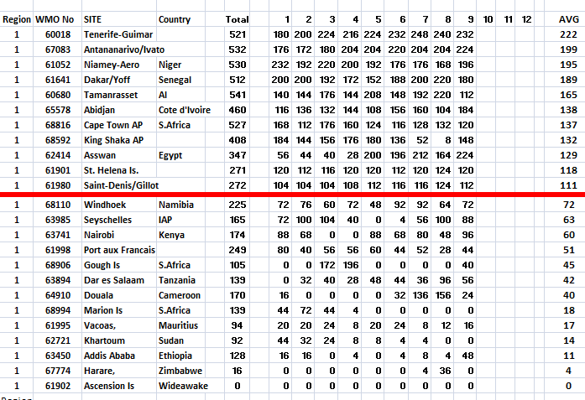

Region 2
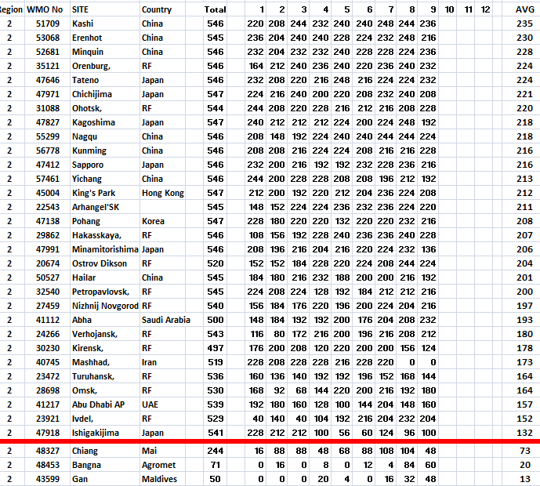

Region 3
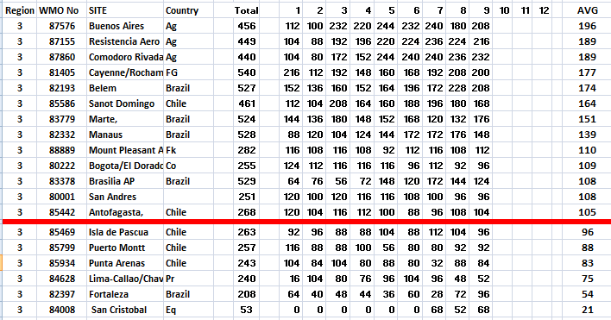

Region 4
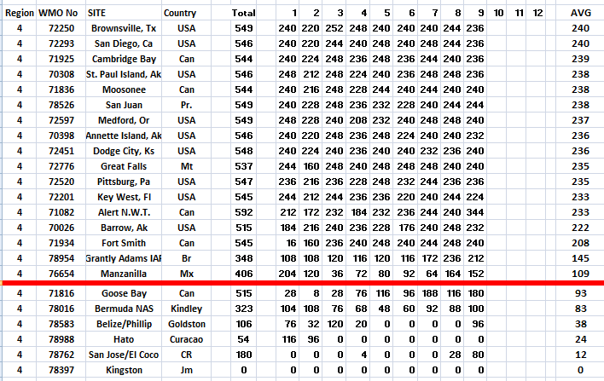

Region 5

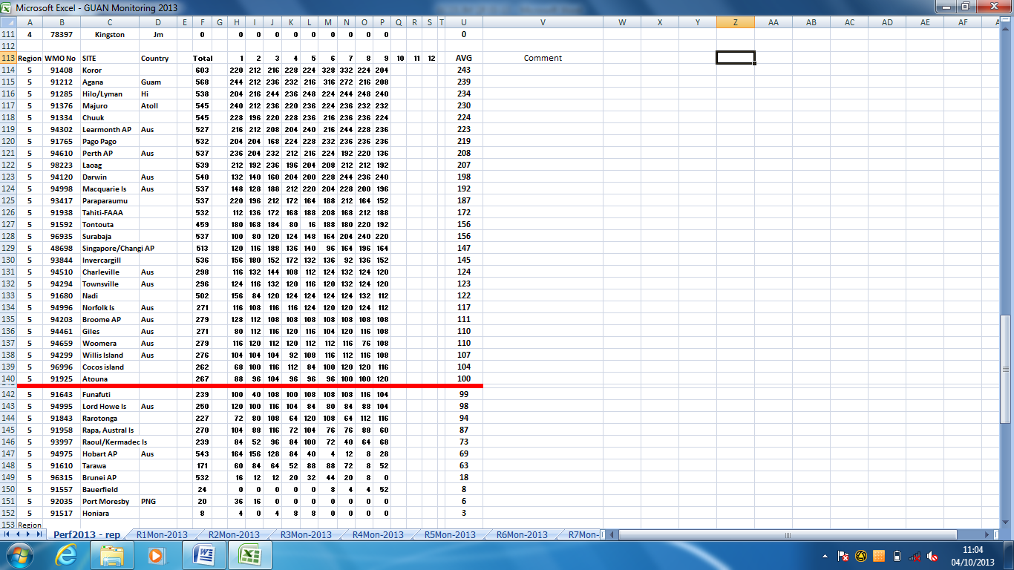

Region 6
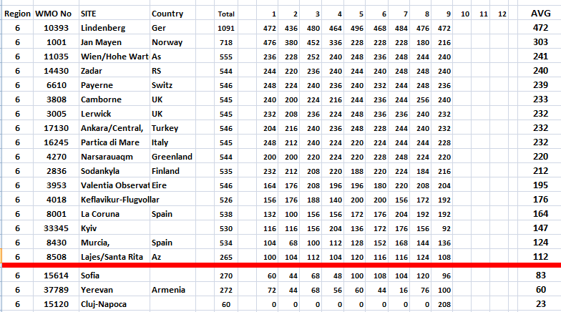

Region 7



