WORLD METEOROLOGICAL ORGANIZATION  _________________  CBS LEAD CENTRES FOR GCOS  COORDINATION MEETING  SANTIAGO, CHILE  8-10 OCTOBER 2013 |  | CBS/GCOS-LC-4/Doc.5 (NCDC) (26.09.2013)  ________  ITEM: 5  Original: ENGLISH

REPORT OF THE CBS-LC-NOAA/NCDC FOR GCOS
(Submitted by Jay Lawrimore and Bryant Korzeniewski, NOAA/National Climatic Data Center)

Summary and Purpose of Document

Activities of the CBS Lead Centre-NOAA/NCDC for the period from November 2011 to September 2013 are reported.

ACTION PROPOSED

The meeting is invited to take into account the information provided in the document when discussing relevant agenda items

____________

NCDC Lead Centre Report

- GCOS Lead/Archive Centre responsibilities at NOAA’s National Climatic Data Center continue to be managed by a team of scientists and data management specialists. The team was joined by Mr. Bryant Korzeniewski in 2012. Mr. Korzeniewski oversees collection of GCOS data by maintaining personal contact with Region IV technical representatives. His activities also extend to other WMO regions. Mr. Jay Lawrimore, Chief of NCDC’s Ingest and Analysis Branch, continues oversight and management of the GCOS Lead and Archive Centres.

- NOAA/NCDC continued its responsibility for calculation and transmission of US CLIMAT messages following the transition of responsibility from NOAA’s Climate Prediction Center to NCDC that had taken place in October 2009. Few problems have occurred in the monthly production of these reports. In two instances monthly US CLIMAT reports were reproduced to correct processing errors and retransmitted following notification by DWD.
- The Lead/Archive Center at NCDC continues to produce web accessible GSN and GUAN reports on a monthly basis which provide information on the number of hourly and synoptic reports received at the Center. The reports are available at ftp://ftp0.ncdc.noaa.gov/pub/data/gcos/. Lead Center representatives are invited to review these reports and provide feedback on their usefulness and any recommendations for further changes.
There are 2 basic type of reports; 1) provides an annual total of the number of reports received by type and hour of the day and 2) provides month-year totals of the number of hourly and synoptic reports received and if CLIMAT data were received.
- GSN_types_short_term: For GSN stations, for the current year, provides the number of observations received by type of report (e.g., FM-12, FM-15, etc.) for each hour of the day (Hours 0 through 23).
- a. GSN_POR_summary: For GSN stations, for each year in the station’s period of record, provides a month by month summary of the number of surface hourly and synoptic reports received for each GSN station. Also indicates if a CLIMAT report was received.
b. GSN_sum_long_term: Provides the same information as GSN_POR_summary from 2001 to present.
c. GSN_sum_short_term: Provides the same information as GSN_POR_summary for the current year.
d. WW_REGx_POR_summary: For all Monthly Climatic Data for the World stations, provides the same information as GSN_POR_summary.
e. WW_ALLREG_POR_summary: For all Monthly Climatic Data for the World stations, provides the same information as GSN_POR_summary broken out by region.

- NCDC continued to collect and process CLIMAT messages on a routine basis. These provide an important foundation for US and WMO climate monitoring activities through the Global Historical Climatology Network-Monthly (GHCN-M) dataset, enabling ongoing perspectives on the state of the global climate. The number of CLIMAT reports received for GSN stations steadily increased from the early 2000s through 2009 and have since leveled off or declined slightly. The percentage of CLIMAT reports for GSN stations received in 2012 exceeded 90% in RA IV and VI, and rates exceeded 80% in RA II and III. Receipt rates dropped below 80% in RA V and remained near 60% in RA I (Figure 1).

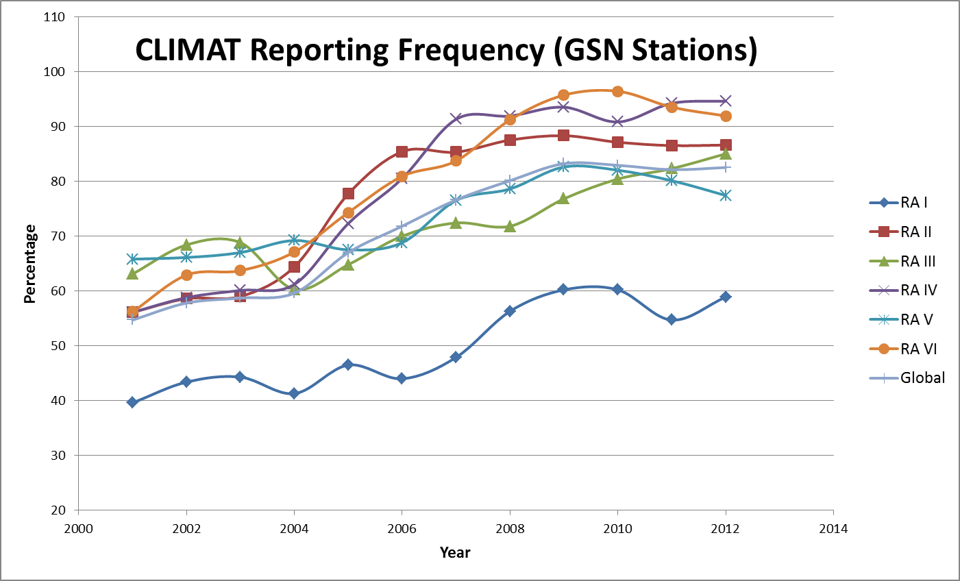
Figure 1. Percentage of GSN stations providing CLIMAT messages from 2001 through 2012 received at the GCOS Archive Centre.

In total more than 2300 CLIMAT messages continue to be received at NCDC via GTS transmission within the first three weeks of each month. Approximately 400 of these stations are not classified as CLIMAT stations in WMO Publication 9, Volume A (Figure 2, blue dots). These stations are not included in the publication Monthly Climatic Data for the World.

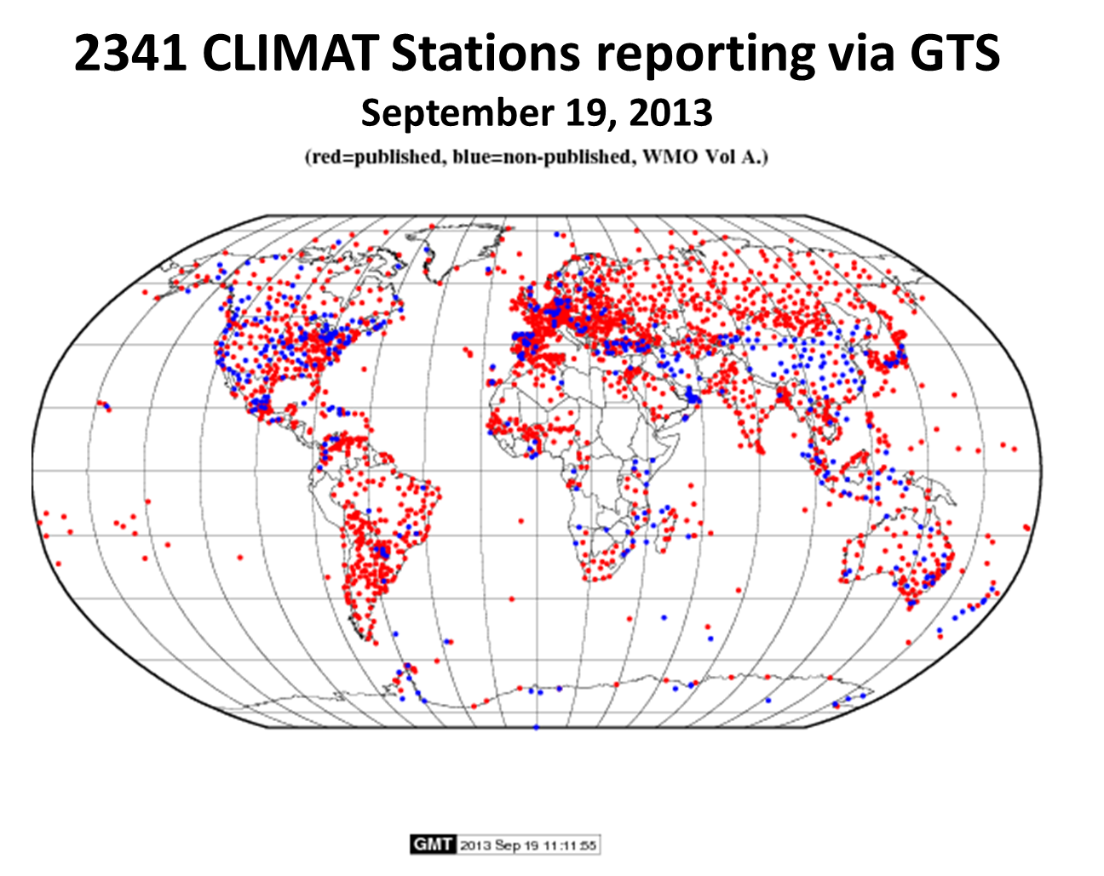
Figure 2. CLIMAT messages received via GTS in September 2013 at the GCOS Archive Centre. Those published in the Monthly Climatic Data for the World are shown in red. Unpublished are shown in blue.

The Met Office/Hadley Centre in the United Kingdom (UKMO) continued to provide NCDC with a complete set of CLIMAT messages received by their centre each month, some of which supplement those received over the GTS.
NCDC now receives less than 200 e-mail or parcel post reports of CLIMAT summaries and corrections on a regular basis each month. These supplement or correct those reports received via the GTS. It takes several months before NCDC’s monitoring reports reflect the mailed messages. As shown in the figure below, many of these are provided by sources in the Eastern Europe, the Caribbean, Chile, and other scattered areas around the world.
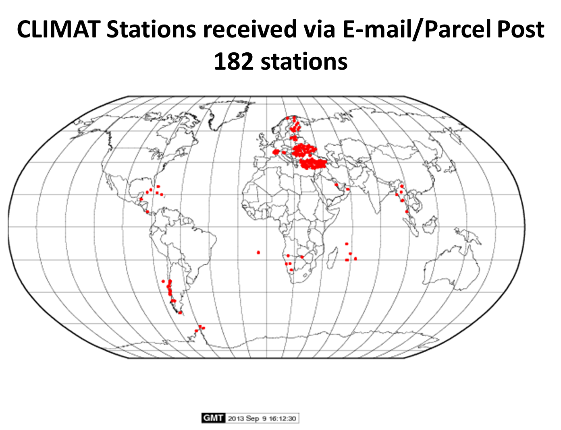
Figure 3. Locations of stations providing CLIMAT messages to NCDC via e-mail or parcel post in July 2013.

- Status of the GUAN: Ongoing rehabilitation and system improvement efforts have led to continued increases in the collection and reporting of data from the GUAN network. More than 160 GUAN stations were operating at some point in 2012. More than 130 routinely provided observations to at least 50 hPa in 2012 (one observation on at least 25 days each month) as shown in Figure 4a. Approximately half as many have historically provided observations to 10hPa (Figure 4b). NCDC’s Integrated Global Radiosonde Archive (DSI-6351) serves as the database for the GUAN.

Table 1. GUAN stations which provided no observations in the past six months (bold) and others with recent problems.

78397 Kingston, Jamaica (Tracking system in process of repair)
78988 Curacao Island (Awaiting parts for antenna/motor repair)
61902 Ascension Island (Closed due to funding constraints)
92035 Papua, New Guinea (No sondes in stock)
15120 Cluj-Napoca, Romania (Closed due to funding constraints)
48453 Bangna, Thailand (Much of 2013 missing; restarted recently)
91517 Honiara, Solomon Islands (Awaiting new sponsor for purchase of sondes)
68906 Gough Island (Generator problems; expect restart in September 2013)

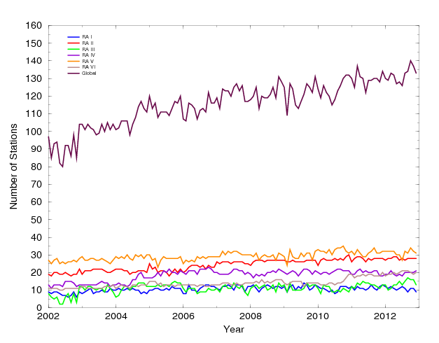
Figure 4a. Time series of the number of GUAN stations reaching at least 50 hPa at least 25 days each month.

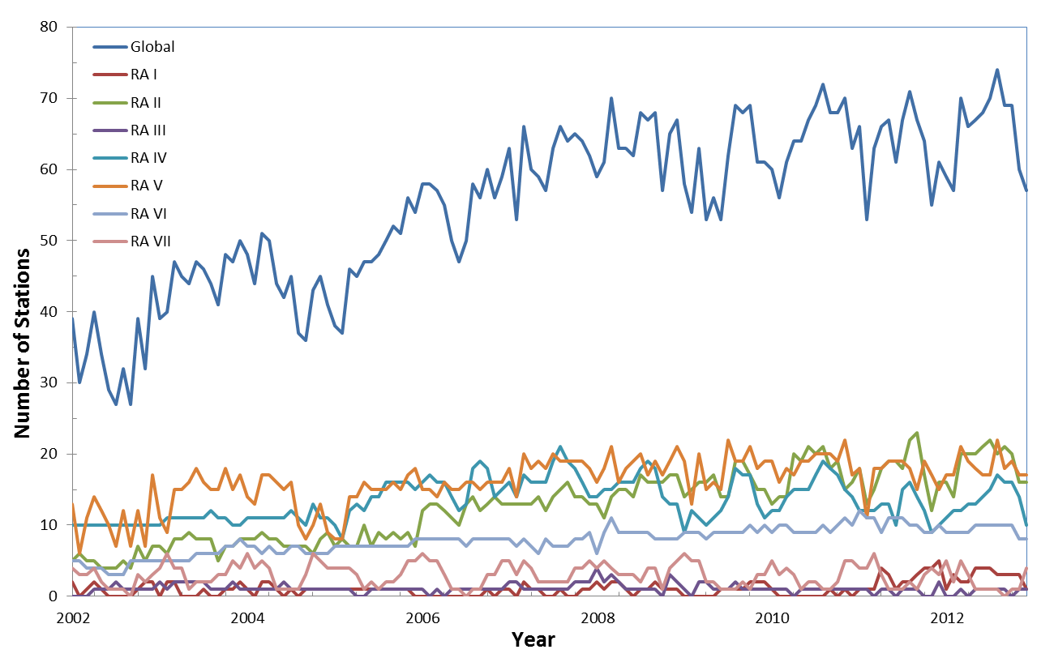

Figure 4b. Time series of the number of GUAN stations reaching at least 10 hPa at least 25 days each month.

