WORLD METEOROLOGICAL ORGANIZATION  _________________  CBS LEAD CENTRES FOR GCOS COORDINATION MEETING  SANTIAGO, CHILE  8-10 OCTOBER 2013 |  | CBS/GCOS-LC-4/Doc. 5(DMN) (08.10.2013)  ________  ITEM: 5  Original: ENGLISH

Report of CBS Lead Centre - DMN for GCOS (GSN and GUAN) Data
for Northern Region I and Madagascar

(Submitted by Feddoul EL OUAZZANY, Direction de la Météorologie Nationale, Morocco
cbs.lead.centre.4gcos@gmail.com, ouazzany@gmail.com)

Summary and Purpose of Document
This document provides information on the activities of the CBS lead Centre, Direction de la Météorologie Nationale (DMN), Morocco and information on the results obtained during the year 2012 and 2013.

1. Background
CBS Lead Centres for GCOS have been designated by the World Meteorological Organization (WMO) Commission for Basic Systems (CBS) as being responsible for monitoring performance of GCOS networks, in particular of the GCOS Surface and Upper Air Networks (GSN, GUAN). They aim to improve the quantity and quality of GSN data, contained in CLIMAT reports exchanged over the GTS, by exchanging the GSN monitoring information directly with NMHSs in accordance with the proposed terms of reference, and to support any follow-up action in designated areas of responsibility.
Implementation of activities of the Lead Centre should generally follow the procedures for WWW monitoring centres, as laid down in the Manual on the GDPS, Attachment II.7 (WMO - No. 485). The Lead Centre will focus on the activities in paragraph 3.

2. Activities
Terms of Reference of the CBS Lead Centres for GCOS are:
- Diagnose problems in the GSN and GUAN by using the monitoring reports produced by the GCOS Monitoring and Analysis Centres;
- Liaise with nominated National Focal Points for GCOS and related Climatological Data, and other responsible officials, to improve data and meta data availability and quality;
- Support to NMHSs for preparing CLIMAT messages in a standard format.
- Co-ordinate activities with other GCOS centres and/or other centres as appropriate;
- Monitor and report to CBS and GCOS on actions taken, progress achieved, concerns and recommendations on a yearly basis in a time frame that corresponds to planned AOPC and CBS meetings;
- Assist AOPC in the revisions of GSN and GUAN stations;
- Assist the WMO Secretariat in maintaining the list of National Focal Points for GCOS and related Climatological Data.

3. Areas of responsibility
Morocco, in the person of “la Direction de la Météorologie Nationale (DMN)”, has been formally nominated as lead centre by the Acting President of the CBS in March 2006. He is responsible of the Northern Part of Region I (Northern, western and central Africa and Madagascar and Comoros islands) which includes the following countries:

Northern Africa | Western Africa | Central Africa | Eastern Africa | Island
- Algeria  - Egypt  - Libya  - Morocco  - Mauritania  - Tunisia | - Benin  - Burkina Faso  - Ivory Coast  - Gambia  - Ghana  - Guinea  - Guinea Bissau  - Liberia  - Mali  - Niger  - Nigeria  - Senegal  - Sierra Leone  - Togo | - Cameroon  - Chad  - Congo  - Guinea Equatorial  - Central African Republic  - Gabon | - Sudan | - Cape Verde  - Madagascar  - Sao-Tomé and Principe  - Canaries islands  - Comoros islands
Table 1: Country of the region RAI (Northern part of Africa)
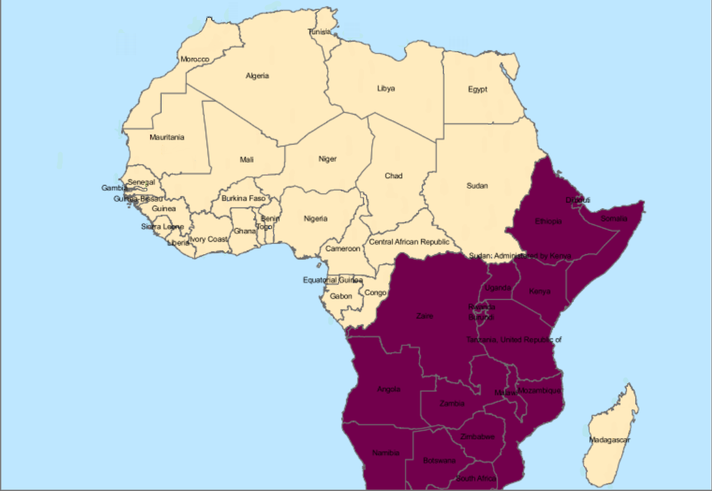
Figure 1: Our responsibility region’s chart (RAI Africa)

4. Analysis, of the Reception by NCDC, of CLIMAT-Reports during 2012-2013.

In this report, we analyze the evolution of CLIMAT-Reports transmission over the years, according to three criteria:
- Evolution of the number of countries without GSN station,
- Evolution of the number of countries with no focal point,
- Evolution of the number of CLIMAT-Reports received at the NCDC, by country and station based on years.

The number of countries without GSN station is 8 and has remained unchanged. These countries are Gambia, Ghana, Guinea, Guinea-Bissau, Equatorial Guinea, Liberia, Central African Republic, Sao-Tome and Principe.
The number of countries with no focal point is decreasing. Thus, there are focal points for two countries more than in 2011 (Cameroun and Gabon). But there is a total of 10 countries with no focal point, including 6 countries with GSN station (with GSN station: Benin, Chad, Comoros islands, Congo, Mauritania and Sierra-Leone) and 4 countries without GSN station: Equatorial Guinea, Liberia, Central African Republic and Sao-Tome and Principe).

To approach the third axis that interests us most, and which concerns the evolution of the number of CLIMAT-Reports, we start with an overview showing the evolution, over the last three years, of CLIMAT-Reports number, all countries and all stations combined, received at the NCDC (see Figure 2). This analysis reveals at first sight, an increased number of CLIMAT-Reports in 2012 compared to 2011 (especially January and months from August to November) while 2013 has registered a decrease compared to 2012, except for January, May and June. Overall, 2012 is better than 2011 and 2013, which are pretty nearly identical.
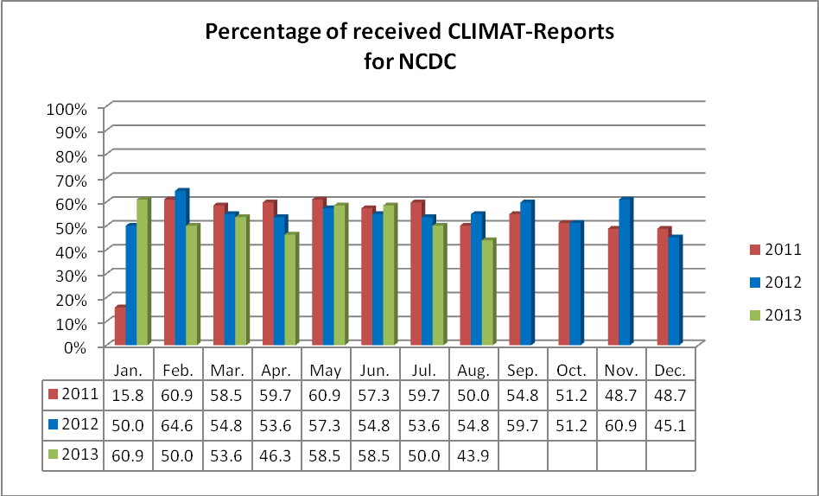
Annual Avg.
52,24%
55,08%
52,74%

Figure 2: Percentage of received CLIMAT-Reports at NCDC during 2011, 2012 and 2013

To better see the evolution, we can make the difference between the years: 2012-2011 and 2013-2012 (see Figure 3). The graph confirms the remark indicated previously. Thus, we find that 2012 recorded a positive evolution compared to 2011, for the first month and for the last months of the year (except December). While 2013 saw a slight decrease compared to 2012 (3 months positive while 5 are negative).

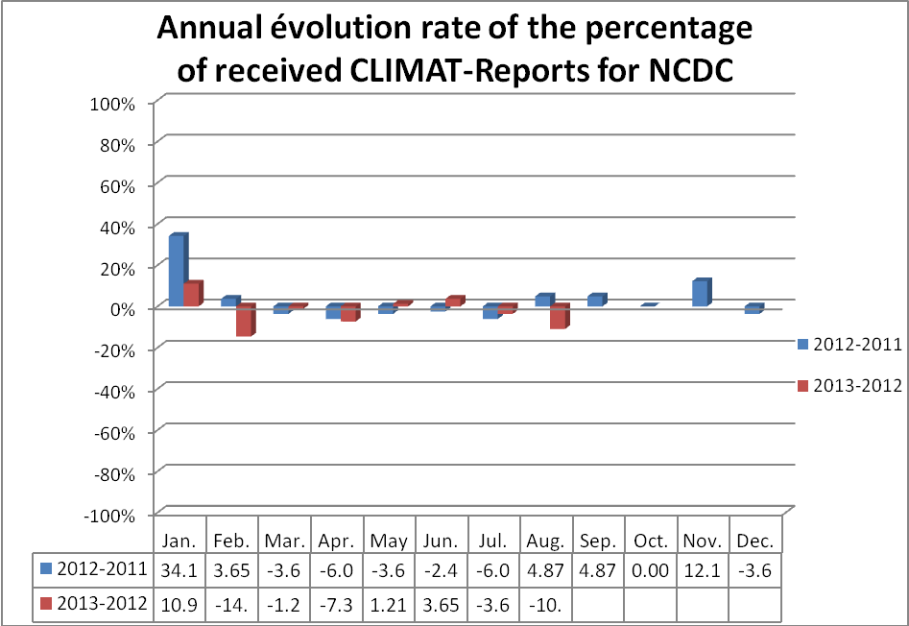
Figure 3: The annual evolution rate of the percentage of received CLIMAT-Reports at NCDC during 2012 and 2013

The CLIMAT-Reports availability during 2012 (Figure 4 A) is good for: Tunisia, Algeria, Morocco (except one station), Senegal and Burkina Faso. Some other countries are moderately good like Sudan, Egypt and Benin. During 2013 (Figure 4 B), the situation is the same for countries with good performances (except one station in Tunisia that completely fall and another in Burkina Faso which slightly decreased). For countries with moderate performances, there is improvement in Egypt that becomes good and degradation in Sudan and Benin. The countries of Niger and Nigeria have improved and showed moderately good performances.
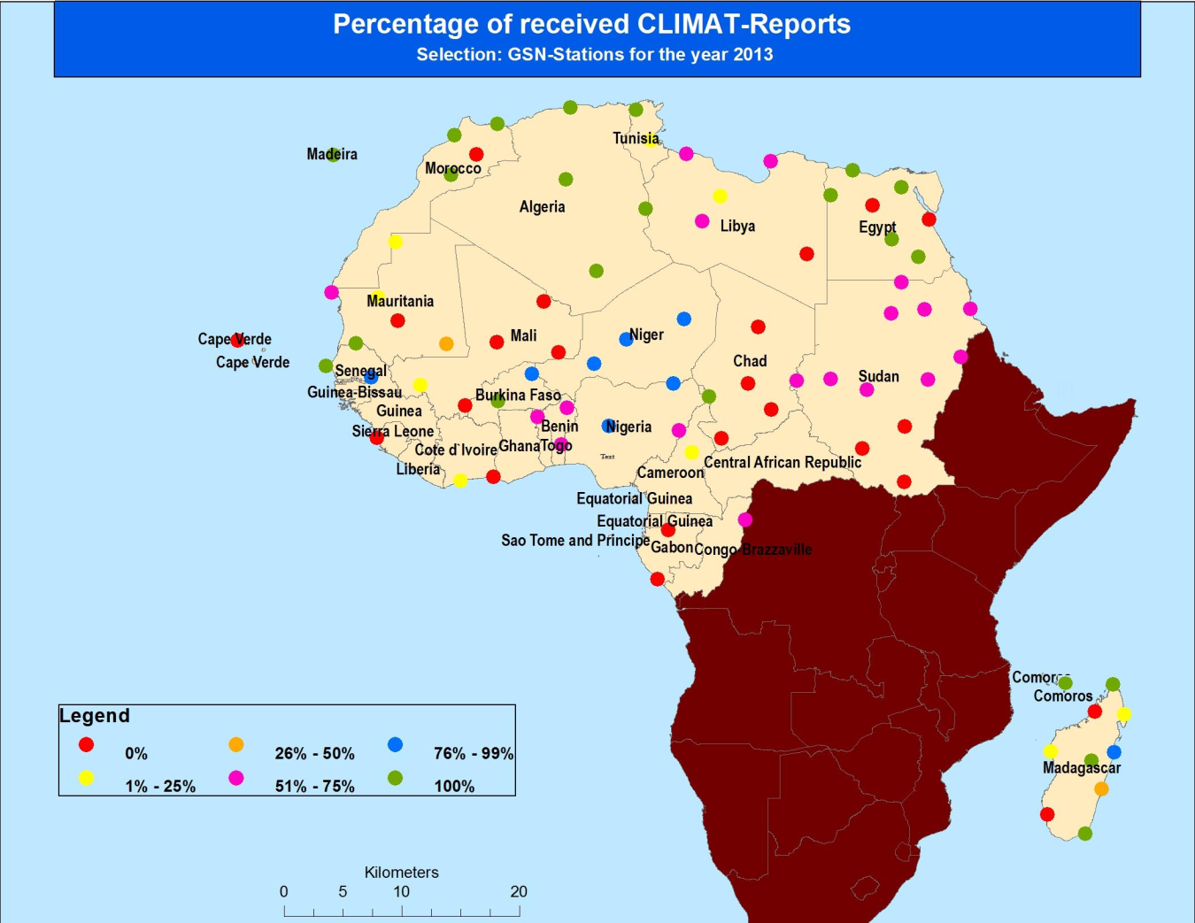
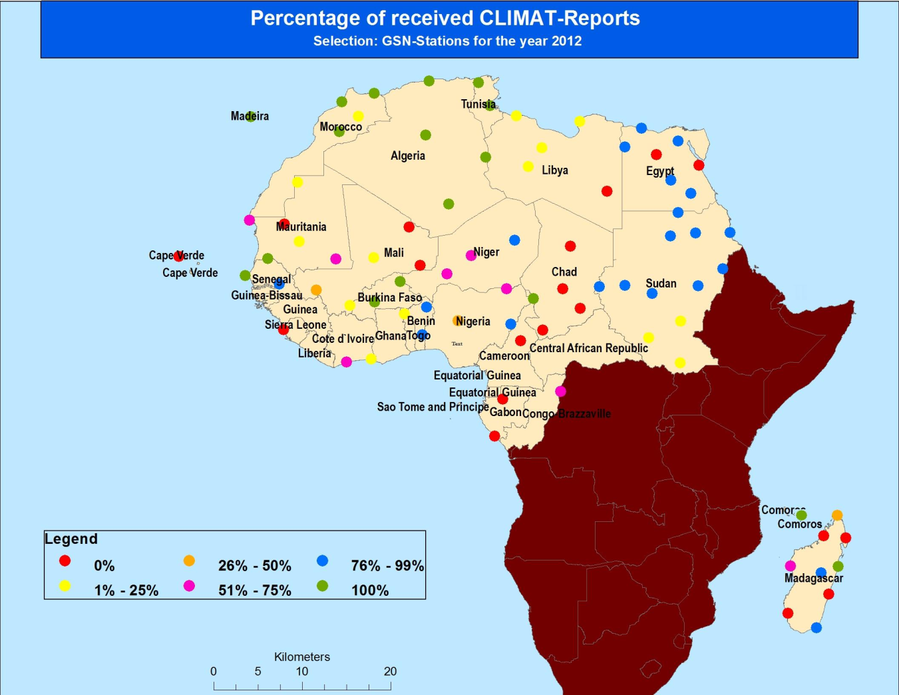
A:
B:

Figure 4: Percentage, by country, of received CLIMAT-Reports at NCDC during 2012 (A) and 2013(B)
If we look at the average percentage in each country, there is a positive evolution in many countries for 2012-2011, and in some others for 2013-2012 (see Figure 5 A). Thus, one can note the positive and significant evolution, between 2011 and 2012, for the following countries: Madagascar, Ivory Cost, Comoros Islands, Congo, Algeria, Tunisia, Libya, Chad, Sudan, Senegal, Burkina Faso, Nigeria, Benin and Togo. Unlike, other countries such as Mali, Niger, Morocco and Egypt have a decrease between 2011 and 2012. But the greatest decrease in 2012 concerns Mali (probably because of the war).
From 2012 to 2013 (see Figure 5 B) some countries recorded a positive evolution. The greatest evolution is made by Togo. Libya still in progress and recorded a great evolution also between 2012 and 2013. Also we note a good evolution in Cameroon and Congo. Madagascar and Nigeria still in progress and Egypt has also improved. Tunisia, Ivory Cost, Benin and Sudan are the countries with the largest negative evolution.
A :
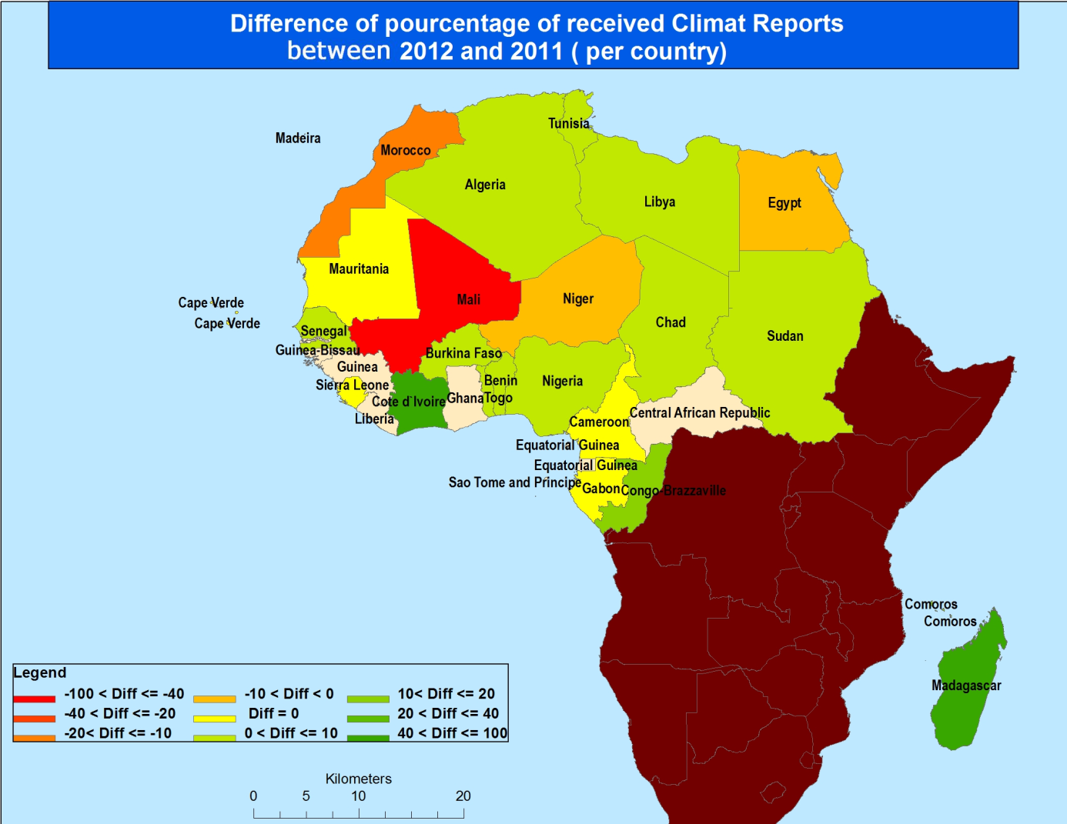
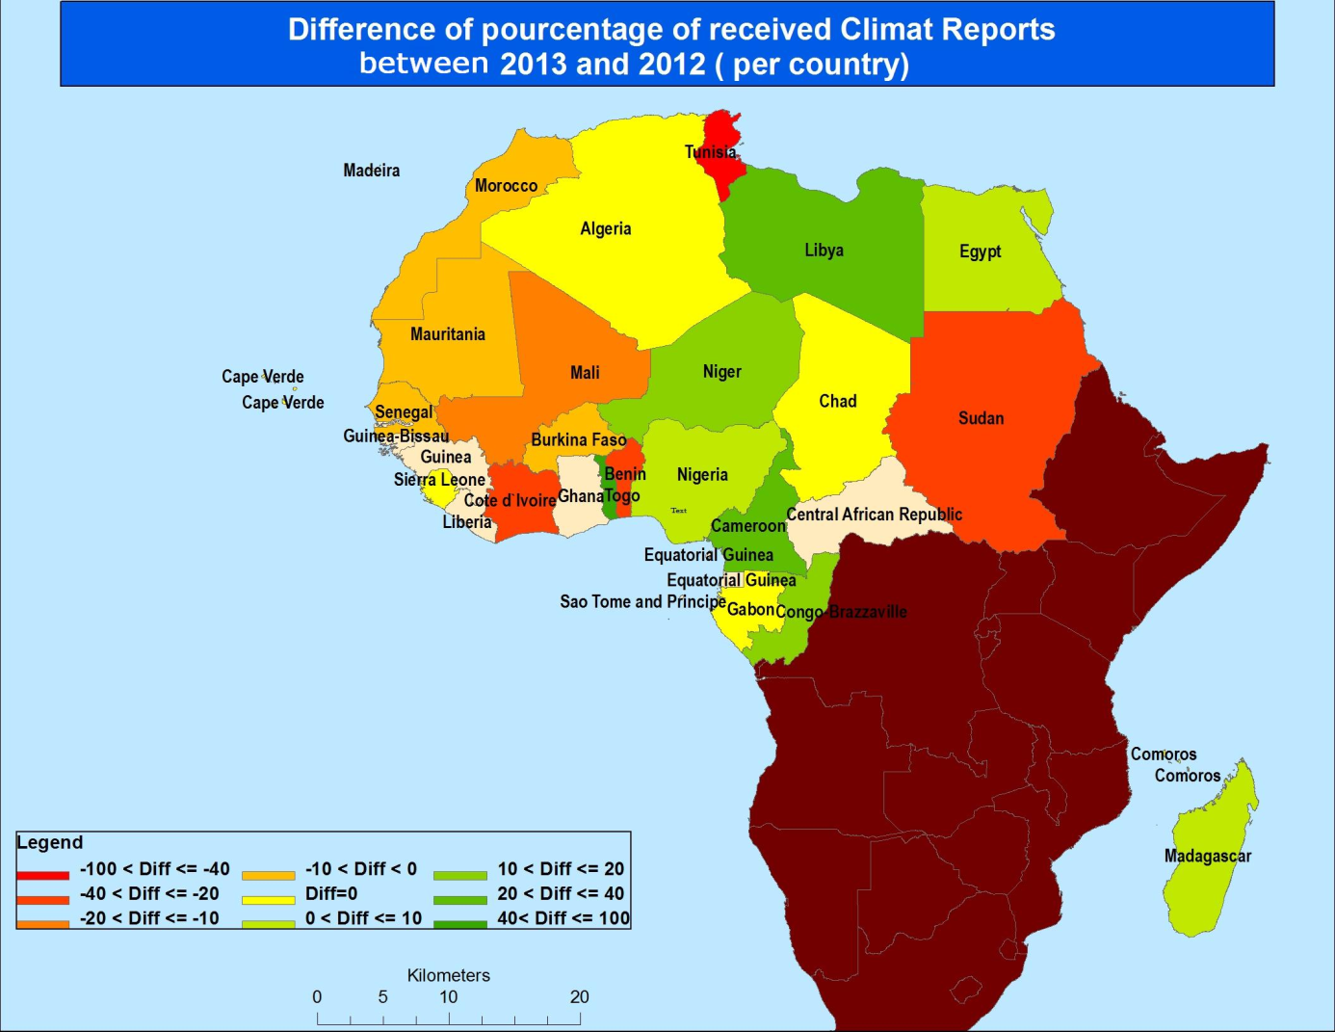
B :
B :
Figure 5: Difference between years, of averaged percentage in each country (A. 2012-2011, B. 2013-2012)

5. Individuals cases discussion and solutions proposals

In Egypt, the two stations BAHARIA and HURGUADA never sent messages while the other five stations are very good and sent 100% of their messages in 2013. The obvious solution in such case is to change them by neighboring stations.
In Mauritania, the station ATAR never sent messages. It is proposed to change it by another station close to it.
In Chad, four of five stations do not send messages. We will try first to get a focal point to this country and then we will try to identify problems with him.
Sierra Leone and Cape-Verde have never sent CLIMAT-Reports. The beginning of solutions passes through research of focal points for Sierra Leone and the updating or confirming of the Cape-Verde focal point.
The Gabon seems not to send Climat Report, but in reality I started to unlock the situation in this country, and now some Climat Report are received manually. We'll have, in the future, to see and solve the problems of the automatic transmission through the GTS.

6. Taken actions:
To overcome the lack on our region of responsibility, contacts have been made. Some of them were moderately successful, but others have not yielded concrete results. In other cases, no response was received:

- Several messages were exchanged with the Director of Meteorology of Gabon, which resulted in the designation of a focal point for this country. The work with the focal point allowed the elaboration and sending manually of Climat Report messages. These data are sent to NCDC and DWD.
- Several messages were exchanged with the Director of Meteorology of Cameroon, which resulted in the designation of a focal point for this country. The work with the focal point allowed an improvement in the percentage of Climat Report reception at NCDC for this country.
- Some messages also were exchanged with the Director of Meteorology of Central African Republic who has promised to review the situation but no news until now. Designation of focal point for this country was asked but no proposition.
- After signaling a problem, by DWD, in the Climat Report of two successive months, from Mauritania, that appear identical, messages were sent to the Director of Meteorology in this country, which has led to the confirmation of the contents of messages and changing the date of the second message. Designation of focal point for Mauritania was asked but no proposition.
- A message was sent to the focal point of Algeria suggesting to him the adding of new GSN stations in areas of the Sahara with a map showing the concerned areas and candidates stations; but no response has been received.
- After a message from DWD (Christiana Lefebvre) to the Libyan focal point and no response, I sent him a new message asking him to identify the problem. He responded this time and promised to study the situation, but no response until now. But Libya is in progress in both 2012 and 2013.
- Message was also sent to Chad but no response
- Message was sent to Ivory Cost focal point for a problem raised by NCDC, following a remark of NCEP. No response.
- Message was sent to Togo for searching the focal point e-mail address and solves problems, but no response.

7. Conclusions:
In general, the overall balance remains positive in 2012 compared to 2011, and that of 2013 recorded a slight decrease (compared to 2012) but it’s almost identical to that of 2011. However, some countries or stations have never sent CLIMAT-Reports. The proposed solutions will vary as the case:
- Case of countries not sending messages: we will continue our efforts to contact the concerned country to identify the problem and seek solutions. The designation and updating of the focal points will be of great help.
- Case of station that does not send message: it may be judicious to change it especially if the other stations, in the country in question, work perfectly.
- In some cases (poor countries), the WMO assistance can be a part of the solution. The experience of Madagascar is a good example.

