WORLD METEOROLOGICAL ORGANIZATION  __________________  EXECUTIVE COUNCIL  WORKING GROUP ON ANTARCTIC METEOROLOGY  NINTH SESSION  St. PETERSBURG, RUSSIAN FEDERATION  28-30 NOVEMBER 2006 | EC/WGAM-IX/Doc. 5.2  (2.XI.2006)  _________  ITEM: 5  Original: ENGLISH

Study of the Ozone Layer over Antarctica

(Submitted by the Secretariat)

Summary and Purpose of Document

This document updates the status of monitoring of ozone over the Antarctic continent.

ACTION PROPOSED

The session is invited to take note of the information contained herein.

Study of the Ozone Layer over Antarctica

- The Secretariat collects data and distributes bulletins that provide an overview of the dynamical and chemical conditions in the Antarctic ozone hole during August-December each year. The Bulletins are made available at the WMO web site at this URL: http://www.wmo.int/arep/ozone.html. Information about the availability of the Bulletins is communicated to a list of approx. 400 persons, among them scientists, journalists, WMO staff and persons who work in national environmental agencies and ministeries. The executive summary of the bulletins is distributed with the GTS. Since 2005, the WMO Antarctic Ozone Bulletin has been expanded with more in-depth analyses of observations, analyses and meteorological conditions. The number of figures and maps has been increased considerably.

- The Bulletins use provisional near-real time data provided by the WMO Global Atmosphere Watch (GAW) stations operated within or near Antarctica by: Argentina (Comodoro Rivadavia, San Martin, Ushuaia), Argentina/Finland (Marambio), Argentina/Italy/Spain (Belgrano), Australia (Macquarie Island and Davis), China/Australia (Zhong Shan), France (Dumont D’Urville and Kerguelen Is), Germany (Neumayer), Japan (Syowa), New Zealand (Arrival Heights), Russia (Mirny and Novolazarevskaja), Ukraine (Vernadsky), UK (Halley, Rothera), Uruguay (Salto) and USA (McMurdo, South Pole). More detailed information on these sites can be found at the GAWSIS web site (http://www.empa.ch/gaw/gawsis). Satellite ozone data are provided by NASA (http://ozonewatch.gsfc.nasa.gov), NOAA/TOVS (http://www.cpc.ncep.noaa.gov/products/stratosphere/tovsto/), NOAA/SBUV/2 (http://www.cpc.ncep.noaa.gov/products/stratosphere/sbuv2to/) and ESA/Sciamachy (http://envisat.esa.int). Satellite data on ozone, ClO, HCl and a number of other relevant parameters from the MLS instrument on the Aura satellite can be found here: http://mls.jpl.nasa.gov/plots/mls/mls_plot_locator.php.

- Potential vorticity and temperature data are provided by the European Centre for Medium Range Weather Forecasts (ECMWF) and their daily T106 meteorological fields are analysed and mapped by the Norwegian Institute for Air Research (NILU) Kjeller, Norway, to provide vortex extent, PSC area and extreme temperature information. Meteorological data from the US National Center for Environmental Prediction (NCEP) are also used to assess the extent of PSC temperatures and the size of the polar vortex (http://www.cpc.ncep.noaa.gov/products/stratosphere/polar/polar.shtml). NCEP meteorological analyses and climatological data for a number of parameters of relevance to ozone depletion can also be acquired through the Ozonewatch web site at NASA (http://ozonewatch.gsfc.nasa.gov/meteorology/index.html).

- Ozone data analyses and maps are prepared by the World Ozone and UV Data Centre at Environment Canada (http://exp-studies.tor.ec.gc.ca/cgi-bin/selectMap), by the Royal Netherlands Meteorological Institute (http://www.temis.nl/protocols/O3global.html) and by the University of Bremen (http://www.doas-bremen.de/). UV data are provided by the U.S. National Science Foundation’s (NSF) UV Monitoring Network (http://www.biospherical.com/nsf). UV indices based on the SCIAMACHY instrument on Envisat can be found here: http://www.temis.nl/uvradiation/. Ultraviolet radiation data from the Dirección Meteorológica de Chile can be found here: http://www.meteochile.cl.

- The past couple of years have been marked by the work on the 2006 issue of the WMO/UNEP Scientific Assessment of Ozone Depletion. The main report is now close to completion and will be available in early 2007. The Executive Summary of the Assessment was finalised in June 2006 at a meeting in Les Diablerets, Switzerland, and published at a press conference in Geneva on 18 August 2006. This document can be found here: http://www.wmo.int/web/arep/gaw/gaw_home.html . It states that the recovery of the Antarctic ozone hole will take more time than previously thought, and the return to pre-1980 conditions is now thought to happen in 2068. The revised date for Antarctic ozone recovery is due to new and improved calculations of the age of air. The Executive Summary also states that one
expects large ozone holes to recur for the next couple of decades. The stratosphere contains more than enough chlorinated and brominated substances to cause total ozone destruction in the 14-21km altitude range and this situation will prevail for several years to come. This means that the severity of the ozone hole will be determined by the meteorological conditions of the Antarctic vortex, in particular by the temperature conditions. The amount of ozone depleting substances in the Antarctic stratosphere peaked around year 2000 and is now slowly declining. However, the Antarctic ozone layer will remain vulnerable as long as the stratosphere contains more than about 1.8 ppb of effective chlorine.

- The last few years have been characterised by both unusually large and unusally small ozone holes. The unusual vortex split in 2002 lead to the smallest ozone hole since 1988 and the ozone holes of 2000, 2003, 2005 and 2006 were all larger than average of the last 20 years. The 2006 ozone hole has turned out to be unusually large and persistent and this is shown in Figure 1 on the next page. Also several stations meausured record low values of total ozone since the beginning of ozone measurements at those sites. Syowa, Dumont d’Urville and Neumayer have all measured record low ozone columns in 2006.

- The low ozone values and the persistence of the vortex in 2006 has led to potentially intense UV radiation in the areas surrounding Antarctica. As shown on the map on the next page (Figure 2) certain regions close to the coast of Antarctica can expect UV indices around 12-15, which is much higher than typical for these latitudes. Biologists should take note of these conditions and carry out research on the effects of this UV radiation on the bioproduction in the ocean.

- The success of the WMO Antarctic Ozone Bulletins is critically dependent upon promptly receiving good quality ground-based measurements of ozone, including both column ozone and vertical profiles from ozonesondes. Without the excellent cooperation presently provided by the Members, these bulletins would not be possible. However, expansion of efforts by Members to fill data-gaps and provide additional ancillary observations of ozone related parameters and biologically active UV radiation should be supported. Members are urged to provide provisional data to the Secretariat in near-real time each year during the August through December period, and to submit final ozone and UV data to the WMO World Ozone and Ultraviolet Radiation Data Centre in Toronto, Canada.

- For more details of the development of the 2006 ozone hole, please consult the web page given in section 1.

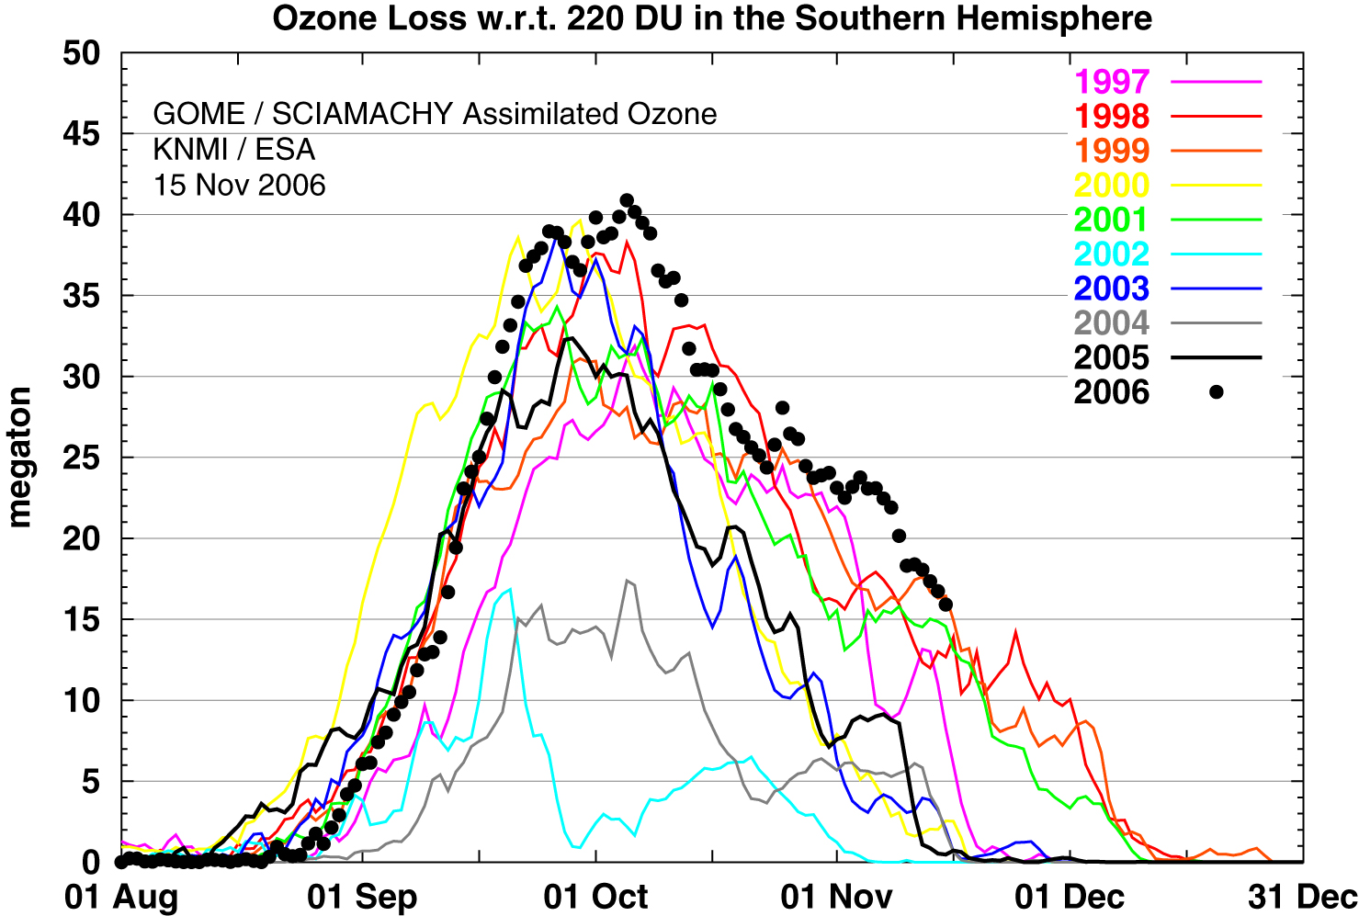
Figure 1. Ozone mass deficit in the Antarctic ozone hole. The figure shows how much ozone (megatonnes) that would have to be added to the ozone hole to reach 220 DU. It can be seen that this parameter has reached the highest value ever in 2006, with more than 40 megatonnes of ozone missing on 5 October. One can also see the persistence of the ozone hole as the ozone mass deficit in early November is higher than ever before for the time of the year.
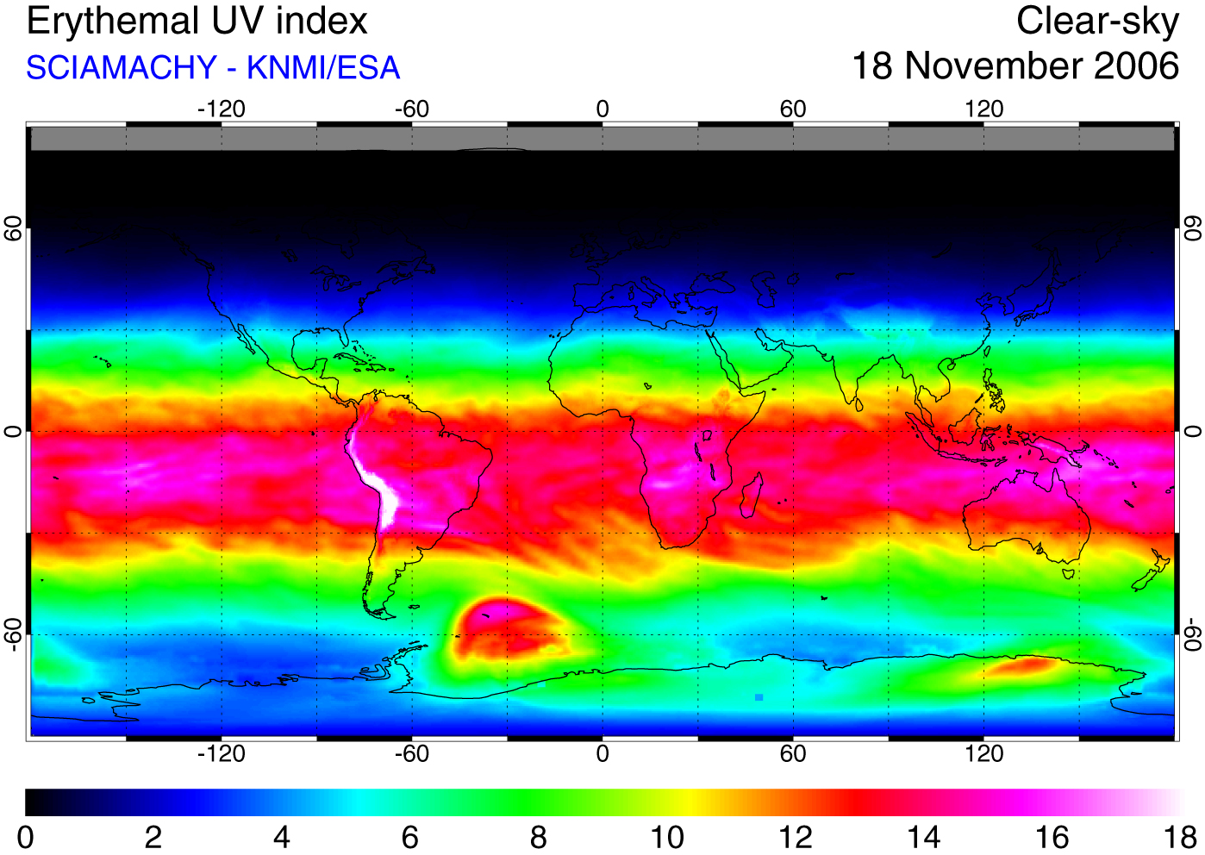
Figure 2. Clear-sky UV index for 18 December 2006 as calculated from forecast ozone from the TEMIS system at the Royal Netherlands Meteorological Institute. It can be seen that a region around South Georgia will be subject to UV indices in the range 12-15, which is much higher than normal for this latitude.

_______________

