WORLD METEOROLOGICAL ORGANIZATION  ________________  WMO Information System (WIS)  Workshop on Information Access Enablers  Geneva, Switzerland, 17-18 May 2010 |  | WIS-Enablers-Doc. 1.2(5)  _______  ITEM 1.2  Original: ENGLISH

LIST OF SPEAKERS IN THE WORKSHOP
 | Bob Bishop is currently spearheading an effort to build the International Centre for Earth Simulation (ICES). He is Chairman and Founder of a strategic consulting organization and Chairman of the Advisory Board for the Blue Brain Project, a research initiative to create a biologically accurate, functional model of the human brain using a supercomputer. He was Chairman and Chief Executive Officer for Silicon Graphics Inc (SGI) from 1999 to 2006, first joining the company in 1986 as the founding president of its World Trade Corporation. Bob was Vice President International for Apollo Computer Inc from 1982 to 1986 and held senior positions with Digital Equipment Corporation (DEC) from 1968 to 1982. During his 40 year professional career, he lived with his family in five countries and established over 100 international subsidiaries for DEC, Apollo and SGI. Bob is an elected member of the Swiss Academy of Engineering Sciences and serves on several international advisory panels. In 2006, he was awarded NASA’s Distinguished Public Service Medal for his role in helping NASA’s space shuttle fleet successfully ‘return-to-flight’ after the 2003 Columbia disaster.
 | Lisa Brodey is a Foreign Service officer - a diplomat - who has focused her career on environmental policy. She currently serves as the Environment, Science and Technology Officer at the United States Mission to the United Nations in Geneva. Lisa is active in dialogues on environmental policy within the World Meteorological Organization, the UN Environment Programme and the UN Economic Commission for Europe. Most recently she participated in negotiations at UNEP's Global Ministerial Environment Forum, the WMO's World Climate Conference 3, and the World Water Forum. Prior to her posting in Geneva, Lisa was the Regional Environment officer for East Africa, based in Addis Ababa. She worked with national governments, NGOs and donors throughout East Africa to address environmental challenges that are inhibiting sustainable growth such as energy poverty, unregulated fishing, and water resource management. Prior to this, Lisa worked in television news and documentary production, including a stint with UNICEF where she created training videos for Bangladeshi doctors and nurses participating in the Expanded Programme for Immunization.
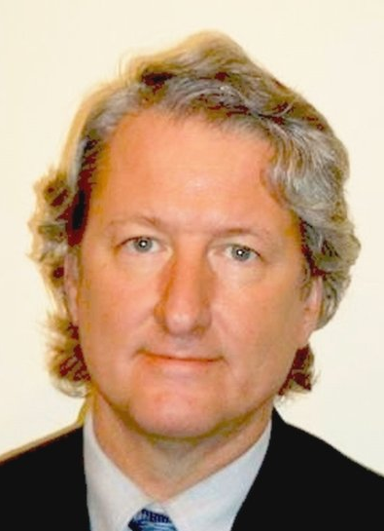 | Eliot Christian works at the World Meteorological Organization (WMO) as the Senior Scientific Officer for the WMO Information System (WIS). He has been a leader in several broad programs, including the Global Earth Observations System of Systems and the Global Information Locator Service. He has also had a key role in technical standards such as the Common Alerting Protocol (ITU X.1303), XML Encoding Rules, and ISO 23950, Information Search and Retrieval. Eliot is especially known for developing and promoting decentralized information discovery and he is expert in metadata and in networked information discovery. Eliot has had a major role in shaping principles of scientific data management, especially the use of library science techniques for data and information systems interoperability.
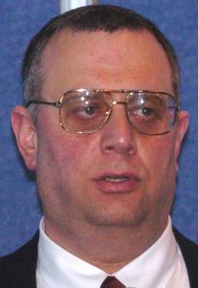 | Howard Diamond is a physical scientist with NOAA's National Climatic Data Center (NCDC) and is based in Silver Spring, Maryland, in the U.S. He has worked for NOAA in a number of different capacities for the past 28 years, and since 1999 has served as the U.S. Global Climate Observing System (GCOS) Program Manager, and among other things he manages the Global Observing Systems Information Center (GOSIC) on behalf of the international observing community. In addition to that, he is the director of the World Data Center for Meteorology based at NCDC, serves as NCDC's International Liaison Officer, and works on a number of bilateral and regional climate observing and data management projects in the Pacific Islands region with partners from across the region including Australia and New Zealand. Howard has a B.S. in Biological Sciences from Florida State University, an M.S. in Technology Management from the University of Maryland, and is currently pursuing a Ph.D. in Geography at the University of Auckland in New Zealand where he is doing a climatological study of tropical cyclones in the Southwest Pacific; and is a member of both the American Meteorological Society and American Geophysical Union. His interest in tropical cyclones led to him being a member of NCDC's International Best Tracks Archive for Climate Stewardship (IBTrACS) team as well as the World Meteorological Organization's Southern Hemisphere THORPEX Committee.
 | Matthew Dovey works as Programme Director for e-Research at the JISC (Joint Information Systems Committee). JISC is funded by all of the UK higher education funding councils to provide leadership, strategic guidance, advice and opportunities in the use of ICT (Information and Communications Technology) in support of learning, teaching, research and administration. His work focuses on engaging with research communities in the use and development of local and national e-infrastructures to support research. He currently oversees programmes on Research Communities Engagement, Virtual Research Communities, Research Data Management, Research e-Infrastructures and Access and Identity Management. Previously, Matthew was Technical Manager at the Oxford University e-Science Centre where he advised scientific research projects based on WebService and GridService architectures. Prior to this, he worked for the Oxford University Library Services implementing numerous library and digital library technologies including Music Information Retrieval and projects on preservation of digital material. He has worked on a number of standards organisations including NISO, OASIS and the Open Grid Forum.
 | Marten Hogeweg is a senior project manager and product manager at ESRI (Environmental Systems Research Institute) Incorporated in Redlands, California. Marten has Master of Sciences degrees in mathematics and in Geographic Information Systems (GIS) and over fifteen years of experience working with GIS. He is Senior Project Manager for the United States Geospatial One-Stop Portal (http://www.geodata.gov) and has provided consulting support to other federal programs related to transparency and accountability (Recovery.gov, Data.gov). Since 2007, he has participated in the Group on Earth Observations’ initiative to develop a Global Earth Observation System of Systems. He is also Product Manager for the ESRI ArcGIS Server Geoportal Extension (http://www.esri.com/geoportal), one of the supporting technologies that serve GIS Portals around the world.
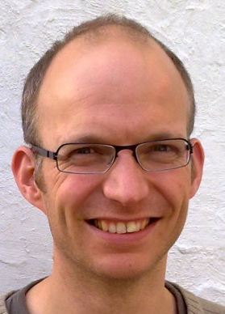 | Heiko Klein works as system developer at the Norwegian Meteorological Institute. He is involved in the development of the open source data management and portal system METAMOD (https://wiki.met.no/metamod/) which has been used to support IPY data management both nationally and internationally and which is currently being adapted for WIS DCPC use. He is also the lead developer of FIMEX (https://wiki.met.no/fimex/), a file interpolation, manipulation and extraction library for gridded data-formats like e.g netCDF and WMO GRIB 1/2. Previously he was a scientist within the UN-ECE EMEP programme for long range air pollutants, where he worked on the borderline between science and politics, and he developed Webdab, the air emmission database.
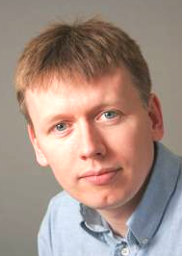 | Jon McLoone has worked with Wolfram Research, the makers of Mathematica since 1992, working on software development, system design, technical writing and strategy. He supports educational projects in cooperation with universities and government research and has lectured on Mathematica around the world. He has a degree in mathematics from Durham University.
 | Claire Martin is a national television weather presenter with CBC Television in Canada. In 2000, 2001 and 2003, the International Weather Festival awarded her "Best Weather Presenter in the World". She has been highly involved in the broadcasting quality of meteorological information as Chairman of the International Association of Broadcast Meteorologists. She also sat on AMS Board of Broadcast Meteorology which judges the AMS "Seal of approval" for on-air meteorologists. Before emigrating to Canada, Claire worked for the UK Met Office as a forecaster and earned a degree in Mathematics, Statistics and Physics. She moved to Canada in 1990 and worked for the Meteorological Service of Canada. In 1995 she received a degree with specialization in Meteorology. She was a staff meteorologist and weather presenter with Global Television Edmonton from 1996 to 2005. She joined CBC Television news n Toronto as CBC introduced nationally-televised weather features. In 2007, she moved to CBC Vancouver to host regional weather forecasts.
 | Tomas Molina is Chief Meteorologist for Televisió de Catalunya and President of the Climate Broadcasters Network Europe of the European Commission and Vice-Chairman of the International Association of Broadcast Meteorology (IABM). He is founder of Canal Méteo (the Spanish weather channel) and produces weather information to the internet, press, TV channels, mobile phones, etc. Tomas holds a university degree in physics. He is chairman of the Catalan Council for Communication of Science, and a teacher of weather forecast at the Master on Meteorology at the University of Barcelona. He has published five books: two referred to the environment and climate variability in Spain and three for children about weather, astronomy and earth physics stories.
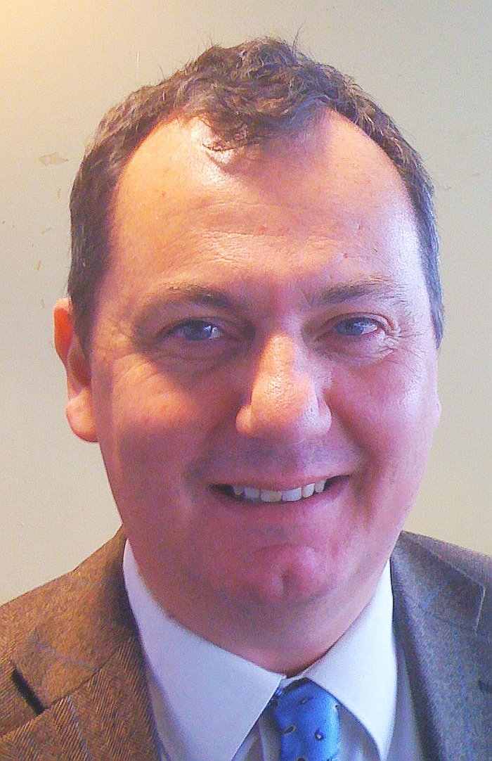 | Baudouin Raoult is the Head of Data and Services Section at the European Centre for Medium-Range Weather Forecasts (ECMWF), where he has been working since 1989. Baudouin has been responsible for the architecture and the development of ECMWF meteorological archive system (MARS). He has also been leading other key ECMWF projects such the design of a high level meteorological data manipulation language, the implementation of a web-based catalogue browsing and data retrieval system and the development of a fully interactive web-based tool allowing forecasters to manipulate and visualise meteorological products. Baudouin is a member of several WMO expert teams and is actively involved in the WMO Information System (WIS) and the THORPEX Interactive Grand Global Ensemble (TIGGE) projects.
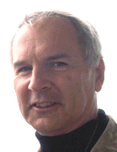 | David Rogers is the President and Chairman of the Board of Health and Climate Foundation, responsible for the vision of the Foundation and overseeing day-to-day operations. David is the former chief executive of Met Office UK. Originally trained as an environmental scientist and oceanographer, he has over 25 years experience in research and development, government and the private sector. Prior to his appointment to the Met Office, David was a Vice President at Science Applications International Corporation (SAIC) in Mclean, Virginia. From 2000—2003, he was the Director of Weather and Air Quality Research at the National Oceanic and Atmospheric Administration (NOAA) in Washington, DC. Before that, David held various research, teaching and administrative appointments at Scripps Institution of Oceanography in La Jolla, California, including Director of Physical Oceanography Research Division, Director of the Joint Institute for Marine Observations and Deputy Director of the California Space Institute.
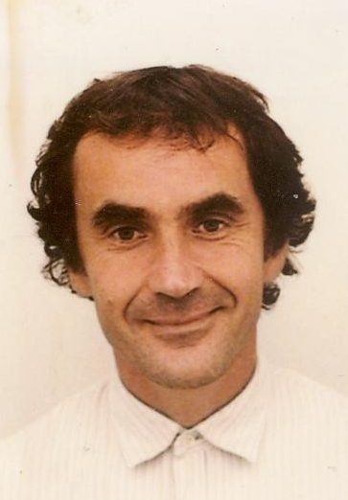 | Jacques Roumilhac is Deputy Head Study & Development Division in Meteo France and involved in the Analysis and Development of different data services (Inmarsat services, GTS switch, VSAT). In the past, he was Project Manager of the satellite diffusion system Retim2000. He is currently in charge of the implementation of the WMO Information System GISC/DCPC function in Meteo France, in collaboration with the UK MetOffice.
 | Joseph Russo is a Senior Scientist and President of ZedX, Inc., an information technology company specializing in decision-support algorithms and data visualization tools for the agricultural and environmental industries. He has been involved in the design and development of interactive, web-based, decision-support platforms and learning services for the agricultural sector, including the ipmPIPE for the USDA, and AgFleet for the precision agriculture community. In 2008, he was one of three recipients of the national PrecisionAg Award of Excellence, which is given by The PrecisionAg Institute. He holds a Bachelor of Science degree in Meteorology from St. Louis University, a Master of Science degree in Meteorology from McGill University, and a Ph.D. in Agricultural Meteorology from Cornell University.
 | Peiliang Shi is now Director of the WMO Information System (WIS) within the Observations and Information Systems Department of WMO. Previously, he was Director of the National Meteorological Information Centre at the China Meteorological Administration. He has been involved in the development and operational management of meteorological information systems for more than 25 years.

