WORLD METEOROLOGICAL ORGANIZATION  ________________  WIS Common Alerting Protocol (CAP, X.1303) Implementation Workshop  Geneva, Switzerland, 6-7 April 2011 |  | WIS-CAP-2011/1.2(5)  _______  ITEM 1.2  Original: ENGLISH

LIST OF SPEAKERS IN THE WORKSHOP
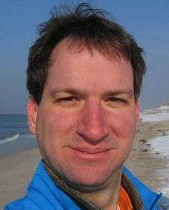 | Alexander Beck is a senior scientist at the Austrian National Weather Service (ZAMG) responsible for product design and development. He is involved in the design and operation of ZAMG's warning system and in particular the dissemination of warnings to Meteoalarm. Before joining ZAMG in 2008 he was a senior scientist at the Department of Meteorology and Geophysics at the University of Vienna. He is involved in training programmes and is an active lecturer at the University of Vienna in the field of numerical weather prediction.
 | Bilel Jamoussi is Chief of the Study Groups Department at ITU-T, which includes responsibility for Global Standardization Initiatives, Joint Coordination Activities, and Focus Groups. Before joining ITU, Bilel was with Nortel for 15 years where he held several leadership roles including Strategic Standards, Advanced Technology, University Research, Software Development for routing/switching platforms, and Data Network Engineering of major international customer networks. Bilel provided strategic technology direction and leadership for Nortel’s involvement in more than 90 standards development organizations, forums and consortia. An experienced standards professional, Bilel was an elected member of the Board of Governors and the Corporate Advisory Group of the IEEE Standards Association. He served on various IEEE committees, and was Technical Liaison to ITU-T and ITU-D. Bilel contributes to the innovation and advancement of technology in the ICT Field. He has 22 granted and filed US patents in diverse areas: packet, optical, wireless, and quality of service.
 | Andrew Schroeder is the Director of Research and Analysis at Direct Relief International. Beginning in 2008 he initiated Direct Relief’s program in spatial analytics and GIS. Since that time he has worked closely with Abbott Fund on mapping the global landscape of PMTCT services (Prevention of Mother to Child Transmission of HIV/AIDS), with Pfizer on spatial analytics for the Diflucan distribution program, with BD-PEPFAR on lab strengthening GIS in East Africa and with Direct Relief’s international partners on a range of crisis mapping activities. During the Haiti earthquake response in 2010 he participated extensively in the Interagency Haiti Health Facility Mapping Group which built the first comprehensive map of Haitian health infrastructure, now in use by Haiti’s Ministry of Health. In October of 2010 he was honored with a special award by ESRI at their GIS and Public Health conference for exceptional work in GIS throughout the Haiti emergency. Andrew received his PhD from New York University’s Department of Social and Cultural Analysis and his Masters of Public Policy with a focus in Science, Technology and Public Policy from the Gerald R. Ford School at the University of Michigan.
 | Carol Cosgrove Sacks is the Senior Advisor on International Standards Policy to OASIS, the global internet standards consortium. Since 2005 she has represented OASIS interests to international and European organizations relevant to standards development. In 2009, on behalf of OASIS, she was a Member of the EU high level Expert Panel on the Review of the European Standardization System (EXPRESS) and she is a member of the EU ICT Standards Board and the EU ICT Standards Steering Committee. She helped to organize two previous conferences/workshops on the CAP in Geneva and is active regarding eGovernment and public administration. She is also a Professor at the College of Europe, Bruges. From 1994 to 2005, she was the Director of Trade & Regulatory Affairs in the United Nations Economic Commission for Europe (UNECE) in Geneva. She was responsible for the administrative and policy support for UN/CEFACT and she initiated the global MoU on eBusines between all the international standards organizations developing electronic business standards. She is a British national living in Geneva.
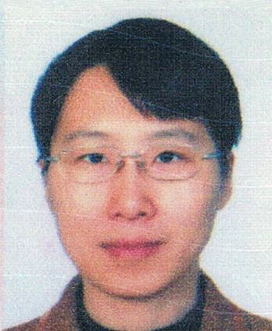 | Chunfang Wang works at National Meteorological Information Centre of China Meteorological Administration as a senior engineer of satellite communication. She is a member of GEONETCast implementation group and GEOSS Common Infrastructure Coordination Team (GCI-CT) since 2009. She is also involved in the design of China national alert distribution system these years.
 | Clive Reece is a Senior Project Manager/Consultant at Esri since 2004. He leads projects and provides geospatial consulting in the area of Spatial Data Infrastructures (SDI) and geospatial web technologies. Dr. Reece has been a consultant/project manager for many GIS Portal and SDI projects around the United States and internationally. He has a background that combines scientific knowledge and technical expertise with business and organizational skills. His career has included directing research and teaching in microclimatology and environmental biophysics at the University of Minnesota, and Product Manager for GIS weather solutions at DTN/Meteorlogix LLC.
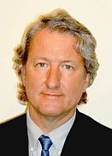 | Eliot Christian works at the World Meteorological Organization (WMO) as the Senior Scientific Officer for the WMO Information System (WIS). He has been a leader in several broad programs, including the Global Earth Observations System of Systems and the Global Information Locator Service. He has also had a key role in technical standards such as the Common Alerting Protocol (ITU X.1303), XML Encoding Rules, and ISO 23950, Information Search and Retrieval. Eliot is especially known for developing and promoting decentralized information discovery and he is expert in metadata and in networked information discovery. Eliot has had a major role in shaping principles of scientific data management, especially the use of library science techniques for data and information systems interoperability.
 | Elizabeth Klute is the National Disaster Director for the Government of Anguilla, British West Indies where she has overall responsibility for the Department of Disaster Management (DDM), National Emergency Operations Centre and comprehensive disaster management programme. Anguilla implemented the first CAP based All Hazard Warning System in the Caribbean in 2007. She serves a Vice Chair of the International Oceanographic Commission (IOC) UNESCO, Intergovernmental Committee (IGC) CARIB Tsunami Warning Project, Working Group III – Public Dissemination. A board member of the Partnership for Public Warning Board of Trustees, Mrs. Klute previously held the position of Community Warning System (CWS) Manager, Contra Costa County Office of the Sheriff (2002-2006) where she developed a countywide public and private entity team to transfer ownership of, enhance and upgrade the industry built CWS to current technologies including CAP. As Senior Consultant/Project Manager for Disaster Management at Environmental Systems Research Institute (ESRI) her In-Vehicle Fire Response System won a 1999 Global Bangemann Award out of Stockholm, Sweden.
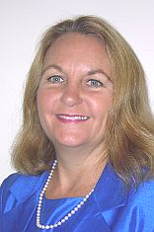 | Elysa Jones is an internationally recognized expert in Emergency Interoperability Communications via Data Messaging. Elysa is Chair of the OASIS Emergency Management Technical Committee (EM-TC) since 2004 and through her leadership; the EM-TC has developed the Common Alerting Protocol (CAP) Standard, which is also an ITU-T recommendation. She is a founding member of the Partnership for Public Warning, works with the Emergency Information Infrastructure Project and with government officials to understand the requirements for open standards adoption in next-generation alert and warning systems for emergency notification. As Chief Technology Officer of Warning Systems, where she has worked since 1998, she directed the design, development and deployment of over 100,000 Tone Alert Receivers for the Chemical Stockpile Emergency Preparedness Program. She developed web-based control systems many types of tone-encoded devices capable of being activated by CAP messages. Previously, she worked for the US Army Strategic Missile Defense Program. She holds a Baccalaureate Degree in Economics and Masters Degree in Computer Science. She is an advocate for the adoption of EDXL messaging standards and implementation of CAP.
 | Gordon Gow is Associate Professor in the Graduate Program in Communications and Technology at the University of Alberta where he conducts research on the social impact of new communication technologies. From 2003-2006 he was lecturer in the Department of Media and Communications at the London School of Economics, where he was Director of the Graduate Programme in Media and Communications Regulation and Policy. Dr. Gow is also affiliated with the Centre for Policy Research on Science and Technology (CPROST) at Simon Fraser University. Dr. Gow's research interests revolve around the impact of social media and other new communication technologies in the areas of public safety, public health, and community engagement. His recent projects include a study on emergency alerting at Canadian post-secondary institutions, as well as two Canadian-funded studies on the use of mobile phones for public alerting and health surveillance in Sri Lanka and India. Dr. Gow is also involved with provincial and federal government stakeholders in Canada on various public alerting related projects including development of the CAP Canadian Profile.
 | Greg Trott is the Project Manager in the Australian Government Attorney-General’s Department who is responsible for managing the CAP Australian Profile (CAP-AP) project currently underway in the Emergency Management Capability Development Branch. He previously served in the Royal Australian Air Force from 1982 - 2010 as an Air Combat Officer, Tactical Coordinator and Navigator Instructor on P-3C Orion maritime patrol aircraft, and since 1995 as a Project Manager responsible for delivery of an array of air power projects including a crew simulator upgrade for the P-3C, requirements development for introduction of the P-8A Poseidon and Global Hawk Unmanned Air Vehicle (UAV) systems, requirements development for Air Base support capabilities and construction of a deployable operations support capability for the Heron UAV system. Greg holds a Master of Management Studies in Defence Capability Development & Acquisition and has been accredited as a Certified Practising Project Director (CPPD) through the Australian Institute of Project Management since 2006.
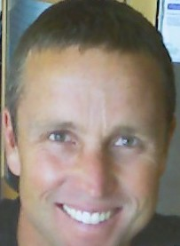 | Joel Kristopher Myhre is a geospatial consultant with two decades of public policy and ICT experience. As the principal of Nordic Geospatial Consulting LLC, he has worked throughout the Pacific Rim and Europe implementing UNGIWG, ISO, US FGDC, OGC, & US DHS-HIFLD geospatial standards. Mr. Myhre is a Member of the Royal Institution of Chartered Surveyors (MRICS), a founder of the California Homeland Security GIS Working Group (HTTR), and a participant in the Global Healthcare Facility Database Initiative. Recent endeavors have focused on global alerting and response (WHO Geneva), port security (Los Angeles), and integrated situational awareness for crisis response.
 | Herb White is Dissemination Services Manager for the U.S. National Weather Service (NWS), an agency of the National Oceanic and Atmospheric Administration, in Silver Spring, Maryland. Herb helps to ensure effective dissemination of NWS products and further redistribution by NWS partners through developing and managing product formats, codes, and service delivery from NWS communications systems. He has been active in enhancing NWS all-hazards dissemination and national public warning capabilities including Common Alerting Protocol. Prior to his current work starting in 2000, Herb worked for 29 years at NWS offices from the Carolinas to Pennsylvania and New York in various capacities including operational weather forecaster, computer systems manager, quality control officer, warning coordination meteorologist, and in weather-related accident investigations with the NWS and National Transportation Safety Board and associated litigation.
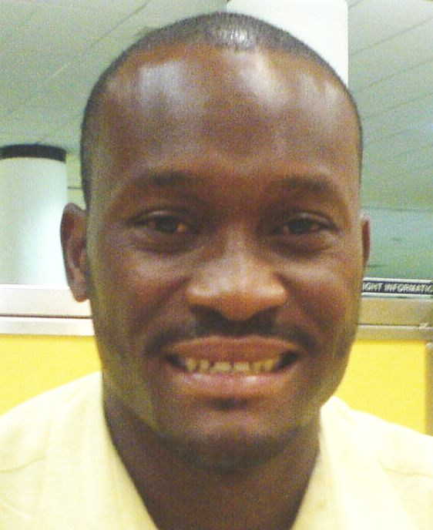 | Marvin Forde has been a member of staff at CIMH (Caribbean Institute for Meteorology and Hydrology) since 2007. His duties include teaching in the instruments module in the meteorological technician course and offer technical assistance and support to CMO (Caribbean Meteorological Organization) member states. He also conducts in-house research and development in hardware and software for data collect systems.
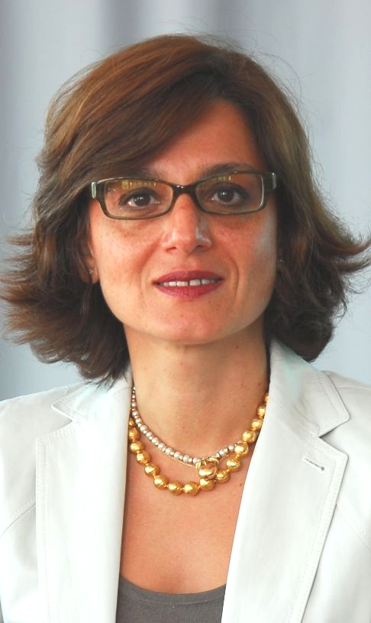 | Maryam Golnaraghi is the Chief of the WMO Disaster Risk Reduction Programme since 2004. She facilitates and coordinates multi-hazard multi-agency national and regional capacity development projects supporting risk assessment and early warning systems, in partnership with the World Bank, the UN, and other regional and technical agencies. She has worked extensively in the area of weather-indexed and catastrophe insurance and is facilitating the development of meteorological, hydrological and climate services to support this area. In 1996, she founded Climate Risk Solutions Inc. in Boston, to provide innovative climate risk management solutions for the energy, agricultural and financial sectors. She worked extensively in risk modeling, private/public partnerships, training programmes on climate risk management, and specialized climate information products and services for sectoral risk management. From 1993 to 1995, as a research associate at the Harvard Business School, she worked in the areas of commercialization of technology and new product development. She holds a B.Sc. in Chemical Engineering from Cornell University, a Masters of Science in Applied Physics and a Ph.D. in ocean general circulation and climate modeling from Harvard University.
 | Norihisa Washitake is an international representative at the Japan Meteorological Agency (JMA); he coordinates discussions on information telecommunication systems in the agency and with other foreign weather services. Before joining the Office of International Affairs, he had been involved in operation and future plans of super computer systems at JMA.
 | Norm Paulsen is a senior meteorologist for Environment Canada and one of the principle architects of the CAP Canadian Profile (CAP-CP). Through his technical expertise on data systems design, the CAP Canadian Profile remains interoperable with CAP systems world wide while at the same time addressing the local needs of Canada. He gained this expertise by being involved in all aspects of warning message production within Environment Canada since 1991. In 2000, Mr. Paulsen was promoted to his current position involving the analysis and strategic planning for EC's alerting and warning programs. Mr. Paulsen's work also enabled Environment Canada to successfully undertake several key projects including the development of a pilot CAP-CP service which then lead to additional improvements to CAP-CP in 2010. Through Norm’s hard work, Environment Canada’s first production ready CAP service will be launched in 2011.
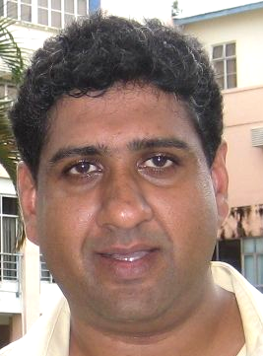 | Nuwan Waidyanatha is a Senior Researcher with LIRNEasia. His expertise are in ICT system design and actionable research working collaboratively with multiple national and international stakeholders. He applies the academic and industrial experience in providing practical solutions for developing nations. Present research interests are in developing early warning systems and information exchange platforms for emergency communication; specifically, the use of Common Alerting Protocol messaging standard in Last-Mile warning technologies and Health risk information dissemination. He is an advocate of Free and Open Source Software and is a member of the project management and standards-interoperability Committees of the Sahana Software Foundation. His master's degree is in Operations Research and bachelor's degree in Mathematics and Computer Engineering.
picture  not  provided | Olivier Dubuisson is coordinating standards for France Telecom-Orange. He was active in the adoption of the Common Alerting Protocol (CAP) as Recommendation ITU-T X.1303. He is the ITU-T ASN.1 OID project leader, and provides help and advice to many organizations and standardization bodies in their use of object identifiers.
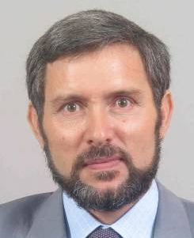 | Omar Baddour is Chief of the WIS Data Management Applications Division. Amongst his duties are coordination of the WMO Climate System Monitoring (CSM) and development of climate data infrastructure in developing and least developed countries. He joined WMO in 2005. Previously, he led the atmospheric research division within the National Meteorological Service of Morocco and developed several projects related to atmospheric science and climatology. He worked with the African Centre of Meteorological Applications for Development (ACMAD) and the African meteorological services to develop a continental wide demonstration project on climate prediction and climate outlook forums. He was the head of the northern regional meteorological office of Morocco during the 5 years preceding his duties at the WMO.
 | Peiliang Shi is now Director of the WMO Information System (WIS) within the Observations and Information Systems Department of WMO. Previously, he was Director of the National Meteorological Information Centre at the China Meteorological Administration. He has been involved in the development and operational management of meteorological information systems for more than 25 years.
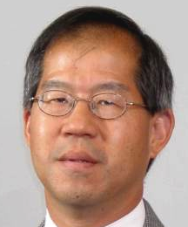 | Peter Chen is Chief of the Data-Processing and Forecasting Division of the Weather and Disaster Risk Reduction Services Department of WMO. He coordinates scientific and technical matters related to operational weather forecasting for WMO Members and relevant international organizations, including numerical weather prediction, and atmospheric transport modeling for emergency response. Prior to his arrival at the WMO, he was Director of Operations of the Canadian Meteorological Centre for 10 years. His career has included various positions including forecaster, senior instructor, and manager of scientific services.
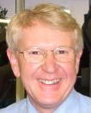 | Peter Kreft has spent about half of his 30 years as a meteorologist working in New Zealand's National Forecast Centre and the other half recruiting and training MetService's meteorologists. His particular area of expertise is broad-scale weather systems and he has been an honorary teaching associate at Victoria University of Wellington. Peter also is keenly interested in the way weather information is communicated. He is Meteorological Service of New Zealand Limited's Chief Forecaster.
 | Prem Ramaswami has been a Product Manager at Google since, 2006. Currently, Prem focuses on Google DotOrg's efforts around Crisis Response. He has worked on projects such as Google Checkout, Google's ecommerce shopping solution, and the Internet Bus Project aimed at increasing Internet penetration in India. Additionally, Prem was instrumental in launching Google Checkout for Non-Profits. Prem was also part of Google's Network Infrastructure team as part of the Make the Web Faster Initiative launching Google Public DNS. Prem graduated from Carnegie Mellon University with degrees in Biomedical and Computer Engineering and worked at MIT Lincoln Laboratory on an airborne 3D laser radar wide area mapping system before joining Google. He also is a diehard Jets fan, loves Duke college basketball, and is addicted to TV.
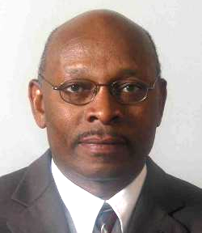 | Samuel Muchemi has served in the position of the Scientific Officer in the Public Weather Services Programme (SO/PWS) of WMO since 2006. His career in Meteorology started when he joined the Kenya Meteorological Department (KMD) in 1980 as a weather forecaster and later as a weather presenter on television in 1985 for the Kenya Broadcasting Corporation (KBC). He was seconded to the African Centre of Meteorological Applications for Development (ACMAD) in Niamey, Niger where he contributed to the initiation of the RANET rural communication project, now adopted in several countries in Africa and in the Pacific Region. Before joining WMO, he had served in the Expert Team on Media Issues from 1999 to 2005 and later in Expert Team on Communication until 2006. He was in charge of the Public Weather Services Division of KMD before joining WMO.
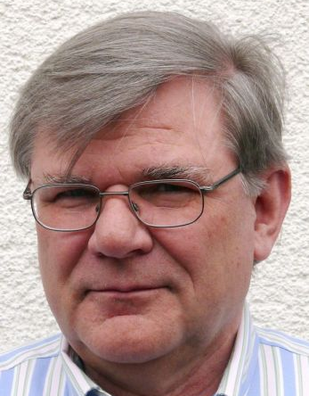 | Siegfried Fechner is a member of the department 'Dedicated systems' of Deutscher Wetterdienst (DWD) and member of the WIS/GISC (Global Information System Centre) DWD-team and member of WMO ET-GDDP (Expert Team on GISC-DCPC demonstration process). He ist responsible for the development of different data distribution systems for national and international customers of DWD. As member of the WMO IPET-MDI (Inter-Programme Expert Team on Metadata and Data Interoperability) he coordinates the introduction of CAP as an additional data format for warning at DWD.
 | Simon Elliott works for EUMETSAT, the European Organisation for the Exploitation of Meteorological Satellites. He is the head of the Product Integration Section in EUMETSAT’s Operations Department and is responsible for the operational deployment of processing systems for deriving meteorological data and products from satellites for use in meteorology and climate monitoring. Simon has been a member of various WMO Teams working on data formats and data exchange. He is currently the Chairman of the WMO Inter-Program Expert Team on Data Representation and Code (IPET-DRC) and a member of the Inter-Program Expert Team on Meta Data and Interoperability (IPET-MDI). Within the meteorological satellite community, Simon is the Chairman of the Coordination Group for Meteorological Satellites (CGMS) Task Force on Satellite Data and Codes. On 24 March 2011, EUMETSAT plans to begin the operational production and dissemination of CAP alerts relating the detection of active fires and volcanic ash.
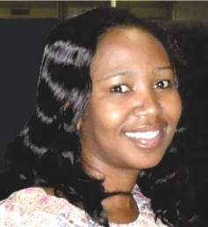 | Sisanda Hanise is the Senior Web Developer for the South African Weather Service. She has been with SAWS since 2009. Her responsibilities involve SAWS web development, management and maintenance. She has recently joined the team that is implementing CAP at SAWS.
 | Steve Hakusa is a software engineer at Google. He currently works with Google DotOrg's Crisis Response team, which focuses on making critical information more accessible during natural disasters and humanitarian crises. Steve has been at Google since 2005, and has worked on numerous other projects in local and television advertising. In his 20% time at Google, Steve has helped improve access to information in Africa using Google's SMS search and local health and agriculture databases. Steve graduated from New York University with degrees in Computer Science and Electrical Engineering and lives in New York City.
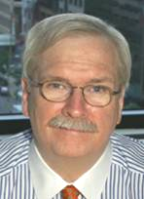 | Tom Fahy consults on homeland security and emergency communications issues and advises CellCast Technologies on domestic and international affairs. He was a strategic advisor on the Emergency Alert System Plan for the U.S. National Capitol Region. He worked on awareness of weather radios and advocated for communities to be Storm Ready and Tsunami Ready. Tom was co-founder and Managing Director of the Summit on EAS and Emergency Communications. He serves on the Board of Directors for the Emergency Interoperability Consortium and is a participating member in several associations focused on hazards mitigation and emergency communications. Tom's accomplishments have been recognized by the U.S. Department of Justice, and by the U.S. National Center for Missing & Exploited Children. NOAA's National Weather Service presented him with its highest recognition for his intergovernmental advocacy efforts to improve emergency alert capabilities and for strengthening ties with the broadcast industry for public warnings. Tom is based in Washington, DC.
 | Tommaso Abrate is Scientific Officer in the Basic Systems in Hydrology Division of WMO. He joined WMO in 1994 and since 1997 he has been in his present position. He has been working extensively in support of the development of the WMO World Hydrological Cycle Observing System (WHYCOS) programme and its regional components since its inception, especially in Africa (Congo, Niger, Senegal and Volta basins). He has also been involved in flood forecasting and management and risk assessment in Africa and Europe. He holds a B. Sc in geology from Turin University in 1988, a postgraduate diploma in environmental engineering from Turin Polytechnic in 1991 and a M. Sc. in hydrology and hydrogeology from University Paris VI “Pierre et Marie Curie” in 2007.
 | Yoshiaki Sugiyama is a coordinator for research and development at the Administration Department of the Japan Meteorological Agency (JMA), and he is also working on information strategy of JMA. He designed JMA’s new information system to assist weather forecasting and warning by using and exchanging XML, when he was at the Information and Telecommunication Division between 2002 and 2009. Since then, he has taken part in planning of information systems utilizing XML

