WORLD METEOROLOGICAL ORGANIZATION  ________________  WIS Common Alerting Protocol (CAP, X.1303) Implementation Workshop  Geneva, Switzerland, 6-7 April 2011 |  | WIS-CAP-2011/1.2(7)  _______  ITEM 1.2  Original: ENGLISH

No-host Group Dinner, Wednesday 6 April 7:00pm
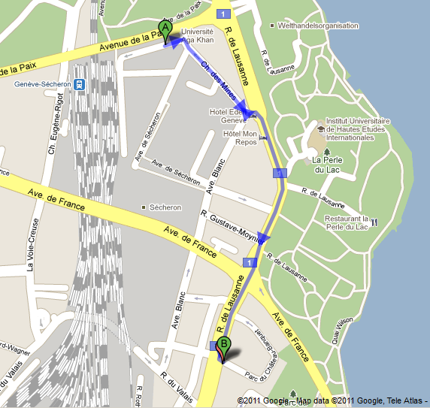
If you will come, please let us know by lunch when we'll finalize the group reservation
WMO
Costa Smeralda
Christian, 4th Floor
12 Chateau-Banquet
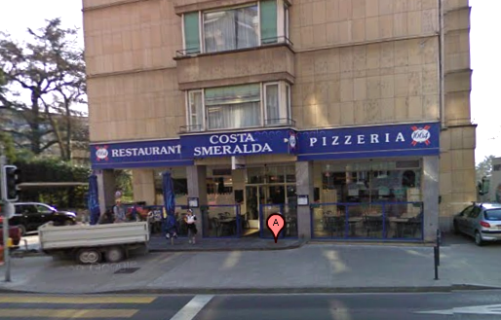

Costa Smeralda
Specializes in wood fired pizza, also offers other Italian and Sicilian dishes
Typical dinner about 30 CHF
(wine would be extra, of course)
10 minute walk from WMO, south on Rue de Lausanne
Please join us for drinks 5:30 - 7:00 at apartment of Eliot & Marcia Christian,
4th floor, Parc du Château-Banquet 12 (apartments to the left of restaurant)

