

Recommendation on C-Band Meteorological radars design to ensure global and long-term coexistence with 5 GHz RLAN

Adopted XX/XX/XX by the XXth EUMETNET council

considering
a) that meteorological radars are key observation stations used for meteorological observing and environmental monitoring and they play a crucial role in providing warnings of imminent severe weather conditions, such as flooding, cyclones and hurricanes, that can endanger populations and damage strategic economic infrastructure
b) that meteorological radars represent the last line of defence against loss of life and property in flash floods and severe storms events, such as those that occurred recently in Eastern Europe, UK, France and Greece, and for these reasons they cannot be put at any risk.
c) that there are currently more than 180 meteorological radars used by EUMETNET members among of which about 160 operate in the 5GHz range (C-Band)
d) that the number of interference cases from RLAN 5 GHz to meteorological radars is increasing and has currently been observed in at least 12 European countries
e) that these interference issues are a matter of great importance and represent a serious potential threat for all meteorological radars operating in the 5 GHz range

recognizing
a) that the authorisation of RLAN to operate in the 5 GHz range was a decision from the World Radiocommunication Conference 2003 (WRC-03), followed by consistent ECC and EC Decisions.
b) that in view of the level of degradation caused to meteorological radars by one single RLAN it is of the utmost important that effective solutions are found as soon as possible before RLAN deployment in this frequency band reaches a point of no-return.
c) that the unlicensed nature of these RLAN 5 GHz devices could lead in rather short-term to an uncontrolled situation in which the number of these devices would be too high for any effective action to be taken by the National Radiocommunication Administrations and a de facto loss of this essential band for the meteorological community
d) that the European Radio community, in particular in the European Commission TCAM as well as the RLAN industry, have taken with the highest care possible these interference cases showing a strong willingness to find a global and long-term coexistence solution between RLAN and meteorological radars
e) that the preferred solution would have been an exclusion of RLAN from the 5600-5650 MHz band but is no longer easily achievable at this stage
f) that it appears that a global and long-term coexistence solution and related technical remedies require efforts to be made by both sides, i.e the RLAN industry and the meteorological community

noting
a) that, if RLAN industry is not able to achieve or implement on a satisfactory basis the envisaged technical remedies, the meteorological community will have no further choice than to request an RLAN exclusion from the 5600-5650 MHz band.
b) that such exclusion solution is already implemented in a number of countries such as Canada and Australia.

recommends
1 that EUMETNET members operating C-Band meteorological radars should take into account in the design of these radars the coexistence with 5 GHz RLAN and their potential for interference
2 that, in particular, the following technical and operational guidelines be considered with the highest care and priority :
- only operate radars in the 5600-5650 MHz band
- transmit minimum number of detectable signals over scanning strategies
- improve to the best extent and at minimum to the regulated levels the out-of-band emissions of radars
- improve to the best extent the out-of-band signal rejection of the radar receiver, with a particular focus on the image-frequency.
3 that detailed elements in the annex be considered when applying the abovementioned guidelines
4 That EUMETNET members maintain high level of contact with their National Radio Administration (NRA) in view to ensure they effectively and efficiently comply with their Market Surveillance obligation under the EU RTTE directive to closely check current and future use of the 5 GHz band by RLAN
5 That EUMETNET members operating C-Band meteorological radars keep in detailed scrutiny their radar networks to monitor any future interference and report back such interference to their NRA and to OPERA and EUMETFREQ programme manager

Annex 1
Technical and operational guidelines to be considered for C-Band ground-based meteorological radars

- Regulatory Background

- RLAN interference to Meteorological radars

- EU TCAM Decision

- EUMETNET commitments

- Meteorological radars emission schemes

  - Current situation
  - Future developments
  - Consequential modification to RLAN design
  - Minimum detectable signal concept

- Operation in the 5600-5650 MHz band

- Meteorological radars Out-of band characteristics
  - Emission mask
  - Reception mask
  - Relation with RLAN out-of-band characteristics

- Conclusions

----------------

Regulatory Background
The allocation of the 5150-5130 MHz and 5470-5725 MHz to the Mobile service for the implementation of Wireless Access Systems (WAS), including RLANs, was made, on a co-primary basis, at the International Telecommunication Union (ITU) World Radiocommunication Conference 2003 (WRC-03), under the conditions of the Radio Regulations Footnote N° 5.446A :
“The use of the bands 5 150-5 350 MHz and 5 470-5 725 MHz by the stations in the mobile service shall be in accordance with Resolution 229 (WRC-03). (WRC-03)”
This Resolution 229 (WRC-3) (see Attachment 1) specifies the conditions under which this allocation was made, in particular with regards to sharing with Radiodetermination / Radiolocalisation services (i.e. radars) in the 5470-5725 MHz band, as in Resolves 6, 7 and 8 of this Resolution, recognising in particular, in considering j) that “studies have shown that sharing between the radiodetermination and mobile services in the bands 5 250-5 350 MHz and 5 470-5 725 MHz is only possible with the application of mitigation techniques such as dynamic frequency selection”.
The DFS principle is recognising the fact that RLAN operating co-channel with a radar will interfere with the radar and that there is hence a need to ensure channel avoidande. To do so, the RLAN DFS mechanism has to ensure a scan of a given channel and perform a radar signal detection prior any use of this channel. If a radar signal is detected, then this channel becomes unavailable for use and the RLAN has then to find another channel.
To this respect, Resolves 8 of Resolution 229 (WRC-07) makes mandatory Annex 1 of Recommendation ITU-R M.1652 (see attachment 2) that provides the DFS requirements for the purpose of protection radiodetermination systems. One can in particular note the following specific paragraph in section 2.3, focusing on the “meteorological radars” band, stating that
“Additionally, in the band 5 600-5 650 MHz, if a channel has been flagged as containing a radar, a 10 min continuous monitoring of the flagged channel is required prior to use of that channel. Otherwise, other appropriate methods such as channel exclusion would be required.”

Following WRC-03, both the European Communication Committee (ECC) and the European Commission translated this International regulation into European Decisions, adopting respectively Decision ECC/DEC/(04)08 (9 July 2004) and Decision 2005/513/EC (11 July 2005) on “the harmonised use of the 5 GHz frequency bands for the implementation of Wireless Access Systems including Radio Local Area Networks (WAS/RLANs)“.
Noting that Decision 2005/513/EC is of mandatory application, it has to date been translated into national regulations in the all 27 European member states, providing a “non-licence” and general authorisation status for RLAN, meaning that from that date, they can be used all over Europe without any specific authorisation.

RLAN interference to Meteorological radars
Initial cases of interference from 5 GHz RLAN to meteorological radars in the C band (5600-5650 MHz) were reported in 2005 by the Hungarian and Polish meteorological services, and by then, about 10 other European meteorological services have now experienced and reported similar interference events.
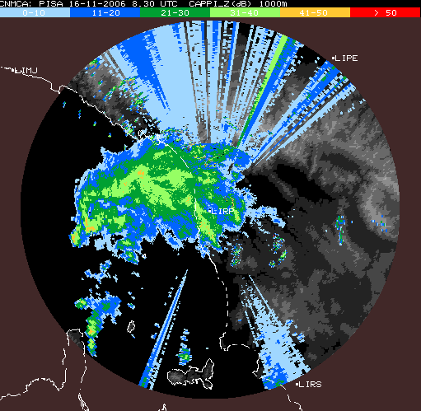
The interference image above clearly shows that interference from one single RLAN device are in general of an harmful nature. The abovementioned interference cases were solved on a case-by-case basis by action of National Radio Administrations (NRA), taking “advantage” that the RLAN market is not currently developed (only few equipments).
However, the industry target is of several millions of these devices deployed in Europe, meaning that in the future, case-by-case actions would not be practicable anymore, justifying the need for a global long-term solution on a European coordinated basis.
To do so, EUMETFREQ undertook several actions at the European Commission and the ECC levels, raising these interference issues and requesting relevant and urgent actions toward a global solution before reaching a point of no return, i.e. before the mass-market development of RLAN in the 5 GHz band (see in particular attachment 3)
In support of these actions, specific testing were performed in 2007 by Meteo France and the French Radio Administration (ANFR) under the EUMETFREQ umbrella that confirmed that most 5 GHz RLAN, in particular their DFS feature, are deficient to detect meteorological signals and hence to avoid transmitting in the corresponding channel.
These results were raised at the European Union level (TCAM) in June 2007 that then requested EUMETNET and the RLAN industry to work together understanding the rationale behind these problems and propose relevant technical solutions.
EUMETFREQ and OPERA programmes undertook a general enquiry on detailed emissions characteristics of all European C-Band meteorological radars (see Section 5 below) that confirmed the specificities of meteorological radars compared to other radar types, in particular concerning the use of staggered PRF, short pulses and “zero check” without emissions, characteristics not covered in the current version of the 5 GHz RLAN ETSI standard (EN 301 893).

EU TCAM Decision
The European Union TCAM group is, among others, responsible for the survey of application of the so-called “R&TTE” Directive that regulates the putting on the market of telecommunications equipments.
Following EUMETNET intervention in TCAM meetings in 2006 and 2007 to raise the high level of concerns of the meteorological community on the RLAN interference to radars, the TCAM chairman decided to organise an Ad Hoc TCAM meeting (1st October 2007) attended, in addition to EUMETNET and the European Commission, by a number of RLAN industry and Radio Administrations representatives.
This meeting allowed first for a general recognition and support on the imperious necessity to ensure protection of meteorological radars and secondly for drawing a general picture of the necessary actions toward solving the issue, including RLAN modifications as well as possible efforts to be made by the meteorological community in future design and operation of meteorological radars.
Such possible efforts were discussed between EUMETFREQ and OPERA at the October 07 OPERA meeting in Dublin at which was agreed the EUMETNET commitments on this issue (see section 4 below), recognising the need to take some part of the constraints to find a satisfactory global and long-term coexistence solution with RLAN in the 5 GHz range.
These EUMETNET commitments were presented at the TCAM plenary meeting end November and were received and considered with the highest care by the European Commission and European Radio Administrations that finally took the following decision toward a global solution:

- To request ETSI to urgently update the standard to take account of the deficiencies that have been observed. ETSI should presume that other radars have characteristics, which are comparable to weather radars. By extension narrow pulse widths and staggered PRFs therefore need to be presumed in the whole of the band.
- To leave it to ETSI to determine, whether such is to be done through 1 or 2 updates with the 2nd update taking into account of 0.5μSec radar pulses, such of course in consultation with radar manufacturers and operators.
Comment: these relate to the necessary modifications at the shortest notice of the RLAN 5 GHz Standard to take into account short-pulses (down to 0.5 μs) and staggered PRF in the whole 5150-5725 MHz band and a solution to solve in particular the “zero check” issue in the 5600-5650 MHz band (10 mn Channel Availability Check (CAC)). ETSI has decided to apply these modifications in a 2 steps approach.
- To set a DoW of v.1.4.1 of the standard on 1/4/2009
Comment: this relate to the withdrawal of ETSI standard version 1.3.1 and 1.4.1 by the 1st April 2009, hence putting a strong pressure on RLAN industry to adopt at the earliest the new Standard version (i.e. 1.5.1)
- To require manufacturers to upgrade at short notice their products to avoid interference resulting from failure to detect staggered PRFs.
Comment: this relate to modification of current RLAN equipments at the earliest (by July 08) either to detect staggered PRF or to exclude the band 5600-5650 MHz from their available channels (subsequently published in the European Official Journal in January 08). This measure is applied on a temporary basis pending application of New standard version
- To request ETSI to develop a harmonised standard for weather radar equipment;
Comment: EUMETNET highlighted that this could put quite important administrative burden on meteorological services and expressed that, preferably, a EUMETNET Recommendation on meteorological radars could provide the same level of information and confidence to the RLAN industry about current and future characteristics of meteorological radars. Such Recommendation is due to be adopted by EUMETNET in 2008
- To ask market surveillance to actively monitor developments and to report to TCAM any issue or new case of interference that has been observed
Comment: this relates to the obligation of all EU national radio administrations, under the R&TTE directive, to perform active market surveillance, including interference monitoring, survey and verification of compliance of equipment put on the market, and all possible legal actions (such as equipment prohibition decision).

EUMETNET commitments
The following EUMETNET position on the RLAN issue was jointly developed between EUMETFREQ and OPERA during the October 2007 OPERA meeting (Dublin) and presented within TCAM plenary meeting (November 07):
- Our preferred solution would have been to request an, exclusion of RLAN from the 5600-5650 MHz band. As this is no longer easily achievable we suggest a compromise solution
- If the RLAN industry accept the necessary modifications, EUMETNET would have to take its part of the constraints; that could be at a maximum:
  - Accept a 2 phase approach of the ETSI standard revision, provided that Zero Check issue is solved at the beginning (since it will also allow solving issue for most emission schemes)
  - Move all radar in the 5600-5650 MHz (or accept interference for those outside the band)
  - Accept for some radar to add one 1 or 2 detectable signal in the overall scanning strategies (this also apply to future developments)
  - Draft a EUMETNET Recommendation (EUMETFREQ and OPERA) to summarise the state of the art of solution to ensure an efficient sharing conditions with RLAN (including immunity and OOB).
- Reinforcing as a closing statement, the opinion that if Industry can not achieve or implement the EUMETFREQ offered mitigation, we will have to return to our preferred option of RLAN exclusion from the 5600-5650 MHz band.

Meteorological radars emission characteristics

Current situation

Emission schemes
At summer 2007,at the request of the European Commission TCAM, the EUMETFREQ and OPERA programmes undertook a general enquiry on detailed emissions characteristics of all European C-Band meteorological radars, including scanning strategies.
This enquiry confirmed that there are no typical schemes that vary based on a number of factors such as the radar capabilities and the radar environment for the required meteorological products and that C-Band meteorological radars in Europe show large ranges of different emission scheme parameters:
– operational elevation ranging from -2° to 90°.
– Pulse width ranging from 0.5 to 2.5 μs (for operational radars).
– Pulse repetition Frequency (PRF) ranging from 250 to 1200 Hz (for operational radars).
– Rotation speed ranging from 1 to 6 rpm
– Use on a given radar of different emission schemes mixing different pulse width and PRF, and in particular the use of fixed, staggered or interleaved PRF (i.e. different PRF during a single scheme)

Some example of such different emission schemes are provided below:
Fixed PRF
0.5 μs
1.666 ms
(600 Hz)
Staggered PRF
0.5 μs
2.222 ms
(450 Hz)
1.666 ms
(600 Hz)
64 pulses
64 pulses
. . . . . .
. . . . . .
Double interleaved PRF (double PRT)
1 μs
1.25 ms
(800 Hz)
0.833 ms
(1200 Hz)
Triple interleaved PRF (triple PRT)
2 μs
2.639 ms
(379 Hz)
3.077 ms
(325 Hz)
3.3 ms
(303 Hz)
These different emission schemes are used on a number of radar in their scanning strategy, during which, at different elevations and rotation speeds, one emission scheme is transmitted.
Below is an example of such scanning strategy (DWD case):

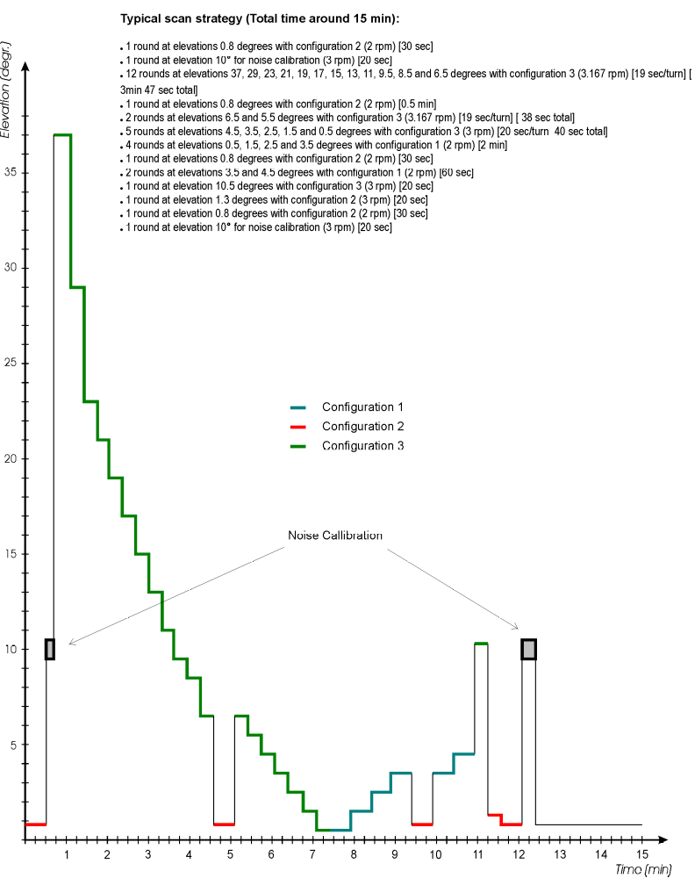

Configuration 1 : 2 rpm
2 μs
2 ms (500 Hz)
Configuration 3 : 2.5, 3 and 3.167 rpm
0.8 μs
1.25 ms
(800 Hz)
0.833 ms
(1200 Hz)
1° azimuth (53 to 42 pulses)
. . . . . .
. . . . . .
1° azimuth (80 to 63 pulses)
Configuration 2 : 2 and 3 rpm
0.8 μs
1.66 ms (600 Hz)

Specificities related to noise calibration
Noting N, the noise level and S the useful signal (i.e. meteorological signal return), meteorological radars perform the following process:
1) for each gate, the radar measures the return signal hence corresponding to the useful signal (S) plus the noise (N), i.e. N+S
2) To get the S, the radar extract from N+S, the noise level N
3) Then, from the S, the radar is able to determine all meteorological products, such as the precipitation (in dBz) or wind velocity by Doppler analysis

In order to get the more precise meteorological products, the signal S has to be as accurate as possible which means that the noise calibration of the radar is a crucial issue.

This noise calibration, also called “Zero Check”, is therefore performed on a regular basis, either during regular radar emissions (by estimation) or during specific periods of time (see the example scanning strategy above) during which the noise is measured, in many cases, without any radar emission. It is quite important to stress that, among all radar types, meteorological radars are the only one to perform such “Zero Check” process without emission.
With regards to RLAN, such situation means that if no radar emission is detected, it can reflect the following situations that will have to be discriminated:
- No radar around the RLAN,
- Radar is transmitting at high elevation
- Radar is performing noise calibration
The analysis of this situation has demonstrated that, to ensure satisfactory detection of meteorological radars, the DFS mechanism of RLAN shall, prior using a given channel, implement a Channel Availability Check (CAC) of 10 minutes, during which radar detection is to be performed and no emissions are authorized, hence confirming the requirement already mentioned in ITU-R Recommendation M.1652 (see section 1 above).

Future developments
During the enquiry, current radar capabilities different than those already used on an operational basis were reported, such as 3.3 μs pulses and 40 μs pulses using pulse compression or PRF down to 50 Hz and up to 2400 Hz.
In addition, future developments are expected to lead to different emissions schemes using in particular very narrow pulses (down to 50 ns) as well as 100 μs pulses using pulse compression, 5000 PRF and/or antenna otation speed up to 10 rpm.
It should be noted that these parameters represent the foreseeable future of meteorological radars but possibilities that different parameters and emissions characteristics will be used cannot be neglected.

Consequential modification to RLAN design
Despite clear indications in the Radio Regulations about the specificities of meteorological radars in the 5600-5650 MHz band, the initial and subsequent versions of the RLAN 5 GHz ETSI standard (EN 301893) only considered “simple” radars characteristics over the whole 5470-5725 MHz (versions 1.2.3 and 1.3.1) :
- pulses down to 1 μs
- fixed PRF
- Channel Availability Check (CAC) of 1 minute
One can also note that some initial radar interference cases were shown to be due to RLAN equipments for which the DFS mechanism was deactivated (whereas the DFS is mandatory). ETSI indeed issued a new version of the EN 301 893 standard (V1.4.1) making clear that DFS parameters shall not be made available to users manipulations.
This was indeed not sufficient to solve the current detection deficiencies and the following modifications are to be made (as requested by TCAM decision) :
- detection of pulses down to 0.5 μs (it will actually be made in 2 steps, 0.8 μs first in version V.1.5.1), and 0.5 μs after a 12/18 months delay (in version V.1.6.1)) (see note 1 below)
- detection of variable PRF (staggered and interleaved) (see note 1 below) (in version V.1.5.1)
- extended Channel Availability Check to 10 minutes before any transmissions on a RLAN channel which bandwidth falls partly or totally in the 5600-5650 MHz band (see note 2 below) (in version V.1.5.1)

Note 1 : the modification related to pulses and PRF will apply to the whole 5470-5725 MHz band since these characteristics also apply to other radar types, in particular military.
Note 2 : An alternative “Off-Channel” CAC process is also proposed, by which an RLAN operating in another channel, will verify on a non-continuous and statistical basis possible meteorological radar signal detection. This process will be based on short-time slots detection periods (down to few ms) over a sufficiently long period of time (several hours), parameters being left to the RLAN manufacturer provided that the overall probability detection requirement be met and corresponding testing be satisfied.

Minimum detectable signal concept

General principle
In order to ensure a global and long-term coexistence between RLAN and meteorological radars, it would make no sense that both applications develop themselves without taking into account the design of the other application.
It is hence necessary that the coexistence conditions based on current and up-to-date radar characteristics and RLAN detection capabilities become the reference (0.5 μs pulses, staggered and interleaved PRF, 1 to 6 rpm rotation speed).
For meteorological radars, it would indeed not be reasonable to expect that RLAN regulation and design would be timely modified in view of reacting and following each new characteristic of radars emission schemes. On the other hand, it would of course not be satisfactory to limit all radar emissions to the abovementioned parameters, hence constraining their future development (foreseeable or not).
To this respect, it is under this rationale that, taking advantage of the extension of the CAC up to 10 minutes, EUMETNET accepted as a global solution to accept that meteorological radars would always transmit, at the minimum, 1 or 2 signals detectable by RLAN (i.e based on the modified versions V.1.5.1 or V.1.6.1) in the overall scanning strategies.
At the present time, most radars make already use of such detectable signals (according to the OPERA/EUMETFREQ enquiry) so that there would only be a need to modify a limited number of radar scanning strategies. For the future, should new signal types / technologies be developed and used, the only constraint to make use of these new signal types would then be to insert in-between these signals the 1 or 2 signals detectable by RLAN.
This was the aim of the EUMETNET commitment presented in TCAM to accept for some radar to add 1 or 2 detectable signal in the overall scanning strategies (also applying to future developments) (see section 4 above).
As mentioned above, this would not have been possible without the RLAN modification to extend the CAC to 10 minutes and it hence appears that this CAC modification not only aims at solving the noise “zero check” issue but is actually a major part of the global technical solution.

Detail definition and schedule of the minimum detectable signals
The minimum detectable signal concept is based on the principle that meteorological radars will transmit at least 1 or 2 detectable by RLAN, hence being covered by the ETSI standard.
On a medium-term basis, 2 versions of RLAN ETSI standard will coexist,
By detectable signal, one should understand:
- operation at minimum elevation used by the radar, to ensure that all RLAN in the potential “interference area” would be able to detect it,
- Fixed, Staggered or interleaved PRF within the range 250 – 1200 Hz. It has to be noted that the highest the PRF, the highest the number of detected pulses.
- Pulse width higher than 0.8 μs (based on EN 301 893 Standard version V1.5.1), at initial step and then, 0.5 μs when version V1.6.1 of the EN 301 893 standard will be the only version in force (i.e. 1st January 2013). It is important to note that, during quite a while, equipment based on V1.5.1 will remain in use so that it is strongly encouraged to use pulse width higher than 0.8 μs as long as possible.
- Lowest possible rotation speed to ensure a minimum 10 pulses detection by the RLAN when the radar main beam is passing over the RLAN location. The determination of this parameter is a combination of the 3 dB beamwidth (0.9° for 45 dBi antenna), the PRF of the signal (or the minimum PRF for staggered PRF) and the rotation speed (RPM) using the following formula :

N = (0.9 x PRF)/(RPM x 6)
Where N is the minimum number of pulses detected

Of course, these characteristics represent minimum parameters to fulfill relevant RLAN detection but, when possible and practicable, simpler characteristics (fixed PRF, high PRF figure, low rotation speed, large pulses) are recommended to be used to minimize the probability of non-detection events.

Operation in the 5600-5650 MHz band
The extension of the CAC process up to 10 minutes is a quite constraining parameters for RLAN design and operation and is hence not practicable to be applied over the whole 5470-5725 MHz band. Outside of the 5600-5650 MHz band, the CAC will remain as in the current situation with a 1 minute duration.
This 10 minutes CAC extension will hence only occur for RLAN channels which fall totally or partly within the 5600-5650 MHz band, meaning that the overall detection and protection of meteorological radars will be maximised in this band.
It is hence strongly recommended that all meteorological radars be operated only in this 5600-5650 MHz band.
Over the current 160 meteorological C-Band radars in Europe, only 20 of them are concerned by this need for frequency change, recognising that it should not represent any difficulty since most of these radars have a tuning range over the whole C-Band 5470-5725 MHz. It has to be noted that such frequency change would likely require close contact with the corresponding National Radio Administration to ensure availability of the 5600-5650 MHz band in the related country and make consequential administrative frequency declaration.

Meteorological radars unwanted emissions and immunity characteristics

Emission mask

Generalities
To ensure global spectrum efficiency, all radiocommunications services have to minimise unwanted emissions levels.
As given in figure below (taken from ITU-R Radio regulations) unwanted emissions are split into out-of-band (OOB) domain and Spurious Domain with the following definition :
out-of-band emission: Emission on a frequency or frequencies immediately outside the necessary bandwidth which results from the modulation process, but excluding spurious emissions. (RR N° 1.144)
spurious emission: Emission on a frequency or frequencies which are outside the necessary bandwidth and the level of which may be reduced without affecting the corresponding transmission of information. Spurious emissions include harmonic emissions, parasitic emissions, intermodulation products and frequency conversion products, but exclude out-of-band emissions. (RR N° 1.145)
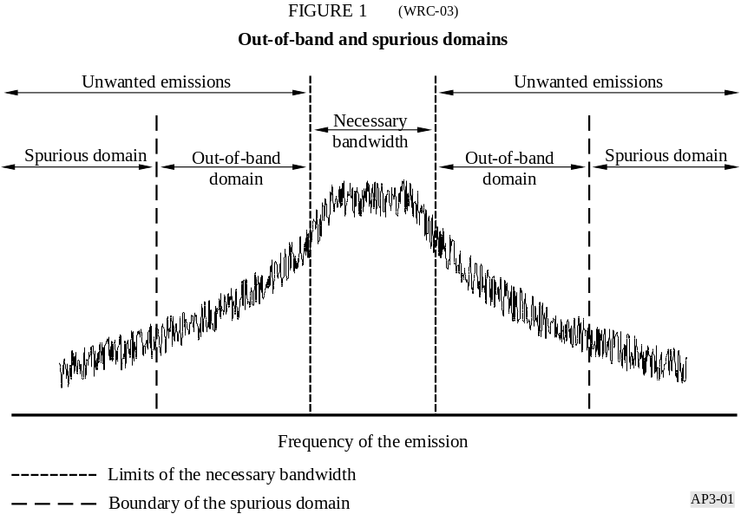

Only Spurious domain is regulated with relevant maximum levels as given in Appendix 3 of the radio regulations whereas OOB domain is in general controlled by the modulation scheme of the transmission as well as the shape of the emission filter. Even though not regulated, OOB recommended limits are provided in Recommendation ITU-R SM.1541.
Annex 1 of Appendix 3 provides elements to determine the boundary between the OOB and spurious domain for which the separation between the centre frequency and this boundary is in the more general cases being given as 2.5 times the necessary bandwidth.
Appendix 2 of the radio regulations is also relevant to this issue since it provides the frequency tolerances applicable to all transmitter types, defined as follows
frequency tolerance: The maximum permissible departure by the centre frequency of the frequency band occupied by an emission from the assigned frequency or, by the characteristic frequency of an emission from the reference frequency. The frequency tolerance is expressed in parts in 106 or in hertz. (RR N° 1.145)

Radar case
The unwanted emission characteristics of radars have always been recognized as specific and problematic, hence requiring specific measures.

Frequency Tolerance
With regard frequency tolerance, RR Appendix 2 provides a 1250 x 10⁻⁶ ratio relative to the radar central frequency. For meteorological radars operating in the 5600-5650 MHz band, this hence leads to a frequency tolerance of about 7 MHz.
One can note that such figure is roughly 1000 times bigger than for typical telecommunications radio systems.

Spurious emission maximum level
Concerning the spurious emission maximum level, RR Appendix 3 provides the following formula to determine the attenuation applicable to spurious emission relative to the maximum power supplied to the antenna :
43 + 10 log (PEP), or 60 dB, whichever is less stringent
Where PEP is the peak envelope power in watts

Assuming a typical 250 kW peak power for C-Band meteorological radar :
43 + 10 log (PEP) = 43 + 10 log (250 10³)= 97 dB > 60 dB

The spurious emission maximum level applicable to C-Band meteorological radar shall hence be 60 dB below the maximum peak power.
One can note that the ECC Recommendation 74-01 on “Unwanted emissions in the spurious domain” specifies much more drastic figures (i.e 100 dB discrimination or -30 dBm level).

Boundary between OOB and Spurious domains
This is actually the most specific parameter related to unwanted emissions for radars concerns the determination of the boundary between OOB and Spurious domains, since RR Appendix 3 states that :
“For primary radar, the boundary between the out-of-band and spurious domains is the frequency at which the out-of-band domain limits specified in the applicable ITU-R Recommendations are equal to the spurious domain limit defined in Table II of this Appendix. Further guidance on the boundary between the out-of-band and spurious domains for primary radar is provided in the most recent version of Recommendation ITU-R SM.1541.”

Annex 8 of ITU-R Recommendation SM.1541-2 provides all elements to determine this boundary not on the basis of the Necessary bandwidth but using the radar “-40 dB Bandwidth”.

Without entering all different cases and radar types, below are given the details for meteorological radars, assuming their non-FM pulse nature.

The determination of the “-40 dB bandwidth” is given as (in MHz) the lesser of:

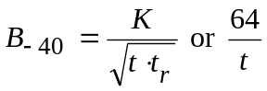
Where :
t = pulse width (in μs)
t_{r} = pulse rise time (in μs)
K = 6.2 for radars output power greater than 100 kW

Assuming a typical pulse rise time roughly 10% of the total pulse width, the following table provides the “-40 dB bandwidth” figures for different pulse width typically used for meteorological radars:

Pulse width | “-40 dB bandwidth”
0.5 μs | 39 MHz
0.8 μs | 25 MHz
1 μs | 20 MHz
2 μs | 10 MHz

Recommendation ITU-R M.1541-2 then provides a design objective for radars based on a roll-off of 40 dB per decade in term of percentage of this “-40 dB bandwidth”, according to the following formula: .
- if F≤50, A=0
- if F>50, A = 40+40log(F/F₀)

where :
F₀ = 50%
F is the frequency separation in %
A = the Attenuation in dBpp

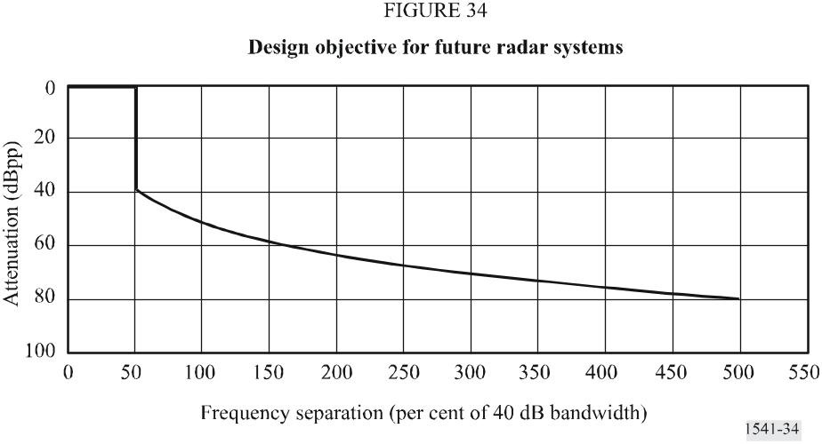

In general, meteorological radars make use of combined various pulse width (e.g. 0.5 μs and 2 μs), and it would make no sense to define different emission mask for a given radar based on its different emitted pulse types since the controlling figure would only be the smallest pulse width transmitted by the radar.
It is hence below proposed to simplify and further the analysis only considering 2 types of pulse widths, typically used on most of the radars, i.e. 0.5 and 0.8 μs representing “-40 dB bandwidth” respectively of 39 and 25 MHz.
Finally, to determine the boundary between spurious levels (as in Appendix 3) and OOB levels as in Recommendation ITU-R SM.1541-2 defined as “the frequency at which the out-of-band domain limits specified in the applicable ITU-R Recommendations are equal to the spurious domain limit defined in Table II of this Appendix” , it has to be considered that levels in spurious levels are considered in a maximum reference bandwidth of 1 MHz whereas OOB levels are given in dBpp, i.e. in spectral density.
It is hence necessary to determine a correction factor depending on the necessary bandwidth of the radar for the 2 pulse widths considered:

Pulse width (τ) | Reference bandwidth (1/τ) | Correction factor  dB -> dBpp | Reference spurious attenuation level in dBpp
0.5 μs | 2 MHz | 3 dB | 63 dB
0.8 μs | 1.25 MHz | 1 dB | 61 dB

According to the figure above, these reference spurious attenuation levels are reached to roughly 167% and 188% of the “-40 dB bandwidth” for 0.8 μs and 0.5 μs respectively.

On this basis, the boundary between OOB and spurious emission of meteorological radars would hence be at 42 MHz from the central frequency for “0.8 μs“ radars and at 73 MHz for “0.5 μs“ radars.

Global unwanted emission mask for meteorological radars
The global unwanted emission mask for meteorological radars combining both OOB recommended levels and spurious mandatory levels can be determined considering the above defined parameters and under the following procedure:
- Step 1 : determine the OOB mask roll-off and boundary using a “-40 dB Bandwidth” for a fixed central frequency (as in 7.1.2.3 above)
- Step 2 : applying the spurious emission level attenuation after the OOB boundary (as in 7.1.2.2 above)
- Step 3 : then shifting the whole mask related to the central frequency by the frequency tolerance (as in 7.1.2.1 above)

For “0.8 μs” radars, these steps would give the following :
Step 1 and 2:
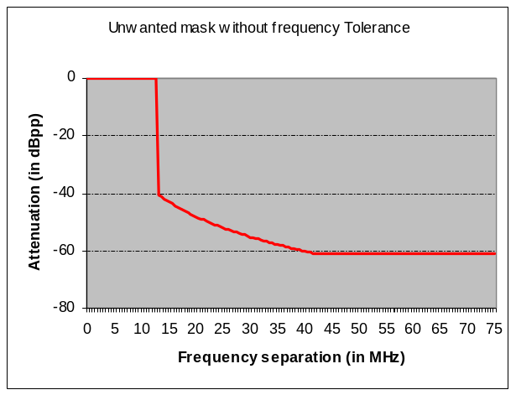

Step 2 :

Step 3 :
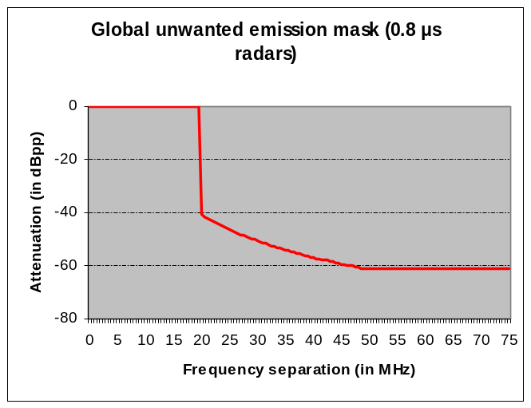
With a -40 dB point at 19.5 MHz and a -61 dB point at 49 MHz

Applying the same steps for “0.5 μs” radars leads to the following :
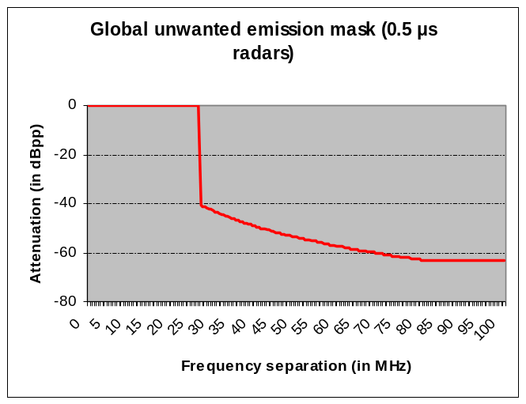
With a -40 dB point at 26.5 MHz and a -63 dB point at 80 MHz

Specific application to the 5600-5650 MHz band
Acknowledging the 50 MHz in which meteorological radars would have to operate, it is obvious from the following that radar emission masks would in any cases extend over the 5600-5650 MHz band, even though all radars would be operated at 5625 MHz. This is indeed not the case since meteorological radars are (or will be) spread over the whole band.
Also, it has to be considered that emission filtering of radar signal is quite specific in that it has to be made after the high-power oscillator or amplification tube at wave guide and not on the IF. Recognising further that a radar frequency may to be changed during its life, it is impossible to fix the filter at the operating frequency without being obliged to design specific filters for each radar, which would either represent an insurmountable burden for meteorological radar operators or even be impossible to apply.
To avoid such situation, it is hence finally proposed to specify an unwanted emission mask that would not apply to specific radars but to the 5600-5650 MHz band, recognizing:
- that meteorological radars shall be able to be operated in the whole 5600-5650 MHz and that hence, at least, central frequency shall be able to be fixed in order that the necessary bandwidth (roughly 2 MHz) falls within this band (i.e. 5601-5649 MHz).
- the theoretical nature of the mask determination as in previous section and in particular that most meteorological radars have a frequency stability better than 7 MHz
- that in order to avoid specific filter design that would be far too constraining or impossible, it would be wise to accept compromises such as limiting the portion of “40 dB bandwidth” falling outside the 5600-5650 MHz
- that within the “40 dB bandwidth” most of the radar energy is concentrated in the necessary bandwidth
On this basis, the following band mask is proposed as a reference emission mask for meteorological radars operating in the 5600-5650 MHz band, applying the unwanted emission mask determined as above for “0.8 μs” radar at the 5601 MHz and 5649 MHz edge radar central frequencies:

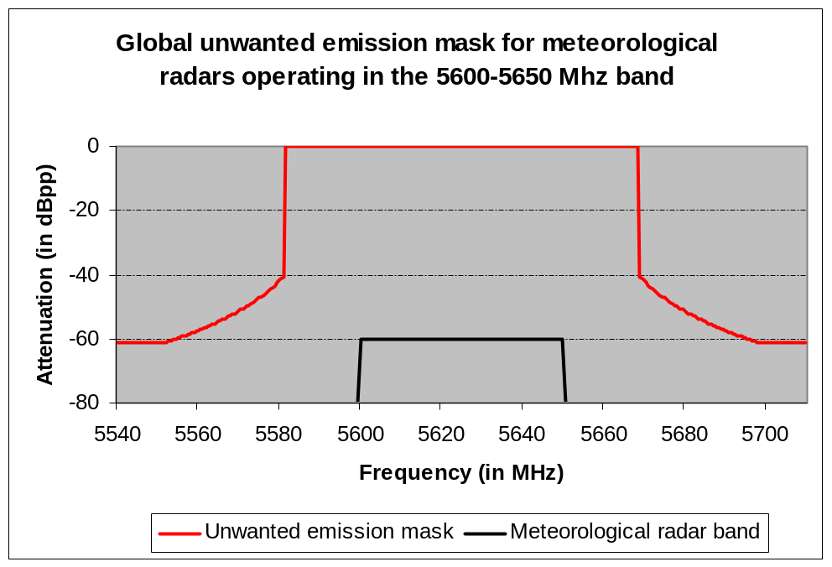
With the following reference points :
- -61 dB at 5552 MHz and 5698 MHz
- -40 dB at 5581 MHz and 5669 MHz

This emission mask is to be understood as a maximum pattern for which, for all radars operating in the 5600-5650 MHz, all possible emission peaks will have to comply. Meteorological services are however appealed to make their almost possible to limit to the best extent emissions outside the 5600-5650 MHz band, taking into account in particular the OOB domain design objective from Recommendation ITU-R SM.1541-2 (as given in 7.1.2.3 above)

Last but not least, for radiodetermination systems (i.e. radars, in particular), spurious domain emission attenuation (dB) shall be determined for radiated emission levels, and not at the antenna transmission line. The measurement methods for determining the radiated spurious domain emission levels from radar systems should be guided by the most recent version of Recommendation ITU-R M.1177. This means that, attenuation measurements will consider antenna spectral response.

Application timeframe
Unlike for OOB emission mask that is a recommended design objective, the spurious emission limits as in RR Appendix 3 are associated with a time schedule relative to their application to existing and future radars as follows:
- radars installed on or before 1 January 2003 : these radars are exempt from application of any spurious emission levels. It is however recommended that “The lowest practicable power of spurious emission should be achieved”
- radars installed after 1 January 2003 : these radars shall comply with the above defined spurious levels.
- After 1 January 2012 : all radars (old and new) shall comply with the above defined spurious levels.

On this basis, the emission mask as defined in section 7.1.2.5 above shall be applied on all C-Band meteorological radars by the 1st January 2012 at the latest but it is strongly recommended to meteorological services to comply with this mask at the shortest notice.
Being a mandatory constrain, should any difficulty in complying with this date arise for some radars (e.g. for some very old radars), it is wise to recommend meteorological services to get in touch with their National Radio Administration far before this date in order to study in detail and due time solution to accommodate such difficulties.

Reception mask

Generalities
Unlike unwanted emissions, there is no regulation related to reception characteristics or receiver sensitivity and immunity.
It is however of the best practice to allow for spectrum efficiency to recommend radio-frequency users to take into account their own protection from transmitters operating in adjacent bands. In general, National Radio Administrations (NRA) tend not accepting interference complaints from transmitters that do not present sufficient (i.e. up-to-date and state-of-the-art) self-protection characteristics.
This has been confirmed and stressed during the discussions related to RLAN issue and meteorological services should be aware that, in the future, interference from RLAN transmitting in adjacent bands would not be considered by NRA or, at least, would be considered with much less care than currently.
In particular, it has been demonstrated that there is a particular issue related to the image frequencies of the radars at which there is a specific sensitivity (less than 30 dB compared to the central frequency, according to OPERA/EUMETFREQ testing but also in specific interference cases in Finland).
These image frequencies are determined by :
F_{image} = F_{c} ± 2IF
Where :
F_{image} = Image frequencies
F_{c} = Central frequency of the radar ± 2FI
IF = Intermediate frequency
Typical values for IF are in the range 40 – 60 MHz hence meaning that, for a radar operating at 5625 MHz and using a 50 MHz IF, frequency images will be found at 5525 and 5725 MHz, far from the necessary bandwidth (or even the 40 dB bandwidth) of the radar, hence presenting no harm at all related to filtering.
This image frequency effect being a receiving only issue, it is obvious that at these frequencies, RLAN will be unlikely detecting anything and could hence transmit without restriction. In such case, should these image frequencies not being correctly filtered, there will hence be a potential for interference from RLAN to the meteorological radar.

Filtering of these image frequency as well as, on a more general basis, filtering of all signals outside what is strictly necessary, is hence strongly recommended and is of the responsibility of meteorological services radar to ensure their own protection and a global coexistence with RLAN (according to EUMETNET commitments on this issue) as well as working toward a more general spectrum efficiency.

Receiving filters design
In the absence of regulation and recognising further the possible receiving specificities of different radars, it is quite difficult to specify and recommend a specific filter shaping design.
It should however be highlighted that filtering reception also represents a challenge since, to allow efficient rejection of signals outside the necessary bandwidth, both RF and IF filters could be required, with evident consequences on radar performance. Indeed, the related insertion losses degrade the radar sensitivity and could also increase the radar noise figure even though implemented behind the LNA.
In addition, in relation with the specific RLAN issue, there is a link to be made between the emission and reception sides.
Indeed, the DFS global link budget is determined on both the Radar-to-RLAN and RLAN-to-Radar paths, assuming a symmetry of the attenuation on both paths and leading to a DFS trigger threshold related to both the radar transmitted power and receiving sensitivity (with actually about 5/7 dB margin).
By principle, the DFS mechanism is not limited to in-band emission but, depending on the distance of the RLAN from a radar, could also be triggered in adjacent band conditions. Consistently, a RLAN emission in adjacent band presents a risk of interference (this already occurred).
A situation assuming a radar with an efficient emission filtering but no reception filter could hence lead that, without being triggered by the radar emission (thanks to an efficient emission filtering) an RLAN would transmit on a adjacent band,producing interference due to the absence of radar reception filtering.
In order to avoid such situation, one can see that the reception filter mask should be roughly symmetric with the emission shape of the radar (and not the emission mask as above), i.e. the shape of the real radar emitted spectrum taking into account both the spectrum wave form response of the pulses and the emission filter.
It can therefore be seen that, even though it would make no sense to specify a reception band mask, the necessity of filtering reception will depend on radar characteristics as well as on a trade-off between related on the one hand impact on radar sensitivity, technical and cost constraints and, on the other hand, the risk of interference from RLAN operating outside the 5600-5650 MHz band, with a particular stress on image frequencies.

On this basis, no specific reception mask is provided but it is recommended to take into account the above elements in studying the need for and designing the reception filtering of meteorological radars. In particular, meteorological services should be aware that, in absence of such efficient filtering, it is more than likely that NRA will not accept future complaints of interference from RLAN operating in adjacent band.

Relation with RLAN out-of-band characteristics
The principle of a rough symmetry between emission and reception masks is general and taken into account in RLAN design. It is hence not consider at this stage that out-of-band characteristics of RLAN could have an impact on their future coexistence with radars.

Conclusions
TBD

Attachment 1
RESOLUTION 229 (WRC-03)
Use of the bands 5 150-5 250 MHz, 5 250-5 350 MHz and 5 470-5 725 MHz
by the mobile service for the implementation of wireless access systems
including radio local area networks
The World Radiocommunication Conference (Geneva, 2003),
considering
a) that this Conference has allocated the bands 5 150-5 350 MHz and 5 470-5 725 MHz on a primary basis to the mobile service for the implementation of wireless access systems (WAS), including radio local area networks (RLANs);
b) that this Conference has decided to make an additional primary allocation for the Earth exploration-satellite service (EESS) (active) in the band 5 460-5 570 MHz and space research service (SRS) (active) in the band 5 350-5 570 MHz;
c) that this Conference has decided to upgrade the radiolocation service to a primary status in the 5 350-5 650 MHz band;
d) that the band 5 150-5 250 MHz is allocated worldwide on a primary basis to the fixed-satellite service (FSS) (Earth-to-space), this allocation being limited to feeder links of non-geostationary-satellite systems in the mobile-satellite service (No. 5.447A);
e) that the band 5 150-5 250 MHz is also allocated to the mobile service, on a primary basis, in some countries (No. 5.447) subject to agreement obtained under No. 9.21;
f) that the band 5 250-5 460 MHz is allocated to the EESS (active) and the band 5 250-5 350 MHz to the SRS (active) on a primary basis;
g) that the band 5 250-5 725 MHz is allocated on a primary basis to the radiodetermination service;
h) that there is a need to protect the existing primary services in the 5 150-5 350 MHz and 5 470-5 725 MHz bands;
i) that results of studies in ITU-R indicate that sharing in the band 5 150-5 250 MHz between WAS, including RLANs, and the FSS is feasible under specified conditions;
j) that studies have shown that sharing between the radiodetermination and mobile services in the bands 5 250-5 350 MHz and 5 470-5 725 MHz is only possible with the application of mitigation techniques such as dynamic frequency selection;
k) that there is a need to specify an appropriate e.i.r.p. limit and, where necessary, operational restrictions for WAS, including RLANs, in the mobile service in the bands 5 250-5 350 MHz and 5 470-5 570 MHz in order to protect systems in the EESS (active) and SRS (active);
l) that the deployment density of WAS, including RLANs, will depend on a number of factors including intrasystem interference and the availability of other competing technologies and services,
further considering
a) that the interference from a single WAS, including RLANs, complying with the operational restrictions under resolves 2 will not on its own cause any unacceptable interference to FSS receivers on board satellites in the band 5 150-5 250 MHz;
b) that such FSS satellite receivers may experience an unacceptable effect due to the aggregate interference from these WAS, including RLANs, especially in the case of a prolific growth in the number of these systems;
c) that the aggregate effect on FSS satellite receivers will be due to the global deployment of WAS, including RLANs, and it may not be possible for administrations to determine the location of the source of the interference and the number of WAS, including RLANs, in operation simultaneously,
noting
that, prior to WRC-03, a number of administrations have developed regulations to permit indoor and outdoor WAS, including RLANs, to operate in the various bands under consideration in this Resolution,
recognizing
a) that in the band 5 600-5 650 MHz, ground-based meteorological radars are extensively deployed and support critical national weather services, according to footnote No. 5.452;
b) that the means to measure or calculate the aggregate pfd level at FSS satellite receivers specified in Recommendation ITU-R S.1426 are currently under study;
c) that certain parameters contained in Recommendation ITU-R M.1454 related to the calculation of the number of RLANs tolerable by FSS satellite receivers operating in the band 5 150-5 250 MHz require further study;
d) that the performance and interference criteria of spaceborne active sensors in the EESS (active) are given in Recommendation ITU-R SA.1166;
e) that a mitigation technique to protect radiodetermination systems is given in Recommendation ITU-R M.1652;

f) that an aggregate pfd level has been developed in Recommendation ITU-R S.1426 for the protection of FSS satellite receivers in the 5 150-5 250 MHz band;

g) that Recommendation ITU-R SA.1632 identifies a suitable set of constraints for WAS, including RLANs, in order to protect the EESS (active) in the 5 250-5 350 MHz band;

h) that Recommendation ITU-R M.1653 identifies the conditions for sharing between WAS, including RLANs, and the EESS (active) in the 5 470-5 570 MHz band;

i) that the stations in the mobile service should also be designed to provide, on average, a near-uniform spread of the loading of the spectrum used by stations across the band or bands in use to improve sharing with satellite services;

j) that WAS, including RLANs, provide effective broadband solutions;

k) that there is a need for administrations to ensure that WAS, including RLANs, meet the required mitigation techniques, for example, through equipment or standards compliance procedures,
resolves
1 that the use of these bands by the mobile service will be for the implementation of WAS, including RLANs, as described in Recommendation ITU-R M.1450;

2 that in the band 5 150-5 250 MHz, stations in the mobile service shall be restricted to indoor use with a maximum mean e.i.r.p. 1 of 200 mW and a maximum mean e.i.r.p. density of 10 mW/MHz in any 1 MHz band or equivalently 0.25 mW/25 kHz in any 25 kHz band;

3 that administrations may monitor whether the aggregate pfd levels given in Recommendation ITU-R S.1426 2 have been, or will be exceeded in the future, in order to enable a future competent conference to take appropriate action;

4 that in the band 5 250-5 350 MHz, stations in the mobile service shall be limited to a maximum mean e.i.r.p. of 200 mW and a maximum mean e.i.r.p. density of 10 mW/MHz in any 1 MHz band. Administrations are requested to take appropriate measures that will result in the predominant number of stations in the mobile service being operated in an indoor environment. Furthermore, stations in the mobile service that are permitted to be used either indoors or outdoors may operate up to a maximum mean e.i.r.p. of 1 W and a maximum mean e.i.r.p. density of 50 mW/MHz in any 1 MHz band, and, when operating above a mean e.i.r.p. of 200 mW, these stations shall comply with the following e.i.r.p. elevation angle mask where θ is the angle above the local horizontal plane (of the Earth):
–13 dB(W/MHz) for 0° ≤ θ < 8°
–13 – 0.716(θ − 8) dB(W/MHz) for 8° ≤ θ < 40°
–35.9 – 1.22(θ – 40) dB(W/MHz) for 40° ≤ θ ≤ 45°
–42 dB(W/MHz) for 45° < θ;
5 that administrations may exercise some flexibility in adopting other mitigation techniques, provided that they develop national regulations to meet their obligations to achieve an equivalent level of protection to the EESS (active) and the SRS (active) based on their system characteristics and interference criteria as stated in Recommendation ITU-R SA.1632;
6 that in the band 5 470-5 725 MHz, stations in the mobile service shall be restricted to a maximum transmitter power of 250 mW 3 with a maximum mean e.i.r.p. of 1 W and a maximum mean e.i.r.p. density of 50 mW/MHz in any 1 MHz band;
7 that in the bands 5 250-5 350 MHz and 5 470-5 725 MHz, systems in the mobile service shall either employ transmitter power control to provide, on average, a mitigation factor of at least 3 dB on the maximum average output power of the systems, or, if transmitter power control is not in use, then the maximum mean e.i.r.p. shall be reduced by 3 dB;
8 that, in the bands 5 250-5 350 MHz and 5 470-5 725 MHz, the mitigation measures found in Annex 1 to Recommendation ITU-R M.1652 shall be implemented by systems in the mobile service to ensure compatible operation with radiodetermination systems,
invites administrations
to adopt appropriate regulation if they intend to permit the operation of stations in the mobile service using the e.i.r.p. elevation angle mask in resolves 4, to ensure the equipment is operated in compliance with this mask,
invites ITU-R
1 to continue work on regulatory mechanisms and further mitigation techniques to avoid incompatibilities which may result from aggregate interference into the FSS in the band 5 150-5 250 MHz from a possible prolific growth in the number of WAS, including RLANs;
2 to continue studies on mitigation techniques to provide protection of EESS from stations in the mobile service,
3 to continue studies on suitable test methods and procedures for the implementation of dynamic frequency selection, taking into account practical experience.

Attachment 2

ITU-R Recommendation M.1652
Dynamic frequency selection (DFS)1 in wireless access systems including radio local area networks for the purpose of protecting the radiodetermination service in the 5 GHz band
Annex 1
The use of DFS in WAS including RLANs for the purpose of protecting the radiodetermination service in the 5 GHz band

1 Introduction
1.1 DFS
Resolution 736 (WRC-2000) calls, inter alia, for studies on the feasibility of sharing between the mobile service for WAS2 and the radiodetermination service in the frequency bands 5 250-5 350 and 5 470-5 725 MHz. Link budget calculations have shown that interference mitigation techniques are required to enable sharing of WAS with other services such as radar systems. This Recommendation describes the interference mitigation technique(s) DFS3 as specified in the 5 GHz RLAN standards, with performance calculations based on typical implementations.
WAS and radars operating in the 5 GHz band will interfere when operating at the same frequencies and within range of each other.
DFS has then been envisaged to:
– ensure a spread of the loading across the available spectrum of the WAS under the field of view of a satellite to reduce the aggregate emission levels at the satellites of the FSS (feeder links) and EESS (active) from WAS; and
– avoid co-channel operation with other systems, notably radar systems.
Extension of the use of DFS as described herein allows WAS to avoid interfering with the radiodetermination service. The general principle applied is that WAS should detect interference and identify radar interferers and shall not use those frequencies used by the radar.
1.2 Objective of the use of DFS with respect to radars
The objective of using DFS in WAS is to provide adequate protection to radars in the 5 GHz band. This is achieved by avoiding the use of, or vacating, a channel identified as being occupied by radar equipment based on detection of radar signals.
For the purpose of this Annex, a discussion of radiodetermination systems in the 5 GHz range utilized in determining DFS characteristics can be found in Annex 3.
The implementation of radar detection mechanisms and procedures used by WAS are outside the scope of this Annex. The main reasons for this are that:
– WAS design affects implementation;
– practical experience may lead to innovative and more efficient means than can be formulated today;
– different manufacturers may make different implementation choices to achieve the lowest cost for a given level of performance; therefore only performance criteria rather than specifications for a particular mechanism should be given in regulatory documents.
2 DFS performance requirements
The DFS performance requirement is stated in terms of response to detection of an interference signal.
5 GHz WAS should meet the following detection and response requirements.
Procedures for compliance verification should be incorporated in relevant industry standards for RLANs.

2.1 Detection requirements
The DFS mechanism should be able to detect interference signals above a minimum DFS detection threshold of –62 dBm for devices with a maximum e.i.r.p. of < 200 mW and –64 dBm for devices with a maximum e.i.r.p. of 200 mW to 1 W4 averaged over 1 μs.
This is defined as the received signal strength (RSS) (dBm), normalized to the output of a 0 dBi receive antenna, that is required to be detected within the WAS channel bandwidth.

2.2 Operational requirements
The WAS should be able to perform channel availability check: A check during which the WAS listens on a particular radio channel for 60 s to identify whether there is a radar operating on that radio channel.
The WAS should be able to perform in-service monitoring: Monitoring of the operating channel to check that a co-channel radar has not moved or started operation within range of the WAS. During in-service monitoring the radar detection function continuously searches for radar signals in-between normal WAS transmissions. This requires the use of quiet spaces between successive WAS transmissions (see Annex 4).
If the WAS has not previously been in operation or has not continuously monitored the channel with in-service monitoring, it should not start transmission in any channel before completion of a channel availability check.
2.3 Response requirements
A channel that has been flagged as containing a radar signal, either by a channel availability check or in-service monitoring, is subject to a 30 min period (non-occupancy period) where it cannot be used by the WAS device in order to protect scanning radars. The non-occupancy period should start at the time when the radar signal is detected.
Additionally, in the band 5 600-5 650 MHz, if a channel has been flagged as containing a radar, a 10 min continuous monitoring of the flagged channel is required prior to use of that channel. Otherwise, other appropriate methods such as channel exclusion would be required.
Channel move time is defined as the period of 10 s needed by a WAS to cease all transmissions on the operating channel upon detection of an interfering signal above the DFS detection threshold. Transmissions during this period will consist of normal traffic for typically less than 100 ms and a maximum of 200 ms after detection of the radar signal. In addition, intermittent management and control signals can be sent during the remaining time to facilitate vacating the operating channel. The aggregate time of the intermittent management and control signals are typically less than 20 ms.

2.4 Summary of the requirements
Table 1 provides a summary of the requirements described above. An example of the operating procedures is given in Annex 2.
TABLE 1
Parameter | Value
DFS detection threshold | –62 dBm for devices with a maximum e.i.r.p. of < 200 mW and  –64 dBm for devices with a maximum e.i.r.p. of 200 mW to 1 W averaged over 1 μs
Channel availability check time | 60 s
Non-occupancy period | 30 min
Channel move time | ≤ 10 s

Attachment 3
Letter EUMETNET to EU TCAM

1 In the context of this Resolution, “mean e.i.r.p.” refers to the e.i.r.p. during the transmission burst which corresponds to the highest power, if power control is implemented.
2 –124 − 20 log₁₀ (h_{SAT} / 1 414) dB(W/(m² · 1 MHz)), or equivalently, –140 − 20 log₁₀ (h_{SAT} / 1 414) dB(W/(m² · 25 kHz)), at the FSS satellite orbit, where h_{SAT} is the altitude of the satellite (km).
3 Administrations with existing regulations prior to this Conference may exercise some flexibility in determining transmitter power limits.
1 DFS is a general term used in this Recommendation to describe mitigation techniques that allow, amongst others, detection and avoidance of co-channel interference with respect to radar systems.
2 Throughout this Recommendation the term “WAS” denotes “wireless access systems including RLANs”.
3 The DFS feature was specified in the 5 GHz RLAN standards initially in order to mitigate interference among uncoordinated RLAN clusters, and to provide optimized spectral efficiency for high-capacity, high bit-rate data transmission.
4 In practice, it may not be necessary for each device to implement full DFS functionality, provided that such devices are only able to transmit under the control of a device that ensures that all DFS requirements are fulfilled.

