CHAPTER 6
OTHER RADIOCOMMUNICATION SYSTEMS FOR METEOROLOGICAL ACTIVITIES

Page
6 Introduction 88
6.1 Broadcasting and dissemination systems 88
6.2 Examples of hydrological radio systems 89
6.2.1 Introduction 89
6.2.2 Representative hydrological systems 89
6.3 Other satellite systems 90
6.4 Fixed remote systems 90
6.5 Meteorological uses of radionavigation systems 91
6.5.1 Terrestrial services 91
6.5.2 Global navigation satellite systems (GNSSs) 91
6.6 Lightning detection and location systems 92
6.7 Ground-based remote sensing 95

6 Introduction
As discussed in Chapter 1 meteorological services need to collect observations from many remote sites, both on land and over the sea. Thus, the meteorological observing system is dependent on many other radiocommunication services in addition to the MetSat and MetAids services described in the earlier Chapters.
It is also essential that meteorologists disseminate information and warnings to customers with minimal delay, whether in densely populated areas or in remote sparsely populated areas. Meteorological services are supplied to support maritime operations and to support aviation operations worldwide. The broadcasting and dissemination systems for meteorological products also utilize a wide range of radiocommunication services.

6.1 Dissemination systems
Of importance equal to the collection and archiving of weather data and the preparation of forecasts is the dissemination of these forecasts. Only by making these predictions available to the public can lives be saved, because only by knowing what is coming, can people take the steps necessary to protect their lives and property.
A number of specialized radio systems have been developed over the years by which forecasts and other meteorological data are distributed. Among the simplest of these is voice broadcasting. Typically using VHF radio, these systems require minimal equipment to be used by the general public. These systems serve to warn the public of threatened storms, floods, extreme temperatures and other natural and man-made hazards. Enhancements may be provided such as brief data transmissions accessible to deaf persons using special equipment. These systems may also be
designed to provide continuous data distribution, or to remain silent until triggered by an alert tone signifying a special event such as foul weather or other imminent hazard. Dissemination systems may be found in the fixed and mobile services, including maritime mobile service. Other dissemination systems operate via radio and television broadcasts and on MetSat downlinks.
Over the years, high frequency radio has been used by many administrations to provide weather and warning information to ships at sea and to aircraft. These systems typically provide voice transmissions and weather facsimile (WEFAX). However, the unreliable nature of HF has caused a transition of many such systems to satellite transmission.

6.2 Hydrologic radio systems

Floods are a natural and inevitable part of life in much of the world, and systems that can aid in predicting their occurrence, location and magnitude have saved many lives and a significant amount of property. Advance knowledge permits the evacuation of vulnerable populations, the construction of levees and dams, and the relocation of such valuable and vulnerable property as can be removed. Hydrologic systems typically are used to measure such things as precipitation, stream height and the depth of snow pack, all of which are useful in predicting flooding and in estimating the availability of water resources. They typically operate in the VHF or UHF bands in the fixed or mobile services.
Annual average flood damage in the United States of America alone now approaches $4 billion. Communities with persistent flood problems and those vulnerable to great losses when flooding does occur are continually seeking ways to minimize these losses. Automated hydrologic systems are an attractive solution because of their low cost of operation and because they can enhance the operation of other flood mitigation methods such as reservoir floodgate operation, flood insurance, or floodplain zoning.

An automated hydrologic system consists of event-reporting meteorological and hydrologic sensors, communications equipment, and computer software and hardware. In its simplest form, hydrologic sensors transmit coded signals, usually via very high frequency (VHF) and ultra high frequency (UHF) radio, to a base station, often through repeater
sites (see Fig. 6-1). The base station collects these coded signals and processes them into meaningful hydrometeorological information that can be displayed or tied to an alarm system and may notify emergency managers when preset criteria are exceeded.
Figure 6-1
Schematic of a hydrologic system
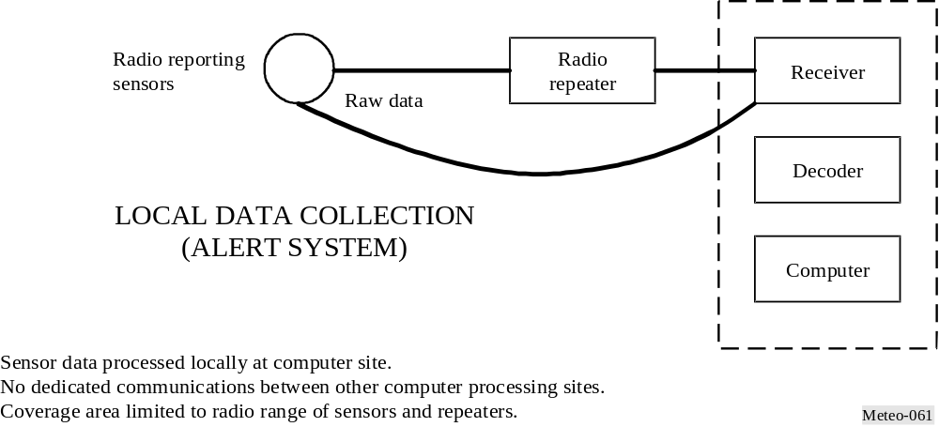

6.3 Fixed remote systems
Technical characteristics, including operating frequencies, of these systems vary widely and almost any of the meteorological RF bands may be used. Selection is frequently made based on the necessary bandwidth, which in turn is determined by the type and quantity of information to be carried. Fixed remote systems in meteorology serve a variety of purposes and operate in a number of RF bands. As would be expected from their name, they operate in fixed allocations. Typical uses include:
Voice keying or feeder links used to carry control or data signals to data dissemination transmitter sites, which are often located remotely (e.g. on mountain tops) to maximize their coverage areas.
Radar remoting used to carry radar return signals from the radar itself (frequently located remotely) to the office where data are processed. Operators also use RF for remote control of equipment at the radar site.
Data collection used to convey from remotely-located collection sites to a central repository or processing facility the data collected by hydrological and meteorological sensors used to measure wind, rain, temperature, snow depth, earth tremors (for the detection or prediction of earthquakes), or any number of other natural phenomena.

6.4 Meteorological uses of radionavigation systems

6.4.1 Terrestrial services
Meteorologists utilize radionavigation service signals for a variety of purposes. The use of Omega navigation signals (frequencies between 10 to 13 kHz) became widespread for tracking radiosondes in the MetAids service from about 1985 onwards until its termination of operation. This was because the radiosonde systems could be used with simple base station antenna, processing was automated and the systems were easy to maintain in remote locations. Loran-C signals at 100 kHz were also used for the same purpose and the use of Loran-C has increased in areas where suitable coverage has been maintained.
At the time of the closure of the Omega transmitters in 1997, more than 20% of the radiosonde systems in the WMO network had to be changed. Most of these ground systems were modified or replaced to use radiosondes receiving and processing GPS navigation signals.

6.4.2 Global navigation satellite systems (GNSSs)
GPS signals currently transmitted at 1 575.42 MHz (designated L1) and 1 227.6 MHz (designated L2) (and those of GLONASS and the proposed Galileo system) are used by meteorologists for the following purposes:
– Location of mobile meteorological observing platforms: for example radiosondes carried by weather balloons, dropsondes falling on parachutes, pilotless aircraft carrying meteorological sensors (see Chapter 3), or marine meteorological systems such as ocean buoys.
– Very accurate synchronization of time: between remote observing sites, as required for instance by lightning detection systems (see § 6.5).
– Measurement of total water vapour in the atmosphere: derived from the phase delay in the GPS signals received by ground based receivers. Computation of total water vapour requires extremely accurate computations of the position of the various GPS satellites and the timing of the satellite clocks. The position of the ground receiver must also be known very accurately. The GPS receivers are usually installed on a fixed mount suitable for accurate tracking of position on the Earth’s surface as well as providing meteorological information. Thus, the measurements may be produced as a byproduct of geodetic/ seismological observations or from sensors deployed specifically by meteorologists. Phase delays introduced in signal transmission through the ionosphere are identified from the differences in the phase delays between the two GPS frequencies, L1 and L2. If the surface
pressure and temperature are known, the dry hydrostatic phase delay introduced by the atmosphere can be estimated, and the remaining phase delay is then proportional to the total water vapour along the path to the satellite. The GPS sensor at the surface receives GPS signals from many directions in a short period of time. Thus, it is possible to estimate the total water vapour in the vertical, as well as gradients in total water vapour in the horizontal direction around the sensor. This technique has relevance for atmospheric propagation studies, since it allows a direct measurement of water vapour content along a slant path from the ground receiver to a satellite. See also [Coster et al., 1997].
– Measurement of temperature and relative humidity as a function of height derived from space-based occultation measurements of the GPS signals: in this application, a receiver on an independent satellite receives signals from the GPS constellation passing through the atmosphere at grazing incidence to the Earth’s surface. The refraction of the GPS signals is measured at a range of heights above the Earth’s surface. This allows the refractive index of the air to be derived as a function of height. At upper levels in the neutral atmosphere, relative humidity is very low and the refractive index of air can be assumed to be directly dependent on temperature. At levels closer to the surface below the tropopause, both temperature and partial pressure of water vapour influence the refractive index. The partial pressure of water vapour can be estimated if the temperature is already known from another source. The measurement of meteorological variables derived from this technique will have a better vertical resolution than the output from nadir viewing passive sensing radiometers, see Chapter 5, but will be averaged over relatively long distances in the horizontal. As with the total water vapour measurement, this technique requires very precise timing and knowledge of the position of both satellites. GNSS receivers are planned for the next generation of polar orbiting meteorological satellites.

6.5 Lightning detection systems
The need by operational meteorologists for remote sensing of lightning activity is rapidly increasing. Customer requirements are developing in conjunction with developments in the use of weather radar and meteorological satellite products, and have a high priority given the need to automate surface weather observations in many developed countries. The reliable operation of these systems has clear links to considerations of public safety on land, sea and air. Provision of an effective forecast service impacts the efficiency of commercial and defence activities. The safety of engineers working on power lines and personnel handling explosive devices are examples of activities that benefit from effective lightning forecasts.
The detection of lightning is a passive activity involving the use of radio receivers to detect wave fronts resulting from lightning. Data from individual detection sites may be distributed by any of the usual means including fixed links, telephone, Internet etc.
In current operational systems, the position of the lightning flash is either determined by measuring the direction of arrival of the associated spheric (atmospheric wave), or by measuring the time of arrival of the spheric, or a combination of both.

Measurements are required at more than three widely spaced sensing sites. The number of sites used in practice is usually larger than the minimum in order to improve the reliability of the reported locations. Time of arrival systems usually provide more accurate locations than direction finding systems when observing at ranges over several hundred kilometres. This is due to the direction of reception of skywaves sensed at the site, which usually differs slightly from the actual direction of the discharge, and will vary according to the state of the surface layers near the sensing site. Time of arrival systems usually rely heavily on GPS radionavigation signals to achieve the necessary time synchronization at the various sensing sites. All systems rely on cost effective, reliable communications from the remote sites to the central processor. The radio frequency used to locate lightning activity varies according to the area of monitoring required and the specific purpose of the system.
Very long-range locations at ranges of several thousand kilometres are achieved operationally by observing frequencies centred at 10 kHz (2-15 kHz) (see Fig. 6-3). In this system, the spherics are received at the remote outstations located around Europe [Lee, 1986] with spacings of up to 2 000 km apart. The spherics are Fourier analysed and time stamped at the sensor sites. The timed samples are immediately transmitted back to a central control station where the locations of the lightning discharges are computed from the differences in arrival times at the sites. Interference is extremely detrimental to the operation of the system and each outstation is equipped with adjustable notch filters to discriminate against local contamination.
Figure 6-3
Map of lightning data for one day for long range system
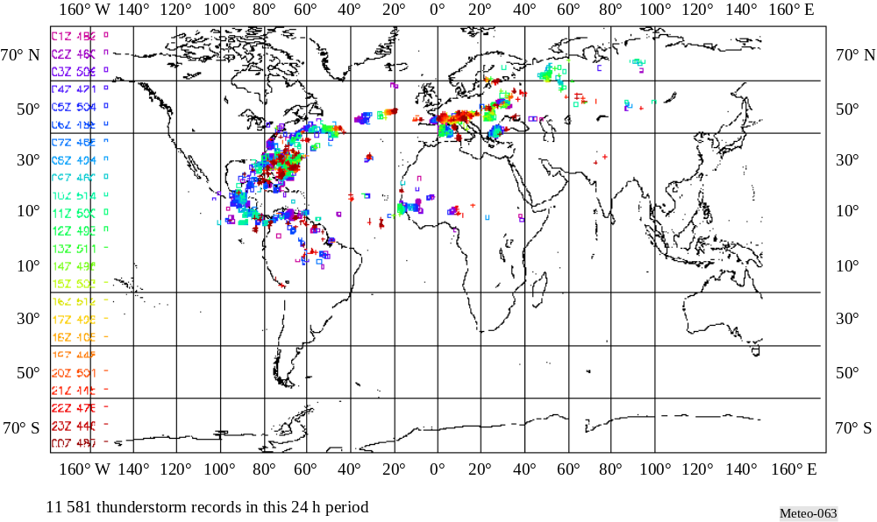

The most widely used operational systems cover a more limited area in detail. In this case, the spherics are observed at higher frequencies centred around 200 kHz (the wideband receivers used are most sensitive in the middle of their range of 1 kHz to 350 kHz), and the sensing sites are usually spaced between 100 km and 400 km apart, depending on whether the emphasis is on cloud-to-ground or cloud-to-cloud flashes. At these higher frequencies, a discharge from the cloud-to-ground can be identified by a pronounced rise in amplitude defining a leading edge to the spheric. The arrival of this leading edge can be accurately timed. The times from the network sites are transmitted to a central processor and used to compute the positions of the discharges. In many cases, the network arrival time differences are operated in conjunction with magnetic direction finding systems installed in earlier years. [Holle and Lopez, 1993] review different lightning detection systems and [Diendorfer et al., 1994] discuss observations from their own network in Austria.
In addition, in some areas it is necessary to observe all the electrical discharges associated with thunderstorm activity, both cloud-to-ground and cloud-to-cloud discharges. This is achieved by observing at very much higher frequencies (63 MHz and 225 MHz are used by the lightning detection and ranging system (LDAR), while the SAFIR system uses 110 to 118 MHz). =Figure 6-4 shows the real-time LDAR display. The storms
must remain within line-of-sight if all the activity is to be observed. This requires that the ground sensors be located in a short baseline configuration – the sensors need to be 30 km apart, and about 50 m from the ground to fulfill the radar horizon criteria. However, in practice some operational systems observing cloud-to-cloud activity are operated with the ground sensors further apart, relying on the cloud-to-ground systems at lower frequencies to fill in the details of the discharges at lower levels.
The lower left panel of Fig. 6-4 shows LDAR data on a map of the East coast of Florida (partially shown). The data are then projected on an East-West vs. altitude panel (upper left) and a North-South vs. altitude panel (lower right, note that this panel is turned 90° on its side). A histogram (upper right) displays the data in five one-minute increments.

Figure 6-4
Real-time LDAR display
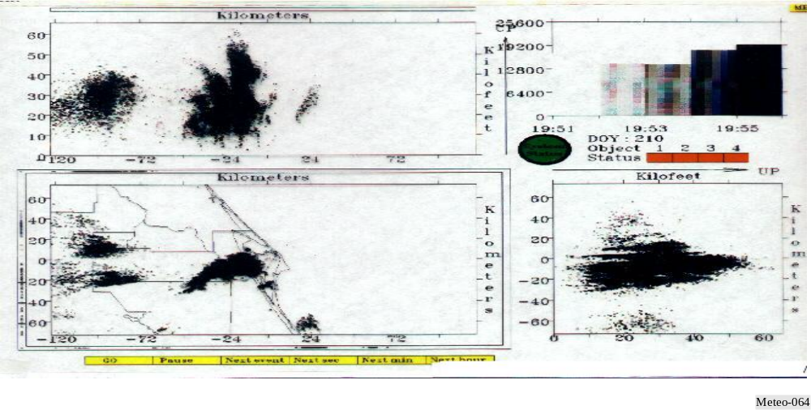

6.6 Ground-based remote sensing
Vertical atmospheric sounding using passive remote sensing from satellites has been discussed in detail in § 5.1. Meteorologists making detailed local forecasts or scientists investigating the planetary boundary have requirements for atmospheric sounding with better vertical resolution near the ground than can be provided by the satellite systems.
One method of providing this information is to use upward-looking passive remote sensing, with a radiometer mounted at the Earth’s surface. Radiometers are now commercially available for this purpose. These use a selection of channels in the oxygen band between 50 GHz and 58 GHz to produce a measurement of temperature structure. Channels between 21 GHz and 24 GHz are used
to provide information on the variation of water vapour in the vertical, and a window observation in the region of 30 GHz is used for cloud identification. Measurement of water vapour in the future may also benefit from additional observations in the lower wings of the water vapour absorption band at 183 GHz.
Although the channels for ground based remote sensing of temperature and humidity are in a similar region to passive satellite remote sensing, they are not identical to those used by satellites. At some frequencies, satellite remote sensing can safely share with terrestrial services, but ground-based radiometers may need protection. The number of ground-based radiometers in operation is still small, but if current developments are successful, larger numbers may be deployed in the future. A pragmatic method of sharing may have to be developed where radiometers are deliberately sited to avoid interference from the other services.
Passive remote sensing of other atmospheric constituents, e.g. ozone, is also expected to benefit from a significant number of ground-based radiometry sites.

6.7 Unmanned Aerial Systems (UAS)

Unmanned Aircraft Systems (UAS) are becoming increasingly important for meteorological and Earth observations operations. UAS address observation requirements in areas where traditional systems cannot be deployed, where manned aircraft flights are not possible due to long flight durations and where hazardous conditions exist. Current UAS operations (2008) for meteorological purposes often use unlicensed spectrum for command and control of the aircraft, though some systems do use licensed frequencies. UAS are used for applications that include routine release of dropsondes over ocean areas where radiosonde data has historically been missing, flights into hurricanes and cyclones for insitu data collection, aerial reconnaissance of areas impacted severe weather or drought conditions, and monitoring of arctic ice melt. Use of UAS for meteorological operations improve the prediction hurricane landfall areas and extend lead times provided to the public, and allow us to obtain a better understanding of our climate. Future ITU-R work and possible WRC decisions should better define the spectrum that is used for UAS command and control. In addition to the command and control of the UAS, spectrum is needed for payload data transmission. This can occur in suitable bands allocated for meteorological purposes or in other frequency bands.
References
COSTER, A. J., NIELL, A. E., BURKE, H. K. and CZERWINSKI, M. G. [17 December 1997] The Westford water vapor experiment: use of GPS to determine total precipitable water vapour. MIT/Lincoln Laboratories.
DIENDORFER et al., [1994] Results of performance analysis of the Austrian lightning location network. ALDIS, 22nd International Conference on Lightning Protection, Budapest, Hungary.
HOLLE, R. L. and LOPEZ, R. E. [1993] Overview of real-time lightning detection systems and their meteorological uses. NOAA Technical Memorandum ERL NSSL-102, National Severe Storms Laboratory, Norman, Oklahoma, United States of America, p. 68.
LEE, A. C. L. [1986] An experimental study of the remote location of lightning flashes using a VLF arrival time difference technique. Quarterly J. R. Meteorological Society.
LENNON, C. and MAIER, L. [1991] Lightning mapping system. Proc. of International Aerospace and Ground Conference on Lightning and Static Electricity, Cocoa Beach, FL., United States of America. NASA Conf. Pub. 3106, Vol. II, p. 89-1, 89-10.
KAWASAKI, Z. I., YAMAMOTO, K., MATSURA, K., RICHARD, P., MATSUI, T., SONOI, Y. and SHIMOKURA, N. [1994] SAFIR operation and evaluation of its performance, Geophys. Res. Lett., Vol. 21, 12, p. 1133-1136.

Annex 1
ACRONYMS AND ABBREVIATIONS COMMONLY USED
IN METEOROLOGY

A
A/D | Analog-to-Digital
AAAS | American Association for the Advancement of Science
AARS | Automated Aircraft Reporting System
ABSN | Antarctic Basic Synoptic Network
ACARS | Aircraft Communications Addressing and Reporting System
ACCAD | Advisory Committee on Climate Applications and Data
ACMAD | African Centre of Meteorological Applications for Development
ADAS | Airborne Data Acquisition System
ADC | Analog-to-Digital Converter
ADP | Automatic Data Processing
ADPE | Automatic Data Processing Equipment
ADEOS | Advanced Earth Observation Satellite (Japan)
AFC | Automatic Frequency Control
AFOS | Automatic Forecasting and Observing System
AGC | Automatic Gain Control
AGRHYMET | Regional Training Centre for Agrometeorology and Operational Hydrology and its Applications
AHRPT | Advance High Resolution Picture Transmission
AIRS | Advanced Infrared Sounder (NASA instrument)
ALC | Automatic Level Control
AM | Amplitude Modulation
AMDAR | Aircraft Meteorological Data Relay
AMI | American Meteorological Society
AMSR | Advanced Meteorological Temperature Sounder
ANSI | American National Standards Institute
AOPC | Atmospheric Observation Panel for Climate
AOS | Acquisition of Signal
APT | Automatic Picture Transmission
ARGOS | Data collection and location system on NOAA series satellites
ASCII | American Standard Code for Information Interchange
ASIC | Application Specific Integrated Circuit
ATMS | Advanced Technology Microwave Sounder (NPOESS/NASA)
ATOVS | Advanced TIROS Operational Vertical Sounder
ATSR | Along-Track Scanning Radiometer
AVCS | Advanced Video Camera System
AVHRR | Advanced Very High Resolution Radiometer
AWIPS | Advanced Weather Information Processing System
B
BCD | Binary Coded Decimal
BER | Bit Error Rate
BPS | bits per second
BPSK | Binary Phase Shift Keying
BR | ITU Radiocommunication Bureau
BW | Bandwidth
C
C/N0 | Carrier-to-Noise density ratio
C&DH | Command and Data Handling
CaeM | Commission for Aeronautical Meteorology
CAgM | Commission for Agricultural Meteorology
CAS | Commission for Atmospheric Sciences
CBS | Commission for Basic Systems
CCD | Charge Coupled Device
CCIR | International Consultative Committee on Radio (see ITU-R)
CCl | Commission for Climatology
CCRS | Canada Centre for Remote Sensing
CCSDS | Consultative Committee for Space Data Systems
CDA | Command and Data Acquisition
CDAS | Command and Data Acquisition Station
CEOS | Commission on Earth Observation Satellites
CERES | Cloud and Earth’s Radiative Energy System
CGMS | Co-ordination Group for Meteorological Satellites
CHy | Commission for Hydrology (WMO)
CIESIN | Consortium for International Earth Science Information Networks
CIMO | Commission for Instruments and Methods of Observation
CIMSS | Cooperative Institute for Meteorological Satellite Studies
CLICOM | Climate Computing
CLINO | Climatological Normals
CLIPS | Climate Information and Prediction Services
CLIVAR | Climate Variability and Predictability
CMA | China Meteorological Administration
CMD | Command
CMIS | Conical-scanning Microwave Imager/Sounder (NPOESS instrument)
CMM | Commission for Marine Meteorology
CNES | Centre National D'Etudes Spatiales
CNIE | Comision Nacional de Investigaciones Espaciales
COADS | Comprehensive Ocean-Atmosphere Data Set
CONUS | Continental United States
COP | Conference of the Parties
COPUOS | Committee on the Peaceful Uses of Outer Space
CORSSAC | Civil Operational Remote Sensing Satellite Advisory Committee
COSPAS | A Russian satellite-borne search and rescue system. See SARSAT
CPCSA | Climate Program Coordination and Support Activities
CPR | Cloud Physics Radiometer, or Cardio-pulmonary Resuscitation
CPU | Central Processing Unit
CRC | Cyclic Redundancy Check/Cyclic Redundancy Code
CrMIS | Cross-track Microwave Imager-Sounder (NPOESS instrument)
CrIS | Cross-track Infrared Sounder (NPOESS instrument)
CRT | Cathode Ray Tube
CSA | Canadian Space Agency
CS&C | Communications Switching and control (CDA portion of GMACS System)
CSIRO | Commonwealth Scientific and Industrial Research Organization
CSIS | Centralised Storm Information System
CSM | Climate System Monitoring
CSMA/CD | Carrier Sensing Multiple Access with Collision Detection
CSTR | Council for Scientific and Technical Research
CTCS | CDA Telemetry and Command System (CDA portion of GIMTACS System)
CW | Continuous Wave
CZCS | Coastal Zone Color Scanner
D
D/A | Digital-to-Analog
DAAC | Distributed Active Archive Center
DADS | Data Archive and Distribution System
DAPS | DCS Automated Processing System
DAS | Data Acquisition System
DAS | Data Base Administration System
DAS | Direct Access System
dB | Decibel
DB | Direct Broadcast
DBMS | Database Management System
DCPLS | Data Collection Platform Location System
DCP | Data Collection Platform
DCPI | Data Collection Platform Interrogation
DCPR | Data Collection Platform Reception
DCR | Differential Correlation Radiometer
DCS | Data Collection System
DEMUX | De-Multiplexer
DIFAX | Digital Facsimile
DIR | Daytime Infrared
DLI | Down-Link Interface (DM/PM)
DLM | Down-Link Monitor
DLR | German Space Agency (Deutsche Zentrum fur Lüft- und Raumfahrt)
DMSP | Defense Meteorological Satellite Program
DN | Descending Node
DOMSAT | Domestic (Communications) Satellite
DPT | Digital Picture Terminal
DR | Direct Readout
DRGS | Direct Readout Ground Stations
DS | Dwell Sounding or Sounding (GOES-4/7 VAS operating node)
DSARS | DAMUS Satellite Archive and Retrieval System
DSB | Direct Sounder Beacon
DSB | Direct Sounder Broadcasts
DSN | Deep Space Network
DUS | Data Utilisation System
E
EBR | Electron Beam Recorder
EC/AGE | Executive Council Advisory Group on the Exchange of Meteorological and Electronics Calibration
ECMWF | European Centre for Medium-range Weather Forecasts
EDC | EROS Data Center
EDIMS | Environmental Data & Information Management Systems
EES | Earth Exploration Satellite
EESS | Earth Exploration-Satellite Service
EIRP | Equivalent Isotropically Radiated Power
EIRPSD | Equivalent Isotropically Radiated Power Spectral Density
ELT | Emergency Locator Transmitter
ELV | Expendable Launch Vehicle
EMC | Electromagnetic Compatibility
EMI | Electromagnetic Interference
ENSO | El Niño/Southern Oscillation
ENVISAT | Environmental Satellite
EOS | Earth Observation Satellites
EOS | Earth Observation Satellites
EPIRB | Emergency Position-Indicating Radio Beacon
EPOCS | Equatorial Pacific Ocean Climate Studies
EPS | Energetic Particle Sensor
ERB | Earth Radiation Budget
ERBE | Earth Radiation Budget Experiment
ERL | Environmental Research Laboratory
EROS | Earth Resources Observing Satellite
ERS | ESA Remote Sensing Satellite
ESA | European Space Agency
ESD | Electrostatic Discharge
ESMR | Electronically Scanning Microwave Radiometer
ETA | Estimated Time of Arrival
ETM | Enhanced Thematic Mapper
ETM | Engineering Test Model
ETS | Engineering Test Satellite
EUMETSAT | European Organization for the Exploitation of Meteorological Satellites
EUV | Extreme Ultraviolet
F
FAX | Facsimile
FC | False Color
FCC | False Color Composite
FCC | Federal Communications Commission
FDM | Frequency Division Multiplexing
FFT | Fast Fourier Transform
FIFO | First-In-First-Out
FM | Frequency Modulation
FOV | Field of view
fps | Frames Per Second
FSK | Frequency Shift Keying
FSS | Fixed-Satellite Service
FSS | Flight Scheduling Software System
G
GAC | Global Area Coverage
GAME | GEWEX Asian Monsoon Experiment
GARP | Global Atmospheric Research Program
GARS | GOES Archive and Retrieval System
GAW | Global Atmosphere Watch
GC | Ground Clutter
GCIP | GEWEX Continental-scale International Project
GCM | General Circulation Model
GCOS | Global Climate Observing System
GDTA | Groupemant pour le Developpement de la Teledetection Aerospatiale
GEO | Geostationary Earth Orbit
GEWEX | Global Energy and Water Cycle Experiment
GHz | Gigahertz
GIMGSP | GOES I-M Ground System Project
GIMTACS | GOES I/M Telemetry and Command System
GIS | Geographical Information Systems
GMACS | GOES Monitoring and Control system (current GIMTACS)
GMDSS | Global Maritime Distress and Safety System
GMS | Geostationary Meteorological Satellite
GMT | Greenwich Mean Time
GOES | Geostationary Operational Environmental Satellite
GOMS | Geostationary Operational Meteorological Satellite
GOOS | Global Ocean Observing System
GOS | Global Observing System
GOSSP | Global Observing Systems Space Panel
GPCP | Global Precipitation Climatology Project
GPS | Global Positioning System
GPSOS | GPS Occultation Sensor
GRC | Glenn Research Center formerly the Lewis Research Center (LeRC)
GRS | Ground Receiving Station
GRT | GOES Real-time (database)
GSFC | Goddard Space Flight Center
GSN | GCOS Surface Network
GSTDN | Ground Spaceflight Tracking and Data Network
G/T | Antenna Gain to System Noise Temperature Ratio (dB/K)
GTOS | Global Terrestrial Observing System
GTS | Global Telecommunications System
GUAN | GCOS Upper-air Network
GVAR | GOES VARiable
GWC | Global Weather Center
H
H1/3 | Significant wave height
HEPAD | High Energy Proton and Alpha Detector
HiRID | High Resolution Imager Data
HIRS | High-resolution Infrared Sounder (TIROS instrument)
HOMS | Hydrological Operational Multipurpose System
HRD | Hurricane Research Day  -or-  High Rate Data
HRD (10) | Hurricane Research Day - GOES-East scans every 10 minutes at selected times.
HRI | High Resolution Image
HRIS | High Resolution Infrared Sounder, or High Resolution Interferometric Sounder
HRIT | High Rate Information Transmission
HRPT | High Resolution Picture Transmission
HRSD (S) | Hurricane Rapid Scan Day (Stereo) GOES-East and West scan every 7 1/2
Hz | Hertz formerly cycles per second
I
I/S | Imager and Sounder
I/O | Input/Output
IAHS | International Association of Hydrological Sciences
IAMAS | International Association of Meteorology and Atmospheric Sciences
IASI | Infrared Atmospheric Sounding Interferometer
ICES | International Council for the Exploration of the Sea
ICSAR | International Committee for Search and Rescue
ICSU | International Council of Scientific Unions
ICDS | International Data Collection and Distribution System
IEEE | Institute of Electrical and Electronics Engineers
IF | Intermediate Frequency
IFOV | Instantaneous Field of View
IFRB | International Frequency Registration Board (see BR)
IGBP | International Geosphere-Biosphere Programme
IGF | Image Generation Facility
IGFOV | Instantaneous Geometric Field of View
IGOSS | Integrated Global Ocean Services System
IHP | International Hydrological Programme
INDOEX | Indian Ocean Experiment
INPE | Instituto de Pesquisas Espaciales
INR | Image Navigation and Registration
INR | Interference to Noise Ratio
INSAT | Indian Satellite
IOC | Intergovernmental Oceanographic Commission
IODE | International Oceanographic Data and Information Exchange
IPCC | Intergovernmental Panel on Climate Change
lPD | IF Presence Detector (CDA)
IR | Infrared
IRIG | Inter-Range Instrumentation Group
IRIS | Infrared Interferometer Spectrometer
IRS | Indian Remote Sensing Satellite
IRU | Inertial Reference Unit
ISETAP | Intergovernmental Science Engineer-ing & Technology Advisory Panel
ISO | International Organization for Standardization
ISM | Industrial, Scientific and Medical
ITOS | Improved TIROS Operational System
ITPR | Inferred Temperature Profile Radiometer
ITU | International Telecommunication Union
ITU-R | ITU Radiocommunication Sector (former CCIR and IFRB)
J
JDIMP | Joint GCOS/GOOS/GTOS Data Management and Information Panel
JERS | Japanese Earth Resources Satellite
JIC | Joint Ice Center
JMA | Japan Meteorological Agency
JPL | Jet Propulsion Laboratory
JSC | Joint Scientific Committee Johnson Space Center
JSTC | Joint Scientific and Technical Committee
K
K | Kelvin
kb | kilobit(s)
kB | kilobyte(s)
KBPS or Kb/s | Kilobits per second
keV | Thousand Electron Volts
kHz | Kilohertz
KSC | Kennedy Space Center
KSPS | kilo samples per second
L
LANDSAT | U.S. earth remote sensing satellite
LANDSAT-TM | Landsat Thematic Mapper instrument
LaRC | Langley Research Center
LAT/LON | Latitude/Longitude
LE | Landmark Extraction
LEO | Low Earth Orbit
LEOP | Launch and Early Orbit Phase
LeRC | see GRC
LGSOWG | LANDSAT Ground Station Operations Working Group
LHCP | Left-Hand Circular Polarisation
LIDAR | Light Detection and Ranging
LMT | Local Mean Time
LOS | Loss of Signal
LPA | Low Power Amplifier
lpi | lines per inch
lpm | lines per minute
LRIT | Low Rate Information Transmission
LRPT | Low Resolution Picture Transmission
LUT | Look-up Table, or Local User Terminal
LW | Long Wave
LWIR | Long Wave Infra-Red
M
mb | Millibars
Mbps | Megabits per second
MBps | Megabytes per second
MCC | Mission Control Center
MCDW | Monthly Climatic Data for the World
MCS | Moisture Channel Support
MDHS | Meteorological Data Handling System
MDUS | Medium-scale Data Utilisation Stations
MEO | Medium Earth Orbit
MEPED | Medium Energy Proton and Electron Detector
MetAids | Meteorological Aids
METEOSAT | European Geostationary Meteorological Satellite
METOP | European Polar-orbiting Meteorological Satellite
MetSat | Meteorological Satellite
MeV | Million Electron Volts
MeV/n | Million Electron Volts Per Nucleon
MHS | Microwave Humidity Sounder
MHz | Megahertz
MLS | Microwave Limb Sounder
MODEM | Modulator/Demodulator
MODIS | Moderate Resolution Imaging Spectroradiometer (NASA instrument)
MOPITT | Measurement of Pollution in the Troposphere (NASA)
MOS | Marine Observation Satellite (Japan)
MPERSS | Marine Pollution Emergency Response Support System
MPT | Mission Picture Transmission
mr | Milliradians
MSFC | Marshall Space Flight Center
MSI | Multi-spectral Imaging
MSS | Mobile-Satellite Service
MSS | Multi-spectral Scanner
MSU | Microwave Sounding Unit
MTF | Modulation Transfer Function
MTBF | Mean Time Between Failures
MUX | Multiplexer
MW | Momentum Wheel Medium wave Microwave Megawatt
N
N/S | North/South
NASA | National Aeronautics and Space Administration
NASCOM | NASA Communications Network
NASDA | National Space Development Agency
NCDC | National Climatic Data Center
NE-delta-N | Noise Equivalent Change in Radiance
NE-delta-T | Noise Equivalent Change in Temperature
NERC | National Environmental Research Council
NESDIS | National Environmental Satellite Data and Information Service
NF | Noise Figure
NHC | National Hurricane Center
NHS | National Hydrological Service
NIR | Night Infrared, or Near Infrared
NMC | National Meteorological Center
NMS | National Meteorological or Hydrometeorological Service
NNODS | NOAA/NOSS Ocean Data System
NOAA | National Oceanic and Atmospheric Administration
NOAA | Polar METSAT
NOS | National Ocean Survey
NPOESS | National Polar-Orbiting Operational Environmental Satellite System
NRCT | National Research Council of Thailand
NROSS | Navy Remote Ocean Sensing System
NRSA | National Remote Sensing Agency
NRZ | Non-Return to Zero
NRZ-L | Non-Return to Zero Level
NSSFC | National Severe Storms Forecast Center
NSSL | National Severe Storms Laboratory
nT | Nano Tesla
NWP | Numerical Weather Prediction
NWS | National Weather Service
O
O&M | Operations and Maintenance
OAD | Orbit and Attitude Determination
OAR | Office of Oceanic and Atmospheric Research
OCTS | Ocean Color Temperature Sensor
OHP | Operational Hydrology Programme
OMI | Ozone Measuring Instrument
OMPS | Ozone Mapping and Profiler Suite (NPOESS)
OOPC | Ocean Observations Panel for Climate
OQPSK | Offset QPSK
P
P/SEC | Pulses per Second
P-P | Peak to Peak
PA | Power Amplifier
PAM | Pulse Amplitude Modulation
PCM | Pulse Code Modulation
PDL | Processor Data Load
PDR | Processed Data Relay (GVAR RF link)
PE | Primitive Equation
PEP | Peak Envelope Power
PEP | Polynomial Error Protection (NASA)
PFD | Power Flux-Density
Pixels | Picture Elements
PKM | Perigee Kick Motor
PLL | Phase Locked Loop
PM | Phase Modulation
PN | Pseudonoise
POES | Polar-orbiting Operational Environmental Satellite
PPM | Parts Per Million
PPS | Pulses Per Second
PR | Precipitation Radar
PRF | Pulse Repetition Frequency
PROFS | Program for Regional Observing and Forecasting Service
PROMET | Working Group on the Provision of Meteorological Information
PSK | Phase Shift Keying
PWM | Pulse-width Modulation
Q
QC | Quality Control
QPSK | Quadrature PSK
R
R | Rayleighs
RA | Radar Altimeter
RASS | Radio Acoustic Sounding System
R/Y | Roll/Yaw
R&D | Research and Development
RBSN | Regional Basic Synoptic Network
RCS | Reaction Control System
RF | Radio Frequency
RFI | Radio Frequency Interference
RGB | Red/Green/Blue
RH | Relative Humidity
RHCP | Right-Hand Circular Polarisation
RMDCN | Regional Meteorological Data Communication Network
RMS | Root Mean Square
RPM | Revolutions Per Minute
RSS | Root Sum of the Squares
RSU | Remote Sensing Unit
RT | Real Time
RW | Reaction Wheel
RWA | Reaction Wheel Assembly
S
S/C | Spacecraft
S/N0 | Signal-to-Noise density ratio
S-VAS | Stretched Visible Infrared Spin Scan Radiometer Atmospheric Sounder
S-VISSR | Stretched Visible Infrared Spin Scan Radiometer
S/N | Signal-to-Noise ratio
SAD | Sounder/Auxiliary Data
SAGE | Stratospheric Aerosol and Gas Experiment
SAR | Synthetic Aperture Radar, or Search and Rescue
SARSAT | Search And Rescue Satellite-Aided Tracking; see COSPAS
SATCOM | Satellite Communications
SBUV | Solar Backscatter Ultraviolet
SC/OMS | Subcommittee on Operational Meteorological Satellites
SC/OES | Subcommittee on Operational Environmental Satellites
SC/N0 | Subcarrier-to-Noise density ratio
SCHOTI | Standing Conference of Heads of Training Institutions of National Meteorological Services
SCIAMACHY | Scanning Imaging Absorption Spectrometer for Atmospheric Cartography
SCO | Subcarrier Oscillator
SCSMEX | South China Sea Monsoon Experiment
SDUS | Small-scale Data Utilisation Station
SeaWiFS | Sea-viewing Wide Field-of-view Sensor
SEC | Second
SEM | Space Environment Monitor
SEU | Single Event Upset
SGLS | Space Ground Link System
SIGWX | Significant Weather
SIR | Shuttle Imaging Radar
SIRS | Satellite Infrared Spectrometer
SIT | CEOS Strategic Implementation Team
SLAR | Side-looking Airborne Radar
SN | Space Network
SNR | Signal-to-Noise Ratio
SOCC | Spacecraft Operations Control Center
SOES | Subcommittee on Operational Environmental Satellites
SOLAS | International Convention for the Safety of Life at Sea
SPM | Solar Proton Monitor
SPOT | Satellite Probatoire d'Observation de la Terre
SQPSK | Staggered QPSK
SPREP | South Pacific Regional Environment Programme
sr | Steradian
SR | Scanning Radiometer
SR-IR | Scanning Radiometer-Infrared Channel
SR-VIS | Scanning Radiometer-Visible Channel
SSA | WWW System Support Activities
SSM/I | Special Sensor Microwave/Imager
SST | Sea Surface Temperature
SSU | Stratospheric Sounding Unit
STA | Science and Technology Agency
STC | Scientific and Technical Committee
Ster | Steradian
STS | Space Transportation System
SW | Short wave
SW | Switch
SWIR | Short Wave Infrared
SXI | Solar X-ray Imager
SXT | Solar X-ray Telescope (Solar-A mission)
T
T/P | Topex/Poseidon
T/V | Thermal Vacuum
T&C | Telemetry and Command
TBUS | A 4-1etter designator for Ephemeris data message
TDM | Time Division Multiplexing
TDRS | Tracking and Data Relay Satellite
TDRSS | Tracking and Data Relay Satellite System
TED | Total Energy Detector, or Turtle Excluder Device
TEMS | Terrestrial Ecosystem Monitoring System
TES | Tropospheric Emission Spectrometer
TIR | Thermal Infrared
TIP | TIROS Information Processor

TIROS | Television Infra-Red Observational Satellite
TLM | Telemetry
TM | Thematic Mapper
TMI | TRMM Microwave Imager
TMR | Topex Microwave Radiometer
TO | Transfer Orbit
TOGA | Tropical Ocean and Global Atmosphere
TOPC | Terrestrial Observation Panel for Climate
TOMS | Total Ozone Mapping Spectrometer
TOS | TIROS Operational System
TOVS | TIROS Operational Vertical Sounder
TRMM | Tropical Rainfall Measurement Mission
TRUCE | Tropical Urban Climate Experiment
TT&C | Tracking Telemetry
TV | Thermal Vacuum, or Television
TVM | Transparent VAS Mode
TWT | Traveling Wave Tube
U
UAS | Unmanned Aircraft System
UHF | Ultra High Frequency
UNEP | United Nations Environment Programme
μrad | Microradian
μs | Microsecond
UTC | Universal Time Coordinated
UV | Ultraviolet
UWB | Ultrawideband
V
VAS | VISSR Atmospheric Sounder
VCP | Voluntary Cooperation Programme
VDB | VISSR Data Base
VDUC | VAS Data Utilisation Center
VHF | Very High Frequency
VIIRS | Visible Infrared Imager/Radiometer Suite (NPOESS instrument)
VIP | VAS Image Processor (with P/DU current SPS)
VIRGS | VISSR Image Registration and Gridding System
VISSR | Visible & Infrared Spin Scan Radiometer
VOS | Voluntary Observing Ship
VREC | Very High Resolution Radiometer Data Recorder
VSWR | Voltage Standing Wave Ratio
VTPR | Vertical Temperature Profile Radiometer
W
WAFC | World Area Forecast Centre
WCASP | World Climate Applications and Services Programme
WCDA | Wallops Command and Data Acquisition (Station)
WCDMP | World Climate Data and Monitoring Programme
WCFP | World Climate Data Programme
WCP | World Climate Programme
WCRP | World Climate Research Programme
WDC | World Data Centre
WEFAX | Weather Facsimile
WHYCOS | World Hydrological Cycle Observing System
WINDAS | Wind Profiler Network and Data Acquisition System
WMO | World Meteorological Organization
WRC | World Radiocommunications Conference
WSFO | Weather Service Forecast office
WSFO-Tap | WSFO ground communications link relaying GOES data
WTC | Wind Turbine Clutter
WWRP | World Weather Research Programme
WWW | World Weather Watch
WX | Weather
X
XBT | Expendable Bathythermograph
XRI | X-Ray Imager
XRS | (Solar) X-Ray Sensor
Y
yr | Year
Z
Z | Common abbreviation for Greenwich Meridian Time or Universal Time

_______________

