CHAPTER 5
PASSIVE AND ACTIVE REMOTE SENSING FOR METEOROLOGICAL ACTIVITIES

Page
5 Introduction 50
5.1 Passive microwave radiometry sensing 51
5.1.1 General capabilities 51
5.1.2 Spectrum requirements 52
5.1.3 Performance parameters 54
5.1.3.1 Radiometric sensitivity 54
5.1.3.2 Radiometer threshold ΔP 56
5.1.3.3 Geometric resolution 56
5.1.3.4 Integration time 56
5.1.4 Typical operating conditions of passive sensors 56
5.1.4.1 Low Earth orbiting satellites 56
5.1.4.2 Geostationary satellites 56
5.1.5 Observation of Earth’s surface features 56
5.1.5.1 Over ocean surfaces 57
5.1.5.2 Over land surfaces 58
5.1.5.3 Auxiliary parameters for other remote sensing instruments 59
5.1.6 Main technical characteristics 59
5.1.7 Performance and interference criteria 60
5.1.8 Three-dimensional measurement of atmospheric parameters 61
5.1.8.1 Passive microwave atmospheric vertical sounders 61
5.1.8.2 Mechanism of vertical atmospheric sounding 61
5.1.8.3 Utilization of vertical atmospheric sounding 64
5.1.8.4 Characteristics of nadir-looking passive sensors operating in the 60 GHz range 66
5.1.8.5 Passive microwave limb sounders 67
5.2 Active sensors 72
5.2.1 Introduction 72
5.2.2 Synthetic aperture radars 73
5.2.3 Altimeters 75
5.2.4 Scatterometers 75
5.2.5 Precipitation radars 79
5.2.6 Cloud profile radars 79
5.2.7 Sensor interference and performance criteria 81
5.2.8 Interference levels 82
5.2.9 Compatibility studies 83
5.2.10 Current status 84

5 Introduction
The existence of meteorological satellites is well known in most of the world and images produced by them are shown regularly on television, in the popular press and on the Internet. The public is therefore used to seeing colour-augmented, map-registered images showing cloud cover, surface temperatures, snow cover and other weather phenomena. Less frequently seen but still of wide (if occasional) interest in much of the world are satellite images showing the distribution of wildfires and the resulting smoke clouds; volcanic ash; and the sea surface temperatures which have received wide public attention because of the El Niño phenomenon. Many of these products have in common the fact that they are generated primarily from data recorded using sensors in the visible and infrared regions of the frequency spectrum that many non-scientists consider “light” and not “radio”. However, many of these products and other products that the public does not regularly see are produced using a variety of microwave frequencies either alone or in conjunction with other measurements. It is therefore not widely known that actual radio frequencies, from VHF through microwaves and into the upper regions of the allocated spectrum, are needed and used by the remote sensing satellite community. There are two classes of remote sensing widely employed: passive and active.
Passive sensing involves the use of pure receivers, with no transmitters involved. The radiation sought by these receivers occurs naturally. Of interest are radiation peaks indicating the presence of specific chemicals, or the absence of certain frequencies indicating the absorption of the frequency signals by atmospheric gases. The strength or absence of signals at particular frequencies is used to determine whether specific gases (moisture and pollutants being obvious examples) are present and if so, in what quantity and at what location. A wide variety of environmental information can be sensed in this manner. Signal strength at a given frequency may depend on several variables, making use of several frequencies necessary to match the multiple unknowns. The use of multiple frequencies is the primary technique used to measure various characteristics of the atmosphere and surface of the Earth.
Active sensing differs from passive sensing in that it involves both transmitters and receivers onboard a satellite. Normally the signal is transmitted and the reflected signal is received by the same satellite. The uses of active sensing vary from measuring the characteristics of the sea surface such as sea wave height and winds to determining the density of trees in the rain forest.
The issue of compatibility for both classes of remote sensing involve the same problems as those associated with other space services: mutual interference between the satellite and other RF transmitting stations, either on the ground or in space. The resolution of these problems involves well-known techniques, typically involving coordination with other users on the basis of power limitations, antenna characteristics, time and frequency sharing. A form of vulnerability peculiar to passive remote sensing satellites, and particularly those having a large footprint, derives from the fact that they are subjected to accumulated radiation from a multitude of emitters on the ground. Thus, even if a single terrestrial emitter does not radiate enough power to cause harm, a large number of them can still be harmful to the measurements being taken. This fact is the basis for concerns regarding such things as high density fixed service (HDFS) emissions, Ultra Wide-Band (UWB) devices, and Industrial, Scientific and Medical (ISM) devices. It is the spatial density of such emitters rather than their characteristics which creates a problem.
In the case of passive remote sensing, the problems are isolated to one direction: the passive sensor is incapable of causing interference because it does not transmit. Its vulnerability to received interference is unique and is caused by the non-deterministic nature of the signal it is designed to receive. In the case of transmitter-receiver pairs, the nature and characteristics of the signal are known and it is relatively simple to determine whether the signal is being received correctly. The literature is full of studies dealing with error detection and correction.
Unfortunately, everything known about error correction in telecommunications is of no use when the characteristics of the various received signals are unknown, and this is precisely the case with passive remote sensing. Perhaps the biggest threat with this type of passive remote sensing system is that the interference will go undetected, that corrupted data will be mistaken for valid data and that the conclusions derived from the analysis of these corrupted data will be seriously flawed. In the case of meteorological applications, lives depend on the validity of the meteorological forecast products that result from the use of the passive remote sensing data. Since received data errors can often be neither detected nor corrected in passive remote sensing systems, maintaining data integrity depends on the prevention of interference. The data is used extensively in global numerical forecast models so that the imposition of strict limitations on interference on a global basis is the only solution.
There has been considerable interest in recent years in the use of millimetre-wave cloud radars for research applications. The need for improved understanding of the role of clouds in our climate system has a very high priority in climate change research. Together with recent advancements in millimetre-wave radar technology this research need has been the driving force for development of millimetre-wave cloud profiling radars. Operating mainly near 35 GHz (Ka-band) and near 94 GHz (W-band), these radars now provide the necessary qualitative and quantitative information needed by climate researchers. Their sensitivity to small hydrometeors, high spatial resolution, minimal susceptibility to ground clutter, and their relatively small size makes the millimetre-wave radar an excellent tool for cloud research. They can be operated from fixed ground, mobile ground, airborne, and space-based platforms.

5.1 Passive microwave radiometry sensing

5.1.1 General capabilities
Passive microwave radiometry is a tool of fundamental importance for the EESS. The EESS operates passive sensors that are designed to receive and measure natural emissions produced by the Earth’s surface and its atmosphere. The frequency and the strength of these natural emissions characterize the type and the status of a number of important geophysical atmospheric and surface parameters (land, sea, and ice caps), which describe the status of the Earth/atmosphere/oceans system, and its mechanisms:
– Earth surface parameters such as soil moisture, sea surface temperature, ocean wind stress, ice extension and age, snow cover, rainfall over land, etc; and
– three-dimensional atmospheric parameters (low, medium, and upper atmosphere) such as temperature profiles, water vapour content and concentration profiles of radiatively and chemically important trace gases (e.g., ozone, nitrous oxide and chlorine).
Microwave techniques render possible observation of the Earth’s surface and its atmosphere from Earth orbit even in the presence of clouds, which are largely transparent at frequencies below 100 GHz. This all-weather capability has considerable interest for the EESS because more than 60% of the Earth’s surface is usually covered with clouds. In addition to this all-weather capability, passive microwave measurements can also be taken at any time of day as they are not reliant on daylight. Passive microwave sensing is an important tool widely used for meteorological, climatological, and environmental monitoring and survey (operational and scientific applications), for which reliable repetitive global coverage is essential.

5.1.2 Spectrum requirements
Several geophysical parameters generally contribute, at varying levels, to natural emissions, which can be observed at a given frequency. Therefore, measurements at several frequencies in the microwave spectrum must be made simultaneously in order to isolate and to retrieve each individual contribution. The absorption characteristics of the atmosphere, as shown on Fig. 5-1, are characterized by absorption peaks due to the molecular resonance of atmospheric gases, and by the water vapour continuum which increases significantly with frequency.
Figure 5-1
Zenith opacity of the atmosphere due to water vapour and dry components
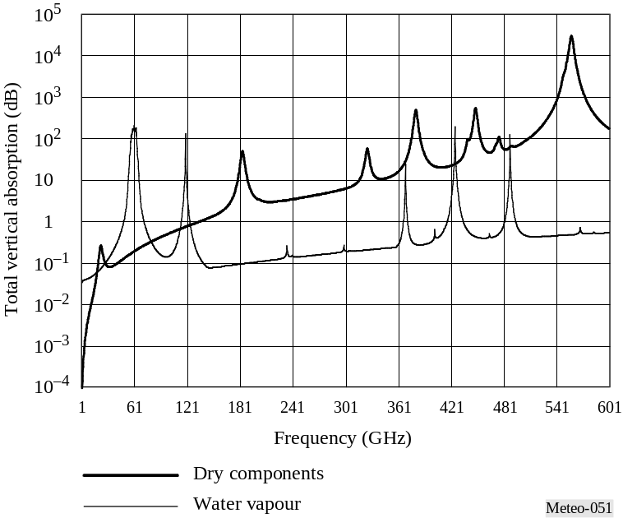
The selection of the best-suited frequencies for passive microwave sensing depends heavily on the characteristics of the atmosphere:
– frequencies for observation of surface parameters are selected below 100 GHz, where atmospheric absorption is the weakest. One frequency per octave, on average, is necessary; and
– frequencies for observation of atmospheric parameters are very carefully selected mostly above 50 GHz within the absorption peaks of atmospheric gases.
The required frequencies, and bandwidths of interest below 1 000 GHz are listed in Table 5-1. Most frequency allocations above 100 GHz contain absorption lines of important atmospheric trace chemical compounds.

TABLE 5-1
Frequency bands and bandwidths of scientific interest for satellite passive sensing below 1 000 GHz*
Frequency  (GHz) | Desired bandwidth  (MHz) | Main measurements
1.4-1.427 | 100 (27) | Soil moisture, salinity, ocean surface temperature, vegetation index (desired bandwidth exceeds allocation)
2.69-2.7 | 60 (10) | Salinity, soil moisture (desired bandwidth exceeds allocation
4.2-4.4 | 200 | Ocean surface temperature
6.7-7.1 | 400 | Ocean surface temperature (no allocation)
10.6-10.7 | 100 | Rain, snow, ice, sea state, ocean wind, ocean surface temperature, soil moisture
15.35-15.4 | 200 | Water vapour, rain
18.6-18.8 | 200 | Rain, sea state, ocean ice, water vapour, snow
21.2-21.4 | 200 | Water vapour, cloud liquid water
22.21-22.5 | 300 | Water vapour, cloud liquid water
23.6-24 | 400 | Water vapour, cloud liquid water
31.3-31.8 | 500 | Window channel associated to temperature measurements
36-37 | 1 000 | Rain, snow, ocean ice, water vapour, cloud liquid water, ocean wind, soil moisture
50.2-50.4 | 200 | O2 (temperature profiling)
52.6-59.3 | 6 700(1) | O2 (temperature profiling)
86-92 | 6 000 | Clouds, ice, snow, rain
100-102 | 2 000 | N2O
109.5-111.8 | 2 300 | O3
114.25-122.25 | 8 000(1) | O2 (temperature profiling), CO
148.5-151.5 | 3 000 | Window channel
155.5-158.5 | 3 000 | Window channel
164-167 | 3 000 | Window channel
174.8-191.8 | 17 000(1) | H2O (Moisture profiling), cloud ice, snow N2O, O3
200-209 | 9 000(2) | H2O, O3, N2O
226-232 | 6 000(2) | Clouds, CO
235-238 | 3 000(2) | O3
250-252 | 2 000(2) | N2O
275-277 | 2 000(2) | N2O
294-306 | 12 000(2) | N2O, O3, O2, HNO3, HOCl
TABLE 5-1 (end)
Note: For current information on passive sensor frequency allocations, the reader is referred to the Table of Frequency Allocations in Article 5 of the Radio Regulations For additional information on the preferred frequencies for passive sensing, the reader is referred to the most recent revision of Recommendation ITU-R RS.515.
Frequency  (GHz) | Necessary or allocated bandwidth  (MHz) | Main measurements
316-334 | 10 000(2) | Water vapour profiling, O3, HOCl, H2O, cloud ice
342-349 | 7 000(2) | CO, HNO3, CH3Cl, O3, O2, HOCl, H2O, window channel, cloud ice and cirrus
363-365 | 2 000(2) | O3
371-389 | 18 000(2) | Water vapour profiling
416-434 | 18 000(2) | Temperature profiling
442-444 | 2 000(2) | Water vapour, cloud ice and cirrus
486-506 | 9 000(2) | O3, CH3Cl, N2O, BrO, ClO
546-568 | 22 000(2) | Temperature profiling
624-629 | 5 000(2) | Bro, O3, HCl, SO2, H2O2, HOCl, HNO3
634-654 | 20 000(2) | CH3Cl, HOCl, ClO, H2O, N2O, BrO, O3, HO2, HNO3
659-661 | 2 000(2) | BrO, window channel, cloud ice and cirrus
684-692 | 8 000(2) | ClO, CO, CH3Cl
730-732 | 2 000(2) | O2, HNO3
851-853 | 2 000(2) | NO
951-956 | 5 000(2) | O2, NO, H2O
(1) This bandwidth is occupied by multiple channels.
(2) This bandwidth is occupied by multiple sensors.

5.1.2.1 Observation of Earth’s surface features
For the measurement of Earth surface parameters (e.g., water vapour, sea surface temperature, wind speed, rain rate, etc.), the so-called radiometric window channels must be selected such that a regular sampling over the microwave spectrum from about 1 GHz to 90 GHz is achieved (one frequency/octave, on average). However, highly accurate settings of frequencies, in general, are not required because natural emissions of surface parameters are not strongly frequency dependent. In general, several geophysical parameters contribute at varying levels to the natural emission, which can be observed at a given frequency. This is illustrated by the Figures 5-2 to 5-4, which represent the sensitivity of natural microwave emissions to various geophysical parameters depending on frequency. Brightness temperature is a measure of the intensity of radiation thermally emitted by an object, given in units of temperature because there is a correlation between the intensity of the radiation emitted and physical temperature of the radiating body.

5.1.2.2 Observation Over ocean surfaces
Remote sensing over ocean surfaces is used to measure many of the same parameters as are measured over land (e.g., water vapour, rain rate, wind speed) as well as parameters that provide information on the state of the ocean itself (e.g., sea surface temperature, ocean salinity, sea ice thickness, etc.).
Figure 5-2
Sensitivity of brightness temperature to geophysical parameters over ocean surface
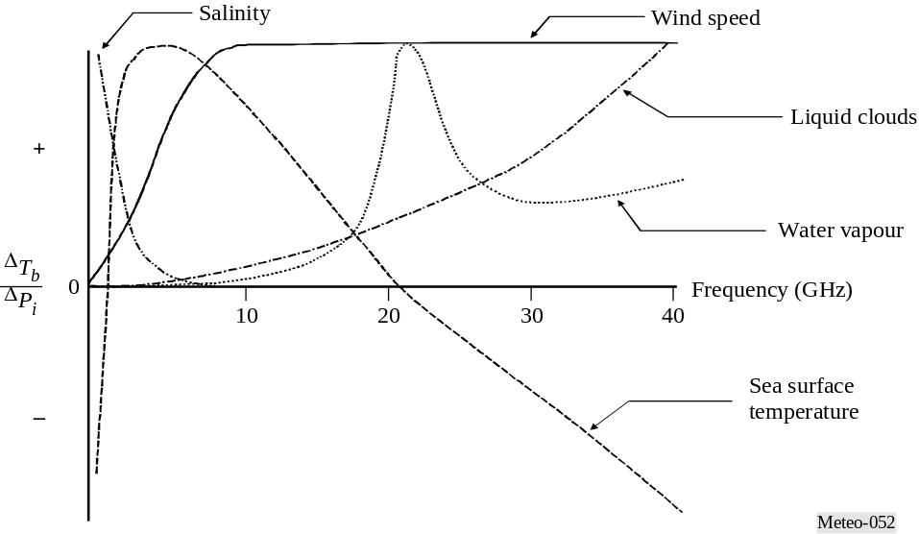

Figure 5-2 shows the sensitivity of brightness temperature to geophysical parameters over ocean surfaces that:
– measurements at low frequency, typically around 1.4 GHz, give access to ocean salinity;
– measurements around 6 GHz offer the best sensitivity to sea surface temperature, but contain a small contribution due to salinity and wind speed which can be removed using measurements around 1.4 GHz and around 10 GHz;
– the 17-19 GHz region, where the signature of sea surface temperature and atmospheric water vapour is the smallest, is optimum for ocean surface emissivity, which is directly linked to the wind speed near the surface, or to the presence of sea ice. Ocean surface temperature also has some sensitivity to water vapour total content and to liquid clouds;
– total content of water vapour can be best measured around 24 GHz, while liquid clouds are obtained via measurements around 36 GHz; and
– five frequencies (around 6 GHz, 10 GHz, 18 GHz, 24 GHz and 36 GHz) are necessary for determining the dominant parameters.

5.1.2.3 Observation Over land surfaces
Remote sensing over land surfaces is somewhat more complex due to the high temporal and spatial variability of surface characteristics (from snow/ice covered areas to deserts and tropical rain forest). Moreover, the signal received by the radiometer has been propagated through a number of different media: basically the soil, perhaps snow and/or ice, the vegetation layer, atmosphere and clouds, and occasionally rain or snow. The second factor to be taken into account is the fact that for each medium, several factors might have an influence on the emitted radiation. For instance, the soil will have a different brightness temperature depending on the actual soil temperature, soil moisture content, surface roughness, and soil texture. Similarly, the vegetation contribution will be related to the canopy temperature and structure through the opacity and single scattering albedo (i.e., the ratio of reflected to incident light). The ways that these factors affect the signal are frequency interdependent. Figure 5-3 depicts the normalized sensitivity as a function of frequency for several key parameters.
Figure 5-3
Sensitivity of brightness temperature to geophysical parameters over land surfaces
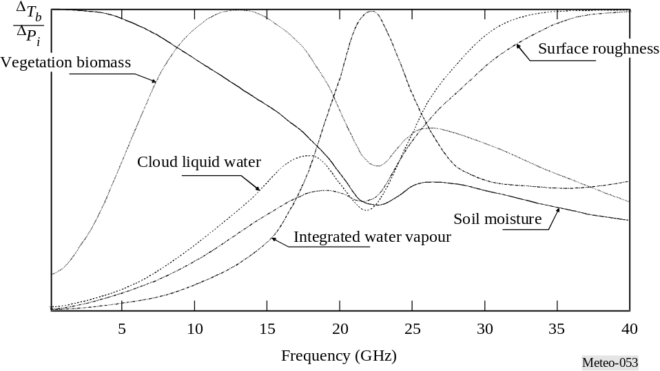

Figure 5-3 shows that over land and for an average temperate area, it is necessary to have access to:
– a low frequency to measure soil moisture (around 1 GHz);
– measurements around 5 GHz to 10 GHz to estimate vegetation biomass once the soil moisture contribution is known;
– two frequencies around the water vapour absorption peak (typically 18-19 GHz and 23-24 GHz) to assess the atmospheric contribution;
– a frequency around 37 GHz to assess cloud liquid water (with use of 18 GHz), and/or vegetation structure (with 10 GHz) surface roughness (with 1 GHz and 5 GHz or 10 GHz).
A frequency at 85 GHz or 90 GHz is useful for rainfall monitoring, but only when all the other contributing factors can be assessed with the lower frequencies.
It has been shown through studies using the scanning multichannel microwave radiometer (SMMR) and the special sensor microwave/imager (SSM/I) that several other variables could be retrieved. These include surface temperature (less accurate than the infrared measurements but with all-weather capabilities) using a channel near 19 GHz when the surface and atmospheric contributions can be estimated.
Snow covered areas are important to monitor and here again the necessity for several frequencies is crucial. Actually snow and ice must be distinguished as well as the snow freshness. The related signal is linked to the structure of the snow layers and the crystal sizes. To retrieve such information it has been shown that several frequencies are required, usually 19 GHz, 37 GHz and 85-90 GHz.

5.1.2.4 Auxiliary parameters for other remote sensing instruments
Space borne radar altimeters are currently operated on a global basis above ocean and land surfaces, with important applications in oceanography and climatology. In order to remove refraction affects due to atmosphere, the utilization of highly accurate altimetric data require that they be complemented with a set of auxiliary passive measurements around 18.7 GHz, 24 GHz and 36 GHz.
To be able to separate the different contributions to the signals measured by a satellite, it is essential to have access simultaneously to measurements made at a minimum of five different frequencies.

5.1.3 Performance parameters
Passive sensors are characterized by their radiometric sensitivity and their geometric resolution.

5.1.3.1 Radiometric sensitivity
This parameter is generally expressed as the smallest temperature differential, ΔTe that the sensor is able to detect. ΔTe is given by:
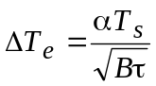 K (5-1)
where:
B: receiver bandwidth (Hz)
τ : integration time (s)
α : receiver system constant (depends on the configuration)
Ts: receiver system noise temperature (K).

5.1.3.2 Radiometer threshold ΔP
This is the smallest power change that the passive sensor is able to detect. ΔP is given by:
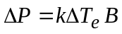 W (5-2)
where:
k = 1.38 × 10–23 (J/K): Boltzmann’s constant.
ΔP above is computed using ΔTe. In the future, Ts will decrease as well as ΔTe (see equation (5-1)). Therefore ΔP must be computed using a reasonable foreseen ΔTe rather than the ΔTe of current technology. In the same manner, the integration time, τ, will likely increase as remote sensing technology developes further (e.g., pushbroom concept). Therefore, the integration time must also be chosen based on reasonable future expectations.

5.1.3.3 Geometric resolution
In the case of two-dimensional measurements of surface parameters (see § 5.1.4), it is generally considered that the –3 dB aperture of the antenna determines the transversal resolution. In the case of three-dimensional measurements of atmospheric parameters (see § 5.1.5), the longitudinal resolution along the antenna axis must also to be considered. This longitudinal resolution is a complex function of the frequency-dependent characteristics of the atmosphere and the noise and bandwidth performance of the receiver.

5.1.3.4 Integration time
Radiometric receivers sense the noise-like thermal emissions collected by the antenna and the thermal noise of the receiver. By integrating the received signal, the random noise fluctuations can be reduced and accurate estimates can be made of the sum of the receiver noise and external thermal emission noise power. The integration time is simply the amount of time it takes the receiver to integrate the received signal. The integration time is also an important parameter for passive remote sensing, which results from a complex trade-off taking into account in particular the desired geometric resolution, the scanning configuration of the sensor, and its velocity with respect to the scene observed.

5.1.4 Typical operating conditions of passive sensors
Passive sensors of the EESS are deployed essentially on two complementary types of satellite systems: low earth orbiting satellites and geostationary satellites.

5.1.4.1 Low Earth orbiting satellites
Systems based on satellites in low, sun-synchronous (i.e., an orbit where the satellilte passes over any given point of the Earth's surface at the same local solar time), polar orbits are used to acquire high-resolution environmental data on a global scale. The nature of such orbits limits the repeat rate of measurements. A maximum of two global coverages at 12 hour intervals are obtained daily, with a single satellite. Passive radiometers operating at frequencies below 100 GHz are currently flown only on low-orbiting satellites. This is essentially due to the difficulty of obtaining adequate geometric resolution at relatively low frequencies from higher orbits, and may change in the future.

5.1.4.2 Geostationary satellites
Systems involving satellites in geostationary orbit are used to gather low to medium resolution data on a regional scale. The repeat rate of measurements is limited only by hardware technology. Typically, data for one region is collected approximately every 30 minutes.

5.1.5 Main technical characteristics
Most passive microwave sensors designed for imaging the Earth’s surface features use a conical scan configuration (see Figure 5-4) centred on the nadir (i.e., the point directly below the satellite) direction, because it is important, for the interpretation of surface measurements, to maintain a constant ground incidence angle along the entire scan lines. The geometry of conically scanned instruments is described in Fig. 5-4.
The following are typical geometric characteristics (for 803 km altitude):
– ground incidence angle around 55°
– half-cone angle 46.7° with reference to the nadir direction
– swath width: 1 600 km (limited by the scanning configuration), enabling two complete coverage’s to be achieved daily by one instrument, at medium and high latitudes
– pixel size: varies with frequency and antenna size, typically from 50 km at 6.9 GHz to 5 km at 89 GHz (based on a 2 metre effective antenna diameter)
– scanning period and antenna feed arrangement are chosen in order to ensure full coverage and optimal integration time (and therefore radiometric resolution) at all measured frequencies, at the expense of hardware complexity.
Non-scanning nadir looking instruments may also be used to provide auxiliary data for particular applications, given the removal of atmospheric effects from radar-altimeter measurements. In order to ease their accommodation onboard satellites, interferometric techniques are being developed, essentially to improve spatial resolution at low frequencies. Such sensors will use fixed arrays of small antennas instead of large scanning antennas.
A “push-broom” (along track) sensor is a type of sensor system that consists of a line of sensors arranged perpendicular to the flight direction of the spacecraft as illustrated in Figure 5-5. Different areas of the surface are detected as the spacecraft flies forward. The push-broom radiometer is a purely static instrument with no moving parts. The major feature of the push-broom radiometer is that all of the pixels in a scan line are acquired simultaneously and not sequentially as with mechanically scanned sensors, enabling this type of sensor to significantly increase the achievable radiometric resolution. Push-broom sensors can be used for a variety of applications including temperature profiles measurements of the atmosphere, and soil moisture and ocean salinity measurements.
Figure 5-4
Typical geometry of conically scanned passive microwave radiometers
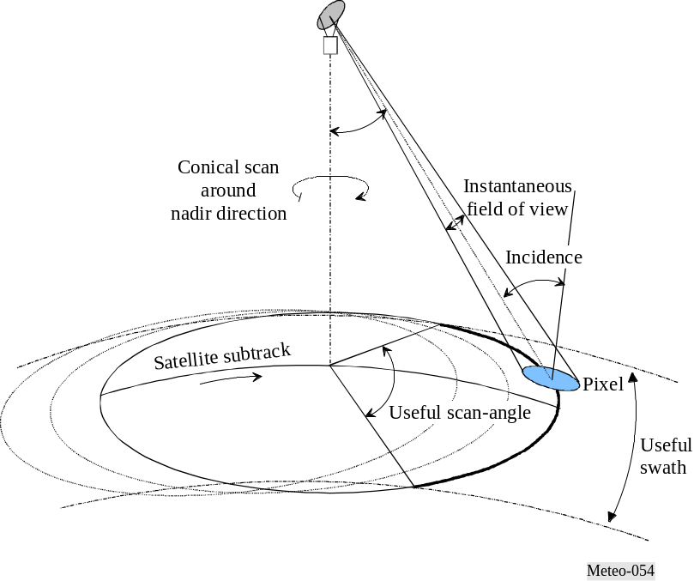
figure 5-5
Typical geometry of pushbroom passive microwave radiometers

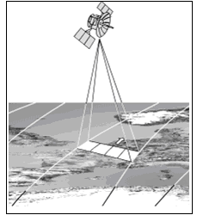

5.1.6 Performance and interference criteria
The performance and interference criteria for spaceborne passive sensors operating in the EESS are contained in Recommendations ITU-R RS.1028 and RS.1029 respectively.

5.1.7 Three-dimensional measurement of atmospheric parameters
The electromagnetic spectrum contains many frequency bands where, due to molecular resonances, absorption mechanisms by certain atmospheric gases are taking place (see Figure 5-1). Frequencies at which such phenomena occur characterize the gas (e.g., O2, O3, H2O, ClO, etc). The absorption coefficient depends on the nature of the gas, on its concentration, and on its temperature. Combination of passive measurements around these frequencies can be performed from spaceborne platforms to retrieve temperature and/or concentration profiles of absorbing gas. Of particular significance to passive remote sensors operating below 200 GHz are the oxygen resonance frequencies between 50 GHz and 70 GHz, at 118.75 GHz, and the water vapour resonance frequency at 183.31 GHz.
Absorbing gas at wavelength λ radiates energy (at the same frequency) at a level that is proportional to its temperature T and to its absorption ratio 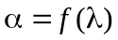. This is governed by-the relationship given in equation (5-3):
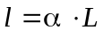 (5-3)
where:
l: spectral brightness of the gas at temperature T
= 2 · k · T/λ 2: spectral brightness of the black body at T (W/(m2 · sr · Hz))
k = 1.38 × 10–23: Boltzman’s constant (J/K)
α: characterizes the gas (O2, CO2, H2O, O3, etc.).
Two atmospheric gases, CO2 and O2, play a predominant role in passive sensing for meteorology because their concentration and pressure in the atmosphere (two parameters which determine the absorption ratio α) are almost constant and known all around the globe. It is therefore possible to retrieve atmospheric temperature profiles from radiometric measurements at various frequencies in the appropriate absorption bands (typically in the infrared region around 15 μm for CO2, and in the microwave region around 60 GHz and 118.75 GHz for O2).
Radiometric measurements in the specific absorption bands of other radiatively and chemically important atmospheric gases of variable and unknown concentration (H2O, O3, CH4, ClO, etc) are also collected. But in that case, the knowledge of atmospheric temperature profiles is mandatory in order to retrieve the unknown vertical concentration profiles of these gases.

5.1.7.1 Passive microwave atmospheric vertical sounders
Atmospheric sounding is a measurement of vertical distribution of physical properties of a column of the atmosphere such as pressure, temperature, wind speed, wind direction, liquid water content, ozone concentration, pollution, and other properties. Vertical atmospheric sounders (i.e., instruments that take atmospheric sounding measurements) are nadir-looking sensors, which are used essentially to retrieve vertical atmospheric temperature and humidity profiles. They use frequency channels carefully selected within the absorption spectra of atmospheric O2 and H2O. Detailed absorption spectra in the vicinity of their main resonance frequencies below 200 GHz are shown in Figs. 5-6 to 5-8. Figure 5-5 also shows the position and the status of allocations between 50 and 60 GHz. Note the very important variability of the water vapour absorption spectrum around 183 GHz, depending on climatic zone and on local weather conditions.

5.1.7.2 Mechanism of vertical atmospheric sounding
In the case of vertical atmospheric sounding from space, the radiometer measures, at various frequencies (infrared or microwave), the total contribution of the atmosphere from the surface to the top.
Figure 5-6
O2 absorption spectrum along a vertical path around 60 GHz
(multiple absorption lines)
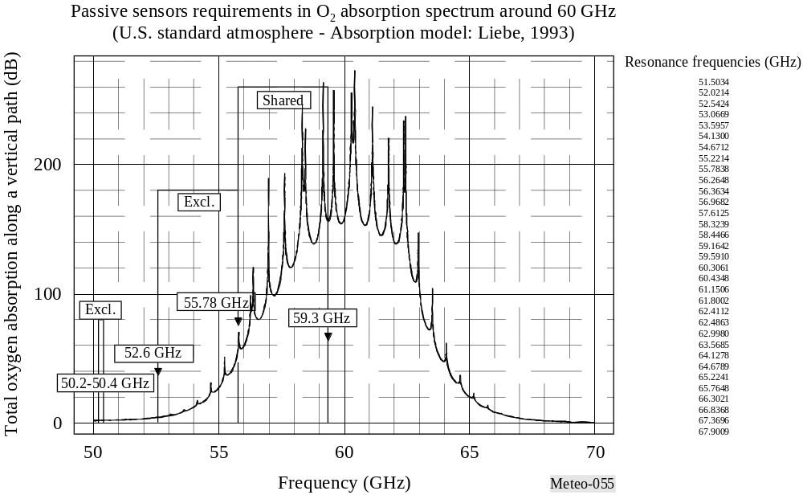
Figure 5-7
O2 absorption spectrum along a vertical path around 118.75 GHz
(one unique absorption line)
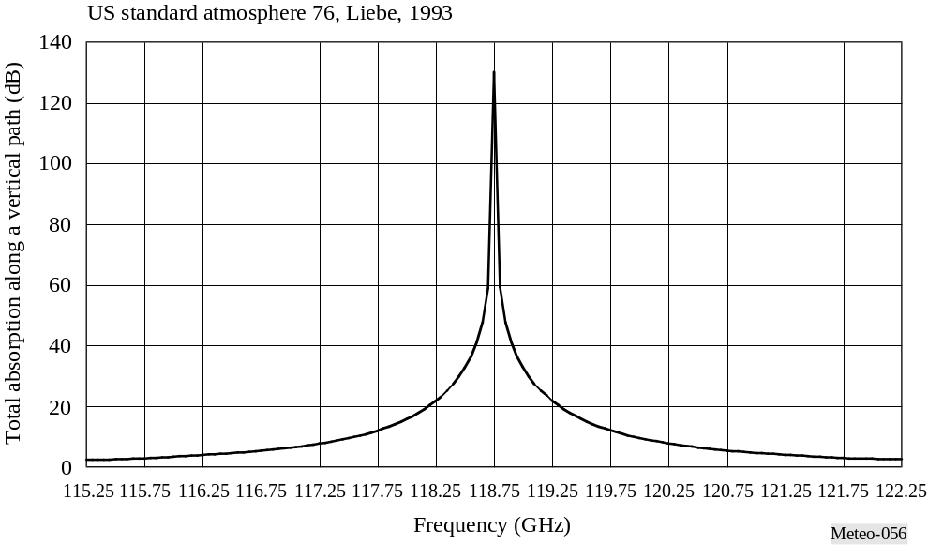
Figure 5-8
Water vapour absorption spectrum along a vertical path around 183.31 GHz
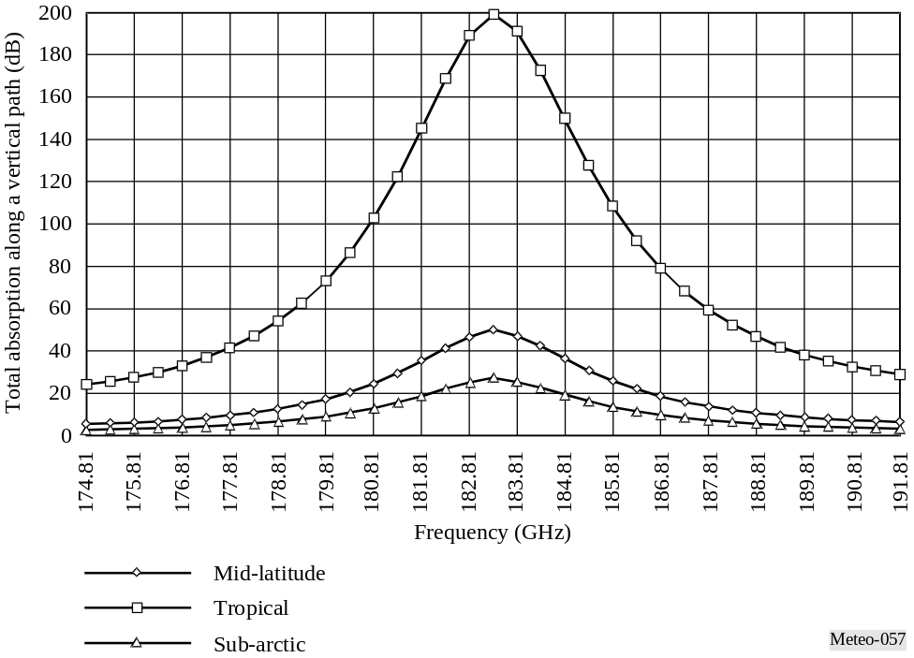

Each layer (characterized by its altitude) radiates energy proportionally to its local temperature and absorption ratio. The upward energy (in direction of the radiometer) is partly absorbed by the upper layers and in turn, the layer partly absorbs upwards emissions from the lower layers.
Integration of the radiative transfer equation along the path from Earth’s surface to the satellite reflects this mechanism, and results in a weighting function which describes the relative contribution of each atmospheric layer, depending on its altitude, and which represents also the longitudinal (vertical) resolution of the sensor.
The peak of the weighting function occurs at any altitude, and depends on the absorption ratio at the frequency considered. At a frequency where the absorption is low, the peak is near the earth’s surface. At a frequency where the absorption is high, the peak is near the top of the atmosphere. A sounder incorporates several frequency channels (see Figure 5-9 for example). They are extremely carefully selected within the absorption band, covering a wide range of absorption levels in order to obtain the best atmospheric samples from the surface up to stratospheric altitudes.
Typical weighting functions for a microwave temperature sounder operating in the 60 GHz band are shown in Fig. 5-9.
Note the particular importance of Channels 1 (23.8 GHz), 2 (31.5 GHz), and 15 (90 GHz). These are auxiliary channels, which play a predominant role in the retrieval process of measurements performed in the O₂ absorption spectrum. As such, they must have similar geometric and radiometric performances and must receive similar protection against interference. In Fig. 5-8, it can be seen that:
– Channel 1 is close to a H₂O absorption peak. It is used to retrieve the total water vapour content along the line of sight, and to determine the corrections, which are necessary in the other channels.
– Channel 2 has the lowest cumulated effects due to oxygen and water vapour. It is the optimum window channel to see the Earth’s surface, and is the reference for the other channels.
– Channel 15 can detect atmospheric liquid water and is used to decontaminate the measurements performed in the other channels from the effects of precipitation.
Figure 5-9
Typical weighting functions for a microwave temperature sounder operating near 60 GHz
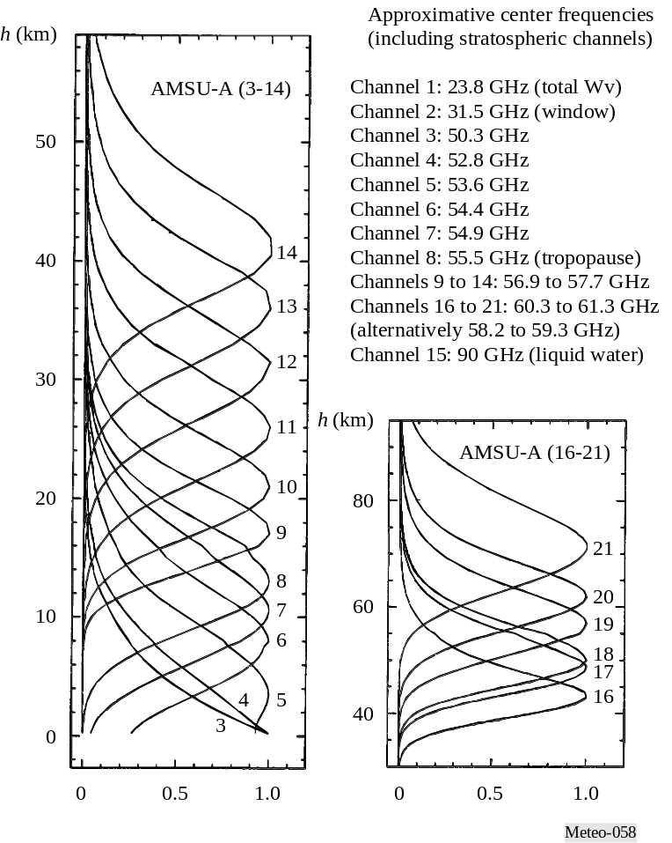

5.1.7.3 Utilization of vertical atmospheric sounding
The vertical temperature and humidity profiles are essentially used as inputs to the numerical weather prediction (NWP) models, which need to be initialized at least every 6 hours. Global NWP (worldwide) models are used to produce a 5 to 10 day weather forecast with a geographical resolution of 50 km. Also, in increasing numbers, there are regional/local models for a fine mesh prediction (10 km or less) on a short-range basis (6 to 48 hours). Figure 5-10 shows the global composite of temperature (K) measurements from the AMSU-A passive microwave sensor, containing measurements produced in a time window of about 12 hours. The observations include emission and reflection from the surface plus emission from oxygen mostly in the first 5 km above the surface (see Figure 5-9).
Figure 5-10
Global composite of temperature (K) measurements from AMSU-A
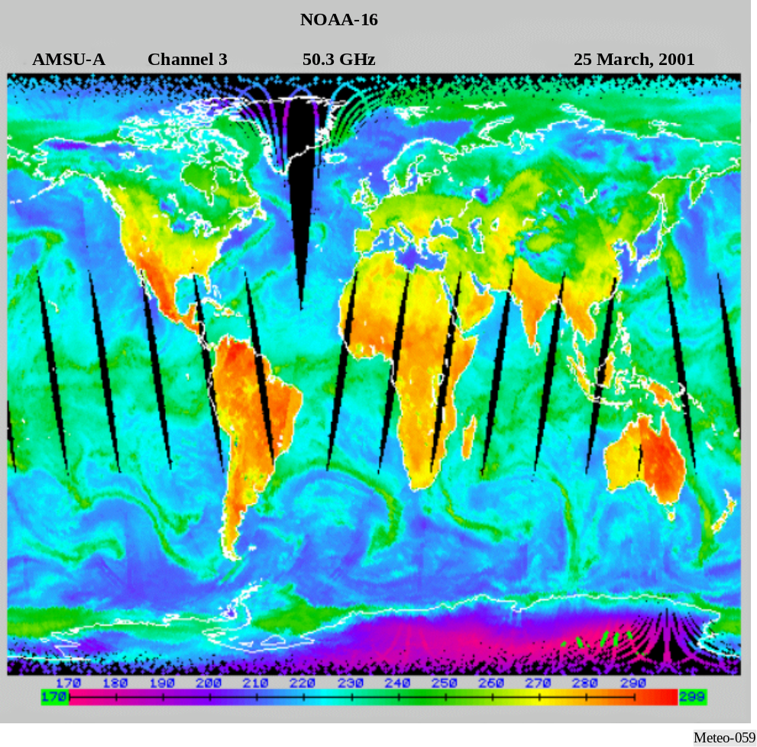

Figure 5-11 shows the global composite of temperature (K) measurements from AMSU-B. Figure 5-11contains measurements produced in a time window of about 12 hours. AMSU-B is a radiometer operated together with AMSU-A to improve the sensing of tropospheric water vapour. At 183 GHz, the radiometer observes high temperature (orange/red colouring) in the tropics and mid-latitudes when the upper parts of the troposphere are dry and the sensor observes nearer the surface, and low brightness temperatures (green) where humidity is high and the radiation originates from higher levels.
The NWP models use partial differential Navier-Stokes equations. Because they simulate highly unstable atmospheric mechanisms, they are extremely sensitive to the quality of the initial three dimensional profiling. This problem has been described by Lorentz and is now clearly explained by the “chaos theory”. To run NWP models, the most powerful super computers are needed.
Figure 5-11
Global composite of temperature (K) measurements from AMSU-B
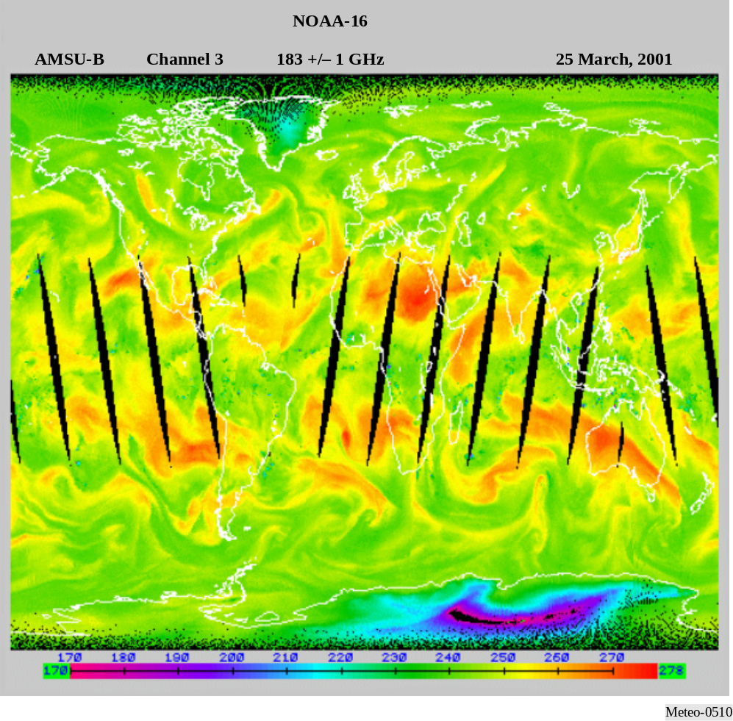

In order to increase the effectiveness of NWP models, it will be necessary to improve and increase the initialization of the models at least every 6 hours on a worldwide basis and at a resolution of 50 km for global NWP and 10 km for regional/local NWP. In the future, it will be necessary to get information approximately every 3 hours.

5.1.7.4 Characteristics of nadir-looking passive sensors operating in the 60 GHz range
Most passive microwave sensors designed for measuring tropospheric/stratospheric parameters, are nadir-looking instruments. They use a cross-track mechanical (current) or push-broom (future) scanning configuration in a plane normal to the satellite velocity containing the nadir direction. This configuration provides optimum field-of-view (FOV) and optimum average quality of data. Typical characteristics of temperature sounders working around 60 GHz and operated on board low Earth orbiting satellites are given in Table 5-3.
TABLE 5-3
Typical characteristics of microwave vertical sounders in the 60 GHz frequency range
Characteristic | Mechanical scanning (current) | Push-broom scanning (future)
Channel bandwidth (MHz) | 400 | 15
Integration time (s) | 0.2 | 2.45
Antenna diameter (cm) | 15 | 45
3 dB points IFOV (degrees) | 3.3 | 1.1
Cross-track FOV (degrees) | ± 50 | ± 50
Antenna gain (dBi) | 36 | 45
Far lobes gain (dBi) | –10 | –10
Beam efficiency (%) | > 95 | > 95
Radiometric resolution (K) | 0.3 | 0.1
Swath-width (km) | 2 300 | 2 300
Nadir pixel size (km) | 49 | 16
Number of pixels/line | 30 | 90

5.1.7.5 Passive microwave limb sounders
Microwave limb sounders, which observe the atmosphere in directions tangential to the atmospheric layers, are used to study low to upper atmosphere regions, where the intense photochemistry activities may have a heavy impact on the Earth’s climate. Major features of tangential limb emission measurements are the following:
– the longest path is used, which maximizes signals from low-concentration atmospheric minor constituents, and renders possible soundings at high altitudes;
– the vertical resolution is determined by the radiative transfer through the atmosphere and by the vertical field of view of the antenna. A typical example is shown in Fig. 5-12;
– the horizontal resolution normal to the line of sight is determined principally by the horizontal field of view of the antenna and the smearing due to the satellite motion;
– the horizontal resolution along the line of sight is principally determined by the radiative transfer through the atmosphere;
– the space background is optimum for emission measurements; and
– limb measurements are extremely vulnerable to interference caused by inter-satellite links.
Figure 5-12
Microwave limb sounding vertical weighting functions (based on a 1.6 m antenna at a 600 km altitude)
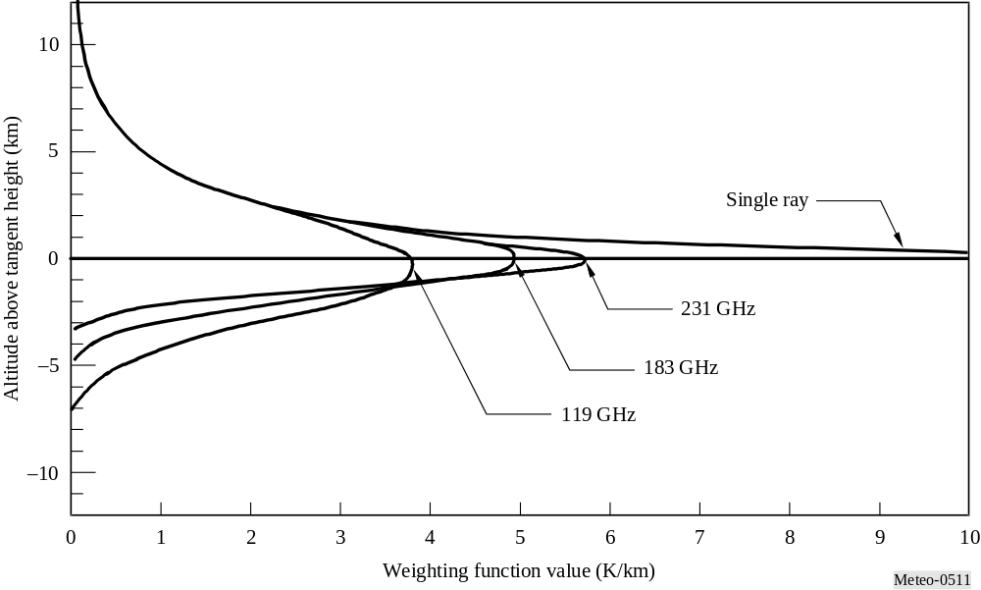

Microwave limb sounders were first launched in 1991, and perform the following functions:
– scan the atmosphere vertically in the 15-120 km altitude range, in two side-looking orthogonal directions;
– typical vertical resolution for profile measurements (weighting functions width at half value) is about 3 to 6 km, as shown on Fig. 5-12;
– typical horizontal resolution is 30 km across and 300 km along the direction of observation;
– complete profiles are obtained in less than 50 seconds; and
– observes thermal limb emission in five microwave spectral regions (see Table 5-4).

The new generation of microwave limb sounders measure lower stratospheric temperature and concentrations of H2O, O3, ClO, BrO, HCl, OH, HO2, HNO3, HCN, and N2O, for their effects on, and diagnoses of, ozone depletion, transformations of greenhouse gases, and radiative forcing of climate change. MLS also measures upper tropospheric H2O, O3, CO, and HCN for their effects on radiative forcing of climate change and for diagnoses of exchange between the troposphere and stratosphere.
TABLE 5-4
Example measurement objectives of typical microwave limb sounders and spectral regions
Geophysical parameter | Spectral region (GHz) | Altitude  (km) | Root Mean Square noise  (interval time)
Atmospheric pressure | 63 | 30-70 | 1% (2 s)
Wind velocity | 119 | 70-110 | 2-10 m/s (10 s)
Temperature | 119 | 20-100 | 0.5-3 K (2 s)
O2 | 119 | 80-120 | 3 × 10–3 v/v (2 s)
Magnetic field | 119 | 80-110 | 0.3-1 m gauss (10 s)
H2O | 183 | 15-90 | 1 × 10–7 v/v (2 s)
ClO | 205 | 20-40 | 2 × 10–10 v/v (10 s)
O3 | 205 | 15-90 | 1 × 10–8 v/v (2 s)
H2O2 | 205 | 20-50 | 9 × 10–10 v/v (10 s)
O3 | 231 | 15-90 | 1 × 10–8 v/v (2 s)
CO | 231 | 15-100 | 1 × 10–7 v/v (10 s)

Microwave limb sounders observe the details of ozone chemistry by measuring many radicals, reservoirs, and source gases in chemical cycles that destroy ozone. This set of measurements will provide stringent tests on understanding of global stratospheric chemistry, will help explain observed trends in ozone, and can provide early warnings of any changes in the chemistry of this region.
The original microwave limb sounders demonstrated the capability of measuring upper tropospheric water vapour profiles. This knowledge is essential for understanding climate variability and global warming but which previously has been extremely difficult to observe reliably on a global scale. Future microwave limb sounders may observe additional atmospheric chemistry components and species at other frequencies.

TABLE 5-8
MASTER channels and radiometric objectives
Millimetre-wave channels  (GHz) | Atmospheric species | System noise temperature (SSB (K)) | NET  (0.3 s interval,  50 MHz resolution)  (K)

The superconducting submillimeter-wave limb-emission sounder (SMILES) instrument is developed by NASDA/CRL. Table 5-9 contains SMILES spectral regions and measurement objectives.
TABLE 5-9
SMILES spectral regions and measurement objectives
Spectral region (GHz) | Atmospheric species | System noise temperature (SSB (K))

5.1.7. 6 Vulnerability to interference of passive microwave sounders
Passive sensors integrate all natural (wanted) and man-made (unwanted) emissions. They cannot, in general, differentiate between these two types of signals because the atmosphere is a highly unstable medium with rapidly changing characteristics, both spatially and temporally. A particular problem for passive sensors is the presence of large numbers of low power emitters within the sensor’s measurement area. Among such low power emitters are ultra wide-band (UWB) devices and industrial, scientific and medical (ISM) devices. The passive sensors are therefore extremely vulnerable to interference, which may have very serious detrimental consequences:
– It was demonstrated that as few as 0.1% of contaminated satellite data could be sufficient to generate unacceptable errors in numerical weather prediction forecasts, thus destroying confidence in these unique all weather passive measurements;
– The systematic deletion of data where interference is likely to occur may render impossible the recognition of new developing weather systems, and vital indications of rapidly developing potentially dangerous storms may be missed; and
– For climatological studies and particularly for “global change” monitoring, interference may lead to misinterpretation of climate signals.
Recommendations ITU-R RS.1028 and ITU-R RS.1029 provide the required radiometric performances and the permissible interference levels respectively.

5.2 Active sensors

5.2.1 Introduction
The purpose of this section is to describe the radio spectrum frequency needs of the spaceborne active sensors, and in particular, those sensors used in the monitoring of meteorological phenomena. The intent is to present the unique types of sensors and their characteristics which determine their individual frequency needs; to present performance and interference criteria necessary for compatibility studies with other services in the frequency bands of interest and to present the status of current compatibility studies of spaceborne active sensors and other services, along with any issues or concerns.
There are five key active spaceborne sensor types addressed in this Handbook:
Type 1: Synthetic aperture radars (SAR) – Sensors looking to one side of the nadir track, collecting a phase and time history of the coherent radar echo from which typically can be produced a radar image of the Earth’s surface.
Type 2: Altimeters – Sensors looking at nadir, measuring the precise time between a transmit event and receive event, to extract the precise altitude of the Earth’s ocean surface.
Type 3: Scatterometers – Sensors looking at various aspects to the sides of the nadir track, using the measurement of the return echo power variation with aspect angle to determine the wind direction and speed on the Earth’s ocean surface.
Type 4: Precipitation radars – Sensors scanning perpendicular to nadir track, measuring the radar echo from rainfall, to determine the rainfall rate over the Earth’s surface and three-dimensional structure of rainfall.
Type 5: Cloud profile radars – Sensors looking at nadir, measuring the radar echo return from clouds, to determine the cloud reflectivity profile over the Earth’s surface.
The characteristics of the five key types of active spaceborne sensors are summarized in Table 5-5.

TABLE 5-5
Active spaceborne sensor characteristics
Characteristic | Sensor types
Characteristic | SAR | Altimeter | Scatterometer | Precipitation radars | Cloud profile radars
Viewing geometry | Side-looking at 10°-55° off nadir | Nadir-looking | – Six fan beams in azimuth  – Two conically scanning beams | Nadir-looking | Nadir-looking
Footprint/dynamics | – Fixed to one side  – ScanSAR | Fixed at nadir | – Fixed in azimuth  – Scanning | Scanning across nadir track | Fixed at nadir
Antenna beam | Fan beam | Pencil beam | – Fan beams  – Pencil beams | Pencil beam | Pencil beam
Radiated peak power (W) | 1 500-8 000 | 20 | 100-5 000 | 600 | 1 000-1 500
Waveform | Linear FM pulses | Linear FM pulses | Interrupted CW or short pulses | Short pulses | Short pulses
Bandwidth | 20-300 MHz | 320 MHz | 5-80 kHz | 14 MHz | 300 kHz
Duty factor (%) | 1-5 | 46 | 31 | 0.9 | 1-14
Service area | Land/coastal/ocean | Ocean/ice | Ocean/ice/land | Land/ocean | Land/ocean

5.2.2 Synthetic aperture radars
SARS provide radar images of the Earth’s surface. The choice of RF centre frequency depends on the Earth’s surface interaction with the EM field. The RF bandwidth affects the resolution of the image pixels. In Fig. 5-13a), the chirp pulse is shown, and the corresponding RF bandwidth is shown below. The range resolution is equal to c/2/(BW sin θ), where c is the velocity of light, BW is the RF bandwidth, and θ is the incidence angle. To obtain 1 metre range resolution at 30° incidence angle, for instance, the RF bandwidth should be 300 MHz. Many SARs illuminate the swath off to one side of the velocity vector as shown in Fig. 5-13b). Any interference sources within the illuminated swath area will be returned to the SAR receiver. The allowable image pixel quality degradation determines the allowable interference level. Figure 5-14 shows a SAR image taken of the Dead Sea between Israel and Jordan.

Figure 5-13
Chirp spectrum and SAR illumination swath
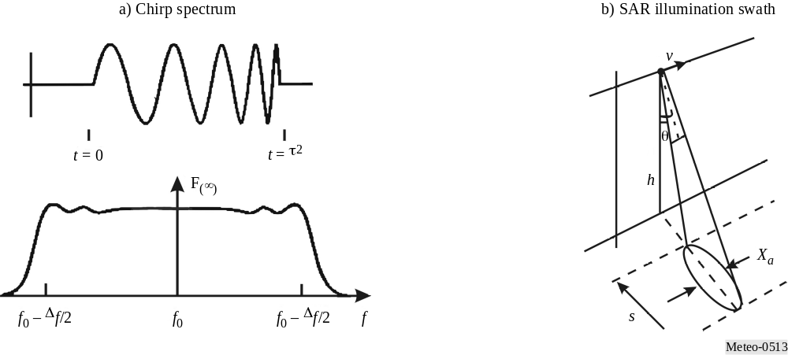
Figure 5-14
SAR image of the Dead Sea along the West Bank between Israel and Jordan
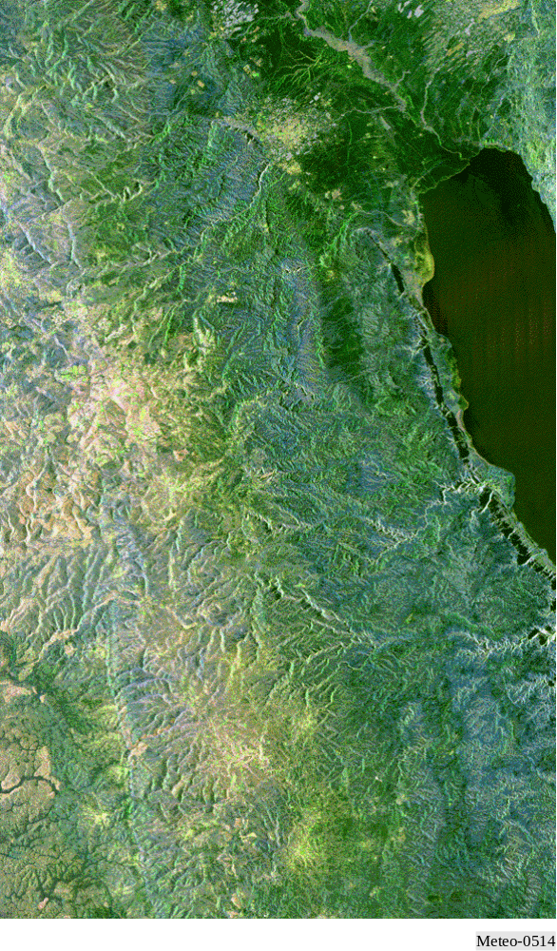

5.2.3 Altimeters
Altimeters provide the altitude of the Earth’s ocean surface. Figures 5-15, 5-16a) and 5-16b) are an illustration of a satellite altimeter and its typical accuracy. The choice of RF centre frequency depends on the ocean surface interaction with the EM field. Dual frequency operation allows ionospheric delay compensation. For instance, the use of frequencies around 13.6 GHz and 5.3 GHz illustrates one possible dual frequency arrangement. The wide RF bandwidth affects the height measurement accuracy. The time difference accuracy Δt is inversely proportional BW, where BW is the RF bandwidth. The allowable height accuracy degradation determines the allowable interference level. Some satellite altimeters have measured ocean topography to an accuracy of 4.2 cm.

5.2.4 Scatterometers
Scatterometers provide the wind direction and speed over the Earth’s ocean surface. The choice of RF centre frequency depends on the ocean surface interaction with the EM field and its variation over aspect angle. Figure 5-18 shows the variation of backscatter level with aspect angle relative to the wind velocity vector direction.
Figure 5-15
Microwave altimeter satellite
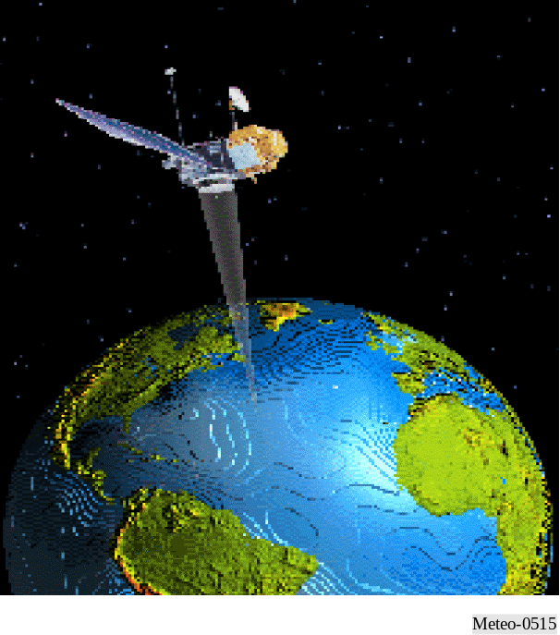

Figure 5-16
Illustration of altimeter return and spreading of return pulse
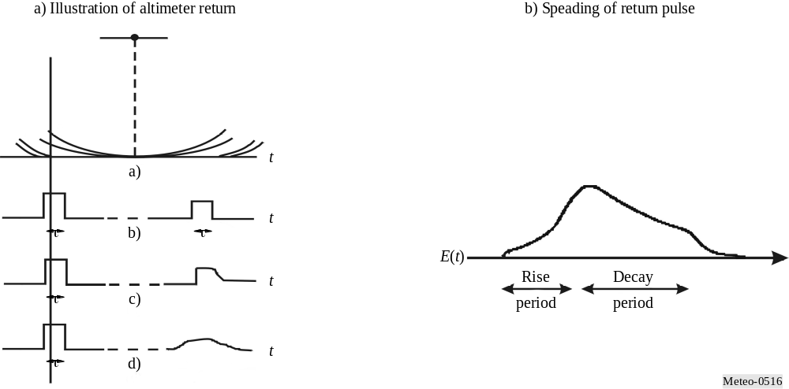

Figure 5-17
SAR detection of warm sea temperatures of El Niño in Pacific Ocean
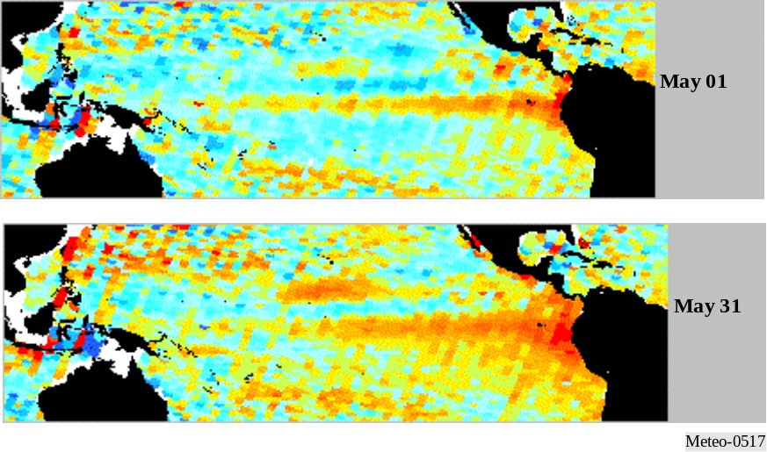
Figure 5-18
Variation of backscatter with aspect angle
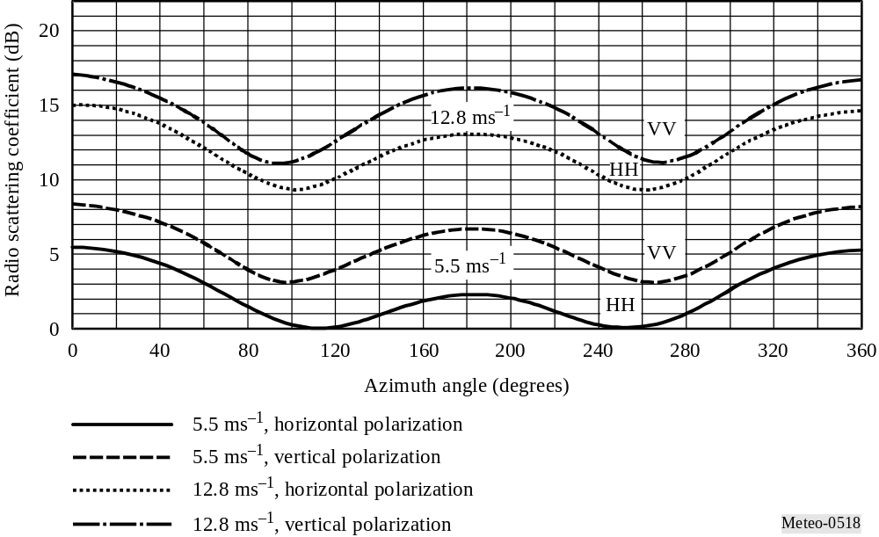
As shown in Fig. 5-19, a typical scatterometer illuminates the Earth’s surface at several different fixed aspect angles. In Fig. 5-20 the a scatterometer scanning pencil beam illuminates scans at two different look angles from nadir, and scans 360° about nadir in azimuth. The narrow RF signal bandwidth provides the needed measurement cell resolution.

Figure 5-19 | Figure 5-20
Scatterometer fixed footprint | Scatterometer pencil beam scan
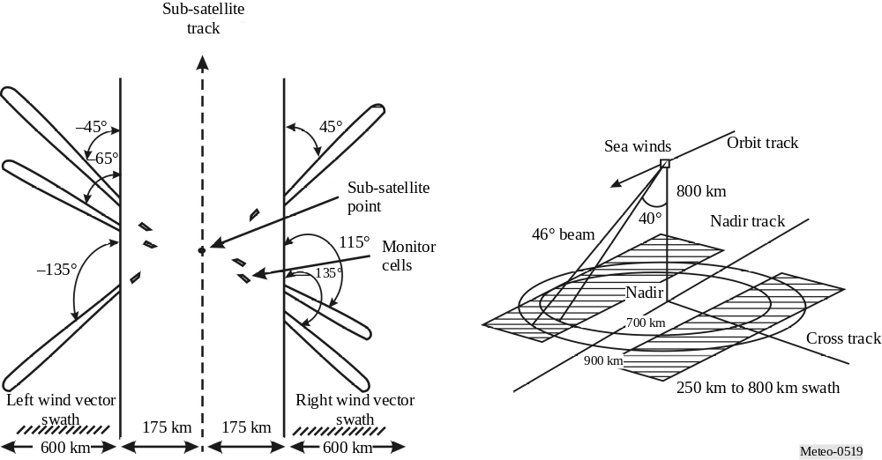
Figure 5-21 shows an example radar image taken from the NSCAT scatterometer of the Amazon rainforest in South America. Other examples of scatterometers used for meteorological purposes are the ERS AMI (wind mode) and METOP Ascat.
Figure 5-21
NSCAT scatterometers radar image of the Amazon rainforest in South America
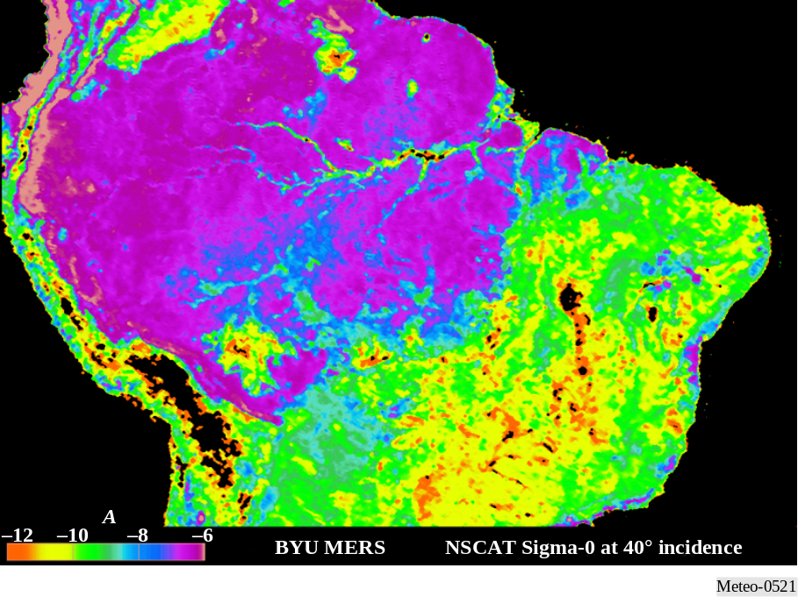

5.2.5 Precipitation radars
Precipitation radars provide the precipitation rate over the Earth’s surface, typically concentrating on rainfall in the tropics.

The choice of RF centre frequency depends on the precipitation interaction with the EM field. The backscatter cross section of a spherical hydrometeor is:
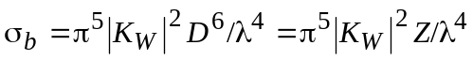 (5-4)
where:
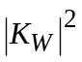: related to the refractive index of the drop’s water
D : diameter of the drop (m)
λ : wavelength of the radar (m)
Z : radar reflectivity factor.
The backscatter increases as the fourth power of the RF frequency.
Figure 5-22 shows an example of a vertical cross section of radar reflectivity factor. The narrow RF signal pulse-width provides the needed measurement range resolution. One example precipitation radar uses a pulse width of 1.6 μs, though the value may vary with other systems. The allowable minimum precipitation reflectivity degradation determines the allowable interference level.

Figure 5-22
Synthesized reflectivity from precipitation reflectivity measurements
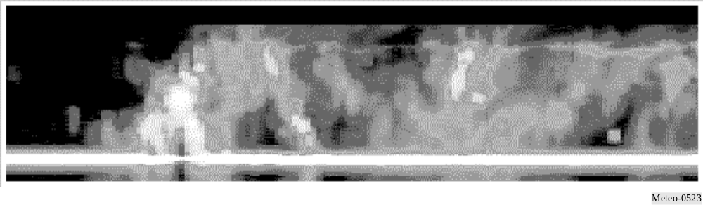

5.2.6 Cloud profile radars
Cloud profile radars provide a three dimensional profile of cloud reflectivity over the Earth’s surface. Figure 5-23 shows a representative backscatter reflectivity versus altitude.

Figure 5-23
Example of cirrus cloud reflectivity
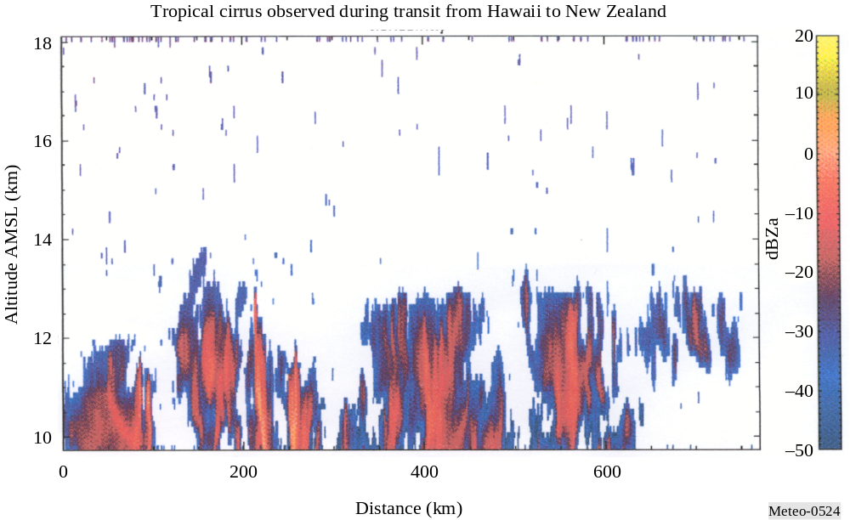
The choice of RF centre frequency depends on the ocean surface interaction with the EM field and its variation over aspect angle.
Equation (5-5) gives the expression for calculation of the return power level of the clouds.
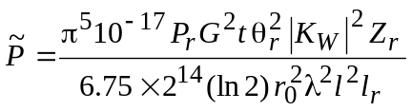 mW (5-5)
where:
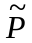: return power level of the clouds (mW)
Pr: radar transmit power (W)
G: antenna gain (numeric)
: pulse width (μs)
θr: 3 dB antenna beamwidth (degrees)
KW: dielectric factor of the cloud water content
Zr: cloud reflectivity factor (mm6/m3)
r0: range distance (km)
λ: radar wavelength (cm)
l: signal loss due to atmospheric absorption
lr: radar system loss.
As illustrated by this equation, the return power decreases with the square of the wavelength. Since frequency is inversely proportional to wavelength, the return power increases with the square of the RF frequency. In the case of small particles (Rayleigh regime), the return power increases as the frequency to the power of four since the ratio depends on the relative particle size with respect to the wavelength. The cloud profile radar antennas have very low sidelobes so as to isolate the cloud return from the higher surface return illuminated by the sidelobes.

5.2.7 Sensor interference and performance criteria
The criteria for performance and interference are provided in Recommendation ITU-R RS.1166for the various types of active spaceborne sensors.

The criteria for performance and interference are summarized in Table 5-11.
TABLE 5-11
Criteria for performance and interference

5.2.8 Power Flux Density levels
The characteristics of the various types of active spaceborne sensors as shown in Table 5-5 indicate that the transmitted peak power and therefore the power levels received at the Earth’s surface will vary significantly in level. Table 5-6 shows the active sensor power flux density levels at the Earth’s surface for some typical sensor configurations.
TABLE 5-6
Typical power flux density levels at Earth’s surface
Parameter | Sensor type
Parameter | SAR | Altimeter | Scatterometer | Precipitation radars | Cloud profile radars
Radiated power (W) | 1 500 | 20 | 100 | 578 | 630
Antenna gain (dB) | 36.4 | 43.3 | 34 | 47.7 | 63.4
Range (km) | 695 | 1 344 | 1 145 | 350 | 400
PFD (dB(W/m2)) | –59.67 | –77.25 | –78.17 | –46.55 | –31.64

.
TABLE 5-14
Allocation status for active spaceborne sensors
Frequency band (GHz) | User objectives | Allocation status | Allocation needed | Users
)
Frequency band (GHz) | User objectives | Allocation status | Allocation needed | Users
Bibliography

ELACHI, DR. C. Spaceborne Radar Remote Sensing: Applications and Techniques. IEEE Press, New York, United States of America.

BROOKNER, E. ed. [1988] Aspects of Modern Radar. Artech House, Boston, United States of America.

ITU-R texts
Recommendation ITU-R RS.515 – Frequency bands and bandwidths used for satellite passive sensing.
Recommendation ITU-R RS.1028 – Performance criteria for satellite passive remote sensing
Recommendation ITU-R RS.1029 – Interference criteria for satellite passive remote sensing
Recommendation ITU-R RS.577 – Frequency bands and required bandwidths used for spaceborne active
sensors operating in the Earth exploration-satellite (active) and space research (active) services
Recommendation ITU-R RS.1166 – Performance and interference criteria for spaceborne active sensors

