CHAPTER 4
METEOROLOGICAL RADARS
4.1 Introduction 4
4.1.1 General 4
4.1.2 Radar equation 6
4.2 Rotating weather radars 7
4.2.1 User requirements 7
4.2.2 Operational aspects of reflectivity 8
4.2.3 Weather radar networks 11
4.2.4 Doppler radars 12
4.2.5 Multiparameter radars 13
4.2.6 Fixed echo elimination 13
4.2.7 Present and future spectrum requirements 13
4.3 Vulnerabilities of radars 16
4.3.1 Types of possible interference 17
4.3.2 Impact of continuous interference 17
4.3.2.1 Geographical Coverage 17
4.3.2.2 Rain Rate 18
4.3.2.3 Wind Measurement 18
4.3.2.4 Impact of pulsed interference 19
4.3.4 Interference From Wind Farms 20
4.3.4.1 Masking 20
4.3.4.2 Clutter 20
4.3.4.3 Backscattered Energy from Turbulent Eddies 21
4.3.4.4 Examples of Wind Turbine Clutter 21
4.3.4.5 Impact of WTC on Meteorological Radar Operations and Forecasting Accuracy 23
4.3.5 Vulnerabilities of systems sharing spectrum with radars 23
4.4 Wind profiler radars 23
4.4.1 User requirements 24
4.4.2 Operational and frequency aspects 27
4.4.3 Present and future spectrum requirements 29
4.4.4 Sharing aspects of wind profilers 29

Page

4.1 Introduction
Meteorological radars are among the best-known life savers in meteorology. It is through the use of radar that we are able to predict the formation of hurricanes, tornadoes, and other severe weather and to track the course of storms on their destructive paths. Modern radar lets us track the path of storms large and small and tells us whether to expect precipitation and at what rates. The rain rate may indicate the potential for flash floods. It lets us know whether high winds and lightning are likely. Meteorological radars operate within the “Radiolocation service”.
This Chapter discusses ground-based radars commonly used in meteorology. The first and most familiar is the rotating radar, which provides data from within a roughly circular area centred on its own location. Commonly referred to as weather radars, these devices are familiar to many, for their output is commonly shown in television weather forecasts. The table below provides bands commonly used formeteorological radar operations. For current information, the reader is referred to the Table of Frequency Allocations in Article 5 of the Radio Regulations.

Band
(MHz)
2700 - 2900
5600 - 5650
9300 - 9500
A more recent development is the wind profiler radar (WPR), which provides data from a roughly cone-shaped volume directly overhead. The WPR is a relatively recent development, having come into common use only within the past decade. It measures wind velocity – speed and direction – as a function of height above ground. If properly equipped, a WPR can also measure air temperature (as a function of height). The radio frequency bands used by the WPR are typically located around 50 MHz, 400 MHz and 1 000 MHz.
A third, less common type, is auxiliary radar used to track radiosondes in flight. The use of such radars is discussed in Chapter 3, which deals with radiosondes.
All radars operate by emitting radio signals, which are reflected from a target that can be anything from a vehicle to raindrops to turbulence in the atmosphere. The return signal of weather radar is weak for several reasons. First, the signal must traverse the path twice, once from the radar to the target and again in the other direction. Secondly, the target is not a particularly efficient reflector. The amount of signal returned is related to target reflectivity and can vary depending on the size and nature of the target. The need to receive these weak signals can be met variously by, e.g., higher transmitter powers, large antennas exhibiting high gain beamwidth product, extremely sensitive receivers, and long signal integration times. Relatively “quiet” spectrum – absence of man-made electronic noise and interference – is also a critical requirement.

4.1.1 General
Meteorological radars are typically volume scanning, pencil beam radars which detect and measure both hydrometeor intensities and velocities of hail, snow, clouds, and especially rain. The radar reflectivity of rain is related to the following parameters: drop size distribution, relative permittivity of the medium under consideration, and radar wavelength. Meteorological radars are also capable of wind measurements. The following three different types of radars can carry out these functions:
1. Doppler weather radars where the hydrometeor is being used as a tracer.
2. Balloon-tracking radars, which provide the wind vector in terms of velocity and direction.
3. WPRs, which detects the air refractive index turbulent variation and uses it as a tracer.

4.1.2 Radar equation
The radar equation (4.0) describes the relationship between the returned power and the characteristics of the radar and the target. The equation can be expressed as follows:

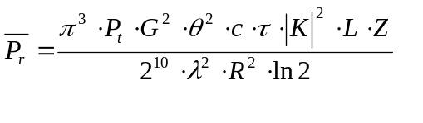 (4-1)
where :
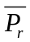 : average return power, watts
Pt : transmitter output power, watts
G: antenna gain, dimensionless
L: loss factors associated with propagation and receiver detection, dB
λ : radar wavelength, meters
c : speed of light, meters/second
θ : antenna half power (3dB) beamwidth, radians
τ : equivalent energy pulse width, seconds
R : range to pulse volume, meters
K: complex index of refraction, dimensionless
Z: effective radar reflectivity, meters³
L : path loss including atmospheric attenuation, dB

Re-arranging terms results in an easy-to-understand formulation of the radar equation (4.2) which shows the different contributions to the received power in terms of constants, radar and target factors.

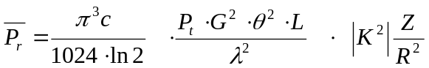 (4-2)
Constants Radar Factors Target Factors

(4-1)

Equation (4-1) can be applied to a distributed target when the following assumptions are satisfied:

- the target occupies the entire volume of the pulse,
- the particles are spread throughout the contributing region.
– the precipitation particles are homogeneous dielectric spheres with diameters small compared to the radar wavelength
– the size of the particles satisfies the Rayleigh Scattering condition
– the dielectric constant 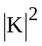 and the size distribution of the scatterers are homogeneous in the volume V considered
- the antenna pattern can be approximated by a Gaussian shape
- the incident and back-scattered waves are linearly polarized

– the effects of multiple scattering are neglected.

A logarithmic form of the radar equation (4.2) (Doviak and Zrnic 1984)

(4.3)

is the most useful in that it illustrates the need to have clearly identified various system parameters in order to make a calibrated reflectivity measurement. These parameters include : the received power 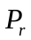 in watts, the range R in meters, the azimuth and elevation angles in degrees, the excess propagation loss 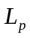 in dB and so-called radar constant C. The radar constant typically includes factors such as the antenna beam width, the pulse width, the receiver conversion gain and system and sites losses.

4.2 Rotating weather radars

4.2.1 User requirements
Meteorologists use weather radar to detect, locate, and measure the amount of precipitation within or falling from clouds. Doppler weather radars use the "Doppler effect" to determine the movement of the precipitation particles. They measure the intensity of precipitation over specific time periods as well as precipitation movement toward or away from the weather radar antenna, enabling the measurement of rotation within storms – a critical factor in detecting severe weather such as tornados or flash floods and providing advance warning.The main user requirement for the weather radar is to detect solid and liquid precipitation and estimate the rate of precipitation and the radial velocity.

4.2.2 Operational aspects of reflectivity

Reflectivity is a radar term referring to the ability of a radar target to return energy. The reflectivity η of rain is related to the water relative permittivity εr, the drop diameter D, and the wavelength λ. For raindrops contained within the volume V under consideration, the reflectivity can be expressed as equation (4-2):
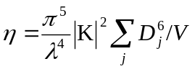 m–1 (4-2)
where 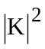is 0.93 for liquid water and 0.18 for ice. Reflectivity is used to estimate precipitation intensity and rainfall rates and is a measure of the returned power.

For precipitation events where the raindrop size in known (or assumed), volume refelctivity can be related to the total liquid water volume per unit volume. The total volume of water in conjunction with the drop-size distribution and the corresponding terminal velocity of the drop facilitate the calculation of rainfall rate.

The radar reflectivity factor Z can be defined as:
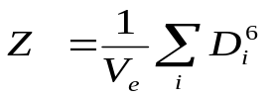 (4-4)
where :
Z : volume that is implied from the scatterer radar cross section of the total number of spheres in the volume
D : water drop diameter
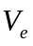 : effective drop volume

The volume Z is related to the radar cross section per unit volume by :

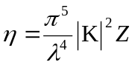 (4-5)

where:
Z : volume
: radar cross section per unit volume
: incident wavelength
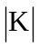 : complex index of refraction

Since the diameter of raindrops within the scattering volume is not uniform, the raindrop distributions can be approximated by :

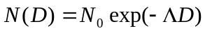 (4-6)

where:
N(D): the number concentration of the diameter
D: diameter
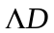 : size interval
And
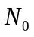and 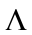are constants for a given meteorological event.
When the raindrop size distribution is known, the summation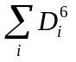 over a unit volume is given by :
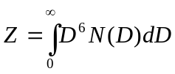 (4-7)
When the vertical airspeed is zero the rainfall rate, , is given by:
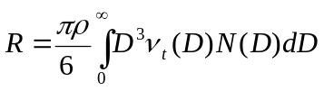 (4-8)
where:
: rainfall rate
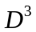 : the raindrop volume that is proportional to Z
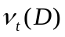 : terminal velocity of a raindrop having a diameter D
 : density of water

When is constant the implied Z-R relationship can be described by the following equation :
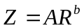 (4-9)

Where Z is usually expressed as dBZ = 10 log Z (mm6/m3) and A and b are constants.(A is the scattering constant and b is the rate multiplier). The most commonly used Z-R relationship is the Marshall-Palmer where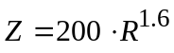.( Z and R are expressed in mm6/m3 and in mm/h, respectively.) The Z-R relationship is however, not unique. Both A and b depend upon the drop size distribution (DSD) which varies with the type and intensity of rain.

4.2.3 Weather radar networks
The main limitation of a weather radar is the fact that the intensity of the echoes that are returned from a given storm event tend to decrease with increasing distance from the radar. As distance from the radar increases, the radar beam becomes further from the ground and the beam broadens (This is due to the Earth's curvature and the elevation angle of the beam). See Figure 4-1.
Figure 4-1
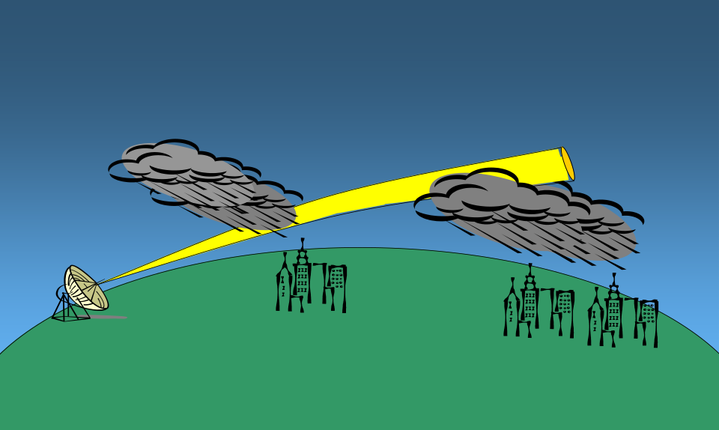

This results in a decrease in the percentage of the storm event that is illuminated by the beam. While the upper portion of the storm can still be seen by the radar, the lower parts of storm may no longer be visable. Precipitation that is taking place at some distance away from the radar may remain undetected or may show up with a reduced intensity thereby limiting the operational range of the radar.
To overcome this constraint, multiple radars are generally equally spaced into distributed networks operating 24 hours per day. These networks often cover large areas such as countries or even a portion of a continent in order to detect and follow the evolution of meteorological phenomena, therefore permitting early weather hazard warnings.

Another approach to overcoming this constraint has been the development of a network (CASA) of small, low-cost, low-power, X-Band radars, which could supplement the data from existing weather radar networks. Such a network is expected to dramatically improve sensing near the ground through a process called DCAS, distributive collaborative adaptive sensing. Within the DCAS process, data from multiple X-Band Radars will be assimilated in real-time for use in detection algorithms, numerical weather prediction and transportation models. Because of the distinct advantages of such a radar network, significant improvements are expected from the system in the analysis and prediction of surface weather conditions.

4.2.4 Doppler radars
Doppler weather radars have been used for more than 30 years in atmospheric research to measure convection within thunderstorms and to detect gust fronts and are now widely used for operational weather radar systems. Unlike earlier radars, Doppler equipment is capable not only of determining the existence and position of reflective targets but also their radial velocity. This permits the measurement of wind speed, detection of tornadoes, and the measurement of a wind field using velocity azimuth display scanning.
Ground clutter suppression is an important capability. New developments in this area are focused on coherent transmitters such as klystrons or traveling wave tubes (TWTs). Conventional radar spectrum phase purity is currently being limited by magnetron technology. However, the existing magnetrons can economically deliver high average power to increase the signal to noise ratio.

4.2.5 Multiparameter radars
Polarimetric radar technology permits the identification of scatterers by remotely sensing their shapes. Polarimetric weather radar has been proposed as a tool for hydrometeor identification and for improving the reliability and accuracy of rainfall rates needed for hydrological applications. In fact, falling raindrops tend to flatten (oblete spheres), the flatness increasing with drop size in the horizontal direction. Combining reflectivity and phase measurements using two polarizations, horizontal (h) and vertical (v), enables a better assessment of the coefficients a and b of the Z-R relationship.
Some recently developed algorithms, based on differential reflectivity ratio Zh/Zv and differential phase ϕh – ϕv, taking into the account the differential attenuation as well, are considered very promising for yielding accurate assessments of rainfall.
In addition to their shape, the hydrometeors are characterized by their dielectric constants, a primary factor in computing scattering and attenuation cross sections. Dielectric properties of hydrometeors vary with radar frequency, where liquid water and ice differ significantly. Taking advantage of these characteristics, algorithms have been implemented to discriminate between rain and snow and to quantify liquid water and ice in clouds using differential attenuation measurements made with dual band radar.

4.2.6 Fixed echo elimination
The so-called fixed echo includes several hidden fixed component; one that includes low frequency scattering, and a second that includes higher frequencies (due to vegetation ruffled by the wind). Different ground clutter suppression methods are used in current weather radars:
– Doppler filtering uses a high pass filter to reduce the ground clutter. That process is efficient if the radial wind velocity is above the cut-off frequency of the Doppler filter.
– Statistical filtering based on the difference between the variances of rain and ground clutter reflectivity. The statistical filtering process is efficient even when the rain radial velocity is null (tangential rain).
– The use of polarimetric radar (proposed) for rain and ground clutter discrimination.

4.2.7 Present and future spectrum requirements
The choice of wavelength λ results from a trade-off between the reflectivity, which varies as λ–4, and attenuation, which decreases as λ increases to become negligible at decimetric wavelengths. For example, the Ka band (8.6 mm) is well suited for detecting small water drops, which occur in non-precipitating clouds (≤ 200 μm). On the other hand, the S band (10 cm) is chosen for detecting heavy rain at very long ranges (up to 300 km) in tropical and temperate climates.
C band (5.4 cm) is sometimes preferred for use in temperate climates to detect the rain at long ranges (up to 300 km), but in fact, the rainfall rate can be successfully measured only to ranges of about 100 km. So this type of radar is best used for short range weather observation.
C-band radar systems are widely used in Europe for meteorological applications and offer the advantage of lower cost resulting from smaller antenna size compared to lower-frequency radars having the same spatial resolution.
X band (2.5-4 cm) weather radars are more sensitive and can detect smaller particles. These radars are used for studies on cloud development because they can detect the tiny water particles and also used to detect light precipitation such as snow. X band radars also attenuate very easily, so they are used for only very short range weather observation. In addition, due to the small size of the radar, X Band Weather Radar Systems are often used as mobile portable units.
The choice for frequency of meteorological radar also defines the performance characteristics of maximum measurable wind speed and maximum range. In pulsed radar, the time between pulses determines the maximum unambiguous range of the radar. The reflection from a pulse must return to the receiver before the next pulse is transmitted, or the received pulse becomes ambiguous. In Doppler radar systems, the pulse repetition frequency (PRF) determines the maximum unambiguous velocity that the radar can measure. In the design of the radar, the designer is limited by the unambiguous range-velocity product, a constant given by:
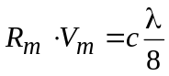 (4-9)
where:
Rm : radar unambiguous range (maximum range the radar can make a measurement)
Vm : radar unambiguous velocity (maximum velocity the radar can measure)
c : speed of light (3 × 108 m/s)
λ : radar signal wavelength.
The wavelength of the signal, set by the radar frequency, is the only parameter at the discretion of the radar designer in order to maximize the maximum range and maximum velocity measurement of the radar. A reduction in wavelength requires a reduction in the effective range, effective velocity measurement capability, or a combination of both by the same magnitude as the increase in frequency.
Other discrete wavelengths used by meteorological radars are selected from radio frequency bands generally used for surveillance radars. Wavelengths may differ slightly from one country to another. Detailed information regarding various radar system parameters and operational frequencies can be found in Recommendation ITU- R M.1464.
TABLE 4-1
Typical Radar system parameters
TABLE 4-1 (end)

4.3 Vulnerabilities of radars
A weather radar determines range to targets (weather) by measuring the time required for an emitted signal to travel from its transmitter to the target and return to the radar site. The travel time is a function of path length, and the accuracy with which it can be measured is critically dependent on the pulse rise- and fall-times (in the case of a pulsed radar.) The leading or trailing edge of a pulse is the marker by which arrival time of a returned pulse is measured, and the shorter it is, the greater the possible precision of the measurement.
The preservation of short pulse transition times requires phase linearity in the transmitter and receiver hardware over a relatively broad band. Required bandwidth is roughly proportional to the shorter of the two pulse transition times, and attempts to reduce the bandwidth of the emitted signal
(by additional filtering, etc.) below the necessary value degrade system accuracy. The necessary bandwidth often surprises those not familiar with radar systems. Received interference within the radar’s necessary bandwidth also degrades performance.
It must also be borne in mind that while most radiocommunication transmissions involve a single traversal of a path between antennas having known characteristics, a radar signal must cover the path twice with an intervening reflection from objects (raindrops, hailstones, wind-borne debris) not designed for that purpose. The resulting received signals are extremely weak. Despite frequently large transmitter powers and highly sensitive receivers, weather radars are extremely vulnerable to noise and interference.

4.3.1 Types of possible interference
A meteorological radars ability to accurately depict the current status of atmospheric conditions can be degraded by various forms of interference which can limit, or in the worst case nullify, the radars ability to detect the speed and direction of the wind at various altitudes, locate and track hurricanes, typhoons, tornadoes, gales, and other storm-related phenomena. Due to the sensitivity of the radars, interfering signals have the potential to significantly reduce the weather radar performance As such, it is important to identify the types of interference that can degrade the radars operational capabilities. Continuous, time varying and pulse like intrusive signals are the primary types of interference that are experienced by meteorological radars. Once these forms of interference have been identified, one can then establish the maximum interference level that meteorological radar systems can withstand before their forecasting capability is compromised. (Radar protection criteria levels for Meteorological Radars can be found in Recommendation ITU-R M.1464-1, Annex 3.)

4.3.2 Impact of continuous interference

4.3.2.1 Geographical Coverage
Continuous interference can decrease the range of the radar resulting in limiting the geographical area of coverage. Current coverage of meteorological radars roughly extends up to 200 km Table 4-2 summarizes the losses in range and coverage as interference (noise) increases.
Table 4-2
Loss in range and coverage
Noise increase  (dB) | Corresponding I/N (dB) | Loss in coverage (km) | Loss in coverage  (% relative to surface)
0.5 | –10 | 11 | 11%
1 | –6 | 22 | 21%
2 | –2.3 | 42 | 38%
3 | 0 | 59 | 50%
4 | 1.8 | 75 | 61%
5 | 3.3 | 88 | 69%
6 | 4.7 | 100 | 75%
7 | 6 | 111 | 80%
8 | 7.3 | 121 | 84%
9 | 8.4 | 130 | 88%
10 | 9.5 | 137 | 90%

4.3.2.2 Rain Rate
Continuous interference also creates an increase of the energy received by the radar that can impact the reflectivity measurement that is associated with various types of precipitation. (e.g. rain, snow and hail) Table 4-4 summarizes the percentage increase for several precipitation events as interference (noise) increases.
Table 4-4
Noise increase (dB) | Corresponding I/N (dB) | Stratoform Rate increase (%) | Convection rate increase  (%) | Snow rate increase  (%) | Hail rate increase  (%)
0.5 | –10 | 7.5 | 8.0 | 5.9 | 9.3
1 | –6 | 15.5 | 16.6 | 12.2 | 19.5
2 | –2.3 | 33.4 | 35.9 | 25.9 | 42.9
3 | 0 | 54.0 | 58.5 | 41.3 | 70.8
4 | 1.8 | 77.8 | 84.8 | 58.5 | 104.2
5 | 3.3 | 105.4 | 115.4 | 77.8 | 144.1
6 | 4.7 | 137.1 | 151.2 | 99.5 | 191.8
7 | 6 | 173.8 | 192.9 | 123.9 | 248.8
8 | 7.3 | 216.2 | 241.5 | 151.2 | 317
9 | 8.4 | 265.2 | 298.1 | 181.8 | 398.5
10 | 9.5 | 321.7 | 364.2 | 216.2 | 495.9

It is worth noting that an increase in interference would not modify the radars ability to detect rain cells (i.e. a measurement not considered as a rain cell will still not be considered as such) but would only have an impact on the rain rate.
It is also interesting to note that either for the loss in coverage or the rain rate overestimation, the current agreed protection criteria of –10 dB or –6 dB represents radar performance degradation in the range of 7 to 20%. (Performance degradation percentages of this magnitude have been generally agreed upon for all radiocommunication services.)

4.3.2.3 Wind Measurement
In the case of Doppler measurements, the assessment of the impact of a given constant interference is somehow different and would in particular depend on how the phase of the interfering signal could modify the phase of the wanted signal impacting the derived wind measurement.
This latter assumption is certainly not trivial to determine and will be signal and/or environmentally dependent. However, it is proposed to consider the different situations on a theoretical basis:

- Case 1: If the phase of the interfering signal detected by the radar is random, it means that the resulting vector would be statistically null; whatever would be its level. Hence, it would theoretically not have any impact on the wind measurements.
– Case 2: On the contrary, if the detected phase is not random and almost constant, it would result in a constant vector with a certain module and the impact on the wind measurement will depend on both the phase and module of such vector. However, the determination of such impact, even for a constant interference level is likely not to be easy and is hence not made at this point.
In addition, one can also assume that when the level of interference is much lower than the wanted signal, the phase of this latter is not modified whereas, on the contrary, if the interfering signal is much higher, then the phase detected by the radar will be the phase of the interfering signal. In this latter situation, the discussion on Cases 1 and 2 above will remain. In between these two situations, i.e. when the levels of both the interfering and wanted signals are consistent, it seems quite difficult to assess which of the signal will control the phase detection.
4.3.3
4.3.2.4 Impact of pulsed interference
Pulsed interference can have a significant impact on the reflectivity data that a meteorologist uses to forecast severe weather events. In some cases pulsed interference could result in a returned data that cannot reliably produce an image of targets in the atmosphere. An example of this can be seen in figure 4-2.
Figure 4-2
Comparison of Interference Free versus Interference Corrupted Meteorological Radar Scan.
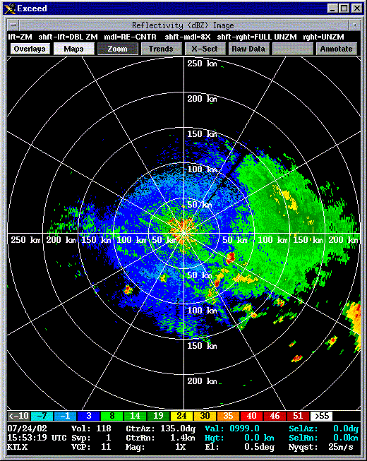
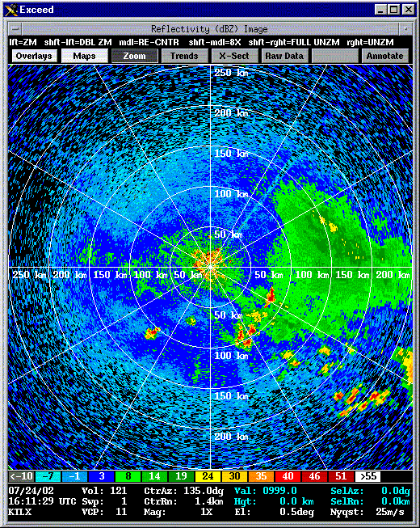
Interference Free
Interference Corrupted

    - Interference From Wind Farms
In recent years, increasingly larger wind turbines are being constructed due in part to generator efficiencies, desire to tap stronger, higher-level wind fields, generator efficiencies, etc. Of course, the economic incentive is the main driving force and careful analysis has provided the impetus for larger wind turbine designs. A typical turbine structure consists of a tower, nacelle, rotor, and three blades. A typical generation facility, or wind farm, is made up many wind turbine generators. Wind turbines and farms, even a quite large distances, present a high potential to degrade meteorological data over very large areas and could have a non-negligible impact on weather nowcasting and forecasts

For accurate weather forecasting, weather radars are designed to look at a relatively narrow altitude band. Due to the sensitivity of the radars, wind turbines, if deployed with line of site of a weather radar facility, have the potential to significantly reduce the weather radar performance. There are three mechanisms through which the performance can be degraded; masking, clutter and backscatter.

      - Masking

Any geographical feature or structure which lies between the radar and the target will cause a shadowing or masking effect. It is possible that, depending on their size, wind turbines may cause shadowing effects. Such effects may be expected to vary, depending upon the turbine dimensions, the type of transmitting radar and the aspect of the turbine relative to it.

4.3.4.2 Clutter

Radar returns may be received from any radar-reflective surface. In certain geographical areas, or under particular meteorological conditions, radar performance may be adversely affected by unwanted returns, which may mask those of interest. Such unwanted returns are known as radar clutter. For an weather forecaster, a wind turbine or turbines in the vicinity of weather radar can present operational problems

Ground clutter signals exhibit large reflectivity, near-zero Doppler shift, small spectrum width, and are consistently localized. Compared to commonly occurring ground clutter (GC), interference caused by wind turbines is a much more difficult challenge. Direct reflections will be received from both the tower (stationary) and the blades (non-stationary). Like GC, the Wind Turbine Clutter (WTC) signal should still have a significantly large reflectivity, with a possible modulation due to blade rotation causing a systematic variation in radar cross-section.
The Doppler shift will be affected by several factors, including the blade rotation speed and rotor orientation with respect to the radar beam. Doppler velocities should be maximum when the rotor is oriented 90° from the radar line-of-sight and near zero when the rotor is facing either away or toward the radar. Since the resolution volume of the radar will likely encompass the entire wind turbine structure, it is expected that the spectrum width will be significantly enlarged.
This is due to the blade rotation away and toward the radar. Multiple turbines within one resolution volume would only exacerbate this effect.

      - Backscattered Energy from Turbulent Eddies

In addition to WTC signals caused by reflections from the actual wind turbines, backscattered energy from turbulent eddies in the wake of the wind farm may be observed. It is expected that these echoes would exhibit characteristics similar to clear-air backscatter from discontinuities in the refractive index at the Bragg scale of the radar. These wake echoes would drift with the wind field and would likely have much lower reflectivity compared to the direct reflections from the turbines. Nevertheless, they could significantly enlarge the radar coverage area affected by WTC and thus exacerbate the problem.

      - Examples of Wind Turbine Clutter

Two distinct examples of interference from Wind Farms are provided in Figure 4-3. As expected, the reflectivity shows large values near 45 dBz with sporadically large spectrum widths of over 10 m/s. The relatively small region of high reflectivity to the south-west of the radar is clearly visible and matches the location of a wind farm that is approximately 45 km from the weather radars location.
Figure 4-3
Examples of Wind Farm interference to weather radar under clear conditions. The images show the reflectivity (left), radial velocity (center), and the spectrum width (right).

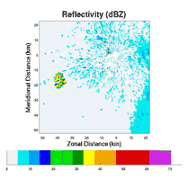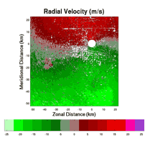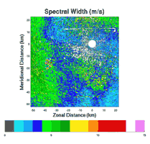

Figure 4-4 shows the same wind farm during a thunderstorm event.
Figure 4-4
Example of interference from a Wind Farm and its impact upon reflectivity during an isolated thunderstorm incident

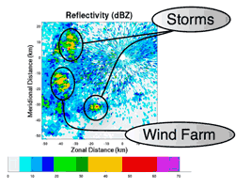

Without prior knowledge, it would be extremely difficult to distinguish between the WTC and the thunderstorms. Since the blades rotate toward and away from the radar, one would expect a near-zero mean Doppler velocity. Of course, the large spectrum widths will reduce the accuracy of the Doppler velocity estimates as illustrated in Figure 4-5 by small deviations from zero.
Figure 4-5
Example of Doppler velocity data estimates during a thunderstorm event.
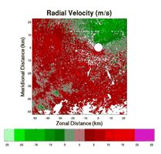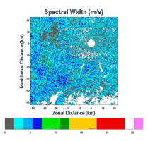

      - Impact of WTC on Meteorological Radar Operations and Forecasting Accuracy

Some field studies that illustrate the impact of WTC upon meteorological radars have been done by other organizations. These studies have shown that wind turbine farms can have a significant effect upon meteorological radars and as such can degrade the accuracy of detecting severe weather events.
These analyses have clearly shown that the clutter produced by a wind turbine will be present over a large sector (several tens of degrees) compared to the direction of the wind turbine, even at quite large distances. Thus the impact of the wind turbines on reflectivity operation of weather radars cannot be neglected.
The analysis have also shown that the impact of the wind turbines on a Meteorological Radars Doppler mode is very significant. In particular at distances lower than 10 km where, within the given sector or sectors in which the wind farm resides, all data within the range of azimuths that cover those sectors will be erroneous.
Some form of WTC mitigation will be required in order to protect meteorological radars from harmful interference from wind turbine farms. The effect of wind turbines on meteorological radar data is still under study.

4.3.5 Vulnerabilities of systems sharing spectrum with radars
As noted above, the transmitter power and antenna gain of weather radars are typically quite high to compensate for extended path lengths. These characteristics tend to extend the range over which a radar can interfere systems on the same frequency(with due recognition given to the width of a radar channel). There have also been cases in which radar and fixed microwave links, which have co-existed for some time, become incompatible when the microwave system is upgraded from analogue to digital equipment with a greater vulnerability to pulsed interference.

4.4 Wind profiler radars
Wind Profiler Radar’s are used to obtain the vertical profiles of the wind over an unattended and sometimes remote area by detecting the tiny fraction of emitted power backscattered from turbulence in the clear atmosphere. (Figure 4-6 is a photograph of a typical Wind Profile Radar installation.)
One of the major advantages of wind profilers to other wind measurement systems is their ability to continuously monitor the wind field. In addition, they can also be used to detect precipitation, measure major disturbances in the vertical velocity field (gravity waves and convective updrafts), measure the intensity turbulence and measure atmospheric stability. They can also provide detailed information on atmospheric virtual temperature through the addition of a Radio Acoustic Sounding System (RASS).

Figure 4-6
Photo of wind profiler installation
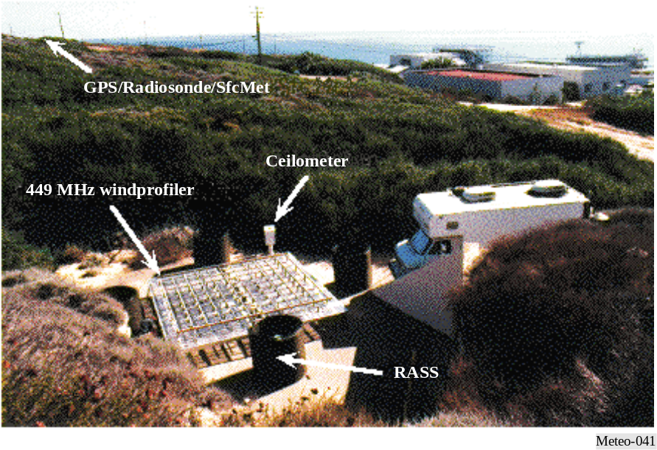
.

4.4.1 User requirements

A good way to examine the impact of user requirements upon wind profiler operating parameters and design is to consider the following equation rewritten from [Gossard and Strauch, 1983]:
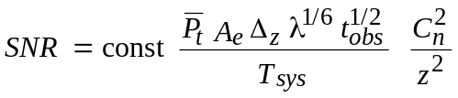 (4-12)
where:
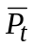: average transmitted power, watts
Ae : effective aperture, degrees
Δz : height resolution, metres
z : height, metres
λ : wavelength, metres
tobs : observation (averaging) time, seconds
Tsys : system noise temperature, degrees Kelvin
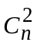: structure parameter, dimensionless
In this equation, the structure parameter is independent of frequency but a strong function of height. Nearly all the frequency dependence is contained in the wavelength factor, but the system noise temperature of a well-designed radar receiver includes a significant contribution from cosmic noise at low frequencies. This equation is also valid only in the inertial sub-range of atmospheric turbulence, effectively limiting the choice of wind profiler radar wavelengths to the range of about 10-0.2 m (30 to 1 500 MHz). Note that turbulence is rapidly dissipated as heat by viscosity outside the inertial sub-range, and at short wavelengths.
A user requirement for high temporal resolution diminishes signal-to-noise ratio by reducing the averaging time. The requirement may be satisfied by selecting some combination of:
– large aperture;
– high peak power and high pulse repetition frequency (PRF) to increase average power;
– long wavelength; and
– operation over a range of heights close to the radar where high PRF does not cause range ambiguity⁷ problems and where atmospheric backscattering and inverse-height-squared are relatively large.
A user requirement for high vertical resolution diminishes signal-to-noise ratio by requiring short pulses and so reducing mean power. High vertical resolution requires large bandwidth. This requirement may be satisfied by selecting some combination of:
– large aperture;
– high peak power, high PRF, and pulse compression to increase the average power;
– long wavelength; and
– operation over a range of heights close to the radar where high PRF does not cause range ambiguity problems and where atmospheric backscattering and inverse-height-squared are relatively large.
Note that using pulse compression (to increase pulse length) means that the lowest range gate must be increased in height.
A user requirement for obtaining wind data at high altitudes diminishes signal-to-noise ratio by decreasing the inverse-squared-height and, while not obvious in the equation, by the decrease with height of the structure parameter and the compression of the inertial sub-range from the short wavelength (high frequency) end with increasing height. This requirement may be satisfied by selecting some combination of:
– large aperture;
– high peak power and pulse compression to increase the average power;
– long wavelength; and
– large averaging times.
Other, and more practical, considerations will be discussed in § 4.3.2.
The user requirement for reliable all-weather operation requires an adequate signal-to-noise ratio also when low scattering conditions exist in the atmosphere. Typical situations are wintertime low humidity periods and cases of low turbulence, i.e. in cases of jet streams in the 10-15 km altitudes. The requirement can be satisfied by suitable selection of:
– frequency band;
– high average power and antenna aperture;
– higher receiver sensitivity; and
– low level of interference and system noise.

4.4.2 Operational and frequency aspects

Large antenna aperture and high average emitted power are expensive. The cost of the antenna and power amplifier of a wind profiler radar often constitutes more than half the total cost of an installed system. Hence, technology developments in these areas are not attractive options for improving performance.
In the case of antenna aperture, however, there is another factor to consider which establishes a minimum size. Multi-beam profilers operate by successively swinging the main beam to two or four orthogonal azimuths at elevation angles of about 75° and often to the vertical to acquire data. The
antenna beamwidth must be narrow enough to delineate the two, four or five beam positions. 3 dB full-width beamwidths of 5° to 10° are usable and correspond to antenna gains of 33 dBi to 27 dBi, respectively. Gain determines the effective aperture through the equation (4-10):
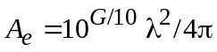 (4-10)
Because of interference and congestion in the radio-frequency spectrum and its consequent regulation, wind profiler radar frequencies cannot be freely chosen. Some demanding applications, such as the MU radar in Japan and those at the Eastern and Western Launch Ranges in the United States of America, have resulted in the use of very large (about 10 000 m2), powerful (250 kW or more peak, 12.5 kW or more average), short pulse (1 μs) radars operating near 50 MHz. Researchers have also operated other profilers on a non-interference basis at frequencies between 40 and 70 MHz.

Resolution 217 (WRC-97) states:
“... to urge administrations to implement wind profiler radars as radiolocation service systems in the following bands, having due regard to the potential for incompatibility with other services and assignments to stations in these services, thereby taking due account of the principle of geographical separation, in particular with regard to neighbouring countries, and keeping in mind the category of service of each of these services:
– 46-68 MHz in accordance with No. 5.162A
– 440-450 MHz
– 470-494 MHz in accordance with No. 5.291A
– 904-928 MHz in Region 2 only
– 1 270-1 295 MHz
– 1 300-1 375 MHz;”
“... that, in case compatibility between wind profiler radars and other radio applications operating in the band 440-450 MHz or 470-494 MHz cannot be achieved, the bands 420-435 MHz or 438-440 MHz could be considered for use;” and
“... to urge administrations not to implement wind profiler radars in the band 400.15-406 MHz”.

Profilers operating in the range of 400-500 MHz have been designed to:
– measure wind profiles from about 0.5-16 km above the radar with vertical resolutions of 250 m at low altitudes and 1 000 m at high altitudes using antennas with about 32 dBi gain;
– mean powers of about 500 W and 2 000 W when probing low and high altitudes, respectively;
– while operating with necessary bandwidths of less than 2 MHz.

Adding a third, very low altitude, mode would permit lowering the lowest range gate from 0.5 km to 0.25 km and possibly reducing the vertical resolution to 150 m or 200 m while remaining within a 2 MHz necessary bandwidth.

Increasing the operational frequency of a Wind Profile Radar provides a higher degree of measurement resolution at the cost of lowering the overall height measurements. As such, profilers operating at 915 MHz and above are typically regarded as boundary layer profilers, capable of measuring the wind profile in only the lowest few kilometres of the atmosphere. These perform with vertical resolution of about 100 m using antennas with gains below 30 dBi and mean powers of about 50 W while operating with necessary bandwidths of 8 MHz or more.

4.4.3 Present and future spectrum requirements
Wind profilers are ground-based systems with antenna heights of one or two metres and vertically directed beams. Geographical separation and terrain shielding are effective protection against interference to and from other profilers. Hence, an affordable network of wind profilers, say separated by at least 50 km over level terrain – less over more rugged or treed terrain – could operate on the same frequency. For the same reasons, profilers tend to be compatible with most ground-based services. Resolution 217 (WRC-97) provides an adequate selection of radio-frequency spectrum, 2 MHz or 3 MHz of bandwidth are required near 400 MHz, 8 MHz or 10 MHz near 1 000 MHz.

4.4.4 Sharing aspects of wind profilers
The bands for profiler use allocated by WRC-97 were carefully selected to minimize the likelihood of interference to and from other users of these bands. Before the identification of bands for wind profiler radars an experimental network was developed in the band 400.15-406 MHz. Operational experience showed operation of wind profiler radars in 400.15-106 MHz caused interference to COSPAS-SARSAT. As a result, ITU Resolution 217 specifically states that wind profiler radars should not be operated in 400.15-406 MHz. The existence of this experimental network did provide considerable information on wind profiler radar compatibility with other services. The e.i.r.p. spectral density of these WPRs in the horizontal direction is about:

– –18 dB(W/kHz) at the centre frequency (449 MHz)
– –36 dB(W/kHz) 0.5 MHz away
– –55 dB(W/kHz) 1 MHz away
– –70 dB(W/kHz) 2 MHz away
– –79 dB(W/kHz) 4 MHz away.
These low values, when combined with low antenna heights and path losses proportional to 1/r4 for propagation over the surface of the Earth, result in making geographical separation a very effective sharing tool. For example, an amateur mobile radio, tuned to the centre frequency of the radar has been able to detect an audible WPR signal out to 3 km over a grassy plain.
However, in the main beam, the e.i.r.p. spectral density is 57 dB greater and, as a consequence, airborne and satellite-based receivers are subjected to a much higher level of interference. Path losses proportional to 1/r2 compound the problem. Subsequent efforts to alleviate the problem with the wind profilers in the band 400.15 – 406 MHz showed that the modulation used by 404 MHz WPRs has a significant impact upon their sharing characteristics. Currently, the pulses are phase-coded to distinguish the two or three “chips” within each pulse so as to effect pulse compression. Were no further coding done, the emitted spectrum would consist of lines separated by the PRF. However, one member of a 64-long pseudo-random phase code sequence was imposed on each pulse in succession so that the spectral lines appear at intervals of PRF/64 with line powers reduced by a factor of 64. In addition, the profiler transmitters were turned off under computer control whenever a Cospas-Sarsat satellite appeared more than 41° above the profiler’s horizon. (There being only a few of these satellites, this results in a negligible loss of profiler data.)
The phase coding applied to 404 MHz profiler emissions must be “undone” in the receiver. As a result, interference from other, non-WPR systems appears incoherent and noise-like to the profiler. Hence, the minimum detectable (profiler) signal is about –170 dBm, while interference is troublesome only at levels of –135 dBm or more.
ITU Resolution 217(WRC-97) identifies spectrum to be used for WPRs. The use of other bands, e.g. 400.15- 406 MHz for WPR is not recommended. The same techniques used to ameliorate interference to satellites in this band are, however, applicable in other bands as well.

An example mobile profiling system operating at 924 MHz produced the plot of wind velocity vs. altitude (see Fig. 4-7). The orientation of each flag represents wind direction as a function of altitude (vertical axis) and time (horizontal axis), while its colour represents wind speed.
Figure 4-7
Wind velocity vs. altitude
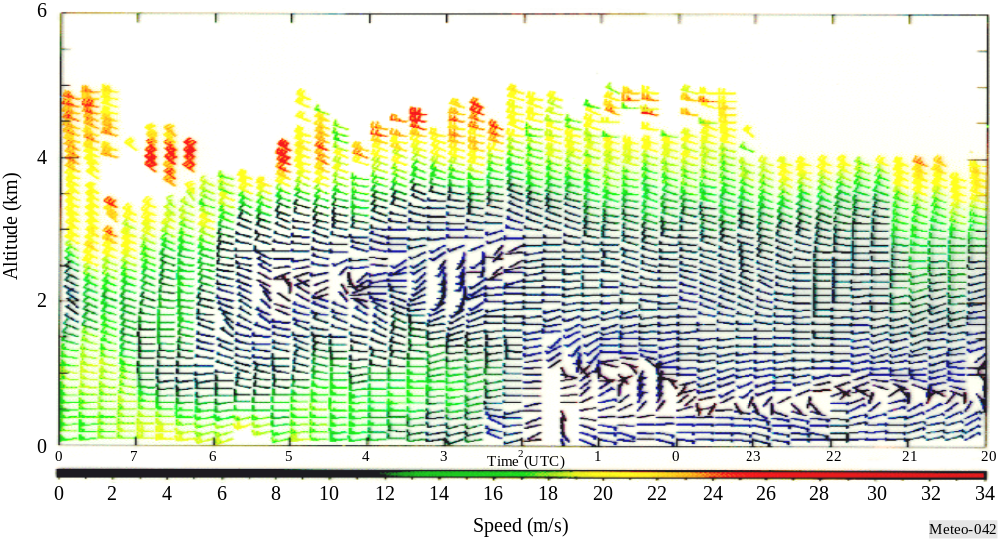

4.4.5 An Example of a Wind Profiler Network
The Japan Meteorological Agency (JMA) is operating a Wind Profiler Network and Data Acquisition System (WINDAS) network for the purpose of monitoring the development of and predicting severe weather events. The network consists of thirty-one 1.3GHz wind profilers installed across Japan that communicate with a control center which is located at the JMA headquarters in Tokyo (Figure 4-8).
Figure 4-8
An Example of a Wind Profiler Radar Network

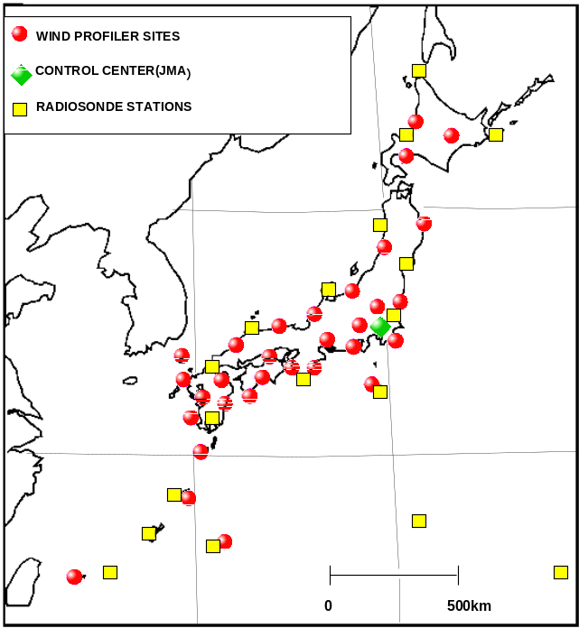

The data from this system has been used as initial values in all the JMA Numerical Weather Prediction models since June of 2001. to aid in the prediction of sever weather events. The data is combined with data from
Doppler radars and commercial aircraft to provide a comprehensive “Upper-air wind analysis”. This analysis is then distributed throughout the world, via the Global Telecommunication System and can also be found on the JMA Web site (http://www.jma.go.jp/jp/windpro/).

. Characteristcs of wind profilers of WINDAS.
Basic data

.

References

GOSSARD, E. E. and STRAUCH, R. G. [1983] Radar Observation of Clear Air and Clouds, Elsevier, New York, United States of America, 280 pages.
“Doppler Weather Radar”, R. Doviak, D. Zrnic, D. Sirmans, Proceedings of the IEEE, Vol. 67,
No. 11, November 1979.
ITU-R M.1464-1 ”Characteristics of radiolocation radars, and characteristics and protection criteria for sharing studies for aeronautical Radionavigation and meteorological radars in the Radiodetermination service operating in the frequency band 2 700-2 900 MHz.”, 2002.
“Mitigation of Wind Turbine Clutter on the WSD88D Network”, Robert Palmer and Brad Isom, School of Meteorology. University of Oklahoma, Radar Operations Center Presentation, February 2006.

McLaughlin, D. J., V. Chandrasekar, K. Droegemeier, S. Frasier, J. Kurose, F. Junyent, B. Philips, S. Cruz-Pol, and J. Colom, 2005: Distributed Collaborative Adaptive Sensing (DCAS) for Improved Detection, Understanding, and Prediction of Atmospheric Hazards. Ninth Symposium on Integrated Observing and Assimilation Systems for the Atmosphere, Oceans, and Land Surface (IOAS-AOLS), American Meteor. Society, Jan.,2005.

Intercomparison of Techniques to Correct for Attenuation of C-Band Weather Radar Signals; Journal of Applied Meteorology: Vol. 37, No. 8, pp. 845–853.

Bibliography

COST Action 76 [March 2000] Development of VHF/UHF wind profilers and vertical sounders for use in European observing systems, Final Report, edited by: J. Dibbern, W. Monna, J. Nash and G. Peters, European Commission, Directorate-General Science, Research and Development.
DOVIAK, R. J. and ZRNIC, D. S. [1993] Doppler radar and weather observations, Academic Press, Inc., San Diego, United States of America.
LAW, D. et. al. [March 1994] Measurements of Wind Profiler EMC Characteristics, NTIA Report 93-301, 63 pages. National Telecommunications and Information Administration.
MAMMEN, T. [1998] Weather radars used by members, WMO instruments and observing methods, Report No. 69.
SESSIONS, W. B. [December 1995] SARSAT SARP instrument performance when receiving emissions from NOAA 404 MHz wind profiler radars, NOAA, NESDIS, E/SP3, 87 pages.
SKOLNIK, M. [1990] Radar Handbook, Second Edition, McGraw-Hill, Inc., New York, United States of America.
WMO [1996] WMO Guide to meteorological instruments and methods of observation, No. 8, World Meteorological Organization.

This is the velocity of the precipitation either toward or away from the radar (in a radial direction). No information about the strength of the precipitation is given. Precipitation moving toward the radar has negative velocity Precipitation moving away from the radar has positive velocity .Precipitation moving perpendicular to the radar beam (in a circle around the radar) will have a radial velocity of zero. The velocity is given in knots.
An Engineering Research Center for the Collaborative Adaptive Sensing of the Atmosphere (CASA) was formed in the fall of 2003 by the National Science Foundation for the purpose of developing a dense network of small, low-cost, low-power radars that could collaboratively and adaptively sense the lower atmosphere (0-3 km AGL).
The Ka band (K-above band) is a portion of the K band of the microwave band of the electromagnetic spectrum, the Ka band roughly ranges from 18 to 40 GHz.
The S band ranges from 2.0 to 4.0 GHz., crossing the imaginary boundary between UHF and SHF at 3.0 GHz. It is part of the microwave band of the electromagnetic spectrum. The S band is used by weather radar and some communications satellites.
The C band ("compromise" band) is a portion of the electromagnetic spectrum in the microwave range of frequencies, ranging from 4 to 8 GHz. It is primarily used for satellite communications.
The X band, ranging from 8 to 12.5 GHz is part of the microwave band of the electromagnetic spectrum. The X band is used by some communications satellites and for longer-range ground and weather mapping.
The maximum unambiguous range is the longest range to which a transmitted pulse can travel and return to the radar before the next pulse is transmitted. In other words, the maximum unambiguous range is the maximum distance that radar energy can travel round trip between pulses and still produce reliable information.
Recommendation ITU-R M.1464-1 “Characteristics of radiolocation radars, and characteristics and protection criteria for sharing studies for aeronautical radionavigation and meteorological radars in the radiodetermination service operating in the frequency band 2 700-2 900 MHz” Annex 3
Wind Farms are clusters of wind turbines that are used to generate power.
“Mitigation of Wind Turbine Clutter on the WSD88D Network”, Robert Palmer and Brad Isom, School of Meteorology. University of Oklahoma, Radar Operations Center Presentation, February 2006.
CBS/SG-RFC 2006/Doc. 3.1(6) “Impact of Wind turbines on weather radars band”, P. Tristant, March 2006
RASS utilizes an acoustic source that is matched in frequency so that the wavelength of the acoustic wave is matched to half the wavelength of the radar transmitted electromagnetic wave. RASS measures the speed of the acoustic wave which is dependent upon temperature. In this way RASS provides a remote measurement of the atmospheric virtual temperature.

