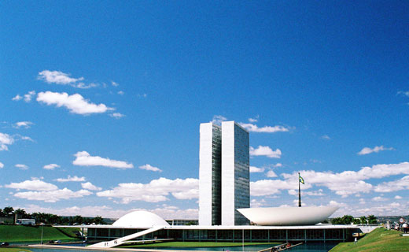

BRASILIA – BRAZIL

General Information about Brasilia

 BRIEF HISTORY
Brasilia was constructed between 1956 and 1960, during the government of President Juscelino Kubitschek. It was inaugurated, as Brazil's new capital, in April 21, 1960. Its master plan ("Plano Piloto") was conceived by Lucio Costa, and its major buildings were designed by Architect Oscar Niemeyer.
Planned for only 500,000 inhabitants, Brasilia has seen its population grow much more than expected. Several satellite towns have been created over the years to house the extra inhabitants. Brasilia's total population (including the satellite cities) is around 2.500.000 inhabitants.
TIME ZONE
Brasília's time is 3 (three) hours earlier than Greenwich Mean Time (England); one hour later than New York when both cities are on their respective standard times. From October through February Brasilia is one hour delayed due to the summertime.

AIRPORT
Brasília's international airport is located on the South part of the city that has an excellent access to Brasilia's Down Town zone where most of the major hotels are located. An efficient taxi service links the international airport with the main hotels. The price of special taxis from International airport to Hotel area (Setor Hoteleiro Sul) is around US$ 18.00.

BUSINESS HOURS
Most offices are open from 8:00 a.m. to 6:00 p.m. Monday through Friday. Stores are open from 9:00 a.m. to 7:00 p.m. Monday through Friday and from 9:00 a.m. to 1:00 p.m. on Saturdays. Most large shopping centers such as Parkshopping, Conjunto Nacional, Brasília Shopping and Patio Brasil Shopping open Monday through Saturday from 10:00 a.m. to 10:00 p.m. Brasília has a number of 24-hour convenience stores, many of which are located in or close to the main gas stations. Banks are open Monday through Friday from 09:00 a.m. to 02:00 p.m.

CLIMATE
Brasília has basically only two seasons: the dry season (May to September) and the rainy season (October to April). In the dry season, the temperatures range from 22ºC to 28ºC during the day and 11ºC to 17ºC at night. In this period, the humidity is low, reaching 11%. The temperature in the rainy season ranges from 25ºC to 30ºC in the day and 19ºC to 23ºC in the night.

Climatological Information
Month | Mean Temperature ºC |  | Mean Total Rainfall (mm) | Mean Number of Rain Days
Month | Daily Minimum | DailyMaximum | Mean Total Rainfall (mm) | Mean Number of Rain Days
July | 12.9 | 25.1 | 11.8 | 3

COMMUNICATIONS
Brasilia has an excellent telecommunications system that links Brasilia to the rest of Brazil and the world. Direct dial and collect calls can be placed from any telephone. Pay phones are located throughout the city and operate with telephone cards. Portable cellular telephones are available to visitors for a small rental charge. The International Direct Dial (IDD) code for Brazil is 55 and the city code for Brasilia 61. To place a domestic call, dial 0+operator+area code+phone number. To place an international call, dial 00+operator+country code+area code + phone number. For instance, operator can be 21 (EMBRATEL).

ELECTRIC CURRENT
The electric current in Brasilia is 220 volts, 60 Hz. Many hotels have 110 volt outlets.

FOREIGN EXCHANGE
The Brazilian monetary unit is the Real (R$ or BRL). The exchange rate available to visitors is published daily in the newspaper along with the commercial dollar rate of the day used in official international business transactions. Cash and traveler checks, especially US Dollars, can be exchanged at most banks or exchange houses as well as the major hotels. All major credit cards are accepted in Brazil and some stores even accept foreign currency. For information, the exchange rate at April 2nd is 1 USD = 1.74 BRL or 1 EURO = 2.68 BRL.

REAL NOTES (R$):

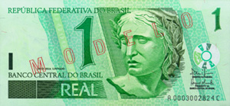 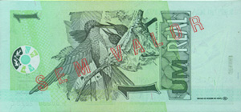 ONE REAL
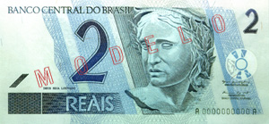 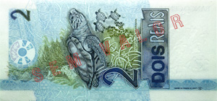 TWO REAIS
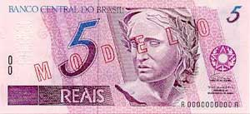 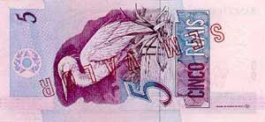 FIVE REAIS
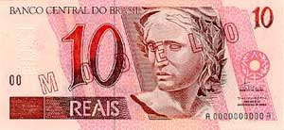 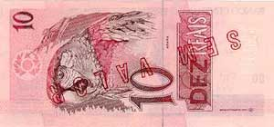 TEN REAIS
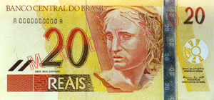 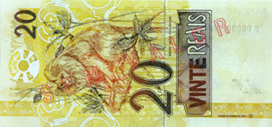 TWENTY REAIS
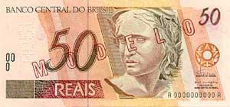 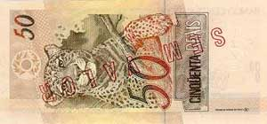 FIFTY REAIS
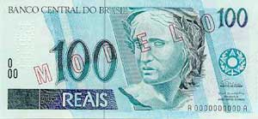 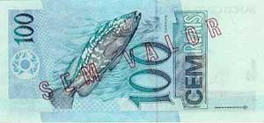 HUNDRED REAIS

COINS (note: the sizes are not in scale)

 | 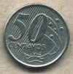 | 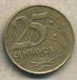 |  | 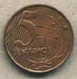
ONE REAL | 50 CENTS | 25 CENTS | 10 CENTS | 5 CENTS

LANGUAGE
The language spoken in Brazil is Portuguese. English is the predominant foreign language taught in schools, and Spanish, if spoken slowly, is understood by a good percentage of the population.

TIPPING
Hotels: hotels generally include any service charge on the bill. Restaurants: tips are discretionary but are often found on the final bills as a "suggestion". In Brazil the norm remains 10 per cent. Taxis: taxi drivers do not expect tips, although most passengers will round the fare up if satisfied with the service. Airport and hotel porters: the Real equivalent to U$1.00 per suitcase.

VISA REQUIREMENTS
As the Brazilian Foreign Office bases its actions on reciprocity, visitors from some foreign countries will require a visa that is usually processed within two working days by applying to the nearest Brazilian Embassy or Consulate. Requirements for a tourist visa include a passport valid for at least six months from the date of arrival, one passport size photograph and a round trip ticket. Most international airlines can advise on visa requirements for tourists. The Brazilian Foreign Office provides NO VISAS at airport.

OTHER GENERAL INFORMATION:
- TV channels: 6 (plus cable TV - Net and TV FILME);
- Major local newspapers: 2 ("Correio Braziliense" and "Jornal de Brasilia");
- Car speed limit: from 40 to 80 km/h depending on the street. Electronic speed control devices have been installed in many streets;
- Measure system: only the metric system is used;
- Car parking: free almost everywhere. However, the "guardadores" (poor, unemployed people) may ask you if they can guard you car. They would expect to receive around 25c to $ 1 no matter how much time you stay;
- Security: at daylight a person can walk almost anywhere in Pilot Plan with no concerns. Of course, you are not supposed to walk alone in empty areas with lot of jewelry and showing to everybody that you have an expensive camera;
- Public restrooms: they are very difficult to find;
- Subway: a subway system is operating from 06:00 a.m. to 20:00 p.m. Monday to Friday. It runs partly underground (including 7 km under Pilot Plan) and partly on surface (the connections to satellite cities).

HOTELS | PRICE | PHONE | HOME PAGE
HOTEL DAS AMÉRICAS | $$ | (61) 3034.3355 | http://www.hoteldasamericas.com.br
HOTEL ALVORADA | $$ | (61) 2195 1122 | http://www.alvoradahotel.com.br
ST. PAUL PARK HOTEL | $$ | (61) 2102-8400  (61) 2102-8456 | http://www.hotelstpaul.com.br
SAN MARCO | $$ | 0800- 618484  Toll Free | http://www.sanmarco.com.br
CARLTON HOTEL | $$ | (61) 3224-8819 | http://www.carltonhotel.com.br
NAOUM PLAZA | $$$ | (61) 3322 4545 | http://www.naoumplaza.com.br
GRAND BITTAR | $$$$ | (61) 3704-5000 | http://www.hoteisbittar.com.br
BONAPARTE BLUEPOINT SUÍTES | $$$$$ | (61) 2104-6600 | http://www.bonapartehotel.com.br/
MELIÁ TRIP PARK | $$$$$ | (61) 3218-4700  0800 -703-3399  Toll Free | http://www.solmelia.com

PRICE REFERENCE
US$ 80.00 - 100.00 | $$
US$ 110.00 -125.00 | $$$
US$ 130.00 – 145.00 | $$$$
US$ 150.00 | $$$$$

Restaurants in the city of Brasilia

Cousine | Name | Prices | Address | Where | Phone | Working Hours
Sea Food | Bargaço | $$$ | CLS 405 Bl. D L. 36 | Asa Sul | 3443-8098 | 12h/24h.
Arab | Lagash | $$$ | SCLN 308/309 bl. B lj. 11/13 | Asa Norte | 3273-0098 | 12h/16h, 19h/24h; Sun 12h/18h; closes on Mondays
Brazilian | O Convento | $$$ | SHIS QI 9 Conjunto 9 Casa 4 | Lago Sul | 3248-1211 | 12h/16h, 19h/24h; Sun 12h/18h; closes on Mondays
Barbecue | Porcão | $$$ | SCE/Sul, Trecho 2, Conj. 35 | Asa Sul | 3223-2002 | 12h/24h.
French | Le Bateau Ivre | $$$ | SHIS QI 23, cj. 8, casa 20 | Lago Sul | 3366-3153 | 20h/24h; Fri/Sat 12h/15h, 20h/24h; Sun 12h/16h; closes on Mondays
French | La Chaumiére | $$$ | CLS 408 bl. A, lj. 13 | Asa Sul | 3242-7599 | 12h/15h, 19h/24h; Sat 19h/24h; Sun 12h/15h; closes on Mondays
Italian | Villa Borghese | $$$ | CLS 201 bl. A, lj. 33 | Asa Sul | 3226-5650 | 12h/15h, 19h/24h; Sun 12h/17h; closes on Mondays
Japanese | Taiyo | $$$ | SHN Qd. 2, bl. A | Asa Norte | 3319-3536 | 19h/1h; closes on Sundays
Spanish | Salamanca | $$$ | CLS 112, bl. B, lj. 37 | Asa Sul | 3346-8212 | 12h/14h, 18h/24h; Sun 12h/17h; closes on Mondays
Portuguese | Mouraria | $$$ | CLS 404, bl.B, lj.35 | Asa Sul | 3224-6405 | 12h/16h, 19h/24h; Sun 11h30/17h
International | La Via Vecchia | $$$ | SHS Qd. 2, bl. I | Asa Sul | 3322-2288 | 12h/15h, 19h/24h; Sat 19h/1h; closes on Sundays
International | Piantella | $$$ | CLS 202, bl. A, lj.34 | Asa Sul | 3224-9408 | 12h/16h, 19h/2h; Sun 12h/17h.

Notes:
- In the column "prices": $$$ = 20 to 40 Dollars.
- In the column "obs", the "*" corresponds to the restaurants classified with 1 star in 'Guia Brasil' (which means "good cuisine"). The others (without "*") figure on the guide as "regular cuisine".
- We listed just some of the restaurants of 'Guia Brasil' - the first ones of each category - in the table above.

ADDRESS

INMET is located at:
Eixo Monumental - Via S1
Sudoeste
Brasília - DF
ZIP CODE: 70680-900

TELEPHONES

Wilson G. Sandoval
Chief of Telecommunication Services
Phone: +(55)(61) 3343-2003 ext. 206
Phone: +(55)(61) 9976-4285 (Wilson Sandoval)
Fax: +(55)(61) 3343-2132

José Mauro de Rezende
Coordinador for Communication Systems
Phone: +(55)(61) 3344-4488
Phone: +(55)(61) 9971-0342
Fax: +(55)(61) 3343-2132

MAP OF PLANO PILOTO (DOWN TOWN AREA)



