WORLD METEOROLOGICAL ORGANIZATION  _______________  REGIONAL ASSOCIATION V  (SOUTH-WEST PACIFIC)  WORKING GROUP ON PLANNING AND IMPLEMENTATION OF THE WWW IN REGION V  FIFTH SESSION  HONOLULU, HAWAII, USA, 7 -10 December 2009 |  | RA V/WG-PIW-5/Doc. 4.1 (30.XI.2009)  ____  ITEM 4.1  Original: ENGLISH

REGIONAL STRATEGIC PLANNING AND

FUTURE WORKING MECHANISM OF THE ASSOCIATION

(Submitted by the Secretariat)

Summary and purpose of document

This document provides information on the development of the Strategic Plan for the enhancement of NMHSs in RA V and proposed future working mechanism of the Association.

ACTION PROPOSED

The Working Group is invited to note the information given in this document and provide guidance on the implementation of RA V Strategic Plan; and to consider appropriate future working mechanism of the Association related to the WWW.

Reference: 1. Final Reports of sessions of the RA V Management Group

Appendices: A. Progress Report on the Development of the Strategic Plan for the Enhancement of National Meteorological and Hydrological Services (NMHSs) in Regional Association V (South-West Pacific)

B. Extract of the text related to the future working mechanism of the Association from the extra-ordinary and third sessions of the RA V Management Group

DEVELOPMENT OF THE STRATEGIC PLAN FOR THE ENHANCEMENT OF NATIONAL METEOROLOGICAL AND HYDROLOGICAL SERVICES (NMHSs) IN REGIONAL ASSOCIATION V (SOUTH-WEST PACIFIC)

1. The fourteenth session of Regional Association V (Adelaide, Australia, May 2006) attached the highest priorities to the following issues:

(a) Maintenance and further development of existing observing and telecommunications systems and data processing facilities;

(b) Natural disaster reduction, mitigation and prevention through the implementation of improved detection, prediction and warning systems of tropical cyclones, tsunamis, monsoons and other extreme events, including associated coastal inundations, flash floods and droughts;

(c) Enhancement of climate observation and monitoring as a regional component of GCOS, in support of research into climate variability and climate change, and its application, including regional climate prediction and advice for sustainability;

(d) Enhancement of environment monitoring, including air and water quality and the ocean;

(e) Development of effective public weather services to ensure better understanding and appreciation of the value of, and increased benefit from, weather and climate and related environmental information;

(f) Promoting and strengthening the principle of free and unrestricted international exchange of data and products among National Meteorological, Hydrological and related Services;

(g) Enhancement of capacity building, including human resources development, to bridge the gap between NMHSs of developing and developed countries and facilitating associated technical transfer through bilateral and multilateral arrangements;

(h) Enhancement of the collaboration and cooperation among all NMHSs in the Region and between regional centres, by exchange of information and knowledge and research studies on meteorology, hydrology, climate change and related environmental sciences, including numerical modeling;

(i) Strengthening meteorological applications and services for aviation, maritime transportation and agriculture;

(j) Enhancement of the planning and management of water resources, including assessment of surface and ground water resources; and,

(k) Strengthening of collaboration with relevant regional bodies, especially SPREP, SOPAC and others.

2. To focuses on the specific needs and requirements within the Region and to enable RA V Members to progress together to meet the evolving needs of the Region in weather, climate, water and related environmental issues, and to contribute to the delivery of the WMO Strategic Plan for the benefit of all WMO Members, the XIV-RA V session decided to develop a RA V Strategic Plan which would encompass the Strategic Action Plan for the Development of Meteorology in the Pacific Region 2000-2009. In this regard, the Association decided to establish a Task Team on the RA V Strategic Plan to assist the president and the Management Group in preparing the RA V Strategic Plan in light of development relating to the overall WMO Strategic Plan. The Task Team is currently composed of Chair (Mr G. Foley, Australia) and the Regional Hydrological Advisor to the president of RA V (New Zealand), and representatives of Malaysia, New Zealand and Vanuatu.

3. A preliminary draft RA V Strategic Plan was formulated in April 2007 by the Task Team based on the outcomes of the Regional Seminar on Enhancing Services Delivery by National Meteorological and Hydrological Services in RA V (Kuala Lumpur, Malaysia, April 2007). The 2007 RA V Regional Seminar identified a set of Strategic Goals, as follows:

- Streamline Association Structure, which addresses WMO Strategic Thrust for efficient management and good governance;

- Capacity building to contribute to Earth Observation, which addresses WMO Strategic Thrust for science and technology development and implementation and capacity building;

- Improve Regional Communications, which addresses WMO Strategic Thrust for capacity building;

- Strengthen Disaster Mitigation, which addresses WMO Strategic Thrust for service delivery;

- Improve Services throughout Region, which addresses WMO Strategic Thrust for service delivery and capacity building;

- Strengthen Relationships with Key Stakeholders, which addresses WMO Strategic Thrust for partnership;

- Address Climate Issues, which addresses WMO Strategic Thrust for service delivery and capacity building;

- Develop Oceanographic Services, which addresses WMO Strategic Thrust for service delivery and capacity building;

- Invest in Training, which addresses WMO Strategic Thrust for capacity building;

- Strengthen International Cooperation, which addresses WMO Strategic Thrust for capacity building and Partnership; and

- Strengthen capability of NMHS, which addresses WMO Strategic Thrust for capacity building.

4. The WMO Strategic Plan was adopted at the Fifteenth World Meteorological Congress (Geneva, May 2007) resulting from the planning process driven by the needs and priorities identified by WMO Members. The WMO Strategic Plan has three Top-level Objectives, five Strategic Thrusts, 11 Expected Results (as given in Annex I) and 211 Deliverables. WMO has built its strategic planning on the results-based management (RBM) concept, which also steers the programme definition and implementation management in the Secretariat.

5. The Management Group agreed to further revise the Plan for the period 2009-2011 to adjust to the WMO Strategic Plan for 2008-2011 and to the need for developing Key Performance Indicators and Targets and for a monitoring mechanism. The Group requested the Task Team to work on the revision of the draft RA V Strategic Plan in light of the above.

6. The RA V Technical Conference (Kuala Lumpur, April 2009) reviewed the draft Strategic Plan and made a number of suggestions and recommendations for ways to further improve the RA V Strategic Plan. The Management Group requested the Task Team to further develop and improve the Plan taking into account the recommendations from the RA V Technical Conference, in particular the streamlining of the proposed deliverables and highlighting high-priority achievable deliverables to ensure that the identified expected outcomes given in the RA V strategic goals and new areas of requirements be properly reflected in the Plan.

7. The updated draft Strategic Plan identified 35 Regional Expected Results and 87 deliverables (streamlined from 37 Regional Expected Results and 173 deliverables of the previous version). The latest version of draft RA V Strategic Plan is given in Annex II. The Group further requested the Task Team to continue to develop its Action Plan by the end of 2009 by proposing concrete action for each corresponding deliverable, in collaboration with Working Group Chairs, in particular with the Chair of Working Group on Hydrology. A complete RA V Strategic Plan would be composed of the executive summary; introduction; regional priorities; review of the implementation of strategic goals; purpose, vision and mission of Strategic Plan; Strategic Plan for the enhancement of NMHSs in RA V (2009-2011); and its Action Plan.

8. For the development of the next WMO Strategic Plan (2012-2015) and the WMO Operating Plan 2012-2015, five strategic priority areas were identified: (1) Global Framework for Climate Services; (2) Disaster Risk Reduction; (3) Capacity Building; (4) Weather, Climate and Water Research, Prediction and Services; and (5) WMO Integrated Global Observing System (WIGOS). The strategic direction of the Organization will be based on a set of Global Societal Needs, and the framework of the next SP will consist of the five Strategic Thrusts (ST) and eight organization-wide Expected Results (ER). The proposed structure of the WMO Strategic Plan for 2012-2015 is given in Annex III.

9. The Regional Association is requested to provide regional inputs to the next WMO Strategic Plan (2012-2015), in particular to the Key Outcomes (KOs).

______________

Annex I

Structure of WMO Strategic Plan 2008-2011

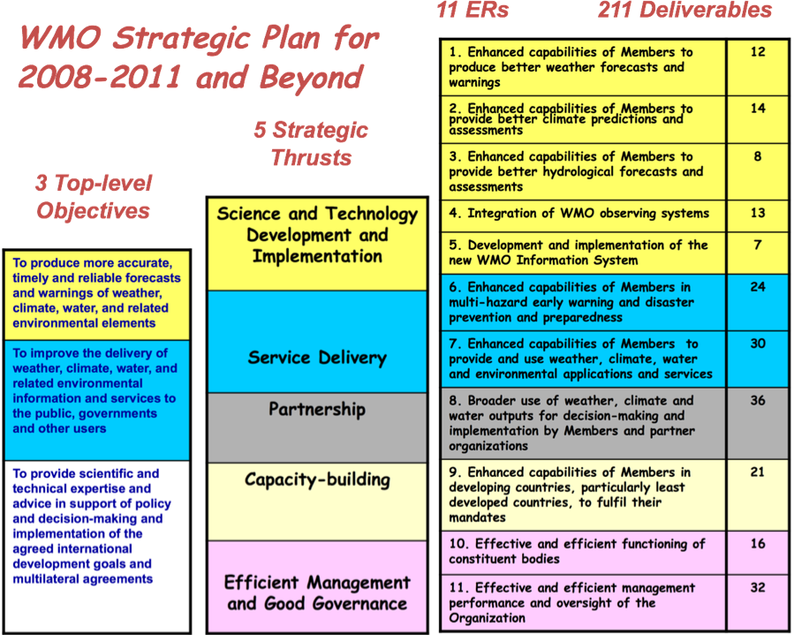
Annex II
(Version 27/10/09)

Strategic Plan for the Enhancement of NMHSs in RA V (2009-2011)

WMO Top-level Objective 1
To produce more accurate, timely and reliable forecasts and warnings of weather, climate, water and related environmental elements
Strategic Thrust 1
Science and Technology Development and Implementation

In order to provide more comprehensive services to satisfy the requirements of end users - and so provide benefits to the safety and well being of people, sustainable development and environmental protection, there is a need to further the scientific and technological infrastructure in the Region. The Region has some advanced scientific and technological expertise within world-leading institutions, such as NMHSs and academia, and in industry. Improved co-operation between Members can help develop the scientific knowledge and technical infrastructure to meet the requirements for more comprehensive services. Such areas include improved quality, range and timeliness of the basic data necessary for the production of weather forecasts, climate predictions and hydrological assessments, whether this be through ground-based or satellite observing; utilizing new technologies to improve the timeliness of the exchange of this data; and improved modeling to forecast a greater range of natural hazards at longer lead times.

RA V will address this through:

- Improving the knowledge of meteorological and hydrological processes and understanding of the requirements of the user community regarding the accuracy and usefulness of the analysis, forecasts, warnings and risk assessments of meteorological and hydrological related hazards and impacts of environmental changes;

- Further developing and capitalizing on existing infrastructures / organizations in order to better answer to users’ requirements, e.g., through the involvement of all stakeholders;

- Modernizing the RA V meteorological and hydrological infrastructure, including by combining the capabilities of NMHSs, regional and sub-regional organizations with those of possible partners, where appropriate;

- Preserving and further developing the hydrological infrastructure for monitoring quantity and quality of both surface water and groundwater;

- Ensuring that the Region develops an efficient and effective infrastructure to feed into the global WMO system; and

- Ensuring that the Region plays its part in the effective operation and delivery of a global multi-hazard early warning system, including disaster preparedness and climate change.

RA V will try to achieve the following results:
1. WMO Expected Result 1
Enhanced capabilities of Members to produce better weather forecasts and warnings

Regional ER1(a): Upgrade in Members’ capability and infrastructure in respect of NWP activities including high-speed computers, use of EPS (ensemble prediction system) products and now casting of high-impact weather
Deliverable:
1.1 | Automatic data reception and archival
1.2 | Automatic data plotting
1.3 | Access to relevant NWP products from major centres operationally
1.4 | Efficient interpretation and employment of all relevant NWP products
1.5 | Operating nowcasting systems for high-impact weather warning
1.6 | Operational use and interpretation of EPS (Ensemble Prediction System) products and probability forecasts
Regional ER1(b): Enhancement in Members’ aeronautical meteorological services including observations, information exchange and quality management
Deliverable:
1.7 | Fully equipped to make and transmit aerodrome meteorological observations
1.8 | Implementation of a quality management system meeting international standards
Regional ER1(c): Improvement in Members’ capability in marine meteorological including forecasts and warnings
Deliverable:
1.9 | Producing marine forecasts/warnings for coastal waters including sea state and wave/swell
1.10 | Producing marine forecasts/warnings for high seas
Regional ER1(d): Encouraging Members’ observation of the principle of free and unrestricted international exchange of data and products among Members and related services
Deliverable:
1.11 | Promoting and strengthening the principle of free and unrestricted international exchange of data and products among NMHSs and related services

2. WMO Expected Result 2
Enhanced capabilities of Members to produce better climate predictions and assessments

Regional ER2(a): Upgrade in Members’ capability in observation and in development of climate services and prediction to meet users’ diverse requirements in respect of sustainable development
Deliverable:
2.1 | Sustaining or increasing the number of climatological stations operated / supervised
2.2 | Providing monthly/seasonal climate prediction
2.3 | Making observations to monitor climate change and climate variability
2.4 | Meeting the needs for climate information of user sectors such as health, tourism, energy and building
Regional ER2(b): Enhanced capability in the provision of products and advice in support of adaptation strategies and mitigation measures to alleviate the impacts of climate change
Deliverable:
2.5 | Maintenance of records of metadata for observation stations
Regional ER2(c): Establishment of Regional Climate Centres (RCCs) and possibly sub-regional centres in RA V; and involvement of Members in regional climate research projects
Deliverable:
2.6 | Wider use of services provided by RCCs (Regional Climate Centre); support to the establishment of other planned RCCs
2.7 | Systematic increase of number and quality of products issued by RCC

3. WMO Expected Result 3
Enhanced capabilities of Members to provide better hydrological forecasts and assessments

Regional ER3(a): Improvement in Members’ capability in observation and development of products and services to the user community, including flood/flash flood and landslide/debris flow warnings
Deliverable:
3.1 | Growth in spatial and temporal coverage of hydrological observation network
3.2 | Reliability of maintenance procedures for measurement and equipment (gauges) in hydrological stations
3.3 | Issuing flood warnings
3.4 | Issuing flash flood warnings
Regional ER3(b): Upgrade in Members’ capability in monitoring changes in hydrological parameters and in assessing water availability in light of climate change
Deliverable:
3.5 | Assessing basin-wide water/precipitation availability, including use of climate scenarios
Regional ER 3(c): Encouragement of Members to contribute to and get access to appropriate databases, resources and expertise
Deliverable:
3.6 | Availability of national joint activities/programmes between hydrologists and meteorologists

4. WMO Expected Result 4
Integration of WMO observing systems

Regional ER 4(a): Upgrade in Members’ capability in maintaining and developing their meteorological observation networks and in implementation of additional equipment/systems to meet users’ needs
Deliverable:
4.1 | Sustainable network of synoptic stations in RA V
4.2 | Sustainable network of upper stations in RA V
4.3 | Sustainable program of maintenance and calibration for observation instruments
4.4 | Ensuring reliability of quality management routines and procedures of weather observations
4.5 | Availability of qualified maintenance technicians in NMHSs
4.6 | Availability of calibration instruments in NMHSs
4.7 | Maintenance/enhancement of rainfall stations in RA-V
Regional ER 4(b): Upgrade in Members’ capability in maintaining and developing their marine and aviation observations and in implementation of additional equipment/systems to meet users’ needs
Deliverable:
4.8 | Maintenance/enhancement of operational tide gauges in RA-V
Regional ER 4(c): Encouragement of Members in collecting and exchanging non-conventional met data for weather applications and disaster mitigation
Deliverable:
4.9 | Involvement in planning and implementation of GEOSS
Regional ER4(d): More cost-effective operation and better supply of good quality information
Deliverable:
4.10 | Existence of monitoring and auditing routines and procedures to minimize inefficiencies and conserve resources
4.11 | Ensuring the accuracy of instruments

5. WMO Expected Result 5
Development and implementation of the new WMO Information System

Regional ER5(a): Upgrade in Members’ telecommunications capability including circuits and connection to broadband Internet
Deliverable:
5.1 | Trend in migrating from low-speed Category I (below 9.6 kbps) to higher-speed Category II (9.6 to 64 kbps) and III (over 64 kbps) GTS connections to RTHs (Regional Telecom Hubs)
5.2 | Connection to Internet by broadband
5.3 | Enhanced use of RANET, HF Radio and EMWIN
Regional ER5(b): Improved data and products exchange for RA V Members under WIS implementation
Deliverable:
5.4 | Implementation of WIS (WMO Information System)

WMO Top-level Objective 2
To improve the delivery of weather, climate, water and related environmental information and services to the public, governments and other users
Strategic Thrust 2
Service Delivery

Service Delivery is the primary area for achieving the Expected Results. The safety and well being of people, the security and efficiency of transport and energy production and delivery, sustainable development and/or environmental protection should be the natural result of weather, climate and water related services.

The Region needs to respond to global change and its challenges that are modifying users’ requirements for services and the market in which service providers operate. For example, the expectation that climate change will increase the frequency of weather and water related hazards in the Region may require improved early warning services in many Member countries, as well as new or more comprehensive services related to environmental protection (e.g., air quality, water resources). Also, governments and economic sectors will require guidance to respond to climate change. Meanwhile, the increased demand from users is leading to a greater involvement of private sector service providers, as well as an expectation for improved services, both providing opportunities for the NMHSs to increase their visibility and improve their effectiveness.

RA V will address this through:

- Better understanding the requirements of governmental bodies, economic sectors, media and general public;
- Better use of RA V capabilities, including the quality and completeness of meteorological and hydrological records for application in development planning and disaster preparedness;
- Working together to provide a broader range of sub-regional and regional services;
- Working together to implement best practices and optimize the activities of existing capabilities within the Region to improve service production and delivery and the use of resources;
- Creating a mechanism to measure the RA V contribution to sustainable development:
- Establishing a monitoring process to capture evolving stakes and challenges and to provide adequate references; and
- Measuring and documenting the socio-economic benefits of the RA V activities.
6. WMO Expected Result 6
Enhanced capabilities of Members in multi-hazard early warning and disaster prevention and preparedness

Regional ER 6(a): Upgrade in Members’ capability in providing short-range forecast/warning, in disaster risk assessment and in contributing to disaster mitigation and sustainable development
Deliverable:
6.1 | Establishment/implementation of Disaster Risk Reduction units in NWHSs
6.2 | Providing nowcasting (0-6 hours ahead) service on high-impact weather
6.3 | Establishment of dedicated units for forecasting high-impact weather conditions
6.4 | Issuing short-range forecasts/warnings (6-24 hours ahead)
6.5 | Issuing storm surge warnings
6.6 | Providing support for search and rescue
6.7 | Involvement in national risk reduction planning and disaster management processes and activities
6.8 | Existence of emergency (fully robust) delivery systems of meteorological products for early warnings
Regional ER6(b): Encouragement to Members in outreach activities to users through public education and liaison with stakeholders
Deliverable:
6.9 | Links with national disaster organizations and other key stakeholders
6.10 | Having a public education programme
Regional ER6(c): Establishment of a Region-wide multi-hazard early warning system, covering in particular hazards coming from the ocean as well as various airborne hazards
Deliverable:
6.11 | Using graphical products including GIS platforms to facilitate early warning, disaster prevention and preparedness
6.12 | Participation in a region-wide multi-hazard early warning system
6.13 | Ability to respond to airborne hazards, in particular smoke from wildfires, volcanic emissions, chemical or biological spills, and nuclear accidents

7. Expected Result 7
Enhanced capabilities of Members to provide and use weather, climate, water and environmental applications and services

Regional ER7(a): Upgrade in Members’ capability in cost recovery and in maintaining close liaison with academia, the media and private sector
Deliverable:
7.1 | Implementation/enhancement of cost recovery of services
7.2 | Maintenance/enhancement of meaningful cooperation with the media
7.3 | Maintenance/enhancement of meaningful cooperation with the private sector
7.4 | Designation as Meteorological Authority for aviation meteorological services
Regional ER7(b): Sharing of experience on service delivery techniques among public weather, agriculture, and marine sectors
Deliverable:
7.5 | Issuing medium-range forecasts/warnings (1 day – 2 weeks ahead)
7.6 | Issuing marine forecasts/warnings for high seas
Regional ER7(c): Improvement in Members’ capability in monitoring key environmental areas including agrometeorological services and water monitoring
Deliverable:
7.7 | Providing agrometeorological information and forecasts to users
7.8 | Monitoring and warning systems for drought

Regional ER7(d): Encouragement of Members to engage in socio-economic studies of the benefits of weather, climate and water related services
Deliverable:
7.9 | Engaging in socio-economic studies demonstrating the benefits of members’ meteorological, climatological and hydrological infrastructure and information and service delivery

WMO Top-level Objective 3
To provide scientific and technical expertise and advice in support of policy and decision-making and implementation of the agreed international development goals and multilateral agreements
Strategic Thrust 3
Partnership

Working together both within the Region and with other bodies outside the Region and outside the normal sectors of WMO is a key strategic thrust for the Region. The weather, climate and water communities already have to work together to exchange needed data for forecasting, and the prospect of reduced government funding requires increased collaboration to share resources. While region-wide organizations or sub-regional groupings overseeing the research and networking of meteorological observations, meteorological/environmental satellites and NWP activities exist in such Regions as RA VI (e.g., COST, EUMETNET, EUMETSAT and ECMWF), similar organizations/groupings are yet to appear in the fast-growing South West Pacific Region (RA V). Also, partnerships can be developed outside the Region to enable others to take advantage of some of the Region’s world-leading expertise. This ensures that the existing infrastructure is included within any future initiatives or included within development projects.

RA V will address this through:

- Identifying where opportunities for regional and sub-regional co-operation are lacking and promote potential bodies for new partnerships;
- Creating the mechanisms to develop the interface and communication with new potential partners;
- Developing a sub-regional framework to cover RA V requirements and reduce overlap in development effort and in deployment of resources;
- Promoting co-operation between meteorological, hydrological and oceanographic services/institutions, where they are separated;
- Promoting cooperation with other national bodies which monitor and assess the hydrosphere;
- Promoting regional co-operation involving international river basins;
- Improving the interaction with other sectors and disciplines including those in the social sciences, health authorities, development planning and disaster preparedness communities;
- Ensuring a fruitful dialogue with other WMO Regional Associations and with WMO Technical Commissions; and
- Securing the relevant participation of NMHSs in the operational implementation of research-funded projects.

8. WMO Expected Result 8
Broader use of weather, climate and water outputs for decision-making and implementation by Members and partner organizations

Regional ER8(a): Strengthened relationships with key stakeholders
Deliverable:
8.1 | Enhanced cooperation with the media, government agencies and weather sensitive sectors
8.2 | Effective interactions with other international agencies such as SPREP in the Pacific and ADPC and ASCMG in Southeast Asia
Regional ER8(b): Enhanced co-operation with other service providers in the provision of specific weather services or advice
Deliverable:
8.3 | Availability of GIS-formatted products enabling users to combine meteorological and non-meteorological information
8.4 | Effective tsunami warnings through strengthened relations with PTWC, IOC, JMA and JATWC
Regional ER8(c): Enhanced co-operation with other sectors (such as social sciences, health, planning and disaster preparedness) in the provision of specific weather services or advice
Deliverable:
8.5 | Partnerships with stakeholders to explore socio-economic benefits
8.6 | Acquisition of extra budgetary fund by NMHSs from stakeholders for providing specific services
8.7 | Effective involvement in the planning and implementation of functions within GEOSS

WMO Top-level Objective 3
To provide scientific and technical expertise and advice in support of policy and decision-making and implementation of the agreed international development goals and multilateral agreements
Strategic Thrust 4
Capacity-building

Underpinning all the above is the need for capacity building. The expertise within the Region is not homogeneous and not all Members can contribute as effectively as they would like to the safety and well being of people, sustainable development and environmental protection. In order to meet the increasing demand for more comprehensive services across the Region to deliver these benefits, there is a need to build capacity so that the whole Region can effectively utilize the expertise contained within the world-leading centres. This can be done by capitalizing on the training provided by WMO and Members’ training centres, RSMCs and programmes carried out by consortia, and to address the technological gaps that exist. Technology transfer can be facilitated through the sub-regional networks, and other multilateral collaborations. This sharing of best practices should not be limited to technology or inside the Region, but is also conducive to institutional capacity building including management and strategic planning, harmonization with existing standards (e.g., ISO) and quality management.
RA V will address this through:

- Assessing the gaps in knowledge and capabilities, especially in observation infrastructure design, operation and sustainability, to meet requirements;
- Developing appropriate structures and planning to make the best use of the Region’s existing capabilities and to establish new structures where appropriate to achieve RA V objectives;
- Setting up the appropriate collective actions/projects to fill the gaps;
- Ensuring that the Region and its NMHSs have the right people with the right skills to achieve their objectives; and
- Sharing experience and best practices with other WMO constituent bodies

9. WMO Expected Result 9
Enhanced capabilities of NMHSs in developing countries, particularly least developed countries, to fulfill their mandates

Regional ER9(a): Ensuring Members’ capability in maintaining a structured training programme for professional, technical and supporting staff and in assisting its staff in acquiring the necessary qualification
Deliverable:
9.1 | Maintenance/implementation of a structured training plan for professional, technical and supporting staff
9.2 | Sufficient resource made available to sustain operation of RSMC Nadi
9.3 | Availability of expertise from developed NMHS for training of staff to encourage self-sufficiency in equipment maintenance programs
9.4 | Encouraging staff to take actions for professional certification in respect of WMO’s latest met personnel classification scheme
9.5 | Ensuring continuous education programmes and refresher courses for staff
9.6 | Ensuring of training for mid- and high-level personnel on management skills, including nurturing partnerships with stakeholders
9.7 | Capability for staff to provide effective media broadcasts
Regional ER9(b): Enhanced Members’ ability in delivering enhanced services through increased technical capacity
Deliverable:
9.8 | Operating and updating a web site for delivering and displaying services and products
9.9 | Rescuing and digitizing climate records
Regional ER9(c): Enhancement in Members’ capability in self-monitoring through user feedback, public surveys and verification of their own products
Deliverable:
9.10 | Verification of the accuracy of forecasts, including public weather forecasts, aviation forecasts (TAF) and warnings
9.11 | Obtaining feedback from the public, marine users and aviation users through opinion surveys, user groups etc
Regional ER 9(d): Encouragement of Members to conduct public education programmes to outreach to the public and user community
Deliverable:
9.12 | Public education programme regarding water-related information, including hazards, hydrological forecasts and warnings
9.13 | Public education programme regarding climate-related information, including climate change and variability, and associated adaption and mitigation issues
Regional ER9(e): Encouragement of Members to take part in WMO’s global weather information services as well as pilot projects in RA V
Deliverable:
9.14 | Contributing operational weather information to WMO’s on-line WWIS (World Weather Information Service).
9.15 | Successful execution of the Severe Weather Forecast and Disaster risk reduction Demonstration Project (SWFDDP) in the Southwest Pacific

WMO Top-level Objective 3
To provide scientific and technical expertise and advice in support of policy and decision-making and implementation of the agreed international development goals and multilateral agreements
Strategic Thrust 5
Efficient Management and Good Governance

RA V has limited financial resources through the WMO budget and relies on the goodwill and contribution of volunteers from its Members to conduct many of its activities. It is therefore imperative that RA V effectively manages its resources and meet the Members’ priorities as articulated in the RA V sessions.

RA V will address this through:

- Reviewing subsidiary bodies of RA V and their role in delivering the Strategic Plan’s objectives;
- Ensuring interaction within RA V to build up common proposals;
- Liaising with WMO Secretariat to convey adequate information to the other UN bodies regarding RA V’s expertise and capabilities;
- Sharing experience, knowledge and capabilities with other Regions to help deliver the WMO Strategic Plan objectives; and
- Enhanced networking with Members, relevant institutions and bodies with a view to pooling the Region’s expertise and capabilities to better meet users’ requirements.

10. WMO Expected Result 10
Effective and efficient management performance of the Regional Association

Regional ER10(a): Streamlined Association structure
Deliverable:
10.1 | Clearly defined role of the RA V Management Group within the structure of WMO
Regional ER 10(b): Review of the subsidiary working groups of RA V
Deliverable:
10.2 | Effectively re-organized RA V subsidiary working groups aligned with Association’s goals

11. WMO Expected Result 11
Effective and efficient management performance and oversight of the Organization

Regional ER 11(a): Increased influence of RA V constituent bodies in regional related matters
Deliverable:
11.1 | Increased influence of RA V constituent bodies in regional matters
Regional ER 11(b): Intensified and easier access to common resources via electronic means
Deliverable:
11.2 | Improvement in access to WMO’s common resources via electronic means

______________

Annex III

Proposed Structure of the WMO Strategic Plan 2012-2015

The revised WMO Strategic Plan consists of 5 Strategic Thrusts and 8 Expected Results that address the three Global Societal Needs (see schematic diagram below). Following from each Expected Result will be a limited number of specific programmatic and management “Key Outcomes” that the Organization as a whole will achieve over the next 10 years to deliver more accurate, timely, useful and cost-effective weather, climate, water and environmental (including ocean and air quality) information and services to meet national and global needs. The related WMO Operating Plan will then address the short-term actions (i.e., deliverables and activities) within the WMO Financial Period 2012-2015 that the organization will take in achieving these “Key Outcomes”.

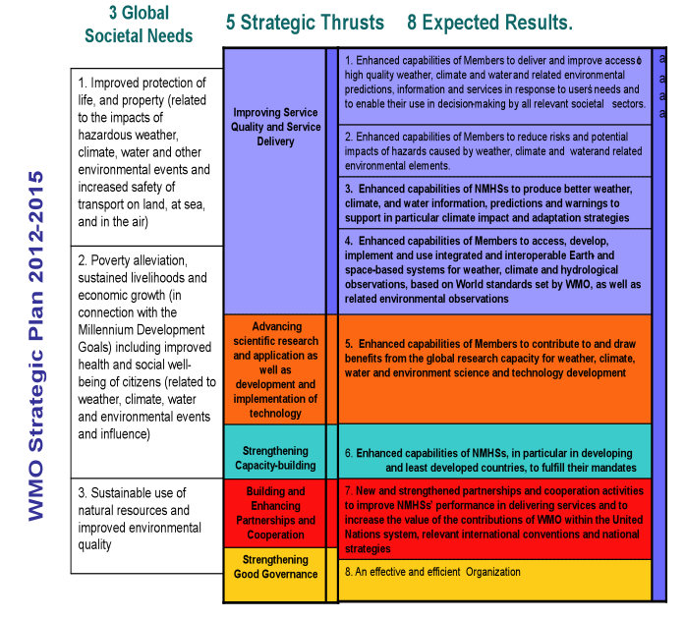

FUTURE WORKING MECHANISM OF THE ASSOCIATION
(Extracts from MG-Ext and MG-3 Final Reports)

1. The Management Group (MG-Ext) was informed of the on-going initiatives undertaken by other Regional Associations (RA II, RA IV and RA VI) to develop a more efficient working mechanism within the Association, including the composition of subsidiary bodies, in particular with reference to the process for RA II to establish new Working Groups.

2. The MG-3 noted that RA II took a comprehensive approach to cover all priority areas of the Association by establishing four Working Groups on: WMO Integrated Observing System and WMO Information System (WG-IOS/WIS); Climate Services, Adaptation and Agrometeorology (WGCAA); Hydrological Forecasts and Assessments (WGH); and Disaster Risk Reduction and Service Delivery (WGDRS), and the Management Group in alignment with Strategic Thrusts and Expected Results of the WMO Strategic Plan as well as Expected Results of RA II Strategic Plan (see Annex I). The established Working Groups maintain strong linkages with the existing Technical Commissions. RA II identified Chairpersons, Coordinators and Theme Leaders of the Working Groups, and all the volunteer experts were also mapped to work with relevant Theme Leaders. The terms of reference for each Working Group were agreed by the XIV-RA II session.

3. RA IV took a flexible approach to focus on regional priority issues by establishing the Management Group, Hurricane Committee and activity-oriented Task Teams to focus on: the development of a WIS/WIGOS Regional Radar Demonstration Project; the development of a Regional Climate Centre; RA IV DRR pilot projects; ICAO requirements for aviation meteorology; RA IV input to the WMO Strategic Plan and development of the RA IV Operating Plan; and identification of RA IV training needs and the gaps in available resources to meet these needs (see also Annex I). In view of the need to maintain linkages with WMO constituent bodies, the Secretariat and other organizations, RA IV requested the president to identify focal points who can serve in areas to be determined by the Management Group.

4. The MG-Ext agreed on the need to align the working mechanism of Regional Association V to the Strategic Thrusts and Expected Results of the WMO Strategic Plan as well as Expected Results of the RA V Strategic Plan. The current working structure of RA V, i.e., RA V Subsidiary Bodies established by XIV-RA V (May 2006), is given in Annex II with corresponding Expected Results of the Strategic Plan. The MG-Ext considered as appropriate to propose the following RA V subsidiary bodies:

- Management Group;

- Working Group on WMO Integrated Observing System and WMO Information System (WG-IOS/WIS);

- Working Group on Climate Services, Adaptation and Agrometeorology (WGCAA);

- Working Group on Hydrological Forecasts and Assessments (WGH);

- Working Group on Disaster Risk Reduction and Service Delivery (WGDRS); and

- Tropical Cyclone Committee for the South Pacific and South-East Indian Ocean.

The membership of RA V Working Groups could be composed of chair, coordinators, rapporteurs and/or theme leaders.

5. In view of the above, the MG-3 recognized some advantages of an action-oriented Task Team approach. The Group considered that in either approach the priority areas for RA V to focus on would include: (1) Communications; (2) QMS in aviation services; (3) RA V Severe Weather Forecasting and Disaster Risk Reduction Demonstration Project (SWFDDP); (4) Regional Climate Centre(s); (5) RSMC Nadi and SPREP Review; and (6) RA V Strategic Plan and Action Plan. It agreed on the need for identifying the necessary expertise to work for the above priority areas in the region.

6. The Group agreed that the Terms of Reference for Working Groups/Task Teams be prepared for concurrence by the XV-RA V session. It further agreed to continue consideration of the most appropriate future working mechanism via e-mail to enable preparation of the relevant document (XV-RA V/Doc. 5.1) in January 2010.

_______________

Annex I
New Working Mechanism of RA II
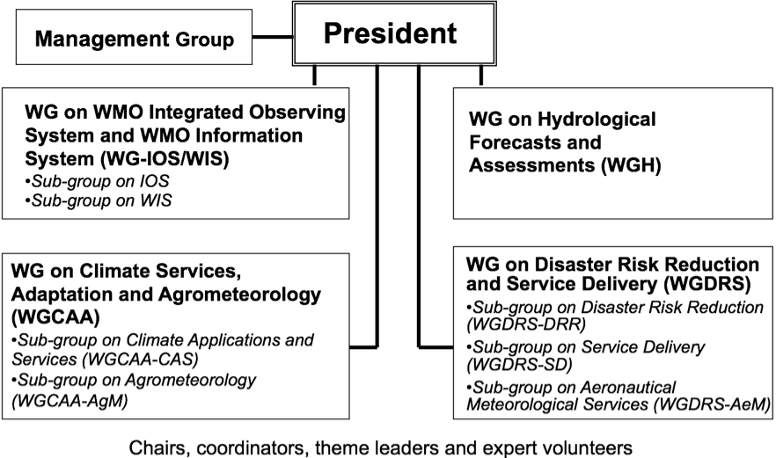

New Working Mechanism of RA IV
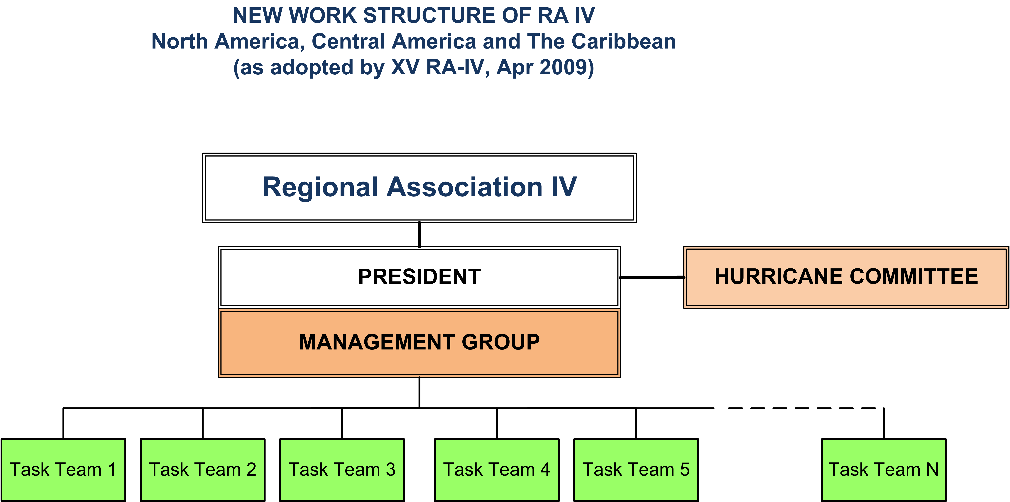
Annex II
BACKGROUND MATERIAL ON DECISIONS OF THE SUBSIDIARY BODIES OF
THE ASSOCIATION

Working Structure (WGs and rapporteurs) of RA V

(1)  Programme | (2)  RA V Subsidiary Bodies established by XIV-RA V (May 06) |  |  | (3)  XV-RA V Agenda  Item |  | (4)  ER |  | (5)  Proposed RA V Subsidiary Bodies to XV-RA V
WWW | WG/PIW  - Coordinator – Subgroup on Information Systems and Services  - Rapporteur - IOS  - Rapporteur - GDPFS  - Rapporteur – PWS  - Rapporteur – AMDAR  - Rapporteur – GEOSS  - Rapporteur – Migration to TDCF |  |  | 4.1  4.4  4.5 |  | 1  4  5  7  8
WWW | Co-Rapporteurs on Instrument Development, Related Training and Capacity Building |  |  | 4.4
WWW | RA V Tropical Cyclone Committee for the South Pacific and South-East Indian Ocean
WCP | WG/CRM  - Rapporteur - Climate Observations and Data management  - Rapporteur – GCOS (including GAW) and GOOS  - Rapporteur - Climate System Monitoring, Analyses and Indices  - Rapporteur – IPCC, UNFCCC, CCl activities  - Rapporteur - CLIPS  - Rapporteur – GIS in the provision of Climate Services  - Rapporteur – Climate Support to DPM  - Rapporteur – Climate-related ETR Requirements  - Co-Rapporteurs – RCC  - Rapporteur – Statistical and Dynamic Climate Modelling and Downscaling |  |  | 4.2 |  | 2  7
HWRP |  | WGH | 4.3 |  | 3
AREP |  | Rapporteur - GAW  Rapporteur - WWRP-THORPEX | 4.4  4.4 |  | (1)  (4)
SAT |  | Rapporteur – WMO Space Programme | 4.4 |  | (4)

DRR | WG/DPM | 4.6 | 6
AMP/AeMP | Rapporteur - AeM | 4.7 | 6
AMP/MMOP | Co-Rapporteurs - MMO | 4.7 | 6
AMP/AGMP | WG/AgM | 4.7 | (7)
- | Rapporteur - GEOSS | 4.4 | (4) (8)
ETRP | Rapporteur - ETR | 4.9 | 9  10  11
Regional Programme | Management Group | 5.1  5.2 | 9  10  11

Note: (1) Column 1 shows the currently active WMO scientific and technical programmes approved by Cg-XV;
(2) Column 2 shows the currently active RA V Subsidiary Bodies (Working Groups and Rapporteurs) approved by XIV-RA V in 2006;
(3) Column 3 refers to XV-RA V Agenda item (or document) where the activities of respective subsidiary bodies are to be discussed;
(4) Column 4 shows the WMO Strategic Plan Expected Results;
(5) Column 5 shows the RA V Subsidiary Bodies proposed to XV-RA V for discussion and approval.

