WORLD METEOROLOGICAL ORGANIZATION  _________________________  REGIONAL ASSOCIATION V  IMPLEMENTATION - COORDINATION MEETING ON THE GTS AND ISS IN RA V  HAWAII, 2-5 DECEMBER 2009 |  | RA V/ICM-GTS 2009/Report  (25.XII.2009)  ____________  Final Report  ENGLISH only

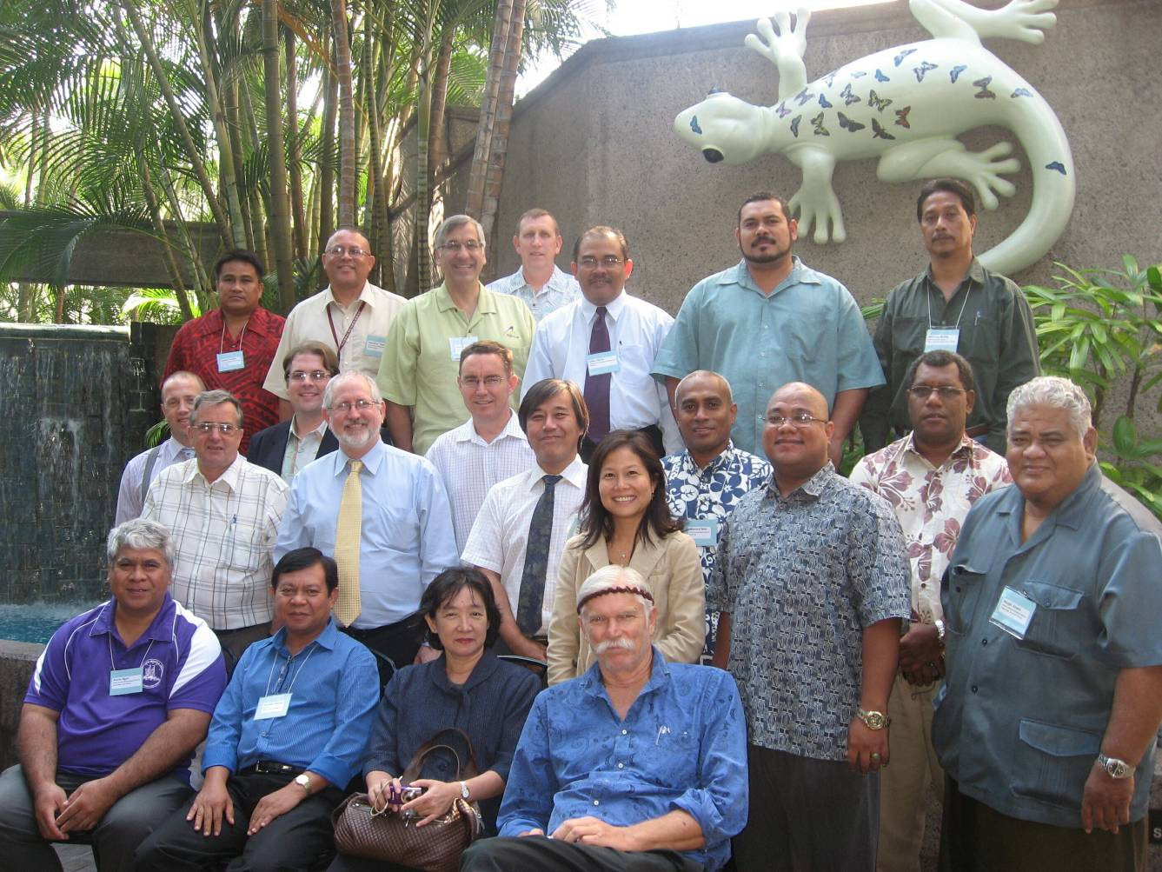

(Draft) Report

This is a report on the meeting of the RAV Sub Group on Information Systems and Services, held in Hawaii, 2-5 December 2009.

Inclusions
Appendix 1. Agenda
Appendix 2. List of Participants
Appendix 3. Meteorological Telecommunication Network for Region V
Appendix 4. Timelines for Migration to TDCF

REPORT - Draft

1. Organization of the Meeting
1.1.1 The meeting of the RA V Sub Group on Information Systems and Services (RAV/SG/ISS) was held at the NOAA Pacific Services Centre, Honolulu, Hawaii, from 2 to 5 December 2009. It was opened by Mr. Ralph J. (Jeff) LaDouce Pacific Region Director, National Weather Service, NOAA. Mr LaDouce noted that the Pacific faced several unique challenges in that it covers a huge area and no one country or organisation has ownership over the critical infrastructure and facilities serving the region. In particular this includes the satellites used for communication. In order to address the needs for communications in RA V it is necessary for this group to identify what capabilities exist in terms of infrastructure in each individual country or island state and the technical ability to support or implement new technology. He welcomed participants to Hawaii and wished them a successful and productive stay. Mr Kevin Alder, chair of the RAV/SG/ISS, thanked NOAA for hosting the meeting and noted the contribution of Mr Ed Young and the WMO Secretariat in making this meeting possible. He highlighted that the outcomes of this meeting will be reported to the RA V Working Group on the Planning and Implementation of the World Weather Watch (WG/PIW), which will in turn report to the next full session of RA V in 2010.

1.1.2 The meeting was chaired by Mr Kevin Alder. The accepted agenda is in Appendix one and the list of participants is in Appendix 2.

2. Review of the Status of Implementation and Operation of the Regional Meteorological Telecommunication Network
2.1 Status of implementation of RTHs, NMCs, MTN, inter-regional and regional links
Wellington ms upgrade for TDCF capability.
2.1.1 Presentations were received from Australia, Fiji, Malaysia, Samoa and the United States of America. (These are available on the meeting web page). The meeting noted that considerable progress was being made in the continuous improvement of the regional telecommunication network (RMTN) including the migration from frame relay to Multi Protocol Label Switching (MPLS). Details of the network topology are in diagram in Appendix 3. In particular, RA V is operating three MPLS clouds. One is the Improved Main Telecommunication Network (IMTN) operated by OBS (Orange Business Services), and managed by the ECMWF as an extension to the MPLS cloud supporting RA VI. This connects Melbourne WMC to Tokyo RTH, Washington WMC and Exeter RTH. The second MPLS cloud is operated by SingTel. These clouds were implemented to replace the BT Frame Relay (FR) circuits which were withdrawn from service in September 2009 from the region. The removal of the BT FR in September and the commissioning of the RMDCN MPLS circuits in mid November meant the IMTN connections between Melbourne and Tokyo, Melbourne and Washington, and Melbourne to Exeter had to run on the internet back up systems. This delay demonstrated the reliability of the GTS internet based backup circuits within parts of the region and inter-regionally to maintain operations for extended periods. The third MPLS cloud is NOAANet. It services the northern Pacific from Washington. In addition to the MPLS clouds, many centres rely on the internet as their prime connection to the RTHs in Melbourne and Wellington, some of which have now been functioning for over 10 years.

2.1.2 Despite these significant advances, it was noted that many centres in RA V still rely on satellite, digital HF radio and email for connection to the GTS. And although internet is available to all centred, it remains very expensive and unreliable in the Pacific. Problems are often associated with limited bandwidth availability so that email can be significantly delayed or lost.

2.2 Status of implementation of data-distribution systems via satellite and radio-broadcasts
2.1.1 Main satellite communications are through EMWIN, LRIT and ISCS as well as SADIS where available. LRIT broadcasts are through GOES, MTSAT and FENGYUNCast, although FENGYUNCast only provides imagery. The meeting was also briefed on the progress in GEONETCAST which utilises GOES and FENGYUNCast, although it present coverage is limited in the Region to the eastern and western edges. Details of the implementation of telecommunication systems via satellite and radiobroadcasts are included in page 2 of Appendix 3.

2.1.2 The variation in communications capabilities across RA V was highlighted by participants’ reports that revealed a key role of Email and Digital HF radio in the Pacific. SMS via telephony including the RANET component known as Chatty Beetle, is also expanding. FM radio also plays an important role, particularly in Chuuk, Majuro, Niue, Tuvalu and Vanuatu. In regard to broadcast distribution systems, the meeting noted that WEFAX has now been replaced by LRIT which is operational in five countries and that there is a transition away from Worldspace broadcasts. HF radio broadcasts for marine users have been maintained in Australia, Hawaii and New Zealand.

2.3 Review of the exchange of observational data and products
2.2.1 The meeting reviewed the Secretariat ’s report on the monitoring of the WWW and noted the improvement in SYNOP and TEMP availability from the region. It also addressed the issues of CLIMAT reports, where the meeting emphasised the important role of Melbourne WMC and Wellington RTH that provide the monitoring to work with the other centres to address deficiencies.

2.1.2 The meeting was pleased to note the completion of Australian Tsunami Warning Service (ATWS) network under IOC/WMO agreement utilising the GTS. It noted that under this agreement the GTS will play a core role in the collection and distribution of sea level observations and products and related information for tsunami warning services in general.

3. Implementation Plan for the Further Development of the Regional Meteorological Telecommunication Network
3.1 WIS overview
3.1.1 The Secretariat briefed the meeting on the progress of WIS implementation, noting that WIS is being implemented in two parallel parts, with part A being the continued improvement of the GTS as evident in the work of RA V with its recent migration to MPLS. Part B relates to the new functionality of WIS, including in particular the Discovery, Access and Retrieval (DAR) and the associated role of metadata will start to be available once the first GISC is functioning, most likely in mid 2010. The meeting noted that as of the end of November 2009, thirty-eight WMO Members and two Organizations have identified over 100 potential Data Collection or Production Centres (DCPCs) and 13 potential Global Information System Centres (GISCs). For RA V, this includes one GISC (WMC Melbourne), and seven DCPCs across the region. It highlighted that RA V will have an interest in the designation process of the WMC GISC, and in any regional DCPCs. The meeting expressed concern about how RA V centres would go about implementing the capability to provide and maintain the necessary metadata for DAR and was pleased to note the offer of technical expertise from the WIS Project Office described on the WIS web page as the “WIS Jump Start.”

3.2 WIGOS overview
3.2.1 The meeting was briefed on the developments and concepts of WIGOS. The meeting noted that WIGOS and WIS will be two fundamental components facilitating improved services in the region. Furthermore, it noted that the success of WIGOS will be dependant on the timely implementation of WIS, especially in RA V where communications is such a critical issue.

3.3 Data communication services, incl. leased lines, network services, internet, satellite
3.3.1 Following the successful move to MPLS so far within the region, consideration is now being given to bringing other centres onto MPLS providing such transitions are economically and technically viable. A Manila - Singapore SingTel MPLS link is in place and is scheduled to be activated in January 2010. Melbourne, Nadi and Noumea are also investigating moving their links to MPLS via SingTel. Similarly, the NWS is planning to connect American Samoa to NOAANet by the end of 2010. In parallel, consultation has begun aiming to strengthen the communication link between Samoa and American Samoa. Two centres still do not have a connection to the GTS, these are Tokelau and Dilli. Tokelau and Samoa are discussing strategies for future improvements, and it was also noted that Australia has three HF systems for Tokelau but due to the limited availability of the necessary technical staff and distance from Tokelau, these have yet to be delivered.

3.3.2 Several presentations given to the meeting contributed to a lot of discussion on the use of satellites for servicing the region. A major concern is the gap between GEONETCAST broadcasts by CMA and NOAA. Active discussion on filling the gap highlighted the potential of GEONETCAST Americas to be expanded to cover gap in the Pacific and the possible use of commercial satellite services. The USA reported on a GEOSS workshop (XXXII) held in Honolulu on 30 November 2009, noting that there were three breakout groups and that each emphasised the need to increase Pacific Island participation in the GEOSS framework. The GEOSS meeting developed a strategy to invite Asia Pacific countries to the next GEOSS forum. This work is being addressed under GEOSS Tasks DI 09-03 “Warning Systems for Disasters” and AR-09-04 “Dissemination and Distribution Networks” and again there was recognition at the meeting of the gap in GEONETCAST coverage in the Pacific. The meeting also considered the potential impact of a failure of GOES 7 (Pacific Ocean GOES) which is supporting PeaceSAT, GEOSS and EMWIN. The satellite is nearing the end of its life and alternatives are now being sought. In particular, PEACESAT is looking at commercial satellite opportunities to replace GOES 7. A presentation from Agiosat revealed expanded satellite options and demonstrated that a commercial satellite communication and distribution is possible across the whole Pacific basin. The meeting also considered future opportunities from MTSAT and additional services available through Japan. It also noted the planned removal of Direct Broadcast from MTSAT post 2015 and migration to distribution via internet. In addition, the meeting noted FENGYUNCast broadcast is limited to images only, however, there is potential for widening this capability to contribute to filling the gaps in the Pacific through GEONETCAST in addition to other Pacific opportunities.

3.4 Data communication techniques and procedures
3.4.1 The region is making extensive use of TCP/IP procedures and has implemented cloud-based services and will continue to enhance as the technology becomes available, noting that some national IP services are still working on Frame Relay technologies. However, the use of mobile networks within countries has resulted from expanded mobile phone services and it is expected that the regional SMS expansion will continue to take advantage of these for distribution of warnings. The meeting noted that capacity building remains a critical element including the need to undertake activities such as train the trainer and taking advantage of distance learning such as offered by PeaceSAT or via the internet. It noted that RANET in particular has a need for provision of central repository of documentation and software source, possibly at WMO under WIS. The meeting was please to note New Zealand’s plans for a RANET technical training course in second half 2010, dates and content to be determined. The meeting endorses this approach as necessary to address the capacity building issues identified. It also noted the request from Wellington of the need for an “in country coordinator” in each centre utilising RANET.

3.5 Operational procedures
3.5.1 The meeting reviewed the current operational procedures and noted that centres should be looking to their associated RTH for assistance with GTS matters, including management of duplication and routing NS allocation of abbreviated headers, etc. Given the desire to progress the implementation of WIS, participants expressed concern at the absence of guidance documentation on how to implement the new functionality of WIS, especially metadata. The meeting also noted that RANET has moved from a pilot project to an operational support system for several centres and there is now a need for a central reporting procedure for RANET support activities. It was also advised that the current technical support from Wellington for aspects of the RANET system would remain ad-hoc and on a best efforts basis unless funding for strengthening support was found.

4. OTHER INFORMATION SYSTEMS AND SERVICES ISSUES
4.1 Data representation and codes
4.1.1 The meeting noted the work being undertaken within CBS on data representation and codes. It highlighted the relevance to RA V of discussions in JCOMM on the importance of uniform codes supporting the sea level monitoring in the region and the impact on the cost and maintenance of tools related to ocean warning services such as tsunamis and storm surge. The meeting also noted the work on a common alerting protocol under PWS and supported the work on a registry of alerting authorities. It considered that the transmission of the CAP message via the GTS would not be difficult to facilitate, although it has some concerns about populating the spatial distribution elements of CAP from current distribution lists.

4.2 Migration to table-driven code forms
4.2.1 The meeting considered the report of the Rapporteur on Migration to TDCF and expressed its appreciation of the ongoing work of the rapporteur and for providing the report. The timelines for migration to TDCF are provided in Appendix 4. It noted the positive progress on the migration, and how the Wellington Message Switch Upgrade presently in pre-operational mode would facilitate code migration for many centres coming through the RTH. However, it suggested that in RA V, the need will persist for RTHs to transmit TAC for some time. In particular, it concluded that complete migration to TDCF will need core forecasting tools such as Digital Atmosphere to be upgraded to ingest TDCF. It also noted that in the Region the dependence on HF email and SMS also require TAC.

5. IMPLEMENTATION COORDINATION AND SUPPORT ACTIVITIES
5.1 Report on RA II ISS-WIS/GTS issues and coordination with RA V
5.1.1 The meeting considered a report from the representative of RA II and noted the status of RA II implementation and the collaborative work on VPN development. The VPN project is now in the advanced stage along with supporting applications for collecting and displaying information available. It noted the value of the use of VPN technologies and applications and encouraged more RA V members to participate. The meeting noted that RA II has only three HF marine broadcast services remaining and that other meteorological HF facilities have all ceased. The meeting considered the potential for future discussions between RA II and RA V on the GISC to GISC relationships including consideration of backup arrangements for the RA V candidate GISC (Melbourne WMC) by Tokyo/Beijing or Washington. It also supported the potential Japanese Government’s development project in Samoa presently under study.

5.2 Proposed working arrangements and issues under WMO strategic plan
5.2.1 The meeting noted the working group structure being proposed by the RA V Management Group to be aligned to the regional strategic plan. It agreed in principle with the focus on WIS and WIGOS, but emphasised there is a need to place special attention to the unique communication technology issues in RA V

5.3 SWFDDP discussion
5.3.1 The meeting noted that the SWFDDP is now underway thanks to support from Wellington and that there are plans to expand the project to include additional countries within the region. It noted that with the unfolding of the Météo France high resolution spectral model, there is a need to distribute this information. It noted that a Pacific GEONETCAST could have a role in providing the required products to the Region and enhancing the SWFDDP principles.

6. RADIO-FREQUENCIES FOR METEOROLOGICAL ACTIVITIES
6.1 Report from RA V rapporteur on radio frequencies
6.1.1 The meeting took note of the recent WMO-ITU joint seminar held in September 2009 and the prime importance of radio frequency matters for meteorological and related environmental operations and research. Members are strongly urged to participate in radio frequency activities, especially the preparation for World Radiocommunications Conferences (WRC) issues, conducted by their national telecommunications administrations, by regional telecommunications organisations, and noted the importance of members in registering the frequencies for meteorological activities utilised with their national regulator.

7. OTHER BUSINESS
7.1.1 The meeting noted that Timor Leste has become the 22nd Member of RA V, and the 189th Member for WMO as of 4th December 2009. This reflects a need to ensure Dili was connected to the GTS as soon as practicable.

8. Closure of Meeting
8.1. Meeting closed at 12:45pm on December 5th 2009.
Appendix 1

Agenda

1. ORGANIZATION OF THE MEETING

1.1 Opening of the meeting
1.2 Adoption of the agenda
1.3 Working arrangements

2. REVIEW OF THE STATUS OF IMPLEMENTATION AND OPERATION OF THE REGIONAL METEOROLOGICAL TELECOMMUNICATION NETWORK

2.1 Status of implementation of RTHs, NMCs, MTN, inter-regional and regional links
2.2 Status of implementation of data-distribution systems via satellite and radio-broadcasts
2.3 Review of the exchange of observational data and products

3. IMPLEMENTATION PLAN FOR THE FURTHER DEVELOPMENT OF THE REGIONAL METEOROLOGICAL TELECOMMUNICATION NETWORK

3.1 WIS overview
3.2 WIGOS overview
3.3 Data communication services, incl. leased lines, network services, internet, satellite
3.4 Data communication techniques and procedures
3.5 Operational procedures
3.6 RMTN development planning (including data distribution systems)
3.7 National GTS components (national centres and networks)

4. OTHER INFORMATION SYSTEMS AND SERVICES ISSUES

4.1 Data representation and codes
4.2 Migration to table-driven code forms

5. IMPLEMENTATION COORDINATION AND SUPPORT ACTIVITIES

5.1 Report on RA II ISS-WIS/GTS issues and coordination with RA V
5.2 Proposed working arrangements and issues under WMO strategic plan
5.3 SWFDDP discussion

6. RADIO-FREQUENCIES FOR METEOROLOGICAL ACTIVITIES

6.1 Report from RA V rapporteur on radio frequencies

7. OTHER BUSINESS

8. CLOSURE OF MEETING
Appendix 2
LIST OF PARTICIPANTS
Kevin Alder (Chair)  Title: Information Services Manager | Meteorological Service of New Zealand Ltd.  30 Salamanca Road  P.O. Box 722  WELLINGTON  New Zealand  Tel. +64 4 470-0720  Fax. +64 4 473-5231  Email. kevin.alder@metservice.com
Akapo Akapo Jr.  Title: Meteorologist-in-Charge | NOAA National Weather Service  Weather Service Office  P.O. Box 789  PAGO PAGO, 96799  American Samoa, USA  Tel. 684 699-9130  Fax 684 699-1550  E-mail Akapo.Akapo@noaa.gov
Arona Ngari  Title: Director, Cook Islands Meteorological Service | Director  Meteorological Service  PO Box 127  RAROTONGA,  Cook Islands  Tel. + 682 206 03 / + 682 259 20  Fax. + 682 216 03  Email. angari@met.gov.ck
Bryan Hodge  Title: Senior Information Technology Officer | Bureau of Meteorology  700 Collins Street  MELBOURNE  VIC 3001  Australia  Tel. 61 3 9669-4858  Fax 61 3 9669 4128  E-mail b.hodge@bom.gov.au
Edward H. Young, Jr.  Title: Deputy Regional Director | National Weather Service – Pacific (W/PRI)  Suite 2200  737 Bishop Street  HONOLULU, HI 96813-3213  USA  Tel. 808 532 6412  Fax 808 532 5569  E-mail Edward.Young@noaa.gov
Fredrick R. Branski  Title: International Data Requirements and Exchange Liaison.  CBS President | NOAA, National Weather Service  SSMC2 Room 17456  1325 East-West Highway  SILVER SPRING, MD 20910-3283  USA  Tel. 301 713 3538 x121  Fax 301 713 9450  E-mail fred.branski@noaa.gov
George Jungbluth  Title: Senior International Relations Specialist | NOAA Satellite & Information Service International and Interagency Affairs (NOAA-NESDIS-IIA)  1335 East West Highway, Room 7305  SILVER SPRING, MD 20910 USA  Tel. 301 713-2024 ext 218  Fax 301 713-2032  E-mail George.Jungbluth@noaa.gov
Hiroyuki Ichijo  Senior Telecommunications Coordinator | Japan Meteorological Agency  1-3-4 Otemachi  Chiyoda-ku  TOKYO 100-8122  Japan  Tel. 81 3 3211-8402  Fax 81 3 3211-6930  E-Mail h_ichijo@naps.kishou.go.jp
Jailan Simon  Title: Head of Climate and Hydrology | Malaysian Meteorological Department  Jalan Sultan,  46667  PETALING JAYA,  Selangor Darul Ehsan, Malaysia  Tel : 6(03) 7967 8162  Fax : 6(03) 7956 3621  E-mail jailan@met.gov.my
Johannes Berdon  Title: Official-in-Charge | FSM Weather Services  Weather Service Office, Chuuk  P.O. Box A  WENO, Chuuk  Federated States of Micronesia 96942-2548  Tel. 691 330-2548  Fax 691 330-4494  E-mail Johannes.Berdon@noaa.gov
Juana Rimba  Title: Telecommunications Manager | Bureau of Meteorology, Climatology, and Geophysic  Jalan Angkasa 1 No. 2 Kemayoran  P.O. Box 3540 JKT  JAKARTA  Indonesia  Tel. 62 21 654 6340  Fax 62 21 424 6703  Email: yuana@bmg.go.id
Kelly Sponberg  Title: Project Manager, International Extension and Public Alert Systems (IEPAS) / RANET | NOAA National Weather Service  International Activities Division R/CP  SSMC2  1325 East-West Highway  SILVER SPRING, MD 20910-3283  USA  Tel. 301 713 1790 x112  Fax 301 587 4524  E-mail kelly.sponberg@noaa.gov
Leonard Bale  Title: Senior Systems Analyst | Fiji Meteorological Service  Private Mail Bag (NAP 0351)  NADI AIRPORT  Fiji  Tel. 679 990 5377 / 679 672 4888  Fax 679 672 0430  E-mail leonard.bale@met.gov.fj
‘Ofa Fa’anunu  Title: Director, Tonga Meteorological Service | Tonga Meteorological Service  Ministry of Transport  P.O. Box 845  Fua’amotu Airport  TONGATAPU  Tonga  Tel. 676 35355  Fax 676 35008  E-mail ofaf@met.gov.to
Mr. Reginald (Reggie) White  Title: Meteorologist in Charge | RMI Weather Services  Weather Service Office  Long Island Road, Rairok  PO Box 78  MAJURO  Republic of Marshall Islands 96960  Tel: +692 247-5705 / 3214  Fax: +692 247-3078  E-mail: reginald.white@noaa.gov
Sagato Tuiafiso  Title: Principal Scientific Officer, Forecasting Section | Samoa Meteorology Services  Ministry of Natural Resources and Environment  P.O. Box 3020  APIA  Samoa  Tel: 685 20856  Fax: 685 20857  E-mail: sagato.tuiafiso@mnre.gov.ws
Vicente Palcon, Jr.  Title: Officer-in-Charge, Telecommunications Section and Meteorological Satellite Facility | Philippine Atmospheric, Geophysical and Astronomical Services Administration (PAGASA).  WFFC Building  BIR Road Dilmon  QUEZON CITY 1100  Philippines  Tel. 632 920 4070  Fax 632 926 3151  E-mail vppalconjr@yahoo.com
WMO Secrétariat  David Thomas  Title : WMO Information Systems Project Manager | World Meteorological Organization  7 bis, Avenue de la Paix  Case Postale 2300  CH 1211 GENEVA 2  Switzerland  Tel. +41 22 730 8242  Fax +41 22 730 8021  E-mail dthomas@wmo.int
Henry Taiki  Title : Regional Programme Officer | World Meteorological Organization  Office for the South West Pacific  APIA  P O Box 3044  Samoa  Tel . +685 25706  Fax . +685 25771  E-mail htaiki@wmo.int

Appendix 3
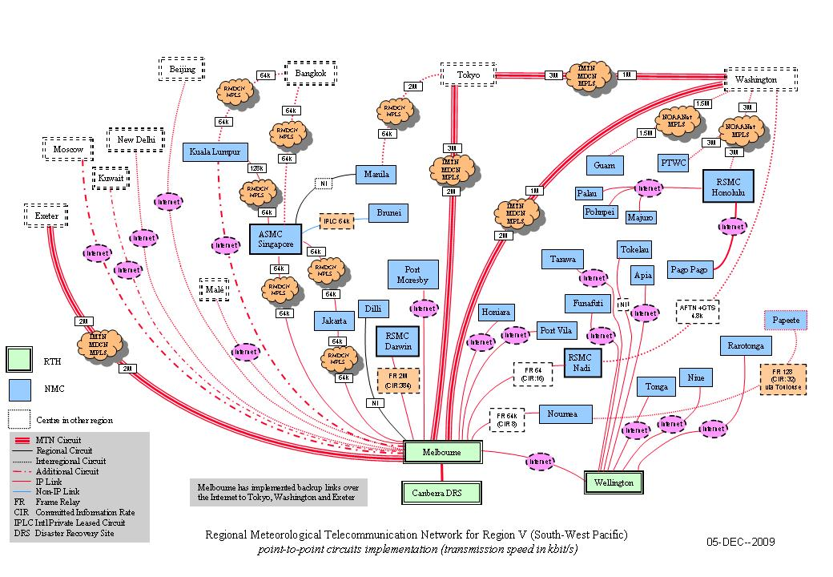

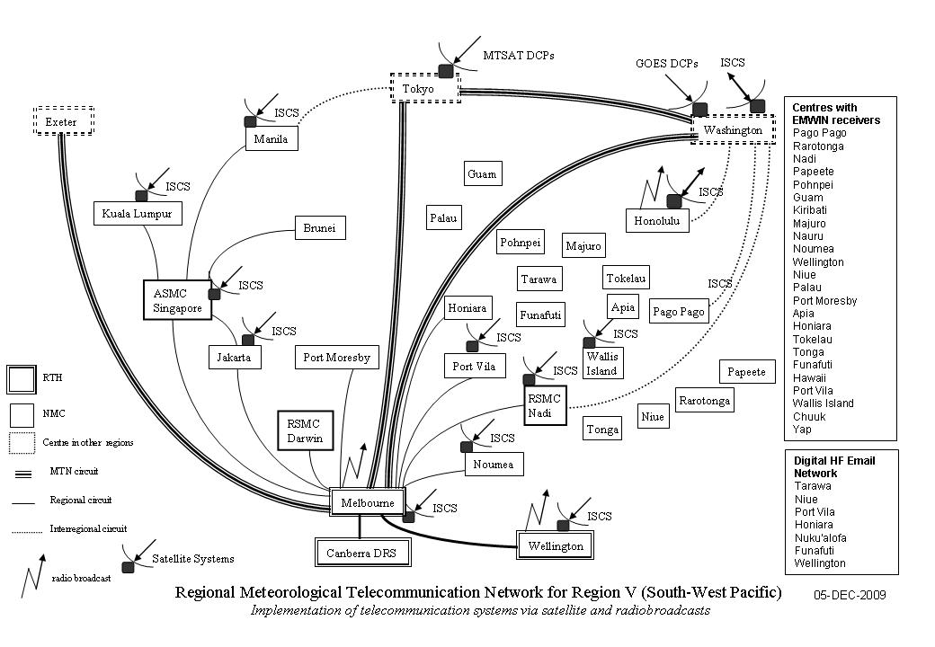
Appendix 4.

TDCF MIGRATION MATRIX

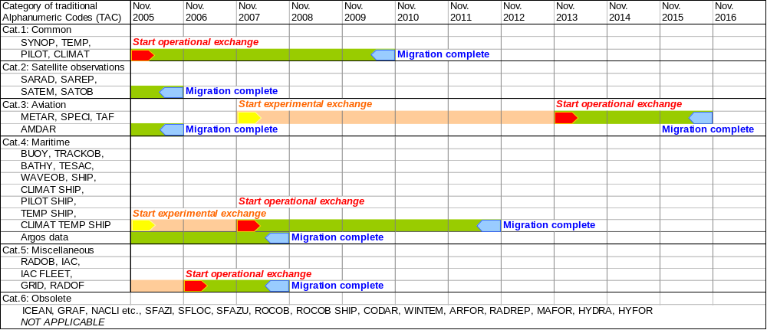

NOTES:
(1) Aviation Codes require ICAO coordination and approval, except for AMDAR.
(2) SAREP and RADOB require coordination by the ESCAP/WMO Typhoon Committee.
(3) For category 5, codes need to be reviewed in order to decide whether or not they should be migrated to BUFR/CREX.
(4) Codes in category 6 are not to be migrated.
(5) All dates above are meant as "not later than". However, Members and Organizations are encouraged to start experimental exchange, and, if all relevant conditions (see below) are satisfied, to start operational exchange as soon as possible.

- Start of experimental exchange means: data will be made available in BUFR (CREX) but not operationally, i.e. in addition to the current alphanumeric codes, which are still operational.
- Start of operational exchange means: data will be made available in BUFR (CREX) whereby some (but not all) Members rely on them operationally. Still the current alphanumeric codes will be distributed (parallel distribution).
- Migration complete means: at this date the BUFR (CREX) exchange becomes the standard WMO practice. Parallel distribution is terminated. For archiving purposes and at places where BUFR (CREX) exchange still causes problems the alphanumeric codes may be used on a local basis only.

Relevant conditions to be satisfied before experimental exchange may start:
- Corresponding BUFR/CREX-tables and templates are available;
- Training of concerned testing parties has been completed;
- Required software of testing parties (encoding, decoding, viewing) is implemented;

Relevant conditions to be satisfied before operational exchange may start:
- Corresponding BUFR/CREX-tables and templates are fully validated;
- Training of all concerned parties has been completed;
- All required software (encoding, decoding, viewing) is operational.

Meeting Web Page http://www.wmo.int/pages/prog/www/ISS/Meetings/RAV_ISS_Hawaii2009/DocPlan.html
See http://www.wmo.int/pages/prog/www/WIS/documents/JumpStartFlyer.doc

