WORLD METEOROLOGICAL ORGANIZATION  _________________________  REGIONAL ASSOCIATION V  IMPLEMENTATION - COORDINATION MEETING ON THE GTS AND ISS IN RA V  HAWAII, 2-5 DECEMBER 2009 |  | RA V/ICM-GTS 2009/Doc. 5.1(1)  (27.XI.2009)  ____________  ITEM 5.1  ENGLISH only

Report on RA II ISS-WIS/GTS issues and coordination with RA V
(Submitted by Hiroyuki ICHIJO (Japan), Coordinator of SG-WIS in RA II )

Summary and purpose of document

This document consists of two parts.
Part I provides information on status of RMTN in Region II including improvement of inter-regional links with Region V.
Part II is an outline of WIS VPN Pilot Project in RAs II and V.

Appendix : A Configuration diagram of RMTN in RA II (as of 14 September 2009)
B Current status of interregional circuits between RAs II and RA V
C Multipoint telecommunication systems in RA II
D Contribution of WIS VPN Pilot Project in RAs II &V to WIS implementation
(an example in RA II)

Part I : Status of RMTN in Region II

Regional Association II (RA II) established Working Group on Integrated Observing System and WMO Information System (WG-IOS/WIS), with Sub-group on Integrated Observing System (SG-IOS) and Sub-group on WIS (SG-WIS) at its fourteenth session (Tashkent, Uzbekistan, 5 to 11 Dec 2008).
One of terms of reference of the SG-WIS is to keep under constant review the Regional Meteorological Telecommunication Network (RMTN) and its implementation, as the WIS component for time-critical and operation-critical exchange, identify shortcomings and recommend appropriate measures for remedial action in the Region. In this context, the SG-WIS surveys the implementation status of the RMTN periodically. This part shows a summary of the outcome of the survey in 3Q/2009.
The improved RMTN project in RA II has been progressing steadily in improvement of circuit speeds, migration to TCP/IP and cost-effective links.

- Implementation of circuits
As of 14 September 2009, the RMTN in RA II includes seventy-eight operational circuits (i.e. 8 MTN, 46 regional, 13 inter-regional and 11 additional circuits). On the other hand, eleven circuits in the Regional configuration plan are not in operation. The configuration diagram of RMTN in RA II is shown in Appendix A

There are four interregional circuits between RAs II and V in operation, i.e. New Delhi-Melbourne, Bangkok-Singapore, Bangkok-Kuala Lumpur and Tokyo-Manila. The latter three were upgraded by migration from Frame Relay basis to IP-VPN with MPLS (Multi-Protocol Label Switching) basis in the first half of 2009.
In addition, there is one MTN circuit, i.e. Melbourne-Tokyo. It has just migrated from Frame Relay basis to IP-VPN with MPLS.
The current status of them is summarized in Appendix B.

In recent years, registration as an additional circuit has increased. The additional circuits based on bilateral agreement are to meet ad hoc requirements such as exchange of specific data/products and establishment of a backup route. Easy implementation of additional links through the Internet and cloud network services may facilitate establishment of the additional circuits.

Table 1 Transition of the number of RMTN circuits in RA II
 |  | Feb 1997 | Aug 1999 | Sep 2000 | Jan 2002 | Aug 2003 | Sep 2004 | Sep 2006 | Aug 2007 | Oct 2008 | Sep 2009
The number of the circuits  in operation | MTN circuits | 8 | 8 | 8 | 8 | 8 | 8 | 8 | 8 | 8 | 8
The number of the circuits  in operation | Regional circuits | 42 | 42 | 42 | 42 | 42 | 42 | 46 | 47 | 45 | 46
The number of the circuits  in operation | Interregional circuits | 11 | 10 | 10 | 12 | 12 | 12 | 12 | 12 | 12 | 13
The number of the circuits  in operation | Additional circuits | 2 | 1 | 1 | 3 | 5 | 5 | 4 | 10 | 10 | 11
The number of the circuits  in operation | Total | 63 | 61 | 61 | 65 | 67 | 67 | 70 | 77 | 75 | 78
The number of the circuits  not in operation | MTN circuits | 0 | 0 | 0 | 0 | 0 | 0 | 0 | 0 | 0 | 0
The number of the circuits  not in operation | Regional circuits | 10 | 10 | 10 | 9 | 9 | 9 | 9 | 8 | 10 | 9
The number of the circuits  not in operation | Interregional circuits | 0 | 2 | 2 | 1 | 1 | 1 | 1 | 1 | 1 | 0
The number of the circuits  not in operation | Additional circuits | 1 | 1 | 1 | 0 | 1 | 1 | 2 | 2 | 2 | 2
The number of the circuits  not in operation | Total | 11 | 13 | 13 | 10 | 11 | 11 | 12 | 11 | 13 | 11
The number of the circuits in Regional configuration plan | MTN circuits | 8 | 8 | 8 | 8 | 8 | 8 | 8 | 8 | 8 | 8
The number of the circuits in Regional configuration plan | Regional circuits | 52 | 52 | 52 | 51 | 51 | 51 | 55 | 55 | 55 | 55
The number of the circuits in Regional configuration plan | Interregional circuits | 11 | 12 | 12 | 13 | 13 | 13 | 13 | 13 | 13 | 13
The number of the circuits in Regional configuration plan | Additional circuits | 3 | 2 | 2 | 3 | 6 | 6 | 6 | 12 | 12 | 13
The number of the circuits in Regional configuration plan | Total | 74 | 74 | 74 | 75 | 78 | 78 | 82 | 88 | 88 | 89

- Improvement of circuit speed
Formerly it was a crucial problem that quite a few circuits were operating at a considerable low speed. A speed more than 9.6kbps at least could be required in consideration of requirements of the improved RMTN such as dissemination of observation data within 15 minutes, distribution of processed information of a large volume and handling various data types (e.g. binary, charts and files).
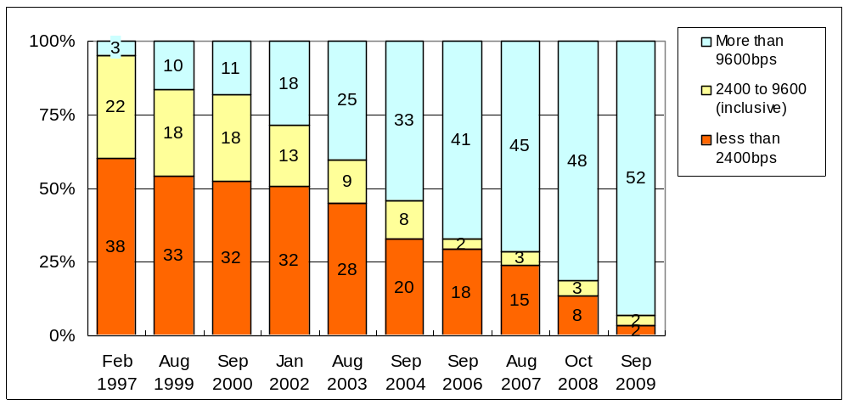
As shown in Figure 1, striking improvement in circuit speed has been progressed in a last few years with the background of renewal of telecom carrier services (e.g. discontinuation of low speed dedicated services, and introduction of cost-effective cloud based services).
Figure 1 Progress of improvement in circuit speed in RA II (except for Internet links)
The number
of circuits

- Migration to TCP/IP
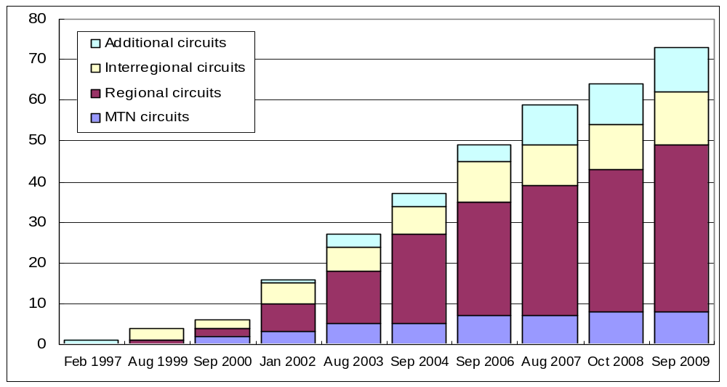
The migration towards TCP/IP on GTS circuits has been progressing considerably since beginning of the 21 century in the Region. All circuits in operation but five are running on pure TCP/IP as of September 2009. The achievement rate is about 94 percent.
Figure 2 Progress in migration to TCP/IP in RA II
number of circuits
- Seeking cost-effective and sustainable connections
4.1 Use of cloud based services (Frame Relay to IP-VPN with MPLS)
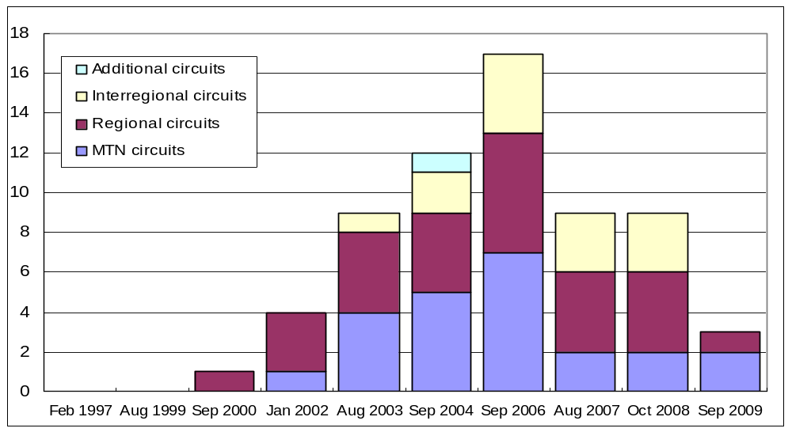
According to the Strategic Plan in RA II and IMTN implementation plan, migration from costly leased circuits to cost-effective circuits by using cloud based services has been promoted by each RTH. As the result, there was steady progress in migration to Frame Relay circuits from 2000 to 2006. Since 2006 GTS links on Frame Relay have been migrating to more cost-effective links on IP-VPN with MPLS, along change of technical and market trends in international telecom services. Actually lots of international telecom suppliers already fulfilled or announced discontinuation of Frame Relay services, and led their customers to use of IP-VPN with MPLS instead.
Figure 3 Transition of the number of Frame Relay circuits in RA II
number of circuits

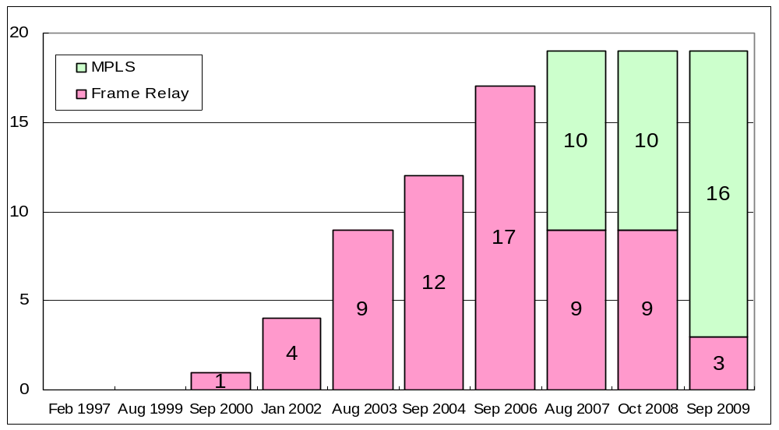
Figure 4 Transition of use of cloud based services in RA II
number of circuits
4.2 Internet links
Expansion of the Internet use in recent years brought a possibility of a GTS link through the Internet. Internet links have specific characteristics of no guarantee in transfer speed, delay time and security, and no responsible body in connectivity. Especially security risks and hidden costs to mitigate them are seriously emerging year by year. In spite of those negative characteristics, there are various opportunities for cost-saving (no charge except for the connection to ISP), vast transport capacity, flexible connectivity and introducing modernized technologies.
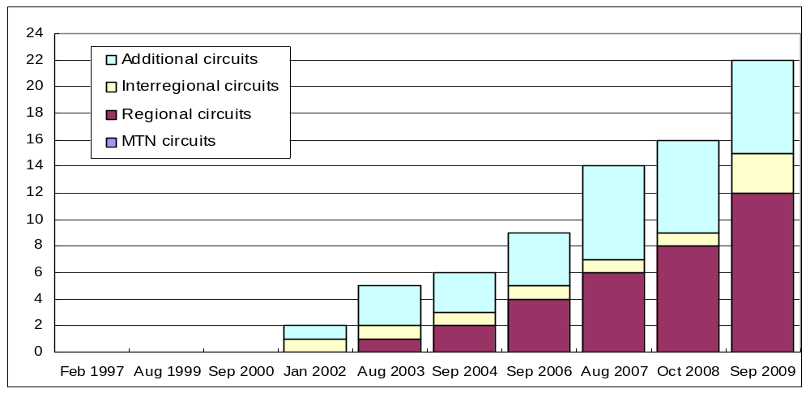
Although use of the Internet for a GTS circuit should be the very end solution in RA II, the number of circuits is currently 22 and is expected to increase further.
Figure 5 Growth in GTS circuits through the Internet in RA II
number of circuits

Since most of the existing Internet circuits do not use any VPN techniques, insecurity factors lurk in them even if filtering of IP addresses and port numbers is implemented. A risk of invasion attacks by address spoofing and pretense definitely exists. It is recommended that VPN techniques, especially IPsec, should be introduced. As of September 2009, only two Internet circuits introduce IPsec.

- Multipoint telecommunication systems (see Appendix C)
5.1 Satellite broadcasting systems
Satellite broadcasting systems are used for complements to the GTS, backup sources and cost-effective alternatives to HF radio broadcasts.

- A Ku-band satellite-based broadcasting system by China Meteorological Administration has been fully operating since January 1998. It totally has a 2Mbps broadcasting rate and supports 256 logical channels. The typical channel rate is 64Kbps. It covers China and some neighbouring countries and is integrated into the RMTN.. CMA-PCVSAT receivers installed in Dhaka, Hanoi, Ulaanbaatar, Yangon and Pyongyang are used for obtaining GTS data, CMA’s NWP products and CMA’s FY satellite data as complements of the low speed GTS circuits.

- CMA is developing a new Ku-band satellite-based broadcasting system, DVB-S system, for replacing the current CMA-PCVSAT system. It supports both data broadcasting and multimedia program broadcasting, has been put into running since April, 2006. Comparing with the current PCVSAT system, the new system gains the main advantages of higher data rates and lower costs for remote stations due to using standard DVB (Digital Video Broadcasting) technology. Currently, the DVB-S system has a hub station and over 400 receiving stations, and its total broadcasting speed is 8.5Mbps.

- CMA also operates a C-band satellite-based broadcasting system – FENGYUNCast. It is CMA’s contribution to GEONETCast, and started operation since 2006. It covers Asia and Pacific Ocean with 2Mbps broadcasting rate, and has different kinds of satellites data distributed, including FY-2C, FY-2D, FY-1D, NOAA/AVHRR, MODIS (TERRA, AUQA), etc. Currently, FENGYUNCast receivers has been installed in Australia, Bangladesh, DPRK, Indonesia, Iran, Kyrghyz, Lao P.D.R, Malaysia, Mongolia, Myanmar, Nepal, Pakistan, Philippines, Sri Lanka, Tajikistan, Thailand, Uzbekistan, and Viet Nam.

- Russian satellite broadcasting system (TV-Inform-Meteo) had provided fax charts and AN bulletins since 1995. It was replaced by a new DVB satellite system named “Meteoinform”. The Meteoinform provides multicast functions for meteorological data based on MITRA (Multi-address Information Transmission) technology. The broadcasting at high-speed (up to 56 Mbps) is carried out in the C-band through 4 Russian satellites (Expres AM1, Expres AM3, Expres AM11 and Yamal-200) providing the coverage of the whole territory of the Russian Federation and a number of adjacent countries. In the majority of towns, the subscribers can receive 2 or 3 satellites simultaneously. More than 100 terminals including terminals in Kazakhstan, Kyrgyz, Tajikistan have already been connected to it. The rates in the channels of various satellites were chosen as required from 64 to 1024 kbps and can be used in the course of operation without changing the H/W and S/W. The programmes over various channels are also different and depend on the users’ requirements in the area of reception.

- RTH New Delhi operates INSAT-DMDD. 37 DMDD receiving systems have been installed at various locations in India. DMDD receiving systems have been installed in NMCs Male and Kathmandu and planned installation in Colombo by October 2009, which will be used for complements to GTS.

- RTH New Delhi switched their data serving for users including marine vessels from HF radio broadcasts to a satellite-based DAB (Digital Audio Broadcast) by World Space through Asia Star Satellite in August 2003. This is a very cost-effective solution. The approximate cost for distribution of 1 Mbytes through the satellite is US$ 12. A user receives required data using a commercial radio receiver with a small L band antenna and a PC card adapter, which is manufactured by several companies at an approximate cost of US$150.

- METEOSAT-MDD service has been discontinued as from 14 June 2006. The MDD data stream itself is now embedded in the EUMETCast dissemination, and the same user-terminal can receive EUMETSAT images as well as MDD data and products. Oman (C and Ku bands) and Uzbekistan (Ku) already implemented EUMETCast receivers.

- WAFS (ISCS, SADIS) broadcasting is regularly used for operation in most of RTHs/NMCs.

- Many RTHs already discontinued HF radio broadcasts because of its high recurrent cost, its obsoleteness and emerging of standard satellite broadcast services. Although RTHs Bangkok, Tehran and Tokyo are still operating HF broadcast, the day is not far distant when HF broadcasts will disappear in Region II.

- RTH Jeddah discontinued HF broadcast in 2007. DVB system via Arabsat (Ku band) is operational as from 1 January 2008 and replaces the former HF broadcast by RTH Jeddah. The broadcasting coverage covers national stations as well as neighbouring countries. The data will mainly be GTS and forecast charts.

5.2 HF broadcasting systems
Three RTHs (Bangkok, Teheran and Tokyo) still continue their HF radio broadcasts for mainly ship users.

Part II : WIS VPN Pilot Project in RAs II and V

The WIS VPN Pilot Project in Regions II and V (Hereinafter referred to as Project) was launched in 2003 as one of the WIS related projects aiming at developing and evaluating technologies required by the WMO Information System (WIS), in particular, evaluating accessibility and effectiveness of the Internet VPN (Virtual Private Network).
The first phase of the Project, which specifically intends to evaluate the VPN technology itself, was successfully completed in September 2004. The advanced (second) phase of the Project started in August 2005 to evaluate stability and availability of the VPN technology through application level tests assuming operational data exchange within WIS.
This part briefly reports on the current status and recent progress.

- Current status
1.1 Participants
In 2009 Pakistan Meteorological Department became a new participant. Seventeen NMHSs are participating in the Project at present as shown in Table 1. The number of participants has been increasing steadily from 11 in the first phase with the support by WMO.

Table 2. Participants in the advanced phase
Country, territory | Organization | Site
Region II
China | China Meteorological Administration | Beijing
Hong Kong, China | Hong Kong Observatory | Hong Kong
India | India Meteorological Department | New Delhi
Islamic Republic of Iran | Islamic Republic of Iran Meteorological Organization | Teheran
Japan | Japan Meteorological Agency | Tokyo
Oman | Meteorological Department | Muscat
Pakistan | Pakistan Meteorological Department
Republic of Korea | Korea Meteorological Administration | Seoul
Saudi Arabia | Presidency of Meteorology & Enviroment | Jeddah
Vietnam | National Hydrometeorological Service | Hanoi
Region V
Australia | Bureau of Meteorology | Melbourne
Brunei Darussalam | Brunei Meteorological Service | Bandar Seri Begawan
Fiji | Fiji Meteorological Service | Nadi
Malaysia | Malaysian Meteorological Service Department | Kuala Lumpur
New Caledonia | Meteo-France, New Caledonia | Noumea
New Zealand | MetService | Wellington
Republic of Singapore | National Environment Agency | Singapore

1.2 Status of establishing VPN links
Almost all participants have permanent connections to the Internet at a speed over 512kbps as shown in Figure 6.

Hong Kong
India
Iran
Korea
Pakistan
Saudi Arabia
Vietnam
Australia
Brunei
Malaysia
New Zealand
China
Japan
Singapore
100Mbps (Max)
Fiji
New Caledonia
Internet
Figure 6 Internet connectivity for the WIS VPN Pilot Project
Oman
100Mbps (Max)
100Mbps (Max)
10Mbps (Max)
2Mbps
4Mbps
256Mbps (Min) –
440Mbps (Max)
2Mbps
1Mbps
1Mbps
3Mbps
2Mbps
2Mbps
128kbps
512kbps

- Recent progress
Taking into account importance of the Project for evaluating WIS related developments and providing developing countries with an occasion to participate in WIS development, the Project needs to be continued, at least, until specifications of operational WIS are fixed. In the advanced phase, it is planned to promote the thematic sub-phases.

2.1 Prototype application software
Japan Meteorological Agency (JMA) started to provide prototype application software named SATAID and the data and products formatted for it in October 2006. The SATAID is a sophisticated stand-alone program for visualization and manipulation of satellite imagery and NWP products. JMA has developed an upgraded-version of the SATAID software. In June 2008, the upgraded-version was made available on the VPN server in addition to its old version. A long-term evaluation test by participants is under progress.

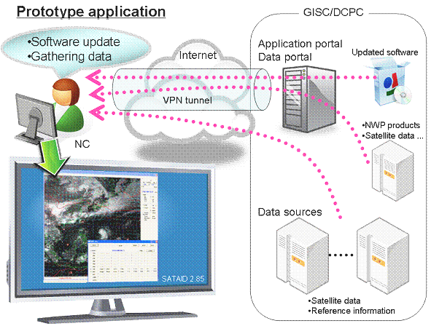
Figure 7 Long-term evaluation test for a prototype application in advanced phase

2.2 Reporting observation data

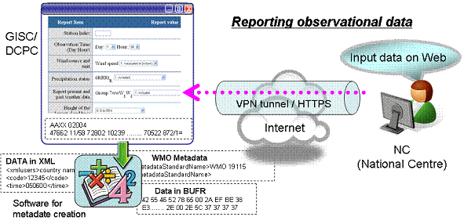
Figure 8 Outline of reporting observation data
China Meteorological Administration (CMA) has developed a Web Data Ingest – WDI for reporting observation data through the Internet VPN setup in RA II and RA IV in 2008. It is designed as follows with the view of scalability and reusability.
- Portal Layer: It is a part of the Beijing WIS portal, and provides the web interface of collecting observations via HTML form or file upload.
- Service Layer: It includes HTML form service, file upload service, user service and management service.
- Provider Layer: It provides the basic data management service, including BUFR encoding, data storage based on file system and database.

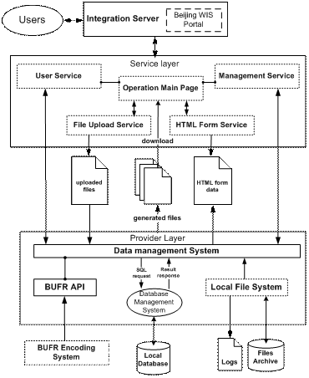
Figure 9 The architecture of Web Data Ingest

The WDI and its User Guide can be accessed via the URL of http://wisportal.cma.gov.cn/web_ingest.jsp. In current phase, the implemented functions include:
- Collecting GTS observations via HTML form and downloading the ingested data files;
- Collecting GTS data and products via file upload interface;
- Converting the ingested SYNOP, TEMP, CLIMAT, CLIMAT TEMP messages in A/N codes to BUFR messages;
- Checking the AHL and message format for the ingested observation data;
- User registration and management interface;
- Logging and querying user activities and data ingesting status.

And, the metadata generation function is being developed.
Figure 10 WDI and its function flow
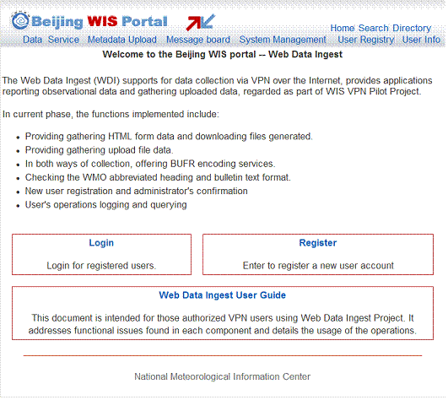
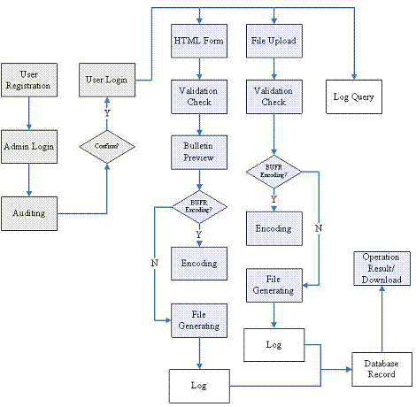

- Contribution of the project to WIS Implementation
The Project is expected to contribute to the WIS implementation through the following activities

(1) Technical consulting body on VPN
The Project will play the role of a technical consulting body on VPN data communications for WIS semi-operation components in all Regions. The Project continues to provide empirical outcomes and technical tips to WIS community.

RA I (Africa), at its 14th session (Ouagadoudou, Burkina Faso, February 2007), approved establishment of RA I WIS pilot projects. One of them is a VPN Pilot Project in RA I (RA I Project, hereinafter) coordinated by Mr William Nyakwada from Kenya (RA I WG-PIW Chair). Participants of the Project agreed with pleasure that the Project would support technical aspects of the RA I Project. It is expected that core centers in RA I would acquire technical knowledge and capability to establish and manage their own RA-I Project through their participation in the VPN Pilot Project in RAs II and V.

- Prototype mechanisms at WIS application level
The Project will develop WIS prototype services at an application level and verify them through participants’ trial use. Some of the WIS prototype services developed by this Project may be applied to services in other Regions. The previously-mentioned recent progress in web input experiment for reporting observation data could be an example.

(3) Capacity building for participants in WIS semi-operation
The Project will provide the participants with better environment so that they can gain experiences on use of VPN and WIS services on a trial basis, and consequently, it would contribute to the early migration to the operational WIS.

Conclusion

Part I : Status of RMTN in Region II

- The following essential factors have brought successful progress of the improved RMTN project in RA II:
- to establish a steering body (e.g. WIS/GTS subgroup with a coordinator);
- to develop and authorize regional strategies with practical implementation plans;
- to clarify the start point that each RTH plays an important role in coordinated implementation in their responsible area;
- to observe and review the progress status periodically, and then share the status information with all in the Region.

- Technical and market trends in ICT fields should be studied timely and carefully. Recent specific items to be studied are as follows:
- shift of telecom services from Frame Relay to IP-VPN with MPLS
- wide range options to introduce satellite broadcasting systems on DVB and DAB

- It is beneficial to review the status of Internet based GTS links in practical views of security and serviceability. It is recommended that VPN techniques, especially IPsec, should be introduced.

Part II : WIS VPN Pilot Project in RAs II and V

- The WIS VPN Pilot Project facilitates good collaboration between RAs II and V, and provides participants with an opportunity to step into WIS implementation. The Project should be expanded in its activity and the number of participants, especially developing countries.

- The Project is expected to contribute to the WIS implementation through the following activities:
- Technical consulting body on VPN
- Prototype mechanisms at WIS application level
- Capacity building for participants in WIS semi-operation

Appendix A

Configuration diagram of RMTN in RA II (as of 14 September 2009)
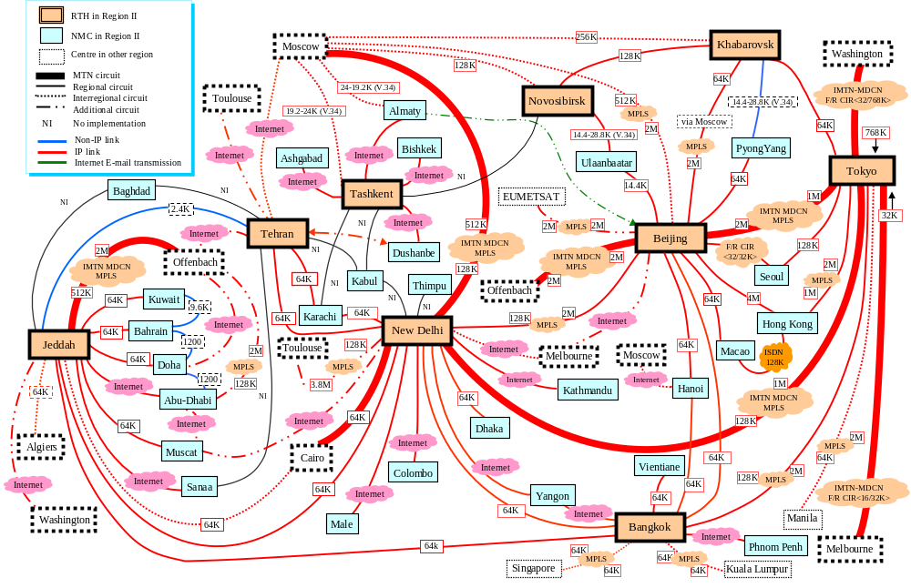
Appendix B

Current status of interregional circuits between RAs II and V

Site A | Constitution  (GTS Type) | Access Port Speed  [bps] | Max throughput  [bps] | Types of Transmission Data | Procedures | Number of Transmission Connections | Allocation Scheme of Link Addresses | Routing Protocol | Supplier(s) | Type of Contract & Payment with supplier(s) | Remarks
Site B
Melbourne  (AMMC) | Internet  (Interregional) |  | (Best-effort) | AN,BI | IP  (socket) | 1 | --- | --- |  |  | - 2 socket connections for each direction  - The Internet circuit (permanent connection)
New Delhi  (DEMS) | Internet  (Interregional) | 10M | (Best-effort) | AN | IP  (socket) | 1 | --- | --- | Tata Comm. Ltd. (former "VSNL")
Bangkok  (VTBB) | IP-VPN with MPLS  (Interregional) | 64K | 64K | AN,  BI(500k) | IP  (socket) | 2 | Official-IP  (formerly allocated by WMO) | Dynamic  (bgp) | CAT | Contract: bilateral under ACASIA framework  Payment: individual in local currency | - 4 socket connections for each data type in each direction  - This link has been in operation through IP-VPN with MPLS since May 2009.
Kuala Lumpur  (WMKK) | IP-VPN with MPLS  (Interregional) | 64K | 64K | AN,  BI(500k) | IP  (socket) | 2 | Official-IP  (formerly allocated by WMO) | Dynamic  (bgp) | TM
Bangkok  (VTBB) | IP-VPN with MPLS  (Interregional) | 64K | 64K | AN,  BI(500k) | IP  (socket) | 1 | Official-IP  (assigned directly to an organization (e.g. the NMHS)) | Dynamic  (bgp) | CAT | Contract: bilateral under ACASIA framework  Payment: individual in local currency | - 2 socket connections for each data type in each direction  - This link has been in operation through IP-VPN with MPLS since May 2009.
Singapore  (WSSS) | IP-VPN with MPLS  (Interregional) | 64K | 64K | AN,  BI(500k) | IP  (socket) | 1 |  | Dynamic  (bgp) | SingTel
Manila  (RPMM) | IP-VPN with MPLS  (Interregional) | 64k | 64k | AN,  BI(500k) | IP  (socket) | 2 | Official-IP  (formerly allocated by WMO) | Static | PLDT | Contract: individual under the Master-contract between JMA and NTTcom.  Payment: individual in local currency | - 2 socket connections for each data type in each direction  - This link has been in operation through IP-VPN with MPLS since 24 March 2009.
Tokyo  (RJTD) | IP-VPN with MPLS  (Interregional) | 2M | 64k | AN,  BI(500k) | IP  (socket) | 2 | Official-IP  (formerly allocated by WMO) | Static | NTT Com.
Melbourne  (AMMC) | IP-VPN with MPLS  (MTN) | 2M | 2M | AN, BI(500k), FAX, File | IP  (socket, ftp) | 3(soc)  1(ftp) | Official-IP  (provided by a telecom supplier) | Dynamic  (bgp) | Orange Business Service (OBS) | Contract: one-stop (Master-contract between ECMWF and OBS, Accession agreement between each center and OBS)  Payment: multi-end payment to OBS in UK pound | - 3 socket connections for each data type in each direction  - This link has been in operation through IP-VPN with MPLS since November 2009.  - Mission Critical (Resiliency): The site has got two diversely routed circuits to different OBS Points of Presence. The circuits are connected to two separate routers on the User Site.
Tokyo  (RJTD) | IP-VPN with MPLS  (MTN) | 3M | 2M | AN, BI(500k), FAX, File | IP  (socket, ftp) | 3(soc)  1(ftp)

Appendix C

Multipoint telecommunication systems in RA II
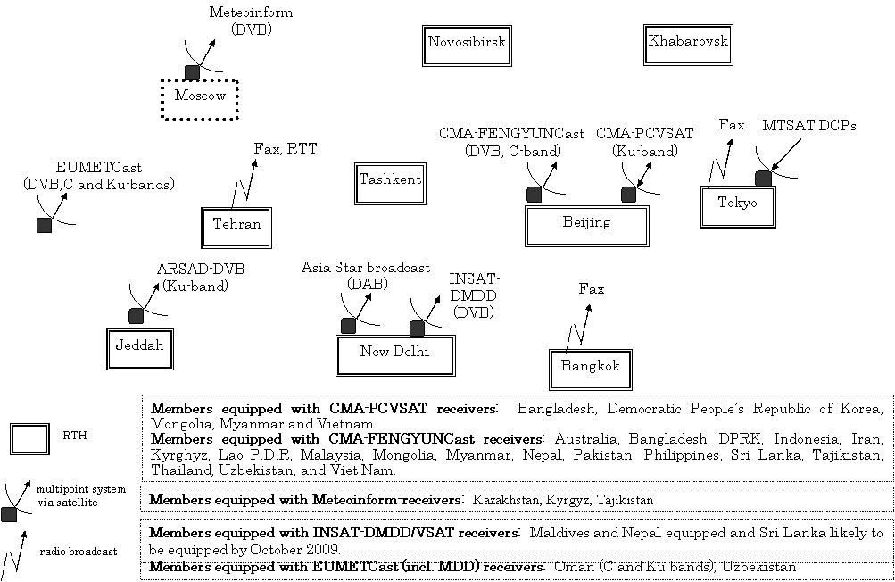
Appendix D

Contribution of WIS VPN Pilot Project in RAs II &V to WIS implementation (an example in RA II)


