WORLD METEOROLOGICAL ORGANIZATION  _________________________  REGIONAL ASSOCIATION III  (SOUTH AMERICA)  WORKING GROUP ON PLANNING AND  IMPLEMENTATION OF THE WWW IN REGION III  ASUNCIÓN, PARAGUAY, 19 - 23 April 2010 |  | RA III/WG-PIW-05/Doc. 5.2(1) (15.IV.2010)  ____________  ITEM 5.1  ENGLISH only

REGIONAL ASPECTS OF WWW COMPONENTS

Information Systems and Services (ISS) - GTS and Data Management
(Submitted by the regional rapporteur on ISS)

Summary and Purpose of Document

This document provides information on the status of the implementation ISS.

ACTION PROPOSED

The meeting is invited to consider the information on WIS implementation included in the document.
The GTS in Region III

Internet is still used to implement some circuits as well as bilateral ones. Standard FTP protocol is largely used to exchange data and products.

RTH Buenos Aires has new Message Switching Systems and implemented TCP sockets between RTH Brasilia and WMC Washington.

RTH Brasilia already generate BUFR and CREX bulletins. RTH Brasilia is also in the position to convert traditional alphanumeric bulletins into BUFR and vice-versa.

RTH Brasilia finished a tender to select a telecommunication provider to replace and renew the services. The frame-relay protocol will be replaced by MPLS. The tender includes a connection to the Network II, the Regional Meteorological Data Communication Network managed by the ECMWF for Region VI.

The Annual Global Monitoring exercise still shows lack of data in Region III. In case of CLIMAT data, for instance, the percentage of reports received in Brasilia in comparison with the number of reports received during the 2009 monitoring is around 30%. In case of Brazil there are 61 stations in two CLIMAT bulletins, and in the monitoring period 11 of them where silent, which means 18%. But, comparing the list of silent stations with the list of available stations only 3 stations was really silent: 82287, 82825 and 83492 which represents only 5%. Station 83492 and 83825 were closed.
It requires a full revision of the reference files in order to have the correct vision of the situation. It looks like also the monitoring procedure is counting CLIMAT and CLIMAT TEMP as the same type of bulletin.

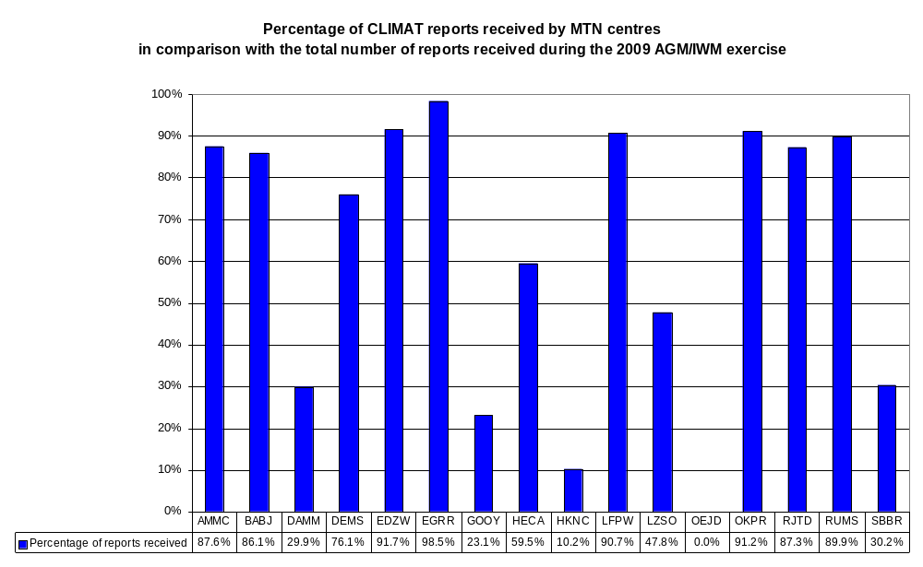

List of silent stations in Region III, according to the 2009 monitoring exercise.

REGION III | SYNOP | TEMP | CLIMAT
SILENT STATIONS | 24 | 8 | 47
ARGENTINA | 52 | 7 | 79
 | 87532 |  | 87065
 | 87585
 | 87800
BOLIVIA | 34 | 1 | 20
 | 85151 | 85201 | 85230
 | 85230 | 85245
BRAZIL | 159 (161) | 29 (41) | 61 (84)
 | 83492 |  | 82287
 | 83818 |  | 82353
 |  |  | 82400
 |  |  | 82825
 |  |  | 83488
 |  |  | 83492
 |  |  | 83566
 |  |  | 83650
 |  |  | 83746
 |  |  | 83783
 |  |  | 83827
CHILE | 22 | 5 | 18
 | 85470 |  | 85470
COLOMBIA | 24 | 3 | 20
 | 80252 |  | 80009
 | 80372 |  | 80035
 |  |  | 80139
 |  |  | 80234
ECUADOR | 13 | 2 | 8
 |  |  | 84071
 |  |  | 84203
FRENCH GUIANA | 4 | 1 | 4
GUYANA | 6 | 1 | 1
 | 81005 | 81002 | 81002
 | 81006
 | 81010
 | 81080
PARAGUAY | 20 | 1 | 15
 |  | 86218
PERU | 26 | 4 | 30
 | 84331 | 84377 | 84390
 | 84440 | 84401 | 84405
 | 84593 |  | 84425
 |  |  | 84435
 |  |  | 84444
 |  |  | 84472
 |  |  | 84474
 |  |  | 84531
 |  |  | 84534
 |  |  | 84542
 |  |  | 84564
 |  |  | 84658
 |  |  | 84670
 |  |  | 84673
 |  |  | 84677
 |  |  | 84680
 |  |  | 84721
 |  |  | 84773
SURINAME | 7 | 0 | 1
 | 81250 |  | 81202
 | 81253
 | 81260
URUGUAY | 7 | 0 | 10
 |  |  | 86370
 |  |  | 86490
VENEZUELA | 22 | 4 | 30
 | 80405 | 80462 | 80405
 | 80453 | 80476 | 80407
 | 80462 |  | 80418
 | 80478 |  | 80478
 |  |  | 80479

The figures in blue next to the country names, represents the total number of stations for international exchange according to the final report of the XIV RA-III meeting held in Lima-Peru, from 7 to 13 September, 2006. The figures in brackets shows the number of stations after the last update.

List of stations for comprising the two CLIMAT bulletins from Brazil (April 2010).

CSBZ01 SBBR | 82024 82098 82106 82113 82145 82181 82184 82191 82212 82246 82280 82287 82326 82331 82336 82353 82397 82410 82425 82445 82460 82533 82562 82571 82578 82583 82586 82598 82678 82704 82723 82765 82784 82791 82861 82900 82915 82983 82986
CSBZ02 SBBR | 83064 83096 83186 83208 83229 83235 83236 83242 83264 83288 83332 83344 83358 83361 83377 83423 83437 83481 83492 83498 83550 83565 83579 83587 83592 83618 83623 83630 83648 83676 83698 83702 83704 83716 83726 83738 83766 83781 83836 83842 83881 83897 83967 83980 83997

In any case, the Region needs to make a move in order to have all the tables updated to solve this problem and also be prepared for the new WMO Information System.

The Region is losing its knowledge regarding the creation and maintenance of “Abbreviated Headings” as well as failing to keep the tables updated. I believe something needs to be done to avoid the total collapse of the GTS.

RA III RMDCN

Considering the non-implementation of the Region III RMDCN project and the end of the contract with the provider, another proposal was made with the view to find a solution to the communication problem within the Region. In this regard, a meeting held in Brasilia came to a proposal to establish a Virtual Private Network over the Internet using free software and a simple configuration keeping all the present connections (Figure 1).

Ten countries attended the meeting, including a WMO representative. During the workshop all the necessary tools were presented to the participants and a simulation of a complete network was done. The entire tools used and there configuration was given to each participant. The list of focal points is shown in table 1.

The following actions were agreed on:

1) Implement a Web site at RTH Brasilia, with characteristics similar to the European Centre, with private access, to hold general information of the current status of the Centres in the Region. Also implement a communication network among members using tools such as “skype” and conventional electronic mail.

2) Establish deadlines for the implementations according to the following schedule:
a) March 15th, 2009: operation notification of the RTH;
b) March 30th, 2009: Start connectivity tests between the Centers;
c) April 15th, 2009: actual start of the operation of the Network;
d) April 30th, 2009: report of RTH´s on the operational status of the network;
e) May 15th, 2009: Report the result to WMO Secretariat through the President of the Region III.

The construction of a web site was started but not yet finished (Figure 2).

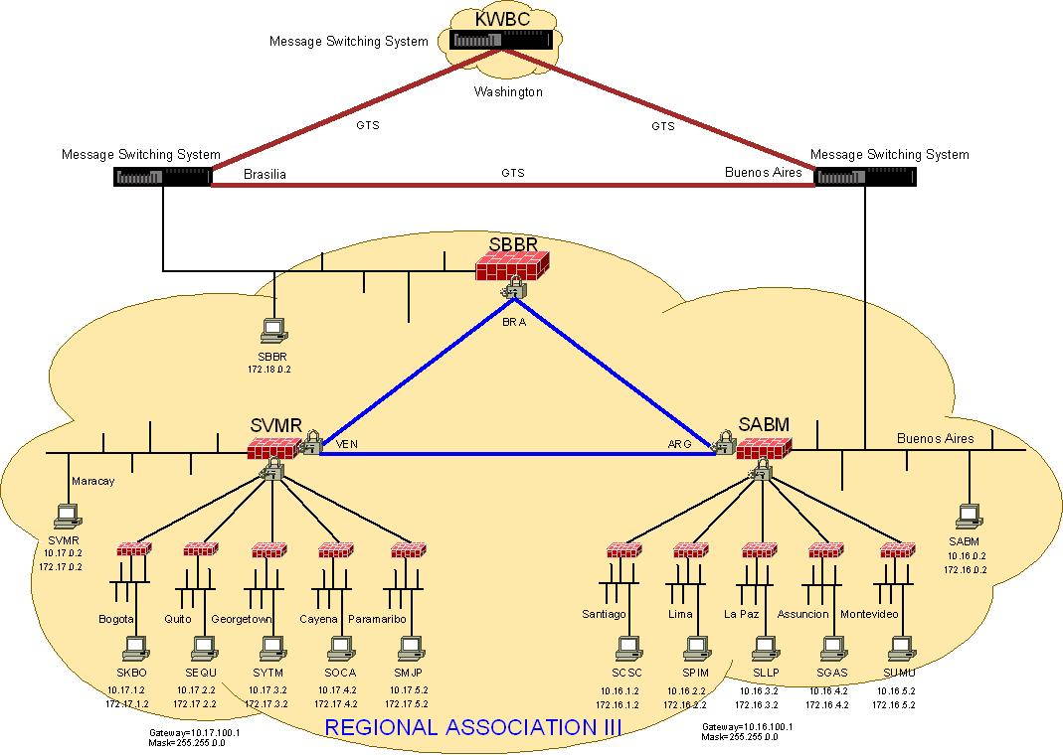
Figure 1

The core part of the proposed solution was already implemented and is working. That means the connection between Brasilia and Buenos Aires; Buenos Aires and Maracay and Maracay and Brasilia. Also the connection between La Paz and Buenos Aires and Montevideo-Buenos Aires are operational.

Some centers, like Venezuela, Uruguay and Ecuador, exchange their data via normal file transfer over the Internet or via e-mail.

There is no technical limitation for the full implementation of the proposed solution. It is only a matter of human resources to have it done.

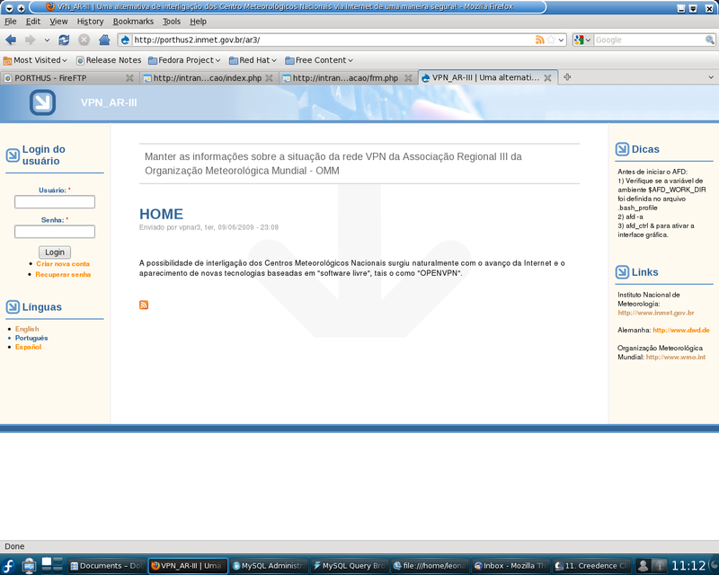

Figure 2

The main problem I found operating the VPN is regarding to the file format and file naming. It is the same problem related to the GTS operation. People always forget there are restrictions to the file contents and frequently use to think one file as one message. The file name problem can be easily sorted out but the content requires additional work.

For instance, in case of the data received from RTH Maracay, there is not a standard way to name the files. To solve this problem the configuration is done in order to let the application scan the directory for specific strings in the file name. If a file is named in different way it will not be taken by the application. An additional step has to be done to prepare the file to be read for the message switching e inserted in to the GTS. Of coarse it slow down the process and there is a risk to lose data.

If a file has some prefix like, for example, BOGOTA_ or MARACAY_, then the application will look only for this specific file and also it will make the monitoring more clear.

The figure 4 at the end of this document shows an example of the operation at RTH Brasilia.

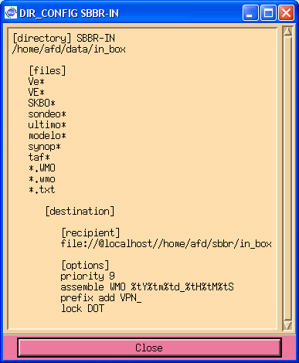

WMO Information System (WIS)

Regarding WIS, Brazil submitted its intention to be nominated a GISC – Global Information System Center for Region III under the WIS infrastructure.
RTH Buenos Aires will act as DCPC – Data Collection and Production Center.

A WIS workshop under the WMO Secretariat Project Office called “Jump Start Offer” (See http://www.wmo.int/pages/prog/www/WIS/documents/JumpStartFlyer.doc) was held in Brasilia from March15th to 19th 2010. It was a kind of “hands on” workshop when all practical aspects of the WIS was discussed, such us installing and configuring the software and protocols to be adopted by the system. The main goal was to bring an expert to help with the WIS implementation.

As a result of this seminar, a pilot GISC site (Figure 3) was set at RTH Brasilia (http://gisc.inmet.gov.br:8080/geonetwork) using the Geonetwork package. Next step is synchronise the GISC center in Brasilia with the DCPC centers located in CPTEC and other expected to be installed at RTH Buenos Aires. Next step is simulating a GISC-to-GISC communication between the GISC pilot in Brasilia and the one located at DWD in Germany.

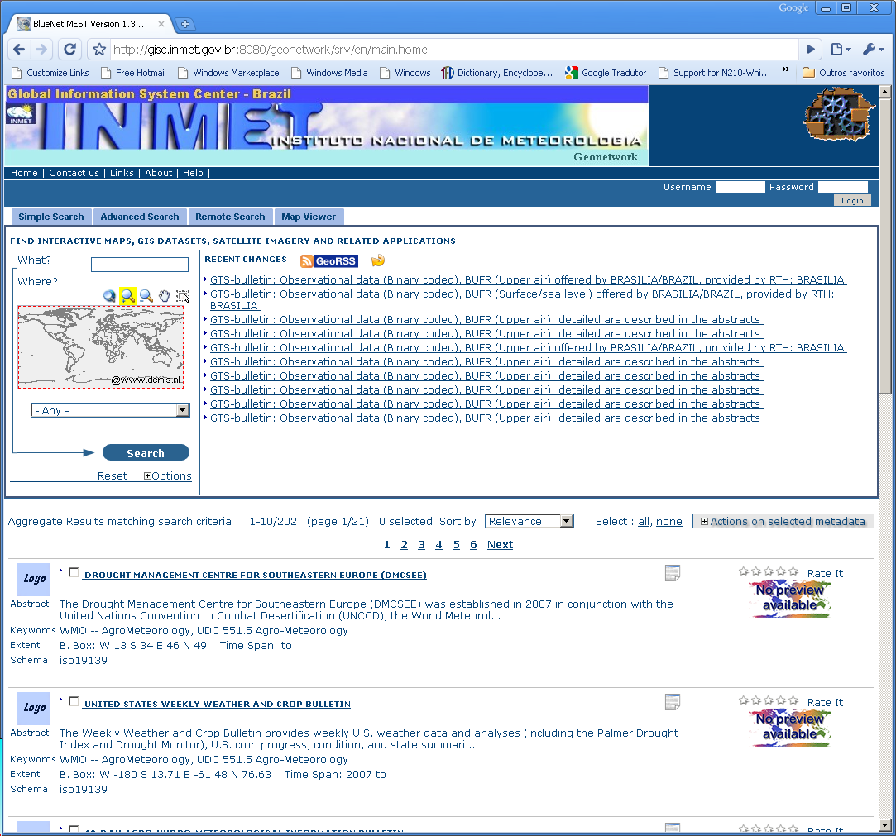
Figure 3

Migration to Table Driven Code Forms (TDCF)

WMO had setup a plan to replace all the Traditional Alphanumerical Code (TAC) such as SYNOP, METAR, TEMP, PILOT, CLIMAT, etc, by codes base on table like BUFR (Binary Universal Form for the Representation of meteorological data). According to the plan, all centers will stop producing TAC bulletins by November 2010. This is a problem to most of the countries in Region III. To know the exact situation in each Region WMO sent a questionnaire to all PR´s but there were not enough answers to have a clear view of the situation.

WMO also wanted to know if there is a RTH in the Region, which could be able to help other centers during the process (migration by zones). RTH Brasilia has tools to compile and convert some type of TAC bulletins into BUFR and vice versa. RTH Buenos Aires is replacing its Message Switching System and might be in the position to offer the same type of support.

The table 2 needs to be updated to reflect the present status of the migration to table driven code in South America. It reflects what was collected until September 24th, 2009.

Table 2
 | Status of Migration to TDCF in RA III
 | - data already produced and distributed in BUFR
 | - published plan approximately conforming to WMO timescales
 | - published plan, missing WMO timescales, or unconvincing statement
 | - no plan visible, or statement
 | - data not produced in TAC
Country | SYNOP or SYNOP MOBIL | TEMP or TEMP MOBIL | CLIMAT | CLIMAT TEMP
Argentina
Bolivia
Brazil
Chile
Colombia
Ecuador
French Guyana
Guyana
Paraguay
Peru
Suriname |  |  | 81225 - Zanderij
Uruguay
Venezuela

Data Representation and Code

Due to the precision required to express horizontal and vertical co-ordinates in Volume A, for instance latitude and longitude in degrees and minutes, it is proposed to request OPAG IOS to implement relevant measures for improving the current situation. It means, WMO Members should be asked to provide horizontal and vertical co-ordinates of their stations with high accuracy and, above all, WMO-No. 9, Volume A should be modified to be capable of accommodating these metadata.

Table 1 - Focal Point for the VPN

Centre | Name | Phone | e-mail
RTH Buenos Aires | José Luis Gianni | +55 11 5167-6767 ex. 18243 | gianni@smn.gov.ar
NMC La Paz | Ramiro Soliz Price | +591 22365288 | pricenet@senamhi.gov.bo  ramiropricenet@gmail.com
RTH Brasilia | José Mauro de Rezende | +55 61 3344-4488 | jmauro.rezende@inmet.gov.br  jmauror@hotmail.com
NMC Santiago | Marcelo Cerda Castillo | +562 4364515 | mcerda@meteochile.cl
NMC Bogota | Julio Cesar Franco B. | +571 3527160 ext 1830  +571 2044445 (Residência) | jcfranco@ideam.gov.co  jcfranco58@gmail.com
NMC Quito | Luis Poveda Zaruma | +593 02 397-1110  +593 02 397-1100 ext 220 | povedal@inamhi.gov.ec  povedal@hotmail.com
NMC Cayena | Stephane Jamoneau | +596 63-99-47 | stephane.jamoneau@meteo.fr
NMC Georgetown
NMC Assunción | Raul Rodas Franco | +595 21 222139  +595 21 422200  +595 21 425046 | raul.rodas@meteorologia.gov.py  raro@supernet.com.py
NMC Lima | Augusto Vargas Valencia | -51 –12511068 | avargas@senamhi.gob.pe
NMC Paramaribo | Ricky Renfrum | +597 8 964657 | r_renfrum@hotmail.com
NMC Montevideo | Marcelo Chico Espinosa | +598 2 4018635  +598 2 4020609 – Tel/ Fax | mceuy@yahoo.com
RTH Maracay | Luis Enrique Perez | -58 243 2324736  -58 416 6436571 | perezluis73@hotmail.com
OMM | Jose Arimatea de Souza Brito | +41 22 7308265 | jarimatea@wmo.int

Monitoring the VPN link

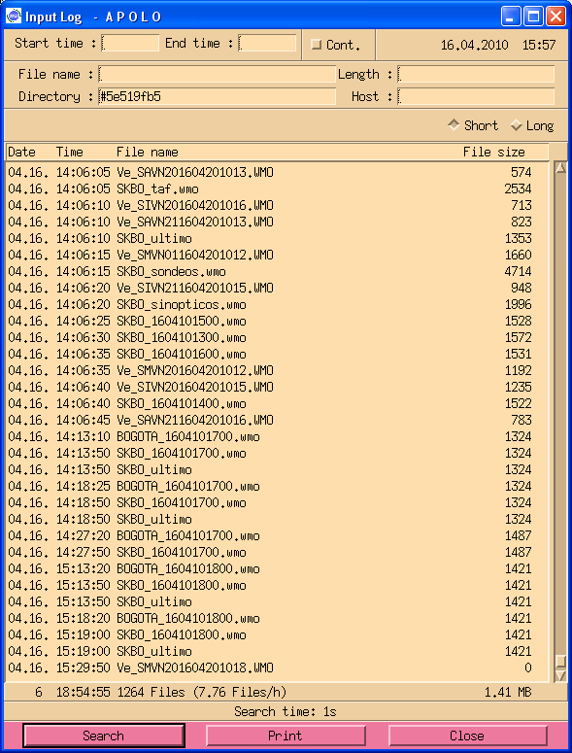

Figura 4

