WORLD METEOROLOGICAL ORGANIZATION  COMMISSION FOR BASIC SYSTEMS  -----------------------------  FIRST MEETING OF  INTER-PROGRAMME EXPERT TEAM ON  DATA REPRESENTATION MAINTENANCE AND MONITORING  TOKYO, JAPAN, 1 - 5 JULY 2013 |  | IPET-DRMM-I / Doc. 7.2 REV 1  (14. VI. 2013)  -------------------------  ITEM 7.2  ENGLISH ONLY

Decisions required:
- definition of what it means to complete migration
- actions needed to complete migration by November 2014

Migration to Table Driven Code Forms

Introduction
CBS-Ext(10) decided on the time table for migration to Table Driven Code Forms (TDCF) shown in Annex 1. With the exception of OPMET aviation information, migration was set to be complete by November 2014. The plan also stated that migration of AMDAR had been completed by November 2006.

This document assesses the current status of migration to TDCF and recommends future actions.

Status of migration in April 2013
Four times a year, WMO coordinates fifteen-day long monitoring of World Weather Watch traffic on the Global Telecommunications System. In the “Special Main Telecommunications Network Monitoring” (SMM), Regional Telecommunications Hubs record the contents of bulletins that are exchanged between them. These records can be analysed to determine the number of reports exchanged for fixed stations in the Regional Basic Synoptic Network, and the number of reports received from mobile platforms. The intent of the analysis in this paper is to identify those territories for which reports are exchanged in TDCF, and it does not attempt to count unique reports from individual stations. Areas shown as reporting in TDCF may have exchanged only one report, or may have relied on a centre outside that area to translate that report into TDCF.

Annex 2 shows the areas for which TDCF reports for surface reports at main synoptic hours were available (equivalent to SYNOP with T₁T₂A₁=ISM) and upper air reports (equivalent to TEMP with T₁T₂A₁=IUS or IUK) were available. Reports with T₁T₂A₁=ISN were not analyzed, and some areas may have reported using these headings but not have been counted in the analysis.

Although much of Regions II, IV and VI are exchanging information in TDCF, there remain many areas for which information is only exchanged in traditional alphanumeric codes, notably in Regions I, II and the islands in Region V,

AMDAR reports were recorded at CBS-Ext(10) as having completed migration. Using the records of the July 2012 SMM (the lastest period for which the pre-analysis of AMDAR reports was performed), no bulletins or files were exchanged containing AMDAR reports in TDCF format, and all were exchanged in Traditional Alphanumeric Code (TAC) form. It is clear that, even though migration is formally complete, in practice exchange is still reliant on TAC.

At CBS-Ext(10), it was expected that OPMET information would start to be exchanged in TDCF from November 2013. The requirements for OPMET information are set by ICAO, and ICAO has not modified its Technical Regulations to permit exchange in TDCF. Instead, it has decided to work towards permitting exchange in XML from November 2013. To address this, the Task Team on Aviation XML has been developing an XML representation of OPMET information that has been derived from the TDCF tables that had been developed but not formally adopted. Migration of OPMET information to TDCF will not, therefore, take place. ICAO has not yet addressed the issue of whether or when it will seek to migrate OPMET information to TDCF.

Potential actions

1 Define what is meant by completion of migration
There are several possible definitions of completion of migration.
a. Migration is complete when all World Weather Watch information exchanged globally on the MTN is represented in TDCF with the exception of specific classes of information for which this is not appropriate (noting that OPMET information is not part of the World Weather Watch).
b. Migration is complete when there is no regional exchange of World Weather Watch information in TAC on the GTS.
c. Migration is complete when any centre is able to obtain World Weather Watch information in TDCF from the WIS.
d. Migration is complete when no centre is required to distribute World Weather Watch information in TAC to any other centre.

2 Actions to support Members that have to date not made progress in migrating to TDCF
Annex 3 proposes a self-help guide that suggests actions that might be of help to Members in migrating to TDCF. IPET-DRMM may wish to publish this.

Action required of IPET-DRMM
IPET-DRMM needs to decide on actions that it needs to take to support migration to TDCF. At a minimum, IPET-DRMM must identify the actions to be taken by its members, and how it will coordinate the work in WMO Member states that are not directly represented on IPET-DRMM. It must also decide on the actions that are required.

Annex 1: Migration Matrix decided by CBS-Ext(10)
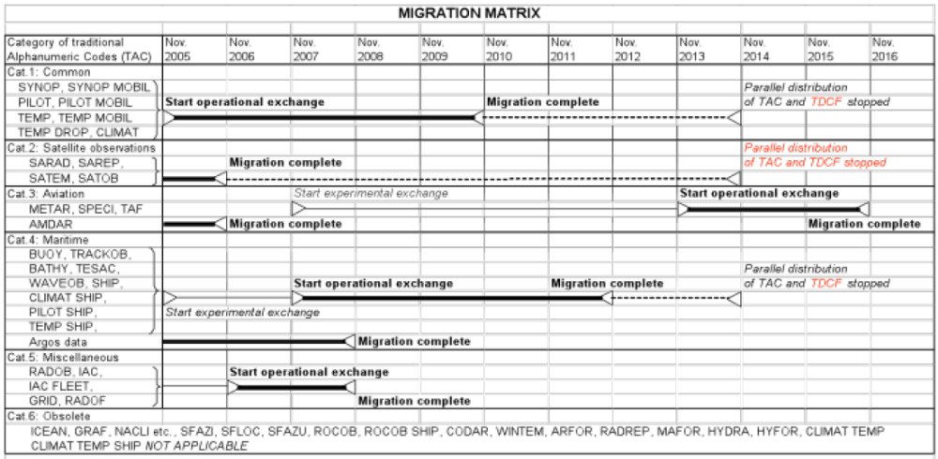

Annex 2: Reports received in Table Driven Code Forms

Table 1: Areas reporting in "IUS" surface BUFR

Region | Area
1 | OCEAN ISLANDS / ILES DANS L'OCEAN
1 | SPAIN (CEUTA AND MELILLA) / ESPAGNE (CEUTA ET MELILLA)
1 | COMOROS / COMORES
1 | SPAIN (CANARY ISLANDS) / ESPAGNE (ILES CANARIES)
1 | OCEAN ISLANDS / ILES DANS L'OCEAN
1 | ALGERIA / ALGERIE
1 | OCEAN ISLANDS / ILES DANS L'OCEAN
1 | MADEIRA / MADERE
1 | OCEAN ISLANDS / ILES DANS L'OCEAN
1 | OCEAN ISLANDS / ILES DANS L'OCEAN
1 | SEYCHELLES
1 | TUNISIA / TUNISIE
1 | OCEAN ISLANDS / ILES DANS L'OCEAN
1 | SOUTH AFRICA / AFRIQUE DU SUD
2 | UNITED ARAB EMIRATES / EMIRATS ARABES UNIS
2 | BANGLADESH
2 | BAHRAIN / BAHREIN
2 | CHINA / CHINE
2 | HONG KONG, CHINA / HONG-KONG, CHINE
2 | INDIA (STATIONS NORTH OF LATITUDE 20~N) / INDE (STATIONS AU NORD DE LA LATITUDE 20~N)
2 | INDIA (STATIONS SOUTH OF LATITUDE 20~N) / INDE (STATIONS AU SUD DE LA LATITUDE 20~N)
2 | IRAQ
2 | JAPAN / JAPON
2 | CAMBODIA / CAMBODGE
2 | REPUBLIC OF KOREA / REPUBLIQUE DE COREE
2 | KUWAIT / KOWEIT
2 | MACAO, CHINA / MACAO, CHINE
2 | MALDIVES
2 | MYANMAR
2 | MONGOLIA / MONGOLIE
2 | OMAN
2 | PAKISTAN
2 | DEMOCRATIC PEOPLE'S REPUBLIC OF KOREA / REPUBLIQUE POPULAIRE DEMOCRATIQUE DE COREE
2 | QATAR
2 | RUSSIAN FEDERATION (IN ASIA) / FEDERATION DE RUSSIE (EN ASIE)
2 | SAUDI ARABIA / ARABIE SAOUDITE
2 | YEMEN
3 | ARGENTINA / ARGENTINE
3 | BOLIVIA / BOLIVIE
3 | BRAZIL / BRESIL
3 | CHILE / CHILI
3 | COLOMBIA / COLOMBIE
3 | ECUADOR / EQUATEUR
3 | FRENCH GUIANA / GUYANE FRANCAISE
3 | ISLANDS / ILES (88: 800 - 998)
3 | PERU / PEROU
3 | PARAGUAY
3 | SURINAME / SURINAM
3 | URUGUAY
4 | BERMUDA / BERMUDES
4 | COLOMBIA / COLOMBIE (SAN ANDRES AND PROVIDENCIA ISLANDS / ILES SAN ANDRES ET PROVIDENCIA)
4 | CUBA
4 | DOMINICA / DOMINIQUE
4 | MEXICO / MEXIQUE
4 | MARTINIQUE
4 | PUERTO RICO AND US POSSESSIONS IN THE CARIBBEAN AREA / PORTO-RICO ET POSSESSIONS DES ETATS-UNIS DANS LA REGION DES CARAIBES
4 | UNITED STATES OF AMERICA (ALASKA) / ETATS-UNIS D'AMERIQUE (ALASKA)
4 | UNITED STATES OF AMERICA / ETATS-UNIS D'AMERIQUE
5 | SAMOA AND AMERICAN SAMOA / SAMOA ET SAMOA AMERICAIN
5 | ISLANDS / ILES (96: 995, 996)
5 | AUSTRALIA / AUSTRALIE (LAT 10~S - 15~S)
5 | AUSTRALIA / AUSTRALIE (LAT 15~S - 20~S)
5 | AUSTRALIA / AUSTRALIE (LAT 20~S - 25~S)
5 | AUSTRALIA / AUSTRALIE (LAT 25~S - 30~S)
5 | AUSTRALIA / AUSTRALIE (LAT 30~S - 35~S)
5 | AUSTRALIA / AUSTRALIE (LAT 35~S - 40~S)
5 | AUSTRALIA / AUSTRALIE (LAT 40~S - 45~S)
5 | AUSTRALIA (ADDITIONAL ISLANDS) / AUSTRALIE (ILES SUPPLEMENTAIRES)
5 | FIJI / FIDJI
5 | ISLANDS IN THE PACIFIC OCEAN NORTH OF THE EQUATOR / ILES DANS L'OCEAN PACIFIQUE AU NORD DE L'EQUATEUR
5 | ISLANDS IN THE PACIFIC OCEAN NORTH OF THE EQUATOR / ILES DANS L'OCEAN PACIFIQUE AU NORD DE L'EQUATEUR
5 | INDONESIA / INDONESIE (JAWA)
5 | INDONESIA / INDONESIE (SULAWESI)
5 | INDONESIA / INDONESIE (NUSATENGGARA)
5 | INDONESIA / INDONESIE (MALUKU AND / ET IRIAN JAYA)
5 | INDONESIA / INDONESIE (SUMATRA)
5 | INDONESIA / INDONESIE (KALIMANTAN)
5 | ISLANDS IN THE PACIFIC OCEAN NORTH OF THE EQUATOR / ILES DANS L'OCEAN PACIFIQUE AU NORD DE L'EQUATEUR
5 | ISLANDS IN THE PACIFIC OCEAN NORTH OF THE EQUATOR / ILES DANS L'OCEAN PACIFIQUE AU NORD DE L'EQUATEUR
5 | MALAYSIA (PENINSULAR MALAYSIA) / MALAISIE (MALAISIE PENINSULAIRE)
5 | MALAYSIA (SABAH AND SARAWAK) / MALAISIE (SABAH ET SARAWAK)
5 | NAURU
5 | NEW ZEALAND / NOUVELLE-ZELANDE
5 | DETACHED ISLANDS / ILES ISOLEES (91: 960 - 998)
5 | PHILIPPINES
5 | ISLANDS IN THE PACIFIC OCEAN NORTH OF THE EQUATOR / ILES DANS L'OCEAN PACIFIQUE AU NORD DE L'EQUATEUR
5 | PAPUA NEW GUINEA / PAPOUASIE - NOUVELLE-GUINEE
5 | FRENCH POLYNESIA (MARQUESAS ISLANDS) / POLYNESIE FRANCAISE (ILES MARQUISES)
5 | FRENCH POLYNESIA (SOCIETY ISLANDS) / POLYNESIE FRANCAISE (ILES DE LA SOCIETE)
5 | FRENCH POLYNESIA (TUAMOTU ISLANDS AND GAMBIER ISLANDS) / POLYNESIE FRANCAISE (ILES TUAMOTU ET ILES GAMBIER)
5 | FRENCH POLYNESIA (AUSTRAL ISLANDS) / POLYNESIE FRANCAISE (ILES AUSTRALES)
5 | SINGAPORE / SINGAPOUR
5 | SOLOMON ISLANDS / ILES SALOMON
5 | TUVALU
5 | ISLANDS IN THE PACIFIC OCEAN NORTH OF THE EQUATOR / ILES DANS L'OCEAN PACIFIQUE AU NORD DE L'EQUATEUR
5 | SAMOA AND AMERICAN SAMOA / SAMOA ET SAMOA AMERICAIN
5 | ISLANDS IN THE PACIFIC OCEAN NORTH OF THE EQUATOR / ILES DANS L'OCEAN PACIFIQUE AU NORD DE L'EQUATEUR
6 | ALBANIA / ALBANIE
6 | AUSTRIA / AUTRICHE
6 | BELGIUM / BELGIQUE
6 | BOSNIA AND HERZEGOVINA / BOSNIE-HERZEGOVINE
6 | BELARUS
6 | SWITZERLAND AND LIECHTENSTEIN / SUISSE ET LIECHTENSTEIN
6 | CYPRUS / CHYPRE
6 | CZECH REPUBLIC / REPUBLIQUE TCHEQUE
6 | GERMANY / ALLEMAGNE
6 | DENMARK AND FAROE ISLANDS / DANEMARK ET ILES FEROE
6 | SPAIN / ESPAGNE
6 | ESTONIA / ESTONIE
6 | FINLAND / FINLANDE
6 | FRANCE
6 | UNITED KINGDOM OF GREAT BRITAIN AND NORTHERN IRELAND / ROYAUME-UNI DE GRANDE-BRETAGNE ET D'IRLANDE DU NORD
6 | GIBRALTAR
6 | GREECE / GRECE
6 | GREENLAND / GROENLAND
6 | CROATIA / CROATIE
6 | HUNGARY / HONGRIE
6 | IRELAND / IRLANDE
6 | ISRAEL
6 | ITALY / ITALIE
6 | LITHUANIA / LITUANIE
6 | LATVIA / LETTONIE
6 | THE FORMER YUGOSLAV REPUBLIC OF MACEDONIA / EX-REPUBLIQUE YOUGOSLAVE DE MACEDOINE
6 | NETHERLANDS / PAYS-BAS
6 | NORWAY / NORVEGE
6 | POLAND / POLOGNE
6 | PORTUGAL
6 | ROMANIA / ROUMANIE
6 | RUSSIAN FEDERATION (IN EUROPE) / FEDERATION DE RUSSIE (EN EUROPE)
6 | SERBIA / SERBIE
6 | SLOVAKIA / SLOVAQUIE
6 | SLOVENIA / SLOVENIE
6 | SWEDEN / SUEDE
6 | SYRIAN ARAB REPUBLIC / REPUBLIQUE ARABE SYRIENNE
6 | TURKEY / TURQUIE
7 | STATIONS OPERATED BY AUSTRALIA / STATIONS EXPLOITEES PAR L'AUSTRALIE
7 | STATIONS OPERATED BY CHILE / STATIONS EXPLOITEES PAR LE CHILI
7 | STATIONS OPERATED BY CHINA / STATIONS EXPLOITEES PAR LA CHINE
7 | STATIONS OPERATED BY GERMANY / STATIONS EXPLOITEES PAR L'ALLEMAGNE
7 | STATIONS OPERATED BY FRANCE / STATIONS EXPLOITEES PAR LA FRANCE
7 | STATIONS OPERATED BY THE UNITED KINGDOM / STATIONS EXPLOITEES PAR LE ROYAUME-UNI
7 | STATIONS OPERATED BY ITALY / STATIONS EXPLOITEES PAR L'ITALIE
7 | STATIONS OPERATED BY JAPAN / STATIONS EXPLOITEES PAR LE JAPON
7 | STATIONS OPERATED BY THE RUSSIAN FEDERATION / STATIONS EXPLOITEES PAR LA FEDERATION DE RUSSIE
7 | STATIONS OPERATED BY UKRAINE / STATIONS EXPLOITEES PAR L'UKRAINE
7 | STATIONS OPERATED BY THE U.S.A. / STATIONS EXPLOITEES PAR LES U.S.A.
7 | STATIONS OPERATED BY THE U.S.A. (UNIVERSITY OF WISCONSIN) / STATIONS EXPLOITEES PAR LES U.S.A. (UNIVERSITE DU WISCONSIN)
7 | STATIONS OPERATED BY SOUTH AFRICA / STATIONS EXPLOITEES PAR L'AFRIQUE DU SUD

Table 2: Areas reporting in IUS (upper air) BUFR.

RA | Country or Area
1 | SPAIN (CANARY ISLANDS)
1 | ALGERIA
1 | OCEAN ISLANDS BETWEEN 30o and 60oS
1 | SENEGAL
1 | OCEAN ISLANDS
1 | SOUTH AFRICA
2 | CHINA
2 | HONG KONG, CHINA
2 | INDIA
2 | JAPAN
2 | REPUBLIC OF KOREA
2 | MONGOLIA
2 | PAKISTAN
2 | DEMOCRATIC PEOPLE'S REPUBLIC OF KOREA
2 | RUSSIAN FEDERATION (IN ASIA)
3 | BRAZIL
3 | CHILE
3 | COLOMBIA
3 | FRENCH GUIANA
3 | ISLANDS (88: 800 - 998)
3 | VENEZUELA
4 | NETHERLANDS ANTILLES AND ARUBA
4 | BAHAMAS
4 | BELIZE
4 | BERMUDA
4 | BARBADOS
4 | CANADA
4 | COLOMBIA (SAN ANDRES AND PROVIDENCIA ISLANDS)
4 | COSTA RICA
4 | CAYMAN ISLANDS
4 | DOMINICAN REPUBLIC
4 | GUADELOUPE, ST MARTIN, ST BARTHELEMY (AND OTHER FRENCH ISLANDS IN THE VICINITY)
4 | MEXICO
4 | PUERTO RICO AND US POSSESSIONS IN THE CARIBBEAN AREA
4 | TRINIDAD AND TOBAGO
4 | UNITED STATES OF AMERICA
4 | UNITED STATES OF AMERICA (ALASKA)
5 | SAMOA AND AMERICAN SAMOA
5 | AUSTRALIA
5 | FIJI
5 | ISLANDS IN THE PACIFIC OCEAN NORTH OF THE EQUATOR
5 | ISLANDS IN THE PACIFIC OCEAN NORTH OF THE EQUATOR
5 | INDONESIA
5 | KIRIBATI
5 | ISLANDS IN THE PACIFIC OCEAN NORTH OF THE EQUATOR
5 | NEW CALEDONIA
5 | NEW ZEALAND
5 | PHILIPPINES
5 | ISLANDS IN THE PACIFIC OCEAN NORTH OF THE EQUATOR
5 | PAPUA NEW GUINEA
5 | FRENCH POLYNESIA (AUSTRAL ISLANDS)
5 | FRENCH POLYNESIA (MARQUESAS ISLANDS)
5 | FRENCH POLYNESIA (SOCIETY ISLANDS)
5 | FRENCH POLYNESIA (TUAMOTU AND GAMBIER ISLANDS)
5 | SINGAPORE
5 | SOLOMON ISLANDS
5 | TUVALU
5 | ISLANDS IN THE PACIFIC OCEAN NORTH OF THE EQUATOR
6 | AUSTRIA
6 | SWITZERLAND AND LIECHTENSTEIN
6 | CYPRUS
6 | CZECH REPUBLIC
6 | GERMANY
6 | DENMARK AND FAROE ISLANDS
6 | SPAIN
6 | FINLAND
6 | FRANCE
6 | UNITED KINGDOM OF GREAT BRITAIN AND NORTHERN IRELAND
6 | GREECE
6 | GREENLAND
6 | CROATIA
6 | HUNGARY
6 | IRELAND
6 | ISRAEL
6 | ITALY
6 | NETHERLANDS
6 | NORWAY
6 | POLAND
6 | RUSSIAN FEDERATION (IN EUROPE)

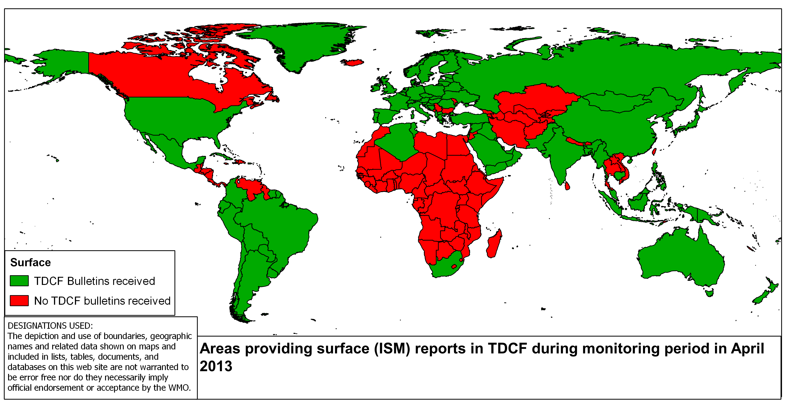
Figure 1: Surface Reports in TDCF (ISM)

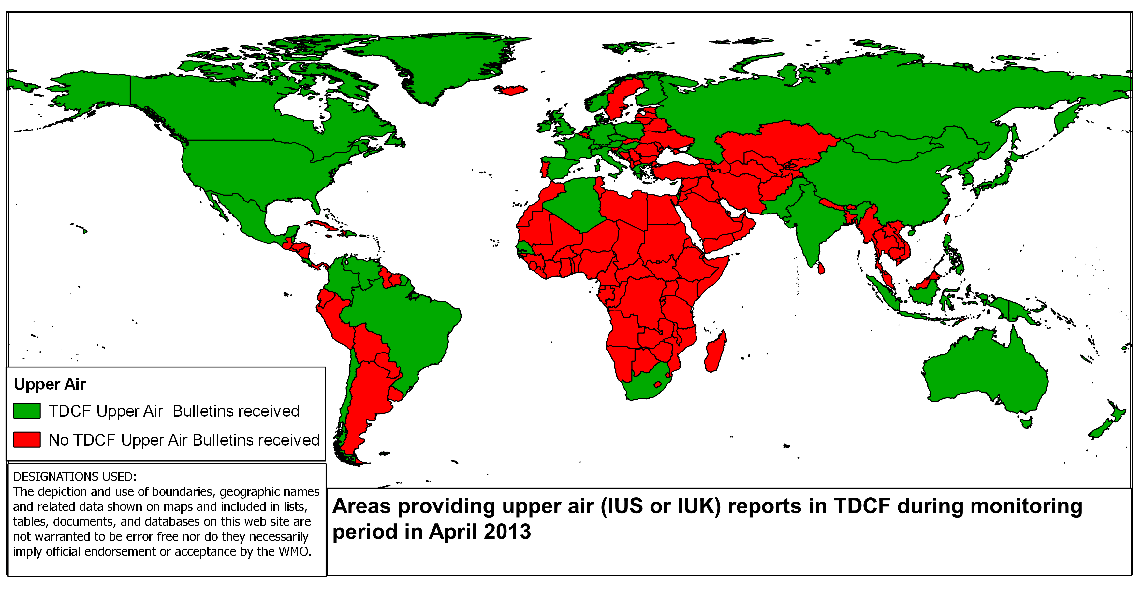
Figure 2: Upper air reports in TDCF (IUS)

Annex 3: Guidance for WMO Members on migration to TDCF

Background for migration plan

Producing information in Table Driven Code Forms
- Modern automatic weather observing stations and radiosonde systems are capable of creating their output directly into TDCF.
- Use the configuration options in new and existing equipment to create observations in TDCF.
- Modern message switche software may be able to convert betweenTAC to TDCF.
- Many climate data management systems are capable of converting from TAC to TDCF.

Using information in Table Driven Code Forms
- Most visualization systems are capable of using data in TDCF
- Many message switch systems are capable of translating from TDCF to TAC.
- Many climate data management systems can convert from TDCF to TAC.

Buying equipment
- Always specify that AWS (in conjunction with the control equipment) must be capable of generating reports in TDCF, and specify that the supplier configures the system to generate TDCF.
- Always specify that message switch systems are capable of handling TDCF
- There is a distinct advantage in using a system that can convert between TAC and TDCF, even if you operate entirely in TDCF; treat such conversion as an additional benefit when formally assessing and comparing systems (you can quantify the additional benefit by considering the impact of not being able to use TAC that others produce)
- Always specify that your visualization system must handle TDCF, and that it is capable of handling the larger station identifiers allowed in BUFR.
- Always specify that any other processing systems you purchase can handle information in TDCF (whenever the information can be represented in TDCF)

And when you have converted to TDCF for your own use
- remember that your external user community may still rely on TAC and be prepared to convert the information from TDCF to TAC for them!

Strategies for Migration

Change systems to use Table Driven Codes now
- update all IT systems to use TDCFs
- change operational practices
- agree revised services with external users

Convert data as it enters and leaves your organisation
- install a system to convert data in TDCFs to TACs
- ensure all future procurements use TDCFs
- plan retirement of systems that only use TACs
- agree revised services with external users

Agree with another Service that they will convert data for you
- ask your RTH to convert data for you (or pass on data others have converted)
- ensure all future procurements use TDCFs
- plan retirement of systems that only use TACs
- agree revised services with external users

Where to find help

Planning assistance:
- Regional Association
- NMHs in your region who have already migrated
- WMO Secretariat

Implementation assistance:
- Regional Telecommunications Hub
- Members in Regional Association
- WMO Secretariat

Technical assistance:
- Regional Telecommunications Hub
- http://www.wmo.int/pages/prog/www/WMOCodes.html

Contacts:
WMO Secretariat: wis-help@wmo.int

Acronyms:
TDCF: Table Driven Code Form
TAC: Traditional Alphanumeric Code
See WMO - No. 386


Migration to

Table Driven Code Forms
A Guide for Permanent Representatives

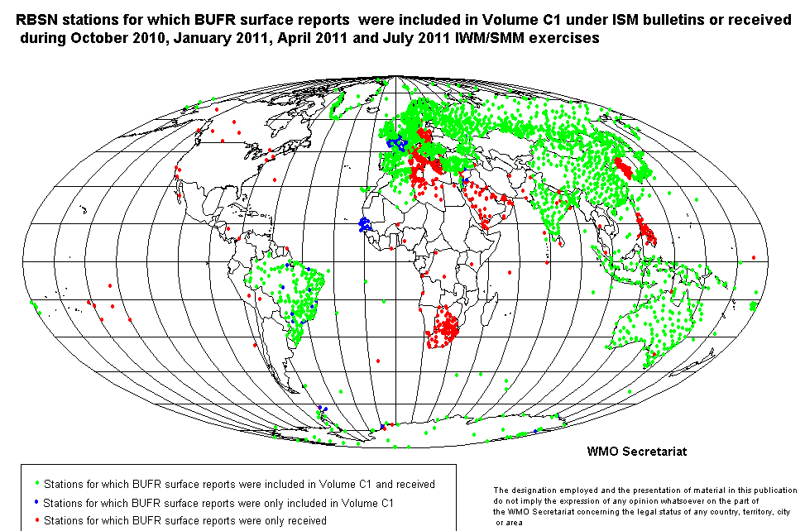

Key issues:
From November 2014
- Critical data will not be useable
- Service quality will fall
- Accuracy of products will reduce

Unless you take action now

Assess

Issues
- some observations will stop being produced in TAC
- some reports cannot be represented in TAC (including some surface reports)
- current operational practices may need to change

Actions
- assess your IT systems: can they handle TDCF?
- assess your operational practices: do people handle data directly?
- assess your services to end users: do users expect TAC?
- asses your observing systems: which formats do they report?
- identify key risks to be managed

Who to involve
- operations managers
- those responsible for relations with external users

Plan

Issues to address
- choose a clear strategy
- expect observations in TAC to decrease
- external users will need time to change their practices and systems

Actions
- agree arrangements with responsible RTH
- set procurement standards
- design and implement changes to forecast and climate operations
- design and procure IT solutions
- plan for November 2014
- plan for when observations cannot be converted to TAC
- manage as a major project

Who to involve
- senior management team
- external users
- forecast and climate managers
- technical staff

Implement

Issues to address
- finances
- rate of progress
- preparedness of external users
- external rate of migration

Actions
- use project management techniques
- check delivery of actions against plan
- track money and effort against plan
- monitor impacts of changes to data on operations
- check impacts on external users
- review progress and adapt plan

Who to involve
- project manager
- senior management team
- project team
- external users

