ANNEX 1

RA III Local Products that uses only data in BUFR format

As the availability of conventional surface data in Brazil is bigger in BUFR than in TAC format, the Brazilian Meteorological Service and other national organizations already have final products that are generated only from data in BUFR format.

One example can be seen in the next figure, where we can see an interpolated temperature field created automatically every hour from AWS observations in BUFR format. This and other products are available in the link: http://www.inmet.gov.br/portal/index.php?r=clima/webService

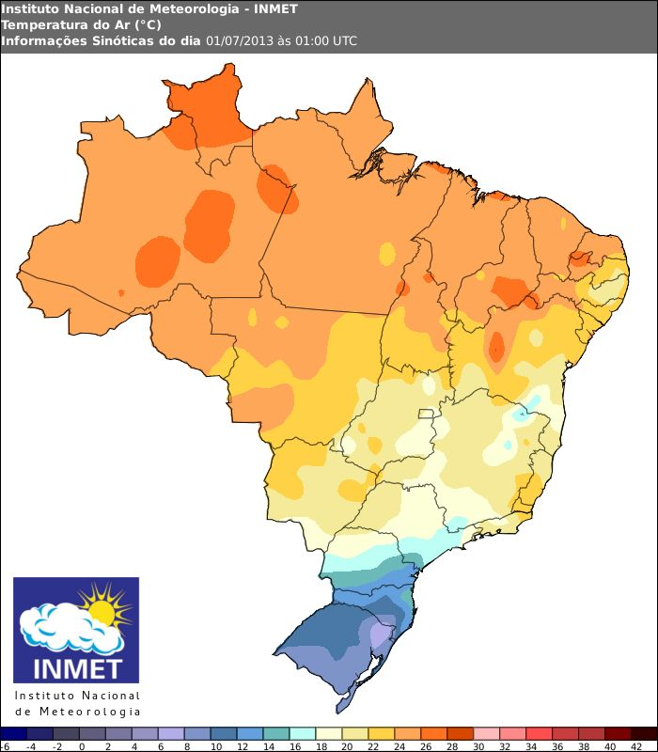
Figure 1 - Example of hourly temperature field generated only from observations in BUFR format

Another example of an product being automatically generated from a BUFR dataset came from the Center of Weather Forecast (CPTEC/INPE) and from the Natural Disaster Monitoring Center (CEMADEN). A monitoring system for precipitation provides alerts from 1-hour BUFR observations from the surface network, as we can see in the figure below, taken from the address: http://bancodedados.cptec.inpe.br/MonitoramentoPrecipitacao/faces/pcda.jsp

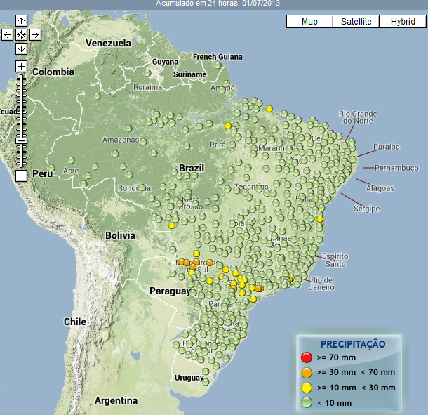
Figure 2 - Example of a precipitation monitoring system that uses only observation data in BUFR

Final Remarks:

The Traditional Alphanumeric Codes (TAC) from RIII bulletins TEMP, PILOT, SYNOP and CLIMAT are being converted by RTH Brasilia in BUFR format and inserted on the GTS. Additionally, the data from the network of Automatic Weather stations (AWS) of Brazilian Meteorological Service (INMET) are being reported only in BUFR format (GTS bulletins ISAI01 SBBR). As a consequence, now the Region III has more conventional data available in BUFR format than in Traditional Alphanumeric Codes.

According the monitoring results these systems are working well but the expected data from some countries were not found in our monitoring datasets. This needs an additional investigation. it is important to note that RTH Brasilia has the capability from to convert all RIII TAC data to BUFR TDCF bulletins, then the reason for the lacking of these data can be investigated and corrected. Another point that called the attention are some few stations that have coordinates unexpected coordinates and more AWS networks with data available as “ISM” bulletins but not in SYNOP TAC. All these details will require time to investigate.

Additionally the tools being used for the BUFR manipulation in Brazil are freely available and can be useful for other WMO centres.

As a final comment we can add that the BUFR migration process is revealing to be very important for the Brazilian Meteorology. The conventional surface network system in the area has some limitations that could be solved only with the BUFR data format and automatic station network. The automated products that several local organizations are generating from these new datasets are showing the technological benefits of the solution. It is highly probable that very soon similar benefits will pop-up for other countries in the area.

